Isadora Ramos Faria
2030449
Digital Skills and Research methods
BMSW4003

Table of contents

Introduction - 2
Literature review- 3
Methodology - 4
Discussion - 5
Conclusion - 12
References - 13

Introduction/aims

In this research report I will be discussing all about the impact of the Virtual Learning Environment, students experience with online learning. I will be talking about how it can affect student’s learning. How it can be useful but also not the best method to learn, showing the advantages and disadvantages of virtual learning.

Virtual learning is a learning experience that is enhanced through utilizing computers and/or the internet both outside and inside the facilities of the educational organization. The instruction most commonly takes place in an online environment. Virtual learning can come in various different forms for example computer based: instructions are not provided by a teacher but instead a software installed on a local computer or server.
Remote teacher online: instructions presented by a teacher but that teacher is not physically present with the student. Instead, the teacher interacts with the student through the internet such as emails, zoom, teams, online forums etc.

Virtual learning helps students learn from wherever they are, it allows you to communicate with the teacher virtually. Having all the necessary equipment, tools and materials to learn.

Of course, it is necessary to have an internet connection as you will need it to be able to communicate with your teacher and access any materials.

I will be collecting primary and secondary and analysing both. The surveys have been collected online instead of face to face due to the current pandemic situation.

Literature Review

A virtual school: ‘an entity approved by a state or governing body that offers courses through distance delivery – most commonly using the internet’.Michael K. Barbour and Thomas C. Reeves, ‘The reality of virtual schools: A review of the literature’, Computers & Education 52.2 (2009), pp. 402-416.
Online learning: ‘education that takes place over the internet’.Joshua Stern,[2] This can be subdivided into asynchronous online courses that do not take place in real-time and synchronous online courses in which teacher and student interact online simultaneously.Fordham University
The rapid, unexpected and ‘forced’ transition from face-to-face to remote teaching has entailed a number of challenges and constraints but also opportunities that need to be examined. Existing literature points to an ‘emergency remote teaching’ (Bozkurt and Sharma 2020, i) or 'emergency eLearning’ (Murphy 2020, 492)
In addition, lack of mentoring and support (Judd et al. 2020) and issues related to teachers’ competencies in the use of digital instructional formats (Huber and Helm 2020) have also been identified.

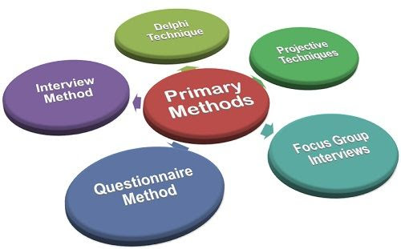
Image 1. Primary data collection

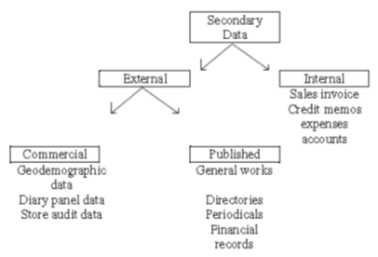
Image 2. Secondary data collection

Secondary data refers to data that is collected by someone other than the primary user. Common sources of secondary data for social science include censuses, information collected by government departments, organizational records and data that was originally collected for other research purposes.

Methodology

The data collected shows the results from the questionnaire which was requested by me to my classmates in order to complete this report. The research method used in this surgery was both data qualitive and quantitative in order to know more about the impacts of virtual learning at the university.
The way this surgery was conducted was by myself creating a form online which I sent out to roughly 25 of my classmates to complete. It was a total of 10 different questions asked. Among these questions were gender, age group, time spent studying at the university, opinions on the university and the course, what they found difficult when it came to virtual learning and if they would recommend this to a friend.
A questionnaire is a type of primary data which is used to obtain direct answers to a specific purpose as Moodle explains. Therefore, the questionnaire helps identify if online learning is a good method of learning or if it is just a waste of time to some.

Discussion
Here I will be discussing the results to the surgery and explain their significance.

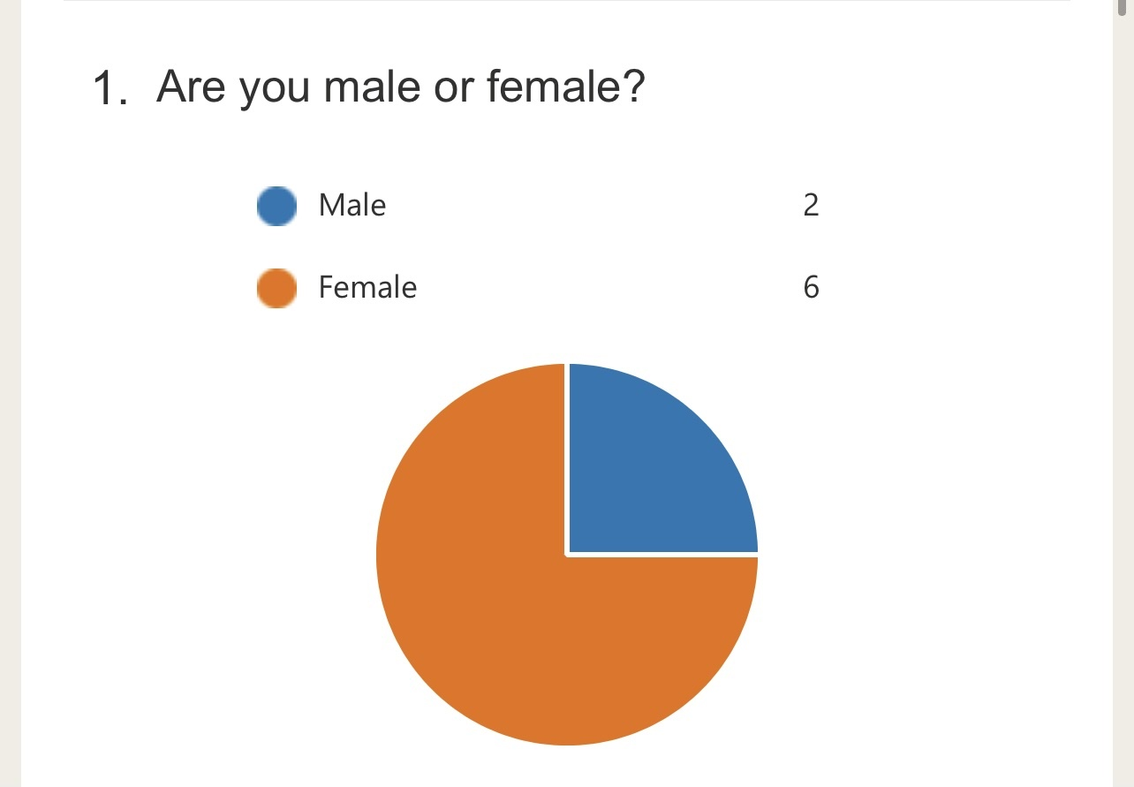
Image 1

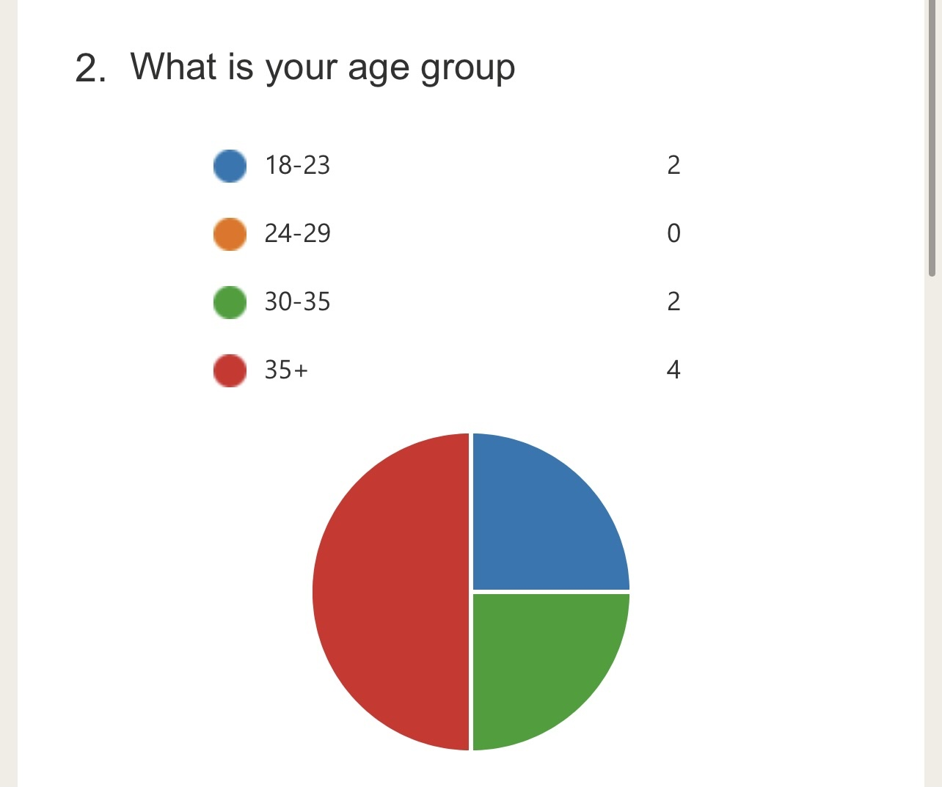
Image 2

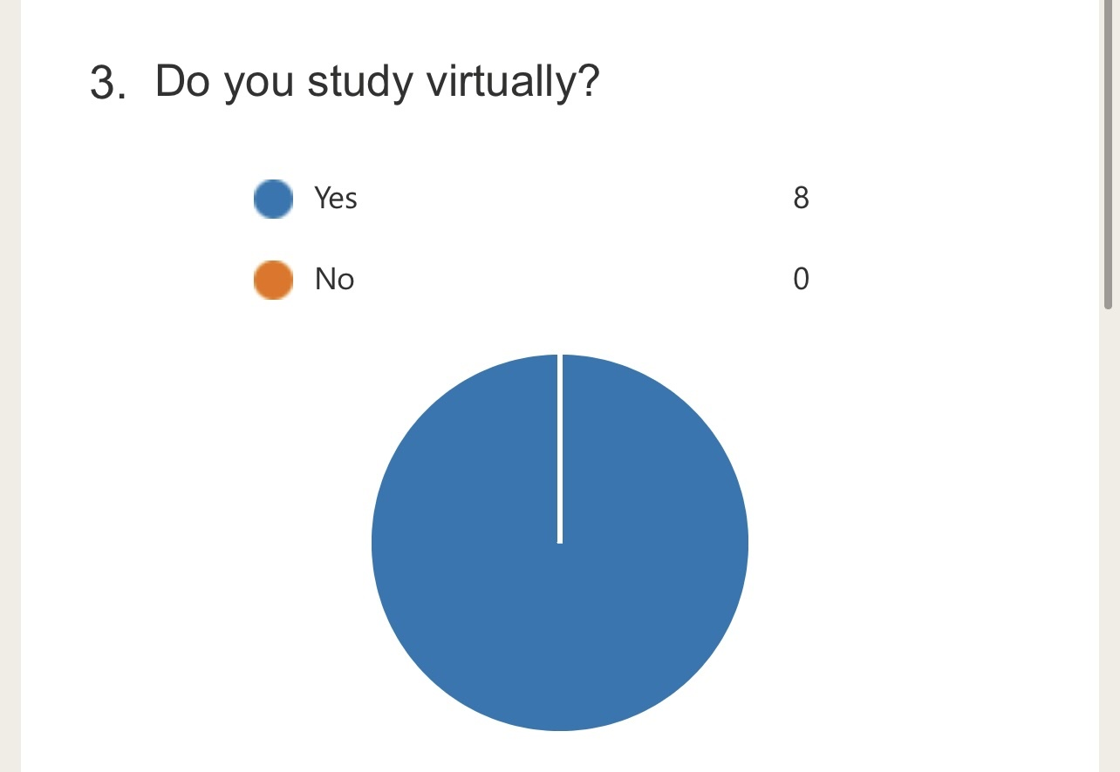
Image 3. From the surgery conducted this is the amount of people who said yes to virtual learning.

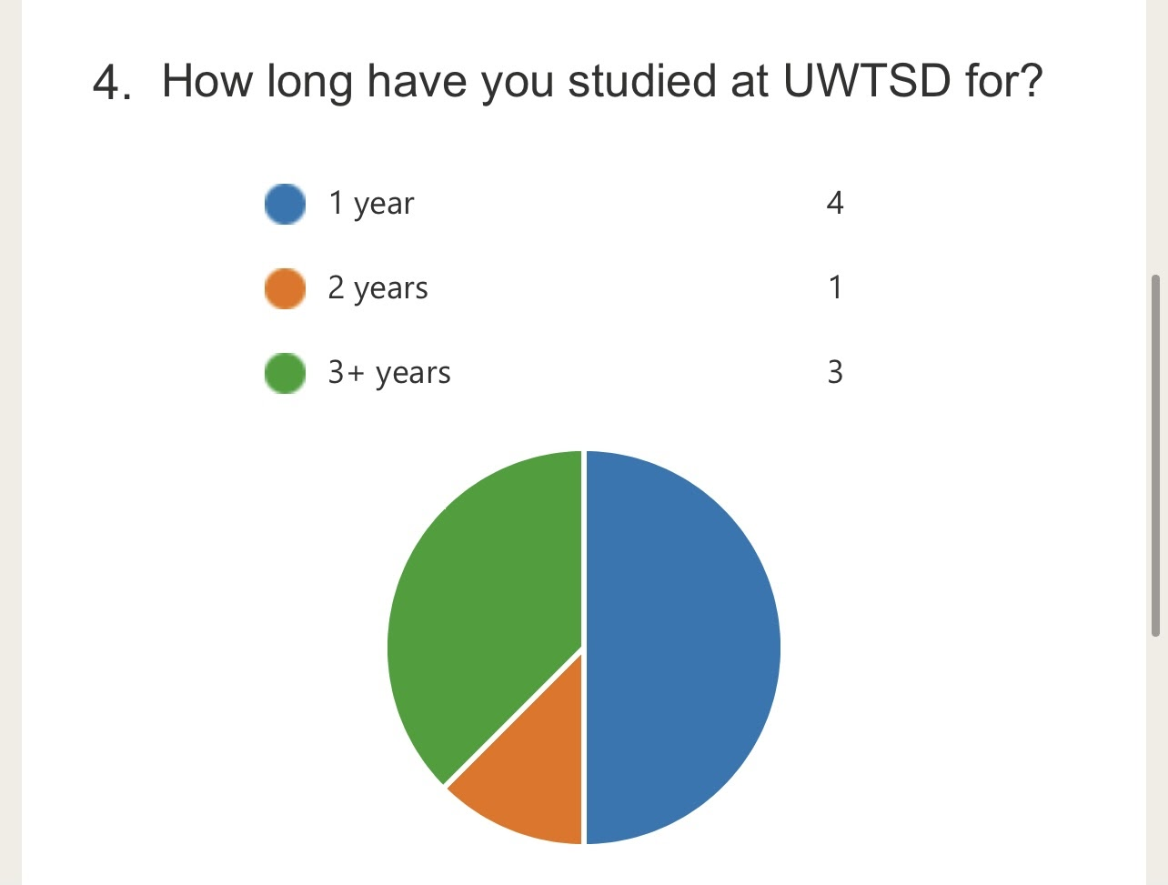
Image 4

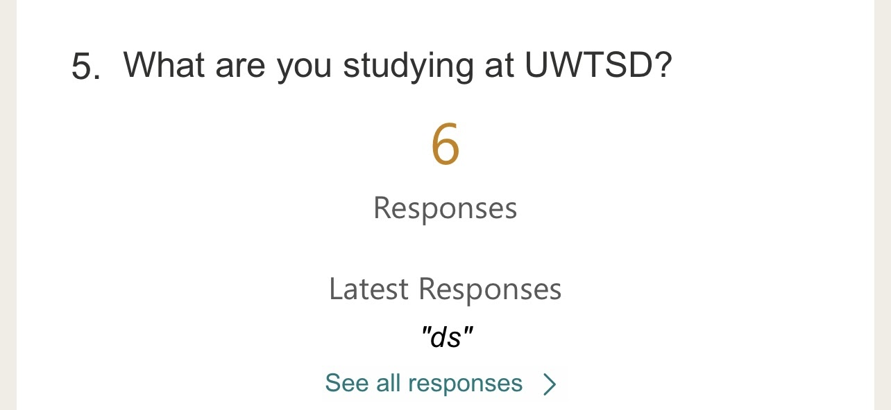
Image 5

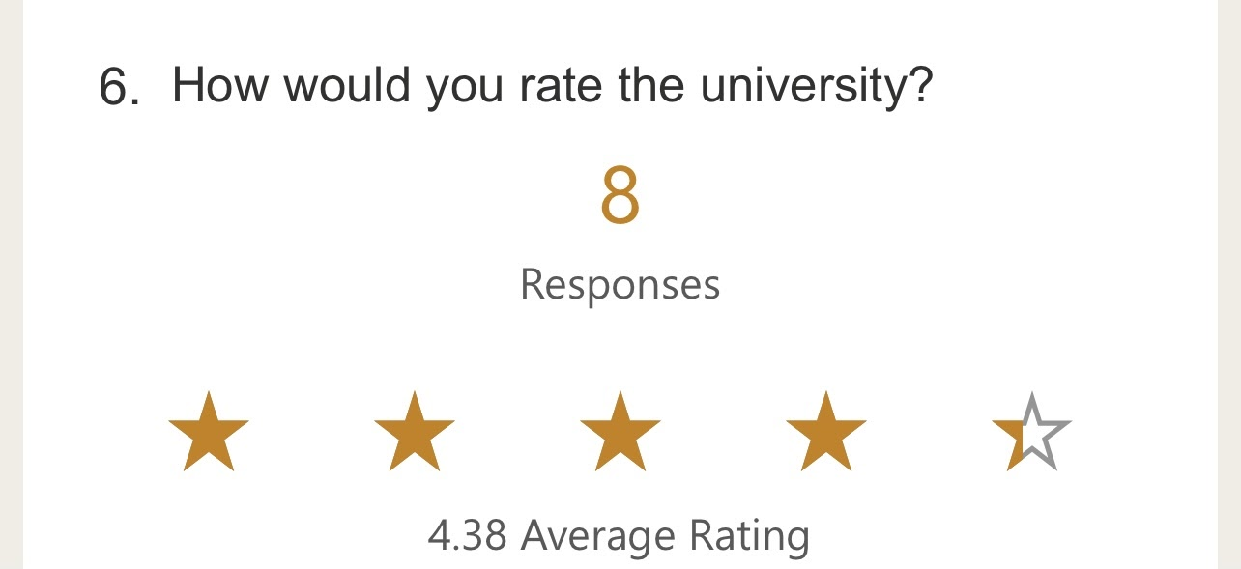
Image 6. This is the average rating for the university.

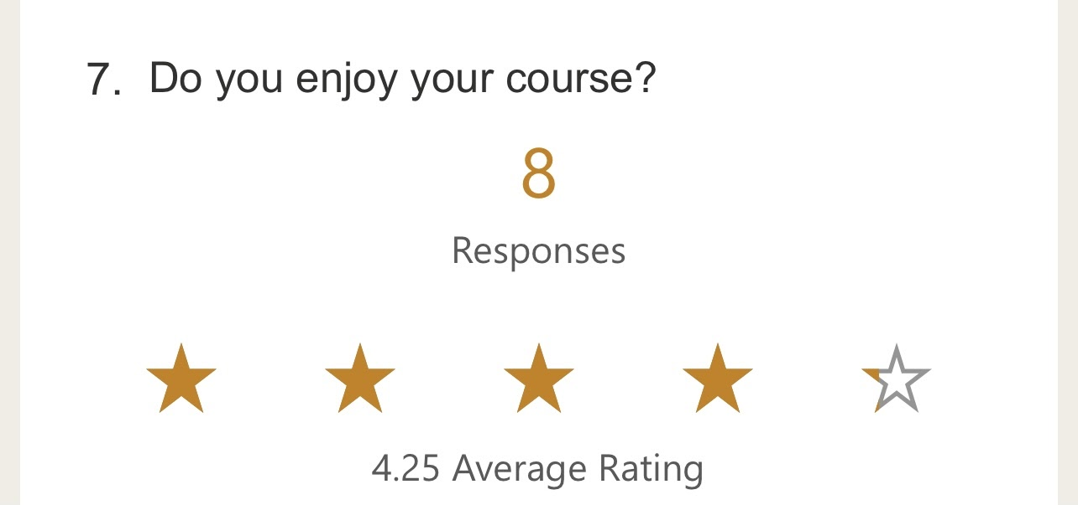
Image 7. This is people’s opinions on whether they enjoy the course or not.

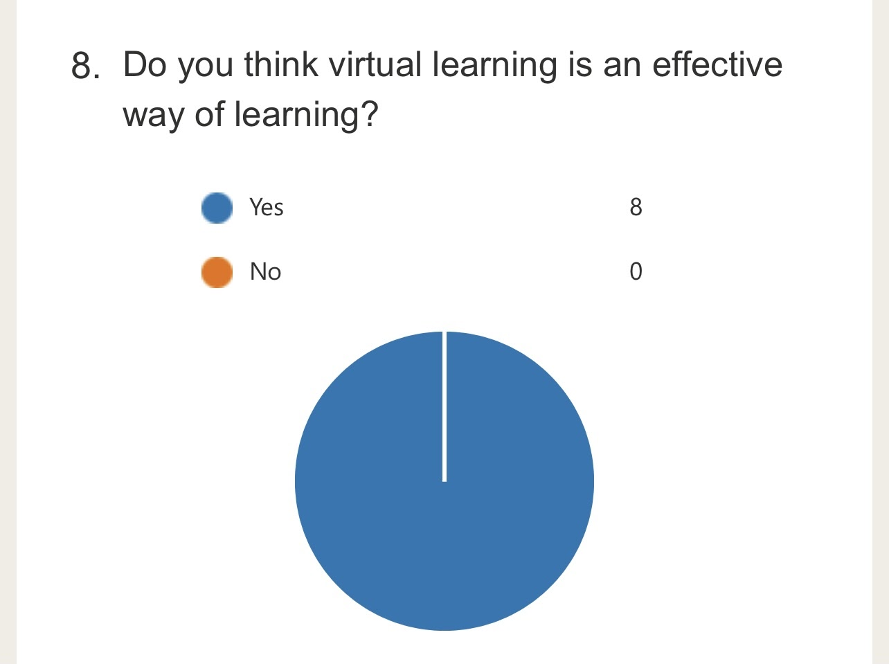
Image 8. People’s opinions on whether they find virtual learning a useful way of learning

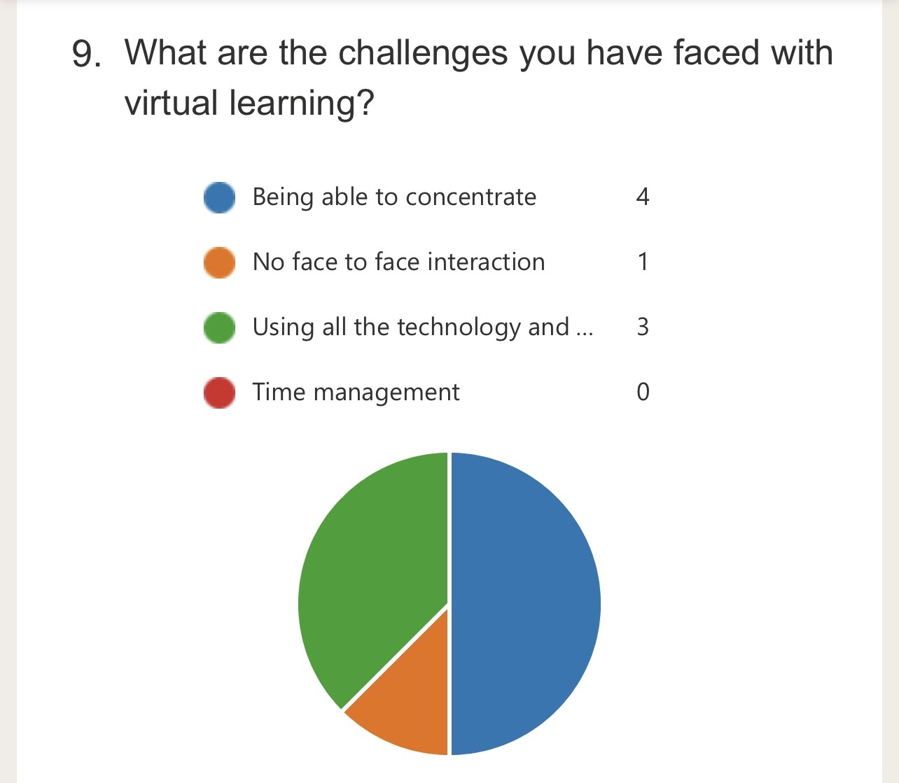
Image 9. Virtual learning can have its advantages but it also has its disadvantages and these are some of the challenges others can face.

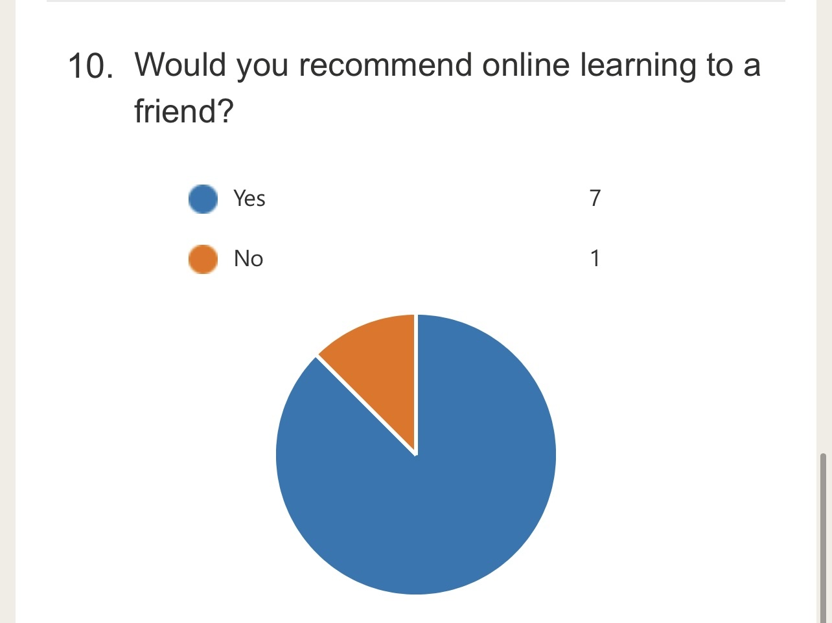
Image 10. When asked if people would recommend online learning to a friend, only 1 person said no. Showing that on average most people would recommend online learning as effective.

Conclusion
In conclusion, by this report we can gain some more knowledge on data collecting and virtual learning. What we have gathered from this report is that in today’s time most people study virtually due to the pandemic. From my survey, every person voted to agreeing to the fact that virtual learning is an effective way of learning. However, that comes with challenges and everyone struggles with different things when it comes to online learning, from things like being able to manage time due to the fact you're in the comfort of your own home or being able to concentrate due to all the distractions around you such as telephones, TVs, food etc.

With this being said, out of 8 people who answered on image 10, 7 said they would recommend online learning to a friend.

The combination of traditional and online methods proves to be very efficient as you are able to increase your interpersonal skills and your computer skills.

References

https://www.tandfonline.com/doi/full/10.1080/02619768.2020.1821184

https://cirl.etoncollege.com/online-distance-learning-a-literature-review/

https://businessjargons.com/primary-data-collection-methods.html

https://www.statswork.com/services/data-analysis/secondary-quantitative-data-collection/

https://www.google.co.uk/amp/s/www.formpl.us/blog/amp/secondary-data

