Yr Iaith ar Daith 2 - Portfolio of evidence

Task 1:
For my 2nd year of professional teaching practice (PTE) I was placed in an English–medium primary school located in Porthcawl. Due to its location the school follows the ‘Welsh Second Language Scheme of Work’ that is provided by the Central South Consortium (CSC). I accessed the CSC website to gain knowledge on the children previous experiences of learning Welsh colours. My PTE was in a reception class with children aged between 4 and 5. According to the CSC, the children should have experienced the story, ‘Balwns Beni’ during the autumn term which includes four Welsh colours (Cscjes.org.uk, 2018). The book I chose for this task was ‘Paintio’r drws.’ The rationale behind the choice of this story was that it would extend the children vocabulary of Welsh colours. Additionally, it would help support them with the next phrase being introduced on their ‘Helpwr y dydd’ chart, ‘Beth wyt ti’n gwisco?’(Appendix 1).

According to the CSC website the children will be introduced the ‘Paintio’r drws’ story in the year 1 scheme of work. It was the next logical step to take to develop their Welsh language skills in the colours area. The story contains 3 additional colours to the ones found in the ‘Balwns Beni’ book. The learning objective for the story was for the learner, “To recognise and say the colours in Welsh.” According to the Foundation Phase Welsh Language Development area of learning, teachers assist learners to make progress in their ability to read by giving them the opportunity to, “Follow stories read to them and respond as appropriate” (Curriculum for Wales, 2015, p.37). The learning resource I chose to support this story was a dice with different colour on each face (Appendix 2). Task 2 provides visual evidence on how this resource was used and task 3 also offers more information on why it was chosen.

Task 2:
https://www.youtube.com/watch?v=yT7xOZS1Log&t=1s

Task 3:
The video clip provided in task 2 shows evidence of how ‘Paintio’r drws’ was delivered to the children and also includes clips of the planned activities being completed. During my time on placement I only observed one Welsh lesson being delivered. The focus for the lesson was the phrase ‘Beth sy’n bod.’ The class teacher read the children the ‘Joio dan 5 – Beth sy’n bod?’ recommended by the CSCS website and then the children participated in a rotation of four activities. The children then completed one reading, two oral and one writing activity. Due to the children’s age and ability the tasks were simple and short. The lesson I planned considered all of these aspects and kept to a similar structure to ensure consistency of the routine the learners were familiar with. (Appendix 3). I received very little support or guidance during the planning process or delivery of the Welsh lesson I planned. As I am new to the language myself I found the task difficult and lacked confidence in my ability. My only previous experience in use of Welsh in a classroom setting was mainly with the use of incidental Welsh and through the delivering of daily routine activities for example the taking the register, lining the children up, tidy up time and transitions.

For my Welsh lesson I split the class in to their usual four groups which were of mixed ability. The first activity for each of the groups involved me presenting the story ‘Peintio’r drws’ to each group. According to research carried out by Lucarevschi, (2016) storytelling is a positive pedagogical instrument that encourages learners to engage with a second language. As seen in the video I used several techniques when delivering the story. Firstly, to ensure that all children were able to see the images and words I used the interactive whiteboard as a visual aid to present the story. Secondly, I pointed to the words whilst reading them in Welsh so that the children were able to follow the story and also see the association between the written and spoken word. Thirdly, I read the words in Welsh and then translated it to English to ensure the children understand what the story was about. I have some previous knowledge of the Welsh colours but was unsure about all of the words in the story so I used the internet to help with translation prior to the lesson.

Paying careful consideration to the age and ability of the children I chose to only ask one simple closed question throughout. The reason for this choice was that I did not want to confuse the children by asking a variety of questions above their level of understanding. Questioning is an important tool for teachers when teaching a second language. According to Maynard (2012, p.21), “Asking open questions when children are beginning to learn another language is not appropriate because children will not have sufficient vocabulary or knowledge of the language to express themselves.” Maynard state there are several elements to consider which include; teacher modelling of the question and answers, allowing sufficient time for the children to respond, giving the children the opportunity to ask the question as well as respond, encourage inclusivity and start by asking whole class then groups and then individuals. I considered all of these points when planning my lesson and as the lesson plan shows (Appendix 3) the tasks were set out in order of completion so that the children were slowly introduced to new colours and became more independent by going from whole class to group word and ending with an individual task.

The school I was placed in also used the ‘Bloom’s Taxonomy’ approach. The focus of the story was to encourage the children to use their prior knowledge of Welsh colours. To show they had understanding they had to recognise and translate the colour in Welsh. I then used a variety of structured activities that allowed the children to apply and use their knowledge to complete the tasks. The game, reading and writing activity allowed the children apply what they knew in a different context. However, the lack of my experience and confidence of using Welsh can clearly be seen in the video clip. Several words were incorrectly pronounced and extension questions could have been included to develop higher attaining children further.

The first task planned after the story included the use of a coloured dice (Appendix 2). The children have had previous experience of using the dice for other learning activities. The game was simple and suitable for the age of the learners. I explained the objective of the game to the children which was once a child had thrown the dice they were to point to another child and ask them ‘what colour?’ in Welsh (pa liw?). The game gave the children the chance to ask and answer the question. The dice included three colours from both the ‘Balwns beni’ and ‘Peintio’r drws’ book. It was a cross-curricular task that also developed skill from to physical development area of learning stated on the lesson plan (Appendix 3). This activity used the language teaching methodology ‘task-based language learning’ as it was fun and engaging and allowed the learners to use the language they already knew to help complete a task they had interest in. As the children were sat in a circle for the game it provided an inclusive and positive environment which allowed me to give instant feedback with the use praise. Behaviourist Skinner believed that children will imitate the language they hear other use and they should received praise to encourage them to continue to practice and develop their language skills in a positive environment (Lightbown and Spada, 2013). There were again times where I was concerned that I was not modelling the correct pronunciation and the repercussions this could have on the children’s development of Welsh language.

Following the game the children were then introduced to the writing task. To make sure I set the task to the appropriate level I used information I had gathered from observing the children during their handwriting sessions. Whilst observing these sessions it was clear that a majority of the children struggled with letter formation. I did not want the children to feel rushed or lose confidence by making the task too difficult so I decided that I would provide support with the use of a word mat. This activity was done with half of the group of children each time which allowed me to be able to give the support required. Doing the activity with a group of children with the use of the word mat created an environment for the children to support each other with. Vygotsky’s Zone of Proximal Development suggests that both adults and more experienced children can provide scaffolding. This task provided scaffolding in written and oral form which offered the opportunity for children to use their Welsh language skill as well as their reading skill. To ensure the task was not too simple the word mat included eight Welsh words. The activity sheet only required the children to write four colours (Appendix 4). By providing too many words the children had to show some upstanding by sounding out the colour and recognising it in written form. Using the children knowledge in phonics of their first language to assist them in the second language is known as the natural approach. However, the letter if the Welsh alphabet are not the same as English. Looking back on the way I approached this task has made me realise that this could cause confusing for the children.

The last task I planned was an individual reading task. The task was differentiated by using the children’s reading ability I observed in Read, Write, Inc (RWI) sessions. The children in the highest ability RWI group had only just begun learning how to blend sounds to read words. I considered this when creating the differentiated worksheets (Appendix 5). I feel that helped ensure the task was set at an appropriate level. This task allowed me to assess how much each child had learnt. But it was not my only way of assessing their development in the language. I finished the lesson with a Welsh colour song and be including such a variety of tasks the children had the opportunity to show their ability in several ways. According to Garner’s Multiple Intelligence (MI) theory, “All humans have these intelligences, but people differ in the strengths and combinations of intelligences” (Richards and Rodgers 2001, p.115). I wanted the learning to be successful so tried to accommodate as many different learning styles as possible.

I do feel that I have made a coincidence effort to include more Welsh language whilst on PTE in my 2nd year of my degree. To help develop my confidence I asked if I could do the daily ‘Helpwr y dydd’ with the class. The ‘Helpwr y dydd’ chart the children used was also an aid for me to know the correct sentence structures. There was a noticeable improvement in my pronunciation of these phrases as I used them on a daily basis whilst in school. As my confidence in this task grew I decided to deliver a ‘Helpwr y dydd’ session for one of my observation as proof of my improvement in the language. However, I do feel my confidence in use and pronunciation of the language would have improved further if support was given by my class teacher. The video clip does not show transitional periods where a majority of the incidental/instructional Welsh was used. Evidence of the incidental/instructional Welsh I used has been provided (Appendix 6).

Reference list

Cscjes.org.uk. (2018). Reception - Welsh Second Language Scheme of Work. [Online] Available at: https://www.cscjes.org.uk/ [Accessed 12 January 2019].

Lightbown, P. and Spada, N. (2013). How languages are learned. 4th ed. Oxford: Oxford University Press.

Lucarevschi, C. (2016). The role of storytelling on language learning: A literature review. [Online] WPLC DIGITIAL EDITION. Available at: https://journals.uvic.ca/index.php/WPLC/article/view/1530 [Accessed 1st March 2019].

Maynard, S. (2012). Teaching foreign languages in the primary school. London: Routledge.

Richards, J. and Rodgers, T. (2001). Approaches and methods in language teaching. 2nd ed. New York: Cambridge University Press.

Wales: Curriculum for Wales: (2015) Foundation Phase Framework Cardiff: Welsh Government. Available at: http://learning.gov.wales/docs/learningwales/publications/150803-fp-framework-en.pdf [Accessed 12 January 2019].

Appendix 1 –
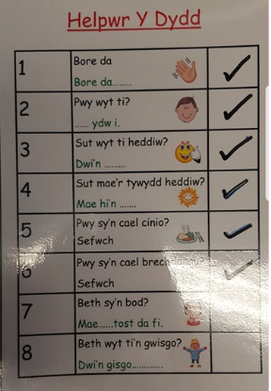

Appendix 2 –
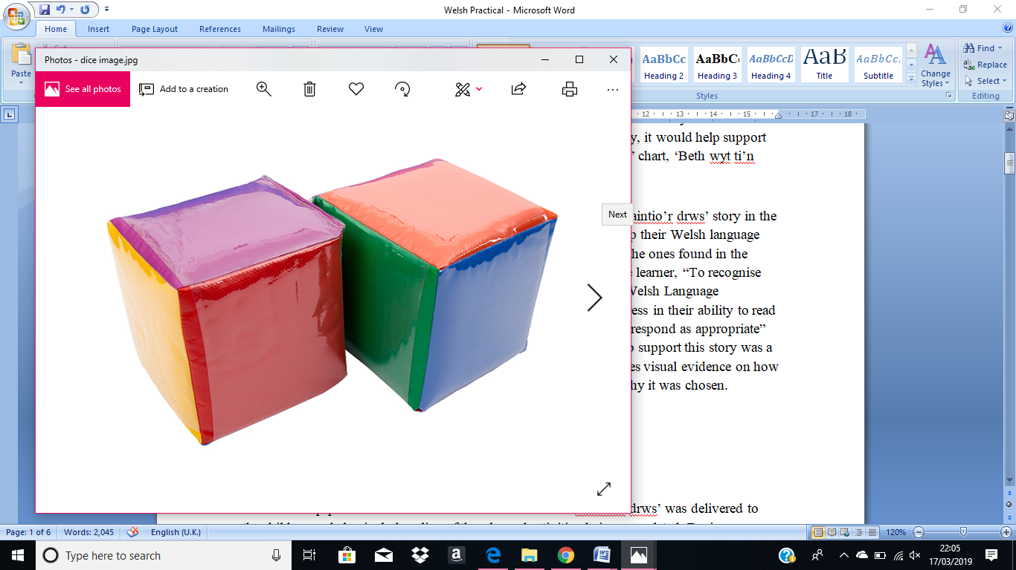

Appendix 3 –
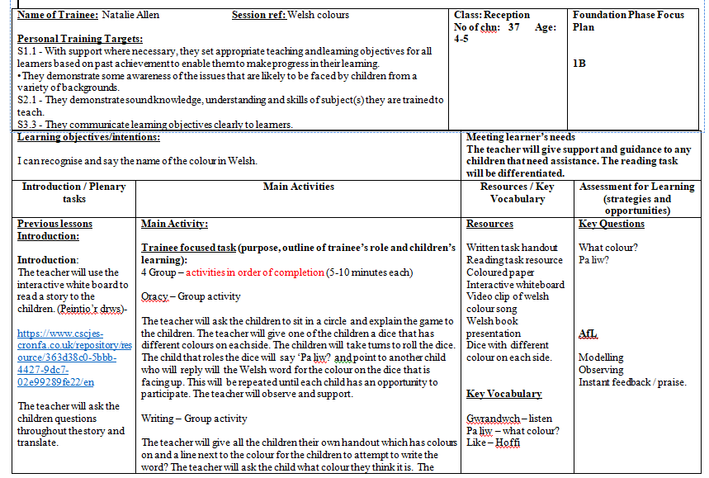
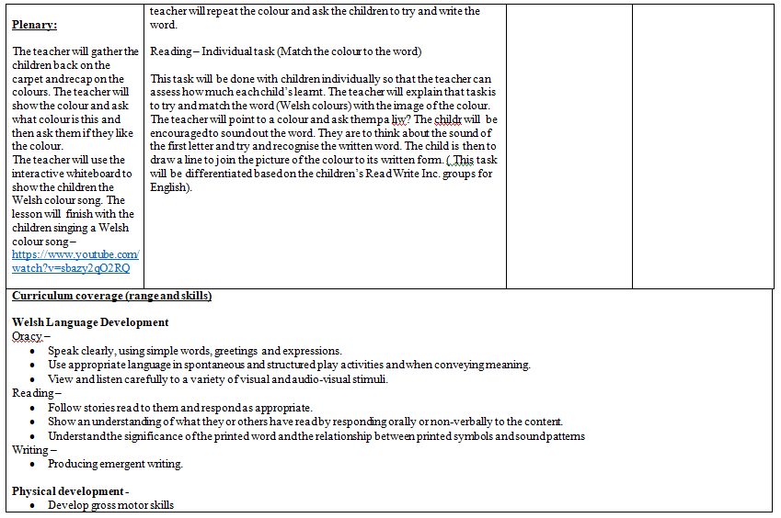
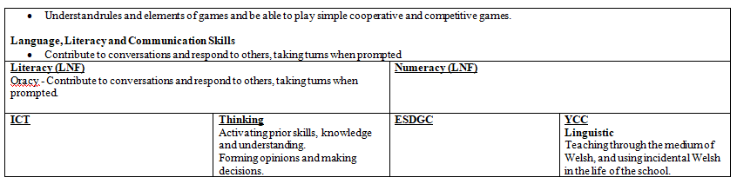

Appendix 4 –
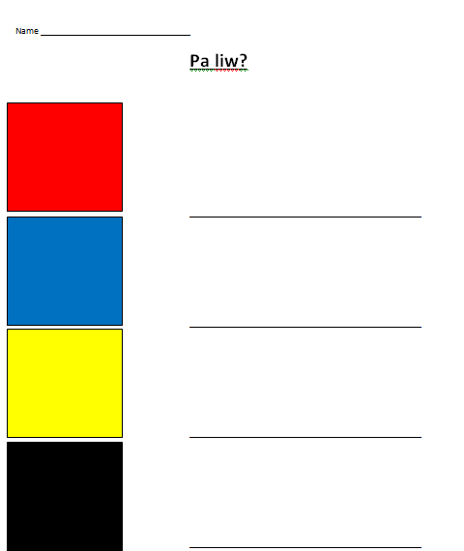

Appendix 6 –
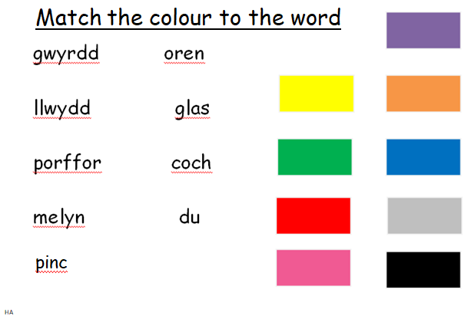
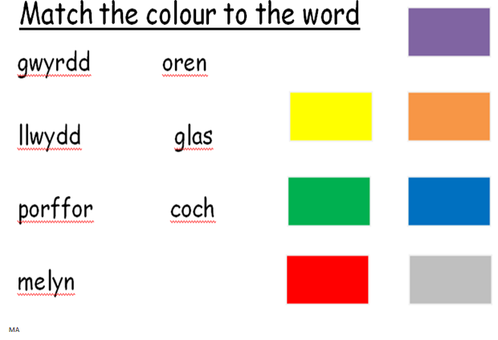

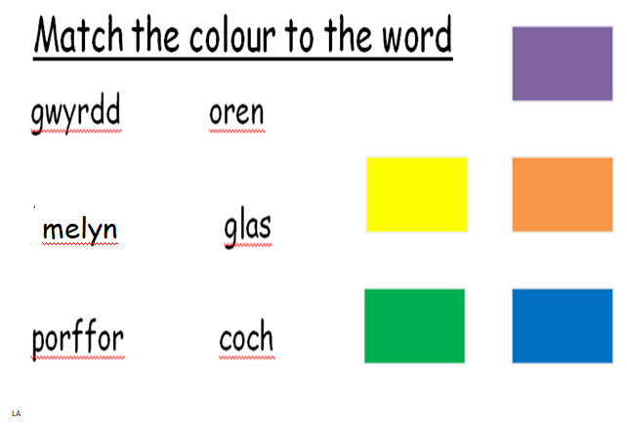

Appendix 6 –


