Student’s Name: Andreea Catalina Mecic
Student Number: 2215573
Assessment 1
Sustainable Hospitality & Tourism Management
BMIH5006
Lecturer’s name:Scott James

Contents
Introduction 2
Main Body 2
Conclusion 7
References 8

Introduction
Sustainability is a multifaceted concept, combined of social, environmental and economic components. This focuses on the current requirements but without endangering the ability of future generations to fulfil their own needs. It covers the wise use of resources, the activities of protection and the social development to guarantee the future viability and resilience. Corporate Social Responsibility (CSR) and sustainability are interconnected as businesses have the responsibility to both conduct ethical conduct and environmental impact as much as possible. CSR takes the form of several undertakings including corporate philanthropy, ethics in labour, community involvement and the environment among others. In the hospitality industry, sustainability and CSR are the two major problems that have to be resolved in order to decrease the environmental impact of this sector and to fulfil the social responsibilities. This essay will study the considerable effect of CSR in the hospitality sector by focusing on Hilton Hotel. In this essay, an integration of CSR principles into the business strategies will discuss which is so important for the promotion of environmental conservation, social equity and economic prosperity.

Main Body
In the hospitality industry, the function of CSR is more focused to sustainability and evident in current practices adopted by UK hotels. As shared by Alatawi et al., (2023), the focus is towards connection between CSR initiatives and financial and non-financial indicators which are related to tourism. In addition, Achmad and Yulianah (2022) also highlight the importance of CSR in sustainable tourism development in the hospitality industry. The research study calls for the position of CSR as an enabling force for effectively realising proper business practices that sustain tourism destinations. Through corporate social responsibility (CSR) activities which hotel firms (such as hotels) are involved in, the environmental impacts are mitigated, social welfare and welfare are promoted as well and ethical standards in operations. In this way, CSR is a tool that enables hospitality businesses to correspond their goals with the sustainable development ones, and thus, to protect natural resources and the well-being of local communities while maintaining a competitive advantage in the industry.
Hilton, a leading brand in the world of hotels, is well-known for its CSR practices globally in line with the theme of sustainable development. In the view of Guzzo et al. (2020), the CSR initiatives of Hilton span a wide range of tactics which are meant to create positive social and environmental impacts. These are among the others such as environmental stewardship, community engagement, and ethical labour practices. Hilton is widely known for its dedication to sustainable practices and got recognition for its sustainability performance. By introducing the "Travel with Purpose" program, Hilton has set attainable goals of its environmental, social, and governance (ESG) by mentioning the enhanced targets of Hilton's climate action and social impact. The proactive nature of these measures shows the strong commitment of Hilton to both the environment and society in relation to sustainability. In analysing Hilton's CSR practices, it can be seen that the company's actions are not just the superficial gestures but an integral part of its business strategy. In a study conducted by Lee et al., (2023), the relationship between CSR and corporate financial performance in the tourism and hospitality industry has been acknowledged more and more. Hilton's CSR strategic point, according to Camilleri (2020), is the interdependent link between how responsible business practices must be with profitability in the long run. Through implementing CSR into its core business functions, Hilton accomplishes not only the ethical responsibilities but it also gains the market advantage.
Added to this, the three pillars of sustainability; environmental, social and economic aspects, are the base on which the ethics for the hospitality industry companies are built. The work by Ramugnani Thirumalesh et al. (2023) shows that these principles form the major role while implementing the CSR programs in the hotels. The concept of environmental sustainability refers to the protection and use of available resources in a more responsible manner. The social sustainability has to do with the implementation of the inclusive policies, the facilitation of the participation of the community and the assurance of the well-being of the main individuals. The third and last factor is economic sustainability as it relies on the ability of businesses to achieve profits as well as sustainable economic development. Moneva et al. (2020) have proposed the concepts of performance and long-term sustainability and accordingly, these concepts should be used in organizational strategies seeking for the best results. By upholding these values, hospitality businesses like the Hilton will be capable of actually balancing the environmental stewardship, social responsibility and economic advantages.
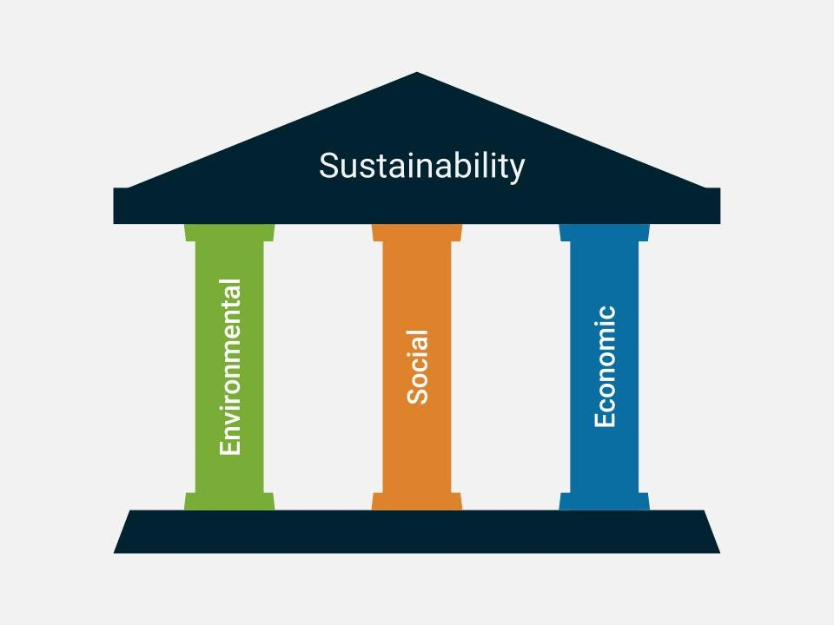
Figure 1 Three Pillars of Sustainability
Source: Ramugnani Thirumalesh et al. (2023)

CSR programs in the hospitality industry influence the sustainability practices in many areas, thus bringing positive results both for businesses and society. Akbari et al. (2021) highlight the importance of CSR in the improvement of customer loyalty, brands' positioning and intention to return for hotel guests. Through CSR, Hilton as a brand can create strong ties with its customers and thus increase both the loyalty and repeat business, as well as carry on the sustainability mission. Nourafkan et al. (2024) stressed the role of CSR in the workplace spirituality and green voice behaviours, which means that CSR initiatives can create an organisational culture that is conducive to sustainability practices. By means of hotels setting up CSR programs that propagate workplace well-being and environmental stewardship, employees will be inspired to play a very critical role in the advancement of the organisation's sustainability objectives. Moreover, Uyar et al. (2020) highlight the connection between board attributes, CSR performance, and financial performance among the hospitality and tourism industry also. An effective CSR governance at the board level is able to drive the sustainable practices throughout the organisation, which in turn leads to the improved financial performance and long-term sustainability. Through targeting CSR initiatives on customer engagement, workplace culture, and governance, hotels like Hilton not only improve their competitive positioning and business performance, but also demonstrate their social responsibility by contributing significantly to sustainable development within the hospitality industry. CSR models set up a system of understanding and putting into practice the responsible business activities that are centred on people welfare, environment and economy. Carroll's Pyramid is a seminal model that delineates four tiers of CSR responsibilities: inclusive, legal, morally sound, and charitable, thereby capturing the progressive nature of CSR responsibilities (Silva et al., 2023). Hence, the pyramid depicts that CSR is multi-sided and thus businesses should not focus on economic profits but rather on legal and ethical standards and dedicate their resources to provide a social welfare through charity. However, the Triple Bottom Line (TBL) concept, which was devised by Elkington, moves beyond traditional financial measures and incorporates social and environmental issues in the assessment of corporate performance (Mendes et al, 2023). The TBL approach evaluates the success of a business by concentrating on the relationships with people, planet, and profits. Thorough assessment of social, economic, and environmental issues should be number one on the list of the process. The TBL implies environmental and social factors in the business decision-making process so that the businesses will apply a sustainability based approach that aims to create values in long-term rather than short-term profit making. These models hold a lot of significance for the hospitality industry where environmental sustainability and social responsibility are the utmost considerations. The study by Moosa and He (2023) highlights the role of environmental management practices in contributing to corporate sustainability within the hotel industry. Through the use of eco-friendly measures, hotels can minimise their environmental impact and at the same time, they can become more sustainable in the long run.
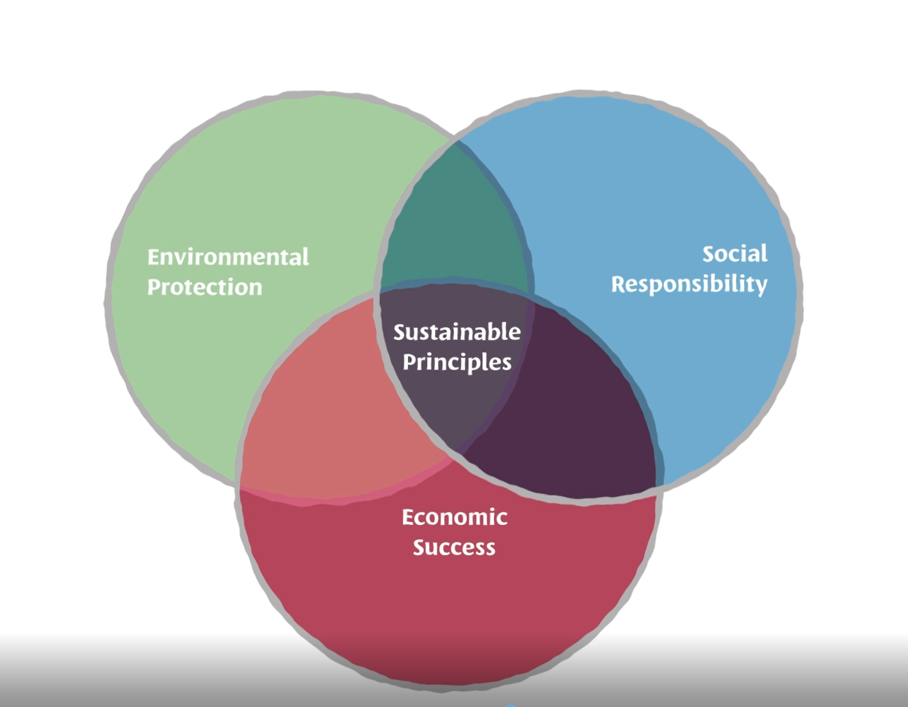
Figure 2 Triple Bottom Line
Source: Mendes et al, (2023)
Hilton demonstrates its CSR involvement in compliance with CSR models such as Carroll's Pyramid and TBL participation, which is a framework to evaluate and assess its CSR practices. As stated by Pereira and Dos Anjos (2023), CSR is a resource of value, when it comes to tourism development, to emphasise, this is due to responsible business practices within the hospitality industry. Hilton's CSR actions, as reflected in different reports, show its dedication to sustainability and responsible corporate citizenship (Hilton, 2022). Through the implementation of the Carroll's Pyramid, Hilton Company fulfils its economic, legal, ethical and philanthropic obligations, adhering to the regulations as well as rising beyond the compliance to ethical standards and benevolence. Likewise, the incorporation of the Triple Bottom Line framework in Hilton's business enables the company to assess and measure its performance based on economic, social, and environmental aspects (Islam et al., 2023). Through initiatives such as the "Travel with Purpose" program, Hilton enhances its Environmental, Social, and Governance (ESG) targets, aligning with the principles of the TBL (Hilton, 2023). This holistic approach to value creation emphasises Hilton's commitment to sustainable business practices that prioritise long-term societal and environmental well-being alongside financial profitability. Hilton's CSR efforts not only contribute to its sustained competitive advantage but also drive positive behavioural outcomes within the hospitality sector (Islam et al., 2023). While Hilton implements CSR principles into their operations, they are not only satisfying stakeholders’ expectations but also may have a good chance of becoming an industry leader whose mission is to make the world a better place for people and the environment.
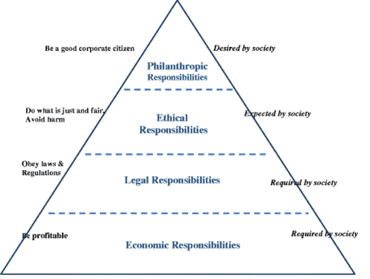
Figure 3 Carroll's Pyramid
Source: Islam et al., (2023)
The adoption of the Corporate Social Responsibility (CSR) policies by the companies like Hilton in the hospitality industry is both difficult and rewarding. One of the main complicating factors is the relationship between economic goals and the social and environmental matters, as demonstrated by Rhou and Singal (2020). Limited resources, among other requests for funds and priorities, may cause the organisation not to be able to afford enough funds for and attention towards CSR, including during hard financial times. Moreover, the dynamic nature of the hospitality industry makes it hard to keep the consistency and continuity of CSR initiatives (Khatter, 2023). Furthermore, similar to Nourafkan et al. (2024), engagement and commitment of employees in social values are also amongst the issues which are specific to large, decentralised companies such as the Hilton. In addition, these obstacles also contain a great number of opportunities for these corporations to enlarge their CSR impact. By making CSR as a strategic priority, hotels will be able to distinguish themselves in the market, attract socially conscious customers, and create stronger relationships with stakeholders (Rhou & Singal, 2020). Sustainably invested could result in cost savings thanks to efficiency improvements and risk mitigation measures that in the long run could be beneficial to the financial stability of the whole community (Khatter, 2023). Despite this, the preventive participation of stakeholders such as workers, local communities and regulators may help build trust and various parties collaborate, so that the performance and authenticity of the CSR initiatives be enhanced. CSR is the priority in that the hotels can make a good reputation, attract the socially responsible customers and build excellent stakeholder relationships (Kasradze et al. , 2023). There is not only cost savings advantage for pro actively engaging organisations in CSR due to efficiency, risk management and access to new business market and innovation.

Conclusion
To sum it all up, the contribution of Corporate Social Responsibility (CSR) into the sustainability of the hospitality industry, as the case of Hilton shows, illustrates the perspective of responsible business strategies to create the transformation. Hilton proves to be well-tuned with CSR models like Carroll’s Pyramid and the Triple Bottom Line (TBL) by balancing economic and social issues as well as the environment for contributions in society. It is resulted that by its CSR programs, Hilton not only promotes its brand image and customer loyalty but also creates a positive work environment and encourages innovation. But, carrying out effective CSR policies by the organisations such as Hilton might be confronted with unique problems, for example, allocation of resources, diversity of culture, and regulatory compliance. Nevertheless, the benefits and potential results from applying CSR exceed the challenges in such a manner that the organisation is presented with the chance to increase its competitiveness, resilience, and long-term sustainability. With shifts occurring within the hospitality sector, the adoption of CSR as a strategic key will be indispensable for Hilton and any other business in the industry to grow in a rapidly changing business environment and contribute to the creation of a more sustainable future for everyone involved.

References
Achmad, W. and Yulianah, Y., 2022. Corporate social responsibility of the hospitality industry in realizing sustainable tourism development. Enrichment: Journal of Management, 12(2), pp.1610-1616.
Akbari, M., Nazarian, A., Foroudi, P., Seyyed Amiri, N. and Ezatabadipoor, E., 2021. How corporate social responsibility contributes to strengthening brand loyalty, hotel positioning and intention to revisit?. Current Issues in Tourism, 24(13), pp.1897-1917.
Alatawi, I.A., Ntim, C.G., Zras, A. and Elmagrhi, M.H., 2023. CSR, financial and non-financial performance in the tourism sector: A systematic literature review and future research agenda. International Review of Financial Analysis, p.102734.
Camilleri, M.A., 2020. Strategic corporate social responsibility in tourism and hospitality. Camilleri, MA, Strategic Corporate Social Responsibility in Tourism and Hospitality. Sustainable Development, pp.1-3.
Guzzo, R.F., Abbott, J. and Madera, J.M., 2020. A micro-level view of CSR: A hospitality management systematic literature review. Cornell Hospitality Quarterly, 61(3), pp.332-352.
Hamrouni, A., Karaman, A.S., Kuzey, C. and Uyar, A., 2023. Ethical environment, accountability, and sustainability reporting: What is the connection in the hospitality and tourism industry?. Tourism Economics, 29(3), pp.664-695.
Islam, T., Khan, M., Ghaffar, A., Wang, Y., Mubarik, M.S., Ali, I.H., Shahid, Z.A., Rehmani, M. and Sharma, A., 2023. Does CSR influence sustained competitive advantage and behavioral outcomes? An empirical study in the hospitality sector. Journal of Global Scholars of Marketing Science, 33(1), pp.107-132.
Kasradze, M., Kamali Saraji, M. and Streimikiene, D., 2023. Challenges to corporate social responsibility adoption for sustainability: A picture fuzzy approach. Integrated Environmental Assessment and Management, 19(5), pp.1254-1275.
Khatter, A., 2023. Challenges and Solutions for Environmental Sustainability in the Hospitality Sector. Sustainability, 15(15), p.11491.
Lee, S., Yeon, J. and Song, H.J., 2023. Current status and future perspective of the link of corporate social responsibility–corporate financial performance in the tourism and hospitality industry. Tourism Economics, 29(7), pp.1703-1735.
Mendes, T., Braga, V., Correia, A. and Silva, C., 2023. Linking corporate social responsibility, cooperation and innovation: the triple bottom line perspective. Innovation & Management Review, 20(3), pp.244-280.
Moneva, J.M., Bonilla-Priego, M.J. and Ortas, E., 2020. Corporate social responsibility and organisational performance in the tourism sector. Journal of Sustainable Tourism, 28(6), pp.853-872.
Moosa, A. and He, F., 2023. Impact of environmental management practices on corporate sustainability: evidence from the Maldives hospitality industry. International journal of emerging markets, 18(9), pp.2869-2889.
Nourafkan, N.J., Karatepe, O.M. and Rezapouraghdam, H., 2024. Corporate social responsibility, workplace spirituality and their effects on green promotive and prohibitive voice behaviours. Current Issues in Tourism, 27(7), pp.1142-1158.
Pereira, T. and Dos Anjos, S.J.G., 2023. Corporate social responsibility as resource for tourism development support. Tourism Planning & Development, 20(5), pp.769-789.
Rhou, Y. and Singal, M., 2020. A review of the business case for CSR in the hospitality industry. International Journal of Hospitality Management, 84, p.102330.
Silva Junior, A.D., Martins-Silva, P.D.O., Coelho, V.D. and Sousa, A.F.D., 2023. The corporate social responsibility pyramid: its evolution and the proposal of the spinner, a theoretical refinement. Social Responsibility Journal, 19(2), pp.358-376.
Thirumalesh Madanaguli, A., Dhir, A., Kaur, P., Mishra, S. and Srivastava, S., 2023. A systematic literature review on corporate social responsibility (CSR) and hotels: past achievements and future promises in the hospitality sector. Scandinavian Journal of Hospitality and Tourism, 23(2-3), pp.141-175.
Uyar, A., Kilic, M., Koseoglu, M.A., Kuzey, C. and Karaman, A.S., 2020. The link among board characteristics, corporate social responsibility performance, and financial performance: Evidence from the hospitality and tourism industry. Tourism Management Perspectives, 35, p.100714.

