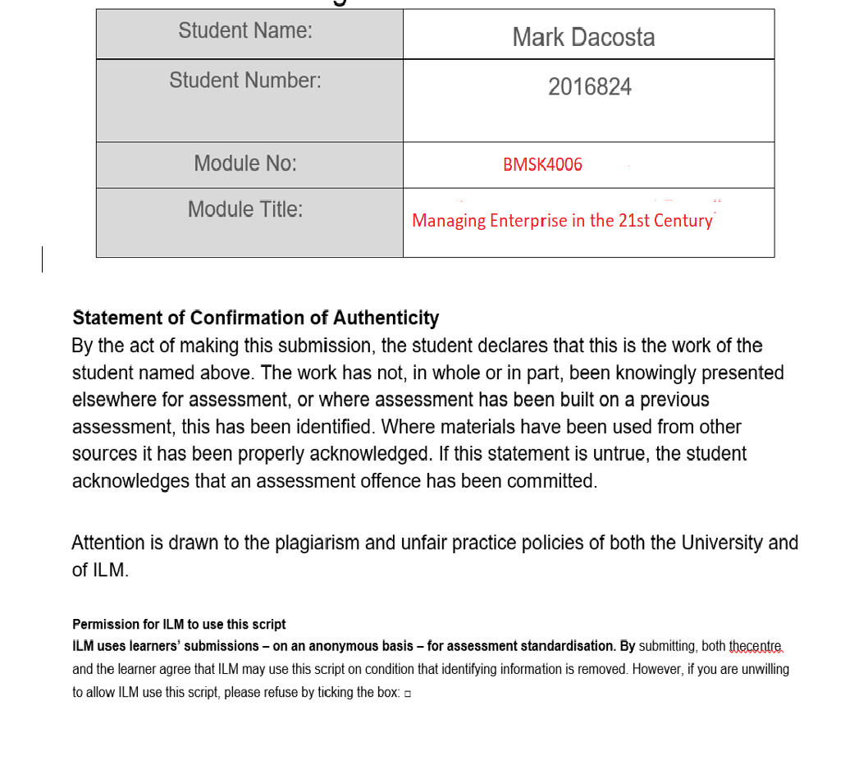

Contents
Executive Summary 4
Business model concept 5
Valued customer: 5
Value proposition: 5
Main Drivers 7
Points of Interest 7
Strategy and competitive edge 8
Mission and Objectives 10
Analysis of the business environment 11
Marketing Strategy 13
Forecasting and Sales Outlook 14
Costs and Revenue 18
Start-up Costs 18
Assets 21
Sensitivity Analysis 22
Marketing 23
Legal Aspects 25
Project Timeline 26
Conclusion 26
References 28

BUNN LEISURE STATIC CARAVAN BUSINESS PLAN

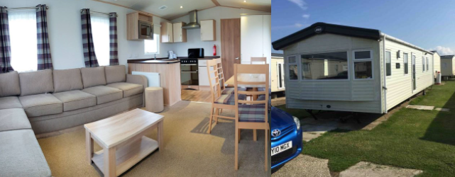

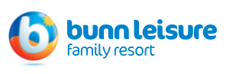

Executive Summary

The following project presents the business plan for a static caravan rental service in the Selby on Sea caravan park run by Bunn Leisure. The property is focussed on a family vacation for an ever-increasing group of the population who are looking closer to home for their vacation needs.

In accordance with the latest statistics and key trends, British families are seeking more holidays within the UK due to complications to international travel brought about by the COVID pandemic. This provides a unique selling point for domestic holiday providers.

Looking to take advantage of this opportunity, this business plan presents an affordable alternative to international holidays with the demand for domestic holidays likely to be sustained after travel restrictions subside due to international holidays more than likely becoming very expensive as holiday providers look to recoup lost revenue from the pandemic.

The location of caravan park on the south coast of England has advantages in terms of accessibility and amenities. It is central therefore attracting families from both east and west, and there is a lot of activities close by for both children and adults alike.

The business model involves a focus on the adventure and exploration opportunities for families that are near the site. It boasts a balanced combination of natural coastal accessibility whilst having lots to do for families who desire adventure based get away.

The idea is to provide a static caravan living space where families can rent for up to a week to have a holiday without the burden of international travel restrictions. The space provided would be on a self-catering basis and give the family a base from which they can go out and do as much or as little as they want by taking advantage of the surrounding amenities.

The caravan itself is 36ft by 12 ft and was built in 2021. It features 2 bedrooms sleeping 4 people and is double glazed with central heating. It contains a fridge freezer, cooker/oven and en-suite bathroom.

Business model concept

The business model summary includes the following elements:

Valued customer:
The market that this plan is aiming for is more niche than mass market. It is aimed at a growing pot of customer base who fall between low and middle class, and are looking for affordable domestic holidays, but need an alternative to beach holidays because of the unpredictable British weather.

A beach holiday in the UK can be perceived as low value if the weather turns out to be rotten. Spending a lot of money to do something you cant really enjoy is low value and customers tend to decide this type of domestic getaway at the last minute when the weather appears to be right, or just book abroad where the weather is more stable. From a domestic point of view, this beach holiday customer would be hard predict for those reasons.

This project however aims for customers who feel they get value what ever the weather as they can go to the beach if it is sunny but can do much more if it is not. For this reason, the main demographic is a family of 4 who fall between the low and middle class.

Value proposition:
Value proposition of the following project is based on a combination of rich domestic activities and affordable local accommodation. This includes a great private accommodation with Bunn Leisure facilities to hand but also a beach and nearby attractions and adventure activities for the whole family.

The family orientated resort provides many adventure activities such as Karting, survival school, marine life walks, swimming pools, archery and much more.

There are also lots of natural resources nearby, not only the beach, but the Isle of Wight is also a short boat trip away.

Value to local business is also added with more customers having their holidays domestically. Local pubs restaurants and other businesses will benefit.

Profit elements
The profit will purely come from room bookings. The prices will vary with seasonal trends but not dramatically as the focus switches to the outdoor adventure in the winter months and as such provides a more regular income stream than general holiday accommodation.

Main Costs
Initial Costs: Property acquisition and internal utilities costs
Fixed and variable costs: maintenance costs (including cleaning and upkeep), insurance, utilities and rates.

Sustainability and Protection
As already mentioned, domestic tourism is on the rise and with uncertainty set to continue for a while that trend would appear to be stable for the immediate future at least.

The Bunn Leisure facility also provides a stable environment for static caravan purchases in its parks. They have a good reputation and a wide range of activities which means they only shut down for January and February.

The project would therefore be looking to gain income for 10 months a year from the site.

Replication
Once the first site is established and bringing in steady revenue the project is planning to expand and bring in more static caravans to increase the revenue from multiple sites.

Main Drivers
As in any business, aiming for profitability is essential and the main driver for this project. However, this project has other important objectives:

- Helping provide alternative holiday solutions for families to combat the international travel restrictions currently in place.
- Contribution to development of the area from an economic point of view.
- Increasing interest in activity-based tourism which is important for the UK due to inconsistent weather.

Points of Interest
Having a lot of points of interest and activities in the area will increase the popularity of holiday destination and make marketing easier and more affective.

The mixture of natural attractions and adventure activities makes the Bunn resort vary attractive to families especially but for all ages also.

The surrounding area includes a beach but there is a plethora of activities and facilities to enjoy also including:

Waterfront Quays: Oasis Bay Pool, Wellness Suite & Gym, Shore Shack Wave Rider Crazy Golf, Millie’s Cookies, Treasure Beach Arcade, The Embassy Club, Cove Cube VR, Smuggler’s Family Restaurant, Smokey’s Ocean Bar.

The Windmill: Fun Fair, Caravan Sales Showground, West Sands Caravan Sales Office & Security Reception, Windmill Nisa Store, Costa Express, Launderette, The Real Fish & Chip Company.

White Horse Village: White Horse Entertainment & Leisure Centre, Outdoor Pool / Lido Sportzone, Pottery Studio, Paddock Lanes, 10-pin Bowling Alley, White Horse Nisa Store, Costa Express Café, The White Horse Theatre, Family Arcade, Wellness Suite, Waterfront Quays, INTERSTELLAR White Horse Theatre, New CRAZY GOLF, White Horse Entertainment & Leisure Centre BOWLING White Horse Entertainment & Leisure Centre, DINO KARTS Windmill Fairground, Waterfront Quays, Lighthouse Point, Eels Cross, Nab’s Top.

Bunn Leisure provides a complimentary bus service which runs from morning to night until the clubs close. This covers Green Lawns, White Horse, Warner Farm & West Sands Holiday Villages. Park Transport, West Sands, Entrance/Main Reception 8 The White Horse Club, The Viking Club/ Green Lawns.

The bus also stops at the beach, and officially it’s the sunniest place in the UK!

Strategy and competitive edge

It is important from a business point of view to have a strong product. Even though there has been a migration from international to domestic tourism due to the pandemic, it is still vital to have great activities for tourist to enjoy and the amount and variation of activities makes this site very competitive in the market.

The strategy is based on several important factors which will be described in the following section.

In general, families are given a home from home environment, so they feel comfortable on holiday. This becomes their base to explore and enjoy the natural resources of the region and take part in the many activities that are locally on offer to them.
As such, the aim is to make every customer feel welcome from their initial booking and make them aware of the different activities and sites on offer to them.

The location of the static caravan is crucial as it is situated near to the beach and with all amenities close by. This is important to the strategy as one of the main selling points is the fun of domestic holidays.

Due to the natural resources and infrastructure the site provides, the following activities are available:

  - Go Karts
  - Wild Marine Life Walk
  - Aqua Paddler
  - Aero ball
  - Mini Crossbow
  - Body Zorbing
  - Drone Flying
  - Frisbee Golf
  - Paintball
  - Toddler Bounce
  - Mini Olympics
  - Human Table Football
  - Pottery Studio
  - Tennis
  - Mini Jet Skis
  - Fishing
  - Funfair
  - Bike Trails
  - Waterfront Complex Arcade
  - Walking Trails
  - Stargazing
  - Bird Watching
  - Bingo
  - The Oasis Swimming Pool
  - Ten Pin bowling
  - Crazy Golf
  - Soft play

There is a distinct advantage to having structured activities on the complex as it gives customers a choice for each day. It strategically increases the likelihood of customers booking the static caravan due to the many activities they can take advantage of by doing so.
Strategically the caravan itself is spacious and tailored to a family of four. The purchase includes siting and connections, internal and external clean, TV aerial, smoke alarm and steps.

With onsite cleaning there would be no need for to hire cleaners as this is included in the site fees.

Mission and Objectives

The mission and objectives of the business model is to provide affordable and sustainable accommodation for families and long-term growth to increase capacity over time in order to expand to acquire additional units. An additional objective is to increase the popularity of domestic holidays, in particular at the Selsby by Sea site.

By providing affordable accommodation at a activity rich site it is expected that the popularity of domestic holidays will be enhanced and would provide a long term alternative to international holidays especially when the restrictions are removed and customers can book holidays more freely.

It is expected that customers having experienced the value of domestic holidays will continue to book them once their holiday options return to normal.

Main objectives of the business model include the following:

- Provide affordable units to preserve domestic holiday making in the area.

- Reach profitability of the first unit by …

- Raise profile and popularity of the site

- Re-invest in new units by….

Analysis of the business environment

The Market

As previously mentioned, the market for family holidays is currently in a lull due to international travel restrictions. This provides a unique opportunity to for domestic holidays as the restrictions are far less severe for travelling within the UK.

As such the market is currently more lucrative domestically than it would normally be which gives this project an opportunity to start up and begin to bring in revenue. The project plans to make the business robust before the full market has re-opened thus establishing itself in this window of opportunity and increasing awareness of this niche market to a wider demographic.

This awareness will in turn give larger choice to travel customers if and when the market changes back to normal. With some experts predicting that COVID could be around for years to come and others even suggesting it is something we may need to live with indefinitely it is likely that domestic holidays will become more and more popular over time.

If indeed the market never returns to “normal” this project would be in a strong position once established to take advantage of this new market trend.

Another reason this project aims for the adventure holiday market is because this market has grown exponentially even before the pandemic. In fact, studies have shown its been growing from as far back as 2010.

According to the Adventure Travel Trade Association (ATTA) adventure tourism is "a trip that includes at least two of the following three elements: physical activity, natural environment, and culture immersion."

The Bunn Leisure facilities provide at least two of these three categories with “culture immersion” being optional for the customer by venturing further afield. If they wish there are short trips to Chichester or even a boat ride to the Isle of Wight available.

According to research published in the 2009 PLos Biology Journal, 15 out of 20 analysed countries have had a steady increase in adventure tourism since the 1990s.
An adventure tourism market size was conducted by the ATTA in 2010 which calculated the market reached 89 billion USD. Only two years later in 2013 a similar study placed the tourism market at 263 billion USD, which meant an increase of 195%. (George Wasington University and Xola Vonsulting company)

Also, according to ATTA in 2014 companies providing adventure tourism had an increased revenue of 24%. At that time the average customer was 48 years old and 53% female. The Demographic is changing though with multigenerational family groups increasing. (Goldberg B., 2015)

This increase in adventure tourism was clearly happening before the pandemic which makes it plausible that this migration to this holiday type would only continue.

In summary the market has been expanding for some time globally and this seems like it will intensify with domestic adventure breaks through the restriction of international holidays.

As such the projection for this market is at worst stable but likely to continue to grow over the coming years.

Marketing Strategy

The promotion of the site is mainly taken care by Bunn Leisure themselves. As they need to have a lot of customers purchase their adventure slots, it is in their interest to fill the accommodation. The more caravan sites that are occupied, the more possibility of adventures slots being purchased.

Some adventures come with the accommodation price, but a lot are chargeable. In this sense the annual site fees that are charged include marketing costs and inclusive adventure fees.
The annual site fee is £5500 which is the largest running cost for the project.

The marketing provided in the annual site cost will be assisted by a Facebook page which will highlight the availability of the static van individually.

In summary the main marketing for the unit is included in the annual site cost but will be assisted with social media promotion. As many units on the Bunn Leisure website are always booked out, the project expects capacity bookings for the summer months at the very least.

The project site plans to undercut other park sites of similar size and spec which should ensure capacity booking for most of the year.

The Bunn Leisure Static Caravan purchase programme works well for both parties in the sense that the investor gets a source of income from purchasing the asset to rent out without the need to market or maintain the unit, and Bunn Leisure gets an initial injection of cash from the sale of the unit ranging anywhere between £20,000 to £60,000 plus an annual site fee between £4500 - £5500 a year for each unit sold.

Both parties gain long term income streams provided the bookings remain steady.

Forecasting and Sales Outlook

Based on current occupancy levels in the park, the project predicts the following level intake throughout the 10-month season.

MONTH | EXPECTED OCCUPANCY
MARCH | 50%
APRIL | 60%
MAY | 70%
JUNE | 75%
JULY | 80%
AUGUST | 85%
SEPTEMBER | 70%
OCTOBER | 60%
NOVEMBER | 50%
DECEMBER | 50%

There will be 3 booking alternatives at 4 different price points. The 3
Booking options are:

Monday – Thursday (WEEK BREAK)
Friday – Monday (WEEKEND BREAK)
Monday – Sunday (ALL WEEK)

There will be 4 price points which include:

PEAK WEEK BREAK/WEEKEND BREAK
PEAK ALL WEEK
OFF PEAK WEEK BREAK/WEEKEND BREAK
OFF PEAK ALL WEEK

The pricing for each booking is shown below.
 | OFF PEAK | PEAK
WEEK BREAK | £395 | £485
WEEKEND BREAK | £395 | £485
ALL WEEK | £500 | £600

Peak represents June, July and August and off peak represents March, April, May, September, October, November and December.

Based on a month being comprised of 2 weeks of week break/weekend break and 2 weeks of all week bookings the revenue would be as follows.

Month | Booking Type | Capacity Revenue | Expected Occupancy | Expected Revenue
March | 3xWeek Break | £1,185 | 50% | £592.50
March | 3xWeekend Break | £1,185 | 50% | £592.50
March | 1xAll Week | £500 | 50% | £250
March |  |  |  | £1,435

Month | Booking Type | Capacity Revenue | Expected Occupancy | Expected Revenue
April | 3xWeek Break | £1,185 | 60% | £711.00
April | 3xWeekend Break | £1,185 | 60% | £711.00
April | 1xAll Week | £500 | 60% | £300
April |  |  |  | £1,722

Month | Booking Type | Capacity Revenue | Expected Occupancy | Expected Revenue
May | 3xWeek Break | £1,185 | 70% | £829.50
May | 3xWeekend Break | £1,185 | 70% | £829.50
May | 1xAll Week | £500 | 70% | £350.00
May |  |  |  | £2,009.00

Month | Booking Type | Capacity Revenue | Expected Occupancy | Expected Revenue
June | 3xWeek Break | £1,455 | 75% | £1,091.25
June | 3xWeekend Break | £1,455 | 75% | £1,091.25
June | 1xAll Week | £600 | 75% | £450.00
June |  |  |  | £2,632.50

Month | Booking Type | Capacity Revenue | Expected Occupancy | Expected Revenue
July | 3xWeek Break | £1,455 | 80% | £1,164.00
July | 3xWeekend Break | £1,455 | 80% | £1,164.00
July | 1xAll Week | £600 | 80% | £480.00
July |  |  |  | £2,808.00

Month | Booking Type | Capacity Revenue | Expected Occupancy | Expected Revenue
August | 3xWeek Break | £1,455 | 85% | £1,236.75
August | 3xWeekend Break | £1,455 | 85% | £1,236.75
August | 1xAll Week | £600 | 85% | £510.00
August |  |  |  | £2983.5

Month | Booking Type | Capacity Revenue | Expected Occupancy | Expected Revenue
September | 3xWeek Break | £1,185 | 70% | £829.50
September | 3xWeekend Break | £1,185 | 70% | £829.50
September | 1xAll Week | £500 | 70% | £350.00
September |  |  |  | £2,009.00

Month | Booking Type | Capacity Revenue | Expected Occupancy | Expected Revenue
October | 3xWeek Break | £1,185 | 60% | £711.00
October | 3xWeekend Break | £1,185 | 60% | £711.00
October | 1xAll Week | £500 | 60% | £300
October |  |  |  | £1,722

Month | Booking Type | Capacity Revenue | Expected Occupancy | Expected Revenue
November | 3xWeek Break | £1,185 | 50% | £592.50
November | 3xWeekend Break | £1,185 | 50% | £592.50
November | 1xAll Week | £500 | 50% | £250
November |  |  |  | £1,435

Month | Booking Type | Capacity Revenue | Expected Occupancy | Expected Revenue
December | 3xWeek Break | £1,185 | 50% | £592.50
December | 3xWeekend Break | £1,185 | 50% | £592.50
December | 1xAll Week | £500 | 50% | £250
December |  |  |  | £1,435

Overall the gross annual revenue would be £20,191.

The occupancy is a conservative projection and the project expects that these percentages would be higher than figures shown. This is based on the price point of the unit being significantly lower than the prices currently on offer.

Off peak units that are of a similar size and quality to the project unit are £495 for a break and £695 for a week.

Peak units that are of a similar size and quality to the project unit are £595 for a break and between £795 and £850 for a week.

As such the project expects the occupancy projections to be exceeded. The conservative projection is a prudent approach to negate any drop in customer uptake.

Costs and Revenue

The Financial plan is based on current occupancy levels displayed previously and this is the only income stream considered in this project although expansion is also planned in from year 3.

One of the important cost factors to consider is that the Bunn Leisure oversee all the bookings and maintenance of the unit which is included in the site fees. This means that there are no wage bills in this project.

The running costs have been based on site averages and have been provided by Bunn Leisure as a guideline. Annual running cost are listed below:

Ongoing Costs | Cost Amount Annually
Site Fees (includes Marketing and Wages) | £5,500
Local Authority rates and water | £516
Gas and Electric | £345
Holiday Home Insurance | £260
Annual Maintenance | £92.50
Total | £6,713.50

Basing the ongoing costs on the site averages yields an annual total of £6,713.50. This would be the total expenditure for the unit.

Start-up Costs

The start-up costs relate to the one-off costs needed to set up the project. The acquisition of the static caravan is the main initial cost. The mid-range caravan selected would cost £29,000.

The cost of this initial outlay is offset by £10,000 savings and £10,000 inheritance acquired through an equity release programme.

This would leave an outstanding balance of £9000 for this unit acquisition which would be covered by a business loan.
A secured loan for £9000 would be repaid over 2 years, and with this being the only long-term debt against the project it would mean the business would break even in 2 years.

Representative
APR 2.80%
Monthly payments
£385.50
Total repayable
£9,252.00

The payments would amount to £385.50 per month and the total repayment amount would be £9,252.00.

This would increase the annual expenditure to £11,339.50. Shown below is the updated running cost including the loan repayment.

Ongoing Costs | Cost Amount Annually
Site Fees (includes Marketing and Wages) | £5,500
Local Authority rates and water | £516
Gas and Electric | £345
Holiday Home Insurance | £260
Annual Maintenance | £92.50
Business Loan | £4,626
Total | £11,339.50

The aim for the project is to acquire new units as it goes along to increase potential revenue streams. It is projected that the first additional unit would be purchased in year four.

The financial plan for the first 4 years is calculated below showing the balance cash flow profit for each year with a projection for the purchase of a second unit.

 | YEAR 1 | YEAR 2 | YEAR 3 | YEAR 4
GROSS OPERATING PROFIT | £20,191 | £20,191 | £20,191 | £40,382
Site Fees (includes Marketing and Wages) | -£5,500 | -£5,500 | -£5,500 | -£11,000
Local Authority rates and water | -£516 | -£516 | -£516 | -£1,032
Gas and Electric | -£345 | -£345 | -£345 | -£690
Holiday Home Insurance | -£260 | -£260 | -£260 | -£520
Annual Maintenance | -£92.50 | -£92.50 | -£92.50 | -£185
Business Loan | -£4,626 | -£4,626 | £0 | £0
OPERATING CASH FLOW | £11,339.50 | £22,679 | £38,644.50 | £65,599.50
Unit Expansion | £0 | £0 | £0 | -£29,000
FINAL CASH FLOW | £11,339.50 | £22,679 | £38,644.50 | £36,599.50

In the first year a gross profit of £20,191 is made. This figure was calculated in the forecasting and sales outlook. A net profit of £11,339.50 is made after the site fees, running utilities and business loan is paid off.

This net profit doubles to £22,679 in the second year as all the income and expenditures costings are identical.

In the third year it goes more than treble the first year though as the 2-year business loan has ended meaning there is £4,626 less in the outgoings. This means that the business has broken even and that the accumulated net profit for the first three years is £38,644.50.

The business is now able to purchase a second unit at £29,000 without taking out another loan. This means that the gross revenue will double to £40,382 and the running costs will double from year three to £13,427 as we have two units to pay fees and utilities on instead of one.

However, with no loans to pay it means that we are still at a net profit of £36,599.50 after paying the £29,000 for the new unit. The project would therefore expect year 5 to yield £63,554.50 net profit.

Assets

At this point (Year 5) the project plans to either purchase another unit of a larger capacity with more features, purchase another unit of the same capacity or even purchase two more units. This decision would be taken with reflection on the first five years by taking into account how well the project has gone to plan.

 | YEAR 1 | YEAR 2 | YEAR 3 | YEAR 4 | YEAR 5
ASSETS
CURRENT PHYSICAL ASSETS | £29,000 | £29,000 | £29,000 | £58,000 | £58,000
RESERVES | £11, 339.50 | £22,679 | £38,644.50 | £32,323.50 | £59,278.50
LOAN BALANCE OWED | £9,252 | £4,626 | £0 | £0 | £0
INVESTMENT | £29,000 | £0 | £0 | £29,000 | £0
TOTAL ASSET CAPITOL | £40,339.50 | £51,679 | £67,644.50 | £90,323.50 | £117,278.50

At the initial stage of the project right up until year 4 the physical assets remain at £29,000, at year 4 this then doubles to £58,000 with the acquisition of the second unit. The liquid assets progressively rise to £58,278.50 by year 5 making an expected total of £117,278.50 by year 5.

Sensitivity Analysis

Sensitivity analysis for the project is based on revenue being 10% lower than expected due to projected bookings being lower than anticipated.

Income statement shows this scenario is show below:
 | YEAR 1 | YEAR 2 | YEAR 3 | YEAR 4
GROSS OPERATING PROFIT | £20,191 | £20,191 | £20,191 | £40,382
Site Fees (includes Marketing and Wages) | £5,500 | £5,500 | £5,500 | £11,000
Local Authority rates and water | £516 | £516 | £516 | £1,032
Gas and Electric | £345 | £345 | £345 | £690
Holiday Home Insurance | £260 | £260 | £260 | £520
Annual Maintenance | £92.50 | £92.50 | £92.50 | £185
Business Loan | £4,626 | £4,626 | £0 | £0
OPERATING CASH FLOW | £10,205.55 | £20,411.10 | £34,780.50 | £55,191.15
Unit Expansion | £0 | £0 | £0 | £29,000
FINAL CASH FLOW | £10,205.55 | £20,411.10 | £34,780.50 | £29,091.15

In the event that bookings are lower than expected, the project has anticipated a 10% drop in revenue as a guide to this scenario.

This has been calculated to ensure that this scenario will not prevent expansion to a second unit at year 4. As the operating cash flow is still potentially as high as £55,191.15 it is still feasible to expand by purchasing the second unit in year 4.

This would still leave a cash flow balance of £29.091.15 after the second unit purchase.

The financial operations are robust enough to even sustain a cash flow 20% below predictions without hindering the expansion plans. As mentioned before the project expects to have higher bookings rather than lower, however it is prudent to expect and plan for the unexpected especially in the holiday market.

Marketing

Bunn Leisure provides all marketing and booking services as part of the site fees.

In addition to their website, customers can also book through Facebook. This includes booking caravans and booking virtual tours.

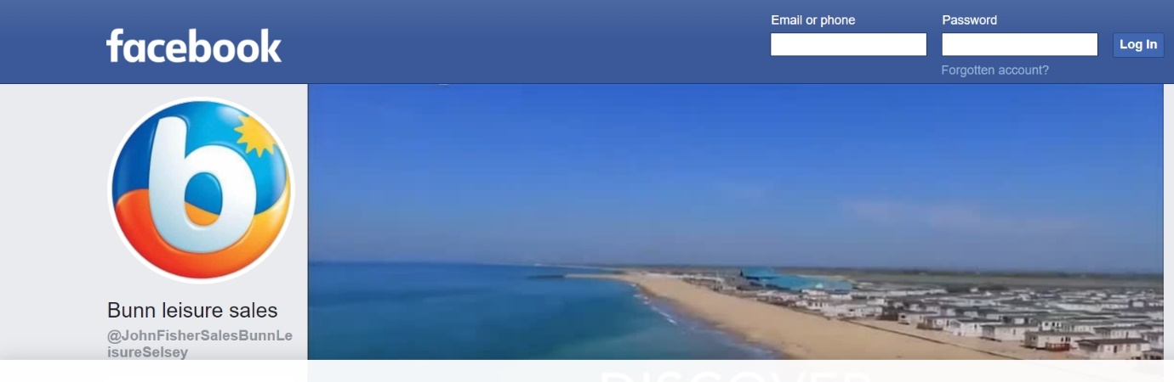
This takes all the pressure off the project in regard to marketing costs and order taking costs. It means that the project runs itself with little input freeing up time to earn from alternative employment.

The project simply collects payments from Bunn Leisure for the bookings received. All maintenance and the winter clean and drainage are done by Bunn, all caravans are fully furnished with laundry, cleaning, tea and coffee replenishments also taken care of.

As the breaks are self-catering all the costs of eating are covered by the customers themselves. Eating out options are highlighted on request along with external excursions.

Any on site assistance is provided at the Bunn Office along with details of daily trips and activities.

There is not a great deal of unique selling points for the project as there are many caravans on the site selling the exact same product. The advantage over the competition as mentioned before is the low cost of the project site.

An example of the difference in price is demonstrated by the current peak time prices shown below.

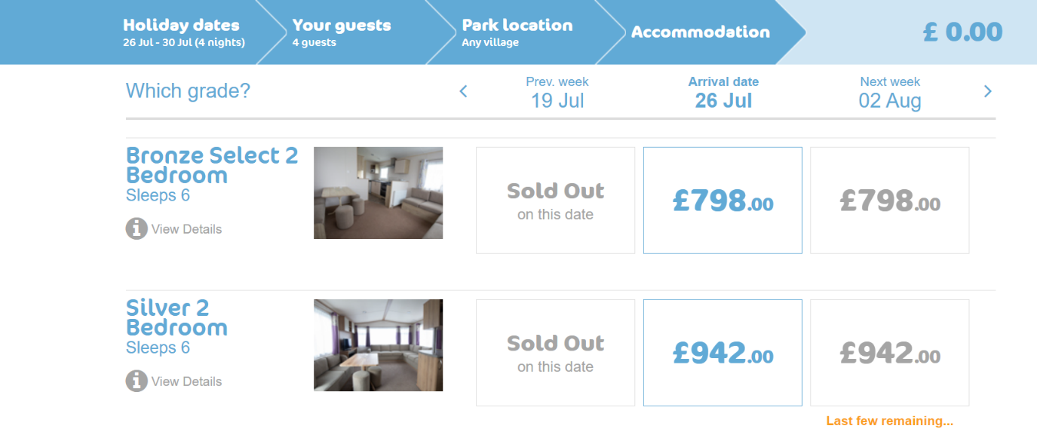
The prices shown are based on a family of four travelling on July 26th for a week. The project caravan which sleeps a family of four would cost £600 for the week giving a £198 saving on the bronze selection and £342 on the silver selection.

Although this is the only unique selling point it is a very profitable one for the customer and gives the project a significant advantage over the other static caravans.

As you can see a lot of dates are sold out and the ones remaining are nearly all gone as well, so from a marketing point of view the project is confident with Bunn Leisure’s approach to filling sites, especially in the current climate.

There is no requirement for the project to have its own name or branding as it is not doing its own marketing and sales. The title given to the project for trading purpose and bank transactions is Pandemic Paradise. As a sole trader there is no need to register this name with Companies House.

Legal Aspects

The legally required business rates are included in the Bunn Leisure site fees of £5500 and are covered every year in this way.

There is also a legal requirement to drain the Static caravan once a year. This is the separate annual maintenance charge of £92.50 and is performed by the on-site maintenance team in the close season (January/February).

The legal form and status of this company will be a sole proprietor as this is all that is required.

The reason that the project has decided to go down this route is because there is less paperwork required as I would only have to report to HMRC for tax purposes and the owner has complete control of the business, tax filings are simple and all income goes to the project owner.

Any complaints of refunds would be managed by Bunn Leisure directly and would not fall on the company name or assets.

Project Timeline

Timeline for setup and first year
YEAR | MONTH | ACTIVITY
2021 | August | View unit/Apply for Loan
 | September | Withdraw Savings/Inheritance
 | October | Arrange Unit Purchase/Fee Payments
 | November | Unit Inspection/Other Expenses Paid
 | December | Provide rental Rates/ Begin Advertising
2022 | January | Winter Maintenance
 | February
 | March | First Booking Occupation/OFF PEAK
 | April | OFF PEAK
 | May | OFF PEAK
 | June | PEAK
 | July | PEAK
 | August | PEAK
 | September | OFF PEAK
 | October | OFF PEAK
 | November | OFF PEAK
 | December | OFF PEAK
2023 | January | First Year Financial Reports
 | February | Review and make changes if needed

Conclusion

The project aims to take advantage of an increase in domestic holiday bookings due to travellers’ reluctance to book international holidays due to Covid restrictions and potential cancellations.
The uncertainty of international travel is set to continue for a few years at least meaning the project has a good chance to establish itself in the market whilst the uncertainty continues.
A static caravan is to be purchased and rented through the project with marketing, booking and site maintenance all taken care of by the Bunn Leisure site for an annual fee.
The range of activities available to customers is huge meaning a large appeal across all different demographics and should provide bookings from all ages not just the targeted family focused on by the project.
The projection shows that a second site can be acquired at the end of year 3 potentially doubling profits moving forward. As the project plans to break even with all loans paid by the end of year 2, all acquisition from year 3 onwards will be done debt free.
The project is a low cost, low risk and has low man hours once the venture is up and running, which allows the project owner to work independently and not rely on the revenue provided as wages. As such, all profit can be re-invested into acquiring more units and generating more physical capitol as time passes.

References

Adventure Travel Trade Association. 2015. Adventure tourism development index 2015. (ONLINE) Available at:http://adventureindex.travel?docs?atdi_2015.pdf. (Accessed 5 June 2121);
Bunn Leisure Family Resort. 2021. https://covecommunities.co.uk/bunnleisure/holiday-home-ownership/buyers-guide/. (Accessed 7 June 2021)
Goldberg B. 2015. 16 Emerging Adventure Travel Trends. (ONLINE) Available at: http://blog.virtuoso.com/traveler_trends/16-emerging-adventure-travel-trends/.(Acessed 10 July 2021);
PS Levin, MJ Fogarty, SA Murawski, D Fluharty - PLoS biology, 2009 - journals.plos.org
Willrby.com. 2021. Renting Out Static Caravan Complete Guide. (ONLINE) Available at: https://www.willerby.com/blog/renting-out-static-caravan-complete-guide (Accessed 9 June 2021)

