

The Issuing of CEDs (Taser) to all Police Officers:
Explore how this will be perceived by serving police officers and other professionals.

Andrew Keeping
2023712
BSc (Hons) Professional Policing Practice

Acknowledgements
I would like to thank my Supervisor, Jordan Rees, and Dissertation Tutor, Vivienne Harpwood, for their continued support through the process of completing the dissertation.
I would also like to thank the University staff and also the Police staff at the police training centre for their support and expertise through initial training.
Finally, I would like to give my eternal thanks to my partner and both our families for the continued support. Through-out not just my final year but the whole time I have been studying and working towards the degree. They have been my driving force in completing the work and continuing through the difficult times. Words cannot fathom the support that I have received.

Declaration
This work has not previously been accepted in substance for any degree and is not being concurrently submitted in candidature for any degree.
Signed: A. Keeping
Date: 07/10/2023

Statement 1
This dissertation is being submitted in partial fulfilment of the requirements for the degree of BSc.
Signed: A. Keeping
Date: 07/10/2023

Statement 2
This dissertation is the result of my own independent work/investigation, except where otherwise stated.
Other sources are acknowledged by footnotes giving explicit references. A bibliography is appended.
Signed: A. Keeping
Date: 07/10/2023

Statement 3
I hereby give consent for my dissertation, if accepted, to be available for photocopying and for interlibrary loan, and for the title and summary to be made available to outside organisations.
Signed: A. Keeping
Date: 07/10/2023

Statement 4
I hereby give consent for my dissertation, if accepted, to be available on the university’s IT system to those who have consent to use the system.
Signed: A. Keeping
Date: 07/10/2023

Abstract
This research project aims to explore the views of serving police officers who both carry Taser and Police officers who do not carry Taser. The researcher also aims to explore the views of other professionals who deal with the consequences of the use of Taser, such as defence lawyers and the Crown Prosecution Service lawyers.
There is a large amount of research and academic literature around CED’s (Conducted Energised Device) or as they are better known, by its brand name of ‘Taser’. However, the majority of this research and academic literature is based on the effects of ‘Taser’ when used and the injuries sustained to the subject after being subjected to the use of the Taser.
This leaves a gap in the research on the issuing of CEDs (Taser) to all police officers and how this will be perceived by serving police officers and other professionals who have first-hand experience with the equipment or the consequences as the result of the use of this piece of equipment.
The main findings of the research are:
- Within South Wales Police, there are 850 Taser trained officers who carry Taser. This does not include police officers who are part of the Joint Firearms Unit who are armed police officers who also carry Taser. There are also an expected 240 further police officers who are expected to participate in the Taser training course within the next 12 months.
- Of all the participants that partook in the questionnaire, the vast majority of the participants have stated that the issuing of Taser within the Police is a good idea.
- Serving police officers feel that student police officers should not be allowed to carry Taser, however, a smaller amount feel that student police officers should be able to carry Taser.
- The perception of the participants of this research project feel that through an almost equal spilt that 41% feel that the public would be supportive and 26% would feel the public would not be supportive with the remaining 21% unsure.

Table of Contents
Chapter 1: Introduction 9
1.1 Aims and Objectives 9
Chapter 2: Literature Review 10
2.1 Introduction 10
2.2 Background of Taser 11
2.3 Current Training on Taser and Requirements 12
2.4 Figures and Statistics 13
2.5 Current Research 14
2.6 Conclusion 16
Chapter 3: Methodology 17
3.1 Introduction 17
3.2 Research Strategy 17
3.3 Ethics 18
3.4 Limitations & Potential Problems 19
Chapter 4: Analysis of Results 20
4.1 Introduction 20
4.2 Demographic 20
4.3 Involvement and Training 22
4.4 Risks of Taser Use 23
4.5 Perspective of Participants 24
4.6 Conclusion 25
Chapter 5: Conclusion and Recommendations 27
5.1 Introduction 27
5.2 Review of Initial Objectives 27
5.3 Main Findings 28
5.4 Limitations 29
5.5 Conclusion 29
5.6 Recommendations 30
Chapter 6: Bibliography 32
Chapter 7: Appendix 37
7.1 Appendix A - Freedom of Information Results 37
7.2 Appendix B – Participant information Sheet 38
7.3 Appendix C – Informed Consent 42
7.4 Appendix D – Questionnaire 44
7.5 Appendix E – Questionnaire Results 54

Chapter 1: Introduction

Aims and Objectives

Aim:
This research project will examine the issues surrounding The Issuing of CEDs (Taser) to all Police Officers and to explore the perspectives of serving police officers and other professionals.

My objectives of this research are as follows:
- Ascertain how many Taser carriers there are working within South Wales Police.
- Explore the thoughts of serving police officers through a quantitative method of research, being a questionnaire.
- Explore the views of other professionals through a quantitative method of research, being a questionnaire.
For the researcher to be able to achieve the aim of this research project, the objectives will need to be met and explored fully. By achieving each objective, this will help the researcher to be able to comprehensively complete the research for the aim outlined.
The research project will be conducted through the collection and use of two types of data, these being primary data and secondary data. Primary data is data collected by the researcher for its specific purpose for the research project Salkind, N. J, (2010). Secondary data is data that has already been collected by previous researchers Zemliansky and Lowe (2010).
Most research projects will use both Primary data and Secondary data whereby both sets of data will be critically analysed within the project to help identify which will assist the researcher with the most appropriate form of data to identify the aims of the project and complete the objectives.

Chapter 2: Literature Review

2.1 Introduction

It was mentioned by Nielson (2004) that Taser was first introduced to law enforcement in the United States of America in 1974, however this was created using gunpowder as the propellant. The model introduced was the 1st generation of the X26. Taser is the brand name of a CED, Conducted Energy Device, a CED is better known by its brand name. The Conducted Energy Device is described by College of Policing (2022) as a less lethal weapon system that is designed not to cause injury but to temporarily incapacitate a subject. The Conducted Energy Device does this by using an electrical current that temporarily interferes with the neuromuscular system College of Policing (2022).
The aim of this chapter is to explore and critically evaluate relevant literature that has been gathered through previous academic research in relation to Taser (Conducted Energy Device). The issuing of Taser (Conducted Energy Device) to all police officers and the views of this on serving police officers and other professional agencies. This will be achieved by utilising the use of the University of Wales Trinity Saint David’s online library database, Google Scholar and other academic publications including journals and medical reports.
Through my current research I have found that the majority of the available literature is based on the effects that the Taser (Conducted Energy Device) has on the human body and the injuries that can be caused by the device. This leaves a gap in the research of the issuing of Taser to all police officers and the views that serving police officers have on this subject.
This chapter will focus on two parts of the research objective:
- The Issuing of CEDs (Taser) to all Police Officers
- Explore how this will be perceived by serving Police Officers and other Professionals.
In terms of ‘Other Professionals’, I will be looking at the views of people who work in a professional environment that would have a first-hand dealing with the use of CED’s (Taser). For example, these could include Defence Lawyers and the Crown Prosecution Service Lawyers.

2.2 Background of Taser

As mentioned in the introduction, the Taser was first introduced into law enforcement in the United States of America in 1974 Nielson (2004). It was created by an American inventor named, Jack Cover, who invented the Conducted Energy Device. As reported by Plouffe, W (2023), in 1993, Taser got its name from a series of books that were the inventor’s favourites, ‘Tom A. Swift Electric Rifle’. It was created as a ‘Less-lethal’ option to police to use rather than using their firearms.
Taser was first introduced into police forces across the United Kingdom in 2003 McGuinness (2016), the initial Taser was the X26 model. Before Taser was introduced, there was extensive medical and scientific tests were carried out before it was approved for use Lancashire Constabulary (2019).
Since its first introduction in 2003, the models of Taser that have since followed have been made due to the advancement and improvement of technology. There have been a further two models of Taser since the X26, the X2 and the most recent, the X7. Currently at South Wales Police, the model in use is the X2 Taser. All models are produced by Axon and all have the distinctive and high visibility look of being bright in colour to make it more visible to others, the Taser X2 are powered by battery and are capable of holding a two cartridges resulting in it being able to provide users with two shots Axon (2022).
Within the police, Taser, is classed as a Use of Force, regardless of if it was fired. From the point of the Taser being drawn, this is classed as force being used. The Taser being drawn is a tactic and therefore will constitute as being used. Through an already requested freedom of information request, West Midlands Police (2023) have defined the different levels of use for Taser, as the following;
Lowest use – Drawn (Removed from Holster)
Non-Discharges – Aimed, Arching and Red Dot
Highest Use – Drive Stun, Angled Drive Stun and Fired.

2.3 Current Training on Taser and Requirements

Police officers at Northamptonshire Police are required to pass a four-day intensive course to be qualified to become a Taser operator, to maintain the ability to carry a Taser, officers much comply with being in date with their First Aid training, personal safety training and also complete a two-day Taser refresher training. This is completed yearly, Northamptonshire Police (2023). This is standard requirement across the whole of the United Kingdom police forces; however, some forces only require a single day refresher training on Taser along with the first aid and personal safety training.
A document provided by Sussex Police 2(2023), to be able to carry a Taser you must have the support of at least the rank of Superintendent, it is also stated by Sussex Police (2023) that their initial Taser course comprises of five sections over a four-day course; Classroom based learning, practical exercises and drills, live fire training, qualification shoot and scenario-based training. The refresher training requires Taser carriers to complete an annual one-day course.
Sussex Police’s ACC Steve Barry is quoted as saying:
Taser is a very useful tool for police but is not without its challenges, especially when dealing with vulnerable members of society. We have taken a great deal of time and effort to try and get the use of Taser right; our training for staff is some of the most comprehensive in the country but we are not complacent. Each incident where a Taser is drawn or used is reviewed by a senior officer so that lessons may be learnt, and we monitor any developing trends in Taser usage (Sussex Police, 2023)

West Midlands Police have provided information that in 2016, 496 police officers attended a Taser course and of these, 494 police officers passed the course. Jumping to 2021, 1412 Police officers attended the course and only 1202 police officers passed the course (West Midlands Police, 2022) This data will be used to compare against data obtained from South Wales Police where through a freedom of information request it was identified that there are currently 850 police officers who are currently Taser trained with the prospect of a further 240 being trained in the following 12 months. With South Wales Police being one of the largest police forces in the United Kingdom, it shows that compared to West Midlands Police, the total number of Taser carriers is low.
In June 2022 the Home Office released an impact assessment in relation to Special Constables being allowed to carry Taser Equality impact assessment (2022). The change in legislation now allows Special Constables to carry Taser and three have been authorised to carry Taser, two constables and an inspector (South Wales Police, 2023).

2.4 Figures and Statistics

In statistics and figures provided by Gov.uk (2021) from March 2020 to April 2021, it is stated that conducted energy devices were used by police officers in a total of 34,429 incidents but of these incidents 29,287 (90%) the conducted energy devices were not discharged. This means that other tactical uses of the device were utilised. This would include as a minimum, the device being drawn and would also include the subject of the incident having been ‘Red Dot’ meaning the conducted energy device would have been armed and aimed at the subject. In total, there was an increase of 2,371 uses of a conducted energy device across all police forces which amounted to a 7% increase. The most notable being the use of the ‘Red Dot’ system which increased by 6% alone, with a total increase of 1,070 uses.
This data shows that over the last couple of years, the use and need for police officers to carry Taser has increased. The fact that there was a 7% increase in the use of Taser across all police forces, shows that there is a need for Taser within the police. The fact that there was an increase in the use of the ‘Red Dot’ means that the incidents that were attended must have meant that the police in attendance were met with some form of violence or aggressive behaviour. This will support the research project by providing an argument for the issuing of Taser to all police officers.
Gov.uk (2021) have identified through this that the increase from March 2018 could very well be due to the increased number of conducted energy device trained officers, police officers having to deal with more incidents with the potential for conflict and also an increase in the recording of uses of a conducted energy device due to simpler methods of recording this information. The most reported impact factor for the use of a conducted energy device across all forces in the United Kingdom were due to Possession of a weapon. Whereby 57% of reported conducted energy device uses were for this reason.
A further report from Gov.uk (2022) has shown that the total number of recorded incidents where a conducted energy device was used for the year ending March 2022 was a total of 34,276. There was an increase in non-discharge uses of 2%, 707 uses, and a decrease of 3% in discharge uses, down by 738 from the previous year.
Since the introduction of the conducted energy device to police forces across the United Kingdom there has been a significant increase in complaints made against the police in relation to the use of the conducted energy device on the subject. As reported by Independent Office for Police Complaints (2021), the rise in complaints for Taser use rises in line with the increase of the use of the Taser. They indicate that between 2009 and 2013, the use of Taser increased from 3,128 to 10,380, a 232% increase. In the same period complaints increased from 44 to 137, an increase of 211%. This data shows that the more police officers that are Taser trained has resulted in more use of the Taser and this has resulted in more complaints from the public. This data will prove to support the argument against the issuing of Taser to all police officers.

2.5 Current Research

With the conducted energy devices being such a controversial tool that the police utilise and the fact that in other countries they are referred to as conducted energy weapons Royal Canadian Mounted Police (2021), this gives the wrong impression to the public. The word weapon alone, is enough to cause alarm and distress to the public and associates the device as something bad and in a negative way. The definition of the word Weapon is outlined by Collins English Dictionary (2012) as ‘any instrument or device for use in attack or defence in combat, fighting, or war, as a sword, rifle, or cannon’, this definition identifies the word as being aggressive in nature.
The issuing of conducted energy devices to police officers around the United Kingdom has increased since its first introduction to police forces and every year this will increase more. Through research it has been identified that there are many who agree with the issuing of conducted energy devices to police officers and there are a number who do not agree with this. In February 2019 the Home Office (2019) approved a request to allow student police officers working the frontline to apply for training of conducted energy devices. This was approved by the at the time Home Secretary, Sajid Javid, who was clearly is supportive of the issuing of conducted energy devices along with Lucy D’Orsi, the National Police Chiefs’ Council Lead for less Lethal Weapons and Deputy Assistant Commissioner. Welsh Police forces are in favour of the issuing of conducted energy devices as reported at the BBC News, in 2020 all Welsh Forces had bid for a share of £10 million to provide the forces with ‘more Taser stun weapons’ (BBC News, 2020). The Police Federation of England and Wales (2019) support the issuing of conducted energy devices to police officers and through research have identified that 89% of their members would routinely carry Taser and ‘nearly 97%’ state their colleagues should be allowed to carry Taser. However, groups such as Liberty (2019) have raised concerns of the issuing of Taser to police officers, stating ‘This proposal reflects an apparent determination to embrace policing by control, while sacrificing policing by consent’. It is apparent that ‘Liberty’ are wholly against the idea of issuing Taser to more police officers. It was also reported at The Justice Gap (2014) that the IPCC commissioner Cindy BUTTS stated that the use of Taser needs to be ‘Robustly Justified’ to avoid ‘Mission-creep’ where Tasers are being used just because they were available and not utilising other tools and skills available such as verbally engaging with the subjects.
However, according to Criscione (2009) it was reported that tests of the X26 model of Taser was carried out on Human Volunteers where they were exposed to a 5 second charge. However, from this testing there was no evidence to suggest that the exposure caused any significant changes to the subject’s respiratory or cardiac function. There are a number of other issues that can arise through the use of a conducted energy device, due to the way that the conducted energy is discharged into the subject. This requires two probes to penetrate the skin of the subject for the device to pass an effective charge to disable to subject.
In relation to the method that the conducted energy device operates, this can cause secondary injuries un-related to the purpose of the conducted energy device (to provide a neurostimulator to de-capacitate the subject) but to cause and inflict physical injuries. These can include penetration injuries to the skin, including parts of the body which would require hospital treatment and injuries to the head where the subject has been unable to protect themselves whilst falling to the floor. In a case report shared by (Campbell et al., 2019) one injury examined was one received to a 15 year old boy who, as the result of being shot with a Taser, one of the barbs had penetrated the boy’s face under the eye. The barb’s removal was successful, and examination of the wound proved that there was no further damage caused resulting in discharge the following day. Another reported injury was reported by (Theisen, K et al., 2016), this was caused by the barb of a Taser was to a 24 year old male in America. This male’s injury was to one of his testicles after an in-accurate shot. The injuries sustained were noted to be of a penetration wound and a small amount of thermal damage.
Police forces across the United Kingdom moved on by upgrading from the Taser X26 to the Taser X2, prior to this the Government conducted an assessment to make sure the upgrade met the operational requirements of the police. This was referred to by the Home Office (2016) as a CAST Assessment and under section 5 of this assessment, it has been identified that a total of 9 Taser X2 devices were used, 895 operational cartridges for the Taser X2 were used and 190 training cartridges were used. There were no faults with any of the 9 devices but there were two failed fires at the first attempt, one for the X2 training cartridge and one for an operational cartridge. The evidence provided in the report shows that both cartridges fired successfully on the second attempt.

2.6 Conclusion

Through the literature available during this research, it has been apparent that there are many organisations and people of note who have a valued opinion of the issuing of Taser to police across the United Kingdom, from Sajid Javid, Lucy D’Orsi and organisations such as Liberty.
However, there is a gap in the literature and research available where the opinions and views of serving police officers and other professionals such as defence lawyers and the Crown Prosecution Service lawyers are not taken into account. This research will look to fill this gap by providing depth into the views of these people.
The College of Policing (2020) have suggested that they ‘well of the way’ to fulfilling the Prime Minister’s commitment to recruit 20,000 more police officers. This is an indication that the more police officers that are employed, the more police officers that are going to want to carry a Taser. Statistically indicating that the natural increase of Taser carriers is likely over the coming years. The views of these police officers will be crucial in the issuing of Taser, as carrying a Taser is completely voluntary and would be down to the individual themselves.

Chapter 3: Methodology

3.1 Introduction

The previous chapter focused on the gap within the current research of which mainly consisted of the effects of the use of Taser on subjects and the injuries that these devices cause. There left a gap within the current research of how CED’s (Taser) is perceived by serving police officers and other professionals who have dealings with the use of Taser.
This chapter will provide detail on the reasons for the chosen research method of which will be used to achieve the objectives of this research project. It will explore why these methods have been chosen and why they are the most suitable methods for this project.
The objects of this research project are to:
- Ascertain how many Taser carriers that are working in South Wales Police
- Explore the thoughts of serving police officers of South Wales Police and other professionals through quantitative method of research, being a survey.
- Examine the views of serving police officers of South Wales Police who both carry Taser and do not carry Taser through qualitive method of research, being an interview.

3.2 Research Strategy

The use of quantitative and qualitive research methods with both be used in a mixed-method approach to gathering data to assist with the current study. Bilgin (2017) has described qualitative research as data collection techniques ‘are interview and observations’. The topic of my research is the issuing of Taser to all police officers and therefore observations would not be complementary to this research. However, part of my research will be to conduct interviews with serving police officers to gather their perspective, thus achieving objective number 3.
As part of my mixed method research of qualitative and quantitative research, I plan to keep all participants anonymous and Nespor’s (2000) journal entry identifies that anonymity within qualitative research usually resembles an ethical issue, however, ‘it conceals assumptions about the nature of entities in the world and our relations with them’. This indicates to me that within qualitative research, anonymity removes the aspect that the participant could withhold information based on them being identifiable and not providing a true and accurate answer to the relevant questions. However, ethically, anonymity helps participants to remain neutral and unbiased with their responses.
To achieve my second objective, the research will also contain quantitative research, where-by I will be conducting a survey that will be distributed to serving police officers, civilian staff and police staff who all have access to the South Wales Police Intranet. This will provide me to ability to access a platform to share my survey to a large group of police employees. Meaning that my survey audience will be the whole of South Wales Police.
The quantitative research will consist of a questionnaire that has and introduction explaining the process, what happens with the data collected, explaining that the survey will be kept anonymous and giving the potential participant the option to partake or to choose not to partake in the questionnaire. There will be a question where the participant provides consent to the data collected to be used within the project. Bilgin (2017) also states that ‘the quantitative method which is widely used to provide valid and reliable information’. This means that the quantitative research method will provide this research with a reliable source of data. Despite this data being reliable, it will lack the detailed response that the qualitative research data will provide.
To complete Objective 1, a freedom of information request was made to South Wales Police, who have replied stating that excluding armed officers from the Joint Firearms Unit, a total of 850 police officers from South Wales Police carry Taser, with a further 240 police officers earmarked to undertake their initial Taser training within the next 12 months. This can be found under 7.1 APPENDIX A - Freedom of Information Results.

3.3 Ethics

Prior to staring any research project, an ethics form was submitted to The University of Wales Trinity Saint David to be granted permission from the ethics committee. Permission was sought for this study to help protect the researcher, the research supervisor, and all participants within this study.
The ethics form is to ensure that the correct process is followed to gain the authorisation of the participants who are to participate within the research project. This will make sure that the participants are given the opportunity to will fully engage with the study or to refuse consent and not participate in the study.
The introduction of any engagement with potential participants will explain the process, advise that the research will be anonymous and outline the intentions of the data collected, including the storage of the data collected and also the destruction of the collected data after the project is completed.
The request for permission is to make sure that the organisation supporting the research does not get undermined by the potential dangers of falling foul to these ethical matters. The University of Wales Trinity Saint David has granted permission to conduct the research providing the researcher follows these ethics.

3.4 Limitations & Potential Problems

The limitations and problems that could arise from my research would be that officers answer the questions could be new to the job having just left training school. This meaning that they have not experienced working a shift with an officer that carries a Taser, or having been at an incident where Taser has been drawn/used. This would greatly impact their choices when completing the questionnaire.
Another problem that could arise, would be if an officer who starts the survey come across a question, which they feel brings back a bad memory of an incident which they had previously attended where a Taser was used due to a subject being extremely violent towards that person or a colleague. Research by Ferrier-Auerbach A, Erbes C, Polusny M (2009) has identified that surveys can affect people already suffering with PTSD by causing them to be ‘feeling sadder and more tense’ than other participants. This could also affect the answers given should the participant remain in the survey. The participant could provide bias answers based on their experience or provide random answers just to get to the end of the survey.

Chapter 4: Analysis of Results

4.1 Introduction

This chapter of the research project aims to analyse the results gathered from the questionnaire provided to staff at South Wales Police, these being of all ranks and positions including police constables and above, but also includes police staff who may not be in the public eye.
The aim of the questionnaire is to achieve the objectives that were initially set out in the project proposal, these objectives are number two and three:
- Explore the thoughts of serving police officers through a quantitative method of research, being a questionnaire.
- Explore the views of other professionals through a quantitative method of research, being a questionnaire.
A summary of the questions asked to participants can be found under APPENDIX D and a representation of all the questions and answers provided can be found under APPENDIX E.
Heiberger and Holland (2015) describe graphs as ‘the best way to gain an understanding of what data have to say’, therefore I am going to display my data in graph form to help with clarity and understanding.

4.2 Demographic

The questionnaire was created through the Microsoft Forms and distributed to the identified target audience though the South Wales Police Intranet. The survey was also distributed to police officers and police staff through the secretary of the Basic Command Unit.
From this distribution I received 72 responses, where 71 provided viable answers to the questions provided. The single participant that was not a viable option indicated that they did not understand the participant information sheet and selected ‘No’ resulting in their removal from the questionnaire. As shown in Fig. 1.
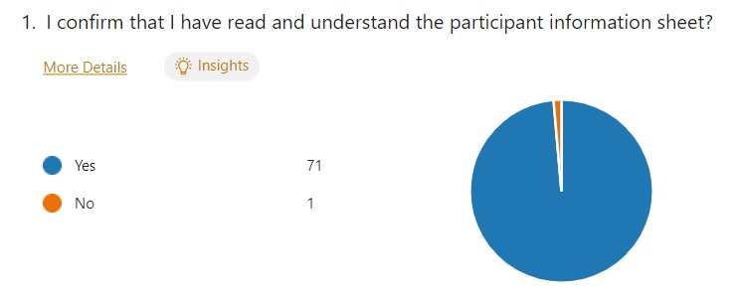
Fig. 1.
The majority of the participants of the questionnaire were identified as being in the constable role, this consisting of 23 participants, equating to 32.4% of the total participants being police constable and 18 participants, 25.4%, being detective constable.
The most popular age ranges from participants were both the age ranges 25-34 and 35-44. These selections were selected by 26 participants (36.6%) each, with the next selection was ages 45-54 with 15 participants (21.12%) which has been identified as per Fig. 2.
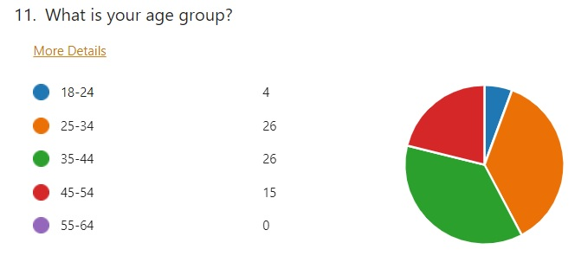
Fig. 2.
Length of service was going to be important, there were 18 respondents who had 20+ years of service (25.4%). Closely followed by 10 years to 20 years of service with 15 respondents (21.13%) as per Fig. 3. This indicates that the respondents have a considerable length of service and would have been in the police service prior to the introduction of Taser within the police.
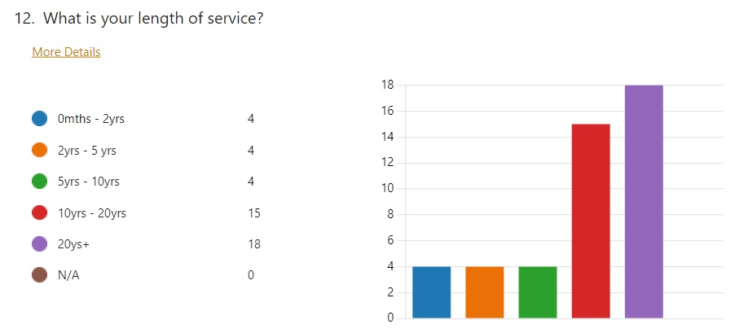
Fig. 3.

4.3 Involvement and Training

It has been identified that 70 of the 71 respondents (98.6%) were aware that police officers were able to carry a Taser. Question 14 (Fig. 4) helps identify what involvement with Taser the participants had, it was identified that none of the participants were legal representatives, and the majority were ‘Non-carriers’ of Taser (64.79%), one participant was an investigator of the use of Taser (1.4%) and the remaining 23 were carriers (32.4%).
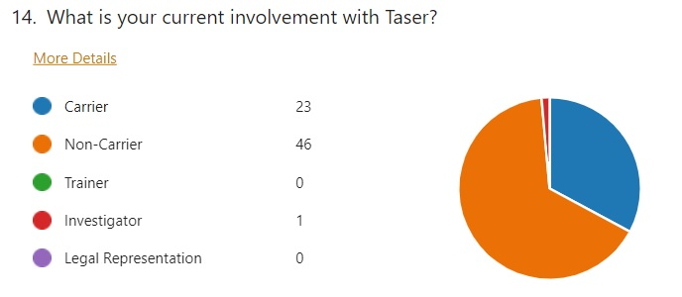
Fig. 4.

These results match closely with the results of Question 16 (Fig. 5) where 23 participants (32.4%) stated that they were Taser trained, 40 participants (56.3%) stated that there were not trained and 8 (11.3%) stated that it was not applicable to them, meaning they are in roles where Taser is not an option.
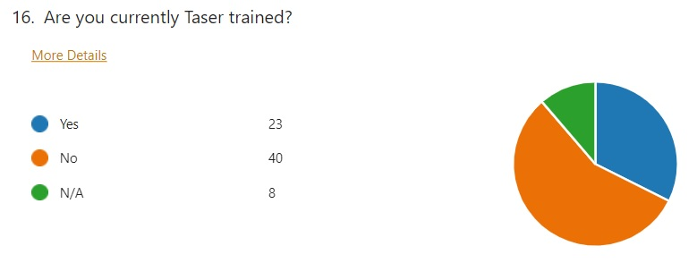
Fig. 5.

The majority of the participants attended an incident whereby the use of Taser had been authorised based on the information passed to the call handler, this being 52 of the 71 participants (73.24%). Again, showing links with questions 14 and 16, where 8 of the participants (11.3%) answered ‘not applicable’ to which also indicated their role does not involve Taser.

4.4 Risks of Taser Use

Findings show that 68 participants (95.8%) are aware of the risks of carrying a Taser, similarly, 67 participants were aware of the consequences of using a Taser of a subject. Again, with similar results, 68 participants were aware of the potential injuries that Taser could cause to a subject. With these questions asked to the participants, it has been identified that 20 participants (28.2%) feel that the risks would play a factor in being Taser trained where, the majority of 44 participants (62%) would not want to carry Taser.
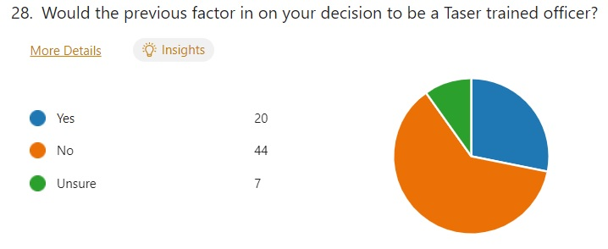
Fig. 6.

4.5 Perspective of Participants

Tversky and Kahneman (1974) stated that ‘Many decisions are based on beliefs concerning the likelihood of uncertain events’, this indicates that the answers provided could be influenced by a bias based on assumptions and not knowing facts.
Within this section, participants were asked questions based on their perspective of Taser, 41 participants (57.8%) stated that they feel officers should carry Taser where 26 participants (36.6%) felt that officers should not carry Taser (Fig. 7).
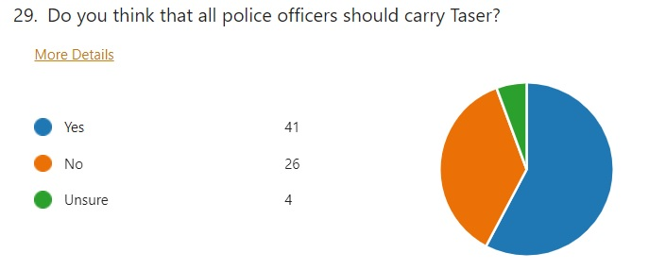
Fig. 7.
The results were the opposite for the next question (Fig. 8), where 38% of the participants (27) stated that they should be able to carry Taser and almost half of the participants, 49.3% (35) stated that they should not be able to carry Taser.
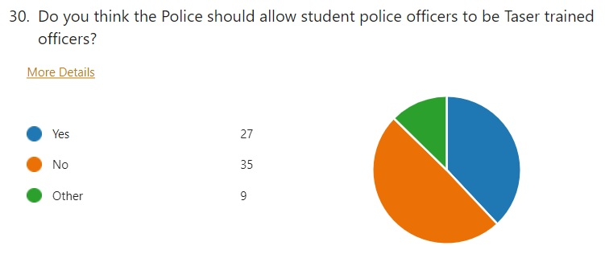
Fig. 8.

4.6 Conclusion

The results of this research found that 77.5% of the participants (55) would be comfortable carrying a Taser and the remaining 22.5% (16) would either not feel comfortable or are unsure about carrying Taser. However, 94% would feel more comfortable with their colleague carrying Taser, these results shows that the majority of Police officers would rather another person carry a Taser than themselves.
The final questions cover the purpose of this research project with two direct questions (Fig. 9 and Fig. 10). These directly ask if the issuing of Taser within the Police is a good idea, where 70 of the 71 participants answered, ‘Yes’ that it was a good idea with a single person selecting ‘No’. Meaning that 98.6% agree that police forces should be able to issue Taser to officers and 1.4% thing that it shouldn’t be issued.
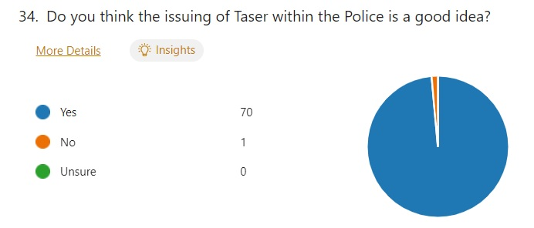
Fig. 9.
Adams and Jennison (2007) have identified that members of the public hold mixed opinions about police use of Taser, however, there is a gap in the research available that goes further than this general observation. Therefore, participants where then asked if they feel that the issuing of Taser to all police officers would be supported by the public. The results of this question were split across three answers, being Yes, No and Unsure. The results were evenly spread with 29 (41%) stating ‘Yes’, 26 (37%) stating ‘No’ and 15 (22%) stating that they were unsure. These results show that despite police officers feeling comfortable with carrying a Taser within their role, they also feel that the public would be split on the support they offer to police with Taser.
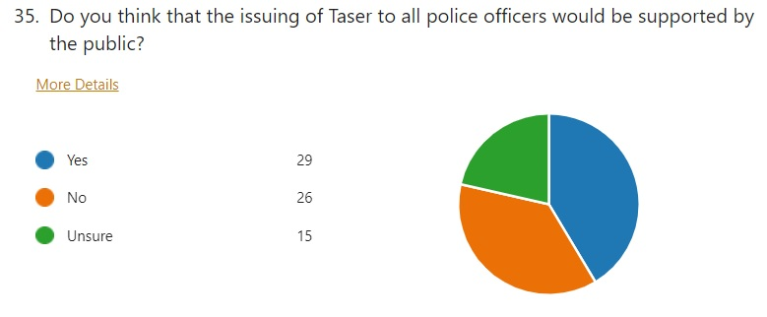
Fig. 10.

Chapter 5: Conclusion and Recommendations

5.1 Introduction

The aim of this chapter is to provide a conclusion in relation to the project question:
“The Issuing of CED (Taser) to all Police Officers: Explore how this will be perceived by serving Police Officers and other Professionals.”
Within the previous chapter, the analysis and data from the primary data that was collected via the distribution of surveys was prepared and presented. This chapter aims to explore this data in more depth, to review the initial objectives and the limitations of this project will be identified for any potential further gaps in research of future researchers.

5.2 Review of Initial Objectives

At the beginning of the project the researcher had identified four objectives for the research project to complete to achieve the purpose of this project. These objectives are listed below, along with the chapter of the research project that the specified objective was completed.
- Ascertain how many Taser carriers there are working within South Wales Police.
This objective was achieved through the submission of a freedom of information request to South Wales Police and can be found in 7.1 APPENDIX A – Freedom of Information Results.
- Explore the thoughts of serving police officers through a quantitative method of research, being a questionnaire and analyse the data to form quantitative data.
This objective was achieved though the distribution of a survey to serving police officers and police staff at South Wales Police and the results can be found under CHAPTER 4.
- Explore the views of other professionals through a quantitative method of research, being a questionnaire.
This objective was not achieved, the surveys were sent to professionals with involvement in Taser use but there were no responses.

5.3 Main Findings

Objective 1:
Through the use of a freedom of information request to South Wales Police, information was obtained that indicated that the number of police officers in South Wales Police who currently (at the time of the request) carry Taser were 850 police officers. As per South Wales Police (2023a) website, it is suggested that they employ almost 3000 police officers, this would mean that 28% of police officers employed at South Wales Police carry Taser. With the aim of a further 240 police officers to take the course meaning a raise from 850 police officers to 1090 police officers, meaning over one third (36.33%) of police officers will be carrying Taser. This is an increase of 8.33% in Taser carriers. This clearly shows that South Wales Police have identified the need to train more police officers to be specially trained Taser carriers.

Objective 2:
Through the use of a survey that was distributed to serving police officers and current police staff at South Wales Police, in Chapter 4 I explored the thoughts of these participants. The research participants totalled 72 participants with one being eliminated due to their selection at the first question. This has been identified through question 1 of the survey. It has been identified that of the total participants, the most participants length of service were between 10 years to 20 years and 20 years plus. This offers a better range of results because these employees have been employed before the introduction of Taser and after continued to work for the force after the introduction of Taser. It was identified that 57.8% of participants feel that all police officers should carry Taser and almost half of respondents (49.3%) feel that student officers should not carry Taser. An overwhelming number of participants, 70 which works out as 98.6%, feel that the issuing of Taser within the police is a good idea with one participant who feels it is not a good idea. However, when asked if the participants feel the issuing of Taser to all police officers would be supported by the public, the results were evenly split, with 29 stating yes and 26 stating no, which corroborates the findings of Adams and Jennison (2007)’s publication that members of the public hold mixed opinions about police use of Taser.

Objective 3:
The objective of finding the perspective of professionals was not completed as a result of the lack of response from members of the professional sector, this included CPS lawyers, solicitors and the like. Due to receiving no response, the project was unable to obtain any data to analyse.

5.4 Limitations

During this research project a number of limitations were identified, these include the method of data collection, the willingness of participants and the limitation of the dissertation itself due to the smaller word count.
In chapter 3, it was anticipated that the willingness of participants might limit the scope of the project, if the participants find a question that brings back a memory that is unfavourable then they are likely to stop the survey. Ferrier-Auerbach A, Erbes C, Polusny M (2009) identifies that PTSD sufferers can feel sadder and more tense that other participants.

5.5 Conclusion

This dissertation has successfully achieved the majority of the objectives set at the start of the research project, also answering the questions “The Issuing of CED (Taser) to all Police Officers: Explore how this will be perceived by serving Police Officers and other Professionals.”
Due to the lack of response from the professional sector, the researcher was unable to complete objective 3 due to no participation from professionals such as lawyers, solicitors, or the CPS.
As the research project evidences, the perception of Taser within the police and the issuing of Taser within the police is greatly varied. The answers provided by the participants, within the survey, the majority were in support of the issuing of Taser to police officers. However, the responses from the participants show that they are less supportive of the issuing of Taser to student police officers.
There are further gaps in the research of this topic and further academic research would help benefit the future perception of Taser issuing and use. These gaps include but are not limited to research into the perception of the public’s opinion on this matter, more research into the thoughts of senior management and also research into the thoughts of any legal representatives that handle cases involving firearms or Taser usage.
More research could be incorporated into the questionnaires and surveys that are carried out to find out more information by answering the following questions:
- How might legal representatives be persuaded to engage in responding to the questionnaires?
- What do members of the public across South Wales really think about the use of Taser within the police?
- How can the police improve the perception of Taser among members of the public in South Wales?
- Do members of the public in South Wales feel there are any other technology that police would benefit from instead of Taser?
- Are there any alternative technologies that are available to police to use instead of Taser?
- Do doctors and nurses in A&E departments see many injuries from the use of Taser?
- What do the doctors and nurses who deal with these injuries think about the gravity of the injuries seen?
- How often do hospitals gets admissions for Taser use injuries?

5.6 Recommendations

These recommendations that follow are based on the findings identified through the completion of this research project. The research completed through the questionnaire has identified a number of recommendations.

Recommendation one: Questionnaire
The first and most obvious recommendation would be to expand or improve the questionnaire that was distributed to participants, with the aim to distribute the questionnaire to a larger target audience. The questionnaire that was originally sent to participants reached a total of 72 people, all within South Wales Police. Despite the numbers reached producing sufficient data, if the questionnaire was distributed to more police forces across the United Kingdom, then the data obtained would be much more valuable and substantial.
It would be beneficial for the questionnaire to be distributed to more organisations involved in the legal side of the topic, such as an agency that deals with solicitors for the police or for the defence to provide a more dynamic range of responses to the questions asked.
Another beneficial factor within the questionnaire would be to introduce open questions that promote the participant to produce a more detailed answer, thus providing qualitive data to the project rather than just quantitative data.

Recommendation two: Time Scale of Questionnaire
Secondly, due to the short time scale for this research project, the time to create the questionnaire and be able to distribute this to participants could be greatly improved and this would help with the quantity and quality of data that is obtained through the research.
If more time is provided to be able to complete the research, then it allows for a larger audience to be reached. It will give participants more time to answer the questions and provide detailed answers.
It will also assist with recommendation one, where the questionnaire will then be able to be distributed to other police forces across the United Kingdom.
With an increased timescale, there could also be the option of producing a specific questionnaire that could be distributed to members of the public to achieve a broader research sample.

Recommendation three: Participants
The third and final recommendation, is for the number of participants to be expanded so the quality and quantity of data obtained will be more substantial. Also with the participants, a wider range of participants could be included. This recommendation falls into place with recommendation one and recommendation two. The participants could be expanded to include a wider range of participants such as lawyers, solicitors, members of the public. This could be key as the main purpose of this research project was the perspectives of serving police officers, where there has been an identification of a gap in the research of the perception of members of the public. The only information out int eh public eye of the public’s perception is that displayed in newspaper articles, not directly from the public themselves.

Chapter 6: Bibliography

Adams, K. and Jennison, V. (2007) 'What we do not know about police use of Tasers', Policing, 30(3), pp. 447-465

Axon (2022) Taser X2. Available at: https://www.axon.com/products/taser-x2 (Accessed: 24th April 2023).

BBC News (2020) Welsh police forces to bid for additional Tasers. Available at: https://www.bbc.co.uk/news/uk-wales-51109152 (Accessed: 4th May 2023).

Bilgin, Y. (2017) 'Qualitative Method Versus Quantitative Method in Marketing Research', in S. Oflazoglu Dora (ed.), Qualitative Versus Quantitative Research [Open Access Version]. Available at: https://www.intechopen.com/chapters/54613 (Accessed: 4th June 2023).

Campbell, F. and Clark, S. (2019) 'Penetrating facial trauma from a Taser barb', British Journal of Oral and Maxillofacial Surgery, 57(2), pp. 188-189.

College of Policing (2020) College of Policing Limited Annual Report and Accounts. Available at: https://assets.publishing.service.gov.uk/government/uploads/system/uploads/attachment_data/file/942944/CoP-Annual-Report-and-Accounts-2019-20-web.pdf (Accessed: 4th May 2023).

College of Policing (2022) Conducted Energy Devices (Taser). Available at: https://www.college.police.uk/app/armed-policing/conducted-energy-devices-taser (Accessed: 24th April 2023).

Collins English Dictionary (2012) Weapon. Available at: https://www.dictionary.com/browse/weapon (Accessed: 4th May 2023).

Criscione, J (2009) An Independent Assessment of the Physiological and Cognitive Effects from the X-26 Taser Device in Volunteer Human Subjects. Available at https://apps.dtic.mil/sti/pdfs/ADA585375.pdf (Accessed: 26 February 2023).

Equality impact assessment (2022) Available at: https://www.gov.uk/government/publications/taser-carriage-by-special-constables-equality-impact-assessment/equality-impact-assessment (Accessed: 25 February 2023).

Ferrier-Auerback, A., Erbes, C. and Polusny, M. (2009) 'Does Trauma Survey research cause more distress than other types of survey research?', Journal of Traumatic Stress, 22(4), Pp 320-323. Available at: https://doi.org/10.1002/jts.20416

Gov.uk (2021) Police use of force statistics, England and Wales: April 2020 to March 2021 . Available at: https://www.gov.uk/government/statistics/police-use-of-force-statistics-england-and-wales-april-2020-to-march-2021/police-use-of-force-statistics-england-and-wales-april-2020-to-march-2021 (Accessed: 3rd May 2023).

Gov.uk (2022) Police use of force statistics, England and Wales: April 2021 to March 2022. Available at: https://www.gov.uk/government/statistics/police-use-of-force-statistics-england-and-wales-april-2021-to-march-2022/police-use-of-force-statistics-england-and-wales-april-2021-to-march-2022#ced-conducted-energy-device-use (Accessed: 3rd May 2023).

Heiberger, R.M. and Holland, B. (2015) Statistical Analysis and Data Display. Available at: https://doi.org/10.1007/978-1-4939-2122-5_4 (Accessed: 3rd August 2023).

Home Office (2016) CED Replacement Project. Available at: https://assets.publishing.service.gov.uk/government/uploads/system/uploads/attachment_data/file/676911/CAST_Assessment_of_the_Taser_X2_against....pdf (Accessed: 4th May 2023).

Home Office (2019) Selected student police officers to receive Taser training. Available at: https://www.gov.uk/government/news/selected-student-police-officers-to-receive-taser-training (Accessed: 4th May 2023).

Independent Office for Police Complaints (2021) Review of IOPC cases involving the use of Taser 2015-2020. Available at: https://www.policeconduct.gov.uk/sites/default/files/Documents/research-learning/IOPC_Taser_review_2021.pdf (Accessed: 3rd May 2023).

The Justice Gap (2014) Watchdog warns police to resist 'mission creep' over Taser use. Available at: https://www.thejusticegap.com/watchdog-warns-police-resist-mission-creep-taser-use-2/ (Accessed: 4th May 2023).

Theisen, K., Slater, R. and Hale, N. (2016) 'Taser-Related Testicular Trauma', Urology, 88, pp. e5.

Lancashire Constabulary (2019) How we use Taser. Available at: https://www.lancashire.police.uk/about-us/our-organisation/use-of-force/how-we-use-taser/(Accessed: 24th April 2023).

Liberty (2019) Liberty responds to Government mass Taser rollout. Available at: https://www.libertyhumanrights.org.uk/issue/liberty-responds-to-government-mass-taser-rollout/ (Accessed: 25 February 2023).

McGuinness, T. (2016) Taser use in England and Wales (House of Commons Library briefing paper 7701). Available at: https://researchbriefings.files.parliament.uk/documents/CBP-7701/CBP-7701.pdf (Accessed: 24th February 2023).

Nespor, J. (2000) 'Anonymity and Place in Qualitative Inquiry', Qualitative Inquiry, 6(4), Pp 546-569. Available at: https://doi-org.ezproxy.uwtsd.ac.uk/10.1177/107780040000600408

Nielsen, E. (2004) 'Taser International X26', Law & Order, Issue 52(10), pp. 118-124.

Northamptonshire Police (2023) Taser. Available at: https://www.northants.police.uk/police-forces/northamptonshire-police/areas/northamptonshire-force-content/sd/stats-and-data/taser/#:~:text=What%20training%20do%20officers%20receive,safety%20and%20first%20aid%20training. (Accessed: 24th April 2023).

Plouffe, W. (2023) Taser. Available at: https://www.britannica.com/topic/TASER (Accessed: 24th April 2023).

The Police Federation of England and Wales (2019) Police officers and the public support Taser roll out. Available at: https://www.polfed.org/news/latest-news/2019/police-officers-and-the-public-support-taser-roll-out/ (Accessed: 25 February 2023).

Royal Canadian Mounted Police (2021) Less Lethal Intervention Options . Available at: https://www.rcmp-grc.gc.ca/en/conducted-energy-weapon-cew (Accessed: 4th May 2023).

Salkind, N. J. (2010). ‘Primary data source’. Encyclopedia of research design, 1, pp. 1095-1097. SAGE Publications. Available at: https://sk.sagepub.com/reference/researchdesign/n333.xml (Accessed: 25 July 2023)

South Wales Police (2023) Three SWP Special officers the first to be authorised to carry Taser following legislation change. Available at: https://www.south-wales.police.uk/news/south-wales/news/2023/ion-jan/three-swp-special-officers-the-first-to-be-authorised-to-carry-taser-following-legislation-change/#:~:text=%E2%80%9CNo%20officer%20is%20made%20to,serve%20as%20safe%20as%20possible. (Accessed: 24th April 2023).

South Wales Police (2023a) Overview. Available at: https://www.south-wales.police.uk/police-forces/south-wales-police/areas/about-us/about-us/overview/ (Accessed: 1st September 2023).

Sussex Police (2023) Professional Training and Scrutiny. Available at: https://www.sussex.police.uk/SysSiteAssets/media/downloads/sussex/about-us/governance-and-processes/taser/professional-taser-training-and-scrutiny.pdf (Accessed: 24th April 2023).

Tversky, A. and Kahneman, D. (1974) Judgement under Uncertainty: Heuristics and Biases. Vol. 185, Issue. 4157. Place of publication: American Association for the Advancement of Science. Pp. 1124 - 1131

West Midlands Police (2022) Freedom of Information. Available at: https://foi.west-midlands.police.uk/wp-content/uploads/2022/06/436A_Attachment.pdf (Accessed: 24th April 2023).

West Midlands Police (2023) Conducted Energy Device (TASER). Available at: https://foi.west-midlands.police.uk/conducted-energy-devices-taser/ (Accessed: 24th April 2023).

Zemliansky, P and Lowe, C. (2010) Writing Spaces: Readings on Writing, Vol. 2. Google Books. Available at: https://www.google.co.uk/books/edition/Writing_Spaces_Readings_on_Writings_Vol/u4VPAgAAQBAJ?hl=en&gbpv=0 (Accessed: 25 July 2023)

Chapter 7: Appendix

7.1 Appendix A - Freedom of Information Results

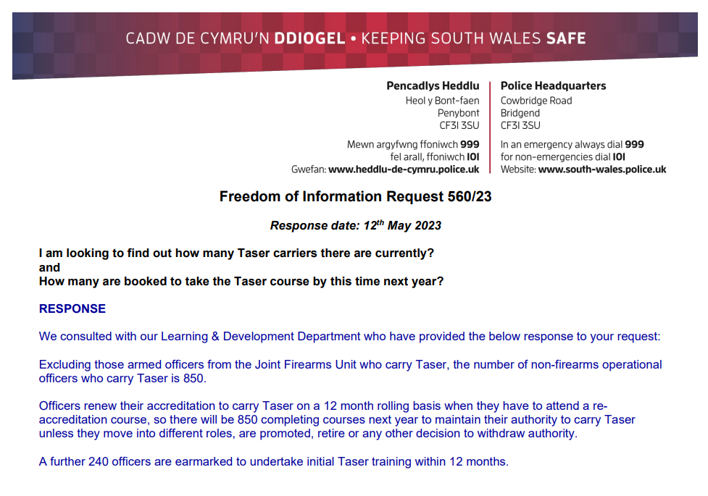
A freedom of information request was sent to South Wales Police to which a response was received on 12th May 2023.

7.2 Appendix B – Participant information Sheet

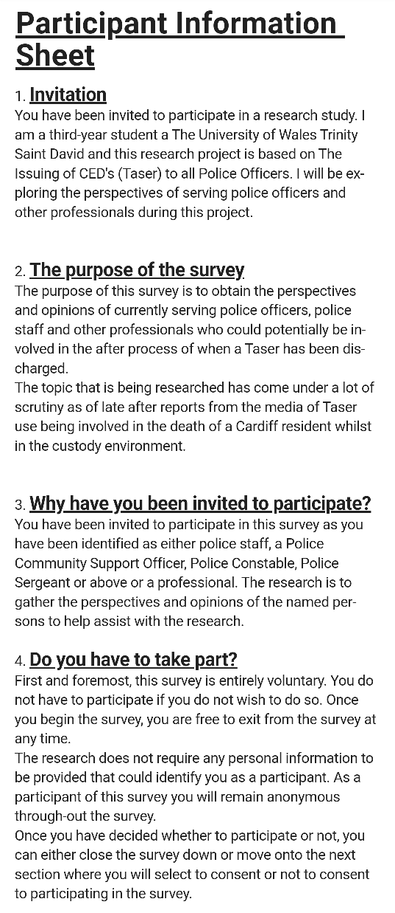
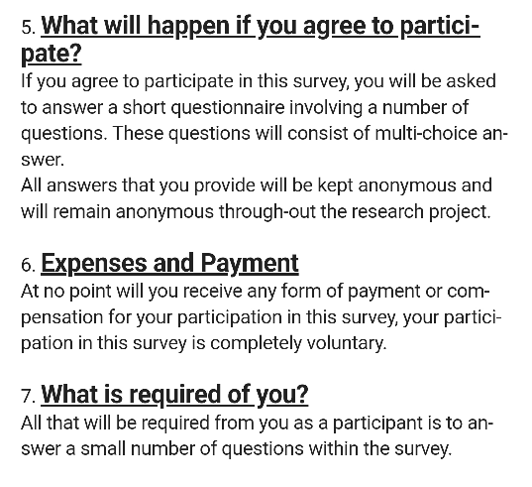
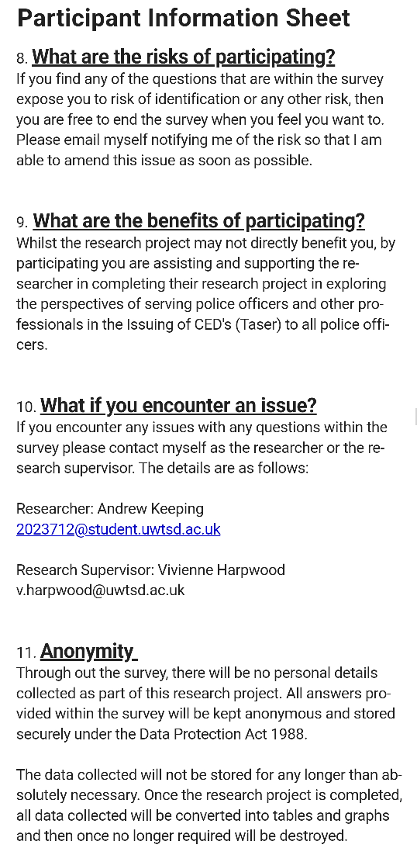
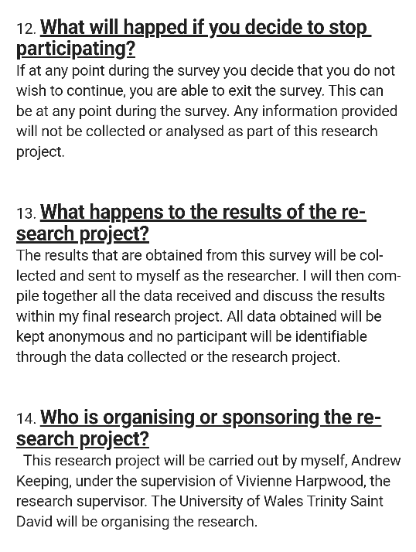

7.3 Appendix C – Informed Consent

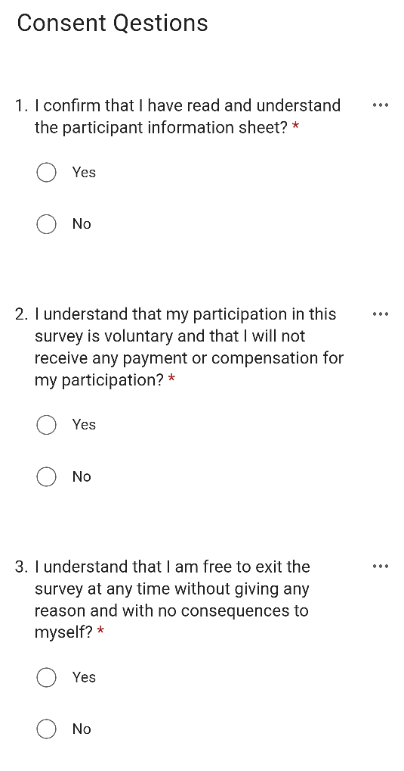
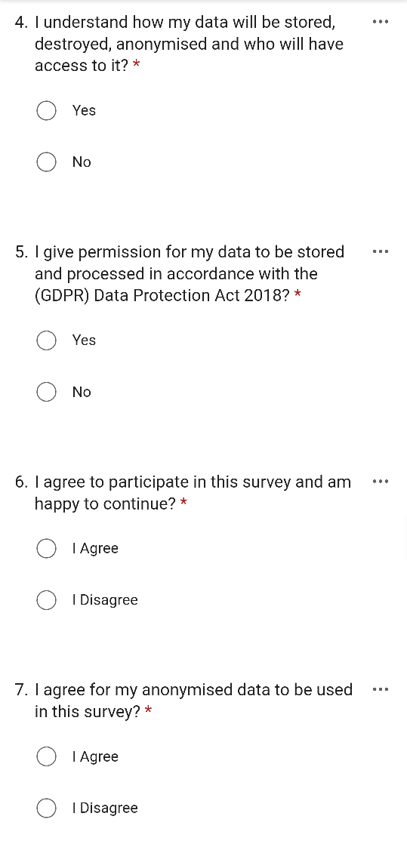

7.4 Appendix D – Questionnaire
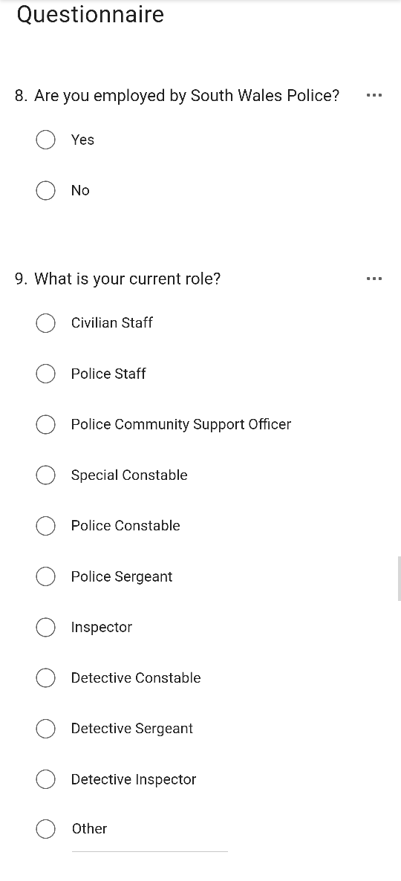
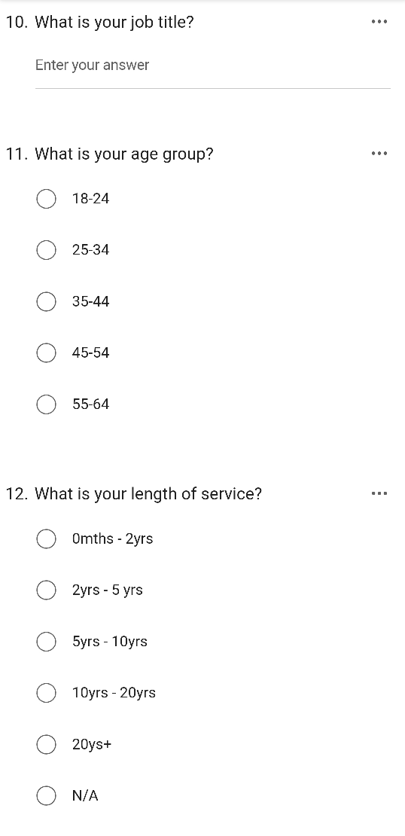
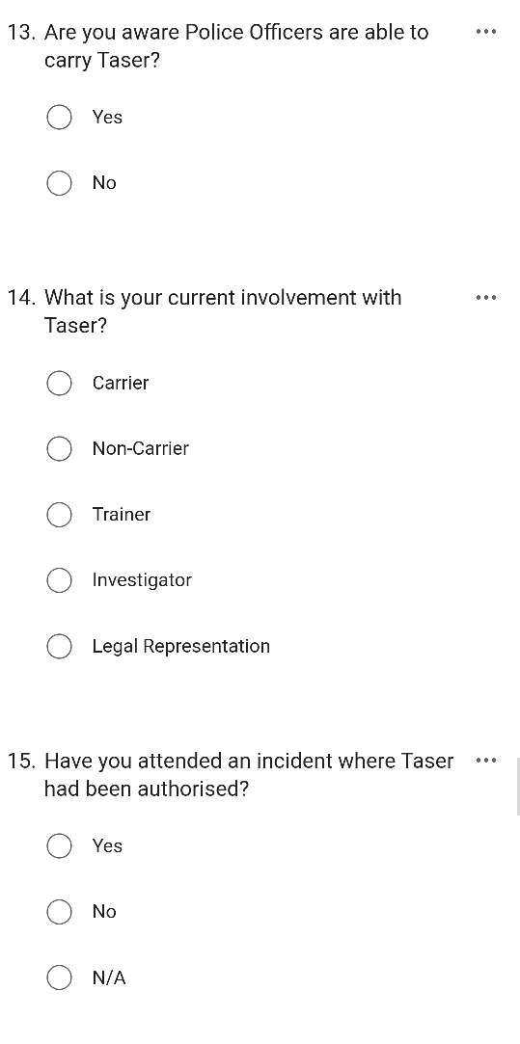
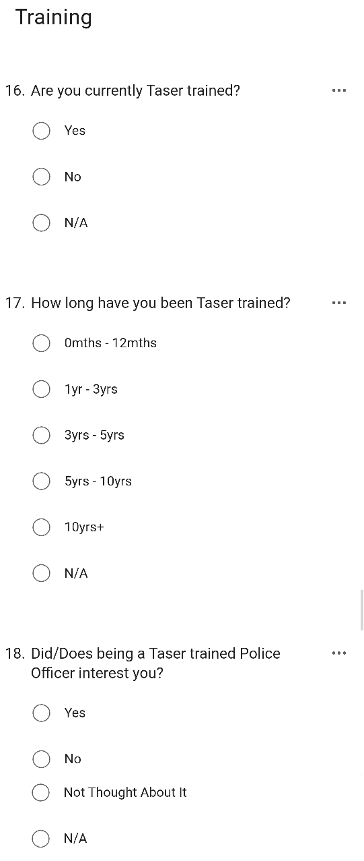
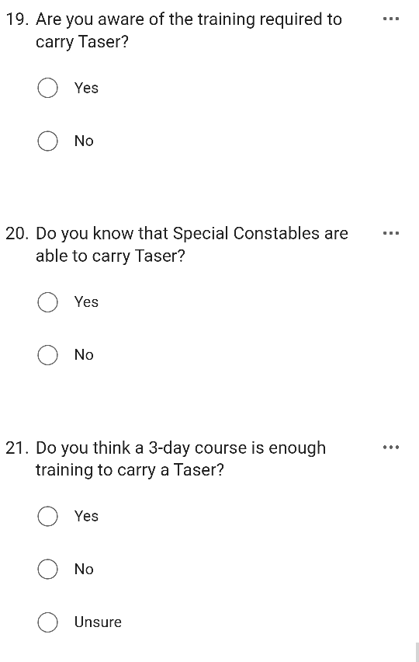
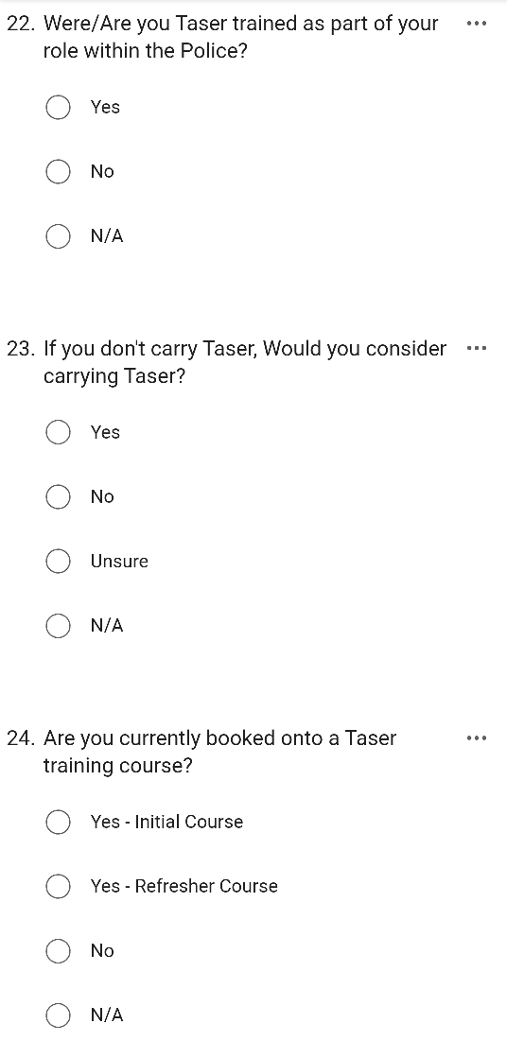
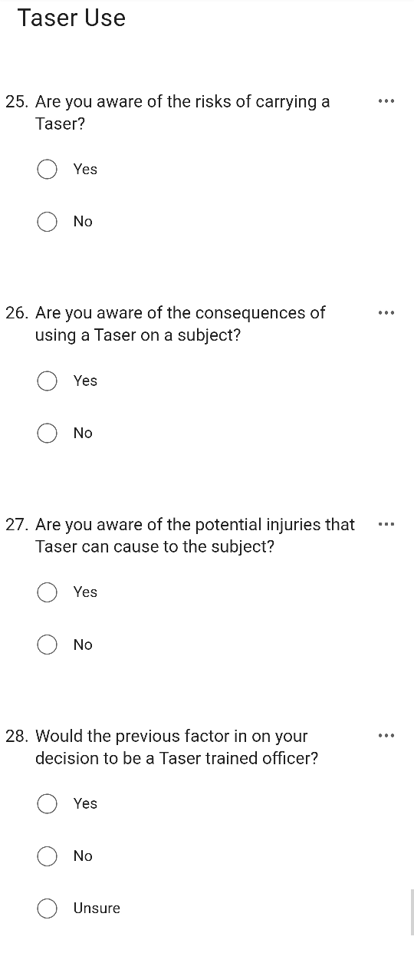
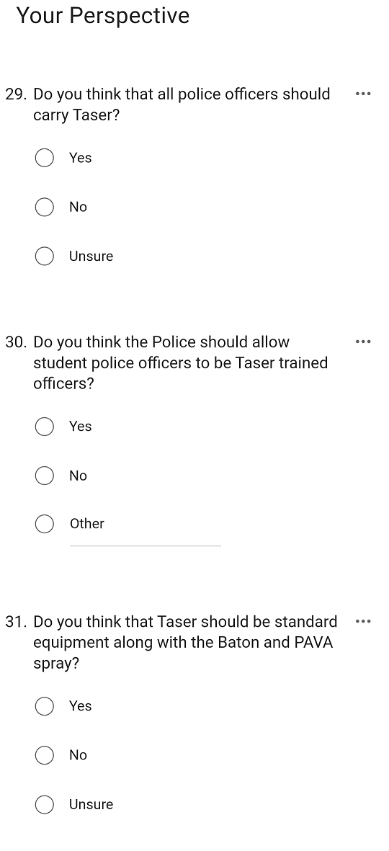
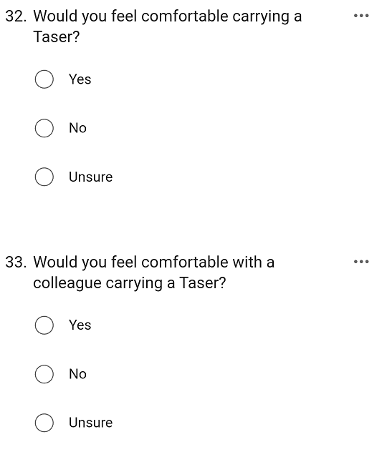
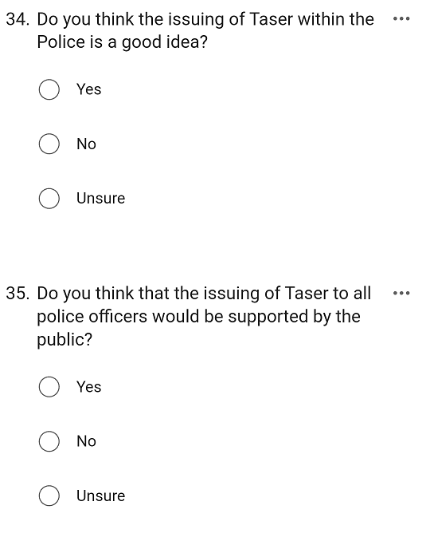

7.5 Appendix E – Questionnaire Results



