Module Code: BMSK5005
Title: Workplace Culture and its Impact on organisational Efficiency: Case Study: Sage Group PLC

Student: Gyurses Sadak

ID: 1605758

Date: 11/01/2019

Executive Summary
The Sage Group PLC is global organisation that is well known for its provision of solutions concerning business management. The company offers various services such as accounting, payroll software as well as enterprise resource planning. It operates globally through various nations such as northern, Central and Southern Europe and North America. Sage PLC Company was started in 1981 by a trio, David Goldman, Paul Muller and Graham Wylie. Its headquarters is situated in New Castle in the United Kingdom.

Table of Contents
Executive Summary 2
Introduction 4
Background of the organisation 4
Critical assessment of the workplace culture of the organisation 4
Evaluation of the culture of an organisation 6
Considering the relevant policies, procedures, and legislation to the support of the evaluation of the organisation 8
Critical evaluation of the organisation and the environment which the company operates 10
Environmental factors associated with the organisation 12
The Influential element of organisation culture of the company 13
SWOT analysis of the organisation 14
PESTLE analysis of the organisation 16
Critical evaluation of ethical and cultural behaviour of the organisation 18
Conclusion 18
References 19

Introduction
Culture is considered to be the backbone of an organisations operating environment. It defines the desired organisational culture as well as the ethical behaviour among the employees in the organisation. However, the organisational culture is majorly influenced by the leadership in the organisation. The assignment will provide a detailed report on the workplace culture of the organisation, the culture of the organisation, the policies, procedures and legislations that support the organisation, the environmental factors associated with the organisation, the influential element of the organisational culture, SWOT analysis, PESTLE analysis and finally the evaluation of the ethical and cultural behaviour of the organisation.

Background of the organisation
Sage PLC is considered to be a British Multinational Company which has its headquarters in New Castle, in the United Kingdom. It is the United Kingdom’s second largest Company regarding technology. However, it is the third largest supplier of enterprise resource planning. It is an organisation that serves approximately 6.1 million customers globally in 24 countries. The company mainly focuses on healthcare, human resource and payroll, construction, transport, payment processing, automotive distribution and accountancy. The company’s segment consists of Europe, German, Switzerland, Poland, Portugal, North America France, Ireland, Canada, and North America

Critical assessment of the workplace culture of the organisation
Culture refers to the character as well as the personality of an organisation. It consists of the values, traditions, beliefs, behaviour, attitudes, and aspects that make the business extraordinary. Hence workplace culture denotes the systems of shared beliefs, values, attitudes and behaviour governing people in the organisation. The workplace culture of Sage PLC is majorly affected by its leadership, management, practices, policies and the employees.
Leadership: It is an important aspect that defines the culture of an organisation. The leadership at Sage PLC company is defined by the effective communication, vision, interaction and decisions made by the different leaders. Leadership is mainly showcased regarding autocratic and democratic (Camillus, 2011). Autocratic leaders mainly direct the employees on what to do while the democratic encourage the employees, listen to their ideas and give them an opportunity to make decisions. However, the two styles are utilized in the organisation depending on the situation.
Management: The Sage PLC Company is well structured regarding management. The employees mostly prefer the democratic type of leadership where the employees make their own decisions concerning their roles and duties. It is an aspect that has made the employees innovative.
Communications: The Sage PLC strong culture is defined by the effective communication among the stakeholders. The communication fosters interaction between the management and the employees thus leading to efficiency in the workflow. There is also transparency in the sharing of information among the stakeholders.
People: The employees at the organisation have diverse personalities, beliefs, skills and experiences that provide the best customer experience. The different skills cultivate different ideas that foster innovation among the employees in the organisation.
Culture is considered to be an important aspect at Sage PLC since it has led to:
- The strong workplace culture at Sage PLC has made the organisation to outstand their competitors financially. Thus, making it successful in the technological industry
- It has attracted talented workforce in the organisation. Most of the candidates in the job market analyse an organisation and its climate before making a decision (Cappricotti, 2012). Sage PLC has proved to have a clearly and well defined communicated culture that attracts the employees.
- It has driven the desired engagement and retention of employee’s interaction with their work and the organisation.
- The strong culture at Sage PLC has greatly affected the employee’s happiness as well satisfaction in performing their duties and responsibilities.


Evaluation of the culture of an organisation
Organizational culture denotes the system of shared norms, values, and beliefs which oversees how persons behave in the organisation. Culture is an aspect that makes the organisation showcase its extraordinary competitive advantage and drive behaviour. The culture is defined by the organisational values. The values assist to provide a guiding architecture that drives the performance and behaviour of the employees in the organisation. Thus the organisational culture is defined by its values. It is an aspect that makes the organisation to take the desired tie to define its core values and share with the employees, customers and the public. Sage PLC organisational culture is normally learned through behaviour patterns, norms of behaviour, symbols, history, believes values and attitudes. For instance, Sage PLC Company has its logo, policies, and products that are identifiable. Historically, the company is believed to have the best accounting and payroll solutions globally.
 Sage PLC logo
The sage PLC Company is defined by the Hendy’s model of culture which consists of power, role, task and person culture. Power culture is defined by the leaders whose influence is spread throughout the organisation. It is a culture that is regulated by the rules and regulations. It is where the employees are evaluated through their achievement rather than the potential to perform their assigned duties and responsibilities. Role culture is also grounded in the rules and regulations (Wyburd, 2015). The different stakeholders at sage PLC comprehend the different roles and responsibilities assigned to them. However, power in role culture is ascertained by the employee’s position in the organisation. The Sage PLC role culture is showcased by the organisation tall organisational structure. Task culture is mostly showcased at Sage PLC when teams are formed to sort out a given problem in the organisation. However, the company chooses team members with diverse skills, personalities ,and leadership. Person culture is where a few persons in the organisation consider themselves to be extraordinary and superior in the organisation. For instance, at Sage PLC we have leaders in the organisation who prove to have the desired powers that control the organisational operations.
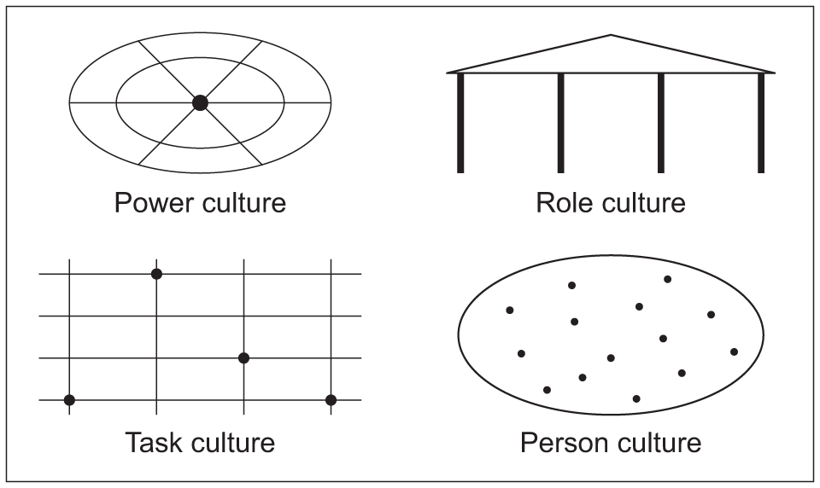
Sage PLC Company is geared towards a groundbreaking high spiritedness and willingness to take the desired risk and commitment towards the customers, company and the community. According to the employees at Sage PLC Company, the aspect of sustainability is imperative to its success and environmental performance. The company creates a culture that makes the environment valuable. The company participates in the creation of awareness n monthly basis through newsletters and environmental management system training.
However, Sage PLC Company culture can be changed due to turnover in leadership, weak culture, and a dramatic crisis.

Considering the relevant policies, procedures, and legislation to the support of the evaluation of the organisation
A policy is regarded as the course of action that is followed. Procedures outline what needs to be done to execute the policy. The policies and procedures affect on the organisational operation. The policies and procedures mainly affect the employees and the suppliers in the organisation.
Regarding employment relationship, the supplier has to establish a strong relation in terms of national laws and good practices (Camillus, 2011). The living wages paid to the employees should meet the national legal standards. The minimum wages paid to the suppliers have to meet the required basic needs.
The company has desired policies and procedures that entail the recruitment,training development and employment of the staff. For instance,the recruitment policies involves procedures such as the advertisement of the vacant policies in the print media, the advertisement of detailed information concerning the duties, salary arrange and contact details. The recruitment procedure is based on the Equal Opportunity Act and Disability Services Act.
The health and safety legislation covers the suppliers and the employees. According to the legislation the supplier has to comply with the health and safety policy, provide the employees with the desired health and safety equipment such as gloves, helmets, masks for protection. The working conditions should also be hygienic and comfortable. On the other hand, the employees should be trained on the health and safety procedures, have regular break as well as access to clean water.
The Sage PLC Company guarantees the desired training and development for its employees when performing their assigned duties and roles. The newly recruited employees are given either off the job or on job training concerning their duties. They are also trained on the health and safety in the organisation. They are given detailed information on the use of different equipment to minimize accidents. The company ensures that it has the desired knowledge of the different legislations to comply with the laws and regulations.
The sage PLC Company also considers the desired laws and regulations regarding its operations. For instance the company considers the employment laws such as working hours, minimum wage, compulsory, and overtime. The employees in the United Kingdom should not work for more than 48 hours per week on a regular basis. The overtime for the employees has to be voluntary and paid for. For instance, in the United Kingdom the increase in the minimum wage and payment of the employees according to the number of hours has greatly affected the organisation operations.
The Sage PLC Company has to comply with the DFID procurement and the environmental agenda. The procurement has to attain the greening government objectives such as reduction in green- house gas emission, waste minimization and water conservation. The Company has to consider the use of equipment that enhances energy efficient regarding IT equipment that reduce carbon iv oxide emission, recycled paper and presence of defectors to manipulate office lighting ( Capprotti,2012).
Policies, procedures and legislation are important since they guarantee the compliance of the organisation with the laws. They also give the required guidance for decision making as well as streamlining of the internal progressions. Policies and procedures guarantee the consistency of the organisational processes and structures. The adherence of the policies and procedures by the employees guarantee smooth operation of the organisation. Quality services are also attained from the policies and procedures. The consistency makes the employees to render the desired services to the customers. Policies and procedures make the environment safe for work. It minimizes the liability risk for an organisation.

Critical evaluation of the organisation and the environment which the company operates
A company cannot operate in a vacuum. Organisational environment denotes the tangible and intangible factors that affect decision-making behaviour. The environment in which the business operates is fundamental. The business environment can either be external or internal. The sage PLC Company is more or less affected by its operating environment.
- Micro-environment
It denotes the internal factors that have an impact on the operation of the company. Sage PLC Company is influenced by factors such as customers, competitors, employees, distributors, suppliers ,and shareholders.
Suppliers: Sage PLC Company has its suppliers of raw materials which it’s well interconnected with. The suppliers are either direct or indirect. The company comprehends the significance of the suppliers and work proficiently.
Competitors: There is high competition in the global market especially in the technology industry. Sage PLC is considered to be the second largest industry in the technological industry. However, the company has to consider its power in the competitive industry to maintain its domineering position.
Customers: Sage PLC Company serves close to 6.1 million customers world-wide. It gives all kinds of technological services concerning accounting, healthcare, human resource and payroll, distribution and payment processing. The company considers its customers as assets thus give them the priority.
Public: They are considered to be the external parties who are interconnected with the company. Sage PLC Company works in association with the media, consumer groups and the government.
Macro-environmental
The external environment denotes aspects such as political, economic, social, technology, legislation and environment
Economic Environment: The success of any business is defined by the economic environment. The economic environment is impacted by diverse aspects such as economic conditions, policies and the system. The economic policies that Sage PLC Company operates in entail of the industrial, fiscal, monetary and foreign investment policy. The industrial policies in the different countries consist of government regulations, policies, rules and procedures (Wyburd, 2015). Fiscal policy entails taxation and public expenditure. Most of the nations that the Sage PLC Company has invested in are characterized by the capitalist, socialist and mixed economy.
Social Environment: The social environment of an organisation entail of the customs, traditions, values, and beliefs. For instance most of the organisation prefers the technological use of accounting processes for proper accountability.
Legal environment: It denotes the laws and regulation that affect the business and its operations (Camillus, 2011). The different businesses of Sage PLC Company have to comply with the set regulations in different countries. The most common business regulations consist of Consumer protection act, Environmental Protection Act, Companies Act, and the Industrial Disputes Act.
The environment provides the desired resources that assist an organisation to provide the required goods and services that meet customer needs. The environment is also considered to be a source of opportunities and threat for an organisation. Opportunities are the trends and events that create an opportunity for an organisation to succeed in the competitive market. Threats are regarded as events and trends that may undermine the success of the organisation. The environment molds the strategic decisions that the management makes when they try to make the organisation successful.

Environmental factors associated with the organisation
Environment refers to the surrounding situations for existence. They can be categorized as external and internal factors. The external factors are considered to be factors that cannot be controlled by an organisation. On the other hand, internal factors can be manipulated by the organisation. The external factors entail all the componentsof the organisational operation. The sage PLC Company is entirely affected by government regulations and policies, agencies of accounting such as the accounting standards board and the demographics of people (Basber, 2009). The Sage PLC Company is entirely associated by the technological factors that are rapidly changing in the industry. The change in technology leads to transformation in the production process as well as innovation. The Company is forced to seek ways of making their products innovative to compete favorably in the market.
The Sage PLC Company is also associated with the different legal factors in the country of operation. The change in the legal aspects regarding working hours, access to materials ,taxation ,import, and exports have an effect on the organisations operations. The company is considered to be global thus has the liability of being affected by different rules and laws.

The Influential element of organisation culture of the company
Leadership is considered to be the most influential element of organisational culture at Sage PLC Company. The leaders in the organisation need to spearhead the cultural aspect by being a role model. Leaders in the organisation cannot expect the employees to follow what they are doing. Thus a strong organisational culture commences with the leaders in the organisation. The words pronounced by the leaders have to be followed by the deeds for the employees to gain confidence. Leadership is used in the following manner to influence the organisational culture:
It is important for leaders to establish a purpose to believe in, concerning the expectations. The employees in the organisation need to be assured of the roles and how it affects the organisation. It is important for the leader to effectively communicate how important an individual organisation leads to the organisational success.
Expectations have to be set by the leaders; however, they should assist in building the required skills (Camillus, 2011). The leaders have to give the desired resources and tools to build the employees capability to attain the vision of the organisational culture. The employees need effective communication concerning the missions, vision and values of the organisation through coaching and training.
Organisational culture is also influenced by the aspect of accountability. Leaders should make the employees learn the aspect of accountability through the given roles and responsibilities. However, accountability is attained through the employees have a clear job description with the desired goals.
The leaders need to be role models in the organisation. They should lead and practice with actions. The leader has to showcase what he or she expects from the employees in the organisation.
There are different devises incorporated by the leaders to maintain the set organisational culture. They entail of the allocation of resources, rewards, status, recruitment, selection, dismissal and promotion of employees (Basber, 2009). The leadership style can either be transformational as well as transactional. Transformational leader refers to one who creates, communicates and embodies a vision which influences changes in attitude and assumption of the subordinates. The main aim of the leader is to build the desired confidence as well as trust among the employees. On the other hand ,the transactional leader is more of business oriented to the subordinates. However, it is believed that businesses require the two types of leadership to achieve its vision concerning organisational culture.

SWOT analysis of the organisation
It entails the micro-environmental factors of the organisation. An organisation needs to analyse its strength, weaknesses, opportunities and threat in order to succeed in the market. SWOT analysis is considered to be a strategic planning technique that assists the manager to perform a situational analysis of the company.
- Strength
It has a strong cash-flow that provides the desired resources for the organisations expansion in different countries.
The company has a strong brand portfolio that has enabled its expansion into new products
Reliable suppliers concerning raw material hence making the organisation overcome any supply chain challenges
High level of customer satisfaction due to its good brand equity among the potential consumers
- Weaknesses
The existing gaps in the range of products sold by the organisation
The companycannot handle challenges of new entrants in the market
It does not have the desired product demand forecast thus leading to missed chances in comparison to the competitors
- Opportunities
The opening of the new markets by the government on free trade agreements
Stability concerning cash flow
Environmental policies that are new in the technology industry leads to the company gaining the desired market share in the new product segment (Alkhafaji, 2016).
Low inflation rates that make the market stable
- Threats
The increased competition in the technological industry
The shortage of skilled workforce in given global markets signify a big threat to the steady growth concerning proceeds
The rising costs of raw materials in the market
The fluctuation concerning the currency rates in numerous countries
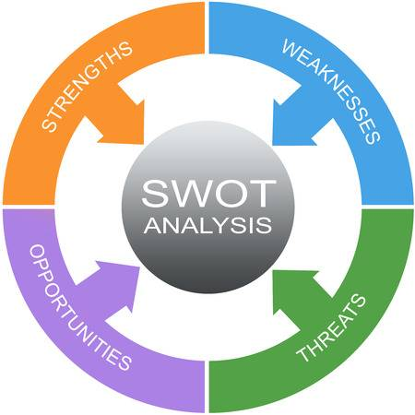

PESTLE analysis of the organisation
The Macro-environment of the organisation is analyzed by the PESTLE concept. It denotes the political, environmental, social, technological, and legal factors. The transformations in the macro-environment have a great effect on the operation of Sage PLC Company. The analysis gives the desired information concerning the operation challenges of an organisation.
Political factors: They perform an important role in the determination of the organisations proceeds in a given nation or market (Sovelainen, 2008). The company operates in various countries worldwide thus being affected by different political decisions. The company is impacted by political decisions concerning the antitrust laws, pricing regulations, trade regulations and tariffs, intellectual property protection, work week regulations in technology, industrial safety regulations and compulsory employee benefits. The company has to adhere to the different political decisions to succeed in the market.
Economic factors: It entails factors such as inflation rate, interest rate, foreign exchange rate and economic cycle (Garcia, 2018). The factors can either make the organisation to gain the desired profits or incur losses in the given market. The organisation has to consider the economic growth rate, discretionary rate; labor costs exchange rates and infrastructure quality in technology before investing in a given market.
Social factors: The organisation is majorly affected by the society’s culture and manner of doing things. The social factors majorly consist of shared beliefs as well as the attitudes of the population. The company has to consider the demographics, class structure, education levels, culture, attitudes and leisure interests being a technological industry.
Technological factors: Technology is an aspect that has great impact on the operation of the various industries. The company has to consider the present technological developments, the rate of technological diffusion and the effect of the value chain structure.
Environmental factors: The environmental standards of the new or existing market have to be analyzed. The company has to consider climate change, laws regulating environment pollution endangered species and waste management in the technology sector.
Legal factors: In various nations, the legal backgrounds cannot safeguard the intellectual property rights of the organisations. Sage PLC Company has to consider the antitrust law in technology, discriminatory laws, and employment laws.

Critical evaluation of ethical and cultural behaviour of the organisation
Ethics in business refer to the moral principles that guide the behaviour of a business person in connection to the society. It leads to the business undertaking the business in a morally warranted way. An individual’s ethical perspective in the organisation is defined by the peers, subordinates, supervisors and organisational culture. However, ethics is considered to be an individual as well as the organisational subject (Meyers, 2008). The organisational culture and ethical behaviour is molded by the leaders in terms of core values such as teamwork, client involvement, and honest communication and on time delivery. An ethical culture and behaviour at Sage PLC Company is defined by a written code of ethics and standards, ethical training, availability of ethical situational advice and confidential reporting systems. However, the employees need to differentiate between what is good and wrong in the organisation. It is believed that the creation of a strong ethical culture leads to an organisation that augments good decision and behaviour. Nevertheless, ethical culture is driven by leadership concerning formal and informal. Formally, the leader provides the desired structures and programs that augment ethics. Informally is through the leader’s actions speaking louder than the words. Thus organizational culture defines the ethical behaviour adopted by the different stakeholders in the Company.

Conclusion
To sum up, organisational culture is considered to be an important aspect in the organisation. It assists in making decisions concerning the policies and procedures in the organisation. The organisational culture in the organisation is majorly influenced by the leadership in the organisation. Conversely, an organisation can be composed of two types of leadership such as transformational as well as transactional. The two types of leadership have to be present in order to make a good basis for the desired culture. An organisation operates in a business environment that is defined by the external and internal factors. The external factors cannot be controlled by the organisation. They consist of Political, Economic, Social, Environmental, Legal and Technological factors. On the other hand, the internal factors are found within the organisation. They entail of the owners, suppliers, customers ,and competitors. The culture of the organisation defines the ethics of the stakeholders in the organisation.

References
Garcia, M. (2018).Changing workplace culture. Don’t Forget the Bubbles,31(1),PP 78-81
Savolainen, T. ( 2000).Towards a new workplace culture: Development strategies for
employer-employee relations. Journal of Workplace Learning,12(8),pp.318-326
Meyer ,S.(2008).Technology and the workplace: Skilled and production workers at Allis-
Chalmers, Technology and culture,29(4),P.83
Alkhafaji, S. (2016). User Satisfaction on Mobile Apps: An Analytical Study on Omani
Business Environment. Archives of Business Research, 4(1).
Basber S. (2009). BPO: A Swot Analysis. SSRN Electronic Journal.
Caprotti, F. (2012). Environment, Business and the Firm. Geography Compass, 6(3), pp.163-
174.
Camillus, J. (2011). Organisational identity and the business environment: the strategic
connection. International Journal of Business Environment, 4(4), p.306.
Wyburd, G. (2015). Reconciling business and the environment. Business Strategy and the
Environment, 4(1), pp.34-35.

