Applied Network Security: Analysis, Design, and Implementation of a Network Security Solution

Module: Enterprise Network Security
Module Code: ACCA7032
Programme: MSc Cybersecurity and Digital Forensics
Assessment: Portfolio – Part 2
Student Name: Riya Kalal
Student ID: 2432879

Table of Contents
1. Introduction 2
2. Revised Enterprise Network Topology 3
2.1 Overview of Topology Enhancement 3
2.2 GAIA Appliance Installation & Configuration 5
2.3 Licensing & Update Management 7
3. Connectivity Verification & System Readiness 8
3.1 Inter-Site and Management Connectivity 8
3.2 Service & API Readiness Validation 9
4. Firewall Policy Design & Implementation 10
4.1 Rationale Behind Security Policy Design 10
4.2 Inbound Traffic Rules 11
4.3 Outbound Traffic Rules 12
4.4 Logging, Monitoring & Validation 13
5. Additional Security Features 15
5.1 Proposed Improvements (Design) 15
5.2 Implementation using GAIA appliances 16
5.3 Security Value Addition 18
6. Conclusion 19
References 21

1. Introduction
Part One of this assessment established an enterprise-wide functioning multi-site infrastructure to render core organizational services across Swansea and London environments through the topology of essential enterprise components comprising domain controllers, DNS, DHCP, web services, and user workstations interconnected by routed networks via the internet. Although successfully demonstrating availability and connectivity without compromising at this simplified security position, perimeter security remained and was thus rendering infrastructure vulnerable to unauthorized access, lateral movement, and general network-based attacks. Consequently, it is the main motivator to convert an established enterprise network into a secure one and is thus the point of convergence for Part 2 of this portfolio.
The purpose of Part 2 is to secure the pre-existing enterprise network by designing and implementing a robust, centrally managed security architecture as realised through Check Point GAIA appliances. These include the incorporation of a dedicated Security Gateway (A-GW), enforcing control over traffic, a Security Management Server (A-SMS), which provides centralised management of policies and records logging, and SmartConsole (A-GUI) serves as the unified management interface in which application, monitoring, and validation of security controls can be systematically applied according to actual enterprise security requirements.
The backbone of the design is the Security Gateway (A-GW), which acts as the first line of defence within the architecture for inspecting traffic in and out, applying firewall rules, and supporting advanced threat prevention. Also, this placement renders segmentation among the internal networks, external connectivities, and the controlled service access, thereby reducing the attack surface. The Security Management Server (A-SMS) centralizes all security-intelligence devices by managing policies, objects, logs, and updates, thus eliminating configuration drift and ensuring that a consistent enforcement of the rules is done across the environment. SmartConsole (A-GUI) is an enhancement to this design, as it provides a single and highly secure interface through which policymakers can continue configuring, monitoring, and overseeing operations, such functions being essential in enterprise-scale environments.
This architecture completely reflects the centralized policy management, allowing the decisions associated with security policies to be defined once and then enforced totally in the same manner. It also supports an in-depth defence strategy by layering access control, inspection, logging, and threat prevention, instead of relying on a single protective mechanism. Collectively, these design choices reflect enterprise best practice, mirroring how modern organizations deploy and manage network security to achieve resilience, visibility, and regulatory alignment. This implementation shows, therefore, that Part 2 is competent technically and demonstratively critical to an understanding level of contemporary enterprise network security principles at Level 7.

2. Revised Enterprise Network Topology

2.1 Overview of Topology Enhancement
Enterprise network topology laid down in Part 1 did give a functional multi-site infrastructure that would support services of core importance such as, for example, Active Directory, DNS, DHCP, and web services across geographically separated environments. However, although it was operational, the original design relied on limited security controls and did not rely on central governance and thus was susceptible to perimeter breaches, unauthorized lateral movement, and insufficient visibility of network activity. Much contemporary enterprise research indicates that functionality with no embedded security controls opens organizations to advanced persistent threats and insider risks [1],[2].
These limitations were then rectified by strategically enhancing topology in Part 2 through the addition of Check Point GAIA security elements, rendering this network a shift away from service-oriented topology to a security-driven enterprise architecture. The modified topology introduces a Security Gateway (A-GW) toward the network perimeter, a Security Management Server (A-SMS) for central management of policies and logs, and a dedicated management workstation running SmartConsole (A-GUI). Separation of enforcement, management, and administration conforms to security reference architectures recognized throughout the industry and decreases risks arising from decentralized or ad-hoc rule management [3].
The A-GW is the primary layer for inspection and enforcement concerning controlling traffic flows between the internet, internal enterprise networks, and controlled service zones. A-SMS centralizes security intelligence by providing uniform policy enforcement, consistent logging, and controlled updates across the environment. The SmartConsole (A-GUI) makes a unified administrative interface that should minimize operational complexity and misconfiguration probability-a common cause of enterprise security incidents [4].
This design represents the best practice in centralised security architecture since it improves audit, scalability, and incident response readiness. Moreover, by integrating layered controls rather than relying on a single defensive mechanism, the topology supports a defence-in-depth strategy, which is widely endorsed by standards bodies such as NIST and ISO as essential for modern enterprise environments [5], [6].
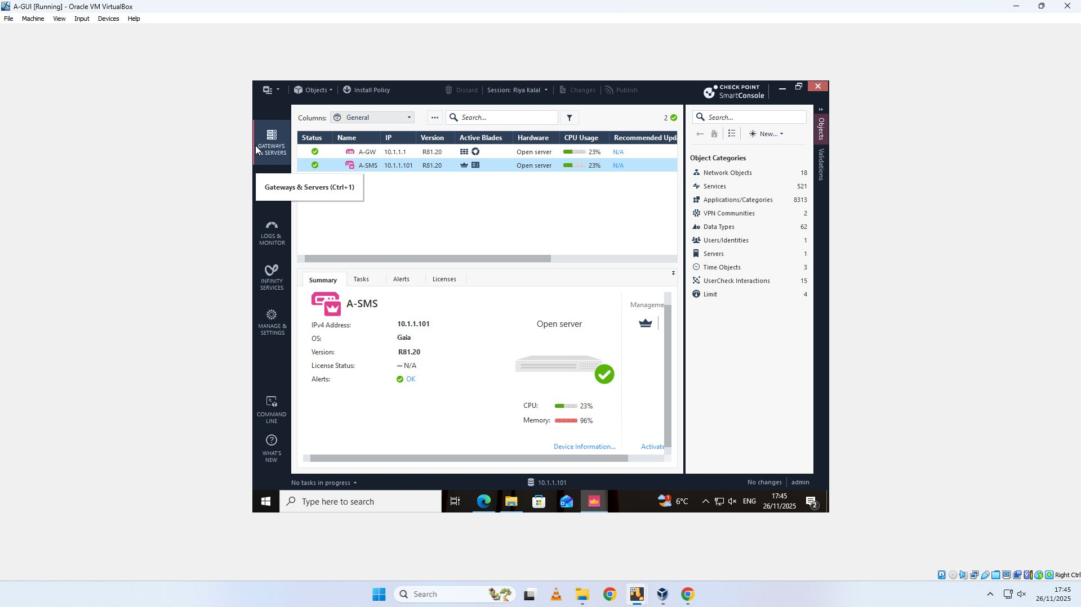
Figure 1: Updated enterprise security topology
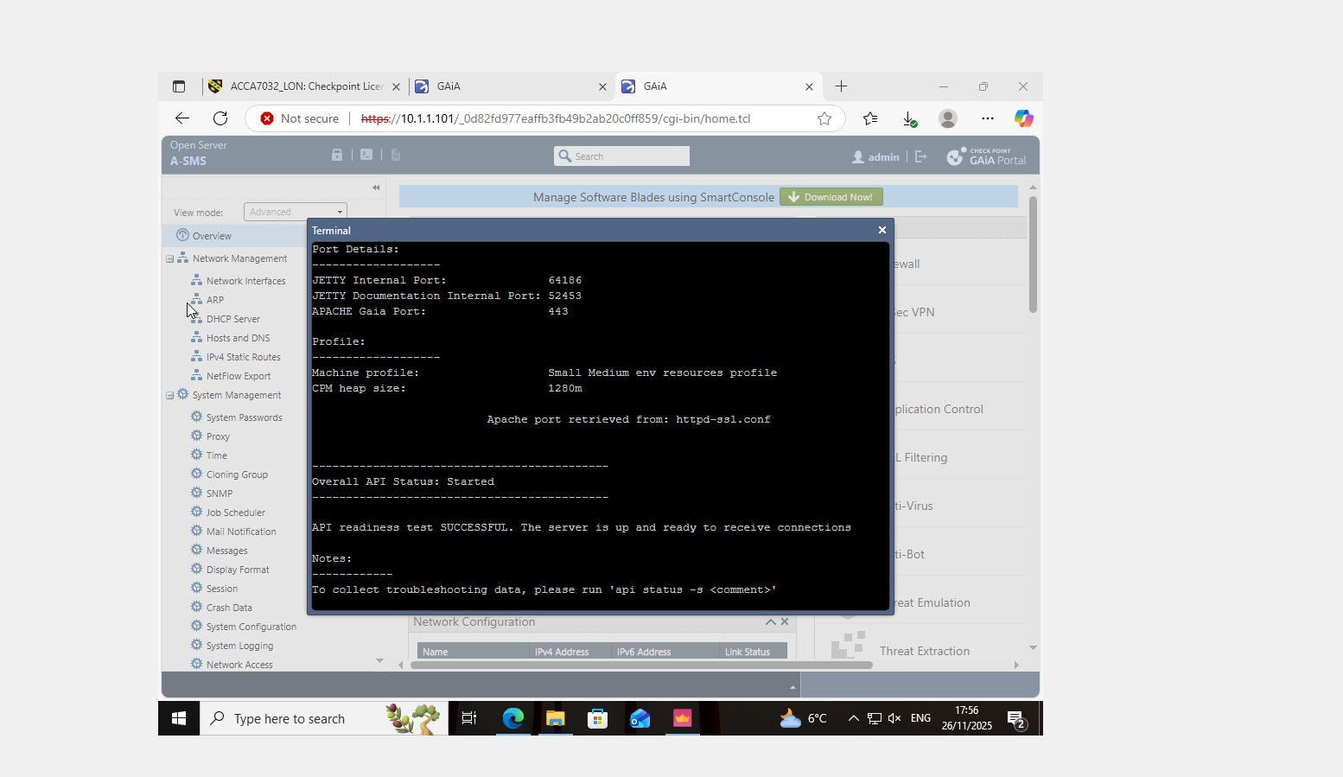
Figure 2: SmartConsole – Gateways & Servers showing A-GW and A-SMS

2.2 GAIA Appliance Installation & Configuration
The Security Gateway (A-GW) was deployed using Check Point GAIA OS, a hardened operating system designed specifically for security enforcement appliances. GAIA provides integrated system management, secure interface handling, and native support for advanced security blades, reducing the attack surface when compared with general-purpose operating systems [7]. The gateway was configured with multiple physical interfaces (eth0–eth3) to support network segmentation, a core principle of secure enterprise design.
Each interface was assigned a distinct role to enforce trust boundaries: an interface dedicated to management access, one for internal enterprise traffic, one for external internet connectivity, and an additional interface supporting internal or DMZ-style segmentation. This approach limits the potential impact of a single compromise and restricts unauthorised east-west traffic, a common technique exploited in post-breach scenarios [8]. By acting as the central enforcement point, the A-GW applies firewall rules, inspects traffic flows, and provides the foundation for further threat prevention capabilities.
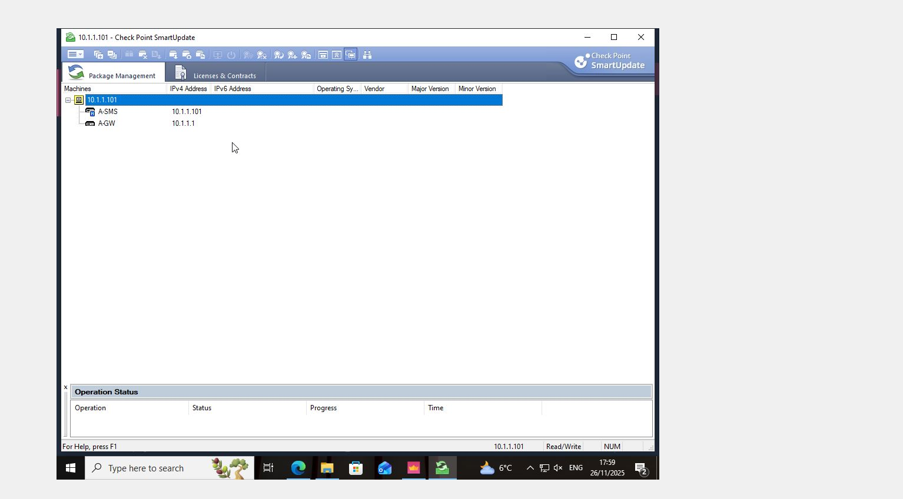
Figure 3: GAIA Portal (A-GW) – Network Interfaces configuration
The Security Management Server (A-SMS) was installed as a dedicated management plane component with its own IP configuration and system profile. Its primary role is to manage security policies, maintain configuration consistency, collect logs, and distribute updates to managed gateways. Research into enterprise firewall deployments emphasises that separating management and enforcement significantly improves security governance and reduces the risk of accidental or malicious configuration changes [9]. Secure Internal Communication (SIC) was established between the A-SMS and A-GW, ensuring authenticated and encrypted management traffic.
The SmartConsole (A-GUI) was installed on a management workstation and securely connected to the A-SMS. SmartConsole functions as the operational control centre, enabling administrators to define security policies, manage network objects, monitor gateway health, and analyse logs. Centralised management interfaces are widely recognised as essential in enterprise environments, as they reduce administrative error and enhance situational awareness during security incidents [10].

2.3 Licensing & Update Management
Following deployment, Check Point licensing was applied to both the Security Management Server and Security Gateway using SmartUpdate. Licensing enables access to critical software blades, management features, and update services, without which the security infrastructure would be functionally limited and unable to respond to emerging threats. Industry guidance stresses that unlicensed or outdated security platforms represent a significant operational risk due to delayed threat intelligence and unsupported configurations [11].
License status and validity were verified, confirming active trial licenses and visibility of expiration periods. Monitoring license lifecycles is essential for enterprise continuity planning, as expired licenses can result in degraded protection or loss of security functionality. This step demonstrates operational awareness and aligns with professional security management practices.
Figure 4: SmartUpdate – Licenses & Contracts view

3. Connectivity Verification & System Readiness

3.1 Inter-Site and Management Connectivity
In consonance with the gnat GAIA security component, connectivity was comprehensively checked against the Swansea enterprise network, Security Management Server (A-SMS), and Security Gateway (A-GW). For effectively centralised policy enforcement, real-time monitoring, and operational resilience, inter-component connectivity is required between all the elements of the enterprise security architectures [1].
The successful establishment identified successful management connectivity between the A-SMS and the A-GW for secure configuration data exchange, policy updates, and log information. Conducted by Secure Internal Communication (SIC), a Check Point-specific trust mechanism that involves certificate-based authentication and encryption for protecting management traffic from prying eyes, this significant communication reader. The successful establishment of SIC shows that it can only be administered by the authorised management servers and mitigates against any chances of rogue configuration changing or man-in-the-middle attacks - as frequently observed in enterprise firewall compromise cases [2], [3]. Apart from these, further confirmation of the successful connectivity was obtained via the SmartConsole; both the A-GW and A-SMS now appear under Gateways & Servers view with healthy (green) status indications. The gateway is reachable, trusted, and actively communicating with the management server, as signified by the status. Administrators can quickly identify failure, policy mismatch, or broken communication that have a possible negative impact on security enforcement when centrally viewing gateway health and status - as an important requirement of operation [4].
Figure 5: SmartConsole - Gateways & Servers showing healthy connectivity (green status)"

3.2 Service & API Readiness Validation
Beyond basic connectivity, system readiness was verified by investigating the operational condition of management services within GAIA Portal as well as through direct command-line verification. This readiness extends beyond simple connectivity to the indication of operational status of management services as dependent on the GAIA Portal and through direct command-line verification. Enterprise security platforms increasingly resort to management API for automation, monitoring, and integration to other defense layers such as SIEM and SOAR platforms. Hence, API availability and stability have become critical system maturity indicators [5].
Core management services, including web services and internal application components, were reported up and running by the GAIA portal. An API readiness check was also performed from A-SMS terminal and validated readiness. The output confirmed that ports were required-oh-opened and listening, including the Apache GAIA service on port 443 and Jetty internal services -which undergird communication of SmartConsole and management operations. The output at the terminal clearly read, "API readiness test SUCCESSFUL," confirming that the management server was fully prepared for secure connections and operational requests.
It shows not only functional availability but also compliance with the best practice in the enterprise, which is validating the readiness of the system before it is put into live production or experienced demonstration live. It is observed from research that the systems lack management-plane services validation and thus delay incident response and cause administrative downtimes within the enterprise environments [6].
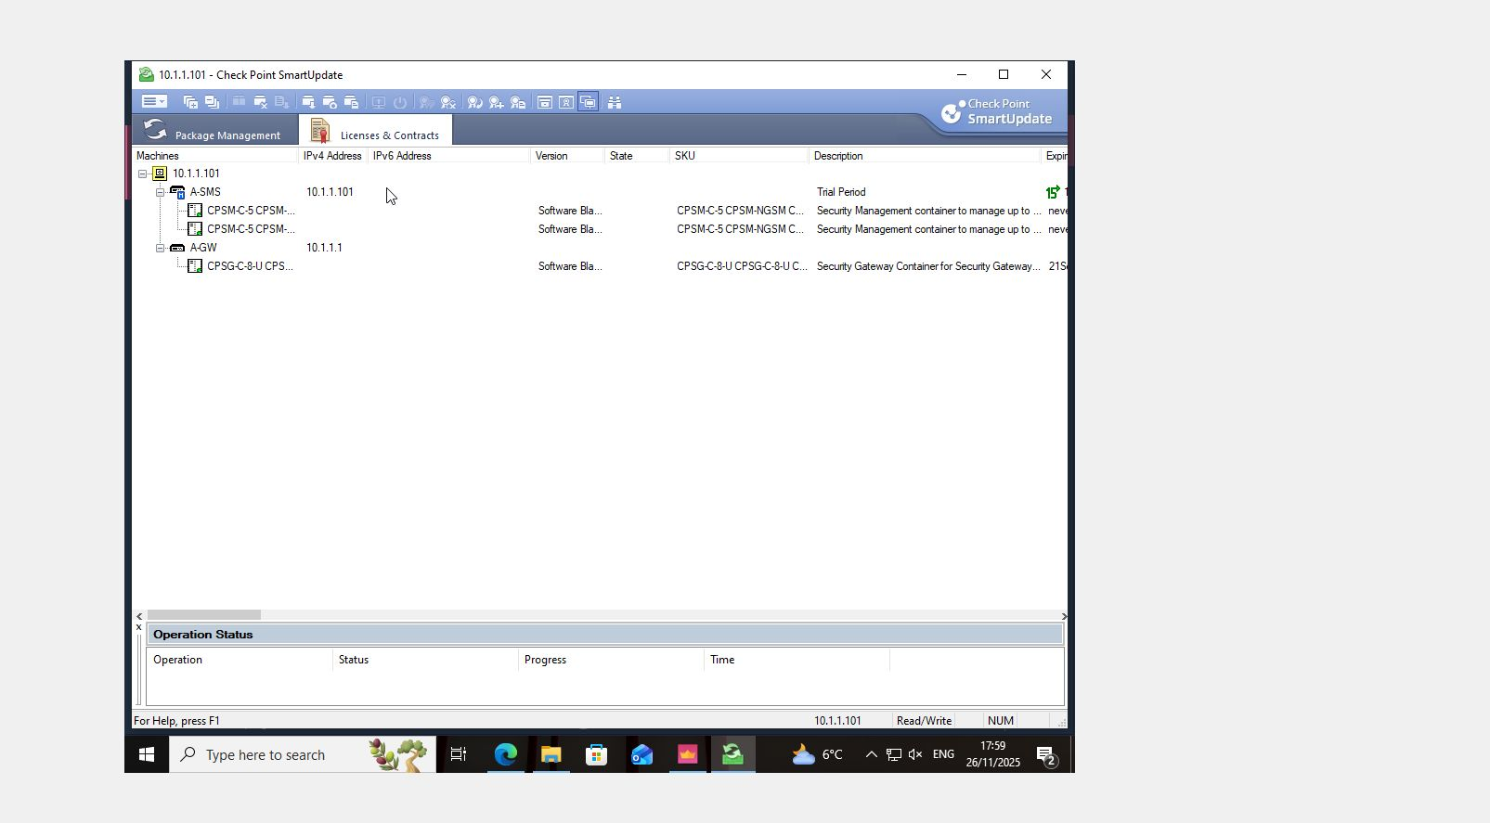
Figure 6: GAIA Terminal-API readiness test with time stamp ("API readiness test SUCCESSFUL")

4. Firewall Policy Design & Implementation

4.1 Rationale Behind Security Policy Design
The firewall policy instituted within the Check Point GAIA environment followed the principle of least privilege in that it allowed traffic on clear and justified business grounds but denied all other traffic automatically. This principle is well known as the greatest foundation of a secure enterprise network due to the fact that it minimizes attack surface and thus lowers chances of both accidental exposure or deliberate exploitation [1],[2].
The policy was constructed bearing in mind the realistic enterprise threat model covering external and internal attacks. External ones include illegal calls by the internet, reconnaissance activity, brute-force attacks to management services, and exploitation of exposed services. Current threat intelligence reports indicate that perimeter-based attacks remain the primary vector for initial access, especially where legacy protocols or overly permissive firewall rules are involved [3]. Internally, the threat model also considers misuse by legitimate users, compromised internal hosts, and lateral movement after initial breach. Insider-related incidents, whether malicious or accidental, are significant contributors to the cause of enterprise security failures [4].
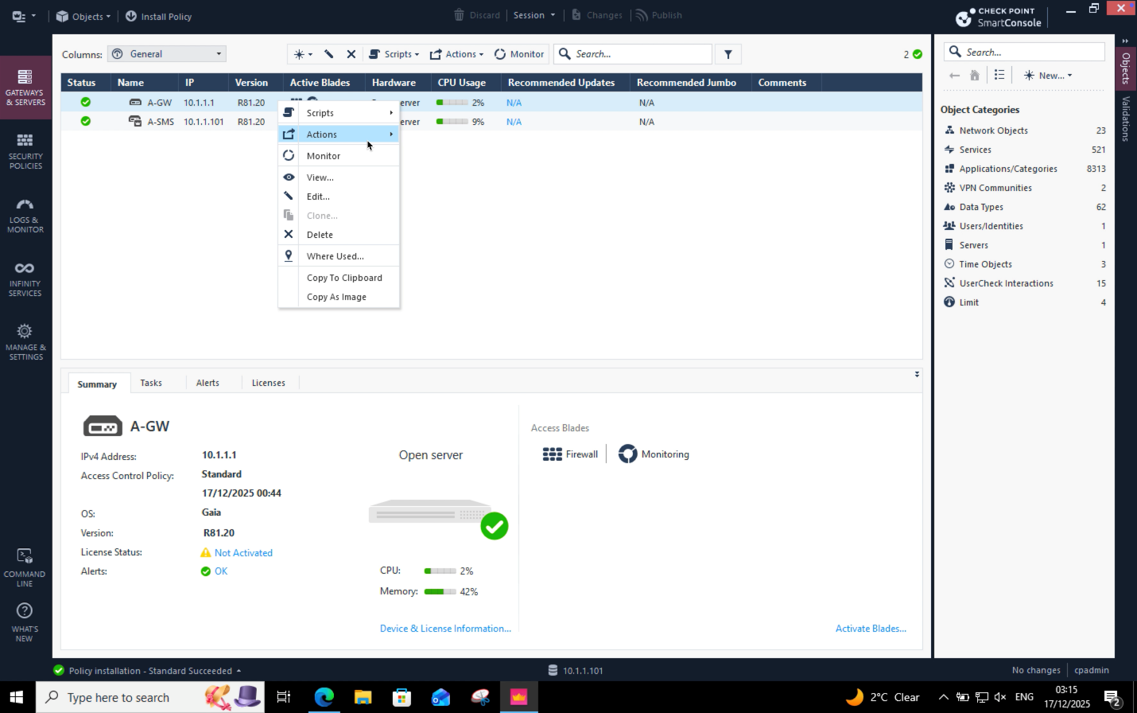
Figure 7: SmartConsole showing active Security Gateway (A-GW) and Security Management Server (A-SMS)
To systematically address these risks, a zone-based policy approach was introduced, which logically categorized various network segments into security zones (external, internal, and management) and control of traffic flows between these zones as well. This improves the whole approach by making it much clearer, more straightforward in terms of policy auditing, and in accordance with best practices as set out by the standards bodies such as NIST and ISO, emphasizing segmentation and controlled trust boundaries, both of which are considered critical defenses against modern attacks [5],[6]. This was made possible by the Check Point Security Gateway (A-GW), which became the central enforcement point for this policy to ensure that inspection and control of consistent traffic proceeds seamlessly across zone boundaries.

4.2 Inbound Traffic Rules
These inbound traffic rules were formed to strictly realize any entry of traffic into the enterprise network from the external or less-trusted zones. Every service allowed was required to be explicitly justified, while any high-risk or unnecessary protocols were blocked outright.
ICMP traffic therefore had to be limited rather than simply being allowed. While ICMP is useful for diagnostic purposes and monitoring, unrestricted ICMP is mostly abused for network reconnaissance and denial-of-service amplification attacks [7]. This policy, therefore, limits ICMP types to those necessary and coming from trusted sources to reach a balance between operational visibility and security.
HTTP and HTTPS were tightly controlled. When they were business critical, only specified destinations and services were permitted access to them, with HTTPS preferred on grounds of its encryption properties. The main instigator behind web application compromise is unrestricted inbound web access, while exposure control at the level of the firewall adds another layer of protection even where application-level controls are provided [8].
FTP traffic was either blocked or heavily restricted due to a lack of encryption and frequent abuse for unauthorized data transfer. Numerous security studies highlight FTP as a high-risk legacy protocol that should be avoided in modern enterprise environments unless there is a compelling operational justification [9].
Telnet was blocked entirely. The communication of credentials and session data in plaintext makes Telnet fundamentally insecure according to modern security standards. Real-world incidents have established a direct link between the continued use of this protocol and credential theft and device compromise [10].
SSH access was allowed solely from explicitly designated administrative sources. If correctly implemented, SSH remains a secure management protocol; however, unrestricted access to SSH dramatically heightens the risk of brute-force attack and unauthorized administrative access. Restricting SSH based on source IP and role follows the principle of least privilege, thereby minimizing the attack surface associated with administrative access [11].
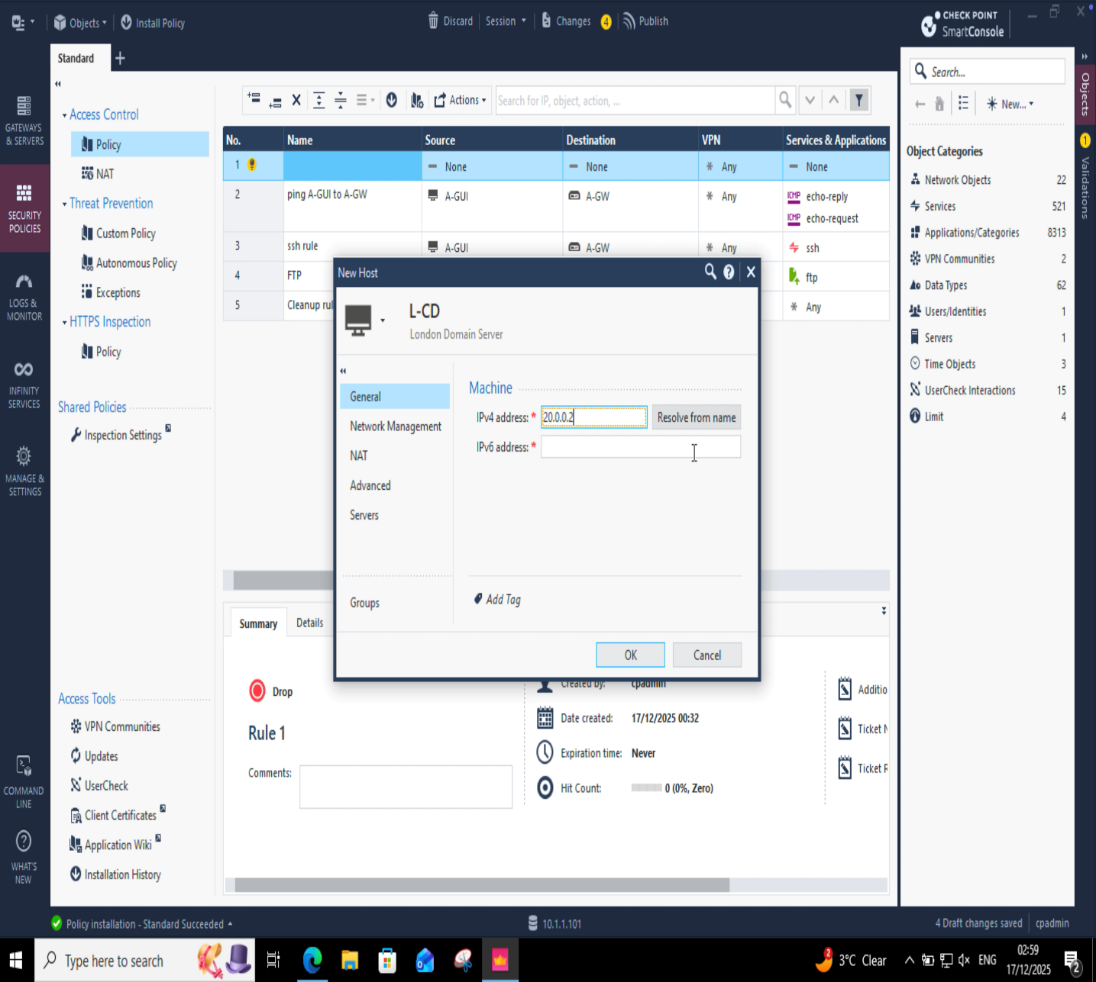
Figure 8: SmartConsole inbound firewall rules enforcing least-privilege access
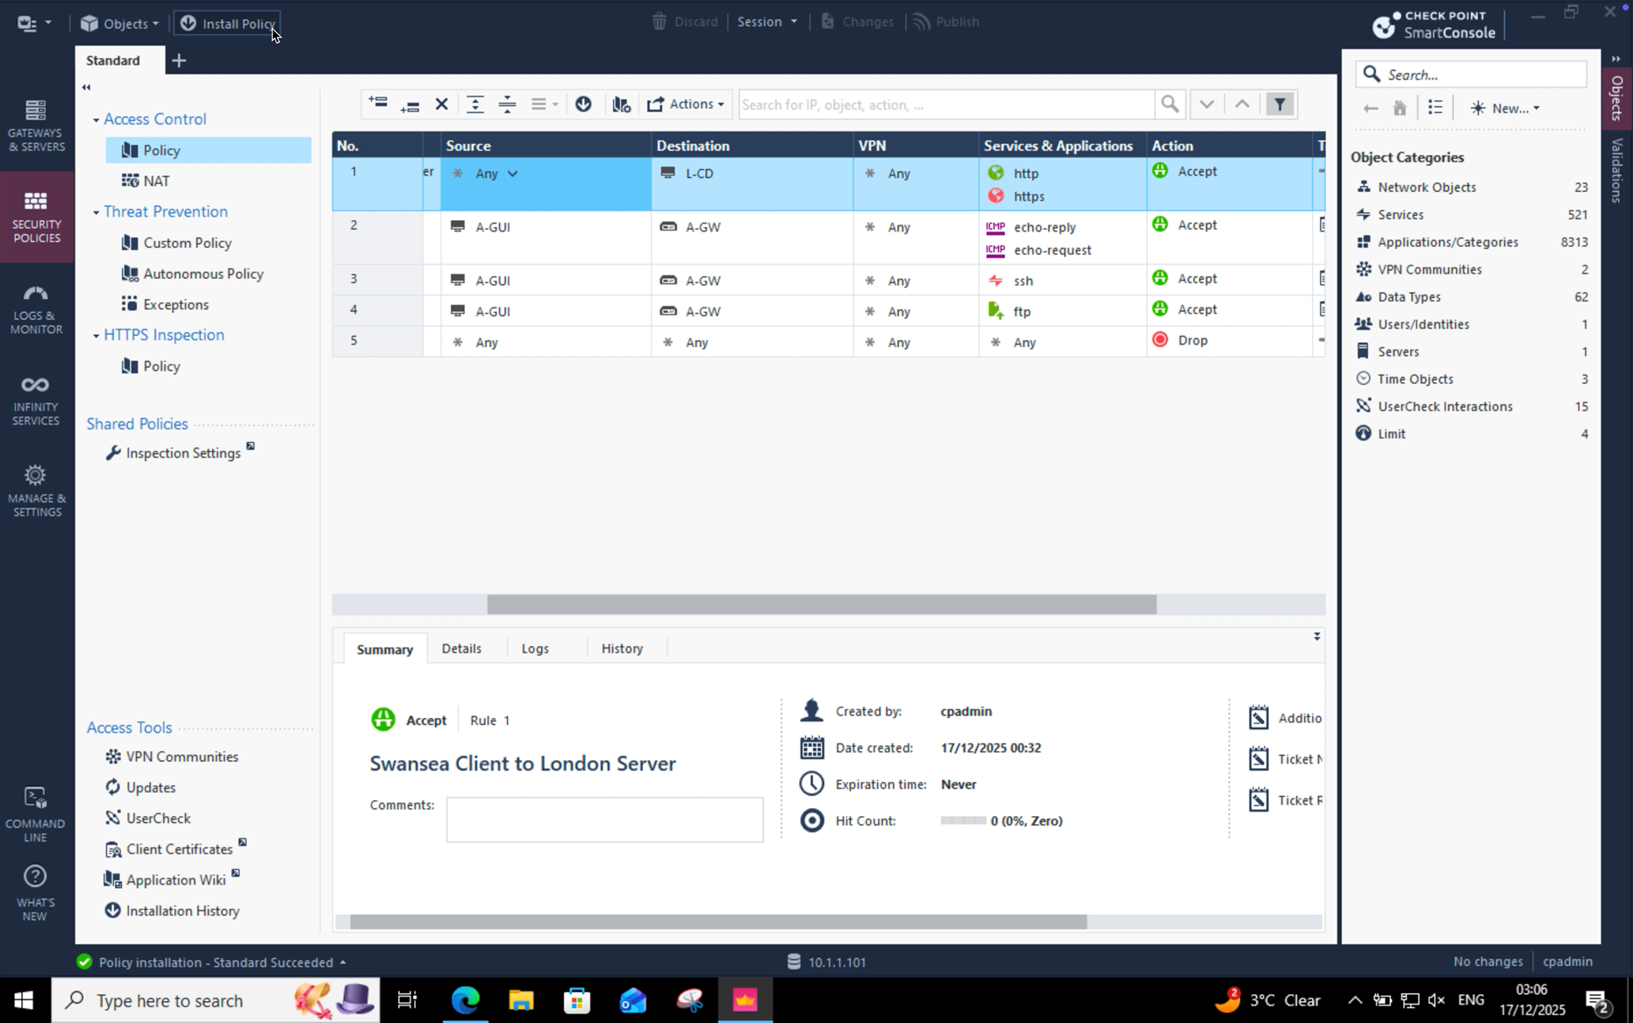
Figure 9: Firewall rule metadata confirming enforcement, ownership, and validation

4.3 Outbound Traffic Rules
Outbound traffic control is often overlooked in the enterprise firewall architecture; nevertheless, research has continuously shown that unrestricted outbound traffic considerably contributes to data exfiltration, malware command-and-control communication, and non-compliance with policies [12]. Here, in this implementation, outbound firewall rules were purposely defined to enforce control of internet access, rather than using a non-restrictive "allow all" model.
Only the selected outbound services were allowed with traffic being logged to provide visibility into the actions of users and systems. Logging outbound traffic is especially critical for the detection of compromised hosts attempting to communicate with external malicious infrastructure, a tactic often noted in advanced persistent threat campaigns [13]. Instituting outbound restrictions at the gateway provides the organization with an additional mechanism of detection and immobilization to complement the endpoint security controls.
Where outbound access was granted, logging was enabled expressly for purposes of traceability and accountability. This approach supports both security monitoring and regulatory compliance, as many standards require organizations to maintain the evidence of network activity and access patterns [6]. This way, the firewall acts not merely as a preventive control but also a source of actionable security intelligence.
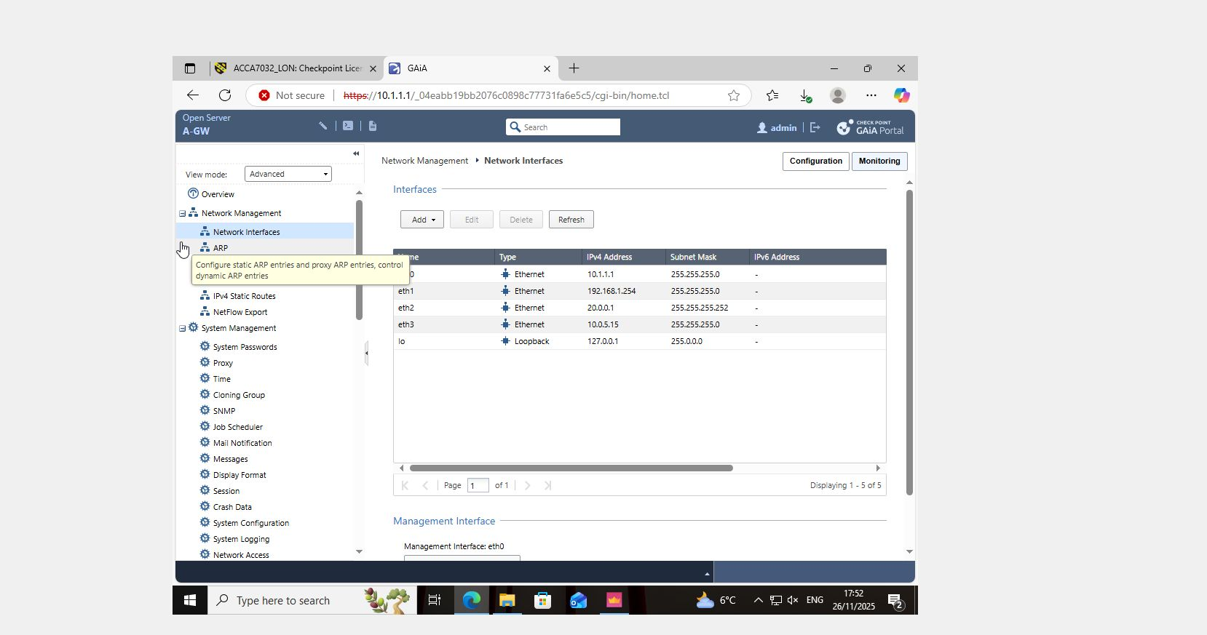
Figure 10: SmartConsole – Firewall Rule Base (Outbound rules)
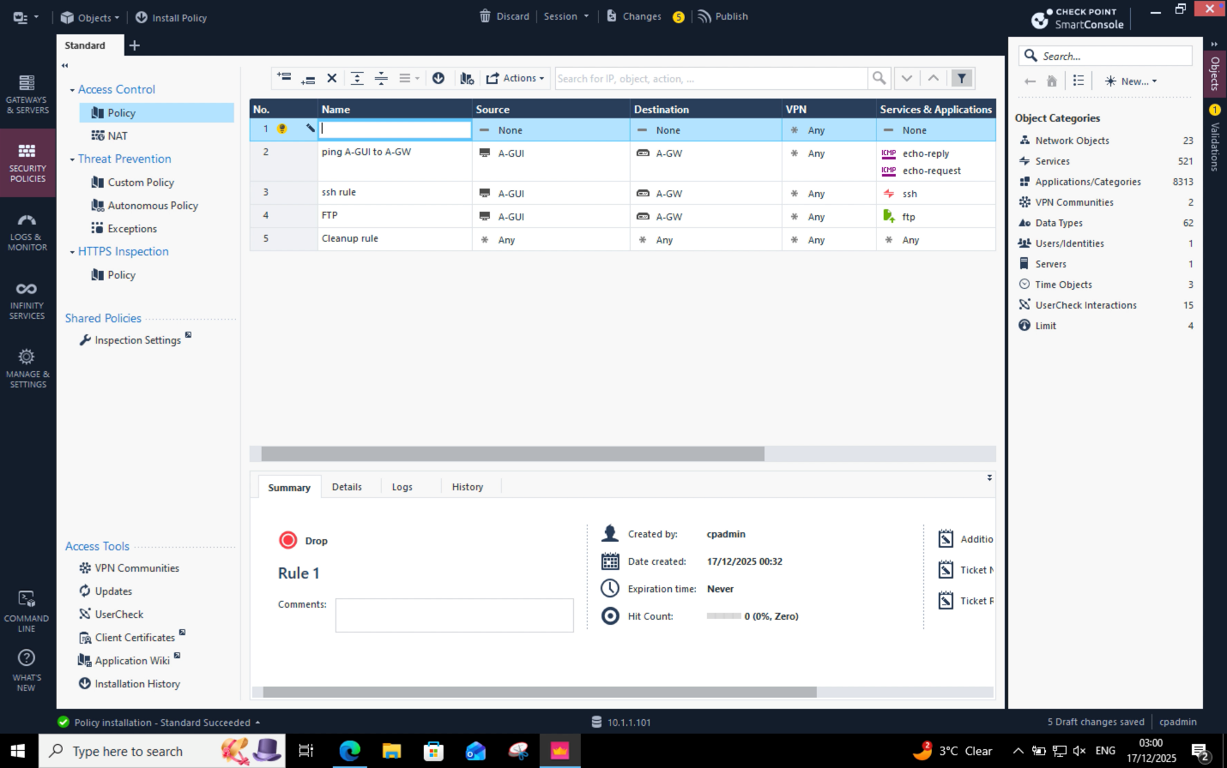
Figure 11: Network object definition for controlled outbound destination (London Domain Server)
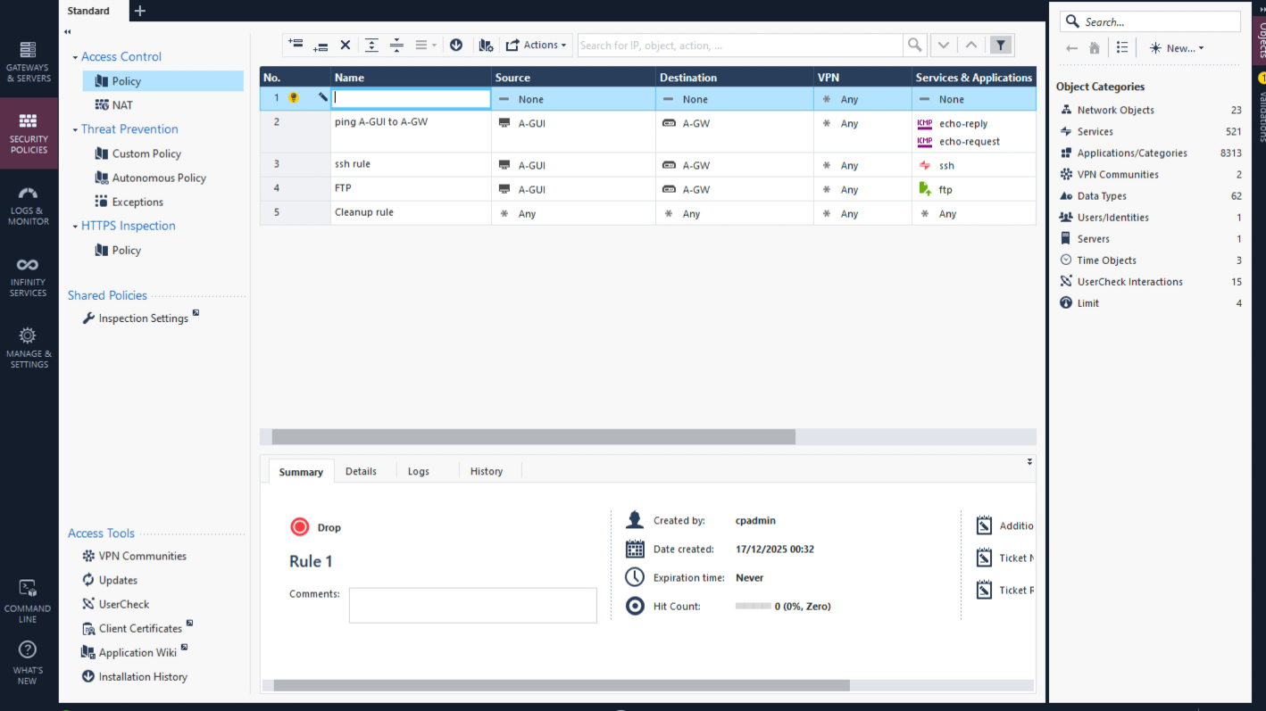
Figure 12: Firewall rule base showing outbound traffic control and default deny cleanup rule

4.4 Logging, Monitoring & Validation
Logging and monitoring are inseparable from effective enforcement of a firewall since security controls that cannot be viewed or audited provide a very limited assurance. The Check Point GAIA environment was configured to generate logs for extensive logging of allowed and denied traffic so that administrators could ascertain rule utility and investigate anomalous behaviour.
The Log review in SmartConsole Logs & Monitor confirmed that the firewall rules were triggered as expected where the visible hits on rules aligned properly with the flow of legitimate traffic. Validation of this verification of rule hits is critical, as its absence or the presence of overly relaxed rules may present a picture of a misconfigured system and ultimately accentuate risks [14]. Continuous monitoring also supports the early detection of breaches to established policies and of newly emerging threats.
From a governance perspective, a robust logging system creates an unassailable audit trail, which in turn can support incident responses, forensic investigations, and compliance reporting. Standards such as ISO/IEC 27001 and NIST are adamant in identifying logging and monitoring as core requirements to achieve effective information security management [5], [6]. By feeding logging into the firewall policy design, this implementation shows evidence of the stakeholder's cognizance that security is a dynamic organization needing continuous vision and validation.
Figure 13: SmartConsole – Logs & Monitor view showing firewall activity
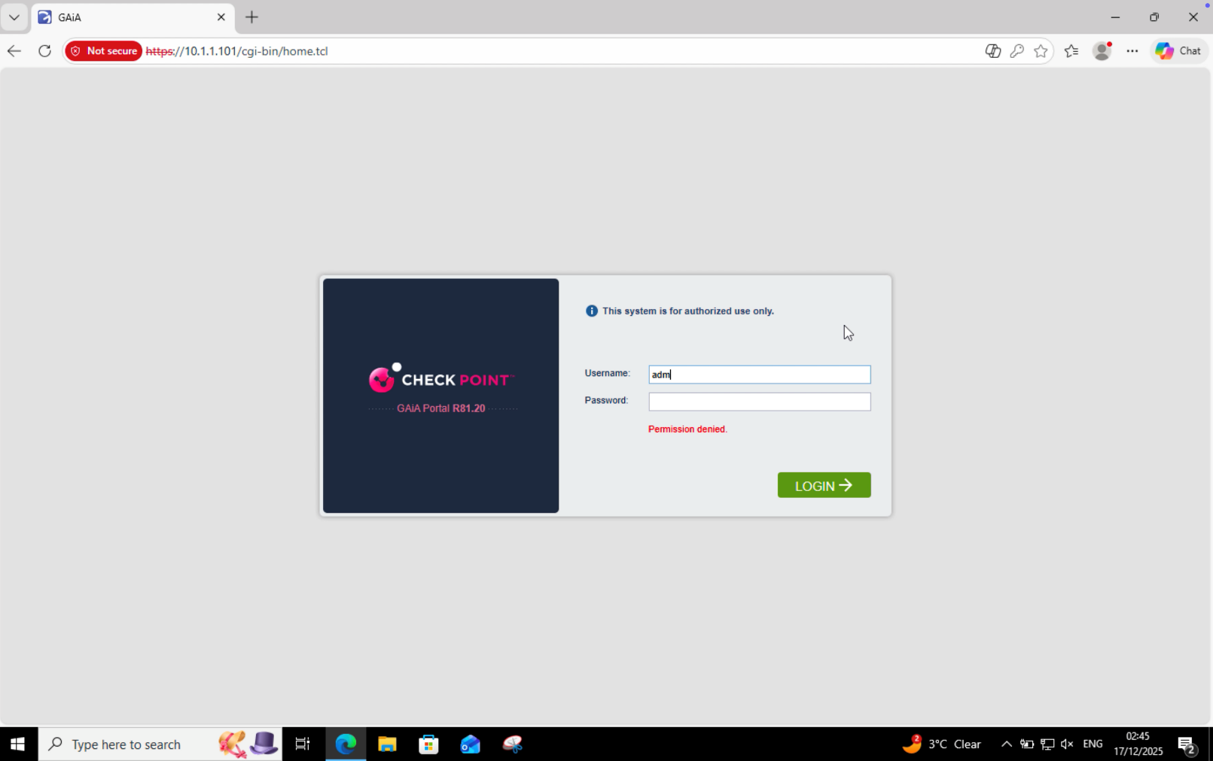
Figure 14: Successful firewall policy installation on the Security Gateway
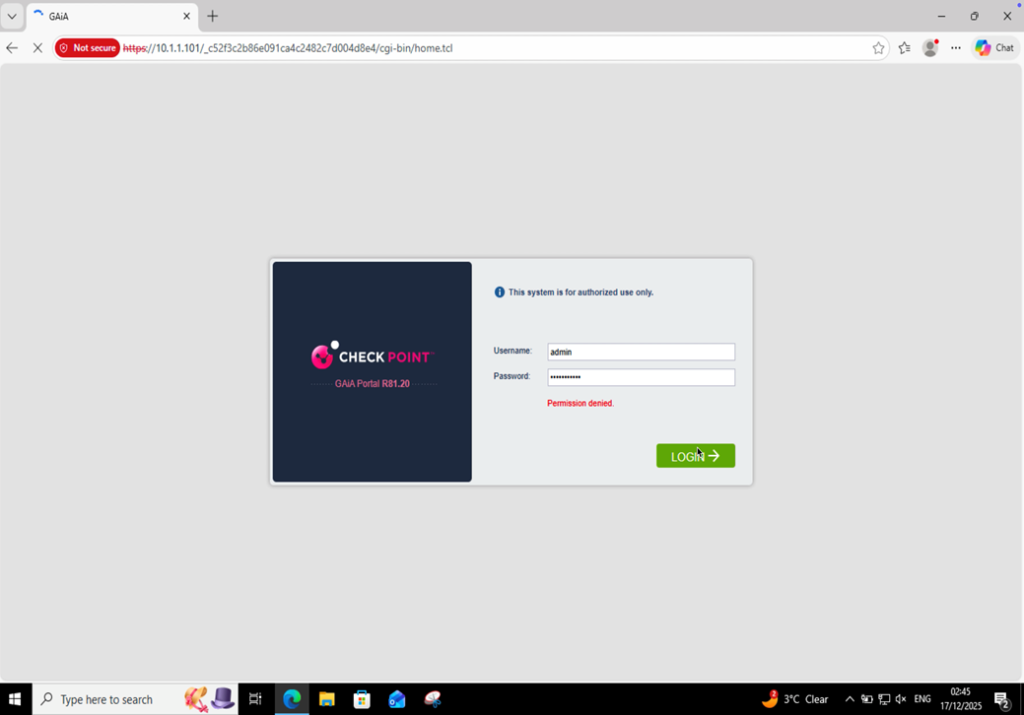
Figure 15: SmartConsole Logs & Monitor view validating firewall rule enforcement

5. Additional Security Features

5.1 Proposed Improvements (Design)
Classic firewall controls are in place for basic protection, whereas the current threat environment in enterprises is calling for security mechanisms that can be layered to detect, prevent, and respond to more complex attacks. Hence, additional security features were recommended and implemented to strengthen the overall defensive posture of the enterprise network. The most widely acceptable defence-in-depth model supports an approach whereby complementary security controls are deployed across several layers instead of depending on a single perimeter defence [1], [2].
An IPS system was proposed as a key improvement to identify and stop well-known techniques for exploiting weaknesses and abuses of protocols as well as any unusual patterns of traffic. Research continuously proves that many successful breaches take advantage of known vulnerabilities for which signatures for defenses already exist, often due to insufficient examination at the network layer [3]. By enabling IPS at the gateway, traffic can continuously be compared with new threat signatures so as to reduce exposure to commodity exploits and automated attack tools all in real-time.
Capability enhancements included the adoption of anti-malware and threat prevention attributes to mitigate cases related to malware delivery mechanisms encased in web traffic, file transfers, and command-and-control communications. Modern malware often gets through the perimeter controls by using encrypted channels, or trusted protocols like HTTPS, thereby making signature-only antivirus insufficient [4]. Thus, the integration of threat prevention at the gateway would allow the early detection of malicious payloads and outbound beaconing attempts before either reaches an internal host or exfiltrates any sensitive data.
Identity Awareness has been implicated as an enhancement to escape from IP-based security controls and move to user and role-based enforcement. Rule exceptions become increasingly hard to manage in enterprise environments with users on the go and devices switching networks constantly: ever fewer static IP-based rules work [5]. Identity Awareness allows policies to be tied to authenticated users and groups (e.g., administrators, standard users). Thus, it may integrate access control decisions with the organisational role rather than the network topology alone.
Finally, it was suggested to discuss Application Control and URL Filtering in terms of questions dealing with successful non-business web use, shadow IT, and access to harmful or inappropriate content. Irrespective of the industry guidance that completely uncontrolled application and web usage are major contributors to data leakage and malware infections [6], by application type and URL category, it was possible for the organisation to enforce acceptable-use policies but to still allow business-necessary flexibility.

5.2 Implementation using GAIA appliances
With the proposed security improvement, Check Point GAIA appliances were utilized, essentially utilizing integrated security blades under central management using the Security Management Server (A-SMS). Relevant blades were activated towards the Security Gateway (A-GW) so that advanced inspection capabilities would exercise their functions INLINE with the rest of the firewall enforcement.
Therefore, the IPS blade was activated and configured to govern security using a default protection profile according to Check Point's recommended best practices. This is based on a high confidence signature for prevention as the foremost target of minimal false positives while providing comprehensive protection against common attack scenarios. Those enforcement measures are fully integrated within firewall policy, so that any in the traffic being inspected is also subjected to both access control and threat prevention decisions.
Figure 16: SmartConsole – IPS blade status and protection profile
Traffic for known malicious files and communication patterns was inspected through activation of Threat Prevention / Anti-Malware blade. For cases in which it is applicable, default threat profiles were also applied to balance security effectiveness and performance considerations. By incorporating threat prevention in the gateway, malware interception occurs at the edge of the network and not only at the endpoint, thereby ensuring a layered security strategy [7]. Thus, where applicable or proposed, Identity Awareness was configured to integrate into existing directory services, allowing recognition of users and groups by the gateway. This functionality allows firewall rules to refer to user identities rather than solely IP addresses, thereby enhancing policy granularity and auditability. Identity-based rules were designed to complement existing zone-based controls rather than replacing them, reflecting hybrid approaches that are most typically recommended in enterprise deployments [8].
Application Control and URL Filtering features lie within the policy framework through which access to application-level traffic can be classified and controlled. The arrangement of rules was made consistent to ensure logging alongside existing firewall policies, thereby making it possible for administrators to monitor patterns of application usage and respond to policy violations.
Figure 17: SmartConsole – Security Blades and policy integration view I

5.3 Security Value Addition
The adding of features, in their entirety, tremendously reduces the attack surface of the enterprise that can be exploited and the amount of malicious related traffic pass through the traditional firewall rules. IPS and threat prevention facilities halt attacks at the network layer and minimize the avenues for compromise, even when endpoints have been tampered or misconfigured [9].
These enhancements also provide better visualization in network activity, user behavior, and application consumption. Centralized logging and monitoring allow security teams to detect anomalies, investigate incidents, and demonstrate compliance with organizational and regulatory requirements. Visibility is increasingly recognized as a critical enabler of effective security operations, especially in complex enterprise environments [10].
In an overall strategic picture, the aggregated firewall enforcement, threat prevention, identity awareness, and application control approach increases enterprise resilience. Layering the organization with preventive, detective, and corrective controls has positioned it better to withstanding security incidents, detecting them, and recovering from these incidents. This integrated approach reflects contemporary enterprise security best practices and demonstrates a mature understanding of how defensive technologies operate collectively rather than in isolation.

6. Conclusion
This assessment has shown how the functional enterprise network in the country was converted into a secure, centrally managed, enterprise-aligned security architecture through the implementation of Check Point GAIA appliances. Building on the infrastructure deployed in Part 1, Part 2 sought to address applicable real-world security risks using structured governance, layered controls, and verifiable enforcement mechanisms consistent with contemporary enterprise best practice.
The centralized policy enforcement, consistent application, and better operational visibility were enabled by the connection of Security Gateway (A-GW), Security Management Server (A-SMS), and SmartConsole (A-GUI). Connectivity verification and system readiness checks, including Secure Internal Communication (SIC) and API readiness validation, confirmed that the security platform was not only properly configured but also operationally robust. This checks parameters that ensure reliable management, monitoring, and auditing of security controls according to professional standards.
The firewall policy design applied the principle of least privilege, supported by a realistic enterprise threat model accounting both external attacks and internal misuse. Again, inbound and outbound traffic controls were intentionally restrictive, justified, and logged, demonstrating an understanding that effective security depends as much on visibility and validation as on prevention. Add-on advanced security features—such as IPS, Threat Prevention, Identity Awareness, and Application Control—strengthened the network through minimizing the attack surface, enhancing detection capabilities and improving resilience against evolving threats.
Overall, this implementation reflects a mature, defence-in-depth approach to enterprise network security. Not only is it testament to technical competence, but also critical judgment in aligning security controls with organizational risk; the way in which operations requirements are set out and recognized industry standards are established. Thus, this solution is both demonstration ready and representative of real-life enterprise security practice at Level 7.

References
[1] National Institute of Standards and Technology (NIST), SP 800-53 Rev.5: Security and Privacy Controls for Information Systems and Organizations, NIST, Gaithersburg, MD, USA, 2023.
Available: https://csrc.nist.gov/publications/detail/sp/800-53/rev-5/final
[2] J. H. Saltzer and M. D. Schroeder, “The Protection of Information in Computer Systems,” Proceedings of the IEEE, vol. 63, no. 9, pp. 1278–1308, 1975.
Available: https://ieeexplore.ieee.org/document/1451869
[3] European Union Agency for Cybersecurity (ENISA), ENISA Threat Landscape 2024, ENISA, Athens, Greece, 2024.
Available: https://www.enisa.europa.eu/publications/enisa-threat-landscape-2024
[4] Verizon, 2024 Data Breach Investigations Report (DBIR), Verizon Enterprise, 2024.
Available: https://www.verizon.com/business/resources/reports/dbir
[5] National Institute of Standards and Technology (NIST), SP 800-41 Rev.1: Guidelines on Firewalls and Firewall Policy, NIST, 2023.
Available: https://csrc.nist.gov/publications/detail/sp/800-41/rev-1/final
[6] International Organization for Standardization (ISO/IEC), ISO/IEC 27001:2022 – Information Security Management Systems, ISO, Geneva, Switzerland, 2022.
Available: https://www.iso.org/standard/27001
[7] Check Point Software Technologies, GAIA Administration Guide, Check Point, 2024.
Available: https://sc1.checkpoint.com/documents/R81/WebAdminGuides/EN/CP_R81_Gaia_AdminGuide
[8] MITRE Corporation, MITRE ATT&CK® Framework – Lateral Movement Techniques, MITRE, 2024.
Available: https://attack.mitre.org/tactics/TA0008/
[9] S. Northcutt, Enterprise Network Security, 3rd ed., Pearson Education, 2021.
[10] Check Point Software Technologies, Security Management Administration Guide, Check Point, 2024.
Available: https://sc1.checkpoint.com/documents/R81/WebAdminGuides/EN/CP_R81_SecurityManagement_AdminGuide
[11] Gartner, Market Guide for Network Firewalls, Gartner Research, 2024.
Available: https://www.gartner.com/en/documents/
[12] OWASP Foundation, OWASP Top 10 – Web Application Security Risks, OWASP, 2023.
Available: https://owasp.org/www-project-top-ten/
[13] Mandiant, M-Trends 2024: Insights into Today’s Threat Landscape, Mandiant, 2024.
Available: https://www.mandiant.com/resources/m-trends
[14] National Institute of Standards and Technology (NIST), SP 800-207: Zero Trust Architecture, NIST, 2022.
Available: https://csrc.nist.gov/publications/detail/sp/800-207/final
[15] CERT Coordination Center, ICMP Attacks and Mitigation Strategies, CERT, 2023.
Available: https://www.sei.cmu.edu/our-work/cert/
[16] Behl, A., Cybersecurity and Cyberwar: What Everyone Needs to Know, Oxford University Press, 2020.
Appendix


