Alexandra Livia Kondra CRN:47028843029


HOTEL TRINITY
Always for your service!!!


MENU


SALADS
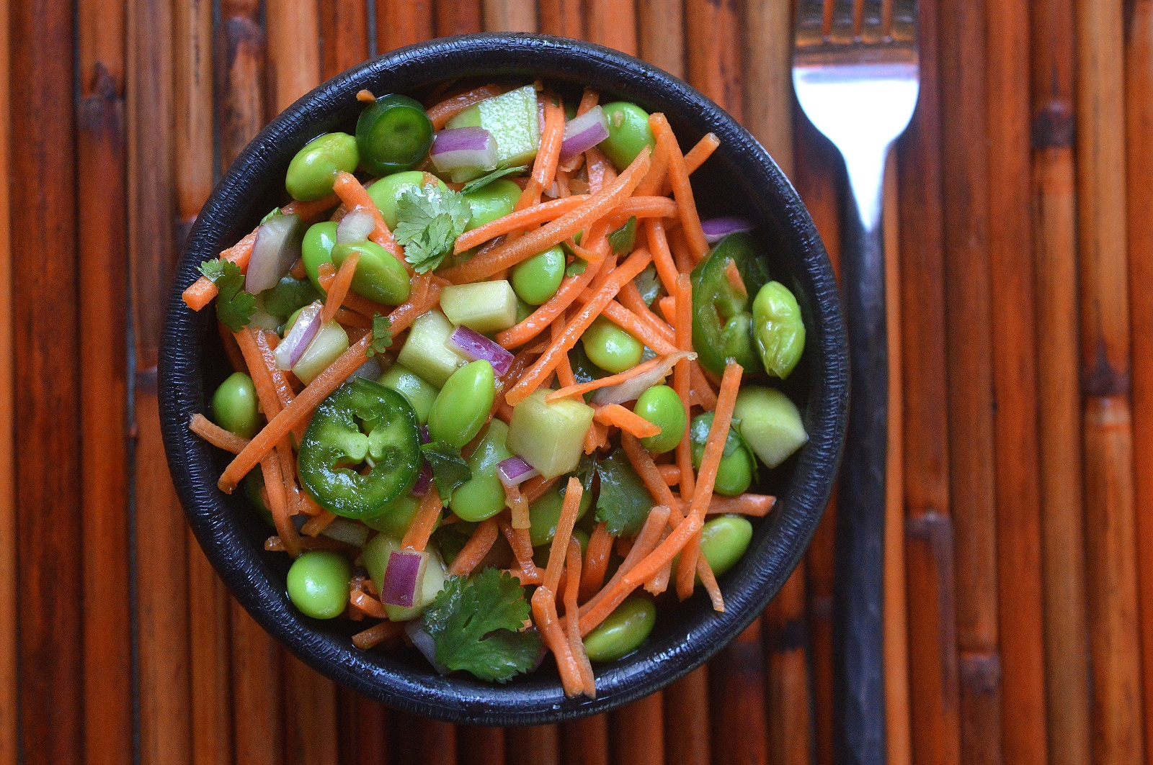Edamame £ 2.5
Springled with spring onion and sea salt.
140kcal per serving

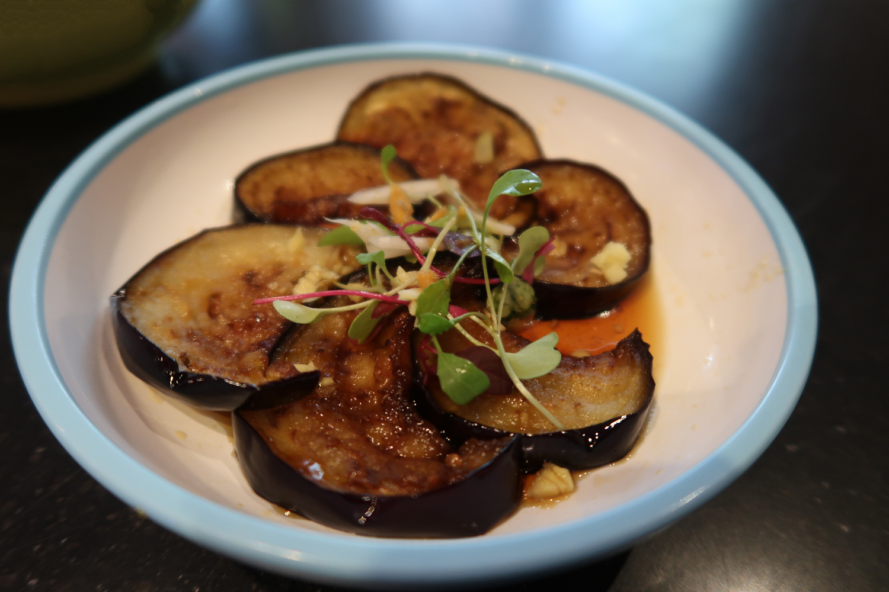Harusame aubergine salad £ 3.5
Fried aubergine with ginger, sesame and garlic
110 kcal per serving

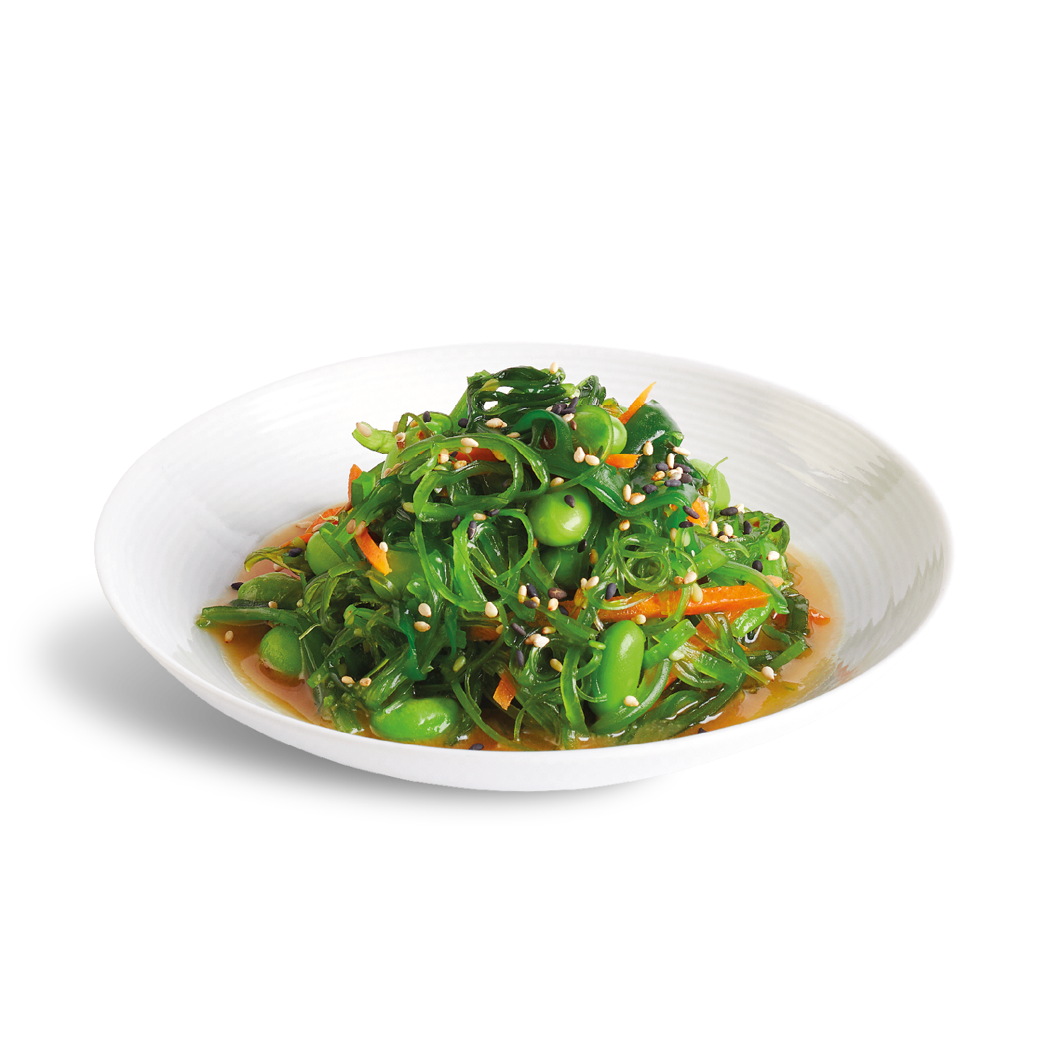
Kaiso Seeweed £ 3.5

Marinated mixed seeweed and carrot in sumiso dressing
180kcal per serving
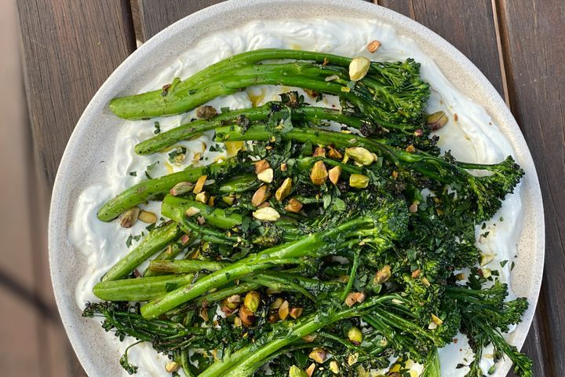
Tendersteam and sesame £ 3.5
Brocolli served on a rich sesame
140 kcal per serving
Our products might contain EGGS, WHEAT, NUTS, MILK, FISH, and SOY. For any kind of allergies, please inform our service head.

Non-Veg Starters
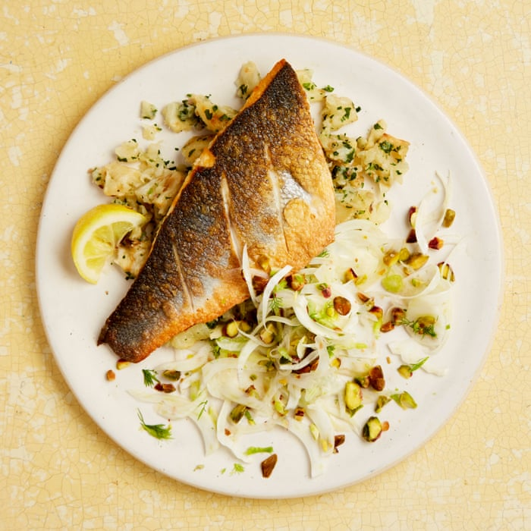
Spicy Fish £10.00
Fish marinated in spiced batter and vegetable mixed.
143kcal in 100 gram serving

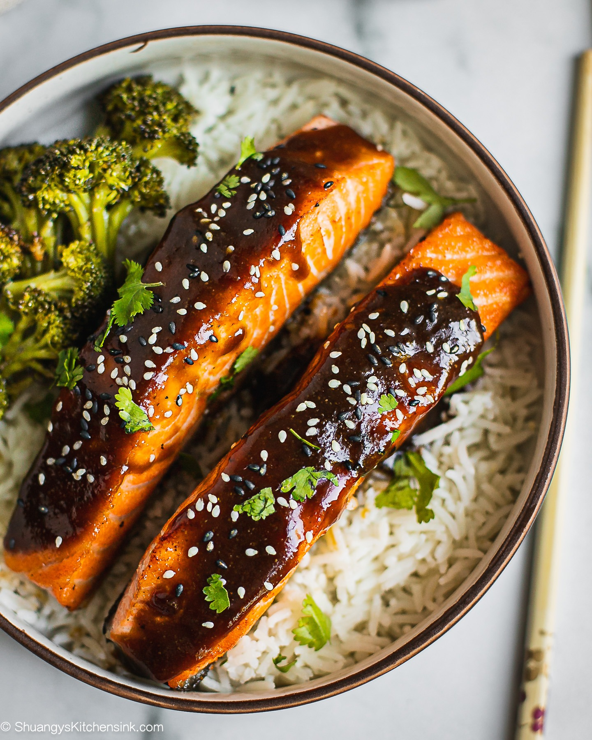
Salmon Tiryaki £ 7.00
Salmon tiryaki served with rice.
174kcal in 1 piece serving
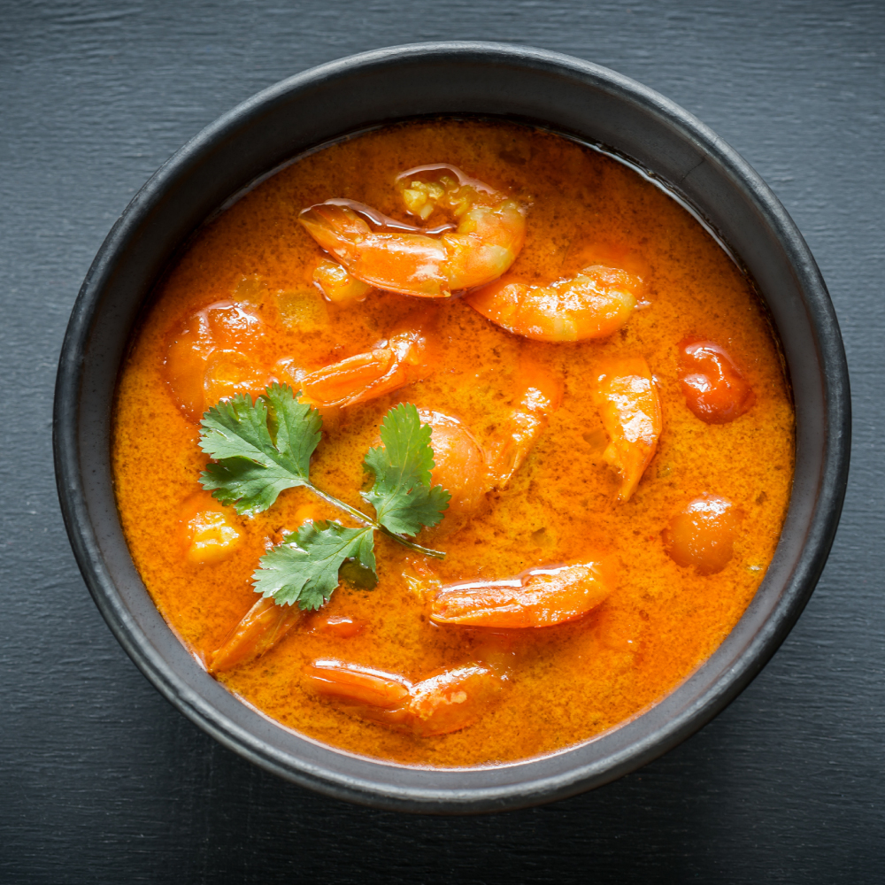
Prawn Red Curry £ 8.00
Served with rice and pumpkin as a veggie.
101kcal per 100gram serving

Curry
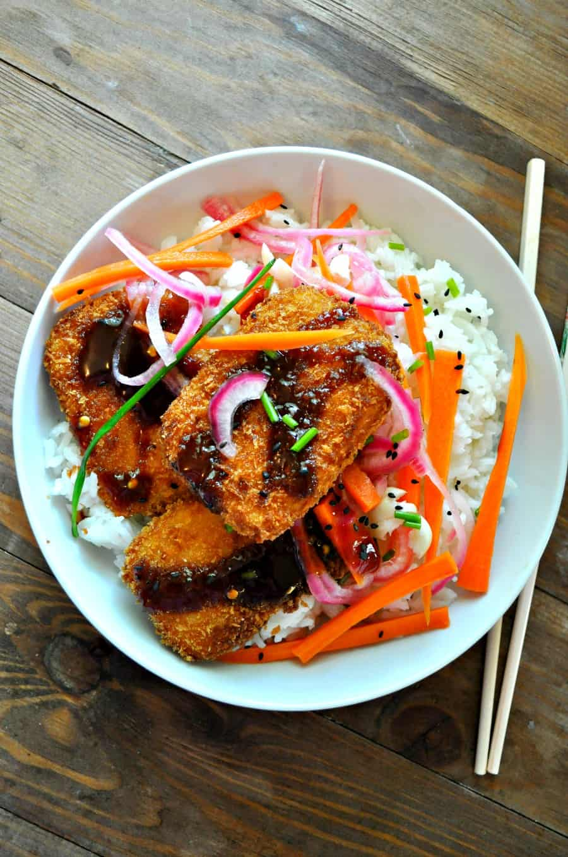
Tofu Katsu Curry £ 4.55
Crispy tofu with mild curry sauce, spring onion and steamed rice
465 kcal per serving
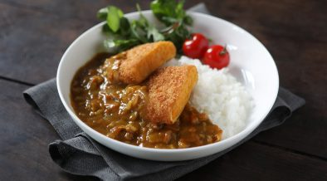
Pumpkin Katsu Curry £ 4.55
Natural Japanese pumpkin with mild curry sauce, steamed rice and spring onion.
420 kcal per serving
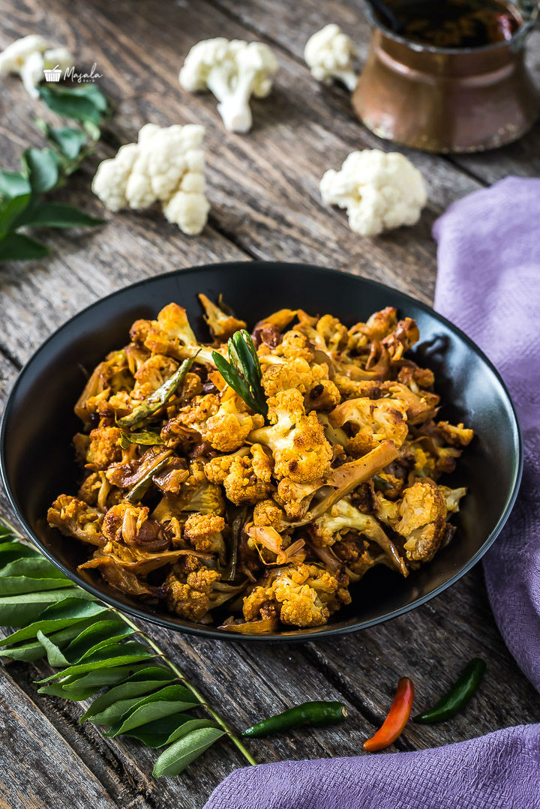
Spicy pepper cauliflower £ 4.50
Cauliflower marinated in spice and crispy fried.
155 kcal per serving

Tofu Katsu £ 4.50
Crispy tofu drizzled with tonkatsu sauce
155 Kcal per serving
We are open from morning 5 am to 11pm.

STAY AWARE, STAY SAFE!!!
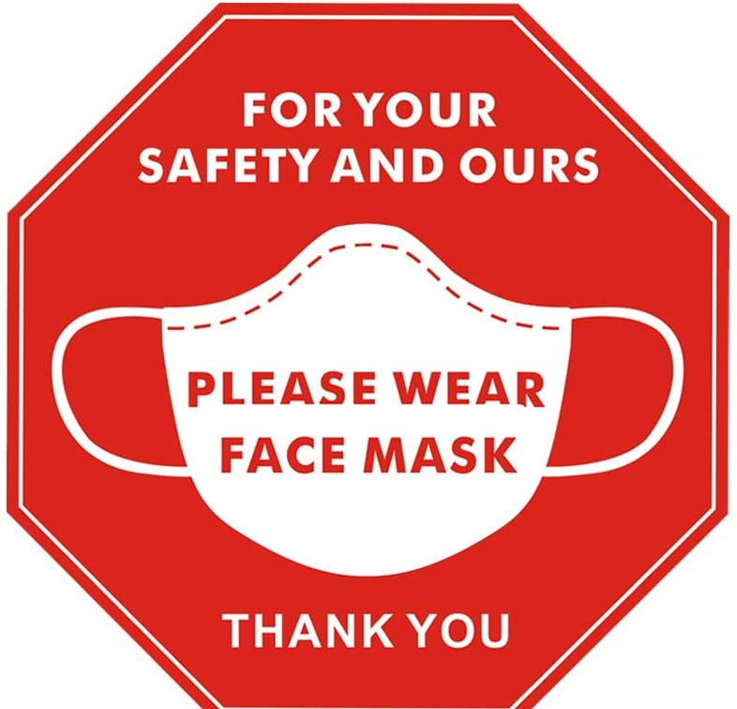

Beverages
SOFT DRINKS
Coca-Cola 330ml £2.95
Diet Coke 330ml £2.85
Sprite 330ml £2.85
Rose Lemonade £2.95
Victorian Lemonade £2.95
BEERS & CIDERS
Birra Moretti £5.55
Peroni ABV 330ml £4.45
Corona 330ml £3.95
Cider 500ml £4.95
Champagne (125ml) with salted dips £16.0
Sauvignon Blanc with Tart Sauces £30.0
Chardonnay with Fatty Fish £25.00

HOT DRINKS
COFFEE
Americano £2.45
Cappucino £2.50
Latte £2.50
Expresso £1.70
Hot Chocolate £ 2.85

ORDER YOUR FOOD NOW!!!
PAY US WITH OUR QR CODE
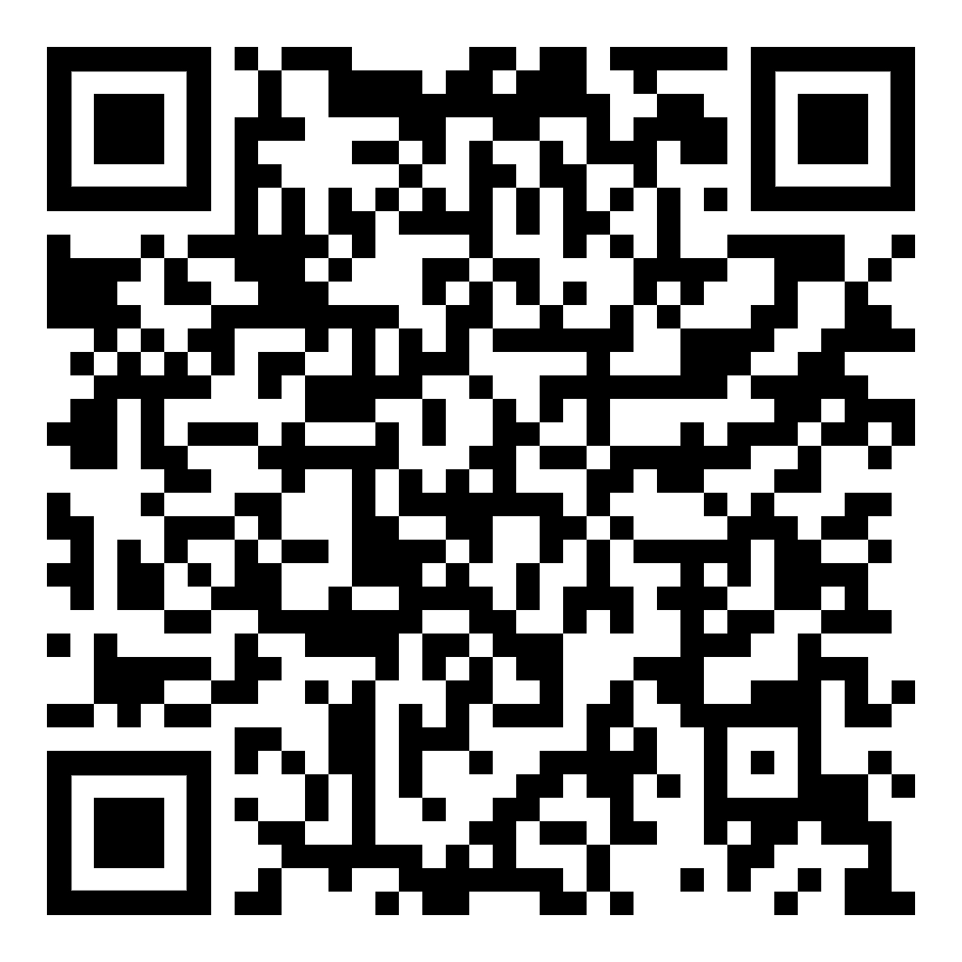


HOTEL TRINITY
SWANSEA, SOUTH WALES



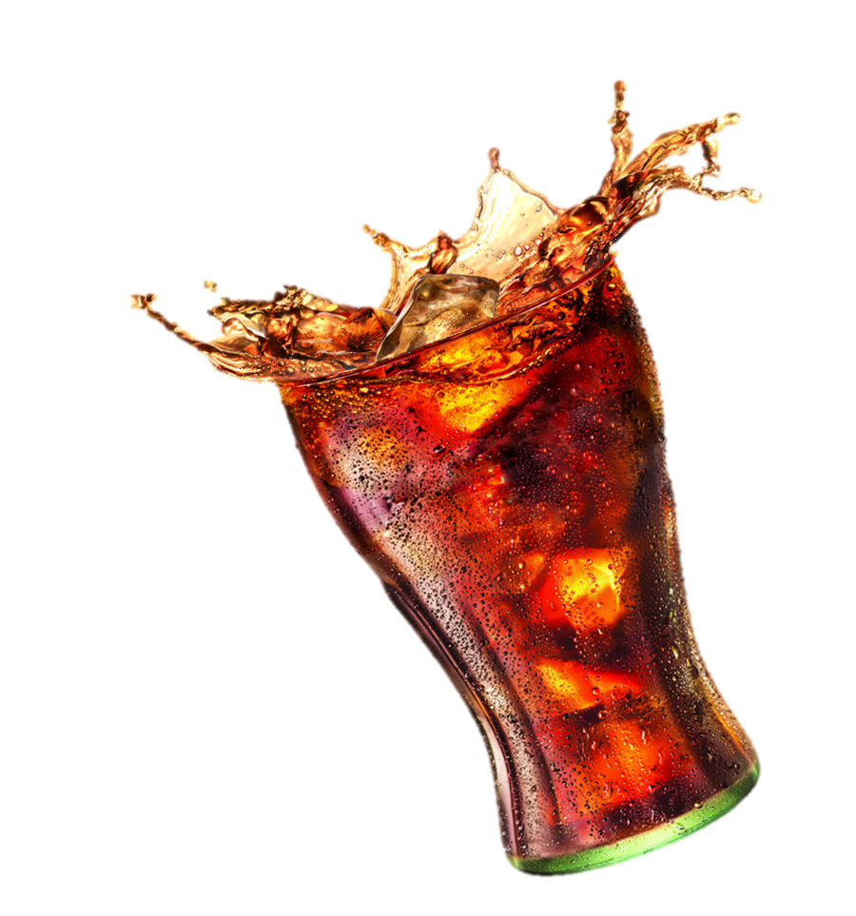


References

Fast Food Menu Prices. (2021). United Kingdom Fast Food Menus - Fast Food Menu Prices. [online] Available at: https://www.fastfoodmenuprices.com/uk/ [Accessed 23 Feb. 2022].
Nations, U. (2022). Social media posters | United Nations. [online] United Nations. Available at: https://www.un.org/en/coronavirus/social-media-posters [Accessed 23 Feb. 2022].
‌

‌

