

Module Name: Digital Skills for Personal and Professional Growth
Module Code: BMSW 4008
Assignment Name: E-Portfolio
Student Name: Sanda-Ionela Vica
Student Number: 2410012
Lecturer: Phillipa Fitzgerald
Deadline: Friday 20th June 2025
Word count:

Task 1: Questionnaire Analysis and the design of the website and marketing materials
Introduction
This E-Portfolio task gave me the chance to develop a business idea that is close to my goals – a chair rental salon for self-employed hairdressers called Royal Chair Studio. I used real data from a questionnaire to shape the business strategy, design a website using Wix, and create flyers on Canva. Along the way, I improved my skills in market research, digital tools, customer thinking, and search engine optimisation (SEO). This helped me connect what I learn in class with real-life situations.

Questionnaire Analysis
I created a 10 - question survey using Google Forms and shared it with 10 people in the beauty industry. The answers gave me clear ideas about what hairdressers want from a chair rental salon.
One major finding was that many people value independence and flexibility. In fact, 66% of respondents said they want to “be their own boss” and work on their own schedule. This confirmed that my business should focus on giving freelancers control over their time and space. Byrd (2021) explains that “digital platforms support the development of entrepreneurial confidence and independence by allowing individuals to control their work environments.” That’s why I used the slogan “Your Chair. Your Craft. Your Crown.” on the flyer – a phrase that reflects ownership, skill and pride.
Another strong theme was the importance of affordable pricing. Most people (90%) said they want chair rental to cost less than £150 per week, and 40% preferred prices under £100. Based on this, I added flexible plans: daily, weekly, monthly, and promotions and discounts when renting per year. Dadwal (2020) highlights that “pricing models must reflect customer expectations for control and value.” I made sure all pricing options were clearly shown on the website to help build trust.
The responses also showed that many stylists worry about finding enough clients. Even though they want freedom, 30% of participants said they were concerned about low visibility. Soltanifar, Hughes and Gocke (2021) note that “independent professionals need digital exposure to survive in saturated markets.” So, I included support like Instagram features, online promotions, to help them grow their client-base.
Finally, I learned the most hairdressers want part-time consistency – not just the option to drop in one or twice. A large group (44,4%) preferred working 3-4 days a week, and 33,3 % wanted 5-6 days. Very few wanted only 1-2 days. Pinto and Guarda (2020) explain that “successful service platforms adjust to the real routines of users.” That’s why my salon is open 7 days a week and offers flexible booking based on the renter’s preferred schedule.

Website development, Flyer and SEO strategy

I designed the website for Royal Chair Studio using Wix, with the goal of creating a modern, professional, and user-friendly platform for independent hairdressers. The visual style was based on my survey findings, which showed that potential clients value flexibility, clear pricing, and professionalism. Sandhu (2020) emphasises that digital transformation tools like Wix allow small businesses to innovate quickly and meet evolving customer needs, which made it the right platform for my project.
The home page features warm beige- gold background, chosen to give the site an elegant and welcoming look.
The top section includes the slogan “Let Your Natural Beauty Shine” and a button prompting visitors to “Apply to Rent a Chair.”
The navigation menu allows users to easily access pages like Services, Rent Your Chair, Pricing Plans and Contact
The services page explains the business offer: fully equipped salon chairs for rent in a supportive, drama free environment. This section includes a personal message from me as the owner, introducing the vision behind the studio and how it supports freelancers in growing their brand.
The pricing section presents tree flexible rental plans:
Daily plan: £40
Weekly plan: £149
Monthly plan: £499
Each plan includes what’s provided (towels, backwash, Wi-Fi and short descriptions to help renters choose what suits them best.
The website also includes client testimonials, such as such as from Leanne R., who said that renting at Royal Chair Studio gave her independence and online visibility. Her comment highlights the value of being listed on the site, which helps stylists get discovered and booked directly.
The Connect with Us section links to the Instagram page (@RoyalChairStudio) and shows real salon images. This makes the brand feel authentic and current. There’s also a “Meet the Team” area and contact details with working hours, email, WhatsApp number and Google Maps integration.
Visitors are guided with consistent call-to-action buttons like “Make an Appointment”,
“Explore Plans” and “Select” on pricing cards, making the journey easy and clear.
As Reedy and Parker (2017) suggest, effective digital communication must be consistent and meet user needs – so I designed the site with clean fonts, balanced colour choices and a smooth mobile experience in mind.
I applied basic SEO techniques to improve the site’s visibility on search engines:
- Added keywords like “chair rental Cardiff “and “freelance hairdressers salon”
- Wrote short meta-descriptions for each page
- Used all-text on all photos (flyer, chairs, salon space)
- Named pages clearly (ex: Home, Services, Pricing) for better crawling by search engines.
- Used heading tags (H1, H2) for structure and readability.

I used Canva to create to create a flyer for Royal Chair Studio. 60% of my survey responses said they wanted the salon to feel professional and easy to trust. Canva helped me design a good-looking flyer even though I don’t have graphic design experience. Research shows that consistent design and clear branding help businesses build trust and long-term value for customers. (Kumar and Reinartz, 2016) That’s why I used the same colours, fonts, and messaging across both the flyer and website to keep everything professional and easy to understand.
The flyer includes:
Slogan: “Your Chair. Your Craft. Your Crown.”
Services: Wi-Fi, towels, backwash, flexible rental terms
Contact details: phone, email.
Motivational line: “Step into Succes”
As Burgess, Marwick and Poell (2018) explain “visual identity builds trust and encourages engagement when the message is clear and consistent.” I made sure the flyer matched the style of the website, using the same fonts and colours.

I also made sure the images were compressed to avoid slow loading times. According to Chaffey and Ellis-Chadwick (2019), both content and technical aspects of SEO matter for online performance. I now understand that designing for search engines is just as important as designing for people.
The site also offers free marketing for hairdressers who rent a chair. They get featured on the website and on our Instagram page, which helps them attract new clients. This added service was inspired by feedback from the questionnaire, where 30% said they worry about client visibility.
The online promotion section is clearly explained across the website to build trust and support renter success.
This project helped me grow as a future business owner. I learned to use tools like Wix, google Forms and Canva. I also understand how research can help you make better decisions – like choosing prices and services. Most of all I learned how to think like a customer. Ng (2012) says, “students gain confidence when digital skills are applied in in a practical and creative context.” I felt that. Delivering the final designs helped me apply my digital skills practically and strengthened my business confidence.

References
Burgess, J., Marwick, A.E. and Poell, T. (2018) The SAGE Handbook of social media. London: SAGE Publications. Available at: https://doi.org/10.4135/9781473984066
Byrd, L.S. (ed.) (2021) Cultivating Entrepreneurial Changemakers Through Digital Media Education. Hershey, PA: IGI Global. Available at: https://doi.org/10.4018/978-1-7998-5808-9
Chaffey, D. and Ellis-Chadwick, F. (2019) Digital Marketing. 7th edn. Harlow: Pearson Education.
Dadwal, S.S. (ed.) (2020) Handbook of Research on Innovations in Technology and Marketing for the Connected Consumer. Hershey, PA: IGI Global. Available at: https://doi.org/10.4018/978-1-7998-0131-3
Kumar, V. and Reinartz, W. (2016) “Creating enduring customer value”, Journal of Marketing, 80(6), pp.36-68. https://doi.org/10.1509/jm.15.0414
NG, W. (2012) “Can we teach digital natives’ digital literacy?”, Computers &Education, 59(3), pp.1065-1078. Available at: https://doi.org/10.1016/j.compedu.2012.04.016
Pinto, F.M. and Guarda, T. (EDS.) (2020) Digital Marketing Strategies and Models for Competitive Business. Hershey, PA: IGI Global. Available at: https://doi.org/10.4018/978-1-7998-2963-8
Reedy, K. and Parker, J. (eds.) (2017) Digital literacy Unpacked. London: Facet Publishing.
Sandhu, H. (ed.) (2020) Digital Transformation and Innovative Services for Business and Learning. Hershey, PA: IGI Global. Available at: https://doi.org/10.4018/978-1-7998-5175-2
Soltanifar, M., Hughes, M. and Gocke, L. (2021) Digital Entrepreneurship. Cham:
Springer. Available at: https://doi.org/10.1007/978-3-030-53914-6

Website link:
https://royalchairstudio.wixsite.com/chair-rental-hair-sa

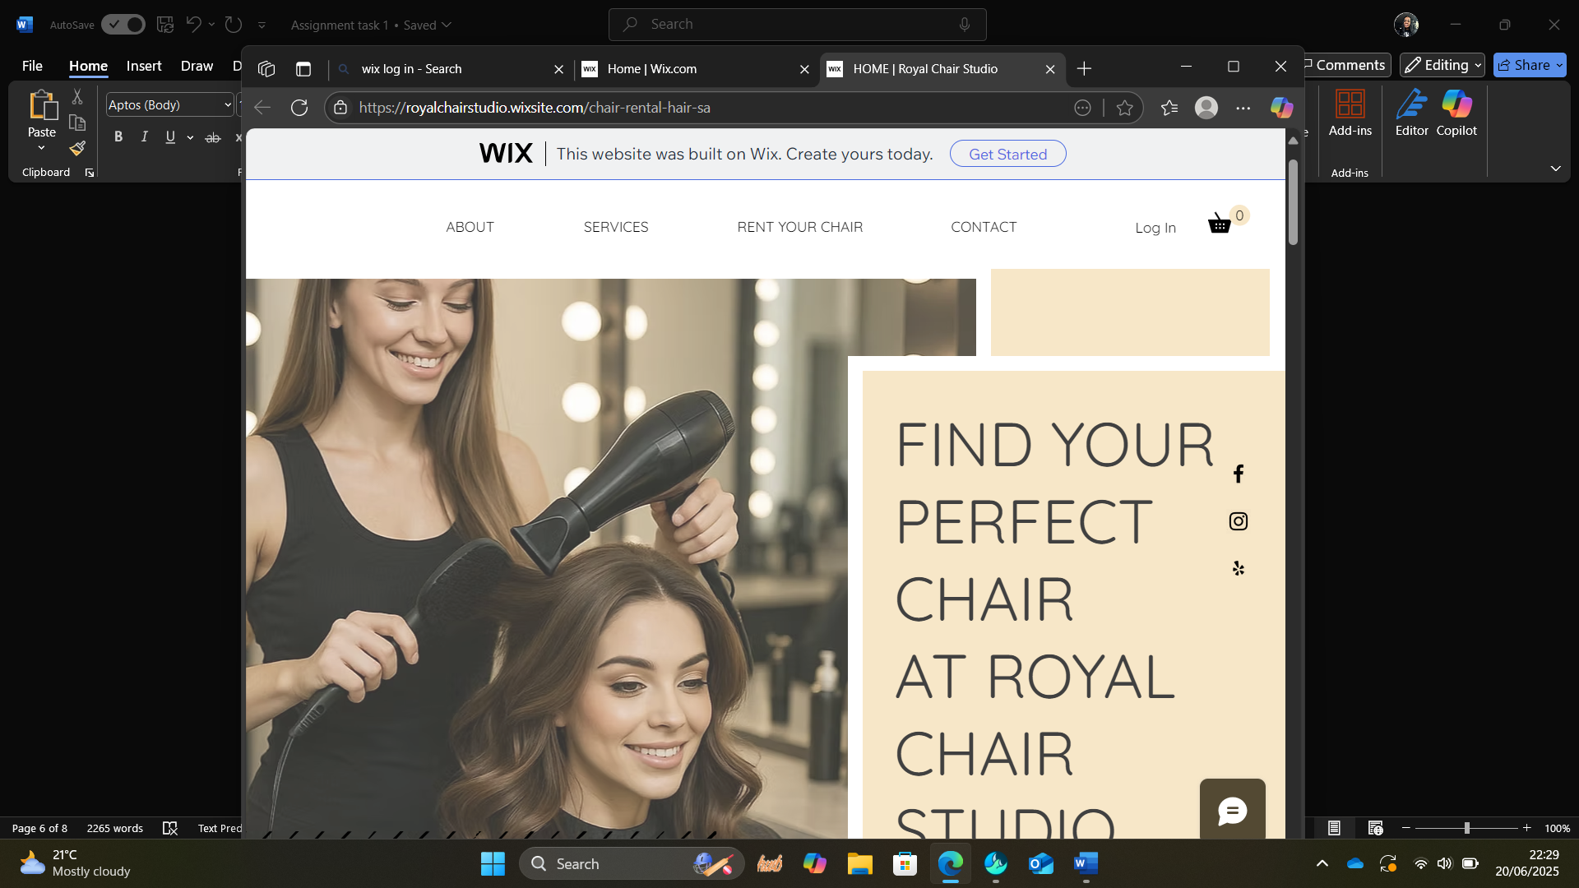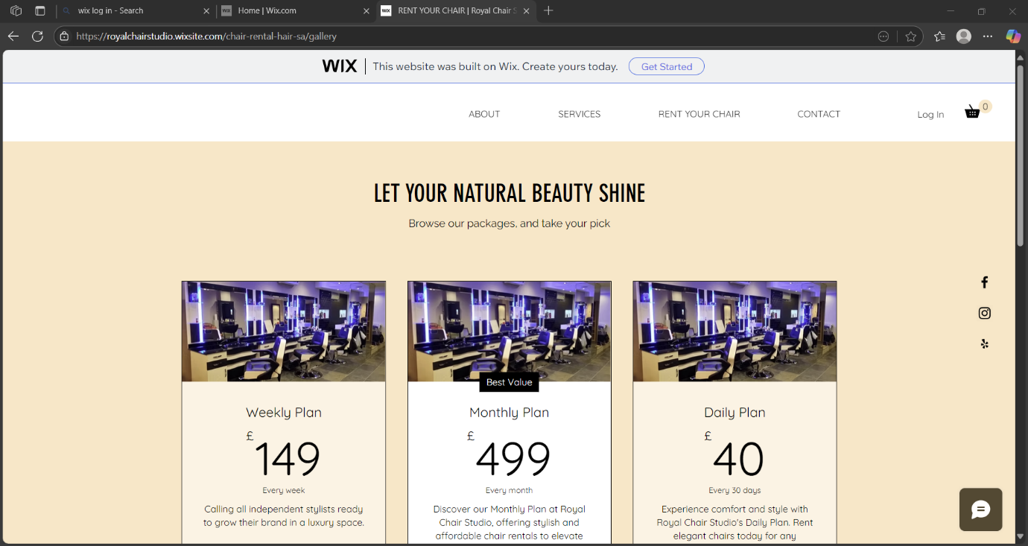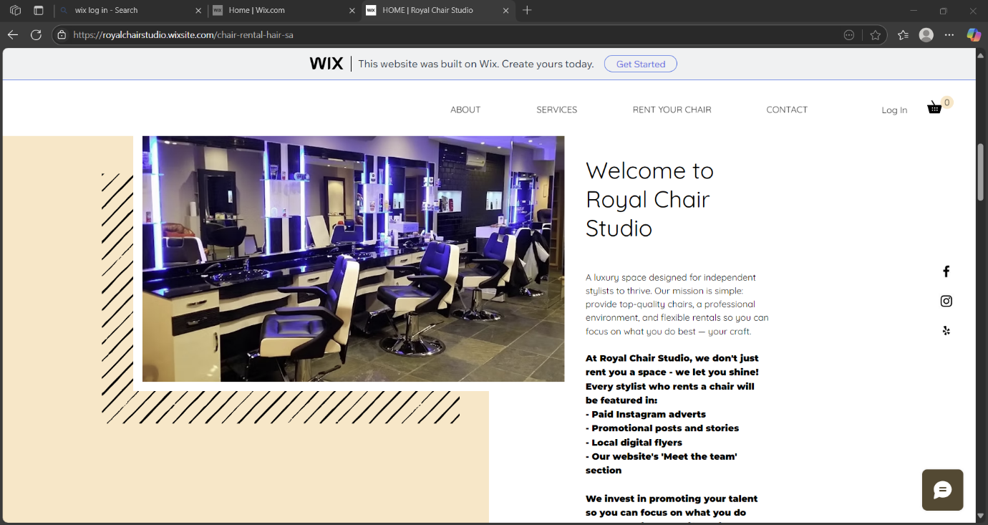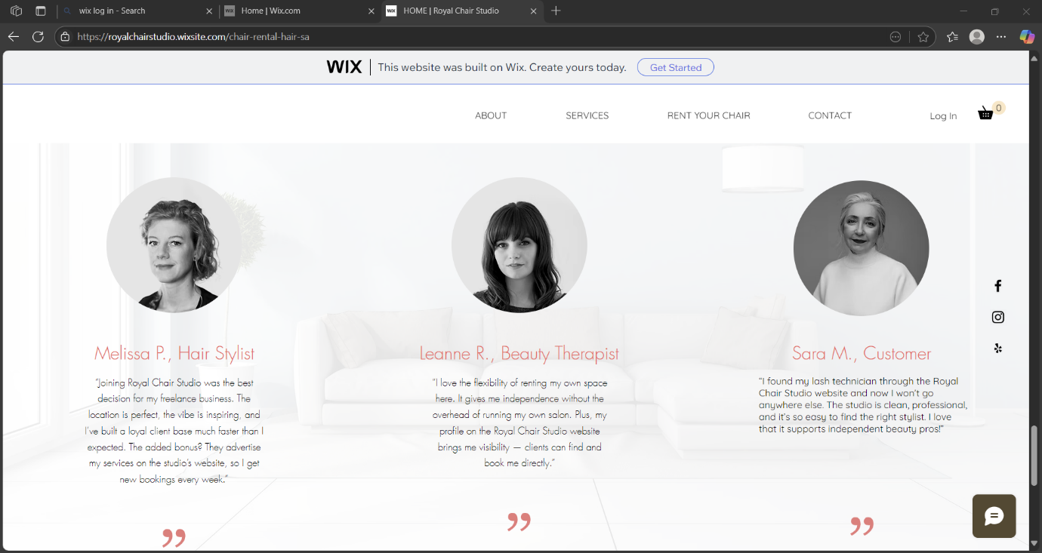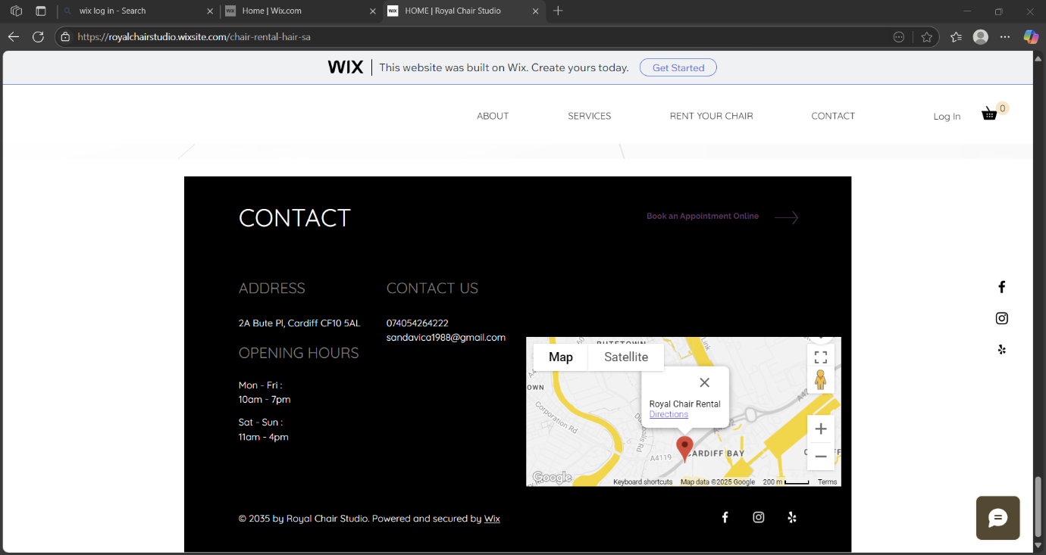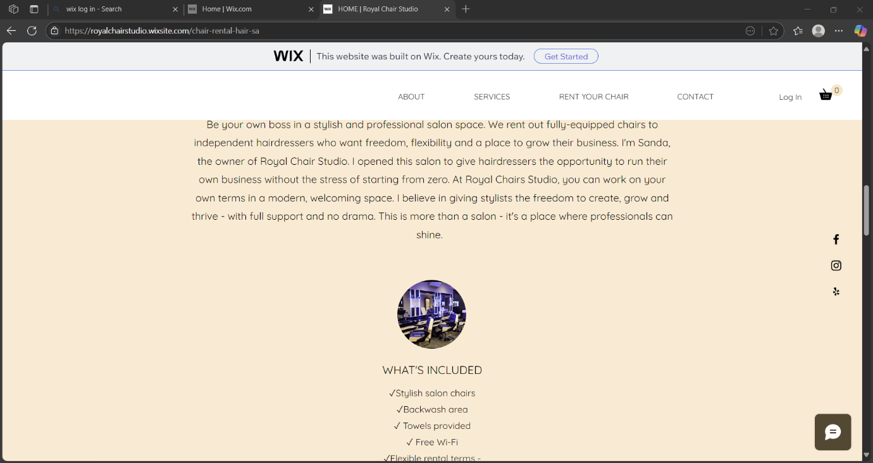
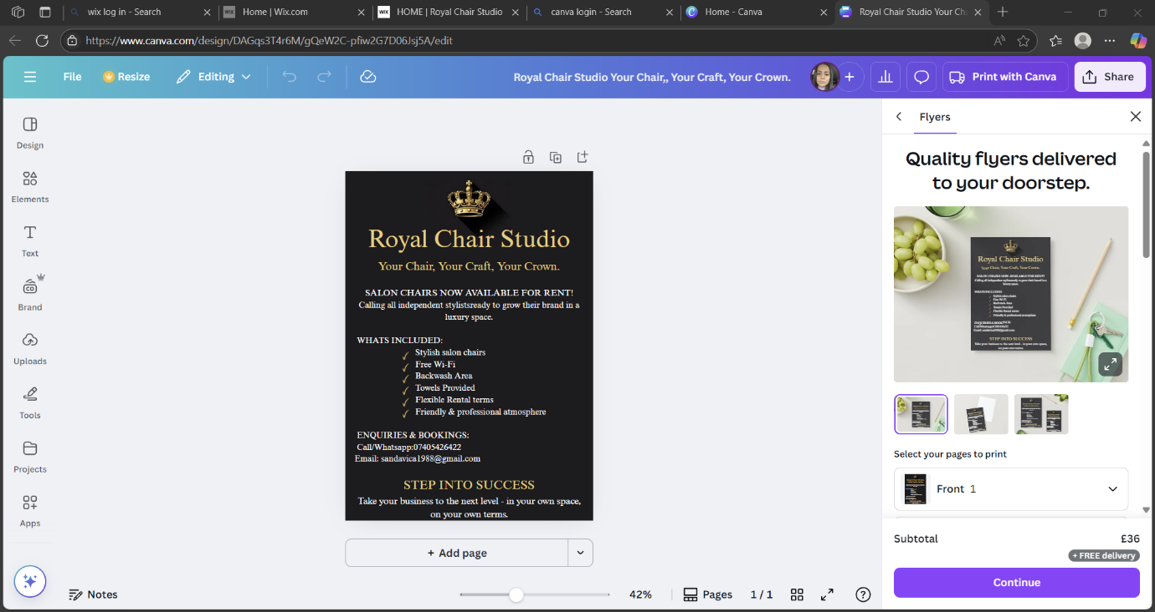

Task 2: The importance of Excel in the digital era

In today’s digital world, Microsoft Excel is still one of the most useful tools for running a business. Even with many new apps available, Excel remain popular because it is easy to use, flexible and reliable. It helps people manage money, create schedules, track data, and make better decisions. For a small business like Royal Chair Studio, which rents out salon chairs to self-employed hairdressers, Excel is great for managing bookings, tracking income and expenses, and planning. Whether is a beauty salon, a coffee shop, or a retail store, Excel provides tools that help small businesses save time and avoid mistakes. This essay explains why Excel is still important and how it supports small businesses like Royal Chair Studio.
One of the biggest advantages of Excel is that it helps manage data in a simple way. At Royal Chair Studio, Excel can track how many chairs are rented, how much money is coming in, and what expenses the salon has each month. That gives a clear picture of how well the business is performing. According to Alhawari and AIShihi (2020), small businesses can use Excel effectively without needing expensive software or advanced digital skills, making it an ideal tool for entrepreneurs.
Excel is also helpful for future planning. For example, if the salon owner notices that January is usually quiet, Excel can help plan promotions or offers to attract more clients. It can also be used to forecast income by using past data. As Nugroho et al. (20240 explain, “Microsoft Excel training significantly improves small business productivity by helping entrepreneurs analyse data and make better decisions.”
Being able to predict low-income months can help the salon prepare in advance, for example by offering discounts or special packages to bring in more clients.
Another great use of Excel is automation. Many salon tasks, such as sending out invoices, calculating earnings, and creating timetables, can be done faster and more accurately using Excel formulas and templates. Akrem and Maspul (2024) showed how a small coffee shop used Excel to manage its finances and save time, proving that even simple digital tools can make a big difference for small businesses. For Royal Chair Studio, the same idea applies – automated spreadsheets can be used to create monthly income reports and generate receipts for each stylist.
Profit tracking is also easier with Excel. At Royal Chair Studio, each chair might be rented at a different price, and Excel can show which chairs make the most money. It can also help calculate total income and expenses to see how much profit is left each month. Winston (2021), a well-known author on Excel for business, explains that Excel’s built-in charts and functions help business owners understand their numbers better and make smarter financial choices. This allows the salon owner to set realistic financial goals and make sure the business is growing over time.
Excel is useful in marketing too. For example, the salon can track which social media ads work best or which promotions attract the newest clients. This helps the owner focus on the strategies that bring in the most results. If Instagram ads lead to more bookings than Facebook posts, the salon can adjust its marketing budget. Perkin and Abraham (2021) explain that small businesses that track marketing data with tools like Excel can adjust quickly to customer needs and spend money more wisely.
Excel can also help with staff management. If Royal Chair Studio hires a receptionist or cleaner in the future, Excel can be used to track their working hours, calculate their wages, and plan their work schedule. Excel also helps track appointments and customer preferences, making it easier to understand busy times or the most popular services. This kind of planning helps the business run more smoothly. It also shows fairness – everyone knows their hours and gets paid correctly. Over time, this builds trust between the salon owner and the stuff.
Using Excel also improves digital and financial skills. The UK government’s Essential Digital Skills Framework encourages all workers to be confident with digital tools, including Excel (Department for Education, 2019). Many small business owners still struggle with understanding their business finances. As Mondry (2025) points out, “46% of small business owners say they wish they had a better grasp of their company’s finances,” showing how tools like Excel are essential for building confidence and making informed decisions. As the digital world grows, these skills become even more important – not just for business owners but for staff and customers too.
In conclusion, Excel is a powerful and helpful tool in the digital age. For Royal Chair Studio, it supports key areas like money management, marketing, planning, and staffing. It saves time, reduces mistakes, and gives clear information for smart decisions. It also helps improve digital confidence, which is very important for today’s small business. Even though there are many new digital platforms, Excel remains one of the best tools to help small businesses stay organised, grow and succeed in a competitive world.

References
Akrem, A.M. and Maspul, K.A. (2024) “Excel as a Sustainable Accounting Solution for SMEe: A Case Study of Bash Coffee Buraidah”, MAR-Economy: Journal Manajemen, Akuntansi dan Rumpun IImu Ekonomi, 2(2).
Alhawari, S, and AIShihi, H. (2020) “Digital tools in small business data management: The ongoing role of Excel”, International Journal of Business Information Systems, 35(2), pp. 158-173
Department for Education (2019) Essential Digital Skills Framework. Available at: https://www.gov.uk/government/publications/essential-digital-skills-framework Accessed 18 June 2025.
Mondry, M. (2025) “20 Small Business Financial Literacy Statistics for 2025”, QuickBooks. Available at: https://quickbooks.intuit.com/r/small-business-data/financial-literacy-statistics Accessed 18 June 2025.
Nugroho, D.N., Widodo, H., Riyanto, S. and Purnamasari, D. (2024) “Improving SMEs Business Productivity with Microsoft Excel Training in the Big Data Era”, Journal of Social Sciences and Technology for Community Service, 5(2), pp. 448-459
Perkin, N. and Abraham, P. (2021) Building the Agile Business through Digital Transformation. 2nd edn. London: Kogan Page.
Winston, W.L. (2021) Microsoft Excel Data Analysis and Business Modelling (Office 2021 & Microsoft 365). New York: Microsoft Press.



