WEEK 9 (week beginning November 27)
Civil Rights: From Plessy to King
In focus:
Washington versus Du Bois

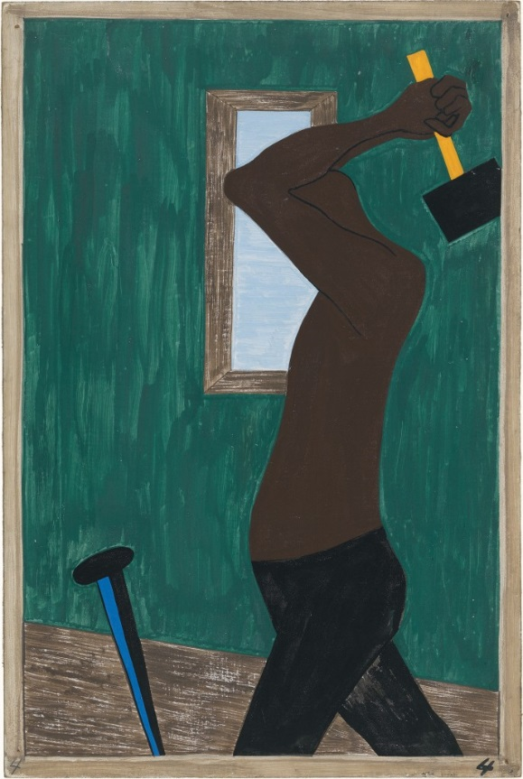

Jacob Lawrence, Migration Series No. 4
This week explores the history of the Civil Rights movement in the United States from the end of Reconstruction through to the 1960s and 1970s. The lecture compares the experiences of African Americans under the ‘Jim Crow’ laws in the southern United State with their experiences in the industrial north, in the process exploring the ideas of key thinkers such as WEB DuBois, Booker T Washington, Martin Luther King and Malcolm X.

- Reading and preparation:
Required reading (and viewing):
- Booker T Washington, ‘Atlanta compromise’ speech (1895)
- WEB Du Bois, ‘Of Mr. Booker T Washington and Others,’ The Souls of Black Folk (1903)
- Jacbob Lawrence, Migration Series (1941). Available via Museum of Modern Art (MoMa): https://www.moma.org/interactives/exhibitions/2015/onewayticket/panel/1/intro.

General background reading:
- George B, Tindall and David Emory Shi, America: A Narrative History (New York: WW Norton & Co, 2010), chapters 34–36.
- Eric Foner, Give Me Liberty! An American History (New York: WW Norton & Co, 2014), chapters 24–25.
- Malcolm Bradbury and Howard Temperley, eds. Introduction to American Studies (London: Longman, 1998), chapters 7, 12

- Background information:
- On WEB Du Bois, see Heath Anthology of American Literature (https://college.cengage.com/english/lauter/heath/4e/students/author_pages/modern/dubois_we.html)
- On Booker T Washington, see Heath Anthology of American Literature (https://college.cengage.com/english/lauter/heath/4e/students/author_pages/modern/washington_bo.html)
- On Jacob Lawrence, see: Peter Schjeldahl, ‘Telling the Whole Story: Jacob Lawrence’s “The Migration Series,”’ The New Yorker, April 20 2015 (https://www.newyorker.com/magazine/2015/04/20/telling-the-whole-story)

- Questions to consider:
Du Bois and Washington
- What are the key features and arguments of Du Bois and Washington’s political positions? How do they compare and contrast with one another?

- What are the central features of Washington’s 1895 speech? Why was the speech labelled a ‘compromise,’ and what are the features of that compromise?

- What criticisms does Du Bois direct towards Washington? How persuasive are his arguments, and why?

- Besides African American Civil Rights, what other themes and topics in US history might be illuminated by Washington and Du Bois’s writings?

Lawrence, ‘Migration Series’
- What insights into African American history do Lawrence’s paintings provide? How is the experience of ‘The Great Migration’ narrated and represented?

- How do the paintings ‘work’ as artworks?

- Which of the paintings do you find the most interesting and affecting? What makes your choice stand out?

