Student Self Evaluation Form
Common Assessment Criteria Applied
Common Assessment Criteria Applied | REFER |  | D |  | C |  | B | A
 | OUTRIGHT FAIL | UNSATISFACTORY | SATISFACTORY | GOOD |  | VERY GOOD |  | EXCELLENT
1. Subject Knowledge and Understanding (which includes using research-informed literature and knowledge and understanding of the subject)
2. Intellectual Skills (Analysis)
3. Pedagogic and Professional Applications (Practical Application and Deployment)
4. Key Transferable Skills

PLEASE COMMENT ON AREAS IN WHICH YOU FEEL THAT YOU HAVE PERFORMED WELL | PLEASE COMMENT ON AREAS you feel that you need TO DEVELOP
I feel that I have used both The mosaic approach and the ASK approach well. | I would like to improve on my analysis skills.

Student’s Name | Kirsty Bourne | Date | 29.5.18
Student’s Signature | K Bourne

A Detailed analysis of Child A’s holistic development, with Justification for the next steps in learning.

Word Count: 4400

Contents
Introduction 5
Data Collection 5
Analysis of the learner 8
-Attitude 8
-Skills 10
-Knowledge 12
Next steps 14
Conclusion 16
References 17
Appendices 20
-Appendix 1- Child Conference 20
-Appendix 2- Tour 21
-Appendix 3- Photographs 21
-Appendix 4- Photograph of class wedding 22
-Appendix 5- Test Practise observation 22
-Appendix 6- DT Observation 23
-Appendix 7- DT Evaluation 23
-Appendix 8- DT worksheet 24
-Appendix 9- Example of English work 24
-Appendix 10- Example of Welsh work 25
-Appendix 11- Example of KUW work 25
-Appendix 12- Example of written work 26
-Appendix 13- Example of Maths work 26
-Appendix 14- Base 10 27
-Appendix 9- Consent form 27

Introduction
School A is in the Cynon Valley, South East Wales. Nearly all pupils live within the local community with a small number of pupils commuting from the surrounding areas. The area is designated a Communities First Area and has both privately owned and rented homes. The schools Free School Meals entitlement was above the local and national average during the last inspection by Estyn in 2013, at 40 % (Estyn, 2013). There are currently 157 pupils on roll (Welsh Government, 2017). These children are split between the Nursery class, three Foundation Phase classes and two Key Stage 2 Classes (Year 3 /4 and Year 5 /6). During my time within School A, I have been placed within the Year 2 class. Within the class, there are 25 children, 2 of whom have been identified as having Additional learning needs and one of whom has English as an Additional Language. After initial observations of the pupils, I decided to base my research on the holistic development of Child A, a 7-year-old girl within the class. Child A is working within the middle ability groups for both English and maths and her PSHE work has recently been externally moderated, resulting in her being levelled at a secure outcome 5. In order to make suggestions for, and justifications of, the next steps for learning for Child A, I have collected data using a Mosaic approach (Clark & Moss, 2011). I have used Child Conferencing, Photographs, Tours and Observations to inform my suggestions. I have also used The ASK model (Nottingham, 2013) which looks at Attitudes, Skills and Knowledge to analyse the data that I have collected.

Data Collection
For the purpose of this assignment, I have used the Mosaic approach as the main form of data collection. Clark and Moss (2011) identify 3 stages of the mosaic approach. Stage 1 involves both children and adults gathering information. Stage 2 involves piecing together this information for reflection and stage 3 involves deciding on next steps. During stage 1 of my research, I used Observations, Child conferencing, Tours of the school conducted by the child and Cameras for the child to take pictures of important places or resources that help them to learn.
Observations
Clark and Moss (2011) have described observations as a ‘snapshot’ that can be discussed with practitioners, parents and the children themselves. They explain that ‘In searching for new ways of listening to young children it is important that we do not abandon established practices such as observation which can contribute to our understanding of children’s lives’ (Clark and Moss, 2011:18). However, they go on to explain that it is only an adult perspective on the child that we gain, and, so this needs to be seen alongside other pieces of the mosaic. I took the roll of a non-participant observer as I was not involved in lessons or activities that my target child was participating in (Bryman, 2008). Non-Participant observations can be considered to be un-natural experiences which do not allow the observers to gain much of an insight into the child (Drew, Hardman and Hosp, 2017: 197).
Child Conferencing
Article 12 of The United Nation Convention on the Rights of the Child outlines that all children have the right to express their wishes, feelings and views in matters that affect them. They have the right to have their views taken seriously (UNCRC, 1989). The National Education Union (2017) explain that 'Pupil voice’ is now a popular concept within schools and is embedded in government guidelines. ‘Curriculum requirements across the UK include developing pupils' abilities to take part in discussion, and to contribute to the life of the school’ (NEU, 2017, Online). Clark and Moss (2011) stress the value of child conferencing when completing research with young people. They believe that the children can give us important information about people, places and activities. I conducted a short child conference with my target child at the beginning of my research (appendix 1). I asked her ‘What helps you learn?’ and ‘Can you tell me about your learning in school and the things that are important to your learning?’. A limitation to using child conferencing can be it’s practicalities. It is important that conferences are undertaken in places that are familiar to the child and put them at ease. Flexibility is crucial, and conferences may have to take place on the move, and with more than one participants.
Cameras
Clark and Moss (2011: 23) explain that cameras are an appealing form of media for children. They explain that cameras ‘provide a form of communication that is fun’ and can provide an ‘in-depth view of their lives’. I provided my target child with an ipad and asked her to take pictures of all the things, places and people that are important to her and that help her learn in school. This was an activity that she enjoyed, providing lots of valuable information through both the photograph she took and the conversations that these photographs prompted. There are both positives and negatives to using cameras as a way of listening to children. Photographs are something that ‘have a value in the adult world’ (Clark and Moss, 2011: 28) and so some children may consider them to be of more valuable than their own drawings and take pride in the photographs that they produce. The camera feature on an ipad is child friendly and, in my experience, children enjoy documenting different aspects of their school day in this way. However, the cost of technology is high, and this can put limitations on children’s access to cameras. Due to my classroom being assigned two ipads, this was not a problem I faced.
Tours
As an extension of the work with cameras, tours led by the children are also a positive way of engaging with children’s views, thoughts and opinions of their school and the resources available to them, that can assist with their learning. I took part in a tour, led by my target child, around the school. During the tour I was introduced to areas of the school, specific resources and people of whom my target child considered to be important to her learning. This experience was extremely beneficial as it allowed her to talk freely about her experiences within the school (Clark and Ross, 2011: 30) however, there were instances where the tour lost focus.
Ethical Considerations
I have taken into consideration the importance of complying with ethical guidelines when conducting research with children. For the purpose of this assignment, I have ensured that I have become familiar with the following guidelines ‘Ethical Guidelines for educational research’ (BERA, 2011), ‘Code of professional conduct and practice for registrants with the Education workforce council’ (EWC, 2017) and ‘Research ethics and integrity code of practice’ (University of Wales Trinity St David, 2017). I made my target child aware that she didn’t have to take part in the research if she didn’t want to (Bera, 2011). I made her aware that if she became distressed in any way that she may choose to withdraw from the research. I gained verbal assent from my target child and consent from the class teacher. I ensured my target child that I would keep her identity anonymous within my assignment and would refer to her as ‘Child A’ and blur her face in any photographs that I use. I have been provided with consent by the school to take photographs. I have adhered to legal requirements for working with children. This includes safeguarding requirements that are laid out within the schools safeguarding policy, which I have made myself familiar with. I have complied with the university guidelines for the storage and use of data ensuring that all data was was confidential and securely stored.
Analysis of the learner
To analyse the data that I have collected from, and with, my target child, I will use the ASK model, outlined by Nottingham (2013). This model looks at the attitude, skills and knowledge of the child in relation to their learning.
Attitude
Lev Vygotsky explained that children learn from those around them, ‘Children adopt many of our attitudes and values through dialogue with us’ (Nottingham, 2013: 5). Nottingham (2013) explains that outstanding learners are curious, have desire to succeed, have resilience and self-control.
Curiosity
Marianne Stenger (2014) explains that curiosity makes learning more enjoyable and effective. Students who are curious ask questions and actively seek out the answers. Child A has displayed that she is a curious learner on numerous occasions. One such occasion happened during a design technology session whereby children were asked to follow instructions to make a catapult (appendix 2). Child A asked…
‘What will happen if I tie the lolly stick on both ends miss? ‘Shall I try it?’.
-Appendix 2
She ties her lollipop sticks at both ends but realises that she cannot continue to follow the instructions as she is now unable to separate her sticks.
‘Aw miss! That don’t work does it. I got that wrong’ She laughs.
-Appendix 2

Desire to succeed
As part of the ‘Successful Futures’ review into the curriculum in Wales, Professor Graham Donaldson CB (2015) has recommended that one of the purposes of the new curriculum should be to create ambitious, capable learners that are ready to learn throughout their lives. Children should ‘set themselves high standards’ (2015: 29). Child A has demonstrated that she is ambitious and holds a strong desire to achieve. During the Child Conferencing session (appendix 1), I asked Child A if she could tell me about her learning and the things that are important to her learning. The following is her response.
‘When I’m learning miss says “Try your best” and I keep on trying and I get more better. My mam says “keep trying”. When I finish my work I have fun then’.
-appendix 1

During recent National test practise, I observed Child A carefully reading each question. She appeared visibly distressed at questions that she found difficult, and is pleased when she understands questions, sharing success with the teacher (appendix 5).
Resilience
Best start (date unknown) explains that resilient children are able to handle stressful situations, develop patience, be creative problem-solvers, be optimistic, try new things and achieve their goals. Child A has displayed on numerous occasions the she has resilience relating to her learning. She shows this in appendix 6 when she laughs after she realises that she has made an error when constructing her model catapult. She also displays that she has a Growth mind set by quoting ‘It doesn’t matter if we get it wrong as long as we try, does it miss’ during National test practise (appendix 5). This is an attitude that is supported by her friends. During child conferencing (appendix 1), she explains ‘My friends help me. If I don’t know it, they say “Have a try”.
Self-Control
Nottingham (2013) explains that children who displayed high self-control in experiments such as those by Walter Mischel (1972), whereby children must wait for something that they want, were less likely to have behavioural problems, had higher exam scores, dealt with stressful situations well, were able to pay attention and did not find it difficult to maintain friendships. Child A displayed she has self-control during our class mock wedding, when she played the part of the bride. During the wedding reception all the children were given a plate of party food but were told to wait to eat the food until the speeches had been made by the best man and the father of the bride. Child A was able to do this with ease, however a lot of members of the class struggled with this instruction (Appendix 4).

Skills
Nottingham (2013) recommends that we should think about the skills that children need for learning. He lists four of these skills, Intellectual skills, social skills, physical skills and communication skills.
Intellectual
During the observation detailed in appendix 6, Child A displays many of the abilities outlined by Nottingham (2013) which indicate intellectual skill. During this particular observation, Child A was following instructions in order to make a model catapult, using lollipop sticks and elastic bands. She was able to understand the relevance of the activity as we had been completing work about castle defences, she also understood why we were using the specific materials in order to construct our catapults. During this activity, she asked relevant questions, such as …
‘Miss, how did the real catapults get made?’
Appendix 6
She is also able to compare and contrast her catapult to that of her friends.
‘Oh my gosh! Yours went straight up and mine went over to the door’
Appendix 6
She is able to identify, describe and alter connections between ideas, drawing conclusions.
‘Miss, If I tie up the sticks more it will be bouncier wont it?’
I explain if she makes her elastic tighter, her pom pom will be shot with a greater force. She tries this and her pom pom travels around 1 meter further.
‘Ok, so a tight elastic makes it go further’
Appendix 6

Communicative Skills
Child A has excellent communication skills. She has the ability to understand instructions given to her by both her peers and adults and makes herself understood (appendix 6). She understands body language cues and responds correctly to changes in tone of voice. I have identified this during teaching and learning times when the children are sitting and listening on the carpet. During these times, Child A pays me her full attention and is able to ask questions if she doesn’t understand something. She has good oracy skills and speaks clearly, with a wide vocabulary (appendix 1 and 2). During her role within the school council she has demonstrated that she is able to talk persuasively and respectfully. Appendix 5 identifies an occasion whereby Child A requested a rubber using welsh.
‘Ga I rubber os gweli di’n dda’
Appendix 5
This identifies that Child A’s communication skills go beyond her first language of English, and, in fact, she is able to communicate purposefully using basic welsh.
Social skills
Child A has an excellent ability to build rapports with other children and adults and has expressed that she enjoys spending time with her friends on the play ground during our tour of the school (appendix 2). She has a wide friendship group that extends beyond her ability group. During work time, she consistently displays that she is able to work as part of a team, respecting the view points of the other members of her group as well as encouraging them. She displays these skills within her role as the school council representative for her class.
Physical Skills
During the tour of the school that Child A led (Appendix 2), she took me to numerous places within the school that help her with her physical skills and abilities. Due to its close proximity to our starting point, the school hall was the first stop. Child A explained…
‘We come in here to do PE, I think we do it on a Thursday or something. I like PE because it makes my body feel fizzy and it’s good for my brain. I like it when we walk on the benches and when miss pulls the apparatus out, but sometimes my feet get cold on the benches’.
Appendix 2
Child A understands the importance that physical activity has on her health and wellbeing and places great value on it. She even takes part in physical activities during leisure time. During our tour, she also took me onto the school yard which she described as ‘A place to run around with my friends’. She regularly displays that she has good physical skills by dancing, acting and singing with her friends, manipulating objects such as construction materials and sand (appendix 3) and catching and throwing the ball during play times.

Knowledge
Nottingham (2013) talks about the knowledge of the child in terms of facts, figures, concepts and ideas. For the purpose of this assignment, I will discuss the subject knowledge of Child A in relation to Language, Literacy and communication, Mathematical development, Knowledge and understanding of the world and Welsh development.
Language, Literacy and Communication
For Language, Literacy and Communication, Child A is in the middle ability group. She is achieving, at best fit, an outcome 5 (appendix 9 and 12) for her writing. She has displayed that she is able to form upper- and lower-case letters accurately, with consistent size and orientation. She uses her knowledge of syllables to spell words and often, incorrect words are spelt phonetically correctly. She uses connectives, ordering words, punctuation and simple grammar accurately. She is able to write for different purposes and different audiences, building on a form modelled by an adult, and can sequence and structure content correctly and extend their writing. She has the ability to re-read her work to check for errors and improve her writing (Welsh government, 2015). Within her reading, however, Child A is achieving at rate that is below average for her age. She is following the ‘Oxford reading tree’ scheme and is currently on stage 4 books, with a reading age of 5 years and 8 months. This is over a year below her chronological age. She is working at an outcome 4 for reading and is able to ‘recognise familiar words and use strategies to decode others, tracking print with their eyes and read punctuation expressively’ (Welsh government, 2015: 55).
Mathematical Development
Child A has proven that she is a best fit outcome 5 for Mathematical development. During my time teaching the class, I have taught a series of lessons based on 3D shape. Child A has demonstrated to me that she is able to recognise and name 3D shapes, talk about their properties, including the number of faces, whether they have curved faces or flat faces, the amount of edges and corners that they have. She has displayed that she is able to use 3D shapes accurately within her play. During practical parts of the lessons, Child A was able to sort and classify 3D shapes using more than two criteria by using sorting hoops in the style of a Venn diagram.

Knowledge and Understanding of the World
During our theme this term ‘Towers, Tunnels and Turrets’ Child A has displayed that she is able to select, organise and communicate items of information about the past and collect information in order to find answers (Welsh government, 2015: 59) and has evidenced this by creating a report on Cardiff castle using a fact sheet to gather information. She has demonstrated that she can ask and answer questions and make observations during a lesson whereby she followed instructions to make a catapult (appendix 8).
‘Miss, how did the real catapults get made?’
I explain they were made with wood, nails and rope.
‘We wouldn’t fit them in school’
Appendix 6

During this lesson, Child A was able to communicate the steps needed to complete her catapult (appendix 8). She also reflected on and evaluated her catapult (appendix 7).

Welsh Development
Child A has expressed a keen interest in her own Welsh language development. She initiates welsh conversations (appendix 5) and has responded well to the ‘Token iath’ box that I have set up. She is achieving an outcome 5 at the moment, showing an understanding of short phrases, communicating in short phrases and responding to various stimuli. She speaks clearly with intelligible pronunciation and intonation. She can communicate by writing sentences using familiar patterns and spells simple word correctly (Welsh government, 2015). She has displayed this on a number of occasions and has used her ‘Blwyddyn 2’ place mat, containing sentence structures. Using this method, she has been able to complete work based on ‘Y Tywydd’, ‘Bwyta’ and personal details (Appendix 10).

Next Steps
In order for Child A to meet the expected level of outcome 5 in reading and possibly achieve outcome 6 in the other aspects of Language, Literacy and communication and Mathematical Development by the end of the Foundation phase, it is necessary to put in place interventions, and provide guidance for the next steps for learning.
Guided Reading
The Guided Reading approach is an approach that I believe would benefit Child A’s reading skills, as well as her motivation to read. Biddulph (2002) has explained the process of Guided Reading. Teachers select texts that are appropriate for the group. They introduce the text to the children by talking about it in relation to personal experiences. They then provide support to the child to enable them to move through the text, talking, reading and thinking purposefully. There are many benefits of using this approach and it is an approach that would have a positive impact on the reading of the whole class. It would allow me to spend time with Child A and focus on how she is progressing and to identify any areas that need to be developed. It will allow Child A, and other children in the class, to develop strategies that will improve their reading, helping them to become independent readers as well as offering support from the teacher if necessary. Guided reading will provide the children with an opportunity to talk about what they have read with the other children in their group, communicating their opinions and ideas whilst learning from other children in their group. Groups are based on ability. This eliminates some of the stress and anxiety that the children may feel about reading aloud and can help to build confidence and motivate the child to read (Williams, Date unknown). This being said, there are also limitations to this approach. Grouping children in ability groups could prove problematic as all children develop at different rates, and so it is unlikely that all children will be at the exact same stage. This means that Child A would need to be placed in the group of best fit, which may not be ideal. Time restraints within the classroom can also have a negative effect on guided reading. It is vital that there is a sufficient amount of time set aside for each child to gain the appropriate amount of individual attention by the teacher. The reading must also be purposeful in order to fulfil learning objectives (Williams, Date unknown).
Read, Write Inc Literacy and language
The ‘Read, Write Inc Literacy and language’ programme is also something that I feel would benefit Child A by pushing her from an outcome 5 to an outcome 6 in her writing. Read, Write inc, Literacy and Language is a programme developed by Ruth Miskin to meet the demands of the National Curriculum in a way that is both fun and meaningful. It is designed for children in years 2-6 and so would be a relevant programme for Child a to engage with. The programme covers spoken language, reading, writing, vocabulary, grammar and punctuation, all of which will help Child A to achieve an outcome 6 at the end of the Foundation Phase. However, it does not cover spelling, an area that Child A needs to improve on. In addition to Literacy and Language, Read, Write Inc also offers a spelling programme for children in years 2-6. This would be beneficial for child A to engage with.
Mathematical Development
In order to improve Child A’s Mathematical development and bring her from an outcome 5 to an outcome 6 at the end of the foundation phase, there are a number of areas that need to be focused on. Within the Outcome 6 level descriptors in the Foundation Phase Framework (Welsh government, 2015) there are a number of elements that have been refined from outcome 5. Child A will need to display that she is able to read, write and recite numbers to 1000 from different starting points. She will need to understand place value of thousands, hundreds, tens and units and make approximations based on place value. This could be done practically by using demonstrations with base 10 blocks, such as the ones shown in appendix 14, allowing Child A to explore the base 10 blocks by herself. Child A could also access ICT based place value games. She will need to understand negative numbers in the context of temperature. Practical activities involving thermometers and ice would be beneficial and engaging for Child A. She will need to begin to use fractions. Again, practical activities involving fractions of pizza will engage Child A and help her to understand the concept. There are numerous ICT games that Child A could access to help her with fractions, including Purple mash’s ‘Fractoni’s pizzeria’. She will need to use complex methods to represent data and extract and interpret data. Purple mash also offers a 2graph feature whereby Child A can create graphs with data that she has collected. In order to achieve outcome 6, Child A will need to demonstrate that she can use 2,3,4,5 and 10 multiplication tables to solve multiplication and division questions and display that she has an understanding of remainders (Welsh government, 2015).
Conclusions
On reflection, the process of looking at Child A’s holistic development, through observations, child conferencing, tours and assessing her work, has made me realise how important and valuable listening to learners is. Information gathered by adopting The Mosaic approach (Clark and Ross, 2011) has allowed me to conclude that Child A is a curious learner with a desire to succeed. She is resilient and has a lot of self-control. She has sound intellectual skills, excellent social skills and enjoys exercising her physical skills during PE and play times. Within oracy and writing, Child A is hitting an Outcome 5, however she needs extra support to ensure that she is at the same level within her reading. She is achieving outcome 5 in maths and enjoys taking part in welsh development sessions. By listening to Child A and identifying her attitude towards learning and the things that she values as helpful to her learning (Appendix 3), I have been able to identify appropriate ‘Next steps’ in order for her to achieve the outcomes that she is capable of at the end of the Foundation Phase. The Mosaic approach (Clark and Ross, 2011) is an approach that I will take forward into future practice, to ensure that children within my class are learning in a way that is suitable for them, and to allow me to identify their individual needs.

References
-Best start (date unknown) Available at: Building Resilience in Young Children Booklet for parents of children from birth to six year, https://www.beststart.org/resources/hlthy_chld_dev/pdf/BSRC_Resilience_English_fnl.pdf, [Accessed on 26.5.18]

-Biddulph, J (2002) ‘The guided reading approach: Theory and Research’ Available at: http://learning.gov.wales/docs/learningwales/publications/130718-guided-reaching-approach-en.pdf [Accessed on 28.5.18]

-British Educational Research Association (BERA) (2011) ‘Ethical guidelines for educational research’ Available at: https://www.bera.ac.uk/researchers-resources/publications/ethical-guidelines-for-educational-research-2011 [Accessed on 25/5/18]

-Bryman, A (2008) ‘Social science research methods’ Oxford university press: Oxford

- Clark, A. and Moss, P. (2011) Listening to Young Children: The Mosaic Approach (2nd ed), London: National Children’s Bureau, [e-book]. Available at: https://www-dawsonera-com.ezproxy.uwtsd.ac.uk/readonline/9781907969423

-Donaldson, G (2015) ‘Successful futures: Independent review of curriculum and assessment arrangement in wales’(Online) Available at: http://fluencycontent2-schoolwebsite.netdna-ssl.com/FileCluster/TyGwynSpecial/MainFolder/Successful-Futures---Welsh-Government.pdf [Accessed on 26/5/18]

-Drew, C, Hardman, M and Hosp, J (2007) ‘Designing and conducting research in education’, Sage publications: London

Estyn (2013) ‘A report on ******* primary school’ Available at: https://www.estyn.gov.wales/sites/default/files/documents/Inspection%20report%20%20Primary%20School%202013_0.pdf.pdf.pdf.pdf.pdf.pdf.pdf.pdf.pdf.pdf.pdf.pdf , [Accessed on 25/5/18]

-Education Workforce Council (2017) ‘Code of professional conduct and practice for registrants with the Education workforce council’ Available at: https://sewales.org.uk/NQT/Resources/NQT-Induction-resources-from-Sept-1st-2017/EWC-Code-of-Professional-Conduct-Practice-(E).aspx [Accessed on 25/5/18]

-Miskin, R (2018) ‘Read, write inc. Spelling’ Available at: http://www.ruthmiskin.com/en/training-courses/spelling/, [Accessed on: 28/5/18]

-Miskin, R (2018) ‘Read write inc. Literacy and language’ Available at: http://www.ruthmiskin.com/en/training-courses/literacy-and-language/ [Accessed on 25/5/18]

-National Education union (2017) ‘Taking pupils seriously: Involving pupils in decisions that matter’ Available at: https://www.atl.org.uk/policy-and-campaigns/policy-posts/taking-pupils-seriously-involving-pupils-decisions-matter, [Accessed on: 29/5/18]

-Nottingham, J. (2013) Encouraging Learning. Oxon: Routledge [e-book]. Available at: https://www-dawsonera-com.ezproxy.uwtsd.ac.uk/abstract/9780203559079

-Stenger, M (2014) Why Curiosity Enhances Learning: A neurological study has shown that curiosity makes our brains more receptive for learning, and that as we learn, we enjoy the sensation of learning, Online, Available at https://www.edutopia.org/blog/why-curiosity-enhances-learning-marianne-stenger, [Accessed on 26/5/18]

-Unicef (1989)’A summary of the UN convention on the rights of the child’ Available at: https://downloads.unicef.org.uk/wp-content/uploads/2010/05/UNCRC_summary-1.pdf?_ga=2.150633141.2053728753.1526493299-527295087.1517853433, [Accessed on 29/5/18]

-University of Wales, Trinity St David (2017) ‘Research ethics and integrity code of practice’ Available at: http://uwtsd.ac.uk/media/uwtsd-website/content-assets/documents/research/research-ethics-integrity-code-practice.pdf [Accessed on 25/5/18]

-Welsh Government, (2015), ‘Foundation phase framework’, Available at: https://gov.wales/docs/dcells/publications/150803-fp-framework-en.pdf, [Accessed on 28/5/18]

-Welsh government, (2017) ‘My local School’ Available at: http://mylocalschool.gov.wales/?lang=en, [Accessed on: 29/5/18]

-Williams, A.(Date unknown) ‘What Are the Advantages & Disadvantages of Guided Reading?’ Available at: http://classroom.synonym.com/advantages-disadvantages-guided-reading-8405104.html. [Accessed on 28.5.18]

Appendices
Appendix 1- Child conference
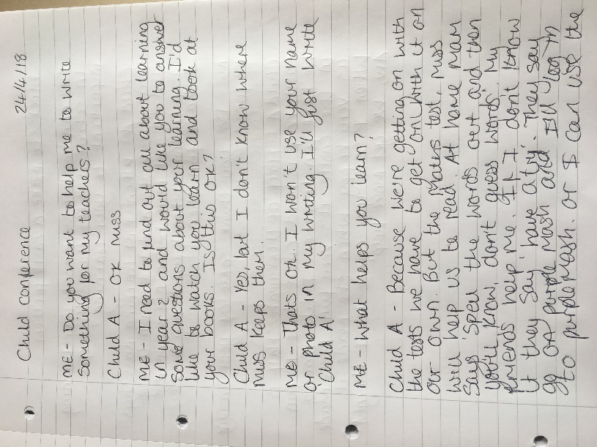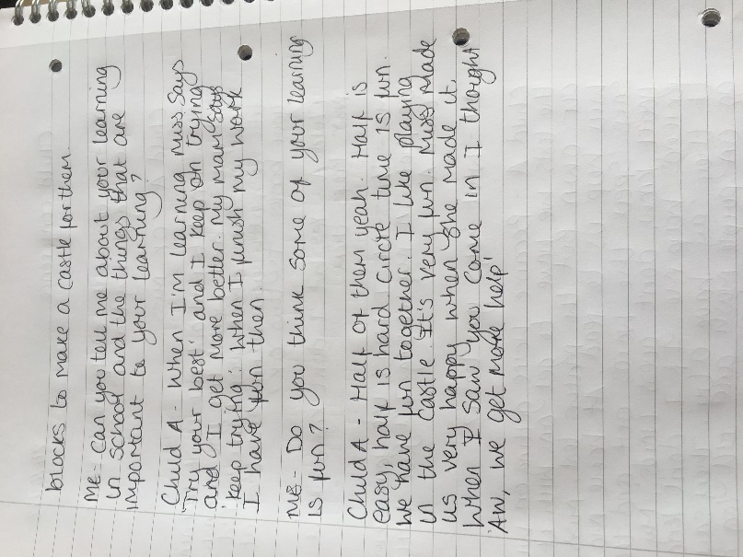

Appendix 2- Tour
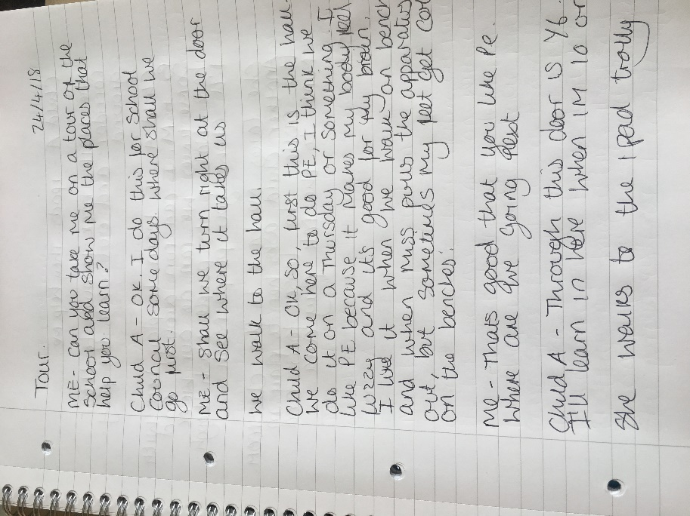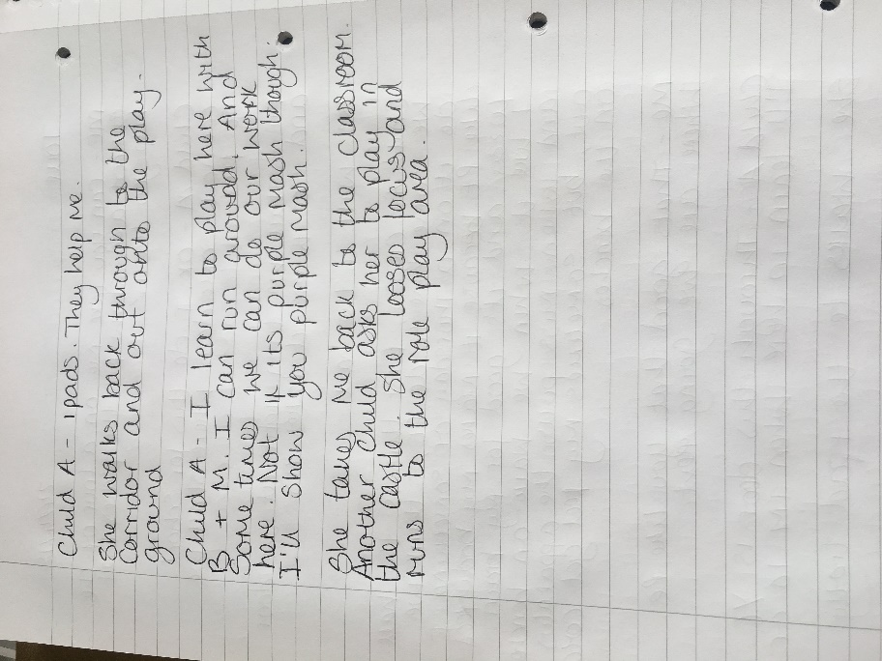

Appendix 3- Photographs of places and resources that help Child A learn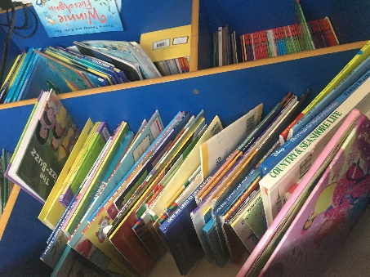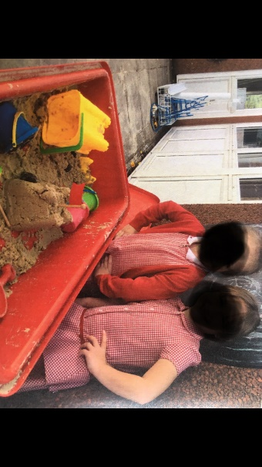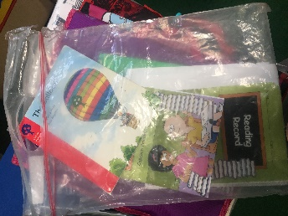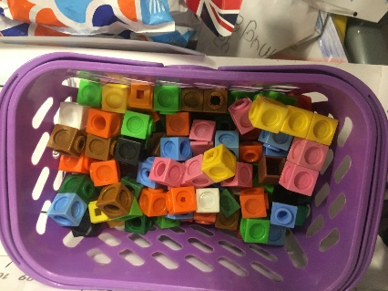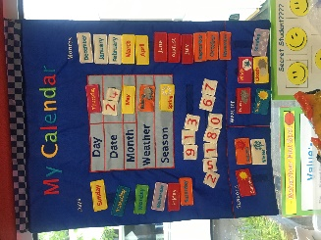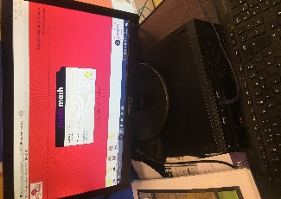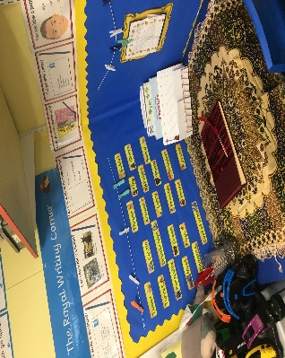

Appendix 4- Class wedding
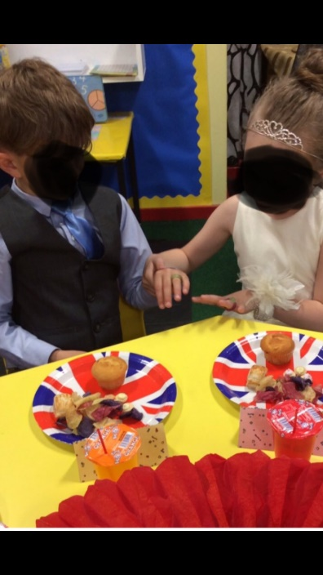
Appendix 5- Test Practise Observation
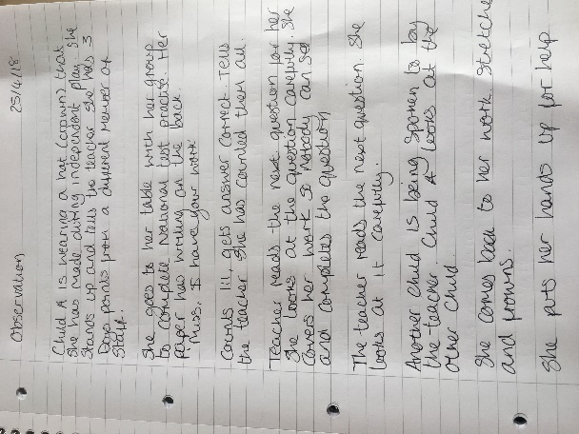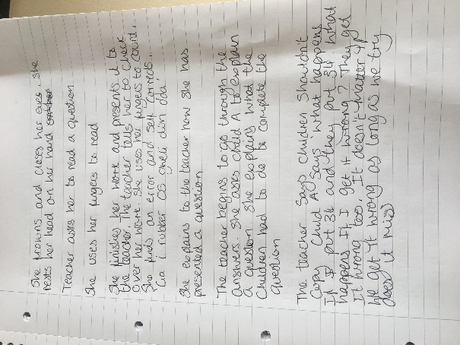

Appendix 6- DT observation
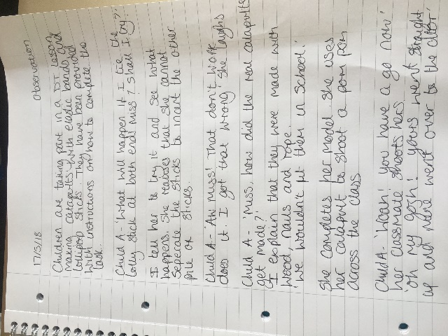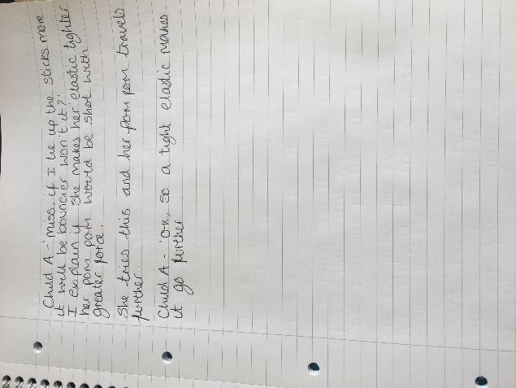

Appendix 7 DT Evaluation
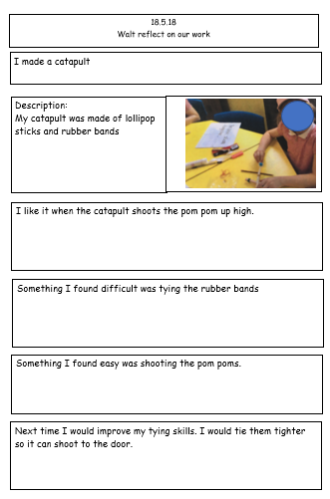

Appendix 8- DT worksheet
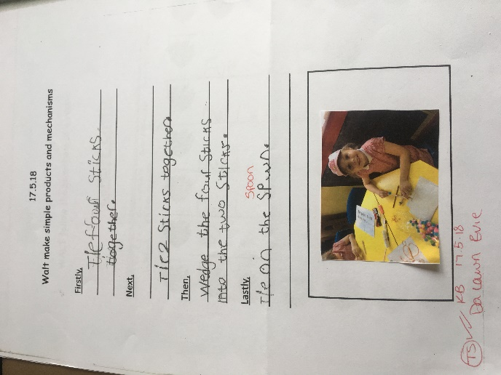

Appendix 9- Example of English work
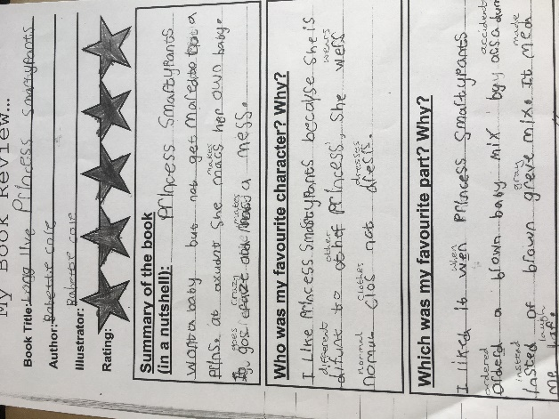

Appendix 10- Example of Welsh work
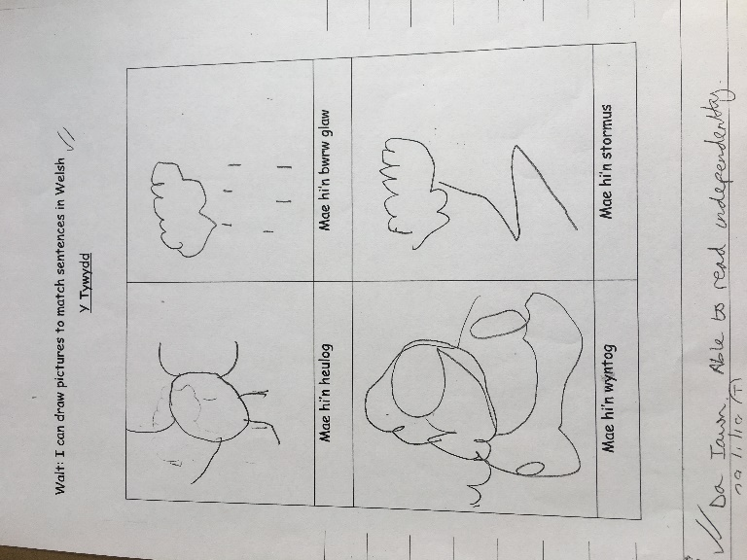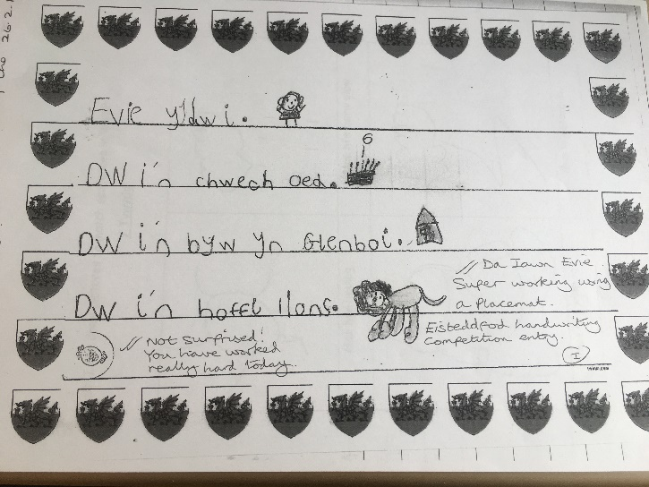

Appendix 11- Example of Knowledge and understanding of the world work
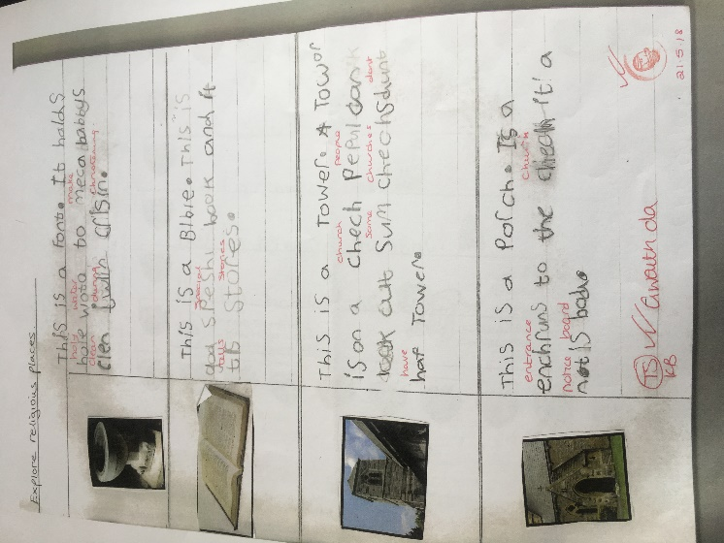

Appendix 12- Example of written work
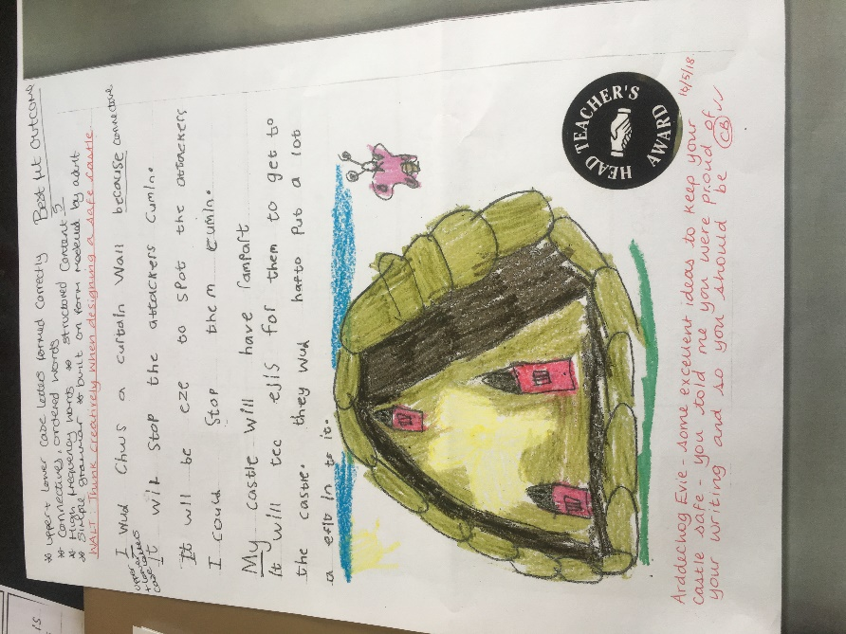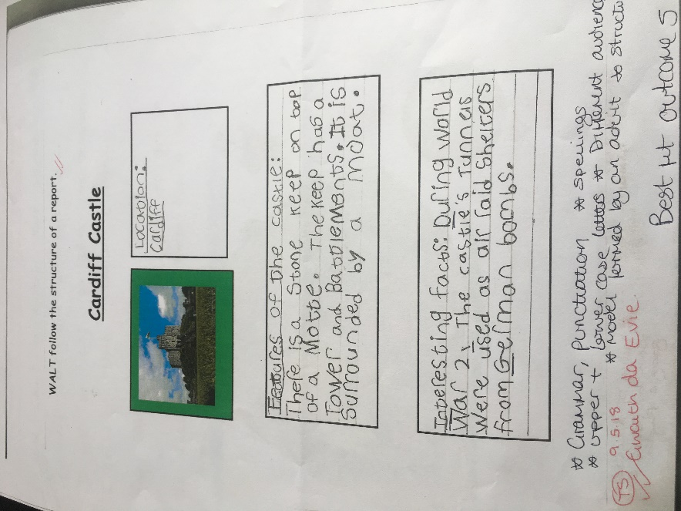

Appendix 13- Example of Maths work
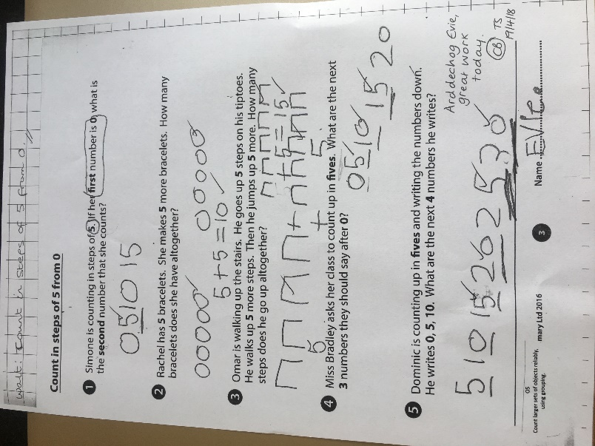
Appendix 14- Base 10

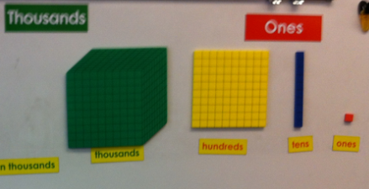

Appendix 15- Consent form


