2025
Full Name : Robel Gebregziabher
Student Id Number 2427640
Submitted To: Amit Naik
University of Saint David Trinity wales (London)
12/17/2025

Networks and Cyber Security Essentials ‘’
Table of Contents
Vigilant Trust & Asset Management (VTAM) 3
1. Executive Summary 3
2. Introduction 3
3. Identification of Modern Threats 4
4 Internal Threats 5
Insider Risks: 5
4.2 IDENTIFY (ID) 6
4.3 PROTECT (PR) 6
4.4 DETECT (DE) 7
4.5 RESPOND (RS) 7
4.6 RECOVER (RC) 7
5. Technical and Administrative Mitigation Measures 7
5.1 Zero-Trust Identity Controls 7
5.2 Network & Micro-Segmentation 8
5.3 Endpoint Security & EDR/XDR 8
5.4 Cloud Security Controls 8
5.5 Email, Phishing & Vishing Controls 8
5.6 Vulnerability & Patch Management 8
5.7 Backups & Recovery 8
6. 24/7 Monitoring & Incident Response Plan 9
6.1 Monitoring Architecture (ASCII diagram) 9
6.2 Incident Response Workflow 9
1. Detection 9
2. Triage (Automated in SOAR) 10
3. Notification 10
4. Forensics & Investigation 10
5. Containment & Eradication 10
6. Recovery 10
7. Lessons Learned 10
7. Continuous Training & Awareness Programme 10
7.1 Core Elements 10
A. Continuous Phishing/Vishing Simulations 10
B. Role-Based Training 11
C. Gamification & Rewards 11
D. Security Culture Activities 11
E. Metrics 11
8. Conclusion 11
Cisco packet tracer certificate 12
References 13
Appendix A — Board Presentation Power Point (Slides + Notes) 14
Appendix B — Board Presentation MS Word Sample (Slides + Notes) 19
Slide 1 — Title 19
Slide 2 — Why Cybersecurity Matters Now 19
Slide 3 — Modern Threat Landscape 19
Slide 4 — Strategic Framework 19
Slide 5 — Zero Trust Architecture Diagram 20
Slide 6 — Priority Controls (Next 12 Months) 20
Slide 7 — Monitoring & Response 20
Slide 8 — Business Impact 21
Slide 9 — Investment Overview 21
Slide 10 — Final Recommendation 21

Vigilant Trust & Asset Management (VTAM)
Comprehensive Zero-Trust Security Framework Report
Prepared by: Robel G.
December 2025

1. Executive Summary
Cybersecurity threats targeting financial institutions are increasing in both frequency and complexity. As VTAM adopts hybrid work, cloud services, SaaS, and additional mobile devices, traditional security measures are insufficient to protect critical systems and sensitive data.
In the past six months, VTAM experienced a phishing attack that bypassed email filters and an attempted ransomware incident. These events demonstrate the increasing sophistication of threats and have prompted the pursuit of a Zero Trust security framework, informed by standards such as NIST CSF 2.0, ISO/IEC 27001, and CISA’s Known Exploited Vulnerabilities.
This report outlines a comprehensive plan to address the evolving threat landscape, implement Zero Trust policies, prioritize rapid adoption of technical and administrative controls, establish continuous detection and response capabilities, deliver ongoing security training, and provide a strategic board-level overview to support risk reduction and stakeholder engagement.
• Technical and administrative controls that VTAM must adopt immediately.
• A 24/7 monitoring, SIEM/SOAR-driven detection and response capability, with an incident flow-chart included.
• A continuous, immersive training and awareness programme designed to empower staff and foster a security-conscious culture, emphasizing that all personnel contribute to the protection of VTAM’s assets and reputation.
• A board-level, business-focused slide deck to support strategic decision-making.
Full implementation of the Zero Trust program is essential to significantly reduce VTAM’s financial, operational, regulatory, and reputational risks, thereby demonstrating proactive risk management to stakeholders.

2. Introduction
VTAM’s transition to hybrid work and accelerated adoption of critical cloud platforms, including Microsoft 365, Azure, and SaaS solutions, has expanded the organizational attack surface. The management of sensitive client records, investment portfolios, regulatory filings, and confidential data positions VTAM among the financial industry’s primary targets for advanced cyberattacks.
Industry trends demonstrate:
• Sharp growth in Ransomware-as-a-Service, enabling even unskilled attackers to deploy enterprise-grade ransomware.
• Increased exploitation of cloud misconfigurations, hybrid-cloud identity weaknesses, and hypervisor vulnerabilities.
• Extensive use of AI-driven social engineering enabling sophisticated phishing/vishing campaigns.
• Attacks on supply chains, allowing compromise through trusted third parties.
To address these challenges, VTAM requires a security model that assumes breaches are possible, eliminates implicit trust, and enforces strict controls over identity, devices, networks, and data. These principles form the foundation of Zero Trust architecture. Adopting this approach demonstrates to stakeholders that VTAM is proactively managing risk.

3. Identification of Modern Threats
3.1 External Threats
Ransomware-as-a-Service (RaaS)
RaaS marketplaces enable attackers to deploy advanced ransomware at low cost. Financial institutions are prime targets due to the potential for data theft, double extortion, and operational disruption. [2]
Typical Tactics:
• Initial compromise via phishing or credential theft.
• Lateral movement using privileged accounts.
• Data exfiltration followed by encryption.
• Extortion threats involving publication of stolen financial data.
AI-Powered Social Engineering (Phishing/Vishing)
Attackers increasingly use AI to:
• Generate tailored phishing emails matching VTAM branding and tone.
• Clone executive voices for vishing (voice phishing).
• Create realistic deep fake audio or video.
These tactics significantly increase the risk of credential theft and fraudulent transactions.
Supply-Chain Attacks
Attacks such as Solar Winds and MOVEit demonstrated how compromise of a trusted vendor can lead to mass data breaches. (More than 200 organizations have been targeted in MOVE it-related breaches, 2023) [3]VTAM relies on:
• Market-data providers
• SaaS platforms
3.2 Internal Threats
Insider Risks:
Internal threats occur when employees, either intentionally or inadvertently, expose sensitive data, compromise systems, or bypass security measures. Effective mitigation depends on comprehensive training and continuous monitoring.
A robust Zero Trust framework enables VTAM to protect critical assets and client data, even as cybersecurity threats become increasingly unpredictable and severe.
• Cloud hosting partners
• Third-party IT [1] maintenance
Each of these partners or services introduces potential vectors for unauthorized access by attackers.
Cloud Misconfigurations & Identity Weaknesses
Hybrid cloud creates risks such as:
• Publicly open data storage
• Too many permissions for user roles
•Nof multi-factor authenticationforn cloud admis
• Not enought loggingord monitoring
Such misconfigurations frequently result in significant cloud security breaches.
Exploitation of Known & Zero-Day Vulnerabilities
Attackers frequently exploit CISA-KEV vulnerabilities within hours of public disclosure. (Third of Exploited Flaws Weaponized Within a Day of Disclosure, 2025) [5] As a result, VTAM must implement rapid patching and maintain continuous monitoring.

4 Internal Threats

Insider Risks:
Insiders may cause harm by exposing data, bypassing controls, installing unauthorized apps, or abusing privileged access through negligence or intent.
- Circumventing established corporate controls.
- Installing unauthorized applications.
- Misusing privileged access rights.
- **Shadow IT & Unmanaged Devices:
When employees use personal devices and unsanctioned SaaS tools, the risk of data leaks and malware infections rises.
4.1 Credential Theft & Weak Authentication:**
Poor password hygiene and reusing credentials remain major security risks.
This report provides VTAM with a clear and urgent plan to enhance defenses in response to rapidly evolving threats. Full adoption of Zero Trust will increase VTAM’s resilience and maintain client trust. Key assets, including hypervisors, VPN gateways, firewalls, and cloud management tools, require heightened protection.
Insider Risks
Insiders acting carelessly or with intent can spill sensitive data, sidestep controls, sneak in unauthorized software, or misuse their privileged access.
Shadow IT & Unmanaged Devices
Employees increasingly use:
• Personal devices
• Personal cloud storage
• Unapproved apps and services. These practices significantly raise the risk of data leaks and malware infections.
Credential Theft & Weak Authentication
Weak password habits and the reuse of credentials are frequent culprits in security breaches.
Insecure Endpoint Posture
Running outdated operating systems, using unsafe browsers, or leaving devices unpatched gives attackers easy ways in. They are organized by the NIST CSF 2.0 Core Functions (Govern, Identify, Protect, Detect, Respond, Recover). (Public Draft: The NIST Cybersecurity Framework 2.0, 2024) [6]
Policy: Cyber Risk Governance & Oversight
- Cybersecurity is a board-level governance priority.
- Quarterly reporting to the Board’s Risk Committee.
- Risk appetite statements must be established and reviewed annually.
Policy: Third-Party/Supply-Chain Management
- All vendors require risk assessments before onboarding.
- Contracts must include security clauses & SLA-based breach notification.
- Annual vendor reassessment is mandatory.

4.2 IDENTIFY (ID)
Policy: Asset & Data Inventory
- All hardware, software, cloud assets, identities, and networks must be documented.
- Data must be classified (Public, Internal, Confidential, Highly Sensitive).
Policy: Shadow-IT Prohibition
- Unapproved SaaS, storage, or applications are prohibited.
- Technical controls will block or monitor unsanctioned services.

4.3 PROTECT (PR)
Policy: Identity & Access Management (IAM)
- MFA required for all accounts, especially privileged/cloud admin roles.
- Least-privilege and RBAC enforced.
- Privileged Access Management (PAM) is mandatory.
Policy: Zero-Trust Network Architecture
- No implicit trust anywhere in the network.
- Micro-segmentation between workloads.
Policy: Endpoint Security
- Mandatory EDR on all endpoints.
- Full disk encryption on laptops and mobile devices.
Policy: Cloud Security & Configuration Management
- All cloud services must follow secure baselines.
- CSPM is required across all environments.

4.4 DETECT (DE)
Policy: 24/7 Monitoring & SIEM
- Logs from computers, servers, cloud, and network devices must go to a central SIEM.
- Alert thresholds and playbooks must be defined.
Policy: Threat Intelligence Integration
- CISA KEV and other TI feeds must be continuously monitored.

4.5 RESPOND (RS)
Policy: Incident Response Plan (IRP)
- Defines escalation paths, containment steps, and forensic procedures.
- Annual IR exercises required.

4.6 RECOVER (RC)
Policy: Backup & Disaster Recovery
- Immutable, encrypted, offline backups are maintained for critical systems.
- Annual complete DR testing is required.

5. Technical and Administrative Mitigation Measures

5.1 Zero-Trust Identity Controls
- MFA across all services
- PAM (Privileged Access Management)
- Just-In-Time (JIT) privileged access
- Device posture checks for all connections.
- Conditional Access policies (location, device, behaviour)

5.2 Network & Micro-Segmentation
- Administrative systems are segmented from production.
- Database servers are isolated from user subnets.
- Hypervisors are placed in a separate secure management network.
- Use of ZTNA gateways or SD-WAN segmentation

5.3 Endpoint Security & EDR/XDR
- Enforced EDR agent (e.g., Microsoft Defender for Endpoint, CrowdStrike)
- Block at first sight for unknown executables
- The application allows listing
- USB control and device control policies

5.4 Cloud Security Controls
- CSPM for misconfiguration detection
- Cloud logging enabled (Azure Monitor, AWS Cloud Trail)
- Key Management Service (KMS)-encrypted storage
- Identity federation (SSO with MFA)
- Auto-scanning of IaC (Terraform/ARM) templates

5.5 Email, Phishing & Vishing Controls
- Advanced email security with sandboxing
- Anti-vishing call-screening and verification procedures
- DMARC, DKIM, SPF for domain protection
- Real-time URL scanning

5.6 Vulnerability & Patch Management
- Continuous scanning
- Patch prioritization based on CISA KEV
- Critical patches within 7 days (Blockchain-Enabled Zero Trust Framework for Securing Fin Tech Ecosystems Against Insider Threats and Cyber Attacks, 2025) [7]
- Legacy systems are isolated and monitored.

5.7 Backups & Recovery
- Immutable backups
- Offline backups weekly
- Quarterly recovery testing
- RTO and RPO are defined for each service

6. 24/7 Monitoring & Incident Response Plan

6.1 Monitoring Architecture (ASCII diagram)
[Endpoints / Servers / Cloud / SaaS / Hypervisors]
│ Telemetry/Logs
▼
┌───────────────────────┐
│ Central Log Collector │
└───────────────────────┘
│
▼
┌───────────────────────┐
│ SIEM │
│ (Correlation, TI, IoC)│
└───────────────────────┘
│ Alerts
▼
┌───────────────────────┐
│ SOAR │
│ (Triage, Playbooks) │
└───────────────────────┘
│ Automated Actions
▼
┌────────────────────────┐
│ Incident Response Team │
└────────────────────────┘

6.2 Incident Response Workflow

1. Detection
SIEM flags suspicious behaviour:
- Unusual logins
- Privilege escalation
- Ransomware behaviour
- Large outbound data transfers

2. Triage (Automated in SOAR)
- Validate alert
- Contain threat (isolate host)
- Disable compromised accounts

3. Notification
- IR team
- CIO / CISO
- Affected business units

4. Forensics & Investigation
- Log analysis
- Memory/disk imaging
- Root cause identification

5. Containment & Eradication
- Patch vulnerability
- Reset credentials
- Remove malware

6. Recovery
- Restore from immutable backups.
- Validate integrity

7. Lessons Learned
- Update policies
- Improve playbooks
- Report to Board

7. Continuous Training & Awareness Programme

7.1 Core Elements

A. Continuous Phishing/Vishing Simulations
- Monthly simulated phishing emails
- Quarterly AI-powered vishing calls
- Immediate feedback for users
- Improved difficulty over time

B. Role-Based Training
- Executives: Fraud, impersonation, BEC risks
- Finance: Payment fraud, invoice tampering
- IT/Admins: Cloud security, privileged access hygiene
- All employees: Data handling, cloud safety, device security

C. Gamification & Rewards
- Leaderboard for best reporters
- Quarterly prizes for “Security Champion.”
- Stickers, digital badges, recognition emails

D. Security Culture Activities
- “Cyber Awareness Month” events
- Lunch-and-learn sessions
- Internal newsletter with real attack stories

E. Metrics
- Phishing click-rate
- Vishing success rate
- Time to report a suspicious email
- Training completion percentages
These metrics will be reported quarterly to the Board as part of the NIST CSF Governance function.

8. Conclusion
This standards-based Zero Trust program equips VTAM with a resilient and modern security posture, capable of addressing threats such as Ransomware-as-a-Service, AI-driven scams, supply-chain attacks, and cloud misconfigurations. It also strengthens regulatory compliance.
- Protect client trust.
- This initiative enables VTAM to adopt new technologies and represents a strategic investment in the organization’s long-term resilience and success.

Cisco packet tracer certificate

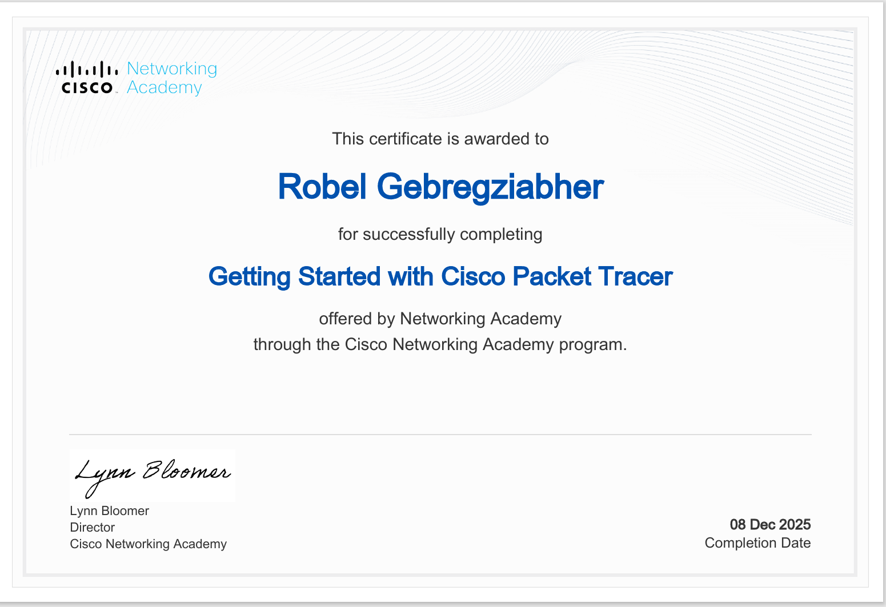

References

[1]B. B. a. V. Singh, "The Evolving Cyber Threat Landscape," in Navigating the intersection of Cybercrime and Cybersecurity. The words wiggle Publications, 2025.
[2]The FATF Report, "Countering Ransomware Financing, 2023," FATF, Paris,France, March 2023.
[3]KonBriefing, "MOVEit hack victim list," Berlin,Germany, 2019.
[4]K. O'Flaherty, "Cloud security: How to detect breaches and stop them quickly," Future Publishing Limited, Quay House, The Ambury, Bath BA1 1UA. All rights reserved. England and Wales company registration number 2008885, published 16 October 2025.
[5]K. Poireualt, "Third of Exploited Vulnerabilities Weaponized Within a Day of Disclosure," Infosecurity Magazine, 30 July 2025.
[6]U. D. o. Commerce, "The NIST Cybersecurity," United States,Washington DC, National Institute of Standards and Technology,his publication is available free of charge from: https://doi.org/10.6028/NIST.CSWP.29, February 26,2024, p. 54.
[7]A. Singh, "Computer Science > Cryptography and Security," 26 July 2025. [Online].
[Accessed 2025]

Appendix A — Board Presentation Power Point (Slides + Notes)

Slides 1
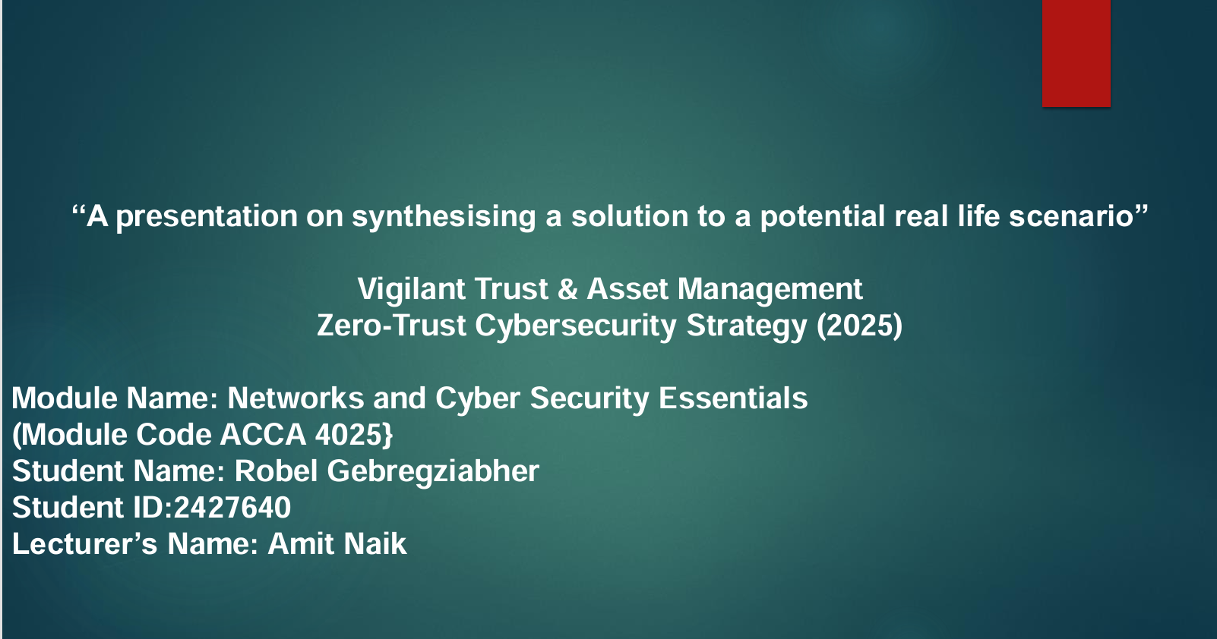

Slides 2

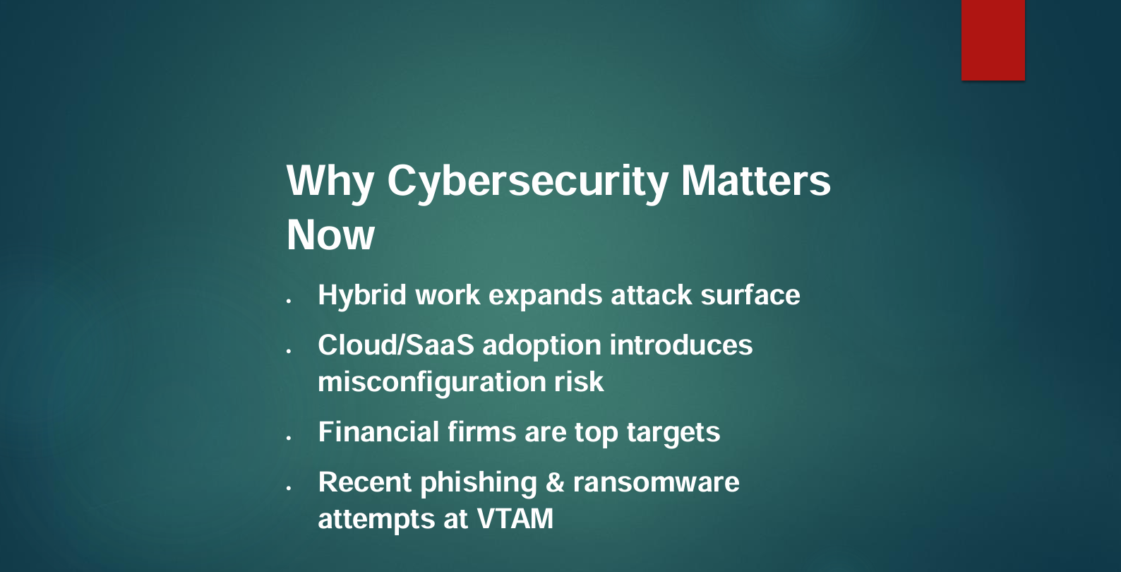

Slides 3

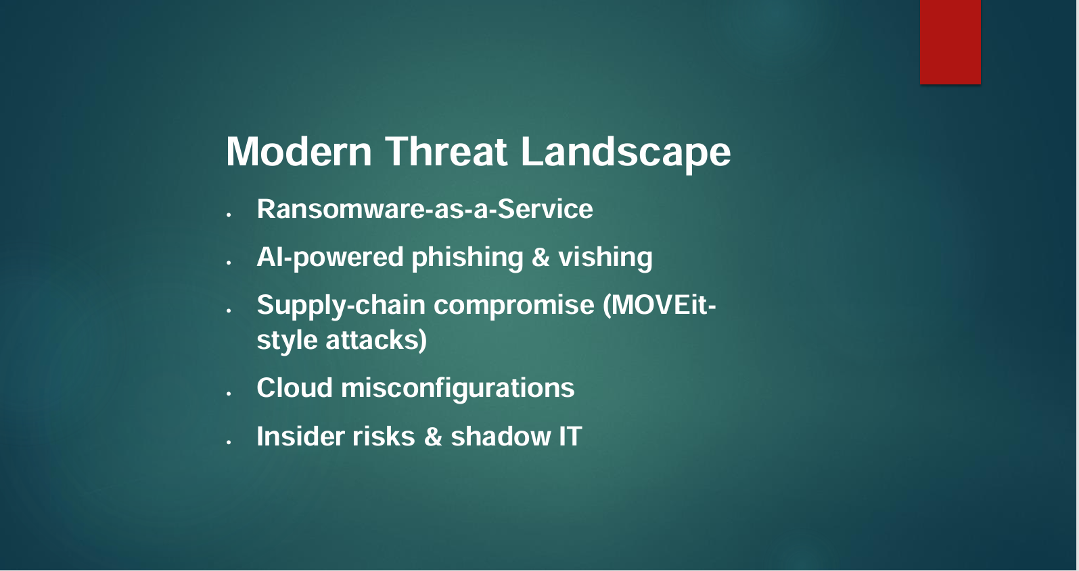

Slides 4
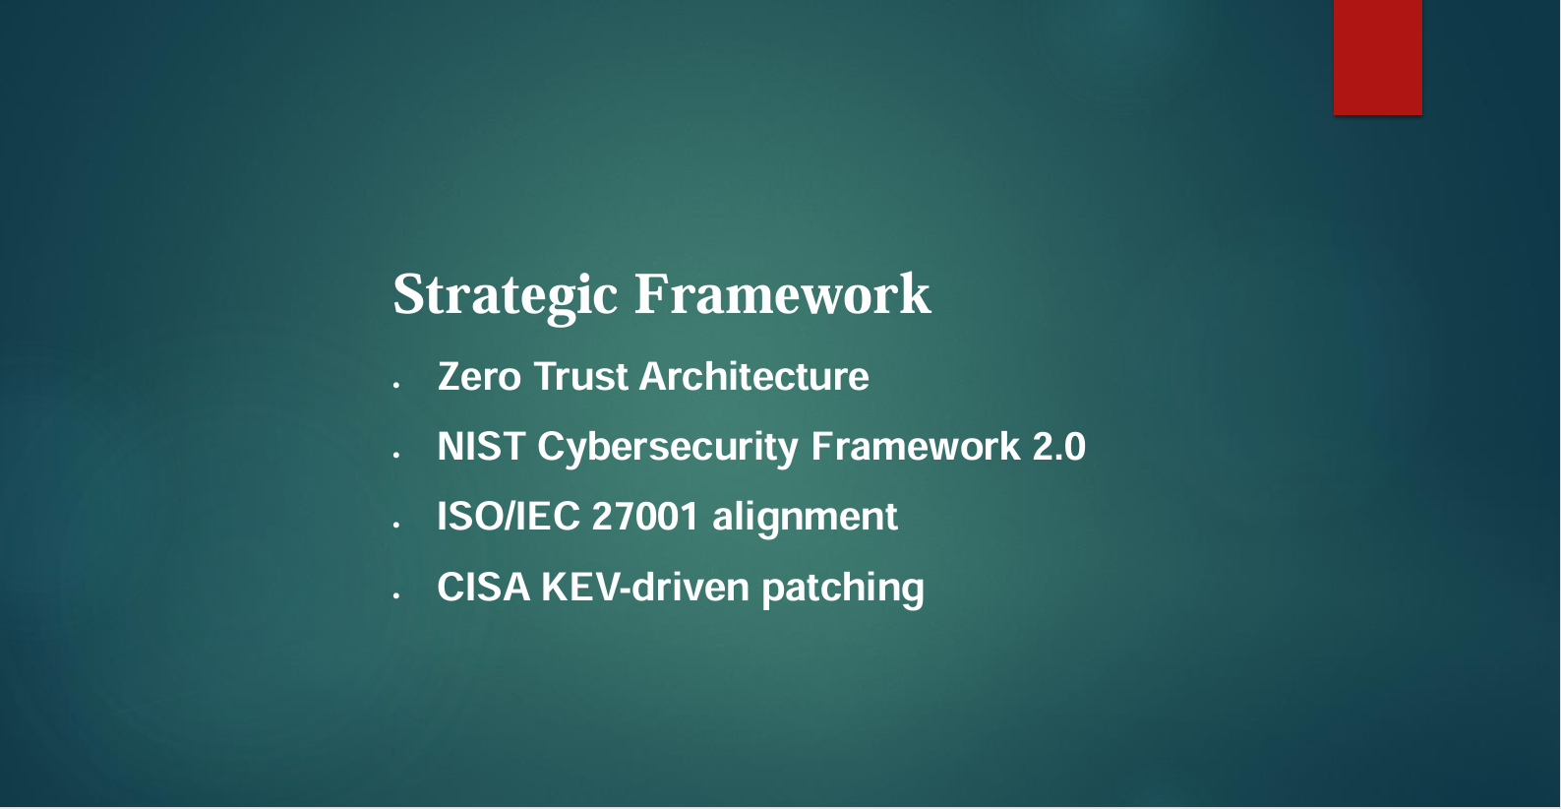

Slides 5

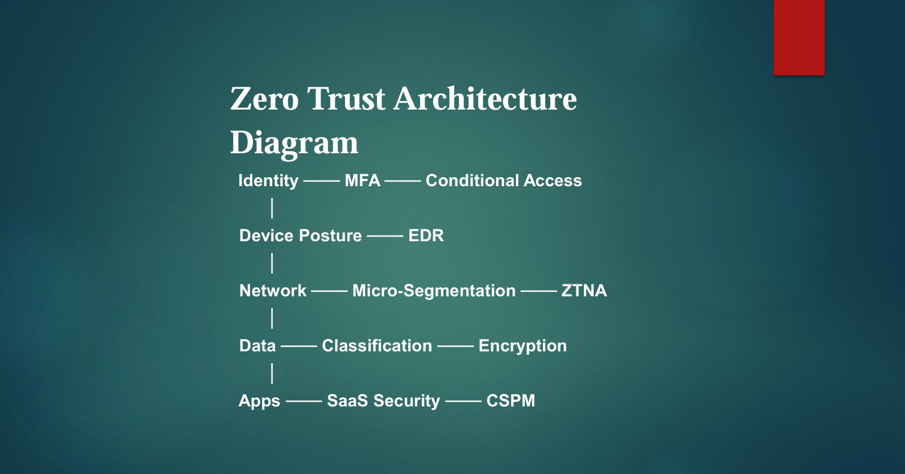

Slides 6

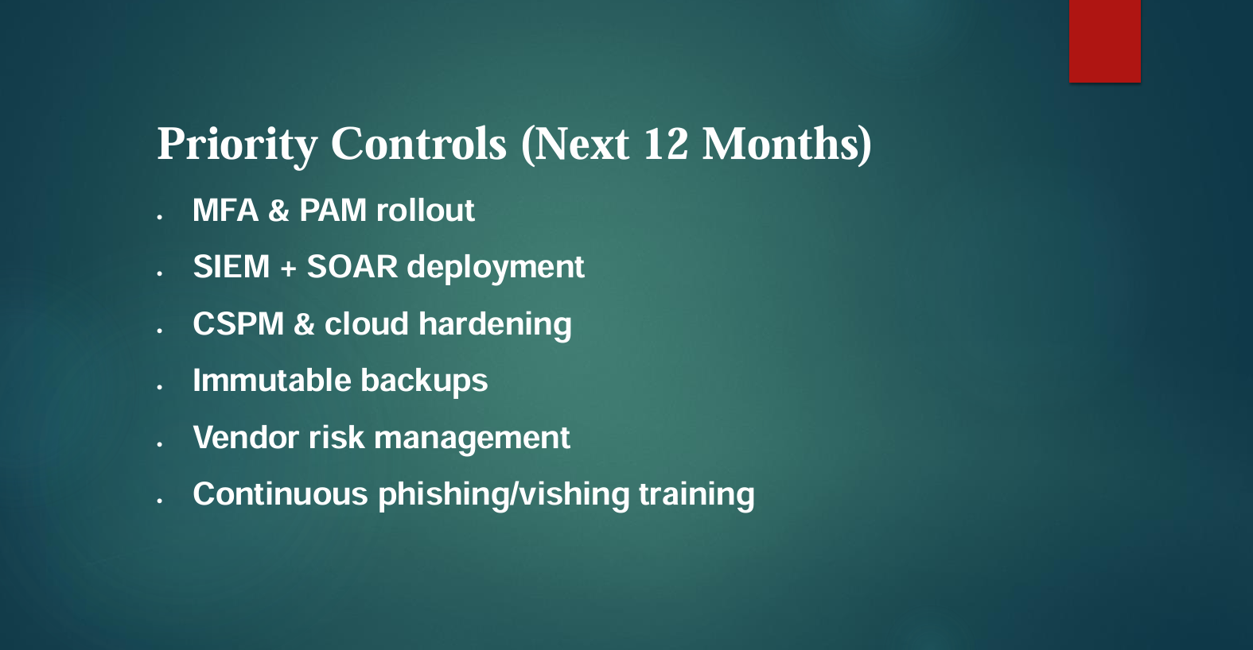

Slides 7

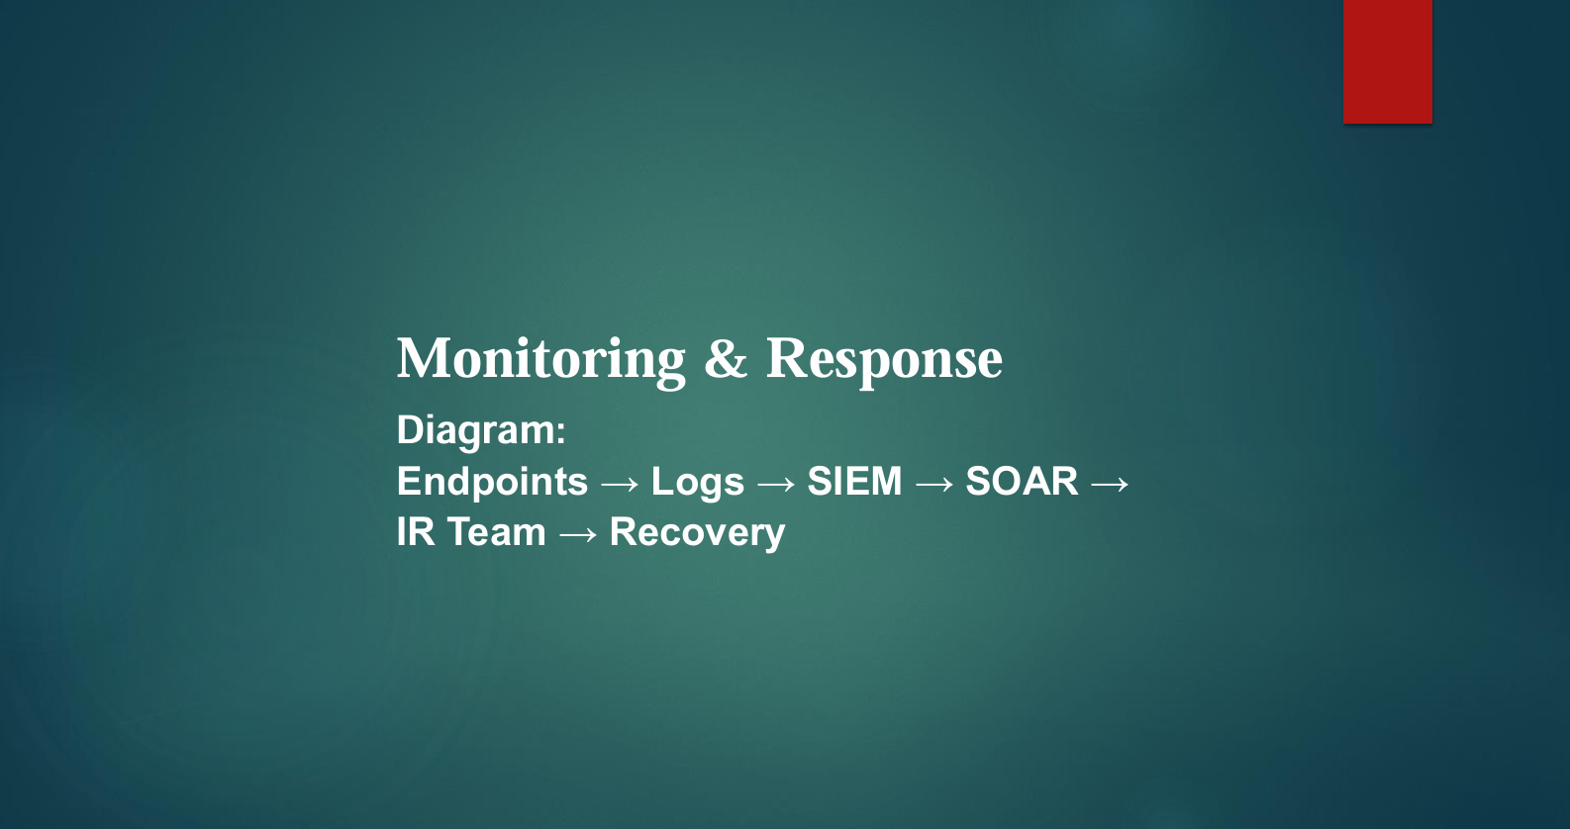
Slides 8

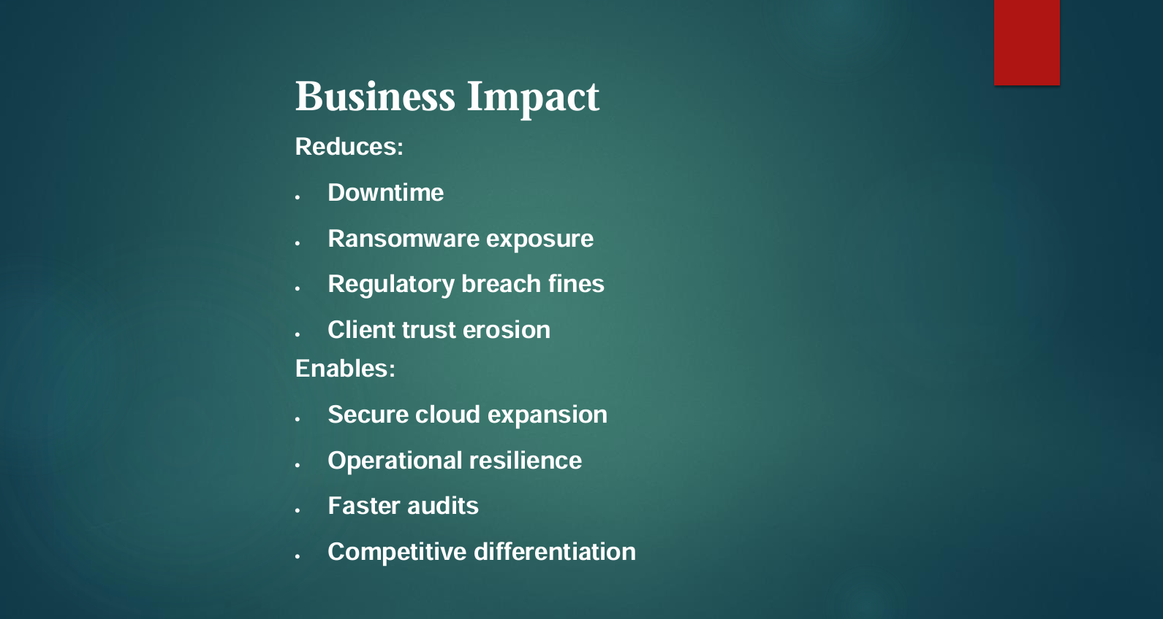

Slides 9

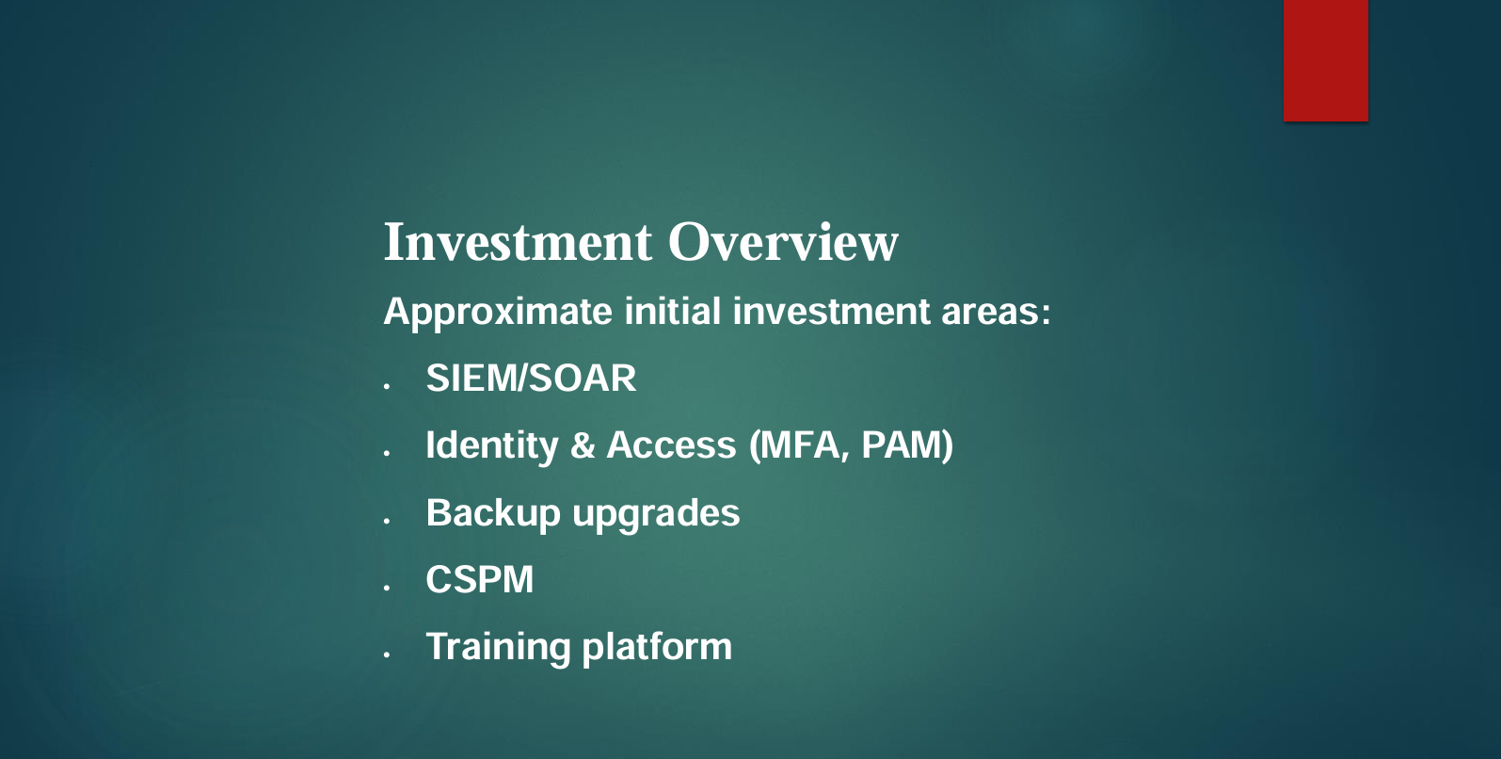

Slides 10

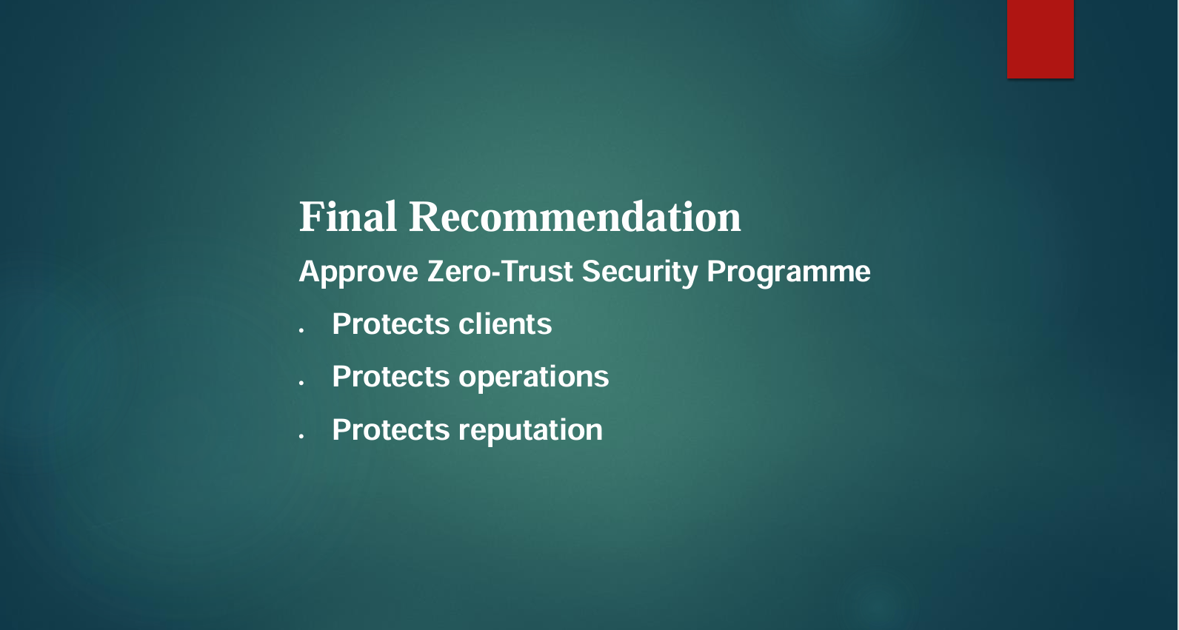

Appendix B — Board Presentation MS Word Sample (Slides + Notes)

Slide 1 — Title
Vigilant Trust & Asset Management
Zero-Trust Cybersecurity Strategy (2025)

Slide 2 — Why Cybersecurity Matters Now
- Hybrid work expands the attack surface.
- Cloud/SaaS adoption introduces misconfiguration risk.
- Financial firms are top targets.
- Recent phishing & ransomware attempts at VTAM

Slide 3 — Modern Threat Landscape
- Ransomware-as-a-Service
- AI-powered phishing & vishing
- Supply-chain compromise (MOVEit-style attacks)
- Cloud misconfigurations
- Insider risks & shadow IT

Slide 4 — Strategic Framework
- Zero Trust Architecture
- NIST Cybersecurity Framework 2.0
- ISO/IEC 27001 alignment
- CISA KEV-driven patching
Zero Trust represents a security mindset that presumes breaches are inevitable and mandates verification of all activities.

Slide 5 — Zero Trust Architecture Diagram
Identity ─── MFA ─── Conditional Access
│
Device Posture ─── EDR
│
Network ─── Micro-Segmentation ─── ZTNA
│
Data ─── Classification ─── Encryption
│
Apps ─── SaaS Security ─── CSPM
This approach restricts lateral movement within the network and facilitates containment of potential breaches.l breaches.

Slide 6 — Priority Controls (Next 12 Months)
- MFA & PAM rollout
- SIEM + SOAR deployment
- CSPM & cloud hardening
- Immutable backups
- Vendor risk management
- Continuous phishing/vishing training
These controls are both pragmatic and deliver significant impact.

Slide 7 — Monitoring & Response
Diagram:
Endpoints → Logs → SIEM → SOAR → IR Team → Recovery
This process substantially reduces attacker dwell time and automates containment procedures.

Slide 8 — Business Impact
Reduces:
- Downtime
- Ransomware exposure
- Regulatory breach fines
- Client trust erosion
Enables:
- Secure cloud expansion
- Operational resilience
- Faster audits
- Competitive differentiation
Speaker Notes:
Security functions as a business enabler rather than solely as a cost center.

Slide 9 — Investment Overview
Approximate initial investment areas:
- SIEM/SOAR
- Identity & Access (MFA, PAM)
- Backup upgrades
- CSPM
- Training. These investments align with the organization's risk appetite and regulatory expectations.

Slide 10 — Final Recommendation
Approve Zero-Trust Security Programme
- Protects clients
- Protects operations
- Protects reputation
- Future-proof. This strategy positions VTAM for secure growth and regulatory resilience. regulatory resilience.

