Programme: MSc Public Health and Social Care in Practice
Module: Health Care System Organisation and Leadership
Module code: LCHS7002
Assignment Title: Case Study Analysis Report
Student name: Vaibhavi Hardik Barot
Student ID number: 2539619
Word count: 5014

Table of Contents
1.0 Introduction 4
1.1 Background 4
1.2 Purpose of the case study 4
1.3 Explanation of what leadership means 4
1.4 Describe centralisation and decentralisation 4
1.5 key leadership theories and styles 5
1.6 Discussion on selecting the right leadership style is important 5
1.7 Report address 5
2. Main Body 6
2.1 Identifying the Problem and Setting the System Context- Applying Systems Thinking and the Rich Picture 6
2.1.1 Defining the Central Problem 6
2.1.2 Establishing the Global and National Significance of the Problem 8
2.1.3 Applying Systems Thinking to the Case Study 9
2.1.4 Identification of System Weaknesses 10
2.1.5 Governance Context 11
2.1.6 Underlying Organisational Challenges 11
2.1.7 Rich Picture: Visualising the System Context 12
2.1.8 Section Summary 13
2.2 Centralisation or Decentralisation within the Case Study 14
2.2.1 Analyse the system structure 14
2.2.2 Centralised system 15
2.2.3 Decentralised system 15
2.2.4 Critical analysis 17
2.3 Leadership Theories and Application to the Case Study 19
2.3.1 Discuss relevant leadership theories 19
2.3.2 Discussion and critical analysis 20
2.4 Improvement and Lessons Learned 23
2.4.1 Critically evaluate how leadership and governance interacted to produce the outcomes 23
2.4.2 Identify missed opportunities 24
2.4.3 Evidence-based solutions 25
2.4.4 Discussion 26
2.4.5 Linking with system structure, feedback and leadership 27
2.4.6 Lesson for other organisations 27
2.4.7 Continuous improvement and accountability 27
3. Recommendations 28
3.1 Strengthening Leadership for Sustainable Patient Safety 28
3.2 Strengthening Clinical Governance and Accountability 28
3.3 Improving Communication and Systems Integration 28
3.4 Enhancing Technical and Allocative Efficiency 29
3.5 Promoting Continuous Learning, Stakeholder Engagement and Co-production 29
3.6 Summary Table 29
4.0 Conclusion 31
4.1 Summarise the main finding 31
4.2 The importance of leadership, governance and system thinking 31
References 32

1.0 Introduction

1.1 Background
This case study-based report focuses on the mentioned case study 2, which mainly focused on an 87-year-old patient admitted to the hospital due to shortness of breath and epistaxis. This case study report was published in 2025 which mainly focused on the fact that the patient was pushed for the anticoagulant apixaban for 10 days due to the delay of scheduled pleural aspiration (HSSIB, 2025). This delay in medication is responsible for fatal ischaemic stroke. This case study's findings mainly cover systemic failure, especially in the acute general medicine (AGM) ward. This also covers resource mismatch along with the absence of senior medical leadership that creates complexity in clinical care settings.

1.2 Purpose of the case study
The purpose of this case study is to explore the leadership and systematic failures that are mainly responsible for medication-related harm. This report has also focused on developing evidence-based improvement in the oversight and governance system, which is mainly responsible for increasing patient safety.

1.3 Explanation of what leadership means
The leadership practice in healthcare is defined as a process of influencing other team members and providing support to meet shared goals. The leaders in healthcare have been involved in delivering evidence to multidisciplinary teams, mainly to manage a complex clinical environment. It is the leader’s responsibility to ensure safety standards and, based on this, deliver necessary care (Fadhel and Alqurs, 2025).

1.4 Describe centralisation and decentralisation
Decentralisation refers to distributing the authority to the local-level clinical team, including ward-based clinical teams. On the other hand, centralisation has been defined as the system where the authority makes the decision and is concentrated within the high hierarchical level, including regulatory standards. Centralisation has been redefined as a range of specialised acute services which are associated with developing care outcomes (Ramsay et al., 2025).

1.5 key leadership theories and styles
The key leadership theories include transformational leaders, transactional leaders, situational leadership, trait theory and behavioural theory. Transformational leaders mainly influence vision-driven practices, whereas transactional leaders support task-oriented practices. Trait theory mainly supports improving the personal quality of leaders.

1.6 Discussion on selecting the right leadership style is important
Choosing the right leadership is highly crucial as they encourage staff and promote psychological safety (Bindel Sibassaha et al., 2025). In the high-pressure environment, the right leaders can make critical decisions with adaptive behaviour.

1.7 Report address
This report mainly covers medication problems with system thinking by analysing leadership theory, organisational structure, and critique response to the medical team.

2. Main Body

2.1 Identifying the Problem and Setting the System Context- Applying Systems Thinking and the Rich Picture

2.1.1 Defining the Central Problem
The main issue identified in the case study is the interruption and failure to restart anticoagulant therapy for an 87-year-old patient. Following repeated delays to the pleural aspiration procedure, anticoagulant therapy remained interrupted and cause preventable ischemic stroke and subsequent death. Anticoagulation was initially withheld because the patient presented with active epistaxis. The absence of clear accountability cause the medication to stay discontinued beyond the clinically appropriate period (Pharmaceutical Pres, 2026). This shows the need for a systematic thinking approach to understand the factors that contribute to adverse healthcare outcomes.
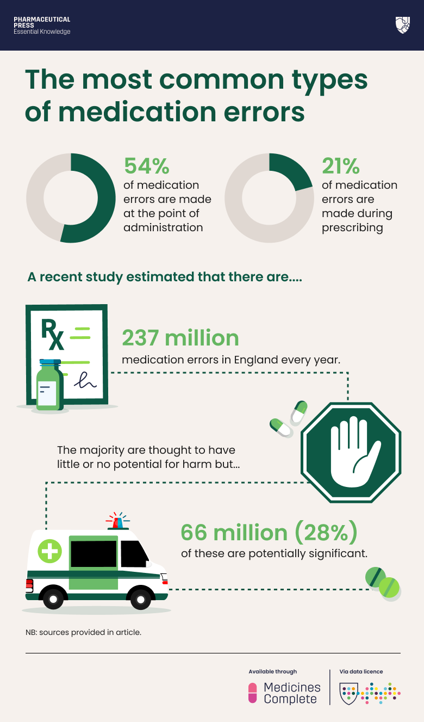
Figure 1: Most common types of medication errors
(Source: Pharmaceutical Pres, 2026)

2.1.2 Establishing the Global and National Significance of the Problem
Source | Latest Statistic | Latest Statistic
World Health Organization (2023) | Almost 1 in 10 patients face harm during healthcare. More than 50% of the incidents are preventable (WHO, 2023). The medication-related harm affects almost 1 in 20 patients. | This shows that the preventable harm to patients reflects the higher global pattern of avoidable harm. This resulted from failure in medication management.
NHS England (2024) | Almost 237 million medication errors occur annually in England (NHS England, 2024). This is almost 66 million considered clinically significant. | This shows that medication-related incidents cause patient safety issues in the NHS. The delayed review and failure to restart the anticoagulation in this case show similar medication management failures.
Health Services Safety Investigations Body (2025) | Annual Report of HSSIB (2025) shows the patient safety risks are related to communication failures. Along with organizational learning in healthcare investigations | This directly reflects the case study, where poor communication, unclear clinical accountability.
Institute for Healthcare Improvement (IHI, 2025) | The IHI shows the improving of patient safety to the total system approach (IHI, 2025). This integrates with the leadership and governance process. | Supports the need for systems thinking in this case, where failures in communication.
Table 1: Example of National and International Data Supporting Problem Analysis
(Source: NHS, 2024; WHO, 2023; HSSIB, 2025)
The described event in the case study reflects on patient safety more broadly. These interruptions and failure to restart the anticoagulant therapy resulted in failures in communication (IHI, 2025). Therefore, this incident within healthcare can show the need for systems thinking related to the factors that contribute to patient outcomes.

2.1.3 Applying Systems Thinking to the Case Study
Application of systems thinking shows that the outcome in the case was not caused by a single clinical mistake. At first, withholding anticoagulant therapy was seen as an effective clinical decisions due to the epistaxis part of the patient (Scherkl et al., 2025). This is not accompanied by proper reassessments; these events reflected on the proper communications and unclear clinical accountability systems. This system is supported by the existing patient safety evidence. As reported by WHO (2023), more than 50% of patient harm is preventable. Medication-related harms affected almost 1 in 10 patients around the world. Similarly, NHS England shows that almost 237 million medication errors occur mostly in England (NHS England, 2024).
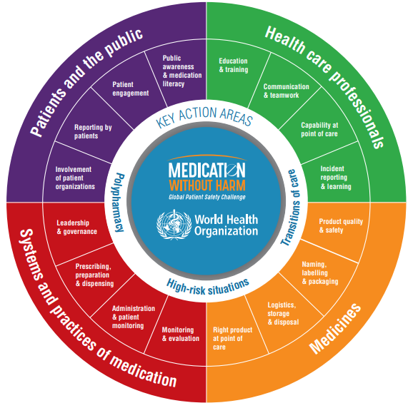
Figure 2: Medication without Harm
(Source: WHO, 2023)

2.1.4 Identification of System Weaknesses
The case study shows several interconnected weaknesses that can contribute to patient outcomes. As opined by Yao et al. (2025), the communication between the multidisciplinary team was affected, resulting in uncertainty. This restarting of the anticoagulant therapy can cause delays. Furthermore, there are limitations with the electronic prescribing systems, and documentation remains a limitation. These weaknesses show that patient safety was compromised by failures related to the organizational process. This highlights the importance of developing integrated safety systems.

2.1.5 Governance Context
This incident reflects that governance failure operates at local, regional and international levels. At the local level, the NHS Trust failed to ensure effective clinical governance and continuous monitoring of the high-risk medicines (Bowditch et al., 2026). Regionally, the patient safety collaborative are responsible for the promotion of quality improvements across the healthcare providers. Nationally, the HSSIB (2025) identified that recurring organizational risks are related to communication and the leadership process. These findings show that effective governance requires the implementation of the national patient safety process.

2.1.6 Underlying Organisational Challenges
There are organizational pressures that increase adverse events. As suggested by Anna Mandziuk (2025), the workforce shortage, patient demand, and operational pressure can reduce the opportunities for medication review. In addition, delays in accessing prolonged the interruptions of the anticoagulant therapy (Anna Mandziuk, 2025). These organizational risks can weaken the safety barriers and increase vulnerability.
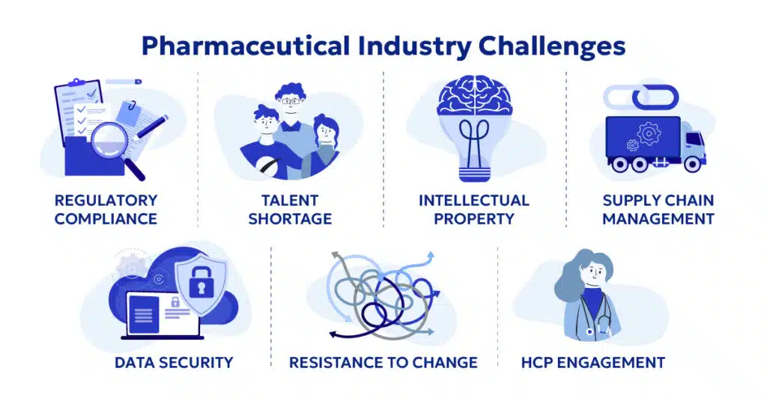
Figure 3: Common Challenges of Pharmaceutical Industry
(Source: Anna Mandziuk, 2025)

2.1.7 Rich Picture: Visualising the System Context
The Rich Picture shows the complex interactions among the organizational structure, healthcare professionals, and healthcare processes. This shows that patient harm can result from the interactions of the multiple systems.
- Actors: Family, patients, nurses, ward doctors, ward managers, respiratory consultants, and the hospital administrators (Guntschnig et al., 2025).
- Processes: Medical prescribing, patient admissions, anticoagulant review and documentation process.
- Feedback loops: These includes the medication reviews, multidisciplinary meetings, incident reports and government audits.
- Emotions: The emotions related to patient anxiety, family stress factors, staff uncertainty, workload pressure and the frustrations related to the delays.
- Structures: NHS trust governance, electronic patient records, clinical policies, staffing arrangements and the national clinical guidance.
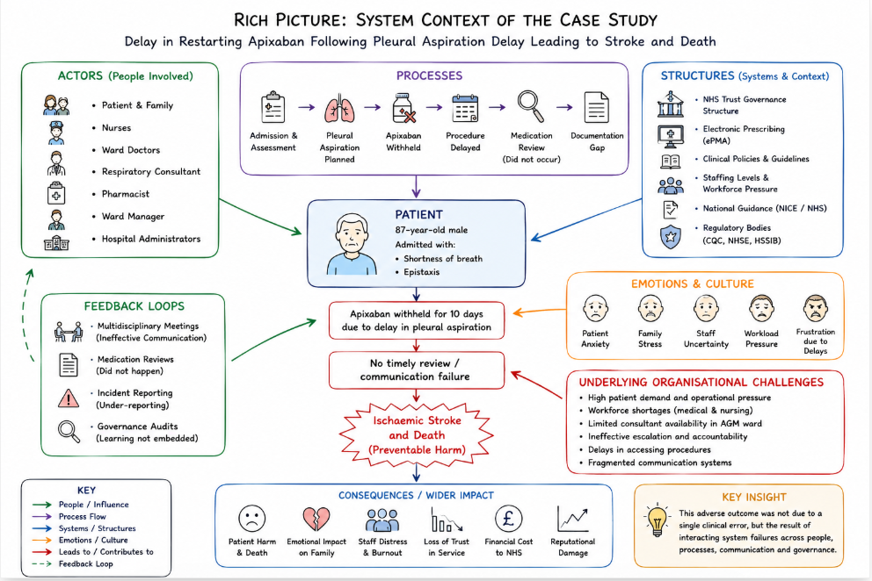
Figure 4: Visual representations of Rich picture
(Source: Self-developed)

2.1.8 Section Summary
This part of the study has shown adverse event resulted from the interconnected organizational and n factors. The application of the “Systems Thinking and the Rich Picture” showed the weakness in governance, communications, and accountability process to improve in future. This developed the foundations for the critical evaluations of the leadership process. This included organizational governance and improvement strategies in these sections.

2.2 Centralisation or Decentralisation within the Case Study

2.2.1 Analyse the system structure
The case study is under investigation for 2024-2025 which is related to a hybrid organisational framework. It mainly adopted a centralised administrative system, which includes Electronic Prescribing and Medicines Administration (ePMA), that supports maintaining the flow of the hospital. However, clinical accountability is considered decentralised at the AGM ward level. This system needs to create a structure for a set boundary regarding the responsibility of professionals in departments. It has been observed that trust has overarching clinical oversight of an electronic record system (EHR), which is mainly responsible for fragmenting the function of the wards. The image below shows that 96% of hospitals adopted electronic health records mainly to maintain secure medical information (Market, 2026).
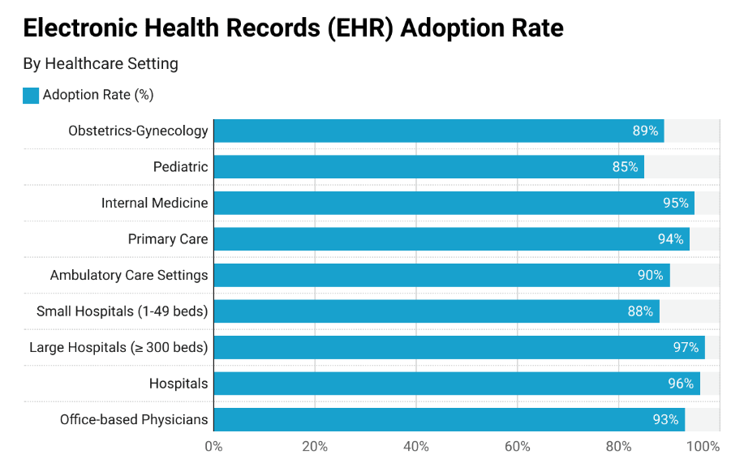
Figure 5: EHR adaptation rate
(Source: Market, 2026)

2.2.2 Centralised system
The way decision-making is concentrated for example
The centralised electronic infrastructure developed by the Trust has been integrated with decision-making practices. For example, the organisation mainly adopts Electronic Prescribing and Medicines Administration (ePMA), which acts as a primary hub for delivering medication orders. EPMA has been used for individual patients to deliver the necessary dose on the ward (Jeffrey et al., 2025). The patient flow is centrally managed by matrons, and collaboration has occurred due to virtual meetings. Through this meeting, they have received the necessary instructions to transform the patients from the emergency department to the speciality ward.
Connecting advantage and disadvantage
Advantage
The benefits of this centralised digital system have shown the instant visibility on the medication status of the patients across departments (Shishkin et al., 2025). This is helpful for the staff to get clear instructions that apixaban has been paused.
Disadvantage
Due to insufficient surface information, the flow of clinical service has been affected. In ePMA, there is a required prompt for automatic work mainly to pause a particular medication; however, due to a lack of instruction, the flaw has been disrupted.
Support discussion with data
The centralised decision-making with bed management has been suffering from total misalignment between the capacity and demand. There was no male respiratory bed available on Day 2 or Day 10. Moreover, due to outdated IT hardware, it is time-consuming and difficult to transfer to a separate module. NHS has focused on digital and technological innovation, which led to 2% employee productivity and 2.6% hospital productivity in FY2026 (NHS, 2026a).

2.2.3 Decentralised system
The way authority is distributed.
The clinical authority of the AGM ward has been distributed among the local clinical teams who have responsibility for documentation and daily assessment (Svensson and von Knorring, 2025). The local clinical team has taken the decision to hold apixaban within the emergency department. However, speciality respiratory consultants have not taken any clinical ownership as they have focused only on the physical needs of the patients. As referred to by Engstrom et al. (2025) stated that a patient needs an individual physical bed rather than a specific specialist. This decentralised approach focuses on tying clinical management to patients' needs.
Connecting advantages and disadvantages
Advantage
This decentralisation is crucial for the ward as it allows the staff to rapidly adjust to the immediate clinical crisis. The nursing coordination role is also beneficial in maintaining the ward miracle and managing the patient flow. In UK healthcare settings, approximately 467,000 nurses and midwives have presented, which is 38% of the total workforce (Nuffield Trust, 2026).
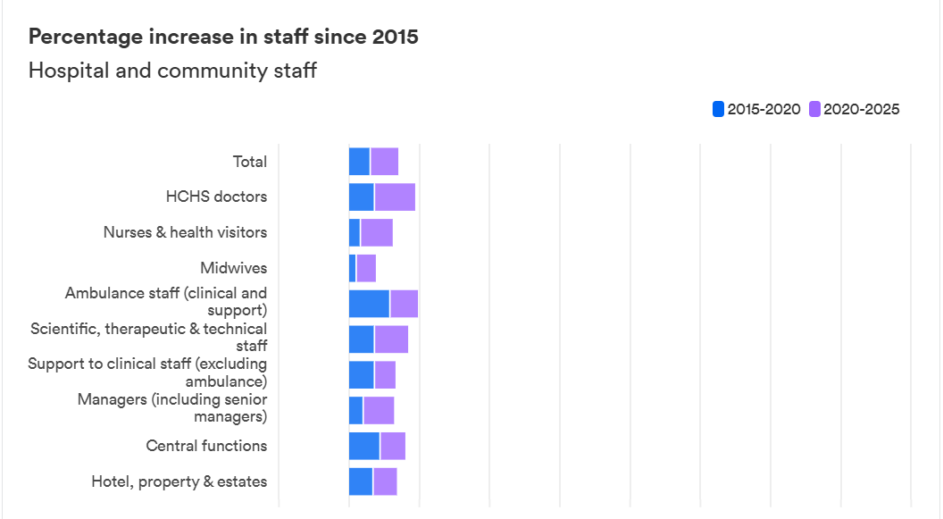
Figure 6: Percentage of nurses and midwives in the UK
(Source: Nuffield Trust, 2026)
Disadvantage
On the other hand, decentralisation is responsible for creating an accountability gap as the speciality team relied on patient referrals when the treatment had been delayed. This mainly creates the complexity as senior professionals mainly avoid taking responsibility for developing a holistic medication plan. Due to a lack of senior leaders within the AGM ward, there was a delay in the complex tasks, such as restarting anticoagulants. Due to inadequate supervision, the resident doctors have also avoided taking responsibility.
Support with discussion
Considering the statistical evidence, the decentralised practice within the ward mainly creates work pressure. The workload is becoming unmanageable due to the decentralised practices, as there is a lack of middle-grade doctors. Due to the staff shortage, the coordination among the professionals has also been compromised in patient care within the AGM ward. For example, as per the image below, in FY2024, 25.9% of staff disagreed with the statement that in the NHS, there are enough staff to manage their job properly. In the same way, ay in the AGM ward, 16.6% of coordinating nurses are not sufficient for maintaining decentralised practices.
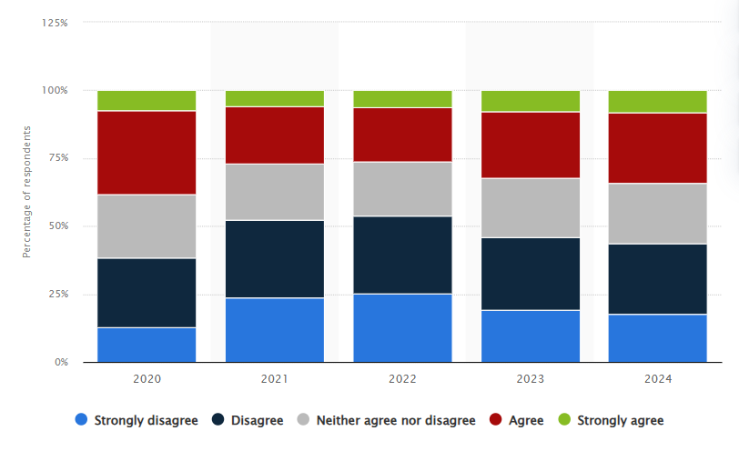
Figure 7: Staff satisfaction rate due to staff shortage
(Source: Statista, 2026)

2.2.4 Critical analysis
As per HSSIB findings, the Trust mainly adopted a hybrid structure, which is fundamentally insufficient for crisis management. In response to the centralised ePMA system, it delivers a visibility and safety approach. However, the management has delivered the necessary prompt related to apixaban, which is responsible for a pause for 10 days. In the same way, decentralised clinical practice has allowed the respiratory team mainly to accept the referral where it is implemented to set the boundaries on responsibilities due to zero input for 10 days. To undermine the policy compliance, it is required to update the interim guideline to improve the safety performance of the Trust.
1:28 staff-patient ratio has been observed along with the presence of only 16.6% nurses, with 3 resident doctors and one consultant. Considering the community health service and NHS England hospitals, the total number of staff has been rapidly increasing from 2018 to 2025, with a 4.4% increase in doctors and a 1.9% increase in nurses (thenhsalliance, 2026). Due to the increasing number of doctors and nurses who are helping to meet the accountability gap. Moreover, this has heavily contributed to increasing local safety as they have ensured high safety priorities. 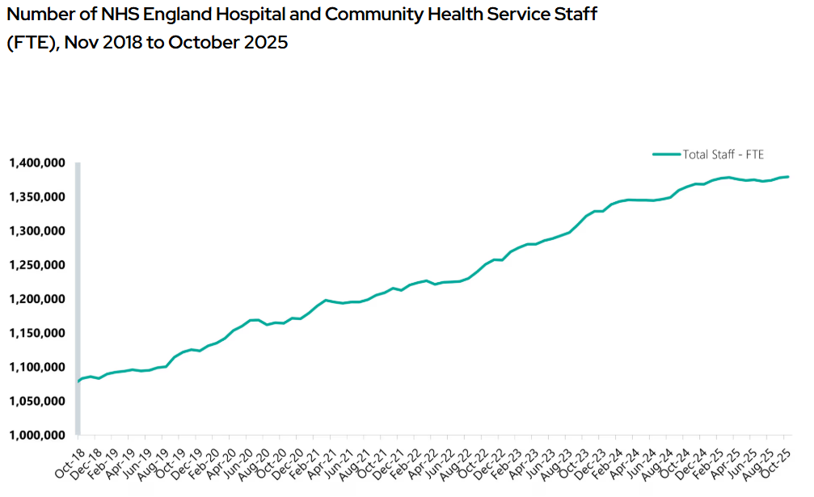
Figure 8: the growth rate of healthcare staff
(Source: thenhsalliance, 2026)

2.3 Leadership Theories and Application to the Case Study

2.3.1 Discuss relevant leadership theories
Leadership in healthcare is the practice of delivering efficient care services along with maintaining patient safety. The table below summarises the key theories and their relevance in 2024-2025 patient service.
Theory/Model | Application example | Supporting data and critique
Transformational Leadership | There's a lack of senior medical leadership in acute general medicine (AGM)  Ward and present of only one consultant for managing the complex situation of 28 patients. | As per the staff survey in the NHS, employee morale has declined as the score was 5.73 in 2024 and in 2025 it was 5.35 (NHS, 2025b)
Situational leadership | Due to the failed leadership, the staff are unable to adapt to the crisis level in the context of a 10-day anticoagulant pause. | 10% employment in the health workforce supports maintaining health resilience for patient recovery (OECD, 2026)
Behavioural | The leaders mainly preferred task-oriented practices; however, they have neglected the communication process with their patients. | The global leaders have adopted a 95% safety standard, 97% of leaders believe in workplace safety, and 64% of leaders believe in safety protocol (Brilliance Security Magazine, 2026).
Trait theory | There is an absence of vision-driven reform within The Trust to implement ePMA safety automatically. | As per the NHS Staff survey (2025), it is observed that the compassionate leadership practice has increased .09% as it was 7.38 for 2024 and 7.47 for 2025 (NHS, 2025b).
Transactional leadership | The team need to remain command-driven practice due to the absence of participatory review. | 1546205 headcounts of staff in NHS by 20,25 which has increased by 1.1% from 2024 (NHS, 2025a).
Table 2: Application of leadership theory
(Source: Self-developed)

2.3.2 Discussion and critical analysis
Justification for selecting appropriate leadership
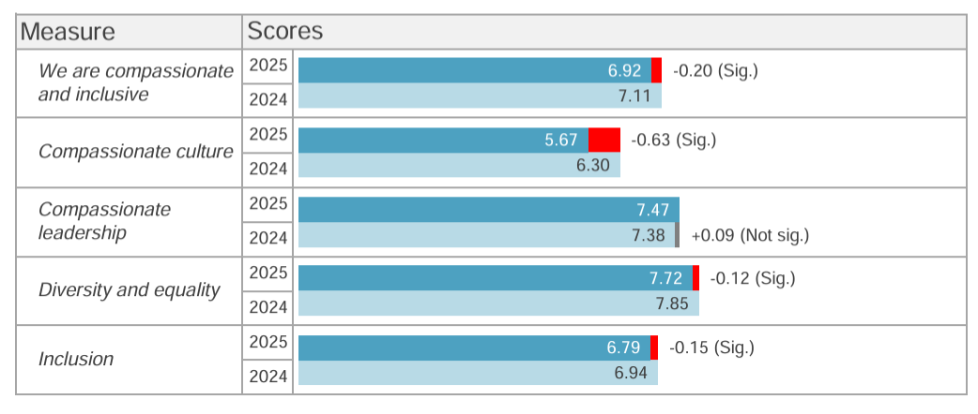
Figure 9: Leadership practice in the NHS
(Source: NHS, 2025b)
Situational leadership style has been selected as appropriate, as the clinical risk mentioned within the case study was dynamic. initial pause in the medication was considered a standard command to control nosebleeds. However, due to changing the situation, the procedure was delayed due to a pause. As referred to by Lindlöf et al. (2025), situation leaders need to address the past conflict and mistakes along with implementing the necessary practical application. To deliver patient care to an 87-year-old patient, the situational leader needs to recognise maturity in the initial phase within the first 3 days. It is highly complex that 3 residential doctors and one consultant have delivered service to 28-30 patients despite a lack of senior leaders. As per the NHS staff survey, compassionate leadership has improved by 0.09 from 2024 to 2025 (NHS, 2025b). The senior staff need to adapt to shifting priorities and show concern for bleeding risk to prevent stroke.
Reactive leaders (command-driven)
Referring to the case study, it is linked with reactive leadership, which involves common-driven. On day 2, the doctor gave instructions to hold apixaban, as the patient only has antiembolism, which is referred to as command-driven practice. The healthcare leaders mainly focus on the reactive approach to offer employee flexibility and wellbeing (Reijmerink et al., 2025). As per the investigation report of the 2025, there is a lack of reassessment in the ongoing decision during the delay in medication of 10 days. Due to this leadership approach, there is an accountability gap among the respiratory and medical teams. Due to a lack of senior staff, the employee's capability to deal with the challenges has declined, which is responsible for delays in medication. However, if the leaders adopt proactive leadership, they can recognise priorities and are mainly triggered by the mandatory review. The proactive leaders are mainly focused on a purpose-driven approach as they have recognised the clinical priority (Haque, 2025). In this case, the leaders need to use automatic ePMA safety prompts to trigger clinical service.
What data reveal about the leadership's effectiveness?
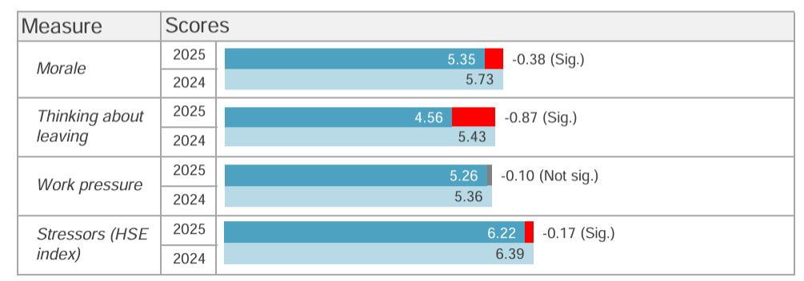
Figure 10: Employee morale in NHS staff
(Source: NHS, 2025b)
As per the investigation, the data reveals there is ineffectiveness in oversight along with an accountability gap. Due to a lack of senior leaders, there is a lack of speciality coordination. For coordinating clinical care, a 4-member nursing team was present, where one acted as coordinator, and the other three nurses delivered care only in the day shift, which accounted for 16.6% (HSSIB, 2025). As per the above image, the staff morale has declined from 2024 to 2025 by 0.38% (NHS, 2025b). Due to this, employee morale has not taken responsibility for patients' health. Moreover, it has also been observed that for operating the ePMA system, the staff have not delivered the necessary prompt, which also signifies a lack of technical leadership. Leaders need to support to improve employee skills equally in non-technical and technical approaches (Lockhart et al., 2025).
What could have been done differently?
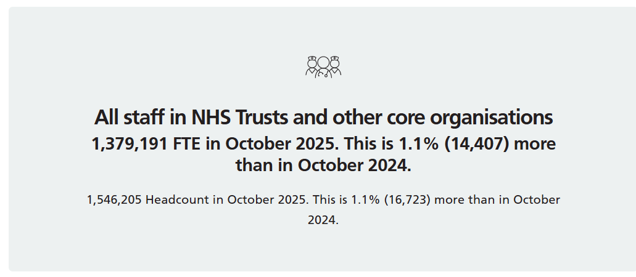
Figure 11: Headcount of NHS staff
(Source: NHS, 2025a)
To improve the condition of clinical outcomes, it is required to implement distributed leadership. Moreover, the Trust needs to hire a specialist nurse who has actively coordinated in complex clinical situations. Moreover, the management needs to support the leaders to increase their emotional intelligence, which supports employee satisfaction and engagement. As referred to by Heikkinen et al. (2026), the train theory has supported leaders to improve emotional intelligence, which potentially supports minimising medication errors. For example, the above image shows that the employee headcount has increased by 1.1% in the NHS, which is evident in employee satisfaction (NHS, 2025a). This leadership style needs to adapt the resident doctors to potentially manage the patient's needs.

2.4 Improvement and Lessons Learned

2.4.1 Critically evaluate how leadership and governance interacted to produce the outcomes
Leadership
Leadership practice within the AGM ward was overstretched and reactive due to an insufficient number of senior leaders, creating complex task execution. Only one consultant specialist has to manage approximately 30 critical patients, which occurs with transactional rather than proactive management. The resident doctors have mainly prioritised the task-oriented practice, which is managing the paper handover system. Due to a lack of senior supervision, they have mainly neglected patient care and patient needs. As referred to by Ceyhu et al. (2025), it is highly required to empower residential doctors to meet the clinical demands of the patients. Due to the failure of leadership, the clinical risk has been adopted and results in shifting the patient’s condition from bleeding to stroke.
Governance
The governance structure of the trust was rigid and fragmented as they impose boundaries on the departmental responsibilities. The limited responsibility of the professional was responsible for creating the service gap as the respiratory team had referred the proactive input to meet the patient's physical needs; however, there was insufficient bed space in the AGM ward. In this insight, the UK government has announced it will invest £450 million in emergency and urgent care facilities. They have a focus to increase 900 new beds for 30 NHS trusts (Healthcare Today, 2025). This will be helpful for this Trust to maintain patient flow in a centralised practice.
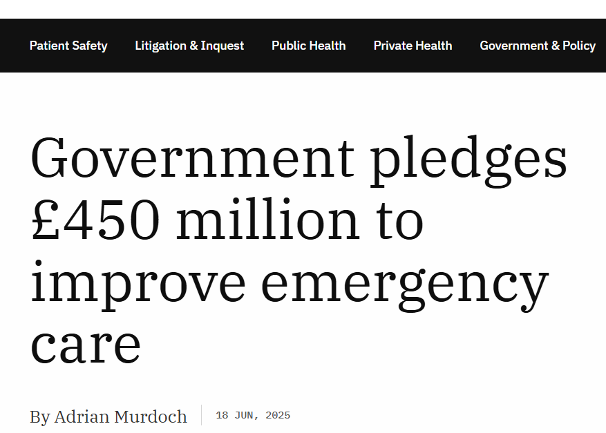
Figure 12: Evidence to invest in emergency care
(Source: healthcaretoday, 2025)

2.4.2 Identify missed opportunities
It was primarily observed that the missed opportunities were due to the absence of a reassessment mechanism which led to a pause in apixaban. Due to holding this decision, the doctors were never revisited and the error was continued for 10 days. An insufficient number of surgical and clinical leaders are mainly responsible for malpractice and medical error (Waters et al., 2025). Moreover, the communication gap among the departments is also responsible for lower coordination in patient care (Meneses-La-Riva et al., 2025).

2.4.3 Evidence-based solutions
Problem | Evidence | Improve strategy
High risk in paused medication | Medication irregularity for a constructive 10 days increases the risk of side effects like ischemic stroke among 5-50% of users (Pharmeasy, 2026). | Implementation of ePMA safety prompts
Unviable task management | Approximately 189 NHS hospital trusts across England currently use a computerised system (NHS, 2026b). | Set mandatory on speciality review
Outdated guideline | In 2023, the digital transformation rate in global health was USD 67.15 billion, and it is expected to increase by 14.6%, reaching USD 262.44 billion by 2032 (Zion Market Research, 2026) | Centralised digital system
Oversight of the fragmented speciality | Related to the case study, there was 0 input from the specialist consultant during the 10 days. | Set the mandatory principle on the speciality review
Table 3: Problem with improvement strategy
(Source: Self-developed)
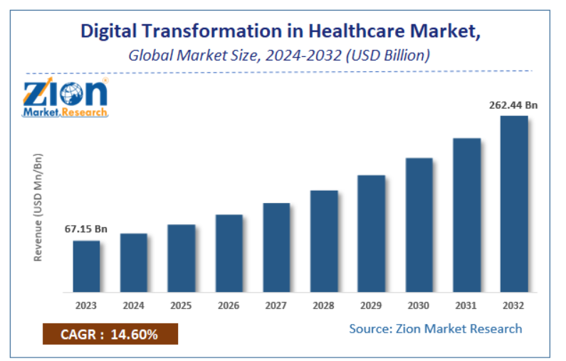
Figure 13: Digital transformation in global health
(Source: Zion Market Research, 2026)
To overcome the challenges, an evidence-based solution is highly required to implement technical efficiency instead of manual tracking. It is required to implement ePMA safety prompts for the automated services, mainly to control high risk through the pausing of medication. EPMA is responsible for managing workload as it helps to restock and order CDs automatically (Walsh et al., 2025). The above image shows that the digital transformation market in UK healthcare has been strengthened as it increases 14.6% from 2023 to 2032 (Zion Market Research, 2026).

2.4.4 Discussion
10-day medication pause is considered a central problem within the Trust, which increases the risk of stroke for the 87-year-old patient. This has occurred due to a lack of a feedback loop, which mainly confirmed the planned restart. Due to high negligence, the resident doctor was responsible for the failure of clinical management, as the doctors had prescribed apixaban from Day 11. To overcome the challenges, the solution strategy has been developed based on digital reporting and local empowerment. These are effective in bridging the accountability gap between the imagined work and the work as done. As per the above finding in leadership practice, 64% of leaders believe in the current protocol, and 97% of leaders prioritise safety (NHS, 2025a). In this case, purpose-driven leadership is crucial to increase clinical priority and focus to prevent catastrophic outcomes (Zhu, 2025).

2.4.5 Linking with system structure, feedback and leadership
To hinder the feedback loop, a hybrid system structure is crucial. Hybrid system structure allows for locally processed data, which allows for distributed decision-making (Almadani et al., 2025). Feedback existence was zero as there was a lack of routine medical review that had occurred in the AGM ward. A command-driven leadership approach is justified to fix the stroke risk.

2.4.6 Lesson for other organisations
The key lesson that has been adopted for other organisations is that clinical risk needs to be reassessed daily, and the system should be designed based on individual heroism. Mandatory review by the senior professionals is supportive in addressing the critical gap (Nesengani et al., 2025). The organisation needs to set an internal medication guideline to avoid a fatal outcome.

2.4.7 Continuous improvement and accountability
Implementation of a regulatory framework and a safety hurdle has support to meet the accountability gap (Ghoul et al., 2025). The Trust will be required to give priority to computerised work instead of paperwork to avoid manual errors and save time.

3. Recommendations

3.1 Strengthening Leadership for Sustainable Patient Safety
The NHS Trust needs to adopt the transformational leadership process to develop the patient safety aspects. As suggested by Agius et al. (2025), this further helps to enhance the multidisciplinary collaborations as well. The senior leaders need to be more visible within the AGM wards. This ensures the timely decision-making process in high-risk medications such as anticoagulants. The transformational leadership promotes psychological safety, empowerment, and the accountability process. These help to reduce the likelihood of communication failures (Bhaladhare and Rishipathak, 2025). The NHS Staff survey showed an improvement in the leadership score of 7.38 in 2024 to 7.47 in 2025. This shows the supportive leadership process and influences the staff engagement aspects.

3.2 Strengthening Clinical Governance and Accountability
Clinical governance needs to be developed with a clear accountability process for reviewing. This standard anticoagulation process reviews procedural delays and routine medication safety. As suggested by Khatri et al. (2025), the Health Service Safety Investigation Body further continues to identify failures in communication. They also work on the weak organizational learning factors. Furthermore, the governance systems need to use the real-time monitoring process. Therefore, the governance systems need to incorporate a real-time monitoring process. This is supported by the executive oversight and the default reporting process to the Trust's patient safety committee. These measures help to improve compliance with the national patient safety standards.

3.3 Improving Communication and Systems Integration
The communications between the multidisciplinary systems need to be enhanced with the daily safety process. These automated electronic alerts need to notify the clinicians when the therapy has been determined beyond the recommended clinical timeframes. As per WHO (2023), medication-related harm affects almost 1 in 10 patients worldwide. While more than 50% of the patient harm is preventable. As suggested by Kuswari et al. (2025), the implementation of digital clinical decision support systems. These would develop the information sharing process and enhance care and reduce medication-related events.

3.4 Enhancing Technical and Allocative Efficiency
The organization needs to improve the technical and allocative efficiency by optimising the workforce deployment. As opined by Luo et al. (2026), this reduces the procedural delays and enhances the medication review process. The dedicated anticoagulation pathways help to schedule the system monitoring process. The NHS workforce exceeded 1.54 million staff. This shows that workforce growth continues. Moreover, staffing pressure remains and is distributed unevenly across the clinical services. More effective allocations and digital resources enhance the service delivery process. This reduces the delay process and improves patient safety.

3.5 Promoting Continuous Learning, Stakeholder Engagement and Co-production
Proper organizational learning needs to be embedded with regular patient safety and multidisciplinary exercises. From the HSSIB investigations, this needs to be incorporated into the local quality improvement programmes. As suggested by Gebremeskel et al. (2025), the organizations should emphasize learning health systems and collaborative governance processes. This can enhance patient safety by developing the workforce capabilities and resilience of the organizations. The culture of continuous learning can enable sustainable improvements in the medication safety process.

3.6 Summary Table
Recommendation Area | Key Action | Expected Outcome
Leadership | Adopt the transformational and situational leadership process. | Enhance the patient safety culture and the higher collaboration process.
Governance | Use the standardised anticoagulation protocols. | Reduce medication omissions to enhance governance
Communication & Systems Integration | Maintain the daily safety process and SBAR communications. | Develop communications and the medication review process.
Technical & Allocative Efficiency | Use workforce deployment and the digital scheduling systems. | Decrease delays and ensure resource utilisation.
Continuous Learning & Co-production | Deliver proper patient safety. | Sustainable quality improvement
Table 4: Summary of recommendations and outcomes
(Source: Self-developed)

4.0 Conclusion

4.1 Summarise the main finding
Focusing on the critical analysis of case study 2 has demonstrated the death of an 87-year-old patient due to the leadership and systematic failure instead of a medical error. The primary finding reveals that a 10-day pause of apixaban, which was unintended, occurred as the residential doctors exceeded the national guidelines. This is responsible for a fatal stroke in the 87-year-old patient. Due to the failure of key leadership, a reactive, command-driven approach is mainly driven. There is a lack of leaders in the AGM ward; the employees lack the capacity to deal with the patients' situation. As the initial instruction for holding the medication became a static directive, it has minimised proactive reassessment. Moreover, another issue observed in days 3- 10 was that there was zero availability of male respiratory beds. Due to high workload pressure among the staff, as 1 consultant, 3 resident doctors, and 4 coordinating nurses oversaw the execution of tasks. Due to fragmentation of governance, a significant accountability gap was created where respiratory specialists have not delivered significant clinical input. Moreover, due to insufficient system information, the ePMA system failed to meet its medical act, which declined the operational resilience.

4.2 The importance of leadership, governance and system thinking
To improve system thinking within Trust, a sustainable leadership approach will be required to build. This has supported an individual to address the failure of an interconnected system which is related to communication, demand capacity and organisational structure. For improving the leadership actions, the management needs to implement a purpose-driven style, situational leadership, mainly to trigger cultural changes within Trust. These leaders will empower the multidisciplinary teams by maintaining psychological safety and distributed authority.

References
Provided
HSSIB (2025) Medication not given: anticoagulation before and after a procedure, Available at: https://www.hssib.org.uk/patient-safety-investigations/medication-related-harm/second-investigation-report/pdf/?utm_source=chatgpt.com. [Accessed on: 3rd July, 2026]
Others
Agius, S., Cassar, V., Bezzina, F. and Topham, L., (2025). Leveraging digital technologies to enhance patient safety. Health and Technology, 15(6), pp.1053-1063. https://link.springer.com/content/pdf/10.1007/s12553-025-01001-6.pdf
Almadani, B., Kaisar, H., Thoker, I.R. and Aliyu, F., (2025). A systematic survey of distributed decision support systems in healthcare. Systems, 13(3), p.157. https://www.mdpi.com/2079-8954/13/3/157.
Anna Mandziuk, (2025). TOP Challenges Facing the Pharmaceutical Industry in 2025. Available at: https://viseven.com/pharmaceutical-industry-challenges/ [Accessed on: 3rd July, 2026]
Bhaladhare, R. and Rishipathak, P., 2025. Strategies of quality improvement in healthcare organizations on sustainable healthcare system. Discover Social Science and Health, 5(1), p.74. https://link.springer.com/content/pdf/10.1007/s44155-025-00226-0.pdf
Bindel Sibassaha, J.L., Pea-Assounga, J.B.B. and Bambi, P.D.R., (2025). Influence of digital transformation on employee innovative behavior: roles of challenging appraisal, organizational culture support, and transformational leadership style. Frontiers in Psychology, 16, p.1532977.https://www.frontiersin.org/journals/psychology/articles/10.3389/fpsyg.2025.1532977/pdf.
Bowditch, L., Molloy, C., King, B., Abedi, M., Jackson, S., Bierbaum, M., Yu, Y., Raggett, L., Salmon, P., Braithwaite, J. and Westbrook, J.I., (2026). Do patient safety incident investigations align with systems thinking? An analysis of contributing factors and recommendations. BMJ Quality & Safety, 35(7), pp.443-455. https://qualitysafety.bmj.com/content/qhc/35/7/443.full.pdf
Brilliancesecuritymagazine (2026) Majority of Safety Leaders Plan to Boost Budgets, Training as Workplace Incidents Persist: Global Survey, Available at: https://brilliancesecuritymagazine.com/press-release/majority-of-safety-leaders-plan-to-boost-budgets-training-as-workplace-incidents-persist-global-survey/.[Accessed on: 3rd July, 2026]
Ceyhun Peker, A.G., Deryal, G.N., Sarıca Çevik, H. and Ungan, M., (2025). Empowering medical residency training: a comparative analysis for understanding outpatient clinic demand and training needs. BMC Medical Education, 25(1), p.454. https://link.springer.com/content/pdf/10.1186/s12909-025-06994-2.pdf.
Engstrom, T., Petrie, C., Perez, W.P., Sullivan, C. and Pole, J.D., (2025). One Size Fits None. How can we do better? using patient reported experience measure findings to drive local quality improvement across wards in a large Australian metropolitan hospital. International Journal of Medical Informatics, p.106078. https://www.researchgate.net/profile/Teyl_Engstrom2/publication/394463631_One_Size_Fits_None_How_can_we_do_better_using_patient_reported_experience_measure_findings_to_drive_local_quality_improvement_across_wards_in_a_large_Australian_metropolitan_hospital/links/68a327567984e374ace9652a/One-Size-Fits-None-How-can-we-do-better-using-patient-reported-experience-measure-findings-to-drive-local-quality-improvement-across-wards-in-a-large-Australian-metropolitan-hospital.pdf.
Fadhel, R. and Alqurs, A., (2025). Enhancing occupational health and safety through strategic leadership: the mediating role of total quality management in Hodeida Hospitals, Yemen. Risk Management and Healthcare Policy, pp.823-842. https://www.tandfonline.com/doi/pdf/10.2147/RMHP.S506296.
Gebremeskel, A.T., Udenigwe, O., Etowa, J. and Yaya, S., (2025). Transforming multi-stakeholder engagement towards coproduction of optimized maternal, newborn, and child health and a resilient community health system in rural Ethiopia: A qualitative study. Plos one, 20(8), p.e0330159. https://journals.plos.org/plosone/article/file?id=10.1371/journal.pone.0330159&type=printable
Ghoul, I., Abdullah, A., Awwad, F. and Dardas, L.A., (2025). Safety huddle in healthcare settings: a concept analysis. BMC Health Services Research, 25(1), p.393. https://link.springer.com/content/pdf/10.1186/s12913-025-12526-x.pdf.
Guntschnig, S., Barbosa, R., Jenzer, H., Greening, M., Hayde, J., Heery, H., Serrano, M.C.I., Lajtmanová, K., Rossin, E., Tentova-Peceva, S. and Kohl, S., (2025). Tackling medication errors: how a systems approach improves patient safety. European Journal of Hospital Pharmacy. https://ejhp.bmj.com/content/early/2025/04/30/ejhpharm-2025-004533?versioned=true
Haque, A., (2025). Responsible artificial intelligence (AI) in healthcare: a paradigm shift in leadership and strategic management. Leadership in Health Services, 38(4), pp.644-656.https://www.emerald.com/lhs/article-pdf/38/4/644/10190898/lhs-01-2025-0018en.pdf.
Healthcaretoday (2025) Government pledges £450 million to improve emergency care, Available at: https://healthcaretoday.com/article/government-pledges-450-million-to-improve-emergency-care. [Accessed on: 3rd July, 2026]
Heikkinen, H., Kuha, S. and Kanste, O., (2026). Exploring the core of emotional intelligence in healthcare leadership: a concept analysis. Journal of Advanced Nursing, 82(2), pp.1760-1774. https://www.researchgate.net/profile/Suvi-Kuha/publication/391523824_Exploring_the_Core_of_Emotional_Intelligence_in_Healthcare_Leadership_A_Concept_Analysis/links/681d9470df0e3f544f531e90/Exploring-the-Core-of-Emotional-Intelligence-in-Healthcare-Leadership-A-Concept-Analysis.pdf.
HSSIB, (2025). HSSIB annual report and accounts: 2024 to 2025. Available at: https://www.gov.uk/government/publications/hssib-annual-report-and-accounts-2024-to-2025 [Accessed on: 3rd July, 2026]
IHI, (2025) Patient Safety, Available at: https://www.ihi.org/library/topics/patient-safety [Accessed on: 3rd July, 2026]
Jeffrey, E., Walsh, Á. and Lai, K., (2025). Automated dispensing cabinets and the effect on omitted doses of ward stock medicines; can implementation reduce delays to first dose antimicrobials?. Exploratory Research in Clinical and Social Pharmacy, 18, p.100583. https://www.sciencedirect.com/science/article/pii/S2667276625000241.
Khatri, R.B., Endalamaw, A., Erku, D., Wolka, E., Nigatu, F., Zewdie, A. and Assefa, Y., (2025). Contribution of health system governance in delivering primary health care services for universal health coverage: A scoping review. PloS One, 20(2), p.e0318244. https://journals.plos.org/plosone/article/file?id=10.1371/journal.pone.0318244&type=printable
Kuswari, M., Gantino, R. and Maratis, J., (2025). Maximizing healthcare service information system: Understanding the influence of integration on efficiency. ADI Journal on Recent Innovation, 6(2), pp.108-117. https://adi-journal.org/index.php/ajri/article/download/1145/794
Lindlöf, H., Savage, C., Härenstam, K.P. and Vicente, V., (2025). Location-independent leadership: managers’ experiences leading prehospital emergency care in Sweden–a qualitative study. BMC Health Services Research, 25(1), p.265. https://link.springer.com/content/pdf/10.1186/s12913-025-12433-1.pdf.
Lockhart, A., Walker, T. and Bowles, K.A., (2025). A qualitative study on the relationship between leadership and clinical skills in paramedicine and the promotion of patient safety. Paramedicine, 22(1), pp.6-18. https://journals.sagepub.com/doi/pdf/10.1177/27536386241259739.
Luo, L., Wang, H. and Jiang, L., (2026). Allocative Efficiency and Distributive Equity in Healthcare Resource Allocation: A Multiregional Comparative Study of China’s Guangxi Region with AI-Enhanced Insights. International Journal of High Speed Electronics and Systems, 35(04), p.2540623. https://www.worldscientific.com/doi/pdf/10.1142/S0129156425406230
Market (2026) Electronic Health Records Statistics By Healthcare, Data, Management (2026), Available at: https://media.market.us/electronic-health-records-statistics/.[Accessed on: 3rd July, 2026]
Meneses-La-Riva, M.E., Fernández-Bedoya, V.H., Suyo-Vega, J.A., Ocupa-Cabrera, H.G., Grijalva-Salazar, R.V. and Ocupa-Meneses, G.D.D., (2025). Enhancing healthcare efficiency: the relationship between effective communication and teamwork among nurses in Peru. Nursing Reports, 15(2), p.59. https://www.mdpi.com/2039-4403/15/2/59.
Nesengani, T.V., Downing, C. and ten Ham-Baloyi, W., (2025). Barriers to effective patient care as experienced by nurses in primary healthcare clinics in African countries: a systematic review of qualitative studies. BMC nursing, 24(1), p.232. https://link.springer.com/content/pdf/10.1186/s12912-025-02877-5.pdf.
NHS (2025a) NHS Workforce Statistics - October 2025, Available at: https://digital.nhs.uk/data-and-information/publications/statistical/nhs-workforce-statistics/october-2025. [Accessed on: 3rd July, 2026]
NHS (2025b) 2025 NHS England Staff Survey Summary Report, Available at: https://www.england.nhs.uk/wp-content/uploads/2026/03/nhs-england-staff-survey-results-2025-summary-report.pdf.[Accessed on: 3rd July, 2026]
NHS (2026) Performance report, Available at: https://www.england.nhs.uk/long-read/performance-report-24-25/.[Accessed on: 3rd July, 2026]
NHS (2026a) Productivity plan – update, Available at: https://www.england.nhs.uk/long-read/productivity-plan-update/.[Accessed on: 3rd July, 2026]
NHS (2026b) Digital transformation, Available at: https://www.england.nhs.uk/digitaltechnology/.[Accessed on: 3rd July, 2026]
NHS England, (2024). Medication safety. Available at: https://www.england.nhs.uk/patient-safety/patient-safety-insight/patient-safety-alerts/enduring-standards/standards-that-remain-valid/medication-safety/ [Accessed on: 3rd July, 2026]
Nuffieldtrust (2026) The NHS workforce in numbers, Available at: https://www.nuffieldtrust.org.uk/resource/the-nhs-workforce-in-numbers.[Accessed on: 3rd July, 2026]
OECD (2026) Health, Available at: https://www.oecd.org/content/dam/oecd/en/topics/policy-sub-issues/health-system-performance/health-brochure.pdf. [Accessed on: 3rd July, 2026]
Pharmaceutical Press, (2026). What are the most common types of medication errors? Available at: https://www.pharmaceuticalpress.com/insights/article/what-are-the-most-common-types-of-medication-errors/ [Accessed on: 3rd July, 2026]
Pharmeasy (2026) Pause 500 Tablet, Available at: https://pharmeasy.in/online-medicine-order/pause-500mg-tablet-9287.[Accessed on: 3rd July, 2026]
Ramsay, A.I., Ramsay, A., Tomini, S.M., Tomini, S., Gandhi, S., Fulop, N.J., Fulop, N. and Morris, S., (2025). Centralisation of specialised healthcare services: a scoping review of definitions, types, and impact on outcomes. Health and Social Care Delivery Research, (43), pp.1-70. https://journalslibrary.nihr.ac.uk/hsdr/published-articles/REMD6648.
Reijmerink, I.M., van der Laan, M.J., Scheele, F. and Wietasch, J.G., (2025). Perspectives and Practices of Healthcare Leaders in Supporting Healthcare Worker Well-Being: A Reality Check. Journal of healthcare leadership, pp.1-11. https://www.tandfonline.com/doi/pdf/10.2147/JHL.S475811.
Scherkl, C., Dierkes, T., Metzner, M., Czock, D., Seidling, H.M., Haefeli, W.E. and Meid, A.D., (2025). . Towards a prescribing monitoring system for medication safety evaluation within electronic health records: a scoping review. BMC Medical Informatics and Decision Making, 25(1), p.244. https://link.springer.com/content/pdf/10.1186/s12911-025-03096-3.pdf
Shishkin, S., Sheiman, I., Potapchik, E., Vlassov, V. and Sazhina, S., (2025). The impact of centralization on structural changes in healthcare: when it works. Frontiers in Health Services, 5, p.1484225. https://www.frontiersin.org/journals/health-services/articles/10.3389/frhs.2025.1484225/pdf.
Statista (2026) Share of NHS England staff who said there were enough staff at their organization to do their job properly from 202 to 2024, Available at: https://www.statista.com/statistics/883485/nhs-england-views-on-staffing-levels/?srsltid=AfmBOopfFRdFoj04jZHAXAyFujF4A8fm1B0aeUyz-eGVEjf8__n_cVCp. [Accessed on: 3rd July, 2026]
Svensson, I. and von Knorring, M., (2025). Connecting distributed leadership and leadership-as-practice to increase understanding of leadership as distributed in healthcare practice. Journal of change management, 25(1), pp.11-30. https://www.tandfonline.com/doi/pdf/10.1080/14697017.2025.2453136.
Thenhsalliance (2026) NHS Digital Workforce statistics: December 2025, Available at: https://thenhsalliance.org/resources/nhs-digital-workforce-statistics-december-2025.[Accessed on: 3rd July, 2026]
Walsh, Á., Jeffrey, E. and Lai, K., (2025). Streamlining and improving controlled drug dispensary workload in a London teaching hospital following the implementation of automated dispensing cabinets on wards: a quality improvement project. Exploratory Research in Clinical and Social Pharmacy, 18, p.100594. https://www.sciencedirect.com/science/article/pii/S2667276625000356.
Waters, P.M., DeMaso, D.R., Horgan, J.J. and Frick, S.L., (2025). How surgeons and surgical leaders manage complications, medical errors, malpractice, and second victim syndrome. Journal of the Pediatric Orthopaedic Society of North America, 11, p.100186. https://www.sciencedirect.com/science/article/pii/S2768276525000306.
WHO, (2023). Patient safety. Available at: https://www.who.int/news-room/fact-sheets/detail/patient-safety [Accessed on: 3rd July, 2026]
Yao, X., Rao, A. and Padman, R., (2025). Analytical approaches for medication management for patient safety: a scoping review. npj Health Systems, 2(1), p.46. https://www.nature.com/articles/s44401-025-00052-1.pdf
Zhu, Y., (2025). Leading with purpose: The transformative impact of servant, authentic, and spiritual leadership on workplace well-being and ethics. In Proceedings of the International Conference on Modern Research in Social Sciences (Vol. 2, No. 1, pp. 15-24). https://www.researchgate.net/profile/Yujia-Zhu-14/publication/391439188_Leading_With_Purpose_The_Transformative_Impact_of_Servant_Authentic_and_Spiritual_Leadership_on_Workplace_Well-Being_and_Ethics/links/68179bb3ded433155742367c/Leading-With-Purpose-The-Transformative-Impact-of-Servant-Authentic-and-Spiritual-Leadership-on-Workplace-Well-Being-and-Ethics.pdf.
Zionmarketresearch (2026) Digital Transformation in Healthcare Market Size, Share Report, Analysis, Trends, Growth, 2032, Available at: https://www.zionmarketresearch.com/report/digital-transformation-in-healthcare-market. [Accessed on: 3rd July, 2026]

