DS 1 Template

My Screenshots/Photos
- Please add 4–6 screenshots or photos of your digital life.
- You can use your phone or laptop.
- For each screenshot, write one or two sentences explaining what it shows.

Screenshot/Photo 1
Instagram
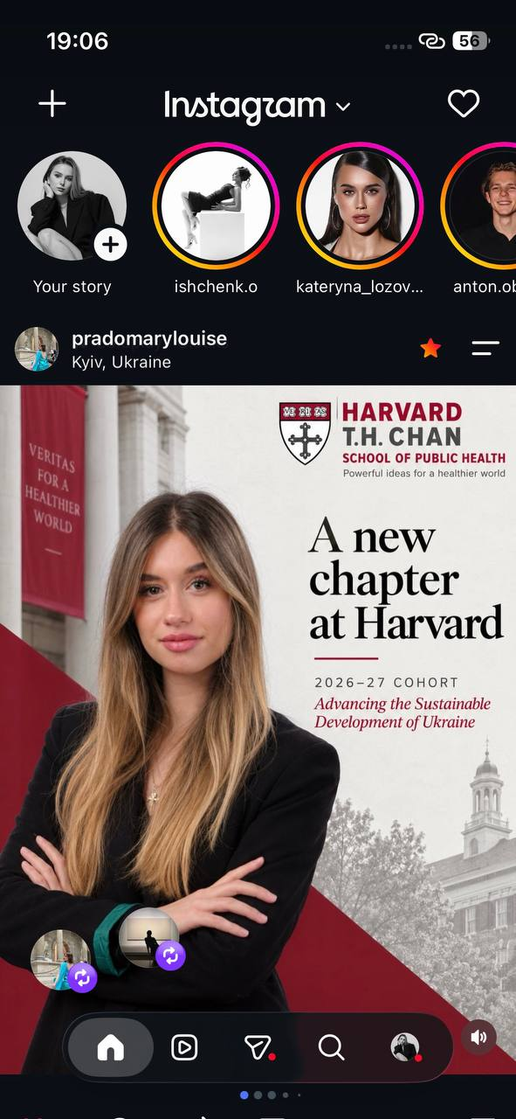
I use Instagram not only to keep in touch with friends, but also to learn useful information about photo and video editing. I also look at beauty business pages to get ideas for presenting my own beauty services and promoting my business in the future.

Screenshot/Photo 2
TikTok
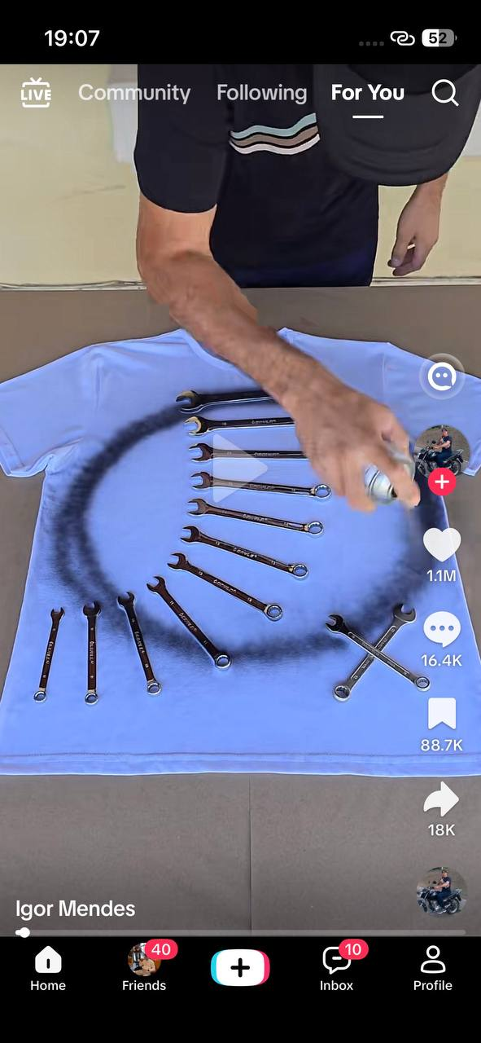
I use TikTok to find interesting places to visit and travel to. People often share the best and most beautiful places in different cities, which saves me a lot of time when I am looking for places to visit.

Screenshot/Photo 3
YouTube
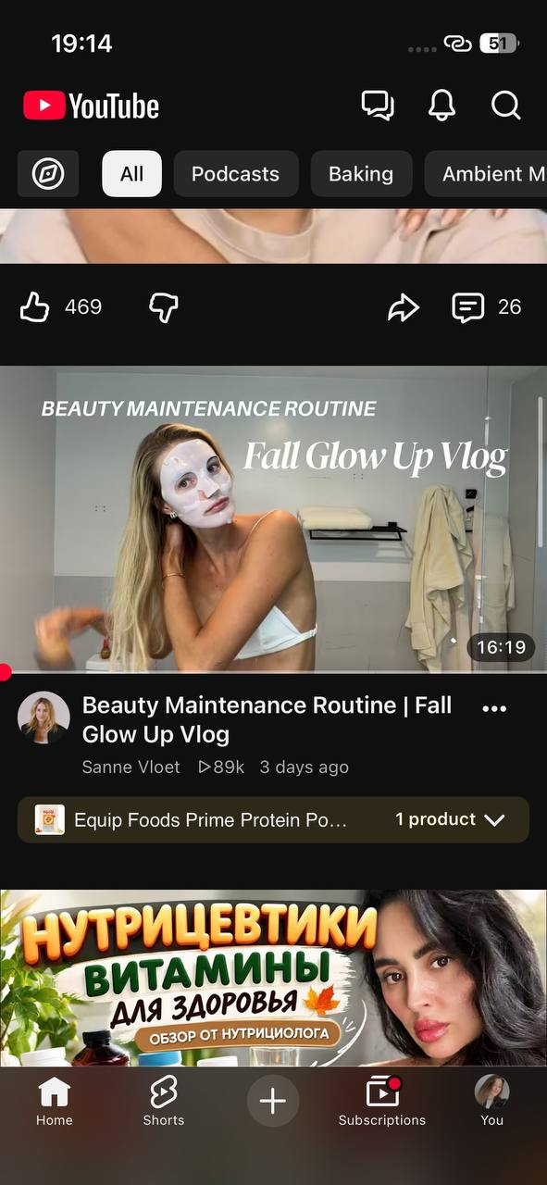
I use YouTube to watch useful interviews with successful business people, motivational videos and educational content, for example, videos that help me improve my English. I think YouTube is a great platform where I can learn a lot of useful information for free.

Screenshot/Photo 4
Spotify
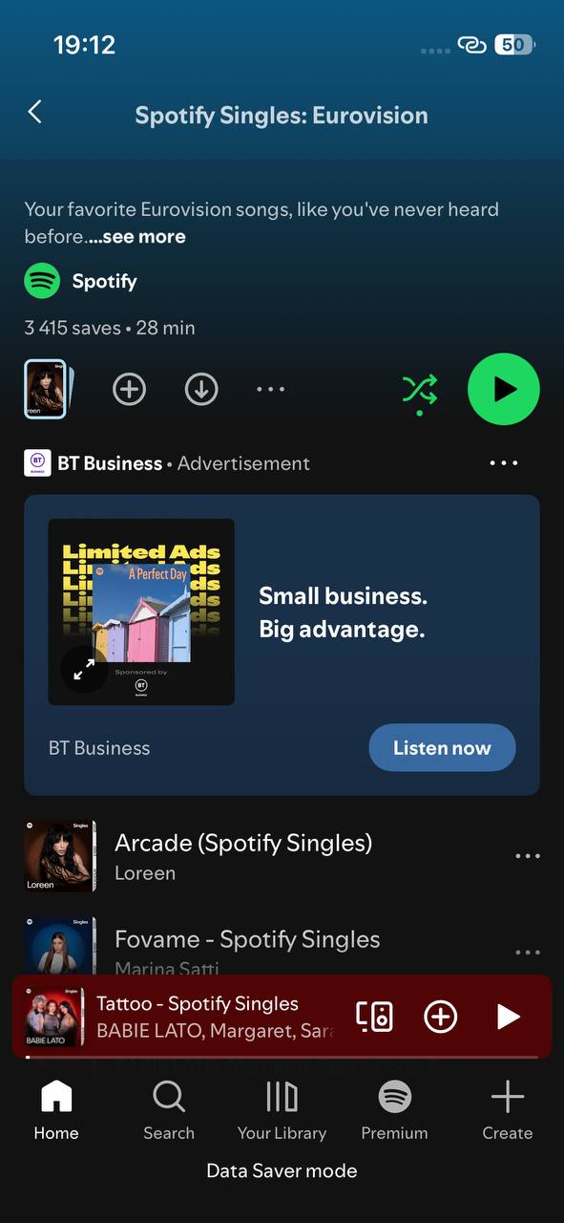
I use Spotify to listen to music and improve my mood throughout the day. Music helps me feel energised before I start my day and relax after a long and tiring day.

Screenshot/Photo 5
iHerb
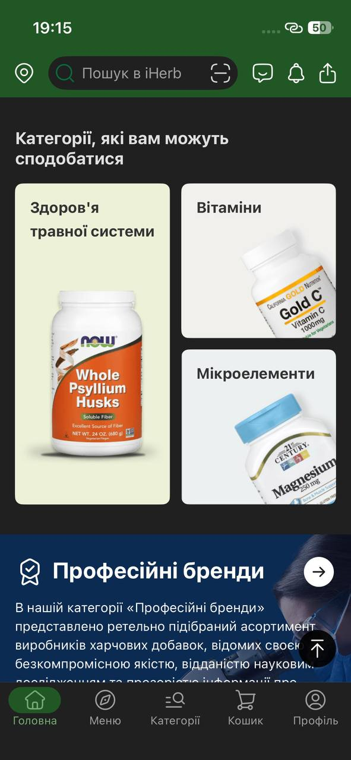
I use iHerb to order vitamins and other health products online. I can find almost all the vitamins I need on this website, and the fast delivery is very convenient for me.

Screenshot/Photo 6
Threads
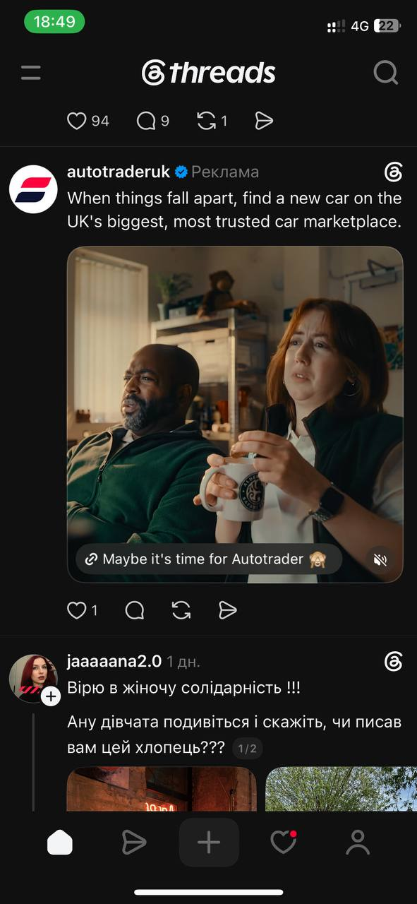
I use Threads to read interesting thoughts and opinions from other people and discover new brands. People on Threads are often very open and share useful advice. I also think it is a good platform for people who are just starting to build their personal brand.

My Short Reflection
- Write 5–8 simple sentences about your digital life.
- You can use the sentence starters below if helpful.
- I use digital tools to learn useful things for myself, such as sports, healthy eating, English-learning videos, video editing, and motivational quotes from books.
- I feel confident when I edit short videos and find useful information online.
- I want to improve my video editing skills and learn how to create ads for my future business.
- I often use these tools: Instagram, Facebook, TikTok, Threads, Spotify, and YouTube.
- I sometimes feel nervous about posting my videos because I'm afraid of negative comments.
- I hope this module will help me learn more about different tools so that I can use them quickly and effectively for my development.
- Digital skills are important for me because I need to understand all the methods of promoting my future beauty business.

Sentence starters
- I use digital tools to …
- I feel confident when I …
- I want to improve …
- I often use these tools: …
- I sometimes feel nervous about …
- I hope this module will help me …
- Digital skills are important for me because …
You can write more if you want.

Submission Checklist
Before you submit, please check:
​​​ ☒ I added 4–6 screenshots
☒ I wrote short sentences for each screenshot
☒ I wrote my short reflection
☒ My work is my own
☒ My file opens correctly
​​☒ My file opens correctly

