Student Name: Robert Nagy
Student Number: 1922896
Module: Financial Management for the Hotel Industry (BMIH5007)
LEVEL 5
Programmes: BA (Hons) International Hotel Management
School of International Hotel Management

CONTINENTAL HOTEL BUDGET PLANNER
July 6, 2022
University of Wales Trinity Saint David

Lecturer: Dale Clarke
Executive Summary

The following report elucidates the aspects of traditional and zero-based budgeting and asserts that zero-based budgeting is the most viable option to boost the efficacy and sustainability of a business.

Table of Contents

Executive Summary……………………………………………………………………1
Introduction……………………………………………………………………………...2
The Budget Planner (Cash-Flow forecast) ………………………………………….3
Traditional budget and Zero-Base budget…………………………………………...4
The process of zero-base budget…………………………………………………….6
Can budgeting control support sustainability?......................................................8
Conclusion………………………………………………………………………………9
Bibliography…………………………………………………………………………….10

Introduction
In the wake of the contemporary era, hotel companies are encountering accelerated competitive and dynamic business paradigms. The altered tendencies are compelling managers and executives to shun the conventional process of incremental budgeting and opt for innovative, modernistic, and pragmatic budgeting methods (Debnath, 2017). Evidently, every business strives for constant growth. However, hitting the projected growth rates seems uncertain in an intensely competitive market, and therefore, in order to obtain augmented competitive advantages, businesses need to transform their previous techniques and methodologies, among which budgeting is a prevalent practice (Timmermans, Roark and Abdalla, 2019).
Undeniably, budgeting provides strong pillars to a business and helps plan and control the overall facets of business finances. In the absence of a substantial budgeting system, businesses become prone to losing control over expenditures and revenues altogether. A concrete budget not only controls the finances of a business but also assists in meeting organizational objectives, making practical decisions, and ensuring a sufficient flow of resources to fulfill prospective commitments without much hassle (Banks, 2018). Based on their underlying attributes and methods, budgeting techniques are segregated into four major types.
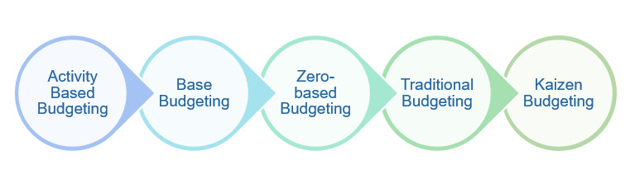

Figure 1. Types of Budgeting (Sharma, 2022)

The budget planner (cash flow forecast) for the hotel for the forthcoming year

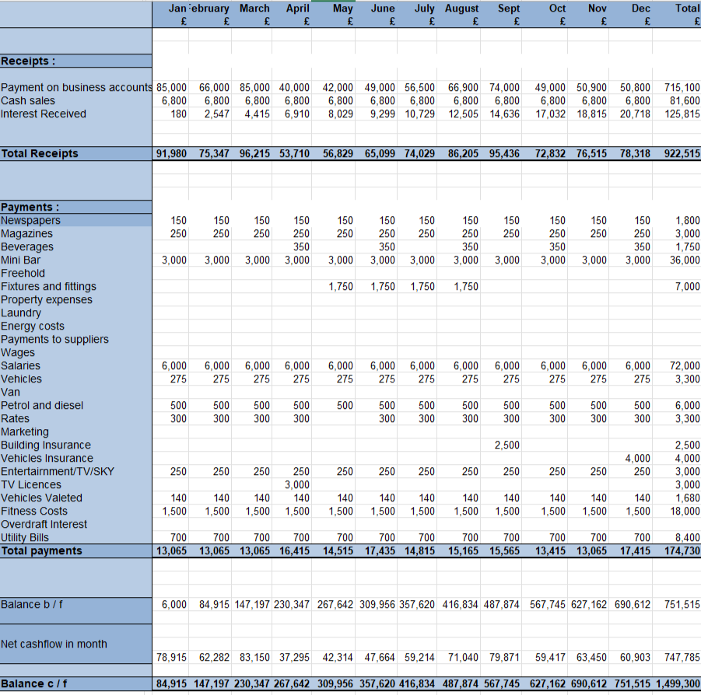

- Traditional based budget and zero-base budge

Traditional Budgeting
Traditional budgeting, also known as fixed budgeting, sets out the expense and income plan. The method enlists all expenditures relevant to the business and compares them with the income level within a specified period of time (Asogwa and Etim, 2017). This conventional budgeting approach proffers a concrete archetype for expedient execution and control. The practice of pursuing preceding budgets mitigates any additional efforts to devise a new budget and encourages the notion of decentralization. The interwoven aspect of preciseness makes the approach a part of organizational culture and helps perpetuate the activity without any perceived scope of hurdles. However, implementing the aforementioned budgeting measures comes with a significant peril of human errors because staring constantly at spreadsheets increases the likelihood of making blunders without even realizing it. The very aspect of spreadsheets makes them a time-consuming activity that cannot be encouraged in the modern, fast-paced epoch. Furthermore, the method is utterly prone to yielding inaccurate predictions because not all years can be the same, and applying identical projections seems impractical (Thakur, 2022).
Zero-based Budgeting
The zero-based budget is a technique that employs the allocation of expenses for each new monetary year while preparing the financial budget. The budget starts from point zero, and all business operations and functions are evaluated as per their unique requirements and associated costs. Assessment of requirements becomes the basis for budget preparation without comparing its elements with preceding budgetary implications (Al-attar, Mashkour, and Hassan, 2020).
The idea of zero-based budgeting first emerged in the 1970s, and therefore, it cannot be deemed as an innovative initiative. However, the implied notion of flexibility and pragmatism increases its plausibility among modern businesses. Many well-known corporations, such as Kraft-Heinz, Mondelez, Unilever, and Anheuser-Busch, have incorporated zero-based budgeting techniques into their operations (Rodney Coyte, Messner, and Zhou, 2021). It is contended that zero-based budgeting infuses a certain tinge of mindfulness into the owners of the assets, which, in turn, never lets them overlook any extravagant expending patterns or asset saving opportunities. Identifying areas of overspending and frugality both play a pivotal role in optimizing the budget, and every dollar automatically finds a purpose to serve. Nevertheless, zero-based budgeting may entail some negative facades as well, among which intensive exploitation of time and labor is prevalent. Moreover, the process necessitates undivided and uncompromised attention to be fruitful, and in the case of an unplanned expense, the parameters can be proven inflexible (Unaru, 2022).

Figure 2. Advantages and Disadvantages of a Zero-Based Budget (Thakur et al., 2022)
The core ideology of zero-based budgets is to provide executives and managers with details on how each penny is utilized within the specified financial period. The practice compels them to rationalize the operational expenses and identify the business areas generating cash inflows (Cheng, 2021). The process of such a budgeting approach takes place on an annual basis and prefers the prospective of short-term objectives over long-term benefits (Willis, 2022).
A unique perspective and unlikely modus operandi of zero-based budgeting make it a relatively contemporary approach that is different from traditional budgeting processes, almost to its entirety. Due to its situational characteristics, zero-based budgeting was widely adopted by hotels during the unpredicted and devasting circumstances of the global pandemic, COVID-19.

Figure 3. Comparing Zero-based and Traditional Budgeting Methods (Burad, 2022)

- The process of zero-base budget and how can this be implemented

Zero-based Budget: Process and Implementation
For business purposes, zero-based budgeting ties the organizational strategic objectives to specified functional areas of the business. The practice requires first grouping the costs and then measuring them against current expectations and previous outcomes. It is considered a rolling process that may take years to completely encapsulate all functional areas but is remarkably efficient in eradicating the possibility of blanket costs and, in turn, lowers the overall operational costs to a considerable extent (Kagan, 2022). The zero-based budgeting process entails the ensuing steps.

Figure 4. Zero-base Budgeting Process (Ueland, 2020)
At the very initial stage, it is imperative to devise a precise objective of budgeting that may include cost reduction or substantial control over cash inflows and outflows (Tamplin, 2021). Business peers and experts can provide a clearer idea regarding the areas of improvement business needs to suffuse into the process (Serven, 2022). The second stage incorporates the visibility of costs associated with the specified budgeting period. Executives and managers must decide the accurate and explicable allocation of costs to refine the choices. Afterward, creating templates by considering the implied scope of required data and range is a crucial step in this regard. Selecting vendors for templates should be carried out by considering the budget consolidation requirements along with the expanse of interlinked data categories. It is recommended to avoid using Excel for this purpose, as the program can restrict the success of the budget. In order to implement change management in the form of zero-based budgeting, organizations must interweave the altered practices into their organizational cultures through effective communication techniques and ongoing training programs. Furthermore, making strategic choices is also an integral part of the process. The controlling step entails monitoring the effectiveness of newly implemented measures and assessing the scope of benefits to either repeat, refine, or abandon the process entirely.

It is not easy to run the zero-based budget because the budget owners will have to be supported by a Cost-Category Owner (CCO) who will put forward budget requests for specific spending categories for a whole business unit (Schreim, 2019). A CCO may look after facilities management to monitor rents, spending on security, and other related items for all the business units. A CCO will also hold regular formal meetings with all the departments of the company having this type of spending in their budget. An example can be the training costs which have to be incurred by almost all the departments.
While assigning the CCOs, there is no specific approach, and it depends on the savings targeted as a result of the process. The average number of CCOs falls between 12 and 15 but it will vary according to the specific sizes and needs of the organization.

- Can Budgeting Control and Support Sustainability

Evidently, budget control and sustainability share a substantial relationship. Sustainability is a complex term but can be simplistically defined as the fulfillment of present needs without risking future resources (Jalali and Gal, 2018). In other words, sustainability can allude to a capacity to preserve some entities, procedures, or outcomes over a certain period of time (Mensah, 2019). Budget control, on the other hand, is defined as the act of managing expenditures and income, comparing actual and planned income and spending to determine whether corrective measures are necessary (Kwadade-Cudjoe, 2020). In this frame of reference, budget control is acknowledged as an effective management tool to retain and substantiate the underlying notion of sustainability (Ramussen, 2020).
Budgeting has emerged as a fundamental, modern managerial tool that participates in the process of instilling maximum efficiency and effectiveness into the business in the recent epoch. Budgeting control allows managers to supervise overall organizational activities of all structural divisions, facilitate productive interactions, and navigate the endeavors towards the accomplishment of mutual, strategic objectives. The accumulation of these effective measures leads to the establishment of a smart system that meets, and in some cases exceeds, the implied standards of sustainability, competitiveness, sustainable development, and maximum organizational gains (Rebrowa et al., 2020). Budgetary control ensures the practicality and usefulness of the business's available resources and capital in order to adhere to sustainability (Yilmaz, 2018).

Conclusion
Conclusively, budgeting plays an integral role in the overall development, sustainability, and enhanced competitiveness of a business. For dynamic métier such as hospitality and hotel industries, opting for zero-based budgeting is highly preferable because such business spheres are prone to encountering situational operational scenarios, and therefore, implementing traditional budgeting techniques can be proven futile for them. The implementation process of zero-based budgeting is generally comprised of five interconnected activities that revolve around the idea of change management. Zero-based budgeting has entered the new century with a new perspective and has secured its position as the most adopted managerial tool among the managers of prestige, intercontinental organizations (Schreim, 2019). Zero-based budgeting is also a realistic solution to deal with economic volatility, globalization, advanced technologies, cutthroat competition, and unanticipated pandemics in such an unprecedented age. Traditional budgetary approaches do not have the potential to tackle the stretched scope of swiftly transforming business dimensions. Therefore, implementing a flexible and situational budgetary approach is a significant strategic initiative that protects businesses from haphazard internal and external chaotic uncertainties.

Word count: 1.578

Bibliography
- Asogwa, I.E., & Etim, O., 2017. Traditional Budgeting in Today’s Business Environment. Journal of Applied Finance & Banking, 7(3), pp.111–120.
- Al-attar, H.A., Mashkour, S. & Hassan, M., 2020. Zero-Based Budget System and its Active Role in Choosing the Best Alternative to Rationalise Government Spending. International Journal of Innovation, Creativity and Change, 13(9), pp.244–264.
- Banks, K., 2018. The importance of budgeting in business: WLF Accounting & Advisory. WLF Accounting & Advisory |.
Available at: https://wlf.com.au/importance-budgeting-business/ [Accessed July 2, 2022].
- Borad, S., 2022. Zero based vs. incremental budgeting. eFinanceManagement. Available at: https://efinancemanagement.com/budgeting/zero-based/zero-based-vs-incremental-budgeting [Accessed July 3, 2022].
- Cheng, M., 2022. Zero-based budgeting: Benefits and drawbacks. Investopedia.
Available at: https://www.investopedia.com/ask/answers/051515/what-are-advantages-and-disadvantages-zerobased-budgeting-accounting.asp [Accessed July 2, 2022].
- Coyte, R., Messner, M. & Zhou, S., 2021. The revival of zero‐based budgeting: Drivers and consequences of firm‐level adoptions. Accounting & Finance.
- Debnath, A., 2018. Budgeting in hotels. LinkedIn.
Available at: https://www.linkedin.com/pulse/budgeting-hotels-abhishek-debnath [Accessed July 2, 2022].
- Jalali, F. & Gal, G., 2017. Can sustainability be budget for? evidence from Iran. Accounting, Finance, Sustainability, Governance & Fraud: Theory and Application, pp.159–178.
- Kagan, J., 2022. Zero-based budgeting (ZBB). Investopedia. Available at: https://www.investopedia.com/terms/z/zbb.asp [Accessed July 2, 2022].
- Kwadade-Cudjoe, F., 2020. Budgeting and budgetary control are time consuming tasks for any organization: Examination of how the preparation, operation and implementation phases are carried out to the benefit and achievement of a successful organization. Archives of Business Research, 8(8), pp.281–293.
- Mensah, J., 2019. Sustainable development: Meaning, history, principles, pillars, and implications for human action: Literature review. Cogent Social Sciences, 5(1), p.1653531.
- Rasmussen, J., 2020. Management control for sustainability activities and procedures for energy management in industrial companies. thesis. Linköping Studies in Arts and Science.
- Rebrowa, N. et al., 2020. Budgeting as an instrument of increasing competitiveness and sustainability of Mining Enterprise. E3S Web of Conferences, 174, p.04054.
- Schreim, S., 2019. Zero-Based Budgeting (ZBB) To Zero-Based Everything: A Business Guide to Augmenting Zero-Based Budgeting to Achieve a Step-Change in Performance, Amazon.
- Serven, L., 2022. What is zero-based budgeting? 8 tips for implementation. Planning and Analytics Blog – Board International.
Available at: https://blog.board.com/budgeting-planning-forecasting/top-tips-implementing-zero-based-budgeting/644/ [Accessed July 2, 2022].
- Sharma, R., 2022. What is budgeting? Types and importance of budgeting. EDUCBA. Available at: https://www.educba.com/what-is-budgeting/ [Accessed July 3, 2022].
- Tamplin, T., 2022. Zero-based budgeting (ZBB): Definition, procedure, and advantages. Finance Strategists.
Available at: https://learn.financestrategists.com/explanation/budgeting/zero-based-budgeting-zbb/ [Accessed July 2, 2022].
- Thakur, M. et al., 2022. Zero-based budgeting. WallStreetMojo.
Available at: https://www.wallstreetmojo.com/zero-based-budgeting/ [Accessed July 3, 2022].
- Timmermans, K., Roark, C. & Abdalla, R., 2019. In The big zero: The transrmation of ZBB into a force for Growth, innovation, and competitive advantage. UK: Penguin Business.
- Thakur, M., 2022. Traditional budgeting. WallStreetMojo. Available at: https://www.wallstreetmojo.com/traditional-budgeting/ [Accessed July 2, 2022].
- Ueland, J., 2020. Zero-based budgeting implementation - an overview. Zero-Based Budgeting Implementation - an Overview | FP&A Trends. Available at: https://fpa-trends.com/article/zero-based-budgeting-implementation-overview [Accessed July 2, 2022].
- Unrau, H., 2022. What is the difference between traditional budgeting and zero-based budgeting? Hardbacon.
Available at: https://hardbacon.ca/en/budget/what-is-the-difference-between-traditional-budgeting-and-zero-based-budgeting/ [Accessed July 2, 2022].
- Walther, L.M., 2021. Managerial Accounting 2021st ed., Utah State University.
- Willis, S., 2022. All about budgeting – part 4. ACCA Global. Available at: https://www.accaglobal.com/pk/en/student/exam-support-resources/fundamentals-exams-study-resources/f5/technical-articles/budgeting4.html [Accessed July 2, 2022].
- Yılmaz, F., 2018. Budgeting as a tool for Sustainable Development. Handbook of Research on Supply Chain Management for Sustainable Development, pp.42–60.

