Domestic Abuse and Substance misuse; Is there a link between substance misuse and the likelihood of someone being a victim or a perpetrator of domestic abuse.

BSc (Hons) Professional Policing Practice

Acknowledgements

First and foremost, I would like to thank anyone who has contributed or assisted me in some way to completing this project. Without the help and support of those people, it would not have been possible to complete this project.

Declaration

This work has not previously been accepted in substance for any degree and is not being concurrently submitted in candidature for any degree.
Signed: D MARTIN Date: 23/10/23

Statement 1
This dissertation is being submitted in partial fulfilment of the requirements for the degree of BSc.
Signed: D MARTIN Date: 23/10/23

Statement 2
This dissertation is the result of my own independent work/investigation, except where otherwise stated. Other sources are acknowledged by footnotes giving explicit references. A bibliography is appended.
Signed: D MARTIN Date: 23/10/23

Statement 3
I hereby give consent for my dissertation, if accepted, to be available for photocopying and for interlibrary loan, and for the title and summary to be made available to outside organisations.
Signed D MARTIN Date:23/10/23

Statement 4
I hereby give consent for my dissertation, if accepted, to be available on the university’s IT system to those who have consent to use the system.
Signed: D MARTIN Date: 23/10/23

Abstract
Over the past few decades, there has been a great deal of academic effort put into the understanding of Domestic Violence which has encompassed various types of research and study, all with the aim of understanding the issue and seeking means to prevent it.

The majority of the research has been found to have at first explored the concept of domestic violence, which then led to research into its causes and how best to prevent domestic violence.

Despite the research that exists being vast, this is still an enormous issue for society today and efforts are ongoing by today’s academics to understand the issue.

The aim of this dissertation was to explore the links, if any, between substance misuse and domestic violence. Through the process of conducting this research, the researcher has further refined the question to define substance misuse as alcohol use only and to define domestic abuse as the broad scope of abuse as a pose to violence or homicide only, in addition to this the research will explore the impact of alcohol misuse on perpetrators of domestic abuse, rather than both perpetrators and victims. The researcher aimed to question police officers on this topic as they were seen by the researcher as a key resource for information that may not be clear in statistics from previous research, given the position of police officers as front-line responders to domestic abuse and experts in intoxication through alcohol, the researcher intended that this unique perspective would reveal the true impact that alcohol has on domestic abuse.

In short, the research identified that there did appear to be a link between alcohol misuse and domestic abuse perpetration, the results and conclusions are documented below.

Contents Table
Acknowledgements 2
Declaration 3
Abstract 4
1. Chapter One: Introduction 6
1.2 Aim of research project. 7
2. Chapter Two: Literature Review 8
2.1 Introduction to Literature Review 8
2.2 Historical context of Domestic Abuse 8
2.3 Law enforcement/Criminal Justice system response to Domestic Abuse 9
2.4 Academic research into Domestic Violence 9
2.5 Summary 13
3. Chapter Three: Methodology 15
3.1 Introduction 15
3.2 Data Collection 15
3.3 Data Analysis 17
3.4 Limitations and Benefits 17
3.5 Ethical Considerations 17
4. Chapter Four: Analysis of Results 18
4.1 Introduction 18
4.2 Questionnaire Limitations 18
4.3 Findings 18
4.4 Conclusion 21
5. Findings and Conclusion 23
5.1 Introduction 23
5.2 The achievement of the Aim and Objectives 23
5.3 Main Findings 24
5.4 Recommendations / Further Research 25
5.5 Self-Reflection 26
6. Bibliography 28
7. Appendices 31
7.1 Appendix One: Questionnaire 31
7.2 Appendix Two: Questionnaire Results 38
7.3 Appendix Three: Dissertation Proposal 41
7.4 Appendix Four: Ethics Form 45

1. Chapter One: Introduction
1.1 Overview of research project

1.1.1 Brief context
This dissertation will look at the links between substance misuse and domestic abuse. From the outset it was intended that this research project would explore the links between substance misuse, such as addiction to controlled substances or alcoholism, and domestic abuse encompassing both victims and perpetrators. However, upon careful consideration the researcher identified that this scope is vast and there was a need to refine the question to a narrower scope. As such this research project will consider the links between alcohol misuse and domestic abuse, specifically how alcohol misuse impacts upon a person being a perpetrator of domestic abuse.
1.1.2 Research in brief
In recent decades the issue has become better researched and various initiatives have been implemented to tackle domestic abuse, these have largely been aimed at better understanding in order to recognise domestic abuse and to be proactive in responding to all incidents. Research suggests that on the extreme end of domestic violence, that being domestic homicide, substance use is a common factor and more generally it is suggested that men who are dependent on alcohol or drugs are 6 times more likely to be perpetrators of domestic abuse. The purpose of this research is to determine if the experience of police officers who are the first responders to incidents of domestic abuse, can recognise whether alcohol is a common factor in incidents of domestic abuse, thus providing a unique insight into the real extent of alcohol and its impact on domestic abuse as a pose to the much narrower scope of only domestic homicide.
1.3 Importance of subject to researcher
This subject was chosen by the researcher as domestic abuse is something that they have first-hand experience of responding to. It is an important subject and one which they believe to be heavily emphasised by the public and police organisations as well as comprehensively researched by academics, yet ultimately there appears to be little forward motion in tackling the issue. Furthermore, the topic of domestic abuse takes up a large proportion of police resources, whilst not disproportionate, the assertation simply speaks to the volume of domestic related incidents reported and investigated by police.

1.2 Aim of research project.
The aim of this research project is to identify if there is a definitive link between alcohol misuse and domestic abuse. From the outset, this appears to be an unreachable aim as it is not likely, given the scope of this research and its resources, that a definitive conclusion can be drawn.

However, an aim is just that, an overriding aim which through setting objectives can be narrowed and specified, leading to a more nuanced question to the one proposed.

1.3 Objectives of research project

The objectives of this research project are set out to guide this research from the outset and crucially to be used as a bar in the projects conclusions to determine what has been learnt from the project itself. The researcher will:

- Conduct a literature review, using global resources where necessary to identify the trends that research into domestic abuse has taken over time and how police services have changed in conjunction with this research.
- Using information from the literature review, identify where the original question can be narrowed or made more specific.
- Identify the most efficient means of collecting information from police officers, be it interview, polling or questionnaires.
- Carry out the relevant information gathering exercise and analyse the information attained.
- Through data analysis of the information from police officers, identify if the overall aim has been achieved.
- As a contingency, should the aim not be achieved or not be clear, the researcher will set out the reasons for this and outline how future research can avoid the same limitations.

2. Chapter Two: Literature Review

2.1 Introduction to Literature Review
Domestic abuse has no doubt long been an issue, since the inception of relationships between human beings. What has changed throughout history is how relationships are defined, what behaviours are deemed as criminal and where these two things become what we now call domestic abuse.

The purpose of this literature review is to provide an overview of existing literature on the topic of domestic abuse and alcohol/substance misuse. The research will explore a range of literature on the topic and how research has evolved from defining the topic of domestic abuse to the topic which is sought to be studied, that being the links between alcohol misuse and domestic abuse.

Further to this, the researcher will seek to identify any gaps in existing research and look to highlight where the proposed research will add to the research which exists.

2.2 Historical context of Domestic Abuse
Domestic abuse has a long history of being viewed as a private matter between intimate partners and families, rather than a criminal matter requiring intervention by the state (Erez, 2002). In many societies throughout history, abuse and/or violence between intimate partners or family members was considered normal. In particular, violence within a marital relationship which was typically between a man and woman, was considered normal and the husband in many cases had the right to carry out acts of violence on his wife. There are examples in history of this type of behaviour being accepted as normal by the authority of the day, Anglo-American laws once provided that a husband as master of his household, could subject his wife to corporal punishment or chastisement, so long as he did not inflict permanent injury upon her (Siegel 1996). It was not until the 19th and 20th centuries that the issues of what we now call domestic abuse, began to be recognised as a problem that required legal and social intervention.

In the United States, for example, the first laws criminalising domestic abuse were passed in Maryland in 1882. However, it was not until the 1970’s and 1980’s that domestic abuse laws became more widespread and comprehensive, this was largely due to the efforts of a rise in feminism and feminist activists who brought attention to gender inequality and the issue of domestic abuse and pushed for legal reform which would eventually recognise domestic abuse as a crime, but also provide for greater protection for survivors of domestic violence (Schneider 2000).

After this, it became more widespread for law enforcement and the corresponding criminal justice systems to recognise and tackle the problem of domestic abuse. The afore mentioned research has helped the researcher to understand the beginnings of the topic of domestic abuse becoming a recognised issue and led to the following topics as both research and the response to domestic abuse evolved throughout the 20th century.

2.3 Law enforcement/Criminal Justice system response to Domestic Abuse
Despite the legislative shift to criminalise inter marital violence or what we now call domestic abuse, there were still examples where the authorities did not change how the issue was tackled by law enforcement. One important development in the criminal justice systems response to this was in the case of the United States, some law enforcement agencies implemented mandatory arrest policies during the 1980’s and 1990’s, where police officers were required to arrest individuals, who were suspected of committing domestic violence. The policies often set out that these arrests were to be made regardless of whether the victim wished to press charges. (Hirchel et al 2007). Even to this day in the United Kingdom, there is a policy of positive action in cases of domestic violence with reference to police making arrests (College of Policing, 2015).

This research has shown that from the very late 20th century and into the 21st century, police forces both in the UK and USA have begun to take the issue of domestic abuse more seriously having implemented positive action policies whereby arrest are made, where in any other given area of crime it may not be the case.

2.4 Academic research into Domestic Violence

2.4.1 Early academic work; Defining Domestic Abuse
Whilst the police response has changed throughout the late 20th century, the topic of domestic abuse also became a well-researched topic by academia. A relatively early work on the topic from the late 1970’s, by Straus & Gelles (1980) surveyed some 2,143 persons in the United States on the subject of family violence. They discovered that domestic abuse affected a variety of demographic groups and was more common than previously believed.

The researchers use of a large-scale survey to compile information on the incidence of domestic abuse is one of its strong points. Additionally, the researchers thoroughly analysed the data, offering insights into the trends and traits of domestic abuse in American families. But there are also problems with the study itself, notably the survey did not explore the context or motivations for the abuse used and further to this, victim reports were used by the researchers to gauge the prevalence of domestic abuse, which may have underreported the real scope of the issue. Lastly, the authors have set out possible causes and solutions to the problem without giving substance to the claims, for example one conclusion drawn is that domestic abuse in families is due to the natural stress and conflict which arises and there is little further exploration on the effects of stress on domestic abuse. Despite these criticisms, the work was a good starting point at a time when domestic abuse was not understood or studied to a great extent and what the work has done is provided a greater understanding on what domestic abuse is, including its form and prevalence and is to this day, a good starting point for other academics to research the topic.

What this researcher gained from the afore mentioned research was an understanding of prevalence of domestic abuse, it appears that existing research recognises that domestic abuse is a prevalent issue in society and that reasons for this have been suggested but not explored further than being merely suggestions. When looking at prevalence of domestic abuse in the UK today, the ONS (2022) issues statistics recorded by police forces in England and Wales whereby almost 911,000 crimes which were domestic abuse related have been recorded in a single year, yet of these recorded crimes only around 53,000 led to prosecutions and only around 75% of those prosecutions led to convictions.

2.4.2 Shift of Academic Effort; exploring the reasons for Domestic Abuse
Moving on from this early research it appears that the shift of academic effort moved from defining domestic abuse, to exploring the possible reasons for abuse within intimate relationships. One such piece of work by Ranzetti (1996) provides a comprehensive examination of intimate partner violence with particular attention to female experience of abuse in intimate relationships. In this piece, Ranzetti highlights the social and cultural contexts in which intimate partner violence occurs, the role of gender, power and social inequality features in the research, as does the role of cultural norm and social institutions including the criminal justice system. A strength of this work is that Ranzetti not only explores the varying forms of abuse experienced by women who have experienced domestic abuse, but she also explored the consequences of this abuse be it physical, psychological or emotional. Ranzetti suggests that there is a need for a victim centred approach to domestic abuse which moves away from the criminal justice centred response of simply punishing perpetrators without addressing the causes of this type of violence. Ranzetti introduces the ideas of support for victims such as emergency shelter and legal assistance as well as the importance of prevention by means of education to address perceived underlying attitudes and beliefs which may contribute to domestic abuse.

This research by Ranzetti is important for this research project as Ranzetti begins to look at the reasons for domestic abuse which is a key theme to this project which is seeking to identify if alcohol is a reason for domestic abuse. Whilst Ranzetti’s focus is on what can be described as non-physical explanations (those being social or cultural reasons) it does not look at what this research sees as a very physical factor, that being the physical affect that alcohol has on a person which may lead to perpetrating domestic abuse.

2.4.3 Alcohol and violence
Specific to this dissertation is one such contributing factor, that being the impact of alcohol. In simplistic terms, does alcohol, make a person more likely to be violent?

In an article by Brisker & Bergman (1998), the topic of the relationship between alcohol use and violence is explored. A wide range of literature is drawn on by the authors to support the argument that alcohol is a significant contributing factor to violence by a person. One strength of the article is the breadth of types of violence considered which included domestic violence and sexual assault which has helped the author to depict the negative impact which alcohol is believed to have on violence. However, the article is very descriptive and as such relies on other work to draw its conclusions rather than presenting any new data. Because of this, the conclusions drawn are as dated as the information which the article is based on and may not be reliable to draw conclusions today. Despite this, the article is a useful piece of work which begins to explore the relationship between alcohol misuse and violence, which ultimately ties into the goal of this research project which is to identify if alcohol is a contributing factor in domestic abuse.

2.4.4 Alcohol as a contributing factor to Domestic Abuse
In an article by Langhinrichsen-Rohling & Selwyn (2015), the authors conduct a review of existing literature on the topic of alcohol and being a perpetrator of domestic abuse. This work concludes that alcohol is a significant risk factor in perpetration of domestic abuse, it also suggests that the link between alcohol and violence may be explained by several factors, including the pharmacological effects of alcohol, but also the social and cultural context in which alcohol misuse occurs. The article also concludes that addressing both alcohol misuse and domestic abuse may be more effective in prevention than only addressing one of the issues.

The literature appears to show that alcohol is indeed a factor in perpetrating domestic abuse, however this research project is seeking to further define this prevalence through research aimed at the views of police officers as it is hoped this unique perspective will provide a more accurate picture of alcohol’s impact on domestic abuse. Using an online tool (Bailii.org) which is a search engine of court results and judge’s rulings in the UK it is possible to identify the apparent links between alcohol and domestic abuse, by searching for cases involving domestic abuse this returns some 12,000 cases, include alcohol to this search and the number of cases is refined to some 2,000 cases which would suggest that around 1/6 of domestic abuse cases involve alcohol in the UK.

2.4.3 Developing research; Understanding how to treat Domestic Abuse
Hester (2009), explores the dynamics of domestic abuse interventions, drawing on interviews with both survivors and professionals working in the field. Through her analysis, she argues that traditional approaches to domestic abuse, which focus on criminal justice interventions and the punishment of perpetrators, are often ineffective and can even exacerbate the harm experienced by survivors. Instead, she advocates for a more nuanced and collaborative approach, which centres on the experiences and voices of survivors, recognising the wider social and structural factors that contribute to domestic abuse.

Overall, Hester's work is an important contribution to the field of domestic abuse research, providing valuable insights into the experiences of domestic abuse victims. Her focus on the limitations of traditional approaches to domestic abuse is particularly noteworthy, highlighting the need for more holistic interventions. One limitation of the work is the relatively small sample of subjects questioned to produce the data utilised, which could suggest that the data attained may not be representative of the wider population of victims and professionals in the field. Hester’s work is one of many studies which have started to explore the idea of holistic interventions, that being seeking to understand the causes of domestic abuse and exploring how through intervention these root causes can be negated to prevent domestic abuse.

2.4.6 Prevention of Domestic Abuse
Of the literature that exists on the topic of domestic abuse, there appears to have been a funnelling in recent years towards the idea of treatment rather than punishment only. It is recognised that the issue of domestic abuse is often repeated by perpetrators, hence the desire to explore methods of prevention which has involved the research into the possible factors which contribute to domestic abuse. Belenko et all (2013) reviews the effectiveness of programmes which treat criminals with issues of substance misuse with a view to preventing re-offending. Similar work by Stevens (2006) explores prison-based treatment with the aim of reducing reoffending and Chatwin et all (2015) reviews the effectiveness of treatment in both prison and the community to prevent reoffending.

Whilst this research does not directly benefit the aim of this project, it is worthy of note as this shows the direction of research, which is what this project seeks to underpin, that being the notion that alcohol misuse is a direct factor involved in domestic abuse. Were this to be definitively proved, the ongoing research into prevention can be guided to rehabilitate offenders who abuse alcohol.

2.4.7 The missing statistics
Through conducting this literature review, the researcher was surprised that there appears to be very little data on the involvement of alcohol in domestic abuse incidents. The research tends to explore offences which have occurred or where alcohol is a factor in that the perpetrator has a diagnosed addiction. This leaves an enormous gap in the true extent of alcohol being an influencer in any domestic incident, however minor it may be. This literature review would have benefitted from more detailed statistics being recorded, perhaps by law enforcement bodies where the involvement of alcohol could be recorded in all incidents where police attend which are domestic abuse related. This could encompass more incidents, such as those where no crime is recorded and where a crime is recorded but the matter is not taken forward to court. Such recording of statistics would greatly improve and guide any future academic research into the topic of domestic abuse.

2.5 Summary
This literature review has discussed the history of domestic abuse and how it has been viewed as a private matter between intimate partners or families, rather than a criminal matter requiring intervention by the state. Research into the topic of domestic abuse has over time become a more populous field of research, with some early work done in the 1970s which covered the topic broadly and research since this has begun to explore the causes of domestic abuse with the most recent research looking at ways to prevent offending.

Looking back to the original question for this dissertation: Domestic Abuse and Substance misuse; Is there a link between substance misuse and the likelihood of someone being a victim or a perpetrator of domestic abuse?

The research appears from the outset to suggest that substance misuse is indeed a factor in a person being a perpetrator of domestic abuse and this is a well-covered topic which has moved past the question of whether the two are connected and onto how domestic abuse can be prevented by treatment of substance misuse.

The second objective of this research was to narrow down the original question, specifically the term substance misuse can be narrowed to include only alcohol as there is a clear link between alcohol and violence, the research can narrow to explore how alcohol abuse impacts upon perpetrating domestic abuse. The topic of alcohol or substance misuse and its impact on victims warrants a research project of its own such is its importance and breadth.

The literature review has also highlighted that research is now looking at treatment of the factors, such as alcohol, which influence domestic abuse. Whilst it would be natural for any researcher to want to carry on this research and to remain at the precipice of a research topic, there a number of reasons why this is not achievable for this researcher. Firstly, the researcher of this dissertation does not have the resources to implement a programme of rehabilitation for alcohol misuse in perpetrators of domestic abuse, to explore the success of such treatment and thus create a tangible link of theory and real word outcomes. The researcher has considered seeking to add to the theory by exploring the beliefs of police officers in the United Kingdom who deal with domestic abuse daily, however this would not add substantively to the field as to some extent it is irrelevant what police officers believe in terms of correction or rehabilitation as this is not within an officer’s remit.

Thus, this research will focus on adding to the research that exists in defining the link between alcohol misuse and perpetrating domestic abuse, with a view that by further strengthening the link between the two this will encourage future research projects to implement the kind of rehabilitation programmes which are likely to be beneficial if explored further. Having carried out this literature review the original question has been amended to the following:

Domestic Abuse and Alcohol misuse; Is there a link between Alcohol misuse and the likelihood of someone being a perpetrator of domestic abuse?

3. Chapter Three: Methodology

3.1 Introduction
3.1.1 Abstract
This chapter will detail the methodology which this research will be using to investigate the link between alcohol and perpetrators of domestic abuse as outlined in previous chapters. It will explore the type of research proposed and lastly, this chapter will look at the weaknesses of the proposed research and the limitations that are anticipated.

The type of research proposed is quantitative which is described by J Creswell (2014) as a systematic empirical investigation that seeks to understand, explain, or predict phenomena by collecting numerical data and analysing it using statistical methods.

This type of research will help to achieve the aim of this project which is to clearly identify a link between alcohol abuse and perpetrating domestic abuse.

3.1.2 Meeting the objectives of the project.
As per the objectives of this research, the scope of the original questions has become more defined owing to the literature review. This research proposes to explore the links between alcohol misuse and a person being a perpetrator of domestic abuse. Through the literature review it had been highlighted how previous research is abundant and it has been well established that there is indeed a link between alcohol misuse and being a perpetrator of domestic abuse.

In order to meet the objectives of this project as set out in chapter 1.3, the questionnaire will be devised in order to answer the following questions:
- Do police officers frequently attend domestic incidents?
- What proportion of those incidents involve alcohol?
- Is alcohol a defining feature in those incidents of domestic violence?

3.2 Data Collection
3.2.1 Questionnaire
This research will be conducted by means of a questionnaire, Adams et all (2008) has explored various types of data collection such as questionnaires, interviews and focus groups. This research has shown that questionnaires are simple and deliverable to a large sample of people with ease, whereas individual interviews for example, are time intensive for the researcher. For these reasons, this researcher has opted to collect data using a questionnaire which will be sent to front line police officers only. The questionnaire will be in an online format and will be anonymous, no personal data of any kind will be collected, other than a confirmation that the participant is part of the target audience for the questionnaire, that being a front-line police officer. The aim of the research is to have 20 respondents as a minimum however should more than this respond, it will only improve the quality of the data set attained.

3.2.2 Questionnaire contents
The questionnaire will in parts, utilise a Likert scale (S. Jamieson, 2022), which is a popular tool used by many researchers since its inception by Rensis Likert in the 1930’s. The Likert scale used by this researcher in the proposed questionnaire will include the following responses on the sliding scale:

- Strongly agree
- Agree
- Disagree
- Strongly disagree

3.2.3 Reasons for using a questionnaire
The researcher has chosen to use a questionnaire as it is a simple and cost-effective means of gathering data and sits within the scope of the resources at the researcher’s disposal. The sample is specific in that only front-line police officers will be asked to take part, this is in order to direct the research at those with the most current experience of dealing with the topic in question and will guarantee an unbiased expert opinion on intoxication through alcohol which is key to the research proposed.

3.2.4 Tools used to create questionnaire
The type of survey tools available vary greatly and this researcher has opted to use an online survey tool called SurveyMonkey. The benefits of this tool are that it has allowed the researcher to easily design a survey questionnaire without having to consult expert statisticians. The survey is easily shared via an open link, or by email to potential participants. Lastly, the survey once complete automatically returns analysis of the responses in the form of charts/graphs which are again easily customisable by the researcher. Further to this the tool is free to use and is extremely useable for the researcher.

3.3 Data Analysis
The data obtained will be analysed and quantified, which will then be best displayed in the form of graphs or charts which will depict the findings of the research and can then be analysed further to identify any outcomes of the research. Due to the restrictions of time and resources as well as the limited word count and scope of this very dissertation, the researcher anticipates a relatively low number of respondents when compared to much larger studies carried out by previous researchers whereby 1000’s of cases have been looked at.

3.4 Limitations and Benefits
From the outset the researcher has identified that there is a swathe of limitations to this dissertation, the first being its scope. Being a relatively small, limited to 10,000 word dissertation and the time constraints placed on the researcher themselves, the study itself has to be limited to a size manageable for the researcher who has previously suggested that the aim of this study is to sample 20 police officers in relation to 3 cases each of domestic violence, meaning in theory around 60 cases will form this study. However, this in itself has a limitation in that it is possible those police officers have attended the same incident.

One of the proposed benefits of asking police officers these questions anonymously, is that the sensitive issue of domestic violence which would ordinarily remain as sensitive data, can be explored for the purpose of the research question without having to disclose those sensitive details such as the names, nature or places where the incidents have occurred. However, this supposed benefit is also a negative in that it is not verifiable and is entirely objective and as mentioned leaves open the possibility of duplicating information.

3.5 Ethical Considerations
The researcher has not identified any significant ethical issues arising as a result of this study. Participants will not be identifiable as they will remain anonymous and the information they provide will be anonymised so as to not reveal any specifics of people or locations involved in the subject matter.

4. Chapter Four: Analysis of Results

4.1 Introduction
The previous chapters have set out the original question, that being: Domestic Abuse and Substance misuse; Is there a link between substance misuse and the likelihood of someone being a victim or a perpetrator of domestic abuse.

Through a literature review, the question was narrowed to; Domestic Abuse and Alcohol misuse; Is there a link between Alcohol misuse and the likelihood of someone being a perpetrator of domestic abuse?

The method used to gather information for inclusion in this research has taken the form of a questionnaire which was intended for police officers only to complete.

4.2 Questionnaire Limitations
Through conducting the research, the use of SurveyMonkey proved to be a limiting factor which was not expected. Despite having several respondents to the questionnaire, given the aim of this researcher was to have 20 plus responses to form the data set, SurveyMonkey only includes the first 10 returns in its analytical data. Due to this the survey was closed sooner than anticipated as further returns were not adding to the data utilised by the researcher. At the time of ending the survey, some 13 responses were received however only the first 10 are included in the analysis of results. Despite this shortcoming, there are clear trends which can be seen in those 10 responses which will be examined in more depth by this researcher.

4.3 Findings
4.3.1 Overall Findings
Overall, the questionnaire was answered by 13 police officers, thus reaching the intended target audience. The survey was closed early as previously stated, owing to limitations of the tool used to build the questionnaire. Despite this, the findings from the research does show that the researcher was right to purport that police officers are on the front line of domestic abuse, as it is shown that they regularly attend incidents of domestic abuse. Further to this, police officers do hold the belief that the majority of those domestic abuse incidents involve alcohol in some way, however the scope of the questionnaire falls short or providing a platform for those officers to evidence why that is. It is also worthy of note that to evidence why officers believe alcohol is involved may infringe on the ethical considerations of this research project, that being that specific details of incidents were to be kept anonymous.

4.3.2 Specifics; Target audience
Of the 10 included responses which were analysed, 90% were from police officers and 10% were PCSO’s. Both are the target of this research as both attend and deal with domestic incidents which is the valuable insight this research intents to extrapolate information from. This means that the survey itself was successful in targeting its intended audience and has no replies from respondents who would otherwise have been discarded from the analysis of results. This is depicted in the following:
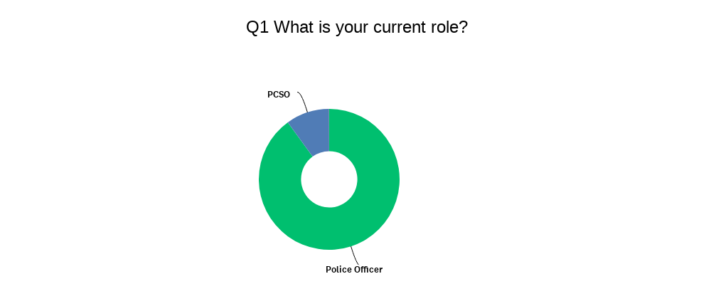

4.3.3 Specifics; Frequency of dealings with Domestic Abuse
As the following graphic depicts, of the respondents some 40% deal with domestic incidents daily and another 40% said they deal with domestic incidents weekly, this means that around 80% of the respondents to the survey deal with domestic incidents on at least a weekly basis which purports that the respondents are at the very front line of dealing with domestic abuse. This was an aim of the research which looked to target police officers for this research as it was believed that police officers deal with domestic abuse very regularly which appears to be the case.

It is worthy of note however, that the research does not identify what geographical areas or specific role the respondents work in and as such the research would presume that 80% of all officers deal with domestic abuse at least weekly, whereas it is possible the respondents all work in a domestic abuse specific department or simply in an area where domestic abuse is perhaps more prevalent.

4.3.4 Specifics; Involvement of alcohol in Domestic incidents
The survey asked the following question; Of the domestic incidents you attend, what % involve intoxication in some way?

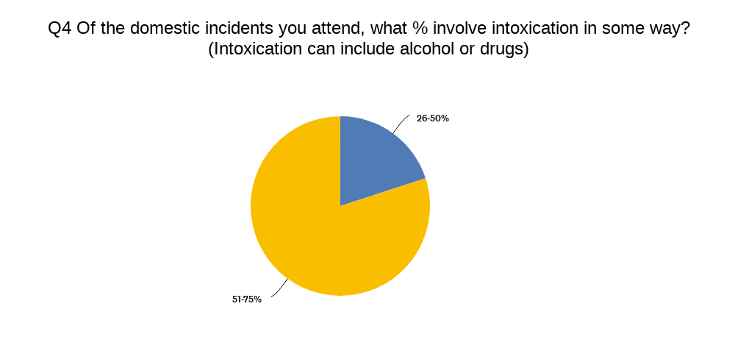

This is an important question for the purpose of this research, the objective of which was to identify how often intoxication is involved in domestic abuse, based on what police officers experience on the ground. This research shows that 80% of the respondents believe that of the incidents they attend, between 51-75% of those incidents involve intoxication through alcohol or drugs. Whilst this appears to show a clear belief by police officers own experiences that intoxication is a factor in domestic abuse incidents, what the research does not learn is the means of intoxication, for example is alcohol, drugs or both a factor. Secondly, it does not identify directly whether intoxication on the part of the victim, perpetrator or simply other persons present is what is being referred to by the respondents.

In order to identify the factors which police officers believe impact on why a perpetrator of domestic violence, commits that specific offence, participants were asked the following:
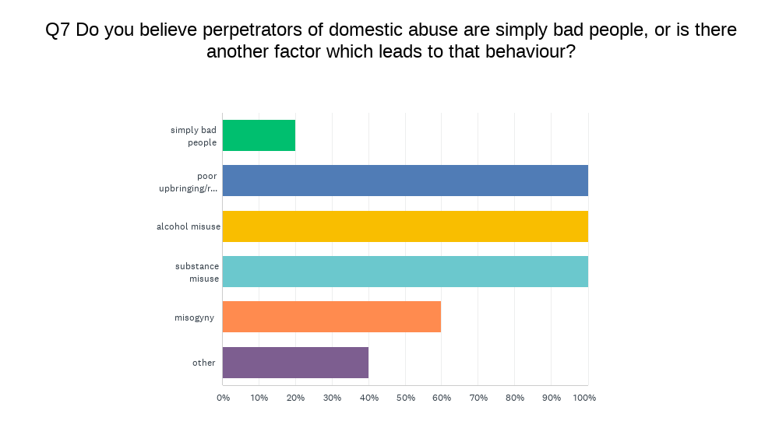
Every respondent included alcohol misuse, substance misuse and poor upbringing/role models as a factor which influences a perpetrator of domestic violence’s behaviour. This is a telling insight into how much alcohol is an impact factor in perpetrating domestic violence, however by having a broad question it has also raised other impact factors which on the face of this research appear to show an apparent equal impact.

4.4 Conclusion
In conclusion, despite the shortcoming of the research being its sample size and as identified the broadness of the questions. The survey has targeted its intended audience and has returned results of interest to this research. It is clear that police officers deal with domestic violence on a regular basis and further research should look to develop on this assertation and explore the specific roles and how they interact with domestic violence, for example a response police officer would deal with the immediate response to an incident, whereas a domestic violence unit officer may deal with the aftermath and ongoing support to victims.

It is also clear that intoxication plays a significant role in domestic abuse incidents, however once again this should be explored in more detail by further research. Examples of this could be to identify what is meant by intoxication such as is this alcohol, drugs or something else and secondly who involved in the incident referred to is intoxicated, is it the victim or perpetrator or both, or is it some other involved person all together.

Lastly, although this research has aimed to focus on alcohol and its impact on domestic violence, there are other factors which police officer believe to be equally important and impactful. The issues of misogyny, upbringing and role models should be defined and further researched as to how they may impact on domestic violence.

4.4.1 Meeting Objectives and Aims
The objectives for the questionnaire were set out in chapter 3.1.2, those being:
- Do police officers frequently attend domestic incidents?
- What proportion of those incidents involve alcohol?
- Is alcohol a defining feature in those incidents of domestic violence?
As explained above, each of these objectives have been achieved which has led to achieving the overall objectives of this project which were set out in chapter 1.3, specifically information has been gathered in the form of a questionnaire and has been analysed in chapter 4. Based on this analysis it would appear that the aim of the project has been met, that is to say that there appears to be based on this research, a link between alcohol abuse and domestic abuse.

5. Findings and Conclusion

5.1 Introduction
The previous chapters of this dissertation have detailed the phases of this research project, from the initial conception through a detailed analysis of previous research into the topic, culminating in a questionnaire which has yielded insight in an effort to answer the following question:

Domestic Abuse and Alcohol misuse; Is there a link between Alcohol misuse and the likelihood of someone being a perpetrator of domestic abuse?

Despite a number of negatives and drawbacks which have been identified and documented throughout this piece of research, trends have been identified and it is possible to identify the needs of further research into this topic. Ultimately, the initial aim of this research project has to an extent been met as there does appear to be a belief amongst police officers that alcohol is a significant factor in perpetrating domestic abuse. However, owing to the limitations this particular researcher has encountered, it would not be prudent to suggest that the evidence contained in this research is definitive and more research is required to add to this research in order to achieve that aim.

5.2 The achievement of the Aim and Objectives
The aim of this research project was to identify the links between substance misuse and domestic abuse. Through this research, that initial goal was further defined, the meaning of substance misuse for the purpose of this research was limited to alcohol abuse only and secondly the research was focused on perpetrators of domestic abuse as a pose to the broader scope of both victims and perpetrators, in short this research sought to identify whether alcohol is a significant factor involved in a person perpetrating domestic abuse. The objectives were set in order to achieve the overarching aim and were met as follows:
5.2.1 First Objective
The first objective was to; Conduct an extensive literature review, using resources globally to identify the trends that research into domestic violence has taken over time and how police services have changed in conjunction with this research.

This project has reviewed in depth, the literature around domestic violence from its early form the review has found how research has begun to narrow from simply defining domestic abuse to identifying the causes of domestic violence and most recently exploring methods and techniques to prevent domestic violence.

5.2.2 Second and Third objectives
The second objective was to use the literature review to narrow the scope of the research, this was achieved and the scope was narrowed to explore alcohol misuse rather than the wider subject of substance misuse and to look at perpetrators rather than victims and perpetrators. The third objective was to identify the most appropriate information gathering tool which was identified as being a survey, ultimately this survey resulted in some significant weaknesses to the research, however as previously stated this was owing to the survey tool used, rather than the method itself.

5.2.3 Fourth, fifth and sixth objectives
The fourth objective was to carry out the research, this was achieved as detailed in the relevant chapter which despite its own drawbacks of limited numbers of participants, was efficient in terms of ease to create the survey and ease of disseminating the survey to the participants.

The fifth and sixth objectives, were perhaps the most key those being:

- Through data analysis of the information from police officers, identify if the overall aim has been achieved.
- As a contingency, should the aim not be achieved or not be clear, the researcher should set out the reasons for this and outline how future research can avoid the same limitations.

These objectives are best commented on in the following chapters.

5.3 Main Findings
5.3.1 Strengths of research
The fifth objective as set out in the introduction to this dissertation south to identify if the overall aim of the research was achieved. The original aim was to identify a definitive link between substance misuse and domestic abuse, definitive being a clear and obvious link which is backed by research. The research which has guided this researcher throughout this dissertation has shown that there is a well-documented link between alcohol, violence and domestic abuse. The most recent research has begun to explore treatment for these factors which are involved, such as on a limited scale there have been research projects where addiction to alcohol is treated and it is hoped that this will prevent re-offending, however there is limited research post this to back up the assertation that treatment will prevent offending.
In the absence of the resources to continue this line of research, this project has sought to further strengthen the assertation that alcohol and addiction to alcohol has a significant influence on domestic abuse. This research sought the views of police officers as main responders to domestic abuse and as experts in identification of intoxication through alcohol. The research does suggest that officers attend a relatively high frequency and number of domestic abuse incidents, furthermore there is a suggestion or belief by those participants that alcohol was a factor in those incidents.
In summary, the research objective has been achieved, there does appear to be a definitive link between alcohol misuse and being a perpetrator of domestic violence.

5.3.2 Weaknesses of research
The research has found a number of weaknesses in the project. it has found that whilst the study was aimed with anonymity in mind, to prevent any breaches of data protection or ethical issues. This very anonymity has meant that there is a possibility that the sets of data are contaminated in that respondents may have attended the same incident, or the respondent may be an officer in a domestic abuse unit which would contaminate the analysis which suggests officers in general attend a high amount of domestic abuse incidents. These weaknesses could mean that the research is not reliable as a sole basis of future research, hence why further research on this topic using police officers as the source of data is recommended.

5.3.3 Trends identified by research
Despite the weaknesses of this research, it has identified some clear trends, it is apparent that alcohol misuse is a significant impact factor in relation to perpetrators of domestic abuse, if the views of police officers are to be believed, this is a far greater factor than previously believed. It is also worthy of note that despite this, officers have identified other factors which to them are of similar or equal importance in terms of impact or influence on domestic violence perpetration.

5.4 Recommendations / Further Research
The sixth objective, was to outline how this research was limited and to guide future research this has been met as follows.

5.4.1 Recommendations to police forces
A statistic from the ONS (2022) shows that almost 911,000 crimes which were domestic abuse related, were recorded by police in the UK. Yet only around 53,000 of those cases led to a prosecution and of those around 75% were successful. Yet none of this data includes whether alcohol or any other substance for that matter, was a contributing factor. By searching the online tool Bailii.org which contains court results and judge’s rulings, by searching for the term ‘domestic abuse’ some 12,000 cases have a reference to domestic abuse yet add the term ‘alcohol’ to that same search and this reduces to some 2,000 cases, which on the face of it suggests only 1/6 cases of domestic abuse involve alcohol. This would be directly contrary to the findings of this project and is likely owing to a lack of statistics as highlighted in chapter 2.4.7. It is the opinion of this researcher, that police forces should record aggravating factors involved in all domestic abuse incidents, such as alcohol or other substances. Such statistics will only further understanding of domestic abuse and will be of great use to future academics researching this topic.

5.4.2 Lessons learned from this project
The researcher would recommend that a larger sample size be attained in any future research. Further to this, the research should follow the methods of this research in that a questionnaire directed at police officers should be utilised. Within this questionnaire, more detail is required to prevent the documented potential contamination of the results, attention should be paid to departments worked, geographical location and more probing information in relation to the incidents referenced obtained.

5.5 Self-Reflection
Throughout this study, the researcher has gained knowledge of the research conducted previously and the trends of ongoing research have been identified. The literature review was important as it helped the researcher to understand what research is taking place and what is founded upon, it also aided in identifying where previous research can guide and underpin the topic being researched in this project.
A number of difficulties and weaknesses have been identified whilst progressing through this dissertation and whilst not foreseen from concept of this research, these weaknesses have been embraced and critically reflected upon by the researcher, rather than simply ignoring and drastically re-orientating the research, this researcher has sought to add value to the research by understanding and embracing these weaknesses in a bit to guide future research whilst not completely hindering this project.
The researcher sought to identify if there was a link between intoxication and domestic violence, it has been found that this is a well-researched field and that there is indeed a link between the two and further research is required to further specify this link with the goal of guiding future research into preventing domestic violence.

Bibliography

Adams, Anne and Cox, Anna L. (2008). Questionnaires, in-depth interviews and focus groups. In: Cairns, Paul and Cox, Anna L. eds. Research Methods for Human Computer Interaction. Cambridge, UK: Cambridge University Press, pp. 17–34.

Belenko, S., Hiller, M., Hamilton, L., & Taxman, F. S. (2013). Treating substance use disorders in the criminal justice system. Current Psychiatry Reports, 15(11), 413. doi: 10.1007/s11920-013-0413-1.

Brisker, Y. S., & Bergman, L. (1998). The Significance of Alcohol for Violence and Accidents. Alcoholism: Clinical and Experimental Research, 22(10), 299S-306S. doi: 10.1111/j.1530-0277.1998.tb04382.x

Chatwin, C., Baldwin, L., Forrester, A., Wylie, L., & Bennett, K. (2015). Substance Misuse Treatment in the Criminal Justice System: A Review of the Literature. Journal of Social Work Practice in the Addictions, 15(4), 313-334. doi: 10.1080/1533256X.2015.1109505

College of Policing. (2021). Arrest and other positive approaches. Retrieved May 5, 2023, from https://www.college.police.uk/app/major-investigation-and-public-protection/domestic-abuse/arrest-and-other-positive-approaches

Creswell, J. W. (2018). Research design: qualitative, quantitative and mixed methods approaches (5th edition.). SAGE.

Erez,E., (2002). Domestic violence and the criminal justice system: An overview. Online Journal of issues in Nursing, 7(1), p.4.

Flatley, J, Kershaw, C, Smith, K, Chaplin, R, and Moon, D (2010), Crime in England and Wales 2009/10 Home Office Statistical Bulletin 12/10 (London: Home Office)

Hirschel, Buzawa, E., Pattavina, A., & Faggiani, D. (2007). Domestic Violence and Mandatory Arrest Laws: To What Extent Do They Influence Police Arrest Decisions? The Journal of Criminal Law & Criminology, 98(1), 255–298.

Hester, M. (2009). Who's Watching Who? A Study of Strategic Interaction in Domestic
Violence and Child Protection Cases. JessicaKingsley Publishers.

Home Office (2013), Domestic violence and abuse: new definition available at https://www.gov.uk/domestic-violence-and-abuse (accessed on 26 Feb 23)

Jamieson, Susan. "Likert scale." Encyclopedia Britannica, 26 Sep. 2022, https://www.britannica.com/topic/Likert-Scale.

Langhinrichsen-Rohling, J., & Selwyn, C. (2015). The Intersection of Substance Abuse and Intimate Partner Violence Perpetration: A Review of the Literature. Aggression and violent behavior, 24, 19-28. https://doi.org/10.1016/j.avb.2015.04.006

ONS (2023) Crime in England and Wales: year ending September 2022, available at: <https://www.ons.gov.uk/peoplepopulationandcommunity/crimeandjustice/bulletins/crimeinenglandandwales/yearendingseptember2022> (accessed 26 Feb 23)

ONS (2022) Domestic abuse prevalence and trends, England and Wales: year ending March 2022, available at:
https://www.ons.gov.uk/peoplepopulationandcommunity/crimeandjustice/articles/domesticabuseprevalenceandtrendsenglandandwales/yearendingmarch2022 (accessed 26 Oct 23)

Renzetti, C. M. (1996). Intimate Partner Violence. Sage Publications.

Schneider, E. M. (2000). The Battered Women’s Movement and the Problem of Domestic Violence. In Battered Women and Feminist Lawmaking (pp. 11–28). Yale University Press. http://www.jstor.org/stable/j.ctt1npsn7.5

Siegel, R. B. (1996). “The Rule of Love”: Wife Beating as Prerogative and Privacy. The Yale Law Journal, 105(8), 2117–2207. https://doi.org/10.2307/797286

Straus, M. A., & Gelles, R. J. (1980). Behind closed doors: Violence in the American family. Doubleday.

Stevens, A. (2006). Prison-Based Drug Treatment: A Review of the Evidence. The Age of Criminal Justice, 33(2), 139-160.

Yu, R (2019) Mental disorders and intimate partner violence perpetrated by men towards women: A Swedish population-based longitudinal study. Available at:
https://doi.org/10.1371/journal.pmed.1002995 (accessed on 27 Feb 23)

7. Appendices

7.1 Appendix One: Questionnaire
Domestic Abuse and Substance misuse; Is there a link between substance misuse and the likelihood of someone being a perpetrator of domestic abuse.
This survey is aimed at serving Police Officers only, participation is anonymous and the responses received to this survey will be used for the purpose of academic research only.

The purpose of this survey is to form part of academic research being undertaken to determine the links between substance misuse and being a perpetrator of domestic abuse, the insight of police officers is hoped to provide a comprehensive picture of the issue at hand given that police officers are subject matter experts in a persons intoxication and are the front line responders to domestic incidents.

Question Title
1. What is your current role?

Police Officer

PCSO

Other Police

Other, non-police

Question Title
2. How often do you attend domestic incidents in your current role?

daily

weekly

monthly

never

Question Title
3. How much of your time on shift is spent dealing with domestic incidents?

0-20%

21-40%

41-60%

61-80%

81-100%

Question Title
4. Of the domestic incidents you attend, what % involve intoxication in some way? (Intoxication can include alcohol or drugs)

0-25%

26-50%

51-75%

76-100%
Question Title
5. Do you agree with the following statement: Most domestic incidents involve substance misuse.

Strongly agree

Agree

Neither agree nor disagree

Disagree

Strongly disagree

Question Title
6. Do you agree with the following statement: Substance misuse has little influence on domestic abuse.

Strongly agree

Agree

Neither agree nor disagree

Disagree

Strongly disagree

Question Title
7. Do you believe perpetrators of domestic abuse are simply bad people, or is there another factor which leads to that behaviour?

simply bad people

poor upbringing/role models

alcohol misuse

substance misuse

misogyny

other

Question Title
8. Do you believe that substance misuse is a significant factor in perpetrating domestic violence?

Yes

No

neither

Question Title
9. Would you support intervention for substance misuse in cases where DV is identified as a risk in a relationship?

Yes

No

Question Title
10. Do you think intervention would prevent DV?

Yes

No

I don't know

7.2 Appendix Two: Questionnaire Results
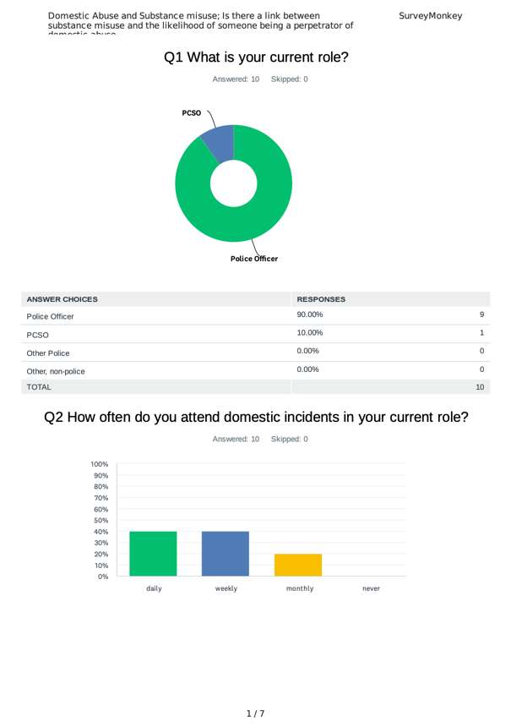
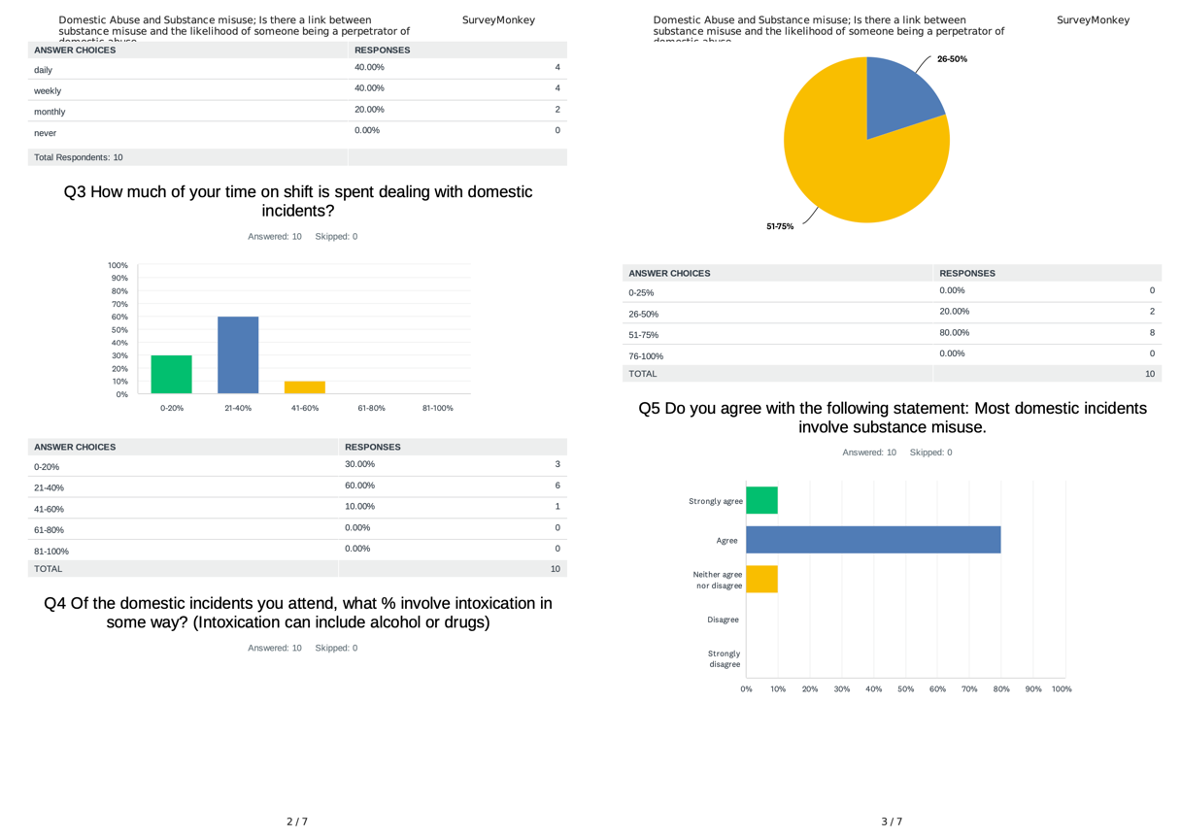
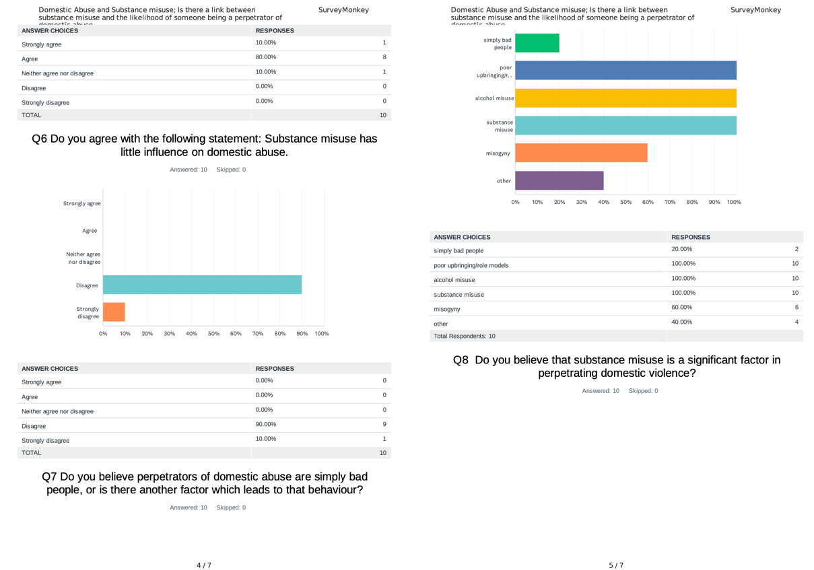
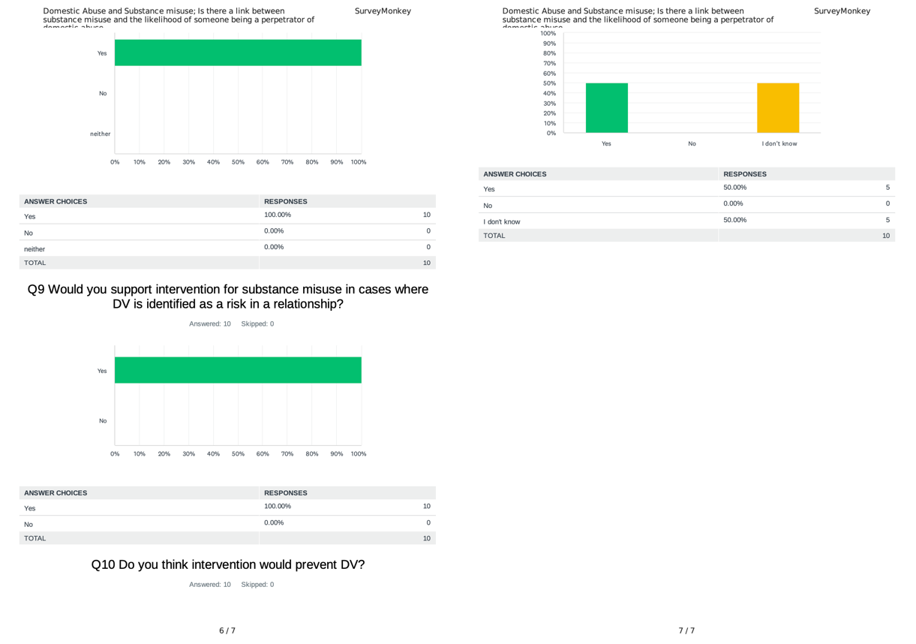

7.3 Appendix Three: Dissertation Proposal
DRAFT RESEARCH TITLE QUESTION:

Domestic Abuse and Substance misuse; Is there a link between substance misuse and the likelihood of someone being a victim or a perpetrator of domestic abuse.

INTRODUCTION:

This dissertation will look at the links between substance misuse and domestic abuse. It will discuss the links between substance misuse, such as addiction to controlled substances or alcoholism, and domestic abuse encompassing both victims and perpetrators. It will explore whether substance abuse makes a person more likely to be a perpetrator of domestic abuse and similarly, does it make someone more likely to be a victim or indeed a repeat victim and is this adequately addressed in rehabilitation of offenders and support to victims.

Research suggests that on the extreme end of domestic violence, that being domestic homicide, substance use is a common factor and more generally it is suggested that men who are dependent on alcohol or drugs are 6 times more likely to be perpetrators of domestic abuse. The purpose of this research is to determine if the experience of police officers who are the first responders to incidents of domestic abuse, corroborates this research.

This subject was chosen by the researcher as domestic abuse is something that they have first-hand experience of responding to. It is an important subject and one which they believe to be somewhat overlooked when it comes to rehabilitation of offenders and victims as if substance abuse is a root cause of the behaviour it should be tackled as a priority to prevent reoffending or becoming repeat victims.

Furthermore, the topic of domestic abuse takes up a large proportion of police resources and is a topic that in recent decades has become better researched and various initiatives have been implemented to tackle domestic abuse, these have largely been aimed at better understanding in order to recognise domestic abuse and to be proactive in responding to all incidents. It would be beneficial to further explore the root causes or exacerbating factors involved in domestic abuse and what can be done to prevent offending and re-offending.

SUMMARY OF RESEARCH OBJECTIVES:

The aims of this study are to identify:
- Is substance misuse and domestic abuse linked?
- Does substance misuse make a person more likely to be a perpetrator?
- Does substance misuse make a person vulnerable to being a victim of domestic abuse?

The research conducted will be guided by the following principles:
- An exploration and understanding of other literature around the topic.
- An evaluation of current services to rehabilitate offenders or support victims.
- Primary surveys will be conducted with responders to domestic abuse, largely police officers but also other involved services.

The surveys conducted will be collated and analysed to be used for the purpose of corroborating existing literature which as previously mentioned suggests a link between substance misuse and domestic abuse and to give backing to the proposed method of reducing offending and victimisation.

LITERATURE REVIEW:

Domestic violence is unfortunately, a common issue within UK society and this is shown by the most recently published Crime Survey for England and Wales (ONS, 2023) which shows that in the year of April 21 – March 22, police in England and Wales recorded 910,980 offences as domestic abuse related. The CSEW also estimates that 5.7% of adults aged 16 – 59 had experienced domestic abuse.

Whilst this figure seems large, it should not be used as a true gauge of incidents of domestic abuse (Flatley et al, 2010), research has previously shown that 47% of victims of domestic abuse had been victimised more than once and 30% stated they had been victimised more than three times.

The UK government defines domestic abuse as follows:

‘Any incident or pattern of incidents of controlling, coercive or threatening behaviour, violence or abuse between those aged 16 or over who are or have been intimate partners or family members regardless of gender or sexuality. This can encompass, but is not limited to, the following types of abuse: psychological, physical, sexual, financial, and emotional’ (Home Office, 2013).

A study by Yu (2019) based on data from Sweden identified 140,000 men whom between January 1998 and December 2013, had received a clinical diagnosis of alcohol or drug abuse. Researchers then looked into the number of these men who had subsequently been detained for assaulting, threatening, or sexually abusing their wives, girlfriends, or female ex-partners.
They discovered that 1.7% of alcohol-dependent men had subsequently been arrested for such offences, which is six times the number in a sample of all males with a comparable age profile. Similarly, 2.1% of drug-using males were subsequently arrested for such offences, which was seven times more than the national average.

Much research has been done on the topic, however the information available largely looks at incidents which are either recorded as crimes, or as with Yu’s research, have led to an arrest. Similarly, in Yu’s work, this only considers persons with diagnosed cases of alcohol of drug dependency. These factors indicate that the research being done is not able to provide a complete picture of the scale of the issue being researched.

This research hopes to identify the gap between the statistics of recorded crime/ domestic abuse arrests and diagnosed cases of substance addiction, with the real world observations of professionals which could encompass incidents which do not lead to arrest or are not recorded as crimes, as well as taking into account those perpetrators or victims who do not have diagnosed addiction to alcohol or drugs, but these influences are a factor.

SUMMARY OF RESEARCH –SURVEY METHOD:

This study will consist of a survey targeted at police officers and other professionals in the field being studied, the questions will be aimed in order to produce quantitative data as a result of the survey which will be for the purpose of this research, the primary data source.

Secondary data from existing literature similar to that previously highlighted, will be analysed against the primary data with any findings critically examined. This method is best suited to this research as it will remain simple and to the point. Given the small sample group the researcher believed that questions aimed toward qualitative data would be prone to returning too broad a data set to answer the question posed.

SUMMARY OF SAMPLING FRAMEWORK:

The target sample for this research will be police officers and professionals in the field of domestic abuse, those asked to take part will only be those involved in the field. This targeted sample of people is preferred to a more generalised questionnaire for the broader public as the research is seeking to identify the observations of professionals who deal with domestic abuse as it is hoped this will depict the larger picture of domestic abuse, rather than that which only leads to recorded crime and arrests as previous research has explored.

ETHICAL ISSUES:

The researcher has not identified any significant ethical issues arising as a result of this study. Participants will not be identifiable as they will remain anonymous and the information they provide will be anonymised so as to not reveal any specifics of people or locations involved in the subject matter.

TIME SCALE:

The time scale for this research has been set out by a schedule of deadlines as dictated by the university institution. Broadly, the study itself should be complete and analysed by August 2023, with final findings and conclusions complete by September 2023.

7.4 Appendix Four: Ethics Form
APPLICATION FOR ETHICAL APPROVAL

In order for research to result in benefit and minimise risk of harm, it must be conducted ethically. A researcher may not be covered by the University’s insurance if ethical approval has not been obtained prior to commencement.

The University follows the OECD Frascati manual definition of research activity: “creative work undertaken on a systematic basis in order to increase the stock of knowledge, including knowledge of man, culture and society, and the use of this stock of knowledge to devise new applications”. As such this covers activities undertaken by members of staff, postgraduate research students, and both taught postgraduate and undergraduate students working on dissertations/projects.

The individual undertaking the research activity is known as the “principal researcher”.

Ethical approval is not required for routine audits, performance reviews, quality assurance studies, testing within normal educational requirements, and literary or artistic criticism.

Please read the notes for guidance before completing ALL sections of the form.

This form must be completed and approved prior to undertaking any research activity. Please see Checklist for details of process for different categories of application.

Delete the Guidance Notes at the end of the form BEFORE submitting your application

SECTION A: About You (Principal Researcher)
Full Name: |  | Daniel MARTIN
Tick all boxes which apply: |  | Member of staff: | ☐ | Honorary research fellow: | ☐
Undergraduate Student | ☒ | Taught Postgraduate Student | ☐ | Postgraduate Research Student | ☐

Institute/Academic Discipline/Centre: | UWTSD
Campus: | Swansea
E-mail address: | 2023879@student.uwtsd.ac.uk
Contact Telephone Number: | Nil
For students:
Student Number: | 2023879
Programme of Study: | Professional Policing Practice
Director of Studies/Supervisor: | Vivienne HARPWOOD

SECTION B: Approval for Research Activity
Has the research activity received approval in principle?  (please check the Guidance Notes as to the appropriate approval process for different levels of research by different categories of individual) |  | YES | ☒ | NO | ☐
 |  |  |  | Date
If Yes, please indicate source of approval (and date where known): Approval in principle must be obtained from the relevant source prior to seeking ethical approval | Research Degrees Committee |  | ☒
 | Institute Research Committee |  | ☐
 | Other (write in) |  | ☐

SECTION C: Internal and External Ethical Guidance Materials
Please list the core ethical guidance documents that have been referred to during the completion of this form (including any discipline-specific codes of research ethics, and also any specific ethical guidance relating to the proposed methodology). Please tick to confirm that your research proposal adheres to these codes and guidelines.
UWTSD Research Ethics & Integrity Code of Practice | ☒
UWTSD Research Data Management Policy | ☒
 | ☐

SECTION D: External Collaborative Research Activity
Does the research activity involve collaborators outside of the University? |  | YES | ☐ | NO | ☒
If Yes, please provide the name of the external organisation and name and contact details for the main contact person and confirmation this person has consented to their personal data being shared.as part of this collaboration.
Institution
Contact person name
Contact person e-mail address

Has this individual consented to sharing their details on this form? |  | YES | ☐ | NO |  | ☐
Are you in receipt of a KESS scholarship? |  | YES | ☐ | NO |  | ☐
Is your research externally funded |  | YES | ☐ | NO |  | ☐
Are you specifically employed to undertake this research in either a paid or voluntary capacity? | Voluntary | YES | ☐ | NO |  | ☐
 | Employed | YES | ☐ | NO |  | ☐
Is the research being undertaken within an existing UWTSD Athrofa Professional Learning Partnership (APLP) | If YES then the permission question below does not need to be answered. | YES | ☐ | NO |  | ☐
Permission to undertake the research has been provided by the partner organisation | (If YES attach copy)  If NO the application cannot continue | YES | ☐ | NO |  | ☐

Where research activity is carried out in collaboration with an external organisation
Does this organisation have its own ethics approval system? | YES | ☐ | NO | ☐
If Yes, please attach a copy of any final approval (or interim approval) from the organisation

SECTION E: Details of Research Activity
Indicative title: | The study of links between substance misuse and domestic violence, with the aim to establish if these is any correlation between substance misuse and being a perpetrator or victim of domestic violence.
Proposed start date: | 1/3/23 | Proposed end date: | 1/5/23
Introduction to the Research (maximum 300 words)
Ensure that you write for a Non-Specialist Audience when outlining your response to the three points below:
- Purpose of Research Activity
- Proposed Research Question
- Aims of Research Activity
- Objectives of Research Activity
Demonstrate, briefly, how Existing Research has informed the proposed activity and explain
- What the research activity will add to the body of knowledge
- How it addresses an area of importance.
Purpose of Research Activity

The purpose of the study is to investigate whether a persons disposition as a substance misuser, be it someone who is an alcoholic or addicted to substances such as heroin or cocaine, can make that person more likely to be a perpetrator of domestic violence, or indeed increase the chance of becoming a victim of domestic violence.

The study will look at the experience of police officers as well as other professionals in the field and ask what they believe to be the factors which may cause someone to be a perpetrator or victim of domestic violence.

It is hoped that the study will depict the observations of those with the most experience of domestic violence, without having to disclose precise details of incidents which would not be appropriate, and these observations will provide an insight into the factors that contribute most to a person being a victim or becoming a perpetrator of domestic abuse.

(this box should expand as you type)
Research Question

Domestic Abuse and Substance misuse; Is there a link between substance misuse and the likelihood of someone being a victim or a perpetrator of domestic abuse.

(this box should expand as you type)
Aims of Research Activity

- To establish what front line responders to domestic abuse believe to be the contributing factors in relation to a person’s lifestyle/characteristics.
- For these factors to be ranked into an order of most to least impactful.
- To identify where substance misuse falls into this ranking.
- To understand how tackling aggravating factors can be a tool in reducing risk of domestic violence

(this box should expand as you type)
Objectives of Research Activity

- Review literature around domestic violence and its links with substance misuse.
- To conduct a study with Police officers and third party organisations with experience of domestic violence, to identify observations or common factors involved in cases of domestic violence.
- Lastly, to collect analyse and display data to depict findings.

(this box should expand as you type)
Proposed methods (maximum 600 words)
Provide a brief summary of all the methods that may be used in the research activity, making it clear what specific techniques may be used. If methods other than those listed in this section are deemed appropriate later, additional ethical approval for those methods will be needed.
I will use an online survey, which will be shared with police colleagues and local council colleagues who deal with domestic violence support. The survey will ask a series of questions which will enable me to gather data for analysis, to identify whether the observations of those most in contact with both victims and perpetrators of domestic abuse, corroborate or contradict the question asked.

(this box should expand as you type)

Location of research activity
Identify all locations where research activity will take place.
Swansea

(this box should expand as you type)
Research activity outside of the UK
If research activity will take place overseas, you are responsible for ensuring that local ethical considerations are complied with and that the relevant permissions are sought. Specify any local guidelines (e.g. from local professional associations/learned societies/universities) that exist and whether these involve any ethical stipulations beyond those usual in the UK (provide details of any licenses or permissions required). Also specify whether there are any specific ethical issues raised by the local context in which the research activity is taking place, for example, particular cultural and/or legal sensitivities or vulnerabilities of participants.
No research will be conducted overseas.

(this box should expand as you type)
Use of documentation not in the public domain: Are any documents NOT publicly available? | NO | ☒
 | YES | ☐
If Yes, please provide details here of how you will gain access to specific documentation that is not in the public domain and that this is in accordance with prevailing data protection law of the country in question and England and Wales.

(this box should expand as you type)

SECTION F: Scope of Research Activity
Will the research activity include: | YES | NO
Use of a questionnaire or similar research instrument? | ☒ | ☐
Use of interviews? | ☐ | ☒
Use of diaries? | ☐ | ☒
Participant observation with their knowledge? | ☐ | ☒
Participant observation without their knowledge? | ☐ | ☒
Use of video or audio recording? | ☐ | ☒
Access to personal or confidential information without the participants’ specific consent? | ☐ | ☒
Administration of any questions, test stimuli, presentation that may be experienced as physically, mentally or emotionally harmful / offensive? | ☐ | ☒
Performance of any acts which may cause embarrassment or affect self-esteem? | ☐ | ☒
Investigation of participants involved in illegal activities? | ☐ | ☒
Use of procedures that involve deception? | ☐ | ☒
Administration of any substance, agent or placebo? | ☐ | ☒
Working with live vertebrate animals? | ☐ | ☒
Other primary data collection methods, please explain in this box  For example, ‘focus groups’. Please indicate the type of data collection method(s) in this box and tick the accompany box. | ☐ | ☒
Details of any other primary data collection method:  (this box should expand as you type) | ☐ | ☒
If NO to every question, then the research activity is (ethically) low risk and may be exempt from some of the following sections (please refer to Guidance Notes).

If YES to any question, then no research activity should be undertaken until full ethical approval has been obtained.

SECTION G: Intended Participants
Who are the intended participants: | YES | NO
Students or staff at the University? | ☒ | ☐
Adults (over the age of 18 and competent to give consent)? | ☒ | ☐
Vulnerable adults? | ☐ | ☒
Children and Young People under the age of 18? (Consent from Parent, Carer or Guardian will be required) | ☐ | ☒
Prisoners? | ☐ | ☒
Young offenders? | ☐ | ☒
Those who could be considered to have a particularly dependent relationship with the investigator or a gatekeeper? | ☐ | ☒
People engaged in illegal activities? | ☐ | ☒
Others (please identify specifically any group who may be unable to give consent) please indicate here and tick the appropriate box. | ☐ | ☒
Other – please indicate here:  (this box should expand as you type) | ☐ | ☒

Participant numbers and source
Provide an estimate of the expected number of participants. How will you identify participants and how will they be recruited?
How many participants are expected? | 10-20 participants  (this box should expand as you type)
Who will the participants be? | Police Officers, Employees of third party organisations which deal with domestic violence  (this box should expand as you type)
How will you identify the participants? | Each respondent will be numerated and as such no person will be identifiable as personal details will not be requested, the respondents will be anonymous.  (this box should expand as you type)

Information for participants: | YES | NO | N/A
Will you describe the main research procedures to participants in advance, so that they are informed about what to expect? | ☒ | ☐ | ☐
Will you tell participants that their participation is voluntary? | ☒ | ☐ | ☐
Will you obtain written consent for participation? | ☒ | ☐ | ☐
Will you explain to participants that refusal to participate in the research will not affect their treatment or education (if relevant)? | ☐ | ☐ | ☒
If the research is observational, will you ask participants for their consent to being observed? | ☐ | ☐ | ☒
Will you tell participants that they may withdraw from the research at any time and for any reason? | ☒ | ☐ | ☐
With questionnaires, will you give participants the option of omitting questions they do not want to answer? | ☒ | ☐ | ☐
Will you tell participants that their data will be treated with full confidentiality and that, if published, it will not be identifiable as theirs? | ☒ | ☐ | ☐
Will you debrief participants at the end of their participation, in a way appropriate to the type of research undertaken? | ☒ | ☐ | ☐
If NO to any of above questions, please give an explanation
(this box should expand as you type)

Information for participants: | YES | NO | N/A
Will participants be paid? | ☐ | ☒ | ☐
Is specialist electrical or other equipment to be used with participants? | ☐ | ☒ | ☐
Are there any financial or other interests to the investigator or University arising from this study? | ☐ | ☒ | ☐
Will the research activity involve deliberately misleading participants in any way, or the partial or full concealment of the specific study aims? | ☐ | ☒ | ☐
If YES to any question, please provide full details
(this box should expand as you type)

SECTION H: Anticipated Risks

Outline any anticipated risks that may adversely affect any of the participants, the researchers and/or the University, and the steps that will be taken to address them.

If you have completed a full risk assessment (for example as required by a laboratory, or external research collaborator) you may append that to this form.
Full risk assessment completed and appended? |  | Yes | ☐
 |  | No | ☒
Risks to participants
For example: emotional distress, financial disclosure, physical harm, transfer of personal data, sensitive organisational information
Risk to Participant:  PTSD or general distress due to recollection of cases  (this box should expand as you type) | How will you mitigate the Risk to Participant  The purpose of the study will be explained and a warning given before any person takes part.  The questionnaire will ask respondents to confirm that they are not victims of domestic abuse or anything other than the target audience for the study.  (this box should expand as you type)
If research activity may include sensitive, embarrassing or upsetting topics (e.g. sexual activity, drug use) or issues likely to disclose information requiring further action (e.g. criminal activity), give details of the procedures to deal with these issues, including any support/advice (e.g. helpline numbers) to be offered to participants. Note that where applicable, consent procedures should make it clear that if something potentially or actually illegal is discovered in the course of a project, it may need to be disclosed to the proper authorities
(this box should expand as you type)
Risks to investigator
For example: personal safety, physical harm, emotional distress, risk of accusation of harm/impropriety, conflict of interest
Risk to Investigator:  Minimal  (this box should expand as you type) | How will you mitigate the Risk to Investigator:  The investigator understands the topic being studied and no details of incidents will be obtained by the study itself.  (this box should expand as you type)
University/institutional risks
For example: adverse publicity, financial loss, data protection
Risk to University:  Nil  (this box should expand as you type) | How will you mitigate the Risk to University:  (this box should expand as you type)

Disclosure and Barring Service
If the research activity involves children or vulnerable adults, a Disclosure and Barring Service (DBS) certificate must be obtained before any contact with such participants. | YES | NO | N/A
Does your research require you to hold a current DBS Certificate? | ☐ | ☐ | ☒

SECTION I: Feedback, Consent and Confidentiality
Feedback
What de-briefing and feedback will be provided to participants, how will this be done and when?
Participants will be thanked for taking part, but it is not expected that there will be any follow up exchange of information. Of course this study will form part of a dissertation that will be available to them and my own details will be passed should anyone wish to know the findings of the study prior to this.

(this box should expand as you type)
Informed consent
Describe the arrangements to inform potential participants, before providing consent, of what is involved in participating. Describe the arrangements for participants to provide full consent before data collection begins. If gaining consent in this way is inappropriate, explain how consent will be obtained and recorded in accordance with prevailing data protection legislation.
The study will outline its content and explain consent in relation to the information provided being used as part of the study, this acceptance will be a precursor to taking part.

(this box should expand as you type)
Confidentiality / Anonymity
Set out how anonymity of participants and confidentiality will be ensured in any outputs. If anonymity is not being offered, explain why this is the case.
As previously stated, the study is anonymous as such no personal details will be requested and no specific detail of a sensitive nature will be gained by completion of the study.

(this box should expand as you type)

SECTION J: Data Protection and Storage
In completing this section refer to the University’s Research Data Management Policy and the extensive resources on the University’s Research Data Management web pages (http://uwtsd.ac.uk/library/research-data-management/).
Does the research activity involve personal data (as defined by the General Data Protection Regulation 2016 “GDPR” and the Data Protection Act 2018 “DPA”)? | YES | NO
“Personal data” means any information relating to an identified or identifiable natural person (‘data subject’). An identifiable natural person is one who can be identified, directly or indirectly, in particular by reference to an identifier such as a name, an identification number, location data, an online identifier or to one or more factors specific to the physical, physiological, genetic, mental, economic, cultural or social identity of that natural person. | ☐ | ☒
If YES, provide a description of the data and explain why this data needs to be collected:
(this box should expand as you type)
Does it involve special category data (as defined by the GDPR)? | YES | NO
“Special category data” means sensitive personal data consisting of information as to the data subjects’ –  (a) racial or ethnic origin,  (b) political opinions,  (c ) religious beliefs or other beliefs of a similar nature,  (d) membership of a trade union (within the meaning of the Trade Union and Labour Relations (Consolidation) Act 1992),  (e) physical or mental health or condition,  (f) sexual life,  (g) genetics,  (h) biometric data (as used for ID purposes), | ☐ | ☒
If YES, provide a description of the special category data and explain why this data needs to be collected:
(this box should expand as you type)
Will the research activity involve storing personal data and/or special category data on one of the following: | YES | NO
Manual files (i.e. in paper form)? | ☐ | ☒
University computers? | ☐ | ☒
Private company computers? | ☐ | ☒
Home or other personal computers? | ☐ | ☒
Laptop computers/ CDs/ Portable disk-drives/ memory sticks? | ☒ | ☐
“Cloud” storage or websites? | ☒ | ☐
Other – specify: | ☐ | ☒
For all stored data, explain the measures in place to ensure the security of the data collected, data confidentiality, including details of password protection, encryption, anonymisation and pseudonymisation:
Laptop used is password protected, only the researcher has access. The laptop used does utilise iCloud services and again this is password protected and only accessible to the researcher.

(this box should expand as you type)
All Data Storage
Will the research activity involve any of the following activities: | YES | NO
Electronic transfer of data in any form? | ☐ | ☒
Sharing of data with others at the University? | ☐ | ☒
Sharing of data with other organisations? | ☐ | ☒
Export of data outside the European Union or importing of data from outside the UK? | ☐ | ☒
Use of personal addresses, postcodes, faxes, emails or telephone numbers? | ☐ | ☒
Publication of data that might allow identification of individuals? | ☐ | ☒
Use of data management system? | ☐ | ☒
Data archiving? | ☐ | ☒
If YES to any question, please provide full details, explaining how this will be conducted in accordance with the GDPR and DPA (and/or any international equivalent):
(this box should expand as you type)
List all who will have access to the data generated by the research activity:
The researcher

(this box should expand as you type)
List who will have control of, and act as custodian(s) for, data generated by the research activity:
The researcher

(this box should expand as you type)
Give details of data storage arrangements, including security measures in place to protect the data, where data will be stored, how long for, and in what form. Will data be archived – if so how and if not why not.
(this box should expand as you type)
Please indicate if your data will be stored in the UWTSD Research Data Repository (see https://researchdata.uwtsd.ac.uk/ ). If so please explain. (Most relevant to academic staff)
(this box should expand as you type)
Confirm that you have read the UWTSD guidance on data management (see https://www.uwtsd.ac.uk/library/research-data-management/) | YES | ☒
 | NO | ☐
Confirm that you are aware that you need to keep all data until after your research has completed or the end of your funding | YES | ☒
 | NO | ☐

SECTION K: Declaration
The information which I have provided is correct and complete to the best of my knowledge. I have attempted to identify any risks and issues related to the research activity and acknowledge my obligations and the rights of the participants.

In submitting this application I hereby confirm that I undertake to ensure that the above named research activity will meet the University’s Research Ethics and Integrity Code of Practice which is published on the website: https://www.uwtsd.ac.uk/research/research-ethics/
Signature of applicant: | D MARTIN | Date:  24/2/23

For STUDENT Submissions:
Director of Studies/Supervisor: |  | Date:
Signature: |  | Date:

For STAFF Submissions:
Academic Director/ Assistant Dean: |  | Date:
Signature: |  | Date:

Checklist: Please complete the checklist below to ensure that you have completed the form according to the guidelines and attached any required documentation:
☒ | I have read the guidance notes supplied before completing the form.
☒ | I have completed ALL RELEVANT sections of the form in full.
☒ | I confirm that the research activity has received approval in principle
☐ | I have attached a copy of final/interim approval from external organisation (where appropriate)
☐ | I have attached a full risk assessment (and have NOT completed Section H of this form) (where appropriate) ONLY TICK IF YOU HAVE ATTACHED A FULL RISK ASSESSMENT
☒ | I understand that it is my responsibility to ensure that the above named research activity will meet the University’s Research Ethics and Integrity Code of Practice.
☒ | I understand that before commencing data collection all documents aimed at respondents (including information sheets, consent forms, questionnaires, interview schedules etc.) must be confirmed by the DoS/Supervisor, module tutor or Academic Director.
☒ | I have deleted the guidance notes before submitting the PG2 for consideration

RESEARCH STUDENTS AND STAFF ONLY
All communications relating to this application during its processing must be in writing and emailed to pgresearch@uwtsd.ac.uk , with the title ‘Ethical Approval’ followed by your name.
You will be informed of the outcome of your claim by email; therefore it is important that you check your University and personal email accounts regularly.

STUDENTS ON UNDERGRADUATE OR TAUGHT MASTERS PROGRAMMES should submit this form (and receive the outcome) via systems explained to you by the supervisor/module leader.

This form is available electronically from the Academic Office web pages: https://www.uwtsd.ac.uk/academic-office/appendices-and-forms/

Application Process

All staff research projects and all research students must submit the Ethical Approval Form to the University Research Ethics Committee via the Academic Office (pgresearch@uwtsd.ac.uk). Staff research directly in relation to personal study for taught undergraduate or Masters programmes should be submitted via the Institute procedures explained below.

Taught masters and taught undergraduate research Ethical Approval Forms are considered within Institutes. Institutes will provide details of the specific processes for this. Where the Ethical issues within any single ethical application are of particular concern the Institute will refer these to the University Research Ethics Committee. Any student activity that involves the collection of primary data needs to undergo Ethical approval, this includes assignment work as well as dissertations.

