Critical Review
Assessing life hacks from where development started, the course of any foundation in life is important to the development of any structure. This sets the course of learning and influences us to make changes or even just improvements. When it came to earn my own academic degree, there were modules set to complete so that could achieve and continue to produce better outcomes to set for a better future. Breaking down problems and steps to build up to standards towards your own goals, learning is at the start. From the start of the groundwork there is learning, from nursery to building your own future in schooling to overcoming a goal.
From a young age the creative side of me has always made an impact on my life from hobbies to schooling. The influences of cinematography, media, the growing of technology is continuously adapting although from this the curiosity and imagination level of creating became a part of my hobbies and interests. Companies like Warner Bros, Universal, Disney became a ritual to fictional characters with fairy tales and magic. The feeling of being transported was popular with children as it was unique to see the imaginative compositions that felt new. From popular artists like Charles Schulz or Dr Seuss or even Stan Lee, superheroes and even a little mouse has taken over the globe. The stages I took were from studying Art, Graphics, Music and watching a large amount of television. Other influences like travelling really took to interest when I thought of making a career out of my hobbies. Finding historic influences changed habits of the way that I drew or spent my spare time. Testing colour and clarity to change up designs was a little influence I had from spectating others.
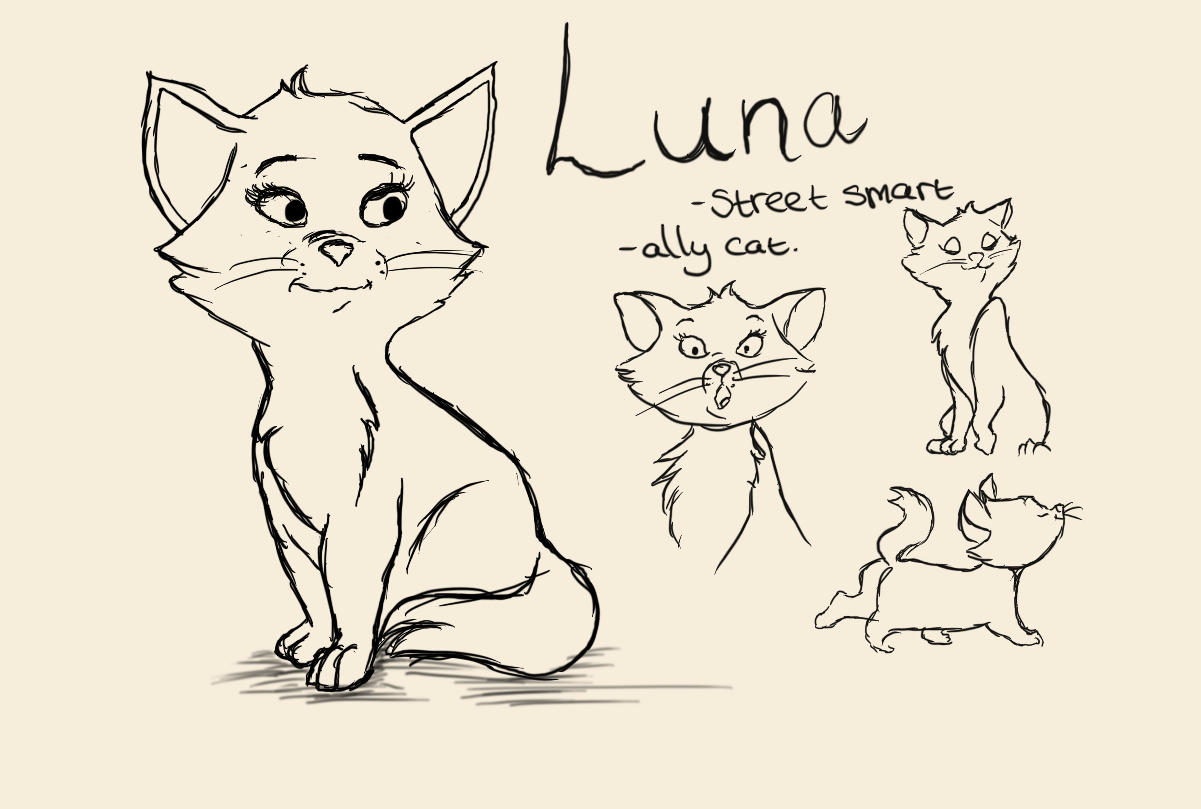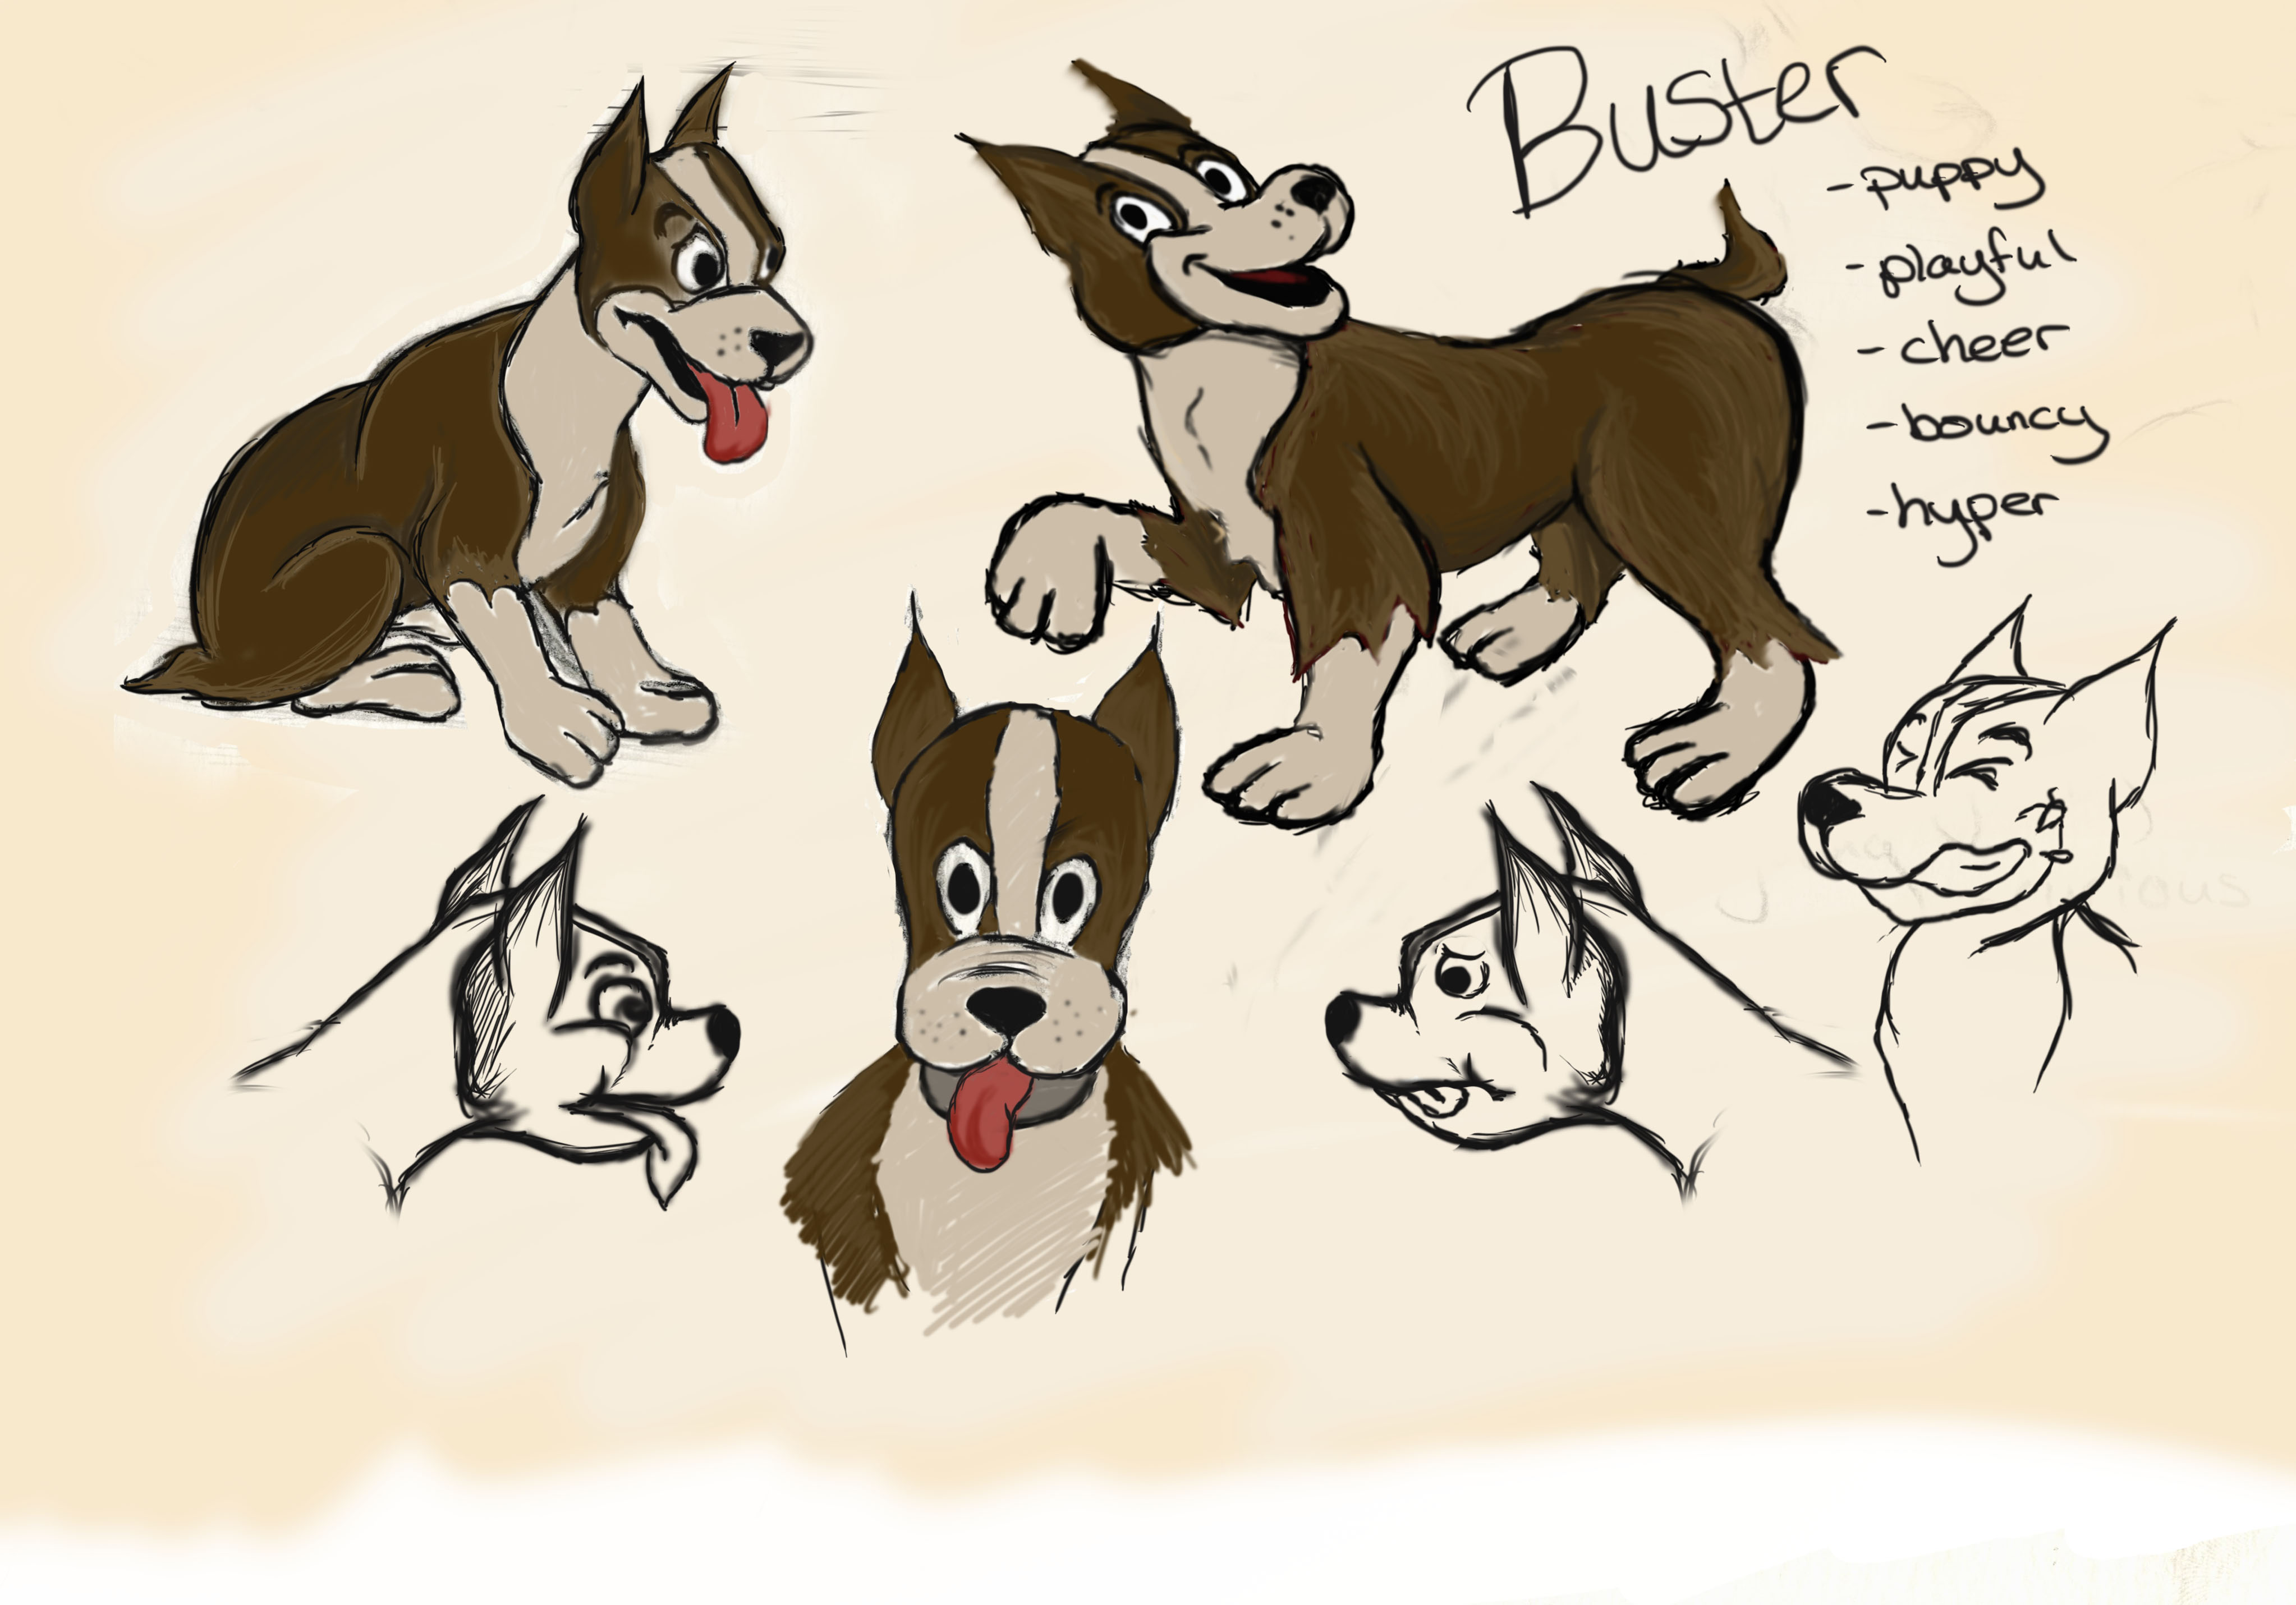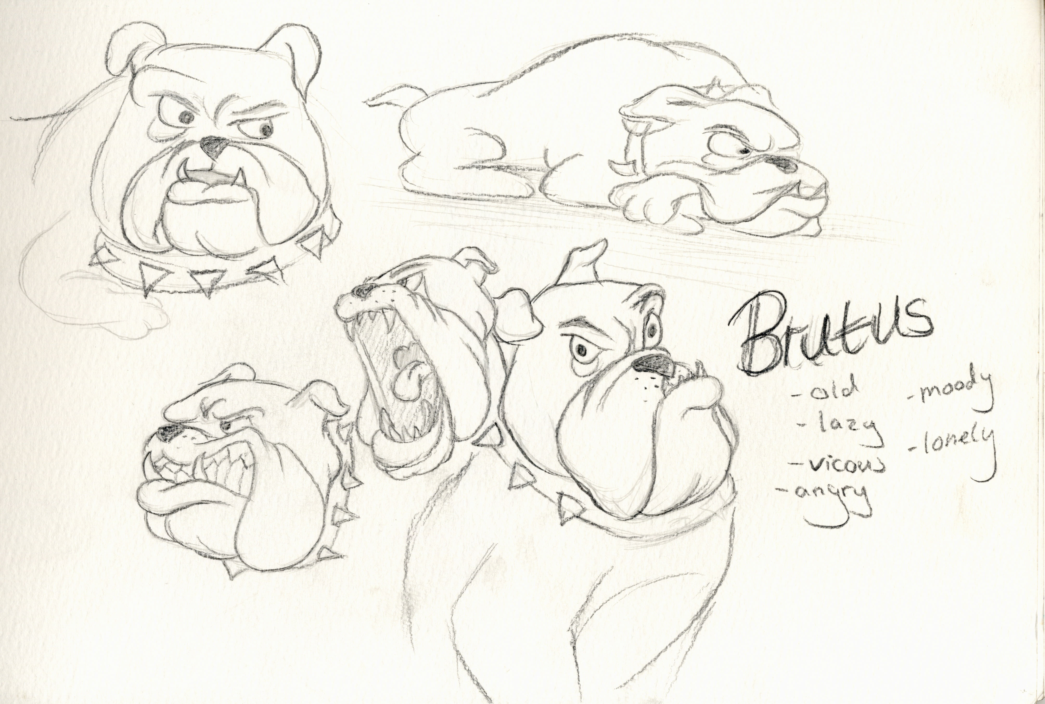
Following different characters and styles the influence of other animators can be easy following tutorials, research and genre. Finding the niche what your target audience and how your character should look. For example the life like character based on realism could be thought as more adult or seen as more relatable to the human eye, where as the design of a character that you might see in a "children's movie" (Disney) could be based on exaggeration of big eyes, tiny nose, excessive cartoon body is easier for the imagination of a child as well as seen as more desirable to watch. As well as designing around these characters the environment is very important too, the style of the character determines the outlook of the world establishing the brand of motion picture. Fictional stories can be wildly vast and the use of details of props can be used to the storyline as well, depending on how you want your audience to feel in the surroundings I would like to think of the audience escaping to unrealistic location however having something relatable to an audience could swing in favour of compatibility as it might be easier to absorb the information in. For example, if there was a story that presented on planet earth compared to a story set during a fictional time this could have a negative impact on the audience as the complications could seem too vast to take in an enjoy the movie, where as a story that is told with an environment we are already used to has less complications of understanding. However, the following could prove that fictional stories are still compatible just the details of some sort of "human life" help to the background. Another way you could put this theory across from character design is comparing the outline of characters is what the human eye takes in first the basic shape is important as a starting establishment, from absorbing a normal biped this is an easier understanding, but if you were to create unusual creature that has a different skeleton the following could be seen abnormal, so the character could be rejected as how the audience obtain him/her. Following from this learning curve feeling more inspired during class time of visual studies, as drawing was already something I am passionate about but the character design in the look of movies and Hollywood gave me the push I needed to develop more. There challenges where I created a monster, developed a stereotypical girly character and the cutest puppy. Getting set a task to create my own story was one of my top priorities as it was one of the things I was looking forward to the most and is probably still my strongest skill. From my influences as a child from creating and watching great minds create incredible stories I am prepared to interpret. We got set to create a story in 2D and preparing to make it as well as producing. Features in pre-production like 2D, concept designs and storyboards was new to me but became important to my development in year 2 and 3. Expressing concepts and the "look" of my characters was exciting as I did not feel restricted, the open pool of different designs was infinite, from this I was nervous to if I was to succeed, to overcome this I put myself towards the receiving end of the target audience as what I would like to see. It was hard to settle on just one design when the possibilities are endless, that is how studying and animating made me feel.
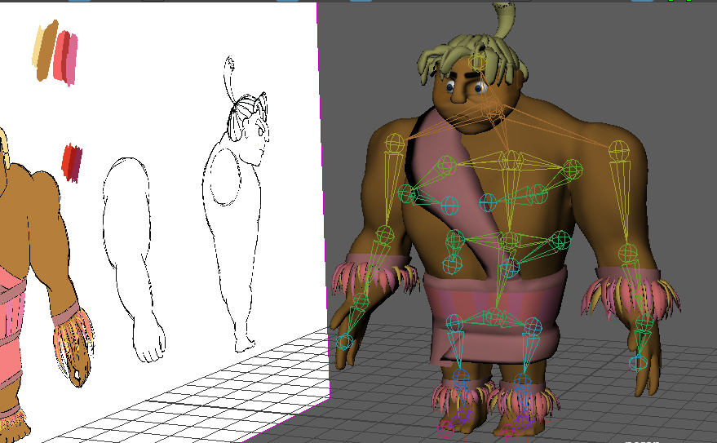
Studying at University of Wales Trinity Saint David one of my favourite classes in third year was history. Learning how far technology has come and the different directions of cinematography that has evolved every generation. Gathering information on the development in genres and audience credibility's to improve my own takes and movies as every influence from the past can improve my own success rate. In the different stages of time we can the growth from 2D animation to 3D animation including the variation between target audiences. Schooling myself in this has affected what field I would see myself in as career as the cinematic community has different audiences is that I would like to affect with my own work. Along with assessing colour in productions and environment set up in movies this helped me give off emotions from the colour and clarity. Advancing in cinematics to create a better sense of life. Researching other successful animations online helps to my benefit to decide the direction to take, taking note of story telling, timing, action and quality. Using reference to live action and real world animatics this will create a better reel for animation. Motion from reference helps the realism of any animation and from this I've considered of performing actions myself or gathering first on experience with other bipeds and quadrupeds. For example, from animating in Maya where I can set my own image plane with my own video footage of the animation to mirror it on to my character has made the biggest difference in my work and speed. Imitating this frame by frame is a good way to portray the correct action, furthermore exaggerating these motions just a little by angles and stretching for that cartoon affect. However, the computer doesn’t always pick up the ticks of key framing and is not always compatible with the naked eye therefore exaggeration is most of the time necessary. In comparison this could seem more lifeless and robotic, noticing this early helped with my own creations as I admire the cartoon style and I target towards. Challenging myself this year was not the smartest thing I could from this point, deciding what was the best story for my project was difficult but emotions got the better of me, so I continued to model and create a story that was for the light hearted. In this challenge my main character was a dog, choosing a quadruped had its weaknesses as it took more time and even in the end the flaws of the project let down the story however I stick by what I did for my story and I'm glad to have finished it. The accomplishment of completing this project solo has its advantages, however working with a team could've been better for experience, the project could have benefitted in better modelling, rigging and lighting. When it came to motion and animation the set up was easy to follow as practice was key from my advanced character, analysing this helped with what bits I could have struggled with. Dealing with this in advance was the wisest thing to do, more time would have been ideal however the beginning rig I had to work with was not the best and this let down the animation. If this I was part of a group I would have liked to rely on someone else's skills as my own experience and knowledge is not as strong as it could have been. However, there is never a bad lesson as there always something to learn.
When I started first year in university I did not have a lot of experience in 3D or in the software I use now. There was always my creative background where I studied A level in Fine Art and Graphics, but my hobbies were painting and drawing, other influences like the desire to film and dream to be an animator for movies was all in theory until I went to university. Modules like modelling, lighting and rendering helped me understand the software behind animation as tasks like modelling and texturing were more challenging but I needed these assignments to push my skills and to improve my practice. The difficulties came when I had less experience in software so when I was set tasks in 3D and had to use Maya and Zbrush I wasn’t familiar with controls, therefore this took me longer and delayed a successful outcome. I worked on projects in 3D where I had to model exterior of a building, anatomy of a male and a character for a gaming reel. The difficulties for me were modelling as there were many struggles with Zbrush as software license set me back, there were limitations. However how I got through this was with help off tutors as well as internet research and one on one time with classmates as we were all sharing experiences and knowledge with each other, I felt like we were constantly working together. First year set the ball in motions and taught me basics of designing and filming.
After a summer of collecting rigs online and practicing animating I went back to the first semester of my second year in university with the intention of being an animator. We got straight to work, and I got set tasks in modules on the first week of the semester. Different courses like Animated Short, Advanced character were the main priority as in advanced character it was all about performing and expressing emotion through characters, this involved a lot of animating and was about how much life the character had which is what was inspiring to me. When it came to animating in Advanced Character there was a lot of research involved as I was animating a biped rabbit, there were times where I acted out the motion myself but also recording other people doing it as I came across the different shapes of people affected how we move, also gathering videos off YouTube helped with my exaggeration of some expression, even just for simple expression the point was to exaggerate the idea and express the emotion, this changed how I was animating as I learnt different shortcuts and visual contents tricks. Animated Short set the challenge of creating your own story and preparing the pre-production with the intention of establishing a finishing film in the next semester, this entailed me to set up my own concepts of characters, storyboards, concept design on landscape and props but also researching similar ideas for inspiration and relatable outlook on the final production. This was to set my standard for third year major project and I understand the benefits this gave me as there were many things I wanted to change when it came to the second semester of second year as modelling and rigging set me back, using only Maya to model it did slow me down however I learnt from this and therefore has influenced me to use Zbrush for a quick model and the draw attention to detail in my character and prop design. Working in a production team in second year was harder than first year as most of my colleagues had their own ideas of planning and producing, so settling on an idea and what roles each of us would have taken us longer than a couple of hours and relying on people for their input was also a struggle at times as we couldn’t determine at what stage we were at. Working on a production where we had a big team and we were working with an independent film maker took longer than planned and set us all back in the process of developing any sort of film, we learnt new software in the process, the pressure was high, and the team was very tense to work with. This was a learning step for all of us, as we were very dependent on people higher than us, this acted as a viscous chain. Even being aware of the consequences there is not enough to prepare you to lose time or work in the preparation of production but being aware of how to handle the issue when it arises.
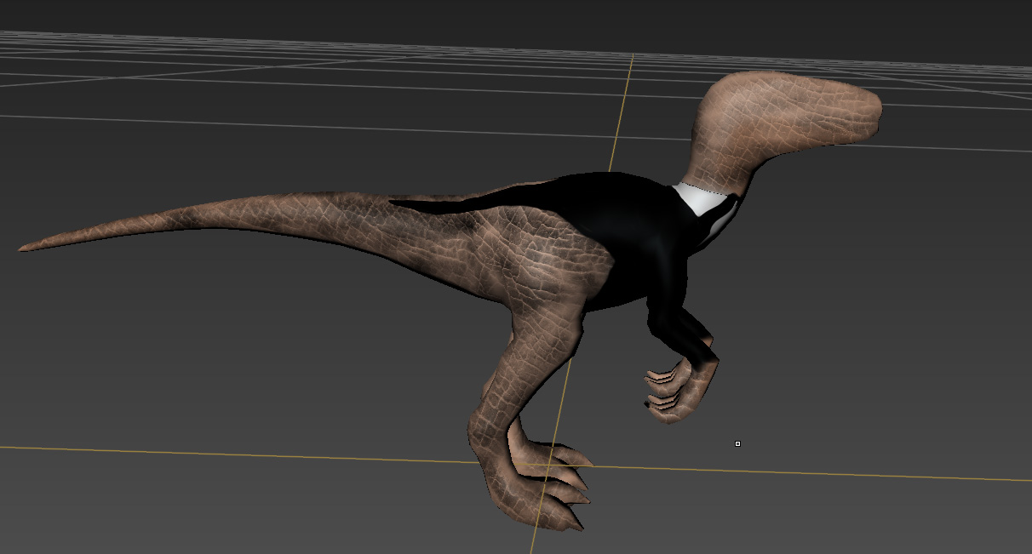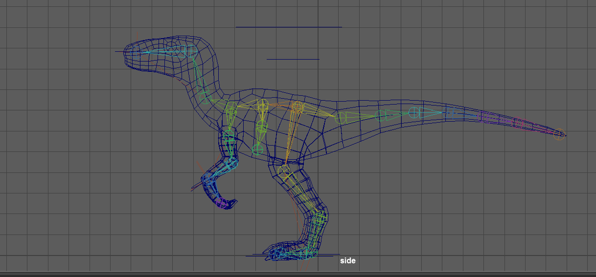
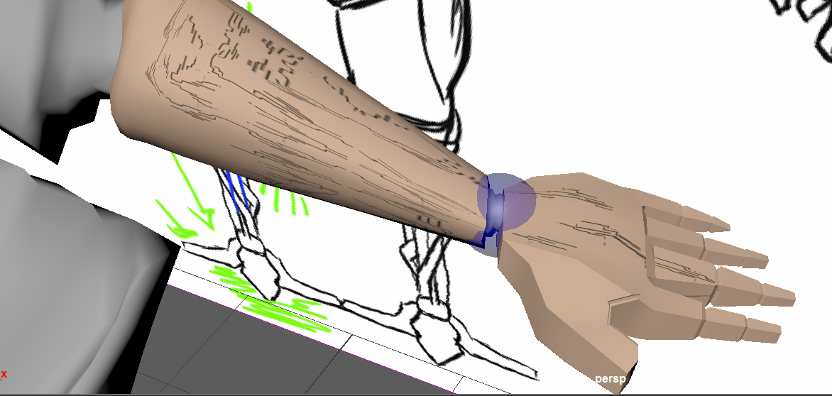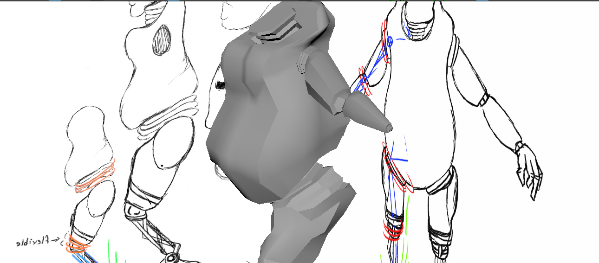
When it came to decide Major Project, my obvious choice was to do a lot of concept design on characters but also do a lot of animating. Asking for a challenge and design a story around a lovable character, a dog. Understanding the difficulties when taking this on, as a quadruped isn’t the easiest to tackle. However, I thought if I was to settle then I would never find my limitations and that’s why my major project means to go the extra mile. This had not proven the best method, but the hope of ambition got me into University there was no stopping now for I want to make a good impression on my audience and for myself. The outcome of this project helped me overcome hurdles that I never thought could be possible and improved skills that have let me down before. Being stubborn never got me far as being experienced held me back from exploring different software. This has affected my ability to work and will now set me for a better future.
Other influences my experience has given is to always try harder as my abilities are always there but pushing them does work. When it came to character design I feel that the more adaptions and stencilling I make the more designs I can adapt to fit the correct description for my character, the slightest curve or exaggeration can benefit a character in anyway.
To conclude from my experience and learning abilities I have learnt techniques from university, ways to tackle challenges, learnt better solutions to problem solving and working together in a team. Also improving my ways of thinking, engage my improvements from past projects. The understanding has helped my future for what I would like to make a career out of in production.

