

Human Resource Management

Assignment
Name: Sandeep Dammalapati
Student Id: 2214841
Subject: HRM Assignment
Module Code: LCMB7000
Lecturer Name: Mushfiqur Rahman

Table of Contents

- Introduction……………………………………………………………………3
- Aim and Objectives……………………………………………………………3
- Background of Organization…………………………………………………..3
- Policies and Procedures……………………………………………………….4
- Labor Market………………………………………………………………….5
  - Developed Countries Labor Market……………………………………...6
  - Developing Countries Labor Market……………………………………..7
  - UK Labor Market…………………………………………………………7
- Tools and Theories…………………………………………………………….10
  - Swot Analysis…………………………………………………………….10
  - Pestle Analysis……………………………………………………………11
  - HRM Strategic Theories………………………………………………….12
- Conclusion…………………………………………………………………….13
- References…………………………………………………………………….14

1. Introduction
In this report, we are going to discuss the Human resource management structure which includes Tata Consultancy Services (TCS), one of the multinational companies which is strongly committed to enhancing social effectiveness and generating immediate financial gain. To gain a sustainable competitive edge, it also helps to have a major goal. It is dependent on the UK labor market or workforce, which is essential to any UK company like TCS as it helps to boost employees' digital skills and capacity for growth. They contrast the labor markets of developed and emerging nations. Additionally, it analyses the SWOT, along with any pertinent organizational theories. Finally, this report draws conclusions based on concepts and theories and recommends the best ways to boost organizational performance using HRM strategies.

2. AIM and Objective
The Aim is to discuss about the Labor Market all over the world including UK.
The main objective of this report is to discuss the Human resource management structure includes the TCS and, we are going to analyze the report of SWOT and PESTLE analysis of TCS which strategies follows by the HRM and its theories.

3. Background of TCS
Tata Consultancy Services (TCS) is an international provider of consulting, business solutions, and information technology services with its headquarters in Mumbai, India. It was established in 1968 by a consortium of Tata businesses under the direction of Tata Sons, and since then it has expanded to become one of the biggest providers of IT services globally, with operations in more than 149 locations throughout 46 countries.
TCS provides its customers with a broad range of services, such as IT consulting, software development, application management, infrastructure support, and business process outsourcing. It provides clients with services across many different sectors, including manufacturing, retail, banking and financial services, insurance, and healthcare, among others.
TCS has won various honors and awards throughout the years for its efforts in corporate social responsibility, innovation, and business performance. It is renowned for its employee-friendly policies and workplace culture and has continuously been regarded as one of the best employers in the IT sector.
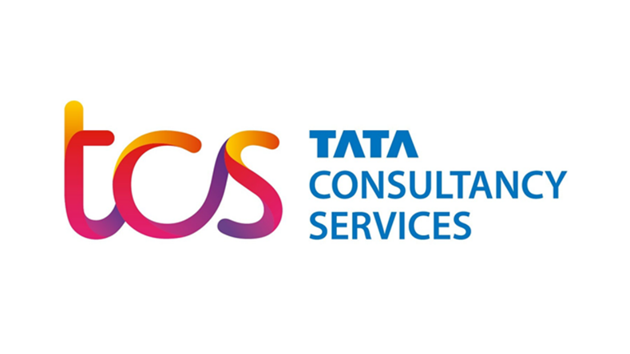
(Source: Tcs.com)
4. Policies and Procedures
Tata Consultancy Services (TCS) is known for its employee-friendly policies and work culture. Here are some key policies and procedures that TCS follows in its human resource management:
Performance Management: TCS has a strong framework in place for evaluating employees' performance and potential. The business makes use of a 360-degree feedback process, which includes input from peers, managers, and consumers. The company TCS claims that "Performance Management at TCS is designed to drive superior performance, align individual goals with organizational goals, and create a performance-driven culture."
Learning and Development: TCS makes significant investments in learning and development initiatives for its staff. The business offers a thorough training program that comprises in-person instruction, online learning, and on-the-job training. According to TCS, "Learning and Development is a key pillar of the TCS Human Resources strategy, which is aligned with the business goals of the organization."
Work-Life Balance: TCS understands the value of work-life balance and has put in place several policies to help employees in this area. For instance, the company provides sabbaticals, telecommuting, and flexible work schedules. According to TCS, "Our Work-Life Balance initiatives aim to help our employees better manage their personal and professional lives and achieve greater work-life harmony."
Diversity and Inclusion: TCS is firmly committed to these issues. The organization has several programs in place to support diversity, including employing people from different backgrounds, providing equal opportunity for all employees, and fostering a welcoming workplace. The statement from TCS reads, "Our diversity and inclusion initiatives are designed to create a culture of respect, empathy, and collaboration, where all of our employees can thrive and achieve their full potential."
Employee Engagement: At TCS, keeping people engaged and motivated is given top emphasis. To that end, we provide several programs. These consist of social gatherings, team-building exercises, and employee recognition programs. According to TCS, "we foster employee engagement by providing a positive work environment, nurturing a culture of innovation and learning, and recognizing and rewarding performance."
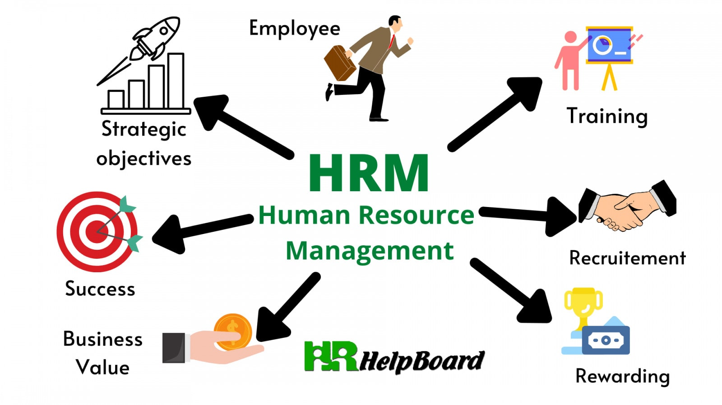
(Source: Nesscom.com)

5. Labor Market
The labor market is a key idea in economics that is investigated by academics, decision-makers, and industry. The market where employees and employers exchange goods and services related to labor is referred to as the labor market. Both the supply side (employers) and demand side (workers) of labor are included. In this market, employees provide companies with their labor and skills in exchange for pay or other remuneration, and firms compete to hire the best and most qualified candidates for the positions they have open.
The state of the economy, governmental regulations, demographic trends, technological advancements, and international rivalry are all factors that have an impact on the labor market. When there are more job vacancies than there are workers to fill them, the labor market is tight, which can result in higher salaries and better working conditions for employees. Conversely, when the labor market is slack, there are more workers than there are jobs, which can lead to lower wages and greater unemployment rates.
For job seekers, companies, policymakers, and economists alike, an understanding of the labor market is essential because it may shed light on the dynamics of employment, earnings, and productivity. It can also assist in guiding decisions about labor policy in other sectors such as trade, immigration, and education and training. "The Labor Market" by David Neumark and William L. Wascher (2010)
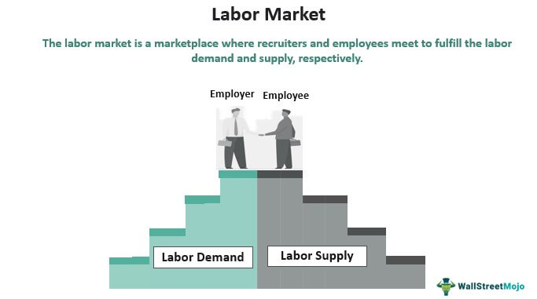
(Source: wallstreetmojo.com)
5.1. Developed Countries Labor Market
The COVID-19 pandemic has had a substantial effect on the labor market in industrialized countries, with many people enduring job losses, reduced hours, and unstable income. All areas of the economy have been impacted by the pandemic, but some have been particularly hard hit, including the hospitality, travel, and entertainment sectors.
Governments in affluent nations have put in place several policies to aid employees and businesses in reaction to the pandemic. Direct income support measures like stimulus payments and unemployment insurance are among these programs, as well as measures to help businesses, such tax incentives and loan guarantees.
The labor economy in affluent nations is starting to improve as vaccination rates rise, and limitations are eliminated. The recovery has been uneven, though, with certain industries and regions rebuilding at a faster rate than others. Additionally, some of the pandemic-related changes, like increased automation and remote work, are probably going to have a long-term impact on the labor market. After COVID-19, it is anticipated that the labor market in developed countries will experience new challenges and continue to change. Policymakers, firms, and employees will need to coordinate to adapt to these changes and ensure that the labor market remains productive, competitive, and equitable for all. "COVID-19 and the Labor Market: Recent Developments and Policy Responses" by the International Labor Organization (2021).
5.2. Developing Countries Labor Market
The COVID-19 pandemic has significantly affected the labor market in developing nations, resulting in many employees losing their jobs, working fewer hours, and experiencing unstable income. All economic sectors have been impacted by the pandemic, but low-skilled, unprotected informal workers have been particularly hard hit.
In response, Governments in developing nations have introduced a few policies to assist employees and businesses in the wake of the pandemic. Direct income support measures like cash transfers and unemployment benefits are among them, as well as business assistance measures like tax reductions and loan guarantees.
However, a lack of fiscal resources and inadequate social protection systems has made it difficult for developing nations to combat the pandemic. Additionally, a lot of developing nations rely heavily on industries like tourism and export-oriented industries that have been severely impacted by the pandemic.
The labor economy in developing nations is starting to improve as immunization rates rise, and limitations are eased. However, compared to developed nations, the recovery has been slower and more uneven, with some sectors and regions facing serious difficulties. The epidemic has also brought attention to the inequities that already exist in the labor market, and there is an increasing need for policies that address these imbalances and ensure a more inclusive and resilient labor market. Overall, it is anticipated that the labor market in developing nations will continue to face difficulties after COVID-19 and will need ongoing assistance from governments, corporations, and international organizations to ensure a sustainable and inclusive recovery. "COVID-19 and the Labor Market in Developing Countries: Joint Study by the ILO and UNDP" by the International Labor Organization and United Nations Development Program (2021)
5.3. UK Labor Market
Over 33 million people are employed across numerous industries and sectors in the UK, which has one of the largest and most diverse labor markets in the world. A key element in the UK's capacity to draw in foreign investment and keep its economy competitive has been its flexible labor market and relatively lax worker protection laws. The COVID-19 epidemic has significantly impacted the UK labor market, resulting in job losses, shortened workweeks, and unstable income for workers in all industries. The government has put in place a few supportive policies, such as the furlough program, which has assisted in averting a more serious unemployment crisis. But recovery has been slower in some industries, like hospitality and retail, which were particularly hard hit by the pandemic. Lack of skilled workers, particularly in the fields of science, technology, engineering, and mathematics (STEM), is another issue the UK is dealing with in the labor market. To fill these skills gaps and guarantee that the UK has the knowledge and abilities required to compete in a world economy that is changing quickly, there is an increasing need for investment in education and training. During the pandemic, the UK government put in place a few supportive policies to aid employees and businesses. These initiatives included the furlough program, which permitted companies to keep staff on a part-time or reduced-hours basis, and monetary assistance for independent contractors. Even still, the pandemic saw a substantial increase in unemployment in the UK, particularly among young people and those in lower-paying occupations. The employment rate is beginning to rise, and the number of open positions is increasing as the UK recovers from the pandemic. The rebound, meanwhile, has not been uniform across businesses, and some, including the transport and hospitality sectors, continue to face serious difficulties.
Additionally, the pandemic has accelerated labor market changes, including an increase in remote work and the development of digital technologies. For both individuals and businesses, this has brought opportunities as well as obstacles. While some people gain from increased flexibility and a better work-life balance, others are faced with job insecurity and the need to adopt new technologies. Overall, it is anticipated that the UK labor market will continue to confront possibilities and problems as it adjusts to the shifting economic environment and resolves issues like employment rights, talent shortages, and the influence of new technology.
In response to the COVID-19 pandemic's effects, the UK labor market is beginning to show indications of recovery, according to research by the Office for National Statistics (ONS). With 32.4 million employed between April and June 2021, up from 32.3 million during the same period in 2019, the employment rate in the UK has reached pre-pandemic levels. However, the report also pointed out that, particularly in industries like hospitality and retail, the number of people on the payroll was still below pre-pandemic levels. (Source: Office for National Statistics. "UK labor market: September 2021.")
The pandemic significantly affected the UK labor market, which saw an increase in unemployment from 3.8% in February 2020 to 5.1% in the three months leading up to June 2021. With low-paid and low-skilled workers bearing the brunt of the economic effects, the pandemic has also brought to light existing disparities in the labor market. Workers in low-wage industries including hospitality, retail, and leisure have been disproportionately impacted by job losses and shortened workweeks during the pandemic, according to research by the Resolution Foundation. (Source: Resolution Foundation, "Low-paid Britain in the pandemic.")
The epidemic has expedited labor market developments, including a surge in distant work and the development of digital technologies. The Chartered Institute of Personnel and Development (CIPD) found that 63% of UK employees worked from home at least once during the epidemic, and 71% of employers anticipate that hybrid working will become more prevalent in the future. (Source: Chartered Institute of Personnel and Development. "COVID-19 and the future of work: implications for HR.")
TCS is a multinational corporation that employs people in the UK and has been affected by the COVID-19 epidemic. TCS has put in place measures, such as remote working and digital technologies, to support its staff and business operations during this trying time. TCS claims that the business has modified its operations to address the difficulties caused by the pandemic and is in a good position to service its clients in the UK. (Tata Consultancy Services. "TCS in the UK.")
TCS works in the technology and IT industry in the UK, which has persevered through the epidemic. According to Tech Nation's analysis, the UK's technology industry expanded by 11% in 2020, outperforming the country's overall GDP, and is expected to do so again in 2021. (Tech Nation. "UK tech sector continues growth trajectory, outpacing wider economy.")
However, the pandemic has also presented difficulties for the technology sector, including changes in consumer behavior, reduced investment, and disruptions to the supply chain. Over 50% of UK tech companies reported a decline in revenue because of the pandemic, and 40% had to reduce their workforce, per a Tech Nation survey. (Tech Nation. "COVID-19 impact report: insights from UK tech businesses.") Overall, as the economy and labor market recover and adjust to the changed landscape, TCS's activities in the UK labor market post-COVID-19 are likely to continue to confront difficulties and opportunities. To continue offering value to its clients and staff in the UK, TCS will need to negotiate these difficulties and take advantage of possibilities. (Tata Consultancy Services. "TCS COVID-19 response.")
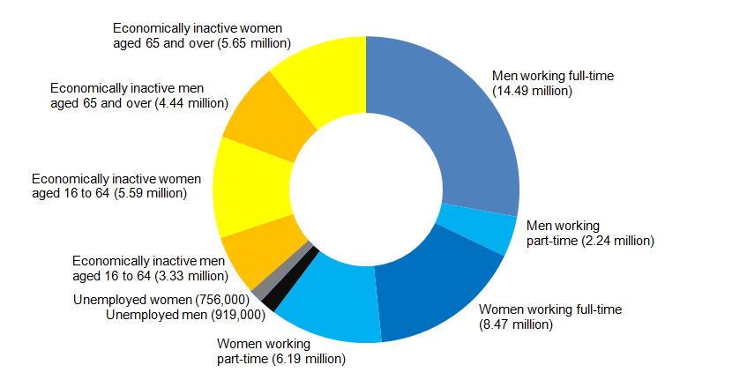
(Source: statistics.com)

6. Tools and Theories
6.1. Swot Analysis
A strategic planning tool known as the SWOT analysis aids organizations in determining their strengths, weaknesses, opportunities, and threats.
Strengths
1. Established brand and reputation: TCS has a well-established brand and reputation in the IT services sector, which aids in customer acquisition and retention. (TCS, 2020)
2. Diverse range of services: TCS provides a wide variety of services, such as consulting, application development, and infrastructure services, allowing it to satisfy a variety of client needs. (TCS, 2020)
3. Strong financial performance: TCS has a track record of stable revenue growth and profitability. (TCS, 2020)
4. Large talent pool: TCS has a big, diverse talent pool that comprises experts in many different fields and technology. (TCS, 2020)

Weaknesses
1. Dependence on key markets: TCS depends heavily on a small number of major markets for a significant amount of its income, making it vulnerable to risks including economic downturns, political unrest, and changes in regulatory regimes. (TCS, 2020)
2. Client concentration: TCS also primarily depends on a select few major clients for a sizeable amount of its revenue, which poses a concentration risk. (TCS, 2020)
3. Limited involvement in developing technologies: TCS has been under fire for adopting new technologies like blockchain and artificial intelligence slowly, which may eventually harm its competitiveness. (Mittal,2018)
4. High attrition rate: TCS has a higher attrition rate than some of its rivals, which may affect its capacity to retain people and provide clients with consistent quality. (TCS, 2020)
Opportunities
1. Growing demand for digital services: The COVID-19 epidemic has hastened the shift to digitalization, generating possibilities for businesses like TCS that provide digital services. 1. Growing demand for digital services. (TCS, 2020)
2. Expansion into new geographies: To diversify its revenue streams and lessen dependence on core markets, TCS can expand into new geographies, particularly in emerging economies. (TCS, 2020)
3. Collaboration and partnerships: TCS can use collaborations and partnerships to create new goods and services, penetrate new markets, and strengthen its position in the market. (TCS, 2020)
4. Investment in developing technologies: To keep ahead of the competition and fulfil changing client needs, TCS can make investments in emerging technologies like artificial intelligence, blockchain, and cloud computing. (Mittal,2018)
Threats
1. Intense rivalry: There are many firms seeking market share in the IT services industry, which is characterized by intense competition. (TCS, 2020)
2. Regulation changes: TCS's capacity to serve clients and operate in specific areas may be impacted by changes to regulations, including those governing immigration rules and data privacy laws. (TCS, 2020)
3. Cybersecurity and data privacy: Because TCS works in a sector that relies heavily on data, any cybersecurity or data breach might harm the company's standing and bottom line. (TCS, 2020)
4. Economic uncertainty: TCS's sales and profitability could be impacted by economic uncertainty, such as recessions and currency changes. (TCS, 2020)5. There is a skills shortage in several crucial fields, especially in artificial intelligence and machine learning
6.2. PESTLE Analysis
A strategic planning method called PESTLE analysis is used to identify and examine the main external elements that could have an impact on an organization's operating environment.
Political
1. Changes in the political climate in any of the nations where TCS works may have an impact on its business. For instance, modifications to immigration laws may affect TCS's capacity to hire people from abroad.
2. Regulations like GDPR and various national data protection legislation may have an impact on TCS's handling of client data.
Economic
1. The state of the global economy has an impact on TCS's financial performance. The demand for TCS's services may decline if the global economy weakens.
2. The income and profitability of TCS can also be impacted by changes in foreign exchange rates.
Social
1. TCS employs a varied group of people from many cultural backgrounds and conducts business internationally. As a result, it must be mindful of the social and cultural challenges present in the many nations where it conducts business.
2. Increased remote work because of the COVID-19 pandemic has altered work-life balance, employee engagement, and productivity.
Technological
1. TCS is well-positioned to benefit from the expansion of digital transformation thanks to its significant investments in technology and digital solutions.
2. TCS is up against fierce competition from other tech firms, therefore being on the cutting edge of innovation will be essential for its future.
Legal
1. TCS must abide by numerous rules and regulations in different nations because it operates in a highly regulated environment.
2. The reputation and financial success of TCS may be impacted by any legal conflicts or lawsuits.
Environmental
1. TCS is dedicated to minimizing its negative effects on the environment and has put in place a few efforts to support sustainability, such as lowering its carbon footprint and practicing water conservation.
2. Customers and stakeholders place an increasing amount of importance on environmental issues, therefore TCS's efforts in this area can boost the company's reputation and brand image.

6.3. HRM Strategic Theories
There are several HRM strategic theories that TCS may adopt to effectively manage its human resources.
Resource-Based View (RBV): According to this, a company's competitive edge comes from its special assets and skills, especially its people resources. The RBV theory may be used by TCS to pinpoint its key competences, such as its highly skilled personnel, and create plans for utilizing these assets to obtain a competitive edge.
High-Performance Work System (HPWS) Theory: According to this report, a set of HR procedures like employee engagement and empowerment, training and development, and performance management can boost worker productivity and corporate results. To foster a culture of excellence and innovation among its employees, TCS may implement HPWS.
Social Exchange Theory: According to this theory, a worker's relationship with their employer is built on a social exchange in which the worker trades talents and effort for benefits like compensation and job stability. To make sure that it pays its workers fairly and equally and to establish a solid employer brand and reputation, TCS may apply the social exchange theory.
Stakeholder Theory: According to this idea, a company is required to consider the interests of all its stakeholders, including its customers, staff, and the larger community. Stakeholder theory is a strategy that TCS may use to make sure that all its stakeholders are well-served by its HR policies and practices.
Goal-Setting Theory: According to this theory, setting precise, measurable objectives for workers can boost motivation and performance. Goal-setting theory may be used by TCS to make sure that its employees are aware of their duties and performance standards, and to give them regular feedback and encouragement to help them reach their objectives.

7. Conclusion
TCS is Multinational company. In this report, this leads us to the conclusion that the COVID-19 has a negative influence on labor markets in countries like the UK. TCS Company is situated in the UK and is a part of the e-commerce sector, which has seen both growth and job losses. As a result, it makes estimates of employment and unemployment using UK statistics. The framework of TCS's HR rules, which are intended to improve communication between managers and employees, may be seen in the context of human resource management.

8. References
TCS Performance Management: https://www.tcs.com/careers/performance-management
TCS Learning and Development: https://www.tcs.com/careers/learning-development.
TCS Work-Life Balance: https://www.tcs.com/careers/work-life-balance
TCS Diversity and Inclusion: https://www.tcs.com/careers/diversity-inclusion
TCS Employee Engagement: https://www.tcs.com/careers/employee-engagement
"The Labor Market" by David Neumark and William L. Wascher (2010)
"COVID-19 and the Labor Market: Recent Developments and Policy Responses" by the International Labor Organization (2021)
"The Uneven Impact of COVID-19 on the Labor Market" by the Organization for Economic Co-operation and Development (2021)
"The COVID-19 Labor Market Shock" by the Brookings Institution (2020)
"COVID-19 and the Labor Market in Developing Countries: Joint Study by the ILO and UNDP" by the International Labor Organization and United Nations Development Program (2021)
"The Impact of COVID-19 on the Labor Market in Developing Countries" by the World Bank (2021)
"COVID-19: Impact on the Labor Market in Low- and Middle-Income Countries" by the International Growth Centre (2021)
Office for National Statistics. "UK labor market: September 2021." (https://www.ons.gov.uk/employmentandlabourmarket/peopleinwork/employmentandemployeetypes/bulletins/uklabourmarket/september2021)
Resolution Foundation. "Low-paid Britain in the pandemic." (https://www.resolutionfoundation.org/publications/low-paid-britain-in-the-pandemic/)
Chartered Institute of Personnel and Development. "COVID-19 and the future of work: implications for HR." (https://www.cipd.co.uk/knowledge/coronavirus/future-work)
House of Commons Library. "Employment and economic recovery from COVID-19." (https://commonslibrary.parliament.uk/research-briefings/cbp-8896/)
Tata Consultancy Services. "TCS in the UK." (https://www.tcs.com/uk)
Tech Nation. "UK tech sector continues growth trajectory, outpacing wider economy." (https://technation.io/news/uk-tech-sector-continues-growth-trajectory-outpacing-wider-economy/)
Tech Nation. "COVID-19 impact report: insights from UK tech businesses." (https://technation.io/news/covid-19-impact-report-insights-from-uk-tech-businesses/)
Tata Consultancy Services. "TCS COVID-19 response." (https://www.tcs.com/covid-19-response)
TCS. (2020). Annual Report 2019-2020. Retrieved from https://www.tcs.com/content/dam/tcs/investor-relations/financial-statements/2019-20/Annual-Report-2019-20.pdf
Mittal, S. (2018). Tata Consultancy Services' SWOT Analysis: A Look at India's Largest IT Services Company. Retrieved from https://marketrealist.com/2018/07/tata-consultancy-services-swot-analysis-a
TCS Annual Report 2020-21: https://www.tcs.com/content/dam/tcs/investor-relations/financial-statements/annual-report/2020-21/tcs-annual-report-2020-21.pdf
TCS Sustainability Report 2020-21: https://www.tcs.com/content/dam/tcs/investor-relations/financial-statements/sustainability-report/2020-21/TCS_Sustainability_Report_2020-21.pdf
"TCS, Infosys and Wipro face headwinds as US, Europe growth slows" (Business Standard, 2022): https://www.business-standard.com/article/companies/tcs-infosys-and-wipro-face-headwinds-as-us-europe-growth-slows-122051201604_1.html

