

MODULE CODE: Digital Skills for Personal Development and Business Growth BMSW4008

ASSESSMENT COMPONENT: PORTFOLIO

STUDENT NAME: Chereen Carter

STUDENT NUMBER: 2530279

LECTURER: Philippa Fitzgerald

DATE: 16th March 2026
AI Acknowledgement
I confirm that I have not presented any AI-generated text as my own work. I confirm that I have retained copies of drafts, notes, and resources used before and after the use of AI tool

Contents
Task 1 4
Assessment of Digital Skills 4
References 7
Task 2 8
LinkedIn Learning Certificates for Office365 8
Task 3 11
Essay on Relevance of Excel in professional and personal life. 11
References 14

Task 1

Assessment of Digital Skills
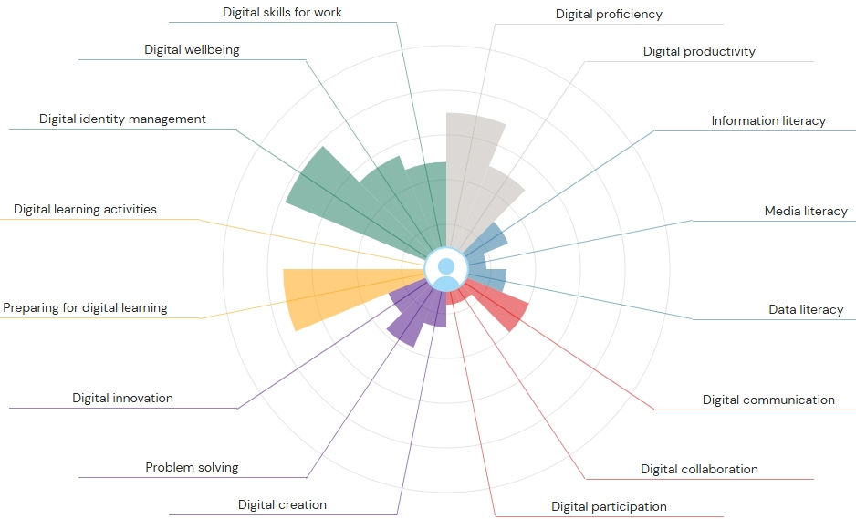
Image 1 Jisc Discovery tool graph

Introduction
There are several reasons why digital skills are important, one being that it improves ongoing learning and promotes personal growth so that you can adapt to change in technology and offers career resilience (Ghani, 2025). Therefore, this essay will discuss the assessment of my digital skills using the above Jisc graph completed which includes my strength and weakness in digital skills. I will discuss two of my strengths and two of my weaknesses, followed by how to improve my two weakness.

Strengths and weaknesses
The image one Jisc graph indicates that the bigger the colour the stronger my digital skills are. The smaller the colour shows my weaknesses. The Jisc tool Graph points out in yellow that I have strong skills when it comes to preparing for digital learning. Another strength it has shown me in grey is that I have strong skills in Digital Proficiency. The graph outlines my 2 weakness are media literacy in blue and digital participation in red. The Jisc tool has also given me recommendations to improve my digital skills. Thus, I plan to complete this recommendation (University of Wales Trinity St Davids, 2026).
Action Plan
The SMART goals method will be integrated into my action plan to improve my digital weaknesses. SMART goals outlines that goals need to be specific, measurable, attainable, relevant, and timely (Bitesize Learning, N.D). It has been discovered that my specific goal is to improve my digital weaknesses on digital literacy. I can do this by completing the recommended course by JISC tools which is digital literacies: essential elements. This will be done via the UWTSD Digi centre where I can obtain Badges after completed learning about information, data, and media literacies (UWTSD, 2026). This source is relevant to my future learning to improve my digital literacy so I can succeed academically in the future. I have set a timeline to complete this by the end of my first term at university which will be the 26th of Aril 2026.
As for my other weakness in digital skills which is digital participation, I have the opportunity to strengthen this by accessing the recommended course from my report which is Digital skills: succeeding in a digital world. I can access this via the Open University website. The course is broken down over a course of eight weeks long, it is free and offers me the opportunity to learn a range of skills starting with digital life, followed by getting up and running and including how to stay safe and legal, making your mark online, getting up and running, critical consumption and more. The course also offers resources to help complete the course along with quizzes and access to all learning. At the end I can obtain a statement of participation (The Open University, 2026). My goal is to complete these by the end of next term. The outcome will be relevant as it will enhance my digital skills and allow me to thrive in the digital world. I have set a target for myself to complete this course by the end of May 2026.
Specific | Measurable | Attainable | Relevant | Timely
My goal is to improve digital literacy. | My goal is objective and I understand what I need to do. | I can complete my goal using resources provided for me via UWTSD Digi Centre website. | The goal is relevant to my learning as I need to improve this area. | Deadline for completion is 26,04.2026
My goal is to improve digital participation. | I understand what I need to do and my goal is objective. | I can complete my goal using resources provided for me via the open University website. | This goal is relevant to improve my weakness in digital skills on digital participation. | My deadline for this will be the 28.05.2026.

Conclusion
In conclusion the report has outlined although I have strengths such as preparing for digital skills and digital proficiency, the report has given me the knowledge on the areas I need to improve on. I have concluded that I can access the recommended courses by JISC tools to improve my media literacy and obtain badges through the University of Wales Digi centre. I can access the open university open learning to strengthen digital participation. This will all aid me in achieving my goals to strengthen my weaknesses in digital skills which will give me the opportunity to succeed in the future through work or academically. I have set myself a sufficient time frame to complete these courses. I have done this to prevent myself from being overloaded with information and prevent me from feeling overwhelmed, as when there are multiple tasks going on at the same time it can cause me to block out everything and lose my motivation to learn. Therefore, the action plan provided is crucial to achieve my goals and ensure a smoother learning process in the digital era.

References
Bitesize Learning SMART Goals: An Expert’s Guide to Success. Available at: https://www.bitesizelearning.co.uk/resources/smart-goals-meaning-examples (Accessed: Mar 5, 2026).
Ghani, U. (2025) '7 Powerful Reasons Why Digital Skills Are Important Today - Digital skill' Digital Skills, -12-01. Available at: https://worlddigitalskill.com/why-digital-skills-are-important/ (Accessed: Feb 28, 2026).
The Open University (2026) Digital skills: succeeding in a digital world. Available at: https://www.open.edu/openlearn/openlearn/digital-computing/digital-skills-succeeding-digital-world/content-section-overview?active-tab=description-tab (Accessed: Mar 6, 2026).
University of Wales Trinity St Davids (2026) JISC Digital Discovery Tool Report. JISC Digital Learning Available at: https://uwtsd.potential.ly/playlists/question-bank-for-students/assessments/current-students-higher-education/report (Accessed: Mar 2, 2026).
UWTSD (2026) Digital Literacies: Essential Elements. Available at: https://digitalskills.uwtsd.ac.uk/resource/digital-literacies-essential-elements/ (Accessed: Mar 6, 2026).

Task 2

LinkedIn Learning Certificates for Office365

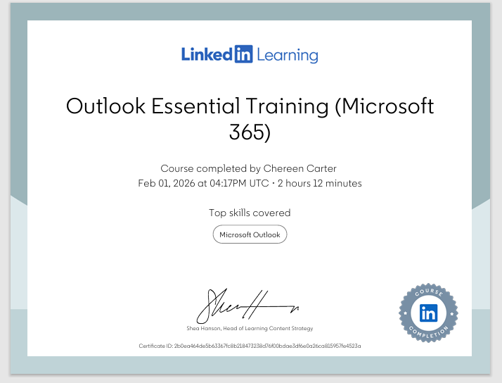

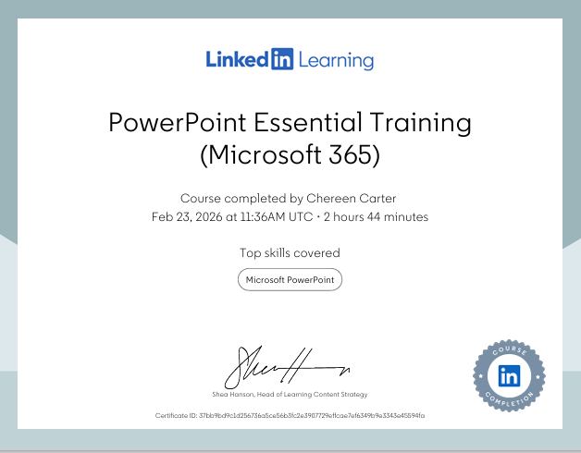
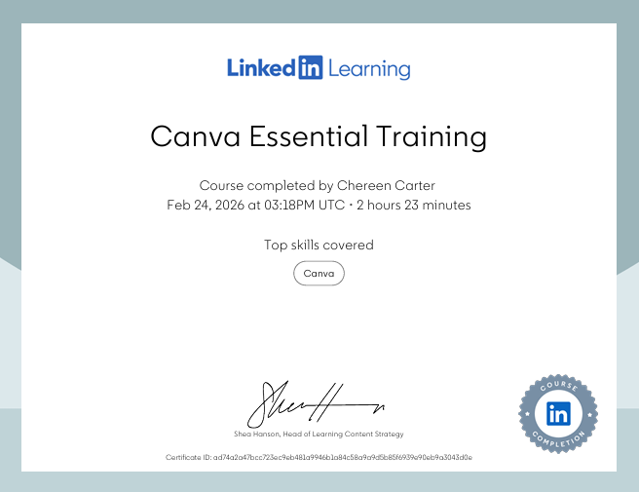

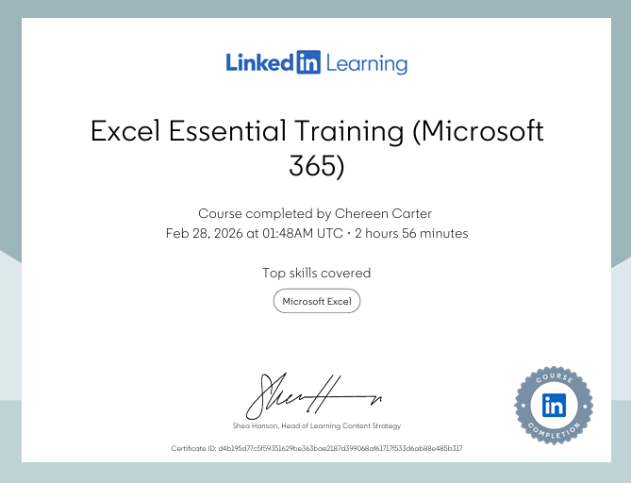

Task 3

Essay on Relevance of Excel in professional and personal life.

Introduction
Firstly, lets introduce what Excel is. Excel is a spreadsheet application that has been made and published by Microsoft and is part of the Microsoft office suite productivity software. When it comes to organising and performing calculations on data, Excel serves this purpose as it has the ability not only to analyse data but to calculate statistics, produce pivot tables and use various types of graphs to represent data (Computer Hope, 2025). Therefore, this essay will discuss the relevance of Excel not only for those in professional background but for personal life too. Furthermore, the importance of Excel and how it can be used for completing tasks such as data analysis, budgeting, reporting and decision-making. Examples will be embedded into the essay to support points giving a better understanding.
Relevance of Excel
The year of 1987 is when Microsoft Excel was first created and although there are so many more software programmes that have been made since then. Excel continues to be relevant over the years later to date. It has remained relevant due to global complex data and cutting-edge technologies (Yambira, 2024). In addition, the adaptability functions and features of Microsoft Excel are continuously updated giving users the ability to analyse complicated data and visualise results efficaciously thus, supports its relevance (Charlesworth, 2024). Microsoft Excel remains a crucial software to not only use when in business but for the use of non-profitable organizations. It is also significant for everyday use in personal life as well as those leading an academic life (Yambira, 2024).

Professional importance of Excel
Excel has professional importance as it helps management and organization of enormous datasets for employees, allowing employees to do this productively. It also offers grid-based layout along with robust features such as sorting, filtering and to render comprehensible complex data. For example, this would be used by a business in sales to organize data which involves customers and figures for sales making it easier for analyzation through accessibility and structure with the use of Excel. Other importance of Excel use in firms is it is a way it could be used for compliance and risk management. For example, it aids firms to remain compliant and keep track of regulatory obligations, along with risk assessments and financial audits. Excel can create audit trails for tax reporting; this ensures clarity as well as accountability (School of Coding and AI, 2025).
In addition to data management and organization it is important for professionals to use Excel for data analysis and reporting. It is effective when it comes to analysing data using formulas, pivot tables, and charts, it has the ability to transform primary data into actionable insights promoting decision-making in aiding data. Perceptive and visually enticing reports can be made by employees. For example, when a team working in finance uses Excel to carry out budgeting and financial forecasting via advanced formulas, or it would be used in a HR department to analyse performance of employees and producing reports for management (GeeksforGeeks, 2025). Another example of Excel use in HR would be using spread sheets to manage data and keep track of employee records and calculate payroll. Also, when it comes to recruiting agencies, Excel shows immense importance as it can track candidates progress throughout the hiring progress (School of Coding and AI, 2025).
Daily life importance of Excel
Excel is a flexible tool for planning, organising, and optimising every facet of daily life. It is important as it can help with things like budgeting, meal planning and even fitness tracking. It is said that users of Excel can leverage its features to help make daily tasks easier efficient and furthermore fun. Its importance to daily life is due to many major benefits one being time saving automation. Excel's ability to automate repetitive activities is one of its biggest features. Excel can analyse data and conduct calculations fast thanks to formulae, functions, and macros. This eliminates the need to manually enter repetitious values or conduct computations every time. For example, you can save time and minimise errors, you can, for instance, configure Excel to automatically update your budget each time you enter a new spend. Excel's automated features spare up time for other important tasks, such as adding up spending, computing averages, or producing reports (Williams, 2024).
Another major benefit of Excel is creating to do lists and daily planners. This is important for daily life as it is a tool that uses smart planning to better everyday productivity by keeping tasks structured as well as searchable with the ease to update. It helps those who use Excel to remain organized and efficient, rather than having notes scattered. Excel also helps with its ability to set priorities organises daily and weekly tasks furthermore tracks the status of completion. For example, this can be done using daily to do lists, weekly planner, and personal productivity tracker (Excel Prodigy, 2026).
Conclusion
In conclusion to this essay, it is safe to say that Excel has been around for a long time and continues to be used today despite the development of other platforms since its creation. This is because Excel shows great relevance and importance within society when it comes to those who are working in a professional background as it helps organizations to collect and store data making it easily accessible. The ability to track and analyse data gives businesses clarity promoting improved decision making. When it comes to Daily living Excel has proven to be a useful tool to help organize and manage busy lives with its use of daily and weekly to do lists and planners keeping things structured. It is the perfect reminder to ensure smooth completion of tasks rather than leaving things chaotic.

References

Charlesworth, L. (2024) 'What is Microsoft Excel used for and is it still relevant? | Kaplan UK' Kaplan, April 7. Available at: https://kaplan.co.uk/blog/features/is-microsoft-excel-still-relevant (Accessed: Mar 6, 2026).
Computer Hope (2025) What Is Excel? Available at: https://www.computerhope.com/jargon/e/excel.htm (Accessed: Mar 8, 2026).
Excel Prodigy. (2026) 'Top 10 Ways MS Excel Helps in Everyday Life & Office Work' Excel Prodigy, Jan 20. Available at: https://excelprodigy.in/top-10-ways-ms-excel-helps-everyday-life-office-work/ (Accessed: Mar 8, 2026).
GeeksforGeeks (2025) Importance of Microsoft Excel in the Workplace (With Real-World Examples). Available at: https://www.geeksforgeeks.org/excel/importance-of-microsoft-excel-in-workplace/ (Accessed: Mar 7, 2026).
School of Coding and AI. (2025) 'Importance of Microsoft Excel in Business: 10 Reasons' School of Coding AI, -01-31. Available at: https://schoolofcodinguk.com/blog/importance-of-microsoft-excel-in-business/ (Accessed: Mar 8, 2026).
Williams, E. (2024) 31 Best Uses of Excel in Daily Life: Practical Applications for Everyday Tasks - Your Excel Buddy. Available at: https://yourexcelbuddy.com/best-uses-of-excel-in-daily-life/ (Accessed: Mar 7, 2026).
Yambira, D. (2024) 'Why Microsoft Excel remains relevant in 2024' Medium, -10-10. Available at: https://medium.com/@yambsen94/why-microsoft-excel-remains-relevant-in-2024-c72770a68b49 (Accessed: Mar 6, 2026).

