Problem
Analysis and Solution
Development

Module Name: Analysing and Solving Problems
Module Code: ACCA 4019
Student Name: Francisca Lerka Fernandes
Student ID: 2510888
Group:1
Lecturer’s Name: Fahad Ahmed

Table of Contents
Table of Contents 1
1. Introduction 0
2. Deconstruct the Problem 0
2.1 MoSCoW Technique Requirement 1
3. Proposed Solution 1
3.1 Flowchart 1
3.2 Flowchart Explanation 2
4. Reflection and Justification 4
4.1 Abstract Thinking 4
4.2 Sub-dividing 4
4.3 Justification of Solution 4
4.4 Limitation 5
4.5 Assumption 5
5. Conclusion 5

1. Introduction
Group projects are a part of learning about computers because they help students work together talk to each other and solve real problems. When students work on a project they have to share the work and finish it on time. It is hard for group members to meet regularly because they have different school schedules, jobs, family things to do and other personal stuff to take care of. This makes it hard to get everything done people do not talk to each other much and they turn in their projects late.
This assignment is about making it easier for student groups to schedule meetings. We want to find a way to pick meeting times that work for everyone in the group so they do not have scheduling problems and can meet before the project is due every week. To solve this problem we need to use a step by step approach of just trying to figure it out on our own or doing it manually. We need to think about how to make Group projects and scheduling meetings, for Group projects better. To analyse the problem effectively, the scenario will first be broken down into smaller components using the MoSCoW prioritization technique, which categorises the system requirements into Must Have, Should Have, Could Have, and Won't Have requirements [1]. This method enables the identification of essential system functions while distinguishing them from desirable but non-essential features. The important variables affecting the scheduling process will also be identified and analysed.
A structured solution will then be proposed using a flowchart that demonstrates the logical sequence of operations required to determine the most appropriate meeting time for all group members. The proposed solution will include decision-making processes, assumptions, and scheduling logic designed to minimise timetable conflicts while ensuring project deadlines are achieved. Finally, the report will reflect on the problem-solving methods used, including abstract thinking and subdivision, and justify why these techniques are appropriate for solving the identified problem.

2. Deconstruct the Problem
The scheduling problem is about finding a time that works for all the students. This is hard because each student has a schedule. The students have things they have to do at different times. They have classes and lab sessions and some of them have jobs. They are also involved in activities and they have personal things they have to take care of. The students and their schedules are like pieces of a puzzle. We have to find a time that fits all the pieces together. To do this we need to know what times each student is free and what times they are not. Then we have to look at all the schedules and find a time that works for every student. We also have to make sure that we have time to get our work done before it is due.
If we cannot find a time that works for everyone we have to come up with a plan. We might have to pick a time that works for most of the students. Not all of them.. We might have to ask some students to change their schedules a little bit. The scheduling problem is, about finding a time that works for all the students and their schedules. We have to think about the scheduling problem and the students and their schedules. Breaking down the problem, into parts makes the design process easier. This is because we can look at each part on its own before we put them all together to get a scheduling solution [2]. We are using an approach that is based on the idea that complex problems can be solved by breaking them down into smaller parts that are connected but easy to manage.
The things we need from the scheduling solution can be listed in order of importance using the MoSCoW technique. This technique helps us figure out which parts of the system are necessary and which parts are not as important. By doing this we make sure that the important things we want to achieve with the scheduling solution are taken care of before we think about adding other things. The scheduling solution is what we are focusing on and the scheduling solution is what we want to get right.

2.1 MoSCoW Technique Requirement
Variables | Description
Student Availability | Time periods when each member is available for meetings
Class Timing | Lectures, tutorials, and laboratory sessions that cannot be changed.
Part-time Work Schedule | Working hours that reduce student availability.
Personal Commitments | Family responsibilities or personal appointments.
Weekly Project Deadline | Submission date that meetings must occur before.
Number of Group Members | Total students involved in the project.
Meeting Duration | Expected length of each meeting.
Preferred Meeting Time | Individual preferences for morning, afternoon, or evening meetings.
Conflict Level | Number of overlapping commitments preventing attendance.
Alternative Time Slots | Additional meeting options if no common availability exists.
These things that can change really affect how we plan meetings because if one thing changes it can change the meeting plan. For example if we have people in a group it is more likely that we will have problems with our schedules but if we make meetings shorter we might have more chances to schedule them. Similarly when a project is almost due it gets harder to find a time that works for everyone so we have to make decisions [3].

3. Proposed Solution

3.1 Flowchart
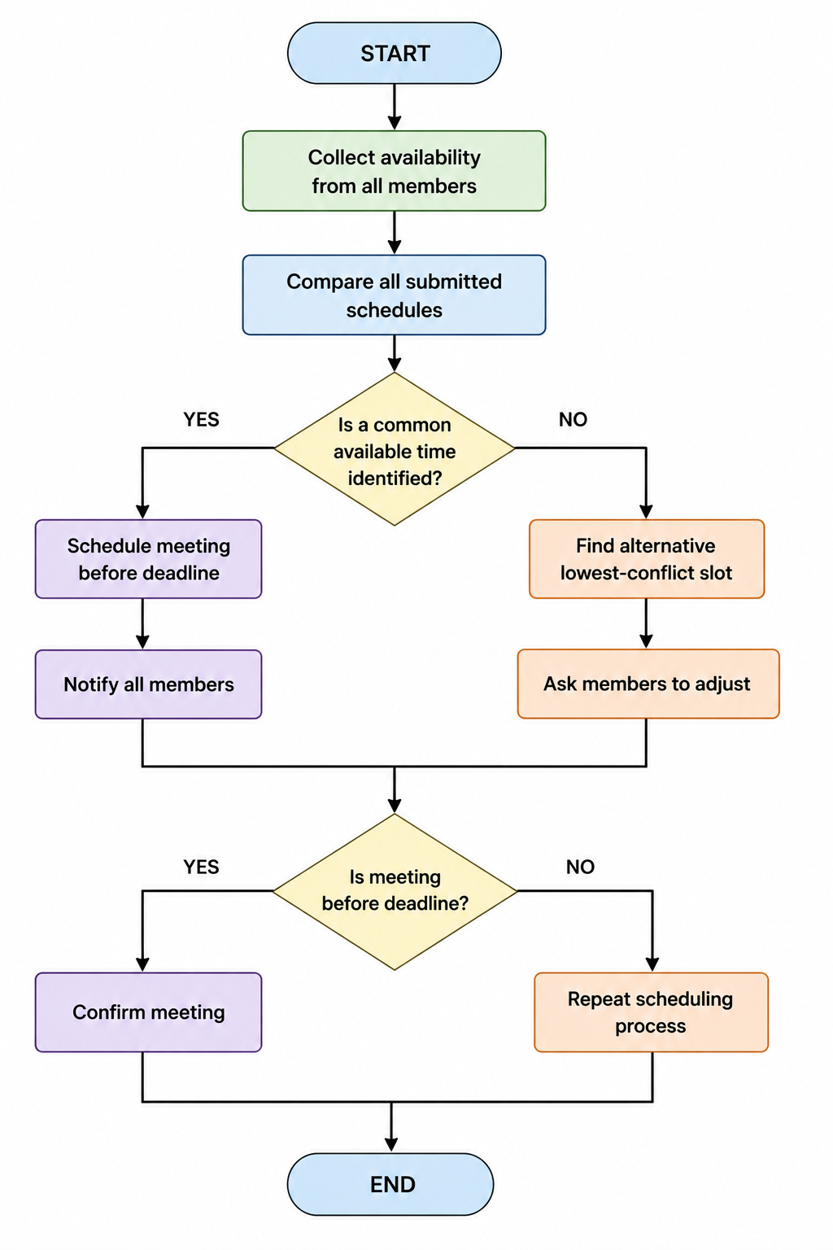

3.2 Flowchart Explanation
The new solution is set up to find the time for everyone in the project group to meet. It does this by following a straightforward plan. This plan helps reduce problems with people schedules and makes sure meetings happen before the project is due every week. The solution is based on a common sense approach, to solving problems. This means we get information look at it think about it. Then use it to make good decisions.
We start by asking every group member when they're free. Each person has to tell us about their schedule, including classes, study groups, lab work, part-time jobs and anything else important they do. We need to know all of this so we can pick a time for everyone to meet. If we do not get all the information we need or if it is not correct we might choose a meeting time that does not work for everyone. This can cause problems. When we get all the schedules we look at them to find the times when everyone's free. This is the part of figuring out when we can all meet. We check every free time slot against everyone’s schedule to see if there is a time that works for everyone. If we find a times that could work we look at things like how easy it is to get to the meeting how close it is to the deadline for the week and if we have enough time to meet. Picking the time that works gives everyone more time to finish their tasks before they are due.
The first big decision happens after we compare all the schedules. At this point we figure out if we have found a time that works for everyone. If we find a time that everyone's free we tentatively schedule the meeting.. Before we make it official we double check to make sure the meeting is before the weekly deadline for the project. If we have the meeting after the deadline it does not help because we will not have time to finish everything. So making sure we are before the deadline is a part of scheduling the meeting.
Once we know the meeting is before the deadline we send a note to everyone in the group. The note includes the date and time of the meeting, where it's a link to meet online and anything we need to do to get ready. Sending the note early helps people plan the rest of their schedule and reduces the chance that someone will cancel at the minute.
We want to make sure the meeting time works for every group member so we use the group members’ schedules to plan it. The group members need to know about the meeting so we send them a note with all the details, about the meeting. When there is no time that works for everyone during the planning stage the system tries an approach. Of stopping the planning process it looks for the time that causes the fewest problems. This way the system tries to get many people as possible to participate even if it is not possible to find a time that works for everyone.
The system considers things when it is trying to figure out what to do about conflicts. It thinks about how many students are affected, how important the things that are causing conflicts are and whether it is possible to change personal plans. University classes and exams are usually treated as set in stone. Personal activities or work shifts that can be changed are adjusted when possible. By thinking about how important each conflict's the system tries to cause the least amount of disruption while being fair to everyone.
After finding the option that causes the conflicts the people in the group are asked to look at their schedules and see if they can make any changes. This part of the process recognizes that planning a meeting time is often about talking things through and coming to an agreement than just using a computer to figure it out. Students may be willing to swap work shifts change their plans or agree on a meeting time that more people can attend.
If making changes creates a common meeting time that works before the deadline the meeting is confirmed and everyone is notified. If conflicts are still a problem the planning process starts again using the updated information about who's available. This process keeps happening until a meeting time is found that works for everyone.
The proposed system, for planning meetings also includes other features to help make sure meetings happen. The proposed solution is based on some common sense ideas. It assumes that all students will give information about their schedules before the scheduling starts. It also assumes that group members will update their availability when things change. These ideas make the scheduling process more reliable because old information can make the schedule less accurate.
There are some rules that are used to make decisions in the solution. Meetings that need to happen before deadlines are given priority. Trying to avoid conflicts is the next goal. This makes sense because the main point of project meetings is to help students complete their tasks not to make sure everyone is there.
If we look at the solution as a system it uses steps and decision making. Each step follows from the one and the solution can handle different situations because of the way it is set up. The scheduling process can handle schedules without needing a completely different approach.
The proposed solution is also fair to all group members. It does not just choose a meeting time based on one person’s schedule. Considers everyone’s schedule equally. This approach helps students work together. Reduces complaints within project teams. The proposed solution really helps to make project meetings work for all students. That is what the scheduling process is all, about. The proposed solution is based on ideas that make sense. It assumes that all students will share their schedules before scheduling begins. It also assumes that group members will update their availability when things change. These ideas make the scheduling process more reliable because using information can make the schedule less accurate.
There are some rules that are used to make decisions in the solution. Meetings that need to happen before deadlines are prioritized. Avoiding conflicts is the goal. This makes sense because the main point of project meetings is to help students complete their tasks not to make sure everyone is there.
If we look at the solution as a system it uses steps and decision making. Each step follows from the one and the solution can handle different situations because of the way it is set up. The scheduling process can handle schedules without needing a completely different approach.
The proposed solution is also fair to all group members. It does not just choose a meeting time based on one person’s schedule. The proposed solution considers every students schedule equally. This approach helps students work together. Reduces complaints within project teams. The proposed solution really helps to make project meetings work for all students. That is what the scheduling process is, about making project meetings work for all students.

4. Reflection and Justification

4.1 Abstract Thinking
The scheduling problem was made simpler by using thinking. This meant looking at the information that was really needed to make good scheduling decisions. We did not look at everything that each student did every day. We just looked at the things like when students were available what time their classes were, when projects were due how long meetings would take and if there were any scheduling problems. We did not worry about why students had commitments because it did not matter for scheduling.
This made the problem a lot less complicated. It was easier to come up with a solution that made sense and was organized. By looking at the really important things the scheduling process was easier to understand and it worked better. The scheduling problem was made simpler by using thinking and looking at the important things, like availability and class timetables.

4.2 Sub-dividing
The problem was also solved by breaking it down into tasks. This made the scheduling challenge easier to handle. The process was broken down into steps like collecting information about when people are available comparing schedules finding common times checking deadlines looking at conflicts confirming meetings and telling group members.
Each step could be looked at. Improved on its own before being put together with the other steps. Breaking down the problem made it less complicated it was more organised. It made sure that no important part of scheduling was missed.
This method also made it easier to make a flowchart because each thing that needed to be done was a step in the overall scheduling process. The subdivision technique was really helpful, in solving the scheduling problem. The scheduling problem was solved by using the subdivision technique.

4.3 Justification of Solution
The proposed solution is an idea because it takes care of the three main goals that we found out in the assessment scenario. It finds times for meetings by looking at when every student is free it reduces problems with the timetable by picking times that work for everyone or that have the least problems and it makes sure meetings happen before the project deadlines every week. The solution uses a flowchart with steps to figure out the best time so it can adapt if no one is available at the same time, which makes the solution flexible. The MoSCoW prioritization technique is used to make sure the important things about scheduling are taken care of when designing the system. Also the steps are in an order because every group member’s timetable is considered equally. The solution is practical. Can be used in schools where students often have changing schedules. The proposed solution is suitable, for environments because it is flexible and can be used with a lot of students. The proposed solution is also scalable which means it can be used with large groups of students.

4.4 Limitation
Despite its advantages, the proposed solution has several limitations. It depends on students submitting accurate and up-to-date availability information. If incorrect schedules are provided or students fail to update changes in their commitments, the system may recommend unsuitable meeting times [4]. Additionally, the solution does not consider unexpected events such as illness, emergency work shifts, or sudden timetable changes after meetings have been scheduled. The proposed approach also assumes equal importance for all group members and does not prioritise individuals based on project responsibilities or leadership roles. As the number of participants increases, the scheduling process may become more computationally complex due to the greater number of timetable comparisons required.

4.5 Assumption
When we came up with the solution we made some assumptions about the students. We thought that all students would give us their accurate availability before we start scheduling. We also thought that the weekly project deadlines would stay the same and that everyone in the group would know about them. We assumed that students would check their notifications often and be happy to attend meetings at the times they agreed to. The solution also assumes that students have access to online or physical meeting facilities whenever they find a time that works for them. We thought that students would work together and be willing to make changes to their personal plans if needed so that they can collaborate successfully with their group members [5]. We made these assumptions about the students and their groups and the solution is based on these assumptions, about the students.

5. Conclusion
Scheduling group meetings is really important for finishing projects on time in computer classes. I found out that it is hard to schedule meetings because students have school schedules, jobs and personal things they have to do. I used a step by step approach to solve this problem, including a method called MoSCoW prioritisation thinking about the picture and breaking it down into smaller parts. This helped me turn a problem into a simple solution.
The flowchart I made shows how to collect information about when students are free compare schedules find good times to meet avoid schedule conflicts and make sure meetings happen before project deadlines each week. The flowchart also allows us to think about scheduling options if there are conflicts, which makes it fairer for everyone in the group. My solution works if we have the information, about schedules and it is not perfect because things can still come up unexpectedly.. It is a practical way to help students work together on projects. Overall my solution is an realistic way to solve the scheduling problem and it meets the requirements of the assignment by being well organised and easy to follow.

6. References

[1] | DSDM Consortium, The DSDM Agile Project Framework, Ashford, Kent, UK : Agile Business Consortium, 2014.
[2] | J. M. Wing, «Computational Thinking,» Communications of the ACM, т. 49, № 3, p. 33–35, 2006.
[3] | P. J. Denning, «The Profession of IT: Beyond Computational Thinking,» Communications of the ACM, т. 52, № 6, p. 28–30, 2009.
[4] | A. V. Aho, «Computation and computational thinking,» The Computer Journal, т. 55, № 7, p. 832–835, 2012.
[5] | D. W. Johnson, R. T. Johnson и K. A. Smith, «Cooperative learning: Improving university instruction by basing practice on validated theory,» Journal on Excellence in University Teaching, т. 25, № 3-4, p. 85–118, 2014.

