Charlotte Holly Preston
P145222
Critical Review Report
University of Wales Trinity Saint David
Word Count: 2932

Contents:
Introduction 3
Concept Art 3
Summer Experience 5
Second Year of University 7
Major Project 9
Storyboarding 11
Conclusion 16

Introduction.

Throughout the time used while studying on the 3D Computer Animation course, there has been an immense amount of knowledge gained, from the overview of subjects such as Computer Animation, Concept Art and Rigging being amongst a few.
This document will review the progress in which the specialised areas such as concept artist and storyboard artist have been developed upon throughout the course of study at university.
While continually growing and learning during the past three years of higher education, the first of which started as a base in the knowledge that’s currently there. The first year of University consisted of learning the techniques needed to pick up the required skills for the 3D industry, during which time there had been a total of six key modules being spread across the course of the year. Starting with 3D Computer Animation, giving an introduction to the course, with a number of exercises, and teaching the twelve Principles of Animation. Ranging from walk cycles to flour sacks, to the bouncing ball, along with other basic animation exercises. These being the basis for other assignments including Visual Studies, Production Practice, History of Animation, and Audio and Visual. One of these assignments being Visual Studies became one of the core elements in the specialised area that’s currently developed, being Concept Art and Storyboard artist.

Concept Art.
Concept Art has been a key element in this academic journey for years, even predating university, although, during the first year of university, gave the opportunity to explore Disney-esque character designs and how to explore different ways of designing.
During the first year of university and while studying the visual studies assignment, this particular assignment became quite prominent with the influence for the experiences and opportunities that were to come later on. The original design brief was to design a story with an accompanying world and its characters. This assignments work had been heavily inspired from the classic hero versus villain storyline in a world where the main character must overcome these everyday challenges. The designs originally had included a group of five characters with the hero being this large muscular character named Jetterson, with his concept being heavily inspired from Disney Pixar’s “The Incredibles” Mr. Incredible or Bob Parr (Disney Wiki, 2018). While using this Mr. Incredible theme, other influences included the fashion style from the “Grease” (1978) (Kleiser et al., 2018) film with the big hair and bomber jacket accompanying a large male ego. Part of the reason why the male character had been inspired from Pixar’s Mr. Incredible was after watching the interviews on the Incredibles film where many character designers stated how his silhouette is all about this powerful and foreboding character stuck in the wrong line of work (The Incredibles, 2004).

As is shown below:
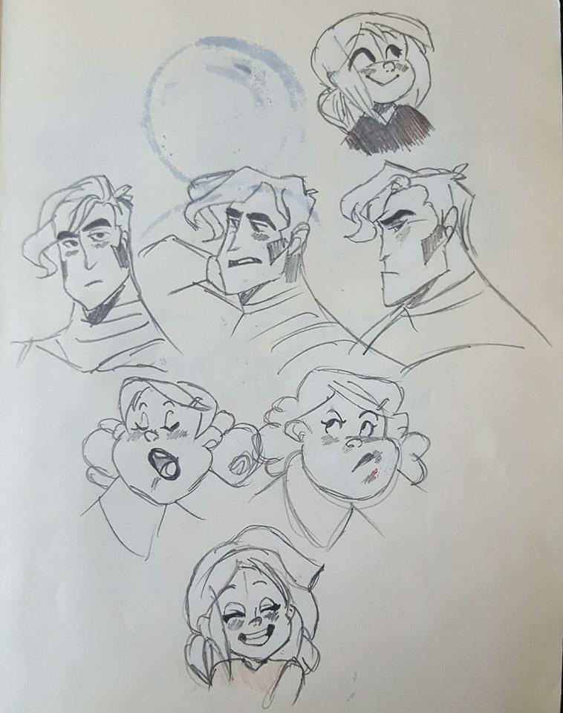
Other character concepts were very flat with how the designs weren’t pushed further. Some concept pieces included a female character inspired by Disney’s “Big Hero 6” Go-Go Tomago (Animation World Network, 2018), with the use of “mono wheel skates” to be able to play around with the designs more than previously.
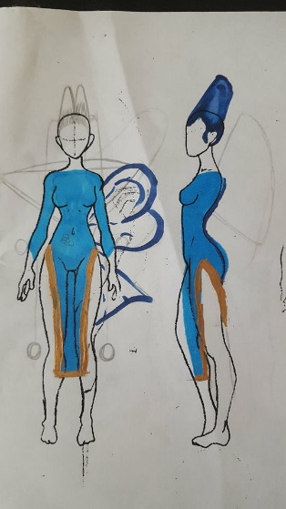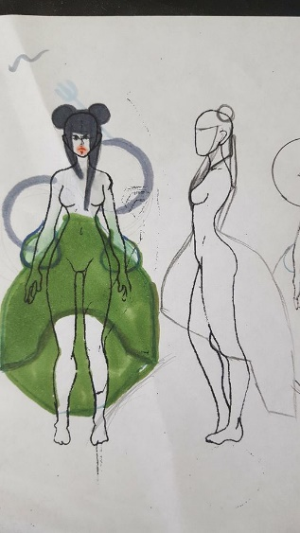
The concepts for this project had been quite reliant on what type of designs currently existed and what would visually sell the design to begin with, rather than designing for the enjoyment of it. The quality of the work had ranged as is shown in previous images and shown below. The quality in the line art hadn’t stayed inconsistent and would often slightly change, even when keeping within the same art style. The line work is very “feathered” and broken apart rather than it being this one continuous line that was needed. While the designs for the characters face had been better than the full body designs, this was something that needed to be worked on in ensuring that the quality in both the facial designs and clothing/body designs were of the same standard.
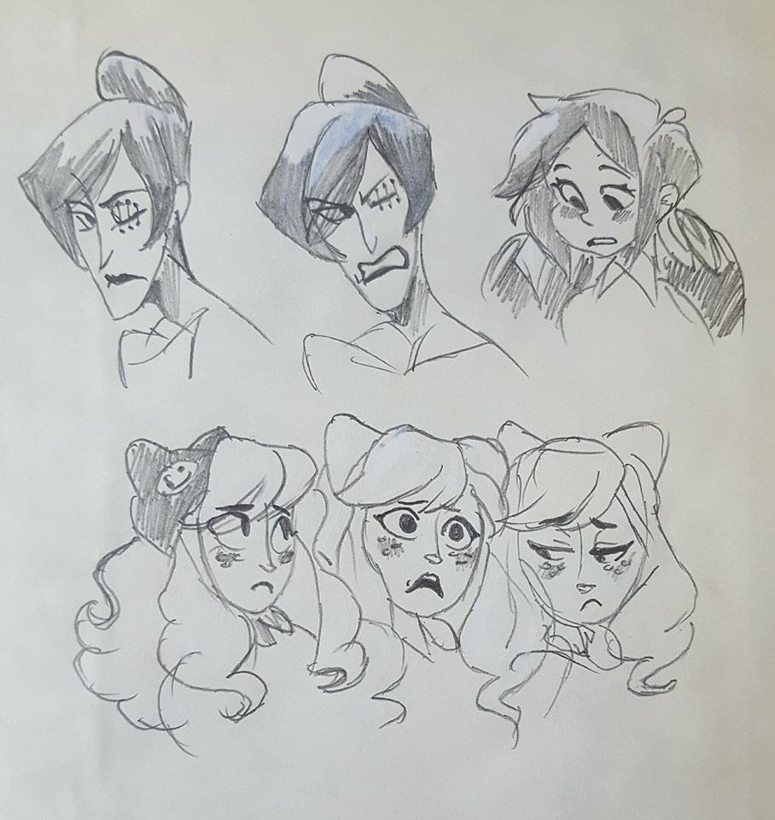
During this time the method of drawing these designs had been drawn using the hand rather than the whole of the arm, which was later learnt though the next project, and through an interview from the character concept artists from Hi-Rez Studios (YouTube, 2018). The problem with using this method in drawing with the hand limited the full length of the line being drawn, so rather than a smooth line, the line had to be broken up and resorted in this “feathered” type of line. While the idea behind the characters had something there, they weren’t as solid in their believability than some more current concepts.
Summer Experience.
Once the completion of the first year of university had past during the first month of summer an opportunity had been presented itself with the universities Al Kang putting forward the opportunity to work as a character concept artist on a new animated series, naturally this was a welcome challenge. After being given character biographies and the first season’s script, the idea for how the characters would look became clearer.
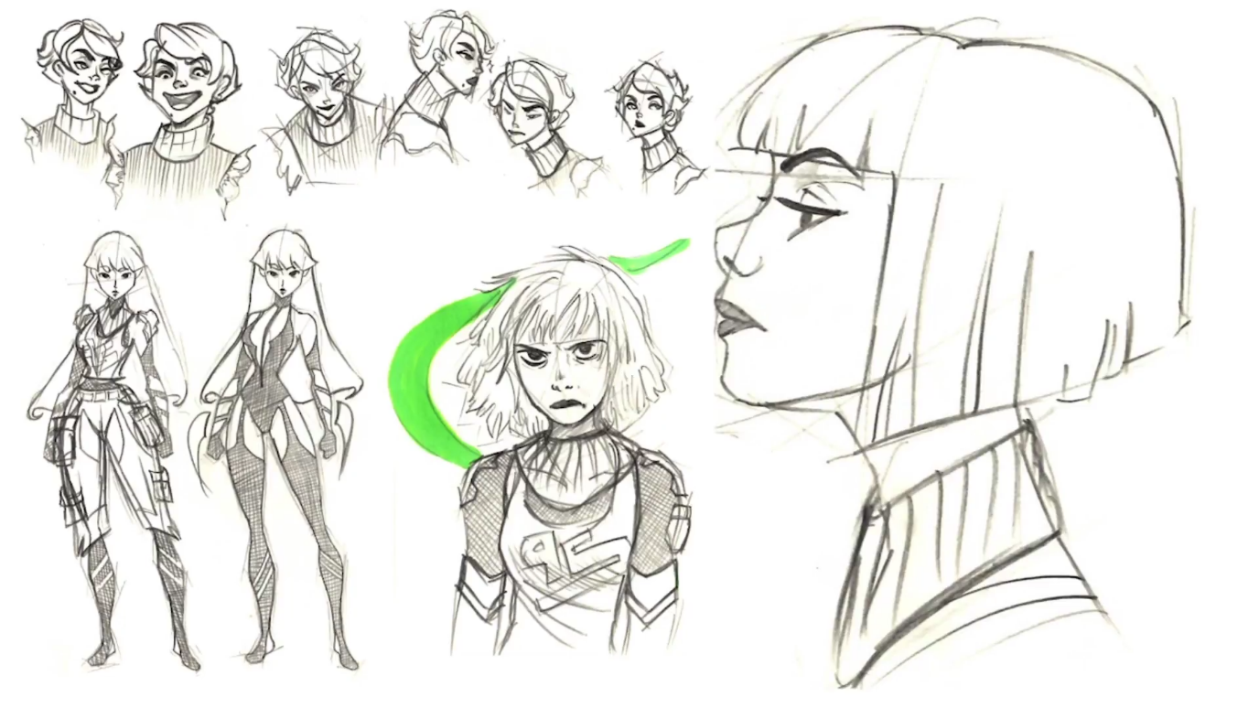
Through using the character descriptions, the designs continuously evolved from head profiles to full body character concepts, although with this project the characters had vastly different clothing designs unlike previous character concepts. While the quality of the line art had been worked on, the level of the design had improved when compared to other projects, using reference to find how clothing falls off the characters’ body and how each material would fall differently. Some designs having a skin tight athletic body suits to large jackets adorned with patches.
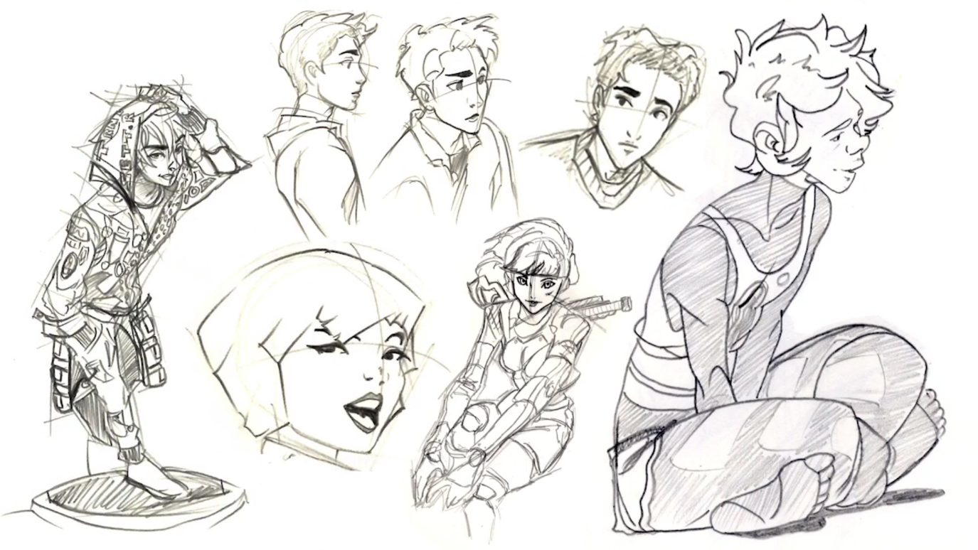
The project quickly progressed the overall quality in drawing especially with character posing and character presentation greatly, one characters side profile that had been created in previous months, the head is rather squashed to try and accommodate to the page, rather than using the space available for the design. While a female side profile during this project had the proportions more accurately portrayed, with the sizing of the head not being confined to page sizes.
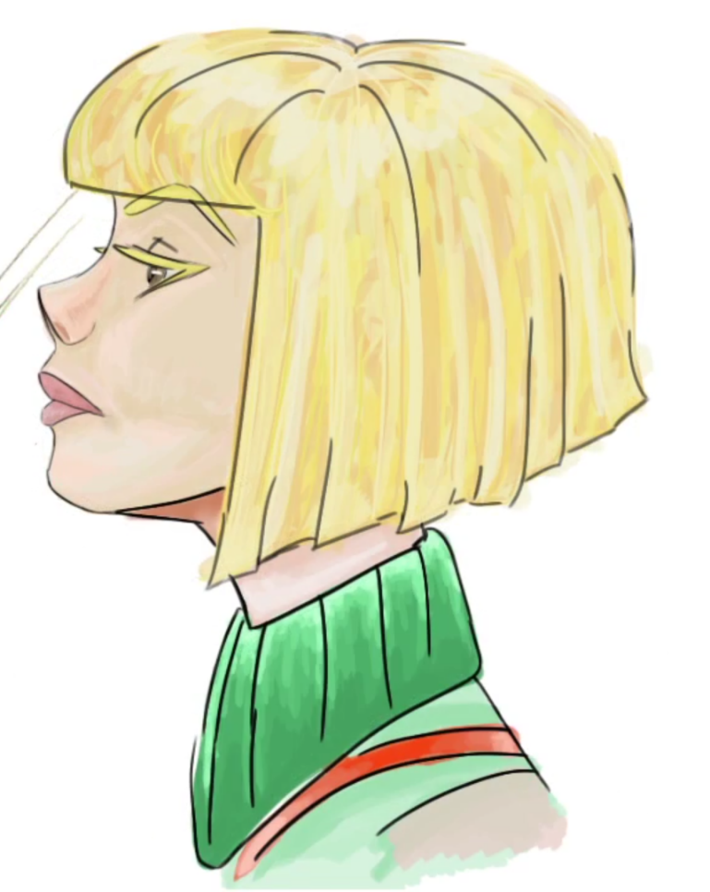
This had been partially due to a piece of advice being given in that when drawing on any size of paper or canvas, to draw small, while including as much detail as is possible or needed for the design. Rather than being confined to the space, to use the given space and change the size of the drawings to accommodate its surroundings. This greatly improved the standard of work.
Second year of University.
Through the completion of the previous project, the second year of university had begun, and with another key assignment for concept art being the second visual studies assignment. The overall aim as with the last, was to create a story with accompanying character designs and environment designs for an animated short which would be set for the second semester.
While going into this project with new knowledge and a greater understanding of character design and line quality, the concept quality had greatly increased. This project gave the opportunity to experiment with many different ethnic characters.
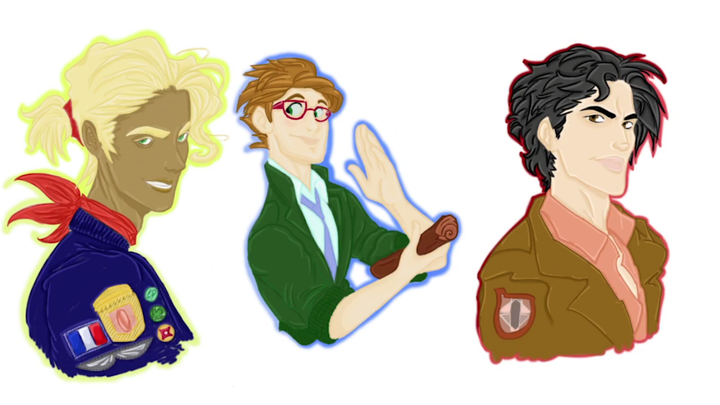
The main protagonist was inspired by French Pilots, with a combination of a cocky personality which had been inspired by existing heroes such as Sonic (Sonicthehedgehog.com, 2018), and in this case Lightning McQueen (Pixar Wiki, 2018). The main protagonist led into having a “side-kick” sort of character, being in the form of a much younger protagonist, Alex Song. Whose character personalities acts as a balance to Guille’s character, with having two largely known personalities, this gave the space to have interesting interactions between both characters when moving onto the animated half of the assignment during the second semester.
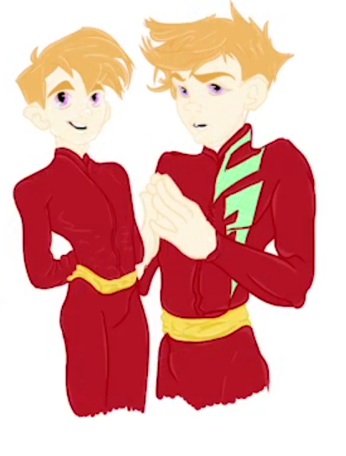
These characters alone pushed the boundaries to previous characters that were created by the willingness to explore more and research a range of cultures, while designing characters that were more believable in their personalities. The technical standard had vastly improved over the previous project during the first year, the experience that was gained from working in an industry environment clearly shows in the line art alone, coupling it with better knowledge of colour theory and clothing design, these designs became a turning point in how concepting character designs became handled from there out. The proportions were accurate to human anatomy, after studying both the male and female human body in greater detail.
Major Project.
While the success for these previous project’s character concepts showed, there would still be other things to keep learning. During the conceptual part of the Major project the understanding of many different art style had already been explored, the designs shown below hold a higher standard again, with continually practicing the newly gained knowledge from industry experience and personal project experience, where there was more creative freedom. Thankfully with the major project there had been more creative freedom than the previous year, while not to the desired level, still gave way to experimenting with a range of character designs and clothing designs. After learning more on the designing of characters it became clear to put more research into how clothing falls off a human body.
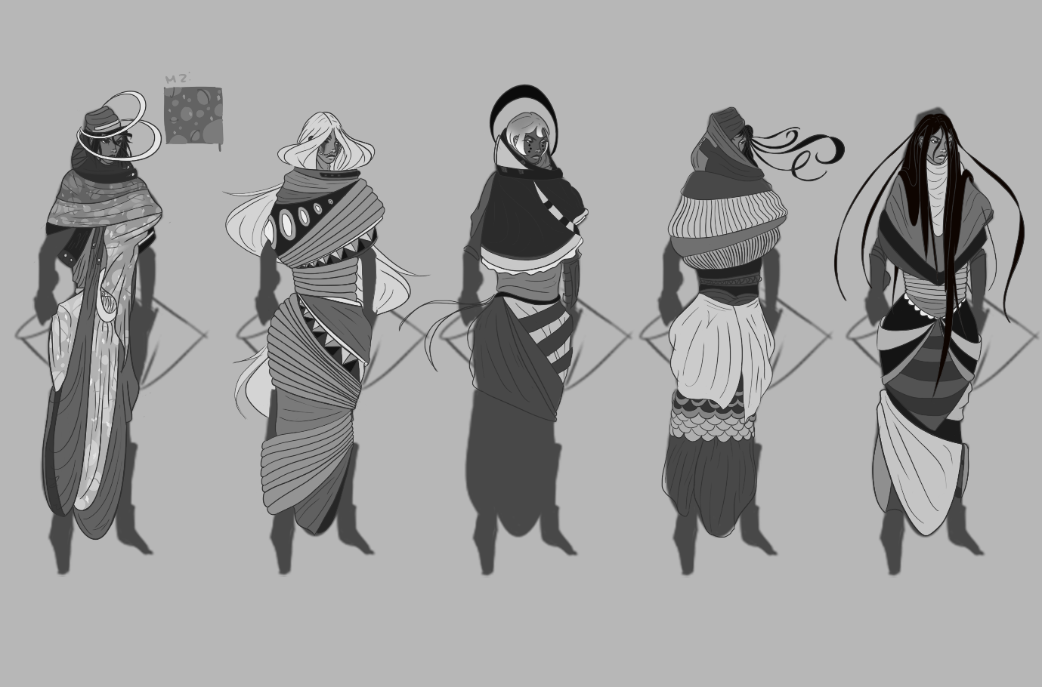
This character being female the body has many other areas that the material flows and hangs off than a male characters’ body. Previous experience in studying human anatomy helped with designing the clothing as the knowledge of the muscle structure had already been there, as is shown below.
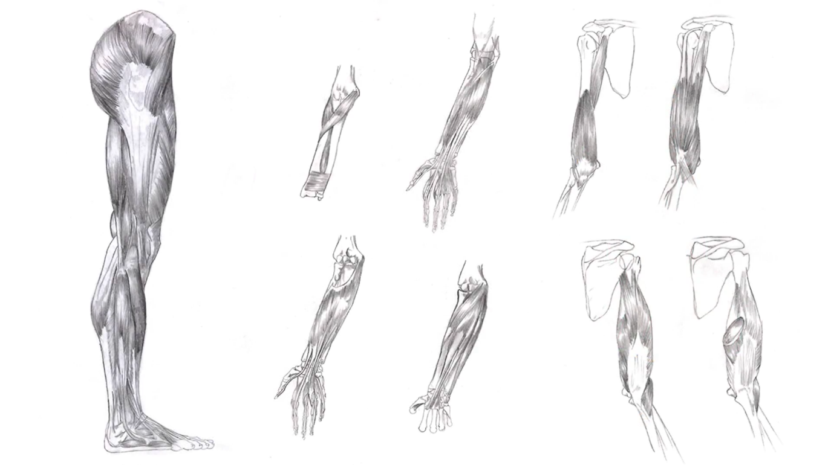
The quality in the concepts had again improved from every other previous project, while the knowledge of human anatomy had already been gained since before university, translating this into a cartoon style was something that needed to be worked on.
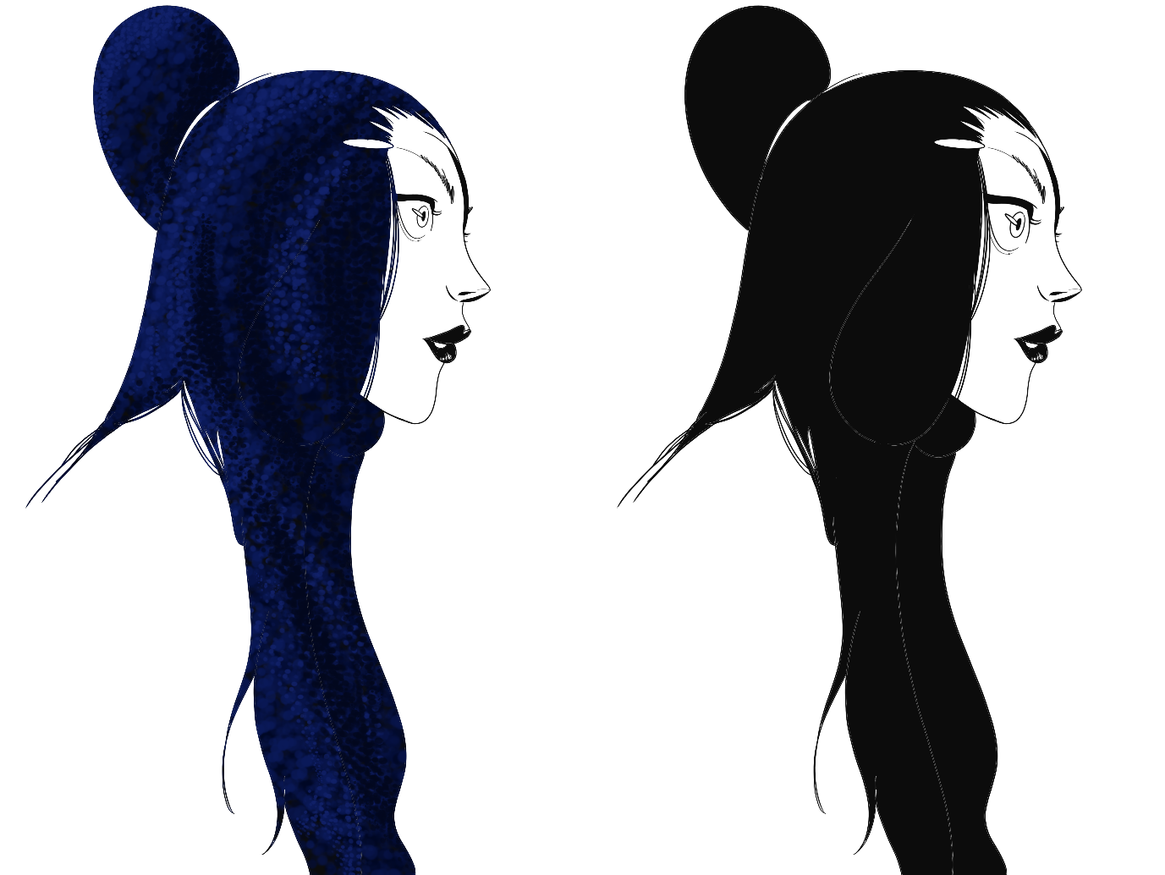
At this point in time designing character facial designs had become second nature and even with the clothing designs, the research behind the designs had been carried out beforehand and was able to draw out of imagination and have much more creative freedom than beforehand.
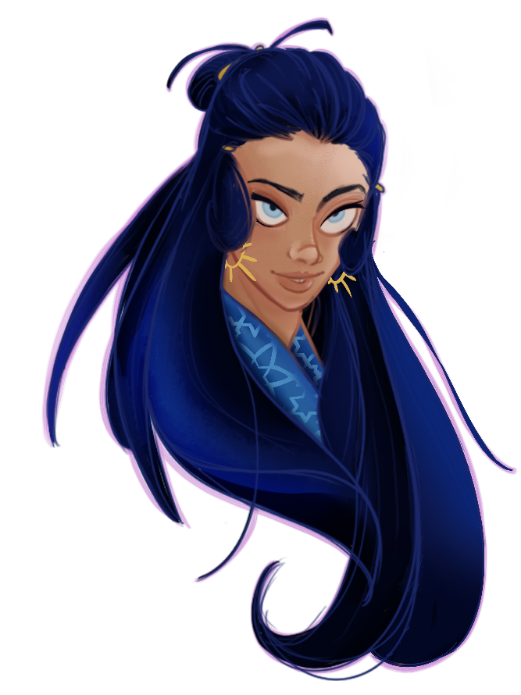
Overall, with regarding the progress with concept art, there is a clear difference in quality comparing the first few designs from the very beginning of university up until current designs, for latest projects. This has been largely due to being given the opportunity to working in the industry as both a character concept artist and a storyboard artist, and later as a 2D animator and clean up artist. These opportunities gave way to fully concentrate on the job, and from this the most knowledge had been gained with compared to the knowledge that had been gained from any university assignment. This being solely because the focus on the assignments within university didn’t concentrate on the key components that were needed for the skills to progress as vastly as they had from gaining industry experience.
Storyboarding.
While continuing with another specialist subject that’s currently the second focus of job opportunities, storyboarding came with a joint effort alongside concept art. Although the progress for storyboarding started slightly later than character concept art, solely because of the lack in focus of it during the first year of university. The focus of storyboarding came with the first industry experience opportunity that came around during the first summer of university.
During the completion of the first year and the focus of visual studies being on the character and environment design, the summer led to a larger focus on storyboarding panels. After being brought on board as being a storyboard artist the previous drawing experience beforehand from both the first year of university and from college and comprehensive, the skills for drawing had already been in place.
While starting out as a storyboard artist, I had been advised to start off with drawing simple block outs of the characters’ poses to gain an understanding of body placement and to further push the shots so everything about the character placement would have a dynamic pose. As shown below the first boards had been extremely simple is figuring out where the placement of the characters should be, and what would sell the shot the most.
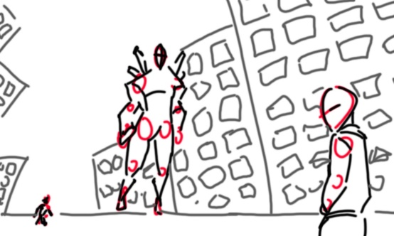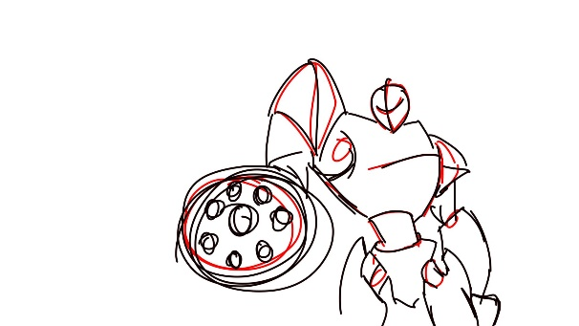
One habit that had started to form was that the storyboards had slowly started to become too detailed slightly too early on, this had been both pointed out by my lecturer and through reading the development of the storyboards for the Star Wars trilogies (Rinzler, n.d.). Just with character concepts, when starting out, a rough base is drafted to experiment with ideas for the posing. After realising that starting off with a simple base quickened the process of boarding, and adopting this process, the next area that needed developing was to think about the lighting in the shot and scene. If the scene had called for an explosion, there needed to be a large visual difference in both the lighting and the scene set up, depending on what was happening in the shot and what the mood called for. As shown below, this experience with storyboarding pushed the posing of the characters and later became useful in how to push poses to their extreme, as with the example below showing a collection of silhouettes that were created for the major project.
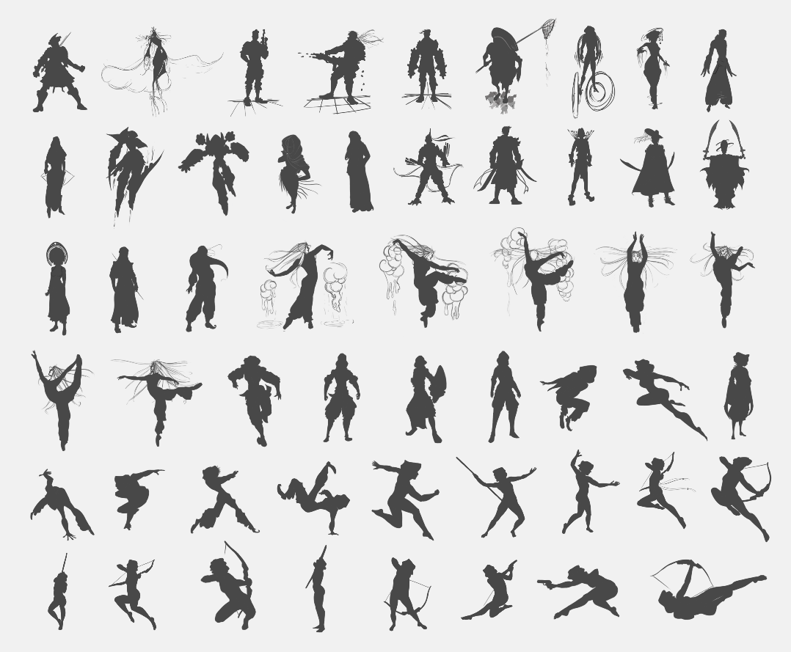

After learning how to storyboard and how to think about the shot set up when boarding from this industry experience, the second year of university had started. While working on the visual studies section of the assignments the freedom to really push the shots and sequences hadn’t been there due to the time given for the assignments coupled with other external projects and internal assignments.
The boards that are shown below clearly aren’t as expressive as a large amount of the previous storyboards, although the knowledge of how to create these expressive storyboards, the time for production with considering render time didn’t give that total creative freedom. Although, this had been a good opportunity to experiment with a more stylised storyboard design. These doubled up as both storyboards and colour theory boards, by doing this it further pushed the production time and being able to explore colour theory for the animated short.
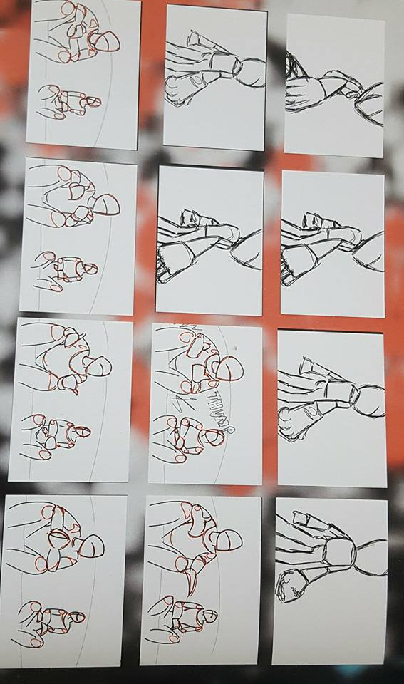
The idea behind these storyboards as previously stated, was to experiment with colour boards. The inspiration had largely come from Disney Pixar’s colour theory boards from the book “The Art of Pixar” (Amidi, 2011) in how the boards explored emotion through colour.
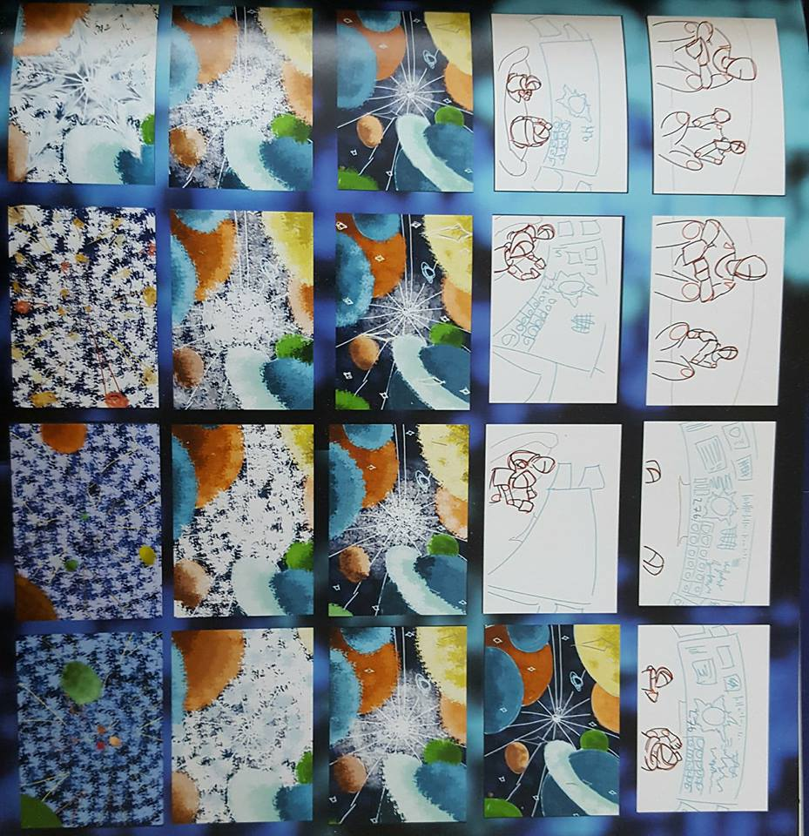
Once the second year of university had been completed and with the introduction of the summer holidays had began I had started with the storyboards to the major project. The project had evolved through many different iterations of the story. Originally the boards shown below were what had been originally chosen, this had been partly from trying to figure out what story I had wanted to tell. Although after continuous development the story kept being tightened in what emotion I wanted to get across to the audience. Luckily with all the previous experience and mentoring for being a storyboarding artist this project became more about how I could promote the animation and gain the most visually stunning shots.
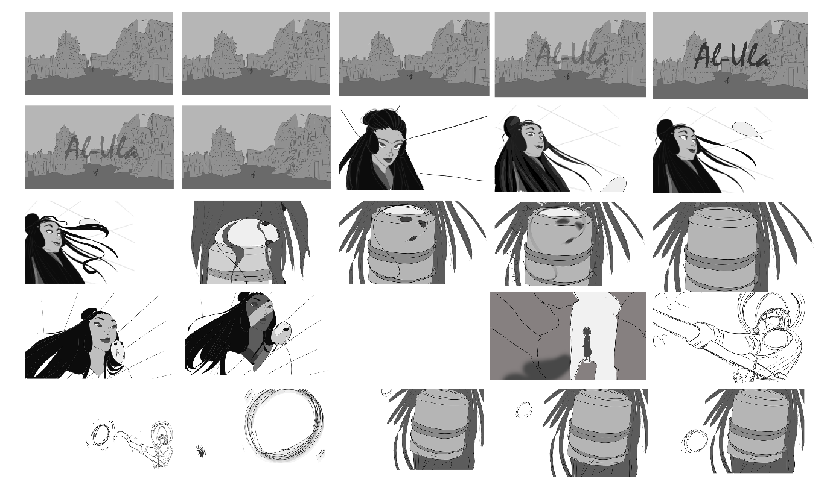
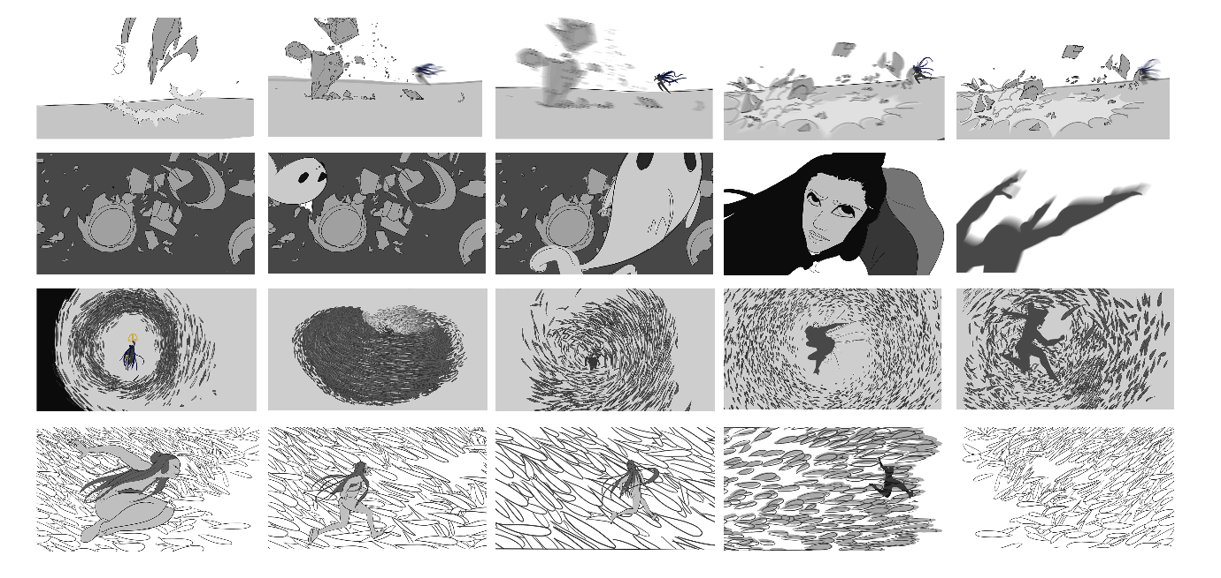
Through gaining more experience through both the university and external projects this gave me more confidence in being able to experiment and be as creative as I could. As shown below the boards that personally felt that they sold what was happening in the scene were where the main character had been positioned within a large school of fish, with attention to light and detail. The progress through storyboarding progressed quickly with coupling this development with character concept art with considering they both work alongside each other.
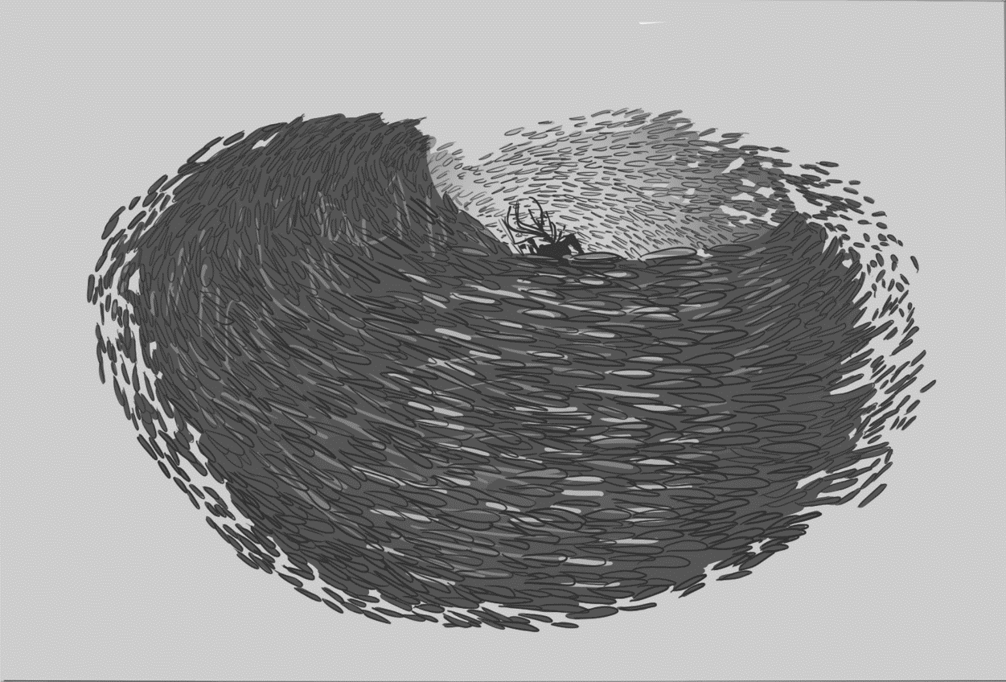
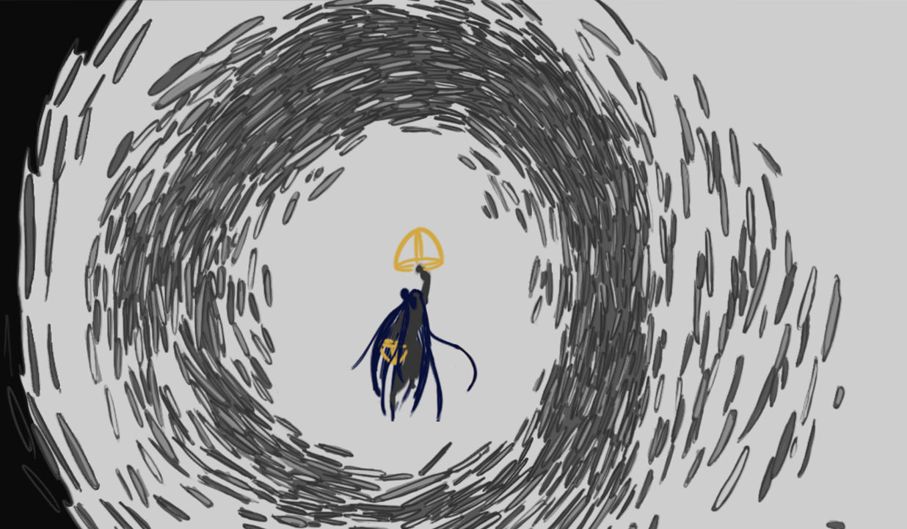
The progress in the quality clearly shows through both with growing knowledge and confidence the more experience was gained. While the art styles themselves had progressed as this learning also progressed.
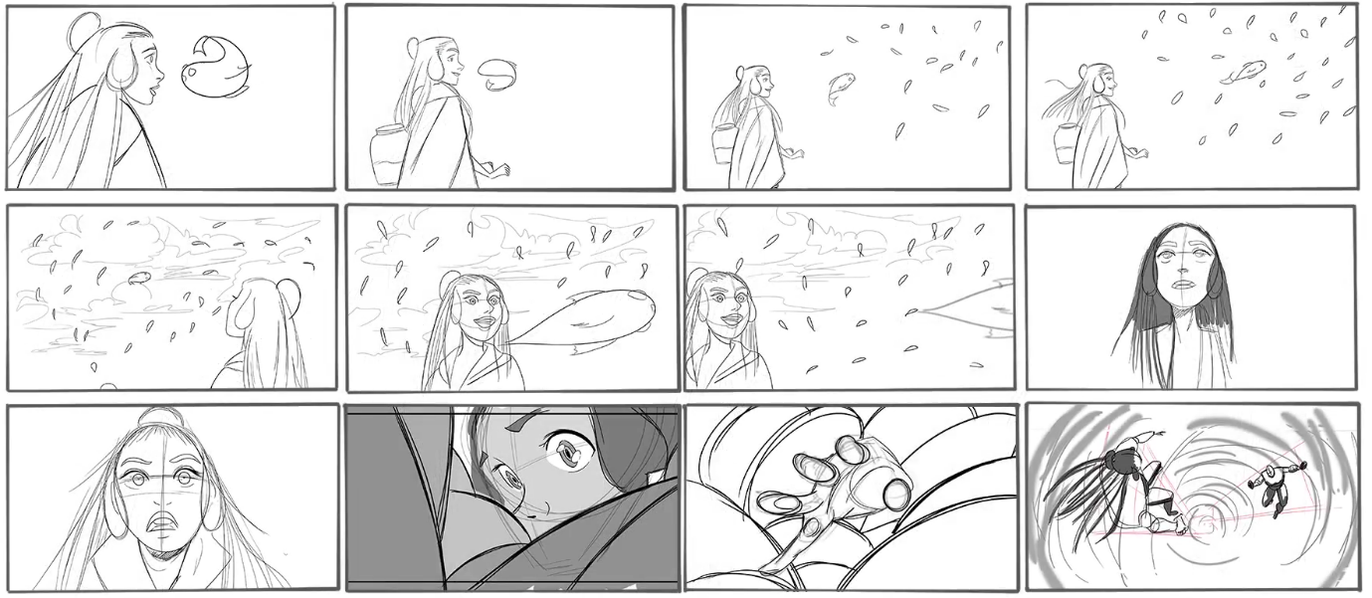
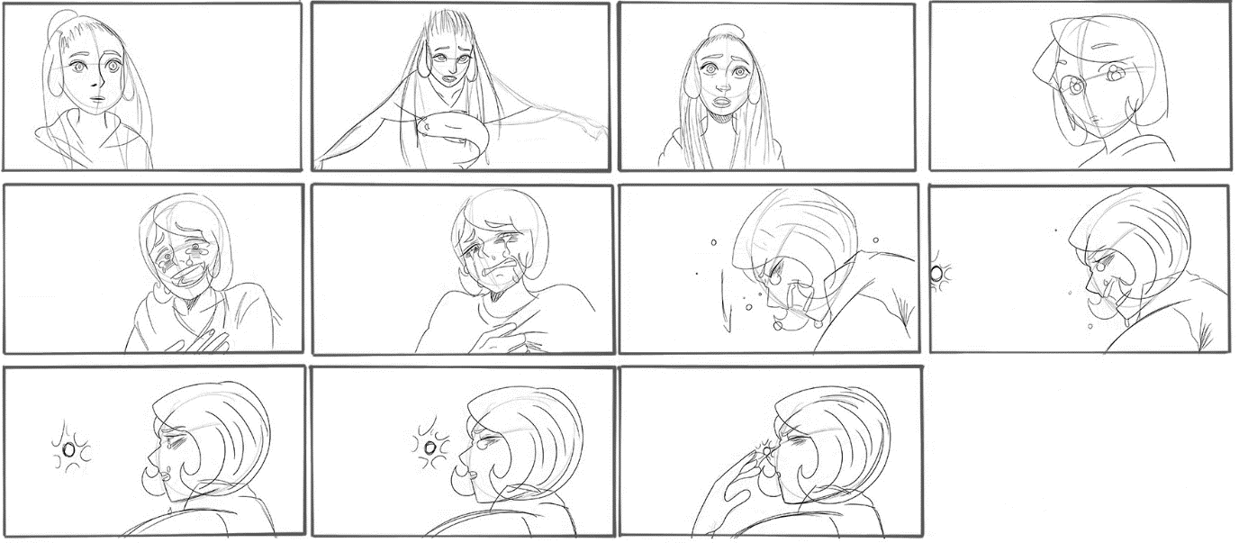

Conclusion.
Overall, through studying at higher education, the speed in which I had improved seemed clear in that more had been learnt through external projects than through internal projects with the university. This had been partly due to being mentored during both these internal and external projects. Although even while being mentored there was much more guidance given with the bigger projects I had worked on. The current level in the quality in the work that is being produced wouldn’t be where it currently is if I hadn’t been asked to join other projects. The goal is to continually improve and at a fast rate to be fully prepared once graduation passes. There seemed to be times when working in groups would become a hindrance as the creative freedom hadn’t been there, while there had been times where it had been there, this was clear that it largely depended on the people I worked with and how they worked within a group. Through industry experience I was able to push the knowledge that I had known and further learned from it.

References:
Websites:
Kleiser, R., Jacobs, J., Casey, W., Travolta, J., Newton-John, O. and Channing, S. (2018). Grease (1978). [online] IMDb. Available at: https://www.imdb.com/title/tt0077631/ [Accessed 30 Apr. 2018].
Disney Wiki. (2018). Mr. Incredible. [online] Available at: http://disney.wikia.com/wiki/Mr._Incredible [Accessed 30 Apr. 2018].
Animation World Network. (2018). Conceptualizing Disney’s ‘Big Hero 6’. [online] Available at: https://www.awn.com/animationworld/conceptualizing-disneys-big-hero-6 [Accessed 30 Apr. 2018].
Sonicthehedgehog.com. (2018). Sonic The Hedgehog Website. [online] Available at: https://www.sonicthehedgehog.com/ [Accessed 30 Apr. 2018].
Pixar Wiki. (2018). Lightning McQueen. [online] Available at: http://pixar.wikia.com/wiki/Lightning_McQueen [Accessed 30 Apr. 2018].
Videos:
The Incredibles. (2004). [DVD] Hollywood: Dianey Pixar.
YouTube. (2018). Breaking into the Game Industry: 2D & Concept Art. [online] Available at: https://www.youtube.com/watch?v=DH5ece6FBNg&t=2s&list=PL0zUjqY1HVT_GfyCLmZvGxOl2hnGM4hhG&index=1 [Accessed 30 Apr. 2018].
Books:
Rinzler, J. (n.d.). Star Wars storyboards.
Amidi, A. (2011). The art of Pixar. San Francisco: Chronicle Books.

