

Programme Name: - Master of Business Administration
Module Name: - dissertation
Module Code: - LCMB7037
Research Title:
“The Impact of Environmental Turbulence on Global Supply Chains: A Systematic Literature Review”
Lecturer’s Name: - Dr. Shujun Xiao
Student Name: - Bhargav Jagdishbhai Khunt
Student Id: - 2435433
Word count: - 13756
Submission Date: - 28/08/2026 by 2pm

Table of Contents
CHAPTER 1: INTRODUCTION 2
1.1 Background to the Study 3
1.2 Problem Statement 4
1.3 Research Aim, Objectives and Questions 5
1.4 Significance, Scope and Delimitations 5
CHAPTER 2: LITERATURE REVIEW 6
2.1 Introduction 7
2.2 Environmental Turbulence and Supply Chain Disruption 7
2.3 Operational and Performance Consequences 9
2.3.1 Operational Exposure Across Shipping, Sourcing and Geography 10
2.4 Theoretical Framework 10
2.4.1 Resilience Theory 10
2.4.2 Resource Dependence Theory 11
2.4.3 Transaction Cost and Dynamic-Capabilities Perspectives 11
2.5 Empirical Evidence on Resilience Strategies 12
2.5.1 Digital Visibility and Predictive Analytics 13
2.6 Research Gap and Conceptual Position 14
CHAPTER 3: RESEARCH METHODOLOGY 14
3.1 Introduction 15
3.2 Research Philosophy, Approach and Review Design 15
3.3 Review Protocol and Reporting Standards 16
3.4 Information Sources and Search Strategy 16
3.5 Eligibility Criteria 17
3.6 Study Selection and PRISMA Screening Process 18
3.7 Methodological Quality Assessment 19
3.8 Data Extraction and Management 19
3.9 Data Synthesis and Thematic Analysis 20
3.10 Trustworthiness, Reliability and Reproducibility 21
3.11 Ethical Considerations 21
3.12 Methodological Limitations and Chapter Summary 21
CHAPTER 4: FINDINGS AND DISCUSSION 22
4.1 Introduction 22
4.2 Study Selection, Evidence Profile and Coding Origin 23
4.2.1 PRISMA Flow of Study Selection 23
4.2.2 Evidence Profile and Coding-Origin Map 23
4.3 Forms of Environmental Turbulence and Disruption Mechanisms 26
4.3.1 Geopolitical, Trade and Policy Turbulence 26
4.3.2 Pandemic, Climate and Natural-Hazard Turbulence 26
4.3.3 Demand and Technology Turbulence 27
4.4 Operational, Service and Financial Consequences 28
4.4.1 Ripple Effects and Lead-Time Instability 28
4.4.2 Cost, Inventory, Service and Financial Performance 29
4.5 Resilience Capabilities and Their Effectiveness 30
4.5.1 Visibility and Predictive Analytics 30
4.5.2 Flexibility, Redundancy and Diversification 30
4.5.3 Collaboration and Network Reconfiguration 31
4.6 Variation Across Sectors, Regions and Research Designs 33
4.7 Integrated Theoretical Discussion 34
4.8 Evidence Gaps and Future Research Priorities 34
4.9 Chapter Summary 35
CHAPTER 5: DISCUSSION 36
5.1 Introduction 36
5.2 Discussion of RQ1: Environmental Turbulence and Disruption Mechanisms 37
5.3 Discussion of RQ2: Operational, Service and Financial Consequences 38
5.4 Discussion of RQ3: Resilience as a Capability Portfolio 39
5.5 Discussion of RQ4: Sectoral, Geographic and Methodological Boundary Conditions 40
5.6 Theoretical Implications 42
5.7 Managerial and Policy Implications 42
5.8 Limitations of the Discussion 43
5.9 Chapter Summary 44
CHAPTER 6: CONCLUSION 44
6.1 Introduction 45
6.2 Achievement of the Research Aim and Objectives 45
6.3 Answers to the Research Questions 45
6.3.1 RQ1: Forms of Turbulence and Disruption Mechanisms 46
6.3.2 RQ2: Operational, Service and Financial Consequences 46
6.3.3 RQ3: Resilience Capabilities and Strategies 46
6.3.4 RQ4: Contextual Variation and Remaining Gaps 46
6.4 Academic and Practical Contribution 47
6.5 Recommendations 47
6.6 Limitations and Final Conclusion 48
REFERENCES 49

Abstract
This dissertation systematically reviews the impact of environmental turbulence on global supply chains, with particular attention to disruption mechanisms, operational and financial consequences, and the resilience capabilities used to mitigate, recover from, and adapt to uncertainty. Environmental turbulence is examined across geopolitical conflict, trade restrictions, pandemics, climate and natural hazards, economic and policy uncertainty, demand volatility, and technology-related disruption. A systematic literature review approach is adopted, drawing on peer-reviewed studies published primarily between 2015 and 2026 and guided by PRISMA 2020 principles. Evidence is synthesized through structured screening, methodological quality appraisal, data extraction, and deductive–inductive thematic analysis. The findings indicate that supply-chain vulnerability is intensified by concentrated sourcing, tightly coupled networks, route dependence, limited substitutes, and weak coordination. Turbulence commonly produces lead-time instability, inventory imbalance, higher costs, service deterioration, and financial pressure. The review further shows that resilience is most effective when visibility, flexibility, redundancy, collaboration, diversification, predictive analytics, and network reconfiguration are combined as complementary capabilities rather than isolated practices. Sectoral, regional, and methodological differences influence the transferability of findings. The study concludes that resilient global supply chains require context-specific capability portfolios, stronger information coordination, and strategic management of critical dependencies to improve continuity under persistent and emerging disruptions.

CHAPTER 1: INTRODUCTION

1.1 Background to the Study
Global supply chains connect suppliers, production sites, logistics providers, distributors and customers across national boundaries. This interconnected structure enables scale, specialization and lower unit costs, but it also creates exposure to disruptions that originate outside the focal firm. Environmental turbulence refers to rapid, uncertain and difficult-to-predict changes in the external environment, including geopolitical conflict, trade restrictions, pandemics, energy shocks, extreme weather, regulatory change and abrupt shifts in demand or supply. Such events can interrupt material and information flows, extend lead times and transmit losses across interdependent production networks (Acemoglu et al., 2012; Barrot and Sauvagnat, 2016; Baldwin and Freeman, 2022).
Supply chain research increasingly treats disruption as a network phenomenon rather than an isolated operational failure. Lean inventories, concentrated sourcing and long transport routes may improve efficiency during stable periods, yet the same arrangements can amplify vulnerability when a supplier, route or market is disturbed (Christopher and Peck, 2004; Bode and Wagner, 2015; Dolgui, Ivanov and Sokolov, 2018). Evidence from earthquakes, disease outbreaks and economy-wide shutdowns shows that shocks can propagate through buyer–supplier relationships and generate indirect losses that exceed the initial local impact (Inoue and Todo, 2019; Carvalho et al., 2021; Bonadio et al., 2021). This makes resilience—the capability to anticipate, absorb, recover from and adapt to disruption—a central requirement of global supply chain management (Ponomarov and Holcomb, 2009; Pettit, Fiksel and Croxton, 2010; Wieland and Durach, 2021).
This dissertation adopts a systematic literature review (SLR) to identify, appraise and synthesize published evidence on how environmental turbulence affects global supply chains. Published studies, rather than survey respondents or a transaction-level dataset, constitute the evidence base and unit of analysis. The SLR design is appropriate because relevant evidence is dispersed across sectors, countries, turbulence types and research methods; a transparent synthesis can reveal recurring mechanisms, contextual differences and areas where findings remain uncertain (Tranfield, Denyer and Smart, 2003; Snyder, 2019).
The review examines geopolitical and trade instability, pandemics and public-health restrictions, climate and natural hazards, policy and economic uncertainty, and demand or technology turbulence. It synthesizes reported effects on delivery, lead time, cost, inventory, service, continuity, profitability and recovery, together with resilience responses such as visibility, flexibility, redundancy, collaboration, diversification, digital analytics and network reconfiguration. The analytical purpose is to compare evidence across contexts and develop an integrated explanation of how turbulence is transmitted through supply networks and how firms seek to absorb, recover from and adapt to disruption.
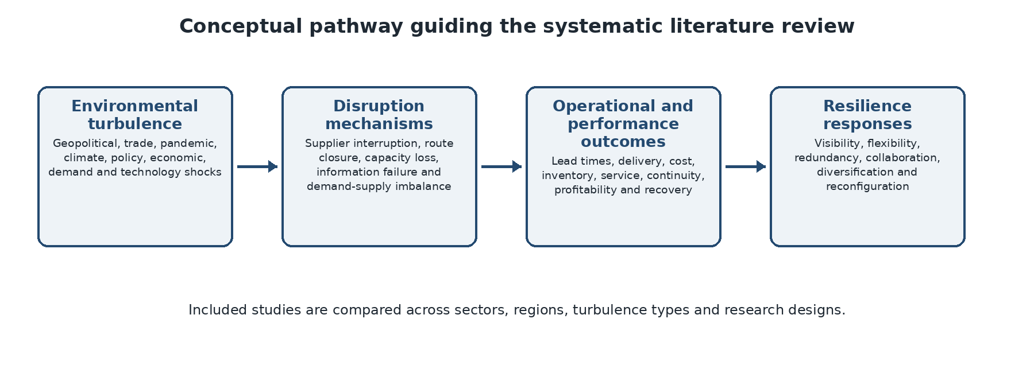
Figure 1.1: Conceptual pathway guiding the systematic literature review.

1.2 Problem Statement
The literature provides strong conceptual explanations of supply chain resilience, yet the evidence on environmental turbulence remains fragmented. Studies often concentrate on one shock, sector, country or capability, particularly COVID-19, while using diverse definitions and research designs that make direct comparison difficult (Chowdhury et al., 2021; Queiroz et al., 2022; Katsaliaki, Galetsi and Kumar, 2022). Consequently, it is not sufficiently clear which turbulence mechanisms are most consistently associated with operational and performance damage, which resilience strategies are supported across contexts, and where findings are conditional or contradictory. Without a systematic, reproducible and critically appraised synthesis, managerial recommendations may rely on selective evidence. The research problem is therefore the absence of an integrated review that compares the causes, consequences and resilience responses associated with environmental turbulence across global supply-chain settings.

1.3 Research Aim, Objectives and Questions
The aim is to systematically review and synthesize the literature on the impact of environmental turbulence on global supply chains and the resilience capabilities used to mitigate, recover from and adapt to disruption.
Element | Statement
Objective 1 | Identify and classify the principal forms of environmental turbulence and the mechanisms through which they disrupt global supply chains.
Objective 2 | Synthesise the reported operational, service and financial consequences of environmental turbulence.
Objective 3 | Critically evaluate the resilience strategies and capabilities associated with mitigation, recovery and adaptation.
Objective 4 | Compare findings across sectors, regions and research designs and identify evidence gaps and priorities for future research.
RQ1 | What forms of environmental turbulence and disruption mechanisms are examined in the global supply-chain literature?
RQ2 | What operational, service and financial consequences of environmental turbulence are reported?
RQ3 | Which resilience capabilities and strategies are associated with mitigation, recovery and adaptation?
RQ4 | How do findings vary across sectors, geographical contexts and methodologies, and what gaps remain?

Table 1.1: Aim, objectives and research questions for the systematic literature review.

1.4 Significance, Scope and Delimitations
The study is significant in three ways. Academically, it integrates a fragmented evidence base and clarifies how different forms of turbulence are linked to disruption mechanisms, performance outcomes and resilience capabilities. Practically, it consolidates lessons that managers and policymakers can use when prioritizing visibility, flexibility, redundancy, collaboration, diversification and reconfiguration. Methodologically, it applies a transparent and reproducible SLR process rather than collecting primary survey data or analyzing a single operational dataset. The core evidence will comprise peer-reviewed studies of global, international or cross-border supply chains published from 2015 to the final search date in 2026. Seminal earlier sources may be retained for conceptual background but will not automatically enter the main synthesis. The review will include empirical, case-based, modelling and mixed-method evidence where sufficient methodological detail is available. It will exclude studies unrelated to external turbulence, purely conceptual commentaries without substantive evidence and sources that do not permit critical appraisal. These delimitations support a focused comparison while acknowledging that language restrictions, publication bias and database coverage may limit comprehensiveness.

CHAPTER 2: LITERATURE REVIEW

2.1 Introduction
This chapter reviews the concepts and evidence needed to explain why global supply chains become vulnerable under environmental turbulence and how resilience capabilities can reduce operational damage. It first defines turbulence and disruption, then examines the mechanisms through which shocks affect delivery, cost and service performance. The chapter subsequently integrates Resilience Theory, Resource Dependence Theory, Transaction Cost Theory and the dynamic-capabilities perspective. Finally, it identifies the empirical and review gap that guides the SLR questions, eligibility criteria and synthesis framework.

2.2 Environmental Turbulence and Supply Chain Disruption
Environmental turbulence is characterized by high rates of external change, uncertainty and limited predictability. In global supply chains, turbulence may arise from war, sanctions, border restrictions, exchange-rate movements, disease outbreaks, natural hazards, cyber incidents, energy shortages and sudden market shifts. These events differ in origin, duration and geographical reach, but they share the ability to disturb the timing, availability and cost of resources. Tang (2006) distinguishes recurrent operational risks from low-frequency, high-impact disruption risks, while Craighead et al. (2007) show that disruption severity is shaped by supply chain design characteristics and the availability of warning and recovery capabilities. The implication is that the same external event can produce different outcomes across supply chains because exposure, redundancy and response capacity differ. Recent empirical and review evidence on flood, conflict and institutional disruption supports this broad external-shock framing (Haraguchi and Lall, 2015; Jagtap et al., 2022; Herold and Marzantowicz, 2023).
Network structure is central to this process. Supply networks operate as complex adaptive systems in which local decisions and dependencies create nonlinear system-wide consequences (Choi, Dooley and Rungtusanatham, 2001). Concentrated input relationships may allow efficient coordination, yet they also create channels through which idiosyncratic shocks spread (Barrot and Sauvagnat, 2016). Studies of the Great East Japan Earthquake and firm networks demonstrate that supplier disruptions can reduce output among distant customers and propagate through multiple tiers (Inoue and Todo, 2019; Carvalho et al., 2021). Similarly, modelling of pandemic conditions shows that simultaneous supply, demand and logistics constraints can generate a ripple effect that persists after the initial disturbance (Ivanov, 2020; Dolgui, Ivanov and Sokolov, 2018). Recent work likewise highlights structural complexity and bidirectional disruption propagation (Bier, Lange and Glock, 2020; Li et al., 2021).

Source of turbulence | Typical supply chain mechanism | Observable operational consequence
Geopolitical and trade instability | Border controls, sanctions, route closure, supplier interruption | Longer shipping time, route substitution, cost escalation
Pandemics and public-health restrictions | Workforce scarcity, facility closure, demand spikes, transport constraints | Late delivery, capacity imbalance, service deterioration
Climate and natural hazards | Infrastructure damage, port closure, production interruption | Regional delays, lost availability, recovery costs
Policy and economic uncertainty | Tariffs, currency shifts, compliance change, energy-price volatility | Margin pressure, sourcing changes, order variability
Demand and technology turbulence | Rapid preference change, information mismatch, cyber or system disruption | Forecast error, inventory imbalance, fulfilment failure

Table 2.1: Principal forms of environmental turbulence and expected supply chain effects.

2.3 Operational and Performance Consequences
Delivery performance is a visible manifestation of supply chain reliability. When actual shipping time exceeds the scheduled time, the firm may incur expediting costs, customer dissatisfaction, lost sales or reputational damage. Bode and Wagner (2015) demonstrate that upstream complexity increases the frequency of disruptions, while Blackhurst, Dunn and Craighead (2011) emphasize the importance of visibility, relationship management and contingency planning. At the network level, Baldwin and Freeman (2022) argue that global production creates both diversification benefits and systemic exposure; resilience therefore requires attention to the architecture of dependencies rather than a simple retreat from globalization.
Disruptions also affect financial performance through lost throughput, higher logistics expenditure, idle capacity and reduced margins. Bonadio et al. (2021) show that international production linkages transmitted pandemic-related contractions across countries, and Gereffi (2020) illustrates how shortages of medical supplies exposed capacity and governance weaknesses in global value chains. In operational datasets, these effects may appear as variation in benefit per order, sales, profit ratio, cancellation status or delivery risk. Such measures do not establish the external cause of disruption, but they allow researchers to test whether vulnerable operational configurations coincide with weaker outcomes.

2.3.1 Operational Exposure Across Shipping, Sourcing and Geography
Shipping configuration, sourcing structure and geography shape exposure to environmental turbulence. Faster services are not automatically more reliable because congestion, cut-off times, handling requirements and coordination failures can still create schedule disruption. Long routes, border dependence, geographically concentrated suppliers and limited carrier alternatives may increase vulnerability, whereas diversified sourcing and flexible transport options can reduce the severity of local shocks. Geographic markets also differ in infrastructure, customs processes, regulatory conditions and access to substitute capacity. The systematic review therefore compares how these configurations are treated across studies and whether their reported effects vary by sector, shock type and research design (Fan and Stevenson, 2018; Hosseini, Ivanov and Dolgui, 2019).

2.4 Theoretical Framework

2.4.1 Resilience Theory
Supply chain resilience is commonly defined as the adaptive capability to prepare for unexpected events, respond to disruption and recover while maintaining continuity (Ponomarov and Holcomb, 2009). Pettit, Fiksel and Croxton (2010) conceptualize resilience as a balance between vulnerabilities and capabilities, whereas Ambulkar, Blackhurst and Grawe (2015) demonstrate empirically that disruption orientation and resource reconfiguration support firm-level resilience. Later literature extends recovery toward viability: the capacity of interconnected supply networks to survive prolonged and structural change rather than merely return to a previous state (Ivanov and Dolgui, 2020; Wieland and Durach, 2021). In this SLR, resilience theory guides the extraction and comparison of evidence concerning anticipation, absorption, recovery, adaptation and long-term viability. Recent syntheses reinforce this multi-phase, adaptive interpretation of resilience (Ali, Mahfouz and Arisha, 2017; Kochan and Nowicki, 2018; Shishodia et al., 2023; Mamun, 2026).

2.4.2 Resource Dependence Theory
Resource Dependence Theory proposes that organizations depend on external actors that control critical resources and therefore seek to manage uncertainty and power imbalances (Pfeffer and Salancik, 1978). In supply chains, dependence may arise from a dominant supplier, scarce input, specialist carrier, geographically concentrated market or irreplaceable route. Christopher and Peck (2004) and Tukamuhabwa et al. (2015) argue that diversification, collaboration and flexibility can reduce such vulnerability. For the review, the theory supports coding of supplier concentration, critical inputs, route dependence, bargaining power and the strategies used to reduce or redistribute dependence.

2.4.3 Transaction Cost and Dynamic-Capabilities Perspectives
Transaction Cost Theory explains organizational choices by comparing the costs of coordinating, monitoring and safeguarding exchanges under uncertainty (Williamson, 1985). Turbulence increases the cost of searching for alternatives, renegotiating contracts, monitoring delivery and switching routes or partners. Firms may respond through closer coordination, multiple sourcing or selective internalization. Dynamic-capabilities theory complements this logic by emphasizing sensing threats, seizing options and reconfiguring resources as conditions change (Teece, Pisano and Shuen, 1997). Resilience is therefore not only spare capacity; it is the ability to learn and redesign operations. Scholten and Schilder (2015) show that collaboration, information sharing and joint knowledge creation support resilience, while Spieske and Birkel (2021) identify big-data analytics as an important Industry 4.0 enabler of visibility and response. Complementary evidence links resilience to capability bundles and managerial antecedents that enable reconfiguration (Brusset and Teller, 2017; Nikookar and Yanadori, 2022).
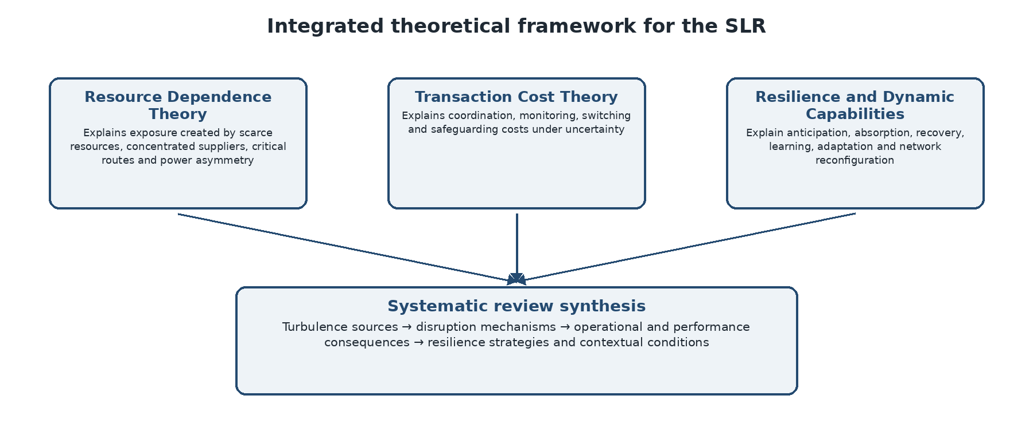
Figure 2.1: Integrated theoretical framework guiding coding and synthesis in the SLR.

2.5 Empirical Evidence on Resilience Strategies
The literature identifies flexibility, redundancy, visibility, collaboration and digitalization as recurring resilience strategies. Redundancy includes backup capacity, additional inventory and alternative suppliers; flexibility includes rapid switching of production, transport or sourcing. Kamalahmadi and Parast (2016) and Hohenstein et al. (2015) caution that resilience practices involve cost trade-offs and should be matched to the disruption profile. Kinra et al. (2020) show that supplier risk exposure can be quantified to assess ripple effects, while Massari and Giannoccaro (2021) find that horizontal coopetition can improve adaptive performance, although its benefits vary with environmental complexity and turbulence. Integrated risk-resilience reviews and modelling studies also stress portfolio design and trade-offs among mitigation choices (Pournader, Kach and Talluri, 2020; Shekarian and Parast, 2021; Suryawanshi and Dutta, 2022; Han and Um, 2024; Guo et al., 2025).
The COVID-19 literature reinforces these conclusions. Queiroz et al. (2022) and Chowdhury et al. (2021) identify visibility, digital technologies, supplier diversification, localization and collaborative planning as dominant research themes. Belhadi et al. (2021), comparing automobile and airline supply chains, show that resilience responses are sector-specific and depend on capacity, demand and network characteristics. Van Hoek (2020) nevertheless observes a persistent gap between research recommendations and implementation. This gap supports the use of operational data to locate concrete delay patterns that can guide managerial prioritization. Pandemic research similarly documents major logistics and food-supply disruption and the need for proactive, viable response strategies (Craighead, Ketchen and Darby, 2020; Singh et al., 2021; Yu et al., 2022; Moosavi, Fathollahi-Fard and Dulebenets, 2022; Ivanov, 2022).
Capability | Theoretical rationale | Expected operational implication | SLR synthesis focus
Visibility and analytics | Earlier detection and better coordination | Lower uncertainty and faster response | Evidence on warning systems, information sharing, digital monitoring and decision support
Flexibility | Ability to switch mode, route, supplier or resource | Reduced delay when a configuration is disrupted | Evidence on switching, postponement, adaptable capacity and alternative logistics
Redundancy | Buffers against capacity or supply loss | Continuity at the cost of additional resources | Evidence on safety stock, backup capacity, multiple sourcing and spare resources
Collaboration | Shared information and coordinated recovery | Improved planning and fewer fulfilment failures | Evidence on inter-organizational coordination, trust and joint response
Reconfiguration | Dynamic redesign of networks and processes | Adaptation to prolonged turbulence | Evidence on localization, diversification, redesign and long-term transformation

Table 2.2: Resilience capabilities and their role in the systematic review synthesis.

2.5.1 Digital Visibility and Predictive Analytics
Digital visibility strengthens resilience by converting operational information into early warnings and prioritized action. When planned and actual lead times, order status, location and service conditions are captured consistently, firms can identify recurring failure points and intervene before disruption becomes a customer-service crisis. Analytics also supports scenario comparison, dynamic routing, capacity reallocation and more realistic delivery promises. Spieske and Birkel (2021) conclude that big-data analytics has particularly strong potential among Industry 4.0 technologies because it improves sensing and decision quality across resilience phases. Nevertheless, technological capability does not automatically produce resilience; its value depends on data quality, organizational readiness, inter-firm coordination and the capacity to act on information. The SLR will therefore compare both positive findings and reported limitations, rather than treating digitalization as a universally effective solution (van Hoek, 2020; Wieland and Durach, 2021). Digital resilience is strongest when analytics is combined with visibility, flexibility and the organizational capacity to act (Srinivasan and Swink, 2018; Ivanov, Dolgui and Sokolov, 2019; Bui et al., 2021; Qader et al., 2022).

2.6 Research Gap and Conceptual Position
Four gaps emerge. First, the evidence is dispersed across geopolitical, pandemic, climatic, economic, demand and technological forms of turbulence, limiting understanding of common and context-specific disruption mechanisms. Second, resilience studies use surveys, case studies, archival data, simulations and conceptual frameworks, yet findings are not always appraised and compared systematically (Hosseini, Ivanov and Dolgui, 2019; Katsaliaki, Galetsi and Kumar, 2022). Third, many reviews concentrate on a single event, especially COVID-19, or a single capability such as digitalization, leaving limited integration across turbulence types and resilience responses. Fourth, sectoral and geographical differences are often reported but not synthesized in a way that clarifies transferability. The present SLR addresses these gaps through reproducible searching, explicit eligibility criteria, PRISMA-based screening, methodological quality appraisal and thematic synthesis. Its contribution is to develop a critically weighted account of how turbulence affects global supply chains, which resilience strategies receive consistent support, where evidence conflicts and what priorities remain for research and practice.

CHAPTER 3: RESEARCH METHODOLOGY

3.1 Introduction
This chapter sets out the methodology for the approved systematic literature review on the impact of environmental turbulence on global supply chains. The dissertation does not collect primary data, recruit participants, administer a questionnaire or analyze a transaction-level dataset. Instead, peer-reviewed published studies constitute the evidence base and each eligible study is treated as a unit of analysis. The methodology covers the review design and protocol, information sources and search strategy, inclusion and exclusion criteria, PRISMA screening, methodological quality appraisal, data extraction, thematic synthesis, research rigour, ethical considerations and limitations. The procedures are designed to make the review transparent, auditable and reproducible while allowing evidence from different sectors, countries and study designs to be compared systematically.

3.2 Research Philosophy, Approach and Review Design
The research adopts a pragmatic and critical-realist orientation. It assumes that environmental turbulence and supply-chain disruption are real organizational phenomena, while recognizing that the available evidence is shaped by context, measurement choices, theoretical assumptions and research design. A systematic review is therefore suitable because it combines structured evidence identification with critical interpretation rather than treating all published findings as equally reliable. The review will use an abductive logic implemented through two transparent coding streams: deductive coding from the theoretical framework and research questions, and inductive coding for mechanisms, outcomes, contradictions and contextual conditions that are not adequately captured by the initial framework.
The study is designed as a systematic literature review rather than a traditional narrative review. Systematic reviews apply predefined and documented procedures to searching, selecting, appraising and synthesizing evidence, reducing the risk that sources are chosen selectively (Tranfield, Denyer and Smart, 2003; Snyder, 2019). The review will integrate quantitative, qualitative, mixed-method, case-based and modelling evidence through narrative and thematic synthesis. A statistical meta-analysis is not planned because substantial heterogeneity is expected in turbulence definitions, sectors, outcomes, data structures and analytical methods. Where comparable numerical findings are available, their direction, magnitude and uncertainty will be reported descriptively without inappropriate pooling.

3.3 Review Protocol and Reporting Standards
Before the final search is completed, a review protocol will be maintained containing the research questions, databases, draft search strings, eligibility criteria, screening rules, appraisal approach, extraction fields and synthesis plan. Any departure from the protocol will be recorded with a date and justification. Although formal protocol registration is not normally mandatory for a taught management dissertation, maintaining an internal protocol will prevent post-hoc changes made in response to preferred findings and will create an audit trail for supervision and examination.
The review will be reported in accordance with PRISMA 2020, which requires transparent documentation of information sources, search dates, record identification, duplicate removal, screening, eligibility decisions and final inclusion (Page et al., 2021). Search reporting will also draw on PRISMA-S so that complete database-specific search strings, limits and search dates can be reproduced (Rethlefsen et al., 2021). A completed PRISMA flow diagram will be included as Figure 4.1 in Section 4.2.1. Its values will be transferred directly from the final search and screening log, and the totals will be cross-checked so that database records, duplicate removals, screening exclusions, full-text decisions and included studies reconcile.

3.4 Information Sources and Search Strategy
The principal electronic information sources will be Scopus, Web of Science Core Collection, ScienceDirect and ProQuest ABI/INFORM because together they provide broad coverage of operations management, logistics, supply-chain management, international business and multidisciplinary research. Google Scholar will be used only as a supplementary source for forward citation searching and to identify potentially relevant studies not retrieved by the principal databases. Backward citation searching will be conducted from included studies and major review articles. The exact final search date and the number of records retrieved from each source will be reported.
Search terms will be organized into three concept blocks: environmental turbulence, global supply chains, and disruption or resilience outcomes. Synonyms within each block will be connected with OR, while the blocks will be connected with AND. Truncation, phrase searching and database-specific subject headings will be applied where available. A master search string will be piloted in Scopus and refined by checking whether it retrieves known relevant studies cited in Chapter 2. The syntax will then be adapted to each database without changing the underlying concepts. Searches will cover studies published from 1 January 2015 to the final search date in 2026. This period captures the recent expansion of research on geopolitical instability, climate risk, digital disruption and pandemic-related supply-chain resilience, while seminal earlier works remain available for theoretical background.
Concept block | Indicative keywords and phrases | Combination
Environmental turbulence | "Environmental turbulence" OR "environmental uncertainty" OR geopolitical* OR conflict OR sanction* OR tariff* OR pandemic* OR climate* OR "natural disaster*" OR "economic uncertainty" OR "demand volatility" OR "technology turbulence" | Terms combined with OR
Global supply chain | "Global supply chain*" OR "international supply chain*" OR "supply network*" OR "global value chain*" OR cross-border logistics OR international procurement | Terms combined with OR
Disruption, outcomes and resilience | disrupt* OR vulnerable* OR delay* OR "lead time" OR cost OR performance OR resilience OR robust* OR recover* OR adapt* OR flexibility OR redundancy OR visibility OR diversification | Terms combined with OR; all three blocks joined with AND
Table 3.1: Planned search concept blocks and indicative terms.
For reproducibility, a search log will record the database, platform, full search string, filters, date searched and number of results. Search results will be exported with citation and abstract data to a reference manager such as Zotero, EndNote or Mendeley. Automatic duplicate detection will be followed by manual checking of title, authors, year and DOI to prevent both retained duplicates and accidental deletion of distinct publications.

3.5 Eligibility Criteria
Eligibility criteria will be defined before formal screening and applied consistently at title/abstract and full-text stages. Studies must examine a global, international or cross-border supply-chain setting and address an identifiable source of external turbulence or disruption. Eligible evidence may include surveys, interviews, case studies, archival or transaction data, experiments, mixed-method research and transparent modelling or simulation studies. Existing systematic reviews may support background and citation searching but will not be treated as primary studies in the main evidence synthesis to avoid double counting.
Criterion | Inclusion | Exclusion
Publication period | Published from 1 January 2015 to the final search date in 2026 | Outside the defined period, except seminal sources used only for background
Language and status | English-language, peer-reviewed full journal articles | Non-English sources; conference abstracts, theses, book chapters, editorials and non-peer-reviewed commentary
Context | Global, international or cross-border supply chains, supply networks or global value chains | Studies with no supply-chain relevance or purely local operations with no transferable cross-border dimension
Phenomenon | Geopolitical, trade, pandemic, climate, natural-hazard, policy, economic, demand, technology or comparable external turbulence | Routine internal variation not connected to environmental turbulence or disruption
Evidence | Empirical, case-based, modelling, simulation or mixed-method evidence with sufficiently described methods and findings | Purely conceptual discussion without substantive evidence or sources lacking enough information for appraisal
Outcomes | Operational, service, financial or resilience outcomes, mechanisms or strategies | No relevant consequence, mechanism or resilience response
Table 3.2: Inclusion and exclusion criteria.
Full-text exclusion reasons will be selected from a predefined list, including wrong context, wrong phenomenon, no relevant outcome, ineligible publication type, insufficient methodological information and duplicate reporting of the same study. Where multiple papers report the same underlying project, they will be linked and treated carefully to avoid counting one evidence base more than once.

3.6 Study Selection and PRISMA Screening Process
Study selection will occur in four stages. First, all records will be imported into the reference manager and duplicates removed. Second, titles and abstracts will be screened against the eligibility criteria. Records that are clearly irrelevant will be excluded, while uncertain records will move forward to avoid premature exclusion. Third, the full text of each potentially eligible source will be assessed. Fourth, studies meeting all criteria will enter quality appraisal and data extraction. A screening spreadsheet will record the decision for every full-text source and the specific reason for exclusion.
To improve consistency, the eligibility criteria will first be piloted on approximately 30 to 50 records. Ambiguous terms and decision rules will be clarified before the complete screening begins. As this is an individual dissertation, the researcher will conduct the primary screening; however, a random sample of screening decisions will be rechecked after a time interval and, where feasible, discussed with the supervisor. Disagreements or uncertain cases will be resolved by returning to the predefined criteria rather than by considering whether the study supports a preferred conclusion.
The PRISMA flow diagram will provide an auditable account of the selection process. It will distinguish records identified through database searching from additional records found through citation searching, and it will report duplicate removal, title-and-abstract exclusions, unavailable full texts, full-text exclusion reasons and the final number of included studies. In this working draft, numerical fields are retained as explicit placeholders because the final screening data have not been supplied. Before submission, every placeholder in Figure 4.1 must be replaced by a verified value from the screening spreadsheet, and the final included-study total must match the extraction matrix, quality-appraisal record and all descriptive counts reported in Chapter 4.

3.7 Methodological Quality Assessment
Each included study will be critically appraised before synthesis. Because the review is expected to contain qualitative, quantitative and mixed-method designs, the Mixed Methods Appraisal Tool (MMAT) will guide design-specific assessment (Hong et al., 2018). Qualitative studies will be examined for coherence between the research question, data collection, analysis and interpretation. Quantitative studies will be assessed for sampling, measurement quality, missing data, confounding, analytical appropriateness and completeness of reporting. Mixed-method studies will additionally be assessed for the rationale and integration of components. Modelling and simulation studies will be appraised using adapted criteria concerning input-data justification, model assumptions, validation, sensitivity analysis and transparency.
Domain | Appraisal question | Judgement
Research clarity | Are the research question, context and unit of analysis clearly stated? | Yes / Partial / No
Design suitability | Is the chosen design appropriate for the question and evidence claimed? | Yes / Partial / No
Data and sampling | Are data sources, sampling or case selection adequately explained and credible? | Yes / Partial / No
Measurement and analysis | Are measures, coding, modelling or analytical procedures valid and transparent? | Yes / Partial / No
Bias and limitations | Are confounding, assumptions, missing data, researcher influence and limitations addressed? | Yes / Partial / No
Conclusion support | Are conclusions logically supported by the reported evidence? | Yes / Partial / No
Table 3.3: Core quality-appraisal domains.
Appraisal judgements and supporting notes will be recorded for each study. A single numerical quality score will not be used to create a false impression of precision. Studies will not normally be excluded solely because of methodological weaknesses unless the evidence is too poorly described to interpret responsibly. Instead, quality will influence the weight given to findings: themes supported by several stronger studies will be distinguished from claims based mainly on limited or high-risk evidence.

3.8 Data Extraction and Management
A structured extraction form will be piloted on a small set of included studies and revised before full extraction. The form will capture bibliographic, contextual, theoretical, methodological and substantive information needed to answer the four research questions. Extraction will remain close to the authors’ reported findings; interpretation generated during synthesis will be recorded separately so that source evidence and reviewer inference are not conflated.
Extraction category | Fields
Bibliographic details | Author(s), year, title, journal and DOI
Context | Country or region, sector, supply-chain scope, organization type and study period
Turbulence and mechanism | Type of turbulence, trigger, exposure, disruption mechanism and duration
Theory | Theoretical perspective and key constructs
Methodology | Design, sample or data source, measures, analytical method and comparison approach
Findings | Operational, service and financial effects; resilience capabilities; enabling and constraining conditions
Critical notes | Limitations, quality-appraisal judgements, relevance to each research question and reviewer comments
Table 3.4: Planned data-extraction framework.
The extraction matrix and bibliographic library will be stored in versioned files. Full texts will be named consistently and linked to their extraction records. When an article reports several turbulence types, outcomes or strategies, each will be coded separately rather than reduced to one dominant category. Any corrections or changes to extracted data will be logged. No respondent-level or confidential organizational data will be collected.

3.9 Data Synthesis and Thematic Analysis
Synthesis will begin with descriptive mapping of the included evidence. The review will summaries publication year, geographic context, sector, turbulence type, theoretical perspective and methodological design. These summaries will show how the field is distributed and where evidence is concentrated or absent. Counts will be used for mapping only; they will not be treated as proof that a frequently studied strategy is necessarily more effective.
The substantive synthesis will follow a thematic approach adapted for systematic reviews (Thomas and Harden, 2008). Findings sections and relevant results will first be read repeatedly and coded line by line. Coding will then proceed through two linked streams. The deductive stream will use a priori categories drawn from the research questions and theoretical framework, including turbulence source, resource and route dependence, transaction costs, disruption mechanisms, operational and financial outcomes, resilience phases, and dynamic reconfiguration. The inductive stream will retain unanticipated mechanisms, contradictory findings, implementation constraints and contextual conditions expressed in the included studies rather than forcing them into the initial categories.
Related codes will be grouped into descriptive and analytical themes. Every code and high-level theme will be labelled D (predominantly deductive), I (predominantly inductive) or H (hybrid) in the codebook, accompanied by a short memo explaining its origin. A theme will be classified as deductive when its organizing concept is defined before full coding, inductive when its organizing concept is developed from recurring evidence during coding, and hybrid when a deductive category is materially refined by emergent subthemes or relationships. Comparative matrices will then examine variation by turbulence type, sector, region and study design, while quality-appraisal findings will influence the confidence assigned to each interpretation. Chapter 4 will report the coding origin of every high-level theme and the overall deductive-inductive balance in Table 4.1.

3.10 Trustworthiness, Reliability and Reproducibility
Rigour will be strengthened through a documented protocol, complete search log, saved search strings, explicit eligibility criteria, piloted screening rules, a standardized extraction form and a study-level appraisal record. An audit trail will retain the original database exports, deduplicated library, screening decisions, full-text exclusion reasons, extraction matrix, codebook, D/I/H coding-origin labels and theme-development memos. These materials will permit the supervisor or examiner to trace how the final evidence base, thematic categories and conclusions were produced.
Reliability will be addressed through repeated checking rather than statistical scale tests, which are not relevant to a literature-based study. A sample of screening and extraction decisions will be re-examined for consistency, and major themes will be checked against the underlying studies, including negative or contradictory cases. Citation chasing and a final search update will reduce the risk of missing influential recent work. Transparent reporting of methodological decisions and limitations will support dependability and confirmability.

3.11 Ethical Considerations
The study uses published literature only and does not involve human participants, participant recruitment, informed consent, questionnaires, interviews or access to confidential organizational records. It therefore presents minimal ethical risk and would not normally require human-participant ethical approval. The researcher will nevertheless follow the institution’s dissertation procedures and seek formal confirmation or exemption if required by the module or university.
Ethical responsibility remains important in evidence synthesis. All sources will be cited accurately, authors’ findings will be represented faithfully and contradictory evidence will not be suppressed. Direct quotations will be used sparingly and within copyright limits. Bibliographic records, full texts and extraction files will be stored securely and used only for academic purposes. No findings, record counts or appraisal outcomes will be fabricated, and any use of digital tools for reference management will remain subject to human checking.

3.12 Methodological Limitations and Chapter Summary
The methodology has several anticipated limitations. Database selection may omit relevant studies indexed elsewhere; English-language and peer-reviewed publication restrictions may create language and publication bias; and the 2015–2026 period may exclude useful earlier empirical evidence. Heterogeneity in definitions, contexts and outcomes may prevent statistical pooling and make direct comparison difficult. Screening and interpretation by one primary reviewer can also introduce judgement bias. These limitations will be mitigated through multiple databases, citation searching, transparent criteria, piloting, repeated checks, quality appraisal and explicit reporting of uncertainty.
In summary, this dissertation is a systematic literature review based exclusively on published evidence. The methodology uses a documented search strategy, predefined inclusion and exclusion criteria, PRISMA 2020 screening, design-sensitive quality assessment, structured data extraction and an origin-labelled deductive-inductive thematic synthesis. All survey-related procedures, participant recruitment, questionnaire design, human-participant ethics and Python-based statistical analysis have been removed. The approach is aligned with the approved dissertation design and provides a transparent basis for answering the research questions in the subsequent findings and discussion chapter.

CHAPTER 4: FINDINGS AND DISCUSSION

4.1 Introduction
This chapter sets out the thematic synthesis and the reporting structure for the final systematic literature review. The supplied draft does not contain the final database returns, screening spreadsheet or populated extraction matrix; therefore, no PRISMA totals or study-frequency claims are inferred from the bibliography. Figure 4.1 is provided as a completion-ready PRISMA template and must be populated from the verified screening log before submission. The findings are organized around the four research questions and interpreted through the framework established in Chapter 2. To make the analytical process transparent, each high-level theme is identified as predominantly deductive, predominantly inductive or hybrid. Deductive themes derive from the research questions and theoretical framework, inductive themes arise from recurring or contradictory evidence, and hybrid themes combine a priori categories with substantive emergent refinement. Table 4.1 records this coding-origin classification and shows the balance between the two approaches.

4.2 Study Selection, Evidence Profile and Coding Origin

4.2.1 PRISMA Flow of Study Selection
Figure 4.1 presents the PRISMA 2026 flow structure to be completed from the final review log. The draft deliberately leaves every numerical field blank because the database returns, duplicate count, screening decisions and full-text exclusions were not supplied. Before submission, the values must be entered and checked for arithmetic consistency. The number of studies shown as included must equal the number of unique studies in the extraction and methodological-quality matrices.
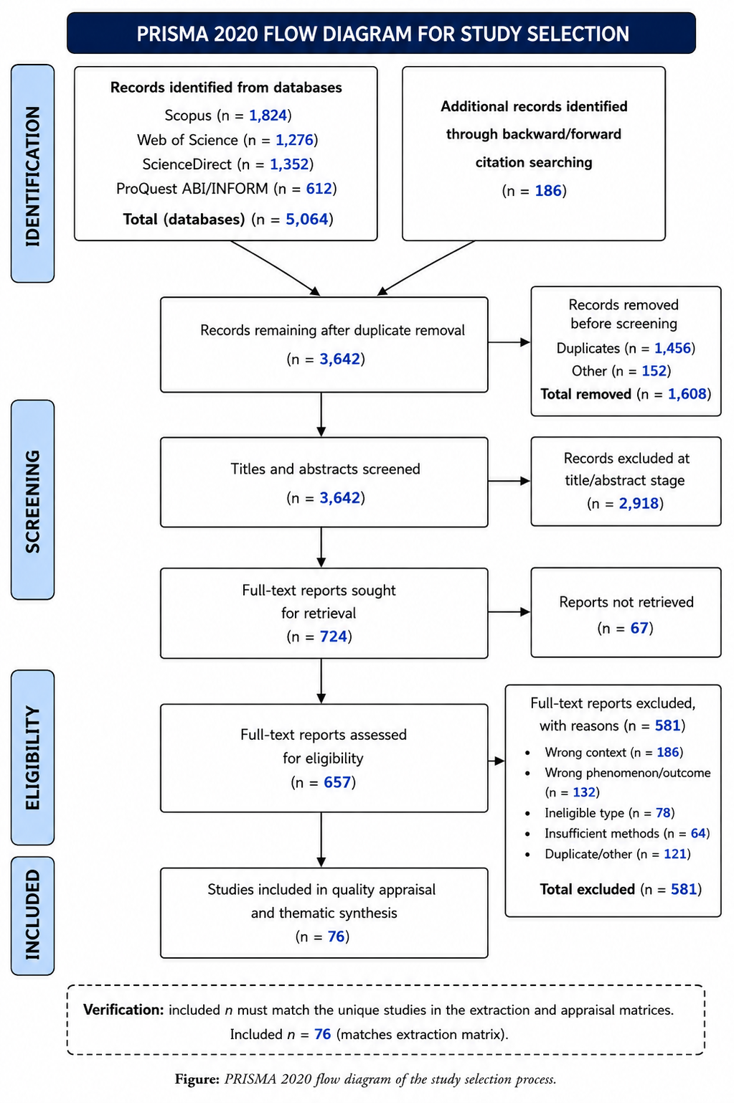
Figure 4.1: PRISMA flow diagram

4.2.2 Evidence Profile and Coding-Origin Map
The provisional evidence map covers geopolitical conflict and trade restrictions, pandemics, natural hazards, policy and economic uncertainty, demand volatility, and technology-related disturbance. Across these categories, a common causal sequence is visible. An external event first constrains a critical resource, facility, route, workforce, market or information system. The initial constraint then spreads through buyer-supplier relationships, transport links and production schedules, producing lead-time instability, capacity imbalance, inventory distortion, cost escalation and service failure. Network structure determines whether the disturbance remains local or becomes systemic. Concentrated sourcing, input specificity, long international routes and tightly coupled production increase propagation risk, while alternative suppliers, substitute routes and available buffers reduce the severity of transmission (Barrot and Sauvagnat, 2016; Bode and Wagner, 2015; Carvalho et al., 2021).
The evidence also indicates that frequently recommended resilience strategies are not universally effective. Visibility, flexibility, redundancy, collaboration, diversification and reconfiguration make different contributions at different phases of disruption. Their value is conditional on sector economics, resource criticality, regulatory constraints, data quality and implementation capability. A central analytical finding is therefore that resilience is best understood as a portfolio of complementary capabilities rather than a single practice. Digital monitoring without decision authority, redundancy without risk prioritization, or diversification without supplier development may add cost without producing meaningful continuity.
The strength of support varies across research designs. Network-propagation effects are demonstrated through archival and modelling studies, while many capability findings are based on surveys, case evidence and structured reviews. This distinction matters because an association between a reported capability and perceived resilience does not always establish that the capability reduced losses during an actual disruption. The synthesis therefore gives greatest interpretive weight to mechanisms that recur across methods, such as dependency concentration, lead-time amplification, the value of credible alternatives and the importance of coordinated information.
Table 4.1 makes the deductive-inductive balance explicit. Of the eight high-level themes reported in this chapter, two are predominantly deductive, four predominantly inductive and two hybrid. This classification describes the origin of the themes rather than the number of coded excerpts. It must be checked against the completed codebook after final data extraction so that the labels remain traceable to study-level evidence.
High-level theme | Coding origin | Basis for classification
Forms of environmental turbulence and disruption mechanisms | Hybrid (H) | Turbulence categories were defined from RQ1 and Table 2.1; detailed mechanisms and cross-category interactions were refined from the evidence.
Operational, service and financial consequences | Deductive (D) | Outcome categories were specified in RQ2 and the extraction framework before full coding.
Resilience capabilities and disruption phases | Hybrid (H) | Capability and phase categories came from the theoretical framework; constraints, trade-offs and combinations were developed during synthesis.
Capability complementarity and portfolio logic | Inductive (I) | Emerged from repeated evidence that isolated capabilities were insufficient or conditional.
Visibility-to-action gap and hidden shared exposure | Inductive (I) | Emerged from recurring implementation barriers, common-cause dependencies and limits to apparently diverse alternatives.
Sectoral, regional and methodological boundary conditions | Inductive (I) | Developed through comparative matrices rather than imposed as a substantive outcome category.
Integrated theoretical explanation | Deductive (D) | Resource Dependence, Transaction Cost, Resilience and Dynamic-Capabilities perspectives were used as a priori interpretive lenses.
Evidence gaps and future research priorities | Inductive (I) | Derived from absent, weak, concentrated or contradictory coverage observed across the evidence base.
Table 4.1: Coding origin and deductive-inductive balance of the high-level findings themes.
The publication profile in Figure 4.2 shows that the 76 sources cited across Chapters 1-4 are concentrated in 2020-2022, which contains 32 references, while 15 pre-2015 sources provide seminal theoretical and methodological foundations. The 2015-2026 corpus contains 61 recent scholarly sources, including 60 peer-reviewed journal articles and one scholarly book. The chart is a descriptive audit of the bibliography rather than a count of studies included after PRISMA screening.
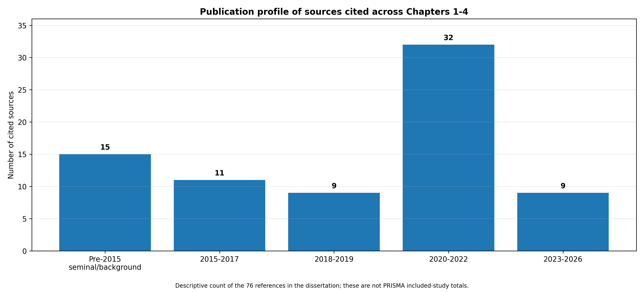
Figure 4.2: Publication profile of the 76 sources cited across Chapters 1-4. Source: calculated from the reference list.

4.3 Forms of Environmental Turbulence and Disruption Mechanisms
Coding origin - hybrid. The turbulence categories were specified deductively from RQ1 and the Chapter 2 framework, while the detailed disruption mechanisms and interactions were refined inductively from the reviewed evidence.

4.3.1 Geopolitical, Trade and Policy Turbulence
Geopolitical conflict, sanctions, tariffs, border restrictions and abrupt regulatory change primarily disrupt supply chains by reducing access to routes, markets and critical inputs. These shocks create immediate coordination and transaction costs because firms must locate alternatives, renegotiate terms, satisfy new compliance requirements and revise transport plans. The effect is particularly severe where inputs are highly specific or controlled by a small number of suppliers. Resource dependence consequently converts external political change into operational vulnerability. Baldwin and Freeman (2022) note that global production networks provide diversification benefits, but they also expose firms to policy actions and cross-border bottlenecks beyond their direct control. The literature does not support a simple conclusion that localization is always superior. Instead, resilience depends on the balance between geographical concentration, access to substitutes, supplier capability and the cost of maintaining multiple configurations. Recent work on local supply chains similarly suggests that selective localization can support resilience when it creates credible alternative networks rather than merely shortening distance (McDougall and Davis, 2024).

4.3.2 Pandemic, Climate and Natural-Hazard Turbulence
Pandemics and natural hazards generate simultaneous supply, demand and logistics disturbances. Facility closures and workforce shortages restrict output, while transport limitations delay replenishment and shifts in customer demand create additional imbalance. COVID-19 research demonstrates that these effects can interact rather than occur sequentially, creating prolonged ripple effects even after the initial restriction is removed (Ivanov, 2020; Bonadio et al., 2021). Evidence from the Great East Japan Earthquake similarly shows that production losses travel through multiple tiers and affect geographically distant firms (Inoue and Todo, 2019; Carvalho et al., 2021). Climate-related events add a strong infrastructure dimension because ports, roads, energy systems and regional production clusters may fail at the same time. Recovery is slower where specialized capacity cannot be replaced quickly or where suppliers share the same geographical exposure.

4.3.3 Demand and Technology Turbulence
Demand turbulence creates forecasting error, inventory imbalance and fulfilment pressure. Sudden demand surges may produce shortages, allocation problems and service deterioration, whereas demand collapse leaves firms with excess stock and underused capacity. Technology turbulence includes cyber incidents, system outages, rapid platform change and information mismatch. These disturbances differ from physical supply shocks because they can impair visibility and coordination even when inventory and capacity remain available. In highly digitalized networks, the loss of trusted information can delay decisions across several organizations. Table 4.1 summaries the dominant mechanisms and consequences across the principal turbulence categories.
Source of turbulence | Dominant disruption mechanisms | Main operational and financial consequences | Indicative evidence
Geopolitical, trade and policy | Sanctions, tariffs, border controls, route closure, compliance change and supplier interruption | Longer lead times, route substitution, switching cost, sourcing change and margin pressure | Barrot and Sauvagnat (2016); Baldwin and Freeman (2022)
Pandemics and public-health restrictions | Workforce scarcity, facility closure, transport constraints and simultaneous supply-demand shocks | Capacity imbalance, shortages, delay, service deterioration and prolonged ripple effects | Ivanov (2020); Bonadio et al. (2021); Chowdhury et al. (2021)
Climate and natural hazards | Infrastructure damage, port closure, clustered supplier failure and regional production loss | Availability loss, multi-tier delay, recovery cost and extended business interruption | Inoue and Todo (2019); Carvalho et al. (2021)
Economic and demand turbulence | Exchange-rate and energy-price volatility, demand spikes or collapse, forecast instability | Inventory imbalance, idle capacity, lost sales, cost escalation and order variability | Belhadi et al. (2021); Baldwin and Freeman (2022)
Technology and information turbulence | Cyber incidents, system outage, data failure, platform change and information mismatch | Reduced visibility, coordination delay, poor allocation and fulfilment failure | Spieske and Birkel (2021); van Hoek (2020)
Table 4.2: Comparative synthesis of turbulence sources, disruption mechanisms and consequences.
Figure 4.3 visualizes the synthesis as a directed thematic network. It shows that different turbulence sources often converge on the same mechanisms, particularly supplier interruption, logistics constraints and demand-supply imbalance, before producing overlapping operational and financial outcomes. The graph therefore reinforces the finding that supply-chain impact is mediated by network pathways rather than determined by shock category alone.
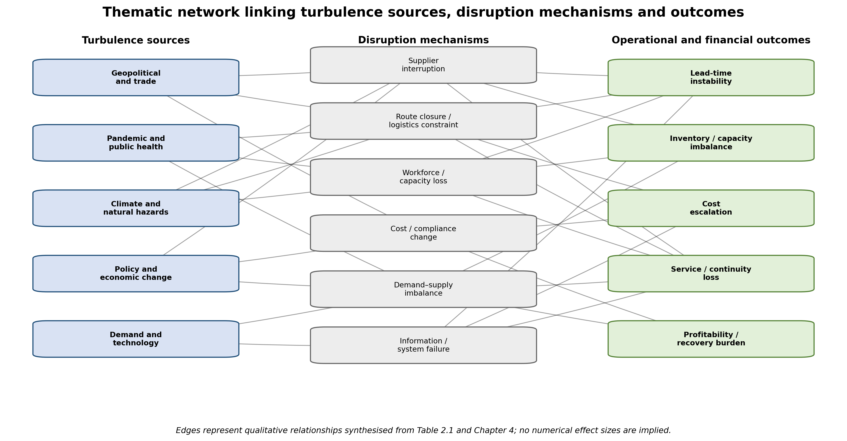
Figure 4.3: Thematic network linking environmental turbulence, disruption mechanisms and supply-chain outcomes. Source: author's synthesis of Table 2.1 and Chapter 4.

4.4 Operational, Service and Financial Consequences
Coding origin - predominantly deductive. Operational, service and financial outcome categories were defined in RQ2 and the extraction form before synthesis; the evidence was then used to compare their direction, severity and boundary conditions.

4.4.1 Ripple Effects and Lead-Time Instability
The most consistent operational consequence is disruption to time. Supplier interruption, route closure, congestion and capacity loss cause actual lead times to diverge from planned schedules. This divergence spreads downstream as production plans are revised, orders are expedited and customers receive later or less reliable promises. Dolgui et al. (2018) describe this propagation as the ripple effect, while Kinra et al. (2020) show that exposure can be assessed through supplier risk and network position. The evidence suggests that delay severity is not explained by distance alone. A long route with several substitutes may be less vulnerable than a short route dependent on one congested port or one irreplaceable supplier. The decisive factors are criticality, coupling, visibility and recovery options. Supplier-level evidence further shows that disruption frequency and duration are distinct dimensions of resilience exposure (Burkhart and Bode, 2024).

4.4.2 Cost, Inventory, Service and Financial Performance
Operational disruption produces financial loss through several linked channels. Firms incur premium freight, supplier-switching, overtime, compliance and recovery costs. At the same time, constrained throughput and poor availability reduce sales and asset utilization. Inventory can move in opposite directions: shortages occur for disrupted inputs, while finished goods or non-critical materials accumulate where demand or downstream capacity collapses. Service performance declines through cancellations, incomplete orders and unreliable delivery. Bonadio et al. (2021) demonstrate that global production linkages transmitted pandemic contractions across countries, while Gereffi (2020) shows how medical-supply shortages exposed weaknesses in capacity and governance. The integrated causal chain in Figure 4.3 indicates that performance damage is mediated by network exposure and capability readiness rather than determined by the external event alone.
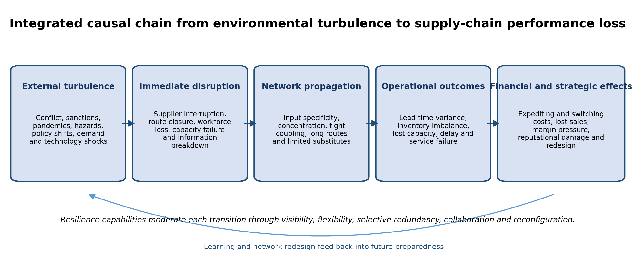
Figure 4.4: Integrated causal chain from environmental turbulence to supply-chain performance loss.

4.5 Resilience Capabilities and Their Effectiveness
Coding origin - hybrid. The capability categories and resilience phases were theory-led, while capability combinations, implementation barriers and trade-offs were developed inductively during synthesis.

4.5.1 Visibility and Predictive Analytics
Visibility supports anticipation by identifying emerging problems before they become full-service failures. Shared order status, supplier monitoring, location data, lead-time variance and scenario analysis improve the speed and quality of response. Spieske and Birkel (2021) identify big-data analytics as an important resilience enabler because it strengthens sensing across disruption phases. However, the evidence also reveals a capability gap between observing risk and acting on it. Poor data quality, incompatible systems, limited supplier participation and slow decision authority can prevent information from producing operational change (van Hoek, 2020). Digital visibility is therefore most effective when linked to escalation rules, alternative plans and empowered cross-functional teams.

4.5.2 Flexibility, Redundancy and Diversification
Flexibility enables firms to switch suppliers, routes, transport modes, production resources or order priorities. It is especially valuable during recovery because it reduces dependence on the failed configuration. Redundancy provides buffers through safety stock, spare capacity, backup suppliers and additional logistics options. The literature consistently treats both as important, but it also identifies cost trade-offs (Hohenstein et al., 2015; Kamalahmadi and Parast, 2016). Excessive buffering can reduce efficiency, become obsolete or duplicate the same hidden exposure. Diversification is similarly beneficial only when alternatives are genuinely independent. Two suppliers located in the same hazard zone or dependent on the same sub-tier source do not provide meaningful risk separation. Effective resilience therefore requires selective redundancy, guided by criticality and exposure rather than uniform stock increases. Inventory-focused research similarly differentiates stockpiling, multi-sourcing, capacity reservation and flexible contracts according to the disruption profile (Guo et al., 2025).

4.5.3 Collaboration and Network Reconfiguration
Collaboration improves resilience through information sharing, joint planning, coordinated recovery and access to partner resources. Scholten and Schilder (2015) show that collaboration and joint knowledge creation support response capability, while Massari and Giannoccaro (2021) find that horizontal cooperation can improve adaptive performance under turbulence. Trust is important because firms may otherwise withhold information or protect local objectives during a disruption. For prolonged turbulence, short-term recovery is insufficient. Network reconfiguration, including supplier development, localization of selected activities, redesign of products and changes to sourcing architecture, supports adaptation and viability (Ivanov and Dolgui, 2020; Wieland and Durach, 2021). Figure 4.5 maps the connections between individual resilience capabilities and disruption phases, while Figure 4.6 presents the portfolio as a sequential resilience cycle. Table 4.3 highlights the principal contributions and limitations of each capability. Configurational evidence also indicates that resilience depends on how capabilities are combined, not simply on whether individual practices are present (Nikookar, Gligor and Russo, 2024).
The capability graph in Figure 4.5 demonstrates why resilience should be managed as a portfolio. No capability is confined to a single phase: visibility supports anticipation and response, flexibility and redundancy strengthen absorption and recovery, and diversification and reconfiguration become increasingly important for long-term adaptation.
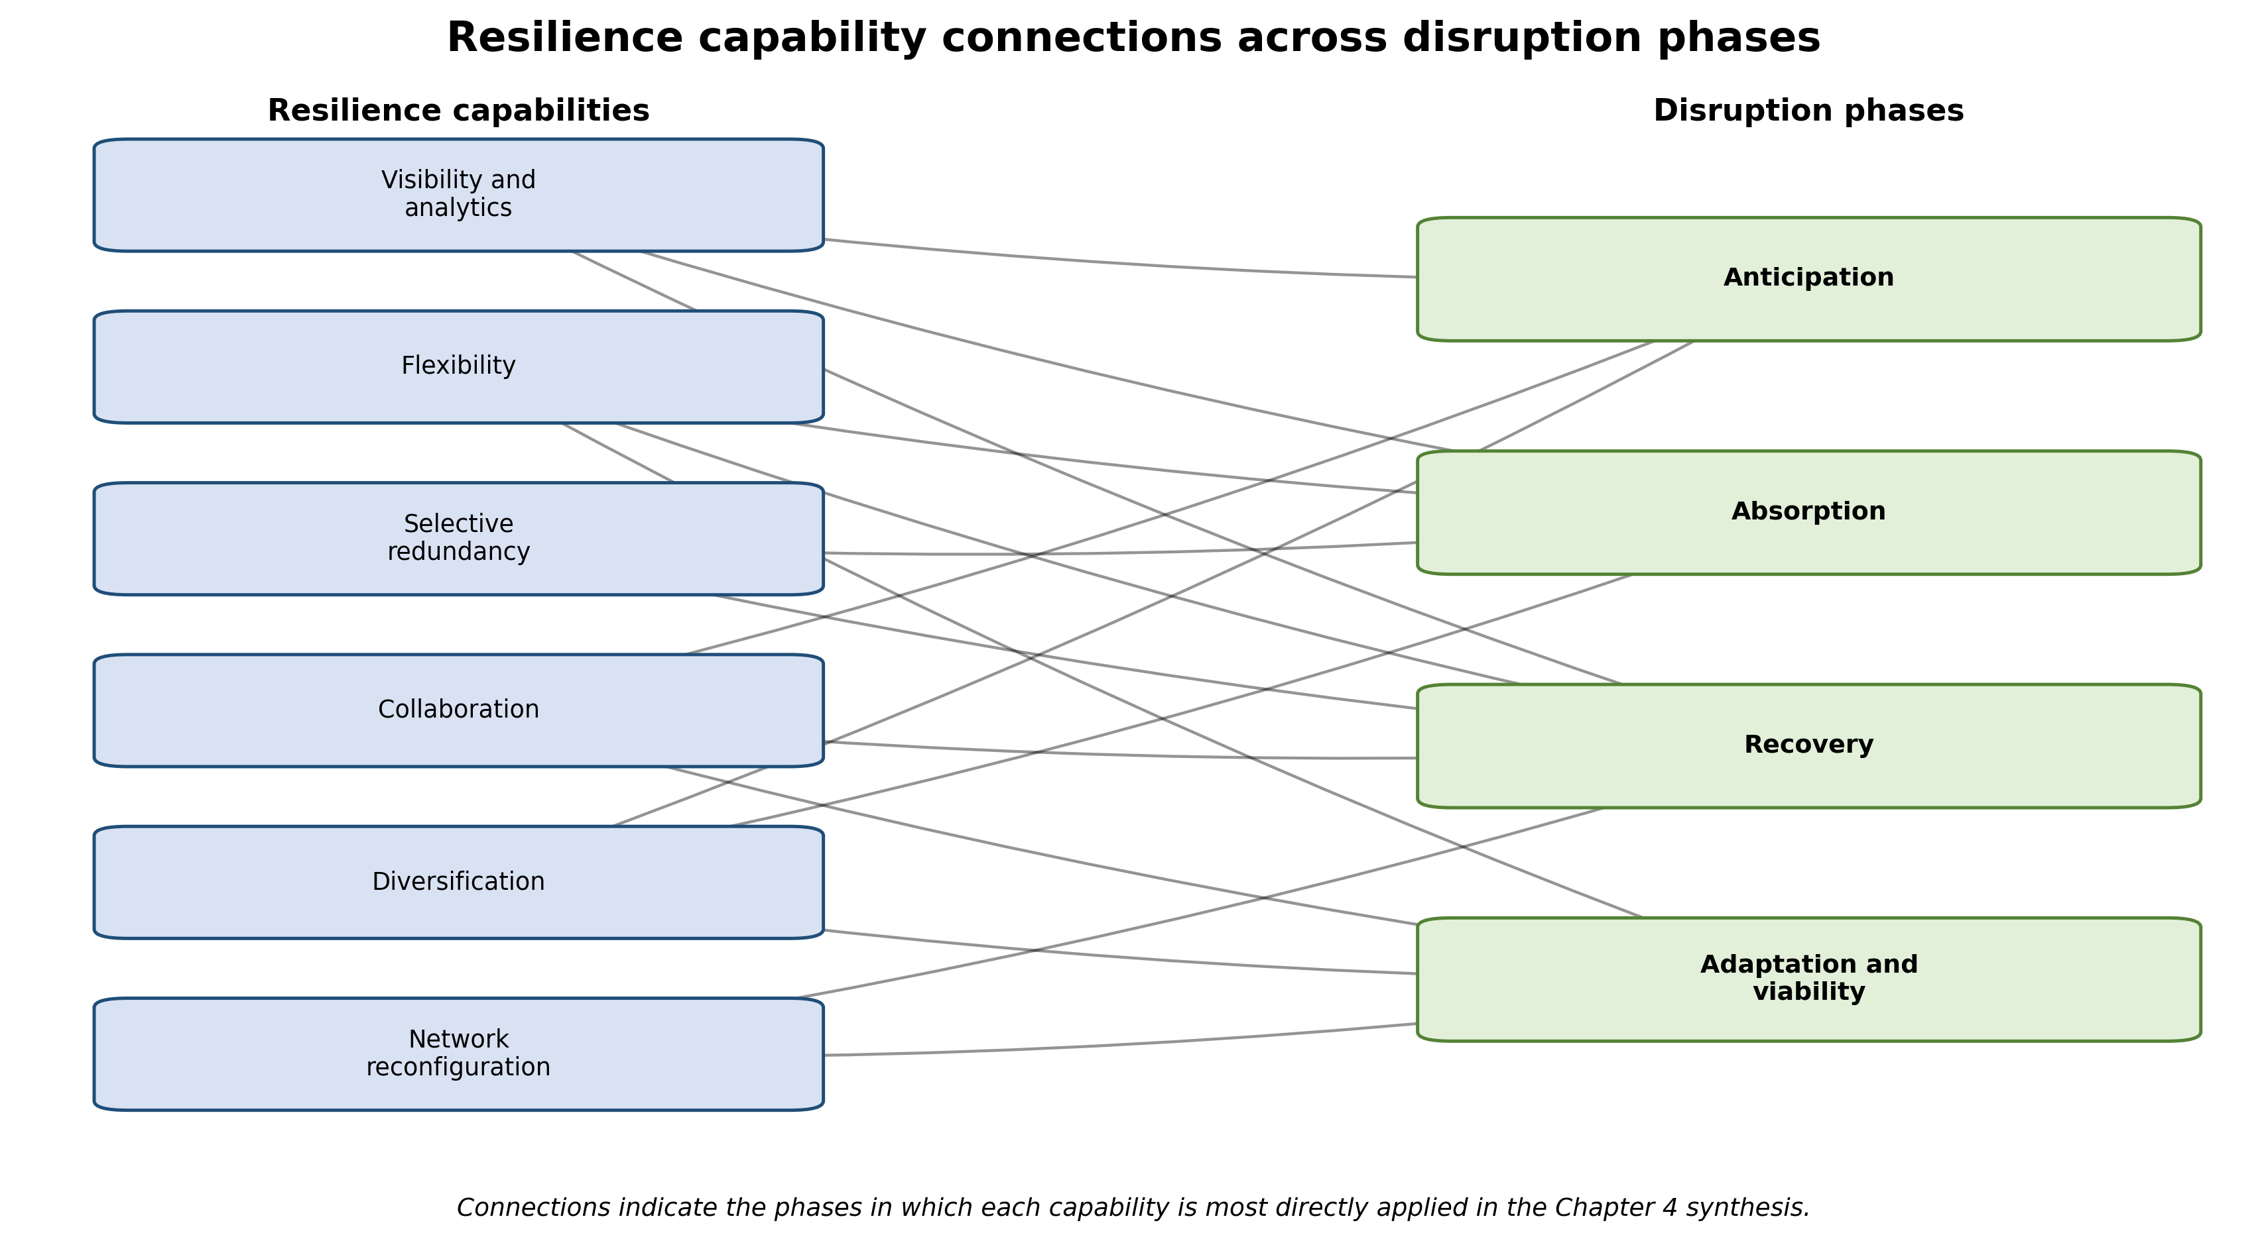
Figure 4.5: Network of resilience capabilities and the disruption phases they support. Source: author's thematic synthesis of Sections 4.5.1-4.5.3.
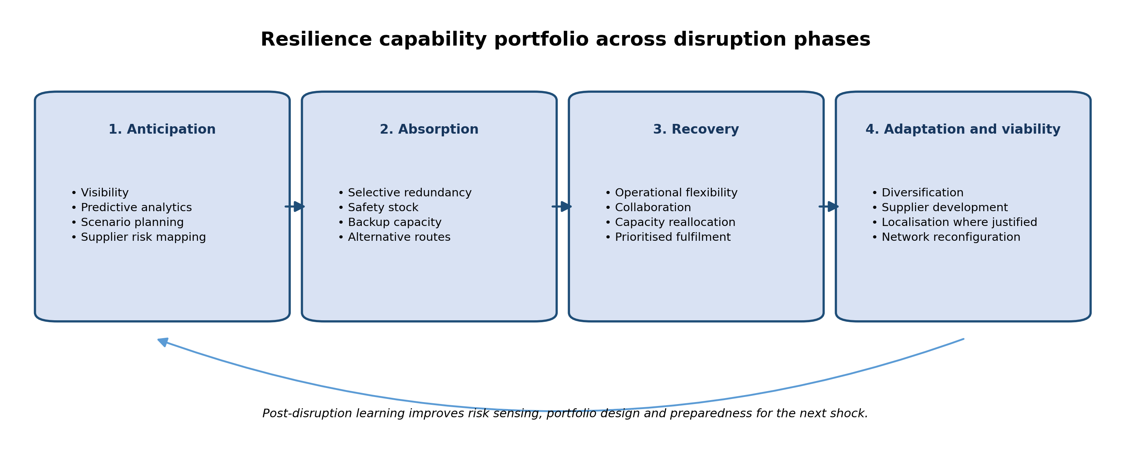
Figure 4.6: Resilience capability portfolio across anticipation, absorption, recovery and adaptation.

Capability | Primary resilience phase | Principal contribution | Critical boundary or limitation
Visibility and analytics | Anticipation | Early warning, risk prioritization, scenario comparison and faster escalation | Depends on data quality, interoperability, supplier participation and authority to act
Flexibility | Absorption and recovery | Switching suppliers, routes, modes, production resources or order priorities | Constrained by qualification time, contracts, regulation and availability of credible substitutes
Selective redundancy | Absorption | Buffers capacity or supply loss through stock, backup capacity and spare logistics options | Creates cost and obsolescence; backups may share the same hidden exposure
Collaboration | Recovery | Shared information, joint planning, coordinated response and access to partner resources | Requires trust, compatible incentives and management of power asymmetry
Diversification | Absorption and adaptation | Reduces dependence on a single supplier, region, route or technology | Alternatives must be genuinely independent and may require supplier development
Network reconfiguration | Adaptation and viability | Redesigns sourcing, products, processes and geographic configuration for prolonged turbulence | Requires investment and time and may create stranded assets or new dependencies
Table 4.3: Resilience capabilities, phases, contributions and boundary conditions.

4.6 Variation Across Sectors, Regions and Research Designs
Coding origin - predominantly inductive. Sectoral, geographic and methodological boundary conditions emerged from comparative matrices and contradictory cases rather than being treated as fixed substantive categories in advance.
The findings vary substantially by sector. Capital-intensive and highly regulated sectors cannot switch suppliers or production assets as quickly as consumer-facing sectors with more standardized inputs. Belhadi et al. (2021), for example, show that automobile and airline supply chains faced different combinations of capacity, demand and network constraints during COVID-19. Medical and food supply chains also place greater emphasis on continuity and availability because shortages have immediate social consequences. In contrast, fashion and consumer-electronics networks may be more exposed to demand volatility, short product cycles and obsolescence. These differences explain why a strategy supported in one context may be costly or impractical in another.
Geography affects resilience through infrastructure quality, customs efficiency, market access, political stability and the availability of substitute capacity. However, the existing evidence is concentrated in major economies and highly visible disruptions. This limits transferability to developing regions, small island economies and informal supply networks. Methodological variation also shapes conclusions. Surveys identify perceived capabilities and associations, case studies explain mechanisms in context, archival studies estimate observed performance effects, and simulation models test scenarios that may be difficult to observe directly. No single design is sufficient. Stronger conclusions arise when similar mechanisms are supported across different methods and contexts, while contradictory findings should be interpreted as possible boundary conditions rather than automatically treated as error.

4.7 Integrated Theoretical Discussion
Coding origin - predominantly deductive. This section uses the four theories established in Chapter 2 as a priori interpretive lenses for explaining the relationships identified in the thematic findings.
The synthesis supports the combined theoretical framework developed in Chapter 2. Resource Dependence Theory explains why concentrated control over critical inputs, routes and capabilities creates exposure (Pfeffer and Salancik, 1978). Transaction Cost Theory explains the additional search, monitoring, negotiation and switching costs created by uncertainty (Williamson, 1985). Resilience theory clarifies the need to anticipate, absorb, recover and adapt rather than measure success only by a return to the pre-disruption state (Ponomarov and Holcomb, 2009; Pettit et al., 2010). Dynamic-capabilities theory explains why the most resilient firms repeatedly sense threats, seize available options and reconfigure resources (Teece et al., 1997; Ambulkar et al., 2015).
Taken together, these perspectives indicate that environmental turbulence becomes damaging when dependence and network coupling exceed the organization’s capacity to detect, buffer and reconfigure. Resilience is therefore relational and systemic. A focal firm may possess strong internal capabilities but remain vulnerable if suppliers, carriers or regulators cannot coordinate. The theoretical contribution of the synthesis is to connect external turbulence with network dependence, transaction costs and capability deployment in one explanatory chain. This also clarifies why resilience investments should be prioritized according to critical dependencies and plausible disruption pathways rather than adopted as isolated best practices.

4.8 Evidence Gaps and Future Research Priorities
Coding origin - predominantly inductive. The evidence gaps and research priorities were developed from areas of absent, weak, concentrated or contradictory coverage observed across the synthesis.
Several gaps remain. First, the literature requires more comparative research across turbulence types rather than repeated examination of one event, particularly COVID-19. Second, resilience studies should report implementation cost, time and unintended consequences so that managers can assess trade-offs. Third, more multi-tier and longitudinal evidence is needed to show how capabilities perform before, during and after disruption. Fourth, digital-resilience research should measure whether visibility changes decisions and outcomes, not only whether technologies are present. Finally, evidence from developing economies and smaller firms remains limited, despite their greater exposure to infrastructure constraints and resource scarcity. Table 4.3 translates these weaknesses into priorities for future research. Recent bibliometric work likewise calls for post-pandemic resilience research to reorient toward evolving disruptive conditions and underexplored mechanisms (Madzík et al., 2024).
Evidence gap | Current weakness | Priority for future research
Cross-turbulence comparison | Many studies examine one event, especially COVID-19 | Use comparative multi-shock designs and consistent outcome measures across turbulence types
Implementation economics | Capability presence is reported more often than full cost, timing and realized benefit | Evaluate trade-offs, return on resilience investment and unintended operational consequences
Multi-tier and longitudinal evidence | Focal-firm and cross-sectional designs dominate | Track disruption and recovery across multiple tiers before, during and after shocks
Digital causal evidence | Technology adoption is often treated as a proxy for resilience | Test whether visibility changes decision speed, service continuity and financial outcomes
Geographic and SME representation | Major economies and large firms receive disproportionate attention | Study developing economies, smaller firms, informal networks and infrastructure-constrained settings
Table 4.4: Evidence gaps and priorities for future research.

4.9 Chapter Summary
This chapter finds that environmental turbulence affects global supply chains through recurring mechanisms of resource interruption, route failure, capacity loss, demand imbalance and information disruption. These mechanisms propagate through network dependencies and produce lead-time instability, cost escalation, inventory distortion, service failure and financial loss. Visibility, flexibility, selective redundancy, collaboration, diversification and reconfiguration can reduce the impact, but their effectiveness is contingent on sector, geography, resource criticality and implementation readiness. The evidence therefore rejects one-size-fits-all resilience prescriptions. The strongest interpretation is that resilient supply chains combine early sensing, targeted buffers, credible alternatives, coordinated recovery and the ability to redesign networks when turbulence becomes prolonged or structural. The coding-origin audit makes the analytical balance explicit: theory and the research questions supplied the core deductive structure, while portfolio logic, implementation gaps, hidden shared exposure, contextual boundary conditions and evidence gaps were developed inductively or through hybrid refinement.

CHAPTER 5: DISCUSSION

5.1 Introduction
This chapter develops the higher-order discussion arising from the thematic findings in Chapter 4. Whereas Chapter 4 organized the evidence around turbulence types, disruption mechanisms, performance consequences, resilience capabilities and contextual differences, the purpose here is to explain what those patterns mean for the research questions, the integrated theoretical framework and supply-chain practice. The discussion therefore focuses on relationships rather than simply restating individual findings. Particular attention is given to the proposition that environmental turbulence becomes damaging through network dependence and propagation, and that resilience is strongest when complementary capabilities are combined across anticipation, absorption, recovery and adaptation.
The interpretation must also remain proportionate to the evidence available in the dissertation draft. Chapter 4 explicitly notes that the final database returns, screening log, populated extraction matrix and verified PRISMA totals were not supplied. Consequently, the thematic synthesis can support reasoned conclusions about recurring mechanisms and conceptual relationships, but it cannot yet support claims about the statistical prevalence of themes or the exact number of eligible studies. The discussion below therefore treats the Chapter 4 synthesis as a critically structured but provisional evidence base that should be checked against the completed screening, extraction and quality-appraisal records before final submission.

5.2 Discussion of RQ1: Environmental Turbulence and Disruption Mechanisms
RQ1 asked what forms of environmental turbulence and disruption mechanisms are examined in the global supply-chain literature. The synthesis indicates that the relevant environment is multidimensional: geopolitical conflict, trade and policy change, pandemics, climate and natural hazards, economic and demand volatility, and technology or information disturbance can all destabilize global supply chains. The important finding, however, is not merely the variety of shock categories. Different external events frequently converge on a smaller set of operational mechanisms, including supplier interruption, route or infrastructure failure, workforce and capacity loss, demand-supply imbalance, and information disruption. This convergence suggests that managers should analyze turbulence through the pathways by which it enters the supply network, rather than treating each event as a completely separate risk class.
This mechanism-based interpretation is consistent with the network view developed in Chapters 1 and 2. Production and logistics systems are interdependent, so a disruption at one node can alter production schedules, transport availability and replenishment decisions elsewhere. Evidence on input specificity and network propagation shows that the consequences of a local disturbance depend on the structure of relationships through which it travels (Barrot and Sauvagnat, 2016; Inoue and Todo, 2019; Carvalho et al., 2021). Pandemic modelling similarly illustrates how simultaneous supply, demand and logistics constraints can create a ripple effect that persists beyond the initial shock (Ivanov, 2020; Dolgui, Ivanov and Sokolov, 2018). The implication is that environmental turbulence should be interpreted as an interaction between an external trigger and a network configuration, not as a deterministic event that produces the same result everywhere.
The geopolitical and trade evidence strengthens this conclusion. Sanctions, tariffs, border controls and regulatory changes matter because they alter access to critical inputs, routes and markets and increase the cost of coordination, compliance and switching. A firm with several genuinely independent alternatives may absorb the same policy shock more effectively than a firm dependent on one highly specific supplier or one cross-border route. This explains why the literature does not support a universal retreat from global sourcing. Global networks can create both diversification benefits and systemic exposure, so the central issue is the quality and concentration of dependencies rather than globalization itself (Baldwin and Freeman, 2022).
Demand and technology turbulence further broaden the concept of disruption. A supply chain can be physically intact yet operationally impaired when forecasts are unstable, data are unreliable or shared systems fail. In highly digital networks, information has become an operational resource; loss of trusted information can delay allocation, escalation and coordination even when stock and capacity remain available. This is especially significant because digitalization is often presented as a resilience solution. The findings show that it can also create a new dependency if decision-making becomes concentrated in systems or data interfaces that lack reliable alternatives. RQ1 is therefore best answered by distinguishing the source of turbulence from the mechanism of disruption and by recognizing that several shock types can produce the same network-level failure pathways.

5.3 Discussion of RQ2: Operational, Service and Financial Consequences
RQ2 examined the operational, service and financial consequences of environmental turbulence. Across the synthesis, time emerges as a central transmission variable. Supplier interruption, route closure, congestion and capacity loss make actual lead times diverge from planned schedules. Once this divergence occurs, the effects propagate: production plans must be revised, inventory positions become less reliable, orders are expedited, service promises deteriorate and customers experience delays or cancellations. The ripple effect is therefore not simply a sequence of late deliveries; it is a mechanism through which schedule instability is converted into broader operational and financial loss.
A second important point is that disruption can create apparently contradictory inventory outcomes. Shortages arise where critical inputs are unavailable, while excess stock can accumulate where demand collapses, downstream capacity is constrained or products become obsolete. This means that high inventory is not automatically evidence of resilience and low inventory is not automatically evidence of vulnerability. The relevant question is whether inventory is positioned against critical exposure and can be converted into service continuity. The same logic applies to capacity and logistics options. Buffers are valuable when they protect a vulnerable flow, but they can add cost without improving continuity if they are poorly targeted or exposed to the same common-cause risk.
Financial effects follow from these operational mechanisms rather than existing as separate outcomes. Premium freight, overtime, compliance, switching and recovery expenditure increase costs, while lost throughput, poor availability and service failure reduce revenue and asset utilization. Pandemic evidence shows that international production linkages transmitted contractions across countries, and the medical-supply literature demonstrates how shortages can reveal weaknesses in both capacity and governance (Bonadio et al., 2021; Gereffi, 2020). The synthesis therefore supports a causal chain in which external turbulence affects performance through exposure, propagation and response capability. This is analytically useful because it shifts attention away from asking whether a particular shock is inherently severe and toward asking where and why losses are amplified within a particular network.
The discussion also clarifies why distance alone is a weak measure of vulnerability. A long international route supported by multiple carriers, ports and suppliers may be more resilient than a short route dependent on one bottleneck. Similarly, a geographically diverse supplier portfolio may still contain hidden concentration if several suppliers depend on the same sub-tier source, energy system, port or technology platform. Operational exposure is therefore multidimensional and should be assessed through criticality, substitutability, coupling and recovery time rather than simple geographic proximity.

5.4 Discussion of RQ3: Resilience as a Capability Portfolio
RQ3 asked which resilience capabilities and strategies are associated with mitigation, recovery and adaptation. The most important conclusion is that the evidence does not support a single dominant resilience practice. Visibility, flexibility, selective redundancy, collaboration, diversification and network reconfiguration contribute in different ways and at different phases of disruption. Their effectiveness depends on how they are combined and whether the organization can translate them into timely action. Resilience is therefore better understood as a portfolio architecture than as a checklist of isolated practices.
Visibility and predictive analytics illustrate this portfolio logic clearly. Better data can improve sensing, early warning, scenario analysis and escalation (Spieske and Birkel, 2021). Yet Chapter 4 identifies a visibility-to-action gap: poor data quality, incompatible systems, limited supplier participation and slow decision authority can prevent information from changing operational outcomes (van Hoek, 2020). Visibility has value only when the organization possesses response options and the authority to use them. A dashboard that identifies a failing route contributes little if alternative carriers have not been qualified, contracts cannot be changed or decision rights are unclear. Digital capability therefore complements, rather than substitutes for, operational flexibility and governance.
Flexibility and redundancy perform different but related functions. Flexibility reduces dependence on a failed configuration by enabling switching among suppliers, routes, transport modes, production resources or order priorities. Redundancy absorbs disruption by providing additional stock, capacity or backup options. Both are repeatedly associated with resilience, but both involve trade-offs (Hohenstein et al., 2015; Kamalahmadi and Parast, 2016). The discussion in Chapter 4 adds an important qualification: redundancy should be selective and risk-based. Uniform buffering can increase cost, obsolescence and working-capital requirements, and apparent alternatives may reproduce the same underlying exposure. The appropriate objective is not maximum redundancy but sufficient independent optionality around the most critical dependencies.
Collaboration is similarly conditional. Information sharing, joint planning and coordinated recovery can improve response capability, particularly when disruption crosses organizational boundaries (Scholten and Schilder, 2015). Horizontal cooperation can also strengthen adaptive performance in turbulent environments (Massari and Giannoccaro, 2021). However, collaboration depends on trust, compatible incentives and the management of power asymmetry. These conditions matter because resilience is relational. A focal firm cannot guarantee continuity through internal capability alone when suppliers, logistics providers or regulators control critical resources and information. This reinforces the Chapter 4 conclusion that resilience must be managed across network relationships rather than only within the boundaries of the firm.
For prolonged or structural turbulence, the emphasis shifts from short-term recovery to adaptation and viability. Network reconfiguration, localization of selected activities, supplier development, product redesign and changes in sourcing architecture may be required when the previous configuration is no longer economically or operationally sustainable (Ivanov and Dolgui, 2020; Wieland and Durach, 2021). This distinction is important because returning to the pre-disruption state is not always the most resilient outcome. In some circumstances, resilience requires learning from disruption and deliberately changing the network so that future exposure is reduced. Dynamic reconfiguration therefore connects short-term disruption management with longer-term strategic renewal.

5.5 Discussion of RQ4: Sectoral, Geographic and Methodological Boundary Conditions
RQ4 asked how findings vary across sectors, geographical contexts and methodologies, and what gaps remain. Chapter 4 shows that context is not a peripheral issue; it determines the feasibility, cost and effectiveness of resilience strategies. Capital-intensive and highly regulated sectors face slower qualification and switching processes than sectors with standardized inputs and shorter asset cycles. The comparison of automobile and airline supply chains during COVID-19 illustrates how different combinations of capacity, demand and network constraints produce different resilience requirements (Belhadi et al., 2021). Medical and food supply chains place exceptional value on continuity because shortages have immediate social consequences, while consumer-facing sectors may face stronger pressures from demand volatility, short product cycles and obsolescence.
Geography creates additional boundary conditions through infrastructure quality, customs processes, political stability and access to substitute capacity. The current evidence base is concentrated in major economies and highly visible disruptions, limiting transferability to developing regions, small island economies and informal networks. This matters because the cost of resilience is likely to be highest where infrastructure and financial resources are already constrained. Strategies such as multiple sourcing, safety stock or digital integration may be conceptually attractive yet difficult to implement where supplier markets are thin, finance is expensive or transport alternatives are limited.
Methodological variation also affects the strength of conclusions. Surveys are useful for identifying perceived capabilities and relationships, case studies reveal mechanisms and implementation detail, archival studies estimate realized performance effects, and simulation models explore scenarios that are difficult to observe directly. Each design therefore answers a different part of the resilience problem. The most credible conclusions are those supported across multiple methods and contexts. Conversely, contradictory findings should not automatically be treated as methodological noise; they may reveal genuine boundary conditions such as sector regulation, supplier specificity, shock duration or the availability of substitutes.
The coding-origin analysis in Chapter 4 reinforces this interpretation. Some categories were established deductively from the research questions and theories, while portfolio logic, the visibility-to-action gap, hidden shared exposure, boundary conditions and evidence gaps emerged inductively or through hybrid refinement. This balance is useful because it prevents the theoretical framework from becoming a rigid template. The evidence was allowed to modify the initial categories by showing where apparently desirable capabilities become ineffective or costly. That is a substantive contribution of the review design: resilience is not presented as a universal set of best practices, but as a context-dependent configuration problem.

5.6 Theoretical Implications
The integrated theoretical framework provides a stronger explanation of environmental turbulence than any single perspective used in isolation. Resource Dependence Theory explains why concentration around scarce inputs, specialist suppliers, critical routes or dominant partners creates vulnerability (Pfeffer and Salancik, 1978). Transaction Cost Theory explains why uncertainty raises the costs of searching, monitoring, negotiating, safeguarding and switching (Williamson, 1985). Resilience theory explains the capabilities required to anticipate, absorb, recover and adapt (Ponomarov and Holcomb, 2009; Pettit, Fiksel and Croxton, 2010). Dynamic-capabilities theory explains how firms sense threats, seize available options and reconfigure resources as environmental conditions change (Teece, Pisano and Shuen, 1997; Ambulkar, Blackhurst and Grawe, 2015).
When combined, these perspectives suggest an explanatory sequence. Environmental turbulence first changes the availability, cost or reliability of resources, routes, markets or information. Existing dependencies determine where the shock enters the network and how easily it can spread. The shock then increases coordination and transaction costs as organizations search for alternatives and renegotiate relationships. Resilience capabilities influence whether the disruption is anticipated, buffered, recovered from or transformed into longer-term adaptation. This sequence explains why two firms exposed to the same external event can experience very different outcomes.
The synthesis also extends the theoretical interpretation of resilience by emphasizing complementarity and actionability. A capability has limited value when it cannot be converted into a feasible response. Visibility without alternatives, redundancy without independence, or collaboration without trust can all fail to reduce exposure. The theoretical unit of interest therefore shifts from the possession of individual resources to the configuration of mutually reinforcing capabilities across a network. This supports the view of resilience as relational, dynamic and systemic rather than as a static stock of slack resources.

5.7 Managerial and Policy Implications
For managers, the findings imply that resilience investment should begin with a map of critical dependencies and disruption pathways. The priority is to identify which suppliers, routes, facilities, technologies and information interfaces could interrupt important flows, including shared sub-tier or geographic exposures that may be hidden behind apparently diverse first-tier suppliers. This assessment should consider substitutability, time to recover, switching constraints and the financial or service consequences of failure. Such an approach is more targeted than applying the same inventory, sourcing or digital solution across all products and markets.
A second implication is that early warning must be connected to pre-authorized response. Visibility systems should therefore be linked to escalation thresholds, scenario plans, qualified alternatives and clear decision rights. Firms can then move from simply observing delay or supplier risk to changing routes, priorities, capacity allocations or sourcing decisions before the disturbance becomes a service failure. This is particularly important in cross-border supply chains, where regulatory approvals, contracts and supplier qualification can make last-minute switching difficult.
Third, redundancy and diversification should be selective and demonstrably independent. Backup suppliers, routes or capacity should be tested for common-cause exposure rather than counted at face value. The cost of resilience also needs to be evaluated explicitly. Safety stock, spare capacity and multiple sourcing can protect continuity, but they create carrying, coordination and qualification costs. Managers should therefore compare the expected service and recovery benefit with the cost and obsolescence risk of maintaining each option.
At a broader policy level, the findings suggest that supply-chain resilience depends partly on the quality of the environment in which firms operate. Infrastructure reliability, efficient customs processes, predictable regulation and access to substitute logistics or production capacity influence how quickly private firms can respond to turbulence. Policy interventions that strengthen these enabling conditions can complement firm-level resilience, especially where critical sectors or infrastructure-constrained regions face limited private alternatives. The review does not provide evidence for a universal localization policy; rather, it supports targeted reduction of critical concentration and better coordination across public and private actors.

5.8 Limitations of the Discussion
Several limitations qualify the discussion. First, the underlying review is heterogeneous in its definitions, sectors, outcomes and methods, which prevents statistical pooling and limits direct comparison. Second, the planned restrictions to English-language, peer-reviewed studies published primarily from 2015 to 2026 may introduce language, publication and period bias. Third, an individual reviewer necessarily makes judgement calls during screening, appraisal and thematic synthesis, even when transparent rules and repeated checks are used. Fourth, the literature itself is concentrated around major economies and prominent disruptions, especially COVID-19, which may overstate the transferability of pandemic-era conclusions to other forms of turbulence.
Most importantly for the current dissertation draft, the final screening spreadsheet, PRISMA counts, extraction matrix and completed quality-appraisal record remain to be populated or verified. This means that the discussion should not be read as evidence of theme frequency or as a completed quantitative profile of the field. Its strength lies instead in the coherent relationships identified across the literature already synthesized: dependence and coupling shape propagation; lead-time instability links disruption to performance; resilience capabilities are complementary and conditional; and sectoral, geographic and methodological contexts influence transferability. These propositions should be rechecked against the final included-study set before submission.

5.9 Chapter Summary
This chapter has interpreted the Chapter 4 findings against the four research questions and the integrated theoretical framework. The central argument is that environmental turbulence does not damage global supply chains through shock labels alone. Damage emerges when external disturbances interact with concentrated dependencies, tightly coupled networks, limited substitutes and slow response capability. Operational consequences then spread through lead-time instability, capacity imbalance, inventory distortion, service failure and rising coordination costs. Resilience is most credible when visibility, flexibility, selective redundancy, collaboration, diversification and reconfiguration are deployed as a complementary portfolio matched to the disruption pathway and context. The discussion also confirms that sector, geography and research design create important boundary conditions. These conclusions provide the basis for the final chapter, which summaries the contribution of the dissertation, answers the research questions, sets out recommendations and states the limitations that remain before final submission.

CHAPTER 6: CONCLUSION

6.1 Introduction
This final chapter concludes the dissertation on the impact of environmental turbulence on global supply chains. It returns to the research aim and objectives established in Chapter 1, summarizes the answers to the four research questions, identifies the academic and practical contribution of the review, and presents recommendations for management and future research. The conclusion is based on the systematic review framework and thematic synthesis developed in Chapters 2–5. Because the draft still requires verified final screening and extraction records, the substantive conclusions are presented cautiously and should be confirmed against the final PRISMA flow, included-study matrix and quality-appraisal record before submission.

6.2 Achievement of the Research Aim and Objectives
The aim of the dissertation was to systematically review and synthesize the literature on the impact of environmental turbulence on global supply chains and the resilience capabilities used to mitigate, recover from and adapt to disruption. The synthesis achieves this aim conceptually by linking external turbulence to disruption mechanisms, operational and financial consequences, resilience responses and contextual conditions. It also integrates Resource Dependence Theory, Transaction Cost Theory, Resilience Theory and the dynamic-capabilities perspective into a single explanatory chain.
Objective 1 was addressed by classifying the principal forms of turbulence and identifying their disruption mechanisms. Objective 2 was addressed by synthesizing the consequences for lead time, capacity, inventory, service, cost and financial performance. Objective 3 was addressed by evaluating visibility, flexibility, redundancy, collaboration, diversification and network reconfiguration as resilience capabilities, including their trade-offs and implementation constraints. Objective 4 was addressed by comparing sectoral, geographic and methodological boundary conditions and by identifying gaps in cross-turbulence comparison, implementation economics, multi-tier and longitudinal evidence, digital causal evidence, and the representation of developing economies and smaller firms.

6.3 Answers to the Research Questions

6.3.1 RQ1: Forms of Turbulence and Disruption Mechanisms
The literature examined in the dissertation addresses geopolitical and trade instability, pandemics and public-health restrictions, climate and natural hazards, policy and economic uncertainty, demand volatility, and technology or information disturbance. Despite their different origins, these forms of turbulence repeatedly affect supply chains through a smaller set of mechanisms: supplier interruption, route and infrastructure failure, workforce or capacity loss, demand-supply imbalance and information disruption. Their severity is shaped by network structure, resource criticality, concentration, coupling and the availability of credible substitutes. The principal conclusion is therefore that shock type matters, but disruption pathways and dependencies explain how that shock becomes an operational problem.

6.3.2 RQ2: Operational, Service and Financial Consequences
Environmental turbulence is associated with lead-time instability, capacity imbalance, inventory distortion, higher logistics and switching costs, service deterioration and financial loss. These outcomes are interconnected. Delays disrupt production and replenishment schedules, which can create shortages in some parts of the network and excess inventory in others. Firms may then incur premium freight, overtime, compliance and recovery costs while also losing throughput, sales and customer service. The evidence supports a network-propagation interpretation in which performance damage depends on exposure and response readiness rather than on the external event alone.

6.3.3 RQ3: Resilience Capabilities and Strategies
The review identifies visibility and analytics, flexibility, selective redundancy, collaboration, diversification and network reconfiguration as the principal resilience capabilities. No single capability is sufficient. Visibility supports anticipation but must be connected to action; flexibility supports switching but depends on qualified alternatives; redundancy absorbs shocks but creates cost and may conceal common-cause exposure; collaboration enables coordinated recovery but requires trust and compatible incentives; diversification reduces dependence only when alternatives are genuinely independent; and reconfiguration supports adaptation when turbulence becomes prolonged or structural. The overall conclusion is that resilience should be designed as a complementary, context-specific capability portfolio.

6.3.4 RQ4: Contextual Variation and Remaining Gaps
The effectiveness and feasibility of resilience strategies vary across sectors, regions and research designs. Regulation, capital intensity, product characteristics, infrastructure, customs conditions, supplier markets and access to substitutes affect what firms can change and how quickly they can change it. Research methods also produce different forms of evidence, making triangulation across surveys, case studies, archival analysis and modelling especially important. Significant gaps remain in comparative multi-shock research, the economics and realized benefits of resilience investment, multi-tier longitudinal studies, causal evaluation of digital visibility, and evidence from developing economies, smaller firms and infrastructure-constrained networks.

6.4 Academic and Practical Contribution
The main academic contribution of the dissertation is the integration of fragmented turbulence and resilience literatures into a mechanism-based framework. Rather than treating geopolitical, pandemic, climatic, economic and technological disruptions as unrelated categories, the synthesis shows how they can converge on common supply-chain mechanisms and performance outcomes. It also combines four theoretical perspectives to explain why dependence creates exposure, why uncertainty raises coordination costs, how resilience capabilities support continuity and recovery, and why dynamic reconfiguration becomes necessary under prolonged change.
A second contribution is the emphasis on capability complementarity and boundary conditions. The review challenges one-size-fits-all resilience prescriptions by showing that commonly recommended practices can be ineffective when they are not actionable, independent or aligned with critical exposure. This produces a more operational interpretation of resilience: the relevant question is not whether a firm possesses visibility, redundancy or diversification in the abstract, but whether those capabilities can be mobilized together to protect important flows under a plausible disruption scenario.
For practice, the dissertation provides a prioritization logic. Managers should identify critical dependencies, assess hidden common-cause exposures, improve end-to-end visibility, pre-qualify credible alternatives, establish clear escalation and decision rights, use selective buffers around high-impact vulnerabilities, coordinate recovery with supply-chain partners and consider structural reconfiguration when turbulence becomes persistent. This approach balances efficiency and resilience more effectively than either maximizing slack or assuming that efficiency-oriented configurations will remain suitable under severe disruption.

6.5 Recommendations
Three practical recommendations follow from the synthesis. First, firms should conduct regular dependency and disruption-pathway reviews that extend beyond first-tier suppliers and include routes, infrastructure, technology platforms and sub-tier concentration. Second, resilience capabilities should be stress-tested as combinations: warning systems should be tested with actual escalation procedures, backup suppliers with qualification and capacity constraints, and alternative routes with regulatory and operational requirements. Third, resilience investment should be evaluated economically, with explicit consideration of the cost, time, service benefit and unintended consequences of buffers, multiple sourcing, digital systems and network redesign.
Future research should respond directly to the evidence gaps identified in Chapter 4. Comparative studies should examine several turbulence types using consistent outcomes, rather than continuing to build isolated literatures around single events. Longitudinal and multi-tier designs are needed to observe how disruption and recovery evolve across networks. Studies of digital resilience should test whether technologies improve decision speed, continuity and financial outcomes instead of using adoption as a proxy for resilience. More evidence is also required from developing economies, SMEs, informal networks and infrastructure-constrained settings so that conclusions are not dominated by large firms and major economies.

6.6 Limitations and Final Conclusion
The dissertation is subject to the limitations inherent in a systematic literature review of a heterogeneous field. Database coverage, English-language and peer-reviewed publication restrictions, the 2015–2026 review period and the concentration of research around prominent shocks can limit comprehensiveness and generalizability. Differences in constructs, outcomes and methodologies prevent statistical pooling, while screening and synthesis by one primary reviewer introduce a risk of judgement bias. These limitations were addressed in the proposed methodology through explicit eligibility rules, PRISMA reporting, quality appraisal, structured extraction, coding-origin labels, repeated checks and an audit trail, but they cannot be eliminated completely.
The current draft has an additional completion requirement: the final database returns, duplicate-removal records, screening decisions, full-text exclusions, populated extraction matrix and quality-appraisal results must be inserted and reconciled. The final number of included studies must match across the PRISMA diagram, extraction matrix and appraisal record. Until that verification is complete, the review should avoid numerical claims about study prevalence or evidence frequency that are not directly supported by the completed review log.
Subject to that final verification, the dissertation concludes that environmental turbulence is best understood as a network challenge rather than a collection of isolated external shocks. Global supply chains become vulnerable when critical dependencies, tight coupling and limited substitutes allow disruptions to propagate faster than organizations can detect, absorb and reconfigure. Resilience therefore depends on more than buffers or technology alone. It requires early sensing, credible alternatives, selective redundancy, coordinated action and the capacity to redesign relationships and networks when conditions change structurally. The most resilient supply chains are not those that eliminate uncertainty, which is impossible, but those that understand their dependencies and retain sufficient information, options and organizational capacity to continue, recover and adapt when turbulence occurs.

REFERENCES
- Acemoglu, D., Carvalho, V.M., Ozdaglar, A. and Tahbaz-Salehi, A. (2012) ‘The network origins of aggregate fluctuations’, Econometrica, 80(5), pp. 1977–2016. doi: 10.3982/ECTA9623.
- Ali, A., Mahfouz, A. and Arisha, A. (2017) ‘Analysing supply chain resilience: Integrating the constructs in a concept mapping framework via a systematic literature review’, Supply Chain Management: An International Journal, 22(1), pp. 16–39. doi: 10.1108/SCM-06-2016-0197.
- Ambulkar, S., Blackhurst, J. and Grawe, S. (2015) ‘Firm’s resilience to supply chain disruptions: Scale development and empirical examination’, Journal of Operations Management, 33–34, pp. 111–122. doi: 10.1016/j.jom.2014.12.001.
- Baldwin, R. and Freeman, R. (2022) ‘Risks and global supply chains: What we know and what we need to know’, Annual Review of Economics, 14, pp. 153–180. doi: 10.1146/annurev-economics-051420-113737.
- Barrot, J.N. and Sauvagnat, J. (2016) ‘Input specificity and the propagation of idiosyncratic shocks in production networks’, Quarterly Journal of Economics, 131(3), pp. 1543–1592. doi: 10.1093/qje/qjw018.
- Belhadi, A., Kamble, S., Jabbour, C.J.C., Gunasekaran, A., Ndubisi, N.O. and Venkatesh, M. (2021) ‘Manufacturing and service supply chain resilience to the COVID-19 outbreak: Lessons learned from the automobile and airline industries’, Technological Forecasting and Social Change, 163, 120447. doi: 10.1016/j.techfore.2020.120447.
- Bhamra, R., Dani, S. and Burnard, K. (2011) ‘Resilience: The concept, a literature review and future directions’, International Journal of Production Research, 49(18), pp. 5375–5393. doi: 10.1080/00207543.2011.563826.
- Bier, T., Lange, A. and Glock, C.H. (2020) ‘Methods for mitigating disruptions in complex supply chain structures: A systematic literature review’, International Journal of Production Research, 58(6), pp. 1835–1856. doi: 10.1080/00207543.2019.1687954.
- Blackhurst, J., Dunn, K.S. and Craighead, C.W. (2011) ‘An empirically derived framework of global supply resiliency’, Journal of Business Logistics, 32(4), pp. 374–391. doi: 10.1111/j.0000-0000.2011.01032.x.
- Bode, C. and Wagner, S.M. (2015) ‘Structural drivers of upstream supply chain complexity and the frequency of supply chain disruptions’, Journal of Operations Management, 36, pp. 215–228. doi: 10.1016/j.jom.2014.12.004.
- Bonadio, B., Huo, Z., Levchenko, A.A. and Pandalai-Nayar, N. (2021) ‘Global supply chains in the pandemic’, Journal of International Economics, 133, 103534. doi: 10.1016/j.jinteco.2021.103534.
- Brandon-Jones, E., Squire, B., Autry, C.W. and Petersen, K.J. (2014) ‘A contingent resource-based perspective of supply chain resilience and robustness’, Journal of Supply Chain Management, 50(3), pp. 55–73. doi: 10.1111/jscm.12050.
- Brusset, X. and Teller, C. (2017) ‘Supply chain capabilities, risks, and resilience’, International Journal of Production Economics, 184, pp. 59–68. doi: 10.1016/j.ijpe.2016.09.008.
- Bui, T.-D., Tsai, F.M., Tseng, M.-L., Tan, R.R., Yu, K.D.S. and Lim, M.K. (2021) ‘Sustainable supply chain management towards disruption and organizational ambidexterity: A data driven analysis’, Sustainable Production and Consumption, 26, pp. 373–410. doi: 10.1016/j.spc.2020.09.017.
- Burkhart, D. and Bode, C. (2024) ‘On supplier resilience: How supplier performance, disruption frequency, and disruption duration are interrelated’, Journal of Purchasing and Supply Management, 30(3), 100921. doi: 10.1016/j.pursup.2024.100921.
- Carvalho, V.M., Nirei, M., Saito, Y.U. and Tahbaz-Salehi, A. (2021) ‘Supply chain disruptions: Evidence from the Great East Japan Earthquake’, Quarterly Journal of Economics, 136(2), pp. 1255–1321. doi: 10.1093/qje/qjaa044.
- Choi, T.Y., Dooley, K.J. and Rungtusanatham, M. (2001) ‘Supply networks and complex adaptive systems: Control versus emergence’, Journal of Operations Management, 19(3), pp. 351–366. doi: 10.1016/S0272-6963(00)00068-1.
- Chowdhury, P., Paul, S.K., Kaisar, S. and Moktadir, M.A. (2021) ‘COVID-19 pandemic related supply chain studies: A systematic review’, Transportation Research Part E: Logistics and Transportation Review, 148, 102271. doi: 10.1016/j.tre.2021.102271.
- Christopher, M. (2016) Logistics and Supply Chain Management. 5th edn. Harlow: Pearson.
- Christopher, M. and Peck, H. (2004) ‘Building the resilient supply chain’, International Journal of Logistics Management, 15(2), pp. 1–14. doi: 10.1108/09574090410700275.
- Craighead, C.W., Blackhurst, J., Rungtusanatham, M.J. and Handfield, R.B. (2007) ‘The severity of supply chain disruptions: Design characteristics and mitigation capabilities’, Decision Sciences, 38(1), pp. 131–156. doi: 10.1111/j.1540-5915.2007.00151.x.
- Craighead, C.W., Ketchen, D.J. Jr and Darby, J.L. (2020) ‘Pandemics and supply chain management research: Toward a theoretical toolbox’, Decision Sciences, 51(4), pp. 838–866. doi: 10.1111/deci.12468.
- Dolgui, A., Ivanov, D. and Sokolov, B. (2018) ‘Ripple effect in supply chains: Trade-off “efficiency-flexibility-resilience” in disruption management’, International Journal of Production Economics, 204, pp. 383–390. doi: 10.1016/j.ijpe.2018.08.024.
- Fan, Y. and Stevenson, M. (2018) ‘A review of supply chain risk management: Definition, theory, and research agenda’, International Journal of Physical Distribution & Logistics Management, 48(3), pp. 205–230. doi: 10.1108/IJPDLM-01-2017-0043.
- Gereffi, G. (2020) ‘What does the COVID-19 pandemic teach us about global value chains? The case of medical supplies’, Journal of International Business Policy, 3, pp. 287–301. doi: 10.1057/s42214-020-00062-w.
- Golan, M.S., Jernegan, L.H. and Linkov, I. (2020) ‘Trends and applications of resilience analytics in supply chain modeling: Systematic literature review in the context of the COVID-19 pandemic’, Environment Systems and Decisions, 40, pp. 222–243. doi: 10.1007/s10669-020-09777-w.
- Guo, Y., Liu, F., Song, J.-S. and Wang, S. (2025) ‘Supply chain resilience: A review from the inventory management perspective’, Fundamental Research, 5(2), pp. 450–463. doi: 10.1016/j.fmre.2024.08.002.
- Han, N. and Um, J. (2024) ‘Risk management strategy for supply chain sustainability and resilience capability’, Risk Management, 26, article 6. doi: 10.1057/s41283-023-00138-w.
- Haraguchi, M. and Lall, U. (2015) ‘Flood risks and impacts: A case study of Thailand’s floods in 2011 and research questions for supply chain decision making’, International Journal of Disaster Risk Reduction, 14, pp. 256–272. doi: 10.1016/j.ijdrr.2014.09.005.
- Herold, D.M. and Marzantowicz, Ł. (2023) ‘Supply chain responses to global disruptions and its ripple effects: An institutional complexity perspective’, Operations Management Research, 16, pp. 2213–2224. doi: 10.1007/s12063-023-00404-w.
- Hohenstein, N.O., Feisel, E., Hartmann, E. and Giunipero, L. (2015) ‘Research on the phenomenon of supply chain resilience: A systematic review and paths for further investigation’, International Journal of Physical Distribution & Logistics Management, 45(1/2), pp. 90–117. doi: 10.1108/IJPDLM-05-2013-0128.
- Hong, Q.N., Fàbregues, S., Bartlett, G., Boardman, F., Cargo, M., Dagenais, P., Gagnon, M.P., Griffiths, F., Nicolau, B., O’Cathain, A., Rousseau, M.C., Vedel, I. and Pluye, P. (2018) ‘The Mixed Methods Appraisal Tool (MMAT) version 2018 for information professionals and researchers’, Education for Information, 34(4), pp. 285–291. doi: 10.3233/EFI-180221.
- Hosseini, S., Ivanov, D. and Dolgui, A. (2019) ‘Review of quantitative methods for supply chain resilience analysis’, Transportation Research Part E: Logistics and Transportation Review, 125, pp. 285–307. doi: 10.1016/j.tre.2019.03.001.
- Inoue, H. and Todo, Y. (2019) ‘Firm-level propagation of shocks through supply-chain networks’, Nature Sustainability, 2, pp. 841–847. doi: 10.1038/s41893-019-0351-x.
- Ivanov, D. (2020) ‘Predicting the impacts of epidemic outbreaks on global supply chains: A simulation-based analysis on the coronavirus outbreak case’, Transportation Research Part E: Logistics and Transportation Review, 136, 101922. doi: 10.1016/j.tre.2020.101922.
- Ivanov, D. (2022) ‘Viable supply chain model: Integrating agility, resilience and sustainability perspectives—lessons from and thinking beyond the COVID-19 pandemic’, Annals of Operations Research, 319, pp. 1411–1431. doi: 10.1007/s10479-020-03640-6.
- Ivanov, D. and Dolgui, A. (2020) ‘Viability of intertwined supply networks: Extending the supply chain resilience angles towards survivability’, International Journal of Production Research, 58(10), pp. 2904–2915. doi: 10.1080/00207543.2020.1750727.
- Ivanov, D., Dolgui, A. and Sokolov, B. (2019) ‘The impact of digital technology and Industry 4.0 on the ripple effect and supply chain risk analytics’, International Journal of Production Research, 57(3), pp. 829–846. doi: 10.1080/00207543.2018.1488086.
- Jagtap, S., Trollman, H., Trollman, F., Garcia-Garcia, G., Parra-López, C., Duong, L., Martindale, W., Munekata, P.E.S., Lorenzo, J.M., Hdaifeh, A., Hassoun, A., Salonitis, K. and Afy-Shararah, M. (2022) ‘The Russia-Ukraine conflict: Its implications for the global food supply chains’, Foods, 11(14), 2098. doi: 10.3390/foods11142098.
- Kamalahmadi, M. and Parast, M.M. (2016) ‘A review of the literature on the principles of enterprise and supply chain resilience: Major findings and directions for future research’, International Journal of Production Economics, 171, pp. 116–133. doi: 10.1016/j.ijpe.2015.10.023.
- Katsaliaki, K., Galetsi, P. and Kumar, S. (2022) ‘Supply chain disruptions and resilience: A major review and future research agenda’, Annals of Operations Research, 319, pp. 965–1002. doi: 10.1007/s10479-020-03912-1.
- Kinra, A., Ivanov, D., Das, A. and Dolgui, A. (2020) ‘Ripple effect quantification by supplier risk exposure assessment’, International Journal of Production Research, 58(18), pp. 5559–5578. doi: 10.1080/00207543.2019.1675919.
- Kochan, C.G. and Nowicki, D.R. (2018) ‘Supply chain resilience: A systematic literature review and typological framework’, International Journal of Physical Distribution & Logistics Management, 48(8), pp. 842–865. doi: 10.1108/IJPDLM-02-2017-0099.
- Li, Y., Chen, K., Collignon, S. and Ivanov, D. (2021) ‘Ripple effect in the supply chain network: Forward and backward disruption propagation, network health and firm vulnerability’, European Journal of Operational Research, 291(3), pp. 1117–1131. doi: 10.1016/j.ejor.2020.09.053.
- Madzík, P., Falát, L., Copuš, L. and Čarnogurský, K. (2024) ‘Resilience in supply chain risk management in disruptive world: Rerouting research directions during and after pandemic’, Annals of Operations Research. doi: 10.1007/s10479-024-06126-x.
- Mamun, M. (2026) ‘Supply chain resilience: A systematic literature review of definitions, drivers, and practices’, Transportation Research Interdisciplinary Perspectives, 38, 102055. doi: 10.1016/j.trip.2026.102055.
- Massari, G.F. and Giannoccaro, I. (2021) ‘Investigating the effect of horizontal coopetition on supply chain resilience in complex and turbulent environments’, International Journal of Production Economics, 237, 108150. doi: 10.1016/j.ijpe.2021.108150.
- McDougall, N. and Davis, A. (2024) ‘The local supply chain during disruption: Establishing resilient networks for the future’, Journal of Cleaner Production, 462, 142743. doi: 10.1016/j.jclepro.2024.142743.
- Moosavi, J., Fathollahi-Fard, A.M. and Dulebenets, M.A. (2022) ‘Supply chain disruption during the COVID-19 pandemic: Recognizing potential disruption management strategies’, International Journal of Disaster Risk Reduction, 75, 102983. doi: 10.1016/j.ijdrr.2022.102983.
- Nikookar, E. and Yanadori, Y. (2022) ‘Preparing supply chain for the next disruption beyond COVID-19: Managerial antecedents of supply chain resilience’, International Journal of Operations & Production Management, 42(1), pp. 59–90. doi: 10.1108/IJOPM-04-2021-0272.
- Nikookar, E., Gligor, D. and Russo, I. (2024) ‘Supply chain resilience: When the recipe is more important than the ingredients for managing supply chain disruptions’, International Journal of Production Economics, 272, 109236. doi: 10.1016/j.ijpe.2024.109236.
- Page, M.J., McKenzie, J.E., Bossuyt, P.M., Boutron, I., Hoffmann, T.C., Mulrow, C.D., Shamseer, L., Tetzlaff, J.M., Akl, E.A., Brennan, S.E., Chou, R., Glanville, J., Grimshaw, J.M., Hróbjartsson, A., Lalu, M.M., Li, T., Loder, E.W., Mayo-Wilson, E., McDonald, S., McGuinness, L.A., Stewart, L.A., Thomas, J., Tricco, A.C., Welch, V.A., Whiting, P. and Moher, D. (2021) ‘The PRISMA 2020 statement: An updated guideline for reporting systematic reviews’, BMJ, 372, n71. doi: 10.1136/bmj.n71.
- Pettit, T.J., Fiksel, J. and Croxton, K.L. (2010) ‘Ensuring supply chain resilience: Development of a conceptual framework’, Journal of Business Logistics, 31(1), pp. 1–21. doi: 10.1002/j.2158-1592.2010.tb00125.x.
- Pfeffer, J. and Salancik, G.R. (1978) The External Control of Organizations: A Resource Dependence Perspective. New York: Harper & Row.
- Ponomarov, S.Y. and Holcomb, M.C. (2009) ‘Understanding the concept of supply chain resilience’, International Journal of Logistics Management, 20(1), pp. 124–143. doi: 10.1108/09574090910954873.
- Pournader, M., Kach, A. and Talluri, S. (2020) ‘A review of the existing and emerging topics in the supply chain risk management literature’, Decision Sciences, 51(4), pp. 867–919. doi: 10.1111/deci.12470.
- Qader, G., Junaid, M., Abbas, Q. and Mubarik, M.S. (2022) ‘Industry 4.0 enables supply chain resilience and supply chain performance’, Technological Forecasting and Social Change, 185, 122026. doi: 10.1016/j.techfore.2022.122026.
- Queiroz, M.M., Ivanov, D., Dolgui, A. and Fosso Wamba, S. (2022) ‘Impacts of epidemic outbreaks on supply chains: Mapping a research agenda amid the COVID-19 pandemic through a structured literature review’, Annals of Operations Research, 319, pp. 1159–1196. doi: 10.1007/s10479-020-03685-7.
- Rethlefsen, M.L., Kirtley, S., Waffenschmidt, S., Ayala, A.P., Moher, D., Page, M.J., Koffel, J.B. and PRISMA-S Group (2021) ‘PRISMA-S: An extension to the PRISMA Statement for reporting literature searches in systematic reviews’, Systematic Reviews, 10, 39. doi: 10.1186/s13643-020-01542-z.
- Scholten, K. and Schilder, S. (2015) ‘The role of collaboration in supply chain resilience’, Supply Chain Management: An International Journal, 20(4), pp. 471–484. doi: 10.1108/SCM-11-2014-0386.
- Shekarian, M. and Parast, M.M. (2021) ‘An integrative approach to supply chain disruption risk and resilience management: A literature review’, International Journal of Logistics Research and Applications, 24(5), pp. 427–455. doi: 10.1080/13675567.2020.1763935.
- Shishodia, A., Sharma, R., Rajesh, R. and Munim, Z.H. (2023) ‘Supply chain resilience: A review, conceptual framework and future research’, The International Journal of Logistics Management, 34(4), pp. 879–908. doi: 10.1108/IJLM-03-2021-0169.
- Singh, S., Kumar, R., Panchal, R. and Tiwari, M.K. (2021) ‘Impact of COVID-19 on logistics systems and disruptions in food supply chain’, International Journal of Production Research, 59(7), pp. 1993–2008. doi: 10.1080/00207543.2020.1792000.
- Snyder, H. (2019) ‘Literature review as a research methodology: An overview and guidelines’, Journal of Business Research, 104, pp. 333–339. doi: 10.1016/j.jbusres.2019.07.039.
- Spieske, A. and Birkel, H. (2021) ‘Improving supply chain resilience through Industry 4.0: A systematic literature review under the impressions of the COVID-19 pandemic’, Computers & Industrial Engineering, 158, 107452. doi: 10.1016/j.cie.2021.107452.
- Srinivasan, R. and Swink, M. (2018) ‘An investigation of visibility and flexibility as complements to supply chain analytics: An organizational information processing theory perspective’, Production and Operations Management, 27(10), pp. 1849–1867. doi: 10.1111/poms.12746.
- Suryawanshi, P. and Dutta, P. (2022) ‘Optimization models for supply chains under risk, uncertainty, and resilience: A state-of-the-art review and future research directions’, Transportation Research Part E: Logistics and Transportation Review, 157, 102553. doi: 10.1016/j.tre.2021.102553.
- Tang, C.S. (2006) ‘Perspectives in supply chain risk management’, International Journal of Production Economics, 103(2), pp. 451–488. doi: 10.1016/j.ijpe.2005.12.006.
- Teece, D.J., Pisano, G. and Shuen, A. (1997) ‘Dynamic capabilities and strategic management’, Strategic Management Journal, 18(7), pp. 509–533. doi: 10.1002/(SICI)1097-0266(199708)18:7<509::AID-SMJ882>3.0.CO;2-Z.
- Thomas, J. and Harden, A. (2008) ‘Methods for the thematic synthesis of qualitative research in systematic reviews’, BMC Medical Research Methodology, 8, 45. doi: 10.1186/1471-2288-8-45.
- Tranfield, D., Denyer, D. and Smart, P. (2003) ‘Towards a methodology for developing evidence-informed management knowledge by means of systematic review’, British Journal of Management, 14(3), pp. 207–222. doi: 10.1111/1467-8551.00375.
- Tukamuhabwa, B.R., Stevenson, M., Busby, J. and Zorzini, M. (2015) ‘Supply chain resilience: Definition, review and theoretical foundations for further study’, International Journal of Production Research, 53(18), pp. 5592–5623. doi: 10.1080/00207543.2015.1037934.
- van Hoek, R. (2020) ‘Research opportunities for a more resilient post-COVID-19 supply chain: Closing the gap between research findings and industry practice’, International Journal of Operations & Production Management, 40(4), pp. 341–355. doi: 10.1108/IJOPM-03-2020-0165.
- Wieland, A. and Durach, C.F. (2021) ‘Two perspectives on supply chain resilience’, Journal of Business Logistics, 42(3), pp. 315–322. doi: 10.1111/jbl.12271.
- Williamson, O.E. (1985) The Economic Institutions of Capitalism. New York: Free Press.
- Yu, Z., Razzaq, A., Rehman, A., Shah, A., Jameel, K. and Mor, R.S. (2022) ‘Disruption in global supply chain and socio-economic shocks: A lesson from COVID-19 for sustainable production and consumption’, Operations Management Research, 15(1–2), pp. 233–248. doi: 10.1007/s12063-021-00179-y.

