CyclingTips Media Pty. Ltd.
Business Analysis

cycling media Industry Overview
The cycling media industry is made up of approximately 50 CMEs (Cycling Media Entities) which is spread across Websites, Print Media, Youtube channels, podcasts and blogs (Maxwell 2019).
- Websites Cycling media websites include news and reviews. News can be race news or other cycling related news about new developments in the pro teams or technological advances etc. Websites raise revenue using a mix of strategies including, advertising based, subscription based and freemium based. Examples of the key players in this space include Road.cc, Velonews, Cyclingweekly, Cyclingnews, Bikeradar.com and pinkbike.com
- Print Media This section of the industry is shrinking but still a viable area in some respects. Print media incorporates similar content to the websites. Examples of players in this area include Cyclist magazine, Rouleur Magazine, Cycling Weekly, Velonews and Cyclingworld.
- Youtube channels include tips and tricks for purchasing and fixing bicycles but also include more independent style video bloggers. A commercial youtube channel example is GCN (Global Cycling Network). Several video bloggers are using youtube as a medium. Examples include GPLama and Rides of Japan.
- Podcasts This space is also filled by the same media companies that have presence on the website space. Other examples of cycling podcasts include The Rapha Cycling Podcast, Ends of the Earth Cycling as well as velonews and bikeradar.
- Blogs This space is taken up by mostly independent bloggers which includes Bikesnob, InnerRing, Bikehacks and Fat Cyclist.

Company Background
Cyclingtips Pty. Ltd. Is part of the Cycling Media landscape and is considered a CME (Cycling Media Entity).
The company was founded in 2008 by Wade Wallace (a Canadian Road Racer) as a blog for giving people road cycling advice. The business was run from a home office (Wade’s Kitchen!) until 2013. In 2013 the business moved into a small office in South Melbourne (Australia). In 2015 the company partnered with Bike Exchange to cover all aspects of cycling. Bike Exchange is an online portal for buying and selling Bicycles and Bicycle parts but was also dabbling in other aspects of Cycling media at the time. In 2019 Cyclingtips was purchased by Pinkbike.com from Bike Exchange. Pinkbike.com specializes in Mountain biking content and by purchasing Cyclingtips was able to expand it’s portfolio into the Road Cycling space.
The company consists of a large team of contributors (approx. 30 staff) including editors, technical writers, writers, podcasts hosts and videographers. The estimated annual revenue is $5M (Owler 2019)

Business Model Canvas
The below Business Model Canvas was generated to explore the internal business environment at Cyclingtips.com.
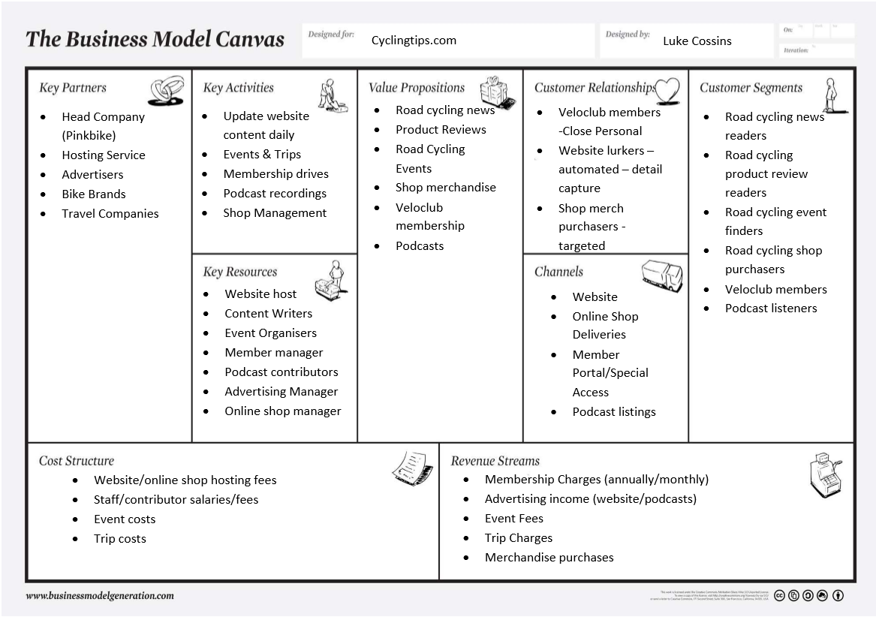
As can be seen above the revenue streams rely mainly on membership subscriptions and advertising but are supplemented by merchandise purchase and events/trips. These revenue streams have to account for cost structures which include website hosting fees, staff salaries as well as trip and event costs.
Customer segments include readers, event finders, members, shoppers as well as podcast listeners. Value propositions include news content, reviews, events, merchandise, membership subscriptions and podcasts. These value propositions are maintained through the customer relationships and channels identified above.
Value propositions are supported by key activities which include website content daily updates, events and trips, membership drives, podcast recordings as well as shop front management.

The key resources needed to do this as listed above. Key partners that relationships need to be maintained with include the parent company (pinkbike) whose resources are leveraged to be able to run the business in a leaner manner as well as the hosting service company, advertisers, bike brands and travel companies.

Porter’s Value Chain Analysis
The below Value Chain analysis takes a slightly different look at the internal environment at Cyclingtips.com (Porter 2004).
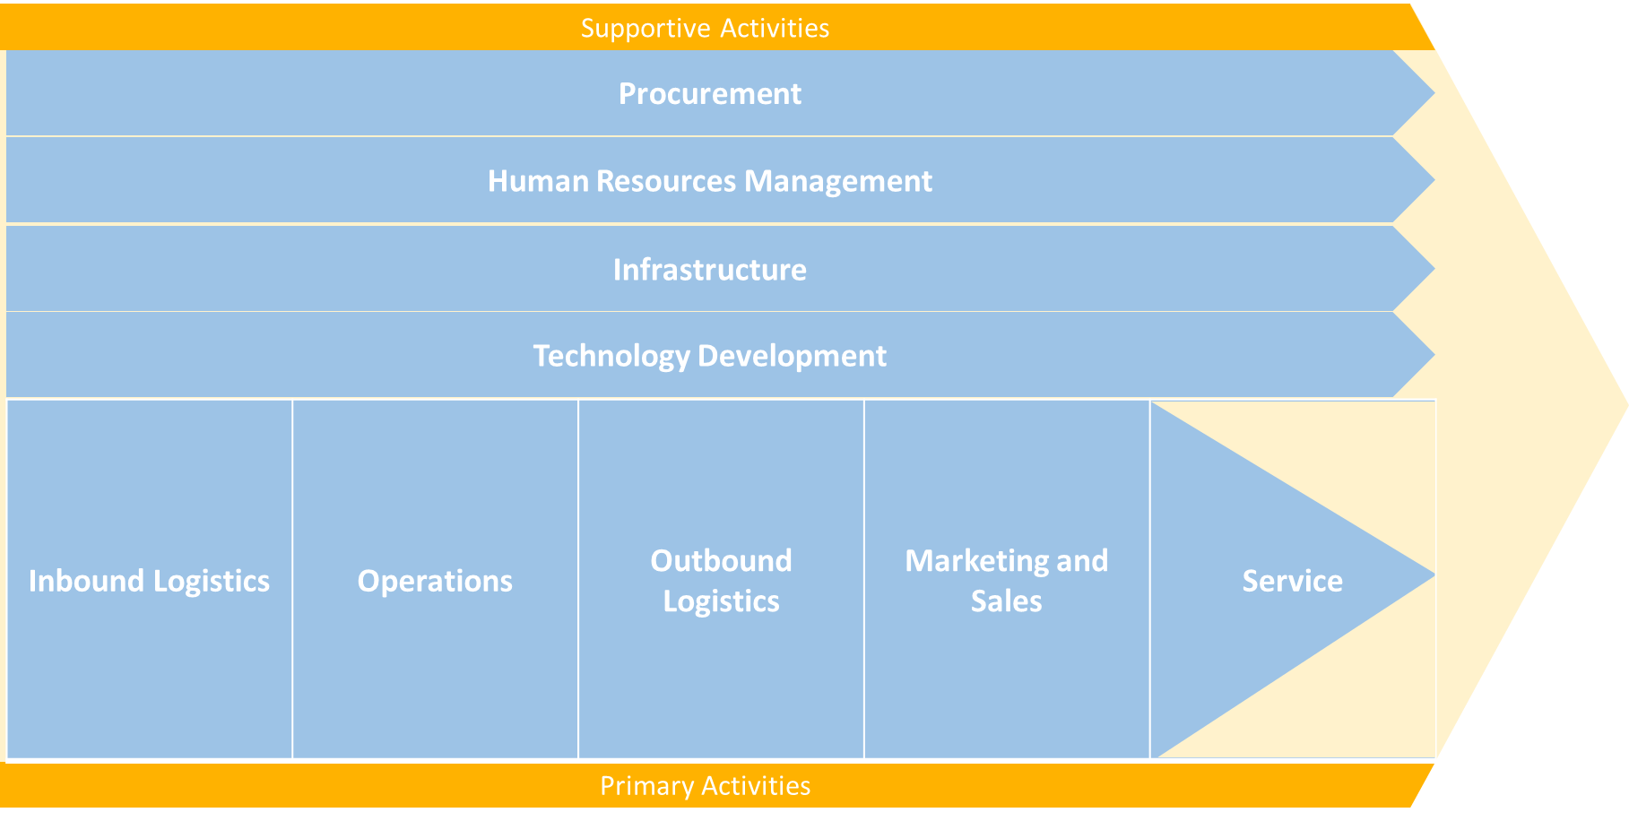
The below Porter’s Value Chain Analysis identifies the Primary and Supporting Activities of the business.
Primary Activities
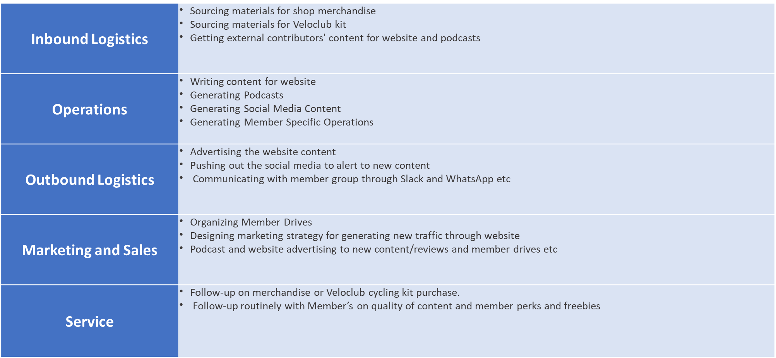
Supporting Activities
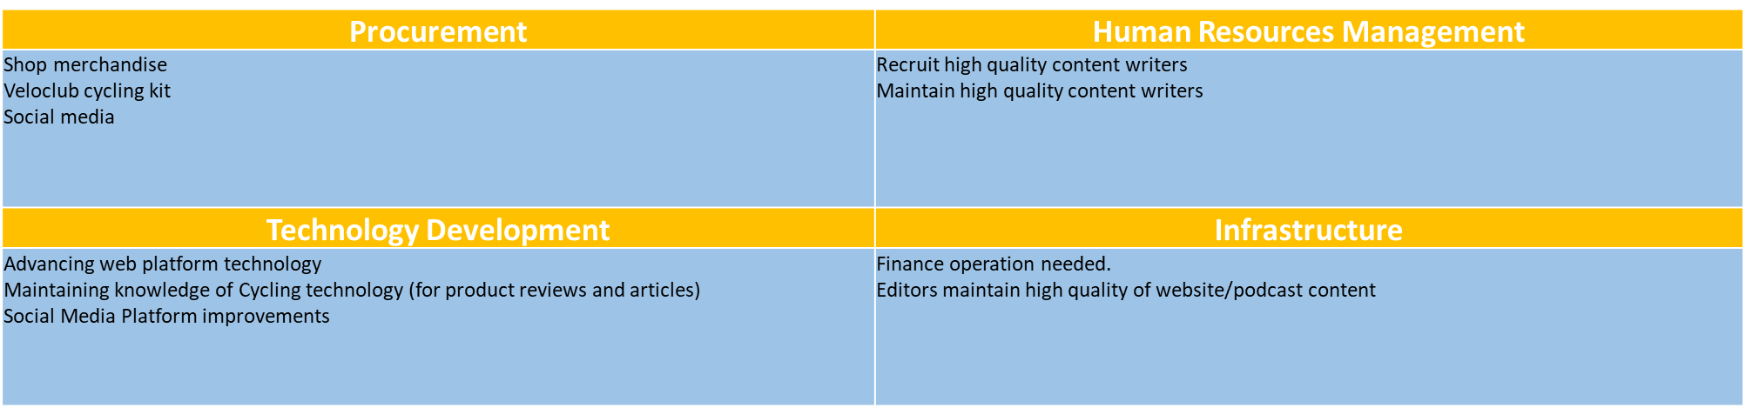
Value Chain Templates sourced from https://upboard.io/
With some if not all of the Supporting activities now being able to be leveraged with Pinkbike Parent company Cyclingtips can refocus efforts on consolidating Primary activities and re-invigorating revenue streams.

Competition
Cyclingtips.com although part of the cycling media industry is really in a niche market as it specializes in road cycling specifically. This limits the number of direct competitors.
Below is a summary of the competitor landscape within the industry:
- Direct competitors - Bikeradar.com, Road.cc, Cyclingnews.com, Cyclingweekly.com, Velonews.com – Each have a road cycling specific arm but are also spread across all aspects of the cycling media and are also diversified across multiple platforms including websites, podcasts, youtube etc.
- Competitor strengths and weaknesses – As all competitors are not just focusing on road cycling only they are diluting there high-quality content across the different disciplines. Furthermore none of the competitors are really focusing on connecting with subscribers personally.
- Status quo – Other competitors are focusing on advertising revenue as well as subscribers but not to the personal level the Cyclingtips.com Veloclub membership base does. The Marketplace has already been disrupted and it is now to see who can make it through this disrupted space to start to make profits in the longer term.
- Messaging – The personal touch the membership platform uses on Cyclingtips is quite unique. The editors and membership manager are quite active in speaking with the membership base through the social platforms of Slack and WhatsApp. This has positives for both subscriber and company. The subscriber feels like there voice is being heard whereas the company is getting valuable insight into the characteristics of subscribers but also gets direct feedback on what to include and not include in the content provided.
- Uniqueness - The personal relationship the platform maintains (through different staff members including editors, contributors, review writers, member managers, event organizers etc) and the interaction directly with the subscriber (membership) base

SWOT Analysis – veloclub membership
This section looks at the strengths and weaknesses on Cyclingtips.com’s Membership business model and below is a SWOT analysis of this aspect of the business.
- Internal Factors | - External Factors
- Strengths | - Threats
- Social media presence | - Competitor subscriber base cannibalising possible new membership subscriptions
- Website presence | - Economic factors limit willingness to sign up
- Weaknesses | - Opportunities
- Limited Subscriber base | - Cycling interest increasing due to “Green” factor
- Australian based limits global reach based on culture | - Global reach in English speaking world

Internal strengths including social media and website presence will need to counteract the limited subscriber base and geolocation of Australia causing cultural difference concerns.
External threats including competitor subscription services slowing membership take-up as well as other economic factors could be diluted by leveraging the increased interest in cycling from a environmental perspective as well as the global reach possible within the English speaking world (yet to be fully tapped).

Summary
Having looked at the 3 business environments (internal, micro and macro environments) in this report as well as the attached video it can be surmised that Cyclingtips has been digitally disrupted previously but is on a path to try to rectify some of the lost revenues streams with a focus on Member Subscriptions.
Member subscriptions should aim to support other revenue streams and shouldn’t be the only revenue stream to be focused on. Just like “The Guardian” newspaper, which is now realizing a profit for the first time in many years, Cyclingtips.com could indeed mimic this strategy to start to realize a more solid foundation of revenue and business growth (Benton 2019).
Now under the wing of pinkbike being able to leverage pinkbike resources and running a leaner and smarter business model should allow Cyclingtips to save costs on infrastructure resources which should help make the business further profitable.
Cyclingtips latest membership drive has resulted in more than 250 members to be realized which has allowed for a Women’s Specific Cycling Podcast to be given the go ahead. Future membership milestones will realize further increases in available content with the extra funds being able to deliver “On the ground” coverage for events and races.

References

Joshua Benton May 1 2019, Nieman Lab, “Want to see what one digital future for newspapers looks like? Look at The Guardian, which isn’t losing money anymore” Viewed November 10 2019, https://www.niemanlab.org/2019/05/want-to-see-what-one-digital-future-for-newspapers-looks-like-look-at-the-guardian-which-isnt-losing-money-anymore/
Cyclingtips Editor, 2019, “About Cyclingtips”, Viewed November 10 2019, https://www.cyclingtips.com/about
Lin Liu & Jin-Nan Wu Oct 2010, "Virtual value chain and competitive advantages in the context of e-commerce", IEEE, , pp. 1467.
Steve Maxwell, June 11 2019, Bicycle Retailer, “Analysis: Surviving the cycling media”, Viewed November 10 2019, https://www.bicycleretailer.com/opinion-analysis/2019/06/11/analysis-surviving-cycling-media-business#.XcdIXjMzZPZ
Motivations & travel behavior of cycling tourists: a youth market analysis. Motivações, comportamento de viagem e benefícios obtidos dos turistas de bicicleta: uma análise do Mercado jovem.
Osterwalder, A. 2010, Business model generation : a handbook for visionaries, game changers, and challengers, Hoboken, N.J. : John Wiley & Sons, Hoboken, N.J.
Owler.com Autogenerated, 2019, “Cyclingtips company profile”, Viewed November 10 2019, https://www.owler.com/company/cyclingtips1
Pinkbike Staff, 2019, Pinkbike.com, “Pinkbike Announces Acquisition of Road Cycling Site CyclingTips”, Viewed November 10 2019, https://www.pinkbike.com/news/pinkbike-announces-acquisition-of-road-cycling-site-cyclingtips.html
Porter, M.E. 2004, Competitive advantage : creating and sustaining superior performance, New ed. edn, New York : Free, New York.
Ramstad, G.O. 1997, "A Model for Structural Analysis of the Media Market", Journal of Media Economics, vol. 10, no. 3, pp. 45-51.
Schilling, M.A. 2016, Strategic management of technological innovation / Melissa A. Schilling, Fifth [revised] edition. edn, New York, NY : Mcgraw-Hill Education.
Sjøvaag, H. 2016, "Media diversity and the global superplayers: operationalising pluralism for a digital media market", Journal of Media Business Studies, vol. 13, no. 3, pp. 170-186.

Link to Part A of Assignment – Marketplace Analysis

https://youtu.be/5lWpuj337Bo

