Data Handling and Business Intelligence
LCBB5000
Student name: Vasile Miculas
Student ID: 2120834

Table of Contents
Part 1: GreenMed dataset analysis 3
Introduction 3
a) Evaluation of the following 4
1. Mean processing time using Hadoop 4
2. Median processing time when using Spark 4
3. Highest processing time of R 4
4. Standard deviation for processing time of Python 4
5. Lowest average processing time 5
6. Interpretation of different processing times across different tools and platforms 5
b) Using MS Excel 5
c) Using SPSS 9
1. Correlation between processing times of Hadoop and Tableau 9
2. Scatterplot graph 13
Conclusion 16
Part 2 17
a) Advantages and disadvantages of using SPSS, Excel or Tableau 17
b) Importance of Data Governance 19
References 21

Part 1: GreenMed dataset analysis

Introduction
Microsoft Excel and SPSS are used for statistical analysis in this study to help analyse and visualise processing time data from a wide range of big data processing platforms. Statistics such as the average Hadoop processing time, the median Spark processing time, the highest R processing time, and the standard deviation for Python are all calculated in Excel. Hadoop and Tableau processing times are connected in SPSS, and the findings are visualised as a scatterplot and reviewed in depth.

a) Evaluation of the following

1. Mean processing time using Hadoop
Calculating the average, often known as the arithmetic mean, in Excel is a breeze because of the program's built-in AVERAGE function.
To calculate the mean processing time using Hadoop in Excel, the below steps are followed –
From the given file of “GreenMed_Healthcare_2023”, Hadoop_ProcessingTime column was selected. In cell I3, the formula to calculate the mean, i.e., “=Average (B2:B51)”.
From the calculation, the result was 2.779. Therefore, the mean processing time using Hadoop is 2.77.

2. Median processing time when using Spark
The MEDIAN function in Microsoft Excel may be used to calculate the median value. For this given dataset of “GreenMed_Healthcare_2023”, the median of the processing time when using Spark can be calculated by entering the median formula in cell I4. The formula for the median is “=Median (C2:C51).
After entering this formula, the result for media processing time when using Spark is 2.74.

3. Highest processing time of R
The highest number in a range of data may be determined using the MAX function in Microsoft Excel. To determine the largest value inside a set of integers, one may use a mathematical operation referred to as the MAX function.
Therefore, in the given dataset of “GreenMed_Healthcare_2023”, the highest processing time for R can be calculated by the formula “=Max (D2:D51)”. The result of the calculation is 4.867.
It can be concluded that as the value 4.867 is in row number 17, the date of this processing time is 2023-01-16.

4. Standard deviation for processing time of Python
To find the standard deviation of the processing time of Python, the formula to be used is “=Stdev.” Therefore, when selecting the column of Python, the formula entered Is “=Stdev (E2:E51)”.
The result from this is 1.284. Thus, the standard deviation for the processing time of Python is 1.284.

5. Lowest average processing time
All the tools or platform’s averages need to be calculated to identify whose average processing time is the lowest among all the tools.
Average processing time of Hadoop - 2.777
Average processing time of Spark - 2.932
Average processing time of R - 2.755
Average processing time of Python - 2.573
Therefore, from the above averages of all the tools, Python has the lowest average processing time of 2.573.

6. Interpretation of different processing times across different tools and platforms
The efficiency of data processing in a tool or platform is significantly influenced by its architecture. The architecture of Hadoop’s framework is primarily focused on batch processing, whereas Spark's ability to do in-memory processing enables the execution of iterative calculations, hence enhancing overall efficiency. R and Python are considered interpreted languages, which means that their code is executed sequentially. This sequential processing characteristic makes them comparatively less efficient in terms of performance when compared to compiled languages such as Java or Scala. The magnitude and intricacy of the data being processed have a significant influence on the duration of the processing. Irrespective of the tool or platform used, the processing time required for larger datasets and more intricate algorithms will always increase. Hadoop, Spark, R, and Python exhibit variations in their typical processing durations, which are influenced by variables like their architectural design, data attributes, hardware resources, optimisation strategies, and unique application scenarios.

b) Using MS Excel
Data presentation using PIVOT table
The PivotTable functionality in Microsoft Excel is a robust tool that facilitates the aggregation and examination of data derived from a substantial dataset (Verma and Verma, 2023). This tool is especially advantageous for the purpose of data visualisation and generating informative reports.
The process of information headers is a vital component in facilitating the appropriate organisation of data. Ensuring appropriate representation and organisation of data necessitates that each column within a dataset corresponds to a distinct variable or category. Identify the range of cells that include all of the relevant information. To use the "PivotTable" feature in Microsoft Excel, go to the "Insert" group located on the Insert tab of the Excel ribbon.
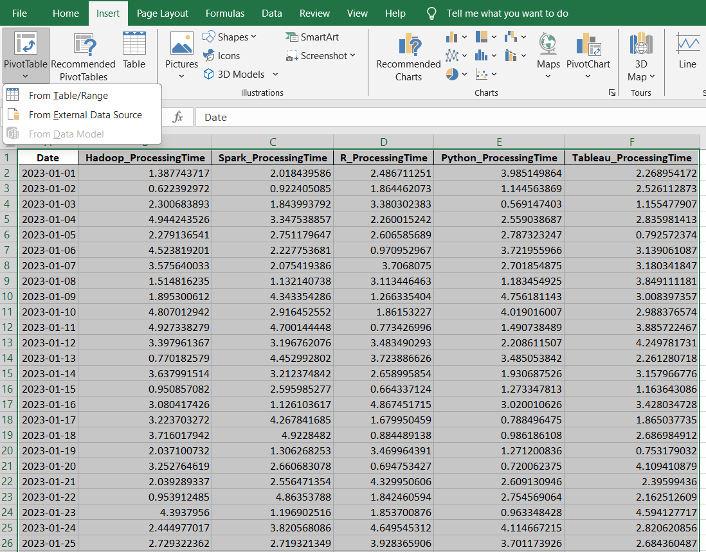
The user is provided with the opportunity to choose the desired location for the placement of the pivot table inside the Create PivotTable dialogue box. The pivot table can be managed either by creating a new worksheet specifically for it or by modifying an existing worksheet. Please choose an option from the "Choose the data to be analysed" dropdown menu that matches the data range provided.
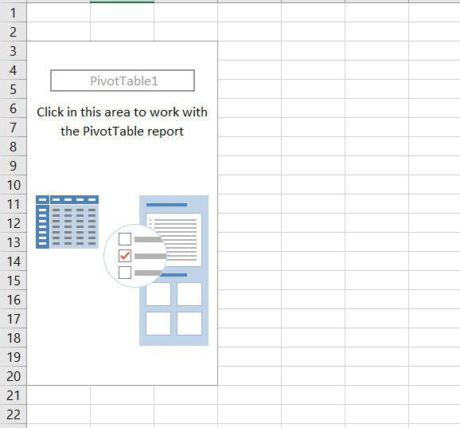
It's possible to rearrange the pivot table's cells in a way that improves its visual appeal. The process begins with the user selecting a cell inside the pivot table (Verma, 2013). Consequently, users may make use of the formatting options supplied in the Format Table group, which can be found on the Home tab of Microsoft Word's ribbon interface. Filters may be added to the pivot table to help refine the data. The user will use a feature known as drag and drop to accomplish this activity. This feature allows the user to move the fields they need for filtering to the Filters area of the PivotTable Fields pane.
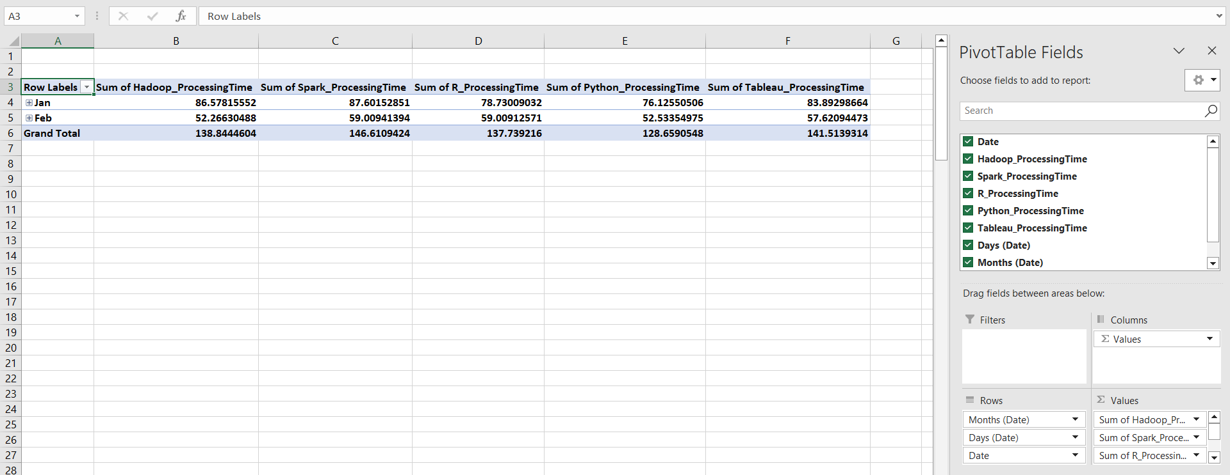
The information in a pivot table may be represented graphically with the help of pivot charts. The user must then choose a cell inside the pivot table to begin the procedure (Tolmie, Muijs and Mcateer, 2012). After that is done, the Insert tab of the ribbon interface should be navigated and the PivotChart group should be selected. One of these options will be marked "Insert Chart." Users may enter a chart when they choose this option. Once a pivot table has been constructed, it becomes viable to undertake a full analysis of the data with the purpose of distinguishing important trends, patterns, and insights. Using pivot charts to analyse the numbers included in a pivot table is one method of data analysis.
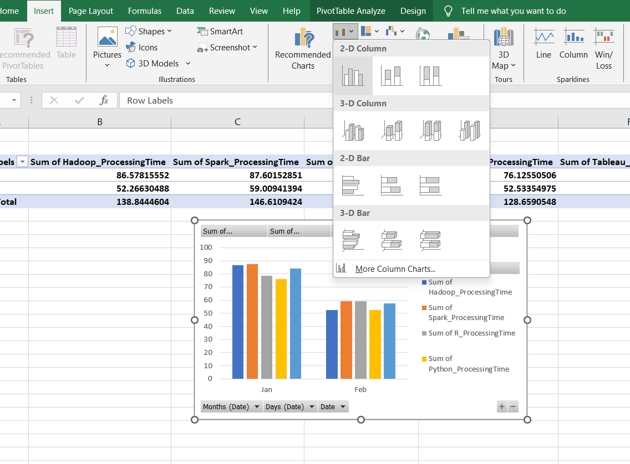
The process of optimising a chart within a pivot table to properly portray the data and effectively transmit the generated insights comprises numerous sequential operations (Slavio, 2019). Depending on the specifics of the gathered information, a suitable chart type may be selected for personalisation. Bar charts, line graphs, and pie charts are typical choices and are good jumping-off places for individualisation. To make the visual depiction more understandable, adjustments may be made to the chart's axes, labels, and legends, among other parts. An important part of making charts more useful is giving them descriptive titles and captions that explain their purpose and highlight key findings. Changes to the colour scheme and fonts may draw attention to key points or recurring themes. It is crucial to explore the numerous customisation choices accessible for data series, as they allow the capacity to exert an impact on the visual features of particular components within the chart (Shanthi R, 2019). Periodic review and, if necessary, revisions to the chart are required to ensure that it continues to conform to the analytical goals and effectively communicates the intended message to the intended audience. To build a pivot table chart that not only provides a clear visual portrayal of the data but also enhances the reader's ability to grasp it, it is necessary to carefully evaluate these choices.

c) Using SPSS

1. Correlation between processing times of Hadoop and Tableau
The SPSS statistical software includes a correlation analysis method for investigating the nature and extent of connections between variables. When it comes to deciphering the interconnections and patterns present in a dataset, this research is invaluable. Multiple correlation coefficients may be calculated using the correlation method in SPSS. Commonly used correlational metrics in scholarly work include the Pearson, Spearman, and Kendall coefficients (Seiner, 2014). The "Correlate" tool in SPSS allows users to pick and choose which variables to include in a correlation analysis. Analysing correlation coefficients and degrees of significance obtained from their data allows researchers to assess the reliability of observed correlations. When the value of a correlation coefficient is positive, it means that the variables in question are positively correlated with one another. A lower-than-expected correlation coefficient suggests less of a relationship between the two variables.
Conducting a correlation study in SPSS necessitates adhering to a certain sequence of procedures inside the programme. To begin the data analysis process, individuals are required to access their dataset inside the "Analyse" section of the SPSS software (Roni and Djajadikerta, 2021). The user initiates a study on the correlation between two variables by selecting "Correlate" followed by "Bivariate" from the available menu options. When confronted with a substantial number of variables, individuals have the choice to choose either the "Partial" or "Distance" alternatives, contingent upon the specific inquiries driving their study. For this analysis, a Bivariate variable is been selected.
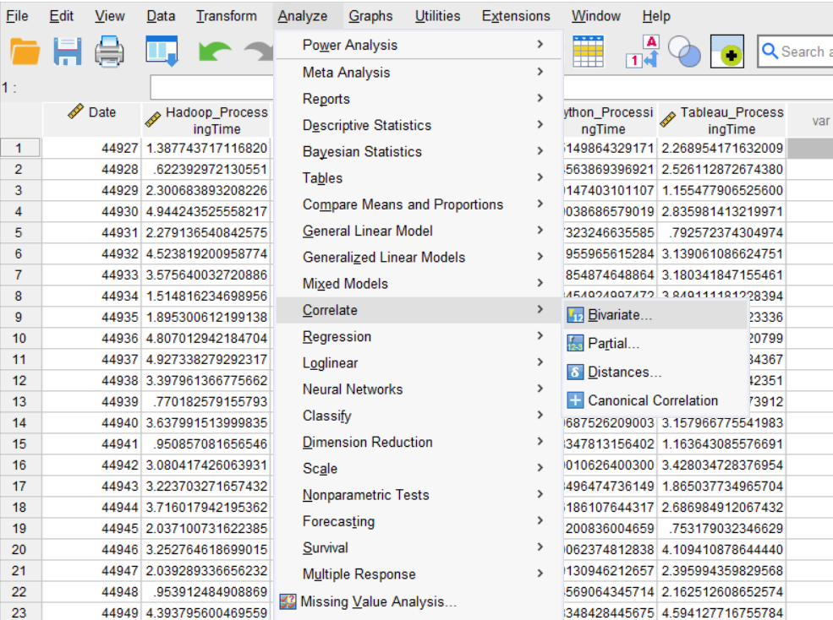
They are shown a dialogue box where one can pick which factors to use in the analysis. It is standard practice in academic writing to specify all relevant variables in the "Variables" section of the study. Researchers often utilise Pearson's correlation coefficient to evaluate the strength and direction of linear correlations between normally distributed data. If the essential parameters for parametric testing are not completed, alternative correlation measures such as Spearman's or Kendall's may be utilised. For this analysis, the Pearson correlation has been selected.
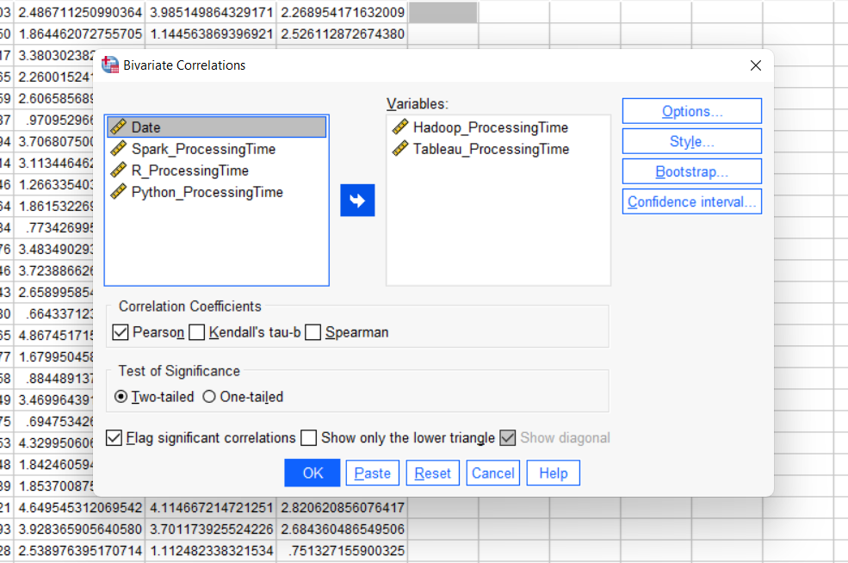
Result of correlation analysis
Descriptive Statistics
 | Mean | Std. Deviation | N
Hadoop_ProcessingTime | 2.776889207962486 | 1.213780264304696 | 50
Tableau_ProcessingTime | 2.830278627515118 | 1.133069151188237 | 50

Hadoop takes an average of 2.7768892 seconds to process data, whereas Tableau takes an average of 2.8302786 seconds. This means that, on average, Tableau is less capable of processing data than Hadoop (Roebuck, 2013). The standard deviation of Hadoop processing time is 1.2137803 seconds, whereas the standard deviation of Tableau processing time is 1.1330692 seconds. Hadoop processing times vary more than Tableau processing times, often taking longer to complete. Empirical research suggests that, on average, Tableau is somewhat slower than Hadoop (Nigam Manisha, 2020). The difference in processing time is, however, negligible. When compared to Tableau, Hadoop's processing speed flexibility is far greater.

Correlations
 |  | Hadoop_ProcessingTime | Tableau_ProcessingTime
Hadoop_ProcessingTime | Pearson Correlation | 1 | .178
Hadoop_ProcessingTime | Sig. (2-tailed) |  | .217
Hadoop_ProcessingTime | The sum of Squares and Cross-products | 72.190 | 11.984
Hadoop_ProcessingTime | Covariance | 1.473 | .245
Hadoop_ProcessingTime | N | 50 | 50
Tableau_ProcessingTime | Pearson Correlation | .178 | 1
Tableau_ProcessingTime | Sig. (2-tailed) | .217
Tableau_ProcessingTime | The sum of Squares and Cross-products | 11.984 | 62.908
Tableau_ProcessingTime | Covariance | .245 | 1.284
Tableau_ProcessingTime | N | 50 | 50

There is a 0.178 Pearson connection between the processing speeds of Hadoop and Tableau. There is probably a positive correlation between the two variables, as shown by the statistics. There is a correlation between how quickly Hadoop can process data and how quickly Tableau can process it.
Since the p-value for the r-value is 0.217, it is not possible to reject the null hypothesis at the 0.05 level of significance. This suggests that the statistical evidence for the presence of the observed link needs to be revised. The correlation between Hadoop and Tableau processing speeds is coincidental. The research showed a moderate but favourable association between Hadoop and Tableau throughput speeds.

2. Scatterplot graph
Creating a scatterplot in SPSS is an easy task, which serves as an effective means of visually comprehending the association between two variables (Mood and Morrow, 2017). The objective of this task is to generate a scatterplot that represents the relationship between the processing time in Hadoop on the horizontal axis and the processing time in Tableau on the vertical axis.
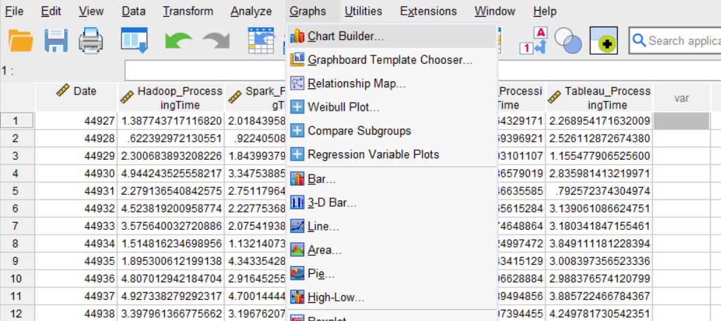
The scatterplot will show the duration of time spent on Hadoop and Tableau. This will enable the identification of trends and patterns within the data. Scatterplots are a valuable tool for identifying potential associations or interdependencies between two variables.
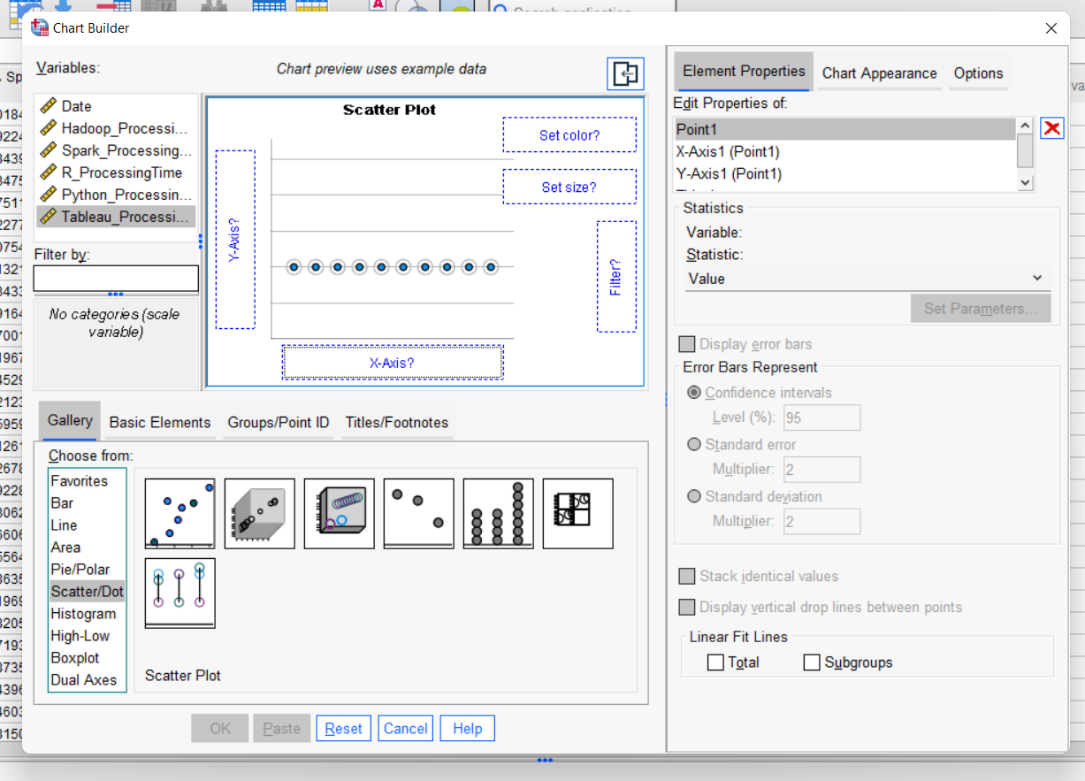

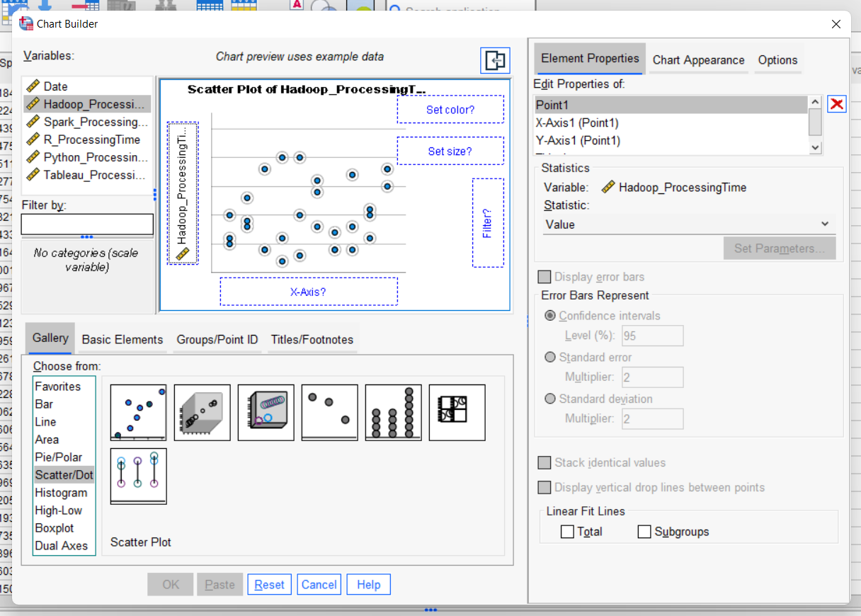

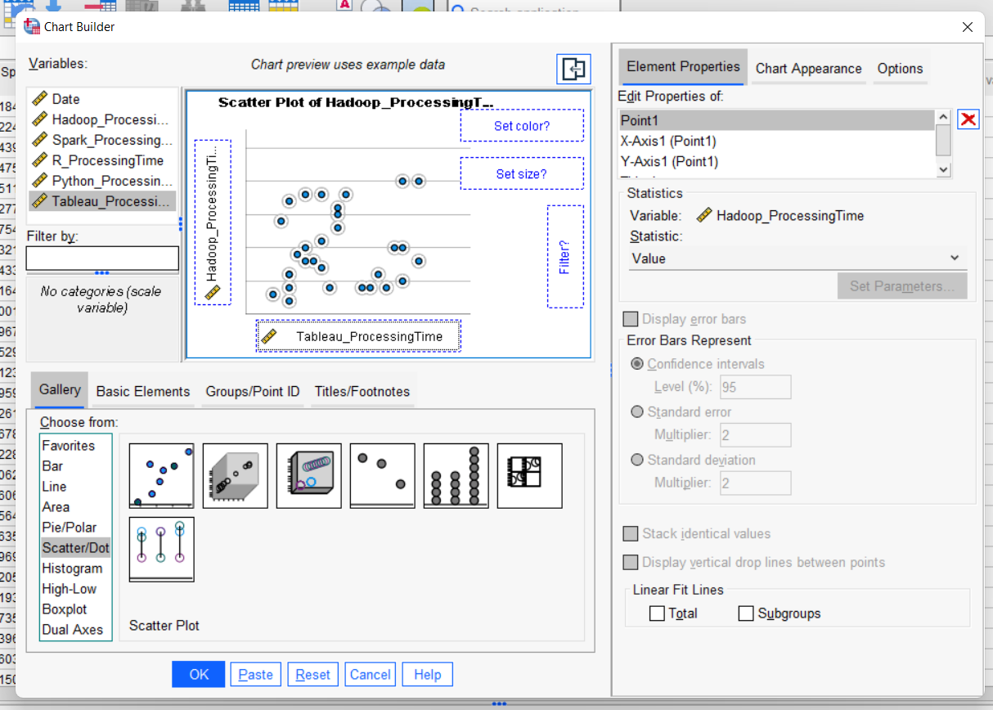
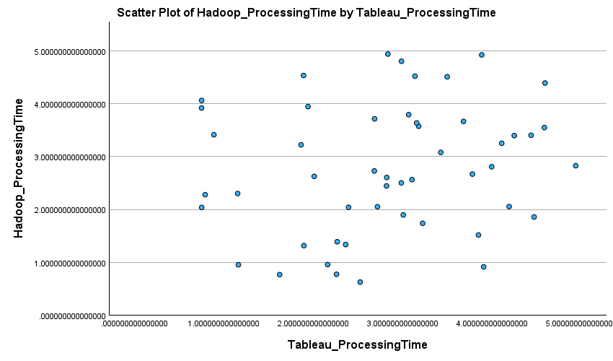

Conclusion
Data processing times for Excel and SPSS from a variety of sources are measured in great detail (Meyers, Gamst and Guarino, 2013). Hadoop takes an average of 2.779 seconds to process data, Spark 2.74 seconds on average, R 4.867 seconds on the high end, and Python 1.284 seconds on the low end, according to the statistics. Analysing processing times using programs like Excel and SPSS may provide insight into tools' efficiency and causal connections.

Part 2

a) Advantages and disadvantages of using SPSS, Excel or Tableau
Commonly used data analysis programs include the statistical package SPSS, the spreadsheet program Microsoft Excel, and the graphical program Tableau. The needs and requirements of the data analysis project dictate which tool is the most suitable.
Data analysis programmes | Advantages | Disadvantages
SPSS | SPSS's emphasis on statistics makes it an invaluable tool. Researchers and analysts working with complicated data sets may find the software's wide variety of statistical tests particularly useful. Regression analysis is a common tool in social science research because it allows researchers to see how different factors interact with one another (Madsen, 2019).  SPSS may not be as sophisticated as Tableau, but it does provide some basic data visualisation features. The ability to make one's charts and graphs to understand better data distributions is made available to users. | SPSS has a steeper learning curve than Excel. Users with proper orientation may find it easier to make sense of the user interface and carry out complex analyses (Meyers, Gamst and Guarino, 2013).  SPSS's data processing and cleansing capabilities are more limited than those of Excel's. Some Excel data cleaning may be required before being ready for import into SPSS.
Excel | Microsoft Excel is extensively used across several disciplines, and a significant majority of users possess a basic understanding of the program's essential functionalities. Excel is widely recognised as a reliable and user-friendly software application for performing fundamental data processing tasks (Lokesh Jasrai, 2020).  Excel has a profound understanding of data processing and purification. The spreadsheet is often used in tasks that need significant data preparation because of its capacity to effectively filter, organise, and manipulate data in a user-friendly manner. | While Excel does include some statistical capabilities, advanced users may find it necessary to seek other software, such as SPSS, to fulfil their more complex statistical analysis requirements. Sophisticated research endeavours may need the use of other resources, such as supplementary software applications or specialised statistical tools (Linoff, 2016).  In contrast to Tableau, Excel's data visualisation capabilities could be much better. The process of generating intricate charts and interactive dashboards may be laborious and anxiety-inducing, potentially yielding outcomes that fall short of desired aesthetic standards.
Tableau | Tableau is widely considered to be the best data visualisation software available. This technology is especially useful for creating interactive dashboards, which may provide a clear visual representation of otherwise difficult-to-comprehend data. Tableau may be used to create dynamic dashboards demonstrating data like sales trends in the field of business analytics.  Tableau's capacity to establish near-instantaneous links to several data repositories ensures that users always have access to the most current information. In fast-paced fields like financial analytics, where information is constantly shifting, this is an invaluable feature. | Commercial tools like Tableau, and especially the more feature-rich subscription levels, are costly. Those at the bottom of the economic ladder may find this to be an obstacle (Hinton and McMurray, 2017).  Although Tableau is easy on the eyes, mastering all of its features may need some time and effort. Users should read the documentation thoroughly to familiarise themselves with the program's capabilities.

b) Importance of Data Governance
The concept of "data governance" refers to the systematic management and regulation of data in order to guarantee its accessibility, usefulness, reliability, and protection (Heiny, 2018). Data governance is an essential component of a comprehensive organisational structure, as it assumes responsibility for overseeing the processes of data gathering, storage, and utilisation. Its primary objective is to guarantee the correctness, dependability, and adherence to legal and regulatory frameworks. Healthcare providers largely depend on the implementation of data governance practises to safeguard the privacy of patients' information and ensure its ethical use. This strategy contributes to the maintenance of patients' confidence and compliance with HIPAA laws.
Improved decision-making
The acquisition of knowledge and the capacity to make informed choices are significantly enhanced by the use of data, making it an indispensable asset (Cunningham and Aldrich, 2012). The primary objective of data governance is to maintain the integrity and accuracy of information, ensuring its completeness and currency at all times. By ensuring the presence of these attributes, enterprises may make informed choices grounded on reliable facts. The use of data governance to monitor and analyse consumer behaviour enables retail enterprises to make informed choices pertaining to marketing strategies, product innovation, and pricing strategies. This intervention serves to enhance client satisfaction and bolster sales performance.
Reduced risk
The implementation of effective data governance may help decrease the risks associated with data breaches, data loss, and non-compliance with legal frameworks (Cronk, 2017). Organisations may mitigate potential hazards and minimise cost implications by implementing comprehensive policies and practices for data management. Manufacturers use data governance practices to monitor manufacturing processes effectively, find potential areas for improvement, and maintain constant high-quality standards for their goods. This approach facilitates the maintenance of affordable costs, enhances production, and safeguards the integrity of the end product.
Increased efficiency
Through the optimisation of data management procedures and the removal of superfluous stages, data governance can enhance the effectiveness of data operations (Cronk, 2016). This has the potential to enhance production, reduce costs, and allocate resources to other essential initiatives. Government entities use data governance practices to effectively oversee the collection, retention, and distribution of confidential personal data. The objective of this initiative is to safeguard individuals' personal information and foster the ethical and conscientious use of data.
Improved data quality
To ensure the efficacy of data analytics and machine learning, the implementation of data governance is vital to maintain the veracity and precision of the used information. Through the use of standardised methods for data collecting, storage, and processing, organisations have the potential to enhance the quality and reliability of their information.
Enhanced collaboration
The implementation of data governance inside an organisation has the potential to foster cooperation across various departments and teams by cultivating a collective comprehension of data management and use (Berson and Dubov, 2012). This phenomenon can enhance interpersonal communication, improve the decision-making process, and increase overall productivity.

References
Berson, A. and Dubov, L. (2012). Master data management and data governance. New York: McGraw-Hill.
Cronk, B.C. (2016). How to Use IBM SPSS Statistics: a Step-By-Step Guide to Analysis and Interpretation. Los Angeles: Taylor and Francis.
Cronk, B.C. (2017). How to Use SPSS®. Routledge.
Cunningham, J.B. and Aldrich, J.O. (2012). Using SPSS: an interactive, hands-on approach. Thousand Oaks, Calif.: Sage.
Heiny, K. (2018). Standard Deviation. New York: Vintage Books, A Division Of Penguin Random House Llc.
Hinton, P.R. and McMurray, I. (2017). Presenting Your Data with SPSS Explained. Routledge.
Linoff, G. (2016). Data analysis using SQL and Excel. Indianapolis, In: John Wiley And Sons.
Lokesh Jasrai (2020). Data analysis using SPSS. Los Angeles: Sage.
Madsen, L. (2019). Disrupting Data Governance.
Meyers, L.S., Gamst, G.C. and Guarino, A.J. (2013). Performing data analysis using IBM SPSS. Hoboken, New Jersey: Wiley.
Mood, D.P. and Morrow, J.R. (2017). Introduction to Statistics in Human Performance. Taylor & Francis.
Nigam Manisha (2020). Advanced Analytics with Excel 2019. BPB Publications.
Roebuck, K. (2013). Data Governance: High-impact Strategies - What You Need to Know. Tebbo.
Roni, S.M. and Djajadikerta, H.G. (2021). Data Analysis with SPSS for Survey-based Research. Singapore: Springer Singapore.
Seiner, R. (2014). Non-Invasive Data Governance: The Path of Least Resistance and Greatest Success.
Shanthi R (2019). Multivariate Data Analysis. Mjp Publishers.
Slavio, J. (2019). Microsoft Excel.
Tolmie, A., Muijs, D. and Mcateer, E. (2012). Quantitative methods in educational and social research using SPSS. Maidenhead: Open University Press.
Verma, J.P. (2013). Data Analysis in Management with SPSS Software. New Delhi: Springer India.
Verma, J.P. and Verma, P. (2023). Understanding Structural Equation Modeling. Springer Nature.

