University of Wales
Trinity Saint David
School of Applied Computing

Title: Manage and maintain network resources and its services,
applying suitable policies, drafting security and redundancy practices.

Module: Network Operating Systems and Services
Code: ACCA 5023
Student: Martin Darzins
ID no.: 1909722
Programme: Applied Computing: Year 2 (Level 5)
Lecturer: Dr. Nitheesh Murugan Kaliyamurthy
Due Date: 29th April 2022

Abstract
This report and Worksheet 2 tasks 1, 2 & 3, demonstrates how to manage and maintain Network Resources and its Services, by applying suitable Policies, Security and Redundancy practices.
The report comprises of 2(two) parts, complete with screenshots and narrative, following the Practical and Observational Work required:

Part 1 – Practical Work
Employment of the Worksheet 2 task 1 will show how to manage and maintain Network Resources, creating local file/drive New Technology File System (NTFS) permissions and highlighting the differences between local based access and shared network access permissions.
The ability to effectively manage Network environment settings and security through Group Policy Objects and the Group Policy Management Console (GPMC).
Similarly, Worksheet 2 Task 2 will incorporate Routing and Remote Access Services, Address Resolution Protocol (ARP), Routing Tables & Protocols, and Firewalls through appropriate IP Packet Filtering to enhance security.

Part 2 – Observational Tasks / Work
By developing Worksheet 2 tasks 1 & 2 and incorporating specific Worksheet task 3 questions, to further understand the technologies involved in the various creation/installation processes, various observations are made resulting from the practical work deployed.

Acknowledgements
The author acknowledges the various lecture notes and tutorial details within the L5 Network Operating Systems & Services module ACCA 5023.

Table of Contents
1 Abstract ii
2 Acknowledgements iii
4 Introduction 1
4.1 Aims 1
4.2 Objectives 1
5 part 1 – practical work 2
5.1 Worksheet 2 Task 1 – Network Resources, Policy and Security Practices 2
5.1.1 New Technology File System (NTFS) 2
5.1.2 Share Permissions 11
5.1.3 Accessing File Share/Server 16
5.1.4 Group Policy Management Console (GMPC) 18
5.1.5 Policies 18
5.1.6 Configuring User & Computer Environment 18
5.2 Worksheet 2 Task 2 – Routing & Packet Filtering 33
5.2.1 ARP and Routing Tables 33
5.2.2 Deploy (FTP Server) Core Services 34
5.2.3 Installing and configuring the Routing & Remote Access Service 42
5.2.4 IP Packet Filtering 47
6 part 2 – observational tasks / work 51
6.1 Worksheet 2 Task 3 – Observations Tasks 51
6.1.1 Password Principles 51
6.1.2 Failover Clustering 52
6.1.3 Network Policy 56
7 References 61
8 Report Planning Methodology 62

Figure 1 - As Administrator in Client 1 2
Figure 2 - Create Share_Files_NOSS folder 2
Figure 3 - Create Important_File 3
Figure 4 - Original permission setting – FAIL 3
Figure 5 - Original settings 3
Figure 6 - Remove inherited permissions 4
Figure 7 - Inheritance Disabled 4
Figure 8 - Add permissions 5
Figure 9 - Full control access granted 6
Figure 10 - New User (Al Thetime) 6
Figure 11 - Restricted permissions 7
Figure 12 - Checking permissions 7
Figure 13 - Original text document details 8
Figure 14 - Text document changes successful 8
Figure 15 - Al Thetime attempt at changing text document 9
Figure 16 - New user changes FAIL 9
Figure 17 - New user attempt at text file deletion FAIL 10
Figure 18 - Server Manager : SMB quick by Volume option 11
Figure 19 - Share_Files_NOSS$ 12
Figure 20 - Configure share settings 12
Figure 21 - Disable inheritance 13
Figure 22 - Add full control for Administrator 13
Figure 23 - Add full control Martin A. Darzins 14
Figure 24 - Read & Execute access only (Al Thetime) 14
Figure 25 - Share permission for Administrators & Other Users 15
Figure 26 - Path files 15
Figure 27 - Share files successfully completed 15
Figure 28 - Access Map Network Drive 16
Figure 29 - Full share drive name 16
Figure 30 - Access verified 17
Figure 31 - Create OU (Non-Admin Users) 18
Figure 32 - Create new User in OU (Mod Erating) 19
Figure 33 - Create Group Policy Object (NoCtrlPanAccess) 20
Figure 34 – Configure & Enable NoCtrlPanAccess 21
Figure 35 - Apply gpupdate /force 22
Figure 36 - No control panel access for User (Mod Erating) 22
Figure 37 - Access available to Other User (Al Thetime) 23
Figure 38 - No Command Prompt Access (NoCmdPrmptAccess) 23
Figure 39 - Force update (NoCmdPrmptAccess) 24
Figure 40 - No access to Command Prompt 24
Figure 41 - Restrict Media Drive Access (No RemDriveAccess) 25
Figure 42 - Client 1 NAT configured for internet 26
Figure 43 - Client 1 internet connection confirmed (BBC website) 26
Figure 44 - New computer object (NWClientComputers) 27
Figure 45 - Create NounauthSoftInstallS 28
Figure 46 - Computer Policy updates enforced 29
Figure 47 - Software install FAIL 29
Figure 48 - Password Settings Changed 30
Figure 49 - New User (Dirty Harry) with poor password FAIL 31
Figure 50 - Dirty Harry Password amended 31
Figure 51 - Successful login to Client 1 mc (Dirty Harry) 33
Figure 52 – image courtesy of educba.com [3] 33
Figure 53 - Server 1 ARP -A at command prompt 33
Figure 54 - Server 1 route print 34
Figure 55 - Server 2/Client 2 pings successful 34
Figure 56 - FTP (IIS) successfully installed 35
Figure 57 - ftpuser22 created 36
Figure 58 - Assign ftpuser22 to MADFTPSITE 37
Figure 59 - FTP Banner 38
Figure 60 - ftpuser 22 confirmed 39
Figure 61 - ftpuser22 permissions 39
Figure 62 - Server & Client 2 Firewall OFF 40
Figure 63 - Client 2 ftp folder & text file 40
Figure 64 - Copy text file from Client 2 to Server 2 41
Figure 65 - Server 2 text file confirmation 41
Figure 66 - Install DirectAccess and VPN 42
Figure 67 - Configure LAN routing 43
Figure 68 - Server 1 RIP v2 installed 44
Figure 69 - Server 2 LAN routing & RIP v2 Installation 45
Figure 70 - Client 1 & 2 Default gateways 46
Figure 71 - Verify PublicNet (ping) Server 1 to 2 46
Figure 72 - Filter 1 : Stop ping from PrivateNet1 to Router Firewall 47
Figure 73 - Client 1 ping to Router Firewall Timed Out (Denied) 48
Figure 74 – Filter 2 : Restrict access to FTP server 49
Figure 75 - FTP Restriction SUCCESSFUL 49
Figure 76 - Specific Host access to FTP (Own Rules) 50
Figure 77 - Risk Levels [10] 57

Introduction

Aims
This practical Worksheet 2 and report aim to show an understanding of Network Resources management, Policies, Routing & Packet Filtering Services, Security practices and critical Failover/Redundancy practices..

Objectives
Through practical implementation of Worksheet 2 tasks 1 & 2, utilising Type 2 Hypervisor management software, Server based Network OS intrinsic services and Client based Network OS, via;
- Network and Security practices, undertake Network Resource management and maintenance,
- Packet Filtering, Routing, Failover and Redundancy practices, enhance Network Security.
Observational Work (via Worksheet 2 task 3) will evidence knowledge of the above practical work conducted, with key element explanations of; Password principles, Failover Clustering concepts, and a potential Network Policy for critical business applications

part 1 – practical work

Worksheet 2 Task 1 – Network Resources, Policy and Security Practices
Creating a local drive/file and folder permissions for a network deployed access controls and manage policies via Group Policy Objects.

New Technology File System (NTFS)
- NTFS permissions used to manage access to files/folders stored in NFTS file systems.
- Text file in folder is created to demonstrate how NTFS permissions are applied.
- As Administrator (Martin A. Darzins), in Client 1, create new folder = Share_Files_NOSS
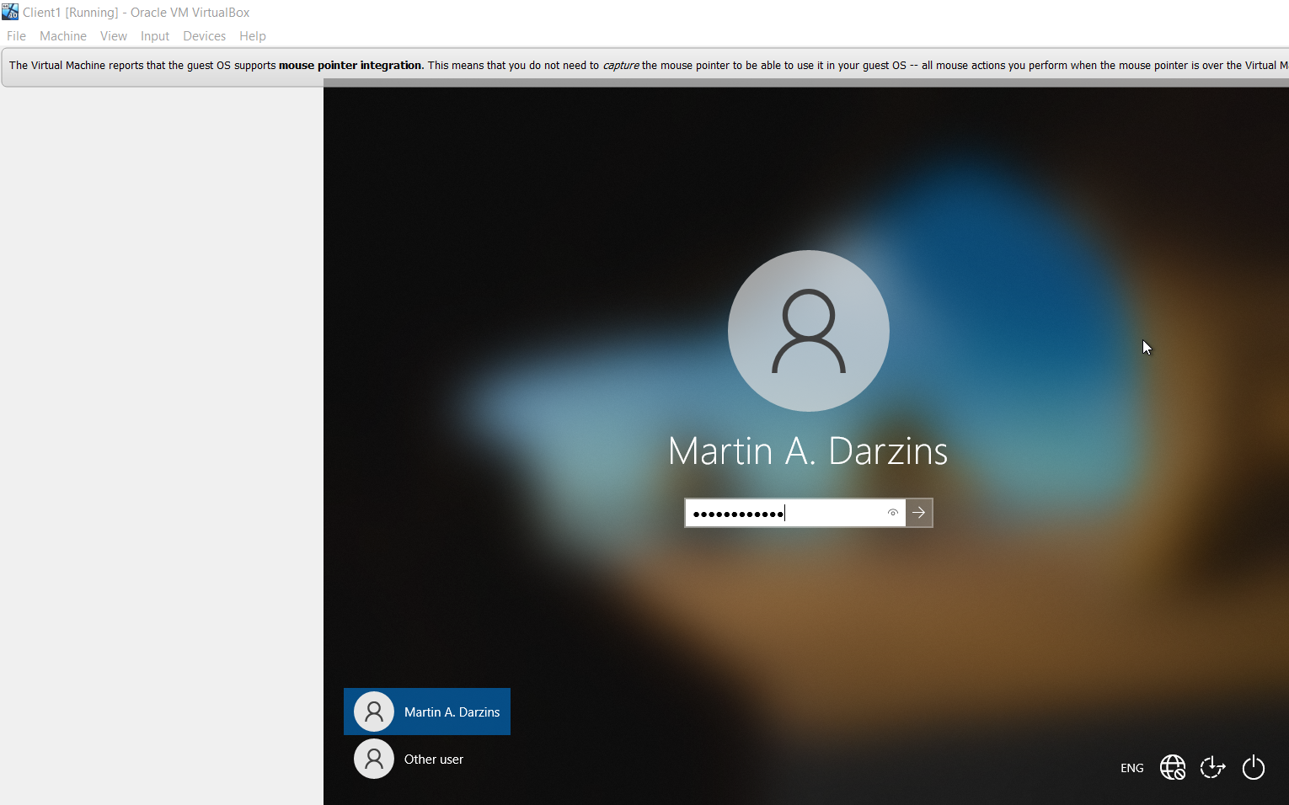
Figure 1 - As Administrator in Client 1
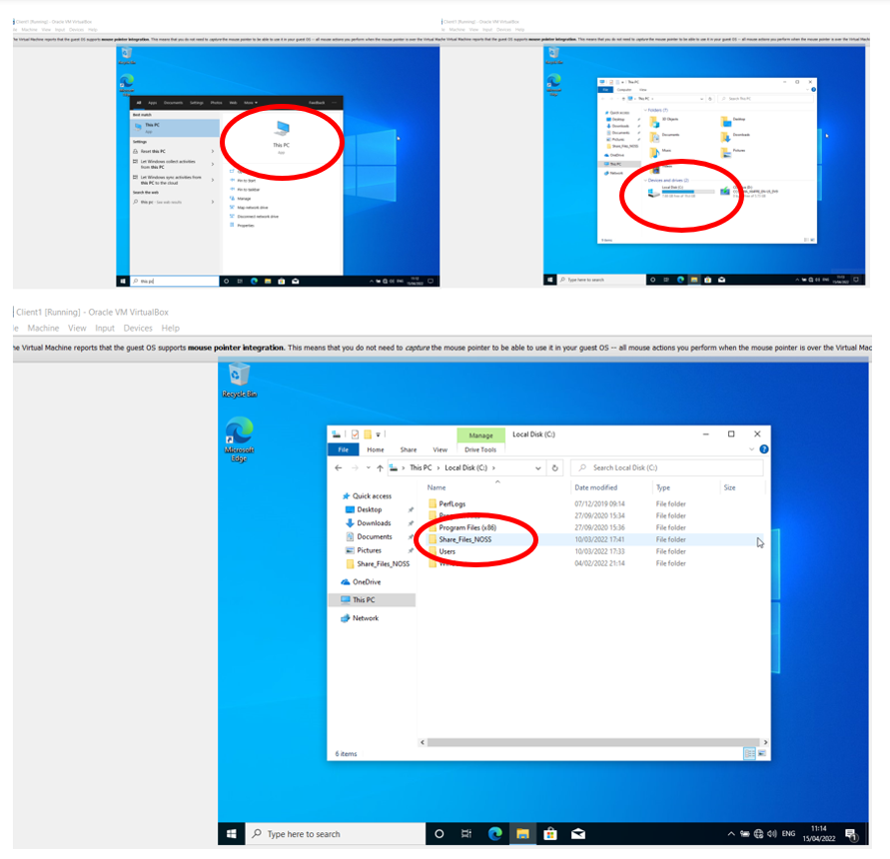
Figure 2 - Create Share_Files_NOSS folder
- Create new text document = Important_File, within folder Share_Files_NOSS
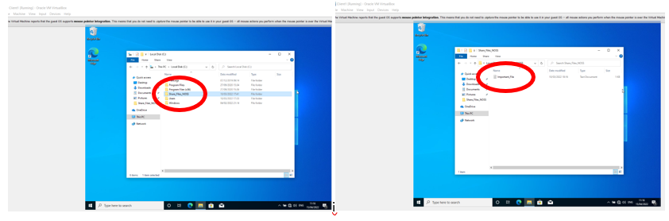
Figure 3 - Create Important_File
- Set local permissions in folder Share_Files_NOSS
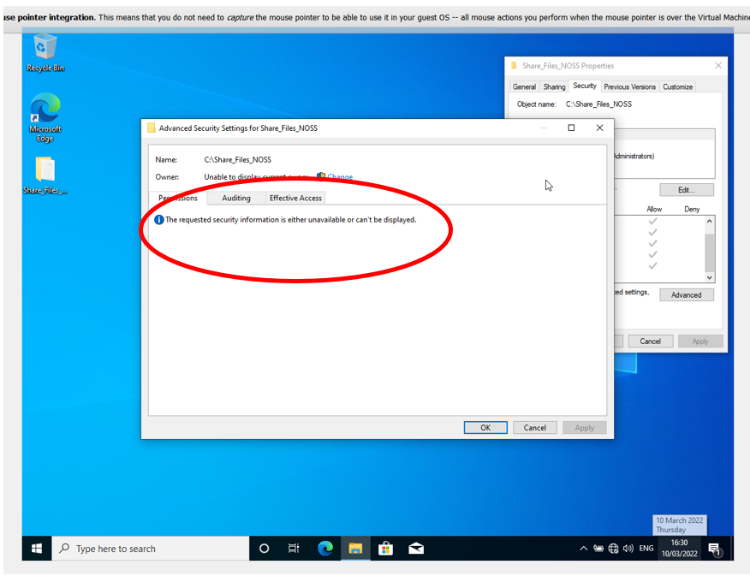
Figure 4 - Original permission setting – FAIL
- Original setting FAILS due to inherited file systems which require deletion via Advanced Security.
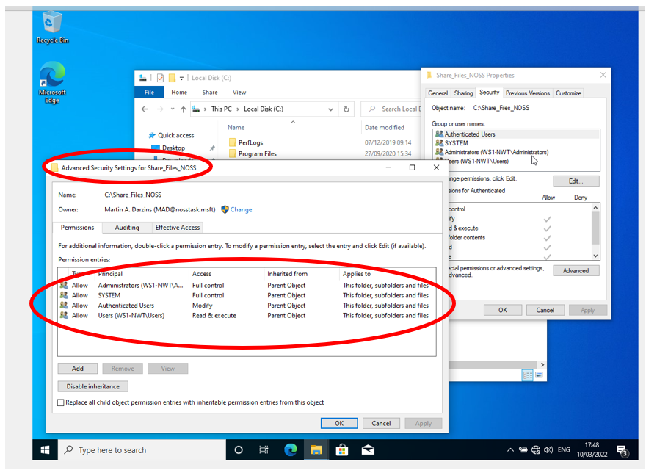
Figure 5 - Original settings
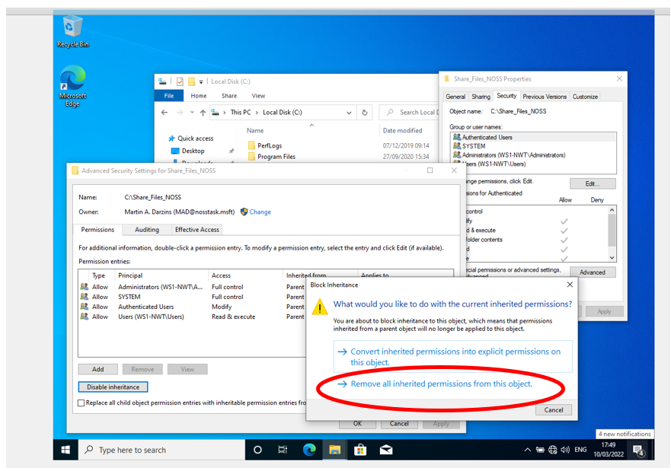
Figure 6 - Remove inherited permissions
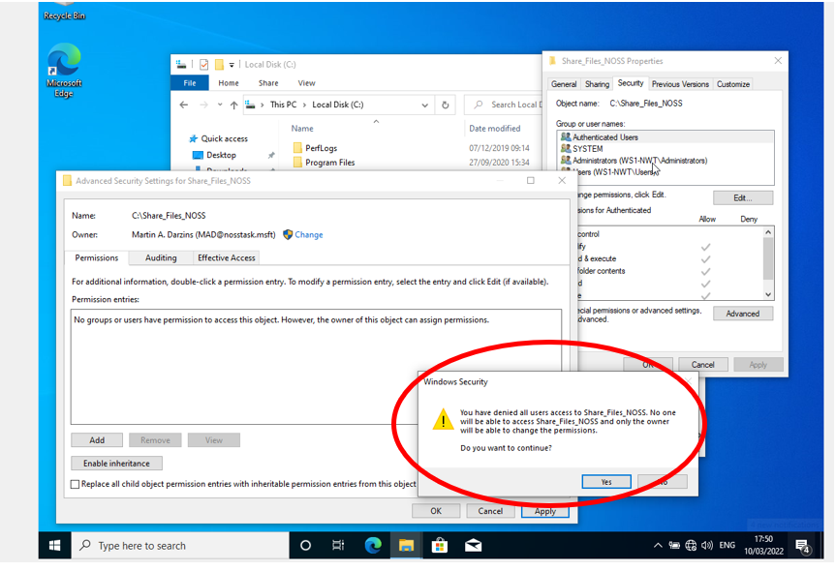
Figure 7 - Inheritance Disabled
- Now able to add required permissions to the folder.
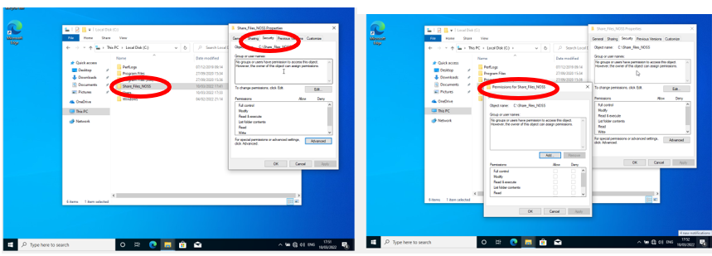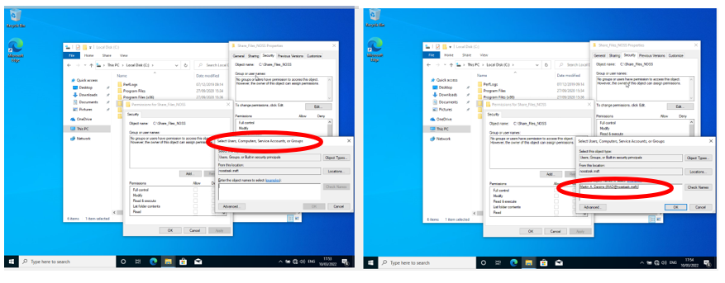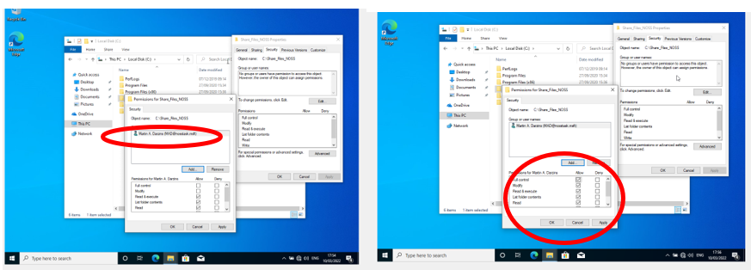
Figure 8 - Add permissions

- Full control options issued to Martin A. Darzins
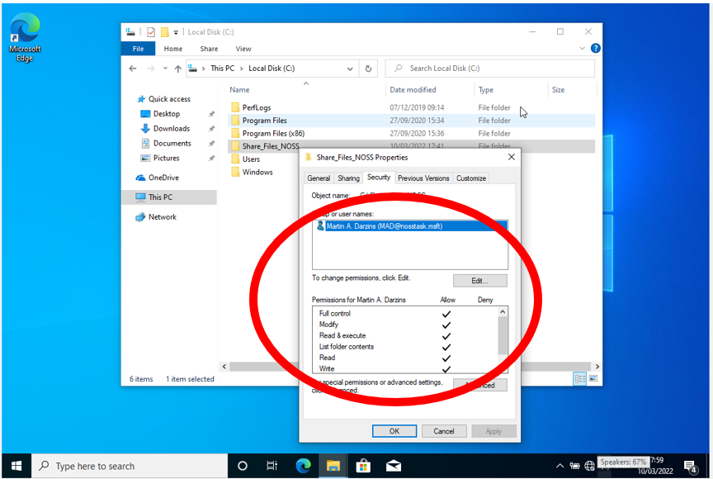
Figure 9 - Full control access granted
- Add another User ( Al Thetime )

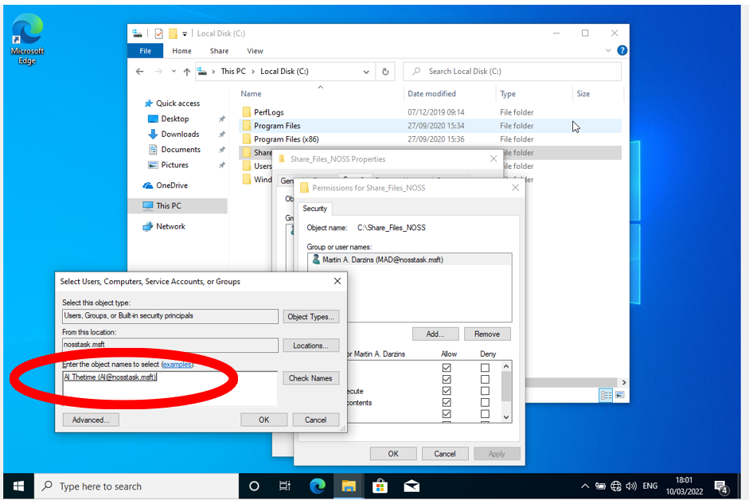
Figure 10 - New User (Al Thetime)
- Restrict permissions for new user (Al Thetime) to folder and Read only.
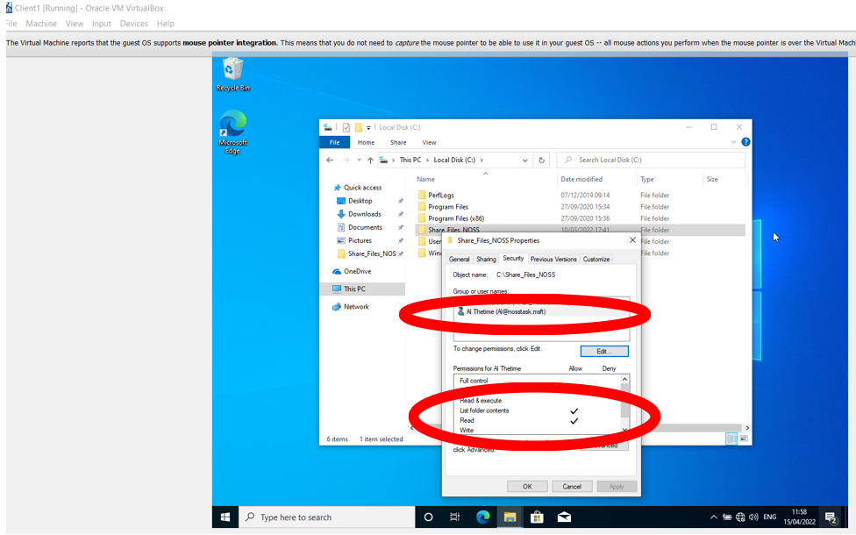
Figure 11 - Restricted permissions
- As Administrator, check who has what permissions
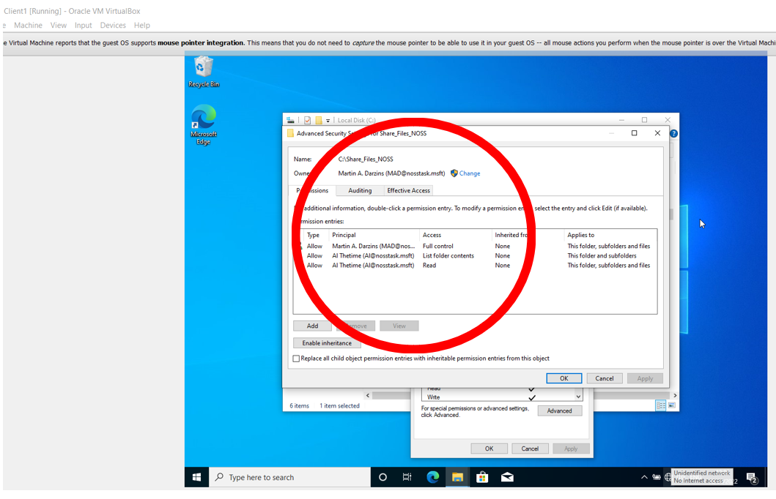
Figure 12 - Checking permissions
- Check who can modify text file (Important_File)
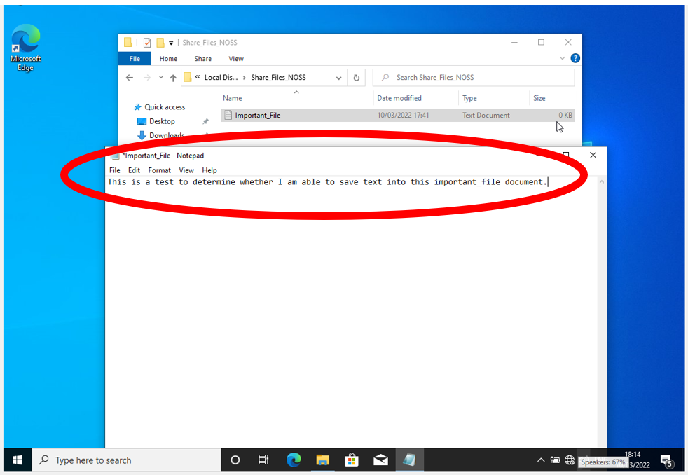
Figure 13 - Original text document details
- As Martin A. Darzins add and save to original text.
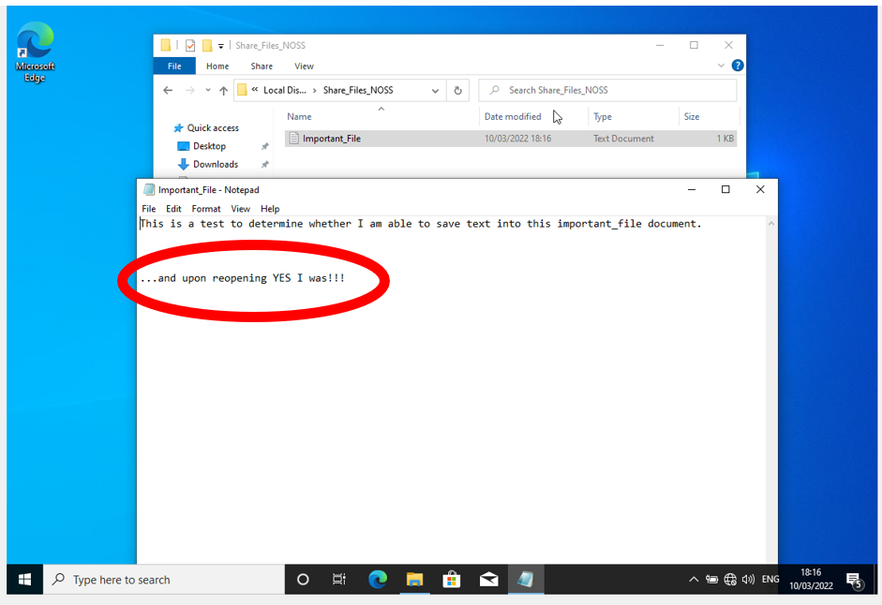
Figure 14 - Text document changes successful
- As new user (Al Thetime) amends text document.
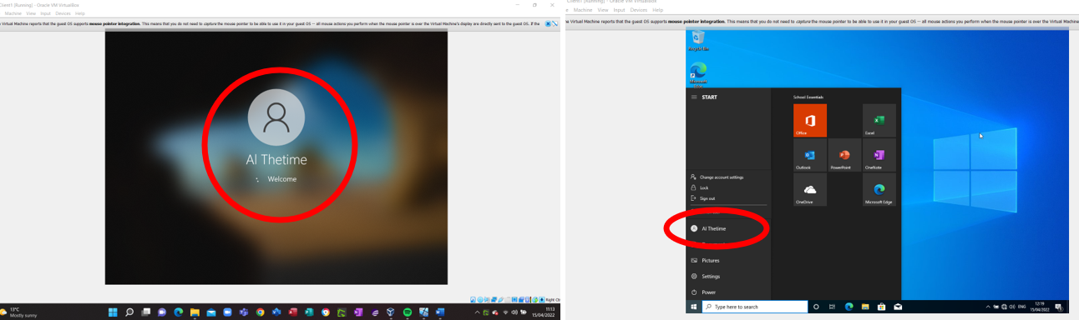
Figure 15 - Al Thetime attempt at changing text document

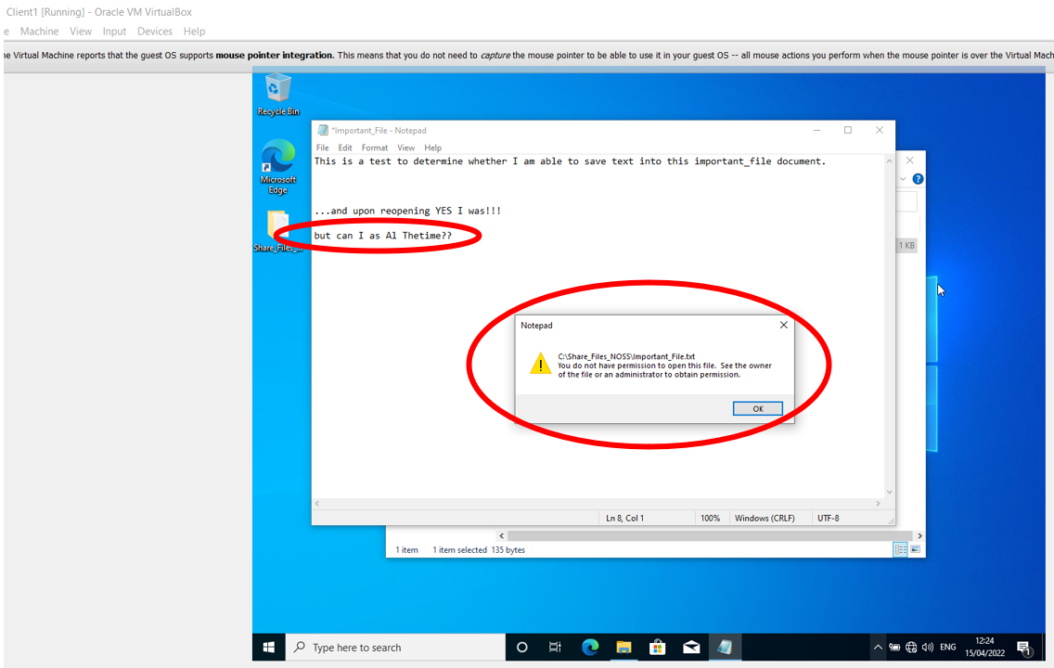
Figure 16 - New user changes FAIL
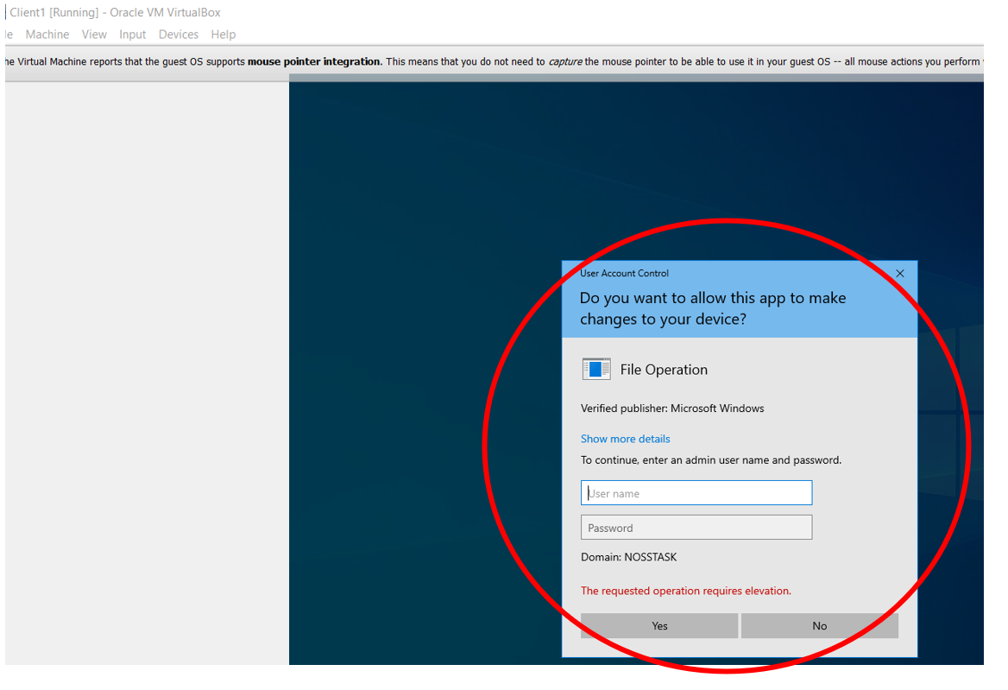
Figure 17 - New user attempt at text file deletion FAIL
- Insufficient permissions allocated to Al Thetime, who cannot change, save or delete the text file details, only read.

Share Permissions
Enables control over who accesses folders over the network but will not apply to Users who access locally.
Whilst both share and NTFS permissions do the same thing restricting access, Share permissions are easier to apply and manage, with NTFS giving ae more granular control of a shared folder and its contents. Share permissions can be used when sharing folder/file systems, but NTFS cannot [1].
NTFS permissions apply to users who are logged on to the server locally, whereas share permissions do not, but share permissions allow you to restrict the number of concurrent connections to a shared folder and NTFS does not. Share permissions are configured in the “Advanced Sharing” properties in the “Permissions” settings. NTFS permissions are configured on the Security tab in the file or folder properties.
Should there be conflict between these permissions, then the most restrictive will apply.
To add the Administrators (Administrator & Martin A. Darzins) with full control and two members of the nosstask.msft domain, (Al Thetime & Tim E. Limited) with just read and execute access;
- As Administrator on Server 1 using Server Manager facility create file Share_Files_NOSS$
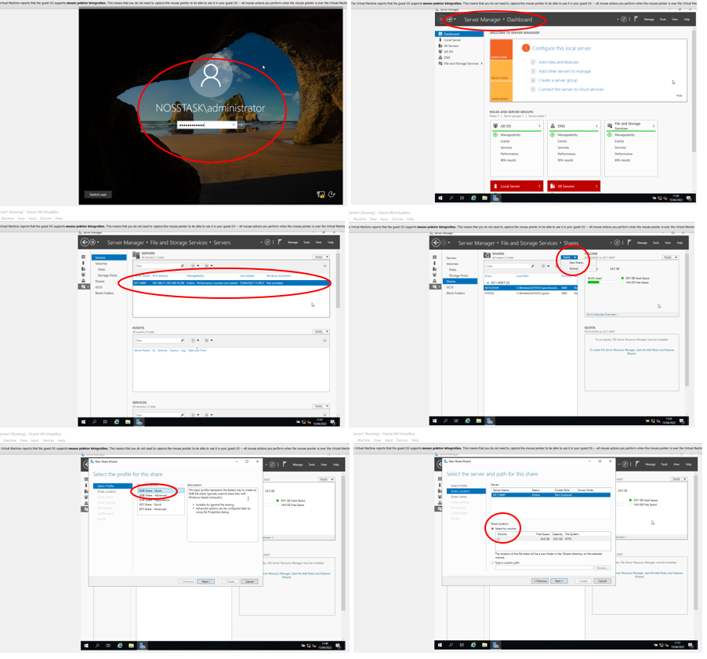
Figure 18 - Server Manager : SMB quick by Volume option
- Create Share_Files_NOSS$ share name, noting file path names when mapping to network
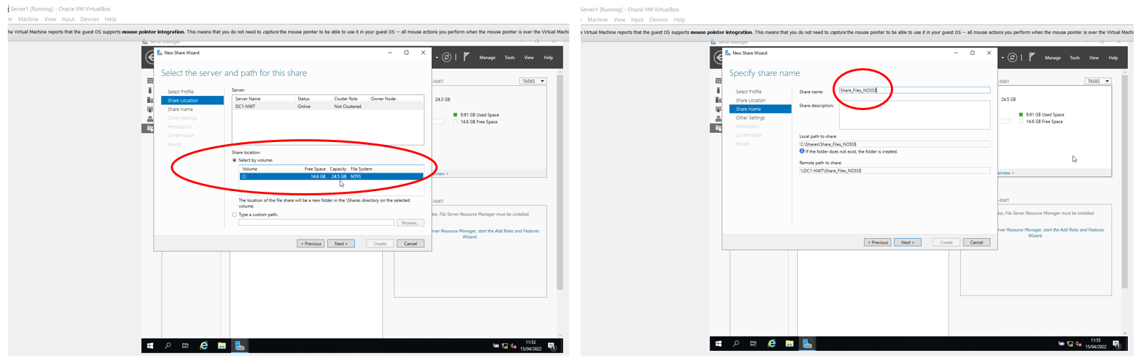
Figure 19 - Share_Files_NOSS$
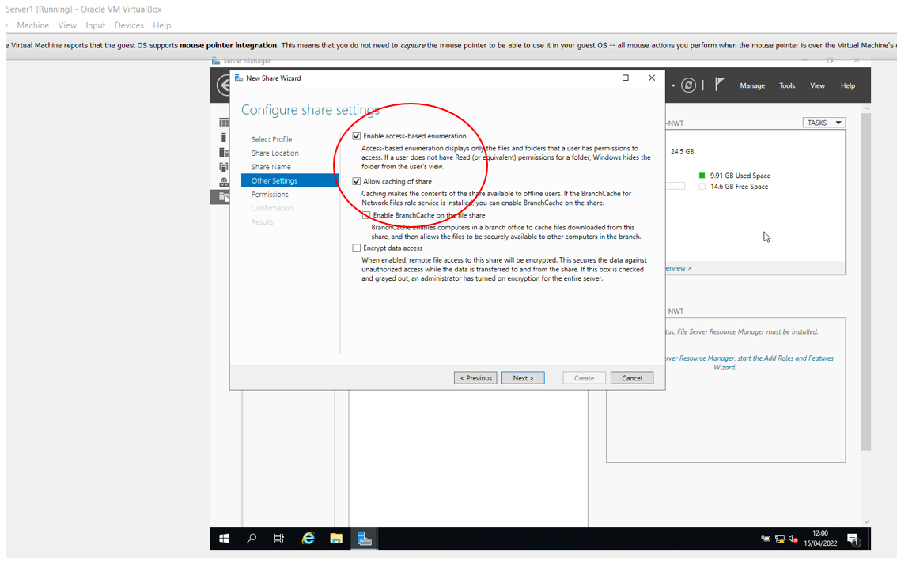
Figure 20 - Configure share settings
- Before specifying specific permissions, ensure inheritance is disabled.
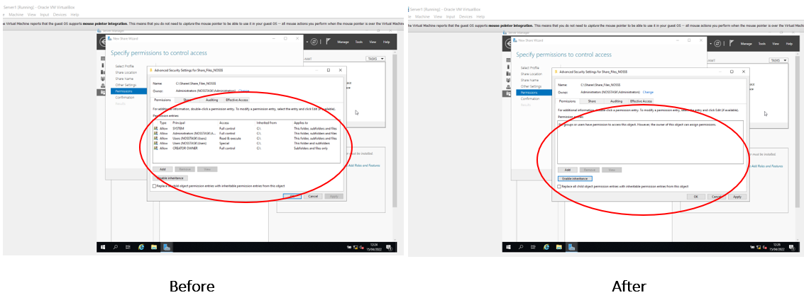
Figure 21 - Disable inheritance
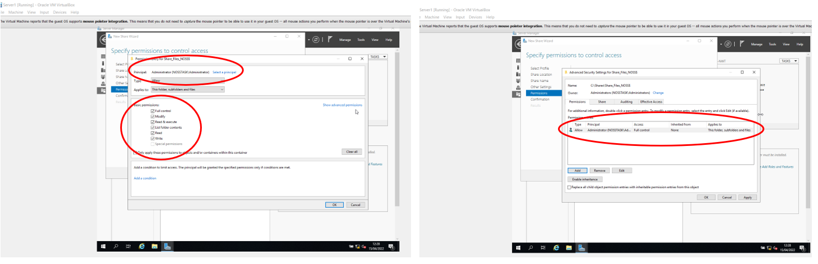
Figure 22 - Add full control for Administrator
- Repeat process for back-up administrator (Martin A. Darzins)
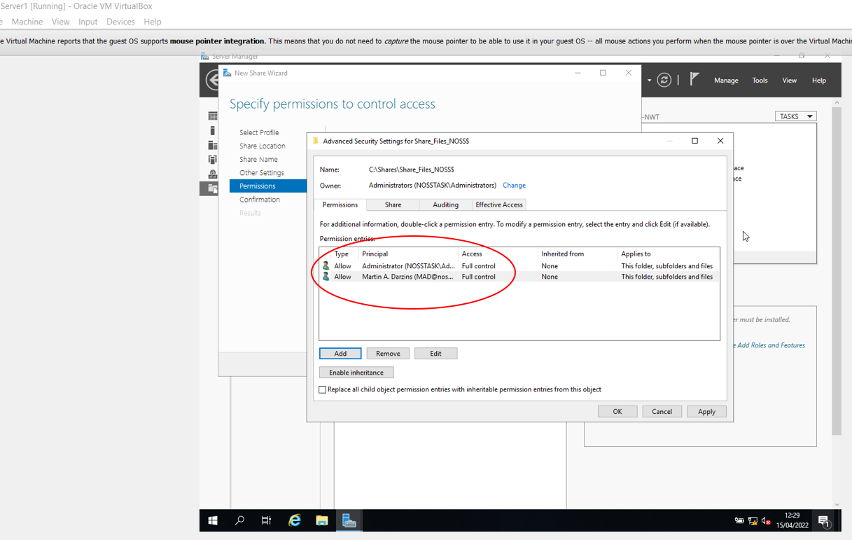
Figure 23 - Add full control Martin A. Darzins
- Add 2 Users with Read and Execute access only.
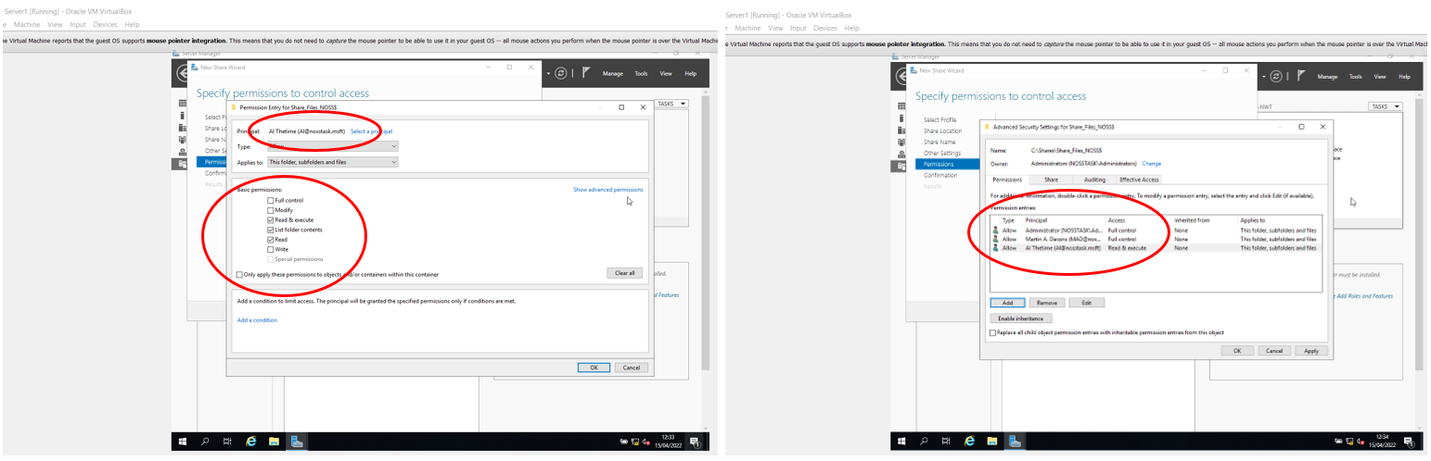
Figure 24 - Read & Execute access only (Al Thetime)
- Repeat process for 2nd User (Tim E. Limited)
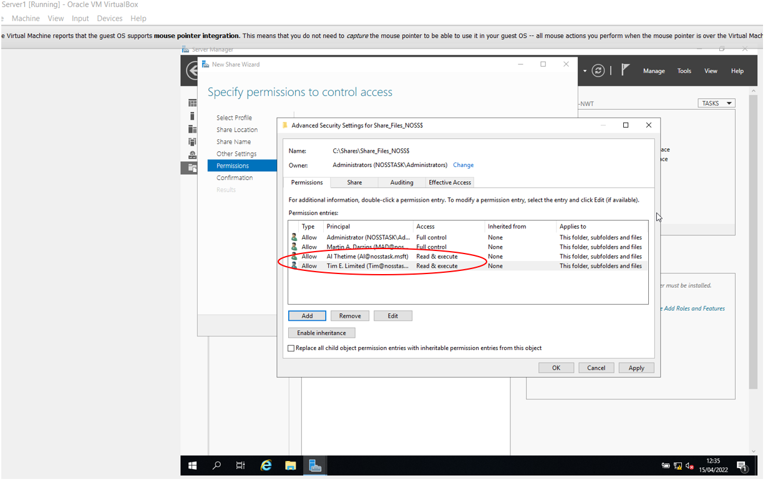
Figure 25 - Share permission for Administrators & Other Users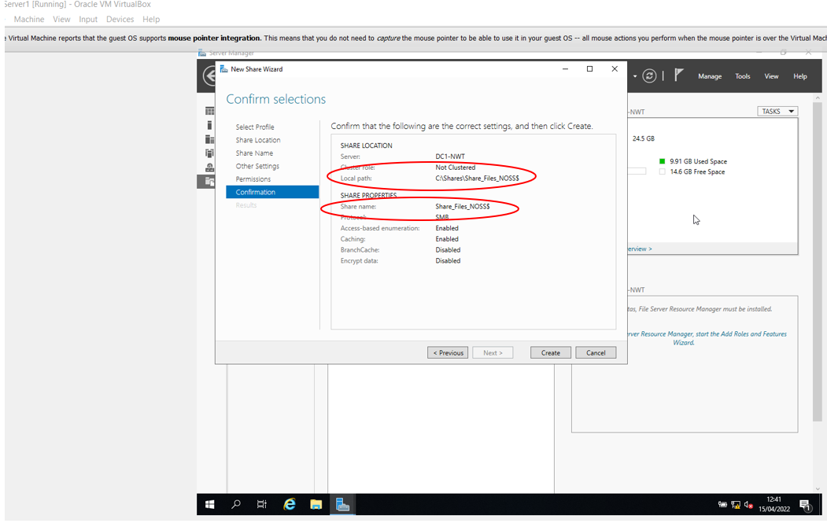
Figure 26 - Path files
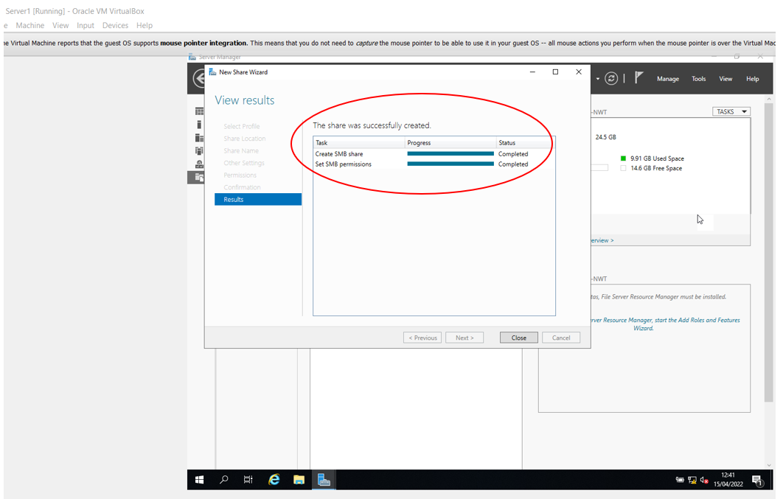
Figure 27 - Share files successfully completed

Accessing File Share/Server
Due to utilising the $ share option in the share name, access is via File explorer and paths, known as Mapped Drive.
- Via Client 1, User Al Thetime, access Map Network Drive
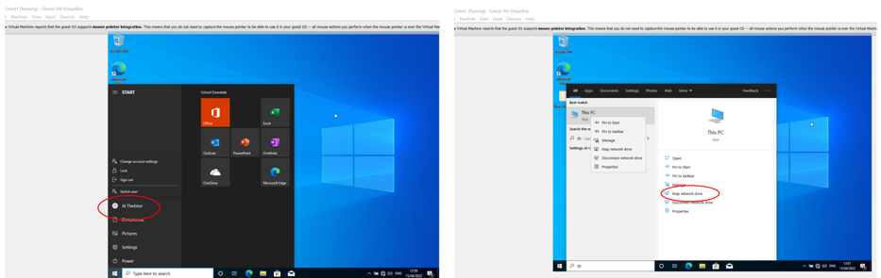
Figure 28 - Access Map Network Drive
- Default drive letter ( Z ) accepted to permanently store network share and full file share name recorded as DC1-NWT\Share_Files_NOSS$
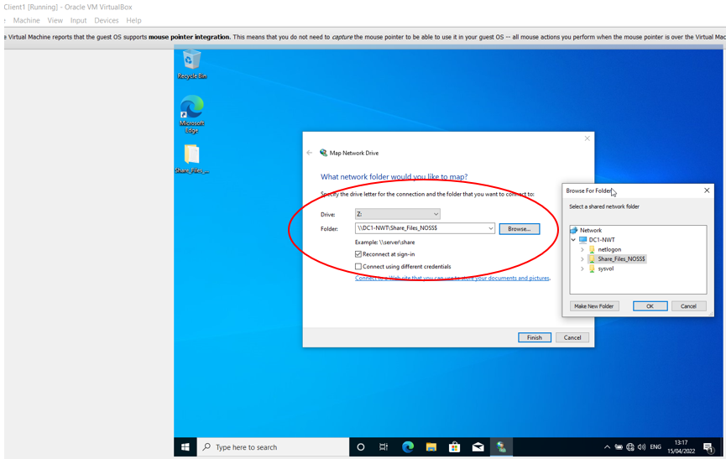
Figure 29 - Full share drive name
- Verify access for user Al Thetime
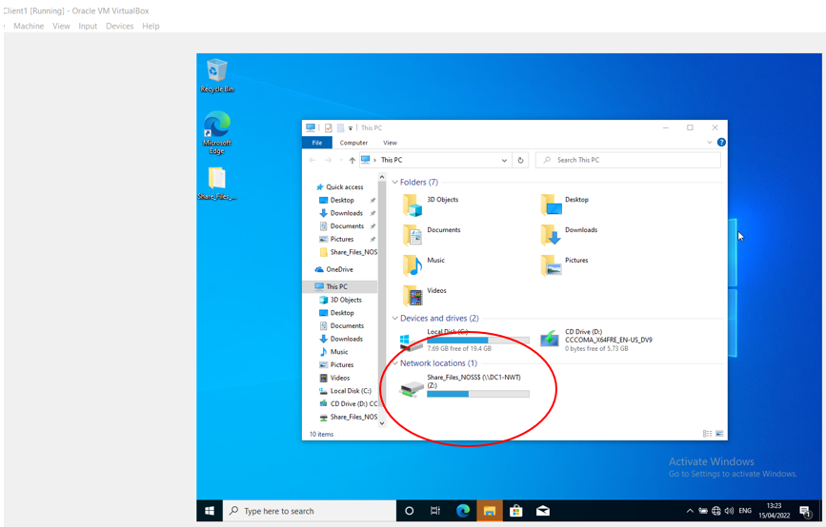
Figure 30 - Access verified

Group Policy Management Console (GMPC)
With the exception of configuring individual policy settings in Group Policy Objects undertaken in Local Group Policy Objects editor, GMPC Is a comprehensive administrative tool for Group Policy management, where Administrators perform all Group Policy management tasks [2].

Policies
GMPC adopts a hierarchical structure for its Group Policy Objects to enable specific filters to be applied such as;
- Local – available to administer on all systems but requires manual configuration.
- Site – configured via site containers in the console tree, with potential to provide different policies to different physical sites.
- Domain Level – where all Organisational Units (OU) and containers and their objects will inherit the settings by default unless inheritance is blocked.
- OU level – applying GPOs at an OU level is the most common method and allows greater control and management of resources.

Configuring User & Computer Environment

GPO 1 – Moderating Access to the Control Panel
- Safeguard users from making administrative changes, as Administrator via Server 1, create an OU for Non-Admin users via Active Directory Users & Computers, within nosstask.msft domain.
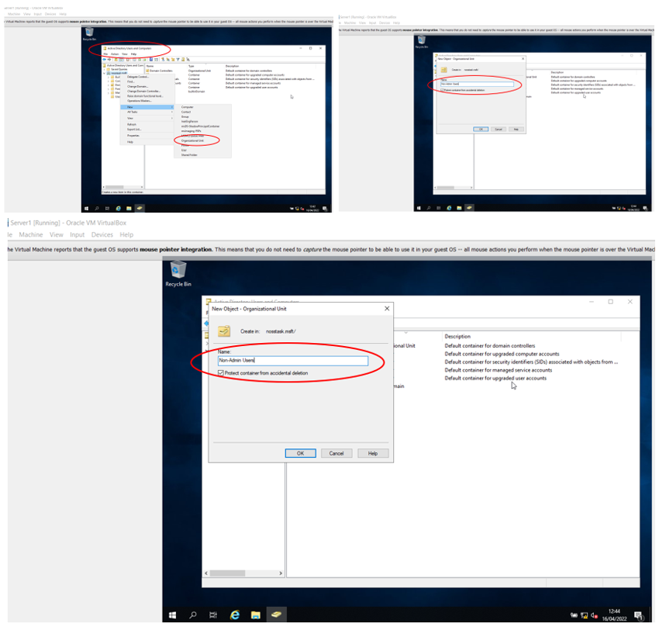
Figure 31 - Create OU (Non-Admin Users)
- Create new user ( Mod Erating ) inside newly created OU
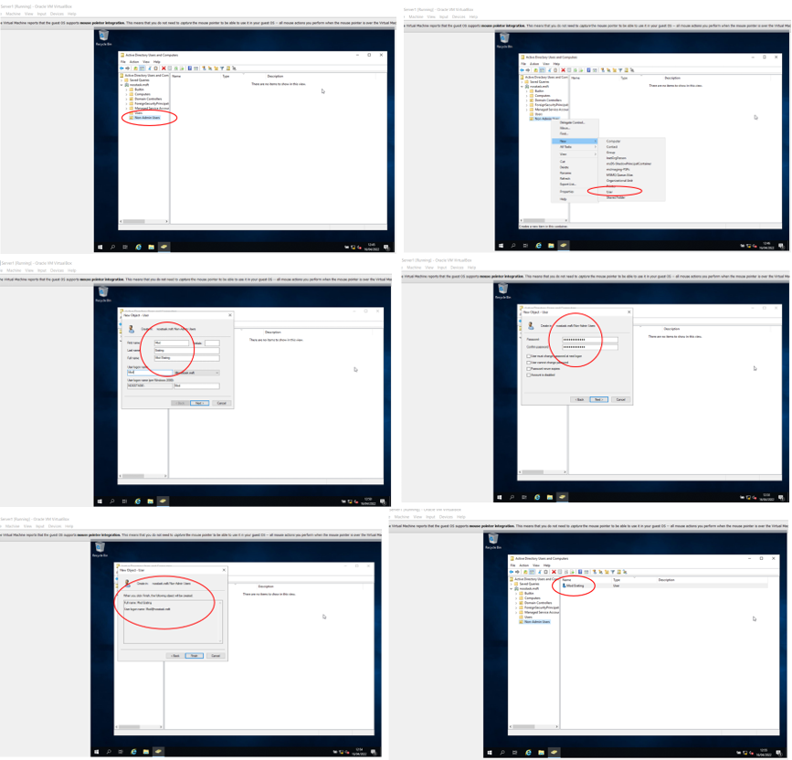
Figure 32 - Create new User in OU (Mod Erating)
- Create required GPO = No Control Panel Access (NoCtrlPanAccess) in Non-Admin Users OU for new User (Mod Erating) via Group Policy Object Editor, ensuring inheritance is disabled to manage policies directly.
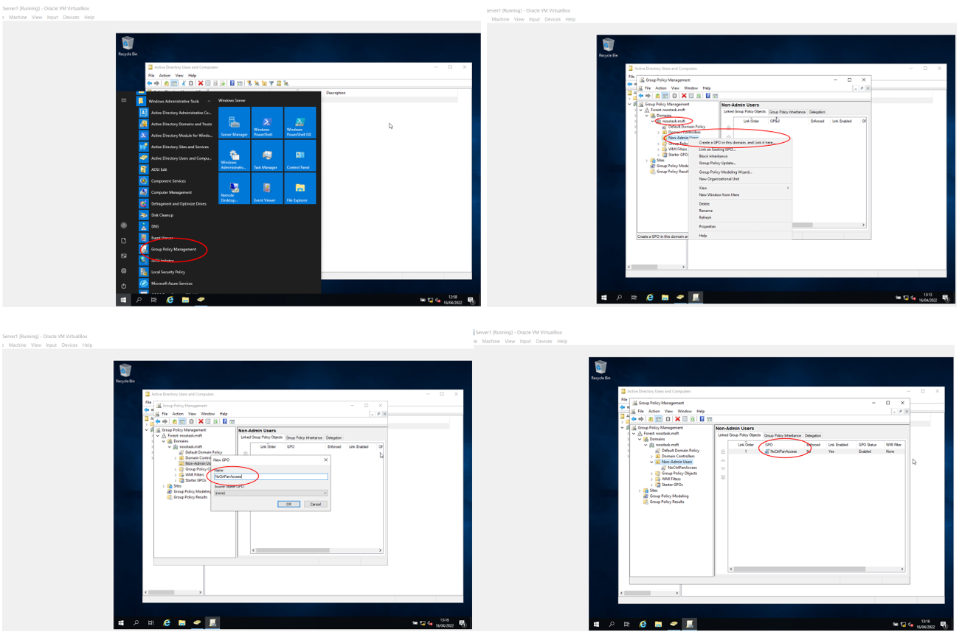
Figure 33 - Create Group Policy Object (NoCtrlPanAccess)
- Configure and Enable new GPO to prohibit User (Mod Erating) access to Control Panel settings, Edit newly created object NoCtrlPanAccess via Group Policy Object Editor.
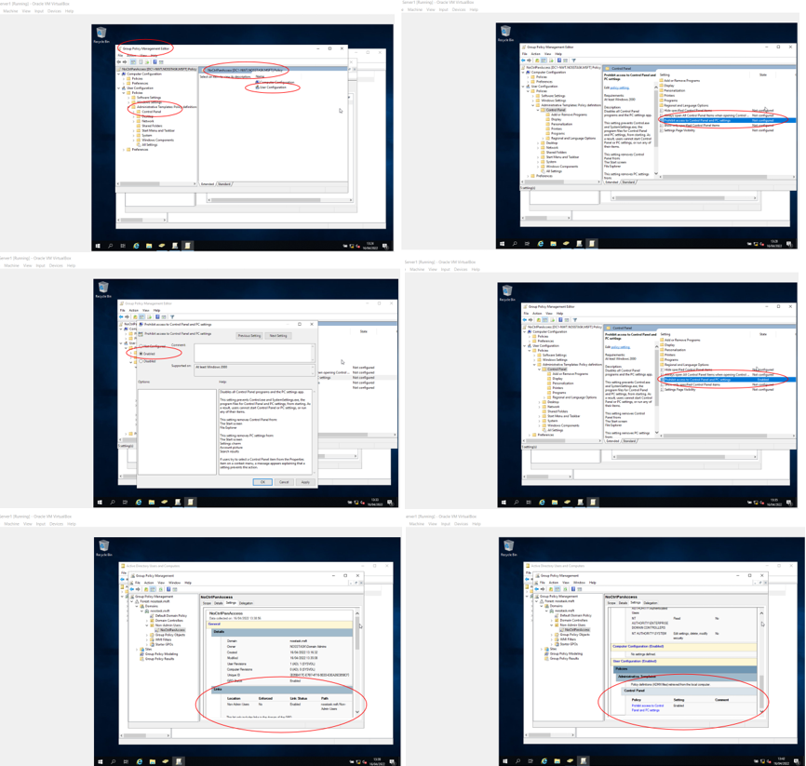
Figure 34 – Configure & Enable NoCtrlPanAccess
- Still as Administrator, and as good practice, always enforce updates to system via command prompt, gpupdate /force function, to ensure changes applied immediately throughout.
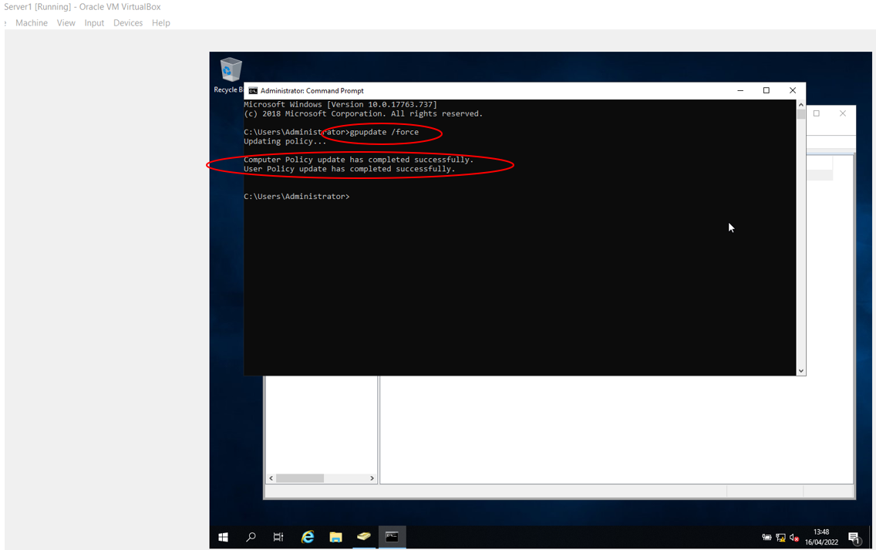
Figure 35 - Apply gpupdate /force
- Using Client 1, log on as new User ( Mod Erating ) to confirm cannot access Control Panel
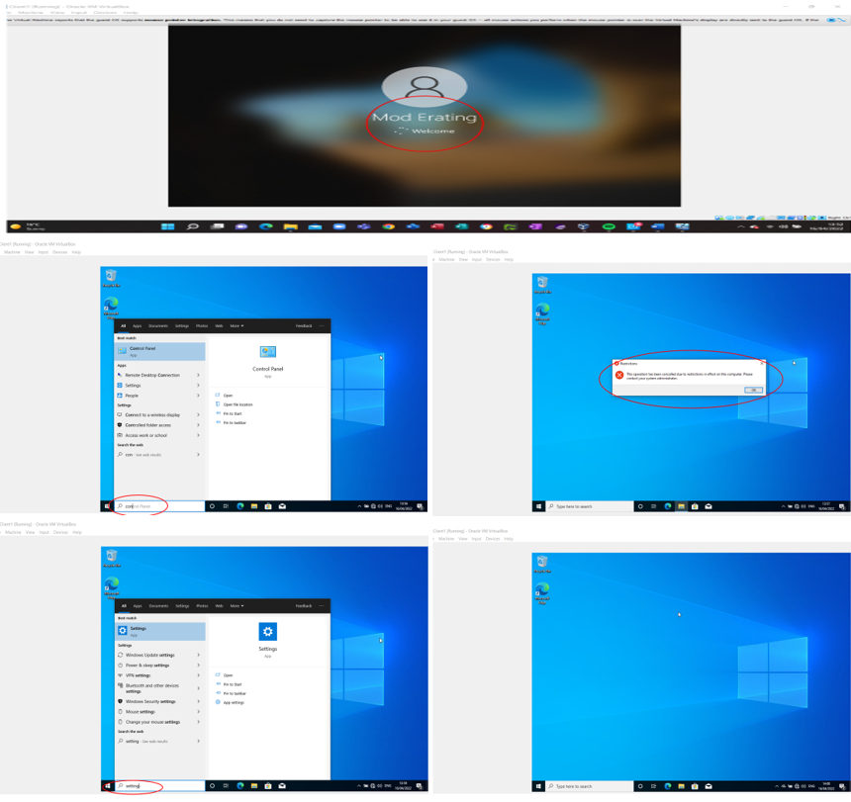
Figure 36 - No control panel access for User (Mod Erating)
- Access still available to another User (Al Thetime)
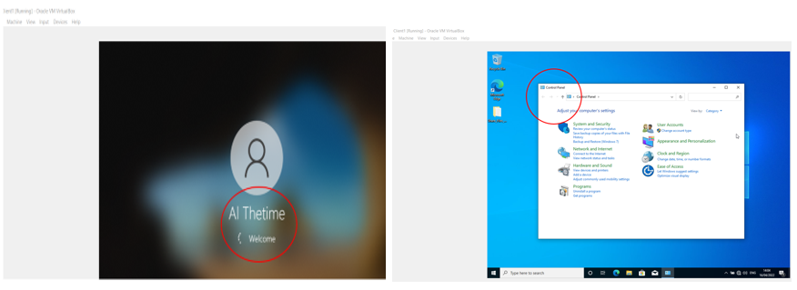
Figure 37 - Access available to Other User (Al Thetime)

GPO 2- Removing Access to Command Prompt
- As an Administrator on Server 1 in Non-Admin OU, apply removing access lessens risks, as system settings can be overridden from the command prompt.
- Utilising similar GMPC instructions to those used for NoCtrlPanAccess
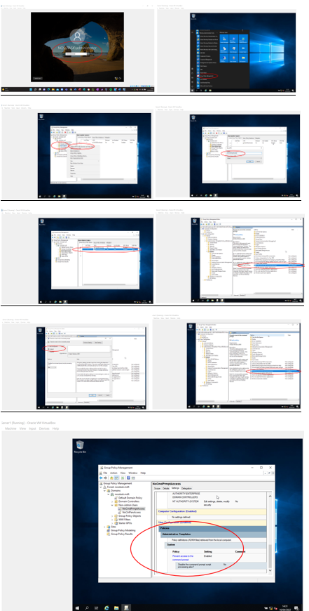
Figure 38 - No Command Prompt Access (NoCmdPrmptAccess)
- Force server updates and test
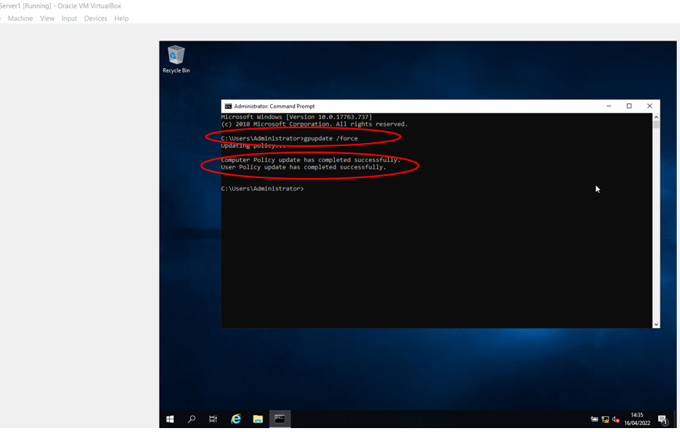
Figure 39 - Force update (NoCmdPrmptAccess)
- Test via Client 1 that User (Mod Erating) cannot access Command Prompt
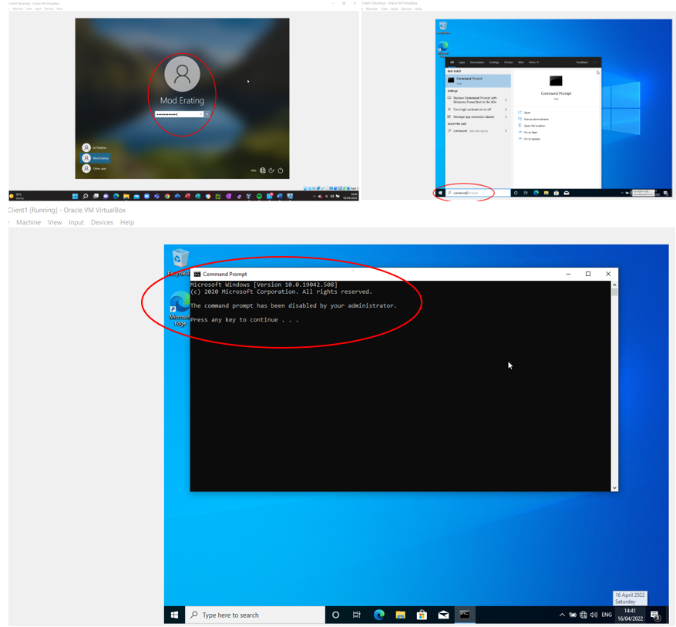
Figure 40 - No access to Command Prompt

Restricting Access to Removable Media Drives
- Restricting access to removable media drives reduces virus/malware transportation.
- On Server 1, Non-Admin OU, GMPC, deny all access by applying new object NoRemDriveAccess.
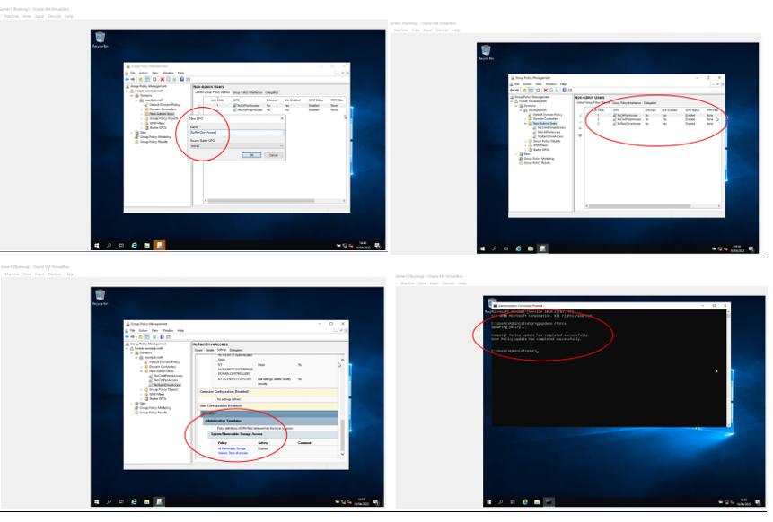
Figure 41 - Restrict Media Drive Access (No RemDriveAccess)

GPO 4 - Restricting Software Installs
- Another threat to network security is unauthorised software installation.
- On Server1, restrictions now applied to computer object, as opposed to User, via ADUC new OU.
- Ensure Client 1 has internet access by installing additional adapter to NAT.
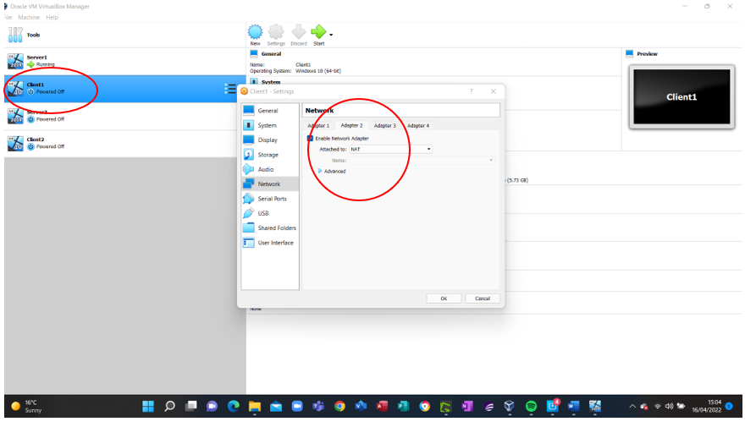
Figure 42 - Client 1 NAT configured for internet
- Check internet connection
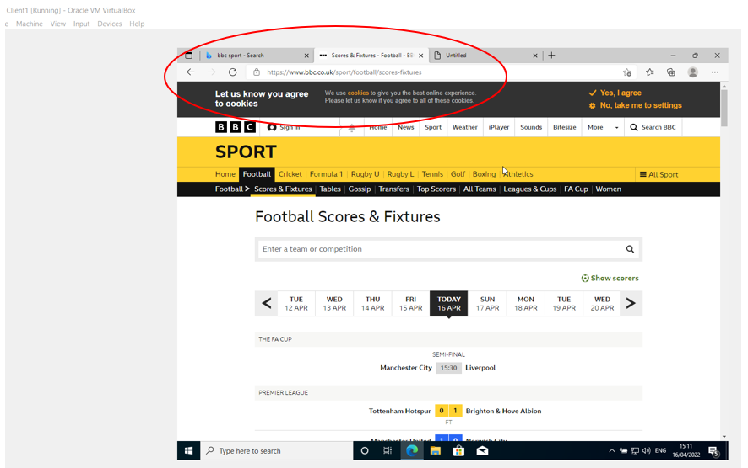
Figure 43 - Client 1 internet connection confirmed (BBC website)
- In Server 1, ADUC, nosstask.msft domain, create new OU NWClientComputers and move Client 1 machine (WS1-NWT) to new OU.
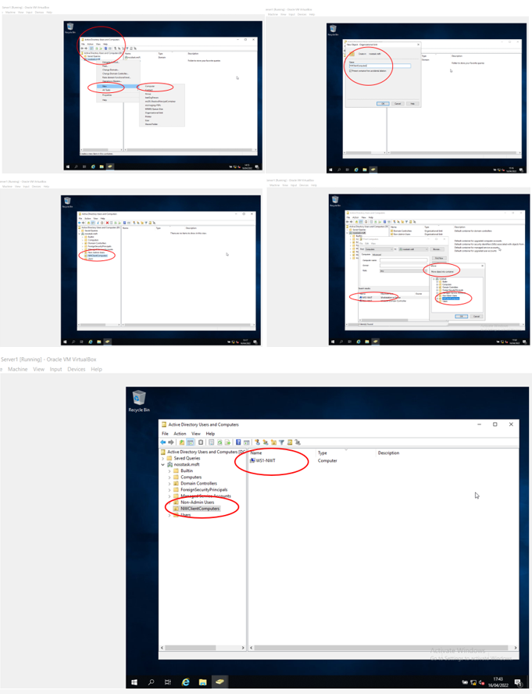
Figure 44 - New computer object (NWClientComputers)
- Install and configure software installation restriction GPO to OU, via GMPC, new object NounauthSoftinstalllS.
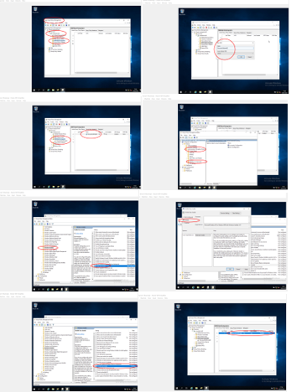
Figure 45 - Create NounauthSoftInstallS
- Force updates via gpupdate /force.
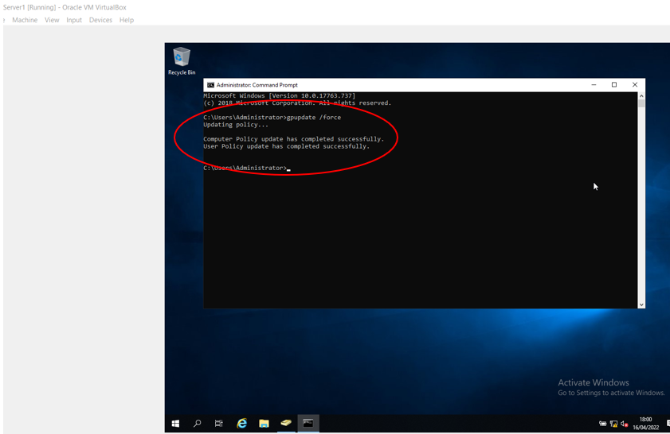
Figure 46 - Computer Policy updates enforced
- Test via Client 1 as non-administrator user (Mod Erating) to upload 7zip software.
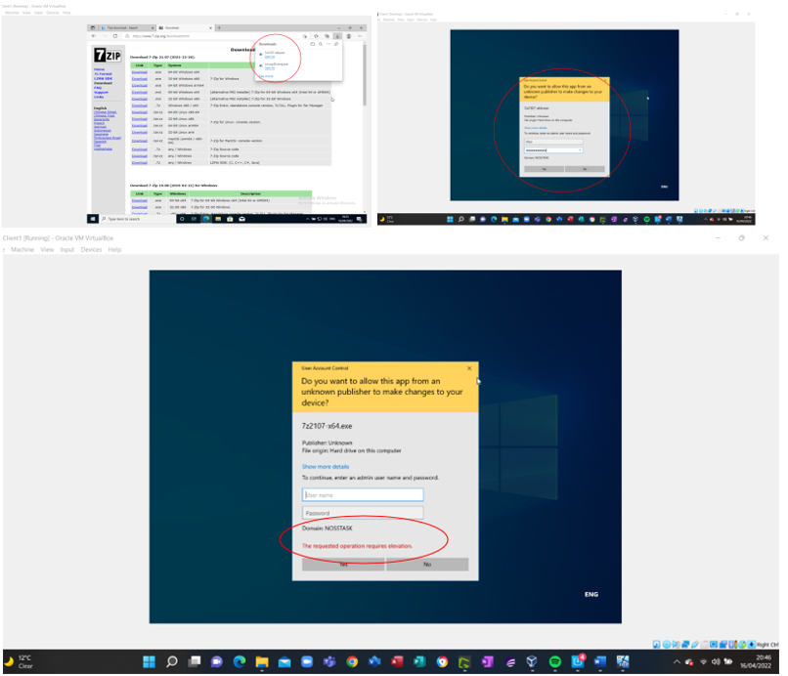
Figure 47 - Software install FAIL
- Install fails requires elevated authority (Administrator) level.

GPO 5 - Enforcing Password Policy in nosstask.msft domain
- Password policies are critical to system security and require Domain level enforcement.
- As Administrator on Server 1, Group Policy manager, default Domain Policy GPO amend pre-defined settings.
- If changes are not required for all then block inheritance.
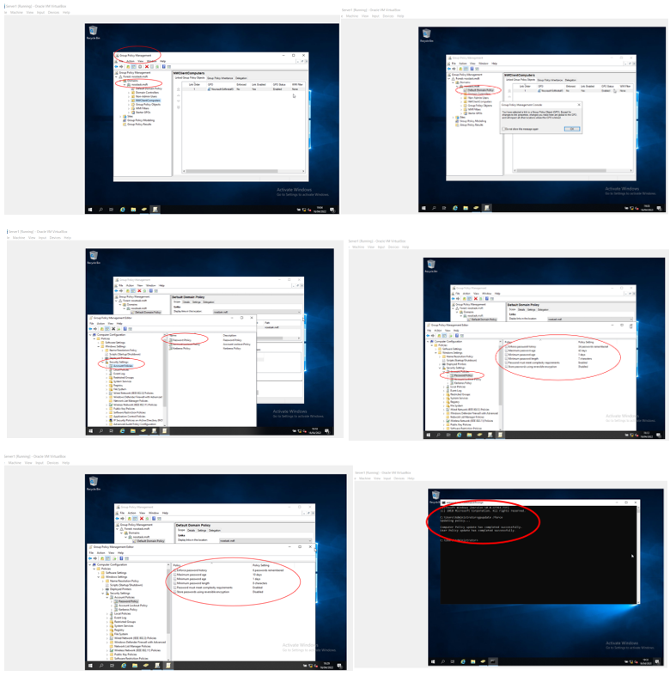
Figure 48 - Password Settings Changed
- Create new User (Dirty Harry) in AD at Domain level, and test with poor password.
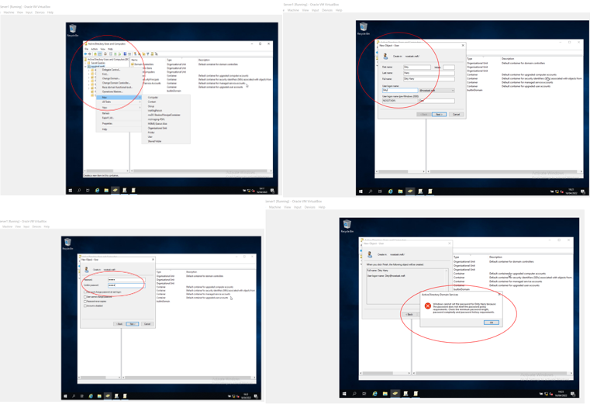
Figure 49 - New User (Dirty Harry) with poor password FAIL
- Amend User (Dirty Harry) password to meet new policy settings
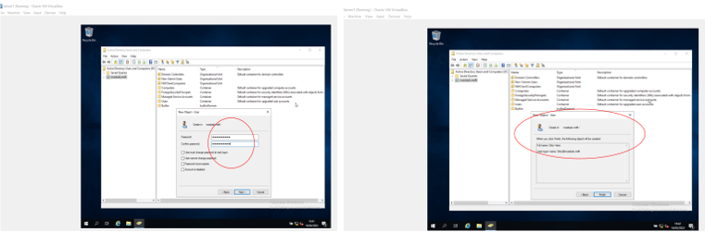
Figure 50 - Dirty Harry Password amended
- Dirty Harry password changed to 12-character phrase
- Passphrase: One question, Do you feel lucky punk ?, Well do ya ?...Dirty Harry 1971
- 1 q D y F l P ? W d Y ?
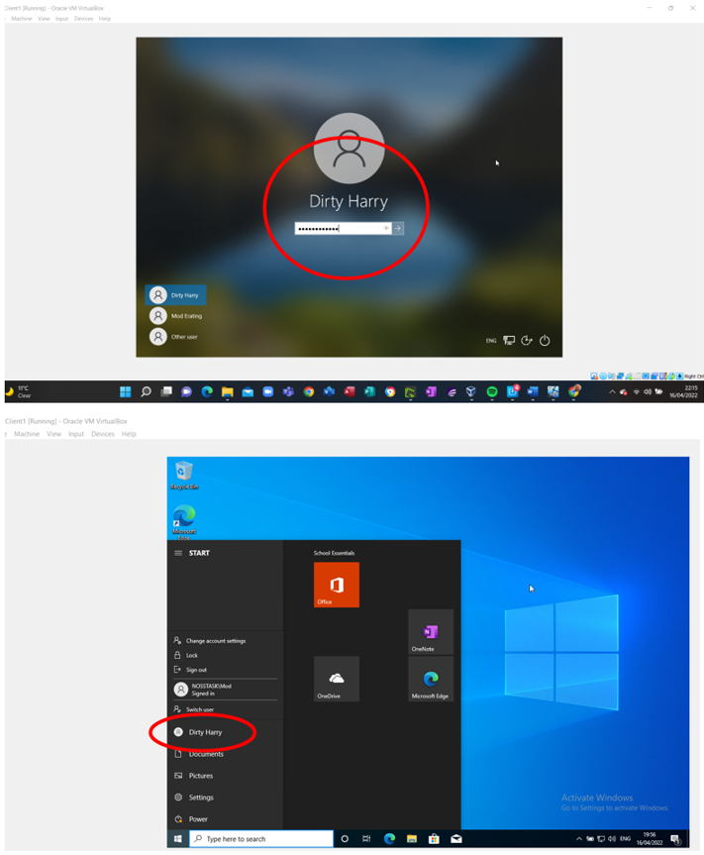

Figure 51 - Successful login to Client 1 mc (Dirty Harry)

Worksheet 2 Task 2 – Routing & Packet Filtering
Without a routing set-up it is impossible for a host on one Local Area Network (LAN) to connect to another host on a different LAN.

ARP and Routing Tables
- Address Resolution Protocol (ARP) is the Dynamic mapping technique used to map the logical address to a physical address, where it accepts the logical address from the IP protocol and maps the address to the corresponding physical address before passing it to the datal link layer [3].
- Protocol is used to resolve the IP address, within IPV4, to the hardware address and works under the network layer to facilitate the delivery of the message to the correct device.
- Without using this protocol, it is not possible to get the message forwarded to the correct device.
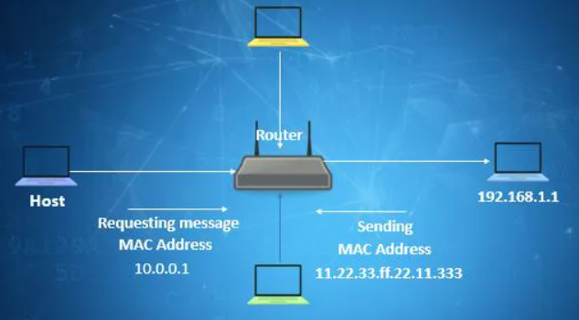
Figure 52 – image courtesy of educba.com [3]
- As Administrator, ascertain current Interface (NIC), Physical (MAC) address and Internet details of Server 1, via ARP -A command thru command prompt.
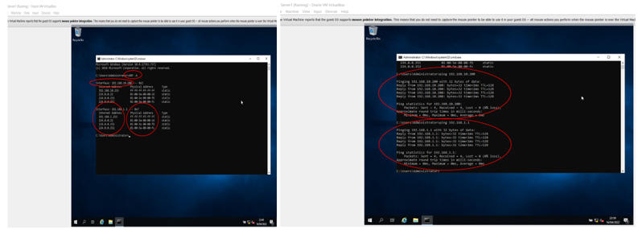
Figure 53 - Server 1 ARP -A at command prompt
- Server 1 route print verifies networks that host is connected, along with Netmask, Gateway, Interface and Metric data.
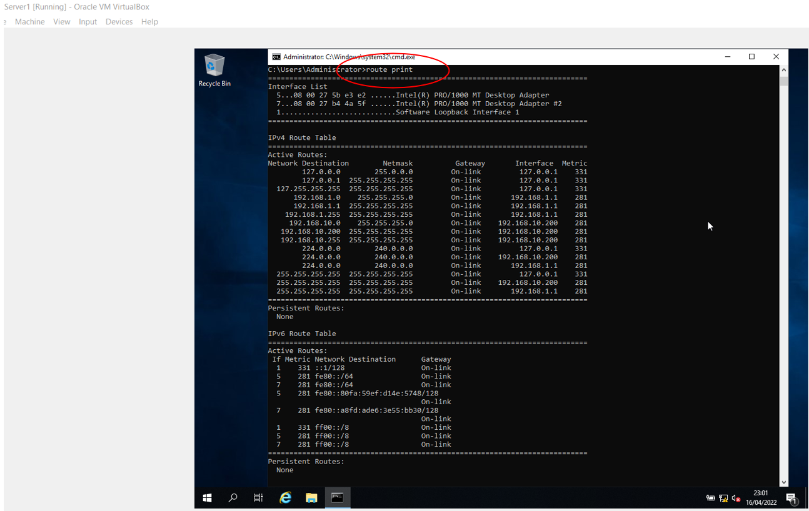
Figure 54 - Server 1 route print

Deploy (FTP Server) Core Services
- Currently only Client 2 is connected to Server 2 via 192.168.11 network
- Check ICMP (ping) connections between Client 2 & Server 2
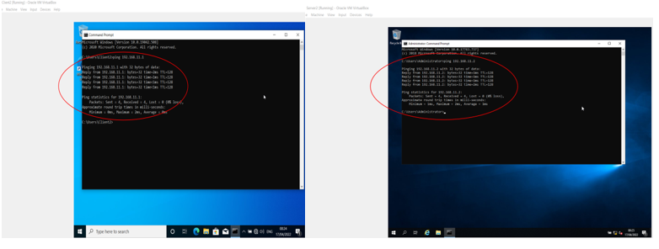
Figure 55 - Server 2/Client 2 pings successful
- As Administrator, install FTP Server on Server 2 via Server Manager, Add Roles & Features, ensuring that No firewalls exist that could create confliction / contradictory filters
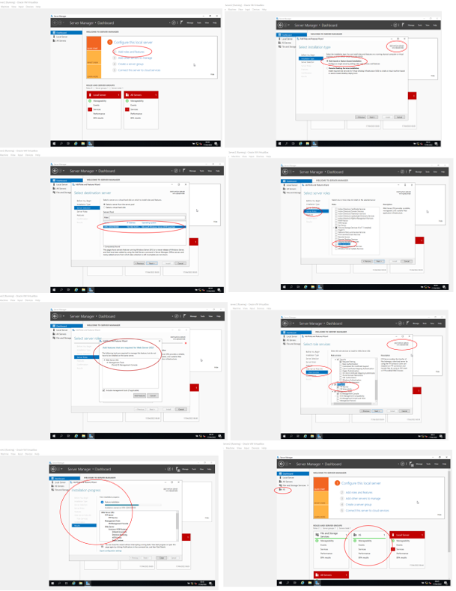
Figure 56 - FTP (IIS) successfully installed
- Create local user account for FTP ( ftpuser22 )
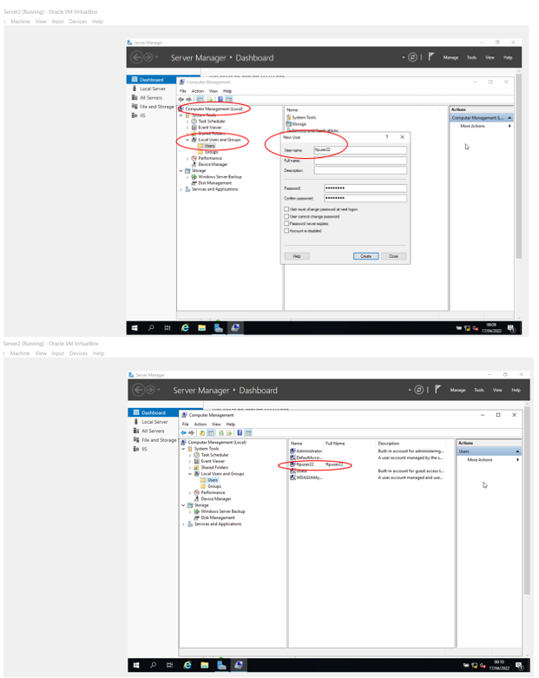
Figure 57 - ftpuser22 created
- Assign ftpuser22 to ftp server (IIS), via Server Manager, Tools, Internet Information Services (IIS).
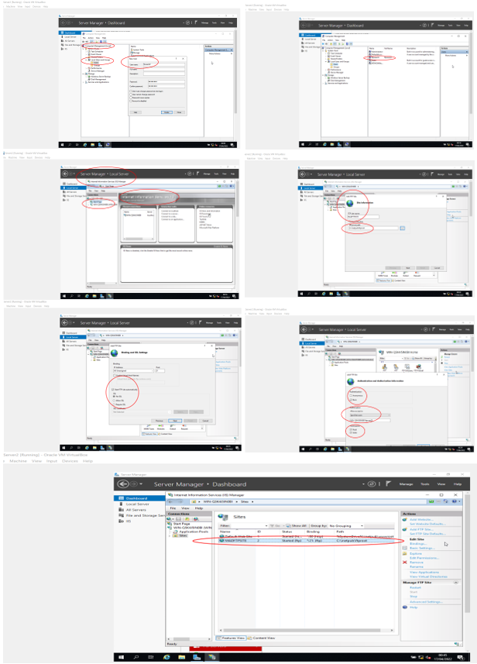
Figure 58 - Assign ftpuser22 to MADFTPSITE
- Create FTP banner (MADFTPSITE)
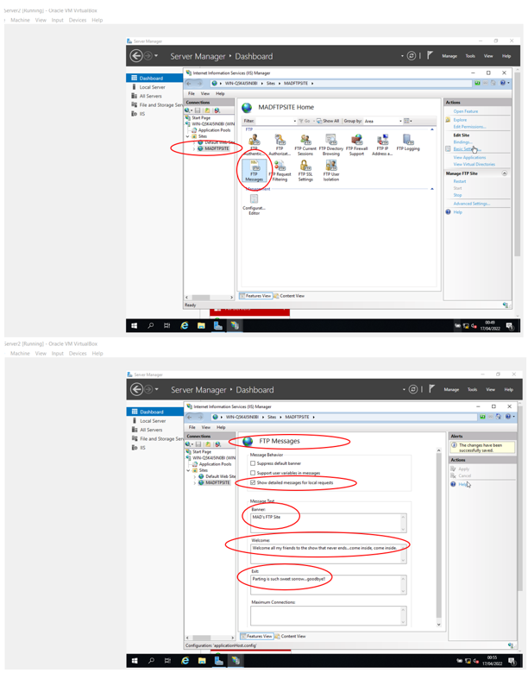
Figure 59 - FTP Banner
- Via Server 2, add user account to ftproot
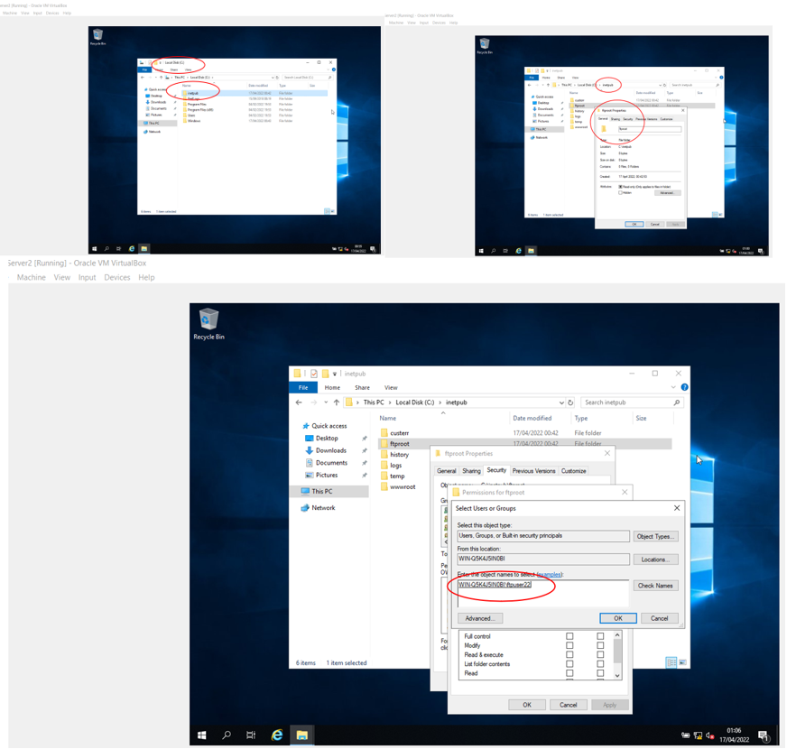
Figure 60 - ftpuser 22 confirmed
- Allocate full control permissions to ftpuser22
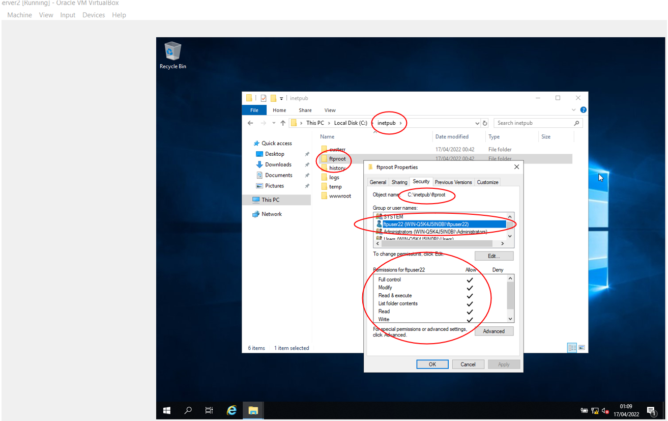
Figure 61 - ftpuser22 permissions
- Firewall status for both Server & Client 2 off
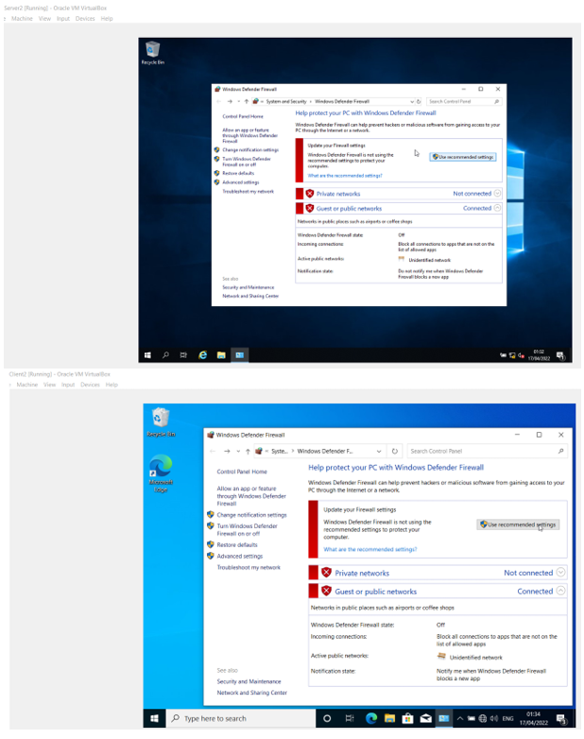
Figure 62 - Server & Client 2 Firewall OFF
- Create MYFTPFiles folder in Client 2 and a text file = myftpfile2upload
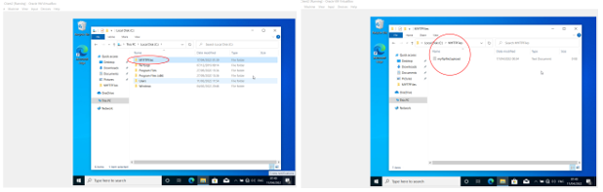
Figure 63 - Client 2 ftp folder & text file
- Upload text file (myftpfile2upload) from Client 2 to Server 2 (MADFtpuploads)
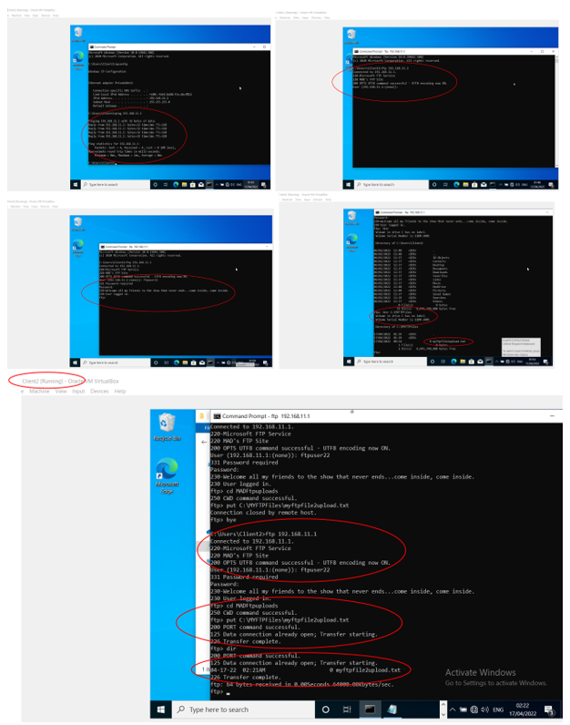
Figure 64 - Copy text file from Client 2 to Server 2
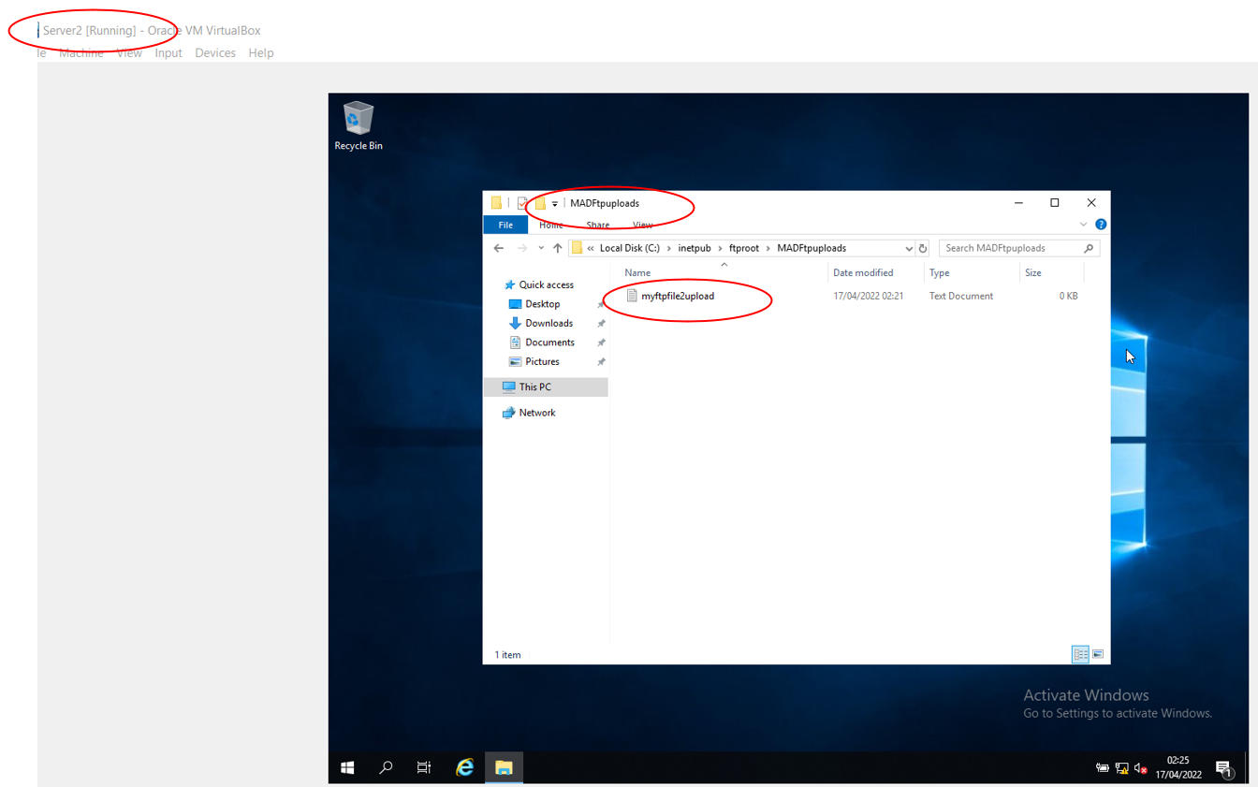
Figure 65 - Server 2 text file confirmation

Installing and configuring the Routing & Remote Access Service
Expand original network building two remotely connected LANs into a Wide Area Network (WAN) utilising Layer 3 devices, such as Routers and Routing Protocols, providing a routing services on both PrivateNet1 and 2 [4].
- As Administrator on Server 1, Server Manager, install DirectAccess and VPN.
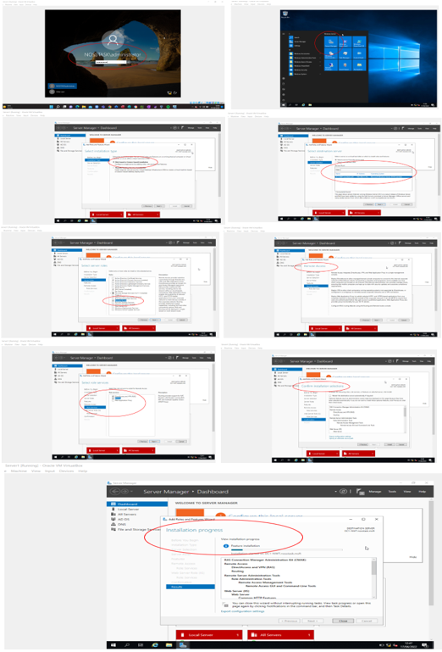
Figure 66 - Install DirectAccess and VPN
- Configure Remote Access and deploy VPN
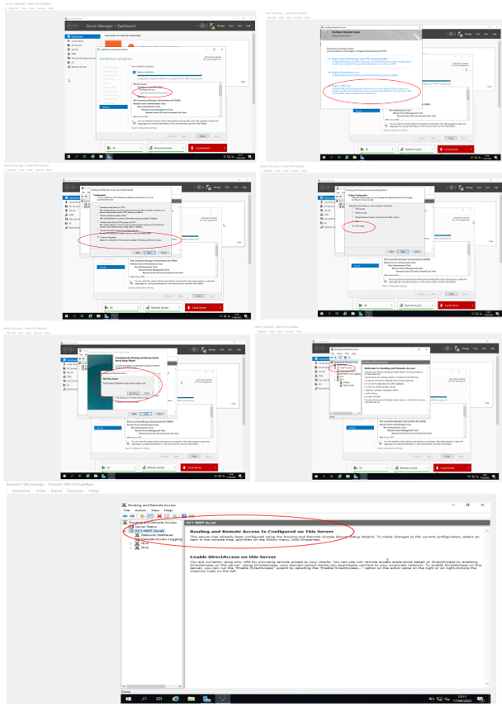
Figure 67 - Configure LAN routing
- Enable Routing Protocols via iPv4 and RIP v2 for Server 1 (PublicNet & PrivateNet 1)
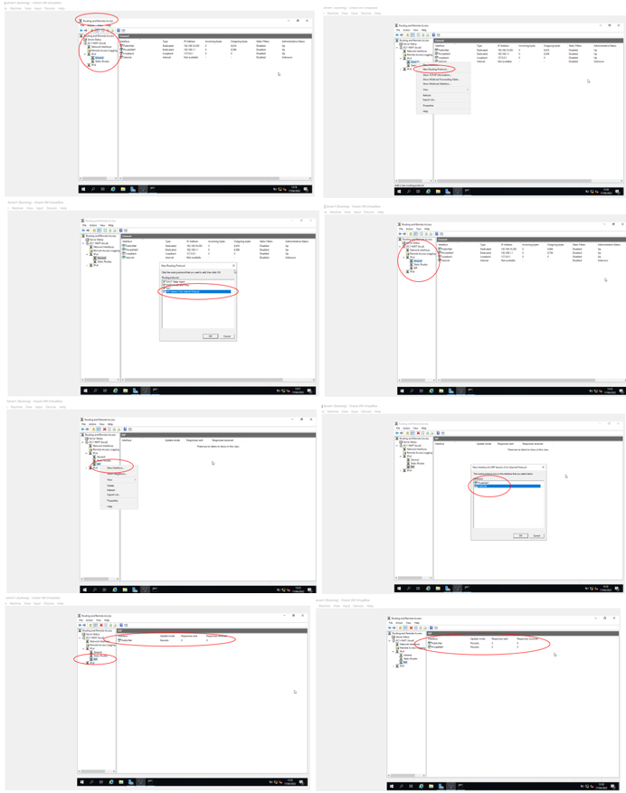
Figure 68 - Server 1 RIP v2 installed
- Repeat LAN routing and RIP v2 installation for Server2 (PublicNet & PrivateNet2)
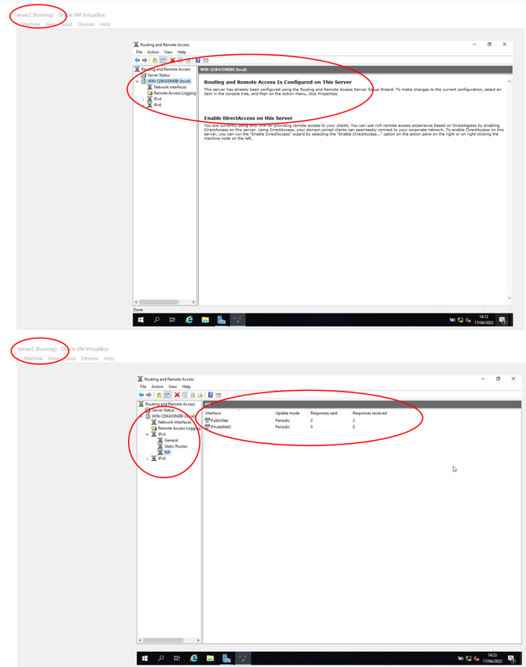
Figure 69 - Server 2 LAN routing & RIP v2 Installation
- As Administrator, set default gateways for Client 1 & 2 and test PublicNet (ping) Server 1 to 2.
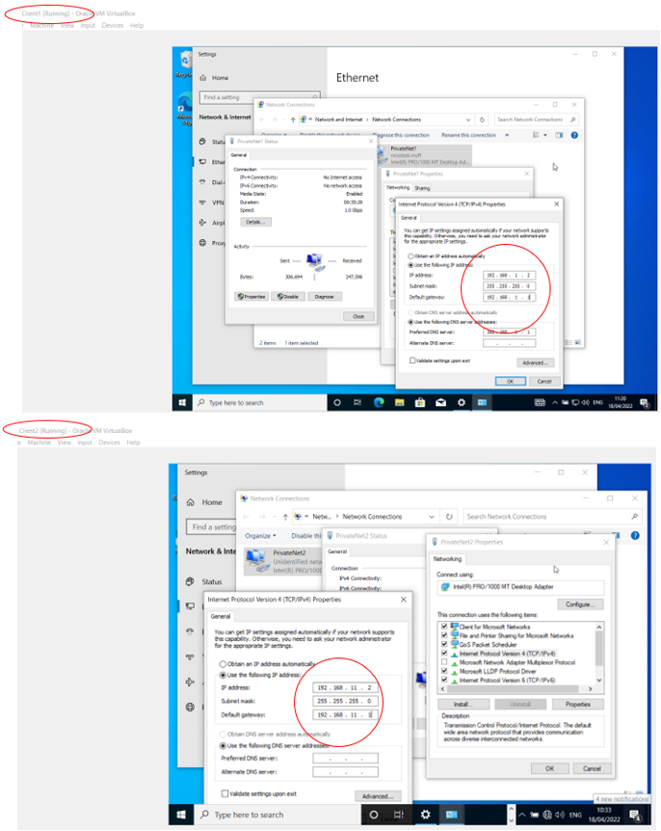
Figure 70 - Client 1 & 2 Default gateways
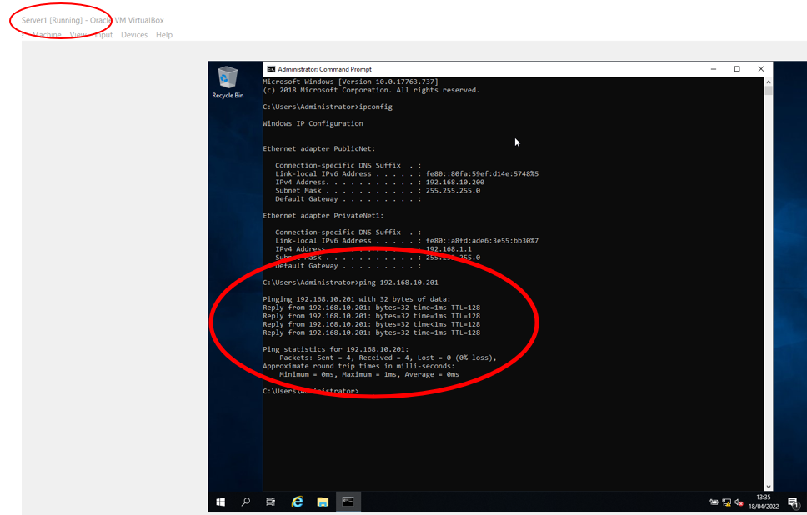
Figure 71 - Verify PublicNet (ping) Server 1 to 2

IP Packet Filtering
IP packet filtering acts as a basic form of firewall by restricting flow via use of protocols and source/destination ports of Inbound & Outbound filters [5].

Filter 1 - Stopping anyone in PrivateNet1 pinging Router Firewall Service
- Via Server 1, Server Manager, IP Routing, PrivateNet 1, Inbound filter (all destinations = Blank)
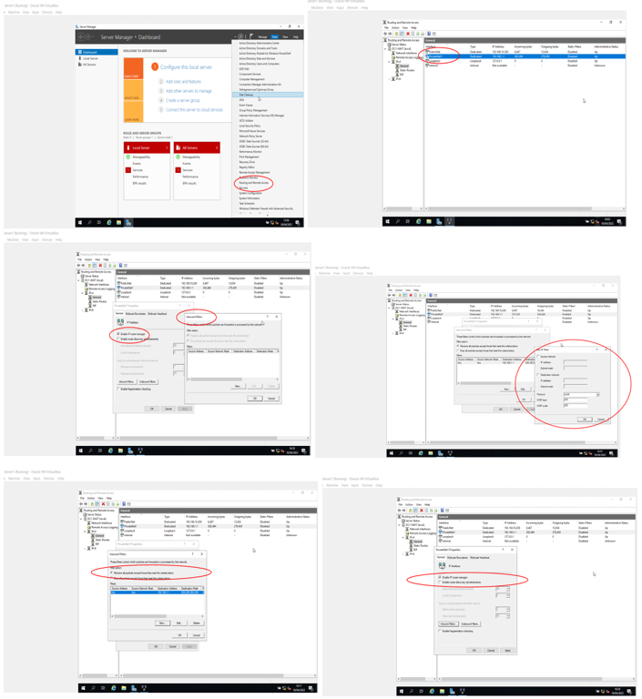
Figure 72 - Filter 1 : Stop ping from PrivateNet1 to Router Firewall
- Test via Client 1 ping
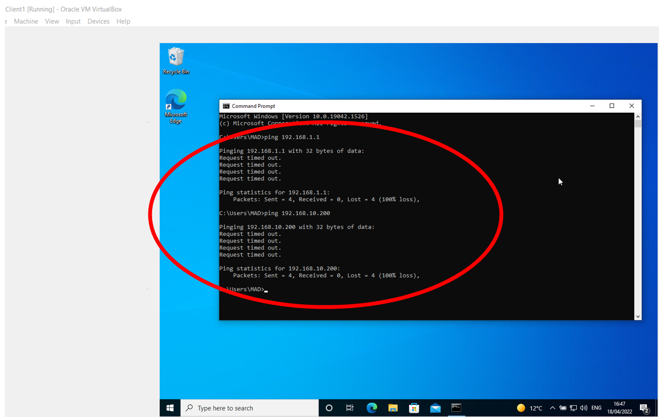
Figure 73 - Client 1 ping to Router Firewall Timed Out (Denied)

Filter 2 – Restrict Access to FTP service (on Server2) to ONLY Hosts in PrivateNet2.
- Via Server 1, using Outbound filter to restrict access to Hosts in PrivateNet1, as Server 1 can connect to FTP via default gateway.
- FTP can be accessed via 2 x IP addresses (192.168.10.201 & 11.1) both require exclusion rules.
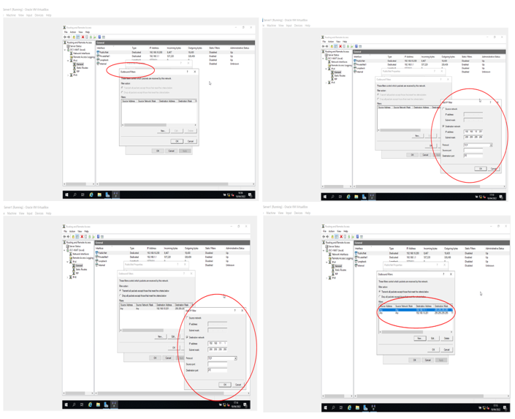
Figure 74 – Filter 2 : Restrict access to FTP server
- Test that neither FTP addresses (port 21) can be accessed, via Client 1.
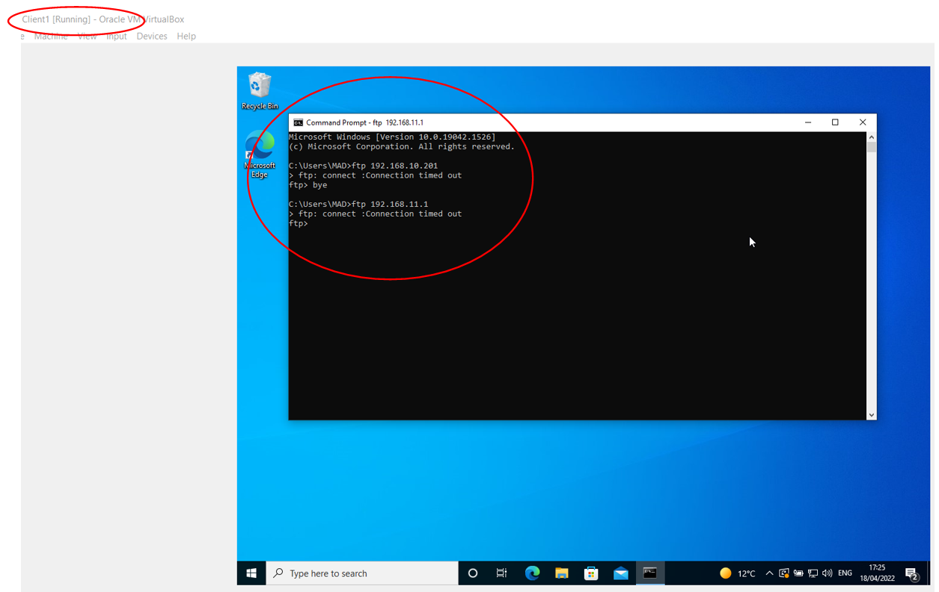
Figure 75 - FTP Restriction SUCCESSFUL

Filter 3 – Only allow Specific hosts in PrivateNet1 access to FTP Service in Server2.
- Delete all previous filters to avoid contradiction.
- On Server 1 Inbound filter.
- Allow source network 192.168.1.2 on PrivateNet1.
- Cater for ftp having 2 IP addresses (192.168.10.201 & 11.1) via 2 rules.
- Drop all packets except these 2 rules.
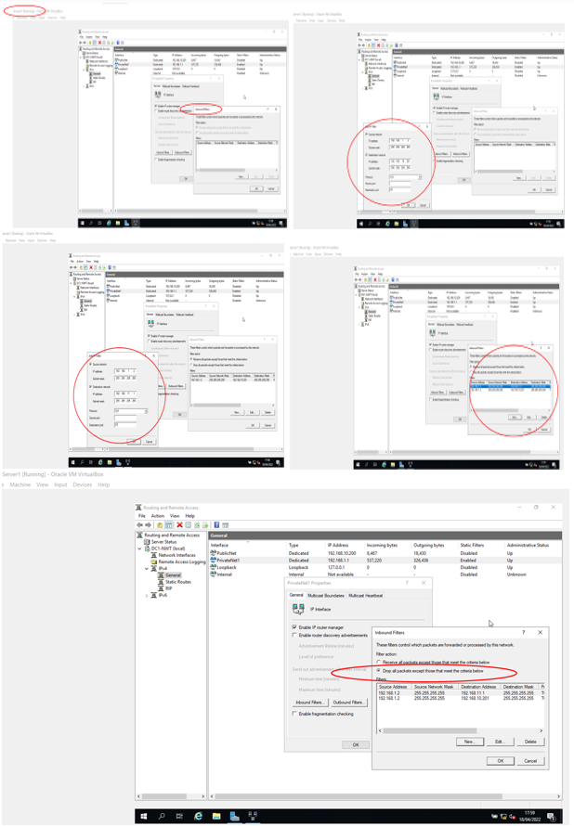
Figure 76 - Specific Host access to FTP (Own Rules)

part 2 – observational tasks / work

Worksheet 2 Task 3 – Observations Tasks

Password Principles

Minimum Microsoft Password Requirements
- minimum length 8 characters, maximum 16,
- cannot contain user's account name or parts of the user's full name that exceed two consecutive characters.
- MUST contain characters from three of the following four categories:
  - Uppercase letters (A through Z)
  - Lowercase letters (a through z)
  - Numbers (0 through 9)
  - The following non-alphabetic characters: ` ~ ! @ # $ % ^ & * ( ) _ + - = { } | [ ] \ : " ; ' < > ? , . / [6]

Own Sound Password Principles
In addition to the Microsoft minimum requirements, the fundamentals of a good Password should be that they are:
- Unique, time limited and not to be reused for multiple accounts.
- Difficult to guess and the protection system should prohibit weak passwords/phrases.
- Able for the Administrator to block certain words/phrases.
- Complex enough that they are too difficult to memorise, see Microsoft minimum requirements.
- Well managed by a Password Manager to automatically generate unique & complex passwords and store them in an encrypted file.
- Having a password of their own, such as Multi-Factor Authentication (MFA) to force another layer of protection.
Such as the example utilised in Worksheet 2 – new User (Dirty Harry).
- Dirty Harry password changed to 12-character phrase
- Passphrase: One question, Do you feel lucky punk ?, Well do ya ?...Dirty Harry 1971
- 1 q D y F l P ? W d Y ?

Failover Clustering
Definition and Concept
High Availability (HA) as the ability for the system to continue functioning after failure of one or more of the Servers. They operate by using high availability software to harness redundant machines in groups of clusters that offer continued service when system components fail.
Failover is within HA and allows for Client connections to migrate from one Server to another in event of Server failure so Client applications can continue to operate with minimum disruption in service. Failover Clusters create redundancy to eliminate single points of failure, including multiple Internet connections and data storage which is redundantly connected via Storage Area Network (SAN).
They are a group of independent computers that work together to increase the availability and scalability of clustered roles, these clustered servers, (nodes), are connected by physical cables and software. Should one of the clustered servers fail, the other servers start to offer service in a process called failover and at any time, a least one of the nodes in a cluster is active, while at least one is passive [7].
Role within Windows Server OS environment
Within Windows Server Failover Clustering (WSFC) the following capabilities are performed [8];
- Unified cluster management.
- Resource management.
- Health monitoring.
- Automatic and manual failover.
WSFC uses a number of different applications including:
- Database Server
- Windows Distributed File System (NFS) Namespace Server
- File Server
- Hyper-V
- Microsoft Exchange Server
- Microsoft SQL Server
- Namespace Server
- Windows Internet Name Server
- Failover cluster configuration wizard
- WSFC voting, quorum and witnesses

How to deploy and implement
Create a failover cluster by using either the Failover Cluster Manager snap-in or Windows PowerShell, covering a typical deployment, with computer objects for the cluster and its associated clustered role, are created in Active Directory Domain Services (AD DS) [9].
1 Prerequisite Verification
- Ensure all servers wanting to add as cluster nodes are running same version of Windows Server.
- All hardware requirements in configuration are supported.
2 Create a failover cluster
- Add clustered storage during cluster creation, ensuring all servers can access storage and all servers wanting to add as cluster nodes are joined to same Active Directory domain.
- Create an organizational unit (OU) and move computer accounts for servers into the OU.
- Place failover clusters in their own OU in AD DS.
- Isolating clusters in their own OU, helps prevent against accidental deletion of cluster computer objects.
- Verify account is a domain user who has administrator rights on all servers.
- Ensure User who creates cluster has Create Computer objects permission to OU/container.

3 Install the Failover Clustering feature
- Install Failover Clustering feature on every server required to add as a failover cluster node.
- Install Failover Clustering feature
- Start Server Manager.
- On Manage menu, select Add Roles and Features.
- On Select installation type page, select Role-based or feature-based installation, and select Next.
- On Select destination server page, select server required to install feature, and select Next.
- On Select server roles page, select Next.
- On Select features page, select Failover Clustering check box.
- To install failover cluster management tools, select Add Features, then select Next.
- Confirm installation selections page, select Install (server restart not required for Failover Clustering feature).
- When installation complete, select Close.
- Repeat procedure on every server required to be added as a failover cluster node.

4 Validate configuration
- Ensure that hardware and hardware settings are compatible with failover clustering.
- Microsoft supports a cluster solution only if complete configuration passes all validation tests and all hardware is certified for version of Windows Server that the cluster nodes are running.
- At least two nodes need to be running to run all tests.

5 Run cluster validation tests
- On computer with Failover Cluster Management Tools installed, from Remote Server Administration Tools, start Failover Cluster Manager.
- On server, start Server Manager, and on Tools menu, select Failover Cluster Manager.
- In Failover Cluster Manager pane, under Management, select Validate Configuration.
- On Select Servers/Cluster page, in Enter name box, enter NetBIOS name or fully qualified domain name of server planned as failover cluster node, and select Add.
- Repeat this step for each server required to add.
- On Testing Options page, select Run all tests (recommended), and select Next.
- On Confirmation page, select Next.
- Validating page displays status of running tests.
- On Summary page, if results indicate that tests completed successfully and configuration is suited for clustering, make sure that Create cluster now using validated nodes check box is selected, and select Finish.
- If results indicate warnings or failures, select View Report to view details and determine which issues must be corrected.
- Realise that a warning indicates that this aspect of the failover cluster can be supported but might not meet recommended best practices.

6 Create the failover cluster
- Ensure that log on user account meets requirements outlined in Verification process,
- Start Server Manager.
- On Tools menu, select Failover Cluster Manager.
- In Failover Cluster Manager pane, under Management, select Create Cluster.
- Create Cluster Wizard opens.
- If Select Servers page appears, in Enter name box, enter NetBIOS/or fully qualified domain name of a server required to add as failover cluster node, then select Add.
- Repeat step for each server required to add.
- When finished, select Next.
- On Access Point for Administering Cluster page, in Cluster Name box, enter name required to use to administer the cluster.
- During cluster creation, this name is registered as cluster computer object (also known as the cluster name object{CNO}) in AD DS.
- To specify different location for CNO, enter distinguished name of an OU in Cluster Name box.
- If a domain administrator has prestaged CNO in a different OU than where the cluster nodes reside, specify distinguished name that domain administrator provides.
- If server does not have a network adapter that is configured to use DHCP, configure one or more static IP addresses for failover cluster.
- Select check box next to each network required for cluster management.
- Select Address field next to selected network, then enter IP address required to assign to cluster.
- This IP address (or addresses) will be associated with cluster name in Domain Name System (DNS).
- When finished, select Next.
- On Confirmation page, review settings.
- By default, Add all eligible storage to cluster check box is selected.
- Select Next to create failover cluster.
- On Summary page, confirm failover cluster successfully created.
- If any warnings/errors, view summary output/or select View Report to view full report. Select Finish.
- To confirm cluster created, verify that cluster name listed under Failover Cluster Manager in navigation tree.
- Expand cluster name, then select items under Nodes, Storage or Networks to view associated resources.

7 Create clustered roles
- After failover cluster created, create clustered roles to host cluster workloads.
- Use Server Manager to install role or feature required for a clustered role on each failover cluster node.
- To create a clustered file server, install File Server role on all cluster nodes.
- Following table shows clustered roles that can be configured in the High Availability Wizard and associated server role or feature that must be installed as a prerequisite.
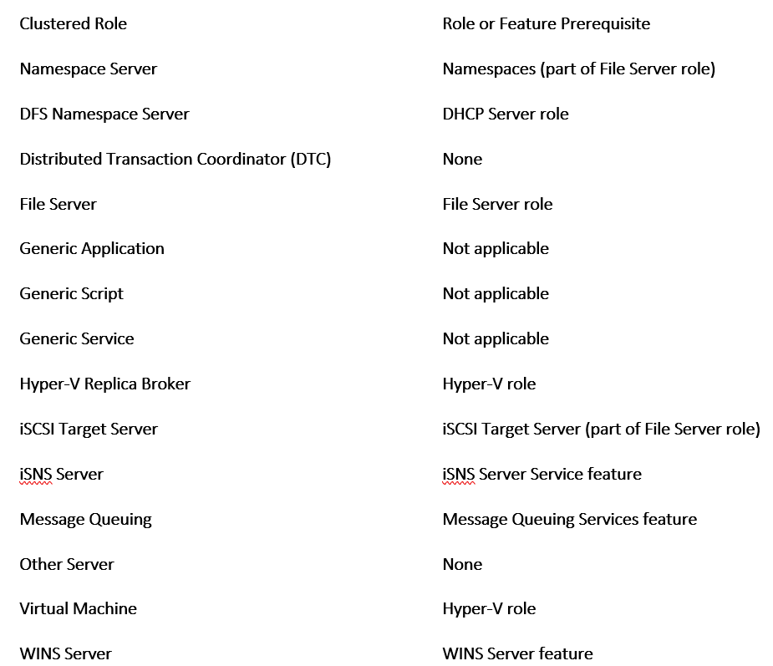
- In Failover Cluster Manager, expand cluster name, right-click Roles, and select Configure Role.
- Follow steps in the High Availability Wizard to create the clustered role.
- To verify clustered role was created, in Roles pane, make sure role has a status of Running.
- Roles pane also indicates owner node.
- To test failover, right-click role, point to Move, and Select Node.
- In Move Clustered Role dialog box, select desired cluster node, and select OK.
- In Owner Node column, verify owner node changed.

Network Policy

Introduction
A Network security policy helps ensure availability of your network and safeguards against it being compromised, this policy will assess the risks and build a team to respond. Policy continuation is implemented via security change management practice and monitoring of the network for security violations, with the review process modifying existing policy and adapting to continuous improvements [10].
Before implementing a security policy, create a usage policy, conduct risk analysis and establish a security team structure.

Create a Usage Policy Statements
- That outlines user roles and responsibilities with regard to security.
- A general policy that covers all network systems and data within the Enterprise that provides general user community with an understanding of the security policy, its purpose, guidelines for improving their security practices, and definitions of their security responsibilities.
- Identify specific actions that could result in punitive/disciplinary actions against an employee, and clearly state how to avoid them.
- Create a partner acceptable use statement to provide partners with an understanding of the information that is available to them, the expected disposition of that information, as well as the conduct of the employees of our own Enterprise.
- Clearly explain any specific acts that have been identified as security attacks and the punitive actions that will be taken should a security attack be detected.
- Create an administrator acceptable use statement to explain the procedures for user account administration, policy enforcement, and privilege review.
- Clearly create and present specific policies concerning user passwords and subsequent handling of data.
- Check the policy against the partner acceptable use and the user acceptable use policy statements to ensure uniformity.
- Make sure that administrator requirements listed in the acceptable use policy are reflected in training plans and performance evaluations.

Conduct a Risk Analysis
That identifies the risks to the Enterprise network, network resources, and data to portions of the network and assign each a threat rating, applying an appropriate level of security, to maintain a workable balance between security and required network access.
Assign each network resource one of the following three system risk levels that if compromised (data viewed by unauthorized personnel, data corrupted, or data lost) that the targeted Enterprise business system/data, would;
- Low Risk - not disrupt or cause legal/financial ramifications, can be easily restored and does not permit further access of other systems.
- Medium Risk - cause moderate disruption, minor legal/financial ramifications, or provide further access to other systems, requiring moderate effort to restore processes.
- High Risk - cause extreme disruption, major legal/financial ramifications, or threaten the health and safety of a person, requiring significant effort to restore processes.

Assign a risk levels to the following:
- core network devices,
- distribution network devices,
- access network devices,
- network monitoring devices (SNMP monitors and RMON probes),
- network security devices (RADIUS and TACACS),
- e-mail systems,
- network file servers,
- network print servers,
- network application servers (DNS and DHCP),
- data application servers (Oracle or other standalone applications),
- desktop computers,
- and other devices (standalone print servers and network fax machines).
Regard network equipment such as switches, routers, DNS servers, and DHCP servers that allow further access into the network, as either medium or high-risk devices.
Identify types of system users of that system, such as;
- Administrators Internal users responsible for network resources.
- Privileged Internal users with a need for greater access.
- Internal users with general access.
- External users (partners) with a need to access some resources.
- Other External Users/Customers.
Risk level identification and type of access required of each network system is the basis of a security matrix, which provides a quick reference for each system, to act as a starting point for further creating an appropriate security strategy restricting access to network resources.
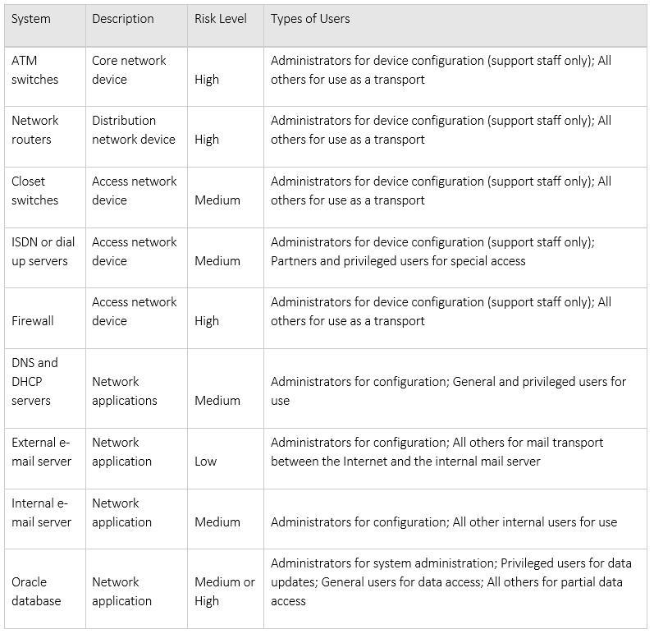
Figure 77 - Risk Levels [10]

Establish Security Team Structure
Create a cross-functional security team led by a Security Manager with participants from each of the Enterprise’s operational areas, with each representative aware of the security policy and the technical aspects of security design, implementation, providing additional training for the team members.
The security team areas of responsibility are:
- Policy development focusing on establishing and reviewing Enterprise security policies, annually reviewing both the risk analysis and the security policy.
- Practice conducting risk analysis, approval of security change requests, reviewing security alerts from both Suppliers and the CERT mailing list, turning plain language security policy requirements into specific technical implementations.
- Response by security team via troubleshooting/violation remedy. Knowing in detail the security features provided by the equipment, along with defined team and individual roles & responsibilities.

Prevention
Prevention caters for approving security changes and monitoring network security.
Where security changes are defined as changes to network equipment that have a possible impact on the overall security of the network. Security policy should identify specific security configuration requirements in non-technical terms, defining a unique set of requirements for the Enterprise. Review the list of plain language requirements to identify specific network configuration/design issues that meet the requirements.
Create and implement the required network configuration changes to the security policy and apply these to any future configuration changes. Security team to review any changes/updates to;
- firewall configuration.
- access control lists (ACL).
- Simple Network Management Protocol (SNMP) configuration.
- software that differs from the approved software revision level list.
Adhering to guidelines, such as;
- Change passwords to network devices on a routine basis.
- Restrict access to network devices to an approved list of personnel.
- Ensure compliance to software revision levels of network equipment and server environments, for security configuration requirements.
- Having a security team representative in the change management approval board, to monitor all review changes, with the power of veto.

Security monitoring focuses on detecting changes in the network that indicate a security violation and determining what is a violation. Risk analysis identifies the level of monitoring required based on the threat to the system, in Approving Security Changes, specific threats to the network are identified. By using both a clear picture of what to monitor and how often is determined. Typically, In the Risk Analysis matrix, firewall is considered a high-risk network device and should be monitored in real time.
Security policy should address how to notify the security team of security violations, with the network monitoring software being the first to detect and will trigger a notification to the operations centre, and thereby notify the security team.
Response
Response comprises security violations, restoration, and review.
When violations are detected, the ability to protect network equipment, determine the extent of the intrusion, and recover normal operations will depends on quick decisions. Having these decisions made in advance allows responding to an intrusion more manageable. A 24 hr a day, 7 days per week procedure required to immediately notify security team when an intrusion is detected, is required.
Define the level of authority given to the security team to make changes, and in what order the changes should be made. Possible corrective actions include:
- Implementing changes to prevent further access to the violation.
- Isolating the violated systems.
- Contacting the carrier or ISP in an attempt to trace the attack.
- Using recording devices to gather evidence.
- Disconnecting violated systems or the source of the violation.
- Contacting the police, or other government agencies.
- Shutting down violated systems.
- Restoring systems according to a prioritised list.
- Notifying internal managerial and legal personnel.
Ensuring to detail any changes that can be conducted without management approval, in the security policy.
Collect and maintain information during a security attack to determine the extent to which systems have been compromised and to prosecute external violations. The manner of collection and type of information differs dependent upon objective, to determine the extent of the violation, do the following:
- Record the event via network sniffer traces, copies of log files, active user accounts, and network connections.
- Disable accounts, disconnect network equipment from network and from Internet, to limit further compromise.
- Backup the compromised system to aid in a detailed analysis of the damage and method of attack.
- Look for other signs of compromise, often when a system is compromised, there are other systems or accounts involved.
- Maintain and review security device log files and network monitoring log files, as they often provide clues to the method of attack.
If taking legal action is envisaged, have legal department review the procedures for gathering evidence and involvement of the authorities, to increase effectiveness of the evidence in legal proceedings. If violation was internal in nature, contact the Human Resources department.
Restoration of normal network operations is the final goal of any security violation response; therefore, the security policy needs to define how to conduct, secure, and make available normal backups. Each system will have its own means and procedures for backing up, the security policy should act as a meta-policy, detailing for each system the security conditions that require restoration from backup. Include any approval process if approvals are required before restoration can be undertaken.

The review process is the final element in creating and maintaining a security policy and its review will include:
- The security policy as a living document that adapts to an ever-changing environment. Reviewing the existing policy against known Best Practices keeps the network up to date. Also, check the CERT web site for useful tips, practices, security improvements, and alerts that can be incorporated into your security policy.
- The network's posture in comparison with the desired security posture, as a high-availability network Enterprise, outside firm specialising in security can annually test the system and attempt to penetrate the network.
- Practice drills/testing of support staff to ensure they have a clear understanding of what to do during a security violation. Often, unannounced by management undertaken in conjunction with a network posture test and identifies gaps in procedures and training of personnel so that corrective action can be taken.

References

[1] dnsstuff.com, “NTFS v Share Permissions”, 2020. [Online].
Available: https://www.dnsstuff.com/ntfs-vs-share-permissions
[Accessed: Apr, 21, 2022].

[2] docs.microsoft.com, “Group Policy Management Console”. 2016. [Online].
Available: https://docs.microsoft.com/en-us/previous-versions/windows/it-pro/windows-server-2012-R2-and- 2012/dn265969(v=ws.11)#:~:text=Group%20Policy%20Management%20Console%20%28GPMC%29%20is%20 a%20comprehensive,done%20with%20the%20Local%20Group%20Policy%20Object%20Editor.
[Accessed: Apr, 23, 2022].

[3] P. Pedamkar, “ What is ARP?”, 2022. [Online].
Available: https://www.educba.com/what-is-arp/
[Accessed: Apr, 23, 2022].

[4] docs.microsoft.com, “Routing and Remote Access Service (RRAS)”, 2016. [Online].
Available: https://docs.microsoft.com/en-us/previous-versions/windows/it-pro/windows-server-2012-R2-and- 2012/dn614140(v=ws.11)
[Accessed: Apr, 24, 2022].

[5] technopedia.com, “Packet Filtering”, 2017. {Online].
Available:https://www.techopedia.com/definition/4038/packet- filtering#:~:text=Packet%20filtering%20is%20a%20firewall%20technique%20used%20to,destination%20Inter net%20Protocol%20%28IP%29%20addresses%2C%20protocols%20and%20ports.
[Accessed: Apr, 24, 2022].

[6] doc.microsoft.com, “Learn more about password requirements for Office 365 mailboxes”,
Dec, 09, 2017. [Online].
Available: https://docs.microsoft.com/en-us/previous-versions/exchange-server/exchange- 150/jj945879(v=exchg.150)
[Accessed: Feb, 28, 2022].

[7] stackoverflow.com, “What is the difference between failover vs high availability?”, 2022. [Online].
Available:https://stackoverflow.com/questions/30525712/what-is-the-difference-between-failover-vs-high- availability
[Accessed: Apr, 24, 2022].

[8] G. Wright, “Windows Server Failover Clustering (WSFC)”, 2022. [online].
Available:https://www.techtarget.com/searchwindowsserver/definition/Windows-Server-failover- clustering#:~:text=%20Windows%20Server%20Failover%20Cluster%20performs%20several%20functions%2C, or%20more%20secondary%20nodes.%20If%20the...%20More%20
[Accessed: Apr, 24, 2022].

[9] docs.microsoft.com, “Create a failover cluster”, 2.22. [Online].
Available:https://docs.microsoft.com/en-us/windows-server/failover-clustering/create-failover- cluster#:~:text=Install%20the%20Failover%20Clustering%20feature.%201%20Start%20Server,Add%20Feature s%2C%20and%20then%20select%20Next.%20More%20items
[Accessed: Apr, 24, 2022].

[10] Cisco.com, “Network Security Policy: Best Practices White Paper”, 2005.[Online].
Available: https://www.cisco.com/c/en/us/support/docs/availability/high-availability/13601-secpol.html
[Accessed: Apr, 24, 2022].

Report Planning Methodology
This Network Operating Systems & Services report assignment was completed by adhering to the following;
- Read and understand the report brief.
- Make plan (Gantt chart) including time management – planning/research most time consuming, catering for other exams.
- Create report format and style – using Moodle template example.
- Follow structure of:
  - Title Page
  - Abstract/Acknowledgements
  - Introduction
  - Main Body
  - Conclusion (if applicable)
  - References
  - Abbreviations/Acronyms (if applicable)
  - Appendices (if applicable)
- Define the problem and purpose of the report – decide assignment title, aims & objectives.
- Define audience – Lecturer/Tutor (Dr. Nitheesh Kaliyamurthy/Dr. Tim Bashford).
- Brainstorm (Mindmaps) and Determine ideas to include.
- Research and gather information (Library, internet etc).
- Collect, sort, evaluate organise material.
- Complete references (as you go) during all research phases.
- Analysing my research/material.
- Prepare outline drafts.
- Write the report, check spelling and grammar.
- Upload draft into Turnitin for draft check
- Incorporate changes into final redraft.
- Submit final report via Turnitin by 29th April 2022.

