Adelaida Terente (2224223)
Module: Strategic Sports Event Management (BMSM6006)

Snowdonia Vitality Challenge Festival
Event Plan

PART 1 - EVENT SCOPING AND FEASIBILITY
1. Introduction
Major sporting events play a significant role in driving tourism, encouraging physical activity, and enhancing regional identity. Wales has a strong reputation for hosting high-profile sport events such as Ironman Wales, Tour of Britain, and the UEFA Champions League Final, aligning with national priorities around active lifestyles, economic growth, and destination branding. Building on this legacy, the proposed Snowdonia Vitality Challenge Festival (SVCF) an international multisport and wellness event, presents a viable and strategically coherent opportunity for North Wales.
Scheduled for 30 May 2026, the event combines open-water swimming, cycling, trail running, a functional fitness competition, and wellness activities within the natural landscapes of Snowdonia National Park. The event aims to attract a broad audience including recreational athletes, international adventure tourists, families, and fitness competitors. By merging sport, culture, and wellbeing, SVCF reflects current trends in the global sports events industry, where experiential and lifestyle-focused events have become increasingly popular.

2. Event Objectives and Concept
The core objective is to position Snowdonia as a leading international destination for adventure and wellness tourism. The festival has the following key aims:
- Increase sport participation by providing accessible multisport challenges for a wide range of abilities.
- Generate substantial visitor expenditure supporting the North Wales economy.
- Promote Welsh culture through music, artisan markets, food zones, and local partnerships.
- Deliver a sustainable event with minimal environmental impact, aligning with Snowdonia National Park guidelines.
- Establish a long-term annual festival that becomes embedded in the Welsh sport event calendar.
The event concept includes several key components:
- Open-water swim (250m-750m) in Llyn Cwellyn with lifeguard and safety escort teams.
- Cycling routes (20-40km) through Llanberis and Beddgelert, using quiet rural roads.
- Trail run/walk (5-10km) around Parc Padarn and lakeside pathways.
- Functional fitness zone, inspired by Hyrox, offering strength-endurance challenges.
- Wellness zone with yoga, recovery sessions, and mindfulness workshops.
- Cultural experiences including Welsh music, storytelling, and local food vendors.
This event design aligns with contemporary multisport events such as Long Course Weekend and Hyrox, but differentiates itself by combining endurance sport with wellbeing, culture, and accessibility.

3. Strategic Fit with Policy and Planning Frameworks
The feasibility of SVCF is strengthened by its alignment with Welsh and UK policy agendas:
- Well-being of Future Generations (Wales) Act 2015 promotes health, sustainability, community cohesion, and a prosperous Wales.
- Sport Wales Vision for Sport encouraging participation, inclusion, and lifelong activity.
- Visit Wales Tourism Strategy supports events that boost the visitor economy and showcase Welsh landscapes.
- UK Government Sport Strategy (Get Active) increasing population activity through community and event-based engagement.
In addition, Snowdonia is already established as a major adventure tourism hub, with strong transport links and a track record of hosting trail runs, cycling events, and outdoor challenges.
SVCF therefore fits well within regional tourism objectives and responds to growing demand for fitness-travel experiences.

4. Market Analysis
Demand for multisport and functional fitness events has increased significantly in the UK and internationally. Research shows rising participation in:
- Triathlon and duathlon formats
- Gravel and adventure cycling
- Functional fitness competitions (e.g., Hyrox, CrossFit events)
- Wellness-oriented tourism
The target market includes:
- Recreational adults (18-45) seeking challenge events.
- Experienced athletes wanting scenic multisport competition.
- Families engaging in accessible outdoor activities.
- International adventure tourists attracted by Snowdonia’s landscapes.
- Fitness community who follows Hyrox-style challenges.
Competitors include Ironman Wales, Cardiff Half Marathon, Snowdon Marathon Eryri, and Hyrox UK events. However, SVCF offers a unique “festival model” blending endurance sport, wellness, and cultural immersion in a single accessible event.

5. Feasibility of Location and Infrastructure
Snowdonia National Park provides an ideal natural environment for the event:
- Existing trails and roads requiring minimal adaptation.
- Llanberis village provides space for an event hub, registration, vendors, and wellness zones.
- Accommodation capacity is sufficient across hotels, hostels, B&Bs, and campsites.
- Transport links (road and rail) support large numbers of visitors.
- Previous events such as Slateman Triathlon demonstrate logistical viability.
Environmental considerations include route protection, waste management, and adhering to National Park regulations. The event design incorporates reusable water points, minimal plastics, and environmentally responsible signage.

6. Financial Feasibility
Projected expenditure: £240,000
This includes infrastructure, staffing, medical cover, marketing, equipment, transport, and contingency.
Revenue sources:
- Sponsorships: £90,000
- Registration fees (3,000 participants @ £50 average): £150,000
- Merchandise and vendors: £20,000
- Public grants: £20,000
- Charitable partnerships and donations: £10,000
Total revenue: £290,000
Projected surplus: £50,000 (20.8% margin for reinvestment/reserves)
Sponsors such as Adidas, Red Bull, Lloyds Bank, Coca-Cola and Wizz Air strengthen financial security and broaden marketing reach. Grants from Event Wales and Gwynedd Council enable infrastructure and safety investments.
The financial model demonstrates strong sustainability and growth potential.

7. Competitive and Calendar Analysis
A review of the Welsh sports event calendar shows no direct conflict with major events in late May. This timeframe avoids clashing with:
- Ironman Wales (September)
- Cardiff Marathon (April)
- Snowdon Marathon (October)
SVCF occupies a strategic mid-season window appealing to preparation, training, and tourism patterns. Its unique blend of activities means it does not compete directly with triathlons or standalone races.

8. Projected Impacts
Economic Impact
An estimated £500,000+ in visitor expenditure through accommodation, dining, transport, and local business engagement.
Social and Community Benefits
- Increased participation in outdoor sport.
- Opportunities for local vendors and artists.
- Volunteer development and community engagement.
Environmental Impact
- Strict route protection plans.
- “Leave No Trace” operations.
- Collaboration with Snowdonia National Park Wardens.
Tourism Impact
Strengthened international visibility for North Wales as an adventure destination.

9. Conclusion
The Snowdonia Vitality Challenge Festival is a feasible and high-impact event proposal that aligns closely with Welsh policy objectives, market demand trends, regional strengths, and local capacity. Its combination of multisport challenges, fitness experiences, and cultural activities positions it as an innovative addition to Wales’s sport event landscape. Supported by strong financial planning, clear strategic fit, and robust operational feasibility, SVCF has the potential to become a landmark annual event that contributes significantly to wellbeing, tourism, and community development in Wales.

PART 2 - STRATEGIC MARKETING OVERVIEW
1. Introduction
For a sporting event to succeed, organisers must develop a strategic, evidence-based marketing plan that effectively attracts, engages, and retains participants and spectators. This section applies established marketing theory including segmentation, targeting, positioning, and the 7Ps marketing mix to outline how the Snowdonia Vitality Challenge Festival (SVCF) will be promoted as a world-class multisport and wellness event in Wales.

2. Market Segmentation
Segmentation divides the market into smaller groups with shared characteristics, allowing tailored marketing strategies (Kotler & Keller, 2016). SVCF uses demographic, psychographic, and behavioural segmentation:
1. Demographic Segments
- Adults aged 18-45 interested in sport and fitness
- Families with children aged 10+
- International tourists, particularly from Europe
- Students and young adults in fitness communities
2. Psychographic Segments
- Adventure-seekers
- Fitness lifestyle participants
- Individuals valuing wellness, nature, and outdoor activity
- Competitors influenced by challenge-based events
3. Behavioural Segments
- Regular event participants
- Social exercisers seeking shared experiences
- Tourists who combine travel with active recreation
- Functional fitness athletes (Hyrox/CrossFit)
This segmentation supports precise targeting and more cost-effective promotional strategies.

3. Targeting Strategy
SVCF will use a differentiated targeting strategy, promoting tailored messages to key segments:

1. Fitness Enthusiasts (Primary Target)
Adults 18-45 actively participating in endurance sports, gyms, and functional fitness training.
- Motivated by challenge, achievement, and physical progression
- Seek well-organised, safe, and scenic events
- Likely to attend in groups or teams from gyms or clubs
2. International Adventure Tourists (Secondary Target)
Visitors seeking unique destinations for sport and nature.
- Motivated by travel, cultural immersion, and landscape exploration
- Snowdonia’s reputation is a strong attractor
- Often book full weekend experiences including accommodation and excursions
3. Families (Tertiary Target)
Families interested in active day-out experiences.
- Motivated by inclusive activities and accessible fitness options
- Prefer events with entertainment, food, and safe environments

4. Positioning Strategy
SVCF will be positioned as:
“Wales’s premier multisport and wellness festival-combining challenge, culture, and nature in an iconic global destination.”
Key elements of this positioning:
- Emphasis on accessibility: not only for elite athletes
- Celebration of Snowdonia’s landscapes and Welsh culture
- A balance of competition, wellness, and festival atmosphere
- International quality within a community-friendly environment
This distinguishes SVCF from triathlons, single-discipline events, and purely competitive fitness races.

5. Marketing Mix (7Ps)
Product
SVCF is a hybrid event offering:
- Multiple race options catering to beginners and experienced athletes
- A functional fitness competition
- Wellness workshops
- Cultural activities such as live music and artisan markets
The diverse product enhances value and broadens its appeal.

Price
A tiered pricing strategy will be used:
- Early Bird discounts increase urgency and boost early revenue
- Standard fees for main registration period
- Family packages to encourage group participation
- Adaptive athlete discounts supporting inclusivity
- Premium packages with merchandise, VIP areas, and wellness sessions
Competitively priced at an average of £50 per participant, SVCF remains accessible while supporting financial sustainability.

Place
The event is hosted physically in Llanberis, with the event village serving as the central hub. Key features:
- Registration and expo area
- Wellness and cultural zones
- Alcohol and entertainment areas
- Vendor and spectator spaces
Digitally, the event's online platform supports:
- Ticket registration
- Route maps
- Travel guidance
- Online shop and merchandise
- Event communication
This integrated digital-place strategy enhances convenience and participant experience.

Promotion
A multichannel promotional strategy will be used:
1. Social Media Campaigns
Instagram, TikTok, Facebook, and YouTube featuring:
- Training videos
- Route previews
- Influencer partnerships
- Countdown campaigns
2. Traditional Marketing
- Posters and banners across Wales
- Local radio
- Outdoor advertising in transport hubs
3. Partnership Marketing
- Gyms and fitness clubs
- Tourism agencies
- Accommodation providers
- Universities and colleges
4. International Promotion
- Collaboration with travel agencies
- English, Spanish, and Polish digital materials
- Advertising through adventure and outdoor magazines
5. Content Creation
Professional photography and video packages, athlete interviews, and behind-the-scenes features create strong storytelling and emotional engagement.

People
Staff, volunteers, sponsors, and brand ambassadors collectively shape participant experience. Training will ensure:
- Friendly and knowledgeable volunteers
- Cultural sensitivity and multilingual support
- High-quality customer service

Process
SVCF adopts seamless operational processes:
- Fast-track online registration
- Clear communication before and during the event
- Efficient bag drop, transitions, and safety systems
- Timely results and post-event follow-up
Good process design increases satisfaction and brand loyalty.

Physical Evidence
Participants will experience:
- Branded banners and signage
- High-quality medals and T-shirts
- Professionally designed event village
- Digital and physical event guides
This enhances perceived quality and strengthens event identity.

6. Strategic Marketing Objectives
- Achieve 3,000 total participants, with 60-70% from outside Wales.
- Generate 5 million online impressions through digital campaigns.
- Reach 85%+ participant satisfaction measured through feedback surveys.
- Grow the event into an annual fixture with year-on-year demand increase.
- Establish SVCF as a leading adventure-wellness festival in the UK by 2028.

7. Tactical Implementation Plan
- Jan–Mar 2026: Early Bird launch, influencer campaigns, gym partnerships.
- Apr 2026: International travel packages promoted; school and family marketing.
- May 2026: Final PR push, on-site branding rollout, live social media coverage.
- Post-event: Participant survey, photo releases, retention campaign for 2027.

8. Conclusion
The strategic marketing plan for SVCF leverages segmentation, targeted promotion, and a strong positioning strategy to attract diverse audiences. The 7Ps framework ensures a comprehensive approach to product design, pricing, promotion, and participant experience. With its unique blend of sport, culture, and wellbeing, SVCF has significant potential to become a flagship Welsh event with international appeal, driving tourism, participation, and community engagement for years to come.

Appendix A – SWOT Analysis
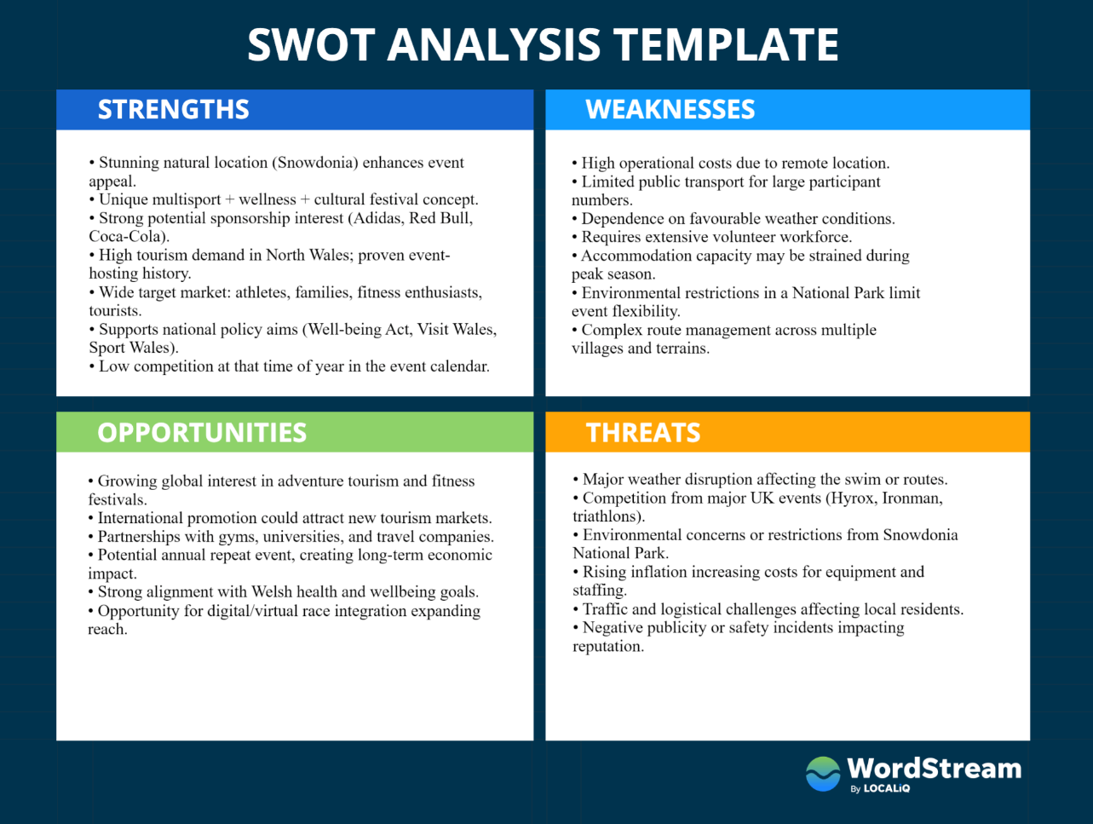
Appendix B
Pestle Analysis

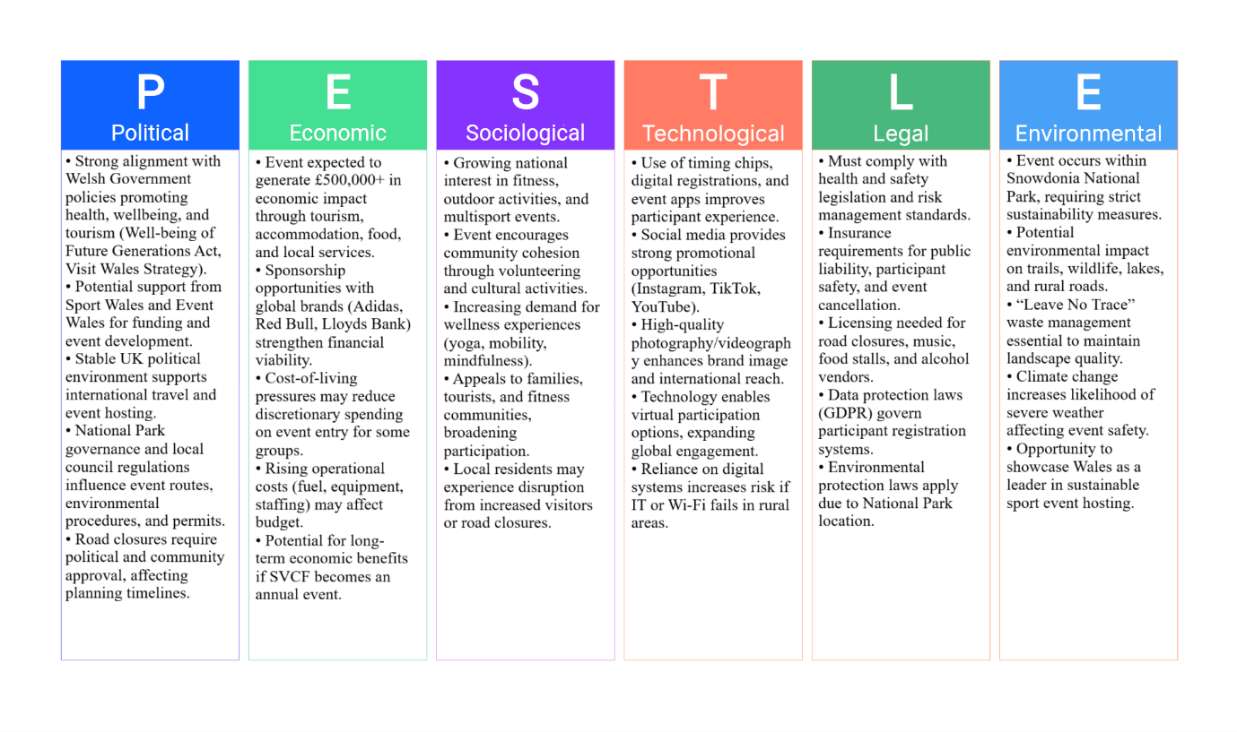
Appendix C - Risk Register
Risk ID | Hazard / Issue | Location / Area | Likelihood | Impact | Main Consequence | Existing Controls | Additional Actions Required | Owner
R1 | Severe weather (rain, wind, visibility) | Swim course, cycle, village | Medium | High | Disruption, cancellations | Weather monitoring, shelters | Bad-weather plan; shorten/cancel swim | Event Director / Safety
R2 | Participant injury (sprains, drowning) | Swim, run, cycle, fitness | High | High | Minor-serious injuries | Medical teams, lifeguards, marshals | Extra marshals, staggered starts, lifeguards | Safety & Medical Lead
R3 | Traffic incident with vehicles | Cycle route & access roads | Medium | High | Serious injury, legal issues | Road closures, signage, police | More marshals; resident notice | Operations Manager
R4 | Crowd congestion/bottlenecks | Registration, start/finish | Medium | Medium | Discomfort, delays, safety | Barriers, queue management | One-way flows; additional stewards | Ops Manager / Security
R5 | Medical emergency (cardiac, heat) | Entire event footprint | Low | High | Serious illness/fatality | Paramedics, ambulance onsite | Strategic AEDs; enhanced emergency plan | Medical Lead
R6 | Environmental damage (erosion, litter) | Trails, lake, village | Medium | Medium | Complaints, reputation | Waste bins, approved routes | No single-use plastics; sweep teams | Environment Lead
R7 | Volunteer/staff shortage | All operational zones | Medium | Medium | Insufficient safety/support | Early recruitment, training | Reserve pool; incentives | Volunteer Coordinator
R8 | IT/timing system failure | Registration, timing points | Low | High | Wrong results, delays | System testing, backup power | Printed lists; manual timing fallback | IT / Timing Manager
R9 | Financial shortfall | Whole project | Low | High | Failure to cover costs | Confirmed sponsors, multi-streams | Monthly reviews; contingency fund | Finance Manager
R10 | Negative publicity/complaints | Media, social media | Low | Medium | Reputational damage | Communication plan, standards | Complaints process; post-event debrief | Event Director / Comms

Appendix D
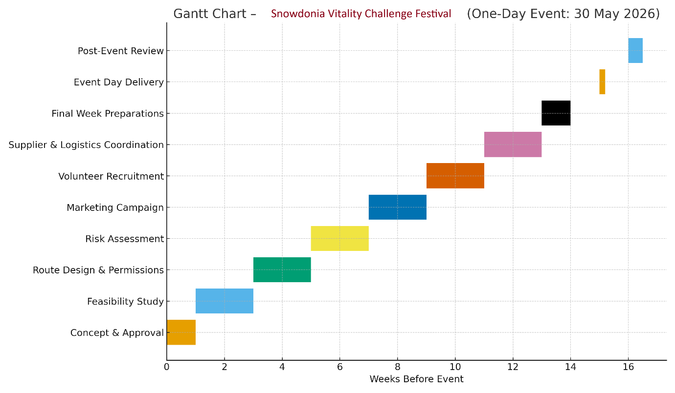
Appendix E
Budget Cost
Category | Item Description | Unit/Qty | Unit Cost (£) | Total Cost (£) | Funding Source
Venue & Infrastructure
 | Event village setup (tents, staging, power, signage) | 1 | 30,000 | 30,000 | Sponsorship / Grants
 | Route marking & barriers | 3 routes | 3,000 | 9,000 | Sponsorship
 | Toilets & sanitation (portable units) | 20 | 250 | 5,000 | Registration fees
 | Water stations | 15 | 200 | 3,000 | Sponsor (Coca-Cola)
Staffing & Volunteers
 | Event director | 1 | 5,000 | 5,000 | Grants
 | Operations managers | 2 | 3,500 | 7,000 | Registration fees
 | Safety & medical staff | 15 | 250 | 3,750 | Grants
 | Volunteer support (meals, shirts, training) | 100 | 50 | 5,000 | Charity support
Equipment
 | Timing chips & race bibs (3,000 units) | 3,000 | 10 | 30,000 | Registration fees
 | Fitness equipment for Hyrox zone | 1 set | 15,000 | 15,000 | Sponsor (Adidas)
 | Audio, PA & music setup | 1 | 7,500 | 7,500 | Sponsorship
Marketing
 | Digital advertising | 1 | 15,000 | 15,000 | Sponsorship
 | Print marketing (posters, banners) | 1 | 3,500 | 3,500 | Vendor fees
 | Content creation (photography, video) | 1 | 5,000 | 5,000 | Sponsorship
Insurance & Permits
 | Public liability insurance | 1 | 7,500 | 7,500 | Grants
 | Permits & licences | 1 | 3,000 | 3,000 | Grants
Catering & Services
 | Participant refreshments (3,000 participants) | 3,000 | 3 | 9,000 | Sponsorship
 | Vendor support (power, equipment) | 10 | 500 | 5,000 | Vendor fees
Transport & Logistics
 | Shuttle buses | 5 | 1,500 | 7,500 | Registration fees
 | Equipment transport | 1 | 5,000 | 5,000 | Sponsorship
Awards & Branding
 | Medals & trophies (3,000 finishers) | 3,000 | 1.67 | 5,000 | Sponsor (Lloyds Bank)
 | Branding (flags, finish arch, banners) | 1 | 4,250 | 4,250 | Sponsorship
Contingency
 | Emergency budget | — | — | 40,000 | All revenue sources
TOTAL EXPENDITURE |  |  |  | 240,000

Revenue Source | Amount (£)
Commercial Sponsorships (Adidas, Red Bull, Coca-Cola, Lloyds, Wizz Air, Shokz) | 90,000
Registration Fees (3,000 participants, avg. £50) | 150,000
Merchandise & Vendor Fees | 20,000
Public Grants (Event Wales, Gwynedd Council) | 20,000
Charitable Donations (Mind Cymru, Welsh Air Ambulance) | 10,000
TOTAL REVENUE | 290,000

Appendix F
Stakeholder Map
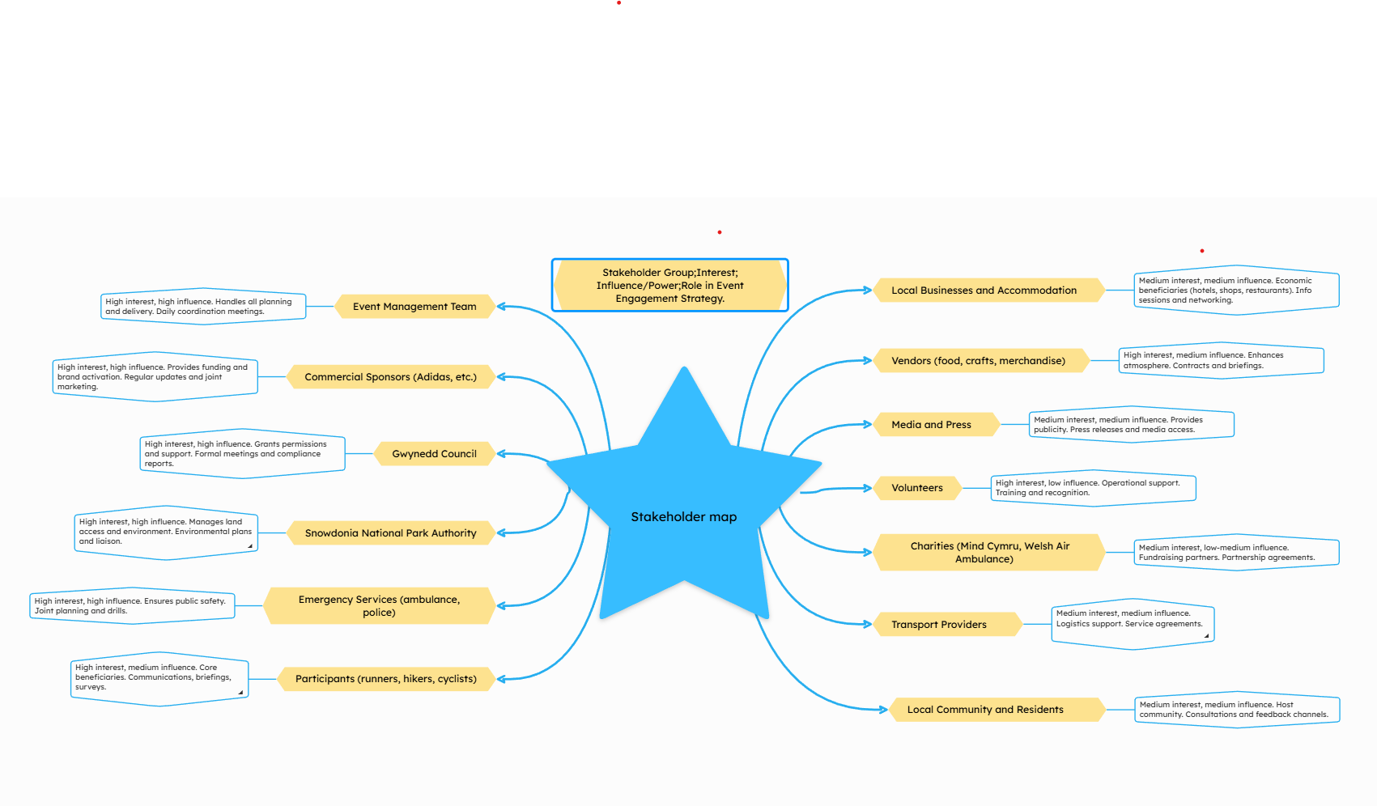

REFERENCES:

BRITISH TRIATHLON GUIDE TO RISK ASSESSMENT FOR EVENTS. (n.d.). Available at: https://events.britishtriathlon.org/uploads/content/British%20Triathlon%20Guide%20to%20Risk%20Assessment%20for%20Events.pdf
Cardiff Half Marathon. (2026, April 10). Cardiff Half Marathon | Flat, fast and scenic course around the Welsh capital. One of the UK’s best supported running events. https://www.cardiffhalfmarathon.co.uk/
Emery, P. (2010). Past, present, Future Major Sport Event Management practice: the Practitioner Perspective. Sport Management Review, 13(2), 158–170. https://doi.org/10.1016/j.smr.2009.06.003
Eryri National Park | Eryri National Park. (2025, November 13). Eryri National Park. https://eryri.gov.wales/
FIRST TIMER GUIDE (n.d.). 21st September 2025 2.4 MILE SWIM -112 MILE BIKE -26.2 MILE RUN. Available at: https://www.ironman.com/sites/default/files/2025-08/IM%20WALES%20FIRST%20TIMER%20GUIDE.pdf
HYROX Cardiff | HYROX. (n.d.). HYROX. https://hyrox.com/event/hyrox-cardiff/
Information for event organisers. (n.d.). https://www.gwynedd.llyw.cymru/en/Residents/Leisure-parks-and-events/Events/Information-for-event-organisers.aspx
Long Course Weekend. (n.d.). Swim, Bike and Run your way. https://www.longcourseweekend.com/
Mallen, C., & Adams, L. (Eds.). (2017). Event Management in Sport, Recreation and Tourism (3rd ed.). Routledge. https://doi.org/10.4324/9781315306155
Marathon Eryri. (n.d.). Marathon Eryri. https://www.marathoneryri.com/
Natural Resources Wales. (n.d.). https://naturalresources.wales/?lang=en
Parent, M. M., & Chappelet, J. (2015). Routledge Handbook of Sports Event Management. https://doi.org/10.4324/9780203798386
Sport England & Coachwise Ltd. (2007). Managing events. In Runningsports [Book]. https://www.britishfencing.com/uploads/files/90753_4_rs_managing_events_quick_guide_layout.pdf
Tables, S. (2021, May 5). Sports Event Management: 14 Secrets to Success. Social Tables. https://www.socialtables.com/blog/event-planning/sports-event-management
Universidad Europea. (2025, October 16). What is a PESTEL analysis in sports management? Universidad Europea (Universidad presencial: Madrid, Valencia, Alicante, Canarias, Málaga, y Online). https://universidadeuropea.com/en/blog/pestel-analysis/
Walzel, S., & Eickhoff, M. (2021). The social value of co-hosting: rethinking the management of sports events. European Sport Management Quarterly, 23(5), 1351–1369. https://doi.org/10.1080/16184742.2021.2010784

