Portfolio of written tasks

Student Name: Mohammad Mustafa Choudhry
Student No.: 2508098

Lecturer Name: Mr. Essa Bah

Employability and Career Development
LCLM4005
Certificate in Higher Education Business Skills for the Workplace

Table of Contents
1: Comparison of two job adverts 3
2: Self-Assessment & Evidence of Readiness 6
2.1: Self-Assessment: 6
2.2: Evidence of Readiness: 7
3: Employment Goals & PDP 9
3.1: Employment Goals: 9
3.2: Personal Development Program (PDP): 9
References: 10

1: Comparison of two job adverts
- Assistant Headteacher:
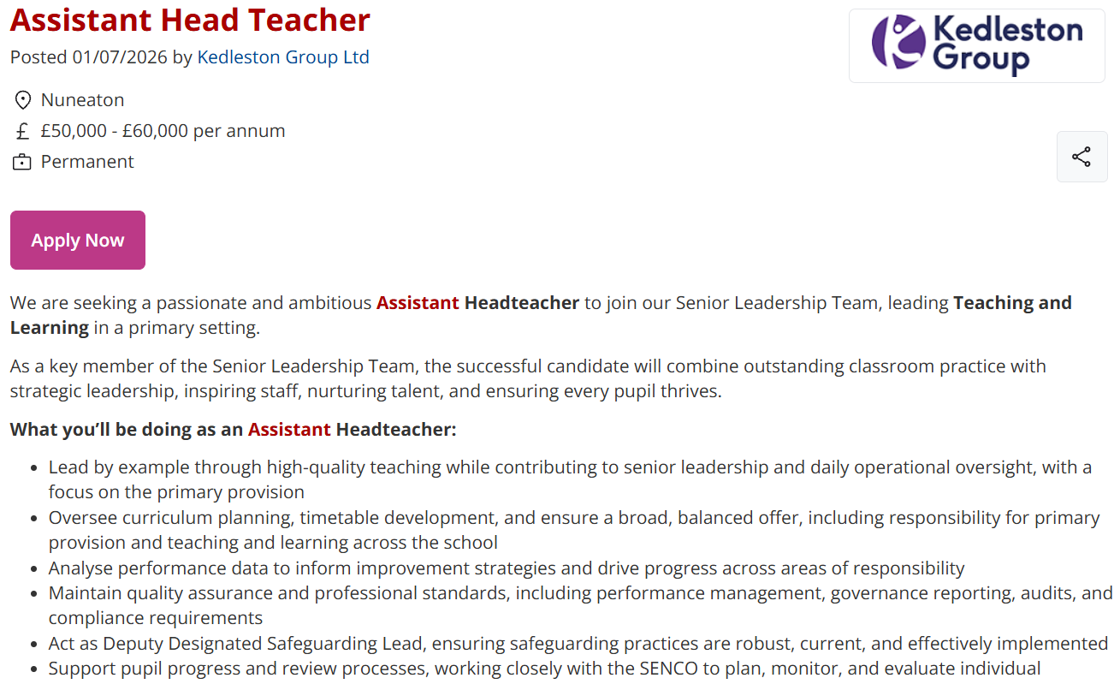
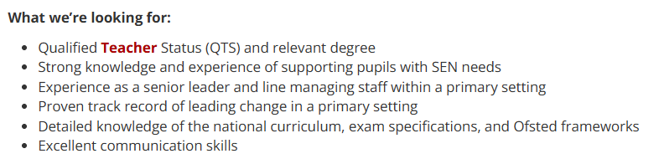
- Secondary school teacher: 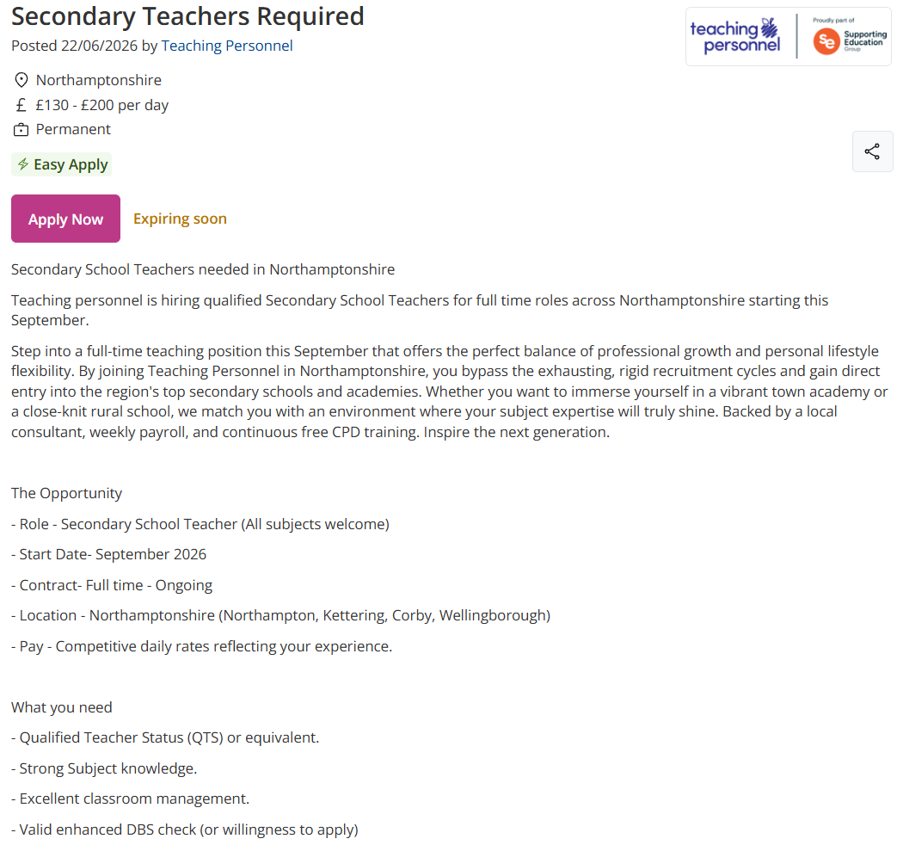

Table 1: Comparing two job adverts
Job adverts: | Key skills: | Qualifications: | Sources:
- Assistant Head Teacher | - Data analysist  - High-quality teacher  - Understanding student behaviour  - Excellent communication skills | - Experience of supporting children with SEN needs  - QTS  - Detailed knowledge of OFSTED frameworks | (Education-jobs.co.uk, 2026)
- Secondary school teacher | - Classroom management  - Lesson planning  - IT proficiency | - Strong subject knowledge  - QTS | (Education-jobs.co.uk, 2026)
Source: Authors own

A comparison between the requirements of the two roles helps to understand the demands of both jobs. With the two having a similar background relating to children, having a DBS is necessary for both jobs, and generally for any job involving minors. This is to ensure the applicant is safe to work in an environment where there is an exposure to children. Having a QTS shows that the individual also has the correct training required and can handle a classroom setting.
There are many differences between the two vacancies. The demands for the management role are substantially greater, considering that it is a far more difficult profession. This is evident in the fact that the applicant must have detailed curriculum knowledge, as well as recognition of the OFSTED framework. Furthermore, this job is in an environment where there are special needs children, a field where many teachers’ professional training doesn’t focus as much. Likewise, this role requires experience in this specific domain (working with SEN students). With limited experience, it would be extremely difficult to take on a leadership role.
On the other hand, there are many skills which the secondary teacher would require that the assistant headteacher does not. For example, the assistant headteacher role does not require strong subject knowledge, whereas the secondary school teacher does. This is partially due to the reason that the leadership role is in a primary school, while the teaching role is specifically in a secondary school environment. Likewise, the teacher should be able to handle a classroom in the most appropriate and effective manner. This is since they would be the only adult inside the classroom, controlling 30 students, who are at a transitional age. Having skills in this area would develop a good and strong connection between the teacher and students. It is also important that the applicant is proficient with their use of technology. Modern classrooms are surrounded by many technological tools, including computers, screens, printers, and many other devices. If they lack skills in this field, it will become exceptionally challenging.
In the teaching role, there is no demand for having any experience. This supports new graduates to easily progress with their career and further develop their CV. If the individual does have prior experience, this would be a means of increase in their wage.

2: Self-Assessment & Evidence of Readiness

2.1: Self-Assessment:
Table 2: Personal SWOT Analysis
Strengths:  - Effective communication with others  - IT & computing  - Ability to work under pressure  - Forbearing  - Passion for teaching | Weaknesses:  - Time management skills  - Limited experience  - Sometimes find it a bit challenging to engage children with learning disorders
Opportunities:  - Placements in different schools  - Many new local institutions requiring staff  - Continuing with further education | Threats:  - Competition for jobs  - Heavy workload  - Constant versatility with curriculum
Source: Author’s own

A SWOT analysis is a useful tool which enables an individual to evaluate their strengths and identify their weaknesses. This facilitates a person to determine which jobs and role are suitable for them. If you can identify and understand your strengths and opportunities, you will know where to tread with confidence and security. (Chaggan, 2021)
From my strengths is that I have effective communication skills. This is very important in a teaching role, evidently in the fact that a school environment involves communication with children, fellow staff as well as parents. Likewise, having a passion for teaching is vital. This is because should there be a lack of passion, this would also reflect upon the progress of the students as well. Whereas if there is passion, then the teacher would do everything in their capacity to ensure that the children get the optimal level of education.
Sometimes, I find it challenging to manage my time. This is more so when I have an overloading workload, which can pose as a threat to me. For example, if I was given several tasks with a limited timescale, it may be tough to balance out my activities, thus making it wearisome as well as burdensome. Additionally, I have experience limited to one school. Having more experience would grant me a further understanding of students and their psychological sense.
There are many opportunities which can help me progress in my career. For example, there are many local institutions which require teachers. This supports me, as I would not have to travel, as well as them being easily accessible for me. I could also further expand my expertise by studying to a PhD level. This would enlarge more job opportunities for me and would help me develop my skills in a certain field.
One of the things which can impact me negatively is a high competition for jobs. Although some schools have many vacancies, there is a slow increase in teacher trainee numbers, with an increase in 11% between 2024-25.

2.2: Evidence of Readiness:
There are many individuals with qualifications in teaching. But employers don’t only look at this; rather, they search for skills, experience and evidence for these forms of personal development. This section will include indications to my work experience, and feedback from mentors and peers.
During my maths bachelor’s degree in university, I was able to develop skills which are relevant to this job. This specific science of maths supported my critical thinking, problem solving abilities, and subject knowledge. It also enhanced my ability to convey complex information in a clear tone. Assignments helped to have good organisational skills to meet deadlines and improve my time management skills, which would aid my career when it comes to lesson planning, attending meetings staff meetings and managing classroom duties. When I would complete my assignments, my lecturers would give me feedback on what went well and where I had room for improvement, which taught me valuable lessons, especially when it would come on techniques which could be deployed to appeal to the audience, advancing my communication skills.
During my degree, I was also able to undertake a role at a part-time religious institution, teaching children of various ages ranging from 6-16 how to read another language. This job helped me to understand the way children think and learn, all whilst keeping them engaged and happy. This also improved my confidence in adapting to the needs of the children. One aspect which developed my temporal efficiency was the class timings, which was limited to one hour, so being punctual as well as efficient was of foundational importance. The headteacher would come often to my classroom to discuss ways in which I could further improve and make the lessons more captivating for the students. I would also get advice from my fellow staff members who were more senior than me. Receiving this advice helped me build my character as an innovative teacher. I would also frequently liaise with parents regarding their child’s progress and how they can have an meaningful input on the child’s education.
Outside of my studies and teaching, volunteering in the local community has also enhanced my vocal and leadership skills required in secondary school teaching. I regularly delivered talks directed towards the youth, which would require a considerable amount of adaptability, as well as some education-based lectures to the wider community. This bolstered my public speaking as well as research skills, as I would have to strengthen my foundation in that specific topic before teaching it. So speaking to different audiences obligated me to build adaptability for the audience, as if I was to have a “one size fits all” approach as the business speaker Ian Altman describes it, the audience would lose interest within the first couple of minutes of the speech, making it ineffective and conclusively useless, losing the ultimate purpose of the speech.

3: Employment Goals & PDP

3.1: Employment Goals:
My short-term goal is to complete the final stages of my teacher training before going on to secure a job as a maths teacher in my local secondary school. Thus, I will be able to apply what I have learnt, and implement all the skills I had developed, regularly seeking feedback from my manager and actively improving where I can. I aim to solidify my role as a teacher by having intriguing, engaging lessons through which the students can learn in an enjoyable environment. I also aim to take regular feedback from department leaders.
Over the long-term, I aspire to build a strong reputation as a high-level, competent maths teacher. As I build this credibility, I also aim to ascend in my duties to become a Head of Department, where I can commit to improving the students’ education to a far greater degree, as well as supporting fellow staff with innovative teaching ideas.

3.2: Personal Development Program (PDP):
Table 3: PDP
PDP | Addressing those weaknesses | Timeline | Resources needed | Success Measure
Develop behaviour management skills | Trial different, modern techniques, observe and take advice from seniors | Within 1 year | School behaviour policy, using CPD training | Positive contribution in lessons by students, decreasing behaviour issues
Widen experience | Going for placements, taking a temporary supply teacher role | During training / +1 year | Local schools, university student services | More confidence in teaching class
Learn how to deal with SEN (Special Educational Needs) students | Undertake SEND training, observe such lessons | Within 1 year | Training services, school mentor teachers | Positive contributions by such students, improved grades
Source: Author’s own
This PDP table is a structural device helps me amend the weaknesses identified in the SWOT analysis, converting them to strengths.
CPD training stands for ‘Continuing Professional Development’. This refers to the structured process of tracking and documenting the skills, knowledge, and experience gained throughout a professional career, both formally and informally, beyond initial qualifications (The CPD Standards Office, 2014). This would help me with enhancing my behaviour management skills and practically implementing them whilst studying them.
To widen my experience, I can go to placements during my studies, saving time for me rather than completing my studies then trying to get experience, allowing me to utilise the valuable years.
Learning to handle SEND (Special Educational Needs and Disabilities) students is very important, especially considering that they had an increase to 14.2% accessing such services (High Speed Training Limited, 2026). This would expand my skillset as well as opening new opportunities, making me a flexible teacher, able to teach any group of students presented.

References:
Education-jobs.co.uk. (2026). Assistant Head Teacher by Kedleston Group Ltd in Nuneaton Ref: 225318798. [online] Available at: https://www.education-jobs.co.uk/job/225318798/assistant-head-teacher
Education-jobs.co.uk. (2026b). Secondary teachers required by Teaching personnel in Northamptonshire ref: 225275753. [online] Available at: https://www.education-jobs.co.uk/job/225275753/secondary-teachers-required
Chaggan, K. (2021). A guide to a personal SWOT analysis: Preparing for your next role. [online] Pepperdine.edu. Available at: https://bschool.pepperdine.edu/personal-growth/article/personal-swot-analysis-guide.htm
Department for Education (2025). More people training to teach. [online] GOV.UK. Available at: https://www.gov.uk/government/news/more-people-training-to-teach
Altman, I. (2018). 3 Keys to Deliver An Amazing Presentation Suited to the Room. [online] Available at: https://www.inc.com/ian-altman/whether-speaking-in-a-convention-center-or-a-conference-room-you-can-deliver-an-amazing-speech-every-time.html
The CPD Standards Office (2014). What is CPD? - The CPD standards office. [online] The CPD Standards Office. Available at: https://www.cpdstandards.com/what-is-cpd/
High Speed Training Limited. (2026). High Speed Training Limited. [online] Available at: https://www.highspeedtraining.co.uk/courses/education/special-educational-needs-and-disabilities-course/

