Organisational Performance and Culture in Practice

AC 1.1
What is organisational structure?
Organisational structure can be defined as how employees are arranged within the organisation and the roles they hold (Campbell and Craig, 2005, p. 54). Structure creates a clear understanding of people’s responsibilities within an organisation.
Flat non- hierarchical structure
Kirsten managed Calmere House, an organisation consisting of 42- employees as a flat non- hierarchical structure. A flat non- hierarchical structure is when there are “empowering teams with fewer management levels” (Baigey, 2025). As a result, there are minimal levels between the employees and company founders.
The case study highlights that whilst the organisation was managed by Kirsten as a flat non- hierarchical structure the organisational culture was extremely positive which resulted in elevated levels of retention. “An organisation is made up of human relationships and human interactions.” (CIPD, 2024) Kirsten was able to maintain this well as a flat structure.
Employees felt valued valued because regular staff meetings were being held whereby, they could raise any concerns, and solutions would be discussed. Solutions could be made promptly due to Kirsten not having to liaise with numerous departments or managers.
The positive work organisational structure was easier to achieve because the organisation could be morally based opposed to policy based. Although policies are the fundaments of an organisation, human aspects need to be taken into consideration by their line manager. This can be harder to achieve with a hierarchical structure because no two people have the exact same morals and an organisation cannot be seen as biased towards selected people.
Hierarchical Bureaucratic Structure
Calmere House was sold to chaffinch Group, a large care home company. Due to the company being a large organisation, they use a hierarchical bureaucratic structure. A hierarchical bureaucratic structure is an organisation which can look like a “pyramid, with a few individuals at the top wielding the most power and numerous lower-level operatives at the base who have limited decision-making authority.” (Mercadal, Trudy M, 2021).
This structure minimises the risk of confusion of who to report to and where to be directed with different queries. The hierarchical structure means that there are multiple managerial levels meaning, the managers who are in direct contact with the carers will have a manager that they need to report into. The case study shows that Kath, the direct line manager, reports into one of eight area mangers, who reports to one of two general mangers, who reports to an operations director. This allows the direct line manager’s performance to be monitored ensuring, they are managing in compliance with company policies however, this could result in longer waiting times in regards to solutions for problems and queries that carers may raise because managers will need to liaise with their line managers within the hierarchical structure. The bureaucratic structure means that there are designated departments for example, HR, H&S, Payroll, etc. Chaffinch Group has a recruitment advisor whereas before, each staff member participated in the recruitment process and the selected candidate would be at the discretion of Kirsten and staff. The recruitment advisor would have experience in identifying a candidate and would likely have qualifications within their role however, this left employees feeling unheard and undervalued.
Employers have a duty of care to “do all they reasonably can to protect workers' health, safety and wellbeing at work.” (ACAS, unknown) therefore, if an error does occur the hierarchical control helps to identify who is liable for an error and can be dealt with in line with company policies and procedures. On the contrary, you must be mindful that a blame culture in not developed within the organisation. Unfortunately, the case study implies that the carers wellbeing at work was not prioritised which resulted in a negative organisational culture.
Evaluation
As highlighted within the case study, employees had a positive relationship with Kirsten which worked well and resulted in a stable workforce. Due to the organisational being led as a flat non- hierarchical structure, employees felt included, valued and heard. Alternatively, this led to Kirsten’s burnout and was not sustainable.
After Chaffinch Group took leadership of Calmere House, turnover increased, they were not retaining customers and was unable to reach their full potential. If the Transfer of Undertakings Protection of Employment) Regulations 2006 Act was followed correctly and they had managed the change effectively the hierarchical bureaucratic structure could have been effective and Calmere House could have reached their full potential and met their goals.
AC 1.2
What is strategy?
Strategy involves creating a plan for an organisation to undertake to reach its aims and objectives and highlights the direction of future needs. It is “the determination of the long- term goals and objectives of an enterprise, and the adoption of courses of action and the allocation of resources necessary for carrying out these goals” (Chandler,1962).

Why does an organisation need strategy?
Strategy allows individuals to have a clear direction in what they are thriving for. All individuals are thriving towards the same goal therefore creates a sense of unity. It is essential that the strategy used is in line with the organisation structure to succeed.
Strategy allows individuals to be hired, managed and developed which in turn improves the performance of the organisation.

Rational approach to strategy
A rational approach to strategy is conducted when an organisation identifies a future risk to the organisation. It is a “systematic, analytical process” (Johnson, Whittington and Scholes, 2017) whereby defined aims and objectives are put in place to attract and retain customers. In order to keep morale high they must set an achievable time frame.
Chaffinch Group has set a goal to fill 100% of rooms within six months. To achieve this, they can use the following four stage of a rational approach to strategy:
- Formulation
- Planning
- Implementation
- Evaluation
Formulation
This is when the plan is created and where internal and external factors need to be evaluated. Chaffinch Group will need to analyse internal factors such as strengths and weaknesses and external factors like opportunities and threats (SWOT analysis).
External factors to consider would be competition. What can Chaffinch Group offer that would attract customers? When Calmere House was under Kirsten’s management, customers could decorate and personalise their room. This is not a common feature, therefore, can attract customers.
An internal factor to consider would be the culture of the organisation. It is evident that the culture of the organisation is not positive which effects employee performance. If the performance is not at a high standard, customer turn over will increase.
Planning
It is essential that a clear plan is put in place, so everyone is thriving to reach the same goal.
Chaffinch Group has a hierarchical bureaucratic structure therefore could use a horizontal integration approach to strategy. This is when an organisation synergises operational departments (Inbound Logistics, 2024) and duties are designated to specific business functions. An example of horizontal integration approach would be the onboarding process.
AC 1.3
External factors within n organisation
The most effective process to use when evaluating external factors of an organisation is PESTLE. PESTLE is an acronym for “Political, Economic, Sociological, Technological, Legal and Environmental” (CIPD, 2025c). A PESTLE analysis is used by people professionals when decision making.
An external factor creating a negative impact on the residential care industry
Economic:
An external factor affecting the residential care industry and the UK as a whole is the cost-of-living crisis. Due to the increase of the cost-of-living, budgets may need to be increased when discussing change within the organisation.
Health.Org completed a survey and found that “Over a quarter of the UK’s residential care workers lived in, or were on the brink of, poverty” (Allen, Williamson, Berry, Alderwick, 2022). Unfortunately, a residential workers salary is often minimum wage therefore is not competitive meaning, individuals are thriving for different work.
Currently in the UK minimum wage is £12.21 (UK Government, 2025a).
This can be avoided by offering above average salaries however, Chaffinch Group would have to review their budget.
One significant economic external factor which is having a negative impact on the residential care industry is the continuous increased cost of labour and operating expenses, following increases in the National Living Wage, inflation and energy price alongside limited funding.
According to research undertaken by leading meals provider, Apetito, in partnership with Care England, 98% of care homes are still experiencing rising costs on a month by month basis (Care England, 2025).
Within recent years the residential care industry have faced “council budget costs, staff shortages, the cost-of-living crisis” (Smith, D & Hichens, J, 2024).
As a result of the staff shortages, quality of care is reducing due to not having the capacity to provide adequate care to individuals. If Chaffinch Group have a reputation of being unable to provide sufficient care, their goal of filling 100% of rooms in six- months is highly unlikely.
Council budget costs and the cost-of-living crisis does not allow carers to be competitively remunerated; therefore, individuals are more likely to choose employment in retail or hospitality which pays similarly but has less emotional and physical demand. This justifies agency workers resulting in an increased cost for Chaffinch Group.
To conclude, increased labour and operating costs have contributed to the economic external factor which is having a negative impact on the residential care industry. This could have contributed to why Calmere House made the decision to sell. Chaffinch Group’s financially driven management approach has played a contributing role in the workforce instability and decrease in occupancy.

An external factor creating a positive impact on the residential care industry
Political:
To become a standard residential carer in the UK you must retain GCSE qualifications or equivalent however, it is also on- the- job training.
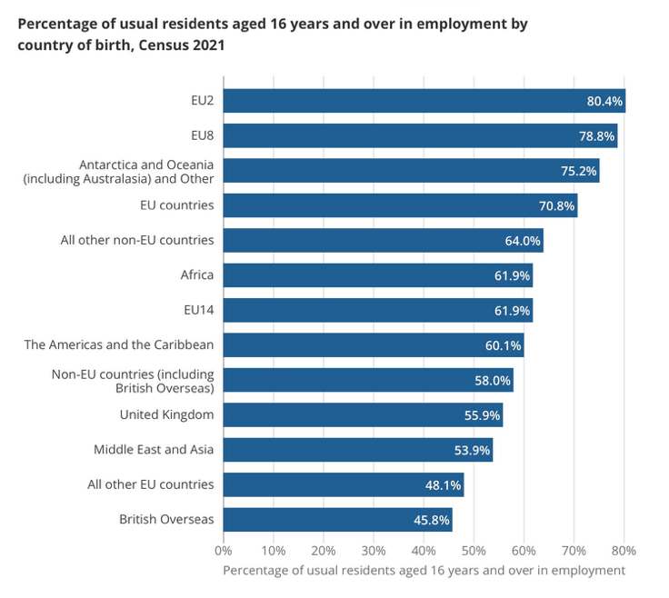
Office for national statistics completed research and identified the below:
(Census,2021)
Since 2021, immigration has increased and in June 2025 records showed that there was a total of “852,000” (UK Government, 2025b) visa’s issued for non- visit reasons such as, employment.
The residential care industry does not require extensive formal qualifications and therefore, is a gateway to employment for migrants. As a result, recruitment has become a faster, easier process. As a result, care homes are less likely to become understaffed.
Technological:
Technology is forever evolving and between 1988 and 1992 digital care systems were introduced to hospitals. (Newton, C, 2024). Not long after, they were introduced to the residential care industry. Introducing and utilising digital care systems have had a positive impact on the residential care industry because it has improved quality, safety operational performance and reduces administrative time when utilised effectively.
Care planning systems and medication management tools allow accuracy and improves compliance with regulatory requirements. Chaffinch Group is a large organisation therefore, these technologies also provide improved monitoring of multiple care homes.
Utilising technology could support Chaffinch Group’s strategic goal of achieving 100% room occupancy. For example, digital systems could highlight standards of care to regulators and residents which, therefore, improves trust and market reputation.
In summary if Chaffinch Group were to provide training and align technology with Calmere House’s original humanistic approach, introducing technology could improve employee engagement, restore continuity of care and enhance resident experience, positively contributing to financial performance and long-term sustainability.

Analysis
The residential care industry has numerous strengths and weaknesses in regards to external factors as previously highlighted therefore, it is imperative that a PESTLE review is undertaken during a change in strategy.

1.4
Technology within the workplace
Technology plays a massive part in the workplace; it cannot be underestimated. “Technology is the new bandwagon that everyone is jumping into; it is the new driving force of today’s world.” (Geet Gunjan Deka, 2019). Technology is constantly evolving and therefore, companies must evolve alongside it to stay competitive and remain as efficient as possible.

Types of technology that is effective in the workplace

Digital care management system:

Originally, employees and customers information was stored as paper copies however, as technology evolved information is now being stored on digital management systems. The advantages of this are:
- Prevents a breach of general data protection regulation (GDPR) and/ or security breach
- Easier to store and locate information.
- Prevents sensitive information being misplaced.
- Processes information fast.

The disadvantages of this are:
- Management systems can be quite expensive.
- Training will need to be conducted.
- If organisations are only now introducing technology, individuals may feel less confident using technology I.e. older generations.

Integrating a digital management system supports people professionals in day- to- day work related activities. Residential care homes could use it to store information which needs to be located and identified for example, next of kins, DNR, medical history, etc.

Alternatively, individuals using the system must be vigilant and aware of GDPR regulations.

Artificial Intelligence (AI):

Research shows “60% of employers” (World Economic Forum, 2025) are expecting AI to transform businesses by the year 2030.
Most employers are already using AI but are not aware. The CIPD conducted research into this and identified the following:
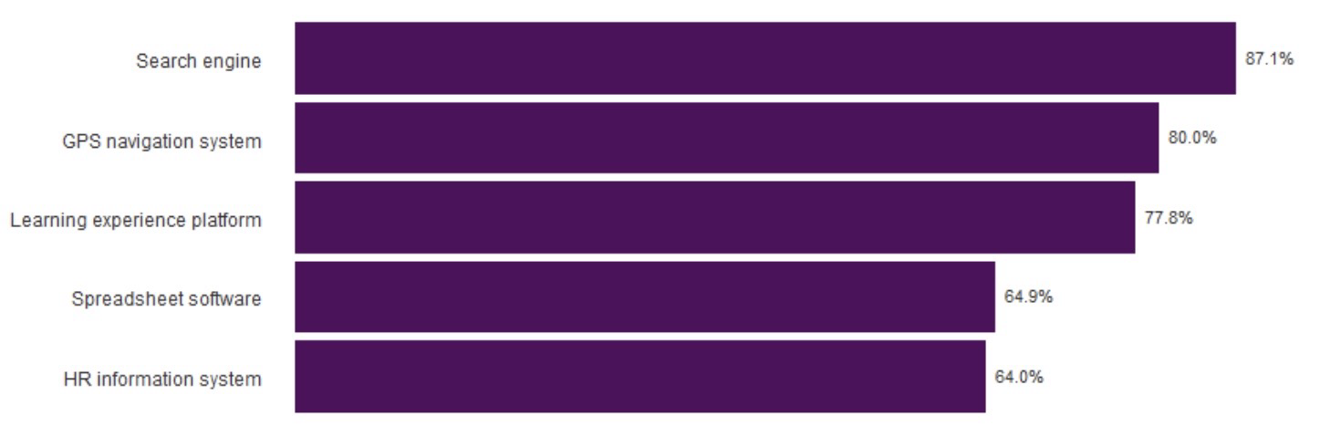
(CIPD, 2023d)

AI is so highly utilised because it is, quicker and more efficient, you are able to filter and sort data, it enables improved productivity and is cost saving.

Alternatively, the disadvantages of using AI in the workplace is that it eliminates the human element and empathy, creates job displacements, can be costly and can create cybersecurity risks which could result in a breach of GDPR.

Involving AI can be used as a cost saving exercise for example, Chaffinch Group could ask AI to create engaging job advert minimising the job roles of their recruitment agent. Taking away the human element would create less of a need for the number of individuals in the department meaning they would need to pay less salaries but still the cost of AI.

Chaffinch Group’s introduction of a digital care management system (DCMS) would positively modify the daily work of carers and senior carers at Calmere House. A DCMS would ensure benefits such as safety and efficiency.
For carers, a DCMS would benefit them day- to- day because it could replace paper-based and ensure accuracy, improve communication between shifts which would reduce the time taken to complete handovers, and reduce errors in essential information such as nutrition, mobility, and medication.
Initially, carers may feel increased pressure before they get used to utilising a DCMS alongside their contracted duties. If not well integrated, it could result in decreased productivity and morale in the workplace lowering. It is important to take into consideration that it’s effectiveness will be dependant on the implementation process.
For senior carers, the system would provide better oversight and accountability. Dashboards and alerts could facilitate monitoring of care plans, medication administration, and risk assessments, thereby ensuring compliance with rules and regulations. In turn, this could improve decision-making and enable senior carers to identify issues at earlier stages. Alternatively, it could increase measurable accountability, which results in added pressure within Chaffinch Group’s hierarchical structure.
Overall, the operation of Chaffinch Group would run smoother and efficiently if they utilised a DCMS however, due to decreased wellbeing in the workplace the success rate of implementing a DCMS is low because engagement is low.

2.1

What is Organisational Structure?

Edgar Schein, an influential psychologist, identified three levels of organisational structure:
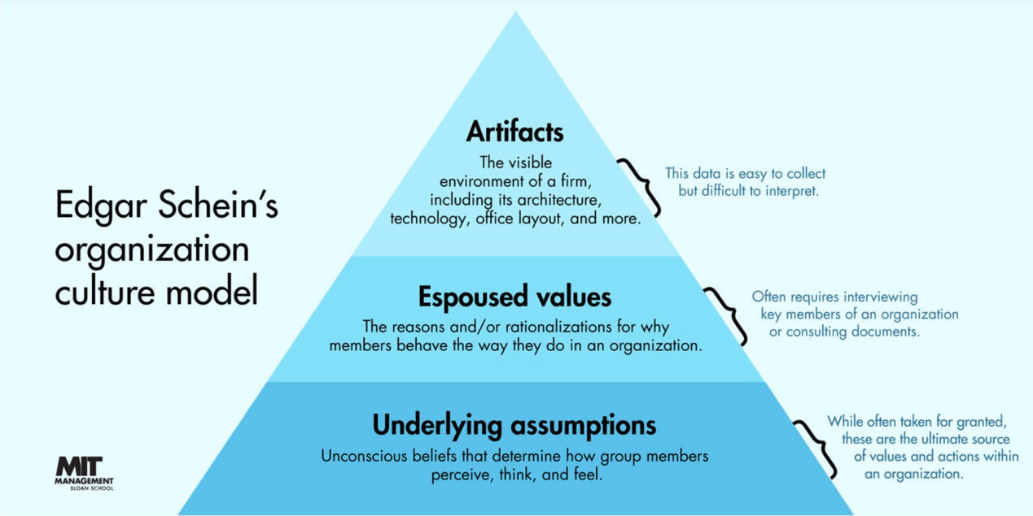
(Schein, 2023)

Artefacts: This is a reflection of the blues of the company which creates the company culture and the way the organisation presents itself.
Chaffinch Group has a hierarchical bureaucratic structure, therefore, has a role culture. Organisations that have a role culture have structured procedures and hierarchies and each person has a clear understanding of where they belong within the hierarchy (Personnel Today, 2023). Chaffinch Group has multiple managerial levels creating a gap in communication. The individuals at the bottom of the hierarchy at Chaffinch Group has very little employee voice leading their concerns to feel unheard.
Espoused values: This is how an individual may portray an organisation and can be measured by looking at their “missions, goals, value statements, and social contracts” (Geraghty, 2021).
Residential care workers at Chaffinch Group must treat all customers with respect, compassion and dignity. They must also prioritise the safety of residents.
Underlying assumptions: On the contrary to espoused values, the underlying assumptions are the reality of the culture. These are the beliefs which guides the behaviour of the organisation. The underlying assumptions and espoused values may be inconsistent and can then highlight why an organisation may say one thing but act in another.
Chaffinch Group seems to be prioritising revenue over the care for residents. This is highlighted when they refurbished the rooms which left residents feeling as though their room lacked individuality.
The Scarf theory was created by David Rock in 2006 to help measure the positivity of an organisation.
- Status – this is the perception of where you are in regards to people around you. Increase in status, results in engaged employees. Feedback from others can be volatile therefore, allowing people to self reflect can be beneficial.
- Certainty- in emergent situations people can become uncertain and become disengaged. Providing a timeframe my be beneficial because individuals have a target goal.
- Autonomy- allowing individuals to think for themselves and make choices. Individuals are left with little decision making when being micro- managed.
- Relatedness- if individuals haven’t bonded with others they can be seen as a threat. Virtual teams need to work harder to create bonds to feel less like an outsider.
- Fairness- leaders need to be clear about treating people fairly to improve engagement.

2.2

Recruitment and selection have an emphasis on personal values and behaviour when including members of the department that will need to work alongside the potential new employee.
Chaffinch Group has now taken a bureaucratic approach to the recruitment and selection process and is completed by a recruitment advisor opposed to when Calmere House was managed by Kirsten whereby, co- workers were involved in the selection process. This has resulted in turnover increasing. Taking employee’s views and opinions into consideration allows employers to make a fully- informed decision (ACAS, 2021).

The onboarding process is an opportunity to promote company values, policies and explain how they are integrated into the organisation.
Chaffinch Group took the initiative to outsource agency workers instead of recruiting. Community Care undertook research which highlighted that the increased “reliance on agency staff was affecting quality of care with 73% finding them less reliable” (Turner, 2022). This could be because they are not long term employees of an organisation and therefore, may not share the same values as the company culture and not familiar with company polices and procedures. This would be a factor that has resulted in the negative company culture at Calmere House under Chaffinch Group’s management.
Chaffinch Group stated that they have an autocratic management style meaning that when instructions are delivered, there should be no discussion. This is also applied to the recruitment and selection process, candidates are chosen be a recruitment advisor without prior discussion with current employees. This is not an effective approach towards performance management. This leads to a loss of employee voice resulting in a loss of trust and confidence in management. Open communication creates trust in an organisation, allows employees to feel safe to express ideas, concerns and feedback which boosts morale. It is highlighted that employees are not being managed ethically.

Employee voice is the considered fundamental right that employees retain to raise their views, ideas, concerns and suggestions to sway organisational decision- making. (CIPDk, 2023). Employee voice during the recruitment selection ensures fairness, inclusivity and organisational performance.
Chaffinch Group could consider undertaking consultations throughout the workforce planning, have employees present during interviews and the recruitment advisor could discuss the qualities individuals could bring to the organisation if they were hired and allow critical feedback from employees to allow employee voice during the recruitment and selection process.

To improve employee performance organisational culture and behaviours Chaffinch Group could use rewards as motivation and appreciation. Motivation is followed by organisational appreciation. Motivation is an individual’s enthusiasm or willingness to complete their task. A motivated employee creates a higher “drive productivity, better products or services, and innovation” (CIPD, 2023e). When an employee is motivated, they retain a happier outlook on their job. Individuals can be motivated by different things, a main one being reward. An individual can be motivated by extrinsic factors such as pay, job title and bonuses. Being awarded a higher job title or pay rise can create intrinsic benefits such as feeling appreciated. An intrinsic reward is when you acknowledge and compliment an employee for their hard work. An employee can be motivated to maintain high levels of work standards when they know their hard work is identified and valued. As a result, this strengthens their relationship with their manager.
Chaffinch Group could consider training to help highlight the values of the organisation and the desirable behaviours. They should consider whether managers have been trained in constructive leadership.
Has Chaffinch Group recruited in line with organisation goals and structure? Too identify this, they should question if potential new employees are willing to learn and develop their knowledge and does the individual align with the core values of the organisation? This is an unrealistic task to achieve when agency workers are being utilised.

2.3

John Kotter created an 8- step model for change:

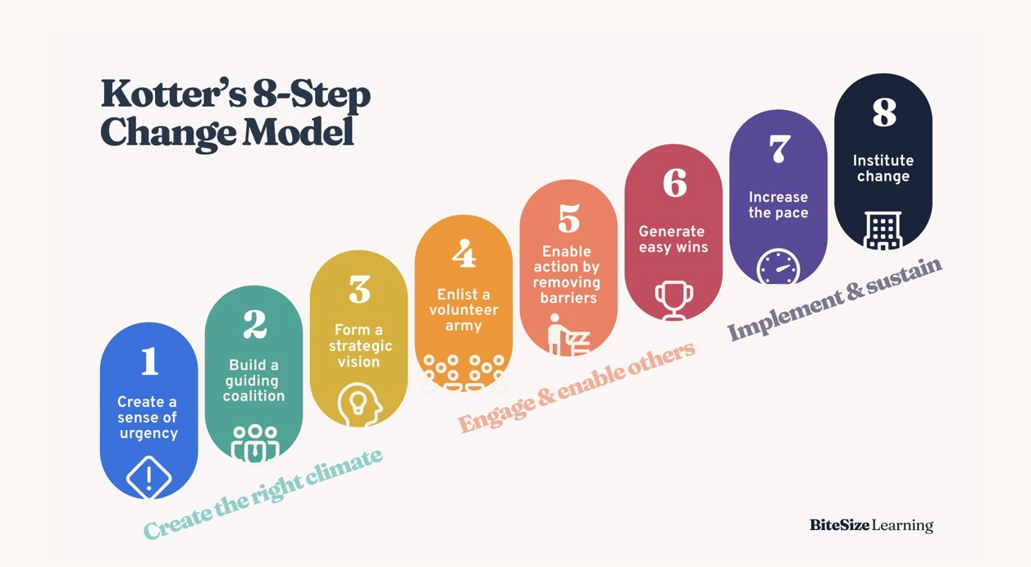
(Bitesize Learning, 2024a)

Step 1: Chaffinch Group could have explained why the structure of the organisation needed to be changed from a flat non- hierarchical structure to a hierarchical bureaucratic structure. They could have been clearer on their goals and how they would achieve them.
Step 2: At this stage, roles will be delegated to different departments and individuals.
Chaffinch Group completed this however, during that process, employee voice was lost. Chaffinch Group needed to be reminded that “this isn't just about senior leadership - include respected team members from various levels” (Bitesize Learning, 2024b). This allows a true insight into the organisations flaws due to the carers have a true insight into the negative impacts of the organisation.
Step 3: This is where you envision your goal and how the company will portray itself after the change has been completed. An achievable deadline must be set in order to maintain enthusiasm towards the change, prevent the feeling of failure and a work- life balance. During this stage, you could use the acronym SMART as the baseline of the change. SMART is an acronym for, “Specific, Measurable, Achievable, Relevant and Time- Bound” (CIPD, 2025f).
Specific- This is where the change needs to be made clear to everyone so that everyone is aware of the goal they are trying to reach. This creates a sense of unity, and no one feels left behind.
Measurable- A clear criteria must be completed in order to measure the success of the change or whether it is failing.
Achievable- As an organisation, will the change be achievable. The organisation will need to take into consideration internal and external factors that may affect the change.
Relevant- Chaffinch Group will need to consider whether the change is in line with the company objectives and question if the bureaucratic hierarchical structure is suitable.
Time- bound- Chaffinch Group will need to envision an achievable timeframe whereby, the structure will be affective.
Step 4: Ensure communication isn’t being lost during the change. Feedback from everyone minimises the risk of worries becoming a long-term negative effect. Chaffinch Group should take the IKEA effect into consideration. The “IKEA effect describes the increased value people place on objects they have partially created themselves.” (Travers, 2024). Chaffinch Group’s approach is once an instruction was delivered, no discussion is required. This is an ineffective, negative approach which created a negative company culture.
Step 5: This is where Chaffinch Group will need to identify obstacles and minimise the risk of mistakes. Mistakes are inevitable therefore, it is essential to prevent a blame culture being developed in the workplace. A blame culture can create a sense of fear (Department of Health and Social care & Hunt, 2016) leading to errors not being raised and errors being missed.
Step 6: In order to maintain momentum, small wins should be recognised. This can be a simple recognition from their line manager to highlight that their hard work is being recognised.
Step 7: Individuals should have found their placement within the change and the change can now be executed at a quicker pace. This is also the stage whereby, Chaffinch Group could be introducing new changes and their next goal I.e. filling 100% of rooms within six months.
Step 8: Now Chaffinch Group should update their policies in line with the hierarchical bureaucratic structure. Going forward, the onboarding process and management training should reflect the new change.

2.4

It is essential that when a TUPE transfer is undertaken that employees are updated with changes, measures that the proposed company envisage taking is communicated and the onboarding process is prioritised.
The Kubler Ross Change Management model highlights the stages that employees experienced when their employment transferred from Kath’s management to Chaffinch Group at Calmere House.
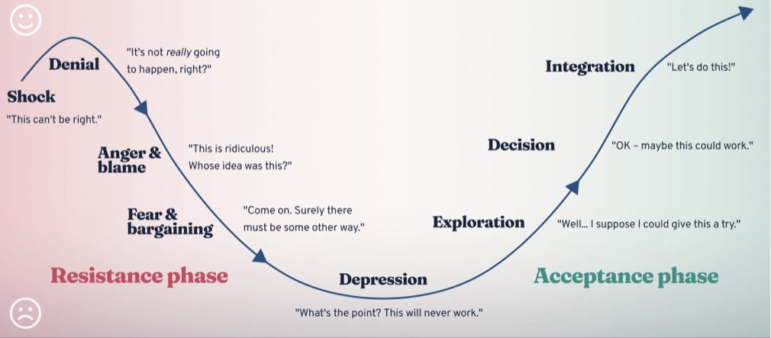
(Bitesize Learning, unknown)

There are two phases to change:
Resistance phase
Initially, it may have been a shock for employees were “shocked” that Kath had decided to leave Calmere House because the company culture was positive, the organisation was thriving and it was inherited from her parents. The employees maybe in denial when they receive formal notification of the change. The next emotion would be anger and blame. Employees may have felt resentment due to not knowing what the future holds and because their current work life is so positive. Employees may start to feel fear and begin bargaining with Kath to try and convince her to stay. After attempts to try and stop the change, employees may feel low and powerless.
Acceptance phase
This phase is likely to begin when the proposed measures that Chaffinch Group envision taking. Employees may decide to be more open to explore the decision for change. After the onboarding process has been completed they should feel ready to be integrated into the new caring provider.
The leadership style, communication and cultural change significantly shape employee's experiences (Kotter, 1996). This is crucial and Essentially, employees are grieving the loss of their work life therefore, Chaffinch Group should be supporting the employees as best they can and making them a priority. unfortunately, it seems as though Chaffinch Group didn’t follow an open transfer procedure leading carers to feel unheard and undervalued when their employment transferred. This lead to carers being closed minded to the transfer which could be a factor to why turnover and absence rates were higher than expected.

2.5

Wellbeing at the workplace is the protection of employee, physical, mental and emotional health. Prioritising wellbeing is beneficial to the organisation as a whole because it is a “core enabler of employee engagement and organisational performance.” (CIPD, 2025g)
Two factors that Calmere House should consider are a work life balance and quality of relationships between employees and managers.
Work life balance
A work life balance is a good balance between someone’s time between working and family or leisurely activities. After Calmere House was being managed by Chaffinch Group, employees began to leave due to the new culture. Ultimately, this would put added stress on the current employees which would eventually leave to burnout increasing the absence rates. Carers would begin to have a negative outlook on the company therefore, performance would drop preventing the company from thriving and reaching its full potential. “Navigating demanding work obligations and rigorous deadlines consistently can affect your relationships with family and friends.” (Indeed, 2025). This is not sustainable and eventually individuals will begin to resent their job and the organisation. Chaffinch Group should prioritise the wellbeing of staff and recruit permanent staff and stop outsourcing agency on a regular basis.
Quality of relationships between employees and managers
The autocratic management style that Chaffinch Group promotes is ineffective. Managers telling employees that they know what Chaffinch Group want and they need to see a return on their investment is highlighting to employees that their concerns are disregarded. This leaves employees to feel as though managers are unapproachable and therefore, will not approach them with errors or concerns. A collaborative workplace climate on employee relations “can improve business outcomes and contribute to employees' wellbeing.” (CIPD, 2025h) Chaffinch Group could hold weekly meetings with managers and staff to address any concerns.
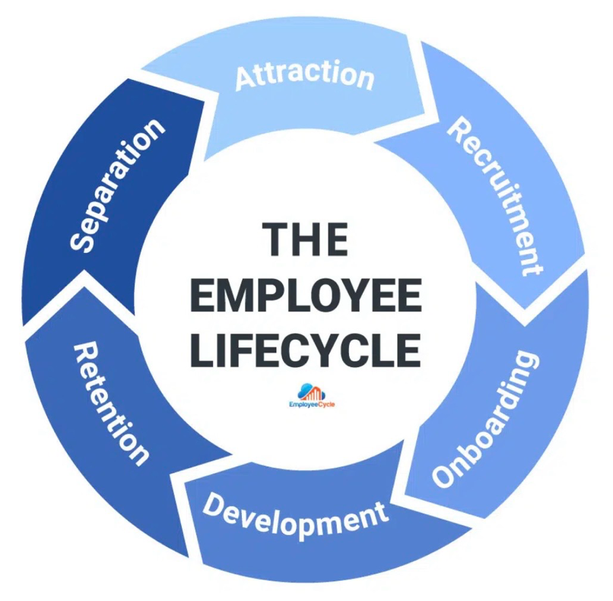
3.1
(Blanks, 2019)

The above diagram shows the stages of the employee lifecycle. The last but one stage is retention. Retention is when an employee is recruited and the organisation retains them within the company.
The CIPD identified that one of the top three reasons why someone leaves an organisation is because they are not satisfied with their people manager (CIPD, 2025i). This can be due to employees feeling unsupported, unheard, undervalued, etc. To help retain employees, the people manager at Chaffinch Group should be supporting the communication within the hierarchy, distributing jobs equally, recognise hard work and achievements and identify early signs of burnout.
The People Manager had a clear expectation of the employees and that was not to be questioned. If the People Manager had listened to the employees concerns, they could have minimised problems, boosted morale and retention could have been higher.
The recruitment advisor could help retain employees by ensuring job adverts have a clear explanation of the company culture and recruit individuals who align with the morals of the business. Although qualifications are essential, if the employee is not the correct fit for the organisation, ripples could be created within the business. The recruitment advisor could also include current employees within the recruitment stage. It would be beneficial for the interviewee to meet a member of the team and the current employee can give feedback on whether they would be a good fit. The recruitment advisor would not spend a lot of time engaging with the workforce.
A relations case advisor is someone who carers can go to with issues and also provides advice to managers. They need to be an unbiased, approachable individual. They are a designated specialist who can help employees with concerns effectively however, if they have the same mind set as the People Manager due to the company culture, carers may feel as though they are unapproachable. As a result, carers may feel that the only option they have left is to resign.

Since Calmere House’s employment transferred to Chaffinch Group, employee turnover and sickness absence have increased. Retention is an essential part of the employee lifecycle for Chaffinch Group, especially because performance is affecting customer satisfaction which in turn is affecting occupancy levels. The people manager, recruitment advisor and employment relations advisor all play a crucial role in the employee lifecycle and should take into consideration the CIPD Profession Map:
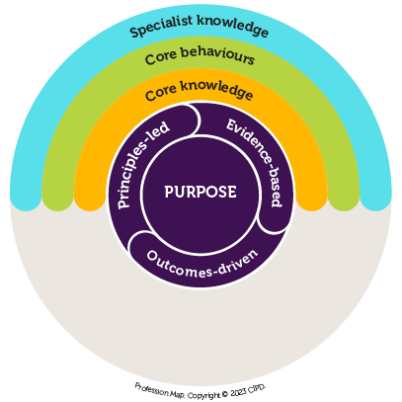
(CIPDl, 2023)
In order to retain employees, the three roles must join together. The people manager must set and implement strategic direction and culture, the recruitment advisor has the responsibility of ensuring effective recruitment is being met and the ER advisor ensures fairness in the workplace and resolves conflicts.
When the three roles are guided by the CIPD Profession Map’s principles of ethical practice, evidence- based practice and valuing people they are enabling trust.
Chaffinch Group is aiming to occupy 100% of Calmere House however, turnover rates are effecting standard of care reducing the chances of achieving their aims and objectives.
It would be within the people managers remit to identify the reasons for the increase of employee turnover by analysing people analytics. The CIPD identified that one of the top three reasons why an individual may resign from an organisation is because they are not satisfied with their People Manager (CIPDi, 2025). Once they have identified the reasons as to why turnover has increased, they would need to enhance engagement and culture by emphasising the importance and allowing employee voice, reinforce people- centred values alongside organisational standards.
The People Manager could review the people analytics regularly. This would highlight Chaffinch Group’s commitment to valuing people, which is key to long-term retention.
Under Kirsten’s management, behaviours were valued as highly as qualifications. The recruitment advisor should consider behavioural and value-based recruitment to ensure new hires align with both care standards and organisational expectations.
The recruitment advisor should design structured onboarding processes to prevent early turnover. This ensures that expectations are clear, agency workers obtain consistent inductions and new employees have an understanding of policies, behaviours and values.
This supports the retention stage by positively integrating new staters and improving early engagement.
The ER advisor helps retention by addressing and resolving any conflicts, dissatisfaction and workplace issues before they result in employees resigning.
The ER advisor should firstly proceed informally like a mediation meeting to discuss the decrease in workplace satisfaction and loss of employee voice. Effective ER practices supports trust which increases retention.
The ER advisor should promote training managers in fair implementation of policies. This ensures consistency throughout Chaffinch Group. Employees are more likely to stay when organisations promote fairness (HR Vision, unknown)
With increasing sickness absence, the ER advisor should implement supportive absence management processes, including return-to-work interviews and welfare meetings. This reduces long-term absence and encourages employees to return.

3.2

People practices including, resourcing, rewards, resolutions and learning and development can help Chaffinch Group’s goal of filling 100% of rooms within the six-month timeframe they have set themselves.
The CIPD have defined resourcing as”identifying, attracting and recruiting to get the right people for the organisation.” (CIPD, 2025j). This will ensure that everyone can work effectively as a team and people professionals are available to offer support and advice.
Rewarding employees can increase employee motivation however, it is important to understand that individuals may be motivated in different ways. Some individuals may be motivated by extrinsic rewards whereas others may be motivated by intrinsic rewards. An extrinsic reward is a physical object that an individual can use such as pay, bonuses and benefits. An intrinsic reward is an intangible reward such as words of affirmation and appraisal. Motivating employees and rewarding when identified can improve performance and employee contribution towards the change.
Resolutions need to be made to ensure individuals are working as a team. This should be completed informally by mediating conflicts between employees and then escalated if there are any further instances.
Learning and development shows employees that they are a valued member of the team and that you want them to progress within the organisation. Chaffinch Group should look at what training the organisation would benefit from during the change. Once someone has developed their knowledge they can use this to help them progress the goal and identify risk factors.
Vertical integration is the “alignment between the organisation’s business strategy and its HR strategy.” (Tolhurst, 2023a). The vertical integration makes sure that HR practices directly assist the organisation to achieve its main objectives and goals. Chaffinch Group may need to update their strategy to align with the goal of filling 100% of rooms.
Horizontal integration “refers to the alignment of various HR practices with each other” (Tolhurst, 2023b). Horizontal intergration assists an intergration approach to managing individuals and makes sure that different departments of the organisation collaborate effectively. Chaffinch Group would designate different departments their own responsibilities to ensure the change is made effectively.

3.3

Firstly, Kath would need to consider the factors as to why turnover has increased and what area the turnover is high. Factors include mismanagement, a change within the company and the culture of the organisation. Consulting with employees forms “good employment relations” (ACAS, 2021b). Consulting with employees increases employee voice which as a result, increases employee wellbeing. Kath could query individuals on why they believe turnover has increased, what they would do differently, what could be improved, how they believe turnover can be minimised, etc. It is an opportunity to receive constructive feedback from employees.
Kath could undertake a direct formal or informal consultations. This is a consultation held with one individual at a time. This creates a safe space for employees to raise concerns. Alternatively, Kath could hold indirect formal or informal consultations which is less time consuming.
Due to the consultation procedure being a formal process, Kath is liable to make employees aware that they can be accompanied at the meeting by a representative. Representatives can offer advice to employees and can highlight concerns they have within the organisation as well as the employee. This allows Kath to make a fully informed decision on how they can minimise turnover.
I would advise Kath to undertake a ‘good practice consultation’. This is when a consultation is held to identify how employees feel towards specific matters (ACAS, 2021c) opposed to ‘consultation under the law’ or ‘collective consultation’ whereby a consultation all is legally required.
An effective ‘good practice consultation’ can improve working relations, identify issues and resolve them, increases employee voice, improve employee engagement in the workplace and minimise the risk of disagreements.
Employee turnover at Calmere House has increased following the change in ownership, the introduction of a hierarchical structure and Kath’s autocratic leadership style. Employees report feeling unheard, overworked and disconnected from decision-making. To understand why turnover has risen, Kath must adopt more effective consultation and engagement mechanisms, drawing on CIPD research on employee voice (CIPDm, 2023), which highlights the importance of meaningful, two-way communication.
The CIPD defines employee voice as the ways in which employees communicate their views to influence decisions at work. This is linked to higher engagement, lower turnover and improved organisational performance. It is highlighted that employee voice has reduced since Kirsten’s departure. Kath therefore needs to re-establish both formal and informal forms of communication.
Kath could begin with structured one-to-one meetings with carers and senior carers. These meetings should be supportive, focusing on listening and understanding concerns about workload, culture and leadership.
Reintroducing regular team meetings with genuine discussion opportunities would allow collective concerns to surface. Kath could facilitate focus groups specifically to explore themes such as workload, agency use, or communication gaps.
Given low morale and possible distrust of management, anonymous engagement surveys could help gather honest feedback (ACAS, 2025)
Kath must combine one-to-ones, team discussions, surveys, exit data and representative forums would provide both qualitative and quantitative insights.
Employees at Calmere House feel their views are no longer valued. Embedding meaningful employee voice, Kath could identify the root causes of dissatisfaction, rebuild engagement and reduce turnover, ultimately supporting service quality and occupancy targets.

Bibliography

ACAS. (Unknown) Health and Wellbeing at Work. Available at: https://www.acas.org.uk/health-and-wellbeing-at-work
(Accessed November 2025)
ACAS. (2021a) Consulting Employees and Representatives. Available at: https://www.acas.org.uk/consulting-employees
(Accessed November 2025)
ACAS. (2021b) Consulting Employees and Representatives. Available at: https://www.acas.org.uk/consulting-employees
(Accessed November 2025)
ACAS. (2021c) Consulting Employees and Representatives. Available at: https://www.acas.org.uk/consulting-employees
(Accessed November 2025)
ACAS. (2025) Duty of Care. Available at: https://www.acas.org.uk/implied-duties/duty-of-care (Accessed November 2025)
ACASb (2025) How Employee Voice Improves Engagement. Available at: https://www.acas.org.uk/podcast/how-employee-voice-improves-engagement (Accessed 14th February 2026)
Allen, L. Williamson, S. Berry, E. Alderwick D. (2022) The Cost of Caring: Poverty and deprivation among residential acre workers in the UK. Available at: https://www.health.org.uk/reports-and-analysis/briefings/the-cost-of-caring-poverty-and-deprivation-among-residential-care
(Accessed November 2025)
Baigey, E. (2025) Flatter Organisational Structure: Definition and How to Implement. Available at: https://factorialhr.co.uk/blog/flatter-organisational-structure/
(Accessed November 2025)
Bitesize Learning (2024a). Kotters 8- step change model, explained. Available at: https://www.bitesizelearning.co.uk/resources/kotters-8-step-change-model
(Accessed November 2025)
Bitesize Learning (2024b). Kotters 8- step change model, explained. Available at: https://www.bitesizelearning.co.uk/resources/kotters-8-step-change-model
(Accessed November 2025)
Bitesize Learning (unknown). The Change Curve, Explained. Available at: https://www.bitesizelearning.co.uk/resources/change-curve-management-model
(Accessed November 2025)
Blanks, K. (2019) HR Metrics For Every Phase Of The Employee Lifecycle. Available at: https://www.employeecycle.com/hr_metrics_for_every_phase_of_the_employee_lifecycle/
(Accessed November 2025)
Campbell. and Craig. (2005) Studying Human Resources Management. 3rd ed. London: Kogan Page.

Care England. (2025) 98% Of Care Homes Are Still Seeing Rapid Cost Increases, Research Shows. Available at: https://www.careengland.org.uk/98-percent-of-care-homes-seeing-rapid-cost-increases/ (Accesses 2nd February 2026)

Census. (2021) Migration and the labour market, England and Wales: Census 2021. Available at: https://www.ons.gov.uk/employmentandlabourmarket/peopleinwork/employmentandemployeetypes/articles/migrationandthelabourmarketenglandandwales/census2021
(Accessed November 2025)
Chandler. (1962) Studying Human Resources Management.3rd Ed, London: Kogan Page.
CIPD. (2024) Organisational Climate and Culture. Available at: https://www.cipd.org/uk/knowledge/factsheets/organisation-culture-change-factsheet/
(Accessed October 2025)
CIPDc. (2025) PESTLE Analysis. Available at: https://www.cipd.org/uk/knowledge/factsheets/pestle-analysis-factsheet/Mercadal,
(Accessed November 2025)
CIPDd. (2023) Using AI responsibly in people management. Available at: https://www.cipd.org/uk/views-and-insights/thought-leadership/insight/ai-people-management/
(Accessed November 2025)
CIPDe. (2023) Employee Engagement and Motivation. Available at: https://www.cipd.org/uk/knowledge/factsheets/engagement-factsheet/
(Accessed November 2025)
CIPDf. (2025) Performance Management: An introduction. Available at: https://www.cipd.org/uk/knowledge/factsheets/performance-factsheet/
(Accessed November 2025)
CIPDg.(2025) Wellbeing at work. Available at: https://www.cipd.org/uk/knowledge/factsheets/well-being-factsheet/#:~:text=Career%20development%20%2D%20Mentoring%2C%20coaching%2C,access%20to%20independent%20financial%20advisers.
(Accessed November 2025)
CIPDh. (2025) Employee relations: an introduction. Available at: https://www.cipd.org/uk/knowledge/factsheets/relations-employees-factsheet/
(Accessed November 2025)
CIPDi. (2025) CIPD Good Work Index 2025. Available at: https://www.cipd.org/globalassets/media/knowledge/knowledge-hub/reports/2025-pdfs/8868-good-work-index-2025-report-web1.pdf
(Accessed November 2025)
CIPDj. (2025) Resourcing. Available at: https://www.cipd.org/uk/the-people-profession/the-profession-map/explore-the-profession-map/specialist-knowledge/resourcing/
(Accessed November 2025)
CIPDk. (2023) Employee Voice. Available at: https://www.cipd.org/uk/views-and-insights/cipd-viewpoint/employee-voice/ (Accessed 13th February 2026)
Departments of Health and Social Care. Hunt, J. (2016) Form a Blame Culture to a Learn Culture. Available at: https://www.gov.uk/government/speeches/from-a-blame-culture-to-a-learning-culture
(Accessed November 2025)
CIPDl. (2023) Explore the Profession Map. Available at: https://www.cipd.org/uk/the-people-profession/the-profession-map/explore-the-profession-map/ (Accessed 13th February 2026)
Geet Gunjan Deka. (2019) Technology is Constantly Evolving. Are you? Available at: https://www.linkedin.com/pulse/technology-constantly-evolving-you-geet-gunjan-deka?utm_source=share&utm_medium=member_ios&utm_campaign=share_via
(Accessed November 2025)

Geraghty, T. (2021) Edgar Schein’s Three Layers of Organisational Culture. Available at: https://psychsafety.com/psychological-safety-edgar-scheins-three-layers-of-organisational-culture/
(Accessed November 2025)

HR Vision. (unknown) What Is Favoritism in the Workplace? Definition and Examples. Available at: https://www.hrvisionevent.com/content-hub/what-is-favoritism-in-the-workplace-definition-and-examples/ (Accessed 14th February 2026)

Inbound Logistics. (2024) Horizontal Integration: Definition, Examples and Strategy. Available at: https://www.inboundlogistics.com/articles/horizontal-integration/
(Accessed November 2025)

Indeed. (2025) Work life imbalance: What it means and its effects. Available at: https://uk.indeed.com/career-advice/career-development/work-life-imbalance
(Accessed November 2025)

Johnson, G. Whittington, R. and Scholes, K. (2017). Exploring Strategy. 11th ed. Harlow: Pearson.

Kotter (1996) Can Cultural Change with Different Leadership Styles Enhance the Organizational Performance? Available at: https://d1wqtxts1xzle7.cloudfront.net/70224308/Can_Cultural_Change_with_Different_Leade20210925-11853-1kqz3ba-libre.pdf?1632599778=&response-content-disposition=inline%3B+filename%3DCan_Cultural_Change_with_Different_Leade.pdf&Expires=1771189630&Signature=W2BnoSwLw4eJtLikwSRO7LY7XaEM6jy4I9rZmTa4-tD5cGH~vbGhZ8dpGbNVv~X4YBY4zqZIjfEfCDSysGAK~rCZqD0pXX4Jt5s3Dz4iTw5Hn6sW-kUnJNpD7zLCOU2T07umk0TRtgCdDU2ulLu9ZPgt1bNxl6x2N1FxC6iBnyAGvaeDN73TcuT2ah5BY09ISp4L2dDgb1b-3oR0ZyD3L~9v8ESsTBJwhsKboTesgWRHj4nGd1Ul1fDHUuCf73UEZzj4U5m8GK6eqjs5GEbXRE3--TR1AXummU1pR30Y~0N7WNRHdduC4sP6hQPwnDjWPXUJCSSV~~JvGETxU9r8VA__&Key-Pair-Id=APKAJLOHF5GGSLRBV4ZA (Accessed 13th February 2026)

Newton, C (2024) The change from manual to computerised care planning at district general hospital (between 1988 and 1992). Available at: https://eprints.soton.ac.uk/462371/ (Accessed 4th February 2026)

Personnel Today. (2023) What are the Models of Organisational Structure? Available at: https://www.personneltoday.com/hr/what-are-the-organisational-culture-models/
(Accessed November 2025)

Schein, E. (2023) 5 enduring management ideas from MIT Sloan’s Edgar Schein. Available at: https://mitsloan.mit.edu/ideas-made-to-matter/5-enduring-management-ideas-mit-sloans-edgar-schein
(Accessed November 2025)
Smith, J and Hichens, J (2024) Care Homes: The increasing cost of care. Available at: https://www.grantthornton.co.uk/insights/care-homes-the-increasing-cost-of-care/ (Accessed 4th February 2026)
Travers, M. (2024) A Psychologist Explains The ‘IKEA Effect’- How Labor Leads to Love. Available at: https://www.forbes.com/sites/traversmark/2024/06/12/a-psychologist-explains-the-ikea-effect-how-labor-leads-to-love/
(Accessed November 2025)
Trolhurst, D. (2025a) HR Strategy Guide. Available at: https://www.practicus.com/what-we-do/hr/hr-strategy
(Accessed November 2023)
Trolhurst, D. (2025b) HR Strategy Guide. Available at: https://www.practicus.com/what-we-do/hr/hr-strategy
(Accessed November 2023)
Trudy M. (2021) Hierarchical Organizational Structure. Available at: https://www.ebsco.com/research-starters/business-and-management/hierarchical-organizational-structure
(Accessed October 2025)
Turner, A. (2022) ‘Unsustainable’ reliance on agency care staff needs urgent government action, warns provider body. Available at: https://www.communitycare.co.uk/2022/08/18/care-provider-body-calls-government-intervention-workforce-crisis-research-highlights-unsustainable-reliance-agency-staff/
(Accessed November 2025)
UK Government. (2025a) Summary of latest statistics. Available at: https://www.gov.uk/government/statistics/immigration-system-statistics-year-ending-june-2025/summary-of-latest-statistics
(Accessed November 2025)
UK Government. (2025b) National Minimum Wage and National Living Rates. Available at: https://www.gov.uk/national-minimum-wage-rates
(Accessed November 2025)
World Economic Forum (2025) The Future of Jobs Report 2025. Available at: https://www.weforum.org/publications/the-future-of-jobs-report-2025/digest/
(Accessed November 2025)

