Motorcycle Geometry Analysis and Dynamic Handling Investigation

Date submitted:

Motorcycle technology
ACHA4003

Koa Brook
2203480

Andrew Harrison

- Introduction (page 3)
- Geometric data (workshop motorcycles) (pages 4 & 5)
- Gear ratios and power/speed requirements (Ducati Pingale v4) (page 6)
- Handling characteristics (page 7)
- Geometry data and handling (modern motorcycles) (page 8)
- Handling improvements (page 9)
- Reference list (page 10)
- Introduction

This report will review the geometrical data of two motorcycles currently in the UWTSD workshop. This data is used to calculate the centre of gravity (COG) positions on the motorcycles, these positions are plotted on the motorcycle schematic diagrams. Using the gear ratios for the Ducati Pingale V4 the maximum possible speed for the bike will be calculated. It should be determined whether the bike can reach this speed by comparing the power requirement for that speed and the power produced by the bike. The forces acting upon the bike should also be considered and calculated as they will impact whether the bike can reach this speed. Using the data in this report the handling characteristics of the bikes (from the workshop) should be analysed and used to explain they handle under dynamic situations. Geometry data for two performance motorcycles will be acquired and analysed. Using this data suggestions should be made to improve the performance of the 2 bikes in the workshop.

- Wr = rear mass
- Wt = total mass
- L = wheelbase
- Wr lifted = rear mass lifted
- Ɵ = lifted angle
- Rav = average wheel radius

- Geometry data (workshop motorcycles)

2.1 Ducati Pingale V4
In reference to Figure 1
Figure 1
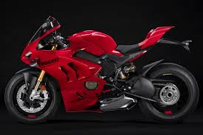
Rear wheel radius
- Rear wheel radius - 0.345m
- Front wheel radius – 0.31m
- Wheelbase – 1.45m
- Bike weight - 186.9kg
- Triple clamp offset – 0.03m
- Rake angle – 27.14°
- Trail – 0.1252m
- COG X – 0.68m
- COG Y – 0.53m
Rake angle
Front wheel radius
COG
trail

Wheelbase
Ducati Panigale V4 improved for 2022 | BikeSocial (bennetts.co.uk)
Bennetts (B.), Ben Purvis, 25/11/2021
COG X = $\frac{Wr ×L}{Wt}$
= 0.68m
COG Y= $\frac{L ×(Wr-Wr lifted)}{Wt ×tanθ}$ + Rav
= 0.53m

Wr = 87.7 kg
Wt = 186.9 kg
L = 1.45m
Wr lifted = 81 kg
Ɵ = 13.76$°$
Rav = 0.315m

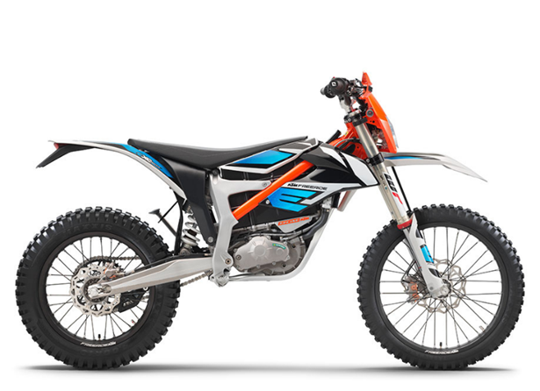
In reference to figure 2
Figure 2
(2022 KTM FREERIDE E-XC, no date)
https://www.tripledmotosport.co.uk/product/2022-ktm-freeride-e-xc.
2.2 KTM freeride
COG X = $\frac{Wr ×L}{Wt}$
= 0.71m
COG Y= $\frac{L ×(Wr-Wr lifted)}{Wt ×tanθ}$ + Rav
= 0.52m

Wr = 56 kg
Wt = 114.2 kg
L = 1.44m
Wr lifted = 52.3 kg
Ɵ = 13.86$°$
Rav = 0.3303m

- Rear wheel radius - 0.32m
- Front wheel radius – 0.33m
- Wheelbase – 1.44m
- Bike weight – 111.2kg
- Triple clamp offset – 0.02m
- Rake angle – 28.98$°$
- Trail – 0.1599m
- COG X – 0.71m
- COG Y – 0.52m
COG
trail
Wheelbase
Rake angle
Front wheel radius
Rear wheel radius
- Gear ratios and power/speed requirements (Ducati Pingale v4)
gearbox 1
primary: | 32 | 64 |  | speed
final: | 16 | 41
Gears |  |  |  | km/h | mph |  | fall in rpm
1st | 14 | 38 |  | 143.0921 | 89.43255
2nd | 17 | 36 |  | 183.4077 | 114.6298 |  | 12873.06502
3rd | 19 | 33 |  | 223.6201 | 139.7626 |  | 13532.89474
4th | 21 | 32 |  | 254.8828 | 159.3017 |  | 14476.19048
5th | 22 | 30 |  | 284.8214 | 178.0134 |  | 14765.625
6th | 24 | 30 |  | 310.7142 | 194.1964 |  | 15125

$$F_{D}= 1/2ρ×C_{D}×V^{2}×A$$
=1049.99 N

$$F_{W}=0.02×m×g$$
= 36.67 N
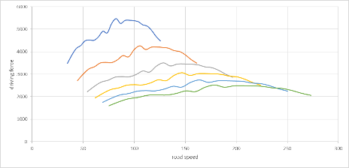

Total resistance force = 1086.66 N
For the bike to be able to achieve its top speed (highlighted in pink above) the resultant force of the bike must be acting in the same direction as the bikes driving force. The force the bike produces at maximum RPM (highlighted in green) and its peak force (highlighted in yellow) in 6th gear, at least the maximum force must be more than the total resistance force acting upon the bike. When comparing the values, it can be seen that both of the driving forces individually are significantly more than the total resistance force (highlighted in red above) acting upon the bike. Therefore, it can be determined that it is possible for this motorcycle to reach its maximum speed.
driving force (N)
1st | 2nd | 3rd | 4th | 5th | 6th
3482.471 | 2716.974 | 2228.396 | 1955.071 | 1749.567 | 1603.77
3852.215 | 3005.443 | 2464.991 | 2162.647 | 1935.323 | 1774.046
4148.01 | 3236.218 | 2654.267 | 2328.707 | 2083.928 | 1910.268
4277.459 | 3337.213 | 2737.1 | 2401.381 | 2148.963 | 1969.883
4488.518 | 3501.878 | 2872.154 | 2519.87 | 2254.997 | 2067.081
4524.236 | 3529.744 | 2895.01 | 2539.922 | 2272.941 | 2083.53
4510.629 | 3519.129 | 2886.303 | 2532.283 | 2266.105 | 2077.263
4663.931 | 3638.733 | 2984.399 | 2618.347 | 2343.123 | 2147.863
4914.153 | 3833.953 | 3144.514 | 2758.823 | 2468.833 | 2263.097
4843.594 | 3778.903 | 3099.363 | 2719.21 | 2433.384 | 2230.602
5262.401 | 4105.65 | 3367.353 | 2954.33 | 2643.79 | 2423.474
5474.2 | 4270.893 | 3502.881 | 3073.235 | 2750.196 | 2521.013
5262.401 | 4105.65 | 3367.353 | 2954.33 | 2643.79 | 2423.474
5395.066 | 4209.154 | 3452.244 | 3028.809 | 2710.44 | 2484.57
5403.106 | 4215.427 | 3457.389 | 3033.323 | 2714.479 | 2488.273
5383.53 | 4200.153 | 3444.863 | 3022.333 | 2704.644 | 2479.257
5339.789 | 4166.027 | 3416.873 | 2997.776 | 2682.669 | 2459.113
5200.49 | 4057.348 | 3327.737 | 2919.573 | 2612.686 | 2394.962
5143.342 | 4012.762 | 3291.169 | 2887.49 | 2583.975 | 2368.644
4952.848 | 3864.141 | 3169.274 | 2780.546 | 2488.273 | 2280.917
4687.516 | 3657.134 | 2999.491 | 2631.588 | 2354.972 | 2158.725
4483.181 | 3497.714 | 2868.739 | 2516.874 | 2252.316 | 2064.623

- Handling characteristics

  - Ducati penagale V4
The Ducati has a shallow rake angle in comparison to other motorcycles. This is as it is a sports bike. Even though it is road legal it was designed for track use. The rake angle helps with this as it means the bike is more manurable. This will help the bike manoeuvre through chicanes more easily. This is as a shallow rake angle makes the steering of the motorcycle more sensitive, so if the rider can efficiently distribute their weight the bike can change direction at higher speeds more effectively. The Ducati has a shorter trail in comparison to other motorcycles this is due to the fact that the bike needs to be able to transition inti and from corners effortlessly. This helps the rider to shorten their lap times as it allows them to be in the optimum position more frequently for corners and other manoeuvres. The short trail and shallow rake angle on this bike will make it extremely aggressive and unpredictable when riding.

  - KTM freeride
The KTM also has a shallow rake angle when compared to other motorcycles. This motorcycle was designed for offroad tracks mainly motocross. The rake angle is important to motocross bikes as it effects how easily the bike can be manipulated around the track. The bike must be able to corner sharply and avoid obstacles that are common on the track such fallen riders. The rake angle helps with this as the shallow rake gives the rider more leverage over the bikes directional course. As the KTM is mainly used for motocross the trail doesn’t have to be short. For the KTM the trail is larger than other bikes, this is because motocross bikes are constantly needing to correct their stability. Motocross bikes are constantly being pushed to their limit and thrown around corners. To prevent them from being too aggressive to handle of from consistently falling the trail has to be longer. The shallow rake angle on this bike will make it more aggressive in manoeuvres, however the larger trail which allows it to regain stability more easily will help this. This is because the stability provided by the trail will counteract the shallow rake angle when moving from corners to straights.

- Geometry data and handling characteristics (modern motorcycles)
Figure 3
  - Enduro
In reference to figure 3
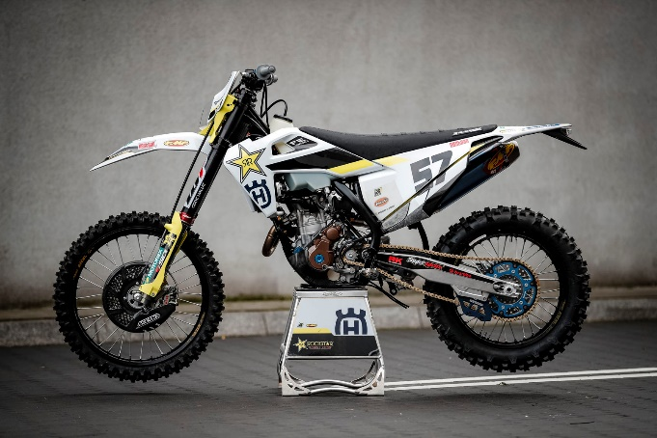
- Rear wheel radius - 0.3406m
- Front wheel radius – 0.3569m
- Wheelbase – 1.5597m
- Triple clamp offset – -1.43$×{10}^{-3}$
- Rake angle – 30.31°
- Trail – 0.2103m

Pearson, J. (2020) Pro Bike: Billy Bolt’s 2020 Super Enduro Husqvarna FE 350. Available at: https://enduro21.com/en/bikes/latest/pro-bike-billy-bolt-s-2020-superenduro-husqvarna-fe-350.

This bike was adjusted for enduro racing. for this it has a larger rake angle and trail. The larger trail gives the bike more stability so it can remain upright. This is important for this bike as it is used over rough terrain and needs as much stability as possible. The increased rake angle allows the rider to maintain stability more easily. If the rake angle was lower, then the bike would easily fall over on the terrain that is used in enduro racing. This increased rake angle sacrifices turning leverage so that the bike can have more consistent stability.
  - WSB
In reference to figure 4
Figure 4
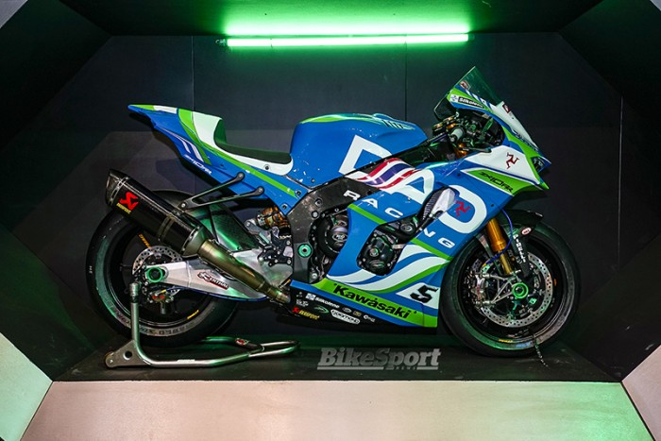
- Rear wheel radius - 0.331m
- Front wheel radius – 0.301m
- Wheelbase – 1.736m
- Triple clamp offset – 6.92$×{10}^{-4}$
- Rake angle – 23.8°
- Trail – 0.132

this bike has a steep rake angle but a large trail length. This is to optimise its performance around the different circuits that it competes on (track and street). The steep rake angle allows the bike to corner fast and aggressively. However, this does sacrifice some stability of the bike. The increased trail gives the bike some more stability to compensate for the lost stability in the steep rake angle. This helps the rider in straight sections of a circuit as the bike would have a higher probability of high or low siding if this trail was shorter.
Staff, B. (2022) DAO Kawasaki unveil new livery for 2022 season.

- Handling improvements (suggestions)

  - KTM freeride
It has been proposed to use the KTM for enduro racing. With this in mind some altercations will be needed to be made to the bike, this includes the bikes handling. Currently the bike is set up for motocross, which relies upon the bike’s stability less than that of enduro racing. To allow the KTM to have more stability on the loose and uneven terrain both the rake and trail should be increased. This will reduce the bike’s ability to make sharp aggressive turns, when increasing rake angle. However, this is not as vital in enduro racing as it is motocross. The increased trail will also help the bike to maintain this stability.

  - Ducati penagale V4
If the Ducati was to be used as a track bike there are some altercations to the setup that could be made to optimise its performance. to further improve the cornering and positioning of the bike the rake angle should be steepened further. However, this would make the bike less stable on straight sections. To allow the bike to be more stabilised on the straight sections the trail of the bike should be increased.

- Reference list
- 2022 KTM FREERIDE E-XC (no date). Available at: https://www.tripledmotosport.co.uk/product/2022-ktm-freeride-e-xc.
- Bennetts (B.), Ben Purvis, (25/11/2021). Available at: Ducati Panigale V4 improved for 2022 | BikeSocial (bennetts.co.uk)
- Pearson, J. (2020) Pro Bike: Billy Bolt’s 2020 SuperEnduro Husqvarna FE 350. Available at: https://enduro21.com/en/bikes/latest/pro-bike-billy-bolt-s-2020-superenduro-husqvarna-fe-350.
- Staff, B. (2022) DAO Kawasaki unveil new livery for 2022 season. Available at: https://www.bikesportnews.com/news/news-detail/dao-kawasaki-unveil-new-livery-for-2022-season.

