Module code: LCBB4004
Module Name: Marketing Fundamentals
Assignment Title: “Assessment 2 – Marketing Fundamentals Analysis and Evaluation”

Student Name: Mariya Ilieva Ilieva
Student ID: 2123768
Table of Contents
Introduction 3
Marketing 3
Main stages in the marketing process 3
PESTLE 4
Porter's five Forces model 7
Segmentation 8
Targeting 9
Positioning 9
Marketing mix 10
Conclusion 11
Recommendation 12
Reference 13

Introduction
The aim of the report is to conduct and analyse the internal and external analysis of Unilever. The impact of Covid-19 has been felt all around the world and great numbers of businesses have been affected by it. The report will analyse the internal and external aspects of the company. In the report the main stages in the marketing process will be discussed. PESTLE will be adhered to as for analysing the external environment for the company. As an industry analysis porter’s five forces model will be used. Moreover, segmentation targeting, and positioning of the company will be analysed as well.

Marketing
Marketing is the kind of activity which a company uses to promote and initiate buying and selling of the product and services (Machado et al., 2019). Marketing is regarded as the act of creating and enhancing awareness, initiating communication, exchanging offerings and delivery of the offerings. Marketing is the method of getting the people interested in the product or service of the company. Marketing helps in initiating and delivering the value to satisfy the wants and needs of the target market. Marketing is the broad spectrum which starts from the creation of awareness to delivery of the value to the consumer.

Main stages in the marketing process
Marketing process is the range of steps which allows the company to identify the problem of the customer, evaluate market opportunities as well as initiate marketing techniques and material to get to the desired audience (Berger et al., 2020). The main stages in the marketing process are:
Situational analysis: situational analysis is the stage in the marketing process which analyses the internal as well as external factors of the company now. It defines the company’s capabilities, potential customers, and the environment affecting the business as well as their impact. Situational analysis helps Unilever in understanding of the environment and its effect on which the plan is established and delivered (Chernobay, 2020). It offers a clear understanding of the internal as well as external factors that can affect or impact the company and its performance. The purpose of the situational analysis is to have a clear understanding of what the company can do and what can affect it.
Objectives: objective is the defined goals of the company. It demonstrates the outcome which the company wants to get from its marketing activities. The objectives are to be achieved based on the current analysis of the company. Moreover, the objective must be realistic as well as measurable to analyse the effort which will be required in a more concentrated way. Unilever sets its objective according to the situation and enhances its performance in the market (Siddique, 2018). This helps the company in being more effective and earning great profits as well as increased sales.
Strategy: Strategy is another important stage in the marketing process as it aims at establishing the plans to achieve objectives. The strategy includes market segmentation, targeting the audience, initiating differentiation as well as positioning of the decision as well as designing the marketing mix process (Han and Kang, 2020). The strategy includes setting goals and analysing internal as well as external factors affecting business, product planning and so on. Unilever sets and plans its strategy in the marketing process to generate more sales and incur revenue.
Implementation and control: Implementation and control is the method or process that must guarantee the achievement as well as attainment of the strategy and objectives adhered to by the organisation. It is the process of turning the company’s marketing strategy in the real-life aspect such as implementing tasks, projects analysing and implementing the people needed for it as well as completion of the company’s task by controlling them. It brings the marketing plan to life. Unilever makes sure that the company analyses its marketing strategy, implements it and then controls the process to gain maximum benefit of the marketing (Hanlon, 2021).

PESTLE
Unilever is a consumer goods company which is affected by many external factors. PESTLE analysis of Unilever will assist in analysing the external factors which affect the company and its performance.
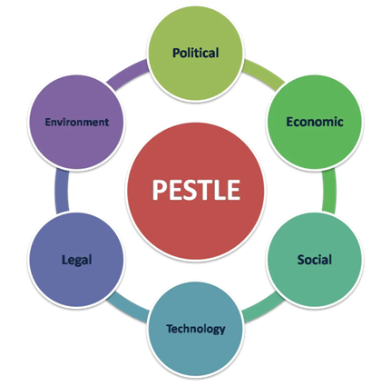
Figure 1: PESTLE analysis
(Source: Nandonde, 2019)
Political factor- political stability of various countries in which Unilever operates serves as an advantage for the company. This helps in minimising the challenges in implementing the strategy in the country. However, the political issues and problems in the European Union is one of the potential disadvantages for the Unilever’s operation (Cheng, 2021). The company has the advantage of expanding its free trade relations in developing countries. Brexit had a negative impact on the company's performance as several operations went halt for some time. The political factors have both positive and negative impacts on the company’s performance. The negative aspects must be looked at by the team of Unilever.
Economic Factor- the economic factor has a great impact on the company. As the countries are developing the income is also increasing, this is an advantage for the company as Unilever can benefit from the increased sales, since the disposable income of the consumers gets higher. However, there is increasing cost in these countries as there is a lot of manufacturing going on in these regions. Economic growth of the company is regarded as an advantage for the company which gives them a steady growth (Kumar et al., 2019). However, the rising Covid-19 virus has led to economic downfall, and this can prove to be disadvantageous for companies like Unilever.
Social factor- the social perspective also plays an important role in the performance of the company. The taste and preference of the social group has an active part in the sale of Unilever (Kpoku, 2021) The rising Covid-19 pandemic has put in great damage to the public’s health hence they are looking for more health-conscious products. The immunity boost food products are highly appreciable by the consumer these days to fight the Covid-19 virus. Unilever will have to stick to the safety standard in producing more innovative immunity-based food for consumers at the time of pandemic. This will raise the opportunity for the company to enhance sales.
Technological factor- since Covid-19 pandemic there were a lot of businesses who had to temporarily stop their functions and operation. Most companies adopted work from home aspects. This was a disadvantage for the company since they were not able to produce as much they used to earlier. However, the automated process such as self-billing and online shopping of the company’s product from the ecommerce platform serves to be an advantage for the company (Gavrila and de Lucas Ancillo, 2021). Hence the cost which will be incurred in research and development of the products after the Covid-19 pandemic will be disadvantageous for the company.
Legal factor- as the Covid-19 pandemic started affecting the world the complexity regarding the environmental regulation also increased. Moreover, the intellectual property as well as patent laws helps the company in securing its position. Moreover, consumer laws initiate an opportunity for Unilever to enhance its customer-service efficiency. This can act as a favourable factor for the company since these enhance the attractiveness of the Unilever’s name in the consumer goods sector. The legal factor needs to be tackled in an efficient manner as it is the most sensitive part of the company. The company needs to comply with many necessary factors to work effectively and without any hurdles.
Environmental factor- as the impact of Covid-19 had on every aspect of a person’s life including the environment (Rumi and Islam, 2020). The company must make plans in order to provide sustainable products which are environment friendly. After the Covid-19 pandemic, most people were more environmentally conscious, this was a favourable factor for Unilever to enhance its environmental program and attract a huge pool of customers who are more concerned as well as attracted to the environment. Sustainable environmental practices play a huge role for Unilever in this case. Thus, after the Covid-19 pandemic the environmental factor has affected the business of Unilever a lot. This can be an unfavourable factor for the business.

Porter's five Forces model
Unilever is a strong as well as global company known across the world (Unilever, 2022). Porter’s five forces model is one of the most useful and authentic ways to evaluate and analyse the competitive environment in the market for the consumer goods industry in which Unilever operates. The five forces which will be discussed ahead are: Buyer Power, Competitive rivalry, threat of substitutes, threat of new entrant, supplier power.
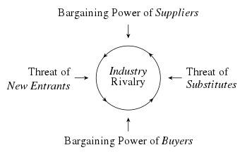
Figure 2: Framework of Porter's five Forces
(Source: Bruijl, 2018)
Buyer Power- High: since Unilever is a company that has huge numbers of buyers which are scattered around the world. Customers have great power since they are the backbone of the company, and they are required to be satisfied in every stage regarding price and quality of the product. They have the power to enhance the company image and make them likeable. Thus, the buyer has great power in the performance of the company. During the time of Covid-19, the company had to go through a lot and along with it they had to take care of the customer. The need and preference of the customer influences the company’s price and supply (Maloletko et al., 2018).
Competitive rivalry- High: Unilever is a giant company which is an international company and operates in great numbers of countries. Hence the competitive rivalry among the companies is great. The company has several rivals such as P&G, Nestle and so on. Several companies introduce innovative and attractive products to attract customers. Moreover, at the time of Covid-19 pandemic more companies are coming forward to make immunity boost products (Wagner et al., 2020). The rivalry among the companies has increased after the Covid-19 pandemic. As the switching cost is low it enables them to switch to different brands easily. Thus, the competitive rivalry in this sector is high which is faced by Unilever.
Threat of substitute- Medium: human nature is such that they tend to try new as well as alternative goods in their life. They will surely try using the substitute product in the market to find the best. However, they will stick to the product which they like. Moreover, due to the Covid-19 the threat from substitute goods has been increased. People tend to buy products which have more nutritional quality hence they are likely to buy the product which is best (Rita et al., 2019). Thus, it has medium power on Unilever since it is a reputed brand and ensures good quality products, thus people tend to stick to this brand as they are assured of the quality.
Threat of new entrants- Low: it is quite difficult to supply the product as Unilever is doing across the world. Hence the threat of new entrants can hardly affect Unilever. As Unilever is the set brand and has brand loyalty for years their customers are unlikely to switch the brand from some other brand. As entering the consumer goods manufacturing market is tough, the threat from new entrants is lower for Unilever. Moreover, at the time of Covid-19 people will trust the brand which they have tested; hence Unilever will have a plus point.
Supplier’s Power- Low: as the company is quite giant and massive in production and operation range with a huge reputation, the power of suppliers is reduced (Ahmad and Zhang, 2021). As the company gives those huge deals and trades with them on a larger basis the supplier has little power in negotiation. Unilever has great power over its suppliers hence the supplier must agree to what the company is saying.

Segmentation
Unilever believes that like every other company one company cannot satisfy the needs, demand, and want of all the consumers. To do so large resources will be drain. Segmentation is the process of categorising and dividing a certain market into sections that shows similar characteristics and behaviour. The company segments its market according to demography, social class and belief, cultural aspect and so on. The product segmentation in Unilever is cost efficient as well as flexible since it lets the changes happen regularly and newer innovations are made (Firthry et al., 2021). The market segmentation allows Unilever to cater to the most needs of the consumers who are in the market. Demographic plays a huge role in the company’s product and market segmentation. This assists the company in catering to most sections of the consumer in the market.

Targeting
Unilever targets almost all the consumers in the market be it youngsters to senior citizens. In almost every household there is one product of Unilever which will be there. Unilever has been able to do this by investing in a great number of products such as food products, personal products, beverages, cleaning agents and so on. The aim of Unilever is to meet the daily needs of the people and enhance their quality of life. Due to the Covid-19, the demand for healthy food products rose, the company also targeted this segment through the production of quality as well as healthy food products and hence they have been able to target the healthy consumers. Unilever hence has a huge capability of targeting every consumer in the market.

Positioning
Unilever faces a major threat regarding the product being substituted with the products available locally at much cheaper price (Godfrey, 2019). This has led Unilever in conducting great advertising as well as promotion techniques to promote its product in order to be appealing to their market base. Efficient positioning includes understanding one's competitiveness and utilising this knowledge to improve the product or service with regards to the target market hence Unilever invests huge amounts of money on the advertising and market campaign and always caters to the needs of the market. Moreover, competitive positioning guarantees that products are efficiently differentiated in a way that the customer feels that they are valuable. Unilever has successfully been able to promote their company and gain loyalty of the consumer who trusts them and their quality. Unilever will have to manage their primary and basic element of positioning such as pricing, service, quality, packaging as well as distribution.

Marketing mix
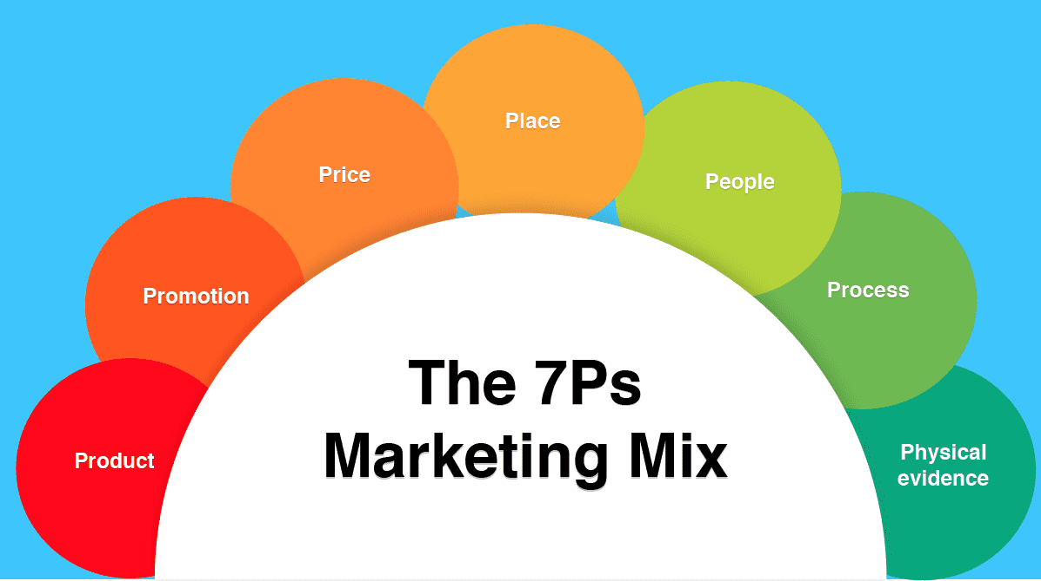
Figure 3: 7Ps of Marketing Mix
(Source: Thabit and Raewf, 2018)
Product- the products of Unilever fall under three sections such as food and beverages, personal care, and home care. The company has more than 400 brands to meet the needs of consumers in those three sections. The strategy of many brands is quite useful for Unilever as it can save the brand from being affected by the failure of other brands. The products of Unilever are present in every household and most of the brands are quite popular such as Dove, Magnum, and Lipton and so on. The products of Unilever are globally recognised and acclaimed. The products of Unilever are widely used on a day-to-day basis and the users have great usage out of these products.
Price-Unilever is the fast-moving consumer goods around the world and this sector is highly competitive (Unilever, 2022). Hence the company such as Unilever in the market must consider its competitors and their undertakings. Unilever mostly follows competitor pricing policy. This assists the company in estimating and determining the price of the products. Unilever caters to various kinds of consumers and thus its pricing also shows the same. Some products are kept at a high price to maintain consistency in maintaining premium quality of the product. Moreover, Unilever sticks to strategic pricing strategy to cater to the needs of consumers that have lower income.
Place- the products of Unilever have reached more than 180 countries. Unilever makes utilisation of wide channels of distribution (Kpoku, 2021). The products of Unilever are available in supermarkets, retail stores, wholesales and even in small convenience and departmental stores. Along with these the company also has its product on various e-commerce platforms. Due to Covid-19 the distribution got affected and disturbed as there was worldwide lockdown. Headquarter of Unilever is in London, and it operates and manufactures in various countries. This makes the worldwide availability of the product. This implies that Unilever adopts an intensive distribution strategy.
Promotion- Unilever holds a vast range of promotional as well as marketing strategies. Unilever spends a great amount of money every year on promotional activity. Various sale promotion techniques for example, discounts, offers and so on. Unilever is also active on social media to engage its brand with the consumer as well as interact with them (Manosca et al., 2022). However, the social media presence of Unilever is not that much as the company he demands in real life. Moreover, the promotional activities and marketing campaign on social media helps the company in constantly reminding the use of the brand and its activity.
People- there are huge numbers of people working under Unilever to provide world class service to the consumers. There are approximately 149,000 of employees working under Unilever (Unilever, 2022). The people are trained to perform their best and deal effectively with the consumers. All the people working under their respective department are guided through how to deal with consumers and cater their needs. Moreover, consumers are also the vital people in aspects of Unilever which are the backbone of the company. The people of Unilever are all the people in charge in various aspects of the company’s operation.
Process- to ensure that the product is always available to the people process plays an important role. The process involves delivery of the product, production process, procurement of goods and service and so on (Qazzafi, 2019). It helps the company in maintaining the efficient flow of goods in the market through smooth functions and processes. Customs are the most important aspect for the company hence, Unilever streamline its process to provide efficient quality service.
Physical Evidence- physical evidence refers to all those aspects of the company which are visible, from distinctive packaging to product on the shelf of the store. From plants and machinery to the workers of the company is regarded as the physical evidence of the company.

Conclusion
It can be inferred that Unilever is a market giant having clout in the consumer goods business. The report's goal was to perform and analyse Unilever's internal and external analyses. Covid-19's impact has been felt across the world, and many enterprises have been affected and so is Unilever. The company's internal and external aspects were examined in the report. The main steps of the marketing process are explained in detail. PESTLE has been used for analysing the company's external environment. Porter's five forces model was utilised to analyse the industry. Furthermore, the company's segmentation targeting, and positioning have been examined along with marketing mix.

Recommendation
- Unilever is required to strengthen and enhance its social media presence to boost its sales in the competitive market. As the social media presence of Unilever is lower, being more active social media platforms such as Instagram will help the company in increasing brand recognition.
- The company must gather feedback from its consumers regarding their packaging and branding and how they can enhance it.
- The company must investigate owning its own store and shop which will be shopping friendly and induce the consumers to buy from them.
- Unilever must investigate innovating as well as improving its process with regards to cost and efficiency. Cost saving techniques will lower the price of the product.
- Unilever must focus on enhancing its online website so that it becomes more user friendly as well as people can shop from them easily.

Reference
Ahmad, T. and Zhang, D., 2021. Using the internet of things in smart energy systems and networks. Sustainable Cities and Society, 68, p.102783.
Berger, J., Humphreys, A., Ludwig, S., Moe, W.W., Netzer, O. and Schweidel, D.A., 2020. Uniting the tribes: Using text for marketing insight. Journal of Marketing, 84(1), pp.1-25.
Bruijl, G.H.T., 2018. The relevance of Porter's five forces in today's innovative and changing business environment. Available at SSRN 3192207.
Cheng, Y., 2021, February. Analysis on the Opportunities and Challenges of Unilever's Differentiated Competition by Using SWOT and PEST. In 6th International Conference on Economics, Management, Law, and Education (EMLE 2020) (pp. 280-284). Atlantis Press.
Chernobay, L., Yasinska, T. and Malibroda, S., 2020. APPLIED ASPECT OF CORPORATE SOCIAL RESPONSIBILITY IMPACT ON COMPANY COMPETITIVENESS (UNILEVER EXAMPLE). Entrepreneurship, 8(1), pp.32-44.
Fithry, A.N.I., Hariyanto, M.I.Z.P. and Utami, E.S., 2021. The Impact of Consumer Behaviour Megashift on Unilever's Product Strategy During COVID-19 Crisis. UNEJ e-Proceeding, pp.61-65.
Gavrila, S.G. and de Lucas Ancillo, A., 2021. Spanish SMEs’ digitalization enablers: E-Receipt applications to the offline retail market. Technological Forecasting and Social Change, 162, p.120381.
Godfrey, L., 2019. Waste plastic, the challenge facing developing countries—ban it, change it, collect it? Recycling, 4(1), p.3.
Han, S. and Kang, E., 2020. The marketing strategy to stimulate customer's interest in art-gallery business plan. The Journal of Distribution Science, 18(8), pp.47-54.
Hanlon, A., 2021. Digital marketing: strategic planning & integration. Sage.
Kpoku, O.K., 2021. Positive and negative influence of globalization on international business actors’ activity (on materials of Unilever Group) (Doctoral dissertation).
Kumar, V., Sezersan, I., Garza-Reyes, J.A., Gonzalez, E.D., and Moh’d Anwer, A.S., 2019. Circular economy in the manufacturing sector: benefits, opportunities, and barriers. Management Decision.
Mahado, M.A.D., de Almeida, S.O., Bollick, L.C. and Bragagnolo, G., 2019. Second-hand fashion market: consumer role in circular economy. Journal of Fashion Marketing and Management: An International Journal.
Maloletko, A., Volkov, D., Vishnyakova, V. and Shatsky, A., 2018. The effect of supply chain and consumer preferences on the formation of economic model. International Journal of Supply Chain Management, 7(5), pp.684-689.
Mañosca, M.K., Poyaoan, A.K. and Vitug, J., 2022. Impact of Content Marketing on the Brand Image of Selected Unilever's Personal Care Brands through the social media. Journal of Business and Management Studies, 4(1), pp.107-114.
Nandonde, F.A., 2019. A PESTLE analysis of international retailing in the East African Community. Global Business and Organizational Excellence, 38(4), pp.54-61.
Qazzafi, S.H.E.I.K.H., 2019. Consumer buying decision process toward products. International Journal of Scientific Research and Engineering Development, 2(5), pp.130-134.
Rita, P., Oliveira, T. and Farisa, A., 2019. The impact of e-service quality and customer satisfaction on customer behavior in online shopping. Heliyon, 5(10), p.e02690.
Rume, T. and Islam, S.D.U., 2020. Environmental effects of COVID-19 pandemic and potential strategies of sustainability. Heliyon, 6(9), p.e04965.
Siddique, F.B. and Sultana, I., 2018. Unilever Sustainable Living Plan: A Critical Analysis.
Unilever. 2022. Briefly. [online] Available at: <https://www.unilever.com/our-company/at-a-glance/> [Accessed 19 April 2022].
Wagner, D.N., Marcon, A.R. and Caulfield, T., 2020. “Immune Boosting” in the time of COVID: selling immunity on Instagram. Allergy, Asthma & Clinical Immunology, 16(1), pp.1-5.

