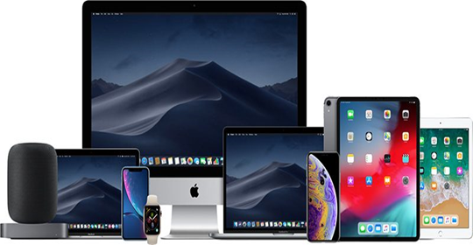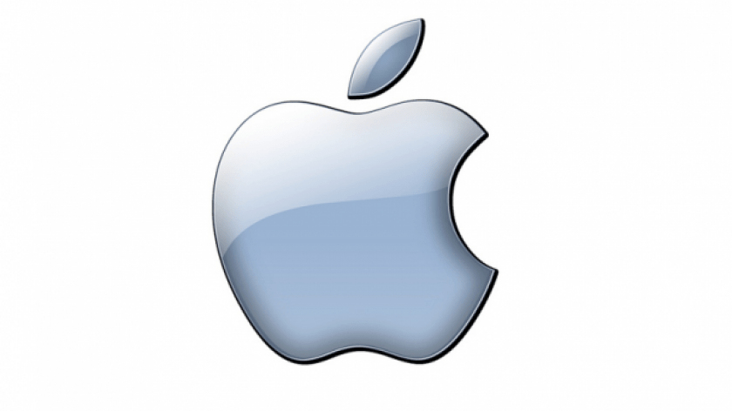
COVER PAGE
HRM LCMB7000 – A1

APPLE INC.: MY CHOSEN COMPANY

Program: MBA – MASTER OF BUSINESS ADMINISTRATION
Module: HUMAN RESOURCE MANAGEMENT
Module Code: LCMB 7000
Assignment Title: ASSESSMENT 1
HUMAN RESOURCE MANAGEMENT
Module Lecturer: HUSSEIN SHOKRI
Prepared By: KAZI NAZRUL ISLAM
Submission Method: MOODLE TURN-IT-IN.
Submission Deadline: 2ND SEPTEMBER 2021
Total Word Count: 2710
CONTENTS PAGE
Page Number

Introduction ……………………………………………………………………….. 03

Background of my chosen Company – Apple Inc.………………… 03

Current and Predicted Changes in the External Environment 03

Political / Legal Environment…………………………………. 04

Economic Environment…………………………………………. 05

Social Environment…………………………………………………05

Technological Environment…………………………………….06

Value Chain Analysis of Apple Inc…………………………………………07

Resourcing Strategies Responding to the Changes………………08

Recommendation………………………………………………………….…….09

Conclusion……………………...…………………………………………………..09

- Bibliography/Reference………..………….………………10

- Introduction:

In HRM (Human Resource Management) People resourcing, sometimes called ‘employee resourcing’ or just ‘resourcing’, is described as the activities of workforce employment, planning, recruitment, and selection process ensures that the organisation has the right people it needs. People Resourcing is a very important activity in the organisation that recognises the strategic capability of a firm depending on its resource capability in the shape of people. It is not only just about recruitment and selection, but also is concerned with any means available to meet the organisation’s need for a particular skills and behaviours. So, it is a strategy to ensure that the organization has the talented and skilled people it needs (Armstrong, 2020).

Worldwide Pandemic COVID-19, and Brexit are the two key factors are affecting UK and its Businesses badly. In this report we will discuss these two and some other external factors in depth

- Background of my chosen company: Apple Inc.:
‘Apple Inc.’ is an American company based in California, USA. Apple started its journey as a Technological company on 1st April 1976, founded by Steve Jobs, Steve Wozniak, and Ronald Wayne. Ever since Apple Inc. continued its journey innovating the world market of Technology and proved to be one of the most successful technological company in the world.
(Stanko, 2015).

- Current and Predicted Changes in the External Environment:
The objective of HRM resourcing strategy is to obtain the right work force with the capabilities of appropriate qualities, skills, knowledge, and potential for future training if required. But external changes affect the Resource strategy significantly. The recruitment of workers to meet the needs of the organization and to form a core HRM policies geared towards their development and building motivation. The strategic capability of an organization depends on its resource capability. (Prashanthi, 2013)

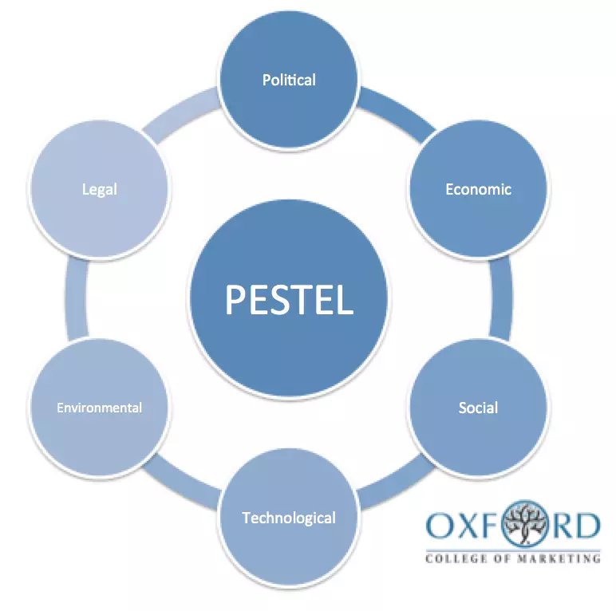
PESTLE / PESTEL ANALYSIS MODEL: Company/Businesses. (Source: Oxford College of Marketing).
BREXIT And COVID-19, Influence on THE UK. And APPLE INC.
P E S T L E

PESTLE ANALYSIS: Figure - 1
United Kingdom in depth PESTLE insights
The Pandemic COVID-19, Brexit and some other external factors influenced many countries around the world including U.K. and having impact heavily on their people resourcing strategies.

  - Political / Legal Environment: BREXIT

The UK follows to a democratic, parliamentary form of governance called ‘Westminster with over system’ that calls for the distribution of power between House of common and House of Lords led by the prime minister, the legislation, and the judiciary, with an unwritten constitution system, means they can change the law anytime. As per the World Bank's statistics, the UK was one of the most successful nations with over 90% performance in terms of voice and accountability, the rule of law, control of corruption, government effectiveness, and regulatory quality in 2019. (Marketline, 2020)

The effects of Brexit on Human Resources:

For many years The UK has been facing with skill shortages in specialized services. The highest shortages in skilled people resourcing are in Health, social services, Information Technology and hospitality industries. This situation has been worsened by Brexit. A survey of 2019 shows that a massive number of EU nationals working in the UK had already started leaving on account of Brexit causing a huge impact on People Resourcing. This led to much smaller pool of talent to recruit from. To minimise this impact the Government has announced plans to introduce a Post Study Visa which provides an opportunity for foreign graduates to live and work in the UK after their studies.
(Odey, 2021).

The UK reached a Trade deal with EU on Brexit, but Brexit triggered some serious Knock-on-effect in various sectors. None the less peoples resourcing is one of them. We can quote a comment of our Prime Minister Mr. Johnson on Brexit deal day: “The country (UK) would no longer participate in the Erasmus exchange program, a Europe-wide program that has allowed 200,000 students a year to travel abroad for study, work experience and apprenticeship since 1987”. (The New York Times). Since Brexit happened, EU residents need a Legal UK visa prior to enter to the UK. This is a massive blow for UK in terms of People Resourcing for any business in the country and my chosen company Apple Inc. is not an exception from there.

3.2. Economic Environment: Pandemic COVID-19.

The UK had a highly competitive economy, but the Pandemic COVID-19 is expected to leave a deep scar on it. According to an international businesses Review UK holds an open and competitive economy, with strong science base and boasts of high-tech manufacturing capabilities in aerospace, defence, and automobiles industries. The knowledge economy sectors such as banking, software, and pharmaceuticals are the strength of UK. According to the Global Economic Forum Report 2019, the UK ranked ninth out of 141 countries in competitiveness and eighth in innovation capabilities. So, the UK has a favourable business environment, and London proved to be the global financial centre between East and the West. (Marketline, 2020)

But Regrettably, The Pandemic COVID-19 has taken this country into deep recession. In the Financial year 2020, the economy shrunk by 21% comparing to 2019. According to a report of Alice Lily in September 2020, COVID-19 cost UK a massive £317 billion pound. On top the Furlough system was extended by the government firm September 2020 to October 2021, which will cost even more. Because of COVID-19 lockdown, the businesses reached hit its lowest level, so many companies either closed or had to cut down its staff. This simply had a huge negative impact on people resourcing strategy countrywide, my chosen company Apple Inc. is certainly one of them. (Alice Lily, 2020).

3.3 Social Environment: BREXIT and Pandemic COVID-19:

On 23rd June 2016 the British people voted to exit the European Union (EU). Brexit happened and UK came out came out from the EU on 31st December 2019 with a one-year transition period until 31st January 2021.

A challenge faced our society during the COVID-19 Pandemic Lockdown is the impact of working from home (Remote working). Research indicates that switch to remote working effects on productivity – an increment or a reduction. However, this switch to remote working has also been characterised by a negative impact on mental health and a rise in stress levels of people working from home. This has resulted in fewer breaks during work, less time away from work and higher stress levels. In a survey 42% of workers reported feeling more stressed working remotely compared to stress levels working in the office, 47% of workers reported negative impact of remote working on their mental health. Reasons behind it is - inappropriate equipment, fewer number of standards break and working excessive hours. Effects of remote working include reported by respondents include Disrupted sleep, Moodiness, General unease, Increased alcohol intake, Reduced exercise, Poor diet etc. This is having a huge impact on people Resourcing and some company simply closed businesses where, working from home is not possible, which is a blow to manage People Resourcing. (Odey, 2021)

It was found that, the impact of Brexit is sensitive to pre-Brexit conditions. The process of industrialisation can significantly alter the Brexit’s impact on the local beef and dairy industry. The impact of Brexit also varies largely across the different region of the country, some will be more resilient than others; some people will gain from Brexit whereas others will lose. (Jiaqi, 2018)

This country has a strong Education and Health care, but income inequality is still high. According to the World Rankings 2021, Four University from the UK, are in the world's top 20. UK’s healthcare system is one of the most successful social venture in the world. The UK’s total healthcare expenditure stood at US$276bn or 9.8% of GDP in 2018. But the healthcare system was severely damaged and nearly collapsed when the COVID-19 pandemic spread rapidly across the country. Rising inequality is a concern. According to the OECD, the UK’s Gini coefficient stood at 0.36 in 2018, compared to France 0.29, Germany 0.29, and Netherland 0.28. It shows that, the UK is amongst the countries whose inequality is rising fast. According to the government press release in 2017–2018, the number of children in absolute poverty rose by 200,000 to 3.7 million. So middle class is disappearing slowly by making a huge gap between the poor and the rich. (Marketline, 2020).

3.4. Technological Environment in terms of Covid-19 and Brexit

One of the challenges technological factors facing is the increased threats to cybersecurity associated with the Remote working due to Pandemic Covid-19. Because people are using their personal devices outside the office infrastructure. The home turned into office made it worse by poor security practice. According to a survey report, 25% of workers noted an increase in phishing emails and 26% are thinking to keep copies of office data on personal devices because of the Phishing. Reports indicate that in April 2020, just one month after the lockdowns around the world, ransomware attacks increased by 148%. It is a digital attack where a victim’s digital files are encrypted and locked out of access, the victim is then needed to pay to unlock and access the files. A report shows 26% were the victims of device password lost and 32% lost their Wi-Fi password. Attackers access to the company files is a serious privacy issue and financial loss. For example, in July 2020, Barak Obama lost $110,000 in few hours. (Odey, 2021).

According to Eurostat in 2018. A total expenditure on Research and development was 47.3 billion, an increase from 43.9 billion in 2017 which is a light of hope from the government for the Technological market in this difficult time of Brexit and worldwide Pandemic of Covid-19. It’s also a great news for apple Inc., Also UK has increased its business expenditure from 1% to 1.2% of GDP in 2018. According to FSB, 1 in 5 small business is the victim of cyber-crime from January 2017 to January 2019 and subject to around 10,000 cyber-attacks a day which is estimated to cost £4.5 bn. This is a direct result of Remote working and excessive online shopping and other transaction because of the countrywide Lockdown for the Pandemic Covid-19. (Marketline, 2020)

The following table shows the current and predicted changes in the Economy of U.K. from 2017 to 2024.

Table 1: The UK – Key Fundamentals, 2017–2024f
2017 | 2018 | 2019 | 2020f | 2021f | 2022f | 2023f | 2024f
GDP, constant 2010 prices (US$ tn) | 2.84 | 2.88 | 2.92 | 2.62 | 2.79 | 2.89 | 2.98 | 3.08
GDP growth rate (%) | 1.89 | 1.39 | 1.40 | -10.19 | 6.17 | 2.87 | 1.93 | 1.94
GDP, constant 2010 prices, per capita  (US$) | 43,022.86 | 43,359.44 | 43,706.41 | 39,025.47 | 41,386.91 | 42,544.98 | 43,777.44 | 45,072.93
Inflation (%) | 2.56 | 2.29 | 1.74 | 1.03 | 1.65 | 1.85 | 1.84 | 1.84
Exports, total as a percentage of GDP | 29.91 | 30.39 | 31.19 | 31.45 | 31.75 | 32.02 | 32.30 | 32.58
Imports, total as a percentage of GDP | 31.90 | 31.64 | 32.51 | 32.81 | 33.15 | 33.41 | 33.71 | 34.01
Mid-year population (millions) | 66.04 | 66.44 | 66.83 | 67.20 | 67.53 | 67.84 | 68.14 | 68.41
Unemployment rate (%) | 4.40 | 4.10 | 3.76 | 5.83 | 5.48 | 5.20 | 4.94 | 4.80
Mobile penetration per 100 people | 118.62 | 117.55 | 117.43 | 117.31 | 117.20 | 117.08 | 116.96 | 116.85
Source: Country Statistics, MarketLine | M A R K E T L I N E

Figure – 2: Source – MarketLine Research. Current and Predicted Changes in the Economy of UK due to Brexit and Pandemic Covid-19. (Marketline, 2020)

- Value Chain Analysis of Apple inc.

Value chain analysis is a way to analyse the activities the Business performs to create a product. Once the activities are analysed, a business can use these results to evaluate the ways to improve its competitive advantage. Goals of Value chain Analysis:
- To improve the operational efficiency.
- To establish an advantage over its competitors.
On completion of your value chain analysis, you’ll be able to identify the ultimate Target you’re trying to gain over the competition. Firms normally target between two types of competitive advantage: cost advantage and differentiation advantage. (Hart, 2020)

People Resourcing

People resourcing is that part of human resource management (HRM) which focuses on the recruitment, Hires Talent as per the company requirements and release of individuals from organisations. HR also monitors and manages their performances and potential while employed by the organisation. In contemporary HR process, it is known as ‘talent planning and resourcing’. (Pilbeam, 2010).

Apple’s current HR Strategy:

Apple has a unique spirit in innovation and an open-minded approach to business. Not only the corporation reflects on the design-and-texture of their merchandises and facilities significantly, but also, they focus on the appearance and impression of their staffs and the workplace environment. In cooperating Apple’s main business philosophy to prospective workers, Jobs designates everyday life at the company headquarters: This strategy got a huge success, and Jobs displays no signs of shame to the ways in which Apple now achieves its most unique and respected resources—its HR. “Business can implement changes, the internal process also may change but workers will never go out of business”, that’s what Steve jobs’ philosophy was toward his business employees. (Assignment Labs, 2020).

Apple managed to create loyalty amongst its employees by providing job satisfaction and invested a huge fund for staff training and development. Apple believes that only a properly skilled and ethically highly satisfied staff can produce a world’s topmost sophisticated and highest quality product for its customers.

- Resourcing Strategies Responding to the changes:

COVID-19 imposed a huge impact on employment and people resourcing. A survey shows that around 28 million jobs were lost because of Pandemic Covid-19 in USA alone. According to the report of McKinsey & Company, more than one million people Lost their job and around 7.6 million jobs or 24% of UK workforce are at risk because of the Covid-19. Apple had also impact on its employment for Covid-19, but company is dealing with it as sensibly as possible. Apple also implemented Furlough system and paid around 80% of contracted salaries to its employees during Pandemic lockdown. (Allas, 2020).

Apple’s Strengths and Weaknesses: (SWOT)

Strengths
- Apple’s biggest strength in the consumer electronic industry is the Innovation of technology.
- Other strength is Apple’s Strong brand image which created customer loyalty through its high-quality products and services.

Weaknesses:
- Sometimes Apple’s products is considered a luxury due to their premium prices. Only middle and high-income consumers can afford it, but it is out of reach low-income consumers
- Apple has created loyal customers, they rely heavily on its iconic retail stores and operates a minimum advertisement policy. Apple’s rival companies can take advantage of this which could have negative impact on Apple.
- Software incompatibility: Apple uses its own software in all its devices. This software is not compatible with any other devices in the world which puts a limitation in worlds electronic market unlike Android operating system

- Recommendations:

Apple can turn its weakness into its strength to increase revenue.

- Instead of targeting only middle-high income earners, it can target also low-income earners by selling it re-furbished product in the market to increase the revenue.
- Apple needs to increase its advertisement campaign by integrating its marketing communication. This will help Apple to sustain its Leadership in future and continue its growth.
- Apple needs to create Business Alliance to create the compatibility for its own software IOs Operating system to access other computing devices such as Dell, Hewlett Packard, Samsung around the world. This will give a huge boost in software market and increase its Revenue in a great deal.

If Apple follows the above Recommendation, it is highly likely they will be able to continue its growth, sustain its leadership in the market. This will also help them to retain and improve its current HR Strategy and the welfare and development of its staff around the world.

- Conclusion:

After critically analysing the current and the predicted changes in the external Environment, taking consideration of two key external factors like Brexit and Worldwide Pandemic of COVID-19, we can conclude that UK had a huge impact on its various sectors such as – Political, Social, Economic and Technical sectors as well as other sectors of the country. In these circumstances most of companies in the countries had to amend or revise its Business and People Resourcing Strategy. Similarly, my chosen company Apple Inc. also needs to revise and amend its Strategy for the benefit and welfare of its staffs and people resourcing.

(----------*----------)

Bibliography
- Alice Lily, G. T. O. D. T. P., 2020. The cost of Covid-19, The Impact of Corona Virus on the UK's public finances.. WHITEHALL MONITOR, 2020 SNAPSHOT , Issue September 2020, p. 1 TO 33.
- Allas, T. M. C. V. H., 2020. COVID-19 in the United Kingdom. McKinsey & Company, Apucis.com.
- Armstrong, M., 2020. Armstrong's Handbook of Human Resource Management Practice. 15 ed. London, UK. Newyork, USA. New Delhi,India.: Kogan Page.
- Assignment Labs, 2020. Critically Analyse the Corporate Strategy of Apple Inc.: Leadership and Innovation. Assignment Labs Case-Study 1.
- Hart, M., 2020. The straightforward Analysis to Value Chain Analysis. HubSpot.
- Jiaqi, G. G. J. P. K. B. M. P. D. G. M. M. s., 2018. Not One Brexit: How local context and Social processes influence policy analysis. PLOS ONE, Issue December 2018.
- Marketline, 2020. The United Kingdom In-depth PESTLE Insights. PESTLE COUNTRY ANALYSIS REPORT: THE UNITED KINGDOM, ML00002-031(November 2020).
- Odey, L. D., 2021. An Evaluation of Challenges Affecting New Technology Startups in the United Kingdom Today: A Pest Analysis. ResearchGate, Issue February 2021, pp. 1-8.
- Pilbeam, S. M. C., 2010. People Resourcing And Talent Planning. Fourth Edition ed. Portsmouth, UK: Pearson Prentice Hall.
- Prashanthi, K. a. J. M., 2013. Human Resource Planning - An Analytical Study. International Journal of Business and Management Invension, 2(1), pp. 63 - 68.
- Stanko, A., 2015. The History of Apple Company. National Technological University, USA., Volume Volume - 1, pp. 97 - 98.

