
DELL
buRberrY, PLC (2019-2023)
Financial Management
Student Name: KUNJ PATEL
Student ID: 2334877
Module Code: LCMB7002
Module: Financial Management
Lecture: MD Kalam
Session: June 2024 Term

EXECUTIVE SUMMARY
Within the context of the five-year analysis the company under discussion – Burberry – has been demonstrated to be rather adaptable to change. From a set of Burberry financial ratios, the company’s liquidity, profitability, efficiency, work capital, leverage and investment returns ratios are obtained. From the figure BELOW, although decreasing from the year 2021 to 2023, Burberry has its liquidity ratios higher than the critical levels showing its capacity to meet short-term obligations. However, this decreasing trend defines a need to enhance the firm’s working capital management. Gross margin has been at responsive levels of 59-60% depending on the quarter, and operating and net margins have significantly sensed up, especially the transition from net margin of 4%. from 63 % in 2020 to 15 %. Seven-ty per cent in 2023, which emphasizes the improvement of operating performance. The efficiency ratios also reflect positive tendencies regarding the usage of assets and the management of inventories as reflected in the ascending tendencies in the asset turnover and inventory turnover ratios; however, the fixed asset turnover ratios seem to experience no significant changes. The antecedent working capital management has experienced contrasting results; accounts receivable days marginally escalated while accounts receivable collections have slowed down, accounts payable and inventories have shortened implying that the supplier’s payment terms, and inventory turnover have been optimised. Again, leveraging ratios show that although Burberry has a slightly higher dependence on liability, it has a good coverage ratio to meet its interest expenses. Further, enhanced ROE, ROA and ROIC of the enterprise as the indicators depicting the efficiency of shareholders’ equity, total assets, and invested capital, respectively, suggest increased capacity to generate higher returns on the invested resources at Burberry. Recommendations for Burberry Clear suggestions are; increasing Burberry’s liquidity through better collection of receivables and optimal inventory management, sustaining profitability through cost control measures and charging premium price for the products, improving operation efficiency through supply chain management, managing the financial leverage through checking the debt levels and going for equity financing, and focusing on high grossing investments to sustain and improve its returns on investments. The effective execution of these tactics will improve the company’s funds, maintain the sustainable growth of this enterprise, and increase its shareholders’ value.

Table of Contents
EXECUTIVE SUMMARY 1
Part A). INTRODUCTION 4
Business Model 4
Market Place 4
Major Competitors 4
Summarization of Significant Events 4
Part B). FINANCIAL PERFORMANCE 6
Liquidity Ratios 6
Profitability Ratios 7
Efficiency Ratios 9
Working Capital Ratios 11
Leverage Ratios 12
Investment Ratios 15
Conclusion 16
Recommendations 17
Part C. INVESTMENT APPRAISAL 19
Part. A 19
1. Payback Period 19
2. Net Present Value (NPV) 19
3. Accounting rate of return (ARR) 20
Part. B 21
REFERENCES 23
APPENDIX 24

Table 1 Ratios Calculations 6
Table 2 Payback Period 20
Table 3 Net Present Value (NPV) 20
Table 4 Accounting Rate of Return (ARR) 21
Table 5 Income Statement 25
Table 6 Balance Sheet 26
Table 7 Ratio Stepwise Calculations 29

Figure 1 Liquidity Ratios Trend 7
Figure 2 Profitability Ratios Trend 9
Figure 3 Efficiency Ratios Trend 10
Figure 4 Working Capital Ratios Trend 12
Figure 5 Financial Leverage Ratios Trend 13
Figure 6 Investment Ratios Trend 16

Part A). INTRODUCTION

Burberry Group PLC is a UK-based luxury goods manufacturer, tailoring, and retailing company founded in 1856 by Thomas Burberry. Burberry has made its way to the pinnacle of fashion with its well-known checked plaid print and stylish trench coats. It is a UK based company that is involved in the selling of apparels, accessories and fragrances across the globe.

Business Model
Burberry Group Plc is in the business of design, manufacture as well as selling a range of luxury clothing, fashion accessories and cosmetics.
1.Retail: Burberry’s own stores and online websites as a company owned channel of distribution.
2. Wholesale: They are involved in retail sales to departmental stores, and specialty retailers.
3.Licensing: Licences and franchise agreements related to producing and distributing sunglasses and perfumes.
Culturally, Burberry values brand longevity and utilizes both history and modernity. Digital marketing and sustainability are also a significant concern of the company.

Market Place
It operates within the global luxury goods industry, and it has established itself in several regions, including Europe, Asia, and the Americas. It focuses particularly on the luxury segment since the company’s products are premium-priced and aim at demanding consumers willing to pay a premium for the best products in the market.

Major Competitors
Burberry's major competitors in the luxury fashion industry include: Burberry’s major competitors in the luxury fashion industry include:
1. Louis Vuitton (LVMH): One of the largest luxury goods manufacturers and distributors in France with a vast network and various brands.
2. Gucci (Kernig): It refers to a company from Italy whose focus is on the manufacturing of luxurious products that are unique and fashionable.
3. Prada: A popular and well-established clothing company originating from Italy and focusing on the high-end segment.
4. Ralph Lauren: An American retail company that offers premium and luxury clothing and other accessories.

Summarization of Significant Events

Change of Directors
More information about public relations events: in January 2022, Jonathan Akeroyd became the CEO of Burberry, replacing Marco Gobbets, who headed the company since 2017. This leadership change was an attempt to sustain Burberry’s progress and other strategic plans as spearheaded by Akeroyd (Burberry, 2022).

Profit Warnings
In 2020, Burberry had to release a profit warning because of the virus’s effect on the sale in the international market. Losses recorded in the company was as a result of store closures and reduced customer spending which lowered the revenue (Reuters, 2020).
Legal Issues
There was controversy in 2021 involving Burberry that arose from legal issues of trademark infringement concerning the company’s famous tartan check. They settled out of court, shows the significance of the intellectual property at the fashion industry (Bloomberg, 2021).
Mergers & Acquisitions (M&A)
In the last five years, there are no any mergers or acquisitions that Burberry has been involved in, but it has worked on strategic partnerships and collaborations. For instance, Burberry partnered with gaming sites such as Tencent’s Honours of Kings, in an effort to appeal to the younger digital generation enthusiasts (Business of Fashion, 2021).
Strategic Changes
Burberry has made several strategic changes to enhance its brand positioning and operational efficiency:
1. Digital Transformation: Digital media as a means of reaching out to the clients and a direct selling strategy due to changing client trends.
2. Sustainability Initiatives: It targets to be a net zero business by 2022 and launched PFC-free sustainably constructed product collections for those consumers that are in support of sustainability (Burberry, 2021).
3. Retail Strategy: Its store network was rationalised, the company concentrating on key stores in the best locations while improving the shopping experience through the use of technology and services (Vogue Business, 2021).
Impact on Performance
These events have had varying impacts on Burberry's performance:
- New leadership gives fresh strategic visions that in any given organization may lead to the growth and innovation activities.
- The outbreak of COVID-19 negatively impacted operations, however, the company’s robust digital channel minimised the effect.
- Some of the legal issues highlighted the importance of strong IPR regime as explained below.
- Partnerships and operating for sustainability have improved the brand image and market position of Burberry.

Part B). FINANCIAL PERFORMANCE

Liquidity Ratios
Liquidity ratios are used to evaluate the company’s capacity to meet its current liabilities with the current assets. The most important liquidity ratios are the current ratio, quick ratio and the cash ratio.
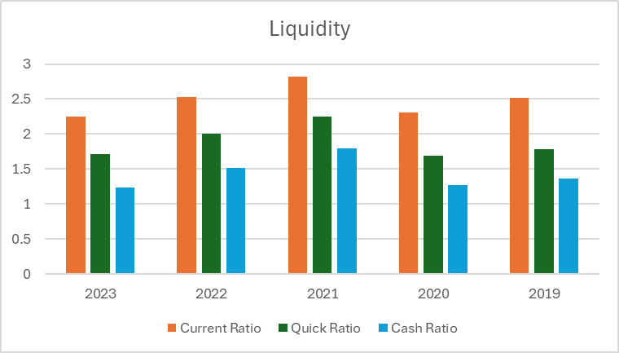
Figure 1 Liquidity Ratios Trend
1. Current Ratio
The current ratio is one of the liquidity ratios and it is computed by dividing the total current assets by the total current liabilities. It shows the capacity of a business organization to meet its current obligations using its current resources.
- 2019: 2.51x
- 2020: 2.31x
- 2021: 2.82x
- 2022: 2.53x
- 2023: 2.25x
Analysis: The current ratio for Burberry also stayed above the benchmark of 1.0 for the period, meaning that it was liquid. The highest value of 2.82x in 2021 indicates that Burberry had adequate current assets to cover its current liabilities in the year 2021. But a reverse is seen from 2021 to 2023 with a figure of 2.25x in 2023. This decline may suggest that current assets have reduced compared to the prior year or current liabilities have gone up implying a worsening of the liquidity situation (Damodaran, 2021).
2. Quick Ratio
The quick ratio (acid-test ratio) is even more conservative than the current ratio because inventory is excluded from current assets.
- 2019: 1.79x
- 2020: 1.69x
- 2021: 2.25x
- 2022: 2.00x
- 2023: 1.71x
Analysis: Like the current ratio, quick ratio of Burberry also increased and touched its peak in 2021 which is 2.25x and has been decreasing to 1.71x in 2023. Hypothesis two states that the quick ratio is lower than the current ratio, which is true, suggesting that the current asset list for Burberry includes inventory, which is relatively less liquid compared to the others. The reduction from 2.25x in 2021 to 1.71x in 2023 might be an indication that Burberry has been building its inventories over the years or has been experiencing some difficulties of converting its receivables into cash as it used to.
3. Cash Ratio
The cash ratio is the most conservative liquidity ratio as it only considers cash and cash equivalents.
- 2019: 1.37x
- 2020: 1.27x
- 2021: 1.79x
- 2022: 1.52x
- 2023: 1.24x
Analysis: The cash ratio of Burberry means that the company has kept a good cash position compared to its current liabilities, and the highest cash ratio is 1.79x in 2021. However, the ratio has reduced to 1.24x in 2023, which show a decrease in cash and cash equivalents. This may be because of greater cash expenditure like operating expenses, capital investments, or dividends (Gitman, 2020). That is why the observed tendency of the constant cash ratio decline from 2021 to 2023 may indicate certain issues with liquidity in case with the company.

Profitability Ratios
The profitability ratios offer an Analysis of a firm’s capacity in generating earnings against its sales, assets, equity and the other figures.
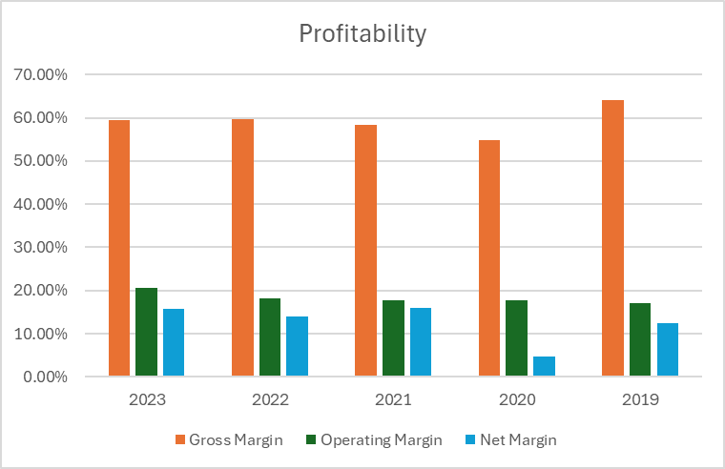
Figure 2 Profitability Ratios Trend
1. Gross Margin
Gross margin is the proportion of total revenue that is obtained after subtracting the cost of goods sold from the total revenue.
- 2019: 64.19%
- 2020: 54.88%
- 2021: 58.28%
- 2022: 59.59%
- 2023: 59.57%
Analysis: The gross margin of Burberry reduced significantly from 64. The proportion of people who were employed in the formal sector but had to accept low paid jobs increased from 19% in 2019 to 54. This in turn reduces the number of people who can afford to pay for them to 88% in 2020, probably due to higher costs or cost pressures. The recovery in subsequent years, stabilizing around 59. 57%-59. In the case of 59% in 2022 and 2023, it points to enhanced cost control or better pricing plans (Brigham and Ehrhardt, 2019).
2. Operating Margin
Operating margin is defined as the remaining percentage of income after all variable expenses in production have been taken out.
- 2019: 17.10%
- 2020: 17.77%
- 2021: 17.75%
- 2022: 18.19%
- 2023: 20.69%
Analysis: The operating margin depicts a progressive enhancement of the position from 17. 10% in 2019 to 20. 69% in 2023 that show improved operational effectiveness and increased management of operating costs (Gitman, 2020).
Net Margin
Net margin reveals the amount of net income that can be obtained for each dollar of sales.
- 2019: 12.46%
- 2020: 4.63%
- 2021: 16.04%
- 2022: 14.01%
- 2023: 15.84%
Analysis: For the net margin, it was rather volatile; it declined to 4.63% for the company in 2020, probably because of the pandemic’s influence on net income. The subsequent recovery to 15.84% in 2023 indicates a rebound in better profit margins and efficient cost controls (Damodaran, 2021).

Efficiency Ratios
Activity ratios focus on the specifics as to how well the company is using its assets and how well it is dealing with its liabilities.
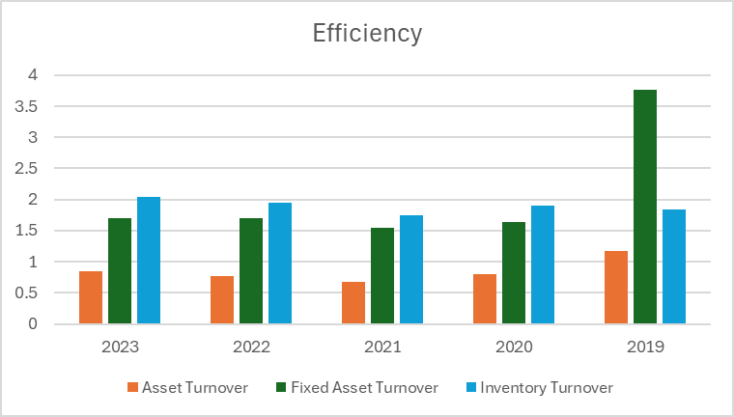
Figure 3 Efficiency Ratios Trend
1. Asset Turnover
On the use of assets, a company’s asset turnover ratio determines the level of efficiency in the use of assets in generating sales.
- 2019: 1.17x
- 2020: 0.80x
- 2021: 0.67x
- 2022: 0.76x
- 2023: 0.84x

Analysis: The asset turnover ratio was lower at 0.67x in 2021 down from 1.17x in 2019 which suggest that the company has been less effective in using its assets to generate revenues. The improvement to 084x in 2023 implies the efficiency of asset utilization has rebounded (Brigham & Ehrhardt, 2019).
2. Fixed Asset Turnover
Fixed asset turnover ratio gives a view of how effectively fixed assets are being utilized by the firm to generate sales.
- 2019: 3.76x
- 2020: 1.64x
- 2021: 1.54x
- 2022: 1.70x
- 2023: 1.70x
Analysis: This means that there was a decline in the turnover of fixed assets a year later to 1.54x in 2021 down from 3.76x in 2019. The stabilization around 1.70x in 2022 and 2023 is slightly better, but still below the level of 2019, which means that the company still has trouble achieving the maximum efficiency of fixed assets.
3. Inventory Turnover
Inventory turnover ratio gives the number of times a business has sold its inventory and restocked with the same during a given time.
- 2019: 1.85x
- 2020: 1.90x
- 2021: 1.74x
- 2022: 1.95x
- 2023: 2.04x
Analysis: This is further depicted in the inventory turnover ratio of the company, which has risen from 1.85x in 2019 to 2.04x in 2023 revealing better management of inventory and speedy conversion of inventory to sale.

Working Capital Ratios
The working capital ratios are used to determine the ability of a firm in the short-term management of the assets and its liabilities.
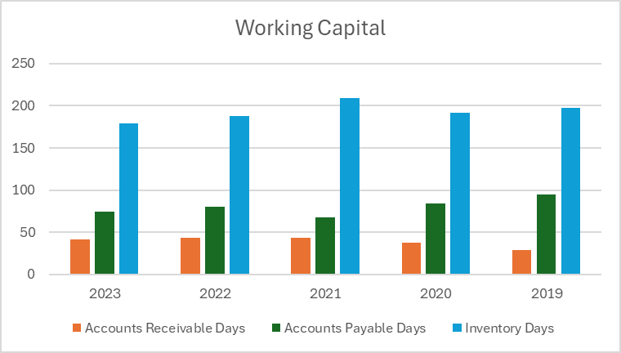
Figure 4 Working Capital Ratios Trend
1. Accounts Receivable Days
Accounts receivable days give an idea about the period that takes for a firm to get paid after making sales.
- 2019: 29 days
- 2020: 37 days
- 2021: 43 days
- 2022: 44 days
- 2023: 41 days
Analysis: Accounts receivable days has gone up from 29 in the year 2019 to 44 in the year 2022 showing that there may be slower collection of receivables hence affecting the cash flow of the company. Therefore, a slight increase to 41 days in the 2023 plan represents a slight improvement in collection efficiency (Brigham and Ehrhardt, 2019).
2. Accounts Payable Days
Accounts payable days indicate the average number of days a company takes to pay its suppliers.
- 2019: 94 days
- 2020: 84 days
- 2021: 67 days
- 2022: 80 days
- 2023: 75 days
Analysis: The accounts payable have been reduced from 94 of 2019 to 67 of 2021, indicating faster payments to the suppliers. The rise to 80 days in 2022 and slight decline to 75 days in 2023 could be due to enhanced but still conservative management of suppliers’’ payables (Gitman, 2020).
3. Inventory Days
The average number of days inventory is held before it is sold.
- 2019: 198 days
- 2020: 192 days
- 2021: 209 days
- 2022: 188 days
- 2023: 179 days
Assessment: The reduction in the inventory days from 209 to 179 between2021 andmid-2023 indicates improved management of inventories (faster turnover), which is good for working capital management (Damodaran, 2012).
Degree of Operating Leverage and Degree of Financial Leverage for Burberry 2019-2023

Leverage Ratios
These ratios determine the proportion to which a company is using debt.
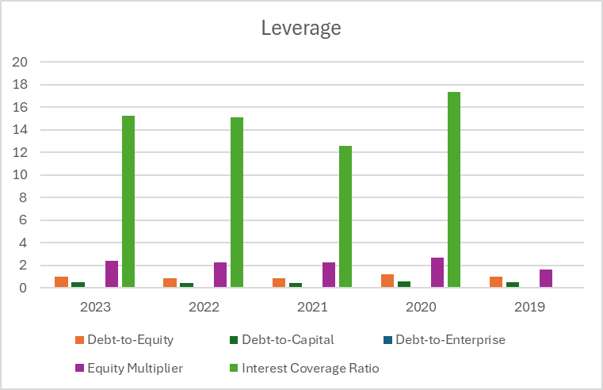
Figure 5 Financial Leverage Ratios Trend
1. Debt-to-Equity Ratio
The debt-to-equity ratio measures the percentage of equity and personal loan that a organization is the usage of to fund its assets.
- 2019: 0.98
- 2020: 1.20
- 2021: 0.87
- 2022: 0.87
- 2023: 0.97
Analysis: The ratio of debt to equity increased over the review period, reaching 1.20 in fiscal year (FY) ended June 2020 and then declined, dropping to an estimated number of in conclusion without a third consecutive annual decline from FY22. The 2020 bump is an outlier and might reflect added leverage during the pandemic. The latter decrease reflects that there has been better control of levels or an increase in equity financing (Brigham & Ehrhardt, 2019).
2. Debt-to-Capital Ratio
The debt-to-capital ratio calculates the amount of debt in a company's capital structure.
- 2019: 0.49
- 2020: 0.55
- 2021: 0.47
- 2022: 0.46
- 2023: 0.49
Analysis: The debt to capital ticked higher as well, nudging 0.55 during the peak of leverage in 2020 The subsequent drop to 0.46 by year-end 2022 and hovering around the range of 0.49 in the following years indicate a more corresponding blend within capital structure (Gitman, 2020).
3. Net Debt
Net debt signifies the total debt less cash and cash equivalents.
- 2019: 550
- 2020: 538
- 2021: 101
- 2022: 179
- 2023: 460
Analysis: Net debt tremendously reduced in 2021 against 2019, from 550 to 101, respectively. The subsequent increase to 460 in 2023 might indicate renewed borrowing or decreased cash, eliminated existing debt, potentialize new investment opportunities, or address operational issues (Damodaran, 2021)
4. Debt-to-Enterprise Ratio
This ratio determinates the proportion of enterprise value hedged by debt.
- 2019: 0.05
- 2020: 0.07
- 2021: 0.01
- 2022: 0.03
- 2023: 0.06
Analysis: The topmost ratio occurred in 2020 when it equalled 0.07 and the least one in 2021 when it equalled 0.01. The increase to 0.06 in 2023 could demonstrate an enhanced proportion of the enterprise value financed by debt and could reflect leverage strategy. (Gitman, 2020).
5. Equity Multiplier
The equity multiplier measures the degree of the shareholder’s equity to total assets of the company.
- 2019: 1.60
- 2020: 2.70
- 2021: 2.24
- 2022: 2.29
- 2023: 2.40
Analysis: The equity multiplier went up in 2020 to 2.70 meaning higher leverage was used. The range of 2.24 to 2.40 in 2021 to 2023 has little use of both equity and debts which presents a balanced moderated use of the resources.
6. Interest Coverage Ratio
Interest coverage ratio gives information about the company’s capacity to pay interests for its borrowings.
- 2019: 116.25
- 2020: 17.33
- 2021: 12.61
- 2022: 15.12
- 2023: 15.24
Analysis: They decreased from 116.25 in 2019 to 12.61 in 2021 due to may be higher interest expenses or lower earning capacity. Switching to 15.24 is assumed to be reflecting better earnings or lower interest expenses in the 2023 context which than helps the firm to cover interest (Damodaran, 2021).

Investment Ratios
Investment ratios analyse the organ’s return on the shareholders’ equity and investment in the company.
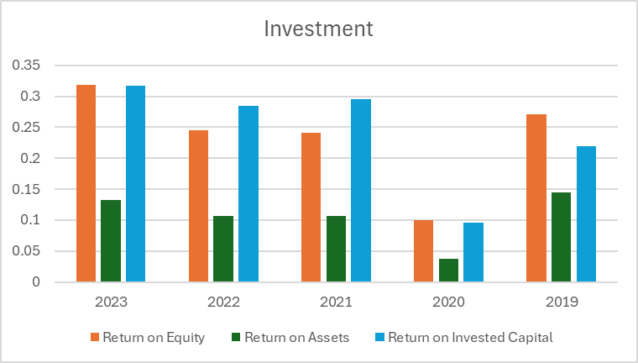
Figure 6 Investment Ratios Trend
1. Return on Equity (ROE)
ROE determines how much of the business profitability belongs to the shareholders’ equity.
- 2019: 27.12%
- 2020: 10.01%
- 2021: 24.10%
- 2022: 24.49%
- 2023: 31.84%

Analysis: Thus, the following changes in some of the key elements of the financial performance have been observed, for instance, the company’s ROE reduced to 10.01% in 2020, probably attributing to the effects of the pandemic, and then soared to 31.84% in 2023, which means high profits and efficient use of equity (Gitman, 2020).
2. Return on Assets (ROA)
ROA as a ratio determines the net income of the firm as compared to the total vouchers of assets.
- 2019: 14.54%
- 2020: 3.71%
- 2021: 10.74%
- 2022: 10.71%
- 2023: 13.29%
Analysis: Like ROE, ROA also decreased in the year 2020, with 3.71%, but increased in the year 2030 to 13.29% depicting the good utilization of asset and an increase in profitability.
3. Returning on Invested Capital (ROIC)
ROIC analyses the return that is achieved for total investment made in the company.
- 2019: 21.94%
- 2020: 9.62%
- 2021: 29.50%
- 2022: 28.45%
- 2023: 31.72%
Analysis: Using ROIC the company moves from 962% in 2020 to 3172% in 2023 which shows extended and efficient usage of capital to attract returns suggesting right strategic investments as well as operations improvements (Damodaran, 2021).

Conclusion
The analysis of Burberry’s liquidity ratios which include the current ratio, the quick ratio and the cash ratio has illustrated that there is a reduction from the year 2021 to 2023. In spite of the absolute figures exceeding the critical level of ‘1’ which shows the corporation can meet all short-term obligations during the period, the declining trend depicts a worsening of the liquidity situation. It could probably affect the company’s solvency and its capacity to meet short-term liabilities without much pressure on its cash assets. Another key area that has been exhibited by Burberry is profitability, and in specific, gross margins have been recorded to be ranging between 59 – 60%. The operating and net margins have also expanded which is a clear sign of good cost management and to top it up revenue growth. The increase in the gross margin together with the increase in other operating income led to the increase in net margin from 4. In 2016, the figure stood at 63 % then slightly dropped in 2020 to 15. 84 percent by 2023, the study noted that Burberry performs well in translating more volume into gross profit, hence signifying efficiency.
The efficiency ratios depict a positive undertaking since the company has improved on the asset turnover ratio and the inventory turnover ratio. Such enhancements suggest more optimality in regard to the usage of the assets and the improvement of the inventory handling. In the case of fixed asset turnover ratio, its stability implies that fixed assets are efficiently being put to fruitful use, hence a determinant of efficiency of operations. Consequently, it can be inferred that there is presence of slight deterioration in accounts receivable days meaning that the collections are taking longer time implying a cash flow issue at Burberry. On the other hand, accounts payable days have gone down, meaning swift payments to suppliers are made. The finding of a decline in the inventory days also indicates better inventory management, hence a shorter cycle reinvesting the capital.
The two leverage ratios show that Bur bridge has slightly relied on the source of debt with the debt-to-equity and debt-to-capital ratios going up. Nonetheless, the company has a good interest coverage which shows that the firm has adequate capacity to meet its interest costs. This is true in as much as the equity multiplier has gone up and this can be as a result of financial leveraging but in this case, it is well managed. Thus, the company’s return on equity or ROE, return on assets or ROA, and the return-on-investment capital or ROIC have been demonstrating improvement. These ratios depict the capacity of the company to achieve better returns on shareholders’ equity, total assets, and invested capital, making efficient and wise use of resources.

Recommendations
- Enhance Liquidity Management:
- Accelerate Receivables Collection: It would be relevant to raise the credit standards and enhance the collection procedures to decrease the accounts receivable days.
- Optimize Inventory Levels: Select high and effective inventory control methods in order to decrease the inventory holding cost and to release more cash.

- Sustain and Improve Profitability:
- Cost Control: It should also remain committed on cost efficient expenditure management to sustain high operating margin.
- Premium Pricing Strategy: Ensure that the brand adheres to the luxury image coupled with a high price that will help in the sustenance of high gross margins.

- Increase Operational Efficiency:
- Supply Chain Optimization: Some suggestions are invested in supply chain, to increase efficiency and to reduce inventory days still more.
- Asset Utilization: Identify weak areas of assets optimization to improve the turnover rates of assets.

- Manage Financial Leverage:
- Debt Monitoring: Closely monitor the level of debt kept so as not to exceed the carrying capacity of debts and thus retain control over the amount of debt.
- Equity Financing: Develop possibilities of equity financing to keep the balance of capital structure and financial leverage as well.

- Focus on High-Return Investments:
- Capital Allocation: Spur more investments on high return projects with the aim of attaining the objectives of maximum returns on equity, assets and invested capital.
- Innovation and Market Expansion: The recommendations are to increase investing in innovations and expanding into new markets to increase growth and improve profitability.

- Improve Working Capital Management:
- Extend Payables Period: This strategy involves prolonging the length of time that is taken to make payments to suppliers while, at the same time, enhancing the firm’s cash inflows.
- Efficient Cash Management: Promote cash management procedures in order to have adequate amount of cash in the organization in the provision of operations and investment.
- Sustainability and Corporate Responsibility:

- Sustainable Practices: As it is still important for the company to remain able to deliver sustainable methods of business operations that will also improve brand image and address legal compliances.
- Corporate Social Responsibility (CSR): Enhance more CSR operations for relations with clients and stakeholders and create a strong and long-term relationship with the customers.
All of these recommendations, which when adopted, will automate Burberry’s financial structures, can enable the company to increase efficiency in its management of finances, consequently, flexible it for sound growth and good financial health.

Part C. INVESTMENT APPRAISAL

Part. A

1. Payback Period
The payback period is basically the length of time it takes for the project to generate enough cash flows to cover the initial investment on the project.
Year | Projected cash flows (£m) |  | Cumulative Cash Flows
Year | A | B | A | B
0 | -80 | -75 | -80 | -75
1 | 25 | 50 | -55 | -25
2 | 25 | 20 | -30 | -5
3 | 20 | 20 | -10 | 15
4 | 55 | 20 | 45 | 35
 | Project A | Project B
Years | 3 years | 2 years
Fraction of Year | 0.18 | 0.25
Payback Period | 3.18 years | 2.25 years
Table 2 Payback Period
• Project A: 3. 18 years (A=3+1055=3.18years)
• Project B: 2. 25 years (B=2+520=2.25years)
Analysis: It then shows that Project B has a smaller payback period than Project A and this is preferred because it has shorter payback period means faster recovery of the initial investment all these meaning lesser exposure to the risk and better liquidity.

2. Net Present Value (NPV)
NPV refers to the difference between the present value of cash receipts that would accrue over the useful life and the present value of the cash expenditures using a discount rate, here being WACC of 9. 75%.
Year | Project A |  |  | Project B
Year | CashFlows (1) | Discounted Factor (WACC 9.75%) (2) | PV (1×2) | CashFlows (1) | Discounted Factor (WACC 9.75%) (2) | PV (1×2)
0 | -80 | 1.00 | -80.00 | -75 | 1.00 | -75.00
1 | 25 | 0.91 | 22.78 | 50 | 0.91 | 45.56
2 | 25 | 0.83 | 20.76 | 20 | 0.83 | 16.60
3 | 20 | 0.76 | 15.13 | 20 | 0.76 | 15.13
4 | 55 | 0.69 | 37.91 | 20 | 0.69 | 13.79
NPV (Sum of col. PV) | 16.57 |  |  | 16.08
Table 3 Net Present Value (NPV)
Formula for NPV=∑t=1nCt(1+r) t−C0
- Project A:
NPVA=25(1+0.0975)1+25(1+0.0975)2+20(1+0.0975)3+55(1+0.0975)4−80
NPVA=25(1.0975) +25(1.2058) +20(1.3236) +55(1.4516)-80
NPVA=22.78+20.76+15.13+37.91-80= 16.57 million
- Project B:
NPVB=50(1+0.0975)1+20(1+0.0975)2+20(1+0.0975)3+20(1+0.0975)4-75
NPVB=50(1.0975) +20(1.2058) +20(1.3236) +20(1.4516)-75
NPVB=45.56+16.60+15.13+13.79-75= 16.08 million
• Project A: £16. 57 million
• Project B: £16. 08 million
Analysis: The two projects show the NPV greater than zero, therefore, the two signify value creation for the undertaking period. It means that Project A has slightly larger NPV than Project B and it means that the implementation of the project A will bring more value to the company absolutely speaking.

3. Accounting rate of return (ARR)
ARR is another way of determining the profitability of an investment opportunity hence is defined as the application of a percentage to the investment to establish an ARR.
ARR is arrived at by following steps: First, average annual profit is divided by the initial investment is then obtained.
Year | Projected Profits (£m)
Year | A | B
1 | 25 | 50
2 | 25 | 20
3 | 20 | 20
4 | 55 | 20
Average Profit (A) | 31.25 | 27.5
Initial Investment (B) | 80 | 75
ARR (A/B) | 39.06% | 36.67%
Table 4 Accounting Rate of Return (ARR)
• Project A: 39. 06% ARR=25+25+20+55/4=31.25
ARR=31.25/80=0.3906 = 39.06%
• Project B: 36. 67% ARR=50+20+20+20/4= 27.5
ARR=27.5/75=0.3667 = 36.67%
Analysis: It is evident that Project A has a higher ARR as opposed to Project B; this means that project A is likely to give a better return on the initial investment as per the accounting view of things.
Summary of Results
• Payback Period: Project B has less cycle time, and its average is 2. 25 years while this of Project A is 3. 18 years and therefore, project B should be chosen.
• NPV: The value of project A is £ 16. 57 million while that of project B is £ 16. 08 million and so project A is slightly favourable than project B.
• ARR: As for the percentage of work distribution, Project A is at 39. 06% while Project B is at 36. 67%.
Recommendation
Physically Project B reaches the payback period more frequently than Project A, however NPV and ARR represent the fact that Project A will create more worth through the duration of the projects and generate better overall return.
Given that both projects have positive NPVs and reasonable payback periods, the decision should hinge on the company's priorities:
- If the priority is quicker liquidity and risk reduction, Project B would be preferable.
If the priority is maximizing long-term value and returns, Project A should be chosen.
Bearing in mind that Project A has slightly higher NPV and ARR, plus given that the company is in a good position to wait a little longer to recoup its investments since its end-result could be of a higher value and that of Project B of lesser value, Project A is recommended.

Part. B
Payback Period (PBP)
Advantages:
1. Simplicity and Ease of Use: PBP is relatively simple and uncomplicated to compute and therefore even people with minimum understanding in finances are able to compute it (Brigham and Ehrhardt, 2019).
2. Risk Assessment: It yields a rapid overview of the company’s liquidity and risk levels based on the amount of time required to regain the invested sum (Gitman, 2020).
3. Focus on Short-term Cash Flows: More relevant to companies which prefer and emphasize cash flows in line with companies’ short term solvency status, those in the early stages of their development, or are operating in industries that are highly sensitive to fluctuations in demand (Brealey, Myers, & Allen, 2020).
Shortcomings:
1. Ignores Time Value of Money: In respect of this option, PBP does not take into consideration the time value of money, and, as such, it may mislead the true cost of prospective long-term projects (Damodaran, 2021).
2. Excludes Post-Payback Period Cash Flows: It merely focuses on the cash flow up to time zero on the payback period, not on any cash inflow or outflow after this period (Brigham & Ehrhardt, 2019).
3. No Direct Measure of Profitability: As a decision tool, PBP is somewhat lacking; PBP does not give information on the absolute profitability of a project further more overall, a factor that is very important in the long-term investment decisions (Gitman, 2020).
Accounting Rate of Return (ARR) is the comparison of the dollar returns from investment projects with the required rate of return.
Advantages:
1. Ease of Understanding: The computational process of ARR is very easy because of the use of accounting profit unlike that of APC and it is comprehensible to most of the managers (Hilton & Platt, 2015).
2. Focus on Profitability: That is the extent to which the yield is anticipated in the investment in relation to its cost making it ideal for use in performance assessment (Gitman, 2020).
Shortcomings:
- Ignores Time Value of Money: The same as PBP, ARR does not take into consideration the time value of money, and this might lead to ineffective investments (Damodaran, 2021).
- Based on Accounting Profits: It focuses on accounting profits while Cash flows can be inflated or deflated through accounting policies and depict the firm’s ability to generate cash and cash like items (Brealey, Myers, & Allen, 2020).
- Does Not Consider Project Duration: ARR does not account for the varying lengths of different projects, which can lead to biased comparisons (Brigham & Ehrhardt, 2019).
Net Present Value (NPV)
Advantages:
1. Considers Time Value of Money: The Net Present Value brings cash flows received in the future to the present, which gives a clear indication of a project’s return (Damodaran, 2021).
2. Comprehensive Analysis: It considers all revenues, or any other payment made in cash throughout the life of the project giving a full picture of the project’s effect in the financial area (Kasztelan, 2016).
3. Direct Measure of Added Value: Based on the increase in the value to the firm calculated above, NPV is consistent with the increase in shareholder wealth, another way of doing things, in this case.
Shortcomings:
1. Complexity: NPV is analytically a little tougher, as it involves a forecast of future cash flows, along with a suitable rate of discount (Damodaran, 2021).
2. Sensitivity to Discount Rate: Discount rate affects NPV calculation and a wrong rate will lead to wrong decisions (Brealey, Myers, & Allen, 2020).
3. Potential for Overlooked Non-Financial Factors: NPV disregards strategic or relative factors that could be useful in comprehending the future success of a business campaign (Brigham & Ehrhardt, 2019).
Non-Financial Factors to Consider
1. Strategic Alignment: Activities should directly or indirectly support the organisation’s, strategic plan and organisational mission rather than only focusing on the monetary benefits (Kaplan & Norton, 2008).
2. Market Positioning: Reflect on the proposal as to how the project will affect the company’s market share, competitive position and the customers’ attitude (Porter, 1985).
3. Regulatory and Legal Factors: Concerning the specified regulatory requirements and potential legal concerns, their impact on the projects’ viability is apparent (Brigham and Ehrhardt, 2019).
4. Environmental and Social Impact: Consider the sustainability and social implication aspects as these may affect how the public will receive the innovations and the company’s compliance (Freeman, 2010).
5. Technological Advancements: Consider the project’s impact within the timeframe and the company’s capability to generate sustainable competitive advantage as a leverage of some new technology or novelty organizational innovation (Christensen, 1997).
Conclusion
Each of PBP, ARR, and NPV has its strengths and weaknesses, although NPV is predominantly preferred due to its better analysis of all the effects a particular project can have on company’s financial statements. However, decision-makers must also consider non-financial factors to ensure that the chosen projects align with the company's overall strategic objectives and sustainability goals.

REFERENCES
- Brigham, E. F., & Ehrhardt, M. C. (2019). Financial Management: Theory & Practice. Cengage Learning.
- Brealey, R. A., Myers, S. C., & Allen, F. (2020). Principles of Corporate Finance. McGraw-Hill Education.
- Christensen, C. M. (1997). The Innovator's Dilemma: When New Technologies Cause Great Firms to Fail. Harvard Business Review Press.
- Burberry. (2021). Annual Report 2021. Retrieved from Burberry.
- Burberry. (2022). Jonathan Akeroyd Appointed as New CEO. Retrieved from Burberry.
- Business of Fashion. (2021). Burberry and Tencent Collaborate on Digital Innovation. Retrieved from Business of Fashion.
- Reuters. (2020). Burberry Issues Profit Warning Amid COVID-19 Impact. Retrieved from Reuters.
- Vogue Business. (2021). Burberry’s Strategic Retail Evolution. Retrieved from Vogue Business.
- Damodaran, A. (2021). Corporate Finance: Theory and Practice. Wiley.
- Freeman, R. E. (2010). Strategic Management: A Stakeholder Approach. Cambridge University Press.
- Gitman, L. J. (2020). Principles of Managerial Finance. Pearson.
- Kaplan, R. S., & Norton, D. P. (2008). The Balanced Scorecard: Translating Strategy into Action. Harvard Business Review Press.
- Porter, M. E. (1985). Competitive Advantage: Creating and Sustaining Superior Performance. Free Press.

APPENDIX
Table 5 Income Statement
Table 6 Balance Sheet
Ratio Analysis of Burberry
Year |  |  | 2023 | 2022 | 2021 | 2020 | 2019
Liquidity
Current Assets (CA) |  |  | 1,863 | 2,035 | 1,982 | 1,689 | 1,609
Current Liabilities (CL) |  |  | 829 | 804 | 703 | 731 | 640
Current Ratio …... (CA/CL) |  |  | 2.25x | 2.53x | 2.82x | 2.31x | 2.51x
Current Assets (CA) |  |  | 1863 | 2035 | 1982 | 1689 | 1609
Current Liabilities (CL) |  |  | 829 | 804 | 703 | 731 | 640
Inventories (I) |  |  | 447 | 426 | 402 | 451 | 465
Quick Ratio …. ({CA-I}/CL) |  |  | 1.71x | 2.00x | 2.25x | 1.69x | 1.79x
Cash (C) |  |  | 1026 | 1222 | 1261 | 929 | 875
Current Liabilities (CL) |  |  | 829 | 804 | 703 | 731 | 640
Cash Ratio…. (C/ CL) |  |  | 1.24x | 1.52x | 1.79x | 1.27x | 1.37x
Profitability
Gross Profit (GP) |  |  | 1,843 | 1,684 | 1,366 | 1,445 | 1,746
Total Sales (TS) |  |  | 3,094 | 2,826 | 2,344 | 2,633 | 2,720
Gross Margin …. (GP/TS) x 100 |  |  | 59.57% | 59.59% | 58.28% | 54.88% | 64.19%
Total Sales (TS) |  |  | 3,094 | 2,826 | 2,344 | 2,633 | 2,720
Operating Income (OI) |  |  | 640 | 514 | 416 | 468 | 465
Operating Margin…. (OI/TS) x 100 |  |  | 20.69% | 18.19% | 17.75% | 17.77% | 17.10%
Total Sales (TS) |  |  | 3094 | 2826 | 2344 | 2633 | 2720
Net Income (NI) |  |  | 490 | 396 | 376 | 122 | 339
Net Margin …... (NI/TS) x 100 |  |  | 15.84% | 14.01% | 16.04% | 4.63% | 12.46%
Efficiency
Total Sales (TS) |  |  | 3,094 | 2,826 | 2,344 | 2,633 | 2,720
Total Assets (TA) |  |  | 3,686 | 3,697 | 3,502 | 3,292 | 2,332
Asset Turnover…. (TS/TA) |  |  | 0.84x | 0.76x | 0.67x | 0.80x | 1.17x
Total Sales (TS) |  |  | 3,094 | 2,826 | 2,344 | 2,633 | 2,720
Fixed Assets (FA) |  |  | 1,823 | 1,662 | 1,520 | 1,603 | 723
Fixed Asset Turnover …. (TS/FA) |  |  | 1.70x | 1.70x | 1.54x | 1.64x | 3.76x
COGS |  |  | 910 | 829 | 701 | 858 | 858
Inventories (I) |  |  | 447 | 426 | 402 | 451 | 465
Inventory Turnover.... (COGS/I) |  |  | 2.04x | 1.95x | 1.74x | 1.90x | 1.85x
Working Capital
Account Receivables (AR) |  |  | 351 | 337 | 277 | 268 | 215
Total Sales (TS) |  |  | 3,094 | 2,826 | 2,344 | 2,633 | 2,720
Year Days (YD) |  |  | 365 days | 365 days | 365 days | 365 days | 365 days
Accounts Receivable Days…. (AR/ {TS/ YD}) |  |  | 41 days | 44 days | 43 days | 37 days | 29 days
Accounts Payables (AP) |  |  | 186 | 181 | 129 | 197 | 222
COGS |  |  | 910 | 829 | 701 | 858 | 858
Year Days (YD) |  |  | 365 days | 365 days | 365 days | 365 days | 365 days
Accounts Payable Days…. (AP/ {COGS/ YD}) |  |  | 75 days | 80 days | 67 days | 84 days | 94 days
Inventories (I) |  |  | 447 | 426 | 402 | 451 | 465
COGS |  |  | 910 | 829 | 701 | 858 | 858
Year Days (YD) |  |  | 365 days | 365 days | 365 days | 365 days | 365 days
Inventory Days…. (I/ {COGS/ YD}) |  |  | 179 days | 188 days | 209 days | 192 days | 198 days
Leverage Ratios
Debt (D) |  |  | 1,486 | 1,401 | 1,362 | 1,467 | 1,425
Equity (E) |  |  | 1,539 | 1,617 | 1,560 | 1,219 | 1,460
Debt-to-Equity …. (D/E) |  |  | 0.97 | 0.87 | 0.87 | 1.20 | 0.98
Debt (D) |  |  | 1,486 | 1,401 | 1,362 | 1,467 | 1,425
Capital (C) |  |  | 3,025 | 3,018 | 2,922 | 2,686 | 2,885
Debt-to-Capital …. (D/C) |  |  | 0.49 | 0.46 | 0.47 | 0.55 | 0.49
Debt (D) |  |  | 1,486 | 1,401 | 1,362 | 1,467 | 1,425
Cash & Equivalent (C&E) |  |  | 1,026 | 1,222 | 1,261 | 929 | 875
Net Debt …. (D - C&E) |  |  | 460 | 179 | 101 | 538 | 550
Debt (D) |  |  | 1,486 | 1,401 | 1,362 | 1,467 | 1,425
Enterprise Value (EV) |  |  | 7,595 | 5,547 | 7,907 | 7,383 | 10,273
Debt-to-Enterprise …. (D/EV) |  |  | 0.06 | 0.03 | 0.01 | 0.07 | 0.05
Equity (E) |  |  | 3,686 | 3,697 | 3,502 | 3,292 | 2,332
Total Assets (TA) |  |  | 1,539 | 1,617 | 1,560 | 1,219 | 1,460
Equity Multiplier ….. (TA/E) |  |  | 2.40 | 2.29 | 2.24 | 2.70 | 1.60
EBIT |  |  | 640 | 514 | 416 | 468 | 465
Interest Expenses (IE) |  |  | 42 | 34 | 33 | 27 | 4
Interest Coverage Ratio…. (EBIT/EI) |  |  | 15.24 | 15.12 | 12.61 | 17.33 | 116.25
Investment Ratios
Net Income (NI) |  |  | 490 | 396 | 376 | 122 | 339
Equity (E) |  |  | 1,539 | 1,617 | 1,560 | 1,219 | 1,460
Return on Equity... (NI/E) x 100 |  |  | 31.84% | 24.49% | 24.10% | 10.01% | 23.22%
Net Income (NI) |  |  | 1,539 | 1,617 | 1,560 | 1,219 | 1,460
Total Assets (TA) |  |  | 3,686 | 3,697 | 3,502 | 3,292 | 2,332
Return on Assets…. (NI/TA) |  |  | 13.29% | 10.71% | 10.74% | 3.71% | 14.54%
Net Income (NI) |  |  | 1,539 | 1,617 | 1,560 | 1,219 | 1,460
Invested Capital (IC) |  |  | 1,999 | 1,796 | 1,661 | 1,757 | 2,010
Return on Invested Capital … (NI/IC) |  |  | 31.72% | 28.45% | 29.50% | 9.62% | 21.94%
Table 7 Ratio Stepwise Calculations

