

BMIH6002

Hotel Placement – Managing Food and Beverage Operations

Student Learning Log

Name: Alexandra Craescu
Student ID:2111926
Lecturer: Jessica Newport

Table of Contents
Introduction 3
Section 1: Reflection on Experience and Personal Development 4
What? 4
So what? 5
Now what? 5
Section 2: Critical Analysis of Work-Based Skills and Technical Knowledge 6
Section 3: Reflection on Organisational Issues 8
Issues and Impact 8
Proposed Solutions 8
Conclusion and Action Plan 10
References 11

Introduction
The food and beverage department of Ibis Birmingham New Street Hotel & Conference Centre serves diverse customers. The department serves an English buffet breakfast from 6:30 to 10:00 AM on weekdays and 11:00 AM at weekends. From 3 to 10 PM, a la carte menus include starters, sandwiches, burgers, mains, and desserts (Accor.com, 2025). A 24/7 cuisine serves customers. My placement includes F&B supervisor shadowing. I learnt guest service and technology at work. This placement learning objectives are:
- Understanding the operational processes within the food and beverage department.
- Developing communication, teamwork, and task management skills.
- Gaining insights into guest service standards and expectations.
- Identifying and addressing organisational challenges within the department.
- Enhancing personal and vocational development to prepare for a future career in hospitality.

Section 1: Reflection on Experience and Personal Development
Driscoll's three-stage (What, So What, and Now What) reflection model was applied to reflect on my experience and personal development (Bassot, 2020). The first stage of this model describes the incident, then assesses its impact, and then recommends future steps. Concluding prior action promotes critical thinking, learning, and practice.
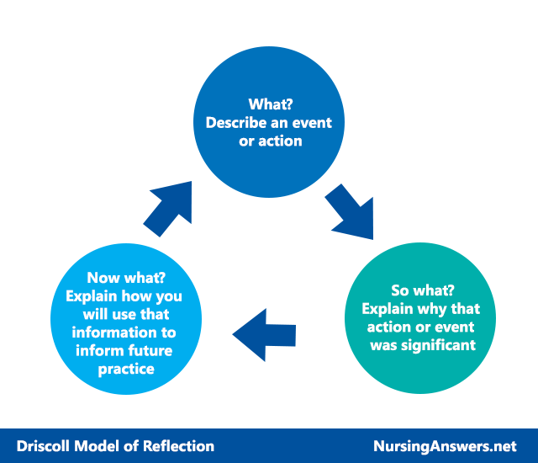
Figure 1: Driscoll's model of reflection
Source: (Bassot, 2020)

What?
I shadowed the food and beverage Supervisor, observing staff coordination, visitor interactions, and service. Breakfast buffet setup, supply inspections, food quality checks, and tourist enquiries were my duties. I watched the supervisor plan, assign, and handle problems. I focused on breakfast service efficiency during placement. The supervisor ordered frequent food replenishment for buffet excellence. Busy buffets needed good service. Guests ordering unavailable things caused problems (Boussard, 2021). The supervisor was calm and professional. The supervisor suggested alternate menu selections and immediately resolved the issue to make the guest feel valued. The supervisor scheduled staff to cover and prevent disturbances. Delegating and communicating kept everything flowing smoothly. I observed the supervisor handle bad orders and major visitor worries.

So what?
Collaboration, work delegation, and communication were emphasised by me as supervisor. Effective team communication and collaboration enable service delivery in my hectic workplace. The staff-guest connection was crucial throughout placement. Food safety, stock management, and service were addressed to please tourists. By shadowing the food and beverage supervisor, I understood how leadership improves guest happiness. Supervisors handled complaints and operational issues gently (ASET, 2017). Leadership is about establishing a great environment where everyone can achieve, not just managing a team. Task management was key to service. Timely supervisor team assignments decreased delays and satisfied visitors. Mismanaged tasks and team roles delayed guests. The hospitality back-of-house was unfamiliar to me before this internship. I learnt how back-of-house operations please guests. I used customer service and hotel management concepts. Fast work helped me adapt. I soon learnt positivity, time, and pressure management. Hospitality is unpredictable, therefore adaptability and resilience are key.

Now what?
I wish to lead and solve problems by accepting them. Leading teams, solving problems, and making quick decisions are my aims. Leadership improves teamwork and efficiency. I need improved visitor and teamwork communication (Khan et al., 2021). I want to listen more to guests and teammates to understand and address future employment challenges. Classify food and beverage safety, cleanliness, and service.

Section 2: Critical Analysis of Work-Based Skills and Technical Knowledge
Communication: Teamwork and service require good communication. Clear supervisor-staff communication improved efficiency and decreased misunderstandings. A manager spoke and gestured during breakfast (Astawa and Ardiasa, 2022). It ensured timely food delivery and guest pleasure. Clear communication helped the team collaborate, reducing errors and ensuring smooth operations during hectic times. Clear communication and prompt replies improve teamwork and visitor pleasure.
Teamwork: Collaboration in food and beverage ensures service continuity. With encouragement, team members worked faster, enhancing client satisfaction. Staff helped each other refill buffets and serve customers in the morning rush (Goh et al., 2022). Communication and cooperation issues are delayed. A worker neglected to disclose low supplies, delaying buffet replenishment and disrupting service. Teamwork and proactive aid were emphasised. Good service and a healthy, reliable workplace require teamwork.
Task Management: Maintaining order during busy service periods needs task management. Supervisors assigned jobs well to ensure service. The supervisor assigned food replenishment, table clearing, and guest help based on team members' skills and availability (Patiar et al., 2020). It was emphasised to refresh food stations during peak hours while serving clients and doing minimum administrative work. This proves that balancing urgent needs with long-term obligations reduces service delays and ensures customer satisfaction. Task management keeps a workplace calm and organised under pressure.
Personal Skills: Supervisor confidence and problem-solving skills enhanced food and beverage service. During my placement, the supervisor handled visitor requests and team dynamics calmly and professionally, even in heated situations (Ngoepe and Theron, 2023). A guest complained about the food temperature, and the supervisor gently replaced it. This remedied the problem and thrilled the guest. Supervisors must trust their decisions and solve problems under pressure. My career depends on team management and guest relations.
Guest Service: The food and beverage department's success depends on service. I realised during my placement that anticipating and meeting visitor needs quickly makes them pleased. A customer ordered a gluten-free breakfast one morning. I instantly gave the guests an option and made them feel important (Khan et al., 2021). Answering visitor questions quickly and efficiently increases satisfaction and loyalty. Personalisation may improve the experience when staff learn and satisfy client preferences. I will strengthen these skills to help consumers in future careers.

Section 3: Reflection on Organisational Issues

Issues and Impact
Guest Service: The staffing shortage affects several departments. Diners waited longer due to late food replenishment and service (Kamar et al., 2023). Food refills disappointed visitors. Breakfast attendees were annoyed by the slow service.
Staff Performance: The staff had to multitask and work harder to replace the absentee. Staff weariness and stress lowered morale and attention. Staff delayed and mishandled service requests. Staff couldn't clean or replenish buffets.
Operational Efficiency: Workforce shortages delayed or rushed key tasks to meet demand, lowering efficiency (Astawa and Ardiasa, 2022). This issue revealed the need for better contingency planning and staffing to handle unexpected absences without compromising service. Delays frustrate customers and exhaust personnel.

Figure 2: Issues and Impact
Source: (Khan et al., 2021)

Proposed Solutions
Cross-Training Staff: To address staffing issues, the hotel may use various methods to reduce unexpected absences and enhance productivity. Multiple-department cross-training is conceivable. The hotel can boost flexibility when staff is away by training receptionists to serve light F&B during busy hours (Cousins and Weekes, 2020). Workers can help each other and trade employment, reducing staff shortages. According to the Resource-Based View (RBV), staff training to diversify skills increases the organization's ability to respond to changing events and internal issues, resulting in more effective resource use.
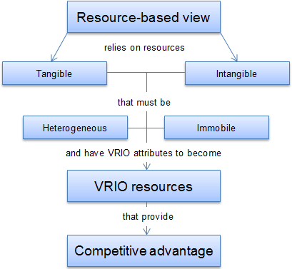
Figure 3: RBV
Source: (Cousins and Weekes, 2020)
Improved Scheduling and Forecasting: Better scheduling and forecasting could predict busy periods and staff levels. Hotel staff and resources can be scheduled by analysing occupancy and client demand. Activity Characteristics Model (JCM) activities improve employee engagement and performance (Patiar et al., 2020). Plan beforehand to decrease stress and aid staff during busy times.
Incentivising Staff Retention: Staff retention incentives may boost hotel staff availability. Recognition, flexible hours, and overtime bonuses enhance morale and prevent turnover. Recognition and awards boost employee retention and happiness, according to Herzberg's Two-Factor Theory (Ngoepe and Theron, 2023). Incentives may reduce labour shortages by retaining skilled people.

Conclusion and Action Plan
I learnt a lot from Ibis Birmingham New Street Hotel & Conference Centre's food and beverage management. The placement emphasised service efficiency through communication, teamwork, and job management. I discovered visitors need confidence and problem-solving. Service delivery during workforce shortages requires planning and adaptability.
Moving forward, I want to improve my leadership skills by taking on more responsibilities. Team and operations management will prepare me for management. My communication skills must improve, especially in guest-facing jobs that need professional complaint handling. Training and development will teach me food safety and service. I want to proactively solve problems using hotel management. It cemented my ambition to work in hospitality and gave me supervisory skills.

References
Accor.com (2025). Ibis Birmingham New Street | Central Hotel in Birmingham - ALL. [online] all.accor.com. Available at: https://all.accor.com/hotel/1459/index.en.shtml#section-facilities [Accessed 26 Feb. 2025].
ASET (2017). A good practice guide for placement and other work-based learning opportunities in higher education. Moorfoot: Aset.
Astawa, I.G. and Ardiasa, I.K. (2022). Enhancing English-Speaking Skills for Food and Beverage Services for Tourism Students Through A Collaborative Learning. Jurnal Kajian dan Terapan Pariwisata, 2(2), pp.26–36. doi:https://doi.org/10.53356/diparojs.v2i2.55.
Bassot, B. (2020). Reflective Journal. 3rd ed. London: Palgrave Macmillan.
Boussard, S. (2021). Food and beverage management in the luxury hotel industry. New York, New York (222 East 46th Street, New York, NY 10017): Business Expert Press.
Cousins, J. and Weekes, S. (2020). Food and Beverage Service, 10th Edition. Hodder Education.
Goh, E., Okumus, B., Jie, F., Djajadikerta, H.G. and Lemy, D.M. (2022). Managing food wastage in hotels: discrepancies between injunctive and descriptive norms amongst hotel food and beverage managers. British Food Journal, ahead-of-print(ahead-of-print). doi:https://doi.org/10.1108/bfj-05-2021-0513.
Kamar, Omaima Munawar Albadry, Samar Sheikhelsouk, Hasan, M. and Alsetoohy, O. (2023). Dynamic Capabilities Influence on the Operational Performance of Hotel Food Supply Chains: A Mediation-Moderation Model. Sustainability, 15(18), pp.13562–13562. doi:https://doi.org/10.3390/su151813562.
Khan, O., Marrucci, L., Daddi, T. and Bellini, N. (2021). Adoption of Circular Economy and Environmental Certifications: Perceptions of Tourism SMEs. Journal of Management and Sustainability, 11(1), p.218. doi:https://doi.org/10.5539/jms.v11n1p218.
Ngoepe, L.L. and Theron, N.W. (2023). Employability Attributes of Hospitality Graduates and Expectations of Hotel Managers. Journal of Teaching and Learning for Graduate Employability, [online] 14(1), pp.88–103. Available at: https://eric.ed.gov/?id=EJ1396225 [Accessed 15 May 2024].
Patiar, A., Kensbock, S., Benckendorff, P., Robinson, R., Richardson, S., Wang, Y. and Lee, A. (2020). Hospitality Students’ Acquisition of Knowledge and Skills through a Virtual Field Trip Experience. Journal of Hospitality & Tourism Education, 33(1), pp.14–28. doi:https://doi.org/10.1080/10963758.2020.1726768.

