`Student Name – Fozia Malik
Student Number – 2130819
Module code – LCH4006_Birm
Module Title – Professional development within the health and social care
Assignment Title - Personal Development Portfolio
Lecturer Name – Farah Islam

Table of content
Curriculum Vitae………………3/4/5
Job Role…………………………6
Cover Letter…………………….7/8
Swot Analysis………………….9/10
Personal development Plan…11/12
Personal Statement………….13/14
Reflection on Presentation………15
Reference List ……………………16

Curriculum Vitae

Fozia Malik

Personal Summary
Currently a student studying Level 4 higher education in Health and Social care. I am an enthusiastic, caring, and hardworking person who wants to pursue a career in counselling. I have a decade experience of excellent communication and client service skills. I have also experienced two years in Volunteering at Victim Support where I decided a career change. I am passionate in supporting people who need help to progress in life. I enjoy reading, cooking, socialising with all kinds of people from diverse backgrounds and attend the gym regularly for my wellbeing.

Contact
Address: Birmingham, England B27 6pl
Phone: 07450915229
Email: Amelia.jaan@hotmail.com

Work History
Victim Support officer 2016-2018
Victim Support McLaren’s Building, Birmingham Town Centre
- Supported clients effected by a crime and traumatic incidents
- Face to face and telephone meetings held
- Provided Emotional and practical support
- Built trust with client
- Signposted to relevant agencies
- Conducted assessments for clients’ needs and progress

Assistant Manager 2007-2009
Colmore News Agent Co-operation Street Birmingham

- Recruited new staff and managed training staff
- Briefed teams with targets and initiatives
- Motivated staff to reach sales target
- Dealt with customer complaints and feedback
- Analysed sales figures
- Managed a team of ten people

Supervisor 2005-2007

Perfume Shop Oracle Town Centre Reading

- Supervised a team of five
- Planned rota’s and workload
- Allocated work to team members
- Resolved customer complaints

Administrative Assistant/Customer service assistant 1999-2005
Safeway Basingstoke road Reading
- Dealt with customer complaints and enquiries
- Answered customer queries telephone and face to face
- Selling products and taking payment
- Used own initiative when management not available

Skills and Knowledge
- Professionalism and responsible
- Ability to Build a Rapport with clients
- Excellent communication skills and customer service
- Ability to work effectively within a team, individuals and independently
- Active listening/empathetic/non-Judgemental
- Management skills obtained
- Maintaining Ethic in workplace
- Demonstrated ability to work effectively with all kinds of people
Education
GCSE 1999
Maths (C) English Literature & Language (C/C) Science (C) business studies (C) Spanish (D) History (C)
Level 4 Higher Education in Health and Social Care 2023 currently
References available on request

Job role applied
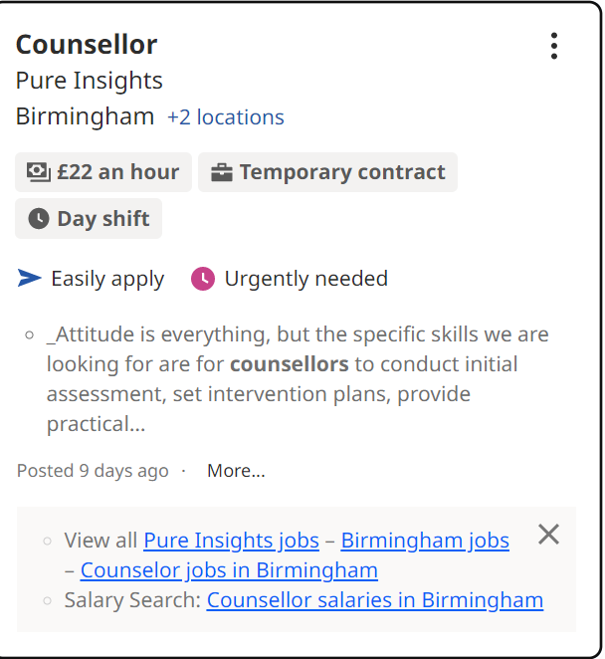
https://uk.indeed.com/Family-Counsellor-jobs?vjk=b8801a5b351d6897

Cover letter

Fozia Malik
1240 Warwick Road
Birmingham, B27 6pl
07450915229
Amelia.jaan@hotmail.com
9, March 2023
Mr Mark Owen
Executive Account Manager
Pure Insights Counselling,
126A High Gate, London

Dear Mr Owen
I am currently Studying Level 4 in Higher Education Health and Social Care. I am extremely interested in the job you posted for a Counsellor position in Birmingham. I believe my passion for this role will allow me to excel in all areas required in this position. My two years’ experience in Victim Support gives me the necessary skills and knowledge to immediately bring forward into your organisation. As a candidate who has previous experiences associated with this job specification, I can therefore go beyond the working expectations required in this job description.
Whilst I was working in my previous job as Victim Support Officer, I developed many skills such as implementing appropriate strategies and intervention plans dealing with barriers and supported all kinds of people from diverse backgrounds assessing their needs and concerns effectively. My confidence and excellent communication skills verbal and non- verbal have been built from the decade experience I obtained from retail management.
After reading my CV and personal statements I hope you do observe my qualifications, experiences and above all my passion and potential for this job role. I am excited to discuss further my specific skills and knowledge and how I can implement them into your organisation.
Please do not hesitate to contact me for any further information or references required from previous jobs I will happily respond.
Your Sincerely
Fozia Malik

Personal Swot Analysis
A SWOT analysis is a good technique to Identify potential issues that could arise for an organisation or an individual it enables you to identify strengths and weaknesses that are followed by opportunities and threats (Raeburn 2022).

Strengths | Weakness
- I can communicate well with others  - I can empathise and I am a very understanding person.  - I am completely committed in helping others to succeed  - I am a confident person  - Good speaker  - Determined to complete task | - Cannot say no, end up working overtime  - Take on too much responsibility  - I am too self-critical
Opportunities | Threats
- I am currently studying level 4 in health and social care this will allow me to go on to psychology in counselling.  - There are many volunteering positions to apply for to allow me to gain experience. | - Family commitment  - Location  - Time commitment  - Not having previous Experience in job role

Personal development plan
(Glassdoor, 2021)
Target | How will I achieve this? | Why will this target benefit me? | What will change when I achieved this? | When do I want to meet this target?
Complete level 4 Health and Social care | Commitment in completing all modules and pass them. | It will allow me to go on to my Level 4 in Psychology in counselling. | I will gain knowledge and a receive a pass certificate in level 4 Health and Social Care. | I want to meet this target by  April 2023,
Complete  Level 4 in Psychology in counselling | Complete all modules before deadlines and pass them.  Read more literature. | It will get me onto the next level which is level 5 in Psychology in counselling. | Further knowledge in Psychology for counselling will be achieved. | I want to meet this target by September 2024.
Complete level  5 in Psychology in counselling | Dedicate my time and use all study skills available at the university to help me pass the modules. | I will be able to get onto level 6 in Psychology in counselling. | A better understanding in this subject. | I want to meet this target by September 2025.
Complete level 6 in Psychology in counselling | Continue with commitment and dedication to complete all modules to pass. | It will complete my degree for Psychology in counselling. | I will achieve my registered BACP degree in Psychology in counselling and seek employment. | I want to meet this target by September 2026.
Volunteer work in Counselling | Research places where there is availability for volunteering. | I will gain experience and further knowledge in this field. | It will help me get into employment. | I want to meet this target by September 2026.

Personal statement
A hardworking and highly motivated individual. I am currently a student studying level 4 in Health and Social Care I am determined and excited to go on to study Psychology in Counselling which is a 3-year degree registered with BACP. I want to resume a professional career in Counselling after taking a career break and devoting my time in raising a family. The experience I gained from Volunteering for two years at Victim Support made me decide I want to definitely change from retail to a much more rewarding position, which involves in helping others going through any kind of difficult situation. My qualities and abilities also initiate from life experiences where I believe I took on the role as a counsellor at home such as when my parents divorced, my sister going through depression and my brother went through becoming an alcoholic I stepped up and supported my family by understanding them with a person-centred approach and being a good listener without being judgemental. More recent my brother was diagnosed with cancer stage 2 in 2020. He reached out to me for one-to-one support I must say I found it challenging. However, I surprised myself as I had then realised, I have the ability to put my emotions aside him being my brother and supported him with his emotions, pain, anxiety, and fears for two years until his treatment plan ended and he was back to himself. This was a massive achievement for me to see him come out of it a stronger person with a positive mind set which we both worked on together. From this event I learnt more about myself I then decided I want to put this experience into practice and become professional and help in the wider community. However, for me now it is not only just wanting to help others I do also want to gain the knowledge aspect of counselling. What I find motivates me is helping people and developing relationships.
One of the strongest skills I believe I have is excellent communication skills which I believe is extremely important to communicate effectively in Counselling. This skill comes from the decade experience I gained in retail which I am so grateful I have because today who I am the confidence I have has originated from there. Keeping in mind I was dealing with customer complaints at the age of sixteen and went on to being a manager at a young age. This gave me the abilities to use my own initiative, manage a team, motivate others and most importantly I lead by example this is something I always valued. My manger position as in my status never meant anything more within a team because we were all in it together wanting to achieve the same goal. As a Counsellor I would be the same the client and I will be working together wanting to achieve the same result in improving their wellbeing.
I am interested in reading books and cooking I find both activities therapeutic and I also enjoy attending the gym regularly this helps me with my wellbeing not only physically but also mentally.

Reflection on presentation
I was given a task to create a 5-minute presentation using PowerPoint. I had to Describe one key skill and state why it was relevant to working within health and social care and I had to Include one practical example of how you might use this skill in a health and social care context. I was confident in creating the presentation as I have done a few now on power point and I was excited with the key skill communication I chosen as I understood the importance of this subject which made it easier for me to present and discuss. However, I had some challenges I faced. Firstly, I struggled with researching a model of communication to use it in the practical example which was worrying me but eventually I figured one out. Secondly, a night before my deadline I rehearsed my slides, and I realised I was well over the 5mins it made me panic because I had little time to make changes putting pressure on myself and I needed to discuss everything that was asked for in the task. I had to go back and make further changes and take out relevant information with regret. However, I was happy with the content and figures I used in my presentation as I followed my assignment brief thoroughly. As the day approached to present my presentation, I was nervous and still worried about whether I will have enough time to go through all my slides, so this made me very anxious. I received the feedback for my presentation and overall, I was proud of the comments made especially where the lecturer comments my Berol model of communication was used well, I was relieved to hear this as I did mention earlier, I found that part difficult. The lecturer also commented I spoke to fast, and it was fair for her to say this as I knew I may have done this. From this I have learnt I need improvement on planning and practicing well prior to deadline.

Reference List
Glassdoor, (2021) How to Create a Personal Development Plan Available at: https://www.glassdoor.co.uk/blog/guide/personal-development-plan/ (Accessed Date 19 March 2023).
Raeburn, A. (2022) Asana “SWOT analysis: What it is and how to use it (with examples)” Available at: https://asana.com/resources/swot-analysis (Accessed Date 18 March 2023).

