
UNIVERSITY OF WALES
TRINITY SAINT DAVID

Topic: Volkswagen Group MNC
International Business Consultancy Report
(Cross Country Analysis: Germany, Brazil, Slovakia, Morocco)

Module: International Business Concepts: LCMB7034
Student: Ivilina Atanasova Atanasova
Student Number: 2028391

Lecture: Dr. Baber Syed

Date: 22/11/2025
Table of Contents
1. Introduction (147 words) 3
2. Benefits and Challenges of International Operations (1466 words) 4
2a. Why Volkswagen Is an MNC/TNC 4
2b. Global Value Chain Overview 8
2c) Country’s Entry modes 11
2d. Key benefits obtained by the company from its international operations 12
3. Volkswagen Group OLI factors (Ownership, Location and Internalisation) 13
3.1. Ownership Advantages 13
3.2 Location Advantages (labour cost, market size, infrastructure) 15
3.3 Internalisation Benefits (retaining control, avoiding leakage, managing quality) 15
3.4 Integrated Comparison of OLI Across Countries 15
3.5. Inter-country Relationship and Risk Link 16
4. Cultural Differences Between Germany and the host countries Influence Volkswagen’s Market Entry Strategy and Long-Term Success (1072 words) 16
4.1. Hofstede Culture dimensions 16
4.2. Volkswagen's cross-country management, hiring, customer-service, and strategies for negotiation. 18
4.3. Integrating Cultural Risks and Training for Entry Mode Success 19
5. Volkswagen’s SOP Adjustments for Effective Operations Across Germany, Brazil, Slovakia and Morocco (1208) 19
5.1. SOP Implications of the SOP Gap Between Germany and VW’s Host Markets (Brazil, Slovakia, Morocco) 20
5.2. Supplementary SOP Requirements: Environmental Reporting, Cultural Integration, and Market-Specific Branding 22
Conclusion 24
Appendix 1. Operation Countries VW 25
Appendix 2. Entry Mode(s) and Theoretical Models 26
Appendix 3. Major Recommended SOP Adjustments for Volkswagen Group 29
Reference List 32

1. Introduction (147 words)
The company was established in 1937 by members of the German Labour Front, Paul A. Brinckmann, Alexander Halder, and Werner Boltz. The first models were manufactured in Wolfsburg in 1938, and civilian production resumed after the war. Wolfsburg, Germany is home to Volkswagen's headquarters, although the company has expanded into 112 facilities in Europe, the Americas, Asia, and Africa. Germany is still the Group's software, battery, and R&D hub, but as you can see from Table 1, Brazil, Slovakia, and Morocco are becoming more strategic players. Such international connections are crucial, according to Volkswagen Group (2024), because sustained expansion requires bringing together disparate locations into a unified worldwide system. The combination of Germany's technological power with the size and efficiency of the EU in Slovakia's production and the growing distribution capacity in Morocco positions the company to better handle the fast-paced changes in the sector.

2. Benefits and Challenges of International Operations (1466 words)
The classic instance of how worldwide development can be both a gain and problematic are Volkswagen's ability in navigating different markets.

2a. Why Volkswagen Is an MNC/TNC
Volkswagen, like a typical multinational corporation (operating in 152 countries—see Appendix 1 for the complete list of countries), would be exceedingly dependent if it relies solely on a single national market. With its high-tech industries, software hubs, and battery centres, Germany is the Group's core component. However, relying just on this expensive environment would limit our long-term flexibility (Deresky, 2020). It need new growth engines for the system in case Germany tightens any further due to cost or regulatory challenges. Brazil is important because it offers scale and localisation that Germany cannot in a market where demand is always changing. However, this equilibrium will only persist provided the efficiency benefits are not diminished by Brazil's unpredictable weather.
At the same time, Slovakia stabilises the connection between low-cost industries and the integrated value chains of the European Union. Its ability to efficiently assemble models helps to mitigate disruptions in other areas. To further fortify the system's resilience, Morocco can expand its distribution and assembly base, which will allow it to fortify its access to North and West Africa - table 1 (Volkswagen Group, 2024).

Table 1. Volkswagen Group – Presence Across the Four Selected Economies 2024
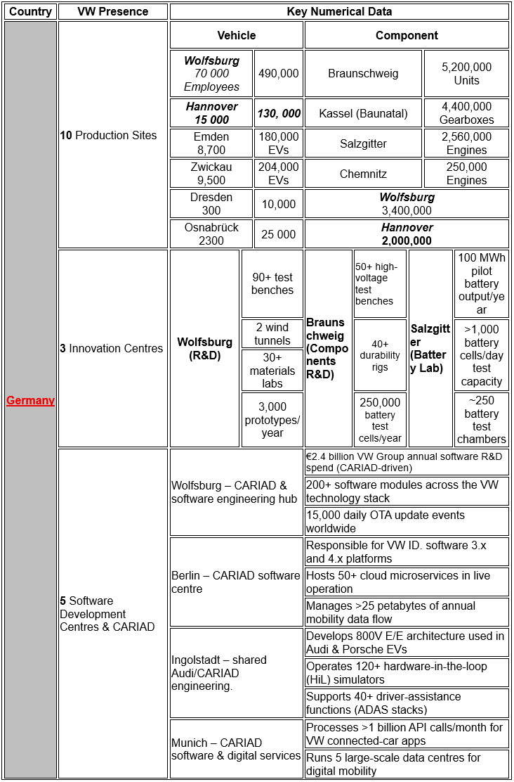

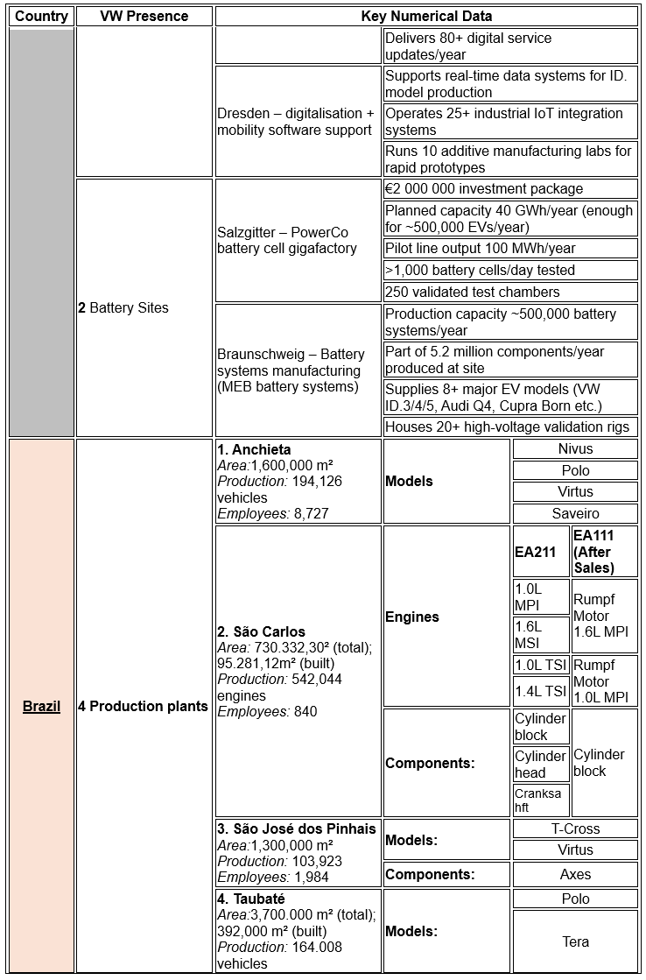
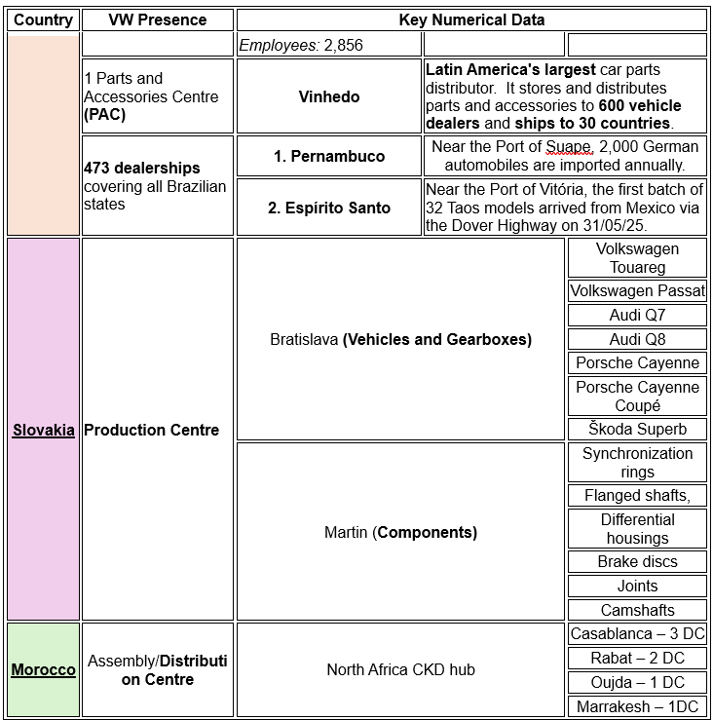
(Source: Created by author from Volkswagen Group Annual Report, 2024)

Why the relationship between these places is crucial to Volkswagen's growth is shown by the numerical differences in Table 1: The strategic significance of Germany's 490,000 vehicle and 5.2 million component innovation base depends on the assistance it receives from large-scale manufacturing in Brazil (over 194,000 cars), production streams in Slovakia that are connected with the EU, and an increasing distribution network in Morocco. The ability of Volkswagen to integrate its geographically scattered capabilities into a global value chain depends on the efficiency with which the company manages this international system (Sloman, 2019, Volkswagen do Brazil, 2025).

2b. Global Value Chain Overview
VW's worldwide value chain shows how effective cross-country integration of R&D, procurement, manufacturing, logistics, sales, and financing gives a competitive edge. Table 2 summarises these 2024 activities in Germany, Brazil, Slovakia, and Morocco, highlighting their distinct yet interacting functions (Deresky, 2016).

Table 2. 2024 Value Chain Breakdown by Country
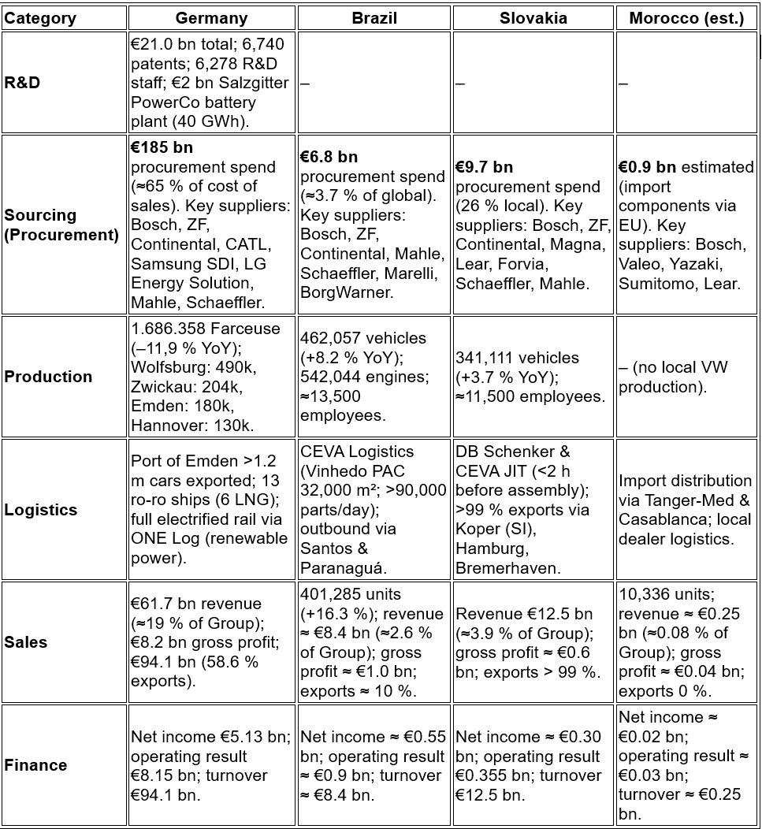
(Source: Created by author from Volkswagen Group Annual Report, 2024)

The inter-regional reinforcement of a company's strengths is more important than its isolated strengths in determining its resilience. Although Volkswagen benefits from Germany's €185 billion procurement base and €21 billion R&D spend, this advantage is only meaningful if it is seamlessly integrated into global production networks (Volkswagen Group, 2024). German high-cost infrastructure can't handle every regulatory or market shock, which is why Brazil is so important. Brazilian volume-driven production, as seen by an 8% rise in deliveries and €8.4 billion in turnover, stabilises margins that might otherwise erode in Europe as pressures tighten.
Also, the Group is vulnerable to transport-route instability due to Slovakia's 99 % export dependency, but the country manages to turn expensive engineering into scalable efficiency. Tanger-Med, with its 9 million-container capacity, connects European supply chains to the quickly growing African markets (Cavusgil et al., 2017), hence Morocco, despite its small finances, answers a strategic need. The link between Volkswagen's cross-country capacity and investment, as shown in Figure 1, is shaped by these interdependencies.

Figure 1. Volkswagen’s cross-country imbalance in capacity and investment (Volkswagen Group, 2024)
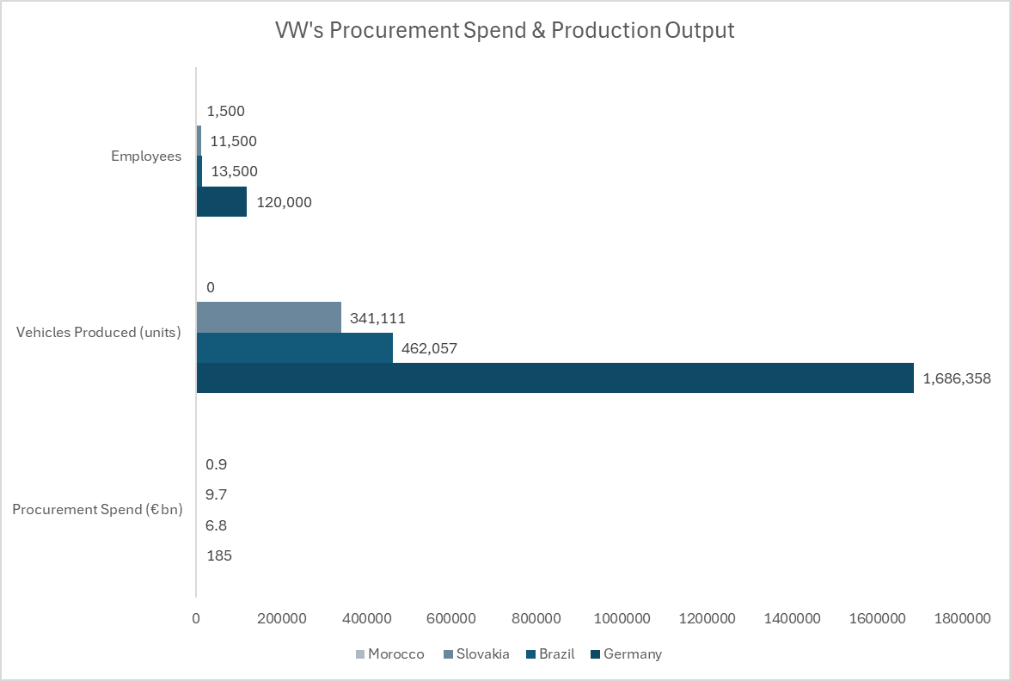

Germany's dominance in procurement (€185bn) and manufacturing (1.69m units) highlights how the network relies on technological depth; without it, Brazil and Slovakia couldn't stabilise regional demand or absorb volume shocks. Morocco's distribution-based role enhances market access in North and West Africa; therefore, Volkswagen's expansion relies on these nations complementing each other through specific functions rather than competing for the same skills. Figure 2 shows the structural differences in export and domestic market reliance among the four countries.

Figure 2. Countries contribute to Volkswagen’s market exposure
(Volkswagen Group, 2024)
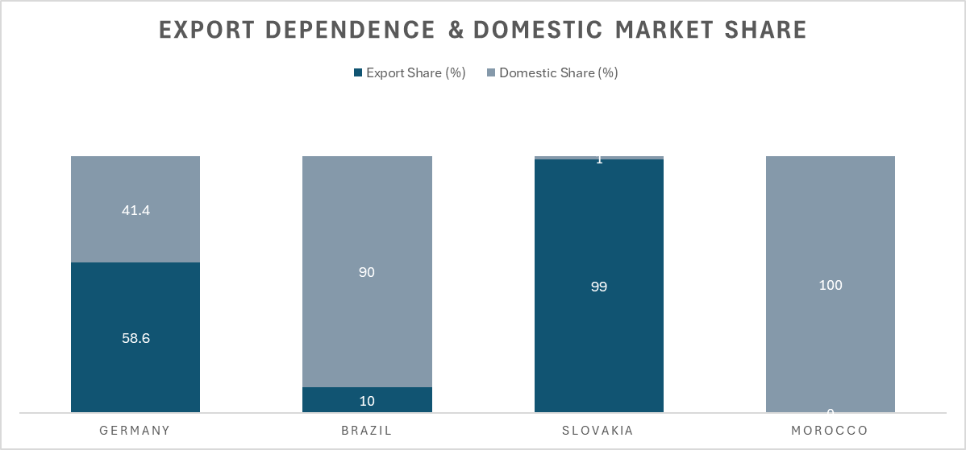
While Germany's exports and domestic sales are rather balanced (58.6% and 41.4%, respectively), Brazil's dependence on local demand (90%) could limit competitiveness in the event of changes in regional conditions. In addition, the strong reliance of Slovakia on exports (99%) means that disruptions due to problems with transit routes through Koper or Hamburg could be worsened rather than mitigated. Assuming high-export economies maintain synchronisation with distribution-led markets, Morocco's entirely domestic focus can mitigate these risks by expanding customer access throughout Africa.
Synergy, not location, is the driving force behind Volkswagen's success, according to these dynamics taken as a whole. Table 3 from Volkswagen Group (2024) shows that the Group is vulnerable to "supply-chain risks, environmental concerns, and currency fluctuations" due to its interconnectedness.

Table 3. Supply-Chain Risks, Dependencies, Environmental Pressures & Currency Fluctuation 2024
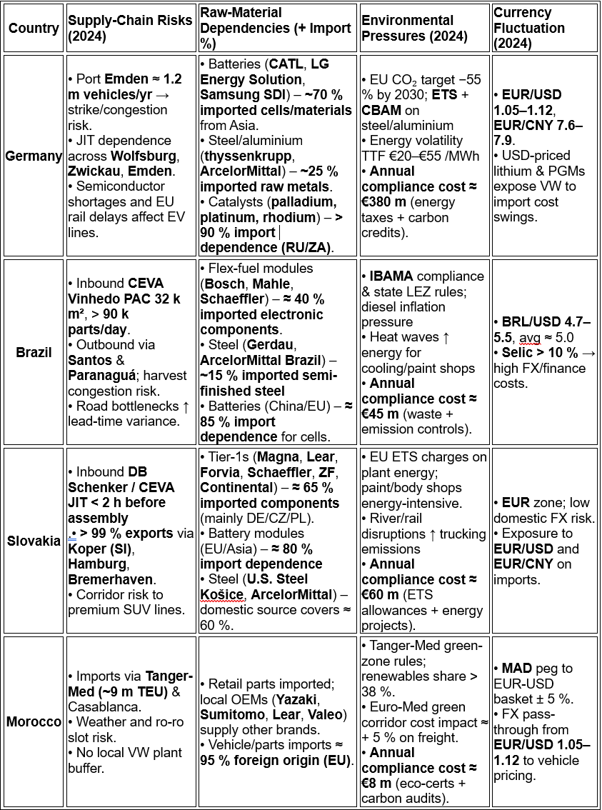
(Source: Created by author from Volkswagen Group Annual Report, 2024)

Strategy management of exposure to supply risks, rather than avoiding them, is what generates growth, according to Volkswagen's cross-country operational network. Cost pressures are increasing in Germany due to carbon levies and volatile energy markets. The country imports 60% of its energy needs and spends €380 million per year on compliance costs. While the EU's carbon restrictions might be somewhat offset by Slovakia's minimum environmental cost of €60 million, which eases regulatory demand on high-cost German industries, this balance would collapse in the event of disruption to export routes through Koper or Hamburg.
As the 55% reliance on imports in Brazil shows, localisation in an emerging market can sustain production even when logistics get tight. The capacity to absorb financial shocks caused by CEVA's inland network and BRL/USD volatility (4.7-5.5) (Wild, 2016) and adaptive sourcing both contribute to resilience. Another factor is flexible inventory management. Conversely, Morocco provides continental reach without substantial capital exposure, serving as a controlled testing ground for Volkswagen's low-risk expansion approach. The country relies on imports at a rate of 95% and has compliance costs of only €8 million.
German innovation helps the Slovaks be more efficient, Brazil dampens cyclical instability, and Morocco opens the door to North Africa. This four-country framework acts as a circular buffer. Using data-driven analysis, Volkswagen will continue to simulate carbon, currency, and localisation restrictions; this interconnected system will influence competitiveness (CACI, 2024).

2c) Country’s Entry modes
The entry modes chosen by Volkswagen in Germany, Brazil, Slovakia, and Morocco demonstrate strategic caution rather than a straightforward expansion strategy, as illustrated in table 4 (Detailed entry mode explanations in Appendix 2).

Table 4. Entry Modes per Country
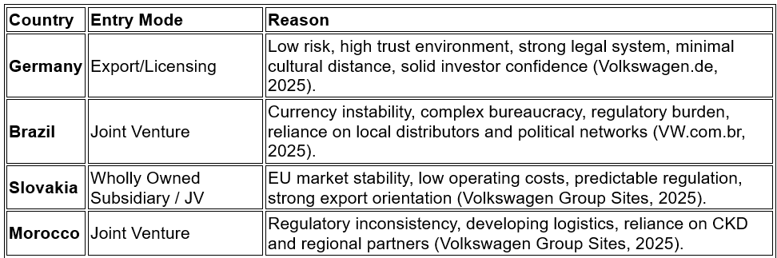
(Source: Created by author from Volkswagen Group Annual Report, 2024)

Germany is approached through export and licensing rather than deeper ownership, which would expose Volkswagen to strict regulations and high labour costs, which might eat into margins. However, the country's market accessibility and investor trust help to lessen uncertainty. Germany serves as a solid operational anchor rather than a launching pad for dangerous expansion.
Full ownership is strategically naïve because to regulatory volatility and currency instability, as Brazil's Joint-Venture approach acknowledges. Daniels et al. (2019) argues that joint ventures reallocate institutional risk to local partners. If Volkswagen assumed entire control, friction costs would be amplified due to bureaucratic enforcement gaps.
Wholly Owned Subsidiary / Joint Venture structures are justified in Slovakia due to the country's predictable regulations and good investor confidence. With full ownership, the export-heavy system is better able to coordinate and take advantage of economies of scale (Volkswagen Group, 2025).
Full ownership would increase vulnerability to conflicting regulations and shaky logistics, making Morocco's Joint Ventures important.
Risk, accessibility, and market performance are all considered by Volkswagen's multi-entry strategy in these four nations.

2d. Key benefits obtained by the company from its international operations
The fact that the four nations are not imitating one another is the very reason why Volkswagen has an advantage in the global market. Slovak cost-efficient engineering, Brazilian size, and Moroccan frontier-market flexibility will cancel out Germany's technical depth and sustainability leadership. According to Wild (2016), growth can only be achieved by turning these imbalances into advantages. This means that Volkswagen needs to do more than just occupy diversity in its institutions; it needs to actively manage it.
Because of inequalities in the distribution of work, logistics, and environmental pressure, economies of scale develop. For Germany's heavy regulation to remain in place, Slovakia must embrace compliance efficiencies; for Brazil's unstable manufacturing base to make a significant impact, it must be combined with the resource-stable EU operations; and for Morocco's incremental CKD environment to be valuable, it must embrace low-risk experimentation without disrupting capital allocation.
Diversification of risk is still the most important advantage. Slovak stability in relation to the euro mitigates volatility in Brazil's currency; low-cost model in Morocco absorbs pressure from rising sustainability costs in Germany. When combined, these synergies strengthen Volkswagen's plans for expansion, new product development, and long-term market dominance (Sloman et al., 2018).

3. Volkswagen Group OLI factors (Ownership, Location and Internalisation)
(1004 Words)
When ownership, location, and internalisation advantages justify involvement, international companies switch from domestic production to foreign direct investment adopting the Eclectic Paradigm in Figure 3.

Figure 3. OLI factors in Volkswagen Group (Lampón, J. et al., 2017)
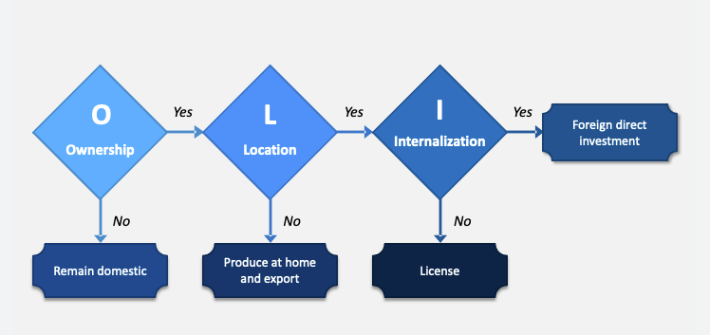

Competitive strength for Volkswagen (VW) results from the interactions between the four economies that were chosen, rather than from any one of them acting alone. Consequently, the OLI framework reveals the reasons behind VW's strategy deviation from a universal approach in Germany, Brazil, Slovakia, and Morocco, as well as how an incorrect mode choice might impact the entire network (Lampón, J. et al., 2017).

3.1. Ownership Advantages
VW's patented technology, electrification platforms (MEB/MQB), brand reputation, R&D, and long-established supplier networks give it ownership benefits. These strengths only matter if they can traverse borders without IP leakage, institutional hindrance, or operational value loss. Table 5 shows ownership benefits in each of the economies.

Table 5. Volkswagen’s Ownership Advantages Across Four Countries
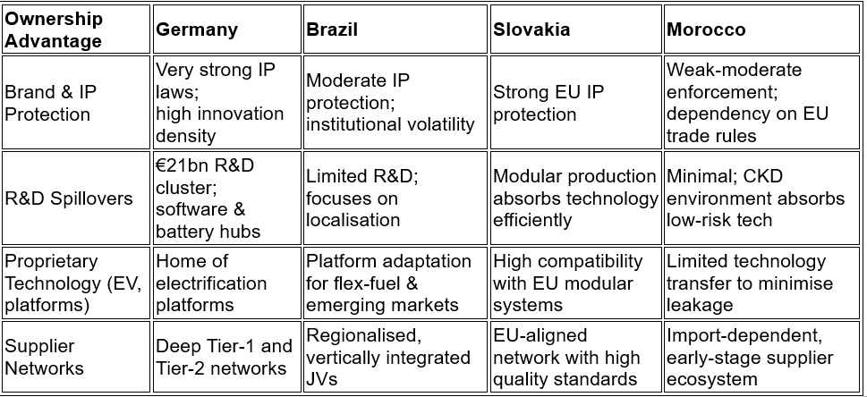
(Source: Created by author from Daniels et al.’s 2022 and Volkswagen Group, 2025)

However, despite Germany's greatest ownership advantages, the country's stringent regulatory framework makes more ownership costly, therefore this does not justify increasing FDI. The advantages of Volkswagen's technological superiority would has decreased if the company aggressively extended its proprietary operations in Germany, due to increasing labour costs and carbon compliance demands (Volkswagen Group, 2024a). Consequently, a high-commitment mode is not always the result of strong ownership.
On the other hand, Brazil presents a problem. Full ownership might erode VW's ownership advantages owing to high regulatory arbitrariness and insufficient institutional enforcement. In line with the claim made by Daniels et al. (2022) that JVs serve as institutional "shock absorbers," the corporation is shielded from potential legal and political risks by dividing them up among local partners in a joint venture.
Due to the stable industrial policy and EU IP legislation, Slovakia provides an environment where ownership advantages can be fully realised. Strategically, wholly owned subsidiaries are more justified in this country than in emerging countries because of the highly trained staff, which increases platform efficiency and decreases adaption costs (Hennart, 2022).
Trade in cutting-edge electronics suffers from restrictions by Morocco's feeble supplier environment and weak intellectual property enforcement. Volkswagen may lose technology and cause a misalignment between its high-cost innovations and its low-capability absorption if it took too much control of this. Consequently, regulated CKD operations and low-commitment JV models are favoured by owners due to ownership advantages.

3.2 Location Advantages (labour cost, market size, infrastructure)
The advantages of location impact the suitability of domestic production, the potential for export, or the integration into overseas manufacturing facilities. Germany presents robust infrastructure and a stable market; however, it is burdened by elevated labour costs and energy vulnerabilities. Brazil has strengths in domestic demand and labour costs; however, the instability in regulations reduces predictability. Slovakia has the advantage of EU logistics corridors and reasonable costs, while Morocco provides access to North and West Africa with competitive labour, though its infrastructure is lacking.
The significance of this cannot be overstated: If VW ignores the variations in location advantages, the company could misallocate production, weaken its competitiveness in electrification, or exacerbate delays in the supply chain (Reuters, 2024).

3.3 Internalisation Benefits (retaining control, avoiding leakage, managing quality)
Because of the highly regulated nature of the industries in which VW operates, outsourcing quality control, safety measures, and software integration would be a huge financial loss. Yet, political vulnerability increases with too much internalisation in high-risk markets, while strategic coordination suffers with too little internalisation in core markets.
Due to their stable industrial policies and strong institutional frameworks, Germany and Slovakia are in favour of complete internalisation. Morocco and Brazil do not because internalisation becomes too high due to infrastructure restrictions, political risks, and fluctuating exchange rates without joint ventures (Daniels, J. et al., 2022).

3.4 Integrated Comparison of OLI Across Countries
The comparison indicates that OLI factors do not result in a consistent entry mode. The interconnection among countries indicates that every choice impacts the entire corporate framework - table 6.

Table 6. Comparison of OLI Implications for Entry Mode Across Four Economies
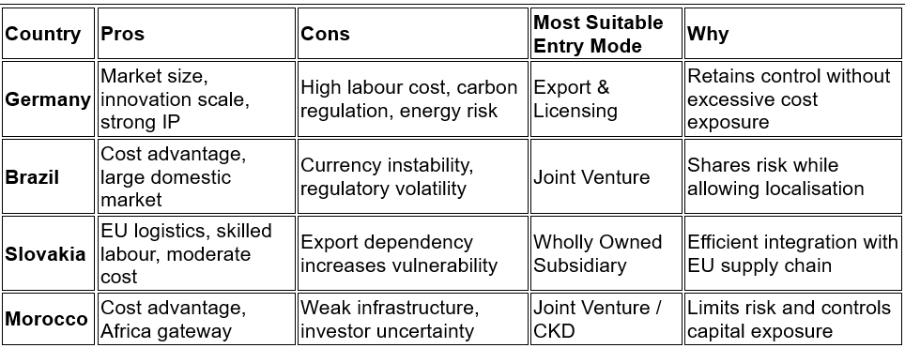
(Source: Created by author from Lampón et al., 2017)
According to the World Bank (2024), the BRL is one of the most volatile emerging-market currencies; if Volkswagen decided to have 100% Brazilian ownership, the company would be vulnerable to this volatility. Additionally, modular-platform efficiency would decrease in a JV-operated Slovakia compared to a WOS-operated Slovakia since shared ownership undermines centralised production planning (Lampón et al., 2017).
The situation in Morocco is the best example of how OLI forces are compelling VW to adopt risk-controlled practices. Full internalisation wouldn't help much, even though Tanger-Med gives it a considerable geographical advantage. Foreign direct investment flows are still unpredictable (UNCTAD, 2024). Volkswagen can test CKD assembly through JVs without incurring sunk expenses.
Foreign direct investment (FDI) is not warranted in Germany, despite the country's strong ownership and internalisation. The viability of high-ownership expansion is undermined by high carbon compliance costs; therefore, licensing and exporting continue to be the best options (Reuters, 2024).

3.5. Inter-country Relationship and Risk Link
On top of serving as a geographical spread, the four-country system is an interdependent risk-balancing mechanism. For Germany to bear technological risk, its lower-cost partners must ensure that innovation does not become economically harmful. A stabilisation of output in Slovakia has no value if the export lanes via Koper or Hamburg become weak. Brazil lowers demand volatility, but it loses all it’s worth when localisation efforts are outpaced by currency instability. If its underdeveloped infrastructure doesn't amplify bottlenecks in the upstream process, Morocco reduces the danger of geographical growth. According to Hennart (2022), there can be no profit to international networks unless their dispersed operations complement one other, not duplicate each other. Everything is on the brink of collapse if Volkswagen misaligns its OLI choices, such as by over-or under-internalizing in Slovakia or Morocco, causing shocks to ripple through the logistics and electrification systems.

4. Cultural Differences Between Germany and the host countries Influence Volkswagen’s Market Entry Strategy and Long-Term Success (1072 words)

4.1. Hofstede Culture dimensions
Using six Hofstede-Minkov dimensions, figure 4 shows the cultural distance that Volkswagen must traverse while coordinating with Brazil, Slovakia, and Morocco from Germany. The hierarchical, collectivist, rule-dependent culture of Brazil stands in stark contrast to the flat, individualistic, and somewhat risk-averse German culture (35 power distance, 79 individualisms, 65 uncertainty avoidance) (Hofstede, 1991; Minkov & Kaasa, 2022). Cultures and Organisations (2010) found that Slovakia is very hierarchical and decisive (PDI 100; MAS 100), whereas Morocco is very collectivist and avoids uncertainty to a significant degree (70 power distance). Success for Volkswagen's entrance modalities in all four markets is ultimately determined by how these variances impact the formation of trust, the interpretation of authority, and the tolerance of risk.

Figure 4. Hofstede Culture dimensions (The Culture Factor Group, 2025)
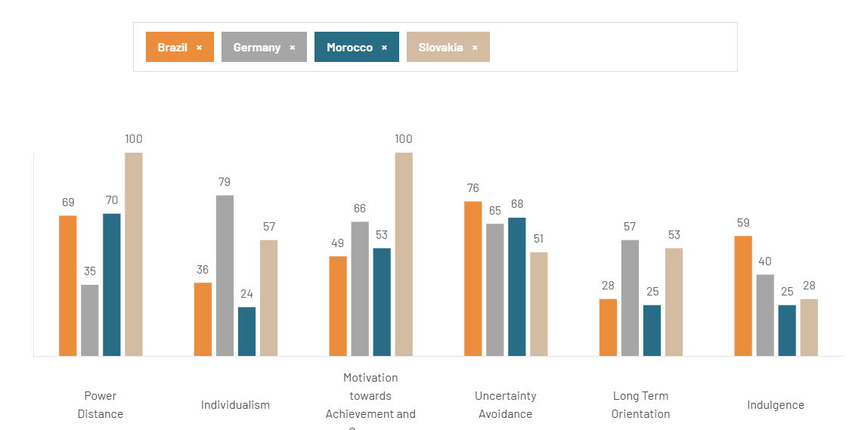

Looking at the chart deeper reveals that cultural distance is a powerful factor that changes Volkswagen's overall strategy for entering new markets. Due to the country's strong individualism and minimal power distance, export and licensing are a good match for Germany. Decisions are anticipated to be decentralised and justified. On the other hand, when applied to Brazil, where social and organisational hierarchies are well ingrained, this reasoning breaks down (Hofstede, 1984). There would be less oversight and slower plant coordination if Volkswagen adopted a decentralisation model similar to Germany's. Joint venture models, which can establish administrative authority at the local level and buffer institutional uncertainty, are more in line with the requirement for a single, esteemed figure.
Even though Slovakia is like Germany in that it avoids ambiguity, the paradoxical combination of its high accomplishment culture (100), extreme power distance (100), and similarity to Germany further complicates the pattern. Fully owned subsidiaries are responsible for enforcing Volkswagen's stringent production discipline in an environment where hierarchy is tolerated but performance must be apparent. Having a joint venture will weaken the platform's efficiency in a culture where executives are required to "prove themselves" (Hofstede, 1991).
Trust in Morocco is relational rather than procedural because of the country's mix of powerful hierarchy, strong collectivism, and rule sensitivity (Cultures and Organisations, 2010). Since foreign dominance is not tolerated but authority is, an entry through a high-ownership structure would backfire. Thus, joint ventures serve as a cultural bridge, enabling Volkswagen to navigate Morocco's inclination towards directed authority and group-based decision norms.
The management style, recruiting procedures, customer service standards, and negotiation strategies of Volkswagen are all impacted by cultural incompatibilities, which in turn affect the perceptions of control, legitimacy, and willingness to share risks.

4.2. Volkswagen's cross-country management, hiring, customer-service, and strategies for negotiations.
The true test will be how Volkswagen handles management, people, and consumers in four distinct cultures, despite the lovely sounding motto "Mobility for Generations" of the company. Volkswagen Group (2024) states that to achieve its strategic goals of resilience, flexibility, and financial stability, the company's leadership must demonstrate credibility on a local level, rather than relying on a single German model.
There is a lack of harmony in the management style. Germans like expert-driven, participatory leadership styles with a minimal power distance and a high degree of individuality. Managers in Brazil and Morocco are expected to make decisions and provide protection rather than constantly seeking employee input. House et al. (2014) warned that workers might see flat hierarchies of the German model as a sign of weakness rather than empowerment if they were to blindly imitate them. Because of Slovakia's distinctive combination of a high-power distance and a strong accomplishment orientation, plant managers there must act as visible "authority figures" while equally enforcing the German process discipline.
These differences carry over into the recruiting process. German locations vie for independent experts, whereas their Brazilian and Moroccan counterparts need to find workers who are loyal, respectful of authority, and able to follow complex protocols even when faced with unknown outcomes. Volkswagen runs the danger of hiring the "wrong" individuals based on local expectations if HR is adamant on using comparable competence models; this would damage retention and foster distrust in the workplace (Tung & Verbeke, 2017).
Dealing with customers and negotiating both widen the divide. Clients in Germany and Slovakia want talks to be based on contracts and on time. The brand's claims of "user-friendly" mobility may be undermined when customers in Brazil and Morocco, who value connections, flexibility, and informal problem-solving more highly, see the rigorous service scripts developed in Wolfsburg as cold and disrespectful (Volkswagen Group, 2024). Inconsistencies across factories, dealers, and contact centres swiftly undermine trust once expectations are formed, due to the high uncertainty avoidance in all four nations.
The fact that Brazil and Morocco value implicit, relationship-based trust more than Germany's 'Low Context' reliance on explicit, contract-bound precision makes this friction even more severe. As a result, VW's strict legalistic enforcement could unintentionally ruin the rapport that is crucial to the success of the joint venture.

4.3. Integrating Cultural Risks and Training for Entry Mode Success
Cultural alignment is crucial for Volkswagen's entry-mode selections to be successful since the four-country network is interconnected and any disruption to one part might affect the other parts. However, if headquarters believes these behaviours naturally transfer outside, coordination gaps will rapidly appear (Taras et al., 2021). This contrasts with Germany's export-and-licensing model, which is successful because of low power distance and strong individualism, which make process compliance and technical autonomy believable. German managers need extensive intercultural training to avoid mistaking informality for inefficiency in Brazil, a country with a joint-venture structure that absorbs institutional volatility but a culture that is more risk averse and relationship-driven in its communication. Over-centralization of decision-making by VW could lead to disengagement in a culture that prioritises achievement visibility over shared authority, which is a problem for Slovakia's wholly owned subsidiary model (Venaik & Midgley, 2019). Structured onboarding, clear hierarchical communication channels, and culturally adaptive quality-control methods are required due to Morocco's large power distance and collectivism, which in turn restrict capital exposure via the JV/CKD route.
Misreading cultural distance raises operational risk, which in turn undermines the rationale of the selected mode, creating a virtuous cycle in all four contexts (Hutzschenreuter et al., 2020). Volkswagen safeguards supply-chain synchronisation across four locations: the innovation hub in Germany, the EU bridge in Slovakia, the demand stabiliser in Brazil, and the regional gateway in Morocco through internal training in communication norms, expectations of decision-authority, and negotiation style. The next section will build on this by suggesting three key changes to VW's standard operating procedures (SOPs) that the company must do if it wants to succeed in the chosen developing market over the long run.

5. Volkswagen’s SOP Adjustments for Effective Operations Across Germany, Brazil, Slovakia and Morocco (1208)
Since developing market frameworks break down under institutional instabilities, Volkswagen's standard operating procedures (SOPs) cannot continue to be strict checklists. Rather, their efficacy is contingent upon their ability to absorb shocks while maintaining operational discipline. To avoid worsening personnel shortages and supply-chain delays, Haleem et al. (2022) state that processes must adapt to local interruptions for cross-border consistency to improve. Determining criteria for disruption response, currency risk levels, and supplier onboarding flexibility is so essential for VW. Bayo-Merino et al. (2023) demonstrates that flexible structures improve global performance by combining central supervision with local autonomy, in contrast to the usual emphasis on control in SOPs. Coordination problems weaken system resilience, according to Meyer and Benito (2020), who caution against ignoring institutional distance.

5.1. SOP Implications of the SOP Gap Between Germany and VW’s Host Markets (Brazil, Slovakia, Morocco)
The VW Group's global competitiveness operates on its ability to balance deeply rooted, centrally administered SOPs with diverse market and operational realities. Table 7 compares the mature German core to the dynamic developing markets of Brazil, Slovakia, and Morocco, setting the framework for SOP changes.

Table 7. Core Differences Shaping SOP Reform Across Germany, Brazil, Slovakia and Morocco
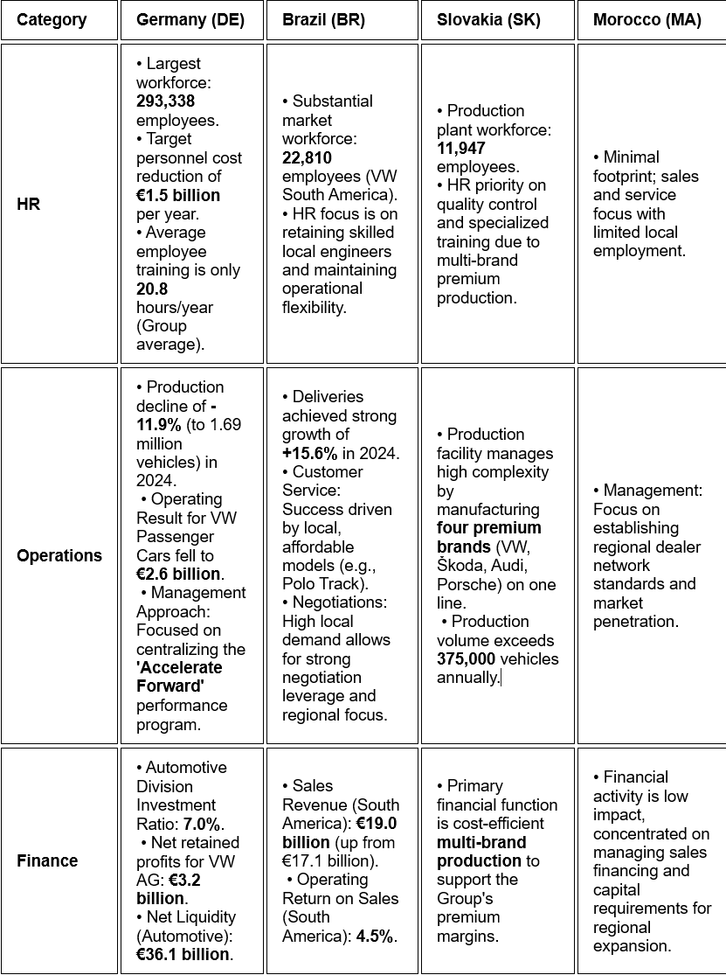
(Source: Created by author from Volkswagen Group Annual Report, 2024)
In Germany, Brazil, Slovakia, and Morocco, Volkswagen's stability depends on whether its SOPs can absorb institutional volatility rather than record processes.
Due to the impending failure of the Group's goal to cut €1.5 billion in people expenditures, the HR SOP is under urgent pressure to reorganise capabilities as core jobs evaporate. If Volkswagen does not formally establish the Transformation Training Pathways (TTP) standard operating procedure, the German core will be unable to synchronise the anticipated loss of 95,000 employment connected to internal combustion engines (ICEs) and gain of 500,000 jobs related to electric vehicles (EVs). Without planned upskilling, the gap in expertise between Germany's high-tech foundation and Brazil's operational flexibility would only expand, throwing the whole production network into disarray, making the TTP SOP crucial, and not only for its administrative neatness (Aguinis and Burgi-Tian, 2021).
Also, a rethought standard operating procedure is necessary for operations since Brazil's €19.0 billion sales performance shows how inflexible workflows delay time-to-market at the same point when momentum is most required in the area. To alleviate this conflict, a new RPAL SOP (Regional-Product Acceleration Logic) is required, which will guarantee conformity with Germany's innovation cycle while also delegating authority to local teams to handle demand surges. The system is at risk of being overtaken by rivals with more agility if RPAL is not implemented. This is especially true in China, where the production of automobiles exceeded 11 trillion RMB in 2023, indicating that innovation cycles on a worldwide scale are now quite short. In Brazil, Slovakia, and Morocco, Volkswagen's heavier central SOP structure risks slower institutional responsiveness, especially when rapid adaptation is needed to manage regulatory shocks and uneven EV-service capacity, unlike Toyota's decentralised Kaizen-driven operating system. To avoid the stifling of Brazil's economic potential or overloading of Slovakia's export-dependent system by standardised German processes, RPAL is essential, but not for irresponsible decentralisation (Verbeke, Kano and Yuan, 2021).
Most basic SOP revamp is necessary in finance. Because of the reliance on Chinese supply chains by 80% of NMC cathodes, the Group's €36.1 billion liquidity cannot be left vulnerable to concentrated battery-material risks. To finance vertical integration, diversify raw material sourcing, and sustain Morocco's high-import environment, a DLD SOP (Decentralised Liquidity Deployment) is necessary. The four nations' interconnectedness becomes systemic vulnerability if liquidity stays concentrated and geopolitical shocks hit hard. Consequently, the DLD SOP serves as a tool to stabilise German R&D, maintain operational cycles in Brazil, and safeguard premium multi-brand manufacturing in Slovakia (Lins, Servaes and Tamayo, 2017).
SOP reforms—TTP in HR, RPAL in operations, and DLD in finance—form Appendix 3's structural backbone. Volkswagen's four-country network cannot function without them, and institutional pressure might fracture its worldwide electrification effort.

5.2. Supplementary SOP Requirements: Environmental Reporting, Cultural Integration, and Market-Specific Branding
Volkswagen Group's efforts to implement consistent corporate policies in spite of significant differences throughout its four-country network are shown by two graphs. Despite the clear differences in institutional frameworks across Germany, Brazil, Slovakia, and Morocco, the Group records almost equal levels of CO₂ compliance (91–95%) and a consistent 20.8 training hours per year (Figure 5).

Figure 5. Standardized Group Metrics: CO_2 Compliance and Workforce Training 2024
(Volkswagen Group Annual Report, 2024)
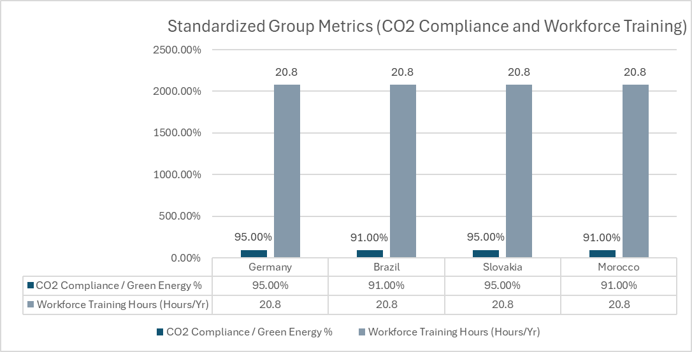

Nevertheless, less obvious disparities in competence are concealed by this numerical symmetry. Standardised measurements often mask operational imbalance instead of fixing it, according to Haleem, Javaid, and Khan (2022).
In contrast to Germany, where sophisticated EV software competency should be prioritised, Morocco's training programs are more likely to focus on fundamental dealer operations. Volkswagen might end up worsening skill gaps rather than fixing them if these variations are homogenised into equal standard operating procedure standards. Similar training hours might hide different strategic requirements in different nations, as Meyer and Benito (2020) demonstrate. This is because centralised methods do not take institutional distance into account.
Instead of seeing conformity to an end—the danger of viewing it as a formal goal—is shown in Figure 5. To accurately quantify competence depth and not only time allocation, the TTP SOP must be quickly adjusted. The strategic mismatch will worsen if VW persists in associating uniform preparedness with uniform hours.
Additional evidence of how operational and market differences weaken inflexible global SOPs is shown in Figure 6.

Figure 6. Regional Disparities: EV Sales Volume and Service Network (2024)
(Volkswagen Group Annual Report, 2024)
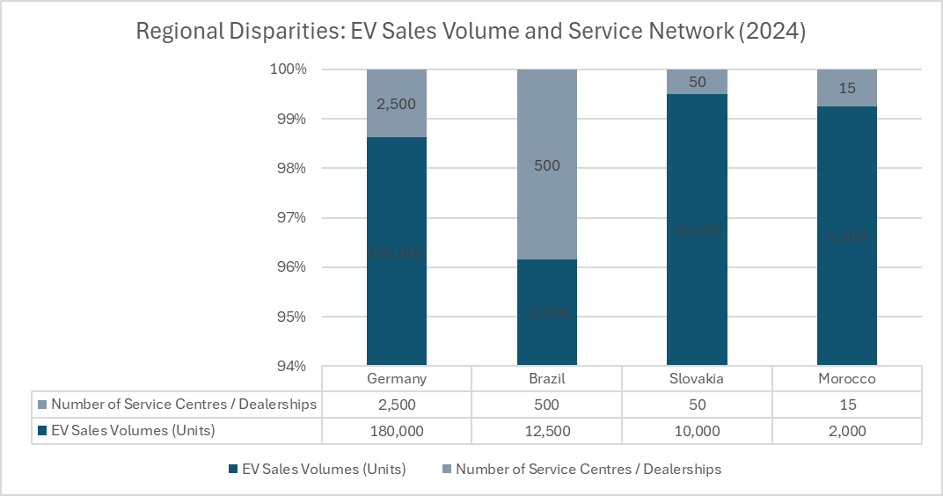

However, there is more ambiguity about the actual development that these 20.8 yearly training hours elicit due to their homogeneity. The use of the same criteria to compare performance becomes meaningless if, for instance, dealer operations training in Germany is more focused on advanced EV competency and in Morocco on fundamental operations (Meyer and Benito, 2020). This highlights the need for the TTP SOP to move away from numerical symmetry and towards competence-specific content, since Figure 5 reveals a structural blind hole rather than operational alignment.
Figure 6, which shows regional differences in electric car sales and servicing network capacity, exacerbates this issue. The evidence of a developed technical ecosystem that can accommodate fast electrification is shown by Germany's 2,500 service facilities and 180,000 EV sales. If this proves true, then the 15 service facilities and 2,000 electric vehicles in Morocco reveal a structural bottleneck that cannot be remedied by a centralised standard operating procedure (Venaik and Midgley, 2019). When institutional limitations alter the practicability of global norms, doing the same things repeatedly becomes ineffective.
As a result, the focus changes from following standard operating procedures to understanding why inflexible global templates are failing in markets that are geographically and economically far apart. When decentralised investment choices, supply-risk exposure, and speed-to-market are influenced by country-specific limits, the strategic value of RPAL and DLD SOPs diminishes without focused modification (Taras, Steel and Kirkman, 2021). Volkswagen loses some of its OLI benefits if rigidity remains, since the company's internalisation processes will no longer boost location-specific productivity.
These statistics show that Volkswagen's operational future depends on whether its standard operating procedures (SOPs) transition from static homogeneity to dynamic responsiveness across locations. Agility in TTP, RPAL, and DLD procedures can address PESTEL risks, cultural-distance constraints, and OLI-based location asymmetries to ensure global coordination improves Volkswagen's multinational performance.

Conclusion
In contrast to the institutional shortcomings shown in Brazil, Slovakia, and Morocco, the research shows that Germany's technical depth, sophisticated regulatory framework, and institutional stability make it the most strategically viable foundation for Volkswagen. Previous cultural, PESTEL, and OLI analyses all point to Germany as the only nation with the innovation potential and degree of predictability needed to anchor a multi-country network. Germany, on the other hand, is in a special position to absorb risk due to the export-driven vulnerability of Slovakia, the infrastructure fragility of Morocco, and the macroeconomic instability of Brazil.
It is this imbalance that is reinforced by the examination of entrance modalities. Due of Germany's strong central supervision, which protects technical advantages, exporting and licensing are the best options. The political and cultural instability in Brazil and Morocco calls for joint ventures, whereas the need for manufacturing accuracy and EU-logistics integration in Slovakia calls for totally owned businesses. As the report's study reveals variations in institutional distance, internalisation advantages, and cultural compatibility, these modes cannot be used interchangeably.
To be strategic, the suggested growth sequence must be staggered. Germany needs to prioritise the consolidation of research and development and digital capabilities, Slovakia should consider reinforce their production architecture as a secondary objective, and Brazil and Morocco ought to wait to receive further investment until operational adaption mechanisms are completely implemented.
According to the research, for Volkswagen to succeed in the long run, the four-country system must be transformed into an ecosystem in which sustainability, resilience, and profitability complement rather than contradict one another.

Appendix 1. Operation Countries VW

Table 1. Operational Countries VW
Economy type | Countries | Entry mode(s) | Strategic purpose
Mature Economies | Germany,  United Kingdom,  France,  Italy,  Spain,  Sweden,  Belgium,  Netherlands,  Austria,  Switzerland,  Portugal,  Finland,  Denmark,  Ireland,  Norway,  USA,  Canada,  Japan,  South Korea,  Australia,  New Zealand | Export/Licensing,  Greenfield investment & Acquisition | • Concentrate R&D, software and electrification innovation  • Strengthen premium brand positioning  • Secure stable, high-value revenue streams  • Maintain dense dealer networks and high aftersales standards
Emerging | China,  India,  Brazil,  Mexico,  South Africa,  Thailand,  Malaysia,  Singapore,  Vietnam,  Indonesia, Philippines, Argentina,  Chile,  Colombia | Joint ventures & Strategic Alliances | • Share regulatory and political risk with local partners  • Access fast-growing consumer markets  • Accelerate localisation of components and EV models  • Expand high-volume production at competitive cost
Emerging Transition Economies | Czech Republic,  Poland,  Hungary,  Slovakia,  Romania,  Slovenia,  Croatia,  Serbia,  Türkiye | Wholly owned subsidiaries (selective JVs) | • Optimise cost-efficient EU and near-EU production  • Support modular platform manufacturing (MQB/MEB)  • Leverage favourable labour and logistics conditions  • Ensure stable export capacity into Western Europe
Developing Economies | Morocco,  Egypt,  Kenya,  Nigeria,  Ghana,  Tunisia,  Algeria,  Angola,  Ethiopia, Rwanda,  Uganda | Joint ventures,  Export & licensing (importers, franchise dealers, CKD where viable) | • Enter markets with minimal capital exposure  • Build progressive brand presence under controlled risk  • Use regional hubs for CKD and re-export operations  • Preserve future expansion options at low cost
(Adopted from Volkswagen Group Annual Report, 2024)

Appendix 2. Entry Mode(s) and Theoretical Models
(Adopted from, Buckley, 2021)

2.1. Export/Licensing: Germany Mature Economies
Considering Volkswagen's dependence on Germany as a regulated entry platform, the significance of Figure 1, which represents the export licensing pathway, becomes more apparent.

Figure 1. Export licensing process (Buckley, 2021)
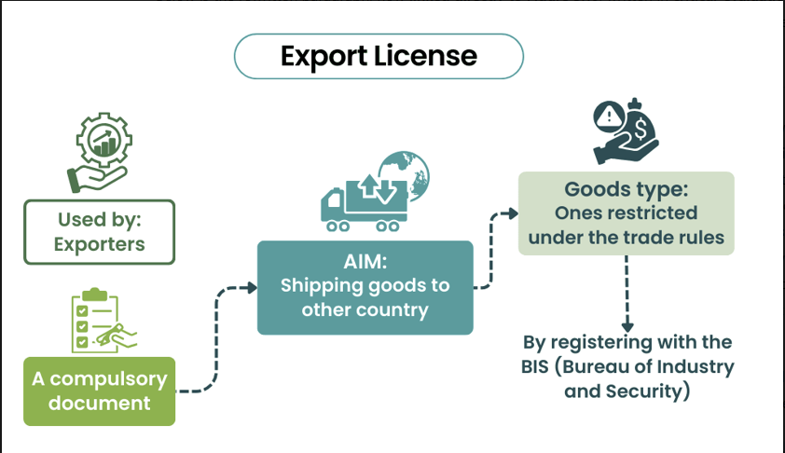

While the picture compresses the process into regulated products categories, required documentation, and BIS registration, the key concern is how Volkswagen utilises this method to manage risk exposure and learning. While shipping goods into uncertain markets, the company can take advantage of Germany's stable institutional framework through export licensing. The question of whether incremental expansion may overcome structural constraints arises when considering that if Volkswagen relied just on this low-commitment mode, growth in regions with inadequate logistics or irregular import regulations would remain confined.
However, Volkswagen transforms uncertainty into a sequential entry route by rooting the procedure in Germany and applying the Uppsala logic of incremental learning. According to Buckley (2021) and Johanson and Vahlne (2017), export and license agreements are not meant to be static documents, but rather to serve as flexible stepping stones that help with managing uncertainty before more substantial commitments are contemplated.

2.2. Join Ventures: Emerging and Developing Economies (Brazil & Morocco)
(Adopted from Wild and Wild, 2016)

The figure 2 divides mergers and acquisitions into simple categories, but Volkswagen's background in emerging markets like Brazil and Morocco complexities it.

Figure 2. Acquisition types
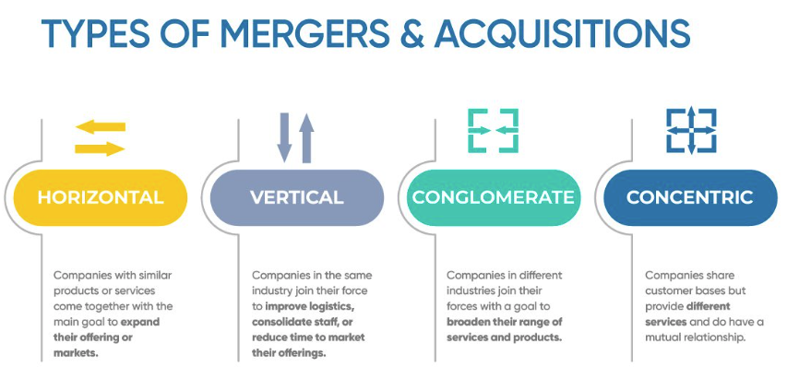

Vertical joint-venture logic, not horizontal consolidation, really affects operational outcomes in these areas, even though the former seems good on paper. For example, due to the intricate institutional framework in Brazil, Volkswagen is compelled to utilise vertical partnerships that bring together suppliers, logistics intermediaries, and local distributors. This is not for the sake of convenience, but rather because going it alone would result in increased cost volatility and regulatory friction. The situation in Morocco is rather similar. A vertical JV model is needed to stabilise flows between ports, assemblers, and dealers due to the country's reliance on CKD assembly and unreliable logistics. It is not a strategic decision, but rather a functional necessity.
Coordination would be hindered by the fragmented market conditions in both scenarios if Volkswagen tried a conglomerate or concentric approach. Therefore, the only realistic way to gradually expand capabilities is through vertical integration (Wild and Wild, 2016).

2.3. Wholly Owned Subsidiary (WOS) model: Emerging Transition Economies
(Adopted from Daniels et al., 2019)

Figure 3 explain the model Volkswagen's Wholly Owned Subsidiary (WOS) structure complicates its application to Slovakia.

Figure 3. Wholly Owned Subsidiary (WOS) model
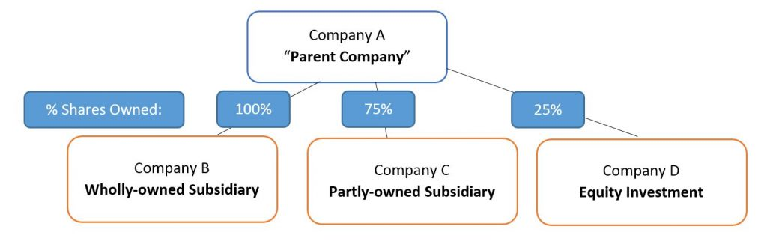

The diagram illustrates clean ownership tiers; however, the real question is why Volkswagen goes with such a top-down strategy in a transition-risk circumstance. It would be easy for the model to expose the firm to concentrated operational weakness if Slovakia's predictable compliance with EU regulations and export-oriented logistics were exaggerated, but WOS appears efficient. Still, by using the WOS method, Volkswagen may rearrange production without involving local partners in negotiations, guaranteeing that production shifts, labour restructuring, and modular platform manufacture are all in direct response to strategic priorities in Germany. But one may say that joint ventures normally offer buffers in new settings, such as when energy prices or labour restrictions tighten, and that without shared ownership, those buffers are gone. Still, the reasoning of complete ownership holds water in Slovakia due to the country's low-cost labour, highly skilled workforce, and enormous investor trust. Volkswagen is willing to take on more responsibility in exchange for reliable compliance at the EU level, smooth operations, and high levels of integration (Daniels et al., 2019), which is hidden by the figure's simplicity.

Appendix 3. Major Recommended SOP Adjustments for Volkswagen Group

1. HR Recommendation: Transformation Training Pathways (TTP) SOP - table 2
In the high-cost German core, this SOP mandates a systematic retraining program to reduce job displacement and skill shortages caused by the change from combustion engines to electric cars.

Table 2. Transformation Training Pathways (TTP) SOP
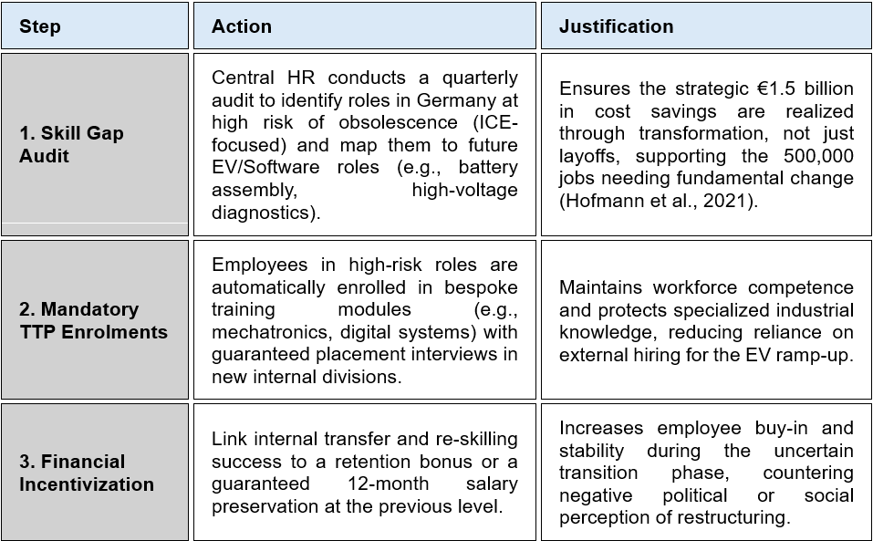
(Source: Adapted from Aguinis and Burgi-Tian 2021 and Hofmann et al., 2021)

2. Operations Recommendation: Regional Product Adaptation Lifecycle (RPAL) SOP – table 3
This SOP moves product development and strategic decision-making to regional offices (e.g., Brazil) to swiftly adjust goods to local market needs, speeding up and enhancing launches.

Table 3. Operations Recommendation: Regional Product Adaptation Lifecycle (RPAL) SOP
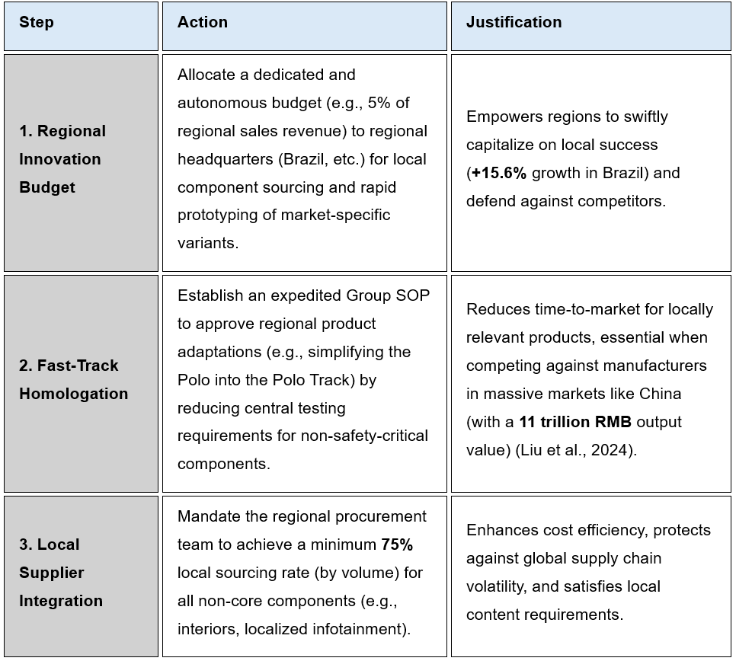
(Source: Adapted from Verbeke, Kano and Yuan 2021 and Liu et al., 2024)

3. Finance Recommendation: Dynamic Liquidity Deployment (DLD) SOP

This SOP refocuses the Group's core finances from general investment to strategic de-risking of the crucial EV battery supply chain to guarantee long-term production reliability – table 4 below.

Table 4. Dynamic Liquidity Deployment (DLD) SOP
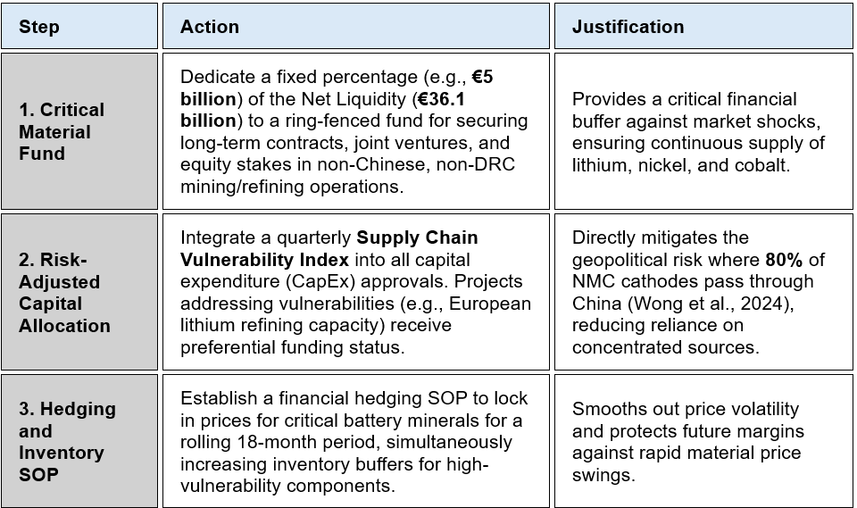
(Source: Adapted from Lins, Servaes and Tamayo 2017 and Wong, Kim and Duerksen, 2024)

Reference List

Aguinis, H. and Burgi-Tian, J. (2021) ‘Talent management and global workforce reskilling for the future of work’, Annual Review of Organizational Psychology and Organizational Behavior, 8, pp. 349–375. Available at: https://doi.org/10.1146/annurev-orgpsych-012420-083209 (Accessed: 21/11/2025).

Almutaairi, S., Heller, M. and Yen, D. (2020) ‘Reclaiming the heterogeneity of the Arab states’, Cross Cultural & Strategic Management, 27(3), pp. 345–369. Available at: https://doi.org/10.1108/CCSM-06-2019-0115 (Accessed: 19/11/2025).

Bayo-Moriones, A., Merino-Díaz de Cerio, J. and Escamilla-de-León, S. (2023) ‘Managerial control and organisational flexibility in MNCs’, International Journal of Human Resource Management, 34(3), pp. 412–432. Available at: https://doi.org/10.1080/09585192.2021.1956564 (Accessed: 18/11/2025).

Buckley, P.J. (2021) ‘The theory of international business: The role of economic models’, Journal of World Business, 56(6), p. 101259. Available at: https://doi.org/10.1016/j.jwb.2021.101259 (Accessed: 21/10/2025).

CACI (2024) Market intelligence and business location data solutions. Available at: https://www.caci.co.uk/ (Accessed: 17/11/2025).

Cavusgil, S.T., Knight, G. and Riesenberger, J.R. (2017) International Business: The New Realities. 4th edn. Boston: Pearson. Available at: https://www.pearson.com (Accessed: 20/10/2025).

Collinson, S., Narula, R. and Rugman, A.M. (2020) International Business. 8th edn. Essex: Pearson Education Limited.

Daniels, J.D., Radebaugh, L.H. and Sullivan, D.P. (2019) International Business: Environments and Operations. 16th edn. Harlow: Pearson. Available at: https://www.pearson.com (Accessed: 17/11/2025).

Daniels, J.D. et al. (2022) International Business: Environments and Operations. 17th edn. Harlow: Pearson. Available at: https://www.pearson.com (Accessed: 18/11/2025).
David, F.R., David, F.R. and David, M.E. (2017) Strategic Management: Concepts and Cases – A Competitive Advantage Approach. Harlow: Pearson Education.

Deresky, H. (2020) International Management: Managing Across Borders and Cultures, Text and Cases. 9th edn. Harlow: Pearson Education.

Haleem, A., Javaid, M. and Khan, S. (2022) ‘Role of standard operating procedures in improving organisational performance’, Journal of Global Business Advancement, 15(2), pp. 145–162. Available at: https://doi.org/10.1504/JGBA.2022.126590 (Accessed: 18/11/2025).

Hennart, J.-F. (2022) ‘International business research: The real challenges are theoretical’, Journal of International Business Studies, 53(9), pp. 1623–1636. Available at: https://link.springer.com/article/10.1057/s41267-022-00566-y (Accessed: 21/10/2025).

Hitt, M.A., Ireland, R.D. and Hoskisson, R.E. (2019) Strategic Management: Competitiveness and Globalization – Concepts and Cases. Boston: Cengage Learning.

Hofmann, C. et al. (2021) Changing automotive work environment: Job effects in Germany until 2030. Berlin: Agora Verkehrswende. Available at: https://www.agora-verkehrswende.de/fileadmin/Projekte/2021/BCG-Jobstudie/2021-07-01_E-mobility-Report_Results-Germany_EN.pdf (Accessed: 18/11/2025).

Hofstede, G. (1991) Cultures and Organizations: Software of the Mind. London: McGraw-Hill.

Hofstede, G., Hofstede, G.J. and Minkov, M. (2010) Cultures and Organizations: Software of the Mind. 3rd edn. New York: McGraw-Hill.

House, R. et al. (2014) Culture, Leadership, and Organizations: The GLOBE Study of 62 Societies. SAGE Publications. Available at: https://us.sagepub.com/en-us/nam/culture-leadership-and-organizations/book117616 (Accessed: 19/11/2025).

Hutzschenreuter, T., Kleindienst, I. and Lange, S. (2020) ‘Cultural distance and entry mode performance: The moderating role of experience’, International Business Review, 29(5), p. 101731. Available at: https://doi.org/10.1016/j.ibusrev.2020.101731 (Accessed: 19/11/2025).
Johanson, J. and Vahlne, J.E. (2017) ‘The internationalization process of the firm—a model revisited’, Journal of International Business Studies, 48(9), pp. 1411–1431. Available at: https://link.springer.com/article/10.1057/s41267-017-0106-8 (Accessed: 21/10/2025).

Lampón, J.F., Cabanelas, P. and González Benito, J. (2017) ‘The impact of modular platforms on automobile manufacturing networks’, Production Planning & Control, 28(10), pp. 827–839. Available at: https://doi.org/10.1080/09537287.2017.1287442 (Accessed: 18/11/2025).

Lins, K.V., Servaes, H. and Tamayo, A. (2017) ‘Social capital, trust, and firm performance: The value of corporate liquidity during financial crises’, The Journal of Finance, 72(4), pp. 1785–1824. Available at: https://doi.org/10.1111/jofi.12505 (Accessed: 21/11/2025).

Liu, C. et al. (2024) ‘Impact of global value chain on China’s automobile industry upgrading’, Asian Journal of Business Research, 14(3), pp. 222–234. Available at: https://ajbr.co.nz/ajbr/ajbr250196.pdf (Accessed: 18/11/2025).

Meyer, K. and Benito, G.R.G. (2020) International Business Strategy. 4th edn. Cambridge: Cambridge University Press. Available at: https://www.cambridge.org/core/books/international-business-strategy/9781108649329 (Accessed: 18/11/2025).

Minkov, M. and Kaasa, A. (2022) ‘Do dimensions of culture exist objectively?’, Journal of International Management, 28(4), p. 100971. Available at: https://doi.org/10.1016/j.intman.2022.100971 (Accessed: 19/11/2025).

Narula, R. (2022) International Business: Globalization and Emerging Markets. Oxford: Oxford University Press.
Porter, M.E. (1990) The Competitive Advantage of Nations. New York: Free Press. Available at: https://hbr.org/1990/03/the-competitive-advantage-of-nations (Accessed: 21/10/2025).

Reuters (2024) ‘Volkswagen cuts 2024 outlook as car demand falters’, Reuters, 27 September. Available at: https://www.reuters.com/business/autos-transportation/volkswagen-cuts-2024-outlook-macroeconomic-headwinds-2024-09-27/ (Accessed: 18/11/2025).

Rugraff, E. and Hansen, M.W. (2021) Multinational Enterprises and Economic Development in Host Countries. London: Routledge.
Shahbaz, M. et al. (2018) ‘Globalisation, economic growth and energy consumption in the BRICS region: the importance of asymmetries’, Energy Policy, 120, pp. 485–499. Available at: https://doi.org/10.1016/j.enpol.2018.05.056 (Accessed: 17/11/2025).

Sloman, J., Guest, J. and Garratt, D. (2019) Economics. 10th edn. Harlow: Pearson Education.

Taras, V., Steel, P. and Kirkman, B. (2021) ‘Improving cultural intelligence for global success’, Journal of World Business, 56(4), p. 101251. Available at: https://doi.org/10.1016/j.jwb.2020.101251 (Accessed: 19/11/2025).

The Culture Factor Group (2025) Country comparison tool. Available at: https://www.theculturefactor.com/country-comparison-tool (Accessed: 19/11/2025).

Tung, R. and Verbeke, A. (2017) ‘Beyond Hofstede and GLOBE: Improving the quality of cross-cultural research’, Journal of International Business Studies, 48(9), pp. 1011–1028. Available at: https://doi.org/10.1057/s41267-017-0105-1 (Accessed: 19/11/2025).

UNCTAD (2024) World Investment Report. Available at: https://unctad.org (Accessed: 18/11/2025).

Venaik, S. and Midgley, D. (2019) ‘Cultural differences and global management adaptation’, Management International Review, 59(3), pp. 375–402. Available at: https://doi.org/10.1007/s11575-019-00389-z (Accessed: 19/11/2025).

Verbeke, A., Kano, L. and Yuan, W. (2021) ‘Theorizing firm regionalization and internationalization: Emerging directions and future research’, Journal of World Business, 56(6), p. 101236. Available at: https://doi.org/10.1016/j.jwb.2021.101236 (Accessed: 21/11/2025).

Volkswagen AG (2021) Annual Financial Statements of Volkswagen AG as of December 31, 2020. Available at: https://www.volkswagen-group.com/en/publications/more/annual-report-2020 (Accessed: 20/10/2025).

Volkswagen AG (2022) Annual Financial Statements of Volkswagen AG as of December 31, 2021. Available at: https://www.volkswagen-group.com/en/publications/more/annual-report-2021 (Accessed: 20/10/2025).

Volkswagen AG (2023) Consolidated Financial Statements of Volkswagen AG as of December 31, 2022. Available at: https://www.volkswagen-group.com/en/publications/more/annual-report-2022 (Accessed: 20/10/2025).

Volkswagen AG (2024) Consolidated Financial Statements of Volkswagen AG as of December 31, 2023. Available at: https://www.volkswagen-group.com/en/publications/more/annual-report-2023 (Accessed: 20/10/2025).

Volkswagen AG (2025) Consolidated Financial Statements of Volkswagen AG as of December 31, 2024. Available at: https://www.volkswagen-group.com (Accessed: 20/10/2025).

Volkswagen do Brasil (2025) Corporate Overview. Available at: https://www.volkswagen-newsroom.com/en/volkswagen-do-brasil-4072 (Accessed: 18/11/2025).

Volkswagen Group (2021) Annual Report 2020. Available at: https://annualreport2020.volkswagenag.com/ (Accessed: 20/10/2025).

Volkswagen Group (2022) Annual Report 2021. Available at: https://annualreport2021.volkswagenag.com/ (Accessed: 20/10/2025).

Volkswagen Group (2023) Annual Report 2022. Available at: https://www.volkswagen-group.com/en/publications/more/annual-report-2022-1732 (Accessed: 20/10/2025).

Volkswagen Group (2024) Annual Report 2023. Available at: https://www.volkswagen-group.com/en/publications/more/annual-report-2023-2671 (Accessed: 20/10/2025).

Volkswagen Group (2024a) Sustainability Strategy – Regenerate+ Framework. Available at: https://www.volkswagen-group.com/en/sustainability-strategy-18157 (Accessed: 20/10/2025).

Volkswagen Group (2025a) About Us. Available at: https://www.volkswagen-group.com/en/about-us-16013 (Accessed: 20/10/2025).
Volkswagen Group (2025b) Annual Report 2024 – Procurement and Supplier Network. Available at: https://annualreport2024.volkswagen-group.com (Accessed: 20/10/2025).

Volkswagen Group (2025c) Annual Report 2024 – Research and Development. Available at: https://annualreport2024.volkswagen-group.com (Accessed: 20/10/2025).

Volkswagen Group (2025d) Global Manufacturing Sites. Available at: https://www.volkswagen-group.com/en/volkswagen-group-sites-17481 (Accessed: 17/11/2025).

Wild, J.J. and Wild, K.L. (2016) International Business: The Challenges of Globalization. 8th edn. Boston: Pearson.

Williamson, O.E. (1979) ‘Transaction-Cost Economics: The Governance of Contractual Relations’, Journal of Law & Economics, 22(2), pp. 233–261. Available at: https://doi.org/10.1086/466942 (Accessed: 21/10/2025).

Wong, M., Kim, S. and Duerksen, B. (2024) ‘Electric vehicle battery chemistry affects supply chain disruption vulnerabilities’, Science Advances, 10(9), pp. 1–11. Available at: https://doi.org/10.1126/sciadv.adl2253 (Accessed: 18/11/2025).

World Bank (2024) Brazil Economic Update. Available at: https://www.worldbank.org (Accessed: 18/11/2025).

