University of Wales
Trinity Saint David
International Financial Management – Assessment 1
Daniel-Florin Lazar
Student ID 2009160

Introduction
International is an important aspect for the MNCs because it helps in the sustainability and success of the corporation. For this essay report, Sony Corporation is chosen for a better understanding of the various concept in this relation. It is situated in Tokyo, Japan in the year 1946. This is one of the leading companies in the multinational corporations and it operates its business in the various range of goods and services which is including gaming, electronics, financial services, and entertainment. It developed new products as per the customer demands and caters to a large-scale base of consumers worldwide. This essay includes the importance and challenges faced by the company of Sony in their international markets. Further, it will consist of the theories of IFM for evaluating the dividend distribution policies as well as efficient market theory. In addition, includes the techniques of choosing appraisal projects by this company and also includes some empirical proofs that support this critical analysis.

Importance of International financial management system for Sony
Multinational companies like Sony rely heavily on international financial management and the coordination of financial activities across national borders. It helps Sony lower potential downsides to its financial performance from factors like currency fluctuations, political unrest, and cultural differences (Madura 2020). Sony's foreign financial management must be efficient and smart if the company is to fund its many business lines, which include consumer electronics, gaming, entertainment, and financial services.
Sony's dividend policy takes into account several variables, including the company's financial health, cash flow, and investment prospects. Shareholder value is prioritized by a consistent dividend policy, and Sony's low payout ratio relative to rivals may signal that the business is keeping more of its income for investment (Suryanto and Komalasari 2019). It can assess the profitability of proposed projects by using efficient project appraisal techniques including, internal profitability index, rate of return, and net present value which take into account variables like investment amount, timeline, and risk.

Challenges faced by Sony enterprise in the international financial market
As a global conglomerate, Sony faces unique challenges in the global financial markets. Problems associated with foreign exchange are significant. Since Sony is a global company, it is vulnerable to the effects of currency devaluation on its bottom line and overall financial health. Sony's assets, obligations, and cash flows are all susceptible to fluctuations in value due to currency fluctuations (Katsikeas et al. 2020). Furthermore, the company's pricing strategy may be influenced by the risk of currency, which automatically affected the demand for the company's products and services.
Sony confronts political risk in international financial markets. Changes in government policy or political instability might have a detrimental effect on Sony's business since the company works across nations with different political and economic systems (Ain and Manping 2022). Tax policy shifts, trade barriers, and asset expropriation are all possible outcomes of political uncertainty. Sony's bottom line and future success might be hampered by global conflicts like trade wars and sanctions.

Sony Corporation's dividend distribution policy
This part of essay includes the various information about how the company used the IFM theories which include the signaling and dividend irrelevance theory for evaluating which policies are best for the distribution of dividends as well enhancing its shareholder's wealth. As per the annual statements and various published reports, it said that the Sony Company aim to balanced approach between retaining earnings and providing dividend amount to its investors. This strategy helps in future growth, investments, meeting requirements of operational activities, and expansion (Sony 2023).
The policy of consistent dividends follows by Sony enterprise. It declares the amount of dividend on an annual basis and it pays dividends two times in the one financial years. The company focuses on the stability of dividends and sustainable dividend growth (Madura 2020). It will help the shareholder to know the expected rate of return they earned and also interpret the company's profitability.

Figure 1- Dividend Payout History
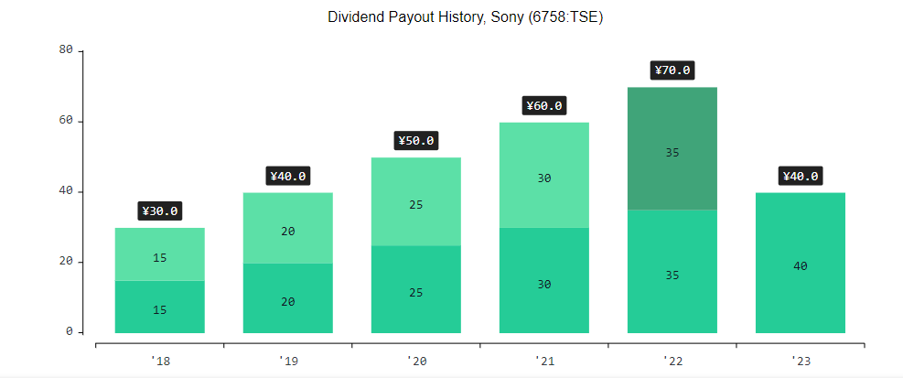
(Source- Finance, 2023)
The above figures represent the payout amount for the previous six years of Sony's company. It refers that the total amount that is distributed in the form of a cash dividend by the firm from its total earnings. It is demonstrating that the throughout the year the amount ratio is increased which also reflects that the firm earnings and cash flow increased as well. In the year 2018, it was ¥ 30.0 but in the next year, it increased by ¥ 10.0. As previously mentioned it pays its dividend in two installments at equal amounts according to the Board information (Source- Finance, 2023). In the year 2022, it was ¥ 70.0 which means it pay ¥ 35.0 on each interval. It was expected that it was increased in the year 2023.
Figure 2- Dividend yield ratio (at average price)
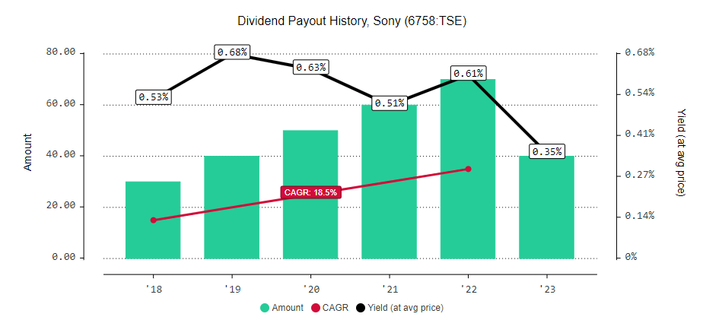
(Source- Finance, 2023)
Here, the graph represents the payout, CAGR, and yield ratio for the previous and current years. CAGR state for the Compound annual growth rate and it refers to the total average rate of growth of investments for a specific period. It was 18.5 % from the annual period 2018 to 2022. Further, it will the line of the graph demonstrates the dividend yield ratio in percentage form, and also important to note it was calculated in the average form (Source- Finance, 2023). It means that the amount is based on the average cost of the shares for the particular year as well as representing the total amount of company pay in the year as compared to its stock price. As the above, it was 0.53% in 2018, and 0.61% in 2022. It falls in 2020 due to the covid-19 and its effect also shows in the next financial year but now it will increase.

IFM Theories-
The company applies IFM theories to provide information about its implications and effectiveness. Two theories here are used, first one is the dividend irrelevance theory, it is proposed or invented by Miller and Modigliani. According to their words, they suggest that the enterprise's shareholders' wealth and value are not impacted by the dividend policy (Katsikeas et al. 2020). It says that the shareholders are not found the difference between the gain of capital that is achieved after the sale of its shares when they needed cash or cash dividend received by the firm.
In addition to this, the Signality Theory refers that the policy of dividend distribution of the company showing the financial health and prospects for growth. Sony payout amount increased which refers that its management is more confident about the profits and earnings in the upcoming years and vice-versa (Fontes et al. 2020). Moreover, it will help the investors because it provides information about management expectations, financial performance, and growth.

Efficient Market Hypothesis Theory- Sony Company
It is an international financial management fundamental theory and it refers that the financial markets were enough capable to provide all the information about the company stock prices for a particular period. When this theory applies to the Sony Corporation then it will provide information about the market performance and investors' reactions or implications. One important point noted is that it only gives publically available information and is published by the company, which means it excluded internal data (Sony 2023). The hypothesis means the assumption that the future pattern and current price are shown by the company information and it consists of all the external factors that may influence the prices.
The Sony company shareholders do not take the decision only to consider outside information and past data or trend because there are so many factors that are impacting the company's performance. The theory does not imply that the financial market always provides accurate or transparent, perfectly efficient and shows the right cost of the stock (Suryanto and Komalasari 2019).
Figure 3- Share of Sony's sales and operating revenue by segment in fiscal years 2019 to 2021

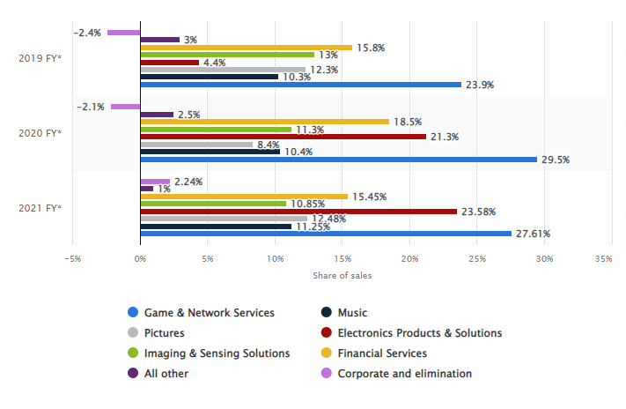
(Source- Statista, 2023)
This graph represents the share of the total sale in the global market by the Sony Company for the years 2019, 2020, and 2021. It demonstrated that the demand for electronics products & solutions and Games & Network services increased throughout this particular financial year (Statista 2023). In addition, it also states that the financial services and imaging & sensing solution demand also rise according to period. The company's share at the global level in 2021 was 44 % in comparison to Samsung, OMNIVISION, and other industries in the same sectors.

Methods of the appraising project by Sony
Projects are evaluated by Sony using several Methods, including NPV, IRR, and the Profitability Index. These Methods are implemented to assess the viability of new initiatives by weighing the costs of the project against its anticipated benefits (Fontes et al. 2020). The predicted cash flows of a venture in upcoming years are discounted to their PV (present value) using the technique of net present value, a popular approach to the valuation of a project. This technique helps Sony firms in the assessment of whether the project is financially viable or not and also takes into account the time value of money.
The IRR approach is another well-liked project evaluation strategy; it determines the rate of return that may be reasonably predicted. Sony may use the IRR approach to calculate the prospective return on the project and compare it to other investment options (Sony 2023). The profitability index approach looks at how the project's cash flows now compare to how much was invested initially. Taking into account the original expenditure and anticipated returns, the PI technique aids Sony in calculating the project's prospective profitability.

Empirical Evidence Supporting the above analysis
The company used the financial statements, annual reports, the pattern of the stock market, and other relevant information for evaluating and interpreting the above analysis of Sony (Finance 2023). There are so many financial indicators that help insight into the IFM theory of dividend policies of Sony which are payout ratio, rate of dividend growth, and dividend yield (Statista 2023). Further, the statistical analysis is used for evaluating the EMH of Sony and it includes the movement of stock price, news, and expectation of investors as per their investing reactions.

Conclusion
It is enlighten the Sony financial markets and its management performances for the particular years as the above graph and theories are mentioned. It concludes that exchange rate influences negatively impact the company's financial performance and it is mitigated by the use of currency risk management measures, such as the use of procedures of hedging according to research. In addition, businesses that handle political risk well outperform their competitors financially. Finally, the importance of effective management of cultural differences and regulatory compliance in international financial markets has been demonstrated through research into the effects of these factors on companies' reputation and brand image.

References
- Ain, Q. U., and Manping, T. (2022) ‘Determinants of Dividend Policy of Non-Financial Publicly Traded Firms: A Review’. Journal of Advanced Research in Economics and Administrative Sciences, 3(2), 95-112.
- Finance. (2023) Sony Dividend 2023. Available at: https://a2-finance.com/en/issuers/sony/dividends. Accessed: 29 April 2023.
- Fontes, M. P., Koppe, J. C., and Albuquerque, N. (2020) ‘Comparison between traditional project appraisal methods and uncertainty analysis applied to mining planning’. REM-International Engineering Journal, 73, 261-265.
- Katsikeas, C., Leonidou, L., and Zeriti, A. (2020) ‘Revisiting international marketing strategy in a digital era: Opportunities, challenges, and research directions’. International Marketing Review, 37(3), 405-424.
- Madura, J. (2020) International financial management. Cengage Learning.
- Sony. (2023) Request Printed reports. Available at: https://www.sony.com/en/SonyInfo/IR/library/ar/request.html. Accessed: 29 April 2023.
- Statista. (2023) Share of Sony's sales and operating revenue by segment in fiscal years 2019 to 2021. Available at: https://www.statista.com/statistics/279272/proportion-of-sonys-sales-by-business/. Accessed: 29 April 2023.
- Suryanto, T. and Komalasari, A. (2019) ‘Effect of mandatory adoption of international financial reporting standard (IFRS) on supply chain management: A case of Indonesian dairy industry’. Uncertain Supply Chain Management, 7(2), pp.169-178.

