Independent Project – Research Proposal

Andreea Ruse 2108815
BSc Applied Computing
ACCA6020 Independent Project
Dr Sana Jokhio
Supervisor: Shantanu Islam

Table of Contents
Introduction 3
Project Design and Methodology. 3
Collection and Preparation of Data. 4
Model Development 4
Risks, Ethics, and Limitations. 5
Evaluation, Reliability, and Validity. 5
Resources Required 5
Conclusion 6

Introduction
Email is one of the most widely used communication tools across business, education and government sectors because it is quick, inexpensive and accessible, yet the rise of fraudulent messages—spam, phishing and scam emails—has become a major security challenge, particularly for HMRC, which reported over 170,000 scam warnings in the year to July 2025, including more than 47,000 counterfeit tax refund attempts [1], as well as over one million phishing emails in 2020–2021, an 87% increase from the previous year [2]. These figures highlight the growing threat of tax-related email fraud, especially as attackers increasingly imitate official HMRC communication, making simple keyword filters or blacklists insufficient at detecting advanced scams. Research shows that spam emails have evolved from being merely annoying advertisements to containing phishing, malware and organised fraud, requiring stronger detection mechanisms [3]. Therefore, this project focuses on addressing the problem of fraudulent HMRC emails by applying data mining and machine learning techniques to improve detection accuracy.
The aim is to compare algorithms such as Support Vector Machines (SVM) and Random Forests (RF) using tools like Weka and Scikit-learn to identify which performs best in recognising suspicious HMRC-related email patterns. The key objectives include analysing public Kaggle datasets, training and benchmarking models, and evaluating their precision, accuracy and overall performance to determine the most reliable approach for fraud detection.
The methodology involves data cleaning, feature extraction, model training and performance comparison, using data mining to uncover hidden patterns [3] and machine learning to enable systems to improve automatically with experience. The ultimate goal is to provide insights that can support the development of a more intelligent and effective filtering solution to protect users from tax-related email scams.

Project Design and Methodology.
This study aims at coming up with a machine learning model that will be more efficient in detecting fraudulent emails associated with HMRC. The project will be of an experimental nature where the algorithms will be trained and tested to identify legitimate and fraudulent emails. It is not merely to identify typical spam, but to develop a specialised solution that will handle the growing list of HMRC tax scams that frequently employ realistic email templates and lookalike governmental communication to defraud users.
Python will be chosen as the main language to implement the project with the help of the PyCharm development environment, and Weka will be used to conduct further experiments and the comparison. Both platforms have an advanced algorithm usage, as well as visualization and performance analysis, which is why they are appropriate to the type of experimental research. The data preprocessing, model building, and evaluation will be performed using scikit-learn. The machine learning models that will be used in this research are Support Vector Machines (SVM) and Random Forests (RF) that have demonstrated excellent results in spam detection problems. The design is based on five major steps, which are data collection and cleaning, preprocessing and feature extraction, model training, testing and evaluation, and performance comparison.

Collection and Preparation of Data.
The data set will be a combination of sources that are publicly available, including the Enron Email Dataset, the Spam Email Collection on Kaggle and real-life examples of HMRC phishing, gathered on the official scam reporting websites and platforms on cybersecurity awareness of the UK government. The use of HMRC-specific samples will make sure the model will acquire the specific language, tone and structure of tax-related fraudulent emails, which are not similar to regular spam emails.
All emails will undergo an elaborate data processing step before training the models. This includes cleaning the text to eliminate unnecessary characters, punctuation and HTML tags after which tokenization and stemming are done to standardize the words. Effective preprocessing approaches, such as TF-IDF, are critical for capturing complicated data in a structured way that machine learning algorithms can comprehend. “Datasets are organized using preprocessing techniques such as tokenization and Tf-IDF” [10].

Model Development
There will be two machine learning models that will be developed and trained independently on the prepared data. “SVM is known for its accuracy and its ability to classify data that is not linearly separable. However, SVM is memory-intensive and hard to interpret [11]”. The model will be the Random Forest (RF) model that will utilize numerous decision trees to categorize messages according to patterns learnt. “Having many decision trees in the random forest makes the random forest algorithm high robustness and for that random forest has high accuracy compare to other machine learning algorithms [12]”. The techniques that will be applied to tune both models include grid search and 10-fold cross-validation to ensure the best accuracy is obtained and overfitting is avoided.
The last stage of the experiment will be the estimation of the two models in terms of their performance indicators. Accuracy, precision, recall, and F1-score will be used as the basis to evaluate the results, and the confusion matrix will be used to determine where each model is doing well or failing. Even though accuracy will be the primary concern, recall and F1-score are especially relevant to the context of fraud detection, as they demonstrate how well the model can detect real fraudulent emails without generating an excessively large number of false alarms.

Risks, Ethics, and Limitations.
There are certain ethical and practical questions that have been considered in this study. Real emails can potentially have personal information and therefore the only examples available publicly or anonymized will be used. The other problem that can be is that the learning machine that I use they cannot be all the time accurate “Random Forest is known to have strong classification capabilities, but there is a risk of overfitting which can reduce the reliability of the model on new data [9]. The problem of overfitting will be addressed through the use of cross-validation and making sure that the testing is performed on unseen data. All data collecting and analysis will be carried out in compliance with GDPR and university ethical standards to ensure data privacy and responsible use.

Evaluation, Reliability, and Validity.
After training the models, the performance will be tested by subjecting them to repeated evaluation on test data that is not seen. This will ascertain how much the models will be able to generalize on the basis of the training data. Random seeds will be attached to make the experiments repeatable to promote the reliability of the results. Statistical tests like McNemar test can be applied to test whether the model performance differences are statistically significant. Lastly, the generalisability of the study will be tested by applying the models to other government-based phishing data, e.g. NHS or GOV.UK, to determine the extent to which the methodology can be generalised to other fraud scenarios.
This research is expected to come up with a consistent and explainable model that can identify fraudulent HMRC emails at a very high accuracy. The findings would subsequently be incorporated into the spam filtering software or email protection systems to safeguard individuals and companies against scams related to taxation.

Resources Required
In this project, technical and informational resources will be needed. A personal computer with a minimum RAM of 16 GB, a multi-core processor, and a stable internet connection will be the primary system to be used to process the datasets and train models effectively. Python will be the programming language, and the primary environment to develop the program will be PyCharm. PyCharm is compatible with advanced debugging and it is also compatible with machine learning libraries like Scikit-learn, Pandas and NumPy which will be utilized in cleaning, pre-processing and evaluating the model. Comparative testing of the algorithms will also be done using weka since it has a user-friendly interface and powerful visualization tools.
The results will be documented, interactively displayed in Jupyter Notebook, and version controlled and backed up in GitHub. The access to such academic databases as Google Scholar, IEEE Xplore, and ResearchGate will be required to review the existing research and cite credible sources. The data sets will be based on the Kaggle Spam Email Collection, Enron Email Dataset, and the HMRC phishing email samples that can be accessed on the UK Government websites on cybersecurity awareness. Such sources of data will enable realistic and heterogeneous training examples to enhance the generalization and performance of the model.
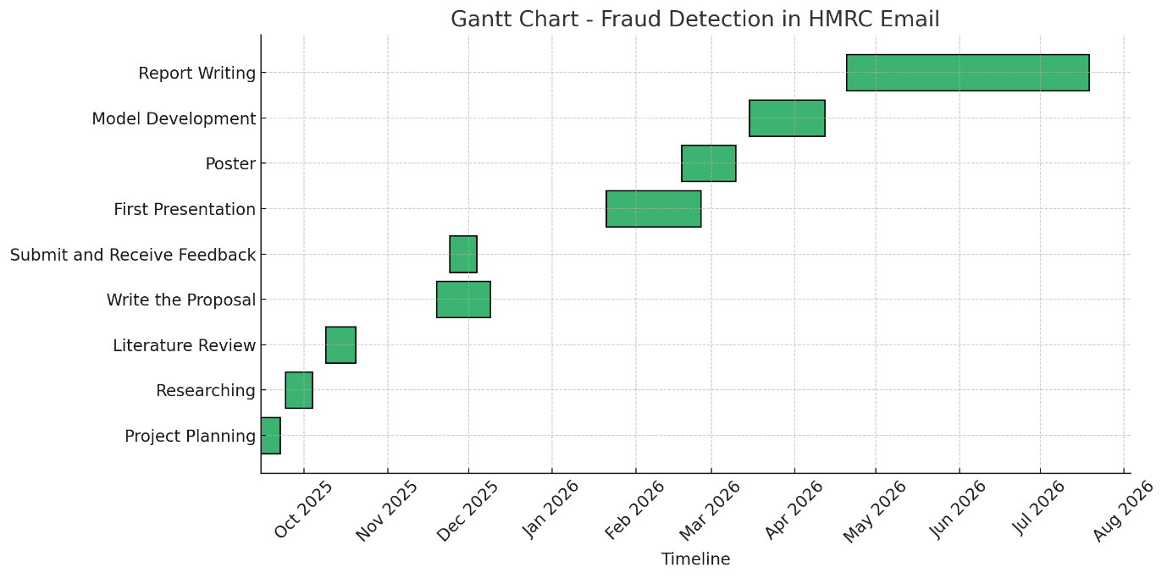

Conclusion
The proposed project will help resolve the increasing issue of phishing emails associated with HMRC by creating a machine learning model that would effectively detect fraudulent emails. The research will use different types of data, perform extensive preprocessing and train two robust algorithms, including SVM and Random Forest, to comprehend which of these two is more suitable to practice fraud detection in the real world. The methodology is fair, reliable and ethical responsible without disregarding the challenges faced like overfitting and ever-changing scam techniques. Even though none of the models can ensure ultimate detection, the study offers a systematic framework to enhance security of email and minimize the chance of a tax-related scam. It is hoped that the end result will aid the creation of smarter email filtering applications that can aid in safeguarding individuals, organisations and government services against an ever more sophisticated cyber threat.

References
[1] “HMRC loses £47m in fraudulent tax repayments,” Icaew.com, 2025. https://www.icaew.com/insights/tax-news/2025/jun-2025/hmrc-loses-47m-in-fraudulent-tax-repayments
[2] D. for, “Fraud and error in the benefit system, Financial Year Ending (FYE) 2025,” GOV.UK, May 15, 2025. https://www.gov.uk/government/statistics/fraud-and-error-in-the-benefit-system-financial-year-2024-to-2025-estimates/fraud-and-error-in-the-benefit-system-financial-year-ending-fye-2025 [Accessed on 20/10/2025]
[3] Jáñez-Martino, F., Alaiz-Rodríguez, R., González-Castro, V., Fidalgo, E. and Alegre, E. (2022). A review of spam email detection: analysis of spammer strategies and the dataset shift problem. Artificial Intelligence Review, 56. doi:https://doi.org/10.1007/s10462-022-10195-4.
[4] Almeida, T.A., Hidalgo, J.M.G. and Yamakami, A. (2011). Contributions to the study of SMS spam filtering. Proceedings of the 11th ACM symposium on Document engineering - DocEng ’11. doi:https://doi.org/10.1145/2034691.2034742.
[5] R. Al-Haddad, F. Sahwan, A. Aboalmakarem, G. Latif, and Y. M. Alufaisan, “Email text analysis for fraud detection through machine learning techniques,” 3rd Smart Cities Symposium (SCS 2020), 2021, doi: https://doi.org/10.1049/icp.2021.0909.
[6] GeeksforGeeks, “Introduction to Weka: Key Features and Applications,” GeeksforGeeks, Aug. 22, 2024. https://www.geeksforgeeks.org/machine-learning/introduction-to-weka-key-features-and-applications/ [Accessed on 20/10/2025]
[7] F. Pedregosa et al., “Scikit-learn: Machine Learning in Python,” J. Mach. Learn. Res., vol. 12, 2011, doi: https://doi.org/10.5555/1953048.2078195.
[8] S. Bobde¹, S. Role², L. Khadke, T. Shirude, and Kakad, “Email Spam Detection Using Hybridization of SVM and Random Forest,” International Journal of Research in Engineering and Science (IJRES) ISSN, vol. 11, pp. 188–193, 2023, Accessed: Oct. 22, 2025. [Online]. Available: https://www.ijres.org/papers/Volume-11/Issue-7/1107188193.pdf?utm_source=chatgpt.com
[9] Ageng, R., Faisal, R. and Ihsan, S., 2024. Random Forest Machine Learning for Spam Email Classification. Journal of Dinda: Data Science, Information Technology, and Data Analytics, 4(1), pp.8-13.
[10] Phani Teja Nallamothu, Mohd Shais Khan. Machine Learning for SPAM Detection. Asian Journal of Advances in Research, 2023, 6 (1), pp.167-179. ⟨hal-05125865⟩
[11] A. Yasin and Abdelmunem Abuhasan, “An intelligent classification model for phishing email detection,” arXiv (Cornell University), Aug. 2016, doi: https://doi.org/10.48550/arxiv.1608.02196.
[12] Nazhir Amaya-Tejera, M. Gamarra, J. I. Vélez, and E. Zurek, “A distance-based kernel for classification via Support Vector Machines,” Frontiers in artificial intelligence, vol. 7, Feb. 2024, doi: https://doi.org/10.3389/frai.2024.1287875.

‌

‌

‌

‌

‌

‌

‌

‌

