Critical Review of the Temporary exhibition “Dead Normal”. Being Exhibited at the Grovsner Museum, Chester from the 1st November 2018 – 22nd April 2019.
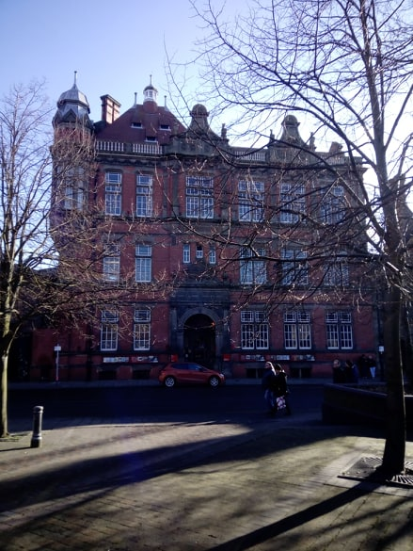

Fig. 1. The Grovsner Museum, Chester (Nye, 2019).

Since the 1970s, museums have developed an ever-growing willingness to exhibit those artefacts which are considered to be “difficult subject matter” (Bonnell, Simon 2007: 65). One such museum is that of the Grovsner Museum, Chester with their temporary exhibit “Dead Normal”. Being displayed from November 2018 to April 2019, the exhibit, according to the website, aims to “explore the ways different cultures and communities have tried to make sense of the end of life…” (Grovsner Museum: 2018). This review will critically assess this exhibition and consider whether it is an effective exhibit whilst discussing the methods of exhibition.
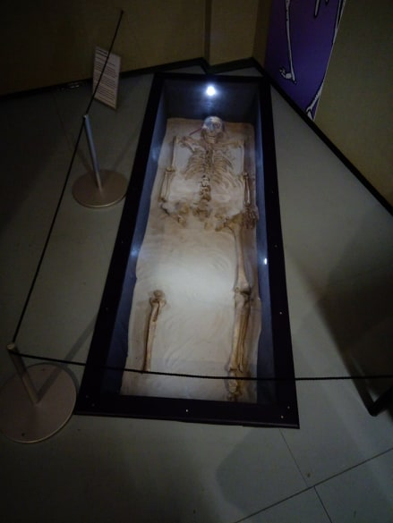
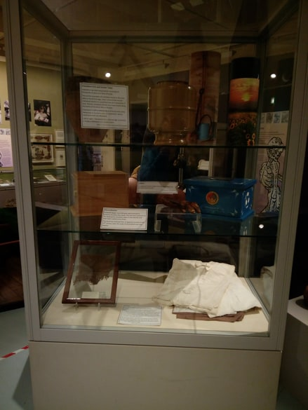
“Dead Normal” is a temporary exhibit handling the ideas and concepts surrounding death which have occurred throughout history. It brings forward the concept of “death” as a universal occurrence and shows how different cultures and societies have addressed and interacted with this; attitudes changing over time. It takes artefacts from a variety of cultures, offering educated suggestions as to how such communities have understood the concept of death, how they have mourned and remembered those close to them (Grovsner Museum 2018). Not only this, but it also examines potential causes of death, even though this aspect of the exhibition is restricted to four replica skulls and a skeleton from Northumbria (Fig 2).
Fig 2. Skeleton on display (Nye 2019).
Fig 3. Artefacts on display in a glass cabinet (Nye 2019).

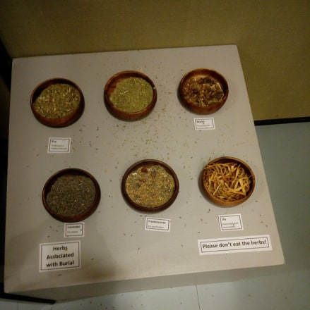

Fig 4. Herbs as part of an interactive display (Nye 2019).
The purpose of this exhibition is to educate people on the different attitudes of cultures surrounding death. It also provides an introduction to the theme rather than an in-depth examination; something which will be examined further. The location of the exhibition, immediately on the right as you enter the museum, also suggests that a potential purpose of the exhibition could be to engage people with the past by examining the darker and morbid aspects of history. This notion of the public becoming more interested with the darker aspects of the past is one that is highlighted by Minic in 2012. This idea that visitors are potentially engaging more with the darker sider of the past is potentially shown within this exhibition (Minic 2012: 82).
The exhibition uses a combination of conventional and interactive methods of display to tell its story. Some artefacts (Fig 3) are carefully encased in a glass cabinet whilst others, in this case replicas, or modern day artefacts (Fig 4), are placed at suitable heights to engage people of all ages, for example the herbs which you can handle and smell (although it should be noted that they have had to place a note informing people to “not eat the herbs”). Dean (1996: 39) highlights how a combination of different elements helps to produce an effective exhibition with Caulton (1998: 18) emphasising the assumption that people learn more when they enjoy what they are learning. However, it could potentially be argued that the relatively small number of artefacts per time period might not sufficiently support the theme although there is no set way of designing exhibitions. For example, there are only a small number of artefacts to put forward an understanding of the medieval attitudes towards death; hardly sufficient to provide the potential learning capacities which it could offer.
The alternative view to the apparent small number of artefacts, other than it not being potentially sufficient enough to support the exhibition, is that each artefact has been carefully chosen with a purpose to directly support the theme. Dean draws attention to how the meticulous organisation of artefacts increases the impact and emphasises any importance that the objects may have (1996: 55). For example, in one glass cabinet displaying artefacts from a Priest’s burial (Fig 5), there are only two artefacts in the case. The case is not overcrowded but directly supports the theme. Furthermore, the size of the room could also be a direct influence over the number of artefacts on display per time period. The room which the artefacts are housed is relatively small, with little space for large glass cabinets or displays. However, for an introductory exhibition, the artefacts do support the theme on display well.

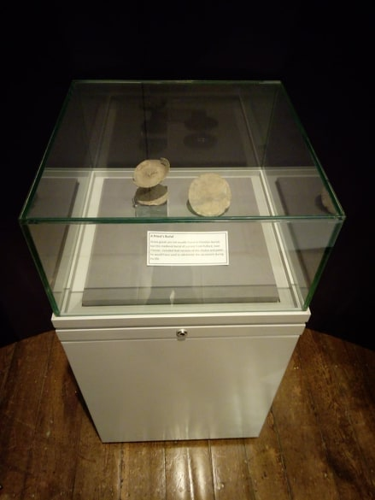

Fig 5. Priest’s burial display (Nye 2019).

From an academic perspective, this exhibition is could be interpreted as of being more entertaining rather than educational. However, this could be a result of the prior knowledge of the theme which the author has; a concept which the museum would have carefully thought about in the creation of the exhibition (McLean, 1999: 83).
One aspect of the exhibition which promotes the effectiveness of the exhibition is the incorporation of a “children’s corner” (Fig 6). This is not the only exhibition in the museum to actively incorporate child friendly aspects, both the Roman exhibition and the Natural History exhibition also have areas in which children can engage with a “hands-on” approach to the past. The museum provides as Caulton puts it, a “dedicated space for young children” and one which ensures that all ages are catered for (1998: 28). A concept which, it could be said, makes the exhibition even more effective as it caters for all age groups.

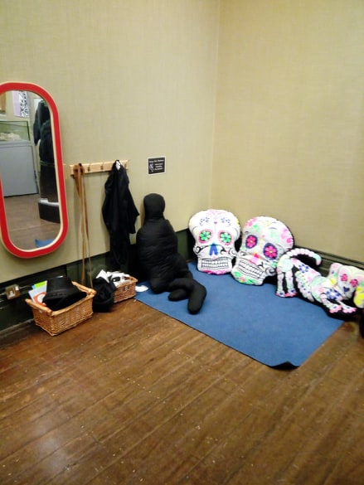

Fig 6. Children’s Corner (Nye 2019).

The exhibition cleverly manipulates the use of different levels in order to draw the eye to every aspect of the display. This is mostly keenly seen with the way the skeleton from Northumbria has been displayed. (Fig 2) The skeleton is displayed below floor level, so visitors are required to look down in order to see it; the museum potentially taking direct inspiration from the burial the skeleton would have been taken from. It ensures that the visitor’s eye is drawn to every aspect and also makes the exhibition more visually enjoyable (Dean 1996: 52).
Personally, one would have preferred a more in-depth examination of the concepts and themes that the exhibition has on display. It is difficult to obtain any further knowledge about the theme than one has already obtained. However, this again could be due to the prior knowledge that one has over a potentially poor exhibition. If taken from the perspective of an individual who has no knowledge, this exhibition could be extremely informative. Nonetheless, it was an enjoyable exhibition to engage with. People are not bombarded with information yet there is enough to be interesting. The layout also makes the exhibition more enjoyable. In order to examine the past, for the most part, chronologically, one has to enter a tunnel to being at the medieval time period and make their way through to the Victorian period. It is an effect method to ensure that all aspects of the exhibition are engaged with; the “mystery” of the tunnel snatches peoples’ curiosity and almost guarantees engagement. According to Dean (1996: 53), this is the quintessential example of a “suggested approach” to towards to concept of traffic flow. The exhibition makes use of the strategic implementation of specific exhibits, structures and lights to encourage visitors along the recommended route. The room is also promoting the use of wheelchairs, ensuring that nearly everyone can experience and enjoy this exhibition.
Another aspect which is interesting, is that it appears that there is very little local knowledge incorporated into this exhibition, especially with how broad the individual time periods are when addressing the theme. This may have been intentional, again suggesting that the exhibition is a tool to provide an introduction to the theme of death across different time periods and to engage and interest people with the past. However, the few artefacts which are from the local area, such as the tombstones (add in photo), are placed centrally in the room and are one of the first things that the eye is drawn to upon entering the exhibition, potentially highlighting the importance of local archaeology. It therefore could be implied that the exhibition not only, if slightly, supports local heritage but also heritage as a whole, for example the Egyptian aspects of the exhibition.
The “Dead Normal” exhibition located at the Grovsner Museum in Chester is an exhibition which does provide, at the very least, an introduction to the concepts of death which they promise. The exhibition itself if meticulously put together and, although there are flaws to the display, the majority being personal preference on the author’s part, it is a good exhibition which supports the museum as a whole. The apparent concern to ensure that children are able to enjoy the exhibition as much as the adults is a nice touch which definitely increases the exhibition appeal. Although a more in depth look at the time periods on display, or even an increased number of time periods would have been preferable, it is still an effective exhibition which puts forward artefacts to support the themes being discussed.

Bibliography
Bonnell, J., Simon, R, I., (2007). ‘Difficult’ Exhibitions and Intimate Encounters. Museum and Society. 5(2): 65-85.
Caulton, T., (1998). Hands-on Exhibitions: Managing Interactive Museums and Science Centres. London and New York: Routledge.
Dean, D., (1996). Museum Exhibition: Theory and Practice. London and New York: Routledge.
Grovsner Museum Events Page., (2018). Dead Normal. http://events.westcheshiremuseums.co.uk/event/dead-normal/ accessed 05/03/19.
McLean, K., (1999). Museum Exhibitions and the Dynamics of Dialogue. America’s Museums. 128(3): 83-107.
Minic, N., (2012). Development of “Dark” Tourism in the Contemporary Society. Journal of the Geographical Institute. 63(3): 81-103).
Nye, R., (2019). Photos from a visit to “Dead Normal” Exhibition, Grovsner Museum Chester. Figures 1-6. Unplublished.

