University of Wales Trinity Saint David
School of Computing
Network Operating Systems and Services
ACCA5023
Jericho Uzzell
1702201
02/03/2021


Table of contents
- Introduction; [page 3]
- Documentation; [page 3-20]
  - Deploying DHCP and creating active directory objects; [page 3-18]
    - Naming server one computer; [page 3-4]
    - Deploying active directory; [page 5-11]
    - Creating user accounts; [page 11-15]
    - Adjoining the domain and testing logins; [page 16-18]
  - DHCP observation task; [page 19-20]
    - What is DNS and how it works within active directory domain service;
    - Two critical roles within an enterprise network;
    - Importance of difference roles;
    - Microsoft's recommendation on AGDLP and AGUDLP; [page 20]
- Reference; [page 21]
- Bibliography; [page 22]

1. Introduction
This report will go over the building, deployment, confirmation and managing of a type two hypervisor platform. It will also look at deployment of DHCP and creating active directories, each will have their own observational task.

2. Documentation;

2.3. Deploying DHCP and creating active directory objects;

2.3.1. Naming server one computer;
We need to rename server one to an appropriate name. First, within the windows search bar, type “This PC”, right click on the first suggestion and click “properties”. It should look like the image below.
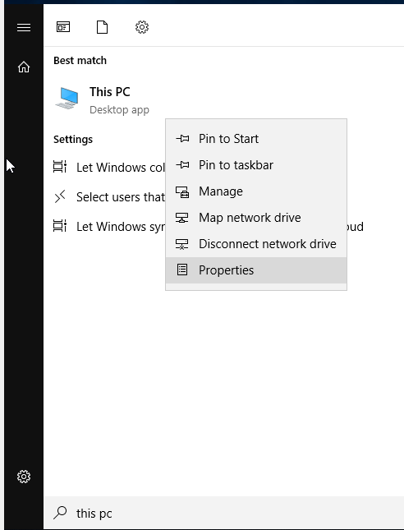
A new window should pop up named “system”. On the left panel, click “advanced system settings”, shown below.
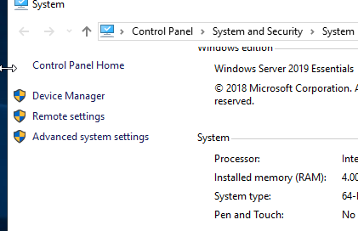

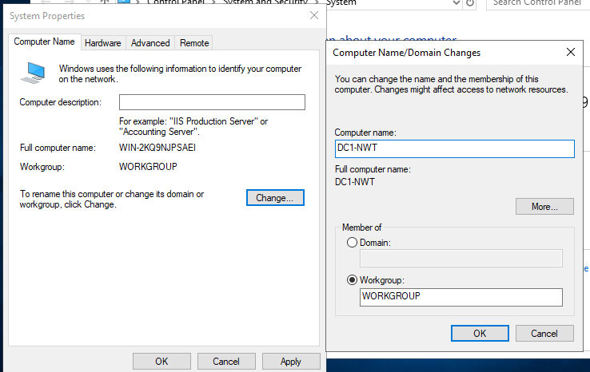
A new window named “system properties” will pop up, click the far left tab named “computer name”. Then click the “change” button to rename the computer, and call the computer “DC1-NWT”, click okay. A dialog will pop up instructing you to restart, click okay and restart (shown below).
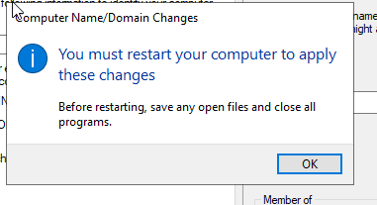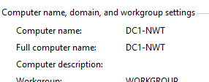

2.3.2. Deploying active directory;
Type within the windows search bar “server manager”.
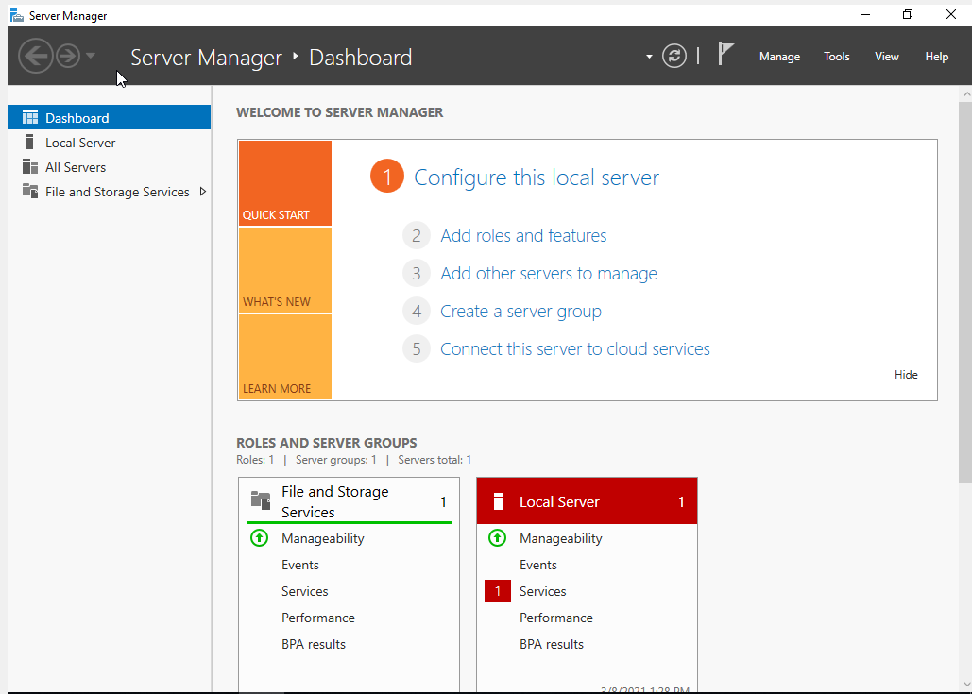
On the page, click the “Add roles and features” button. If the button is not there, in the top right you can click “manage” and then “add roles and features”. On the wizard that pops up, click next.
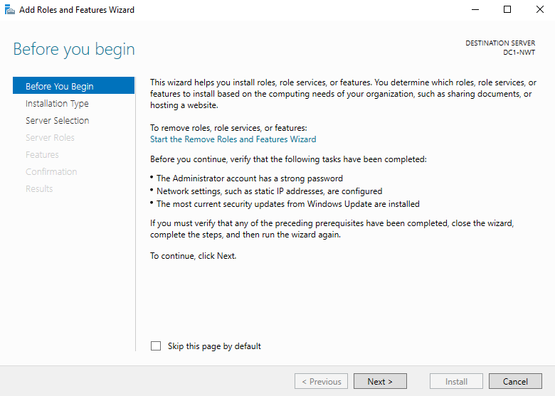

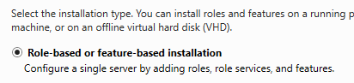
Select “role-based or feature-based installation”, then click next.

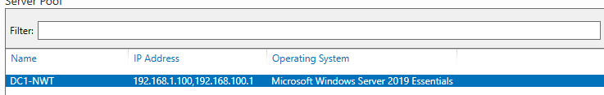
Ensure the above name (or whatever you name the machine) is selected.

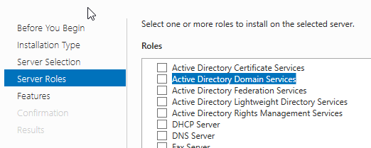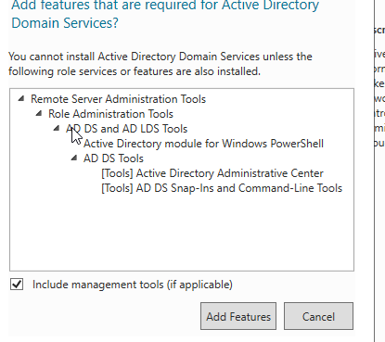
On the server roles window, click the “Active directory domain services” and the “add features” on the pop-up window. Then click next on the server roles window.
The next window, the features page, you can click next on as default options are fine.
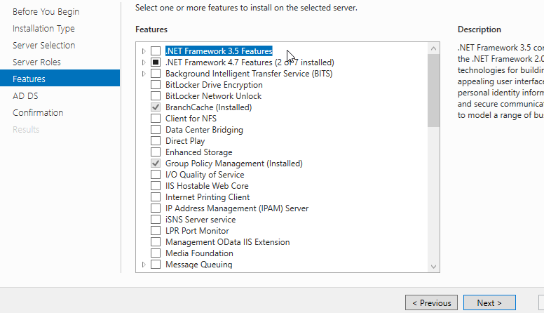
Once again, AD DS window can be passed by pressing next.

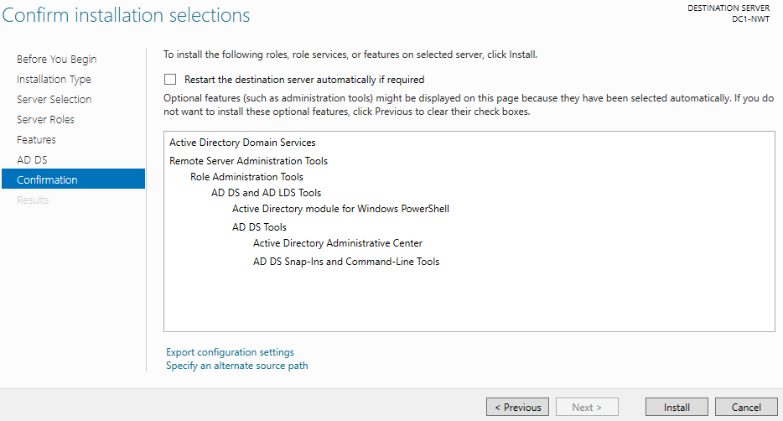
Lastly, the confirmation window simply goes over what will happen. Clicking install will install what you need.

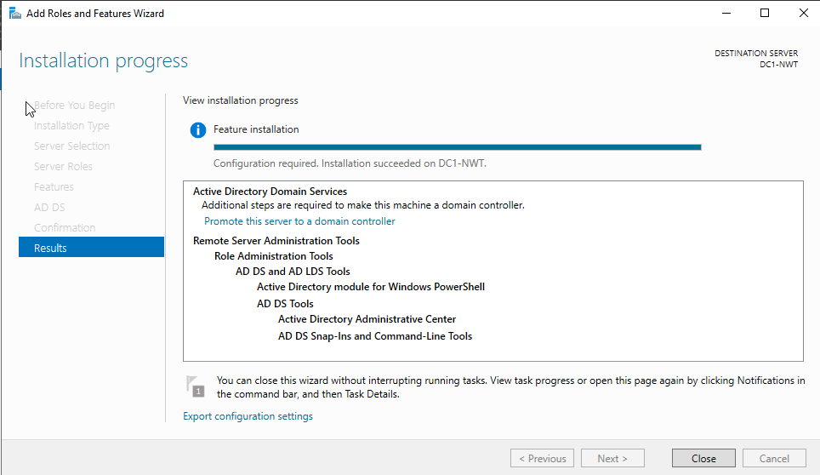
The results page should take five minutes to complete. Once done, click close.
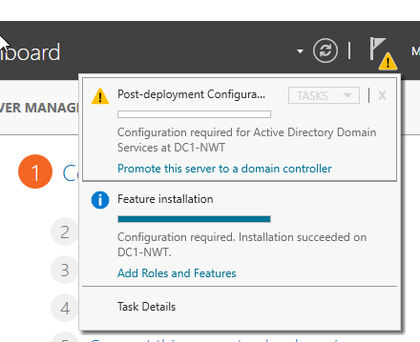
Now you will observe a triangle in the top right handle corner. This is windows informing you that you need to promote the server to a domain controller -- click the blue link.

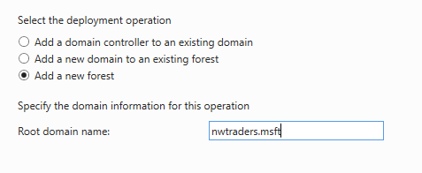
Ensure you click “add a new forest” and name the root domain your domain name, for this server, we will call it “nwtraders.msft”, the click next.

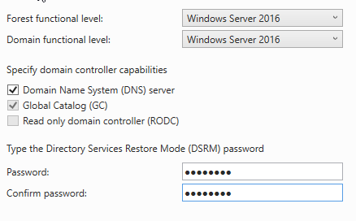
Ensure forest functional level and domain functional level are “windows server 2016”. Click the domain name system (DNS) server and make sure your password is strong, this example will use “N3tW0rk1”, then click next.
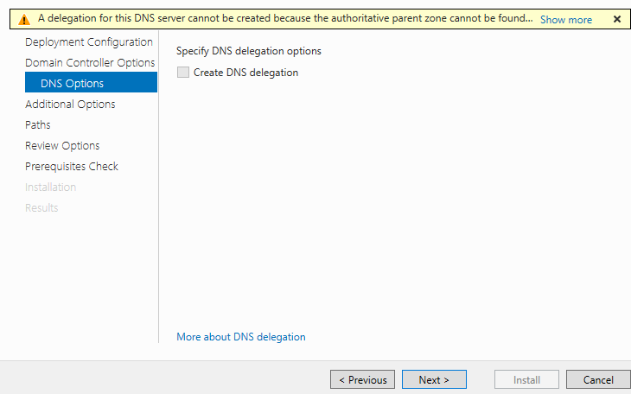
Ignore this error, click next.

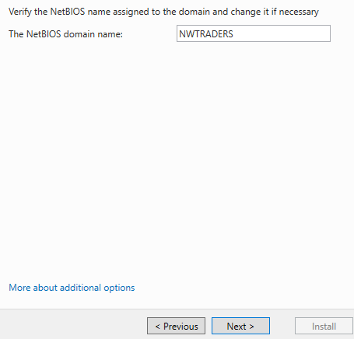
Like our previous comment, click next for additional options window.

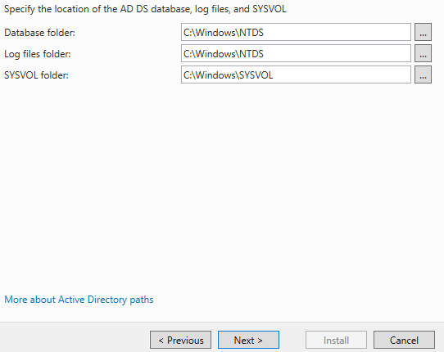
The paths window is more for you to take note. You should note where these files are located as these are the active directory database and logs of what it does. Click next when ready.

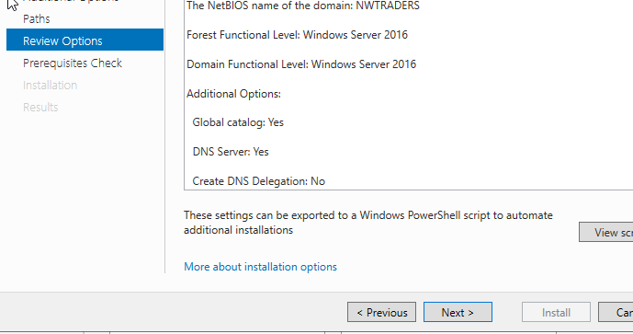
On the review options page, you can click next as this will give you a detailed list of what will be installed.

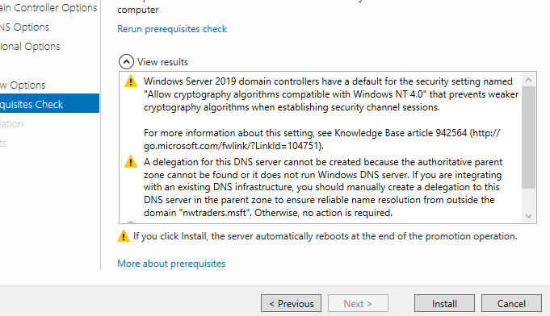
You can now click install on the prerequisites check (this should take five minutes -- the machine will restart once done).
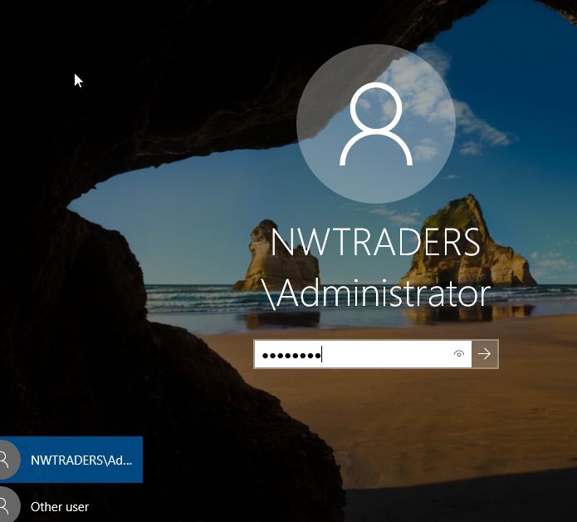
To log in, you can use your default administrator password, being “P@ssw0rd”.

2.3.3. Creating user accounts;
Once logged into the administrator account, click start and look under the administration tool folder for “active directory users and computers” or type it into the search bar.

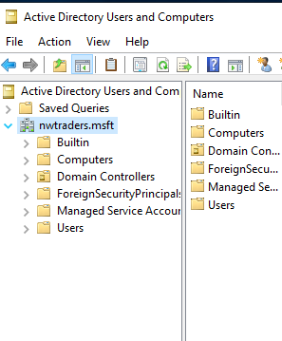
Click on the arrow next to “nwtraders.msft” to expand the list.

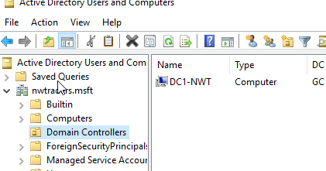
As you can see, under domain controllers we are presented with the computer we renamed.
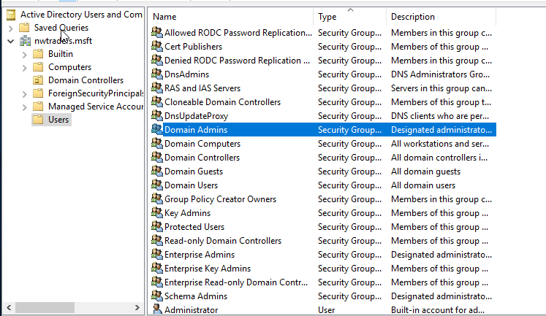
Under the users object (the yellow ‘files’ as referred to in windows are known as objects), you should see a group for “Domain Admins”, locate it and double click it (or right click and go into properties).
Note, you can filter the type for Security Groups and User to be placed in their sections.

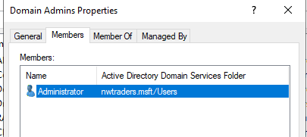
Under the members tab of the Domain Admins group, you will see one user known as administrator which is you. You should add another account, be it a backup in the event something happens to the administrator account.
Click okay to close the window.

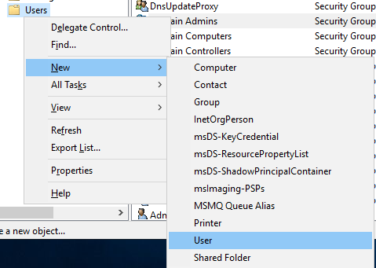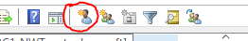
Right click on the Users object, under new click User. Alternatively, click the star person (highlighted in red) to add a new user.
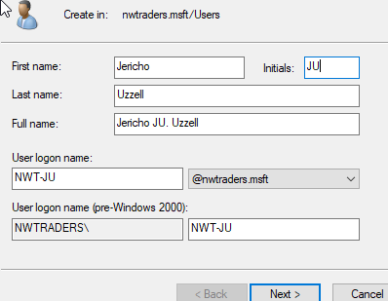
Create login information for the user. Click next when you have filled out the information.

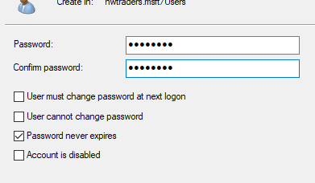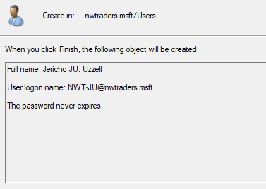
The password we are using is “P@ssw0rd”, with that said you should pick something different and that meets the requirements. Also, uncheck “user must change password at next logon” and check “password never expires”, click next when one and then finish.

Now head back to the Domain Admins group, double click it (or right click and click properties). Under Members click add, a window will appear -- type the logon name or firstname of the person and then click “check names”, windows will autofill the rest (our logon name is “NWT-JU”). Click okay when done.
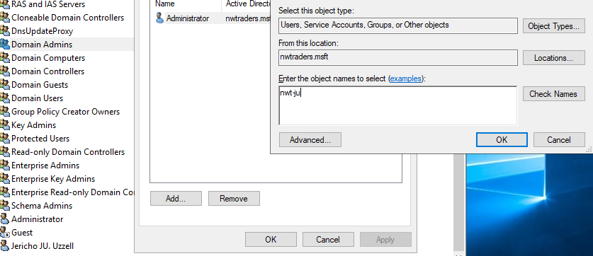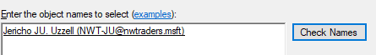
Then click okay on the Domain Admins properties.
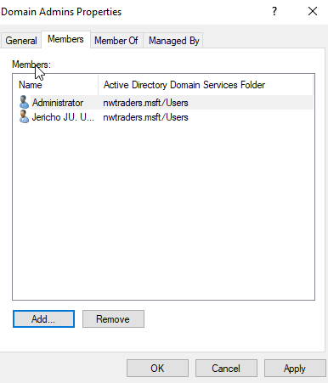

The backup admin account has now been created successfully. We will now create another user who will have limited access.

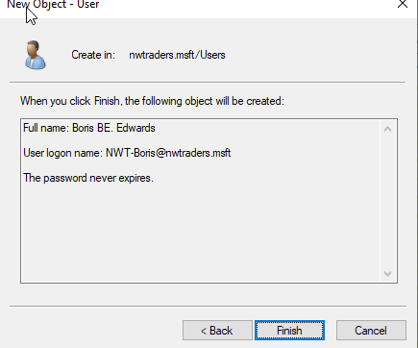
Create a new user, the same way you created the backup admin account.

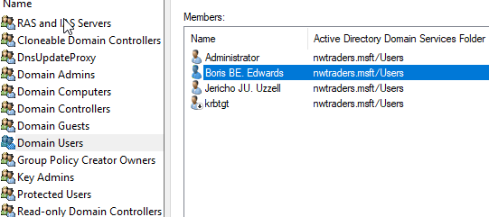
Under Domain Users Group, you will see the new account is under the members tab.
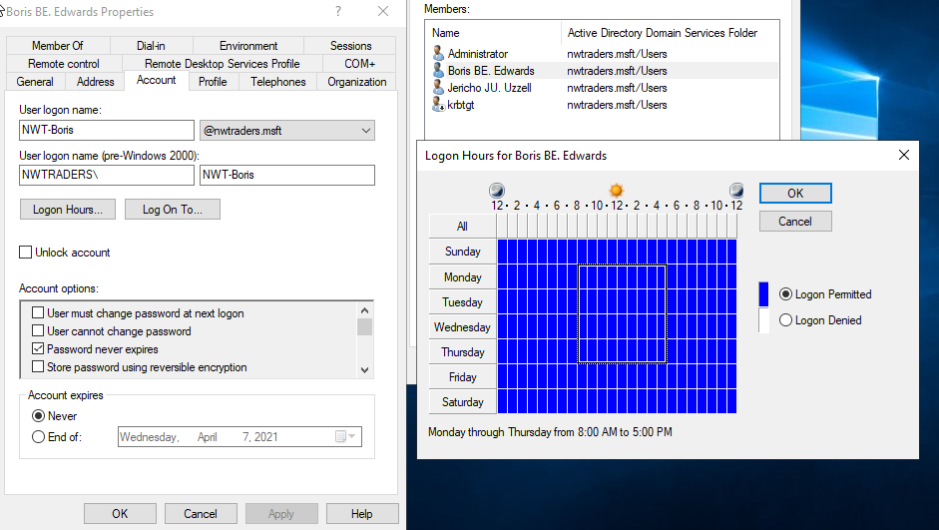
Within the Domain Users group, double click on the user you just created and go to the account tab. Under the account tab, go to Logon Hours and you can set the times of which this person can logon -- we have done this between Monday 8am all the way through to Thursday 5pm (each day is 8am until 5pm).

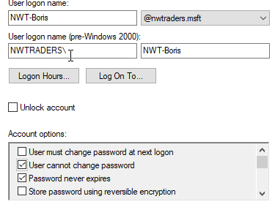
On the same tab (account) you can set that the user cannot change their password under the account options field, click okay to proceed.

2.3.4. Adjoining the domain and testing logins;
We are going to need to add the client one computer name (workstation) to our domain. Load Active Directory Users and Computers, then within there look for the computers container (shown below).
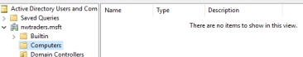

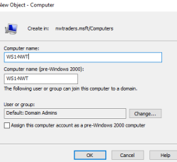
Right click within the whitespace and click new and then computer. Within the dialog box, type “WS1-NWT” and then okay.
Now shutdown and start client one.

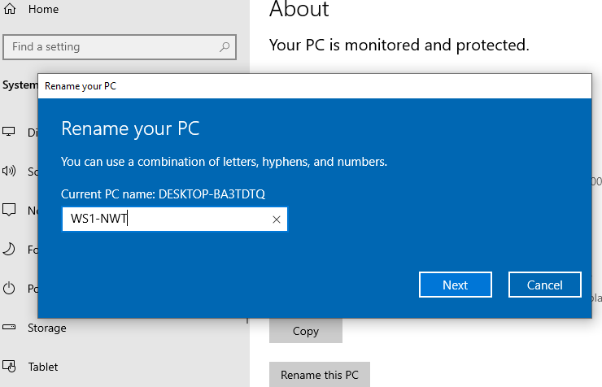
Type in the windows search bar “This PC”, right click and go to properties. You should see “rename this PC” button under the about pane -- click it and name the PC WS1-NWT“, click next and then restart.
Now, we must navigate back to the control panel, under network you will see “view network status and tasks”, click it. On the left panel, click “change adapter settings” and go into the properties of PrivateNet1. Go into the properties of IPv4 (left click and click properties or double click).

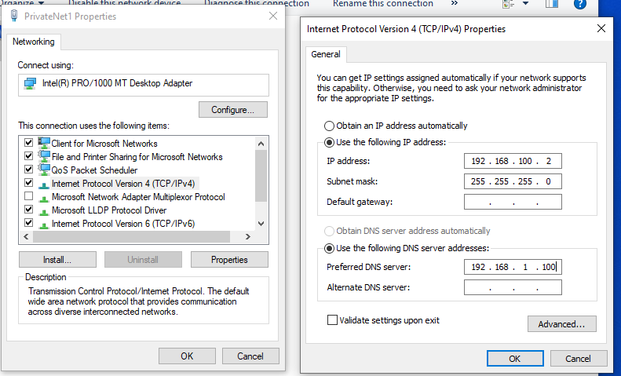
Now ensure you enter into the preferred DNS server “192.168.1.100”, then click okay.

Type into the windows search bar, “this PC”, go into the properties of that and locate “advanced system settings”, usually found in the right panel at the bottom. You will be presented with some tabs, go into the “computer name” tab and locacte the “change” button which has text to its left stating it will rename the computer.

Within this window, click the “domain” radio and type “nwtraders”, click okay.
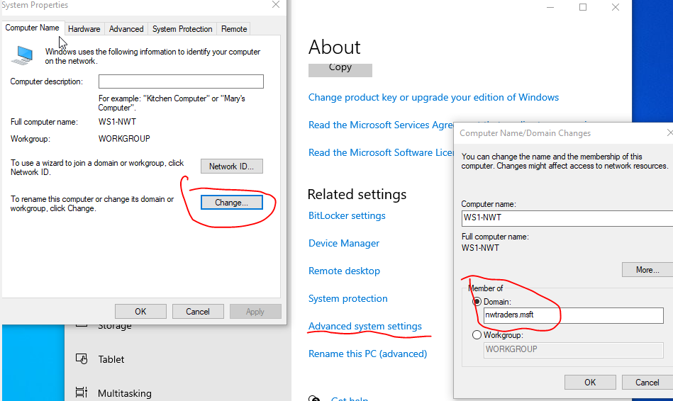

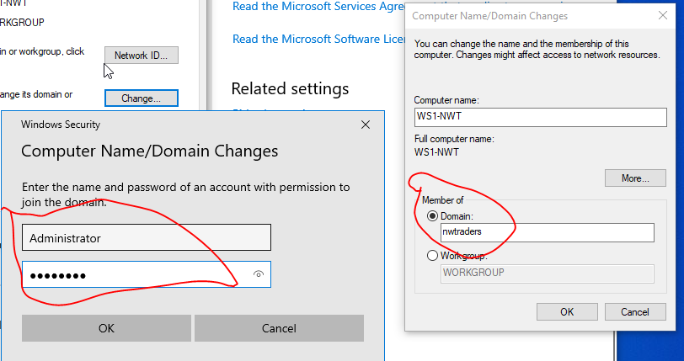
The above authorisation box will appear, type in the username and password.
cannot connect to domain...prob an ipv4 issue or im typing in password wrong -- got board so moving on.

Restart the machine and ensure server one is launched whilst starting client one -- you should now be able to login with the administrator accounts for nwtraders and for the normal account.

2.4. DHCP observational task

2.4.1. What is DNS and how it works within active directory domain service;
According to [8], domain name system (DNS) is a phonebook for the internet, it stores IP addresses and a friendly name for the IP address, an example could be the following. If you wanted to access Google, you will type “google.co.uk” which takes you to “https://google.co.uk”, could you remember “43.23.23.234” (this is not Google's IP) and every other website's IP?

[8] states that “google.co.uk” is a friendly name for us humans, the computer and the browser will keep the difficult to remember IP address in its “phonebook”, other parts of the internet such as your router, your ISP and then a DNS nameserver should hold the IP address of the domain -- it works so if your browser or computer does not know the IP, then your router will look, if it does not know it will ask your ISP, lastly if they do not know then the DNS nameserver is contacted, if they do not know then an error is returned.

2.4.2. Two critical roles within an enterprise network;
We have already named “Role or feature based installation” within active directory (AD) so we will not mention anything further. A critical role within an enterprise network is ensuring your network is set up correctly, deciding whether your network is required to be an A, B or C network.

2.4.3. Importance of difference roles;
What is the difference between a domain admin and a DHCP admin? A domain admin has access to all of the network, they have complete access whereas a DHCP admin will have access to a part of the network. It is important to segment roles to reduce the impact of an attack if one was to happen.

It is why you should have a certain amount of domain admins, as if one account is locked then another can sort the issue out and so the pool of domain admins is limited.

2.4.4. Microsoft's recommendation on AGDLP and AGUDLP;
AGDLP (account, global, domain, local, permission) and AGUDLP (account, global, universal, domain, local, permission). [9] states that the advantages to using AGDLP is that everything is equally straightforward when implementing users and groups within a domain local group. If relevant groups already exist within the resource, permissions can be changed by adding memberships within the active directory (AD).

Disadvantaged to AGDLP according to [9], is that the structure must already be in place before use which is done manually.

[10] states that administration can essentially be divided up across other administrators, auditing permissions is better understood and done due to users being in a universal group and lastly universal groups is the only way you can use cross-domain authentication for if the domain has more than one forest.

3. References
author/site, “Title”, site, [written/current data], [Online.], Available: URL, [Accessed: DATE]
[1] S.Simic, “What Is A Hypervisor? Types Of Hypervisors 1 & 2”, phoenixnap, 24 Jan 2019, [Online.] Available: https://phoenixnap.com/kb/what-is-hypervisor-type-1-2, [Accessed: 05 March 2021]
[2] avinetworks, “What is Subnet Mask?”, avinetworks, 2021, [Online.], Available: https://avinetworks.com/glossary/subnet-mask/, [Accessed: 05 March 2021]
[3] anblicks, “Benefits of Cloud Computing”, anblicks, 12 May 2016, [Online.], Available: https://anblicks-inc.medium.com/benefits-of-cloud-computing-8f6eee9a28e, [Accessed: 05 March 2021]
[4] A.Larkin, “Disadvantages of Cloud Computing”, cloudacademy, 7 August 2019, [Online.] Available: https://cloudacademy.com/blog/disadvantages-of-cloud-computing/, [Accessed: 05 March 2021]
[5] J.Gerend, E.Ross, T.Krokli, J.Parente, L.Poggemeyer, C.Plett, “ping”, microsoft, 11 July 2018, [Online.], Available: https://docs.microsoft.com/en-us/windows-server/administration/windows-commands/ping#:~:text=ping%20is%20the%20primary%20TCP,IP%20address%20of%20the%20computer, [Accessed: 10 March 2021]
[6] J.Gerend, E.Ross, J.Parente, I.Prittie, L.Poggemeyer, C.Plett, “Server Manager”, Microsoft, 16 October, [Online.], Available: https://docs.microsoft.com/en-us/windows-server/administration/server-manager/server-manager, [Accessed: 10 March 2021]
[7] D.Vangel, D.Simpson, M.Imran, M,Cruz, jcaparasm D.Mabee, et al, “Windows Defender Firewall with Advanced Security”, Microsoft, 21 October 2020, [Online.], Available: https://docs.microsoft.com/en-us/windows/security/threat-protection/windows-firewall/windows-firewall-with-advanced-security, [Accessed: 10 March 2021]
[8] cloudflare, “What is DNS?”, cloudflare, 2021, [Online.], Available: https://www.cloudflare.com/learning/dns/what-is-dns/, [Accessed: 10 March 2021]
[9] tenfold, “AGDLP”, tenfold, 2021, [Online.], Available: https://www.tenfold-security.com/en/wiki/agdlp/, [Accessed: 10 March 2021]
[10] zap, “About Cross-domain Windows Authentication and AGUDLP”, zap, 15 February 2021, [Online.], Available: https://help.zapbi.com/DataHub/CurrentVersion/content/topics/Security/security_about_agudlp.htm#:~:text=The%20AGUDLP%20method%20has%20the,provide%20access%20to%20Data%20Hub, [Accessed: 10 March 2021]

4. Bibliography
https://www.watchguard.com/help/docs/help-center/en-US/Content/en-US/Fireware/overview/networksecurity/slash_about_c.html

https://docs.microsoft.com/en-us/previous-versions/windows/it-pro/windows-server-2003/cc755692(v=ws.10)?redirectedfrom=MSDN

