

Financial Management
Assignment Title: Assessment component: Financial performance and management
Module Code: LCMB7002
Lecturer’s Name: DR SHENGFENG MEI
Student Name: PATEL MEETKUMAR KANTILAL
Student ID: 2536671
Word Count: 5,171
Submission Date: 13 August 2026
TERM 1

Table of Contents
1. Financial Health Check 4
1.1 Overview of Financial Statements 4
1.2 Five-Year Trend Analysis 4
1.3 Ratio Analysis 5
1.3.1 Profitability Ratio 5
1.3.2 Investment Ratios 7
1.3.3 Efficiency Ratios 8
1.3.4 Liquidity Ratios 9
1.3.5 Financial Structure (Gearing) Ratio 10
1.3.6 Cash Flow Ratios 12
1.4 Overall Financial Performance Evaluation 13
1.5 Overall Ratio Summary 13
2. Working Capital Management Analysis 14
2.1 Introduction 14
2.2 Cash Operating Cycle 14
2.3 Working Capital Problems 15
2.4 Strategies to Improve Liquidity 16
2.5 Financing Options 17
3. Strategic Financial Restructuring Plan 17
3.1 Need for Financial Restructuring 17
3.2 Financial Restructuring Options 17
3.3 Impact on Shareholder Value, Debt Structure and Operational Flexibility 18
3.4 International Considerations 18
3.5 Ethical and ESG Considerations 19
4. Investment Appraisal and Capital Budgeting 19
4.1 Project Information 19
4.2 Payback Period 20
4.3 Accounting Rate of Return 21
4.4 Net Present Value 22
4.5 Profitability Index 23
4.6 Internal Rate of Return 24
4.7 Comparative Evaluation 24
4.8 Recommended Project 25
4.9 Capital Rationing 25
5. Critical Reflection on AI Usage 26
5.1 Tool Disclosure 26
5.2 Verification of AI Outputs 26
5.3 Identification of Hallucinations 26
5.4 AI Contribution vs Personal Analysis 26
5.5 Ethical and Professional Reflection 27
References 28
Appendix 32

1. Financial Health Check

1.1 Overview of Financial Statements
The financial statements of InterContinental Hotel Group show the company's financial performance between 2021 and 2025. Revenue increased from $1,517 million to $5,189 million, along with an improvement in gross profit from $1,031 million to $4,425 million. The operating profit of the Intercontinental Hotel groups doubled during the period as it is used to $1,198 million as it was on $494 million (IHG, 2026). The total assets also increased from $4,716 million to $5,345 million, which highlights the continuous investment of the hotel in expansion and its digital capabilities. The operating cash flow was also positive throughout the period as it increased from $636 million to $898 million. It indicates that the four operations of the company were generating sufficient cash for financing the investment, representing the debt and maintaining the distribution of the funds to the shareholders.

1.2 Five-Year Trend Analysis
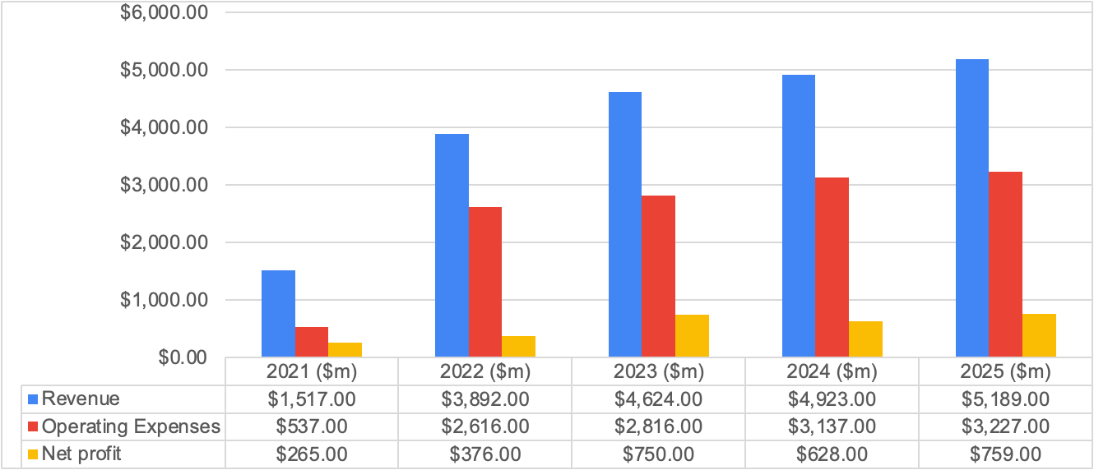
Figure 01: Trend Analysis
Source: (Ms-Excel)
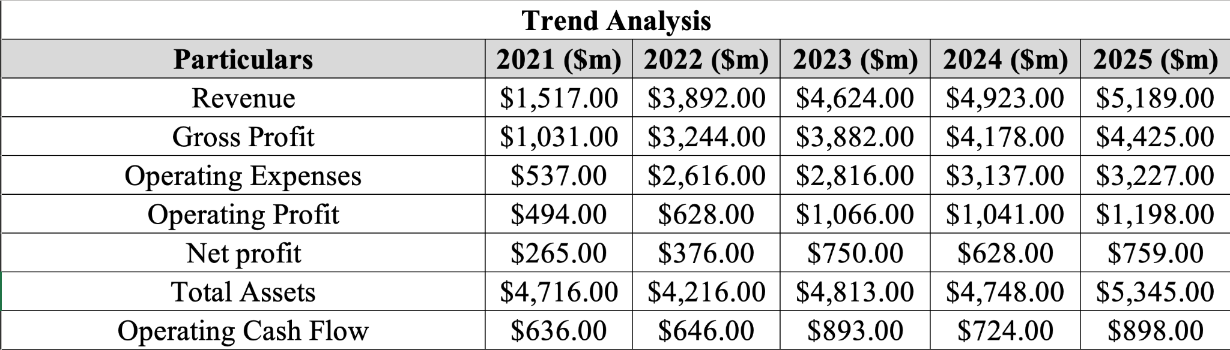
Table I: Trend Analysis
Revenue of InterContinental Hotel Group increased by approximately 242% in 2025, which was mainly due to the recovery in international travel, high occupancy levels and continuous expansion of the franchise as well as management. The increase in revenue was possible due to the increase in the Revenue per Available Room, which was approximately 1.8% (London Stock Exchange, 2025). The gross profit also increased consistently as it reflects the benefit of the asset-light business model of the InterContinental Hotel Group, where the franchise and management fees are generating a high margin with limited operating costs. The operating profit also improved, but it slightly declined in 2024 mainly because of high admin expenses, wage inflation, and increasing technology investment. Net profit fluctuated during the period, but there was a strong increment in the operating cash flow as a demonstration of the effective generation of cash. Trend analysis highlights that InterContinental Hotel Group successfully improved its profit, operational efficiency and financial resilience even after the ongoing macroeconomic challenges.

1.3 Ratio Analysis

1.3.1 Profitability Ratio
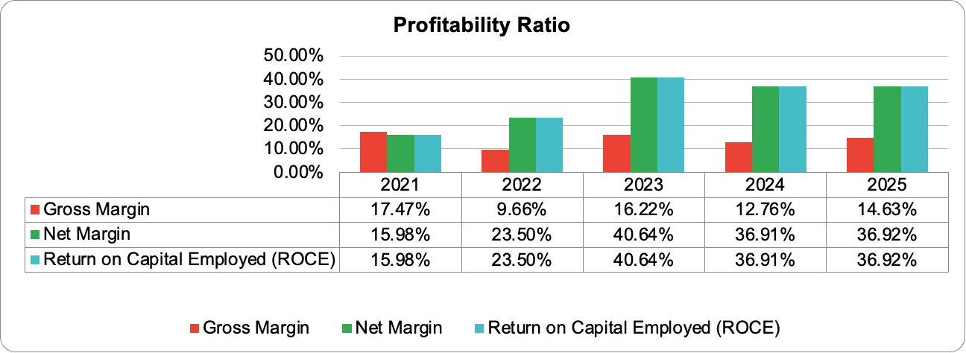
Figure 02: Gross Margin, Net Margin and Return on Capital Employed
Source: (Ms-Excel)
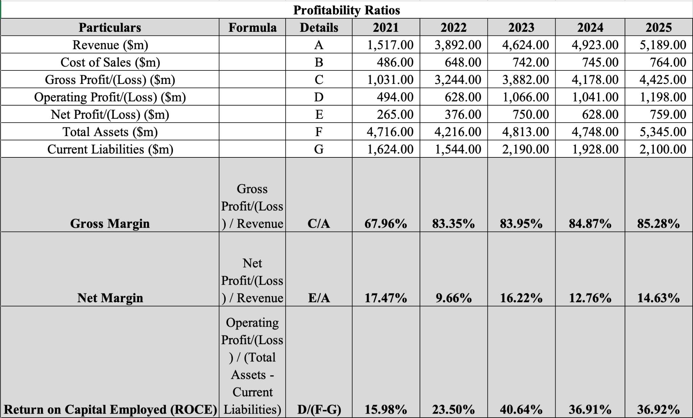
Table II: Calculation of Profitability Ratio
The profit of InterContinental Hotel Group improved as the gross margin increased from 67.96% in 2021 to 85.28% in 2025, which indicates improvement in operational efficiency and a great contribution to the high margin. Sharp improvement after 2021 shows the recovery of hotel demand after the pandemic and the continuous expansion of the asset-light strategy of the company (Pereira et al., 2026).
The net profit margin declined from 17.47% in 2021 to 9.66% in 2022 before recovering to 14.63% in 2025. Fluctuations were attributed to rising finance costs, inflation, and high operating expenses in place of the weak generation of revenue. The overall upward movement in the earning is demonstrating the effective control over costs and sustains the growth of the business.
Return on capital employed also increased substantially from 15.98% to 36.92%, which indicates that IHG is generating a high operating return from the capital invested in the business. The improvement also shows effective utilisation of the assets and disciplined allocation of capital.

1.3.2 Investment Ratios
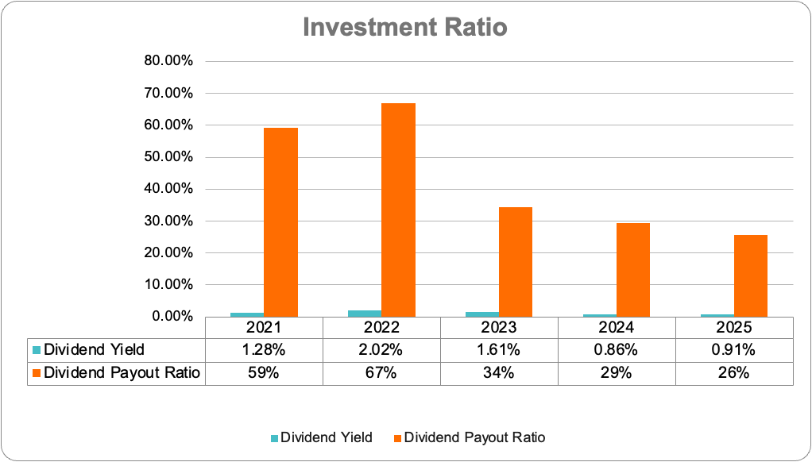
Figure 03: Dividend Yield and Dividend Payout Ratio
Source: (Ms-Excel)
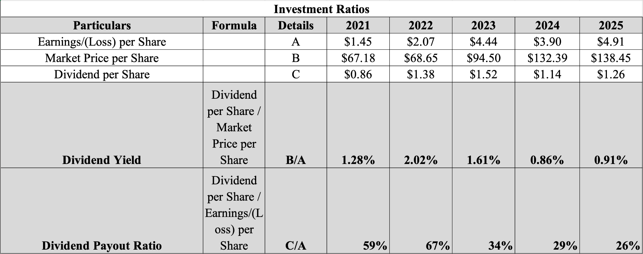
Table III: Calculation of Investment Ratio
Dividend yield declined from 1.28% in 2021 to 0.91% in 2025, which was primarily due to the increase in the share price of IHG more rapidly than the payment of dividends, as the confidence of investors improved during the recovery of the industry. The dividend payout ratio decreased from 59% to 26%, which indicates that the company was retaining a large proportion of the earnings for the expansion of the business. The conservative dividend policy is considered for improving financial flexibility along with supporting long-term growth (Lubis et al., 2024). It also suggests that the management is focusing on the sustainable creation of value in place of the short-term distribution to shareholders.

1.3.3 Efficiency Ratios
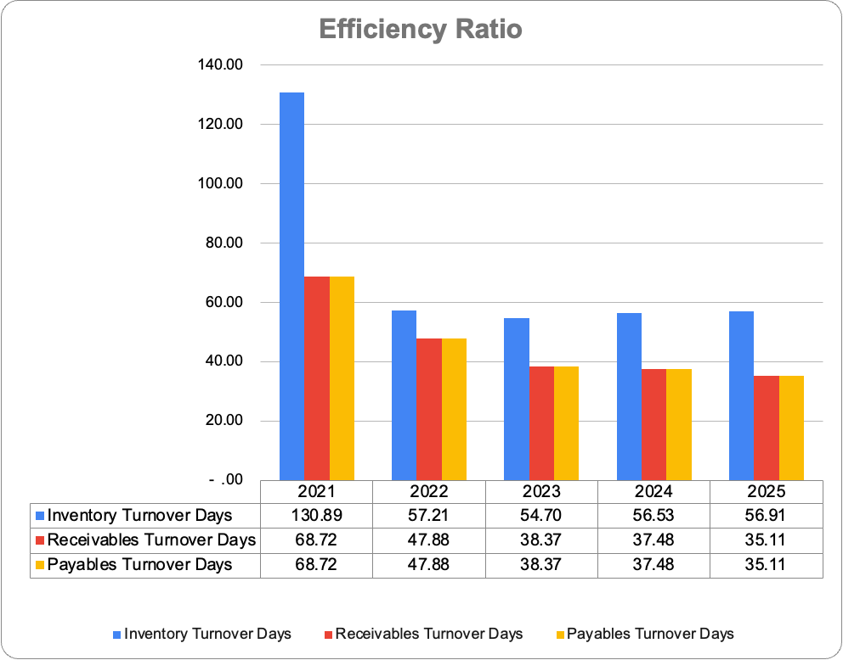
Figure 04: Inventory Turnover, Receivables Turnover and Payable Turnover Days
Source: (Ms-Excel)
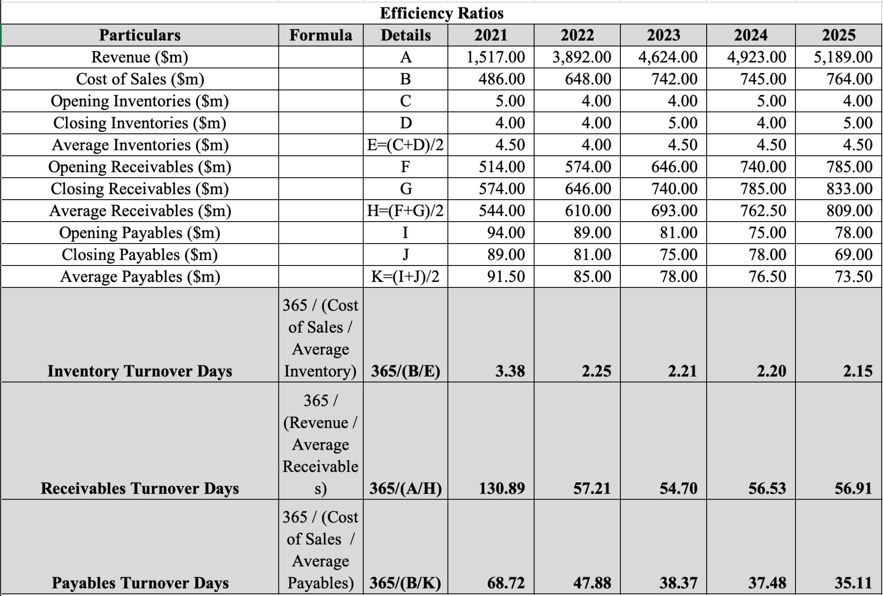
Table IV: Calculation of Efficiency Ratio
InterContinental Hotel Group is maintaining strong efficiency in the operation throughout the 5 years, as the inventory turnover declined from 3.38 days to 2.15 days in 2025. It reflects the efficient management of the inventory in the hotel and the limited requirements of an asset-light business model. The receivable turnover days also improved from 130.89 days to approximately 57 days, as it indicates the fast collection of the franchise and management fees along with strong credit control after the recovery of international travel. Payable turnover decreased from 68.72 days in 2021 to 35.11 days in 2025, which indicates that IHG settled their obligations to suppliers more quickly. This strategy consumes working capital but improves the relationship with the suppliers and operational reliability. The combined effect eventually reduced the cash conversion cycle from 66 days to 24 days, which highlights the significant improvement in the efficiency of the working capital. It aligns with the continuous expansion of IHG through their franchise and management contracts that require low inventory levels and improvement in operational efficiency.

1.3.4 Liquidity Ratios
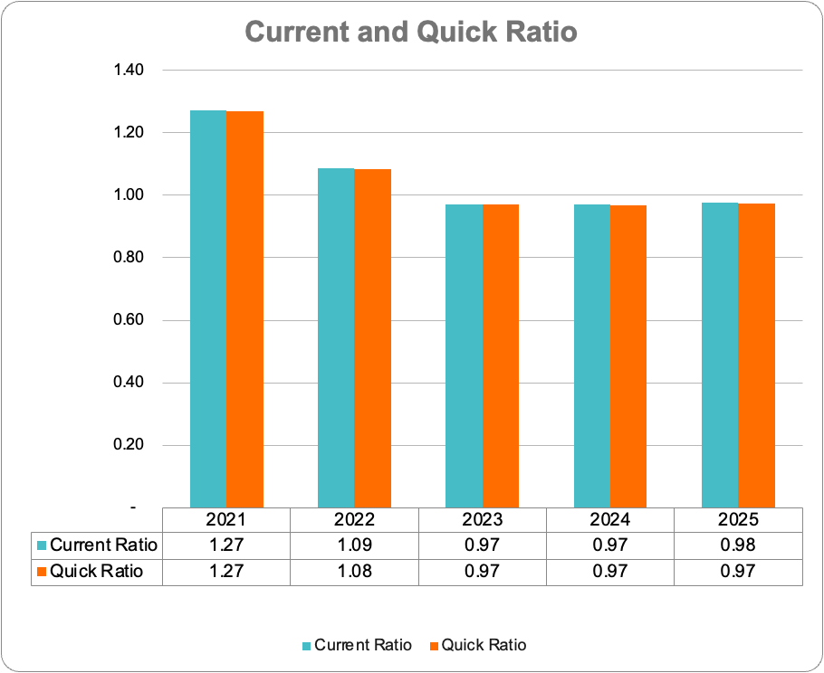
Figure 05: Current and Quick Ratio
Source: (Ms-Excel)
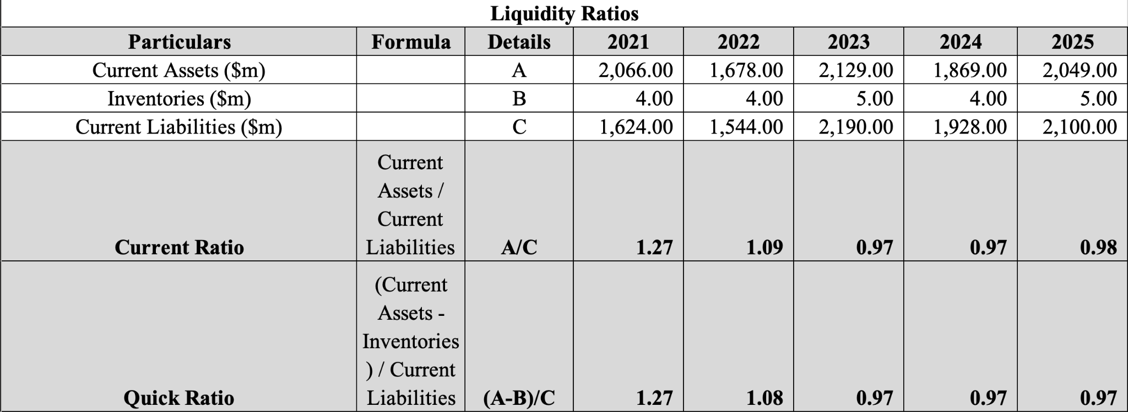
Table V: Calculation of Liquidity Ratio
The current ratio of IHG declined from 1.27 to 0.98 in 2025, as the quick ratio also fell from 1.27 to 0.97. Ratios below 1.0 indicate that current liabilities marginally exceeded current assets, largely because of higher trade and other payables associated with business growth. The risk of liquidity could be manageable for IHG because they are consistently generating positive operating cash flow and getting the benefit from the asset-light business model. The hospitality sector commonly operates with a low liquidity ratio due to the continuous inflow of cash from customers, as it reduces the dependency on maintaining a high current assets balance.

1.3.5 Financial Structure (Gearing) Ratio
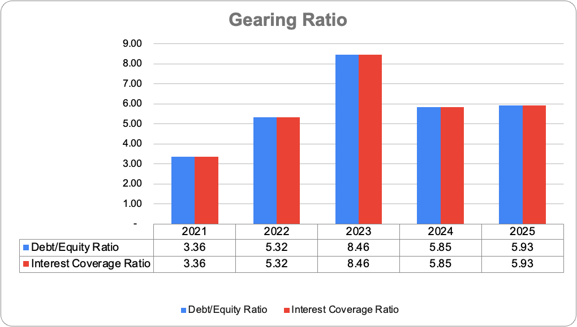
Figure 06: Debt/Equity and Interest Coverage Ratio
Source: (Ms-Excel)
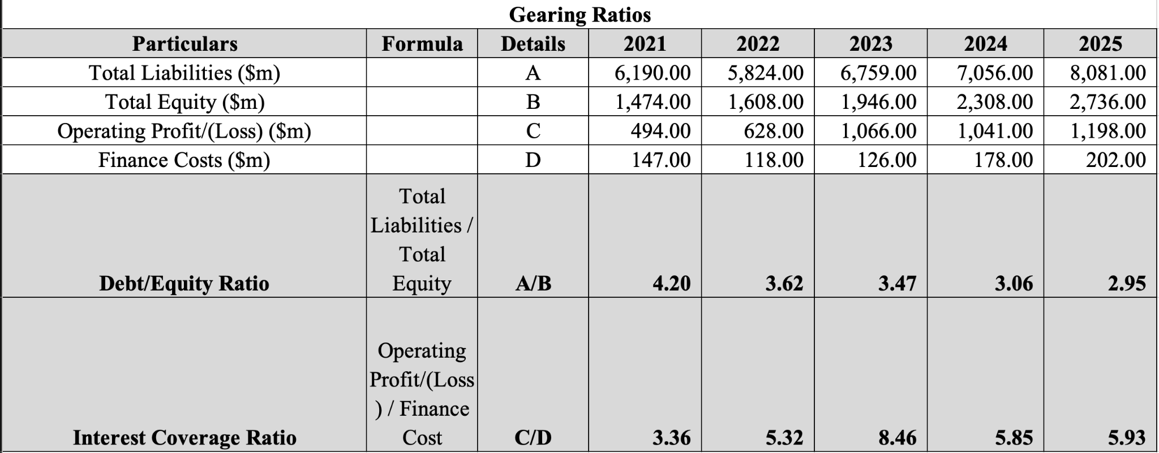
Table VI: Calculation of Gearing Ratio
Debt-to-equity ratio also decreased from 4.2 to 2.95 in 2025, which reflects the strong growth of equity and gradual reduction in financial leverage. Increasing the return earned in the business improved the profit and contributed to the favourable debt-to-equity performance even after continuous investment in business expansion (Mareta et al., 2022). The interest coverage ratio also improved from 3.36 times in 2021 to 5.93 times in 2025, and it also went peak to 8.46 times in 2023. High global interest rates increased the finance cost after 2023, as the operating profit was sufficient for meeting the interest obligations. It also indicates that the low financial risk and strong following capacity improve the financial flexibility of IHG for future investment in strategic expansion.

1.3.6 Cash Flow Ratios
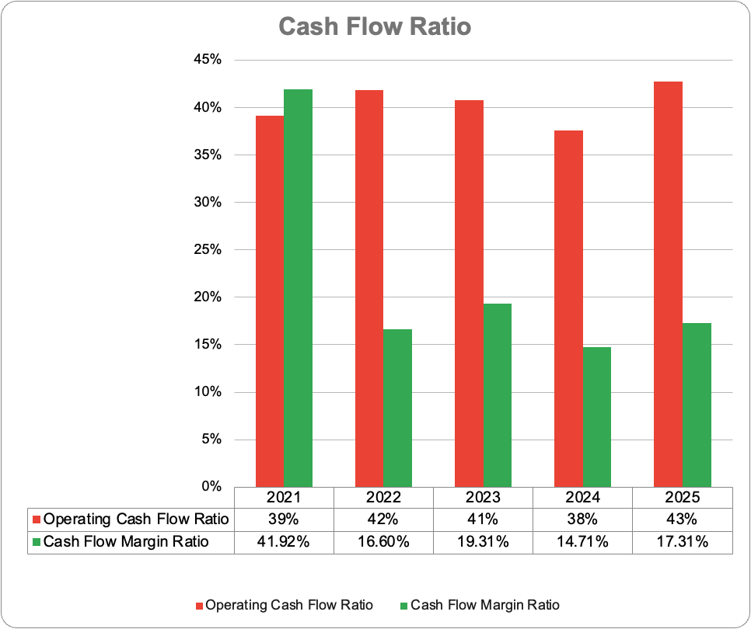
Figure 07: Operating Cash Flow and Cash Flow Margin Ratio
Source: (Ms-Excel)
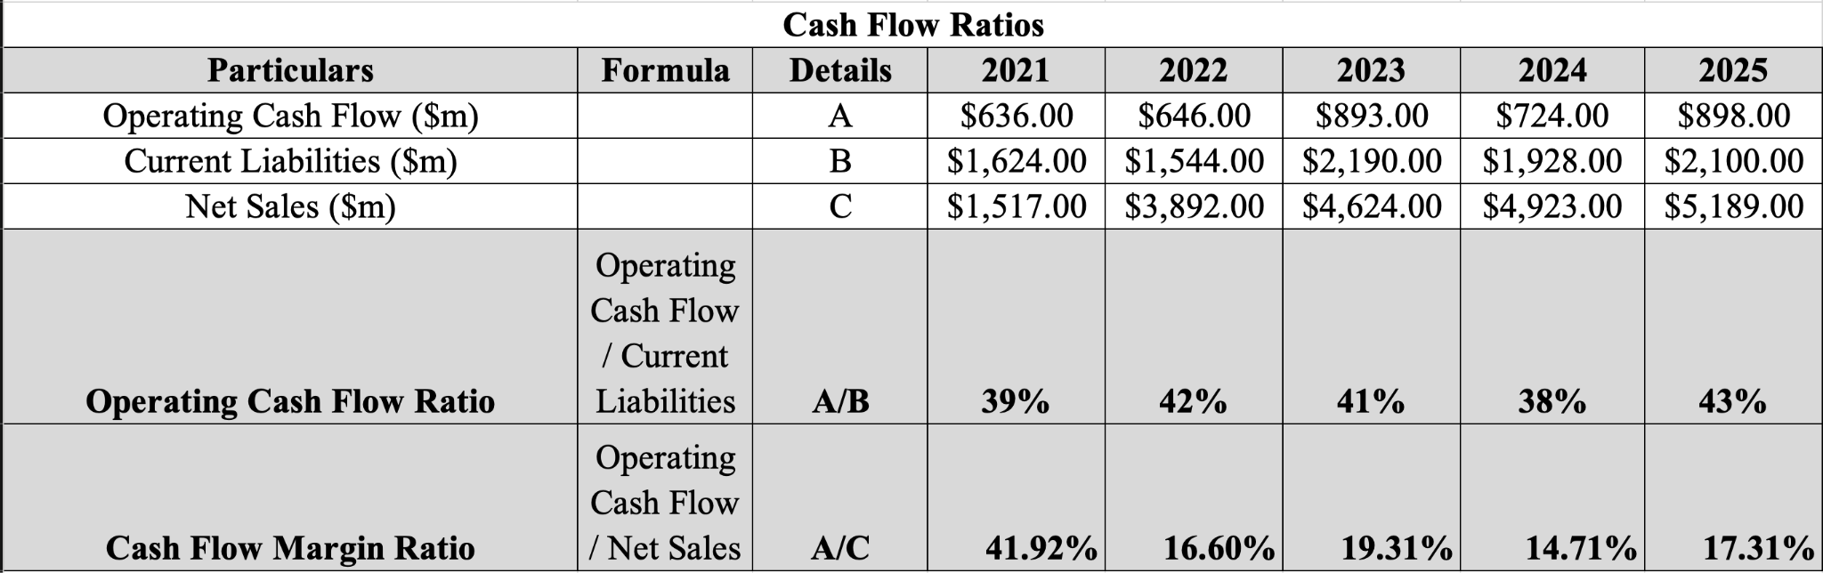
Table VII: Calculation of Cash Flow Ratio
Operating cash flow fluctuated between 38% and 43%, and it also reached 43% in 2025. It highlights that there are improvements in the ability for meeting short term applications with the use of the generated cash from operations. The cash flow margin ratio also declined from 41.92% to 17.31% because the revenue of the company increased faster than the operating cash flow. Continuous positive operating cash flow in the business confirms that IHG is generating internal funds for supporting operations, capital investment and shareholder returns.

1.4 Overall Financial Performance Evaluation
IHG has demonstrated strong financial recovery and sustainable growth between 2021 and 2025. The revenue growth, improvement in gross margin, high ROCE and strong coverage of interest indicate that there are improvements in operational performance and effective utilisation of capital. The liquidity ratio declined and profit fluctuated because of inflation and high finance costs, as the company was maintaining effective operating cash flow and reducing financial leverage. It also reflected the resilience of the asset-light business strategy of IHG and the ability to create shareholder value even after the challenging economic conditions.

1.5 Overall Ratio Summary
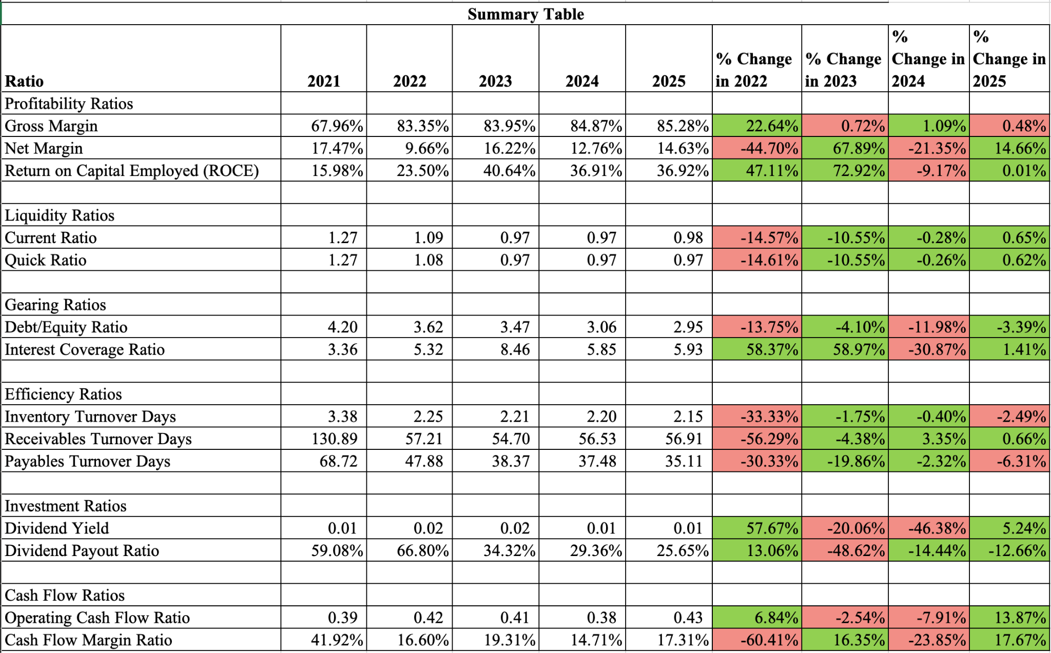
Table VIII: Summary of Ratios
Profitability, efficiency, and gearing ratios were improved during the period, with the below level of the liquidity ratio. Strong operating cash flow and decline leverages was compensated for the weak short-term liquidity, which indicates that the companies are maintaining a stable financial position with favourable long-term growth prospects in the market.

2. Working Capital Management Analysis

2.1 Introduction
Working capital means the management of the current assets and current liabilities to ensure the business maintains sufficient liquidity for meeting short-term obligations with its operations (Alade, 2024). Effective management of working capital is important in the hospitality sector because the hotel is facing seasonal fluctuations in demand, continuous operating expenses and substantial cash flow influences. Efficient management of receivables, payables, and inventory for IHG is necessary due to its global operations and asset-light business model.

2.2 Cash Operating Cycle
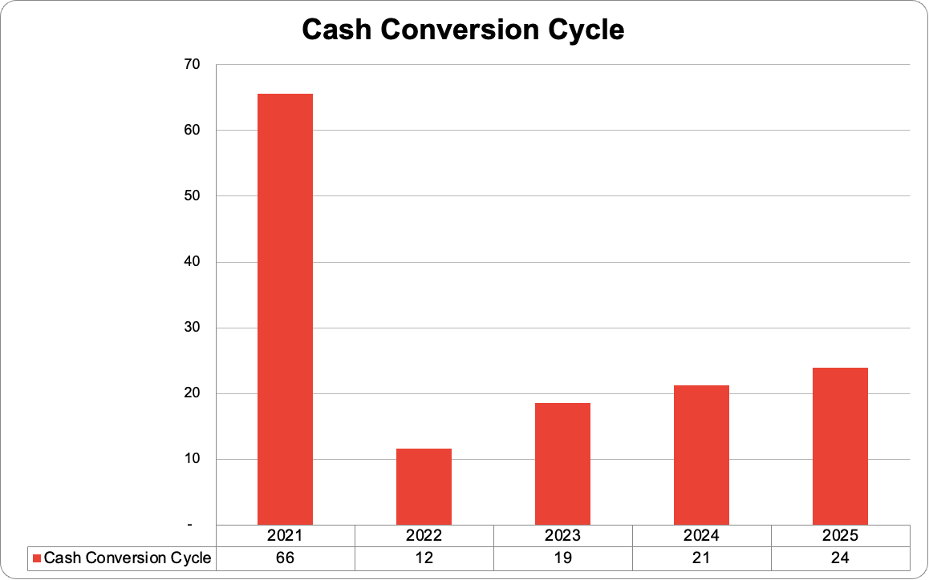
Figure 08: Cash Conversion Cycle
Source: (Self-designed)
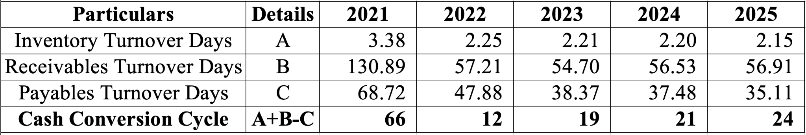
Table IX: Cash Conversion Cycle
The cash operating cycle means the number of days required for converting the inventory purchase into the receipts of cash (Asman et al., 2022). It is calculated by adding the inventory turnover days and the receivable collection days before deducting the payables turnover days.
The cash conversion cycle of IHG declined from 66 to 12 before increasing moderately to 19 days in 2023 and then 24 days in 2025. The improvement between 2021 and 2022 was primarily due to the reduction in the receivable turnover, which decreased from 130 days to 57 days as indicated by the first collection of the franchise and management fees. The inventory turnover also improved from 3.38 to 2.15, which reflected the efficient management of the inventory and limited requirements associated with the franchise-based business model of IHG.
The payable turnover declined from 68 days to 35 days, which indicates that suppliers were paid quickly, as it reduced the benefit of the trade credit and increased the cash conversion cycle after 2022. The cycle was considerably shortened in 2021, which demonstrates the improvement in operational efficiency. The continuous expansion of the management and franchise agreement reduced the complexity in the operation and accelerated the collection of cash. There is the storm of demand for international tourism in the market, which allows the hotel operator to generate stable operating cash even after persistent inflationary pressures.

2.3 Working Capital Problems
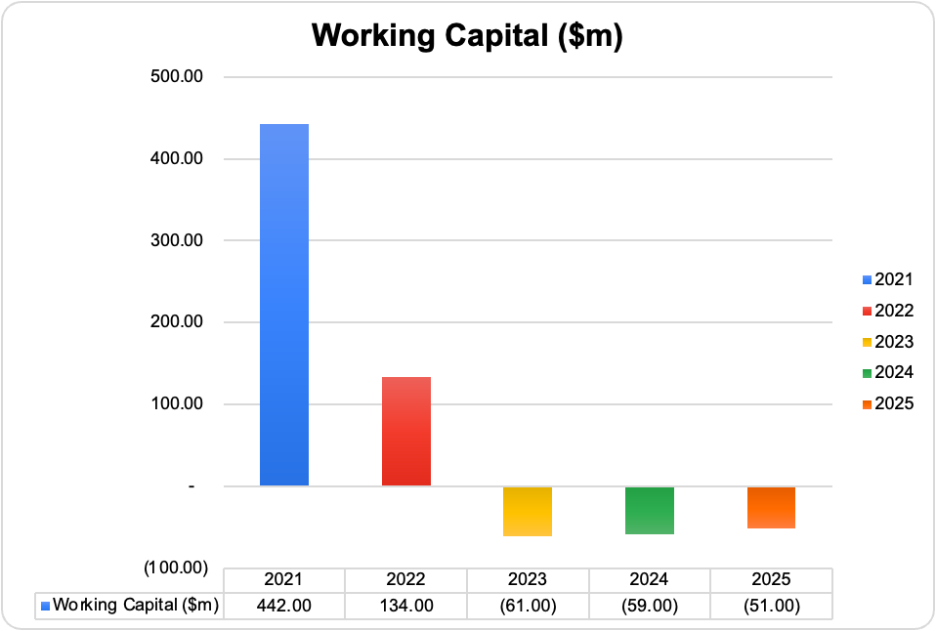
Figure 09: Working Capital
Source: (Self-designed)
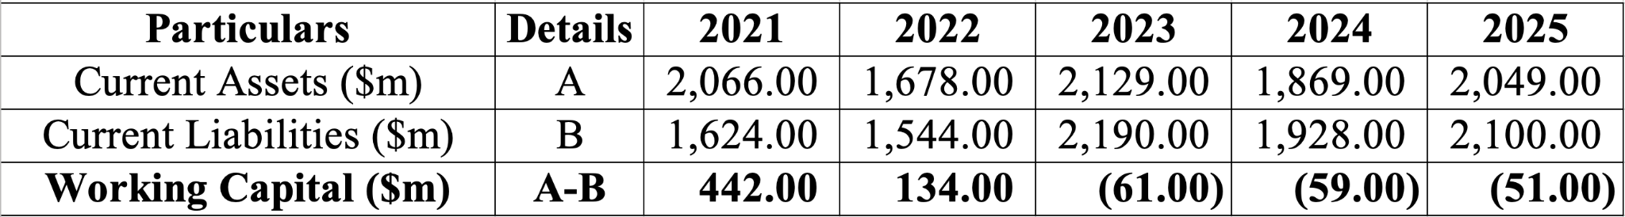
Table X: Working Capital
The working capital of IHG declined from being positive at $ 442 million in 2021 to $134 million in 2022, before becoming negative at $61 million in 2023, $59 million in 2024 and $51 million in 2025. It occurred because the current liabilities were increasing faster than their current assets as the company was expanding its operation and increased the obligations in the short term.
The current ratio also decreased from 1.27 in 2021 to 0.98 in 2025, while the quick ratio also declined from 1.27 to 0.97. The ratio was less than the benchmark of one, which indicates that the current assets were marginally insufficient for covering the short-term liabilities. It could increase the need to refinance this during the period of economic uncertainty, as it should be interpreted in the context of the asset-light business model of IHG. The franchise operators required slow inventory and generated a regular inflow of cash in the context of the hotel industry through the management and franchise fees (Xiao, 2025).
The fast supplier payments improved the commercial relationship but reduced the available trade credit and placed pressure on short-term liquidity. Rising global interest rates and inflation increase the finance cost across the hospitality industry, which requires the company to maintain a strong reserve of cash (Koduru, 2026). IHG is continuously generating positive operating cash flow, and careful monitoring of the working capital was necessary for preserving financial flexibility.

2.4 Strategies to Improve Liquidity
IHG has to continue improving receivable management by expanding the automated billing system, digital payment platforms and real-time monitoring of franchise fee collections. It is demonstrated that fast collection would be considerable for reducing the receivable days and improving the availability of cash.
Management has to focus on the optimisation of the supplier management policies by negotiating long credit periods where they are commercially feasible without damaging the supplier relationship (O’Brien, 2022). This strategy allows for the improvement in the cash conversion cycle along with maintaining the stability in the operation.
Improvement in the forecasting of cash supported by advanced data analytics, as it will allow for the management of the anticipation of the seasonal fluctuations in the demand of the hotel and the allocation of cash effectively across international operations. IHG has already invested in digital transformation and uses predictive financial analytics for improving liquidity planning.

2.5 Financing Options
Short-term sources of finance included revolving credit facilities, bank overdrafts, and trade credit for providing flexible funding for seasonal fluctuations (Junli, 2025). Major dependency on short-term borrowing can expose the refinancing risk of the company as interest rates rise. Long-term finance through retained earnings, corporate bonds and long-term bank loans can offer great financial stability and support strategic investment. The increasing profits and lower debt-to-equity ratio of IHG support selecting the retained earnings combination with selective long-term borrowing as the most appropriate financing strategy.

3. Strategic Financial Restructuring Plan

3.1 Need for Financial Restructuring
InterContinental Hotels Group is expected to have a strong financial recovery between 2021 and 2025, as the financial analysis indicates that there is a need for strategic restructure for sustaining the long term growth. The revenue was increased to $5,189 million, with an increase in operating profit, but liquidity was weak, with a declining current ratio. It suggests that the improvement in profit was not sufficient, as there is a need for short-term financial flexibility for further improvement.
External economic conditions justify the financial restructuring, with high global interest rates increasing borrowing costs across the hospitality industry. Global inflation was moderate, as the finance cost was at the pre-pandemic level, which increases the financial pressure on the multinational companies (Vieira and da Silva, 2024). Geopolitical tensions and volatility in the exchange rate are also influencing international demand for tourism. IHG has to focus on improving liquidity, reducing financial risk and improving capital efficiency, along with maintaining sufficient capacity for future expansion through its global franchise and management network.

3.2 Financial Restructuring Options
Expansion of its asset-light business model: IHG generates the majority of their revenue through franchise and management agreements, which reduce capital expenditure along with focusing on the high-margin fee income. The improvement in the gross margin from 67% to 85% demonstrates the effectiveness of the approach and supports future expansion in the high-growth international market.
Gradual debt refinancing: The debt-to-equity ratio declined from 4.2 to 2.95, where refinancing existing debt in the long-term facilities can reduce refinance risk. It can improve financial stability, particularly if the interest rate declines over the medium term.
Financing expansion through retained earnings: The dividend payout ratio decreased from 59% to 26%, which indicates that the management is committed to reinvesting the profit in technology, development of the hotel and strategic growth. The policy was also considered for improving the financial flexibility along with reducing the dependency on external finance.

3.3 Impact on Shareholder Value, Debt Structure and Operational Flexibility
Continuous expansion of the asset-light business model is expected to improve profits because the franchise and management contracts require low capital investment along with the generation of stable fee income. High profits are considerable for supporting the future growth of earnings and improving the value of the shares through the sustained appreciation of the share price.
Reinvestment in the retained earnings in place of increasing dividend payment is also supporting the long-term creation of value (Anuforo et al., 2026). The dividend payout ratio declined during the analysis period as the retained earnings provided an internal source of finance for the expansion without increasing the borrowing cost. The approaches are considerable for improving the financial sustainability along with preserving the wealth of the shareholders over time.
Debt refinance and reduction in the leverage would also allow for the improvement in the balance sheet of the company from the perspective of finance (Elkamhi et al., 2025). The declining debt-to-equity ratio and the interest coverage ratio of 5.93 times indicate that the companies already have the sufficient capacity for meeting its financial obligations.
Operational flexibility would also improve with the increasing investment in technology and digital infrastructure. Improvements in the data analytics and management system for revenue and customer loyalty programs can allow for a fast response to changes in demand in the market. It would allow IHG to expand the service in the international market along with maintaining efficient operations and controlling costs during the period of economic uncertainty.

3.4 International Considerations
IHG has to consider international financial risk when implementing the restructuring strategies because they have operations in more than 100 countries. Fluctuations in interest rates can directly influence the reported revenue and profit because the earnings are generated in multiple currencies (Ogunbiyi-Badru et al., 2024). Conflicts in the geopolitical scenario, inflation and changing regulations of travel can also affect occupancy and decisions for investment. Maintaining diversification in the market, applying appropriate foreign exchange risk management and allocating the investment across multiple international market communities reduces dependency on individual economies.

3.5 Ethical and ESG Considerations
IHG is already committed to reducing carbon emissions, improving energy efficiency and supporting responsible tourism through its sustainability programs. Maintaining transparent governance, ethical financial reporting and responsible allocation of capital can improve confidence among stakeholders. Integration of the environmental, social and governance objectives in the financial restructure can be considerable for improving the long-term competitiveness of the. Increasing investment in efficient hotels, renewable energy initiatives, and sustainable supply chains can reduce the cost of operations along with supporting the commitment to the environment. Enhanced ESG reporting can also ensure transparency, confidence among stakeholders, and attract responsible investment tools. The initiative would support regulatory compliance and reinforce the reputation of IHG as the sustainable global hospitality company.

4. Investment Appraisal and Capital Budgeting

4.1 Project Information
Investment appraisal allows the organisation for the evaluation of the financial viability of the proposed project and alignment with the strategy (Daming and Widyawati, 2024). It is necessary for IHG to allocate capital effectively because of the long-term strategy of focusing on the expansion of the global hotel portfolio, improvement in the digital capability and maximisation of the value for the shareholders. Each of the projects requires an initial investment of £50 million have been evaluated using a discount rate of 8%, representing the company's required rate of return. The cash flow of the project occurs over the five years with no residual value at the end of the life. Payback Period, Accounting Rate of Return (ARR), Net Present Value (NPV) and Internal Rate of Return (IRR) are applied to demonstrate the most attractive investment.

4.2 Payback Period
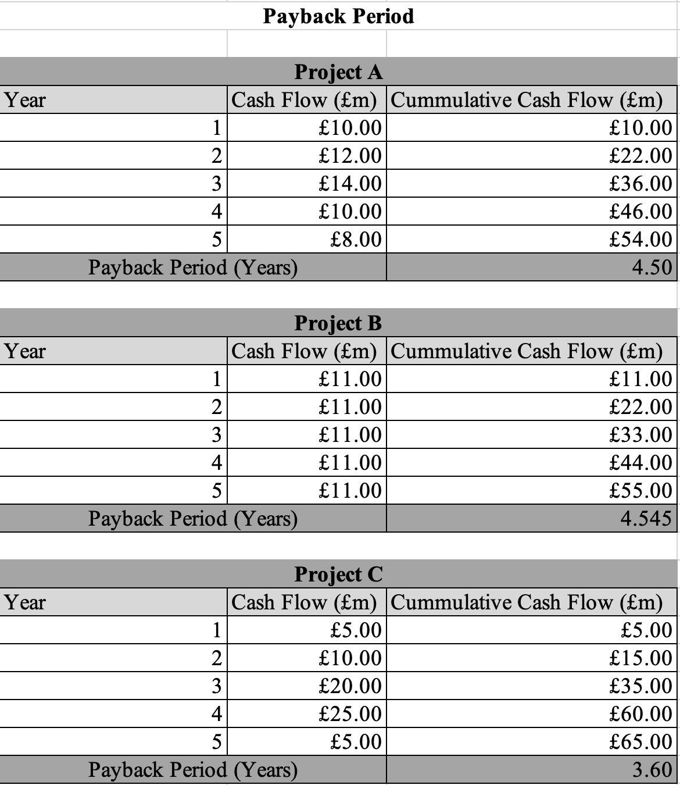
Table XI: Calculation of Payback Period
Payback period analysis demonstrates that the time required for recovering the initial investment from future cash flow makes it a useful indicator for the liquidity and the risk of the investment (Dai et al., 2022). Project C has the shortest payback period of 3.60 years, followed by Project A at 4.50 years and Project B at 4.55 years. Project C recovers the initial investment almost 1 year earlier than the other alternatives because it has the highest cash flow included during Years 3 and 4. The early recovery is considerable for reducing the exposure to uncertainty, inflation and changes in market conditions, which is particularly important in the hospitality sector. The payback period method is simple and focuses on liquidity because it ignores the inflow of cash after the payback period and does not consider the time value of money. Project C performs the best using this technique, as the result has to be interpreted along with the discounted appraisal method before making the final investment decision

4.3 Accounting Rate of Return
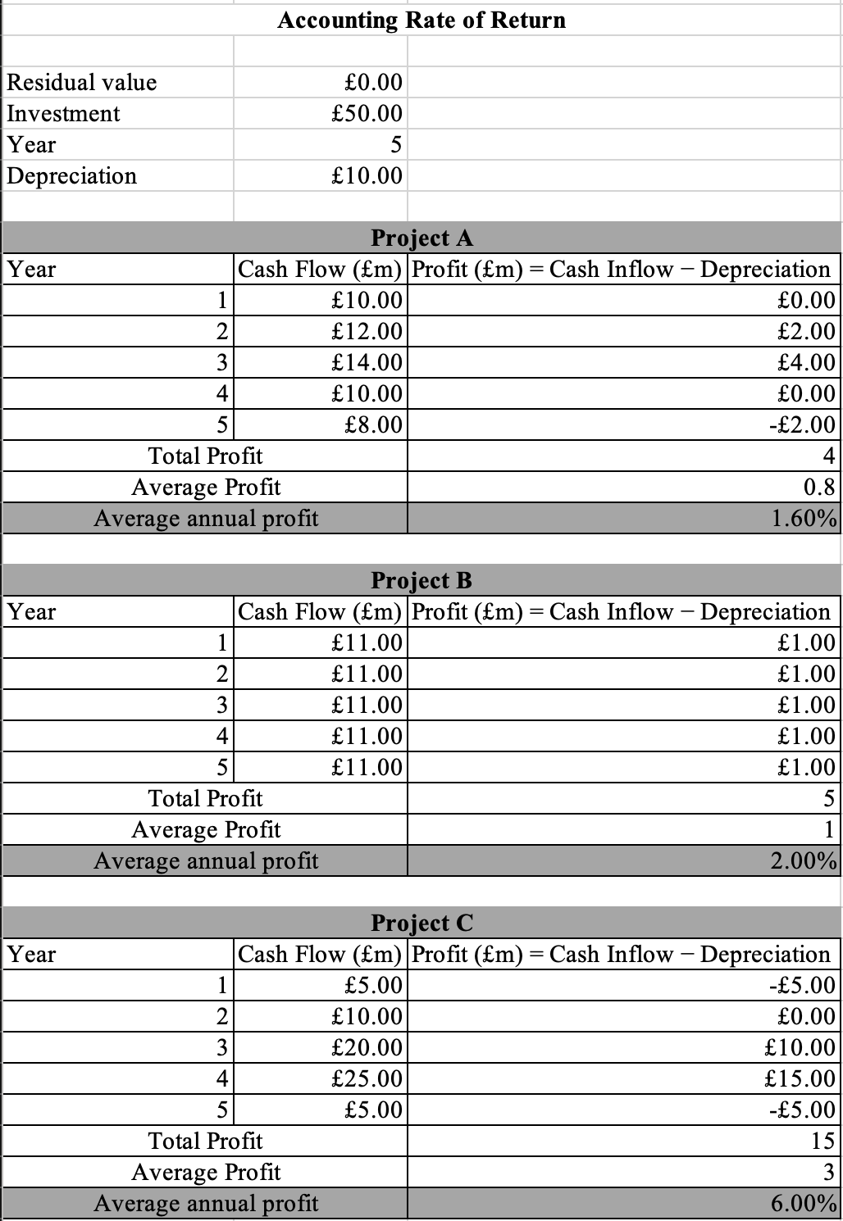
Table XII: Calculation of Accounting Rate of Return
Accounting rate of return evaluates the accounting profit generated related to the initial investment. Project C records the highest accounting rate of return of 6% in comparison to the 2% for Project B and 1.6% for Project A. Project C generates the total accounting profit of 15 million euros in the 5 years that exceeds the profit generated by the other project. Superior profit and strong utilisation of the invested capital are demonstrated in Project C. Project A recorded a profit of only 4 million euros compared to 5 million euros for Project B, and both are less attractive from an accounting perspective. The accounting rate of return is limited because it is based on the accounting profit in place of the cash flow and ignores the timing of the returns. Project C is outperforming the alternative options, but it should not be isolated and considered together with the discounted cash inflow techniques.

4.4 Net Present Value
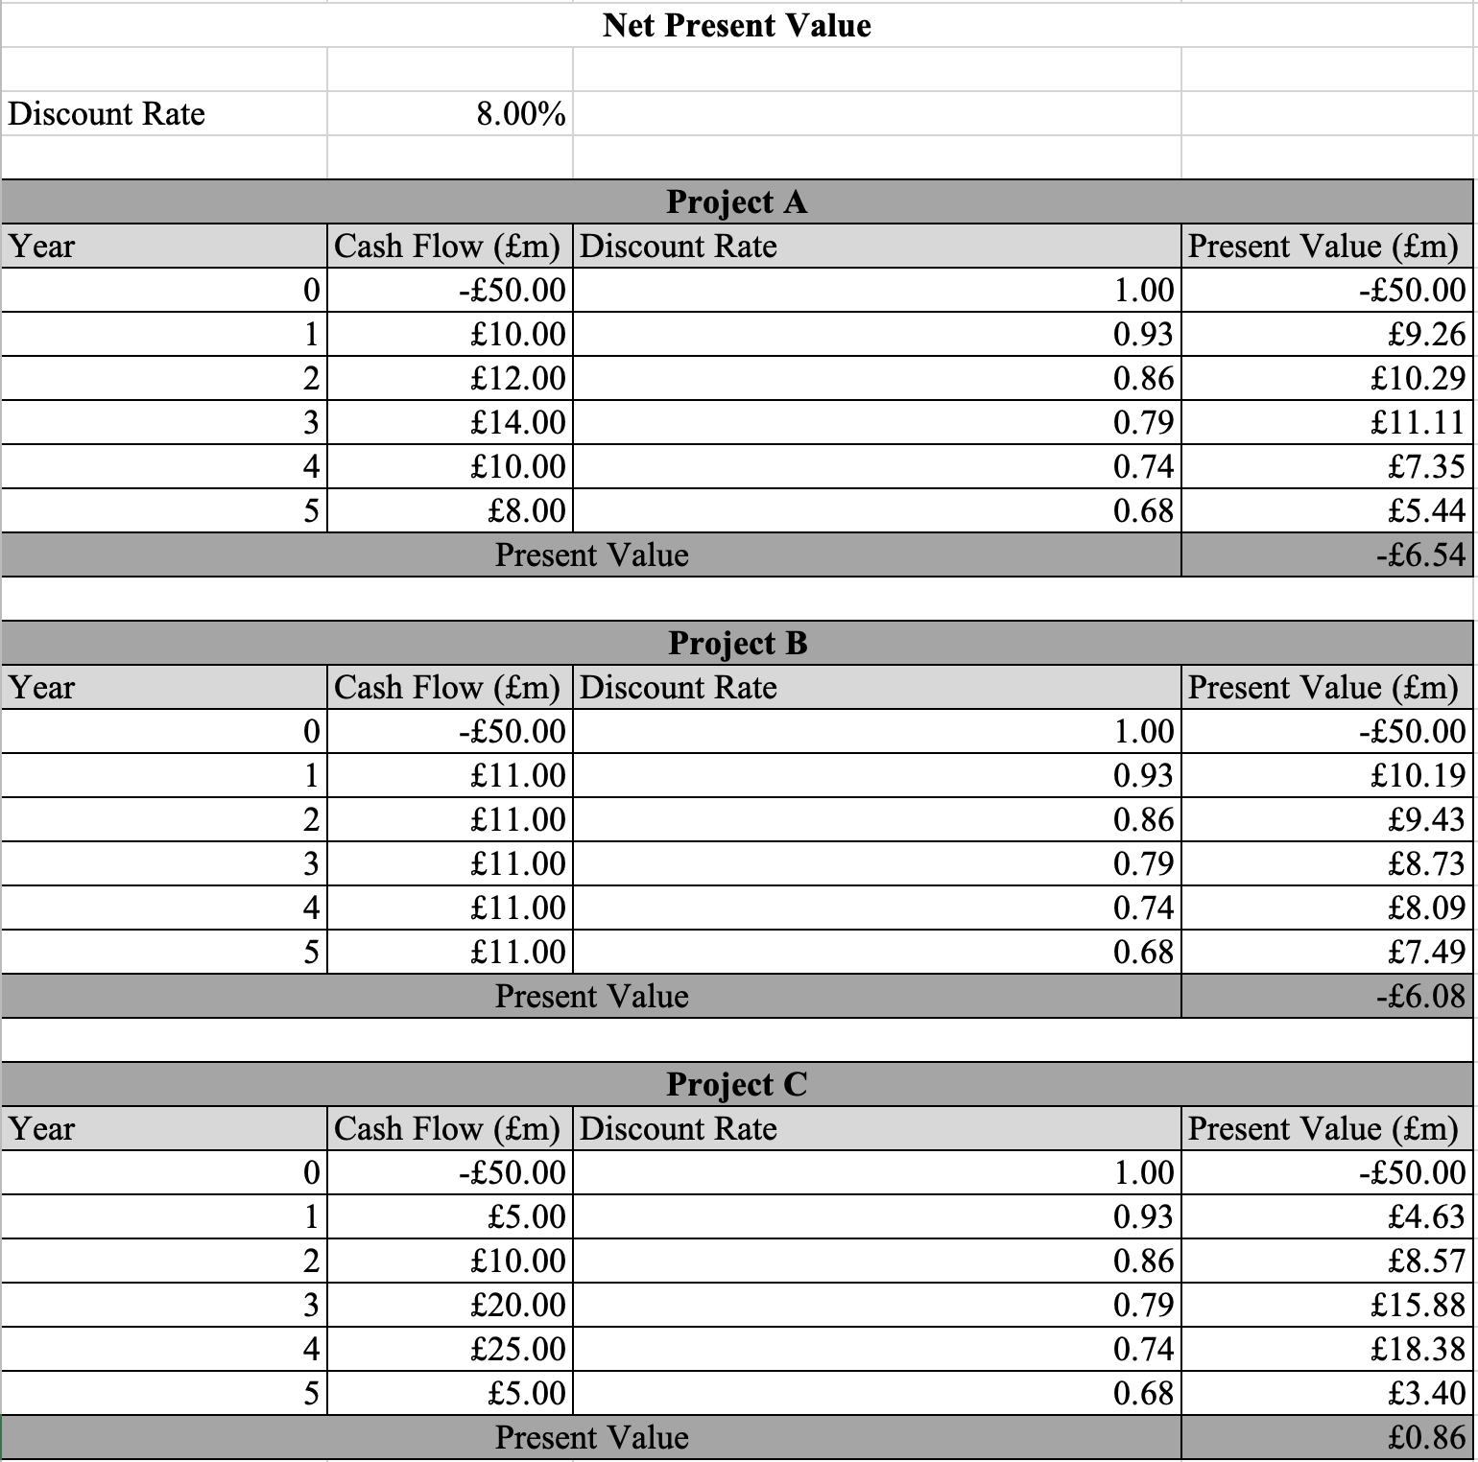
Table XIII: Calculation of Net Present Value
Net present value is the most considerable investment appraisal technique because it includes the time value of money and directly measures the value created for the shareholders (Cotter, 2023). Project C produces a positive NPV of £0.86 million, whereas Project A and Project B generate negative NPVs of £6.54 million and £6.08 million, respectively. The positive net present value in Project C is expected to generate returns exceeding the required rate of return for IHG, and it increases shareholder wealth. Negative net present value for Projects A and B demonstrates that the discounted future inflows of cash are not sufficient for recovering the initial investment, which resulted in the destruction of value. The positive result for Project C is attributed to the large inflow of cash during years 3 and 4 that offset the initial investment even after discounting. Capital budgeting focuses on the maximisation of the value for the shareholders, as the net present value provides the strongest evidence. Project C is most considerable from the perspective of the economy among all investments, and it should be focused on the subsequent valuation.

4.5 Profitability Index
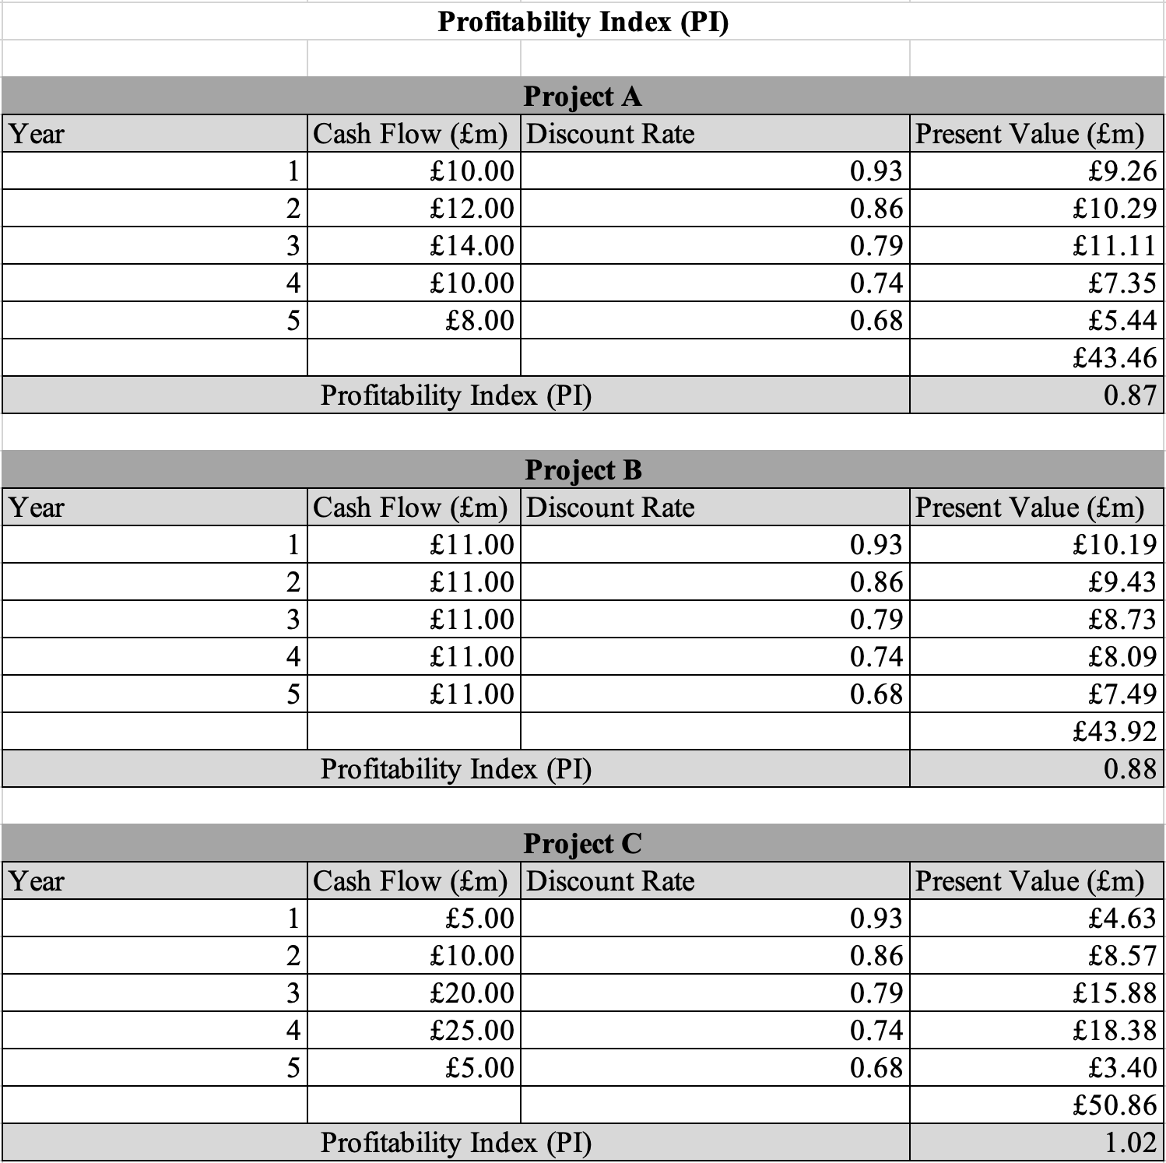
Table XIV: Profitability Index
Profitability Index measures the present value of future cash inflows that are generated, performed and assisted for the ranking of the comparative investment project (Zatrochova and Katrencik, 2023). A profitability index more than 1 demonstrates that the project can create value, but less than 1 suggests that it should be rejected. Project C achieved the highest PI of 1.02, while Project A and Project B recorded 0.87 and 0.88, respectively. The positive profit index for Project C demonstrates that the discounted future inflow of cash exceeds the initial investment, confirming that the project can create value for the shareholder.

4.6 Internal Rate of Return
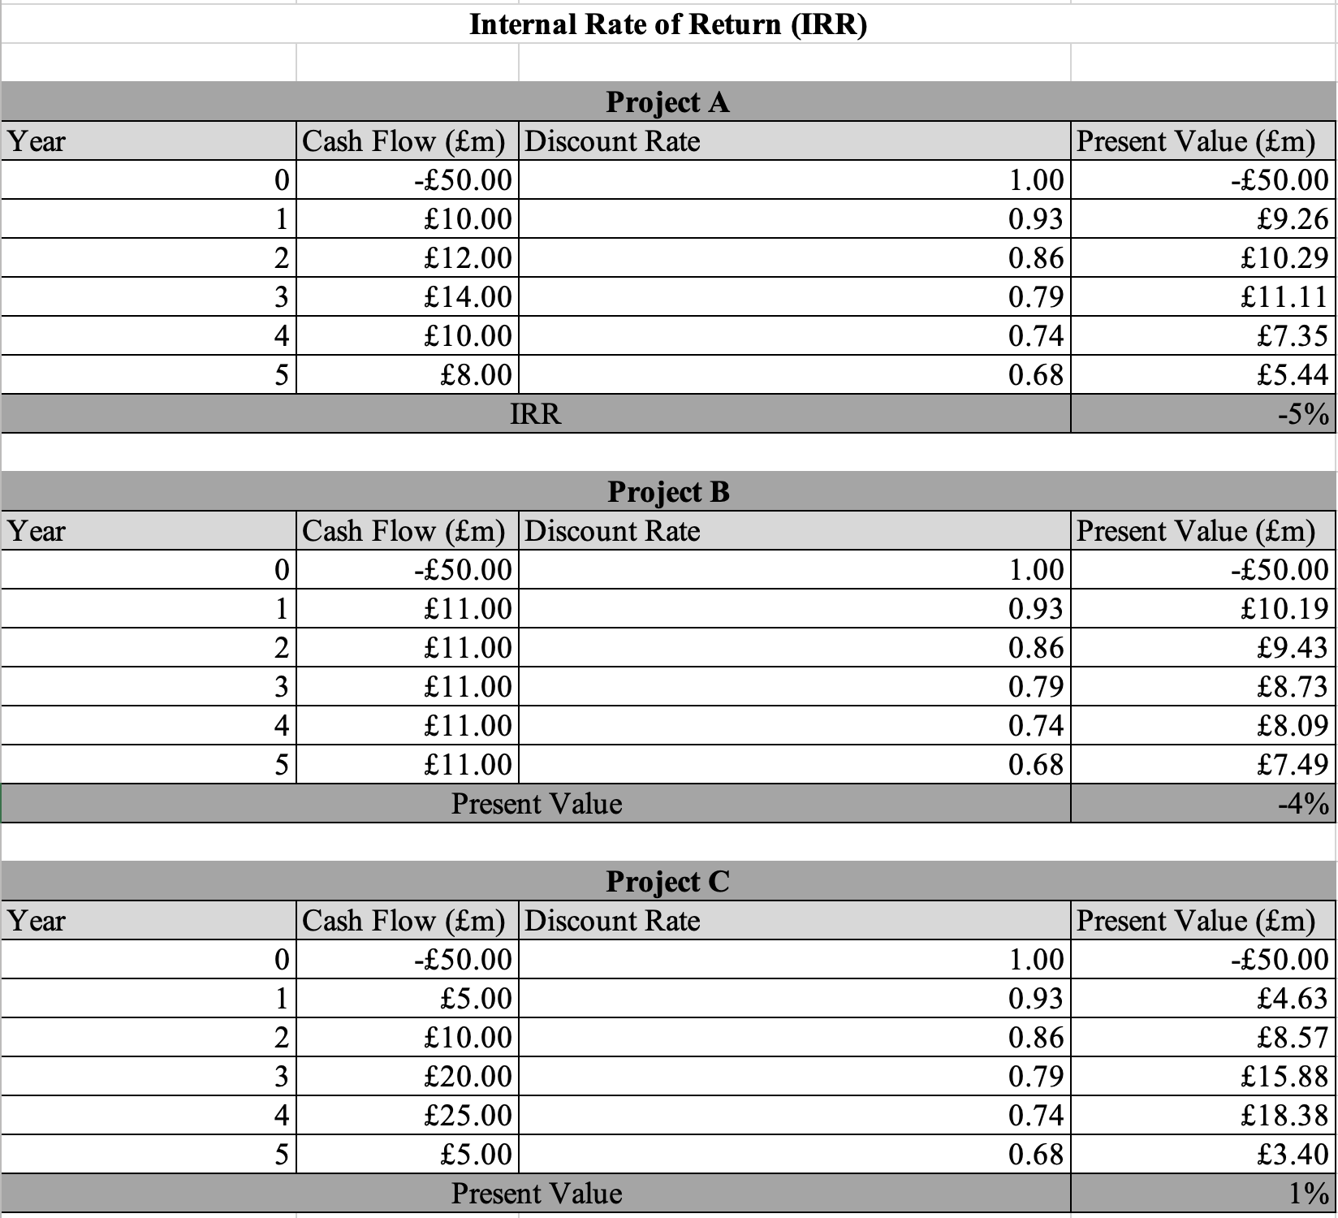
Table XV: Internal Rate of Return
Internal rate of return identifies the discount rate at which the net present value of the project is equal to zero and is commonly compared with the required rate of return of the company (Arjunan, 2022). The calculation highlights that Project C is achieving the IRR of approximately one percent with -5% and -4% for Project A and Project B, respectively. None of the projects is receiving the required rate of return of 8%, but Project C is suitable and better than other alternative options because of its positive value. Negative internal rate of return of Projects A and B demonstrates that the insufficient return for recovering the initial investment makes them financially unacceptable.

4.7 Comparative Evaluation
Each of the investment appraisal techniques provides a different understanding about the performance of the project, but the decision must be based on the combination of the method in place of the single criterion. Project C is consistently performing better across all the appraisal techniques as it has achieved the shortest payback period (3.60 years), the highest ARR (6%), the only positive NPV (£0.86 million) and the highest PI (1.02). Projects A and B are also similar but fail to satisfy the primary financial criteria. Both of the projects are generating a negative net present value and a profit index less than 1, which indicates that the future discounted inflow of the gas cannot recover the initial investment. Project C would provide the early recovery of the cash, improve liquidity and reduce the exposure to market uncertainty. Net present value is generally considered the most reliable appraisal technique because it directly measures the wealth of the shareholder, as it represents Project C as the strongest investment opportunity among the alternatives. Project C also has great strategic alignment with the long-term expansion objective of IHG apart from the quantitative result. Strong inflow of cash in the middle of the years improves the financial flexibility and reduces the risk of the investment during the period of economic uncertainty. IRR is less than the required return, as the positive NPV indicates that it can be expected to generate incremental value for the shareholders, which makes it balance investment decision than the competing alternatives.

4.8 Recommended Project
Project C should be selected for implementation because it is the only project which satisfies the most important value of the investment criteria by generating a positive net present value and PI more than 1. The calculated internal rate of return is below the required rate of return, but Project C still outperforms the alternative investment and demonstrates the potential for the creation of long-term value for the shareholders. In the context of IHG, the selection of a project which can generate sustainable cash flow and maximise efficiency can support the strategic objective by expanding the global hotel portfolio along with maintaining disciplined financial management.

4.9 Capital Rationing
Capital rationing occurs when the funds for the investment are limited, and management has to allocate the resources for the project which can maximise the value for the shareholder (Jain, 2024). IHG can finance only a £50 million investment, as Project C has to be focused because it is the only project with a positive NPV and a PI greater than one. Investment in Projects A and B would reduce the value for the shareholders because it has a negative net present value. Under the capital constraints, selection of project C would ensure that the available financial resources are allocated for the investment to offer the highest economic return and the contribution to the long-term financial performance.

5. Critical Reflection on AI Usage

5.1 Tool Disclosure
There was no inclusion of artificial intelligence in the preparation of the report as the research, calculation, ratio analysis, investment appraisal, interpretation and report writing were completed independently by the author. The financial data was collected from the published annual report of InterContinental Hotel Group, along with supporting literature from academic journals, textbooks and professional reports. Microsoft Excel was primarily used for the performance of the financial calculations, preparation of the ratio analysis and generation of the charts.

5.2 Verification of AI Outputs
There was no AI-generated content used during the preparation of the report; verification of the output was not applicable. All of the calculations were independently checked with the use of Microsoft Excel, while the financial information and company performance were verified against the annual report of IHG.

5.3 Identification of Hallucinations
There was no use of the AI tools for the generation of the content and analysis of the financial information, as no AI-generated inaccuracies or hallucinations were identified during the completion of this assignment.

5.4 AI Contribution vs Personal Analysis
The report was completed through independent research and personal analysis. The financial statements were collected from the annual report of IHG, with all trend analysis, financial ratios, calculations of the working capital and investment appraisal techniques. Interpretation of the results, evaluation of the financial performance and recommendations were developed based on the author's understanding of financial management principles and supported by the academic literature. Some of the relevant textbooks, peer-reviewed journal articles and professional publications also concurred to support the critical discussion and justification of the conclusion. Independent research was considerable for improving the analytical, problem-solving, and financial evaluation skills along with ensuring a comprehensive understanding of the concepts throughout the project. Completion of the report also improved the ability to interpret the financial data independently and make evidence-based recommendations. Application of the financial management theory in the real business context can improve analytical reasoning, improves the decision making skills and confidence for the evaluation of investment opportunities.

5.5 Ethical and Professional Reflection
Completion of the assignments without the AI assistant demonstrates the importance of independent learning, critical thinking and professional judgement (Estaphan et al., 2025). Analysing the financial statement, performing the investment calculations and evaluating the Working Capital Management required interpretation of the financial information in application of theoretical knowledge. Conducting independent research improves confidence in the use of Microsoft Excel for financial Modelling and improves the ability to evaluate corporate financial performance objectives. The process also highlights the importance of academic integrity and ethical responsibility. All of the information in this study used in the report was collected from legitimate sources, including the annual report of IHG, academic textbooks, and professional publications; appropriate acknowledgement is provided through the Harvard reference. Ensuring transparency in the use of the evidence and presentation of the original analysis demonstrates ethical standards expected in higher education and professional financial practice (Winkelmes et al., 2023). The knowledge and analytical skills in this report were developed through the completion of the assignment independently, which will also contribute to future academic support and informed financial decision-making in the professional environment. Completion of the report also improves professional competence, including financial analysis, critical evaluation, interpretation of the data and report writing skills. Extraction of the financial data from the annual report and preparation of the ratio and investment appraisal models in Microsoft Excel improve the technical and analytical capabilities. The assignment also improves the ability to apply financial management theories to real-world multinational organisations and the development of evidence-based recommendations.

References
Alade, T.A., (2024). Poor working capital management remain major cause of business failure. International Journal of Research and Innovation in Social Science, 8(1), pp.1120-1124. Available at: https://www.researchgate.net/profile/Tesleem-Adelodun-2/publication/378004593_Poor_Working_Capital_Management_Remain_Major_Cause_of_Business_Failure/links/65c25b4034bbff5ba7f09123/Poor-Working-Capital-Management-Remain-Major-Cause-of-Business-Failure.pdf
Anuforo, P.U., Umar, A.A., Mathias, J. and Kaka, B.B., (2026). Does Dividend Payout and Retained Earnings Influence Firm Value? An Integrated Review. UMYU Journal of Business Administration and Management, 2(1), pp.212-240. Available at: https://publications.umyu.edu.ng/jbam/index.php/ujbam/article/view/43
Arjunan, K., (2022). A new method to estimate NPV and IRR from the capital amortization schedule and the advantages of the new method. Australasian Accounting, Business and Finance Journal, 16(6). Available at: https://www.uowoajournals.org/aabfj/article/id/941/
Asman, F.N., Fernandez, D., Jamaludin, N.A., Omar Zaki, H. and Ghazali, A.W., (2022). Cash conversion cycle and firm’s performance. International Journal of Academic Research in Business and Social Sciences, 12(11), pp.2682-2692. Available at: https://www.academia.edu/download/106769993/cash-conversion-cycle-and-firms-performance.pdf
Cotter, E., (2023). Net Present Value and Payback Period: An Analysis. Available at: https://scholarworks.wmich.edu/honors_theses/3796/
Dai, H., Li, N., Wang, Y. and Zhao, X., (2022), March. The analysis of three main investment criteria: NPV IRR and payback period. In 2022 7th International Conference on Financial Innovation and Economic Development (ICFIED 2022) (pp. 185-189). Atlantis Press. Available at: https://www.atlantis-press.com/proceedings/icfied-22/125971510
Daming, S. and Widyawati, W., (2024). A Qualitative Investigation into Financial Strategy, Performance, Investment Decision-Making. Economics and Digital Business Review, 5(2), pp.885-882. Available at: http://ojs.stieamkop.ac.id/index.php/ecotal/article/view/1769
Elkamhi, R., Lee, J.S. and Salerno, M., (2025). The Strategic Role of Balance Sheet Management in Asset Management. Journal of Portfolio Management, 51(6). Available at: https://search.ebscohost.com/login.aspx?direct=true&profile=ehost&scope=site&authtype=crawler&jrnl=00954918&AN=184561989&h=83AnGWswihqFKju4pNxksZMajkt0HPXATz3r20D2pwOn9Cxz0pQd%2FocXqgU1%2FqzwAyg7KrU5qX0IS7CUUpEI6g%3D%3D&crl=c
Estaphan, S., Kramer, D. and Witchel, H.J., (2025). Navigating the frontier of AI-assisted student assignments: challenges, skills, and solutions. Advances in Physiology Education, 49(3), pp.633-639. Available at: https://journals.physiology.org/doi/abs/10.1152/advan.00253.2024
IHG, (2022). Annual Report 2021. Available at: https://www.ihgplc.com/~/media/Files/I/Ihg-Plc/investors/shareholder-center/annual-reports-and-responsible-business-reports/annual-reports/2021/ihg-2021-annual-report.pdf
IHG, (2023). Annual Report 2022. Available at: https://www.ihgplc.com/~/media/Files/I/Ihg-Plc/investors/shareholder-center/annual-reports-and-responsible-business-reports/annual-reports/2022/annual-report-2022.pdf
IHG, (2024). Annual Report 2023. Available at: https://www.ihgplc.com/~/media/Files/I/Ihg-Plc/investors/annual-report/2023/annual-report-2023.pdf
IHG, (2025). Annual Report 2024. Available at: https://www.ihgplc.com/~/media/Files/I/Ihg-Plc/investors/annual-report/2024/annual-report-2024-IHG-144ppi.pdf
IHG, (2026). Annual Report 2025. Available at: https://www.ihgplc.com/~/media/Files/I/Ihg-Plc/investors/annual-report/2025/ihg-ar25-interactive.pdf
IHG, (2026). Full Year Results for the year to 31 December 2025. Available at: https://www.ihgplc.com/en/news-and-media/news-releases/2026/full-year-results-for-the-year-to-31-dec-2025
Jain, Y.K., (2024). Financial management and market dynamics. Xoffencerpublication. Available at: https://books.google.com/books?hl=en&lr=&id=XIsrEQAAQBAJ&oi=fnd&pg=PA1&dq=Capital+rationing+occurs+when+the+funds+for+the+investment+are+limited,+and+management+has+to+allocate+the+resources+for+the+project+which+can+maximise+the+value+for+the+shareholder&ots=JYBclWH3zl&sig=uhw1tqlWobDNV11ZbR2hSyqNp4c
Junli, C., (2025). Credit. In Dictionary of Contemporary Chinese Economics (pp. 1623-1626). Singapore: Springer Nature Singapore. Available at: https://link.springer.com/content/pdf/10.1007/978-981-97-4036-9_794.pdf
KODURU, D.R.S., (2026). FINANCIAL MANAGEMENT IN HOTELS AND RESTAURANT INDUSTRY. Vaagai international publishing house. Available at: https://books.google.com/books?hl=en&lr=&id=CeKuEQAAQBAJ&oi=fnd&pg=PA1&dq=Rising+global+interest+rates+and+inflation+increase+the+finance+cost+across+the+hospitality+industry,+which+requires+the+company+to+maintain+a+strong+reserve+of+cash&ots=-290J26RKh&sig=fv2N59WynPtN6XlKEFj-fJXA1Ys
London Stock Exchange, (2025). Half-year Report, INTERCONTINENTAL HOTELS GROUP PLC. Available at: https://www.londonstockexchange.com/news-article/IHG/half-year-report/17172364
Lubis, E., Khaddafi, M. and Satriawan, B., (2024). Dividend policy as a tool to increase firm value. Business and Investment Review, 2(3), pp.20-27. Available at: http://lgdpublishing.org/index.php/birev/article/view/109
Mareta, F., Ulhaq, A., Resfitasari, E., Febriani, I. and Elisah, S., (2022), February. Effect of debt to equity ratio, current ratio, total assets turnover, earning per share, price earning-ratio, sales growth, and net profit margin on return on equity. In International conference on economics, management and accounting (ICEMAC 2021) (pp. 417-426). Atlantis Press. Available at: https://www.atlantis-press.com/proceedings/icemac-21/125970196
O'Brien, J., (2022). Supplier relationship management: Unlocking the value in your supply base. Kogan Page Publishers. Available at: https://books.google.com/books?hl=en&lr=&id=_jlUEAAAQBAJ&oi=fnd&pg=PP1&dq=Management+has+to+focus+on+the+optimisation+of+the+supplier+management+policies+by+negotiating+long+credit+periods+where+they+are+commercially+feasible+without+damaging+the+supplier+relationship&ots=LDWooN3jIp&sig=uvE0vULmviiKHxrmKsSf0mexmjU
Ogunbiyi-Badaru, O., Alao, O.B., Dudu, O.F. and Alonge, E.O., (2024). The impact of FX and fixed income integration on global financial stability: A comprehensive analysis. Unpublished. Available at: https://crrjournals.com/crrst/sites/default/files/CRRST-2024-0039.pdf
Pereira, R., Alves, J. and Moutinho, N., (2026). The impact of hotel operational factors and crises on corporate debt. Investigaciones Turísticas, (31), p.122. Available at: https://openurl.ebsco.com/contentitem/gcd:193675289?sid=ebsco:plink:crawler-gcd&id=ebsco:gcd:193675289&crl=c&jrnl=21745609
Vieira, F.V. and da Silva, C.G., (2024). Global inflation before and after the covid-19 pandemic: a panel data approach. Economics Bulletin, 44(3), pp.889-903. Available at: http://www.accessecon.com/Pubs/EB/2024/Volume44/EB-24-V44-I3-P67.pdf
Winkelmes, M.A., Boye, A. and Tapp, S. eds., (2023). Transparent design in higher education teaching and leadership: A guide to implementing the transparency framework institution-wide to improve learning and retention. Taylor & Francis. Available at: https://books.google.com/books?hl=en&lr=&id=ABDJEAAAQBAJ&oi=fnd&pg=PA1979&dq=Ensuring+transparency+in+the+use+of+the+evidence+and+presentation+of+the+original+analysis+demonstrates+ethical+standards+expected+in+higher+education+and+professional+financial+practic&ots=EdGDf1tXsM&sig=FjE2q6Ye66rWWdXP1pwB13LkVGc
Xiao, Q., (2025). Franchising. In Encyclopedia of Tourism (pp. 410-411). Cham: Springer Nature Switzerland. Available at: https://link.springer.com/content/pdf/10.1007/978-3-030-74923-1_89.pdf
Zatrochova, M. and Katrencik, I., (2023). Investment evaluation methods for business performance. In Developments in Information and Knowledge Management Systems for Business Applications: Volume 6 (pp. 211-244). Cham: Springer Nature Switzerland. Available at: https://link.springer.com/chapter/10.1007/978-3-031-27506-7_9

Appendix

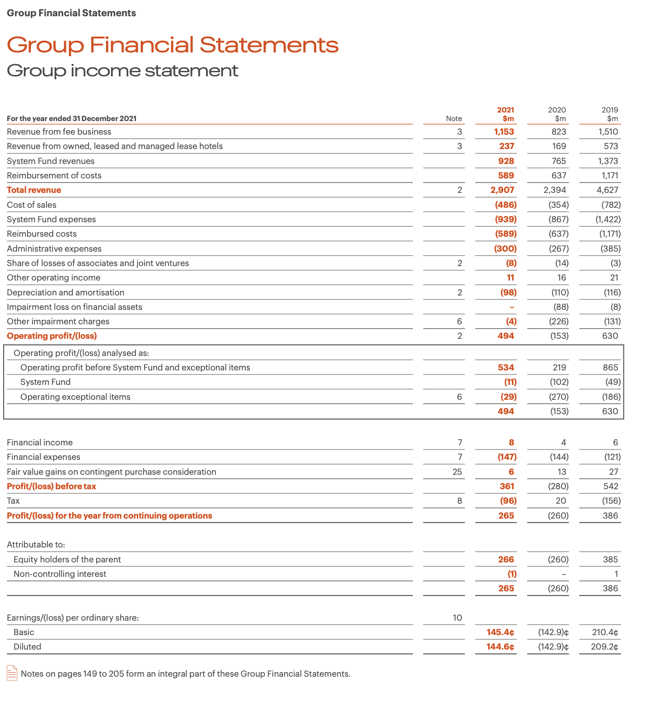
Figure: 2021 Income Statement
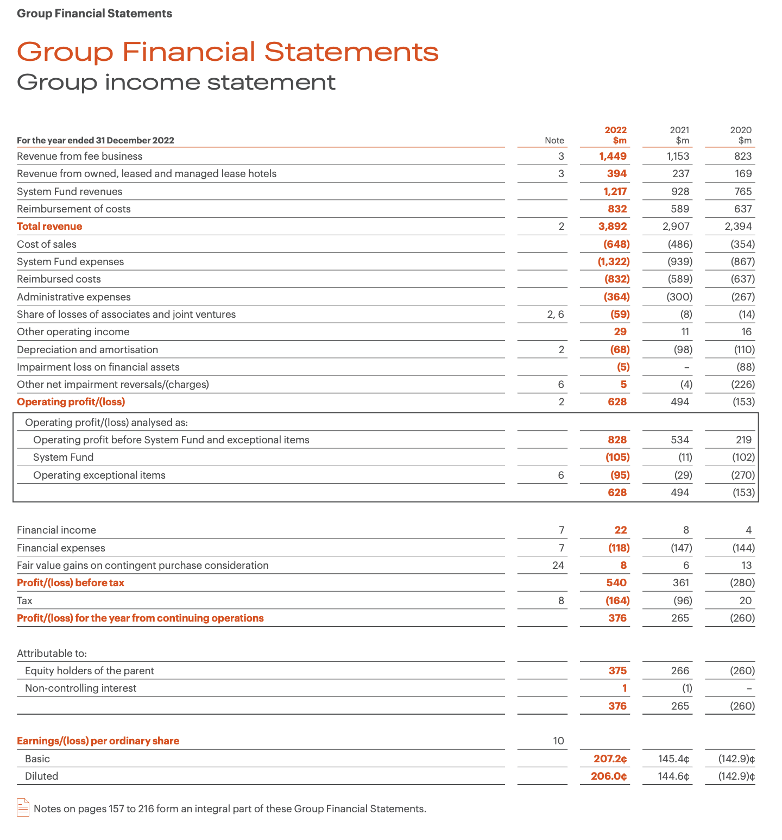
Figure: 2022 Income Statement
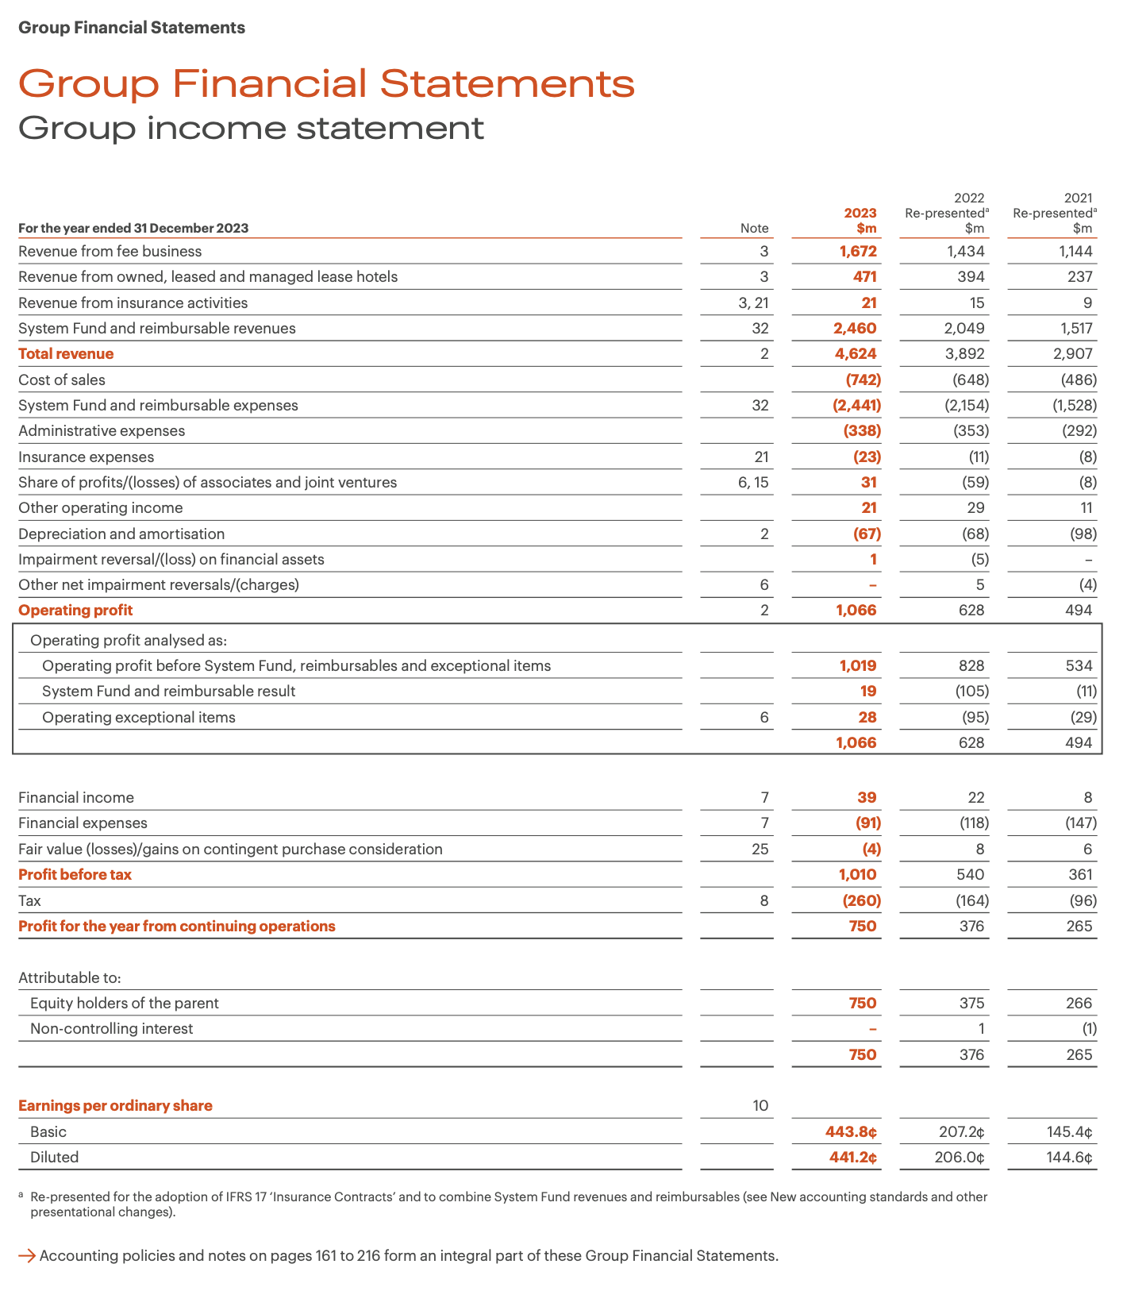
Figure: 2023 Income Statement
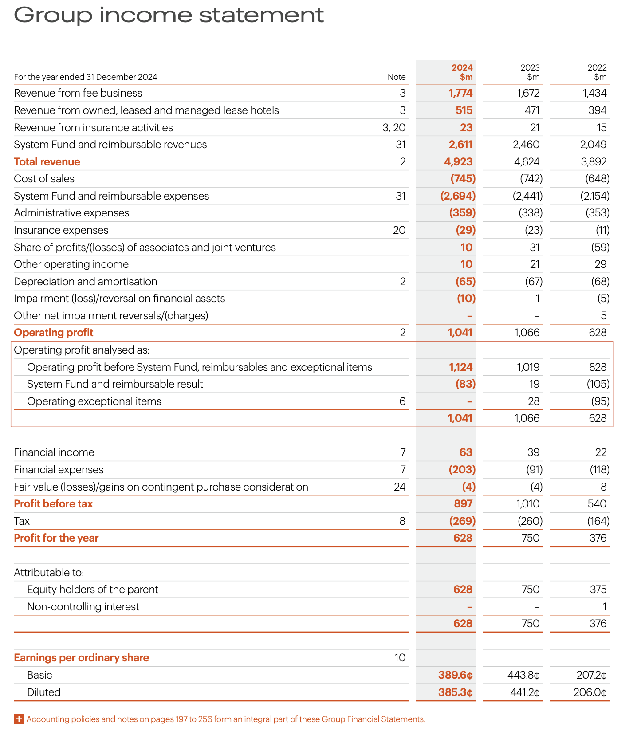
Figure: 2024 Income Statement
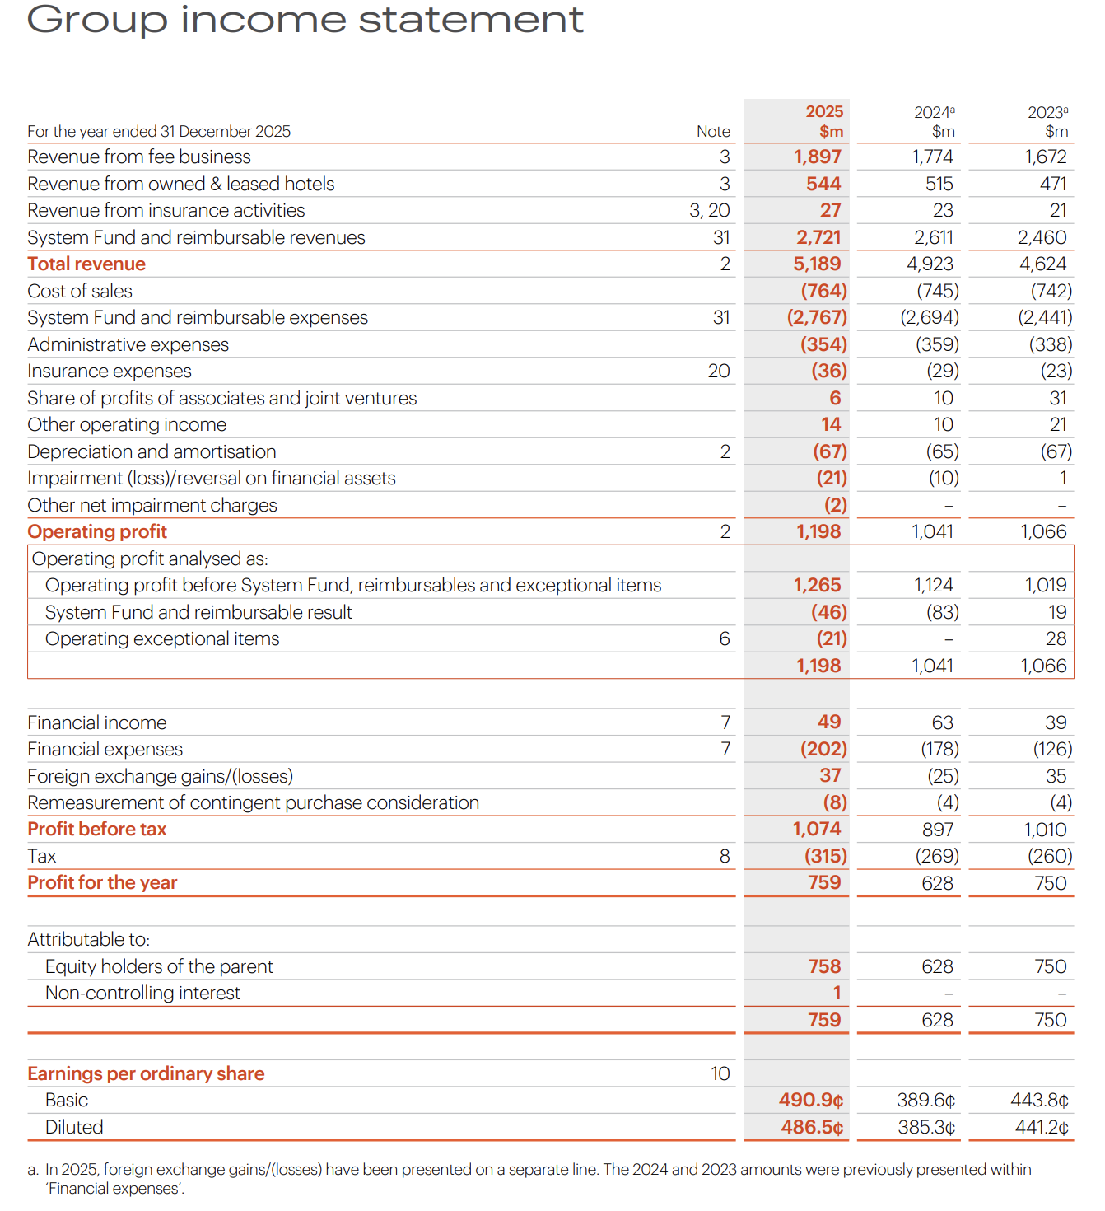
Figure: 2025 Income Statement
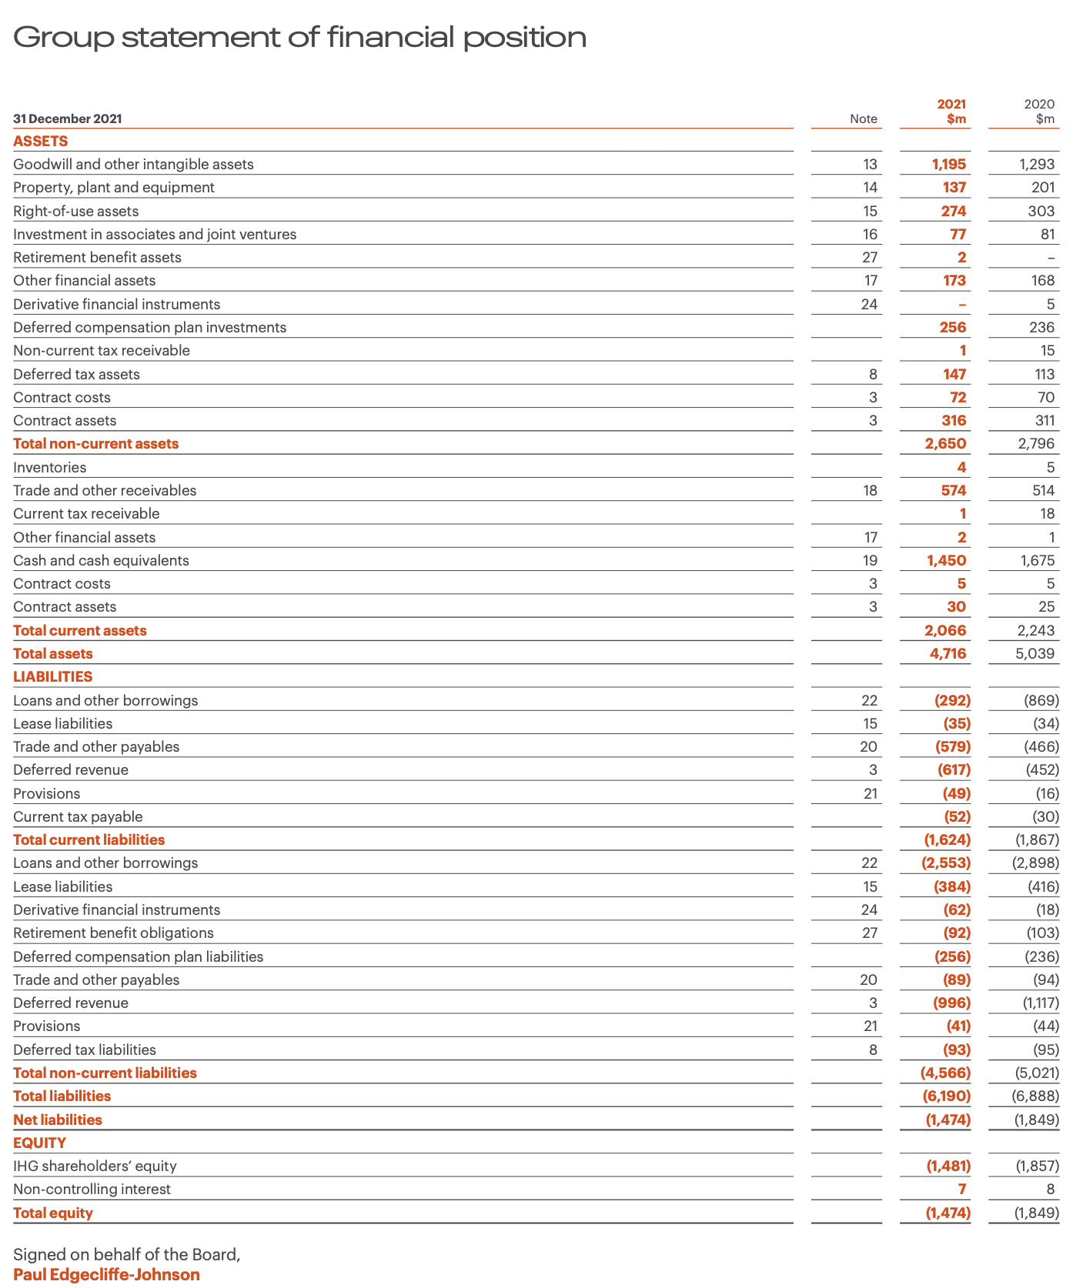
Figure: 2021 Balance Sheet
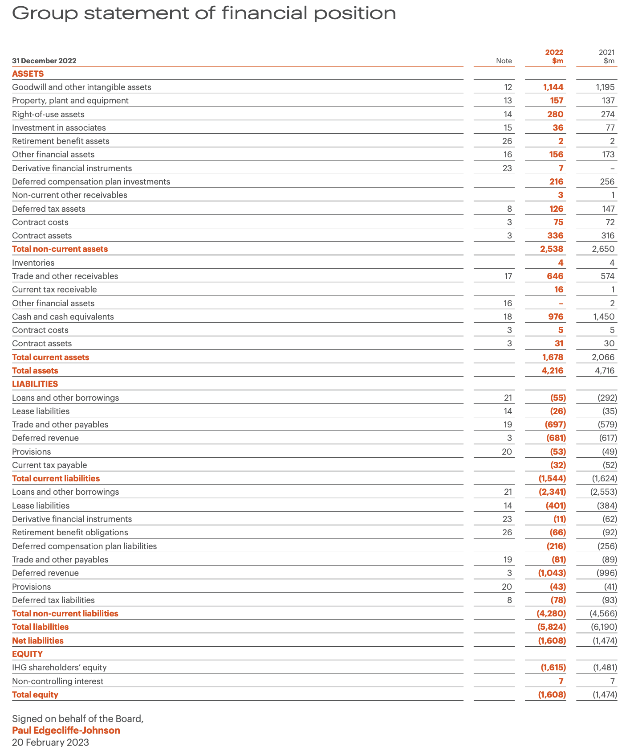
Figure: 2022 Balance Sheet
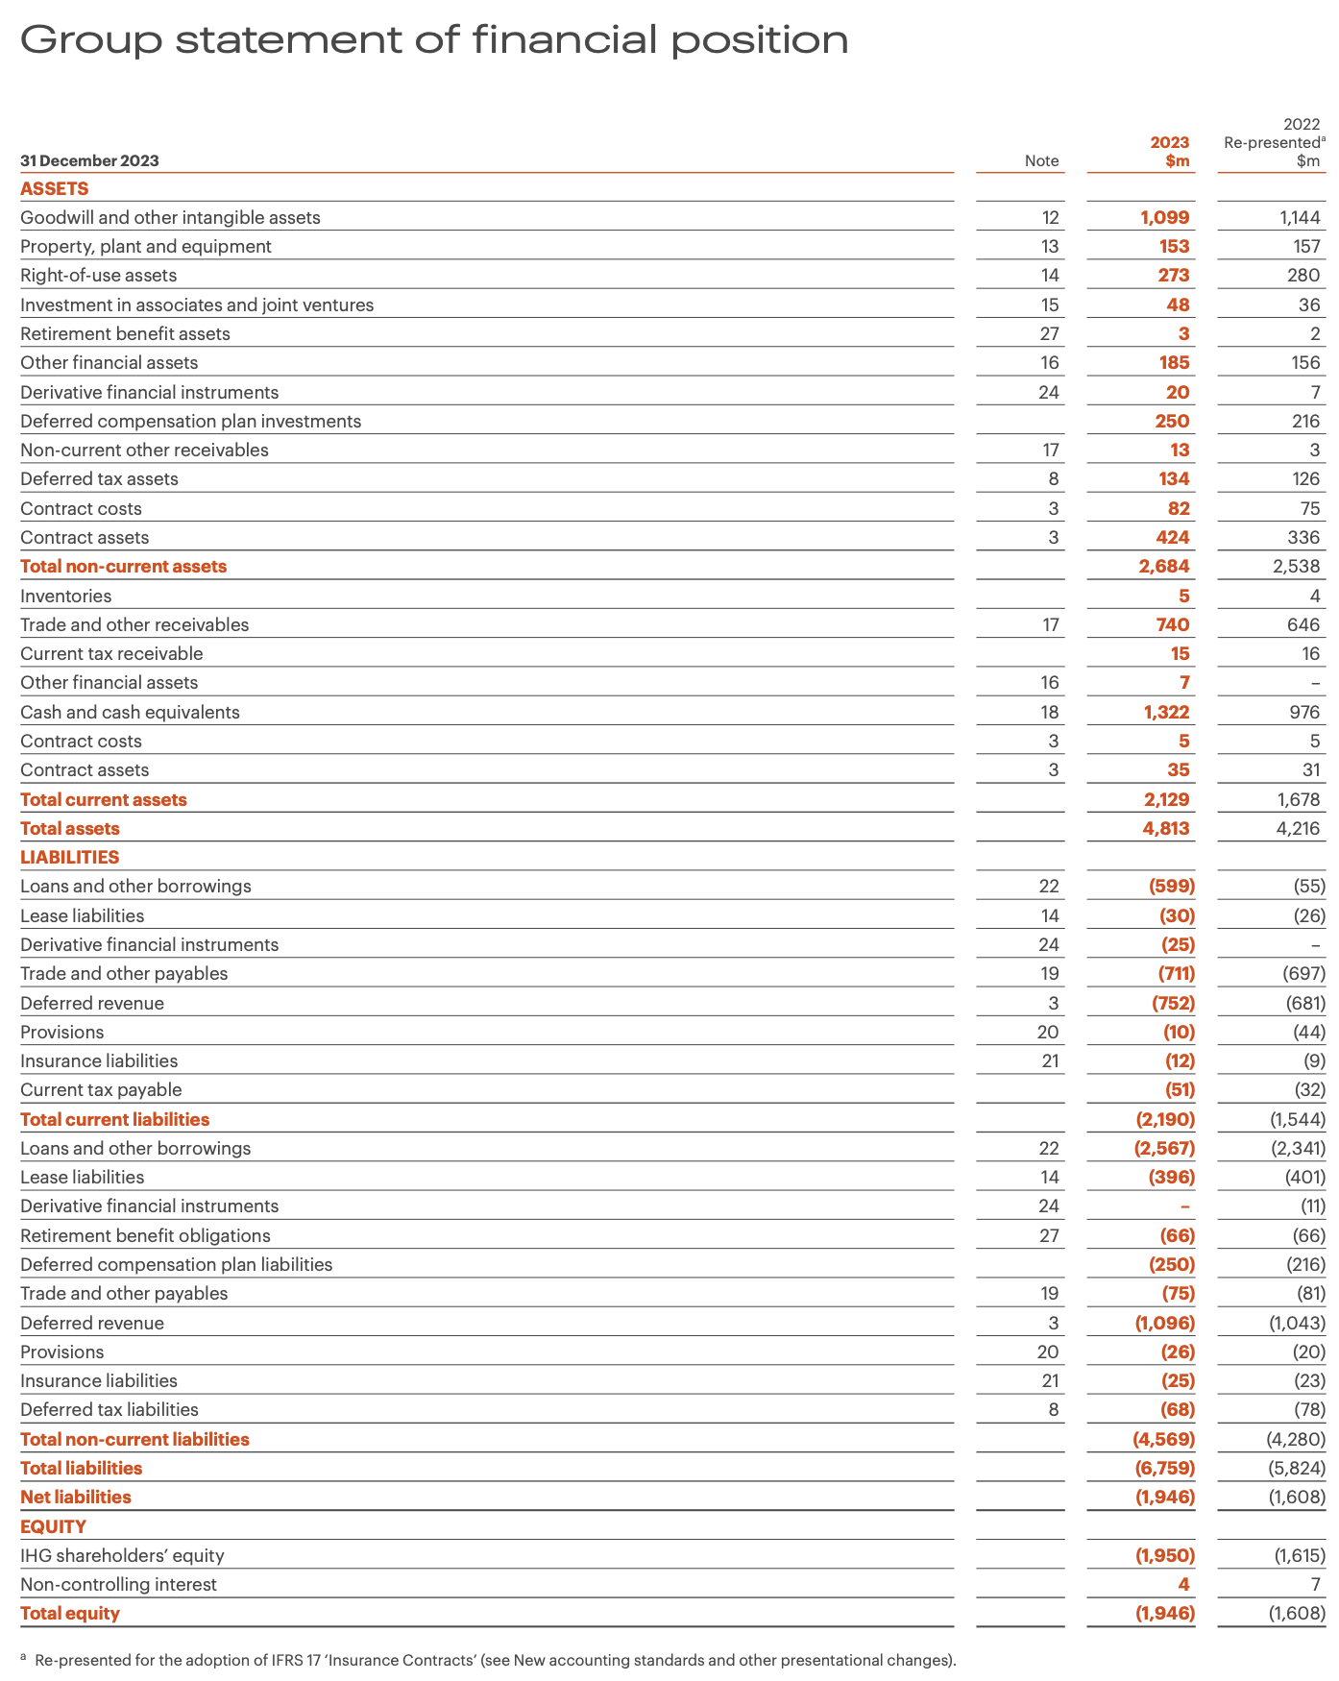
Figure: 2023 Balance Sheet
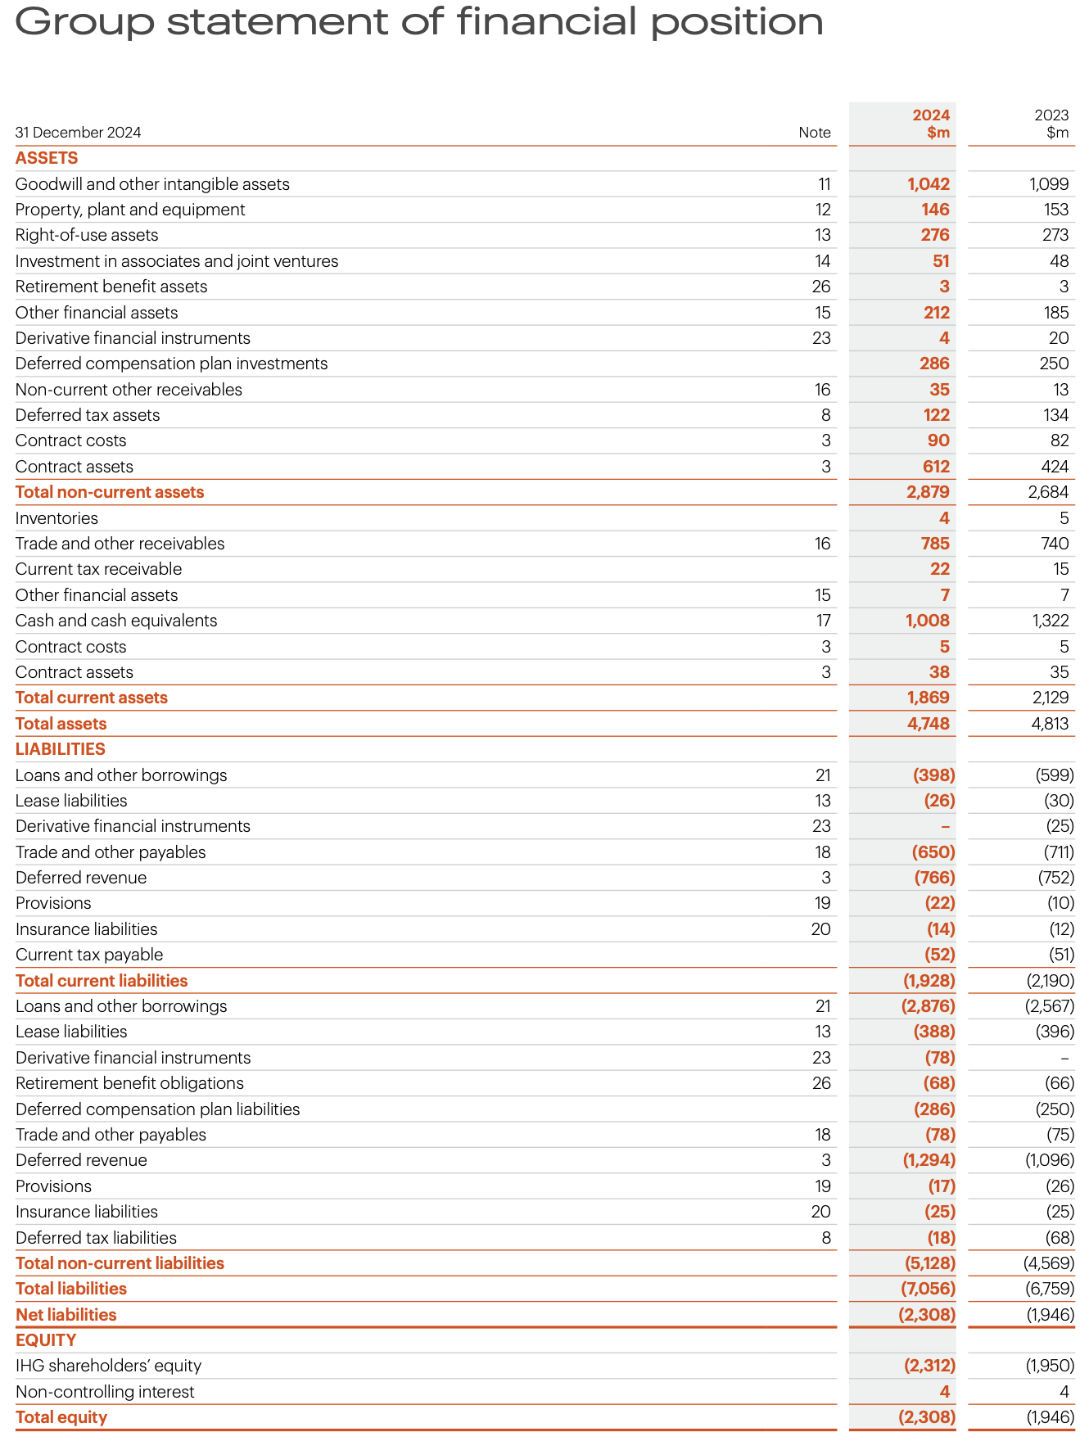
Figure: 2024 Balance Sheet
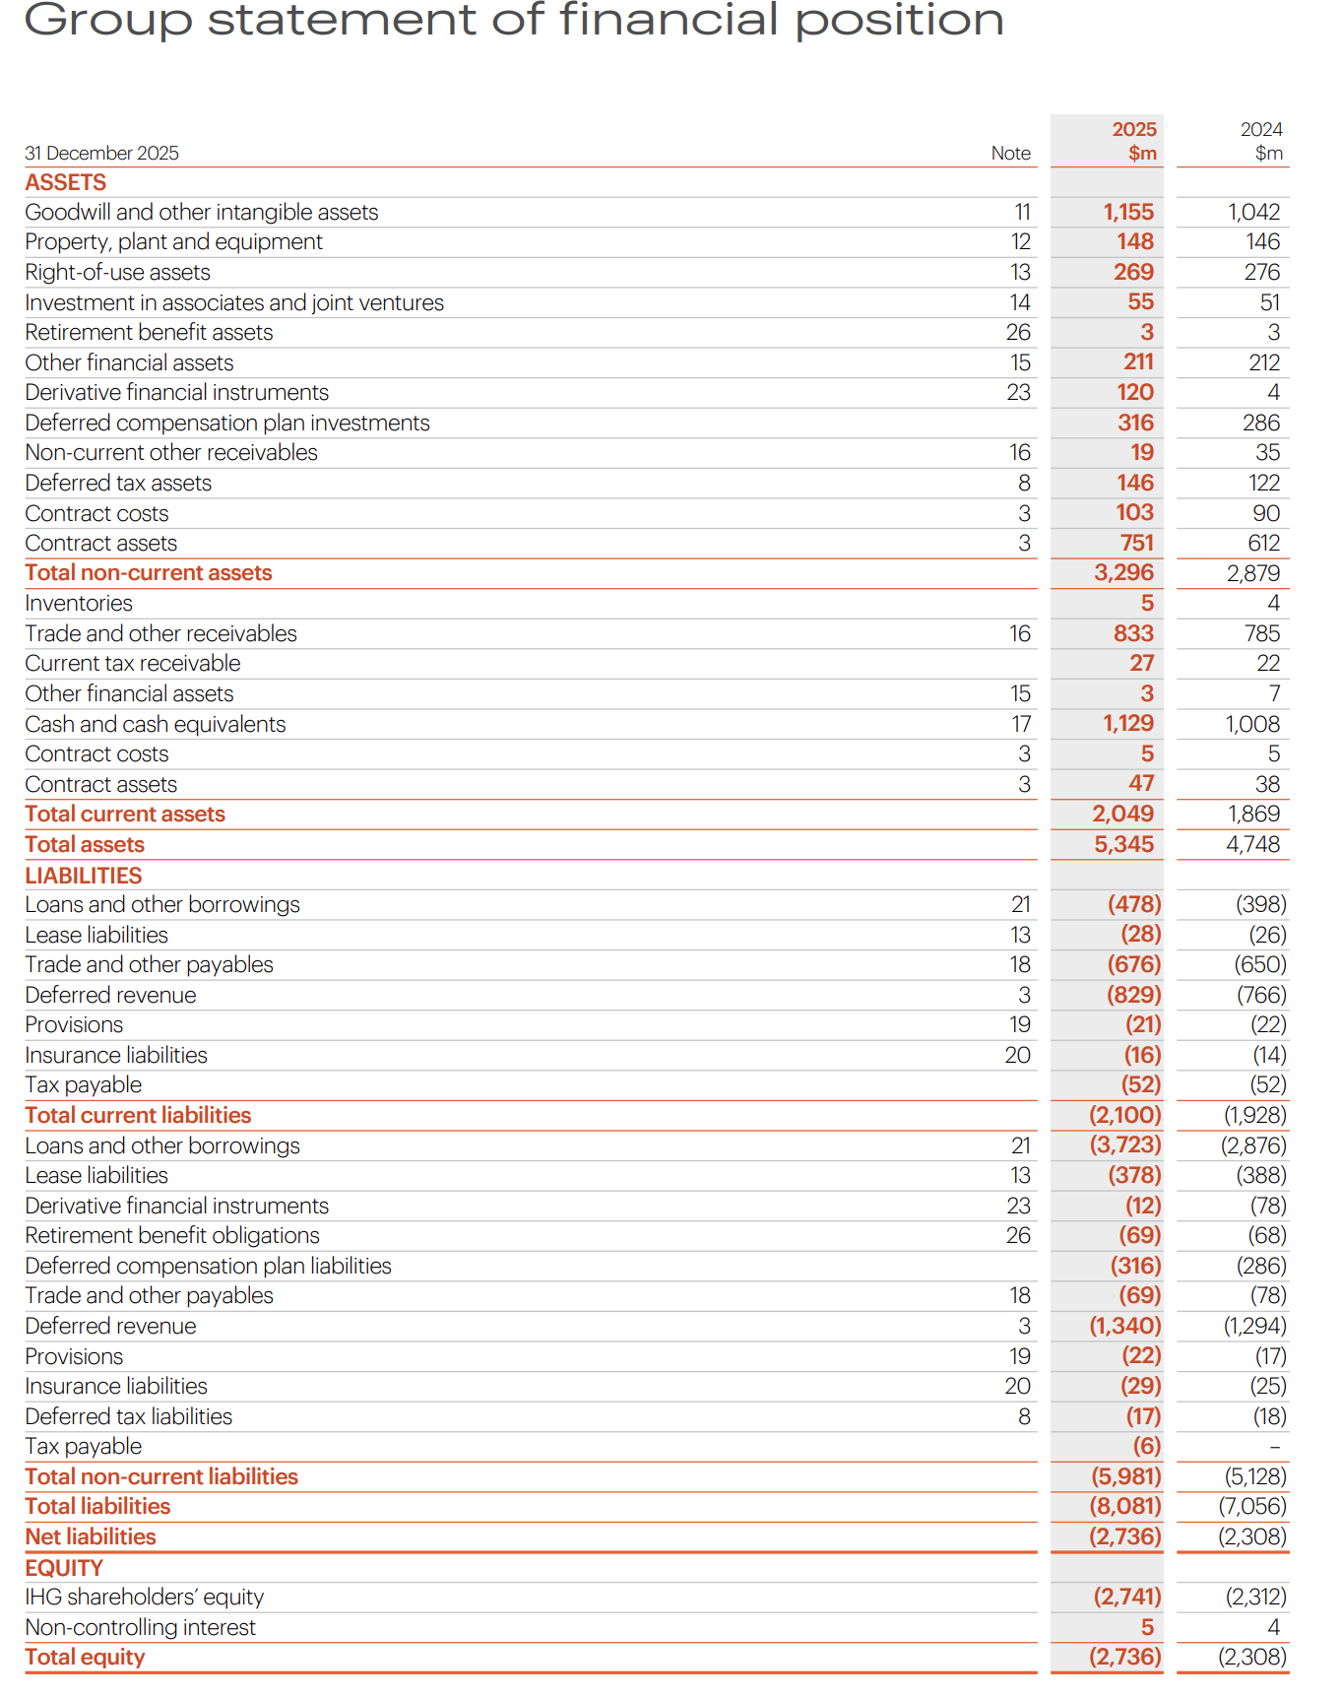
Figure: 2025 Balance Sheet
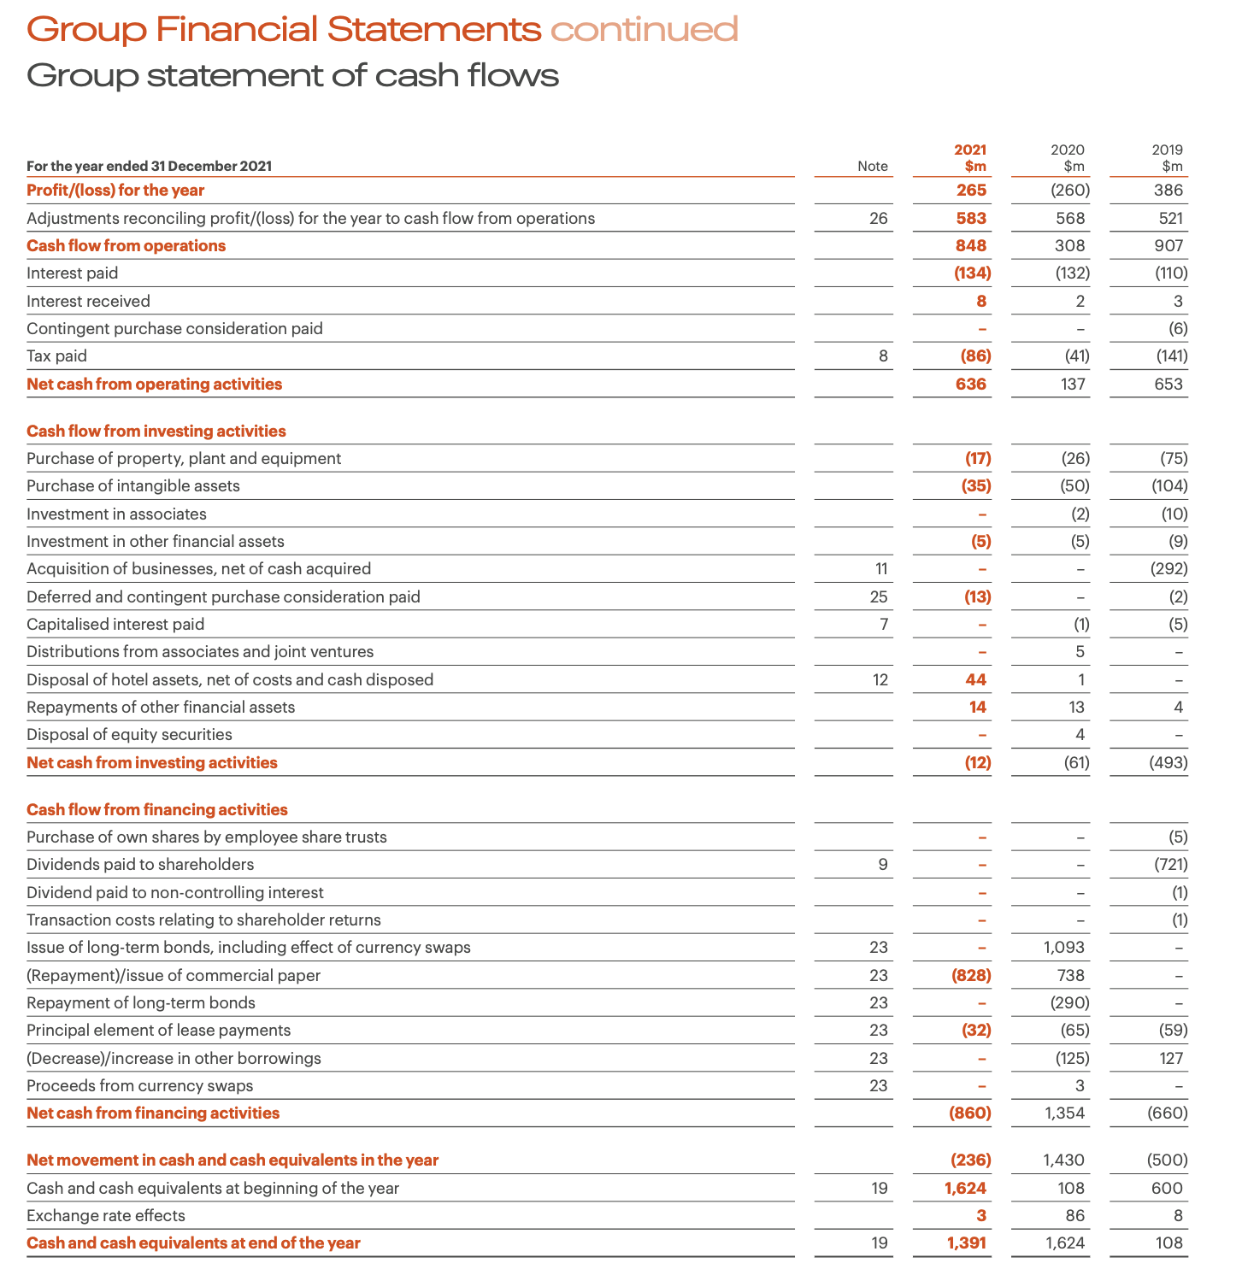
Figure: 2021 Cash Flow
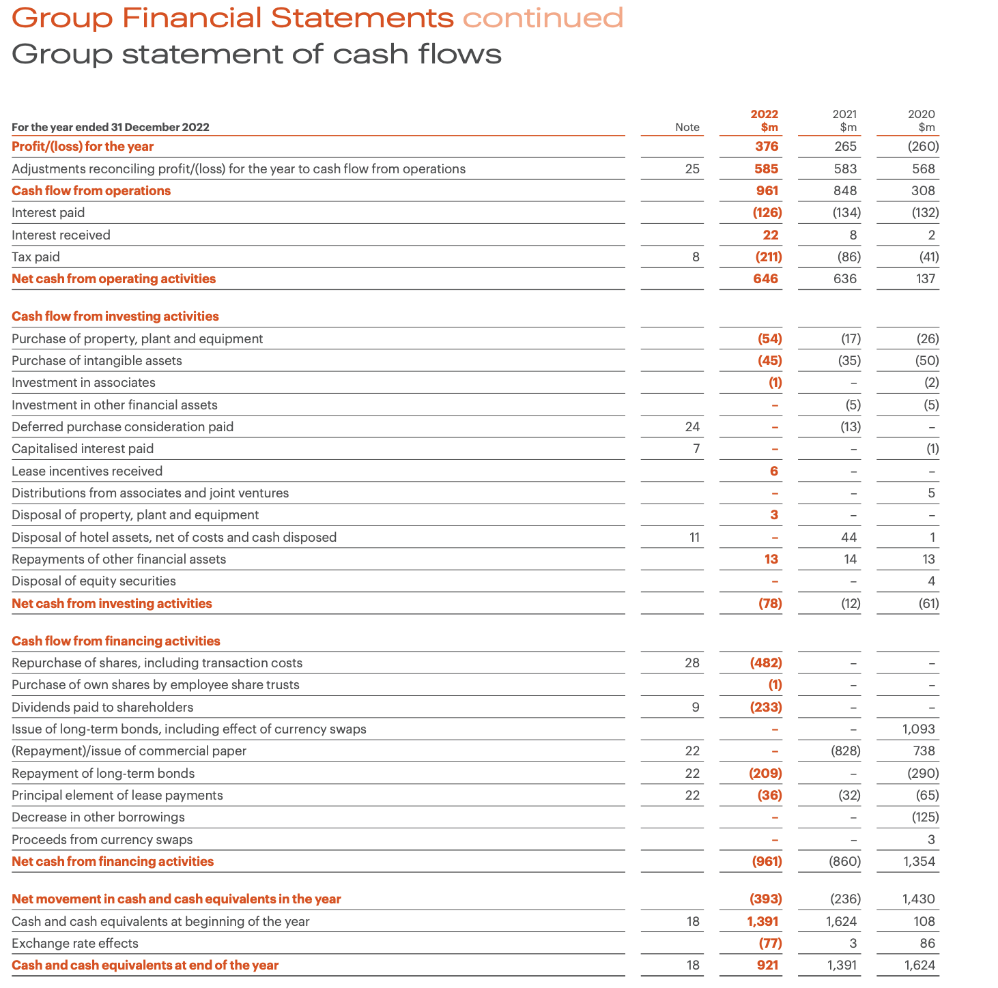
Figure: 2022 Cash Flow
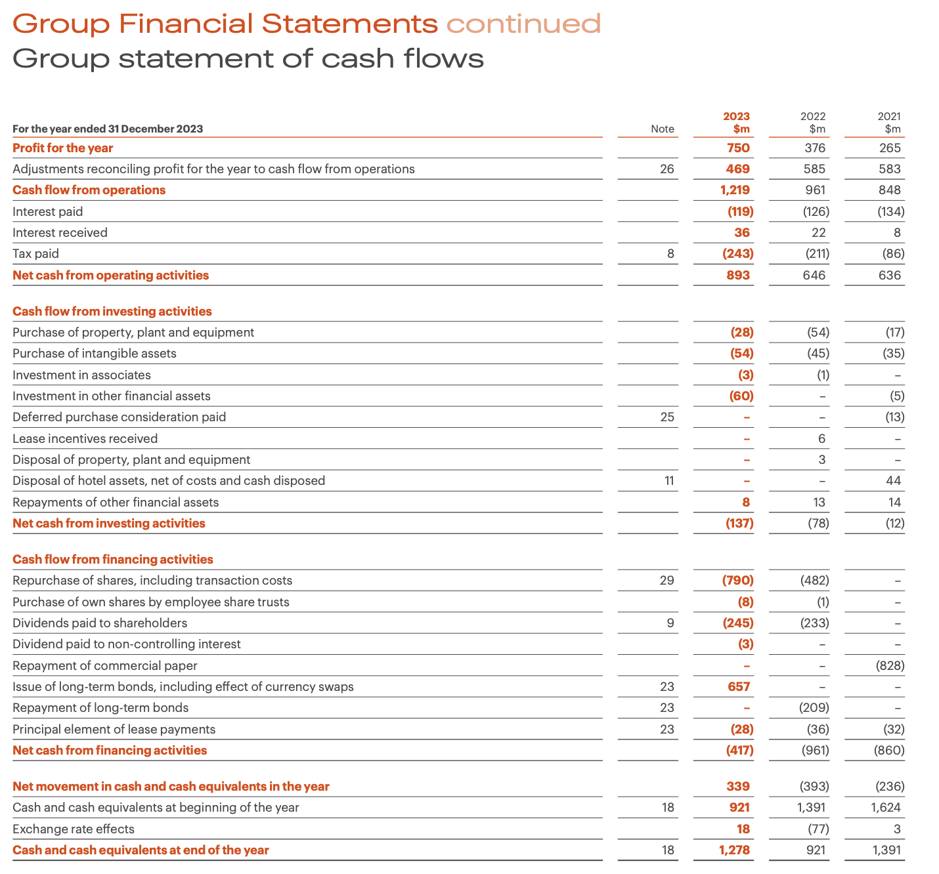
Figure: 2023 Cash Flow
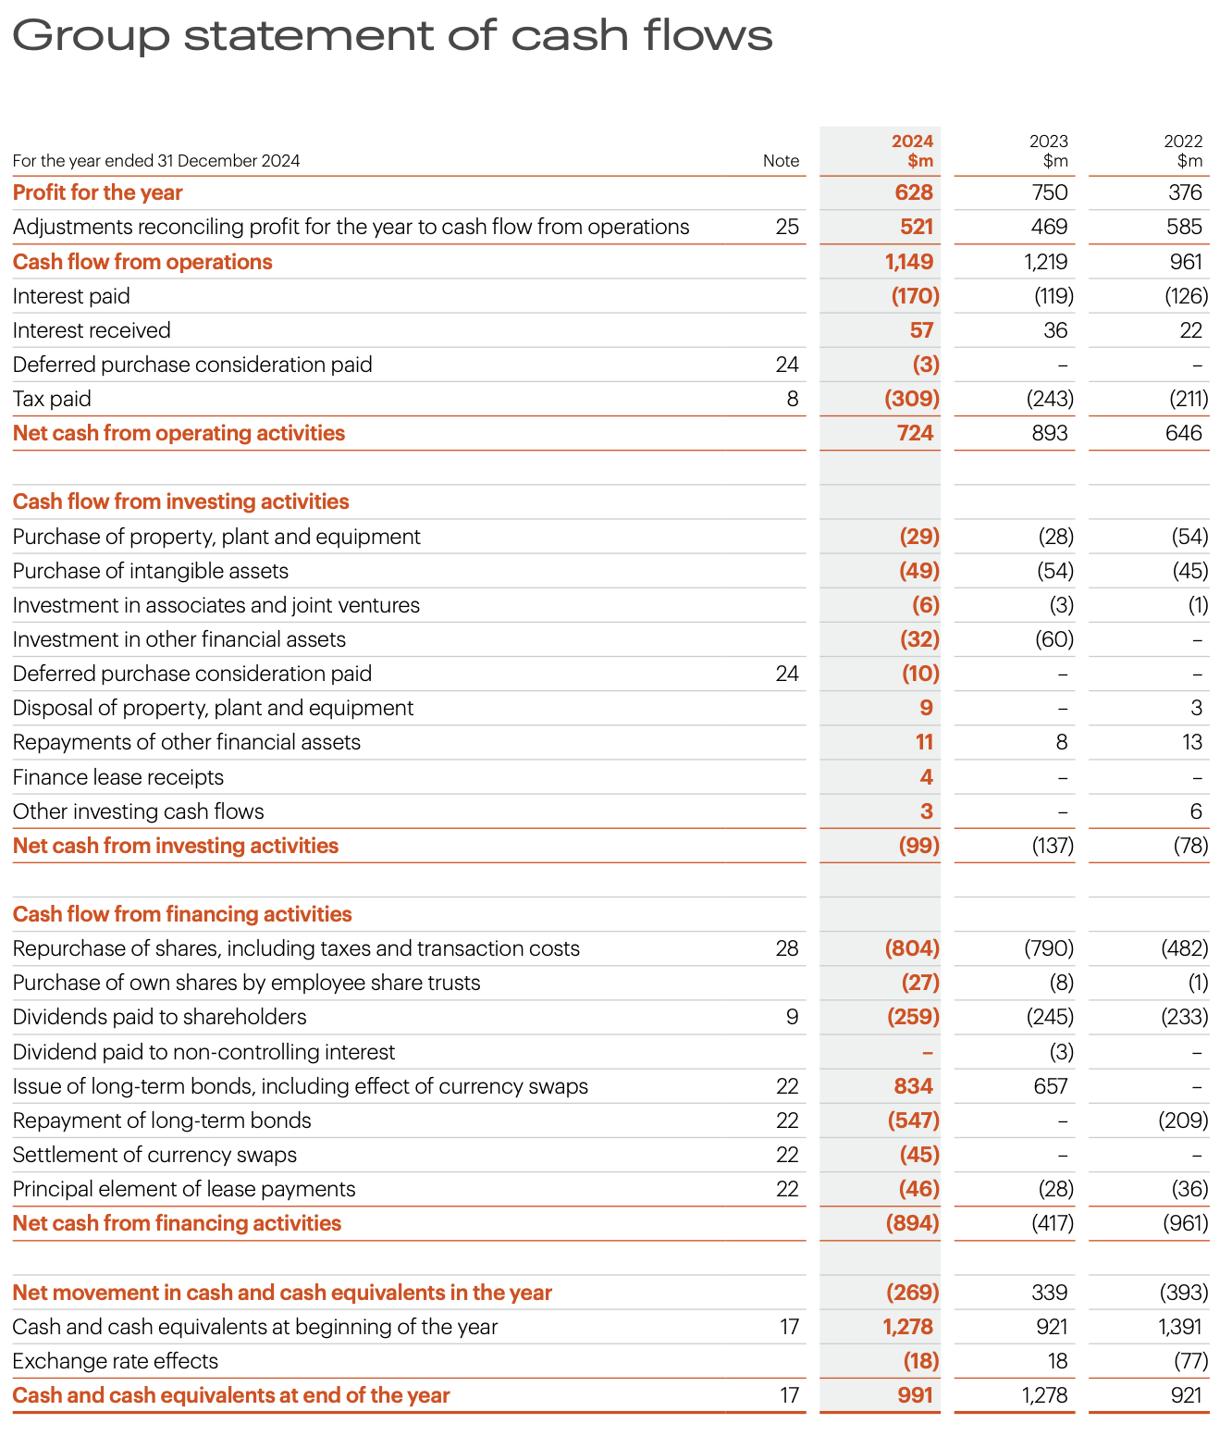
Figure: 2024 Cash Flow
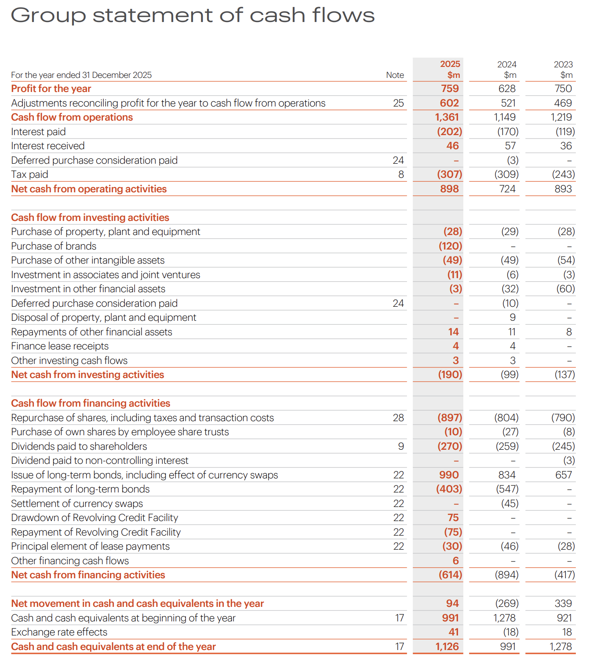
Figure: 2025 Cash Flow

