  Digital Skills and Research Methods | Name: Roland Nwaosu  Student Number: 1917495  BMSW 4003 _LON  Dr Terry Walcott

Table of Contents

- Introduction 1

- Background 1-3

- Aims and Objectives 3

- Method 3

- Results in Tabular Form 4

- Discussion 6

- Conclusion 7

- References 8

- Appendices 9-14
Introduction

This survey is about the impact of Virtual Learning Environment on students. The literature review defined Virtual Learning Environment. It is argued that Virtual Learning Environment is not a new phenomenon but has been in used in combination with face to face learning. The survey specifically focused on family life of students. Participants are my fellow students and family members. The selection of participants was restricted due to spread of coronavirus virus. The data was collected through distribution of questionnaires sent to participants and it was delivered through email. More than half of selected participants responded to the questionnaires.by filling out the forms on internet email and sending it back.
The government lockdown to stop the spread of coronavirus meant that face to face learning in classes was suspended for the time being. The only option available is virtual learning. This survey’s target is to unravel what learning from home is like. It wants to establish if there are benefits as well as shortcomings

Background

There different opinions on what Virtual Learning Environment is exactly about. Some refer it as E-learning. Others see it as Web-based learning, online learning or distance learning. But what is Virtual learning? Veronica Racheva writing on Vedamo E-Learning define it as an online system that allows education materials to be transmitted through the internet to transfer knowledge from organization to employee, or teacher to student (Racheva, 2018).
According to tophat.com, Virtual Learning Environment is an online-based platform that offers students and professors digital solutions that enhance the learning experience. It also added that unlike a virtual classroom, which is meant to replicate and replace the physical classroom environment for distance learners, a virtual learning environment (or VLE) harnesses technology to supplement an in-class experience, with, for example, digital communication, interaction and quizzes or polls run through the VLE.

It has been argued that Virtual learning is not a new phenomenon. In a blog posted on Scand.com, it was written that a lot of University and school have already implemented Virtual learning software (scand.com, n.d.) From onset Virtual learning has been used in combination with face to face learning. It could be accessed from home, work place or a school.

However, due to coronavirus pandemic of 2020, the concept has been restricted to home. The lockdown imposed to stem the spread of the virus meant that virtual learning can only be accessed from the comfort of home where users are either in quarantine or shielding. The question now is what is the impact of this mode of learning on student life?

From my perspective as an adult student, virtual learning has had an enormous positive impact on my life and that of my family. It was a privilege and a lifetime opportunity for me to be admitted into University of Wales Trinity Saint David. As a fulltime parent before the admission, my priority was my two children. I have never missed both the morning and the afternoon school runs before then. Therefore, I was confronted with how to manage my full time education and the school run. I managed to convince my wife to persuade her employer to allow her to work from home. She was waiting for the authorisation to work from home for just one day a week when the pandemic struck.
Since then I and my wife have continued to be on full time education and full employment respectively from the comfort of home without an inkle of worry about childcare.
Although Virtual learning has few limitations like the difficulty of using it to teach someone on how to build or use a complicated piece of machinery and devoid of human to human contact, its benefits are gigantically overwhelming. To buttress the benefits of Virtual learning, Dr Amjad, a Professor at The University of Jordan during World Economic Forum says, “It has changed the way of teaching. It enables me to reach out to my students more efficiently and effectively through chat groups, video meetings, voting and also document sharing, especially during this pandemic. My students also find it is easier to communicate on Lark. I will stick to Lark(a form of virtual learning) l even after coronavirus, I believe traditional offline learning and e-learning can go hand by hand" (Cathy Li, 2020).
Generally, Virtual learning benefits includes saves travelling time, flexibility, low cost and elimination of unnecessary travel.
Virtual learning saves a lot of travelling time for students as well as employees of organisations. It saves an average of 3 hours travelling to and coming back from school daily. With virtual learning this saved time can be put into other uses.
It enables flexibility. Virtual learning has made the dogmatic 9 to 3 school time almost a history. There is no skipping of class by any student because he or she is running late due to heavy traffic or train delays. The preceding stress is completely elimination. The system creates freedom and let individual become master of her time.
Virtual learning makes the cost of education very low and eliminates unnecessary travelling. The cost of travelling to learning location has been eliminated. There is even no need to rent a location for the learning. Unnecessary travelling is no longer made. There is no more pressure on public transport which in turn will reduce

environmental pollution. All these has made the cost of education cheaper. So overall the impact of virtual learning environment is all-round positive.

Aims And Objectives

The aim of this research is to ascertain the impact of virtual learning on students. Is the impact negative or positive? How does it feel having lessons whilst in the comfort of your home with family members moving or not moving about. What group is mostly affected? The result could be used to make marketing decision and the best place to locate internet facility.

The means of collecting the required data was through sending questionnaires to participants by emails. Google form was used to deliver the interview questions to participants.
The current climate of coronavirus played role in my choice of participants. They are my fellow students and family members.
The responses would be analysed and presented in a tabular form before conclusion reached

Method

The geographical area of this research possibly would have been different but because of coronavirus it was only carried out through email. Coronavirus changed the studying our programme from face to face to Virtual Learning. The input of social media platform, WhatsApp to this research cannot be overemphasized. It would have been easier to send out questionnaires survey through students' school email addresses but almost all the student preferred their personal email addresses. Each of the student participants posted his or her email address through WhatsApp group chat the filling the survey forms. What inspired the design of the survey questions was quest to know the effect coronavirus has on my selected participants for the survey. Educationally, coronavirus changed our original means of learning to Virtual. I am curious about how students managed their live online in the comfort their homes with family members. Except for this research, I have never heard of Google forms. I discovered in the pursuit of this research the importance of it. It was simple and easy to use. The questions were first drafted in Microsoft word before copied and pasted on google form. The form even helped to present the data in various forms. I sent out 20 questionnaires survey for the interview. 16 of the participants are students of UWTSD while the rest are my family members. Only 14 of the participants including my family completed the survey and returned the questionnaires. All data collected as a result of the questionnaires were returned by email.

Results In Tabular Form

1, What is virtual Learning ?
a) E-learning | 3
b) Web-based learning | 4
c) Online learning | 7
d) Distance learning | 3
Grand Total | 14

2. What is your student status?
a) Former student | 2
b) Current student | 12
Grand Total | 14

3. Assess your accessibility of internet connection for your Virtual Learning Environment.
a) Always accessible | 7
b) Mostly accessible | 7
Grand Total | 14

5. How easy is it to access Virtual Learning for you?
a) Easy | 7
b) Fairly easy | 5
c) Difficult | 1
d) Fairly difficult | 1
Grand Total | 14

6. Has virtual learning impacted your family life?
No | 10
Yes | 4
Grand Total | 14

8. Have you ever been asked to do class presentation through Virtual Learning Environment? | 0
 | 2
No | 12
Yes | 14
Grand Total

9. How motivated is tutoring of presentation skills through Virtual Learning Environment.
a) Very high | 1
b) High | 7
c) Moderate | 5
d) Low | 1
Grand Total | 14

10. Are you familiar with any of the following Virtual learning platforms
b) Canvas | 1
c) Blackboard | 2
d) Google classroom ( please tick ) | 10
Grand Total | 13

11. Do you currently use any social media platforms?
No | 3
Yes | 11
Grand Total | 14

14. Virtual Learning Environment foster inter personal relationship amongst group members?
a) Strongly agree | 1
b) Agree | 6
c) Neutral | 6
e) Strongly disagree | 1
Grand Total | 14

Discussion Of Results

The viability of Virtual learning is greatly recognised. The lockdown instigated by coronavirus currently makes it the only source of learning available. Out of 20 questionnaire survey I sent out, only 14 participants took time to complete and submit them.

According to the survey responds 12 out of 14 participants who completed the questionnaires are current students. It is not surprising as most of the participants are my fellow students (Appendix Two). All the participants agreed that their accessibility to internet is mostly or always accessible. (Appendix Three.) The outcome is very important for the government which definitely would be happy with the provision of internet facility. Going forward from the effect of coronavirus, it will assist the government regarding the distribution and improvement of internet facilities in the country.

The main question of this questionnaire survey is whether Virtual Learning Environment has any impact on the participants' family life. The result demonstrated that there is no impact at all on 8 out 14 participants that responded to the questions. So, it makes little or some impact to participant. (Appendix Four). Half of participants demonstrated that their understanding of Virtual learning is online learning against the rest who thought it to be either E-learning, Web-based learning, Distance learning or None of the above (Appendix One). Subsequently, 10 out of 14 participants showed that learning online from home has no impact on their family life (Appendix Six). There are varying opinions on how exactly Virtual learning has affected the minority of 4 out 14 participants' family life. From the responses, the impact on their family life is mostly positive: Studying at home has

helped a participant to continue studying during the pandemic; some are happy studying in the presence of family members; and someone responded that it opened his or her mindset. The negative impact as demonstrated by a participant is that it causes more stress.

The participants were asked if they have been asked to do presentation through Virtually Learning Environment. 12 out 14 participants agreed. Now one of the doubts being casted on Virtual learning is that it lacks human to human contact. As the result demonstrated, it makes sense to investment more on Virtual technology, because from my personal experience it feels real when doing presentation virtually. So not long in future, Virtual learning would be broadly embraced (Appendix Eight). On the question of how motivated was the tutoring of presentation skills through Virtual Learning Environment, it is a good development that 13 out 14 of the participants who responded are either moderately, highly or very highly motivated. The outcome would be highly welcomed by the tutors (Appendix Nine).

Often surveys are used for marketing purpose. So, the responses of 10 out 14 participants that they use media will assist organisations on the best platform to advertise their products and services (Appendix11). It is a good outcome that 11 out of 14 participants never or rarely encountered any difficulty accessing resources online. This further proves that virtual learning is viable. It is assuring that the educational system will still function in an event of incessant disruption like covid19. (Appendix 13).

Conclusion

Available literature has it that Virtual learning is not a new phenomenon. However, nobody would have imagined it would play such a vital role in delivering education for students of learning during this pandemic. The result has demonstrated that it has tremendously positively impacted on the life of students and their families. The stress of travelling to places of face to face learning has diminished and its attendant cost eliminated. Confronted with such benefits the government and educational institutions should consider improvement internet service to make Virtual Learning a viable option of learning educationally.

References

Anon., 2017. www.frontiersin.org/articles. [Online]
Available at: https://www.frontiersin.org/articles/10.3389/feduc.2017.00059/full
[Accessed 09 July 2020].
Anon., n.d. [Online].
Cathy Li, F. L., 2020. weforum. [Online]
Available at: https://www.weforum.org/agenda/2020/04/coronavirus-education-global-covid19-online-digital-learning/
[Accessed 2 August 2020].
Hox, J. &. B. H., 2005. In: Data Collection Primary vs Secondary, Encyclopedia of Social Measurement. s.l.:s.n., pp. 593-599.
https://www.thehartford.com/business-insurance/strategy/market-research/primary-second-research, 2020. hartford.com/business-insurance/strategy/market-research/primary-second-research. [Online]
Available at: https://www.thehartford.com/business-insurance/strategy/market-research/primary-second-research
[Accessed 15 August 2020].
John Fatteros, 2017. In: Market Research The Basics, 2017, Business Owners. s.l.:s.n.
Platform., S. A. C. t. B. f. V. L., 2020. . Telecomworldwire,. [Online]
[Accessed 24 August 2020].
Racheva, /., 2018. [Online]
Available at: https://www.vedamo.com/knowledge/author/veronica-racheva/
[Accessed 29 July 2020].
scand.com, n.d. [Online]
Available at: https://scand.com/company/blog/the-use-of-virtual-learning-environment-in-education/
[Accessed 5 August 2020].
Smidts, I., 2020. businesswire.com. [Online]
Available at: https://www.businesswire.com/news/home/20200331005511/en/
[Accessed 23 August 2020].

Appendices

Appendix One
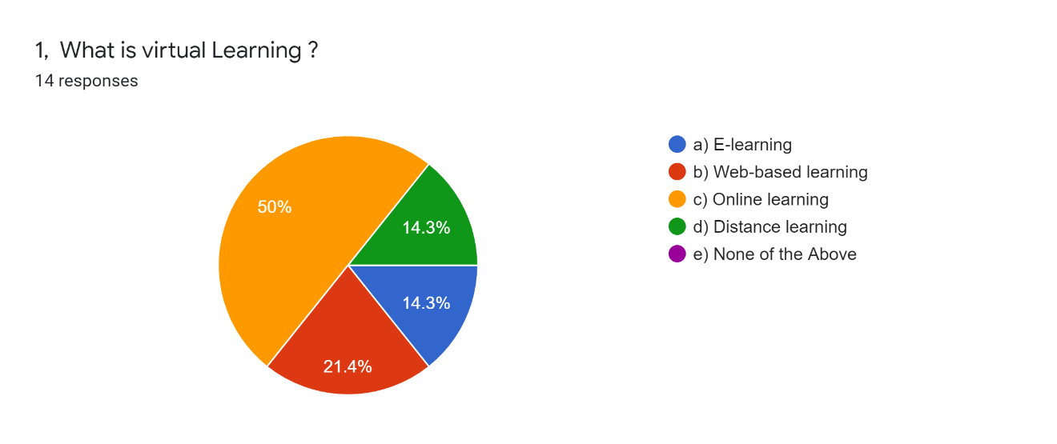

Appendix Two
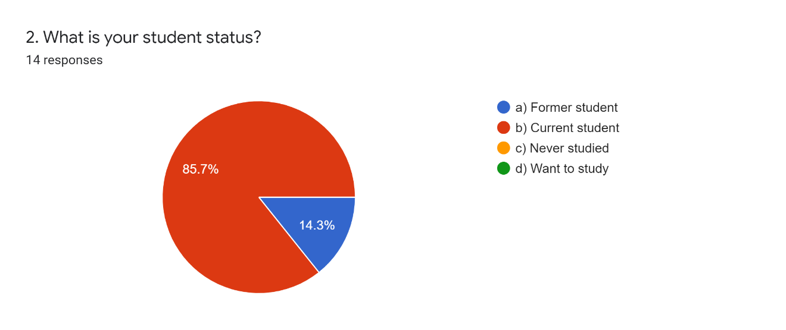
Appendix Three
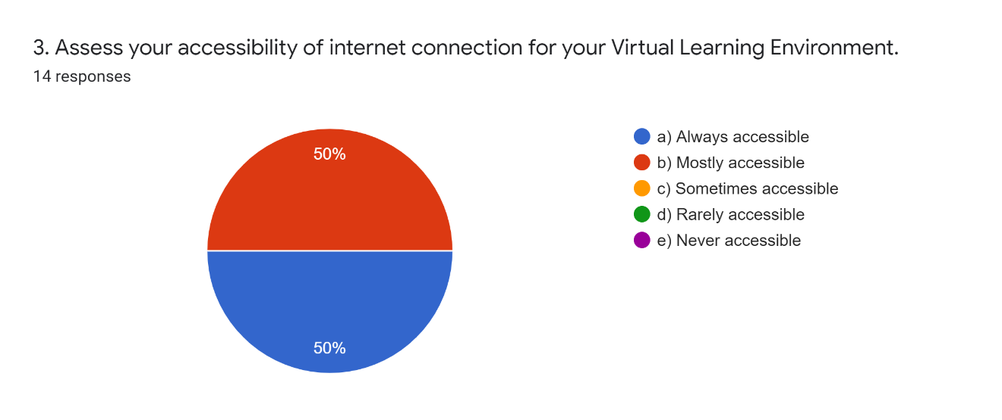
Appendix Four
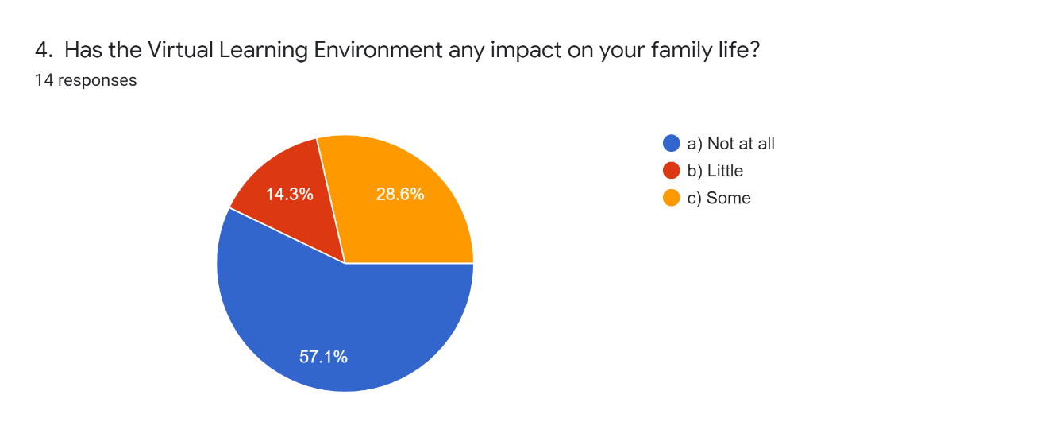
Appendix Five
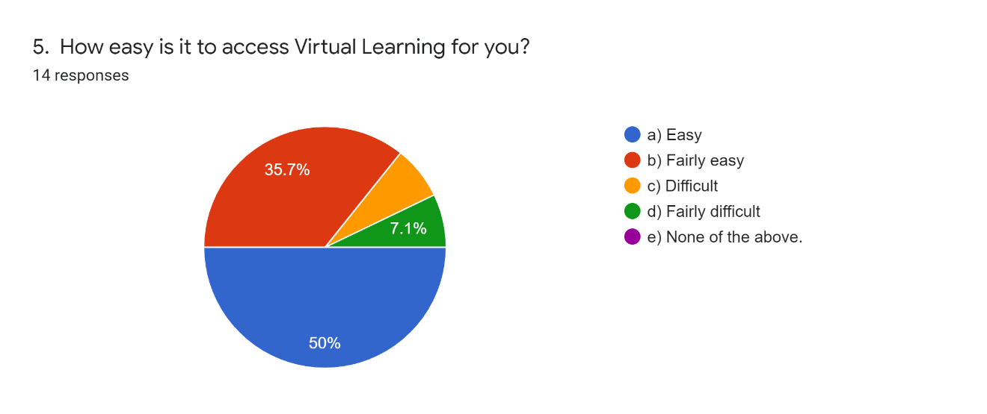
Appendix Six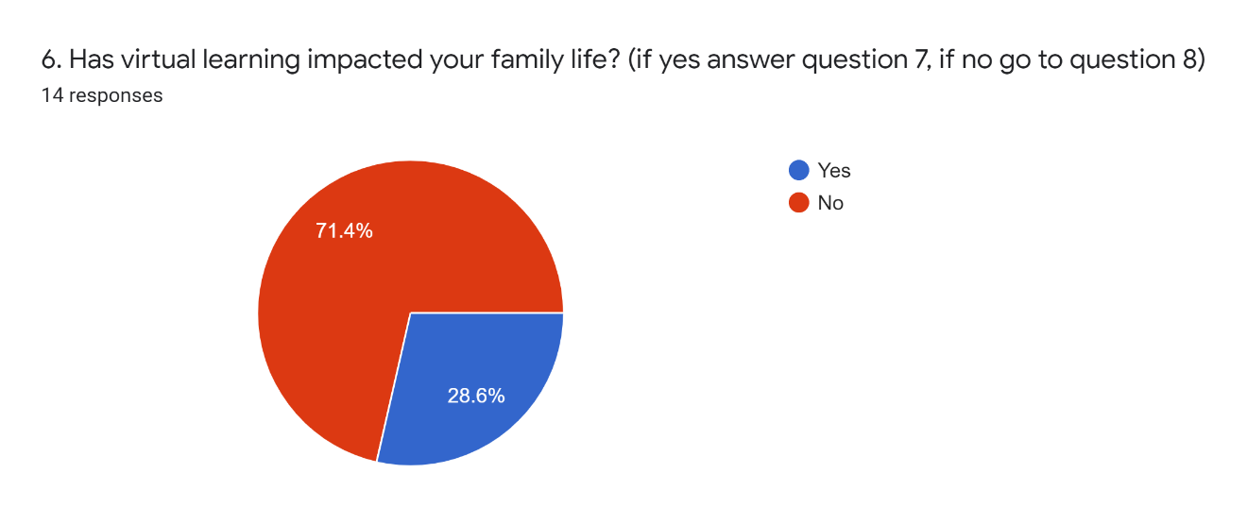

Appendix Eight

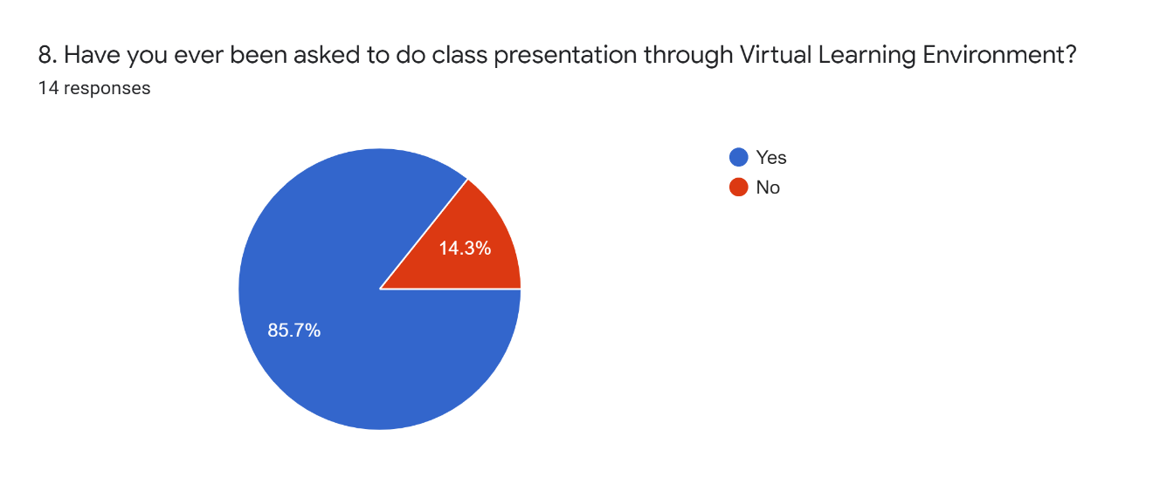

Appendix Nine
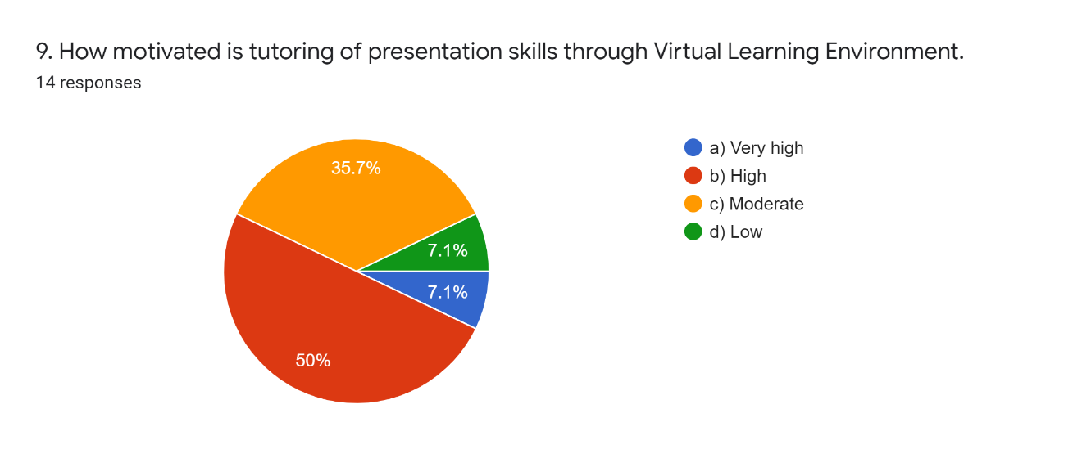
Appendix Ten

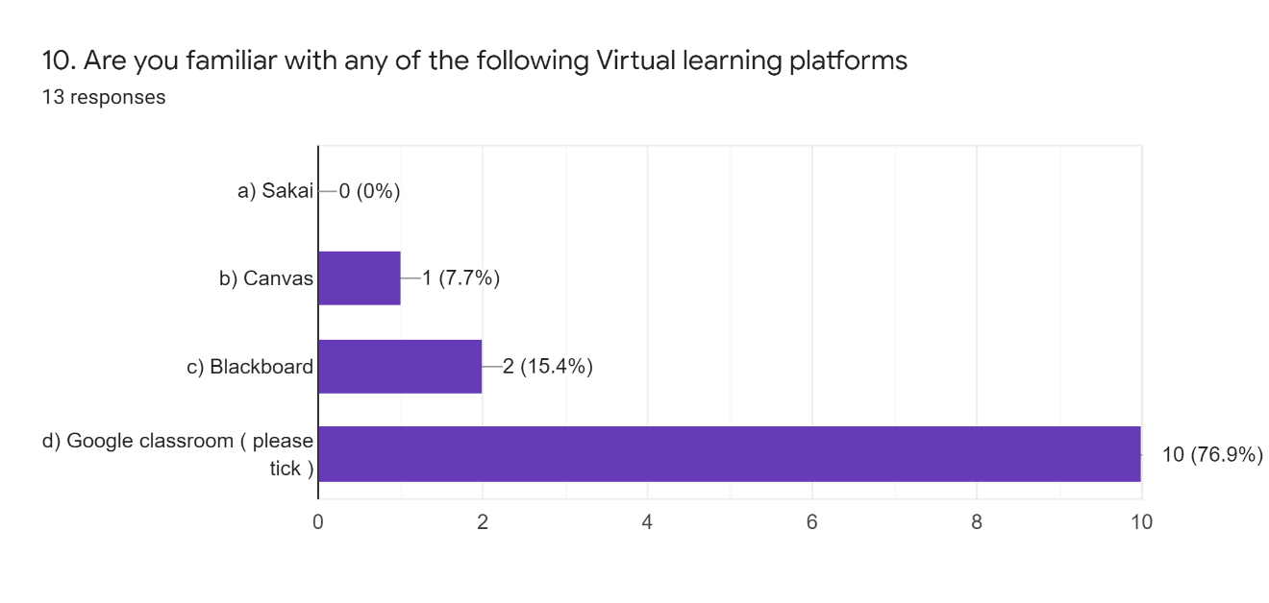

Appendix Eleven

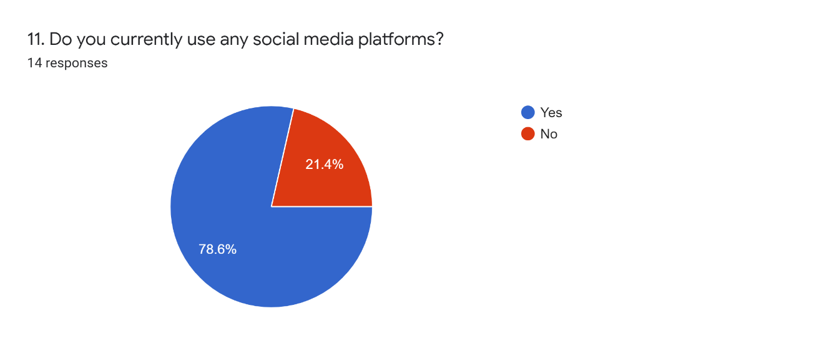

Appendix Thirteen

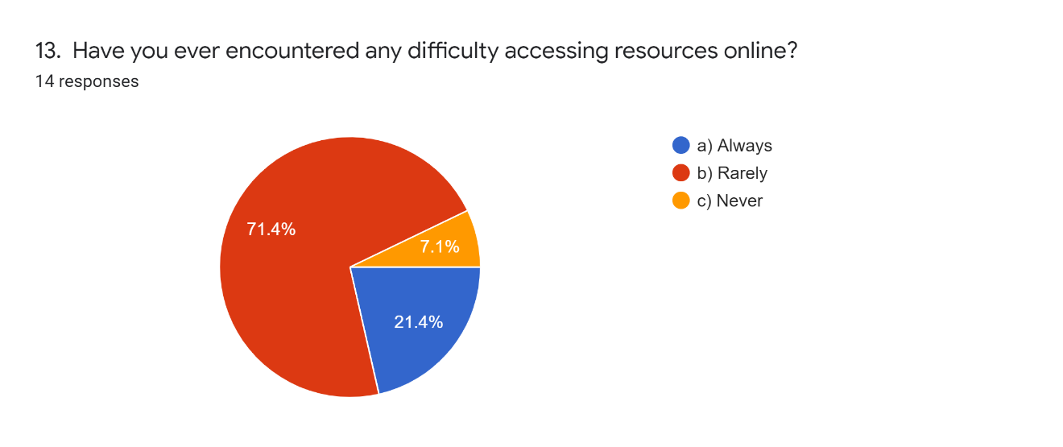

Appendix 14



