University of Wales Trinity Saint David

School of Engineering



Engine Management System Analysis

Electrical Control System (ACHA4010)
BEng Motorsport Engineering

Franklin Spencer Tim Attwood
2004876
March 2021

Table of Contents
Table of Figures and Tables 3
Tables 3
Figures 3
1 Introduction 5
2 Testing 6
2.1 Equipment 6
2.1.1 Diagnostic Station 6
2.1.2 Digital Multi-meter 8
2.2 Test Procedure – L.E. 3 Jetronic 9
2.2.1 Static Ignition Off/On 9
2.2.2 Sensors and Actuator – Static Test 9
2.2.3 Sensors and Actuators – Live Test 9
2.3 Test Procedure – Motronic 1.5 11
2.3.1 Static Ignition Off/On 11
2.3.2 Sensors and Actuators – Static Test 11
2.3.3 Sensors and Actuators – Live Test 11
2.4 Working practices 13
3 Results 14
3.1 Static Test Results 14
3.1.1 L.E. 3 Jetronic 14
3.1.2 Motronic 1.5 16
3.2 Live Tests 20
3.2.1 Jetronic Warm-up Phase 20
3.2.2 Motronic Warm-up Phase 20
3.2.3 Engine Sensors 22
3.2.4 Spark 25
3.2.5 Injection 28
4 System comparison 31
5 System Modifications 32
6 Conclusion 33
7 References 34

Table of Figures and Tables

Tables
Table 1 - Jetronic Static Ignition Off Results 14
Table 2 - Jetronic Static Ignition on Results 14
Table 3 - Jetronic Injector Resistances 16
Table 4 - Motronic Static Ignition Off Results 16
Table 5 - Motronic Static Ignition on Results 17
Table 6 - Motronic Injector Resistances 19
Table 7 – Jetronic Injection On-time During Warm-up Phase 20
Table 8 – Jetronic NTC 2 Temperature Sensor Voltage and Resistance 20
Table 9 - Motronic Warm-up Phase Data 21
Table 10 - Motronic NTC 2 Specification 21

Figures
Figure 1 - Bosch BEA 850 Diagnostics Station 6
Figure 2 - Example of an Oscilloscope Display (Vinci, 2021) 7
Figure 3 - Multi-meter Used 8
Figure 4 - Bosch L.E. 3 Jetronic Schematic 15
Figure 5 - Motronic ECU Pinout 18
Figure 6 – Jetronic Crankshaft Position Sensor Signal Waveform 22
Figure 7 - Motronic Crankshaft Position Sensor Signal Waveform 22
Figure 8 - Engine Speed Signal to Fuel Management Waveform 23
Figure 9 - Motronic IACV Wave Patterns 24
Figure 10 - AFM and TPS Wave Patterns 24
Figure 11 - Motronic Lambda Sensor Wave Pattern 25
Figure 12 – Jetronic Amplifier Pins 1 & 4 Waveforms 25
Figure 13 - Motronic Ignition Primary Waveform 26
Figure 14 – Jetronic Secondary Waveform 27
Figure 15 - Motronic Secondary Waveform 27
Figure 16 – Jetronic Injector Waveform at Idle 28
Figure 17 - Motronic Injector Waveform at Idle 28
Figure 18 – Jetronic Injector Waveform During Acceleration 29
Figure 19 - Motronic Injector Waveform During Acceleration 29
Figure 20 – Jetronic Injector Waveform During Deceleration 30
Figure 21 - Motronic Injector Waveform During Deceleration 30

Introduction
In this report the operation and control of two different engine management systems will be investigated, the Bosch L.E. 3 Jetronic system and the Bosch Motronic 1.5 system. Each system controls its own engine on an engine test stand where the electronics are monitored using test equipment in a workshop environment. There will be several tests which will be done under two main conditions static where the engine is not running and live tests with the engine running. During the tests electrical data will be collected and analysed and comparisons will be made to manufacture specifications. The main difference between the two systems will be compared along with any modifications that could be made to one of the systems.

Testing

Equipment
For the analysis of both engines two devices were used, a Bosch BEA 850 diagnostics station and a digital multi-meter.

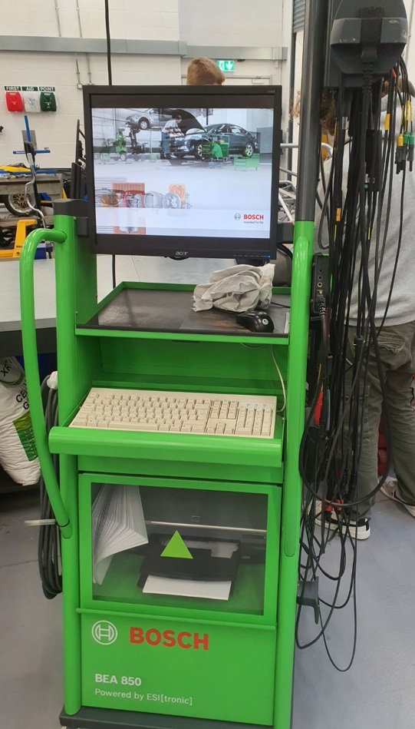
Diagnostic Station
Figure 1 - Bosch BEA 850 Diagnostics Station
The Bosch BEA 850 is a diagnostic station with many different functions ranging from exhaust-gas testing to oscilloscopes, a full list of the features is as follows:

- On-board diagnostics OBD
- Gas values CO, CO2, O2, HC, lambda, NO (option)
- Lambda sensor voltage (graphical display)
- Moment of ignition and dwell angle, advance angle
- Speed measurement
- Oil temperature measurement
- Multiple curves: Up to 6 measured variables can be shown simultaneously as a curve: CO, CO2, O2, HC, lambda, NO (option), speed, moment of ignition, dwell angle, oil temperature and battery voltage
(Robert Bosch GmbH, 2012, p. 4)

During the tests on the engines only the oil temperature measurement and oscilloscope functions were used to analyse the components. The oil temperature is measured using a temperature prob which goes in place of the engine oil dip stick and set to the level of the engine oil, the temperature value is then displayed on the monitor. The oscilloscope (scope) function measures voltage but unlike a voltmeter it measures the voltage against time on a graph, “voltage is displayed vertically on the Y axis and time is represented horizontally on the X axis.” Vinci (2021) This is a real time graph so voltage changes can be seen as and when they happen however the graph can be paused to analyse the data from a snapshot time.
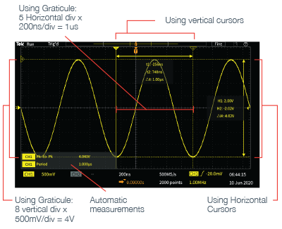
Figure 2 - Example of an Oscilloscope Display (Vinci, 2021)
For the tests carried out it would have been possible to use a lab oscilloscope however for use in workshop environment a diagnostics station which is designed for workshop use is a far better option. Most lab oscilloscopes are designed to be used on workbenches which for bench testing an ECU is fine but in this case where a running engine is being tested on a test stand the diagnostics station more suitable. The same can be said about the oil temperature monitoring, using a temperature prob and simply having a separate display showing the temperature would be fine however it means additional wires and displays all of which are incorporated in the diagnostic station making it an obvious choice. The BEA 850 is an older unit which is adequate for the two systems being tested with early types of on-board diagnostics however for a more modern fuel injection system which uses European on-board diagnostic (EOBD) a more capable diagnostics station would be required to read and analyse the system.

Digital Multi-meter
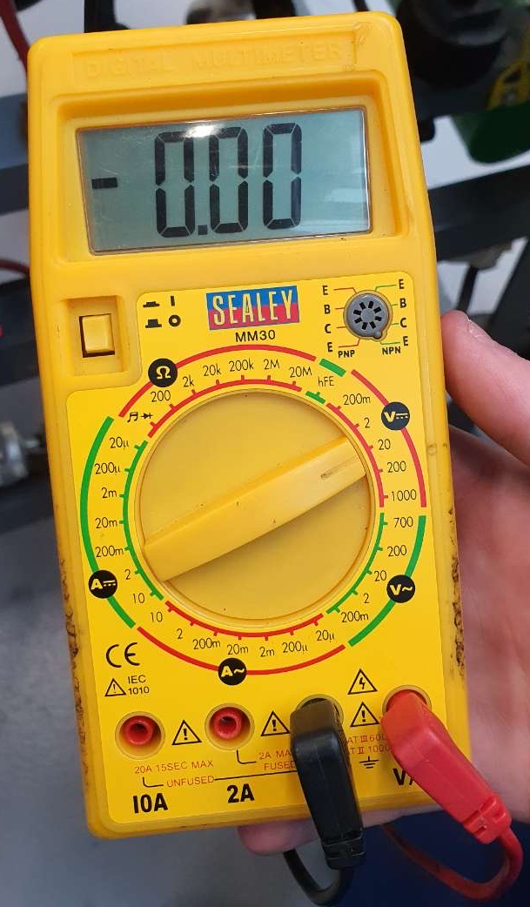
The multi-meter was used as a voltmeter to measure the voltage of the pins on the ECUs, sensors, and switches, in addition it was used as an ohmmeter to measure the resistance of other sensors and the continuity of switches. For the voltage measurements the multi-meter was set to a range of 20V which measures voltages up to 20V with two decimals places e.g. 12.67V. When using the muti-meter as an ohmmeter it was set to 200Ω which is adequate for most measurements of the sensors. When measuring resistance with the multi-meter it is important to measure the resistance of the leads which in this case was 0.2Ω which needs to be taken away from the resistance shown on the display. Although separate meters could be used to measure the sensors it would require an ammeter, voltmeter, and ohmmeter which both adds cost and complexity when one could simply use a multi-meter which combines all three types into one unit and then only the mode needs to be changed to measure the different voltages and resistances.
Figure 3 - Multi-meter Used

Test Procedure – L.E. 3 Jetronic

Static Ignition Off/On
- First the battery isolator was turned on and the battery voltage is measured using the voltmeter set to the appropriate voltage range. It is important to note the ignition key remains off initially.
- Now the COM lead on the muti-meter can be connected to a suitable ground such as the battery negative and using the other lead every pin on the spark advance control unit can probed and the voltages noted down. Not all pins on the module will be terminated so for these pins note them down as no connection.
- The same process is then repeated on the ignition amplifier and the fuel injection module.
- Now the ignition key is turned on and the battery voltage measured again. Then the voltages on the pins on the 3 modules can be measured again.

Sensors and Actuator – Static Test
The following tests use the multi-meter set to ohms with a range of either 200Ω or 2kΩ.

Throttle Switch – The connector is disconnected from the switch then the multi-meter is used to probe pins 2 & 18 then pins 3 & 18 making notes of the resistance values. Note the throttle is left at the idle position during this test.

Auxiliary Air Valve – With the plug disconnected the two pins can be probed and the resistance value noted.

Injectors – The injector plug is disconnected and the two pins on the injector are probed with the multi-meter and the resistance value is noted down, this process is repeated for all 4 injectors.

Sensors and Actuators – Live Test
In the live test the engine is run through its warm-up phase while several sensors and actuators are analysed using both the diagnostic station and multi-meter. The oil temperature probe is used to monitor the engine temperature, the battery is connected to the diagnostic station for a voltage reference on the scope and pin 3 on the fuel injection module is connected to channel one on the scope. The oil temperature is displayed on the screen to monitor, and the oscilloscope shows the injector voltage from which the injector on-time can be observed.

- The static engine temperature is recorded then the engine is started, looking at the scope to note the time of first injection, how long it took to start, and the normal injection time once started.
- Now the engine is left to run until the engine temperature reaches 20ºC at which point the engine is stopped and the resistance of pin 8 is measured with the multi-meter followed by the voltage at pin 8. The engine is then restated and the injection on time is recorded.
- The engine is now left running to increase the temperature by 10ºC at which point step 2 is repeated recording the values for 30ºC. This continues until the engine temperature reaches 60ºC.
- Finally the injection on-time can be recorded for the maximum recorded engine temperature.
With the engine now at operating temperature pin 1 on the amplifier can be connected to channel one and pin 4 connected to channel two on the oscilloscope. The primary wave can be measured from pin 1 and the dwell time noted, pin 4 gives the spark advance signal which can be compared to the primary wave form.

Test Procedure – Motronic 1.5

Static Ignition Off/On
This test is the same as the Jetronic however there is only one module (the ECU) to probe and measure the pin voltages.

Sensors and Actuators – Static Test
The following tests use the same multi-meter setting as the Jetronic tests.

Throttle Position Sensor (TPS) – Disconnect the connector from the sensor and probe pins 1 & 2 and note the resistance value. Now probe pins 1 & 3 with the throttle fully open and note the values

Airflow Meter (AFM) – With the connector disconnected, pins 4 & 2 are probed and measured followed by pins 4 & 3.

Injectors – The injectors are measured the same way as the Jetronic system.

Idle Air Control Valve (IACV) – The same process of measuring the injectors.

Sensors and Actuators – Live Test
This test on the Motronic system is very similar to the Jetronic test however many more components are measured. The oil temperature probe is still used but pin 16 is connected to channel one and pin 4 connected to channel two of the scope. Pin 16 is the injector voltage from which the injector on-time can be observed and pin 4 is the idle speed control signal. Pin 28 is connected to the lambda monitor on the diagnostic station which will indicate the switching of the lambda sensor and pin 5 is connected to show when the fuel tank purge valve operates.
- The engine temperature is measured before the engine is started and the injection on-time is noted for the cold start.
- The engine is now left to warm up to 20ºC at which point it is switched off and pin 44 (NTC 1) and pin 44 (NTC 2) voltages are measured with the ignition on but engine not running, NTC 2 resistance is also measured with the connector unplugged. The engine is then restarted, the injection on-time is recorded along with the idle speed control pulse signal and the switching of both the tank purge valve and lambda sensor are noted. In addition when the electric cooling fan actives the temperature at which it activates need to be noted.
- The engine is then warmed up a further 10ºC at which point step 2 is repeated making notes of all the values except for NTC 1 which will not be measured until 80ºC. This step is repeated until the final temperature of 80ºC.

Working practices
The testing of the engines took place in a workshop where several health and safety protocols needed to be followed.
- The necessary personal protective equipment (P.P.E.) must always be worn, this includes protective overalls, steel toecap boots and safety glasses.
- Exhaust from the engine needs to be extracted using the extractor system to ensure there is no build of exhaust fumes in the workshop.
- Special care needs to be taken when the engine is running especially around the spinning components such as the flywheel and ancillary drive running the alternator and water pump. These spinning components must not be touched, and care must be taken to not allow wires to be caught in them.
- The engines will get very hot when running a care must be taken not to touch hot surfaces such as the radiator, engine block and exhaust.
- The electric cooling fan will be spinning later in the tests so care must be taken to stay clear of the fan even when it is not spinning as it may start up at any time when then engine is warm.

Results

Static Test Results

L.E. 3 Jetronic
Table 1 - Jetronic Static Ignition Off Results
L.E. 3 Jetronic
Static Ignition Off
Battery Voltage = 12.26V
Spark Advance Control Unit | Ignition Amplifier | Fuel Management
Pin 1 – 15 = 0V  Pin 4 and 9 = no connection | Pin 1-3 = 0V | Pin 1 – 15 = 0V  Pin 6, 7, 9, 11, 13 = no connection

On the Jetronic system there was no expectation for any of the pins to have voltage on them due to the system having very little adaptive control. If the system did have adaptive control, it would require power to be constantly supplied to it to keep the adaptive control data stored in volatile memory. With the battery voltage at 12.26V according to VARTA (2022) the battery is partly charged being between 12.0V and 12.4V and should be charged as soon as possible.
Table 2 - Jetronic Static Ignition on Results
L.E. 3 Jetronic
Static Ignition On
Battery Voltage = 11.98V
Spark Advance Control Unit | Ignition Amplifier | Fuel Management
Pin 1 = 0.03V | Pin 1 = 11.67V | Pin 1 = 0.06V
Pin 2 = 0.03V | Pin 2 = 0.02V | Pin 2 = 11.70V
Pin 3 = 11.60V | Pin 3 = 11.67V | Pin 3 = 0V
Pin 5 = 0.06V | Pin 4 = 0.13V | Pin 4 = 0.02V
Pin 6 = 0.03V |  | Pin 5 = 0.03V
Pin 7 = 2.47V |  | Pin 8 = 1.97V
Pin 8 = 0.95V |  | Pin 10 = 0.15V
Pin 10 = 0.03V |  | Pin 12 = 11.78V
Pin 11 = 0.03V |  | Pin 14 = 4.97V
Pin 12 = 0.06V |  | Pin 15 = 0.02V
Pin 13 = 0.13V |  | Pin 6, 7, 9, 11, 13 = no connection
Pin 14 = 4.97V
Pin 15 = 0.14V
Pin 4 and 9 = no connection

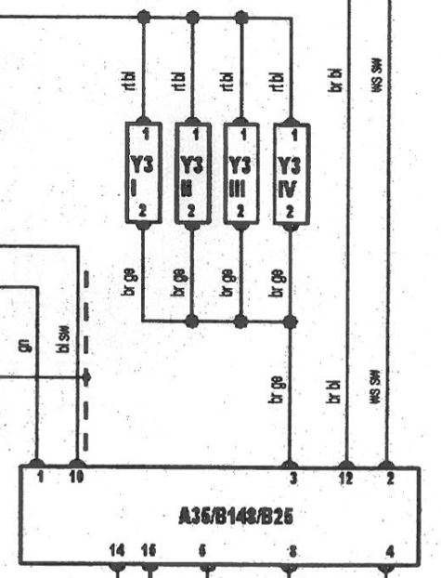
Now with the ignition on, the battery voltage drops slightly to 11.98V which is normal due to the electrical load and all the terminated pins have voltage except for pin 3 on the fuel management. Pin 3 showing absolutely 0V means there is no path for current flow at all meaning pin 3 is likely to be connected to the injectors or be an earth, this is confirmed when looking at the schematic for the Jetronic system. As seen in the schematic the 4 injectors are grouped together and when the fuel management wants to inject fuel it pulses all 4 at the same time. This is known as multi-point fuel injection (MPFI) where “all injectors will spray fuel at the same time. This will keep the fuel sprayed even if one cylinder is in the combustion step.” (Muchta, 2018)

Figure 4 - Bosch L.E. 3 Jetronic Schematic
Throttle Switch – As per the workshop manual, pins 2 & 18 are probed with the throttle closed and the resistance is measured at 0Ω then pins 3 & 18 are probed with the throttle closed. The multi-meter shows 1 for pins 3 & 18 which means open circuit or infinite resistance, in this case both readings are within the specification given in the workshop manual.

Auxiliary Air Valve – The resistance measured on the valve was 45.6 Ω and the specification given is 40Ω, the manual does not give a tolerance for the air valve therefore it would be seen to be out of tolerance however the likely hood is the value would likely operate correctly anyway.

Injectors – The manual states the injectors should be between 15 and 17Ω and as seen in the table below all the injectors are with in spec.

Table 3 - Jetronic Injector Resistances
Injector | Resistance (Ω)
1 | 15.5
2 | 15.5
3 | 15.6
4 | 15.6

Motronic 1.5
Table 4 - Motronic Static Ignition Off Results
Bosch Motronic
Static Ignition Off
Battery Voltage = 12.44V
Pin 1 = 0V | Pin 16 = 0V | Pin 37 = 0V
Pin 2 = 0V | Pin 17 = 0V | Pin 40 = 0V
Pin 3 = 0V | Pin 18 = 12.67V | Pin 41 = 0V
Pin 4 = 0V | Pin 19 = 0V | Pin 42 = 0V
Pin 5 = 0V | Pin 22 = 0V | Pin 44 = 0V
Pin 6 = 0V | Pin 24 = 0V | Pin 45 = 0V
Pin 7 = 0V | Pin 26 = 0V | Pin 46 = 0V
Pin 10 = 0V | Pin 27 = 0V | Pin 48 = 0V
Pin 12 = 0V | Pin 28 = 0V | Pin 49 = 0V
Pin 13 = 0V | Pin 32 = 0V | Pin 53 = 0V
Pin 14 = 0V | Pin 36 = 12.36V | Pin 55 = 0V
Some pins do not exist on this ECU hence the missing pins in this table.

Since the Motronic 1.5 has some adaptive control, it is expected to have a constant power supply to the ECU and both pins 18 and 36 both have battery power on them.

Table 5 - Motronic Static Ignition on Results
Bosch Motronic
Static Ignition On
Battery Voltage = 12.37V
Pin 1 = 12.47V | Pin 16 = 12.24V | Pin 37 = 12.24V
Pin 2 = 0.04V | Pin 17 = 12.34V | Pin 40 = 0.07V
Pin 3 = 12.34V | Pin 18 = 12.35V | Pin 41 = 0.07V
Pin 4 = 9.93V | Pin 19 = 0.03V | Pin 42 = 0.04V
Pin 5 = 12.27V | Pin 22 = 0.92V | Pin 44 = 3.47V
Pin 6 = 11.57V | Pin 24 = 0.04V | Pin 45 = 1.57V
Pin 7 = 0.32V | Pin 26 = 0.07V | Pin 46 = 0.07V
Pin 10 = 0V | Pin 27 = 12.31V | Pin 48 = 0.06V
Pin 12 = 5.07V | Pin 28 = 0.46V | Pin 49 = 0.11V
Pin 13 = 10.29V | Pin 32 = 11.52V | Pin 53 = 0.69V
Pin 14 = 0.04V | Pin 36 = 0.31V | Pin 55 = 11.21V
Some pins do not exist on this ECU hence the missing pins in this table.

Like the Jetronic system with the ignition on the battery voltage drop slightly although the voltage does not drop quite as much as the Jetronic possibly due to the Motronic system being more efficient. Looking at pin 10 being 0V it can either be an injector or an earth and in this case looking at the ECU pinout below it shows it as an earth.
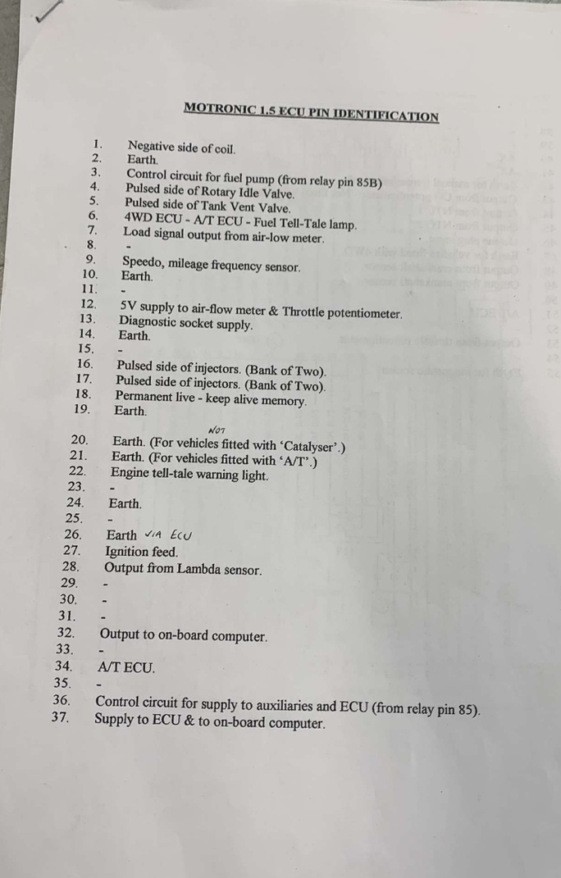
Figure 5 - Motronic ECU Pinout
Throttle Position Sensor – As pointed out in the workshop manual pins 1 & 2 are measured with the throttle closed to be 2000Ω which is within the 1900 to 2000Ω specification. Pins 1 & 3 are now measured but this time with the throttle fully open and measured to be 2580Ω which is over the 2000Ω limit however many ECUs can be calibrated to read the range of the throttle position sensor.

Idle Air Control Valve – Probing the two pins the resistance is found to be 8.2Ω which is only 0.2Ω over the specification and is unlikely to affect the operation of the valve.

Air Flow Meter (AFM) – Pins 4 & 2 are measured at 33Ω which is within the 8 to 2500Ω spec, pins 4 & 3 are then measured at 560Ω which is only 10Ω out of the 300 to 550Ω spec indicating the air flow meter is probably worn out.

Injectors – Just like the Jetronic system the manual states the injectors should be between 15 and 17Ω and again all the injectors are with in spec.
Table 6 - Motronic Injector Resistances
Injector | Resistance (Ω)
1 | 16.3
2 | 16.2
3 | 16.4
4 | 16.4

Live Tests

Jetronic Warm-up Phase
Starting the engine from cold the scope measured the first injection event at 77.1ms and the injection time was 6.4ms, the engine took approximately 500ms to start.
As can been seen in the table below, injection on-time is decreased meaning less fuel is injected as the engine temperature increases.
Table 7 – Jetronic Injection On-time During Warm-up Phase
Approximate Oil Temperature (ºC) | Injection On-time (ms)
20 | 3.5
30 | 3.4
40 | 3.2
50 | 2.8
60 | 2.8
The NTC 2 coolant temperature sensor is used by the fuel management module to adjust the injection on-time based on the engine temperature. Throughout the warm-up phase the NTC 2 sensor was measured at each temperature interval, the 20ºC resistance value of 1830Ω can be compared to the spec given in the manual of 2100 to 2900Ω and the sensor is out of range suggesting the sensor maybe damaged. However, as the oil temperature is being measured and not the coolant temperature which is what the NTC 2 sensor measures it is more likely that the coolant temperature is not at the same 20ºC as the oil.
Table 8 – Jetronic NTC 2 Temperature Sensor Voltage and Resistance
Approximate Oil Temperature (ºC) | NTC 2 Pin 8
Approximate Oil Temperature (ºC) | Resistance (Ω) | Voltage (V)
20 | 1830 | 1.5
30 | 1020 | 1.1
40 | 770 | 0.9
50 | 530 | 0.7
60 | 400 | 0.5

Motronic Warm-up Phase
For the Motronic system while cranking injection on-time was 20.3ms but quickly dropped once the engine started, as can be seen in the table below just like the Jetronic system as temperature increases the injection on-time decreases except at the 70ºC where it bumped up to 2.9ms. This was because the thermostatic cooling fan turned on which add significant electrical load to the engine consequently the ECU recognises that and added more fuel and air to account for the extra load, this is evident with the IACV and injection on-time. The tank vent solenoid starts to switch anywhere between 40 and 51ºC and the lambda switching starts between 28 and 37ºC.
The NTC 2 values can be compared to the manufacture’s specification and like Jetronic test the values look like they are out of the limits, but this is likely because of the temperature difference between the oil and coolant.
Table 9 - Motronic Warm-up Phase Data
Approximate Oil Temperature (ºC) | NTC 2 Pin 45 |  | NTC 1 pin 44 | Injection On-time (ms) | IACV Pin 4 (%) | Tank Vent Pin 5 | Lambda Sensor Pin 28
Approximate Oil Temperature (ºC) | Resistance (Ω) | Voltage (V)
20 | 1830 | 3.2 | 3.7 | 3.3 | 43 | Off | Off
30 | 1033 | 2.6 | N/A | 3.3 | 42 | Off | Switching
40 | 673 | 2.0 | N/A | 3.5 | 41 | Off | N/A
50 | 453 | 1.6 | N/A | 2.7 | 40 | Switching | N/A
60 | 327 | 1.3 | N/A | 2.8 | 40 | N/A | N/A
70 – Fan on | 247 | 1.0 | N/A | 2.9 | 43 | N/A | N/A
80 | 251 | 1.0 | 3.3 | 3.1 | 44 | N/A | N/A

Table 10 - Motronic NTC 2 Specification
Temperature (ºC) | NTC 2 Resistance (Ω)
0 | 4800 - 6600
20 | 2200 – 2800
40 | 1000 - 1400
80 | 270 - 380

Engine Sensors

Crankshaft Position Sensor Signal
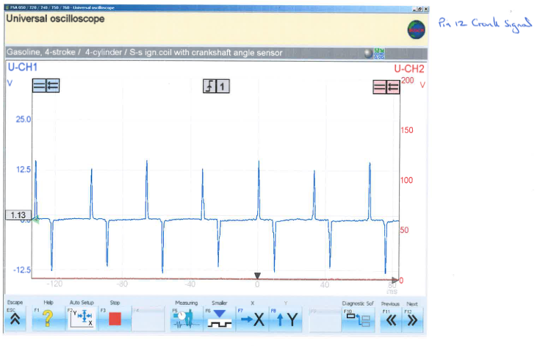
Figure 6 – Jetronic Crankshaft Position Sensor Signal Waveform
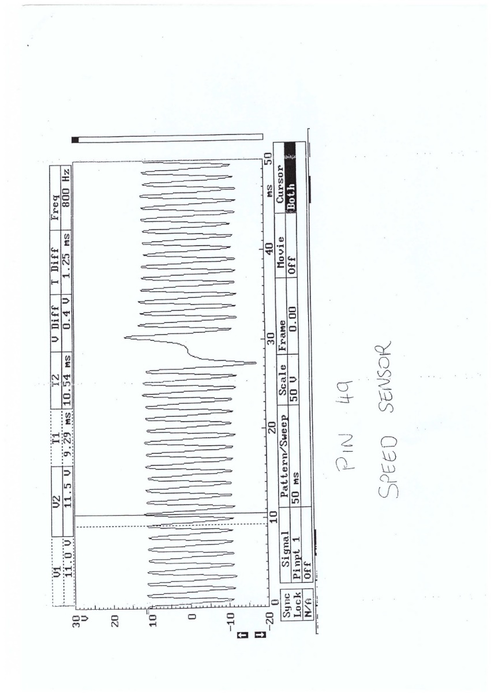
Figure 7 - Motronic Crankshaft Position Sensor Signal Waveform
These waveforms show the crankshaft position sensor signal which is a magnetic reluctance sensor which is a self-energising sensor meaning it does not need external power. This type of sensor creates an analogue signal which can be seen in the waveform above,” this output voltage will increase in magnitude and frequency as the engine rpm rises and the speed at which the reluctor passes the sensor increases.” (Land Rover, 2004, p. 144) The ECU needs to convert this signal to digital requiring an analogue to digital converter to be used which creates a delay before the ECU can read the digital signal.

Engine Speed Signal to Fuel Management (Jetronic Only)
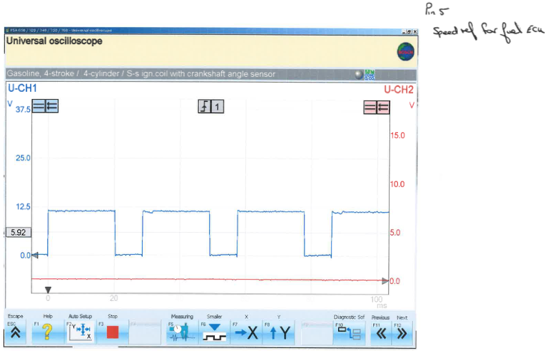
Figure 8 - Engine Speed Signal to Fuel Management Waveform
This square wave shown above is the digital speed signal running from the spark advance unit to the fuel management module, the frequency of the square wave will increase as engine speed increases but is magnitude will not.

Idle Air Control Valve (Motronic Only)
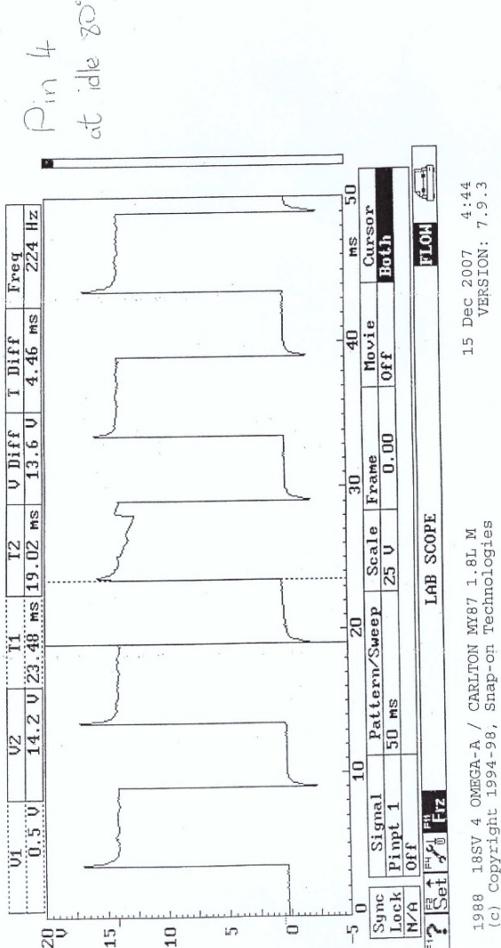
Figure 9 - Motronic IACV Wave Patterns
This shows the IACV pulses keeping the engine at a constant idle speed.

AFM and TPS (Motronic Only)
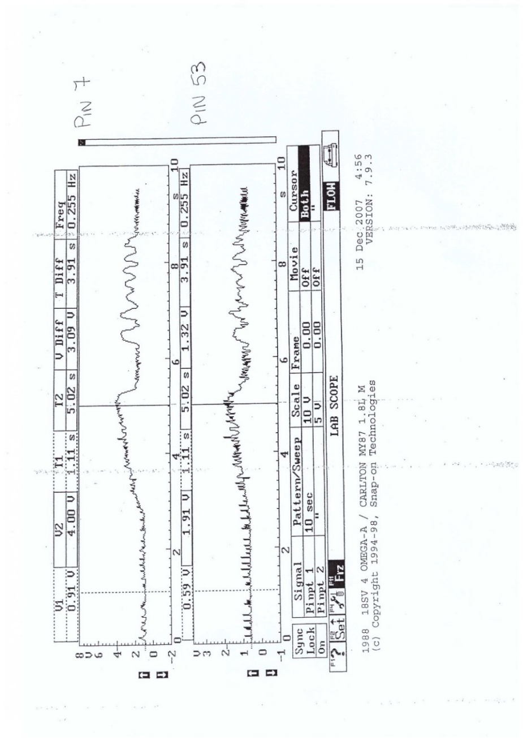
Figure 10 - AFM and TPS Wave Patterns
This shows both the air flow meter and throttle position sensor when the engine was given some throttle and when the throttle was increased the air flow meter reading also increases indicating more air entering the engine.

Lambda Sensor (Motronic Only)
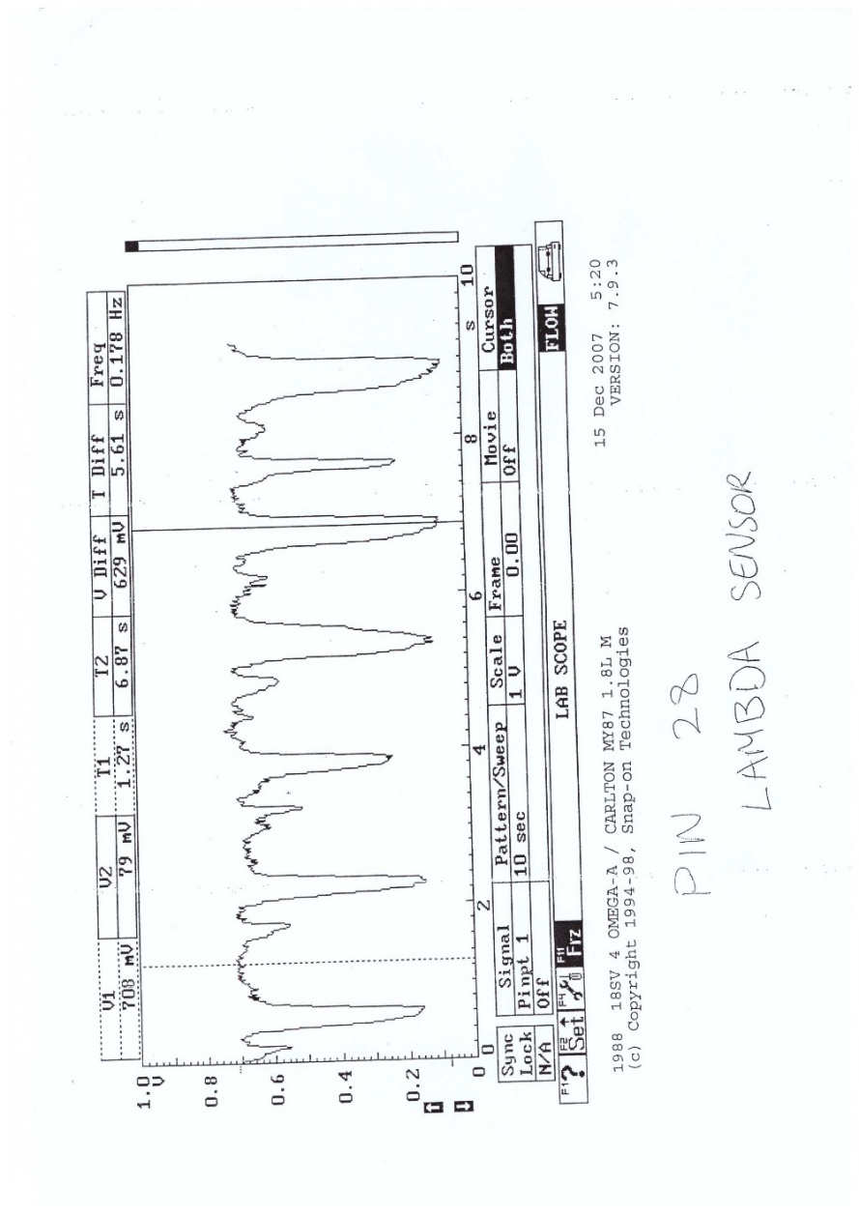
Figure 11 - Motronic Lambda Sensor Wave Pattern
The switching of the lambda sensor is shown here where the sensors read lean when the voltage drops then rich when the voltage increases again.

Spark

Primary Waveform
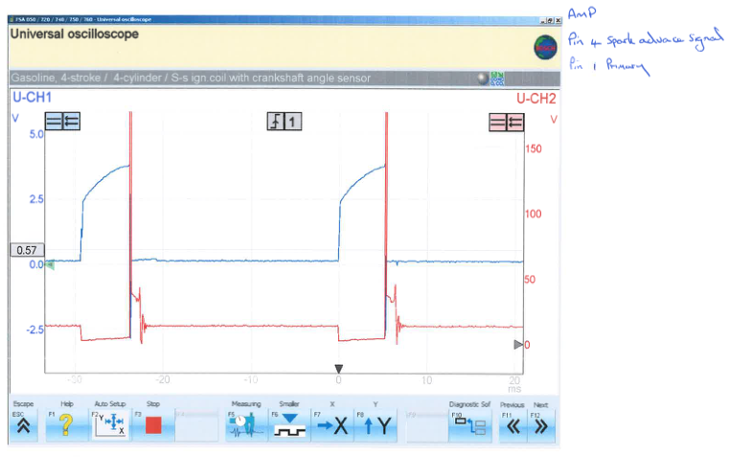
Figure 12 – Jetronic Amplifier Pins 1 & 4 Waveforms
Pin 4 (blue line) is the signal from the spark advance unit to the amplifier to tell the amplifier to charge up the ignition coil (dwell time) and the red line is pin 1 which is the output from the amplifier to the ignition coil. The dwell time can be seen on both pin 1 and 4 from 0ms to about 5ms, then from 5ms onwards pin 4s voltage drops and pin 1s voltage goes from 0V to 175V this is the back electromotive force (EMF) which is generated from the magnetic field in the coil dropping and inducing a voltage spike, then the spark that ignites the air fuel mix has a duration of about 2ms.
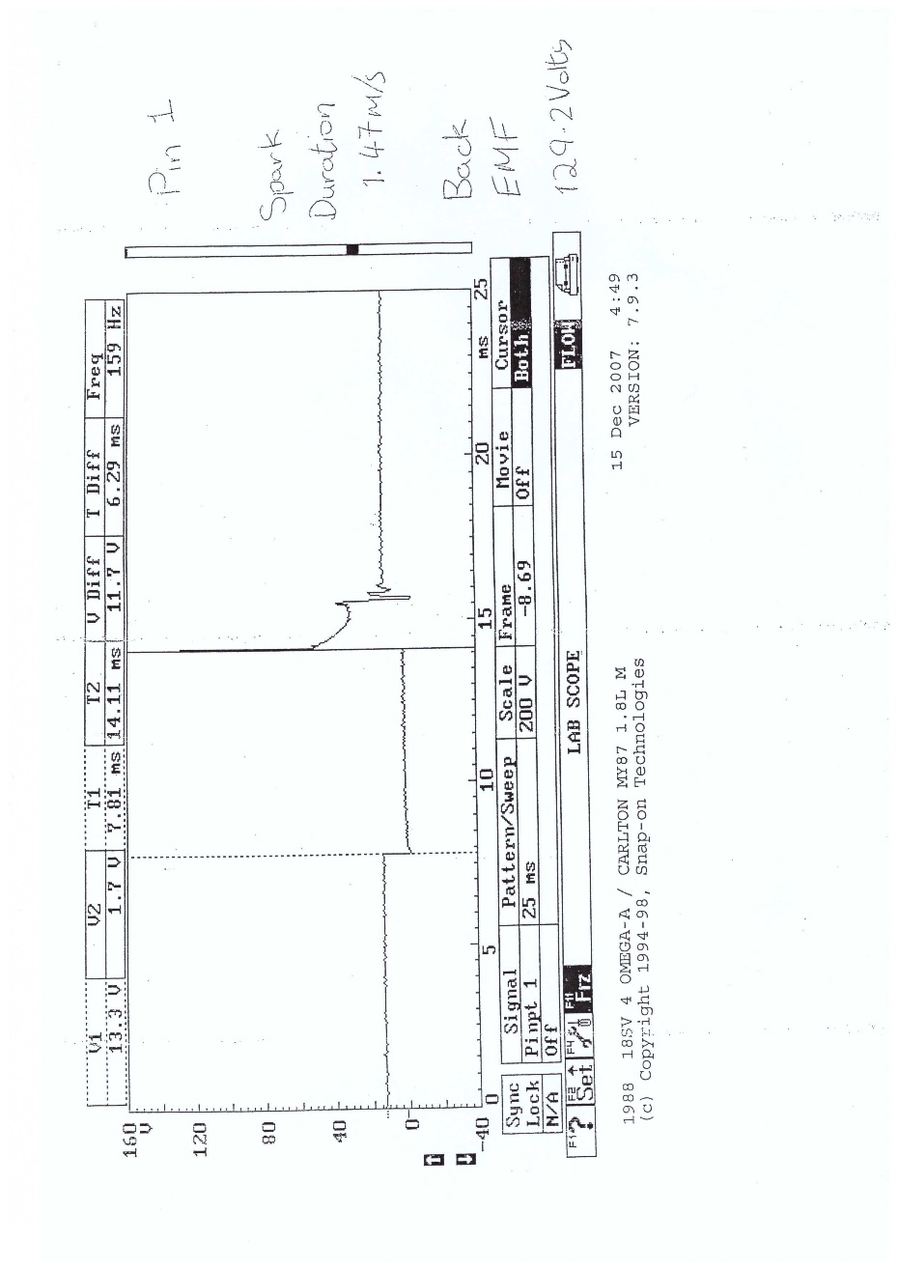
Figure 13 - Motronic Ignition Primary Waveform
On the Motronic system the primary waveform shape looks the same but has 6ms of dwell followed by 129.2V of back EMF and a spark duration of 1.47ms.

Secondary Waveform
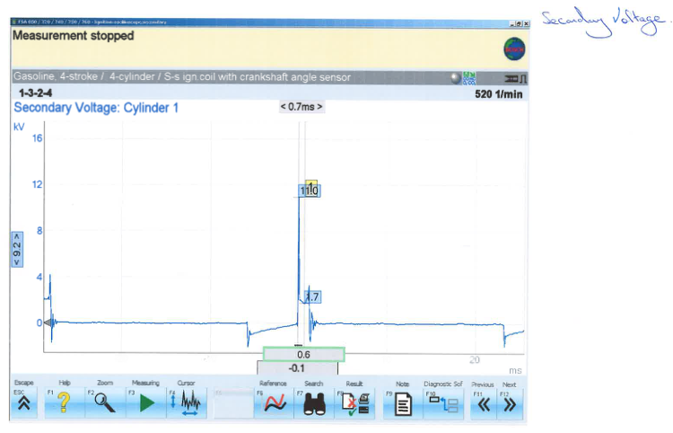
Figure 14 – Jetronic Secondary Waveform
The secondary voltage is the voltage which is sent from the secondary coil winding to the spark plug to ignite the air fuel mix in the engine. The waveform above shows a voltage spike of about 12kV which is when the magnetic field in the coil collapses and induces a large voltage which is what is sent to the spark plug.
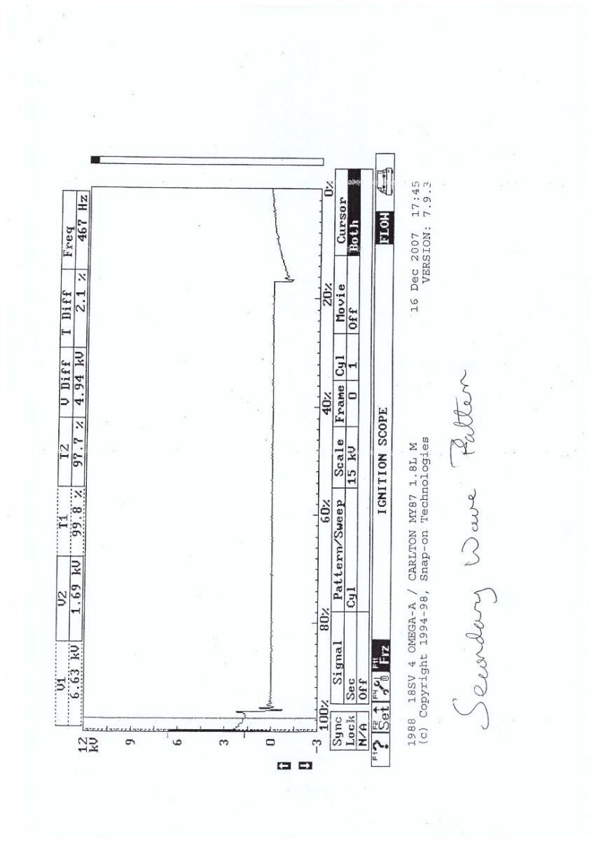
Figure 15 - Motronic Secondary Waveform
As with most of the waveform shapes the Motronic is very similar to the Jetronic however the Motronic has a peak voltage of 6.63kV opposed to the Jetronic’s 12kV.

Injection

Idle – Engine at Operating Temperature
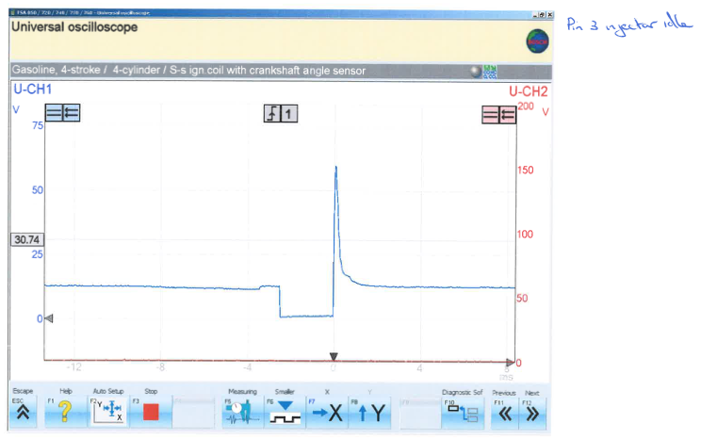
Figure 16 – Jetronic Injector Waveform at Idle
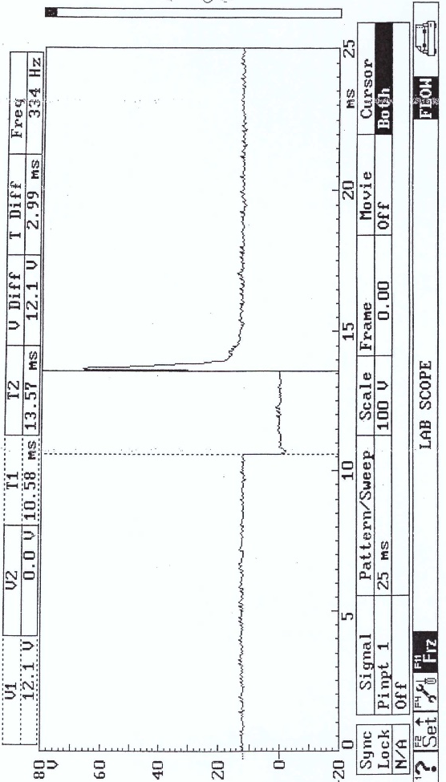
Figure 17 - Motronic Injector Waveform at Idle
With the engine at operating temperature the injection on time for the Jetronic system is about 3ms which is where the voltage drops to 0V because there is no longer potential voltage. The spike of about 60V is the EMF voltage which happens for the same reason as the primary waveform on the ignition amplifier. The Motronic shares the same wave pattern but with 13.5ms injector on-time this is because the Motronic system uses batch injection and pairs 2 injectors together not 4 therefore the 2 injectors need to be open for longer to flow the same amount of fuel as 4 injectors.

Acceleration
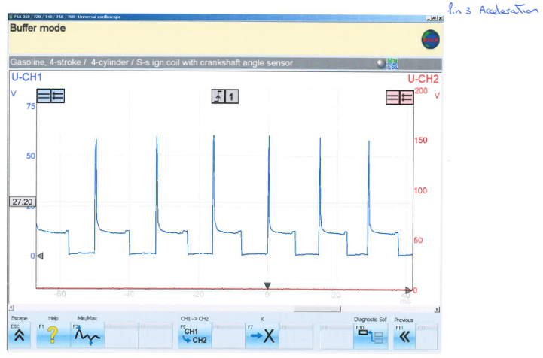
Figure 18 – Jetronic Injector Waveform During Acceleration
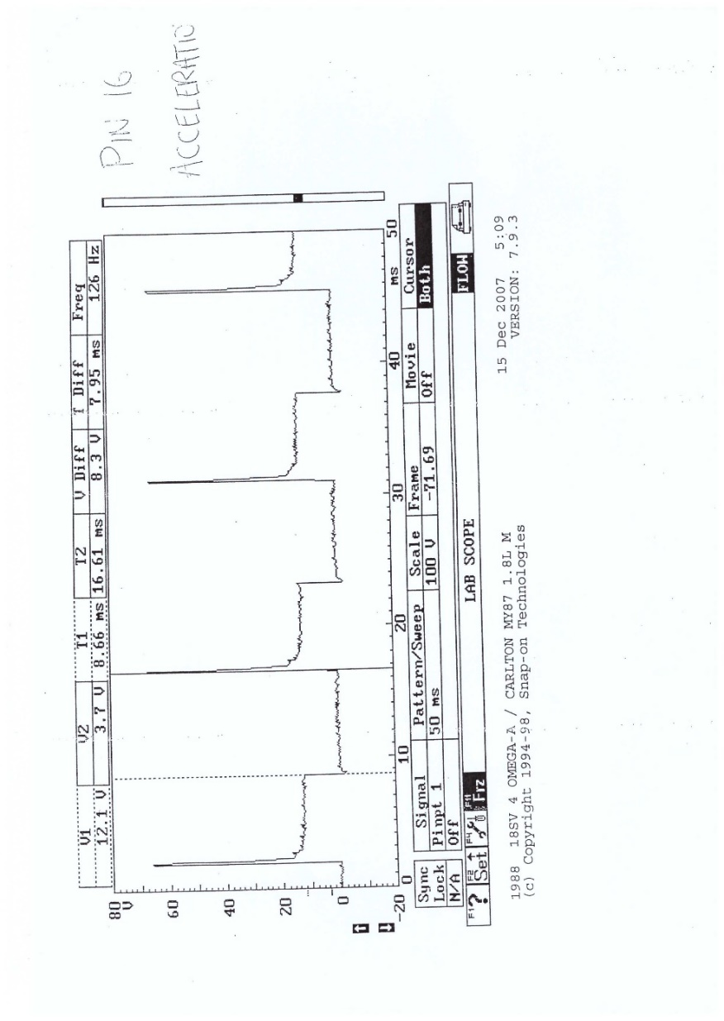
Figure 19 - Motronic Injector Waveform During Acceleration
When the engines accelerate it requires more fuel and while increasing the injector on-time will inject more fuel there is less control and the injector spray pattern can be very poor therefore the frequency of the injector pulses is increase instead.

Deceleration
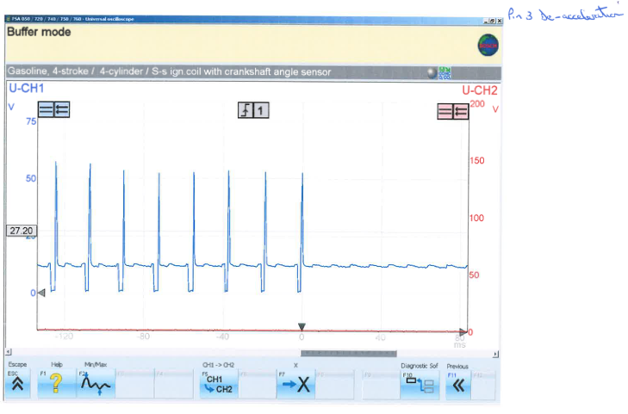
Figure 20 – Jetronic Injector Waveform During Deceleration
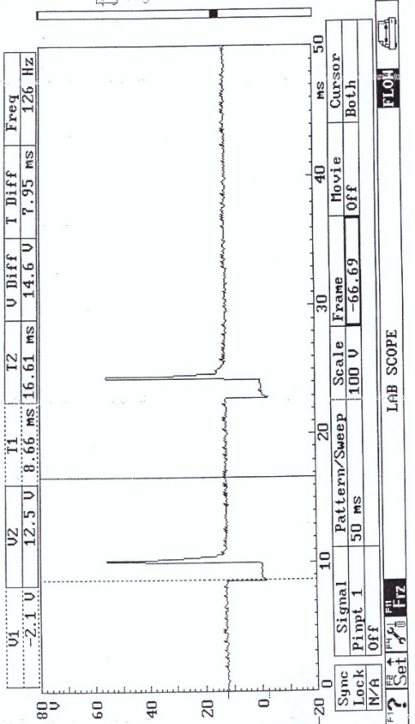
Figure 21 - Motronic Injector Waveform During Deceleration
Under deceleration conditions since the engine speed is above idle and the throttle is closed there is no need for fuel to be injected so instead of pulsing the injectors for an idle speed the ECU simply turn off injection until the engine speed drops to the target and requires fuel again.

System comparison
The main difference between the two systems is the Motronic combines the fuel and spark control into one module which allows for less electrical interference and quicker communications between the fuelling and ignition parts of the system. The Motronic also has closed loop idle control, so it maintains the idle speed no matter of engine load and external conditions where the Jetronic system only has a high idle for low external temperatures (cold starts) and then a normal idle speed for when its fully warmed up.

System Modifications
A good upgrade for the Motronic system would be sequential control of the fuel injectors, this means each injector would be controlled by the ECU separately. The main advantage of this is less fuel is wasted because only the cylinders that need the fuel e.g. the cylinder on the intake stroke would get the fuel. Sequential injection also gives better drivability and means the engine produces less pollution.

Conclusion
In conclusion, both systems run their respected engines correctly and reliably however the Bosch Motronic 1.5 with its adaptive control strategies seem like a better system. The test procedures worked well and the data that was collected had consistent trends when looking at the data. The testing equipment worked well however it would have been advantageous to have the ability to have multiple items displayed at the same time but due to the limitation of the diagnostic station it was not possible. With a sequential injector upgrade the Motronic system would very likely perform even better using less fuel and improving drivability.

References
Land Rover (2002) Electrical Troubleshooting Manual
5th Edition
Solihull: Rover Technical Communication

Land Rover (2004) Bosch 5.2.1 Engine Management System
Solihull: Rover Technical Communication

Muchta (2018) 4 Types of Fuel Injection System with Differences and Explanations
Available at: https://www.autoexpose.org/2018/11/types-of-fuel-injection-system.html
(Accessed: 19/04/2022)

Robert Bosch GmbH (2012) A tidy affair: Emissions Analysis
Available at: http://www.adesystems.co.uk/brochures/bosch_mot_emissions_bea850_bea350_general.pdf
(Accessed: 18/04/2022)

VARTA (2022) Car Battery testing Instructions
Available at: https://batteryworld.varta-automotive.com/en-gb/battery-test-car
(Accessed: 19/04/2022)

Vinci, A (2021) What is an oscilloscope?
[Blog]
Available at: https://www.tek.com/en/blog/what-is-an-oscilloscope
(Accessed: 18/04/2022)

