Policy Zone I on Loch Fyne
Saskia Judd

Evaluation of the Previous Integrated Coastal Management Plan and Suggestions for a Future Management Plan
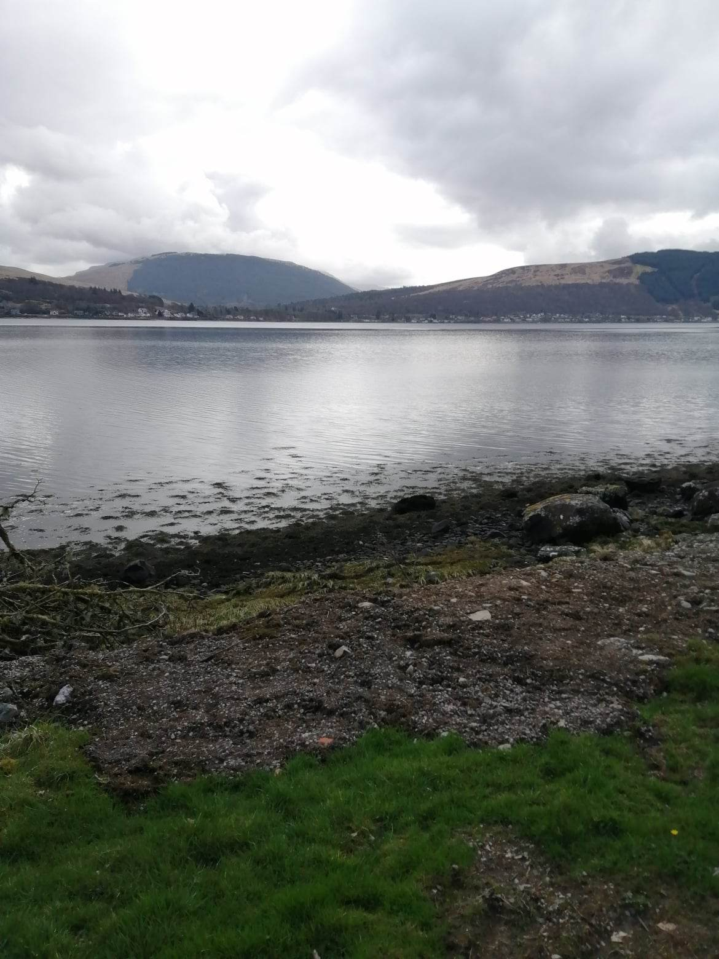
Figure 1 Picture across Loch Fyne (Judd, 2023a)
Contents
1.Introduction 2
2.Site Description 3
2.2 Site Usage 6
2.3 Biodiversity and Ecology 8
2.3.1 Invasive Species 11
2.4 Site Habitats 11
3. Existing management 12
4. Site Visit and GIS Map 14
4.1 GIS Map 15
5. New Management 16
6. Conclusion 21
7. References 22
Appendix One: ICZM Plan Collaborators 25
Appendix Two: Policy Zone I Map 26
Appendix Four: Consultation Table for Aquaculture Developments 28
Appendix Five: Table PZI 29

1.Introduction
Due to the ever-changing nature of Loch environments and anthropogenic activities, management plans are needed to ensure protection of natural areas. In the in the past twenty years, a greater integration of council and governmental sectors is needed to promote and protect local environments.

Integrated Coastal Zone Management (ICZM) Plans are a ‘dynamic, multidisciplinary, and iterative process to promote sustainable management of coastal zones. It covers the full cycle of information collection, planning (in its broadest sense), decision making, management and monitoring of implementation.’
(European Environment Agency, 2000)

Argyll and Bute Council created and produced an Integrated Coastal Zone Management Plan for Loch Fyne after receiving funding for such an undertaking due to the significance of the site. This was approved on 25th November 2009 but did not come into action until 2010. This Plan was originally for 2010 to 2015 and there have not been any updated versions since. The plan was an extension and management side to the 2002 Argyll and Bute Structure Plan (Argyll and Bute Council, 2023). This outlined future objectives of development in the county. The ICZM was also created to complement the Argyll and Bute Development Plan and also offer guidance to any stakeholders who needed it (Argyll and Bute Council, 2023). Due to the nature of ICZM Plan there were many other plans and strategies which had to be integrated into the plan as the Loch is not a standalone feature and is impacted by its surroundings and further issues (Appendix 1). This also ensures compliance with Scottish, UK, and international policies (Argyll and Bute Council, 2010).

An ICZM is more important than ever due to the designation of the North of the Loch in 2014 in which states the site is a Nature Conservation Marine Protected Areas (MPA). These sites are established to maintain and promote sustainable use (JNCC, 2023) There was a previous designation of a Site of Special Scientific Interest in Strone Point from 1990 (Nature Scot, 2023) but with a much larger area, now having a designation and is protected the regulations and activities which are completed at this site need to take the designation into account.

2.Site Description
Perimeter - 15.4Km

Area - Whole Site - 90.53 Km2, Policy Zone I - 55.61 Km2

Grid reference ICZM boundaries - North Boundary - 218940, 712452, South Boundary - 190279, 683255

Policy Zone I Boundaries - North Boundary - 207724, 704272, South Boundary - 203607, 699680

Jurisdiction - Argyll and Bute Council

Habitat type - Coastal Loch with riparian habitat surrounded by Native and Non-Native woodland.

Access within Policy Zone I: There is one access road throughout the site that runs parallel to the Loch boundary, with only one way to enter and exit at the north and south boundaries. These are at the Argyll Caravan Park (North) and the path adjacent to the Granite Quarry (South) (Figure 3). This path connects the small settlements lining the Loch in Policy Zone I. The only other point of access is via boat.
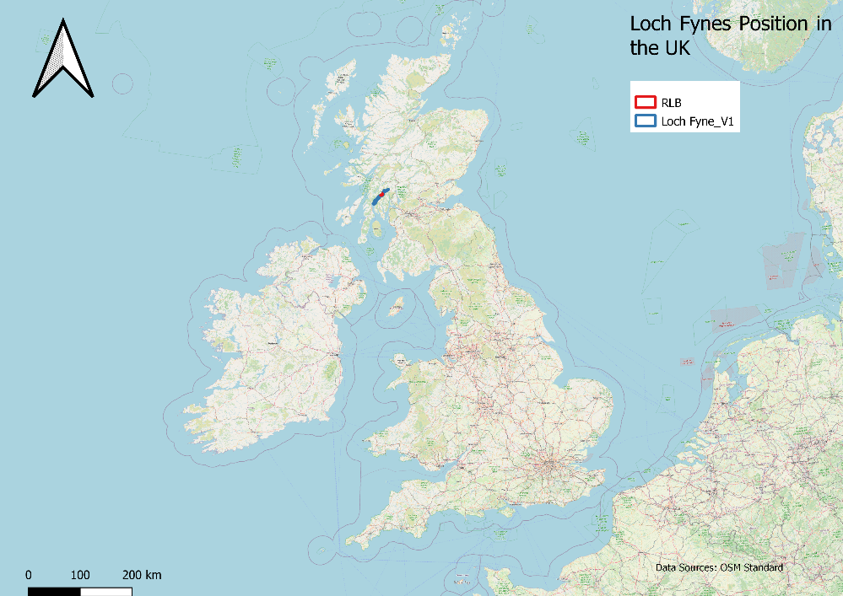

Figure 4 Loch Fyne's position in the UK (QGIS, 2023a, Edited by Judd, 2023)
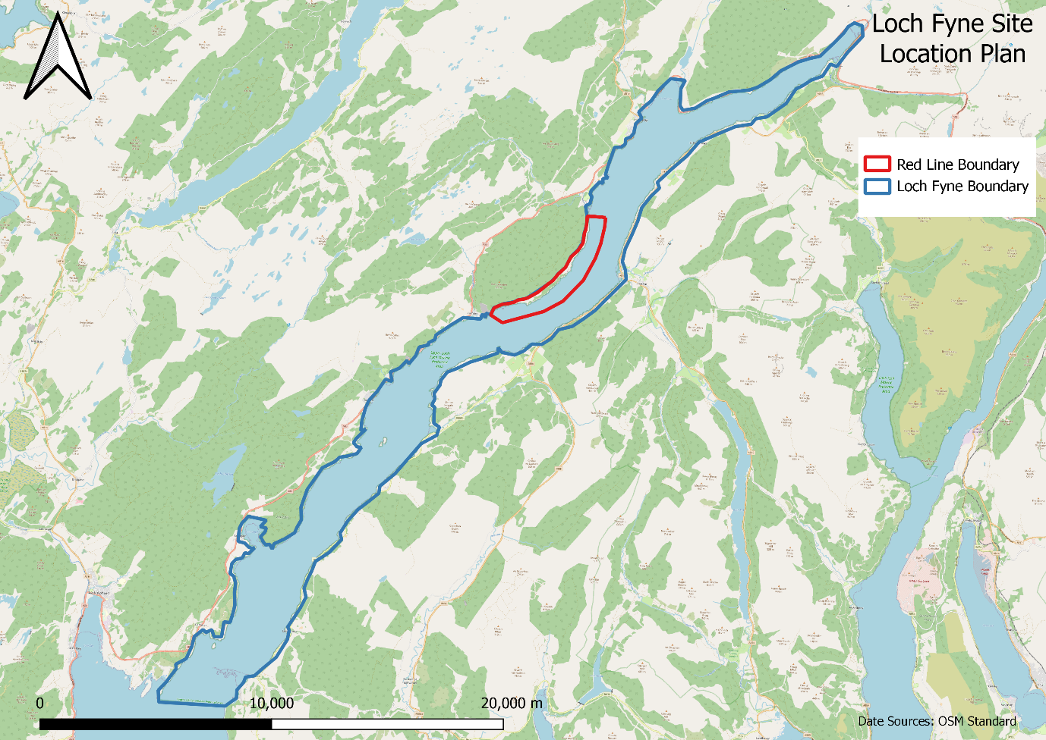
Figure 2 Loch Fyne with Policy Zone I (QGIS, 2023b, Edited by Judd, 2023)

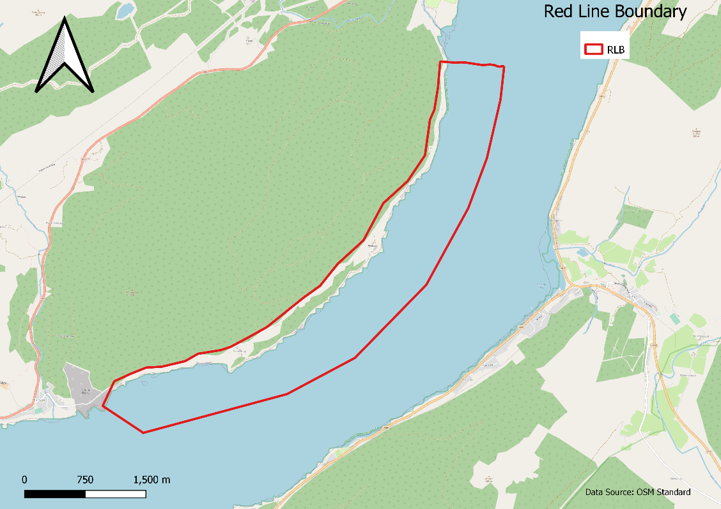

Figure 3 Close up of Policy Zone I with track (QGIS, 2023c, Edited by Judd, 2023)
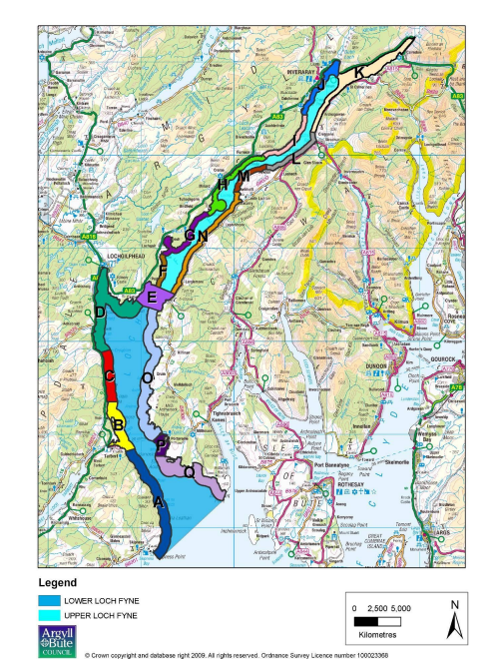
Much like any other coastal management plan, the plan for Loch Fyne is extensive and covers a large area. Due to the size of Loch Fyne the management plan has been broken down into 17 Policy Zones (Figure 5). This research will focus on Policy Zone I which covers the section of the Loch from Furnace to Rubha Nam Frangach.

Figure 5 Diagram of the 17 Policy Zones on Loch Fyne (Argyll and Bute Council, 2010)

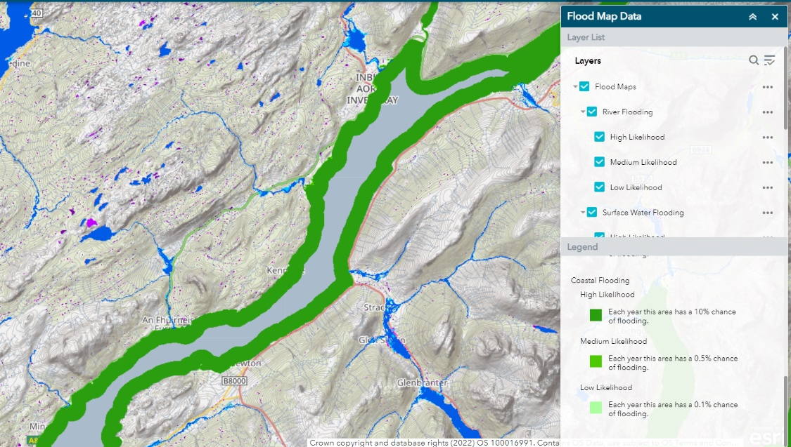
This Policy Zone has been chosen as it has much through traffic as the Northern boundary of the site is capped by a caravan park. This results in many people who chose to stay on the site walking their dogs along the path at the site, hiking or cycling creating erosion and damage to habitats. The site has also been chosen as there is a yearly occurrence of flooding. Flooding is not from the main body of water itself as it is a coastal loch, but rather from the upland water runoff flowing down the hills and making the small waterfalls and channels much larger and faster running. Even though it is stated that there is a high coastal flood risk in this area (SEPA, 2023) (Figure 6)locals are more negatively impacted by the smaller watercourses which are not indicated by agencies as they are much smaller and often deemed insignificant. Due to the increase these cannot contain the excess water and lead to flooding of the path and subsequent erosion and habitat damage. This site is continuously impacted by both anthropogenic and natural processes. The added pressure of the people living within the research area increases footfall and vehicles which are in this area, year-round. This zone also has relatively high biodiversity with species such as Anemone (Protanthea simplex), Brachiopod (Neocrania anomala), Seasquirt (Ciona intestinalis) and Fan worm (Sabella pavonina), as well as many sea birds such as Oystercatchers (Haematopus ostralegus) (Argyll and Bute Council, 2010). There are also larger mammals which can be seen in this Policy Zone and use the shoreline, such as Grey Seals (Halichoerus grypus).
Figure 6 Flood Map showing Coastal Flooding Risk of Policy Zone I (SEPA, 2023)

2.2 Site Usage
This site has many uses. These range from on land to water activities, such as walking, cycling, and diving. These activities can have major and long-lasting impacts on the site. Without proper management strategies and an integrated approach, local biodiversity could be negatively impacted by anthropogenic activities which occur in this location. Usage of the site greatly increases over the spring and summer months due to tourism. This creates greater through flow on paths as well as more water sports.
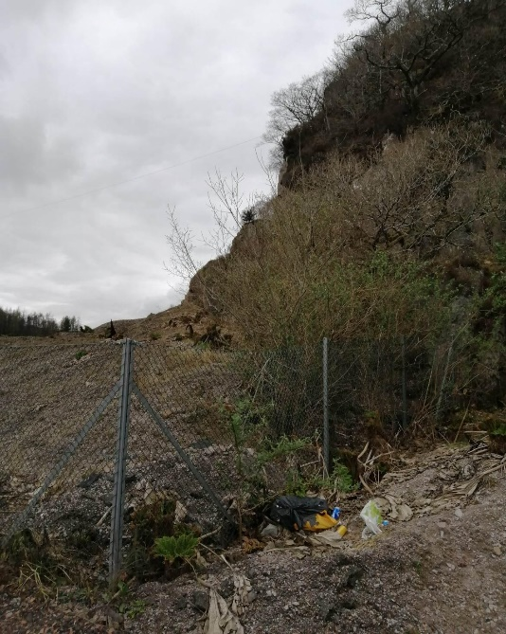
Anthropogenic site usage leads to many issues. One of the key concerns in litter. There was litter seen at various points along the policy zone both on the shore and in the water itself (Figure 7). Litter, especially plastic litter, can be harmful for the environment as microplastics can be easily swallowed by local fauna and sit in their stomachs and if this does not lead to the death of the creature then it can impact their behaviour and make them ill (Tosetto, Et. al., 2016). Littering was most associated with anglers in the original ICZM Plan but now it seems to be an issue with all groups of people who interact with the environment.

Figure 7 Litter in the Policy Zone (Judd, 2023b)

There is also commercial usage of the site with a salmon hatchery and farm in the South of the Policy Zone. Cooke Aquaculture is currently manning this farm. Salmon hatcheries and fisheries can cause many environmental issues due to the heightened chances of the fish catching lice and illnesses which can migrate into the local natural populations. This can cause large scale death amongst the salmon population and cause future issues in the number of salmon in the area.

Another usage of the Loch is a Ministry of Defence (MOD) site in the North of the Policy Zone (Figure 8). This site is primarily used for underway ranging of surface vessels due to the Lochs depth of 140m (T3E, 2023). Due to this usage, the spread of the fish farms and hatcheries are limited (Argyll and Bute Council 2010).
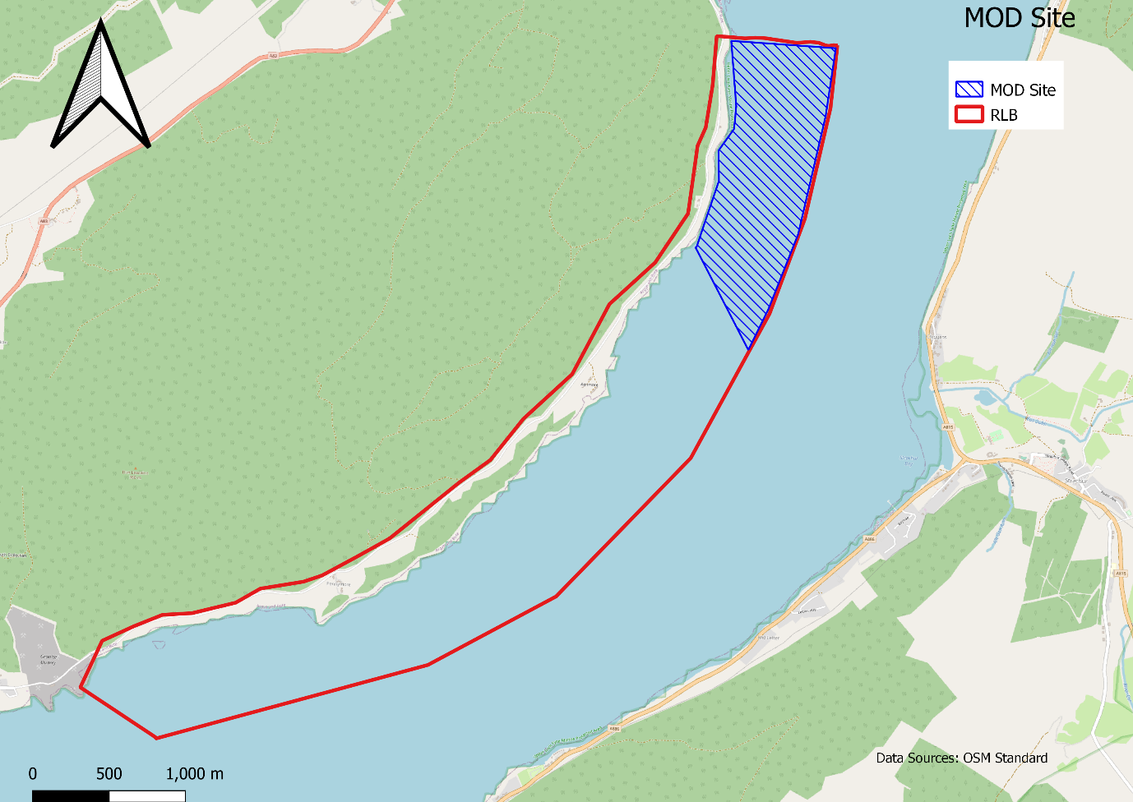
Figure 8 MOD Site highlighted with the Policy Zone (QGIS, 2023d, Edited by Judd, 2023)

Furthermore, the Loch is used for recreational activities by locals and public. There are many boats and other powered water sports which take place on the Loch (Figure 9).
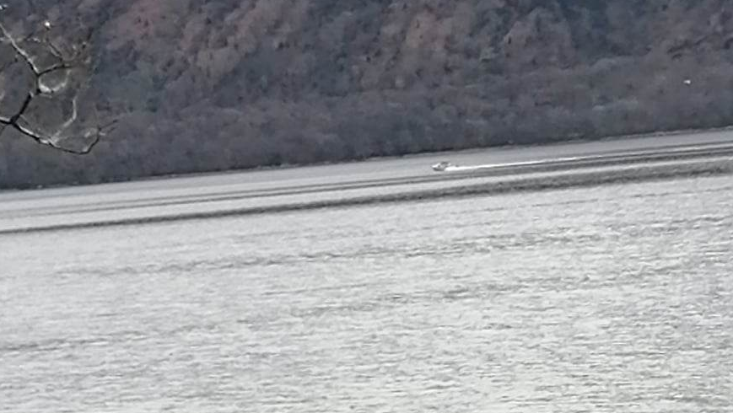
Figure 9 Speed boat on the Loch (Judd, 2023i)

2.3 Biodiversity and Ecology
There is a vast range of wildlife in the area as there is a split of different habitats within the Policy Zone. Even with the many animals, much of it is unseen. Even though there is constant bird song, few can be spotted. Also, when it comes to habitats many are along the shoreline so are not easily accessible or in thick woodland along the path which again is inaccessible. The loch itself holds many creatures with a key one being seals (Figures 10 and 11).
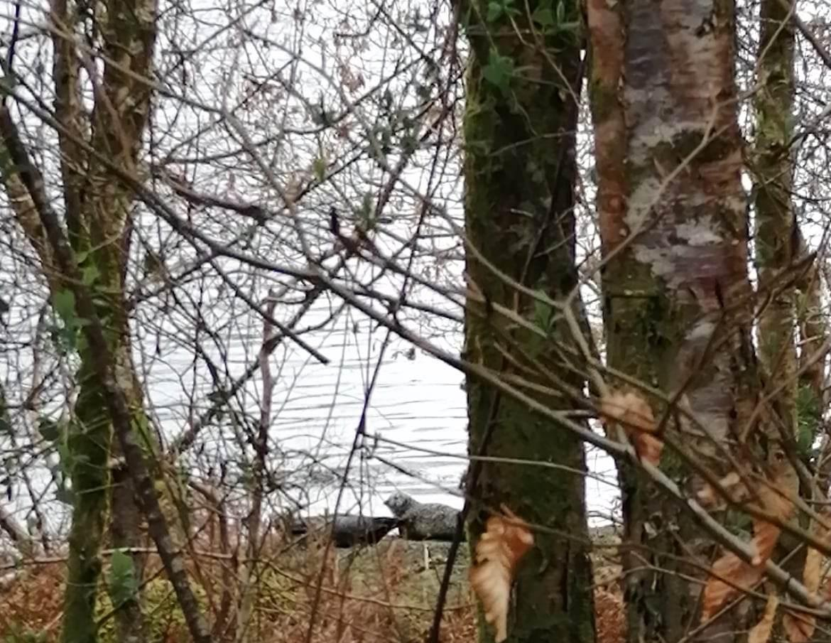
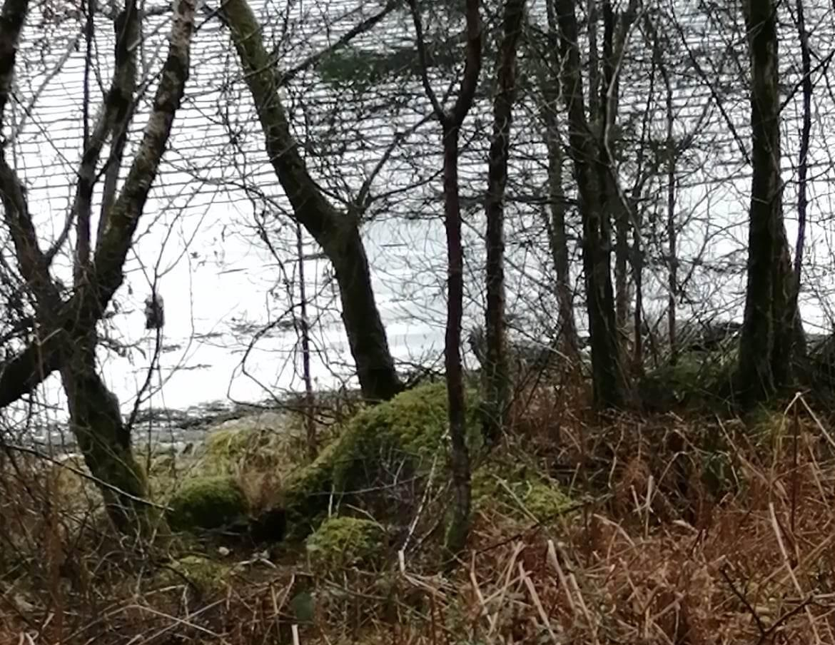
Figure 10 Image of Seals on the shores of Loch Fyne 2 (Judd, 2023d)
Figure 11 Image of Seals on the shores of Loch Fyne 1 (Judd, 2023c)

Other marine mammals and animals live in Loch Fyne such as dolphins and otters. Due to the illusive natures of these creatures and the lack of access of a boat makes it harder for these animals and habitats to be seen.

There were also more common creatures seen on the site such as rabbits (Oryctolagus cuniculus) and garden and sea birds. As stated above few were seen but the likes of Gulls (Larus Canus), Shags (Gulosos aristotelis) and Herons (Ardea cinerea). The nests and burrows for these creatures were not seen in the research area except for one nest (Figure 12).
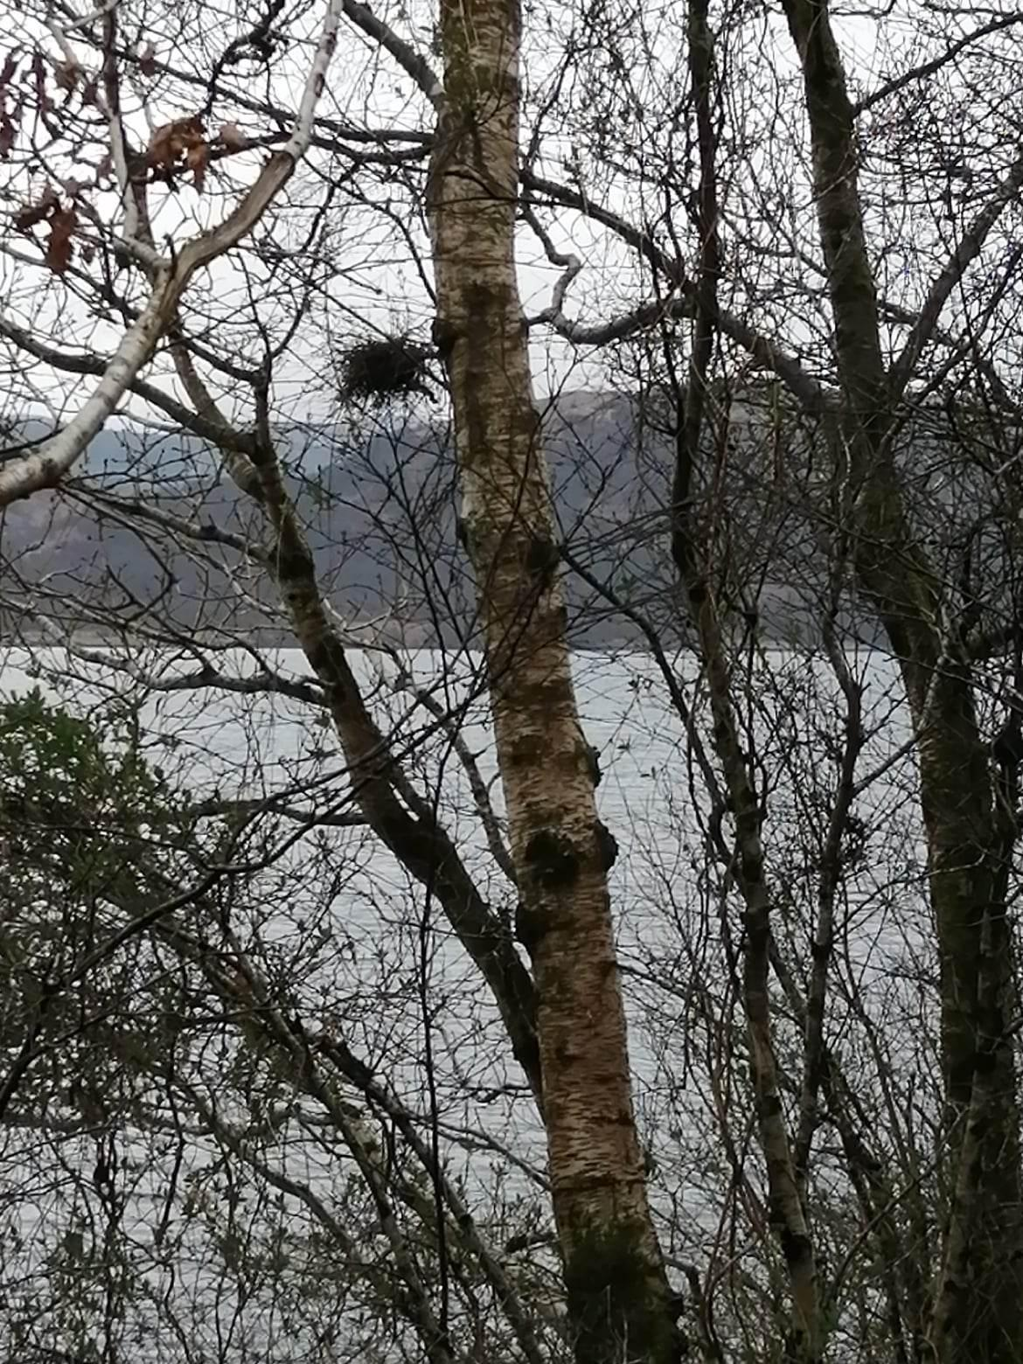
Figure 12 Nest seen within the Policy Zone (Judd, 2023e)
Environments are carefully balanced. If a part of the environment is impacted or destroyed, then the rest of the environment can fall out of balance and cause many issues. Even though many of the species are not classed as endangered within this Policy Zone they all still have their place within the environment. The rarest and most protected creature in the Policy Zone is the Basking Shark (Cetorhinus maximus). Basking sharks are present in the research area, but they only occupy the Loch during the summer, so were not seen during the data collection during the time of year the study was completed in. They are classed as endangered in the Northeast Atlantic and are separately protected in the UK by Wildlife and countryside as well as being a priority species under Convention on International Trade in Endangered Species of Wild Fauna and Flora (CITIES) (Wildlife Trusts, 2023). They are tracked but are an example of a creature we know very little about (Wildlife Trusts, 2023). Greater knowledge on this species and others would allow Loch Fyne and the ICZM to better improve its environmental management strategies.

Many of the trees in the Policy Zone are Scottish native such as silver birch (Figure 14). Silver Birch is not only one of the most common native trees in the Policy Zone but in the whole of Scotland (Scottish Forestry, 2023). There are also alder and ash trees with fir trees (Figures 13 and 15) added in due to the local branch of Scottish forestry. Many of the hills in the area have cut outs which have replaced the native trees and have been replaced with the faster growing firs. In the Policy Zone there is a large area which has been deforested but due to the legal definitions of deforestation this site is not classed as deforested due to there being no change of usage (Parker, Et. al., 2009)

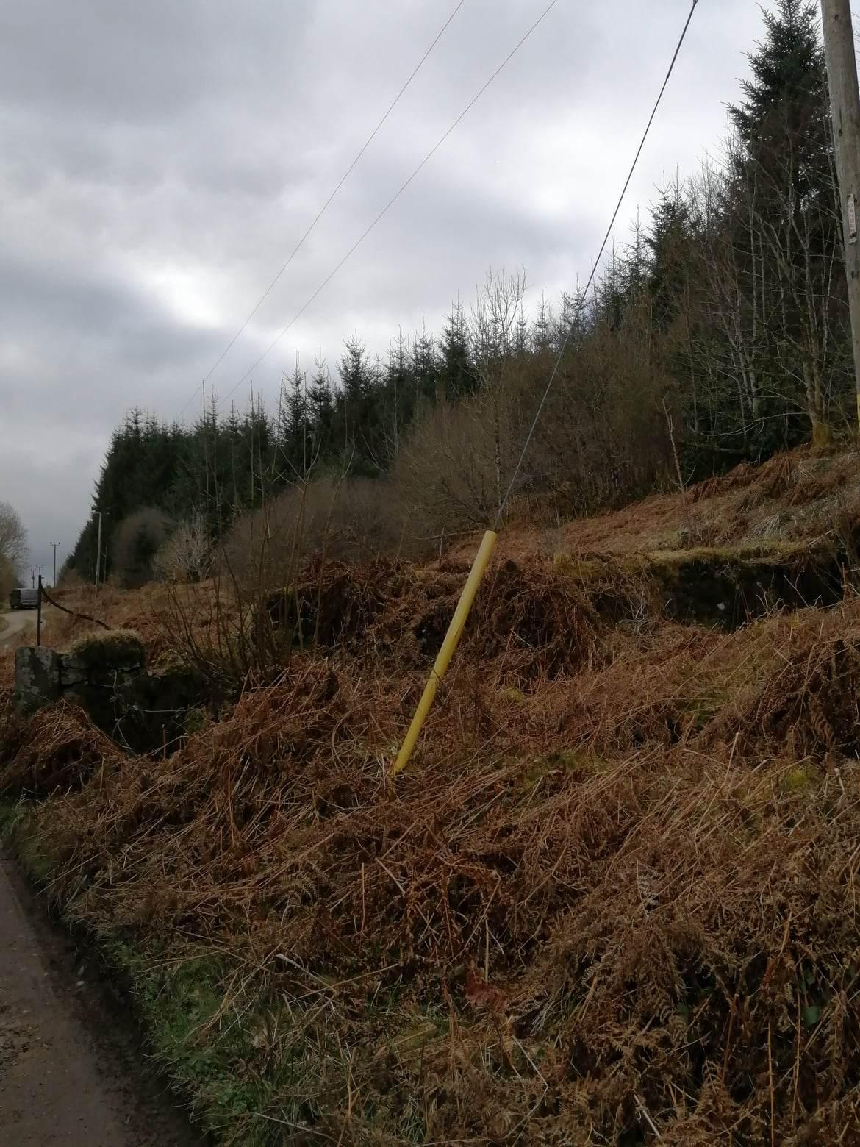
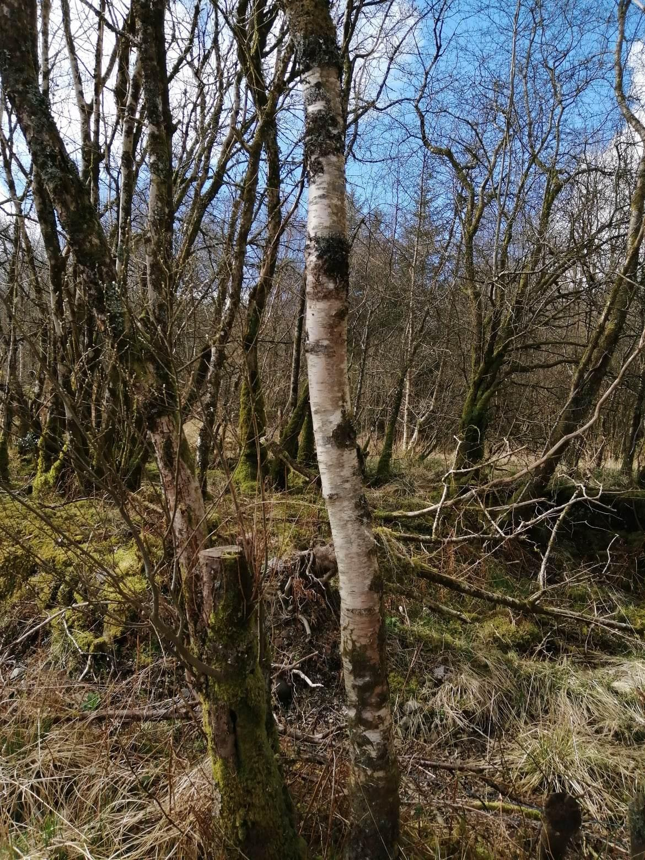
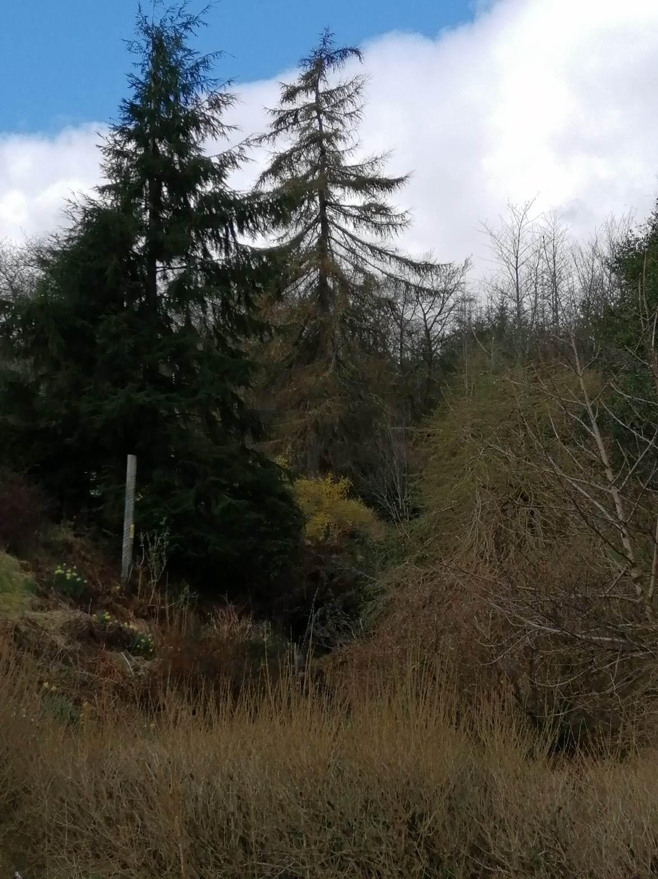
Figure 13 12 Example of Fir Trees in Policy Zone 2 with evidence of overhead cables (Judd, 2023h)
Figure 14 Example of Silver Birch in Policy Zone (Judd, 2023f)

Figure 15 Example of Fir Trees in Policy Zone 1 (Judd, 2023g)

As with any site, this Policy Zone cannot be viewed individually. The area is impacted by surrounding Policy Zones and upland areas out of the study area. These all have an impact on the concerns which are seen in this area. As stated above the upland areas just outside of the study area cause much of the flooding in this area. Also, wildlife is affected by subsequent policy zones. This is because the zone is mainly a coastal Loch habit so the fauna has more flexibility to move, so areas up or down the Loch could present issues for the wildlife.

To best protect fauna and flora a knowledge of species and habitats is a must. With many marine creatures it is also customary to track them as it allows for better knowledge of their routes and lives as well as seeing how best to keep them safe.

Scotland uses the NWSS to manage the woodlands. Table 1 shows the usages of such surveys. The application of this data alongside other management plans for other sectors of biodiversity would allow a more informed ICZM.

Table 1 Table showing the usages of the NWSS (Scottish Forestry, 2023)
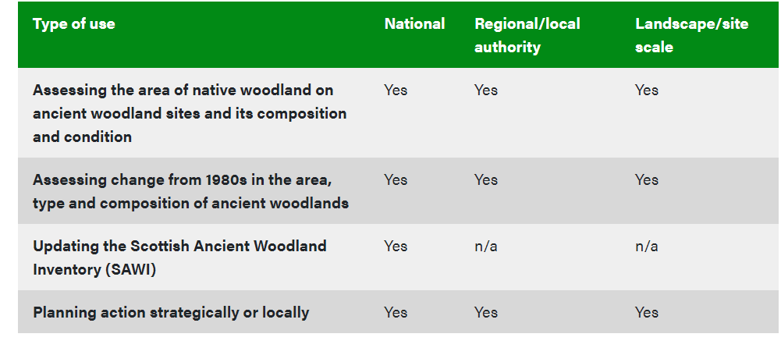

2.3.1 Invasive Species
In the UK there are estimated to be 79 marine non-native species, 24 of which are present in Scotland (Argyll and Bute Council, 2010). Management of invasive species allows for the betterment and protection of the natural environment as these species can often cause death of local species.

In the original ICZM plan there is mention of an invasive species that would prove devastating in this area. The Gyrodactylus salaris is a parasite which is currently the biggest risk to Atlantic Salmon populations. This has to be of utmost priority for the fisheries in the Policy Zone and anywhere there are fisheries as this could dramatically decrease natural populations, more than it already has.

Invasive species are not confined to animals but are seen within flora as well. Most native tree species in Scotland colonised after the last ice age around 9,000 years ago but new species of flora have entered Scotland over the past centuries (Scottish Forestry, 2023). The most well-known and notable is Japanese Knotweed (Fallopia japonica) which is known for its invasive roots (Argyll and Bute Council, 2010).

2.4 Site Habitats
There are multiple habitats within the policy Zone the most obvious one being the Loch environment itself (open water). The Loch is bordered by a ‘coastline’ which is constituted of pebbles and shingle. As the Loch is tidal this section is in a state of flux and varies in width. Behind this is a hummocky riparian landscape made up of small watercourses as well as waterfalls. The trees and shrubbery offer much cover for habitats and nests. Behind the riparian habitat is vast woodlands, much of which extends far beyond the boundaries of the Policy Zone. Some is native but much is now non-native fir trees which have been planted after removal of native species. Furthermore, many trees have been felled leaving large openings in the landscape. This Policy Zone covers both terrestrial and aquatic sites as well as the intersect between them. This offers many different species a chance to live and thrive in the area.

3. Existing management
Existing management and legislation form the basis for future management. From the ‘Loch Fyne ICZM’ the current management can be observed. There is little focus on management, especially on-going management, of the Loch in terms of biodiversity which much of the management focused on people and economy. There are some mentions of habitat management but not sufficient to the level needed to make the Loch thrive and be protected. The management is broken down into sections, so is spread across the document, but the objectives are as follows:
- “Guide and advise local authority planners, regulators and stakeholders on future use and development;
- Assist decision-making in relation to development proposals;
- Help minimise conflicts of interest and guide future investment;
- Secure the long-term sustainable use of the marine resources within Loch Fyne;
- Fulfil the coastal framework plan requirements outlined by the Council’s Structure Plan and Complement Argyll & Bute Development Plan (Structure and Local Plan)”
(Argyll and Bute Council, 2010)

As can be seen these are mainly economically focused with only two even partially focused on the environment of Loch Fyne. This is a downfall of this ICZM Plan as the focus is not on biodiversity or the environment so neither will the management. Even though this is a negative in context this makes sense as the ICZM was written in 2009 only a year after one of the worse financial crashes in history (Bank of England, 2018).

Most of the references used in all documents of the ICZM Plan date back to 1979. The issue with this is that this data is now outdated by over 40 years. With actions such as erosion acting on cliffs and features around the Loch the information could quite possibly be incorrect. Even at the time of writing the original document the data was 30 years old. This added to climatic changes makes the data used look even more reliable. The use of such data may have been due to the last full survey of the Loch being conducted in the 1980/90s, so it is the only data to work from but many figures in this work cited earlier work (JNCC, 2015).

During covid the management of the site was almost non-existent. Money and resources were redirected due to the pandemic and the natural world in management terms were more so neglected but also flourished due to the lack of human action in the area.

The lack of continual active monitoring and management leaves the whole of Loch Fyne at risk. This added to the fact that there is little specific detail and information offered for the specific sites in the ICZM Plan indicates that the knowledge, and what should be managed, is lacking. Moreover, most of the Policy Zone I document has an anthropocentric view rather than natural biodiversity. The overview document is more detailed but still there is little focus on the species which are a key part of any habitat. The only real mention of fauna management in the Policy Zone I document is in relation to fish farms. Even this is economic as it discusses it in terms of ‘loss of biomass’ (Argyll and Bute Council, 2010). The only mention of wider impact is about lice and how this could impact the local population of Salmon.

Only five different species/ species groups are classed as wildlife interests. This discounts many of the other species in the area and this could lead to environmental breakdown as all creatures impact the local environment. Even mammals such as porpoises are not included in the wildlife interest list which includes - Basking Sharks, Common Seal, File Shells, Fireworks Anemone (Pachycerianthus multiplicatus) and Nesting Seabirds.

This document, as stated above, is an extension of the Argyll and Bute Structure Plan or Local Development Plan is currently being updated from the original version and a reporter has been appointed for the independent evaluation of the Scottish Parliament on the 18th May 2023 (Argyll and Bute Council, 2023). The focus of this document is much more economic, and people focused rather than the natural environment. Biodiversity and habitats are not even mentioned until page 96 (Argyll and Bute Council, 2023).

A positive of the overall document is that it does end each section with a ‘good practice’ section offering information on what legislation is needed to be followed or where such management plans have been successful as well as a list of the agencies and legislations used to manage or plan each section.

The future plans and considerations which are included in the plans, such as the salmon fishery expansion and tour boats from Furnace have not been undertaken as of yet. This could be partially due to Covid. Even though Covid started in 2020 which is five years after the end of the original ICZM Plan some planning takes many years so Covid could have set the planning and surveying back for these happening.

A further issue is that weather has changed since the application of this management plan, so any further management plan has to take this into consideration, but the original ICZM Plan did not allow for environmental or weather changes so that in itself offered a fault in its methodology.

Enhancement is a key part of environmental planning today. If the ICZM Plan was rewritten there would need to be a greater focus than there was in 2010. There was only one mention of enhancement in the original document and there was no mention in the Policy Zone I document. In more modern and current ICZMs Plans and management plans enhancement is given more acknowledgment. But it is not just current ICZMs which contain enhancement features. The 2002 East Riding of Yorkshire ICZM mentions enhancement many times with a focus on the natural landscape (East Riding of Yorkshire Council, 2002). This ICZM Plan could be seen as an example of best practice.

4. Site Visit and GIS Map
A site visit was conducted on the 2nd April 2023 to put the ICZM Plan into context and to offer a current view of the site. After the completion of the site visit a map was completed on QGIS to indicate the differing habitats and sightings in the Policy Zone. The habitats are classified by using the Phase 1 Habitat Codes as listed by the Joint Nature Conservation Committee (JNCC) Handbook.

4.1 GIS Map
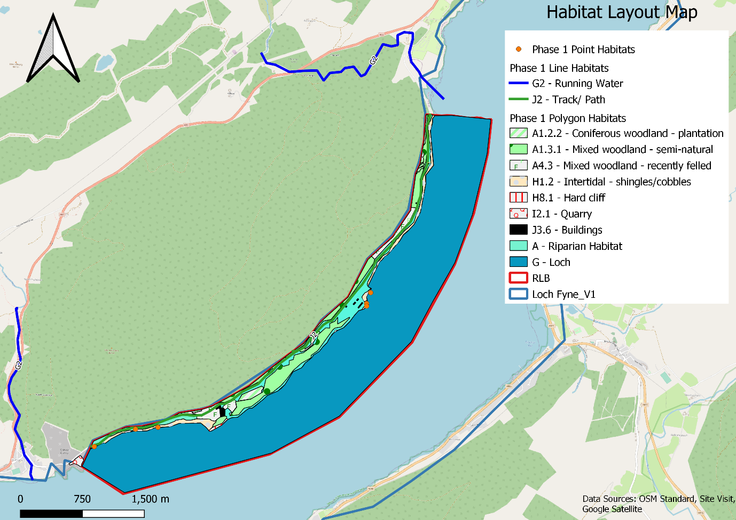
Figure 16 Habitats of Policy Zone I (QGIS 2023e, Edited by Judd, 2023)
The GIS model was created to indicate the different habitats clearly across the Policy Zone including Polygon, Line and Point Habitats.

There are ten different polygon habitats present on the site. Line habitats are in green (Path/ Road) and the point habitats as orange dots. The habitats listed have to be classed as assumptions as some P1 codes listed, such as J3.6, are only used in Wales. Since the site and Policy Zone are in Scotland the codes are used as a base. Furthermore, some of the environments do not fully fit the description of any P1 code so the code which was deemed closest to the actual habitat was used. Since there was no code which perfectly fitted Riparian Habitat ‘Woodland and Shrub’ was used and the watercourses where can be seen are added but due to the streams being small many were difficult to locate on the maps as they did not show up or were not included due to size. The Quarry is included on the habitat map even though half is outside of the Red Line Boundary to indicate where it is due to it being the Southern boundary of the Policy Zone and also due to the impact the quarry has on the Policy Zone. Each habitat has a list of attributes which help further identify the areas this can be seen in Table 2.
Table 2 Table showing the attributes for part of the Phase 1 polygon habitats (QGIS, 2023, Edited by Judd, 2023)
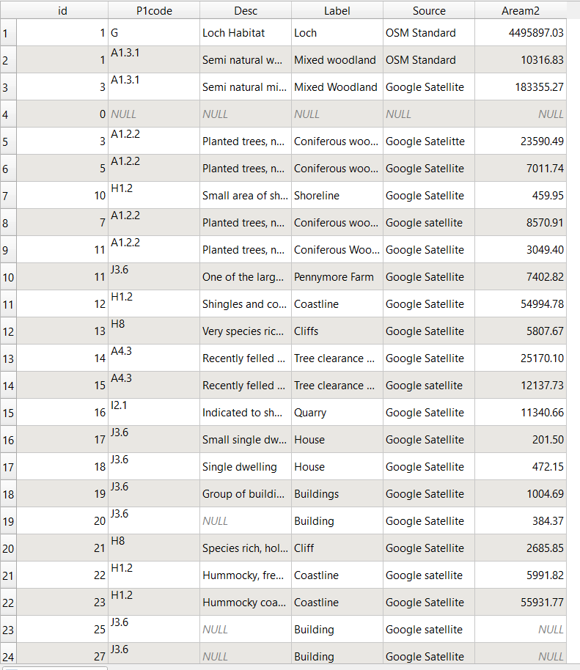

5. New Management
Unlike the 2010 plan the new management suggestions focus on the environmental impacts of the activities undergone in and around the Loch. Below are some of the management strategies which could be put into place.

There is a caveat in the Policy Zone I section which discusses what would happen if the Furnace fishery was relinquished then ‘additional finfish, mussel or scallop development, over and above that detailed in Table PZI (Appendix 5)may be appropriate.’ This could be problematic as it could allow further development of the site and introduction of more biomass. The site as of current has 450 tonnes of biomass which sounds like it could increase if the site was relinquished. The issues stated above about disease would have to be considered and much mitigation might be needed. Due to the site and its location the expansion or any changes to the site would need to be actively discussed and possible impacts looked at. The best way to mitigate against this is to simply not allow the site to change even if it is relinquished and for it to be reinstated at its current rate. The main issue with this is that the population is growing so the need for food and supplements is also growing so sites need to keep up with supply and demand and be able to keep their staff paid. Garthwaite, 2021 stated that the world's consumption of fish is likely to increase by 80% by 2050. This is a huge increase and will put much pressure on the world's aquaculture. Moreover, the issue of aquaculture spreads much further than just the Policy Zone. Just outside of the Policy Zone there are two major Salmon migratory rivers, the Leacann and Douglas (Figure 17) which run into the Loch adjacent to the zone.
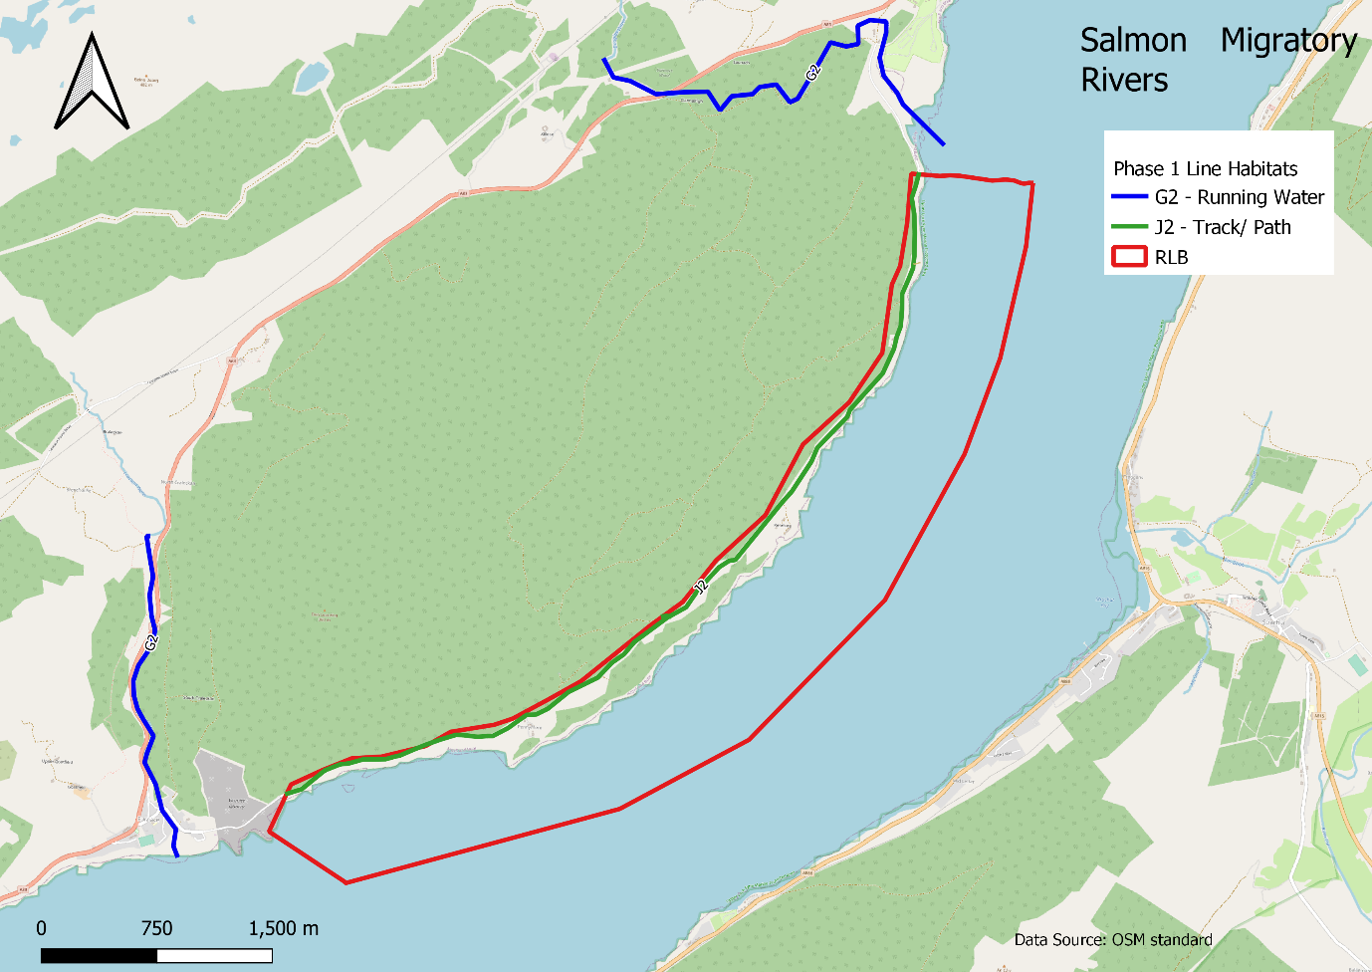
Figure 17 Policy Zone I with Salmon Migratory Rivers indicated (QGIS 2023f, edited by Judd, 2023)
This could lead to an even more substantial threat to the natural populations if the fisheries were to expand. An effective way to manage this would be very regular checks on the animals and to make sure that the nutrition in the waters of the tanks does not get to a stage which would allow for diseases to breed. Also, having adequate living conditions for the salmon could lead to cleaner tanks and healthier fish. However, with growing fish consumption globally (Stanford University, 2021), there will be a higher demand for fish, heightening the risk of the food supply and local populations. Much like battery hens the more fish in a tank the worse the quality of life (Schwingle, 2021). Harvey, 2021 indicates the severity of the fish farming industry on natural populations. They state that losses and pollution are costing $50 billion globally. This is not a small sum and with the current global economic crisis it is a quantity which the world could really do without losing. The pollution from fish farms can be equal to as much as a city with half a million people (Schwingle, 2021). Disinfection of the fish farm could be considered but this would in itself cause many issues as it is using chemicals such as Chlorine, that could harm the local environment (WOAH, 2009). However, the need for better conditions is vital as in 2017 the mortality rate at Cooke’s Aquaculture was 47%, the second highest in Scotland, due to an outbreak of salmon gill pox (Edwards, 2019). This highlights that the standard in the past 10 years has not been suitable and could lead to further natural animal deaths. Orlowski, 2020, states that fisheries that have intense management have led to healthier fish populations and higher abundance. Also having full sufficient information also makes the sites much more sustainable. Places where this has most failed is in South Asia and Southeast Asia as there is no information to work with (Orlowski, 2020)

Removal of the trees, both native and foreign species, has led to greater surface runoff of the uplands, due to loss of roots and uptake. This is linked to the greater flooding. The flora of the area works symbiotically with the natural processes but with human intervention this is causing an imbalance, so the flooding is becoming more apparent. A method to improve this and lower the flooding and loss of biodiversity in the area would be to replace the removed trees with native species which would be allowed to grow and thrive in these areas, decreasing the current surface runoff and lessening the risk of flooding (Devon County Council, 2023). Management of the trees would be of utmost importance. Even with replanting of trees, many do not take and due to many of the current methods used it causes mass death of saplings and local biodiversity which can also be seen in other parts of the UK such as the A14 (BBC, 2023). The best method of reforesting this area would be to plant the trees with adequate space so there is no, or little, competition for the nutrients and space. This is not seen in many sites where there is mass planting and the competition in itself leads to the death of many of the trees. Also, the continued management would allow for any changes needed on the site to maximise the number of saplings which would survive. Furthermore, the usage of natural, renewable, and biodegradable tree guards would be more positive for the local environment (Woodland Trust, 2023) as it would not leave pieces of plastic on the site, which could easily get into animals' stomachs leading to illness and fauna death in the surroundings.
No take zones as seen in Arran by the Community of Arran Seabed Trust (COAST) could benefit the area as it would allow for fish and other marine life to rejuvenate (COAST, 2023). Figure 18 Shows the zone for Arran. If these areas were put into place they would allow for healthier sea life, which could grow bigger and have greater offspring to help increase the dwindling numbers of many species seen across Scotland.
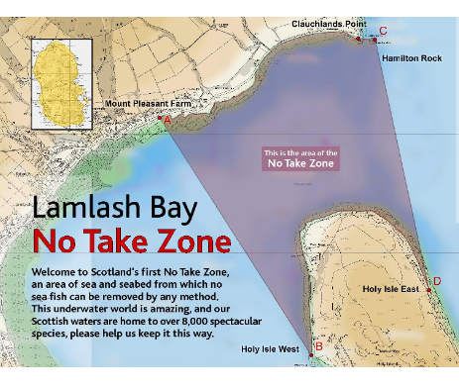
Figure 18 Lamlash Bay No Take Zone in Arran (COAST, 2023)
Furthermore, fishing is unregulated in the Policy Zone. To prevent damages to the local fish population by anglers, permits could be given to locals. The ICZM Plan stated that there was a lack of signage and similar issues which could quite easily be solved. The introduction of signs would be an easy way to try and mitigate against anglers in the area. Anglers do not only cause issues in the water but also on land, in the form of littering. This is as much a problem now as it was when the ICZM was put into place. There were talks of putting more rubbish bins and even toilets so people using this section of the Loch for recreational purposes would have some low-level amenities. The issue with this is that it could negatively affect the local landscape but also lead to animals fighting for rubbish. Signs break up the natural beauty of the landscape but if done effectively they could be worked into the landscape, whilst still being visible. Even though there are signs already located around the site, most seem to be ignored and adding more may be futile. Bins would most likely mostly improve the experience of dog walkers. This is because the lack of bins along the route makes it difficult to dispose of dog waste and makes people less likely to pick up after their pets. This is again dangerous to the local environment due to dog poo being toxic in many cases and is damaging wildlife (Carrington, 2022).

Furthermore, even areas with signage have been negatively impacted by illegal fishing. The Southern boundary of the Policy Zone is a known spot for illegal fishing. The point which is in the centre of the quarry is often illegally entered for fishing as it is close to the fishery and would seem to have a high fish count. In areas such as this better security would benefit such as higher fences, but this would impact the environment of the area. This is not a massive issue due to the quarry already having damaged the natural environment, but fences would further damage the visuals of the area. Furthermore, this indicates that even with signage and warnings that fishing will still occur. Without the ability to regulate the fishing in the area there could be lasting effects on the local natural fish population. It would be beneficial to work closely with other agencies which specialise in marine fish numbers and complete a study on how the fish are impacted in this area. A joint effort could bring forward the betterment of local environments in this Policy Zone and the overall area of Loch Fyne.

Some animals such as dolphins do not mind the presence of boats and actively engage with them but other creatures such as porpoises are much more timid creatures (National Marine Sanctuary Foundation, 2020), and the use of boats and jet skis can frighten them and impact their habitats. Moreover, boats are often painted with antifoul. This is a type of paint which is applied to boat hulls to improve performance. Its main purpose though is to repel anything that would normally attach to the sides and undersides of boats, such as barnacles . This is useful for boat owners but since this is applied every year due to it wearing off, means that it is actively mixing with the water and is a poison to water life (RYA, 2023). This could over time become an issue. The antifoul added to the pollution given off from outboard and inboard engines creates a much lower quality of water for the inhabiting creatures (Icemer, Et, al., 2022), especially in the summer months when there is much tourism and many more people using the loch for recreation. To minimise this and to create a safer environment for the animals’ new rules and regulations could be put in place. Many forms of antifoul have been previously banned such as tributyltin (Law, Et. al, 2012) But this is not enough further bans and nontoxic alternatives need to be produced. Even though this would take a long time to develop it would benefit water life greatly. The issue with changing the laws and banning the currently used copper antifoul is financial and also environmental too. Without antifoul boats would sail 10% slower and have a fuel efficiency which is 40 - 50% lower, resulting in more fossil fuels being used (Mcneil, 2018). Also, adequate education for people who own or hire boats could be beneficial. Many people who own and helm boats do not have any qualifications (Boatsetter, 2021). The requirement for qualifications, even as basic as powerboat 1, would mean more people are aware of how to keep boats in better shape and more efficient, so better for the environment and would be less dangerous and cause less fauna deaths in the area. The requirement for basic boating qualifications is seen across the globe. The current qualification needed in countries around the Mediterranean and much of Europe is the International Certificate for Operators of Pleasure Craft (ICC) (RYA, 2023a).

6. Conclusion
The 2010 to 2015 management plan for the site seemed to be lacking much management of the environment and natural world, with a focus on anthropogenic issues and the economy. There are many aspects missing one would expect to find in management plans such as lists of species and ongoing management commitments. With the objectives having so little to do with the fauna and flora of the site and the habitats themselves it is hard to know if these have been achieved with the site visit. A greater focus on biodiversity is key for any future planning. There is great improvement which could be completed over the next decade with areas of focus including stricter rules for licences and recreational usage of the site and consideration for the greater impact that the commercial businesses in the Policy Zone and Loch Fyne as a whole have on native species.

7. References
Argyll and Bute Council (2010) POLICY ZONE I: FURNACE TO RUBHA NAM FRANGACH. Accessed on: https://www.argyll-bute.gov.uk/lochfyne (Accessed on: 15th March 2023)
Argyll and Bute Council (2010) Integrated Coastal Zone Management Plan
Loch Fyne. Available at: https://www.argyll-bute.gov.uk/lochfyne (Accessed on: 15th March 2023)
Argyll and Bute Council (2023) Local Development Plan. Available at: https://www.argyll-bute.gov.uk/planning-and-environment/local-development-plan (Accessed on: 11th April 2023)
Bank of England (2018) The financial crisis – 10 years on. Available at: https://www.bankofengland.co.uk/news/2018/september/the-financial-crisis-ten-years-on (Accessed on: 7th May 2023)
BBC (2023) ‘Trees to be replanted by A14 after mass death’, BBC, 20 March. Available at: https://www.bbc.co.uk/news/uk-england-cambridgeshire-65018423 (Accessed on: 3rd May 2023)
Boatsetter (2021) Do You Need a Boating Licence to Rent a Boat? Available at: https://www.boatsetter.com/boating-resources/do-you-need-a-boating-license-to-rent-a-boat (Accessed on: 3rd May 2023)
Carrington, D. (2023) ‘Deluge of dog pee and poo harming nature reserves, study suggests,’ The Guardian, 7 February. Available at: https://www.theguardian.com/environment/2022/feb/07/dog-pee-and-poo-harming-nature-reserves-study (Accessed on: 30th April 2023)
COAST (2023) No Take Zone, Available at: https://www.arrancoast.com/no-take-zone/ (Accessed on: 3rd May 2023)
Devon County Council (2023) Land Management Guidance. Available at: https://www.devon.gov.uk/floodriskmanagement/document/land-management-guidance/ (Accessed on 30th April 2023)
East Riding of Yorkshire Council (2002) East Riding Integrated Coastal Zone Management Plan. Available at: https://www.eastriding.gov.uk/council/plans-and-policies/other-plans-and-policies-information/sustainable-environment-policies-and-strategies/ (Accessed on: 8th May 2023)
Edwards, R. (2019) Mass deaths: nine million fish killed by diseases at Scottish salmon farms. Available at: https://theferret.scot/salmon-deaths-farms-nine-million/ (Accessed on: 2nd May 2023)
European Environment Agency (2000) integrated coastal zone management. Available at: https://www.eea.europa.eu/help/glossary/eea-glossary/integrated-coastal-zone-management (Accessed on: 7th May 2023)
Harvey, F. (2021) ‘Global salmon farming harming marine life and costing billions in damage,’ The Guardian, 11 February, Available at: https://www.theguardian.com/environment/2021/feb/11/global-salmon-farming-harming-marine-life-and-costing-billions-in-damage (Accessed on: 21st April 2023)
Icemer, G., Et, al. (2022) ‘ASSESSMENT OF ENVIRONMENTAL IMPACTS OF RECREATIONAL YACHT / BOAT ACTIVITIES ON MARINE WATER QUALITY AND
MARINE VEGETATION VARIATION IN PHASELIS BAY IN TURKEY,’ Fresenius Environmental Bulletin, 31, pp. 8416 - 8422
JNCC (2015) ‘Species point records from 1988-90 UMBSM Loch Fyne survey,’
JNCC (2023) About Marine Protected Areas, Available at: https://jncc.gov.uk/our-work/about-marine-protected-areas/ (Accessed on: 2nd May 2023)
Judd, S. (2023a) Picture across Loch Fyne
Judd, S. (2023b) Litter in the Policy Zone
Judd, S. (2023c) Image of Seals on the shores of Loch Fyne 1
Judd, S. (2023d) Image of Seals on the shores of Loch Fyne 2
Judd, S. (2023e) Nest seen within the Policy Zone
Judd, S. (2023f) Example of Silver Birch in Policy Zone
Judd, S. (2023g) Example of Fir Trees in Policy Zone 1
Judd, S. (2023h) Example of Fir Trees in Policy Zone 2 with evidence of overhead cables
Judd, S. (2023i) Speed boat on the Loch
Law, R, Et. al, (2012) ‘Butyltin compounds in liver of harbour porpoises (Phocoena phocoena) from the UK prior to and following the ban on the use of tributyltin in antifouling paints (1992–2005 & 2009),’ Marine Pollution Bulletin, 64(11), pp. 2576-2580
Mcneil, E (2018) ‘Antifouling: Regulation of biocides in the UK before and after Brexit,’ Marine Policy, 92, pp. 58 - 60
National Marine Sanctuary Foundation (2020) WHAT’S THE DIFFERENCE? DOLPHIN VS. PORPOISE. Available at: https://marinesanctuary.org/blog/whats-the-difference-dolphin-vs-porpoise/ (Accessed on: 8th May 2023)
Nature Scot (2023) EU Exit does not alter the standard of protection for these sites. Available at: https://www.nature.scot/professional-advice/protected-areas-and-species/protected-areas/international-designations/european-sites/special-protection-areas-spas (Accessed on: 21st April 2023)
Orlowski, A. (2020) Fish populations are thriving in areas with intense management, global study finds. Available at: https://www.seafoodsource.com/news/environment-sustainability/fish-populations-are-thriving-in-areas-with-intense-management-global-study-finds (Accessed on: 2nd May 2023)
Parker, C., Et. al., The Little REDD+ Book (2009) An updated guide to
governmental and non-governmental proposals for reducing emissions from deforestation and degradation, Oxford: Global Canopy Programme
QGIS (2023a) (Edited by Judd, 2023) Loch Fyne's position in the UK. Scale 1:500000
QGIS (2023b) (Edited by Judd, 2023) Loch Fyne with Policy Zone I. Scale 1:150000
QGIS (2023c) (Edited by Judd, 2023) Close up of Policy Zone I with track. Scale 1:30000
QGIS (2023d) (Edited by Judd, 2023) MOD Site highlighted with the Policy Zone. 1:25000
QGIS (2023e) (Edited by Judd, 2023) Habitats of Policy Zone I. Scale 1: 30000
QGIS (2023f) (Edited by Judd, 2023) Policy Zone I with Salmon Migratory Rivers indicated. Scale: 1:30000
RYA (2023) Antifouling. Available at: https://www.rya.org.uk/knowledge/environment/antifouling (Accessed on: 3rd May 2023)
RYA (2023a) UK ICC issued by RYA. Available at: https://www.rya.org.uk/knowledge/abroad/icc (Accessed on: 4th May 2023)
Scottish Forestry (2023) What are Scotland's native woodlands? Available at: https://forestry.gov.scot/forests-environment/biodiversity/native-woodlands/scotlands-native-woodlands (Accessed on: 18th April 2023)
Schwingle, N. (2021) The Environmental and Public Health Impact of Commercial Fish Farming. Available at: https://www.onegreenplanet.org/animalsandnature/the-environmental-and-public-health-impact-of-commercial-fish-farming/ (Accessed on: 27th April 2023)
Stanford University (2021) Study suggests rising and shifting demand for seafood by 2050. Available at: https://earth.stanford.edu/news/study-suggests-rising-and-shifting-demand-seafood-2050 (Accessed on: 21st April 2023)
T3E (2023) MOD Loch Goil, MOD Loch Fyne & Grove Point. Available at: https://www.t3e.uk/en/sites-and-ranges/mod-loch-goil-mod-loch-fyne-and-grove-point (Accessed on: 21st April 2023)
Tosetto, L, Et. al. (2016) ‘How microplastics make their way up the ocean food chain into fish,’ The Conversation. 1 December. Available at: https://theconversation.com/how-microplastics-make-their-way-up-the-ocean-food-chain-into-fish-69148 (Accessed on: 2nd May 2023)
WOAH (2009) ‘CHAPTER 1.1.3. METHODS FOR DISINFECTION OF AQUACULTURE ESTABLISHMENTS’, Manual of Diagnostic Tests for Aquatic Animals 2009. Pp. 31 - 42
Woodland Trust (2023) TREE GUARDS: OUR RESEARCH INTO PLASTIC-FREE ALTERNATIVES. Available at: https://www.woodlandtrust.org.uk/about-us/what-we-do/research-and-evidence/plastic-tree-guards/ (Accessed on: 2nd May 2023)

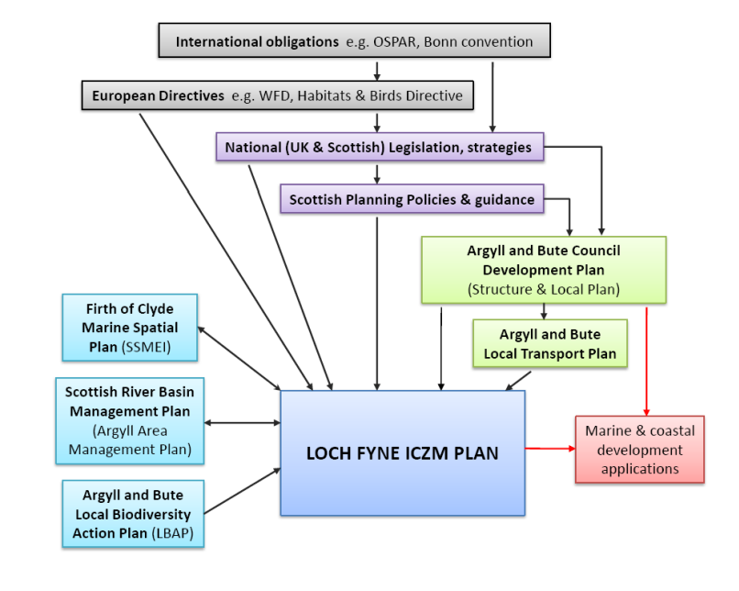
Appendix One: ICZM Plan Collaborators
Figure 19 Loch Fyne ICZM Plan collaborators (Argyll and Bute Councill, 2010)

Appendix Two: Policy Zone I Map
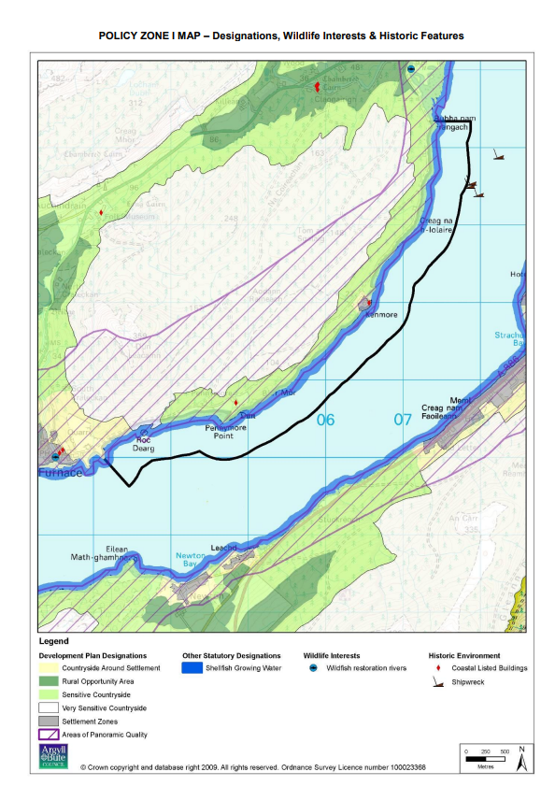
Figure 20 Policy Zone I Map (Argyll and Bute Council, 2010)

Appendix Three: Policy Zone I Current Use Map

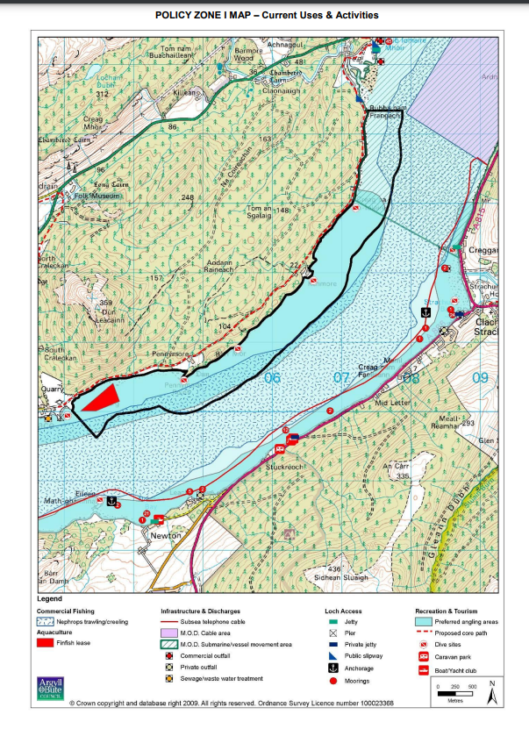
Figure 21 Policy Zone I Current Use Map (Argyll and Bute Council, 2023)

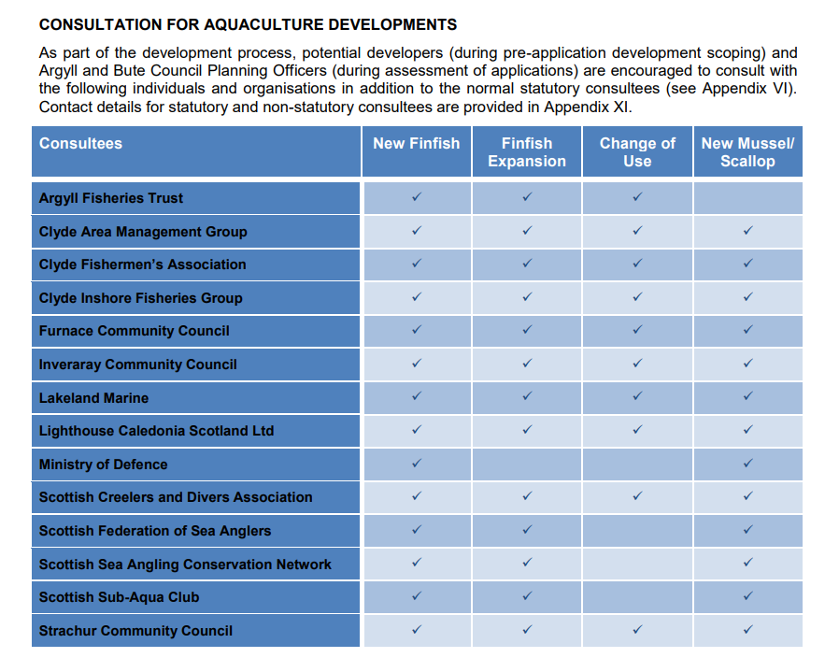
Appendix Four: Consultation Table for Aquaculture Developments
Figure 22 Consultation Table for Aquaculture Developments (Argyll and Bute, 2023)

Appendix Five: Table PZI
Table 3 Table PZI (Argyll and Bute Council, 2010)



