Christopher James Denning
Jdenning.151597@student.uwtsd.ac.uk
Abstract
[Draw your reader in with an engaging abstract. It is typically a short summary of the document.
When you’re ready to add your content, just click here and start typing.]
Applied programmable logic circuits

Table of contents
Contents
Introduction. 2
Task 1 3
Task 2 5
Task 3 6
Task 4 9
Task 5 19

Introduction.
This paper documents the progress of using PLC trainer software to instruct an PLC control system, in this case an electronic conveyer to follow particular logic and operation set by the programmer to obtain the objective of using the PLC system to differentiate between the diameter and hight from a set of aluminium pucks.
The puck of different dimension much be sorted as follows…
- Pucks both tall and short which are a narrow diameter, must be collected by the first bin pushed by cylinder 1.

- Short pucks with a medium diameter are to be collected by the second bin that is pushed by cylinder 2.

- Tall pucks with a medium diameter are required to traverse the conveyer and not to be redirected by any cylinder, so that the puck will be collected by the final fourth bin.

- Tall pucks with short diameter are to be collected by the third bin, redirected by the piston of cylinder 3.

- Tall pucks with large diameters are to be collected by the bin at the start of the conveyer by reversing its direction.
With this PLC system, a Human Manual Interface (HMI) is required to for a use to control the function of the device, be notified of any errors of the PLC system and the speed of the conveyer.
The HMI should include two screens for the user to interface with, the main screen should display the main features of the system with the inclusion of an emergency stop button. The second page will indicate any errors that may accrue during the PLC devices’ operation.
The ladder logic programme method that will be applied to instruct the device and structure the HMI interface will be constructed though the use of the Siemens TIA16 or 13 software.
This development of both the ladder logic software and HMI interface will be documented and broken down to describe operation.

Task 1
Before stating on the development of the ladder logic from the Totally Integrated Automation (TIA) software. The device that will be used to organise the pucks into the desirable groups by based by their diameter must be analysed, to foresee any complication that may interfere with the device’s operation. Complications that will require the device to cease its operation entirely or lead to its potential maintenance.
Looking at the diagram below we can see what functions that the device acquires. the main feature of this device is the conveyer belt that can carry a small item from one end to of the device to the other end.
The device consists of two push buttons, one red and the other green. These can be designated a function to however the user may prefer, though the use of ladder logic.
The device also has two optical sensors with adjustable hight, that can detect any object when its beam has been broken by that item.
There are also three gas pressured cylinders that are able to be used by the ladder logic programme to push an object at a particular time sequence so that the item can be redirected by the piston of a cylinder to the bucket or container adjacent to that cylinder.

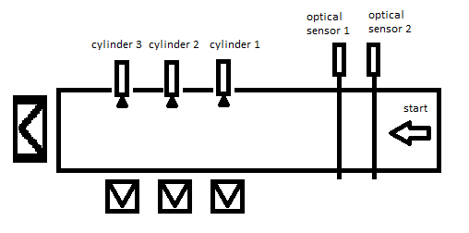

Observing the device or its crude diagram, the devices functions can be now be identified and overall evaluate what errors and warnings to the system that may occur.
The list of potential errors that will be indented and indicated by the HMI interface will be listed in the next page in the form of a table.

The table created below lists the problems that may occur during the devices operation and that have been applied to the ladder logic programme.
Each problem addressed has been placed into two categories, errors: problems that require the device to stop operation and restart after problem is resolved, and warnings: problems that are gradually arising, but do not require the process of organising of the pucks to stop.

Error type | Description
Optical sensor obstruction | If an item is still in the path of the beam that originates from the optical sensor, that item could be stuck in place, therefor no other item can detect by the device to acknowledge its presents.
Cylinder malfunction | when a cylinder is unable to extend its piston to redirect a puck. The fault could be either the gas pressure to push out the piston could be insufficient, maybe a problem with the cylinder or piston itself.
Box full | If the box were to be full, no other puck could be added and therefore, it may continue on the conveyer or build up with others to form an obstruction in the path of others.

Warning type | Description
Box almost full | This warning could alert the user on the inevitable build up of pucks in the collective bins (buckets), avoiding an overflow and possible misplacement of pucks.
Conveyer speed | This warning is necessary for the operation of this PLC system, because the optical sensor determines the diameter of a puck by the duration of the puck in contact or breaking the sensors beam.  If this slows down, the diameter of pucks will be incorrect.

Although these are the errors and warning that are applied to the ladder logic programme, there are others that would be applied to this system. Such as the indication that the conveyer has stopped entirely and could be applied in later improvements to the PLC system though ladder logic.

Task 2
A short inaccurate timing diagram is available to show the signals occurring at particular points of the system. This will illustrate when each signal occurs. This diagram will only show the operation when a tall-medium puck is applied to the device.
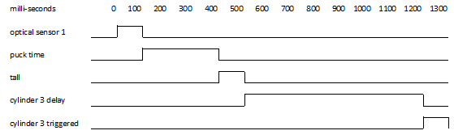
Once a tall-medium puck is placed on the conveyer belt, the first thing that will occur is the braking of the beam from optical sensor 1. The time length of the beam broken will be transformed to the puck time, where it will be evaluated.
The next stage of the is to confirm if the puck is tall or not. This is confirmed if the beam of optical sensor two has been interrupted.
With the diameter of the puck measured by the time of breaking the beam of optical 1 and interrupting the beam of optical sensor 2 to confirm if the puck is tall, the device has identified the puck as a tall-medium.
Now that the puck has been identified, a delay has been applied to engage the third cylinder. The distance from the start of the conveyer to the third cylinder is approximately 4.5 seconds (4500 milli-second), this will be the length of the delay for the puck to reach the third cylinder. After the delay, the signal is then applied to engage cylinder three to push the puck into place.

Task 3
This section shows the layout and contents of the Human Manual Interface (HMI) display. The display will consist of two screens for the user switch too. The main root screen displays the main key operations that was demanded for the PLC device operation. These requirement were the manual start and stop of the device, the number and type of puck accounted for, the indication of the puck time, conveyer speed, error and warning indications and an emergency stop button in case an immediate stop was required by a user.
The second is the error and warning screen, which displays all the errors and warnings considered for the PLC system, including a reset button to reset all errors, warnings, and puck box quantity counters.
On the first screen, are a visual indication of the features are present for the device. Two buttons are needed to start and stop the conveyer on the PLC system. Note that pressing both of these buttons will also reset the errors and warnings detected.

Green button pressed will start the operation of the conveyer.


Red button will stop the operation of the conveyer.

one of the features requested was the acknowledgement, number, and puck type placed on the PLC device.
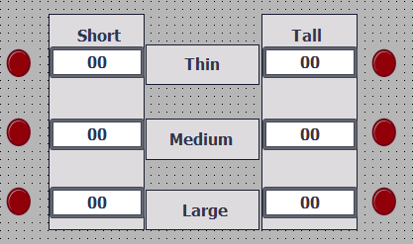
Once a puck has been acknowledged, a light will change from red to green to which ever puck has been recognised and increment that number to the displayed counter.
the feature to moniter puck time and convayer speed is another function that can be found on the HMI root screen.
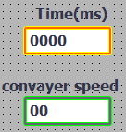
The time of the beam broken on optical sensor 1 will imply the diamitor of the puck applied to the device. The timer indicated in yellow will display the time of the puck for the user to see for himself.

The speed is determind by how quick the puck triggers optical sensor 1 and two. Thid is required so that the user can see if the speed of the convayer is to fast for slow to avoid incorrect puck size.
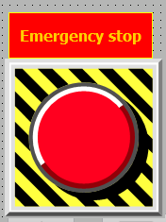

The emergency stop is needed in case a problem occurs that require an immediately stop of the conveyer to remove an error in the system.

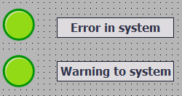
to indicate an error or warning is present in the system, two lights are used to flag the user of either one or the other.
If the indicators are on, it would switch from turned-off green icon to a turned-on red icon.


once an error or warning is present in the system, the user can switch to the Errors and Warnings page to identify which error or warning has accored.

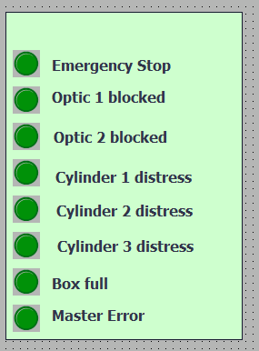
The left side of the display lists the errors and flags that may occur during the operation of the PLC system. Once an error has occurred, the light icon will change from turned off green to turned on green.
Emergency stop is indicated in case the user needs to know that the button pressed has been confirmed.
If a puck remains in the path of the beam for too long, it will indicate that the optic sensor, either one or two is blocked.
If one of the three cylinders are no able to eject their piston to redirect a puck, the light for that cylinder will indicate an error.
The box full indicator will imply that the capacity of one of the boxes has met its maximum.

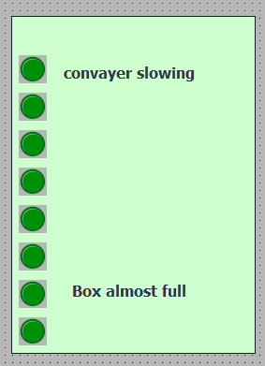
the right side of the displays the warnings that may occur in the PLC systems’ operation.
If a puck takes too long to though both optical sensor 1 and 2, the indicter will illuminate to imply that the conveyer is slow or slowing down.
To stop an overflow of pucks in the collector buckets. A warning will be indicated to alert that the capacity is almost at its reach.


to reset the errors and warnings after correcting them, the user may press the button with the exclamation mark to reset all warnings, errors and the counters that monitor the capacity of the storage containers.
The grey button can be pressed by the user to return to the main screen after the errors and warnings have been identified and reset.

Task 4
Here are the networks that are applied in the ladder logic programme that follows the parameters set by the objective, which is to identify and organise three groups of pucks into the desired collective containers with the use of a PLC system, this being a electronic conveyer.
The paramotors are broken down into five strategies. These five strategies are as follows.
- Pucks both tall and short which are a narrow diameter, must be collected by the first bin pushed by cylinder 1.

- Short pucks with a medium diameter are to be collected by the second bin that is pushed by cylinder 2.

- Tall pucks with a medium diameter are required to traverse the conveyer and not to be redirected by any cylinder, so that the puck will be collected by the final fourth bin.

- Tall pucks with short diameter are to be collected by the third bin, redirected by the piston of cylinder 3.

- Tall pucks with large diameters are to be collected by the bin at the start of the conveyer by reversing its direction.
With the objective explained with the demanded parameters, the networks can be displayed and described.

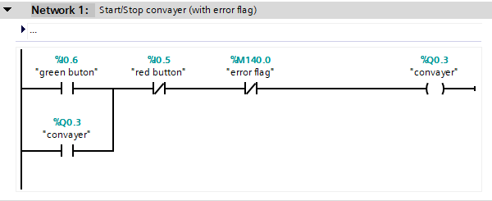
The first network consists of a green button contact to start the conveyer and puts it in a “or” loop state. Only by pressing the red button or the programme detecting an error to set the error flag high will cease the conveyer’s operation.

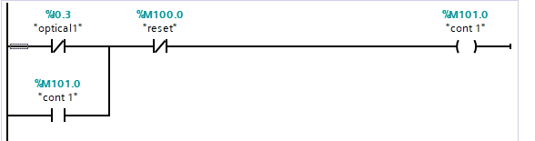
In Networks 2 and 3, when the beam of optical 1 or 2 is broke. Con1 for optical sensor 1 or con2 for optical sensor 2 will turn on and remain in a “or” loop. The reset contact will later set con 1 to low or off.

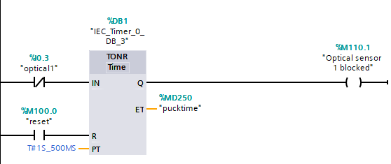
The other half of network 2 and 3, waits for the beam of both optical sensors to be broken. While the beam of optical sensor is disrupted, the time of the disruption will be recorded in puck-time. If the time lasts longer than 1500 milli-seconds, the timer will trigger the output to optical sensor blocked. This programme is applied for both optical sensors 1 and 2.

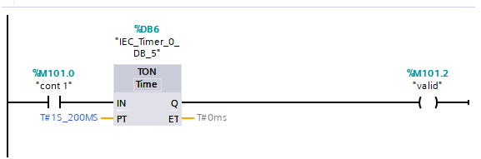
Once con 1 is triggered by optical sensor 1, a short delay is applied before confirming that the item passing optical sensor 1 is validated as a puck.

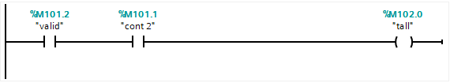
If the item is verified as a buck and optical sensor 2 set con 2 high or on, the tall contact will be set. This is how a puck is determined if it is a short or a tall.

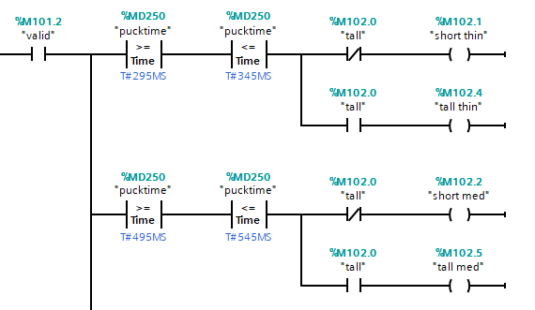

At this stage if a puck as been confirmed, the time collected and stored as puck time is compared. If the time meet the time parameters of the comparators it will be in one of the three diameter categories, thin, medium, or large.
Once the puck has been designated as one of the categories, it will be determined if the puck in the group is a tall or short, by interrupting optical sensor two or not.

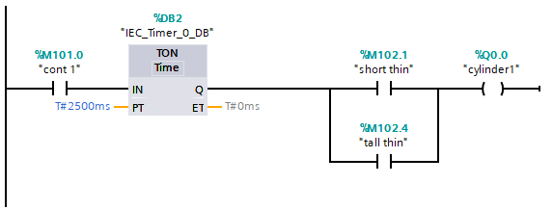
The first strategy confirms that con 1 is set, this trigger signal from con 1 is delayed by the timer for 2.5 seconds before confirming that the puck is a short thin or tall thin. For the buck to reach cylinder 1 the delay must be 2500 milli-second, for it is this distance away from the start of the conveyer.

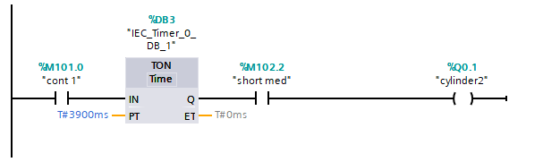
The second strategy confirms that con 1 is set, this trigger signal from con 1 is delayed by the timer for 3.9 seconds before confirming that the puck is a short medium. For the buck to reach cylinder 2 the delay must be 3900 milli-second, for it is this distance away from the start of the conveyer.

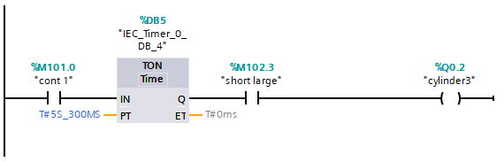
The third strategy confirms that con 1 is set, this trigger signal from con 1 is delayed by the timer for 5.3 seconds before confirming that the puck is a short large. For the buck to reach cylinder 3 the delay must be 5300 milli-second, for it is this distance away from the start of the conveyer.

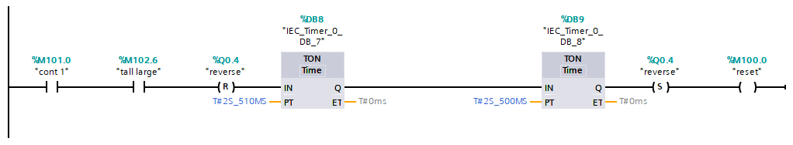
The fourth strategy confirms that con 1 is set, this trigger signal from con 1 confirms that the puck is a tall large. After confirming that the puck is a tall-large, the signal state is inverted to a specified operand to 0, coursing the conveyer to reverse direction.

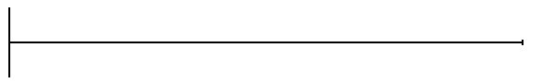
The fifth strategy requires nothing from the tall mid or the tall large.

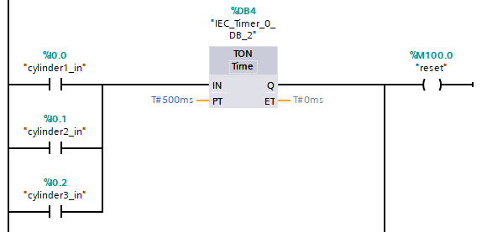

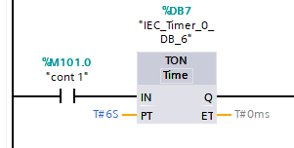
Once pistons have returned or con1 is set for six second delay, reset operation.

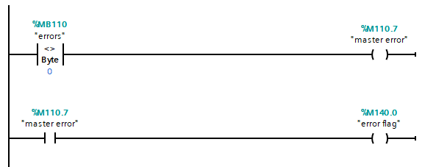
If errors are detected, set master error which sets error flag.

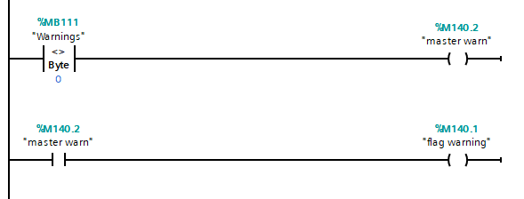
If warnings are detected, set master warning which set flag warning.
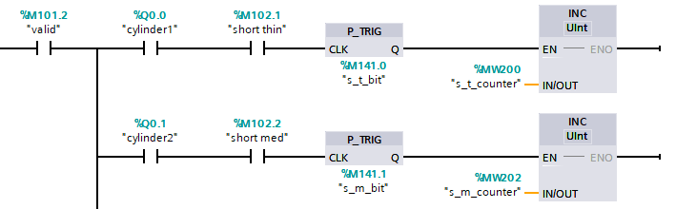

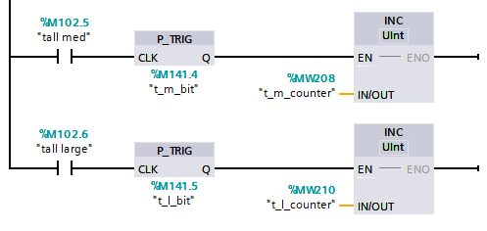
When puck type confirmed, increment once to counter.

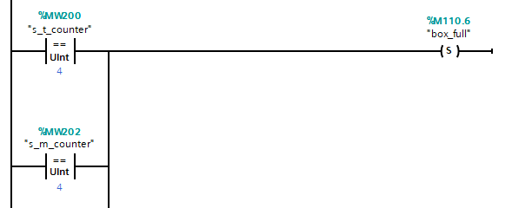
If counter value is equal to set value, indicate full box.

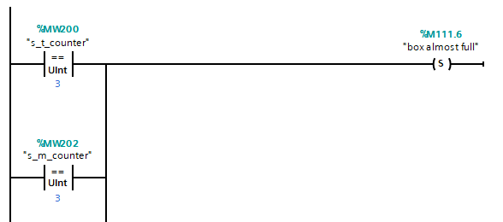
If counter value is equal to set value, indicate box is almost full of pucks.

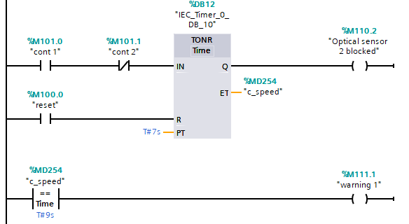
If the time for buck to reach optical two from optical 1 is prolonged by 9 second set warning 1.

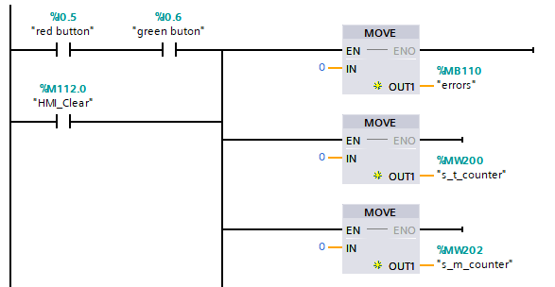

If both red and green buttons are pressed or exclamation button are pressed. Reset all box capacity counters, errors and warnings.
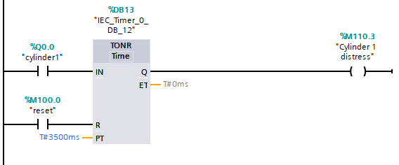

For cylinders one, two and three are not response 1 second later after their main delay time, indicate cylinder malfunction error.

Task 5
From evaluating the diagram of the PLC system, the identified errors and warnings has been applied to the device. Using ladder logic programming, this device is now able to use timers for determining the diameter of the pucks and delay the use of pistons from cylinders, using the stored time values to evaluate which puck type is present.
Though the development of this project, improvements to this system have been considered and have been documented below. The improvement that could be applied are as follows.
- Identify unwanted items which maybe to large or inappropriate for this device.
- Indicate if the gas pressure of the cylinders is still adequate to push the pistons.
- Confirm if the optical sensor itself is operational.
- Confirm the direction of the conveyer and notify user though the HMI display.
- Individually identify which storage box is almost over flowing.
If the PLC system would expand its features and paramotors, the suggestions might improve the system if other items may be applied or to thoroughly monitor other errors of the device.

