An Analysis into the Decline of Ford
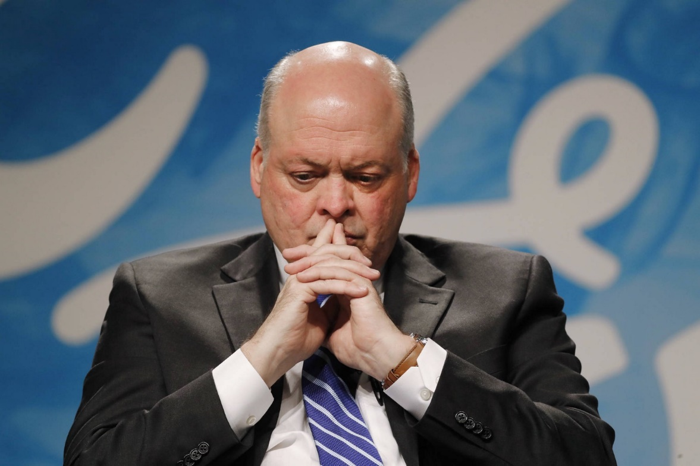

By student: Zilvinas Miksys
Student number: 1815997

Host organization:

Date of Report Publication: 10 January 2020
Executive Summary
Ford Motor Company has been and continues to be regarded as the King of Innovations in the Automotive Industry. We have been remarkably internationally expanded by their research and development team and the invention of interchangeable parts in shifting assembly lines. Ford ruled by a long-time dynasty that has dominated the world automotive market and still does amazing work. Ford is also the property of some prestigious engine brands. In all of these good things, Ford Motor was met with a failure due to a number of wrong decisions made by the executives on their business strategy. The attempt to centralize operations caused them to look similar, contributing to overly Americanised local market awareness in the rest of the world. This caused them to lose the world market.
Contents
1.0 Introduction 4
2.0 Findings 5-9
3.0 Conclusion 10
4.0 Options (Recommendations) 10
5.0 Action Plan 11
6.0 Appendices 12
7.0 Acknowledgements 15
8.0 Reference List 16

1.0 Introduction
This report was requested by Ford motor company on December 10, 2019. Report was compiled by student Zilvinas Miksys representing UWTSD (University of Wales Trinity Saint David). Submission date on January 10, 2020. By this report will provide an analysis of the current problem faced by Ford by using SWOT and PESTLE analytical tools to gather information. This information will help to offer a conclusion and suggest options for improvement at Ford. Researching’s will be made using information from websites, journals, and official company’s documents.

2.0 Findings

2.1 Brief introduction to the Ford motor Company
In 1899 H.Ford founded own car producing company named The Detroit Automobile Company..
2.1.1 The history of Ford
The firm was nevertheless founded and restructured as the Henry Ford Firm in 1901. Yet, in 1902, Henry Ford fell out with his investment supporters and left the company with only $900 of the rights to its name.
Henry Ford turned to the relative of Alexander Y. Malcomson, to fund another car company. A bond was established, and they started to buy parts. Nonetheless, the money went off quickly and the manufacturer demanded payment. Malcomson referred to John Gray president of the German American Savings Bank. He proposed the incorporation of Ford and Malcomson and the introduction of new investors. In 1903, the Ford Motor Company was owned of 12 founders with 1,000 in shares. The engine company was immediately profitable despite concerns of the shareholders.
The death of Henry Ford on 7 April 1947 is estimated to have caused seven million people to mourn his passing. As chairman and chief executive officer Henry II took over.
2.1.2 Products offered
2019 Ford company produces Vans & Pickups (TRANSIT, RANGER), Future Vehicles, Small Cars (Ka+, Fiesta, EcoSport and new Puma), Electric & Hybrid(All electric: mustang Mach-e, Plug-in hybrid, Hybrid and Mild Hybrid), Family Cars, People Carriers, SUVs, Active Crossovers.
2.2 Identification of various problems facing the Ford Motors
The main issue of Ford company is long term restructuration, in that period of time they will lose the leading position in the auto market that they had before. Investments of $11 billion and plus $3.5 billion for last months for restructuration at this hard time made a big impact on companies share market. Even new CEOs Jim Hackett effort to make a deal with Volkswagen AG for producing and innovate future models doesn't make a big impression for investors and shareholders.

2.2.1 Selection of one major problem for investigation
During investigation time on the case study, the major problem is CEO Jim Hackett long term restructuration trying to align with Volkswagen AG, which already cost for the company $11 billion, big loses in the share market.

• Nature of the problem
Ford announced last year that it would implement a massive $ 11 billion restructuring initiative that would move the company toward trucks and SUVs. This year's restructuring costs are expected to include $ 3.5 billion, meaning that there will still be more restructuring costs. As a result, net income decreased 57% year over year to $ 423 million. USD. On an adjusted basis, excluding special items, Ford's net income was $ 1.79 billion. Total revenue fell 1.8% to just under $ 37 billion. However, the case study reveals that in this crisis situation the company did not give an income guideline this year that could provide the hope for shareholders. However, Hackett has always remained optimistic about the issue, introducing new models. At the Detroit Motor Show, the CEO's biggest bet was to start the redesigned version of older Explorer. The newly founded Ford-VW alliance for the production of commercial vehicles was also shown in this illustration.
• Scope of the problem
This strategic move was valued and welcomed in two ways. Investors have been listening and worried about why it took almost a decade to upgrade the Explorer model. Whether after the restructuring the development and production of new models will depend largely on Volkswagen. Fears of increased job loss risk for Ford employees. Will this cooperation really help meet financial expectations?
• Impact of the problem on the organization
Ford and Volkswagen AG group was hoped to focus on the construction and design of new carriers and heavy-duty vehicles as well as a forward-looking hybrid and independent car development plan. However, it helps to further delay the impact on investment opportunities for business and the domestic economy. This company union must have a big impact on the development of the European car industry. But nobody expects that this union will help to solve main Ford company problems.

2.3 SWOT Analysis-Micro
STRENGTHS:
Ford is one of the leading players in the global automotive industry with a strong brand identity and a strong product attractiveness and loyalty. Ford also has a global supply chain that funds its international operations. Another positive is the company's engineering systems, which were already successful after the introduction of the One Ford Project in 2008.
WEEKNESES:
One of the weaknesses of Ford Motor is the restriction of its production network, especially against Toyota's large global network. Ford has also closed several European manufacturing facilities in recent years, exacerbating this shortage. Moreover, Ford's costs and prices are relatively above rivals, and its innovation methods are relative slow in tackling new or changing trends, even when it has improved its innovation efficiency. Consequently, the Ford SWOT study reveals that in contrast with other top players is relatively weak.
OPORTUNITIES:
In the process of entering the market (for example, more retailers, stronger marketing) and developing products (for instance, new technologies that meet environmental demands), Ford Motor Company has the ability to develop and expand its services. Ford can also boost its financial position by widening the supply chain to increase productivity and cut production costs. In this segment of the SWOT study, Ford has potential for growth through organisational development and creativity.
THREATS:
Competitors such as General Motors and Toyota, who participate in aggressive marketing and creativity, challenge Ford. Ford is also threatened by large innovation companies such as APPLE and GOOGLE. to produce free driver cars. The volatility in gasoline markets threatens the sales performance of Ford, which has internal fuel engines in large numbers. This section of the SWOT analysis therefore shows that in order to preserve a competitive advantage Ford must innovate.
The main issues addressed in this Ford SWOT study are the constraints of innovation speeds and the reach of their production network and competition with existing and new enterprises. Ford needs to improve its investments in research and development, and to speed up innovation, in order to tackle intense competition and entering the market in high-tech companies. Ford needs to expand its production grid and increase savings in volume in order to make Ford's automobiles more attractive, reducing cost and price.
2.4 PESTEL Analysis on the Macro environment.
Political Factors
Governments are gradually encouraging technological innovation in order to strengthen the economic situation. This encourages Ford to use government stimulus for innovation, products that are affordable and environmentally friendly. It is also important for Ford to extend its activities through trade agreements that allow businesses to access foreign markets. Furthermore, the high crop developing countries have improved their infrastructures, including transport infrastructure. This remote situation / macroenvironment helps to increase the demand for automobiles in these countries and enables the Ford Motor Company to grow globally. This part of the PESTEL study shows that international factors create important opportunities for Ford for development and expansion.
Economic Factors
Ford is able to develop because the American economy is slowly but markedly growing, which is the largest business. Ford has also a chance to grow in high-potential countries in which it still has limited presence. However, the rising US dollar declines Ford's profit margins and profits, even though many of their raw materials and car parts are manufactured in the US. The remote / macro-ambient situation indicates that Ford needs to improve its market performance to take advantage of the perspectives contained in the PESTEL report.
Social/Sociocultural Factors
Ford is expanding by supplying vehicles to meet the growing demand for hybrid and electric cars. Ford has the opportunity to improve its offerings, particularly after sales, to attract more customers. Nevertheless, the increasing wealth gaps reflect a distant and macroeconomic environment that threatens Ford's expensive high-end cars. Building on this aspect of the PESTEL Study, the Ford solid strategies for growth should focus on the product development to satisfy the demands of consumers and on the social and cultural externalities of the sector.
Technological Factors
The willingness of Ford Motor Company to expand is an external factor delivering mobile services and Internet marketing. Nevertheless, the company can improve its efficiency by improved online regulatory tools. Such compliance agencies, for example, will provide consumers with Ford products. On the other hand, inadequate alternative fuel stations could impede the company's potential growth in alternative fuel supplies. The technical side of the PESTEL analysis helps Ford to concentrate on quality improvement and product development, in order to guarantee productivity under distant or macro environments.

Ecological/Environmental Factors
Climate change is an external factor that helps Ford to expand green products. Low carbon models can be used with the same strategy. Ford could also offer new models that tackle the impact of diminishing oil reserves on vehicles using alternative fuels or energy sources, either globally or in a macro-economic environment. Ford must therefore emphasize product creativity to increase the efficiency of its market by PESTEL research, which is focused on the ecological aspect.
Legal Factors
Ford should increase company sustainability to counter the impact of environmental protection legislation. On the basis of safety standards, Ford is also able to develop product design and use the opportunities. In addition, enhanced intellectual property legislation enhances Ford's macro-environment by enhancing intellectual property and protection of rights. Ford will evolve in this section of the PESTEL study as the external regulatory environment changes.

3.0 Conclusion
All car manufactures expectations before they deliver a new car model remaining positive and 100%optimistic. But in this full-fledged rival, Ford has double the risk. The new CEO Jim Hackket is working in the right direction and is well-suited to Ford as he can withstand the pressures of shareholders and investors, including the stock market. The study concludes that just after the arrival of the new CEO, Ford company is slowly gaining momentum in Ford's revival. Yes, the problems of an established Ford company cannot be resolved in the time provided by investors, it is simply too short, but the gigantic restructuring of the company is already yielding tangible results: lively new car design, expanded car series (Ford Focus Crossover, a fully expanded range of electric and hybrid cars). All-new Ford models are 100% recyclable, so Ford's approach to environmental protection is at a very high level. Perhaps only one thing worries are the alliance with Volkswagen AG, as there are far more advanced car companies in terms of greening than Volkswagen AG.

4.0 Options (Recommendations)
- Expand and increase the market for affordable and quality cars in Asian countries, first place – China.
- Look for a more experienced manufacturer than Volkswagen AG.

4.1 STP analysis for development of sales strategies
To increase sales in China again, STP plans to invest in new factories, collaborate with local auto parts manufacturers, maintain quality standards, reduce production casting. Include more features in the standard car kit at no extra cost. Create reliable, cheaper, more capable electric cars than sold by a competitor. Ned to create a positive and inspiring interaction with present and future customers.

5.0 Action Plan
Description of options | Communicated | Monitored | Reviewed
Expand and increase the market for affordable and quality cars in Asian countries, first place – China. | It is now imperative to contact the Ford Development Board and contact Ford's General Board and investors about additional investments and to convince everyone that during this restructuring, the drop-in stock and profits is a temporary consequence | Restructuring or business development benefits used will be closely monitored, with comprehensive reporting | Must ensure that whoever is doing the work is keeping appropriate records so that progress can be assessed.
Look for a more experienced manufacturer than Volkswagen AG. | CEO meetings and communications | A detailed monitoring of future partners' offers and opportunities | If a mutually beneficial agreement is reached, additional investment will be attracted

6.0 Appendices
6.1 Appendix 1: SWOT Table

STRENGTS | WEEKNESES
1.Very strong brand name  2. World supply chain  3. Efficient methods of creativity | 1. The global production network is small  2. Costs higher than competitors  3. Slow processes of creativity and innovations.
OPORTUNITIES | THREATS
1. global growth by penetration of the market  2. Product development growth  3. Reducing costs by control of the strategic supply chain. | 1. Fierce competition between automakers.  2. High technology companies’ entry.  3.Not stable world’s oil price market.

6.2 Appendix 2: PESTEL
Political Factors
1) Government funding for technological innovation (opportunity) state
2) More contracts and agreements on international trade(opportunity)
3) Increasing government focus on infrastructure in developing countries(opportunity)

Economic Factors
1) Local economic prosperity, in our situation, the United States (opportunity)
2) Business formation growth rate (opportunity)
3) US dollar strengthening (threat)

Social/Sociocultural Factors
1) Hybrid and Electric Cars Growing Demand (opportunity)
2) Average client support strategy (Opportunity)
3) Enlargement of the asset gap (opportunity and threat)

Technological Factors
1) Mobile computing rising (opportunity)
2) Better use of online services (opportunity)
3) Not many alternate fuel (electric charge) filling stations (threat)

Ecological/Environmental Factors
1) Increased factors of climate change (opportunity)
2) low carbon production development(opportunity)
3) Quite limited stock of oil (opportunity)

Legal Factors
1) Regulations on the environment (opportunity)
2) Higher standards of safety (opportunity)
3) Growing Worldwide Rights to Intellectual Properties (opportunity)
STP ANALYSIS FOR DEVELOPMENT OF SALES STRATEGIES

FORD
Segmentation:
- Geographical Asia, China, Big cities
- Demographical Middle age, low – middle income, both male and female
- Behavioural Day to day usage
- Physiographical People who have families

Target market:

- The target market for Ford is middle aged people with low and middle income
- Ford customers mostly have middle income and high-income people
- Brand is popular with all age people because cars are not very expensive
- Ford targeting on males and females because design and all fittings are for all types of needs and sex.

Positioning strategy:
- Ford has implemented a marketing approach, which leads in contrast to its international competitors, to a highly reliable and safe producer of vehicles.
- Local production, low cost servicing
- The cars rely on style, fashion and low fuel consumption rather than speed as well as on well-engineered luxurious vehicles. This is targeted at middle and younger customers who like driving.

7.0 Acknowledgements
I want to thank both the university and the professors who have given me the opportunity to research this very interesting subject as a result. It was tough but special thanks go to my teacher Maria. I would not have been able to accomplish the project without her valuable encouragement and advice. Also, special thank you for my university friends, each time I get interesting and useful information and communicating skills.

8.0 Reference List
1. Media.ford.com. (2020). “Ford China 2.0” Combines “Best of Ford, Best of China”: Marks Acceleration of Company’s Transformation in World’s Largest Auto Market; Supports Global Redesign | China | English | Ford Media Center. [online] Available at: https://media.ford.com/content/fordmedia/fap/cn/en/news/2019/04/03/Ford_China_2_0_Combines_Best_of_Ford_Best_of_China.html [Accessed 9 Jan. 2020].
2. Ghosh, I. (2020). The People’s Republic of China: 70 Years of Economic History. [online] Visual Capitalist. Available at: https://www.visualcapitalist.com/china-economic-growth-history/ [Accessed 9 Jan. 2020].
3. Zafeer (2020). Mercedes Benz market. [online] Slideshare.net. Available at: https://www.slideshare.net/unique_presenter/mercedes-benz-30566604 [Accessed 9 Jan. 2020].
4. http://www.drawpack.com (2020). Segmentation, targeting, positioning business diagram. [online] Slideshare.net. Available at: https://www.slideshare.net/anicalena/segmentation-targeting-positioning-business-diagram [Accessed 9 Jan. 2020].
5. YouTube. (2020). Marketing: Segmentation - Targeting - Positioning. [online] Available at: https://www.youtube.com/watch?v=0srjdRDh99Y [Accessed 9 Jan. 2020].
6. YouTube. (2020). PESTLE Analysis - The Simplest explanation ever. [online] Available at: https://www.youtube.com/watch?v=Gv5fza6wHE4 [Accessed 9 Jan. 2020].
7. YouTube. (2020). Ford SWOT analysis 2018. [online] Available at: https://www.youtube.com/watch?v=MQag_Vp0U6c [Accessed 9 Jan. 2020].
8. Slideshare.net. (2020). Strategy Management of Ford Motor Company.. [online] Available at: https://www.slideshare.net/zrezwana1/strategy-management-of-ford-motor-company [Accessed 9 Jan. 2020].
9. Ford.co.uk. (2020). About Ford. [online] Available at: https://www.ford.co.uk/experience-ford/about-ford [Accessed 9 Jan. 2020].
10. Bloomberg.com. (2020). Bloomberg - Are you a robot?. [online] Available at: https://www.bloomberg.com/news/articles/2019-01-23/ford-ceo-s-thoughtful-approach-fails-to-win-over-wall-street [Accessed 9 Jan. 2020].
11. Diycommitteeguide.org. (2020). Strategic Plan Step 1: Who Should be Involved? | DIY Committee Guide. [online] Available at: https://www.diycommitteeguide.org/download/strategic-plan-step-1-who-should-be-involved [Accessed 9 Jan. 2020].
12. CNBC. (2020). Ford's China sales decline again despite new models. [online] Available at: https://www.cnbc.com/2019/10/11/fords-china-sales-decline-again-despite-new-models.html [Accessed 9 Jan. 2020].
13. Volkswagenag.com. (2020). Volkswagen Group Homepage. [online] Available at: https://www.volkswagenag.com/# [Accessed 9 Jan. 2020].
14. YouTube. (2020). Ford's CEO on company outlook in 2019. [online] Available at: https://www.youtube.com/watch?v=NyvMa03dswQ [Accessed 9 Jan. 2020].

