

INTERNATIONAL BUSINESS MANAGEMENT
Ahammed Azharudeen master House
Student id:2229990
Submission date:05-01-2024

Table of Contents
Introduction 3
1. Analysis of the influence of Globalisation on the operation of business in Microsoft 3
Overview of the Company 3
Microsoft's operations for globalisation 4
Changes in the globalisation factors 5
2. Scrutiny of cross-cultural issues in international business 5
Importance of cross-cultural factors in businesses operating internationally 5
Issues faced by Microsoft in the cross-cultural aspect 6
3. Macro and Micro Factors of the International Market and Analysis of the Impact on Microsoft 8
Analysis of the Macro Factors of the International Market using PESTLE Analysis 8
Micro-factor analysis of the International Market using SWOT analysis 12
4. Current value chain of Microsoft, its potential configuration and coordinate challenges related to analysis 15
Current value chain analysis of Microsoft 15
Primary Activities 15
Secondary Activities 17
Potential challenges regarding the configuration of the value chain and coordination 18
5. Assessment of the entry-mode strategy taken up by Microsoft in the overseas market 19
6. Analysis of the applied international strategies of Microsoft in the global market 20
7. Critical Reflection on ethical policies and sustainability practices of Microsoft across Countries 23
8. Recommendations regarding improvisation of international business 24
Conclusion 26
References 27
Appendix 35

Introduction
This report will mainly highlight the business management strategies in the global market of Microsoft, which will include the influence of globalisation on Microsoft’s operations. Moreover, it will also include the cross-cultural issues in Microsoft’s international business along with the macro and micro factors of the market and its impact. Microsoft’s present value chain system and potential changes in its configuration along with coordinate challenges will be in this report, however, the entry-mode strategies in the company’s overseas market will be mentioned. Analysis of the international strategies applied by Microsoft along with the reflection on the company’s ethical policies and sustainability practices and further recommendations to upgrade the international business of Microsoft will be in the report.

1. Analysis of the influence of Globalisation on the operation of business in Microsoft

Overview of the Company
Microsoft is an American-based multinational business company dealing in technology, which was founded on April 4th, 1975 and has its headquarters in Redmond Washington. Microsoft in today’s environment mainly develops as well as markets software, hardware devices and related services intending to deliver new opportunities, and higher convenience to users also enhancing people’s life values (Microsoft.com, 2023). Moreover, it is regarded as the mission of Microsoft to enable an individual or an organisation to recognise its full potential with the help of technologies created by the company. The global revenue of Microsoft has grown in the fiscal year of 2022-23 and reached 212 billion U.S. dollars, which shows a growth rate of seven per cent year-on-year (Statista.com, 2023).
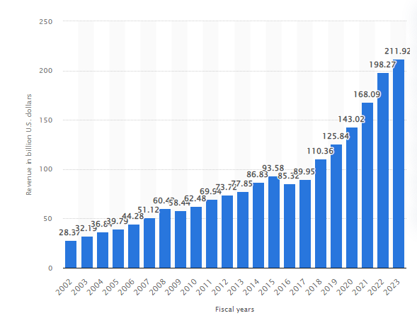
Figure 1: Worldwide Annual Revenue of Microsoft
(Source: Statista.com, 2023)

Microsoft's operations for globalisation
Being a brand which has ventured into different regions of the world, Microsoft has been following various interesting approaches regarding the company’s global expansion model. Microsoft has set up operation centres, which help the company by supporting all the operations in different regions including customer contracts, collections and credits, order and information processing as well as vendor management and logistics (Microsoft.com, 2023). To maintain such global ventures smoothly, establishing all these operation centres in different regions has helped Microsoft to run all its operations across the world with ease. In addition to this, to serve the multinational customer base and improve the products according to the market needs, Microsoft has also localised many of its products to reflect local languages and conventions (Microsoft.com, 2023). Providing such significant changes in the global market, the minute changes in local marketplaces have helped Microsoft to capture a large demography of customers and businesses. An increase in flexible business operations has the capability to play a major role in the decline of the dynamics of a firm (Tang, Wang and Yu, 2020).

Changes in the globalisation factors
Microsoft, being a multinational technology-oriented company, has been known to embrace the strategy of a multi-domestic approach, which caters for the requirements of each market. To enter into any new market, companies have to focus on and adopt multi-domestic strategies and at the same time give attention to the development of products (Kolhei, 2023). This shows that Microsoft has made the right decision in the context of the global expansion of the company by focusing on a market-based product development scheme. Microsoft has also focused on implementing basic changes in the ways of interaction and communication among the company’s employees by using Microsoft Teams for communication, meetings, and callings (Microsoft.com, 2023).

2. Scrutiny of cross-cultural issues in international business

Importance of cross-cultural factors in businesses operating internationally
Cross-cultural factors are efficient quadrants that depict skill development to expand its territories on the global market, working with people from distinctive cultures is associated with empathy and tolerance development. This involves the execution of crucial marketing strategies that businesses may perform to enhance its appearance internationally, cross-cultural management may help business firms understand its motivation factors. The identification of working styles to initiate effective management strategies is imperative for the fulfilment of expansion goals. Cross-cultural interactions help to achieve interpersonal skill development as it encourages people to be more open-minded to others thoughts and opinions considering individual experiences and evaluation (Wang et al., 2022). A diverse range of perspectives boosts the efficiency and performance of an organisation that helps to gather resources from all over the world, engagement through national and cultural boundaries is an integral part of this process. This improves communication skills and fastens the business objectives more explicitly, the access to technology has played an important role in globalisation that establishes smooth and flexible interactions with people from distinctive cultural backgrounds (Bader and Stomberg, 2018). Cross-cultural business associations help create an impactful impression on the overall productivity of the organisation, establishing opportunities for the workers by navigating cultural differences.

Issues faced by Microsoft in the cross-cultural aspect
Microsoft is equipped with cross-cultural attributes and has been successfully navigating cultural barriers to establish significant superiority in terms of validating the distinctive opinions of people around the world. The leaders of the company have witnessed evident challenges and obstructions during the elaborate process that have made all efforts irrelevant and devastating (Wilson et al., 2020). The multinational company tries to develop a systematic approach to embrace a diverse range of employees to create a positive work environment. It often encounters various allegations concerning the same, serving customers and creating business relationships irrespective of caste and gender will promote brand identity and reputation in the global market. Cultural imperialism is a major concern that affects Microsoft’s engagement and interaction with other countries, racial discrimination within the organisation has been questioned substantially by the US government to which the software company has declined. The effective implementation of diversity and inclusion within the organisation has been interpreted as an absent quadrant by the former employees of the company. Black and African Americans have been racially discriminated against during the process of recruitment followed by major criticism, the firm has committed to double the number of black senior staff by the year 2025 (Bbc.com 2023).
Another issue faced by the multinational company has been of extreme concern regarding the treatment towards women which includes sexual harassment and job inequality. According to various reports, women have been deprived of equal opportunities in the association along with the privilege of being promoted which signified gender inequality within the firm (Variety.com 2023). There has been inappropriate evidence of women being verbally abused by the managers and other male employees which had created an awful impression within the community. There have been instances that have affected Microsoft vividly for the team to implement strict HR policies within the firm, the CEO further apologises to the public and the people who have faced such inappropriate and demeaning experiences. It may be gathered that the women employees of the software company only make up 27.6 % of the entire workforce, the number has continuously declined in regards to women leadership throughout the years of development (Forbes.com 2023). Insights have been gathered that determine the women population that insignificantly represents the cultural views of the overall brand, currently only 25% are equipped with managerial positions, 20% of directors and 19.3% of executive operations. Although Microsoft has pledged to enhance diversity, inclusion and quality in various events, the spokespersons have been unable to provide fulfilled solutions that give rise to undesirable issues impacting the overall growth and global expansion. The company gradually has focused on effective recruitment of employees considering the diverse range of cultural backgrounds, this will create a positive impact as well as expand company resources while validating the experiences and perspectives of all workers. These issues have been quite problematic for Microsoft which had a long-term effect within the software industry. The critical issue concerning the negligence of black people has given rise to adequate defamation, and the racial harassment on the job sites of Microsoft has been elaborately discussed by labourers (Kiro7.com 2023).

3. Macro and Micro Factors of the International Market and Analysis of the Impact on Microsoft

Analysis of the Macro Factors of the International Market using PESTLE Analysis
Political Factors
The impact of political factors in any industry is massive, and when it comes to a global company such as Microsoft, such factors are more prevalent. The global ranking in the sector of political stability, the USA has the rank of 95 between the years 1996 and 2021 (Theglobaleconomy.com, 2023).
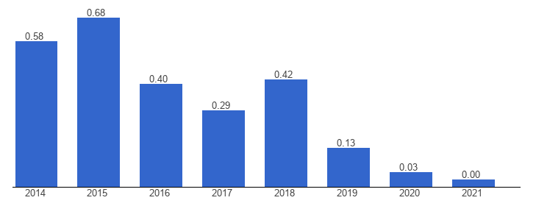
Figure 2: Political Stability Index of USA
(Source: Theglobaleconomy.com, 2023)
In this context, it has been well understood that in the headquarters country of Microsoft, there have been various situations which have given rise to political turmoils. However, Microsoft has actively engaged itself with the concerned government, policymakers and civil society makers across the world to point out important issues impacting the business (Microsoft.com, 2023).
Economic factors
Microsoft has observed a potential boost in sales revenue in developing countries, as there are high chances of growth in the market for the company. In the year 2022, the GDP of the USA has increased substantially to previous years and generated almost 25.46 trillion U.S. dollars (Statista.com, 2023).
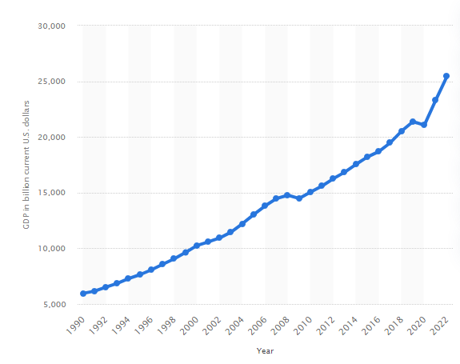
Figure 3: GDP of the USA
(Source: Statista.com, 2023)
In this context, Microsoft has taken the opportunity to expand its business in developed nations as well and there is much more economic stability than in developing nations. In addition to this, the annual inflation rate of the USA has increased drastically from 2011’s 3.2% to 8.3% in 2022 (Statista.com, 2023).
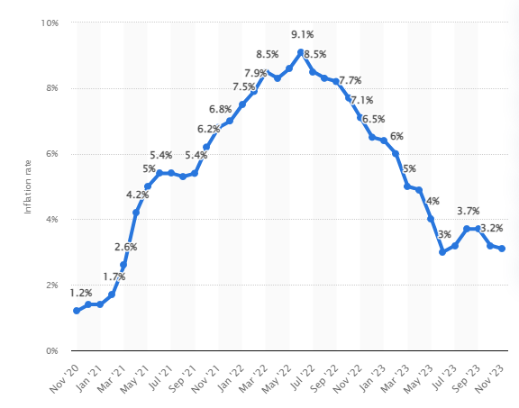
Figure 4: Inflation rate in the USA
(Source: Statista.com, 2023)
Social factors
Advancement in technology has made customers demand more than relevance in any product, instead smooth, non-disruptive services are required to attract customers in any business. Microsoft has also noticed a few significant customer behaviours in all these years, which are luxury shoppers, activists who are empowered, self-care-conscious individuals, and digital geeks (About.ads.microsoft.com, 2023). In the previous decade renovation of websites was done after almost five years, however with modern technology, now customers have access to far more demands regarding services and products. Understanding the current market trends has made Microsoft aware of customer behaviours and has impacted the marketing strategies of the company (About.ads.microsoft.com, 2023).
Technological factors
In the technological sector, Microsoft is required to implement more automation in business while increasing online transactions. Science, technology and innovation are regarded as the base bricks in the sector of the economy of the USA, such factors play a major role in developing modern society and improving international economics (State.gov, 2023). Moreover, an increment in online transactions might appear as a threat to Microsoft, as there might come many rival companies who might use such an opportunity to enter the market. To ensure that America manages to take the lead position in the science and technology sector, the country is committed to its robust agenda, which advances America’s value across the globe (Trumpwhitehouse.archives.gov, 2023).
Legal factors
The USA is a leading country in almost all sectors, and the country’s rules and regulations play a critical role in all businesses including Microsoft. American rules regarding business dictate that corporations have to do initial and annual meetings with the company’s directors and stakeholders regularly (Sba.gov, 2023). In this context, Microsoft also has focused on updating the company’s stakeholders about all the important decisions taken by the directors regarding the expansion of business. Foreign Corrupt Practices Act of America also talks about how it is illegal for any company or individual to pay or promise to pay any amount to foreign officials for the sake of business (Sba.gov, 2023).
Environmental factors
In any business development, environmental factors also play a significant role regarding the expansion of the company and Microsoft has also focused on that for business. The Clean Air Act was developed keeping in mind the protection and enhancement of the quality of national resources (Guides.loc.gov, 2023). To run the business smoothly, Microsoft had to check on the air pollution factors that might come out of the company.

Micro-factor analysis of the International Market using SWOT analysis
 | Microsoft
Strengths | - Microsoft is the second largest company in terms of market capitalisation having a valuation of 2.783 trillion U.S. dollars (Forbesindia.com, 2023)  - The revenue generation has been 56.5 billion U.S. dollars with a growth rate of 13% (News.microsoft.com, 2023)  - Microsoft’s Windows has been able to take almost 70% of the market shares, dominating this sector (Statista.com, 2023)
Weaknesses | - The increase in cybercrime has left Microsoft in a bad situation, as the negligence in hacking Windows  - A lack of innovative measures has been seen in the company in the sectors of computers and phones  - The overexposure of the PC market and the currency fluctuations have made Microsoft a vulnerable company.
Opportunities | - Microsoft services have the ability to deliver the clients’ desired cloud computing state (Microsoft.com, 2023)  - Microsoft has a massive chance in the field of artificial intelligence and game technology by incorporating innovation  - Microsoft has planned to acquire Acitivison Bizzard in all cash transactions which is valued at 68.7 billion U.S. dollars (News.microsoft.com, 2023)
Threats | - The workforce diversity statistics have shown that in Microsoft, the number of female and minority workers is quite low.  - The changing dynamics of the customer demands in the sector of smart gadgets have increased while Microsoft has a moderate share in such smartphones and laptop market  - The rising rates of cybercrimes and software piracies have not been handled by Microsoft in an effective manner, which impacted the security systems of Windows.
Table 1: SWOT Analysis
(Source: Self-assessed)

4. Current value chain of Microsoft, its potential configuration and coordinate challenges related to analysis

Current value chain analysis of Microsoft

Primary Activities
Inbound Logistics
The main resources of values in this sector of Microsoft come from sales economics, the presence of strategic relationships with suppliers and detailed knowledge of the supply chain management practices. Quality checks have provided a lot of functionality in the company, as rapid checks on quality are done in the company at the time of receiving to the inbound deck area (Learn.microsoft.com, 2023).
Operations
The productivity and business process of Microsoft is made up of a range of devices and services related to productivity, communication and information services. More personalised computing in Microsoft provides products and services towards more balanced user end interest, developers and IT professionals. In addition to this, the intelligent cloud facility of Microsoft has the ability to empower modern businesses.
Outbound logistics
The outbound logistics of Microsoft has several sectors in which various channels are used for this sector, among which smart packing is the first one. The shipping of small packages adds functionality in the creation of carrier login credentials, additional freight terms, charging freights to the customer's third-party account and many more (Learn.microsoft.com, 2023).
Marketing and sales
All the major sources of Microsoft’s value creation have a dependency on the company’s marketing and sales, which includes viral marketing and licensed sales approaches to decrease the cost of sales. Many organisations have licensed Microsoft’s products and services through enterprise agreements with direct sales support from solution integration, web agencies and developers as well as independent software vendors (Microsoft.com, 2023).
Service
Services are used to refer to the identification of common interests, shared market knowledge and development of new opportunities in business (Devaux et al., 2018). In this context, Microsoft has aimed to support its customers in the sector of providing online security and maintaining higher customer service pre-purchase. Microsoft provides a feature of apps and services, which might be used by clients to connect multiple apps and services across the company with the email providers (‌Support.microsoft.com, 2023).
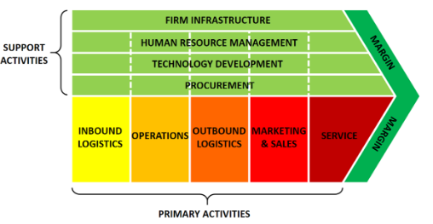
Figure 5: Value Chain Analysis
(Source: Devaux et al., 2018)

Secondary Activities
These activities are used to provide support and act as the backbone of the primary activities, which also play a crucial role in the effective delivery of a company’s products and services. The infrastructure of Microsoft is known as a globally expansive sector in both ways, physically through office buildings, and retail stores and virtually through the extensive digital platforms and systems. Microsoft has also embraced innovations in infrastructure such as underwater data centres, technologies of hydrogen fuel cells and liquid immersion cooling projects (Azure.microsoft.com, 2023). The human resource management at Microsoft mainly focused on the creation and management of an inclusive, innovative as well as high-performance working ambience in the company. Management of human resources strategically and effectively might provide a solid foundation in the sector of competitive benefits (Alzoubi et al., 2020). Microsoft is undoubtedly a tech giant, and for such a company technological development is an essential area, and the research and development team of the company is constantly working on that. Technological advancement has the capability to influence the relative density regarding the globally dispersed and localised network of production (‌Kano et al., 2020). In addition to this, the last segment of this secondary action is the procurement part, and in Microsoft, it involves a varied range of resources which are necessary for the company’s operations. The Supplier Code of Conduct in Microsoft outlines the company’s expectations for the suppliers and respective employees as well as the agents, and subcontractors (Microsoft.com, 2023).

Potential challenges regarding the configuration of the value chain and coordination
Microsoft is such a big brand in technology, still, it did not escape from the issues of the value chains and coordination in the company. In a supply chain not considering the major social factors might have a significant impact on a company’s reputation and image as well as on long-term success (Ghadimi, Wang and Lim, 2019). In this context, Microsoft has been struggling with some issues in the supply chain as cloud providers have scrambled at the time of securing enough servers. In addition to this, the advent of a pandemic situation in the form of COVID-19 has made the company face a lot of difficulties in the sector of supply chain on a global scale (News.microsoft.com, 2023). Moreover, such a pandemic situation in the future may hinder the supply chain and also impact intensely on the global economy and loss of potential opportunities for Microsoft.
Proper and undisturbed coordination is an important aspect of a company such as Microsoft, that too being in the technology industry and issues in this area might cause a huge problem for the company. Through communication, the workers of a company tend to create and negotiate shared understanding and meaning, which are connected to important work-related issues (Valo and Mikkola, 2019). In addition to this, the research done by Microsoft has found that employee communication networks have become static and less interconnected in the pandemic situation. In this context, with lesser communication among the team members has lowered the productivity of the organisation (Refer to Appendix 1). On the other hand, as Microsoft is a multinational company, it may also be observed that, due to a lack of coordination, Microsoft will be unable to deliver the right products and services to customers at the right time, which will be responsible for staining the brand image.

5. Assessment of the entry-mode strategy taken up by Microsoft in the overseas market
To expand its market space on a global level, Microsoft has adopted the internationalisation strategy model, which has impacted the company a lot. The international strategy mostly focuses on multidivisional firms coming from developed economies and business groups (Holmes Jr et al., 2018). In this context, it has been observed that Microsoft tends to follow a transnational approach in the sector of entry mode strategy in the overseas market. The transnational approach is used to derive the financial results regarding a business by taking the record of revenue, expense and other purchase-related transactions.
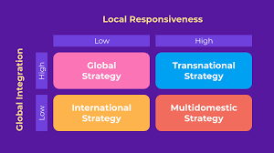
Figure 6: Internationalisation Strategy
(Source: Holmes Jr et al., 2018)
In addition to this, while expanding Microsoft’s business in India, the company provided services which are related to the global cloud from the local data centres with the motive of accelerating the digital transformation in India (Microsoft.com, 2023). In this context, it has been seen that Microsoft has helped in the advancement of digital technologies in India, which has created a great image of Microsoft. Tech Mahindra is a leading company in the digital sector of India that has collaborated with Microsoft, and Tech Mahindra has provided its talent expertise and comprehensive solutions in the sector of the company's 5G core networks (News.microsoft.com, 2023). Such collaborative measures have helped Microsoft to utilise the expertise of the big brands in India and at the same time, have allowed the company, to expand its market appearance in a crowded marketplace. In addition to this, the USA is the birthplace of Microsoft, and in the field of expansion in that area as well, the company has taken various approaches to enter into the evolved marketplace of the country. Accenture and Microsoft have jointly planned to do combined ventures which are known as Avante, which have worked on critical issues of climate change, as it is an alarming issue for both the business and individual (News.microsoft.com, 2023). In this context, it is clear that Microsoft has triggered the most talked about issues in the town, which helped the company to become in the headlines on the news and get customer confidence. Apart from all the other countries, Microsoft has taken a unique initiative regarding the expansion of business in the overseas market which focused on Italy. Leonardo and Microsoft have joint forces and are known to contribute to the field of Italy’s digital development and also in the region of innovation and cyber-security (Leonardo.com, 2023).

6. Analysis of the applied international strategies of Microsoft in the global market
Understanding and implementing the correct market drivers, having the data on customer trends, sharing strategies, and finalisation plans and taking stakeholders' opinions are some important aspects (Support.microsoft.com, 2023). In addition to this, the company never fails to heavily invest in the sector of marketing and promotions, so that more people get to know about the company’s schemes. In the fiscal year 2023, Microsoft spent a whopping amount of 22.67 billion U.S. dollars in marketing and sales, which is the highest amount to date (Statista.com, 2023).
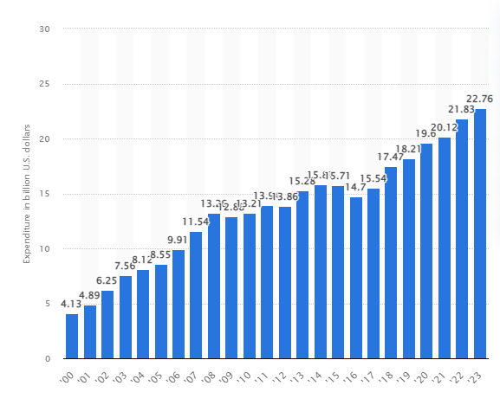
Figure 7: Microsoft’s expenditure on Sales and Marketing
(Source: Statista.com, 2023)
Yip's framework determines the distinctive systematic approaches and global strategies of multinational companies through effective evaluation and prediction of strategic behaviours (Benevolo et al., 2020). This model is approached in the case of Microsoft, to explore the opportunities for economic expansion, analyse the political barriers, and demonstrate the competitive pressures effectively emphasising globalisation. The existence of the cost drivers in the multinational software company depicts the quadrants that impact the overall costs of the resources, services and operations within the organisation. Microsoft's critical expenses are employee compensation, designing and manufacturing of software items along advertising and promotion. The workload costs include the potential expenditures that encompass operational expenses, vendor costs, billing model choices etc to enable precise budgeting and forecasting (‌Microsoft.com 2023). The competitive drivers focus on the inclusion of primary contemporaries of a similar industry, incase of Microsoft, the alternate software companies such as Apple, Google and Oracle act as potential barriers. The company strategically focuses on a wide range of product portfolios that include software, hardware and cloud services (Dutta and Dutta, 2019). The competitive advantage it has established over the decades is the impactful network effect and strong brand positioning.
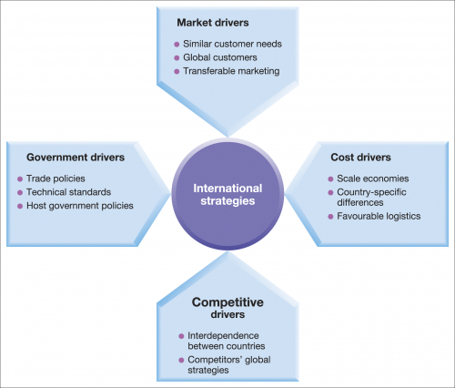
Figure 8: Yip’s Framework
(Source: Dutta and Dutta, 2019)
The price strategy is one of the best among its contemporaries which has established a reputable brand identity and impression along with the product quality that genuinely caters to innovative functions. The government drivers of Microsoft operate through dynamic advances that incorporate the functioning of the association, several laws and policies are followed to regulate a systematic structure. For the company to significantly prosper in the global markets it may have to meet the government restrictions and requirements that are designed considering the country’s tariff barriers and technical standards (‌Rissman et al., 2020).

7. Critical Reflection on ethical policies and sustainability practices of Microsoft across Countries
Microsoft has pledged to become carbon-negative, and water-positive and accomplish zero waste by the year 2030, it has been promoting ethical policies and collaborates with several experts around the world to achieve science-based standards (Microsoft.com 2023). It has started its sustainability journey through the effective implementation of waste management strategies, transitioning completely to renewable energy resources. In the UK, the company has developed the concept of being carbon neutral for a while, along with that it also claims to protect and conserve land. Microsoft and Fujitsu have collaborated effectively into a global partnership to work together on environmental challenges and achieve sustainable excellence in Japan (Shih, 2023). The CSR policies have established low-carbon business solutions and cloud-operated technologies, recycling and reusing have also been consistent policies that have gathered significant attention to mitigate the societal damages. Microsoft has also partnered with the South Korean government to encourage the relevant goals of sustainable and responsive development (Lee, Shin and Lee, 2023). It has specifically curate sustainable policy lead for Asia Pacific which plays the role of participating in sustainability and energy-related programs and initiatives. Cloud services such as Azure and Microsoft 365 enable a flexible estimation of carbon emissions generated during industrial development, an Excel-based program has been established to interpret the environmental impacts of soil remediation activities in the US (‌Lehne et al., 2021). Microsoft aims to develop significant changes in its ethical policies through beneficial compliance of rules and regulations, the company has encountered critical challenges previously that have affected the overall reputation of the firm. It has been evident from numerous instances and insights from former employees have confirmed the existence of unethical practices and leadership which included authoritative behaviour. The company has lasted and emerged again through effective survival of threats and has curated preferable laws and regulations to maintain dignity in the workplace. The company tends to ensure that employees are not differentiated in terms of caste, colour or gender, racial discrimination and harassment have been strictly ruled out due to the negative impression and reputation it sought. The legal policies of Microsoft in India promote the policy of EEO which stands for equal employment opportunity which signifies the ability of the employees to share individual thoughts and experiences and be treated with dignity and respect (Kamath, 2021) The anti-discrimination law protects the fundamental rights of a human being while working in an association to contribute towards the organisational growth. Employee performance and efficiency are directly related to the treatment received resulting in a positive work culture and environment. The code of conduct of the company may adequately enforce punishments for unacceptable behaviours within the workplace, in 2023 Microsoft was awarded with AAA rating which is the highest rating available to the organisations.

8. Recommendations regarding improvisation of international business
Microsoft is a well-established and reputable brand that has been operating through the years with innovative designs and advanced software tools. To expand its global territories, the company should eliminate resource consumption and perform waste management accurately. Furthermore, Microsoft should gather insights to develop sustainability through data-driven solutions and utilise minimum natural resources, the carbon emission should adequately decrease in the process (Bibri and Krogstie, 2020). The company should advocate and address the current issues of global warming, climate change and plastic pollution, relevant campaigns and programmes should be conducted to gather the attention of the public which will eventually provide a vast global platform. The business operations should be able to meet the sustainability goals to enhance brand perceptions and ethical awareness. However, the company may seriously consider the threats and criticisms while promoting its services, the work culture has been termed toxic and negative by the former employees of the organisation (Koropets, 2019). The company should adequately manage its resources to take strict actions to discipline the people practising racial harassment and violate the standards and policies of the association. The leaders and managers who serve the purpose of guiding and regulating team collaboration should be acquired effectively through a standardised identification of experts, trained professionals will be able to handle disruptions within team members significantly (Chen Das and Ivanov, 2019). It has been observed that due to these events, firms lose efficient employees creating a sense of dissatisfaction which is followed by a lack of respect in the workplace.
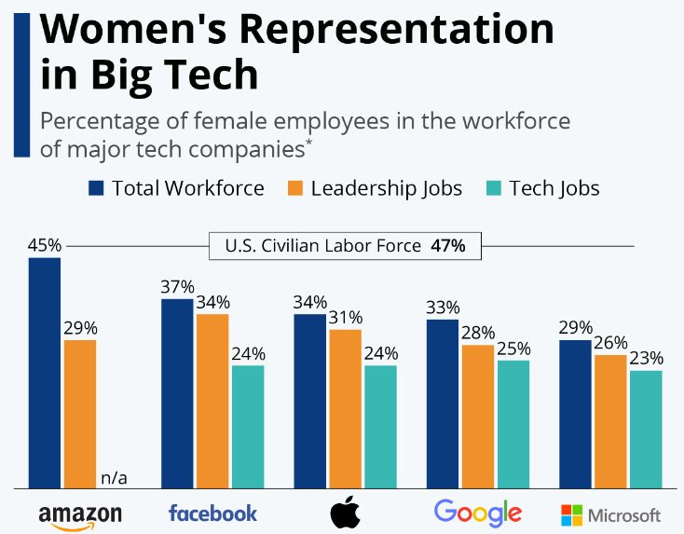
Figure 9: Women's employment in tech industries
(Source: Statista.com 2023)
Another major allegation that Microsoft has been associated with was gender inequality within the workspace where women employees do not receive significant validation and have to struggle for years to be promoted. According to several articles and reports, women who have been part of the organisation over a long period have confirmed the lack of exposure and entitlement in terms of job opportunities at Microsoft. While the other industries have significantly enhanced women's employment, the tech industry which is considered to be the most progressive and advanced, still struggles in that aspect (Statista.com 2023). Microsoft should implement strategies to maximise its employee strength based on talent acquisition rather than gender differentiation, the futuristic approach will enable smooth operations management and create an appealing brand identity to establish superiority among its rivalries. Women also seem to receive lesser compensation than men, statistics state that the chances of men getting promoted are higher in the institution, and the women also receive less validation and performance evaluation than the other gender.

Conclusion
It may be concluded that Microsoft functions through systematic business approaches that signify the evident impacts of globalisation, the accurate interpretations of the current changes in business scenarios are highlighted in the study. The ways the tech company may expand its territories in the international market have also been analysed. A brief composition has been provided considering the cross-cultural issues and challenges encountered by Microsoft along with effective interpretation of micro and macro factors that may impact the organisation. A critical evaluation of the company’s value chain has also been discussed along with the relevant entry mode strategies. The ethical policies and sustainability goals of the organisation have been highlighted, determining the various ways the company may be able to maintain dignity to enhance performance and productivity.

References
About.ads.microsoft.com, (2023) Microsoft Advertising. Available at: https://about.ads.microsoft.com/en-in/insights/life-reinvented-four-emerging-personas (Accessed: 18 December 2023).
About.ads.microsoft.com, (2023) Microsoft Advertising. Available at: https://about.ads.microsoft.com/en-in/insights/g/consumer-trends-2021-report (Accessed: 18 December 2023).
Alzoubi, H.M., Ghazal, T.M., Sahawneh, N. and Al-kassem, A.H., (2022) ‘Fuzzy assisted human resource management for supply chain management issues’. Annals Of Operations Research. Available at: https://doi.org/10.1007/s10479-021-04472-8
Bader, M. and Stomberg, P., (2018). The Effect of Organizational Cultural Differences on International Joint Ventures–A Case Study .https://gupea.ub.gu.se/bitstream/handle/2077/57050/gupea_2077_57050_1.pdf?sequence=1&isAllowed=y (Accessed on 10th December 2023)
Bbc.com (2023) Microsoft probed over aim to double black staff numbers. (2020). BBC News. [online] . Available at: https://www.bbc.com/news/technology-54449164.
Benevolo, C., Penco, L. and Torre, T., (2020). Global strategies and entrepreneurial firms: the role of the entrepreneur’s features in the decision-making process. International Journal of Economic Behavior (IJEB), 10(1), pp.79-9 Available at : https://doi.org/10.14276/2285-0430.2385
Bibri, S.E. and Krogstie, J., (2020). Environmentally data-driven smart sustainable cities: Applied innovative solutions for energy efficiency, pollution reduction, and urban metabolism. Energy Informatics, 3, pp.1-59. Available at: https://doi.org/10.1186/s42162-020-00130-8
Chen, H.Y., Das, A. and Ivanov, D., 2019. Building resilience and managing post-disruption supply chain recovery: Lessons from the information and communication technology industry. International Journal of Information Management, 49, pp.330-342. Available at: https://doi.org/10.1016/j.ijinfomgt.2019.06.002
Devaux, A., Torero, M., Donovan, J. and Horton, D. (2017) 'Agricultural innovation and inclusive value-chain development: a review'. Journal of Agribusiness in Developing and Emerging Economies, [Online]. Available at: https://doi.org/10.1108/JADEE-06-2017-0065
Dutta, P. and Dutta, P., (2019). Comparative study of cloud services offered by Amazon, Microsoft & Google. International Journal of Trend in Scientific Research and Development, 3(3), pp.981-985. Available at: https://d1wqtxts1xzle7.cloudfront.net/59570109/214_Comparative_Study_of_Cloud_Services_offered_by_Amazon__Microsoft___Google20190607-32579-14c3b82-libre.pdf?1559896643=&response-content-disposition=inline%3B+filename%3DComparative_Study_of_Cloud_Services_Offe.pdf&Expires=1704435473&Signature=RB0etMQ2vm1-pnZ3IR8g4y9aWPm5kuZE3rmeh5TaOgMOu-t5CqqyvD8yYgBb6zT-VXQY5lOTOuwuCH0a-DR4UniW3TOrqQuUYxCzARaP1~50bKvjQekLDWGEsTFSQIKB5CCBFpxNSrCk7XNBbIv~HknViYG64TmvSgC5L53u7NOffyy7bGSrpwx-XeHW~5BWW5yO2VvCIoaR--4km4quyeaGe5f-UEBOKjgwafDNZcfxAciDvhvEebWR6wail88I5LIFx7NwbzFnh5gRqhNTTRhV-De0Q0zTuGAHJIkQYUIv0MGH2DaOt8jjpAmArupRxmDPh817uS56gwFIb47zDg__&Key-Pair-Id=APKAJLOHF5GGSLRBV4ZA
Forbesindia.com, (2023) Top 10 Biggest Companies In The World By Market Cap In 2023, Forbes India. Available at: https://www.forbesindia.com/article/explainers/top-10-largest-companies-world-market-cap/86341/1.
Ghadimi, P., Wang, C. and Lim, M.K., (2019). ‘Sustainable supply chain modeling and analysis: Past debate, present problems and future challenges’. Resources, conservation and recycling, 140, pp.72-84. Available at; DOI 10.1016/j.resconrec.2018.09.005
Guides.loc.gov, (2023)’ Research Guides: Environmental Law: A Beginner’s Guide: Federal Laws’, guides.loc.gov, Available at: https://guides.loc.gov/environmental-law/federal-laws.
Holmes Jr, R.M., Hoskisson, R.E., Kim, H., Wan, W.P. and Holcomb, T.R., (2018). ‘International strategy and business groups: A review and future research agenda’. Journal of World Business, 53(2), pp.134-150.Available at: http://dx.doi.org/10.1016/j.jwb.2016.11.003
Kamath, P.,( 2021). ‘Outcast (e): The Case for Recognizing Caste Under US Anti-Discrimination Law. Available at SSRN 4026180. Kamath, Priya, Outcast(e): The Case for Recognizing Caste Under U.S. Anti-Discrimination Law (September 20, 2021). Available at SSRN: https://ssrn.com/abstract=4026180 or http://dx.doi.org/10.2139/ssrn.4026180
Kano, L., Tsang, E.W. and Yeung, H.W.C., (2020). Global value chains: A review of the multi-disciplinary literature. Journal of international business studies, 51, pp.577-622. Available at; https://doi.org/10.1057/s41267-020-00304-2
Kiro7.com (2023) ‘Racial harassment allegations at Microsoft campus construction site’. [online] Available at: https://www.kiro7.com/news/local/racial-harassment-allegations-microsoft-campus-construction-site/Z5AYDFWT5BA5LASNCP4ZW6CPME/ [Accessed 18 Dec. 2023]..
Kolhe, A., (2023). ‘Exploring the Factors Constraining the Adoption of Multi-domestic Strategy Among the Fast-Food Chains: A Case Study of Fast-Food Chains in Europe’ (Doctoral dissertation, Dublin, National College of Ireland). Available at: https://norma.ncirl.ie/6785/1/ayushkolhe.pdf
Koropets, O., (2019). ‘Toxic workplace: Problem description and search for management solutions’. Academic Conferences and Publishing International Limited. Available at: DOI: 10.34190/MLG.19.134
Learn.microsoft.com, (2023) Inbound and outbound logistics improvements - Dynamics 365 Release Plan, learn.microsoft.com. Available at: https://learn.microsoft.com/en-us/dynamics365-release-plan/2020wave1/dynamics365-supply-chain-management/inbound-outbound-logistics-improvements.
Lee, K.H., Shin, D. and Lee, M., (2023). ‘Business group affiliation and corporate sustainability performance in emerging economies: Evidence from South Korea’. Business Strategy and the Environment. Available at; https://doi.org/10.1002/bse.3378
Lehne, J.H., (2021). ICT Architecture for a Key Performance Indicator (KPI) Management Application for Zero Emission Neighborhoods (Master's thesis, NTNU). Available at; https://ntnuopen.ntnu.no/ntnu-xmlui/bitstream/handle/11250/2825095/no.ntnu%3Ainspera%3A80718798%3A33282781.pdf?sequence=1
Leonardo.com (2023) Leonardo and Microsoft: A New Partnership for a Secure Digitization of Public Administration and National Infrastructures. Available at:https://www.leonardo.com/en/press-release-detail/-/detail/26-05-2021-leonardo-and-microsoft-a-new-partnership-for-a-secure-digitization-of-public-administration-and-national-infrastructures (Accessed: 18 December 2023).
Microsoft.com (2023) ‘Recommendations for creating a cost model - Microsoft Azure Well-Architected Framework’. [online] learn.microsoft.com. Available at: https://learn.microsoft.com/en-us/azure/well-architected/cost-optimization/cost-model [Accessed 18 Dec. 2023].
Microsoft.com (2023) What is Sustainable Development? | Microsoft Sustainability. [online] Available at: https://www.microsoft.com/en-us/sustainability/learn/sustainable-development-meaning#:~:text=Microsoft%20is%20committed%20to%20becoming%20carbon%20negative%2C [Accessed 18 Dec. 2023].
Microsoft.com, (2023) ‘Business Description, Microsoft.com. Available at: https://www.microsoft.com/investor/reports/ar13/financial-review/business-description/index.html.
Microsoft.com, (2023) Microsoft Teams increases collaboration in the modern workplace at Microsoft, Inside Track Blog. Available at: https://www.microsoft.com/insidetrack/blog/microsoft-teams-increases-collaboration-in-the-modern-workplace-at-microsoft/.
Microsoft.com, (2023) Microsoft. Available at: https://www.microsoft.com/en-us/corporate-responsibility/public-policy-engagement.
Microsoft.com, (2023) ‘Microsoft’. Available at: https://www.microsoft.com/investor/reports/ar12/financial-review/business-description/operations/index.html.
Microsoft.com, (2023) ‘Microsoft’. Available at: https://www.microsoft.com/en-us/microsoftservices/Cloud-Infrastructure-and-Management-Services.aspx.
Microsoft.com, (2023) ‘Microsoft’. Available at: https://www.microsoft.com/investor/reports/ar12/financial-review/business-description/distrbution-sales-marketing/index.html.
Microsoft.com, (2023) ‘Microsoft’. Available at: https://www.microsoft.com/en-us/procurement.
Microsoft.com, (2023) ‘Microsoft’. Available at: https://www.microsoft.com/en-in/about/india-story.aspx#:~:text=Microsoft%20set%20up%20its%20India.
Microsoft’s New Report On Diversity And Inclusion Leaves Readers With More Questions Than Answers. [online] Forbes. Available at: https://www.forbes.com/sites/erinspencer1/2019/11/14/microsofts-new-report-on-diversity-and-inclusion-leaves-readers-with-more-questions-than-answers/?sh=6871ba484e74 [Accessed 18 Dec. (2023)].
News.microsoft.com, (2023) Accenture, Microsoft and Avanade expand partnership to help organizations tackle their greatest sustainability challenges, Stories. Available at: https://news.microsoft.com/2022/06/02/accenture-microsoft-and-avanade-expand-partnership-to-help-organizations-tackle-their-greatest-sustainability-challenges/#:~:text=NEW%20YORK%2C%20REDMOND%2C%20Wash..
News.microsoft.com, (2023) Microsoft Cloud strength fuels first quarter results, Stories. Available at: https://news.microsoft.com/2023/10/24/microsoft-cloud-strength-fuels-first-quarter-results-3/.
News.microsoft.com, (2023) Microsoft Stories India. Available at: https://news.microsoft.com/en-in/tech-mahindra-and-microsoft-join-hands-to-bring-cloud-powered-5g-core-network-modernization-to-telecom-partners/.
News.microsoft.com, (2023) Microsoft to Acquire Activision Blizzard to Bring the Joy and Community of Gaming to everyone, across Every Device, microsoft. Available at: https://news.microsoft.com/2022/01/18/microsoft-to-acquire-activision-blizzard-to-bring-the-joy-and-community-of-gaming-to-everyone-across-every-device/.
News.microsoft.com, (2023) Tackling Global Supply Chain Disruption, Microsoft News Center Canada. Available at: https://news.microsoft.com/en-ca/2022/03/23/tackling-global-supply-chain-disruption/.
Rissman, J., Bataille, C., Masanet, E., Aden, N., Morrow III, W.R., Zhou, N., Elliott, N., Dell, R., Heeren, N., Huckestein, B. and Cresko, J., (2020). Technologies and policies to decarbonize global industry: Review and assessment of mitigation drivers through 2070. Applied energy, 266,Available at: p.114848. https://doi.org/10.1016/j.apenergy.2020.114848
Sba.gov, (2023) Stay legally compliant, Stay legally compliant. Available at: https://www.sba.gov/business-guide/manage-your-business/stay-legally-compliant.
Shih, A.J., (2023). Multicultural Diversity Workforce and Global Technology Collaboration Empowered Semiconductor Manufacturing Excellence in Taiwan: A Manufacturing Engineer’s Perspective. Journal of Manufacturing Science and Engineering, 145(9), p.090801.Available at; https://doi.org/10.1115/1.4062729
State.gov, (2023) United States Department of State. Available at: https://www.state.gov/policy-issues/science-technology-and-innovation/.
Statista.com (2023) ‘Infographic: The Tech World Is Still a Man’s World’. [online] Statista Infographics. Available at: https://www.statista.com/chart/4467/female-employees-at-tech-companies/.
Statista.com, (2023) ‘Desktop OS market share 2013-2018’ | Statista,. Available at: https://www.statista.com/statistics/218089/global-market-share-of-windows-7/.
Statista.com, (2023) Microsoft: revenue 2002-2018 | Statista,. Available at: https://www.statista.com/statistics/267805/microsofts-global-revenue-since-2002/
Statista.com, (2023) Statista. Statista. Available at: https://www.statista.com/statistics/506534/microsoft-sales-marketing-expenditure/.
Statista.com, (2023) ‘U.S. GDP 1990-2018’, Statista,. Available at: https://www.statista.com/statistics/188105/annual-gdp-of-the-united-states-since-1990/.
Statista.com, (2023) United States - Monthly Inflation Rate February 2021/22, Statista. Available at: https://www.statista.com/statistics/273418/unadjusted-monthly-inflation-rate-in-the-us/#:~:text=The%20annual%20inflation%20rate%20in.
Support.microsoft.com, (2023) ‘what Microsoft apps and services is and how it enables connection to your email account’, support.microsoft.com. Available at: https://support.microsoft.com/en-us/topic/what-microsoft-apps-and-services-is-and-how-it-enables-connection-to-your-email-accounts-31b5b1b8-26cb-2637-18c4-6bf4e223dd9a.
Support.microsoft.com, (2023) ‘Build a market winning strategy ‘. support.microsoft.com. Available at: https://support.microsoft.com/en-us/office/build-a-winning-marketing-strategy-79979121-6fb5-42dd-9714-fa20d7a5b725.
Tang, J., Wang, W. and Yu, Z., (2020). ‘Globalisation, ICT investment and firm dynamism’. Transnational Corporations Review, 12(2), pp.193-202. Available at: https://doi.org/10.1080/19186444.2020.1756724
Theglobaleconomy.com, (2023) USA Political stability - data, chart, TheGlobalEconomy.com. Available at: https://www.theglobaleconomy.com/USA/wb_political_stability/.
Trumpwhitehouse.archives.gov, (2023) ‘America Leading World Science Technology ‘.trumpwhitehouse.archives.gov. Available at: https://trumpwhitehouse.archives.gov/articles/america-leading-world-science-technology/.
Valo, M. and Mikkola, L., (2019). ‘Focusing on workplace communication’. In Workplace communication (pp. 3-14). Available at: https://jyx.jyu.fi/bitstream/handle/123456789/68401/1/Valo%2520%2520Mikkola%2520Focusing.pdf
Variety.com (2019)’ Microsoft Employees Confront Microsoft CEO About Sexism, Harassment at Company’. [online] Variety. Available at: https://variety.com/2019/gaming/news/microsoft-employees-confront-microsoft-ceo-about-sexism-harassment-at-company-1203181233/.
Wang, C., Wu, S.Y., Nie, Y.Z., Cui, G.Y. and Hou, X.Y., (2022). ‘Open-mindedness trait affects the development of intercultural communication competence in short-term overseas study programs: a mixed-method exploration’. BMC Medical Education, 22(1), pp.1-9. Available at: https://doi.org/10.1186/s12909-022-03281-2
Wilson, S., Tan, S., Knox, M., Ong, A., Crawford, J. and Rudolph, J., (2020). ‘Enabling cross-cultural student voice during COVID-19: A collective autoethnography’. Journal of University Teaching & Learning Practice, 17(5), Available at: doi.org/10.53761/1.17.5.3

Appendix
Appendix 1
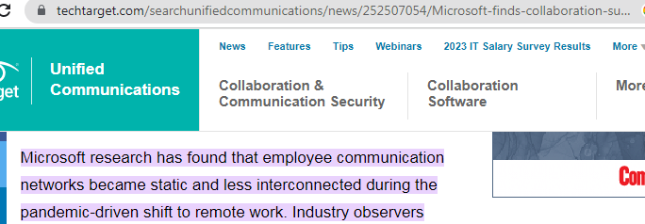
https://www.techtarget.com/searchunifiedcommunications/news/252507054/Microsoft-finds-collaboration-suffers-during-remote-work#:~:text=Microsoft%20research%20has%20found%20that,benefits%20of%20in%2Dperson%20communication.

