A reflection on completing a masters research project
Mortari (2015) suggested that reflection is fundamental in everyday life. Without reflection it would be hard to engage in a ‘thoughtful relationship with world-life' and therefore even harder to ‘gain an awake stance’ about your own lived experiences. Reflection is an important constitute of the plethora of skills required by an outdoor/education practitioner (Schon, 1983; Kolb, 1984; Priest & Gass, 2017 & Asfeldt & Stonehouse, 2021). The pragmatist approach to reflection, so embedded in the researchers practice as an outdoor educator, is that it is an important part of the experiential learning cycle. Primarily used for increasing the action’s effectiveness (Dewey, 1933 & 2008). Reflection is also a ‘crucial cognitive practice in the research field’ (Mortari, 2015).
Reliability and validity are ways of demonstrating and communicating the rigour of research processes and the trustworthiness of research findings (Roberts & Priest, 2006). Utilising a mixed methods research (MMR) approach, the research project reflected the pragmatic paradigm. Pragmatism in research focuses on trying to answer the research question with a mixture of methods of data collection and analysis. Cohen et al., (2018 pg.35) stated that it is ‘driven by a fitness for purpose, employing quantitative and qualitative data as relevant, as long as they work. Both inductive and deductive reasoning is used to investigate multiple views of the research question.’
Cohen et al., (2018) further stated that this may add a greater reliability through amongst other capacities, triangulation. Denscombe (2014, pg. 154–5) suggested 5 different types of triangulations, the most closely related to this projects research design being methodological (between methods). Denscombe’s definition stated that this enables research to be carried out from a variety of different angles utilising completely different methods.
It has also been suggested that MMR can strengthen the validity of research (Cohen et al., 2018; Newman et al., 2008 & Creswell, 2014). Including the conclusions that can be drawn from it, the rigour of research and methodological design and its appropriateness in achieving the purpose of the research. Methodological rigour is also essential and is a characteristic of research that has been subject to serious, strict academic judgment. Research design and implementation through reflexive practice with methodological rigour in sharp focus should result in studies that are of higher scholarly quality and are well aligned. Reflexivity can often be confused with reflection and can be defined as contemplative, conscious self-awareness. ‘Reflexive analysis in research involves a continuous evaluation of subjective responses, intersubjective dynamics, and the research process itself’ (Finlay, 2002 pg.532).
The alignment of the research project, the effectiveness of both quantitative and qualitative data collection and analysis, as well as the researchers own influence will be reflected upon. An indication of how the researchers approach in the future can be improved will also be inferred.
Engagement with literature is a vital component of the research process. It can indicate specific fields and topics related to your research problem, it can foster insight and expertise on debates in the field, identify key theories and give context to the problem (Bloomberg & Volpe, 2019). The researcher attempted to frame the context of the specific research problem by completing extensive searches and executing a literature review. The primary focus initially was on exam stress, with only a single study (Aherne, 2001) relating to further education (FE) key-stage 5 (selected cohort) discovered. The search was broadened to include exam stress in key-stage 4 learners, this proved effectual with the addition of four studies (Denscombe, 2000; Putwain, 2009; Banks & Smythe, 2015 & Roome & Soane, 2019). Multiple sources were retrieved relating to higher education (HE) learners in the USA and Asia. Due to differing age groups, exam types and geography and other alignment issues, combined with warnings about predatory journals (Elmore & Weston, 2020), these were omitted. The next stage of the engagement with literature was guided by the selected theoretical framework.
The theoretical framework, selected with some consternation, was Attention Restoration Theory (ART) (Kaplan, 1995; Kaplan & Kaplan, 1989). A well-conceived theoretical framework can serve as a good guide and play a key role in the research process (Bloomberg & Volpe, 2019). Lederman & Lederman (2015 pp.593) stated that the lack of a well-conceived theoretical framework is the most ‘frequently cited reason’ for the editorial decision not to publish a manuscript. Ravitch & Carl (2019) explained that the framework generates the focus of the research and offers a source of thinking, planning and conscious action. Thus, helping the researcher to contextualise, ground their philosophical stance and present well-related key methodological elements. Although the researcher received positive feedback in relation to alignment, as mentioned, there was some consternation over the theoretical framework selected to achieve this. Figure 1 highlights two potential framework alignment options that were considered when drafting the research proposal. Due to the nature of the study (exam stress) the column on the left was the preferred option. However, after researching the Perceived Stress Scale (Cohen, Kamarck, & Mermelstein, 1983), the ethical concerns around the types of questions and the implications for the cohort, led the researcher to consider other options. The timeframe in which to complete the project meant that ethical approval needed to be swift, utilising a pre-validated questionnaire can assist with this (Kelly et al., 2003). However, the researchers’ professional relationship with the cohort, them being from the same institution, meant that any pastoral issues raised through participation needed to be given equal gravitas. Therefore, an alternative theoretical framework (column two) was conceived and, as suggested by both Bloomberg & Volpe (2019) and Ravitch & Carl (2019) helped to guide the rest of the literature review. With the inclusion of ART, research around wellbeing and nature relating to a similar age group (Birch et al., 2020), linking stress to wellbeing (Berto, 2014) and the inclusion of the Warwick Edinburgh Mental Wellbeing Scale (WEMWBS) (Tennant et al., 2007) as the quantitative measure were included in the literature review. All contributing to alignment and the design of the intervention.
The design of the intervention (4 x wellbeing walks) was heavily influenced by ART, the need to provide ‘soft fascination’ and a ‘restorative environment’ (Kaplan, 1995; Kaplan & Kaplan, 1989) and the New Economics Foundation (NEF) (2008) ‘Five ways to wellbeing’. The research proposal outlined that these would be based around nature identification with the original conception being around building a connection with nature (one of the objectives outlined in the research proposal) (Pretty et al., 2005). Due to the selected location, participants, and the enthusiasm of the researcher, these were adapted over the duration of the intervention period. The conservation site on campus was small and limited in its biodiversity. To complete a circuit of the entire site took only ten minutes which left us congregating at the forest school fire pit.
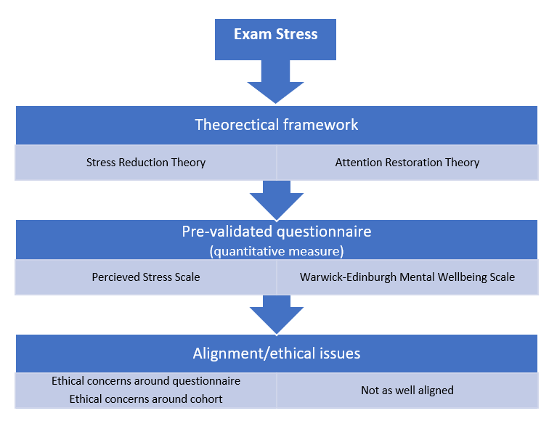
Fig. 1: Two options for theoretical alignment – own work (Reynolds, 2022)
Although there were a variety of birds to identify, it was clearly not holding the interest of the group and there was also a distinct lack of flowers and trees for the following weeks. Concerned about engagement and attendance and, with a clear indication from most of the group that they would like to have some more practically based activities included, the following two weeks (walk two and three) were changed to include fire lighting and shelter building. These were led with minimal instruction and utilising the challenge by choice (Schoel, Prouty & Radcliff, 1998) facilitative approach. However, I was acutely aware that adjusting the interventions, through potentially a lack of reflexive practice, could have biased the data collection (Denscombe, 2014). So much so that, without giving too much away, during the shelter building activity I asked one of the participants what they thought the impact would be on their ability to connect with nature and to de-stress (potentially compounding my issues further!). The reply was ‘we are doing the activity in a beautiful place surrounded by nature, we are even more hands-on as we are touching nature’ (Participant 4, 2022).
Although the quote gave some relief, reflections around the impact on the research project had clearly started to manifest. With more time to complete the interventions, a more biodiverse location with enough space to fill the allocated walking time, would have allowed the originally planned interventions to proceed. Most importantly the researcher should become more aware of the impact of their own background characteristics when conducting research interventions.
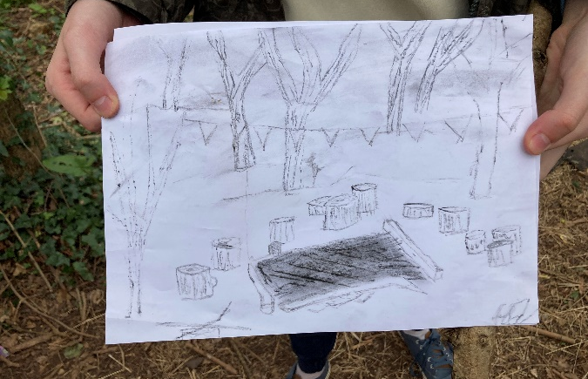
The final ‘wellbeing walk’ was inspired by literature, with the participants requested to find a space in the conservation site and complete a drawing around what resonated most with them about their time in nature. Birch et al., (2020) in their research around how urban nature supports mental health and wellbeing, also employed ART as the underpinning theoretical framework. Birch (2020) utilised ‘arts facilitators’ and ran arts-based workshops to ‘understand more deeply the experience of urban nature for wellbeing’, including recording, and coding the conversations based around the outcomes. Included by the researcher for two reasons, to try a different research approach and to attempt to meet the differing needs of individuals within the participant group. On reflection, the value of these is limited due to not being included in the data analysis and the lack of experience of the researcher in both research and arts-facilitation. However, the outcomes were informative and to some extent heartening on a personal level, especially when participants eight & nine took a piece of charcoal from the fire they had lit in a previous intervention, to complete their drawings. (See figure 2).
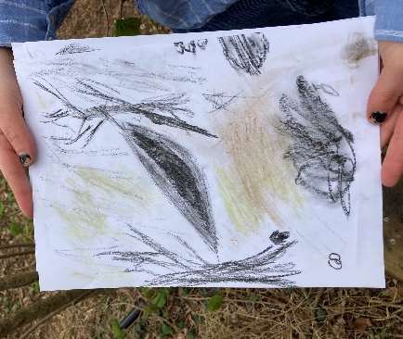

Fig. 2: Participant 8 & 9 drawings from wellbeing walk four - own work (Reynolds, 2022)
Another conclusion that may be drawn from the images though, is that the changes made to the interventions may have impacted on the rigour of the process. Because one participant drew the fire pit from week two, and the other the shelter they built in week three.
Once the interventions had been completed, pre and post WEMWBS scores were analysed utilising SPSS 28.0. Pre WEMWBS scores were assessed for normality, and the Kolmogorov-Smirnov statistic showed a significance 0.200. This non-significant result indicated normality, so parametric statistics were used.​ A paired-sample T-test was conducted to evaluate the impact of the wellbeing walks on pre and post intervention WEMWBS scores. Initial indications are that there was a statistical difference observed between pre-test (M=45.22, SD =13.08) and post-test (M=53.00, SD=11.24, t(8)=-3.974, P<0.05). P= 0.04 and a medium effect size of 0.6 was observed (Cohen, 1988). Although the results demonstrated statistical significance was achieved, this needs to be treated with some caution.
Cohen et al., (2018 pg.246) posited that in many cases ‘validity involves being faithful to the assumptions underpinning the statistics used.’ Shadish et al., (2020) highlighted that statistical conclusion validity may be threatened if assumptions in the statistics used are misappropriated. Prior analysis of the guidance stipulated that the participants need to complete the questionnaire independently to avoid bias in their responses (this condition was met). Upon further analysis guidance also stipulated that WEMWBS scores approximate to a normal distribution, permitting parametric analysis and the most statistically efficient approach was to calculate mean and standard deviations and compare results using a T-test (Warwick Medical School, 2022). Both discoveries would have been useful in terms of efficiency; in not needing to check for normality and for informing the researcher of the type of statistical analysis to use. Neither of these had a major impact on the research process. However, recommendations that data sets need to include a minimum of thirty participants (Stewart-Brown et al., 2008) and that coding of the data could include gender and socio-economic group, should be reflected upon. Similarly, the cut points recommended in the research completed to validate the WEMBWS are essential if future studies are to stand up to academic scrutiny. Tennant et al., (2007) set the cut points at forty-two for the lower end of the scale and sixty for the higher (recognising that 15% of the population fall outside these). This knowledge prior to completing the statistical analysis would have removed a further four sets of results. Whilst these are only recommendations, the correct analysis of data and cohort size are essential for validity, reliability, and rigour (Bloomberg & Volpe, 2019 & Cohen et al., 2018). This should be considered in the future, along with more time spent reviewing the literature related to the selected validated questionnaire.
A further consideration for improving the accuracy of quantitative data is utilising a control group. In randomised controlled trials (RCTs) participants are assigned randomly either to experimental group (receives intervention) or the ‘control’ group (no intervention). Control is the attempt to minimize the effects of variables other than that of the intervention (Lambert, 2019). RCTs are seen as the gold standard in research, indeed Cohen et al., (2018) called it the ‘true’ experiment (see figure 3).
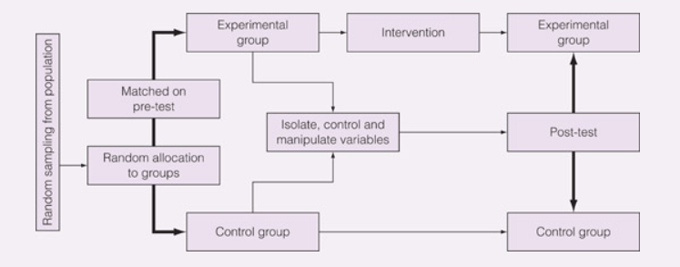Fig. 3: Pretest Posttest Design – The ‘true’ experiment (Cohen et al., 2018)
Through the random allocation of participants to either the control or experimental group and the isolation and control of variables, all threats to internal validity are controlled (Campbell & Stanley, 1963 cited in Cohen et al., 2018). The ethics involved with conducting such an experiment in education need to be considered, it could be unethical to exclude students through randomisation (Lambert, 2019). If the researcher were to scale this research project in the future, the number of participants recommended through the reflection on both the cohort size (Tennant et al., 2007) and quantitative research design methodology (Cohen et al., 2018 & Lambert, 2019) would mean aiming to recruit between 80-100 participants. Whilst this is achievable through the researcher’s current place of work, it is also ambitious. Especially considering the mixed methods approach utilised in BMOE7004 and the impact this would have on data collection timeframes, for the qualitative method of semi-structured interviews.
Cohen et al., (2018) suggested that in semi-structured interviews (SSIs) the topics and questions are given, but the questions are open-ended. The researcher based the five questions around the research objectives and following advice (Dr. Kate Williams, 2022), two sub-questions were also prepared for each. Whilst trying to make sure that the questions were open, at least one did not illicit an open response and the sub-questions proved useful in this circumstance. The second piece of advice received was around time management (Dr. Andy Williams, 2022). Completing nine interviews and subsequent coding of qualitative data would have severely impacted on the time management. A focus group would have helped to counter this issue, and more participants could have been included. However, the researcher was acutely aware that interviewees may have been less candid and influenced by others in their responses (Adams, 2015). Two participants were interviewed and recorded, this proved useful to the researcher, in terms of highlighting any issues with reflexivity for reflection. Coding was attempted using Nvivo12 with word frequency the metric most employed. Unfortunately, both the construction and coding of the semi-interview questions were rushed due to professional time pressures. It would have been beneficial to code the participant responses to each individual question (Schmidt, 2004) giving much more in depth qualitative analysis. However, the responses highlighted in the research poster, did go some way to adding depth to the quantitative analysis. In the researcher’s opinion, justifying the selection of a mixed methods approach.
It would be too bold to conclude that the aims and objectives of this research project were met. However, having gone through the process of reflection, there are many positives that can be taken. Table 1 captures an overview of the researcher’s pertinent observations made throughout this reflection. Most importantly, the conclusions drawn if the research project were to be scaled in the future. One unexpected outcome is how much an enjoyable process it has been. The synthesis of current knowledge, applied to achieve an in-depth exploration of a

Research process | Strengths | Weaknesses | Reflection for future research
Literature review | Comprehensive.  Adapted and guided by TF.  Previous recent study utilised. | Validated questionnaire not researched in full at conception. | Further research will always benefit the research process. This includes research methodology, TF and validated questionnaire.
Theoretical framework (TF)  &  Methodology | Well aligned.  Contributed to rigour of the research.  Paradigm selected appropriate for both researcher and project. | Other (potentially better aligned) options available. | Further comprehensive research of the validated questionnaire’s explored, would help to draw better conclusions around the TF to follow. Therefore, improving alignment further.
Intervention &  Data collection | Utilised available resources (SDC).  Timely.  Followed ethical guidelines (GDPR).  Experienced facilitator. | Influenced by external and personal delivery pressures.  Lack of reflexivity in changing the intervention activities. | Reflexivity although considered, needs to be a focus of personal development, if validity, reliability and rigour are to be achieved in full.  Size of cohort will need to be bigger in the future.  Consider reflexivity when asking SSI questions.
Data analysis  (Quantitative) | Quants – process followed easily and logical. | Validated questionnaire not researched in full prior to analysis.  Stipulations for analysing the WEMBWS scores not followed in full. | Thorough literature review of validated questionnaire to make sure analysis matches recommendations.  Inclusion of control group next time.
Data analysis  (Qualitative) | Quals – Range of questions used, elicited valuable responses.  Advice received and followed contributed to successful completion. | Time requirements for coding SSIs not fully appreciated.  Number of participants interviewed. | Comprehensive review of SSI: coding each question individually. Consider number to be interviewed.  More time spent researching SSI approach and construction of questions.
Ethics | All ethical concerned raised in proposal, were managed effectively.  Considered when selecting TF. | Didn’t consider other learners not receiving intervention. | Ethics will need to be considered when scaling to take into consideration those not receiving the intervention.
Time management | Well planned and executed. | Managing internal & external pressures. | Highly developed skill, put to good use to manage the process effectively.
Table 1: Summary of reflections for future research – Own work (Reynolds, 2022)

current issue, that resonates personally is a rewarding challenge. Along with the development of a new set of theoretical, academic research and practical skills and through the essential process of reflection, personal development has been facilitated.

Reference list
Adams, W.C., (2015) Conducting semi-structured interviews. Handbook of practical program evaluation, 4, pp.492-505.
Aherne, D., (2001) Understanding student stress: A qualitative approach. The Irish Journal of Psychology. 22. 3-4. 176-187.
Asfeldt, M., Stonehouse, P. (2021) On Becoming a Reflective Practitioner. In: Thomas, G., Dyment, J., Prince, H. (eds) Outdoor Environmental Education in Higher Education. International Explorations in Outdoor and Environmental Education, vol 9. Springer, Cham.
Banks, J., & Smyth, E., (2015) ‘Your whole life depends on it’: academic stress and high-stakes testing in Ireland, Journal of Youth Studies, 18:5, 598-616.
Benz, C.R., Ridenour, C.S. and Newman, I., (2008) Mixed methods research: Exploring the interactive continuum. SIU Press.
Berto, R., (2014) ‘The role of nature in coping with psycho-physiological stress: a literature review on restorativeness’, Behavioural sciences, 4(4), pp.394-409.
Birch, J., Rishbeth, C. & Payne, S.R., (2020) ‘Nature doesn't judge you–how urban nature supports young people's mental health and wellbeing in a diverse UK city’, Health & Place, 62, p.102-296.
Bloomberg, L. D., & Volpe, M. (2019) Completing your qualitative dissertation: A road map from beginning to end (4th ed.). London: Sage.
Creswell, J.W., (2014) A concise introduction to mixed methods research. SAGE publications.
Cohen, L., Manion, L. & Morrison, K., (2018) Research methods in education. New York: Routledge
Cohen, S., Kamarck, T., & Mermelstein, R. (1983) A global measure of perceived stress. Journal of Health and Social Behaviour, 24(4), 385–396.
Denscombe, M., (2000) ‘Social conditions for stress: young people's experience of doing GCSEs’, British Educational Research Journal, 26(3), pp.359-374.
Denscombe, M., (2014) The good research guide. Milton Keynes: Open University Press.
Dewey, J., (1933) How we think. Boston, MA: Heat
Dewey, J., (2008) Experience and Education. London: Penguin.
Elmore, S. A., & Weston, E. H. (2020). Predatory Journals: What They Are and How to Avoid Them. Toxicologic pathology, 48(4), 607–610. https://doi.org/10.1177/0192623320920209
Finlay, L., (2002) “Outing” the researcher: The provenance, process, and practice of reflexivity. Qualitative health research, 12(4), pp.531-545.
Kaplan, R. & Kaplan, S., (1989) The experience of nature. Cambridge: Cambridge University Press.
Kaplan, S., (1995) ‘The restorative benefits of nature: toward an integrative framework', Journal of Environmental Psychology, 15 (3), 169–182
Kelley, K., Clark, B., Brown, V. and Sitzia, J., (2003) Good practice in the conduct and reporting of survey research. International Journal for Quality in health care, 15(3), pp.261-266.
Lambert, M. (2019) Practical research methods in education an early researcher’s critical guide. Abingdon, England: Routledge.
Lederman, N., & Lederman, J., (2015) What Is A Theoretical Framework? A Practical Answer, Journal of Science Teacher Education, 26:7, 593-597.
Marks, N.A., Cordon, C., Aked, J. and Thompson, S., (2008) Five ways to wellbeing. New economics foundation, pp.1-23.
Mortari, L., (2015) Reflectivity in research practice: An overview of different perspectives. International Journal of Qualitative Methods, 14(5), p.1609406915618045.
Pretty, J., Peacock, J., Sellens, M. and Griffin, M., (2005) The mental and physical health outcomes of green exercise. International journal of environmental health research, 15(5), pp.319-337.
Priest, S. & Gass, MA. (2005) Effective Leadership in Adventure Programming. USA: Human Kinetics
Putwain, D.W., (2009) ‘Assessment and examination stress in Key Stage 4’, British Educational Research Journal, 35(3), pp.391-411
Ravitch, S.M. and Carl, N.M., (2019) Qualitative research: Bridging the conceptual, theoretical, and methodological. London: Sage Publications.
Roberts, P., & Priest, H., (2006) 'Reliability and validity in research', Nursing Standard, 20(44), 41+, available: https://link.gale.com/apps/doc/A149022548/HRCA?u=anon~67dc8ea0&sid=googleScholar&xid=a57ac43e [accessed 26 Apr 2022].
Schmidt, C., (2004) The analysis of semi-structured interviews. A companion to qualitative research, 253(41), p.258.
Schoel, J., Prouty, D., & Radcliffe, P., (1988) Islands of healing: A guide to adventure-based counselling. Hamilton, Massachusetts: Project Adventure Inc.
Schön, D., (1983) The Reflective Practitioner. London: Maurice Temple Smith Ltd.
Shadish, W. R., Cook, T. D. and Campbell, D. T. (2002) Experimental and Quasi-experimental Designs for Generalized Causal Inference. Boston, MA: Houghton Mifflin Company.
Stewart-Brown, S., (2008) Warwick-Edinburgh Mental Well-being Scale (WEMWBS) User Guide. 1st ed. [ebook] Edinburgh: NHS Health Scotland. Available at: <http://user-guide.pdf> [Accessed 2 May 2022].
Tennant, R., Hiller, L., Fishwick, R., Platt, S., Joseph, S., Weich, S., Parkinson, J., Secker, J. and Stewart-Brown, S., (2007) The Warwick-Edinburgh mental well-being scale (WEMWBS): development and UK validation. Health and Quality of life Outcomes, 5(1), pp.1-13.
Warwick Medical School (2022) Collect, score, analyse and interpret WEMWBS. [online] Available at: <https://warwick.ac.uk/fac/sci/med/research/platform/wemwbs/using/howto/> [Accessed 2 May 2022].

