

Peer Observation Report

Date: 3 December 2015
Module: Sacred Geography Seminar 8
Type of session: Module lecture
Title: Cyberspace as Sacred Space
Observed: Frances Clynes
Observer: Darrelyn Gunzburg
Objectives for Session: Teaching Observation to give feedback to the tutor so that the tutor can improve their presentation and delivery of material to students of the MA in Cultural Astronomy and Astrology.

Strengths (potential sector-leading practice)
Planning and preparation:
The work was clearly planned and prepared. You offered the students a well-laid out PowerPoint on ‘Cyberspace as Sacred Space’. Your first slide outlined the agenda (considering Dualism, Cyberspace, and Utopia and Dystopia) and then stepped students through these ideas of dualism, space and place, the sacred and the profane, and then ideas on cyberspace.
Appropriate AVAs:
Each slide was clearly thought out as to placement of images and words. You used a large font so it was easy to read. Your placement of the names of writers in black and the ideas they were ascribing in grey worked well, as it made the words easy to read and helped encapsulate the ideas you were outlining.
Presentation of self:
You sat close to the screen so you were clearly visible. You were well-dressed and spoke clearly. You were most enthusiastic when you moved into talking about cyberspace. At one stage you lost a couple of slides but you were able to regroup and continue on without being flustered. You handled questions following your presentation well.
Timing:
You were aware of time and timing. The material fitted the allotted time, and was neither rushed, nor padded out to fill the time.

Points for consideration
Material covered:
The first 15 minutes of your presentation essentially reported on the work of previous seminars and thus this time could have been used more fruitfully with a one slide summary and then proceeding to your research on Cyberspace. More importantly, the lecture appeared to deliver facts only, rather than drawing out the original ideas that you had discovered about cyberspace. If you had focused more on the latter, it would have been extremely helpful for the students, as they could then have metamodelled not only how you had researched but what you did with that research and how you then made an original contribution to the field.
Presentation:
Looking directly at the camera: It is seductive to look at the images of the students rather than looking into the impersonal camera but by doing so, we were robbed of the power and intimacy that looking directly into the camera generates. So it felt like we were being lectured at rather than being offered original information. In an almost contradictory statement, after the presentation in answering questions it looked absolutely fine for you to look at the person’s image as you were then responding directly to one person at a time by looking ‘off-screen’ at that person.

Voice modulation: It would be helpful to modulate your voice a little and make your presentation more than just delivering facts. It was as if you felt that you had to get through a certain amount of factual material, rather than creating a narrative, a story for the students, to make the information come alive. As noted above, you were most enthusiastic when you talked about cyberspace but again as noted above, we were not privy to your insights on cyberspace.

Eliminate bullet points: On your PPT, it would be helpful to eliminate the bullet points to achieve a less fact-driven screen, as the rest of the layout of each slide is beautiful, balancing images with words.

Bibliography: Although you mentioned that you had uploaded recommended reading on Moodle, it would be helpful to include a bibliography at the end of your PPT, as students may wish to follow through on some of your points.

Conclusion: Your conclusion was a little abrupt. It’s useful to have a way of winding-up that allows you to alert the students that you are drawing your presentation to a close.

If particularly relevant, comment on further contextual factors (e.g. group size, accommodation, student profile, resources)
Not relevant to this presentation.

Post observation notes (to be agreed by observer/tutor).
Having sent Frances a copy of this report, we set up a WebEx meeting on Sunday 6 December 2015 to put into practice what I had observed. Frances presented part of a PowerPoint presentation and we worked on posture, looking into the camera, adjusting her seat so that she was fully in view, rather than being obscured by the students’ image in the lower right hand corner, voice modulation, pacing, and allowing herself the time to go off-text and, in so doing, relaxing and showing the students a less formal side to the presenter. Frances responded extremely well. She recorded the session so that she could revisit these ideas.

Frances also responded well to removing bullet points for her PowerPoint presentation and adding in a bibliography. I am sure that all of this will be reflected in any future presentations that Frances gives.

Signed (observer) 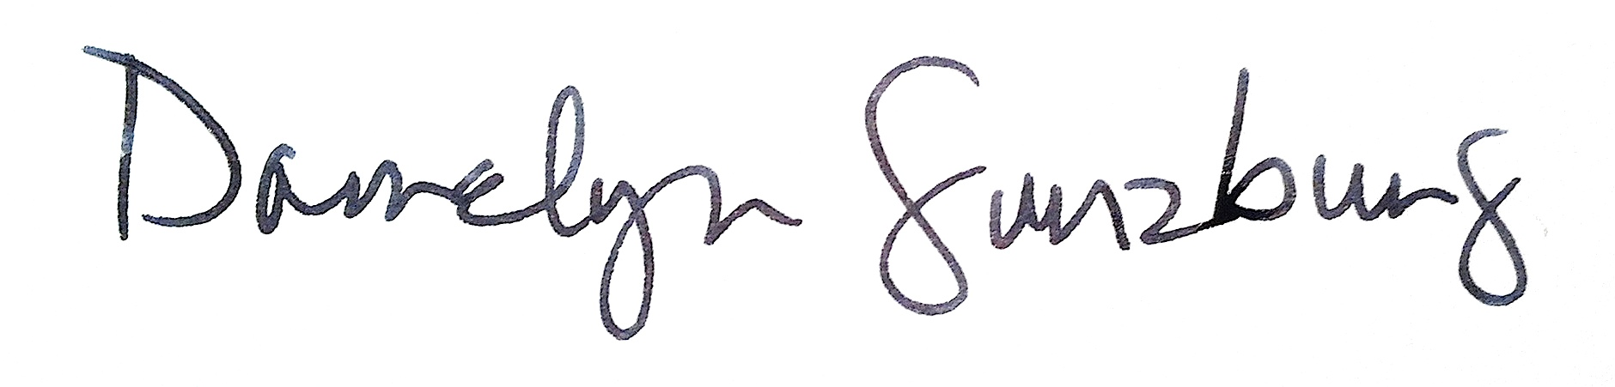

Signed (tutor)_____________________

Date: 6 December 2016

