Learning in the Digital Era (ACCA4025)
Assignment 1: E-Portfolio

Student Name: Emad Muhith
Student ID: 2516011
Programme: CertHE Computing Skills for Workplace
Module Name: Learning in the Digital Era
Module Code: ACCA4025

Table of Contents

E-Portfolio Section 3
Link to Homepage 3
Screenshot of Homepage 3
Task 1 4
Task 2 5
Task 3 6
Task 4 7

E-Portfolio Section

Link to Homepage
https://sites.google.com/view/acca4025-e-portfolio?usp=sharing

Screenshot of Homepage
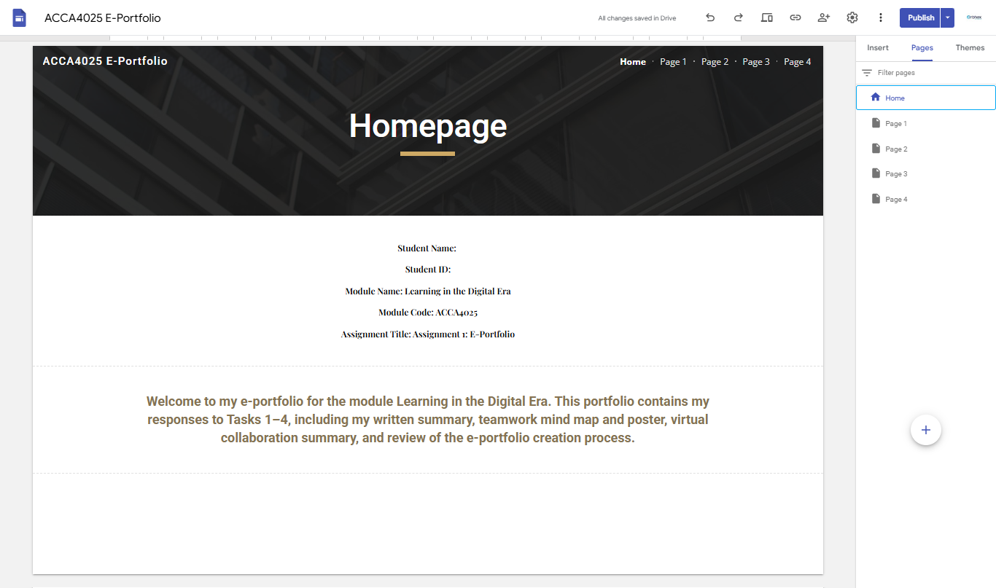

Task 1

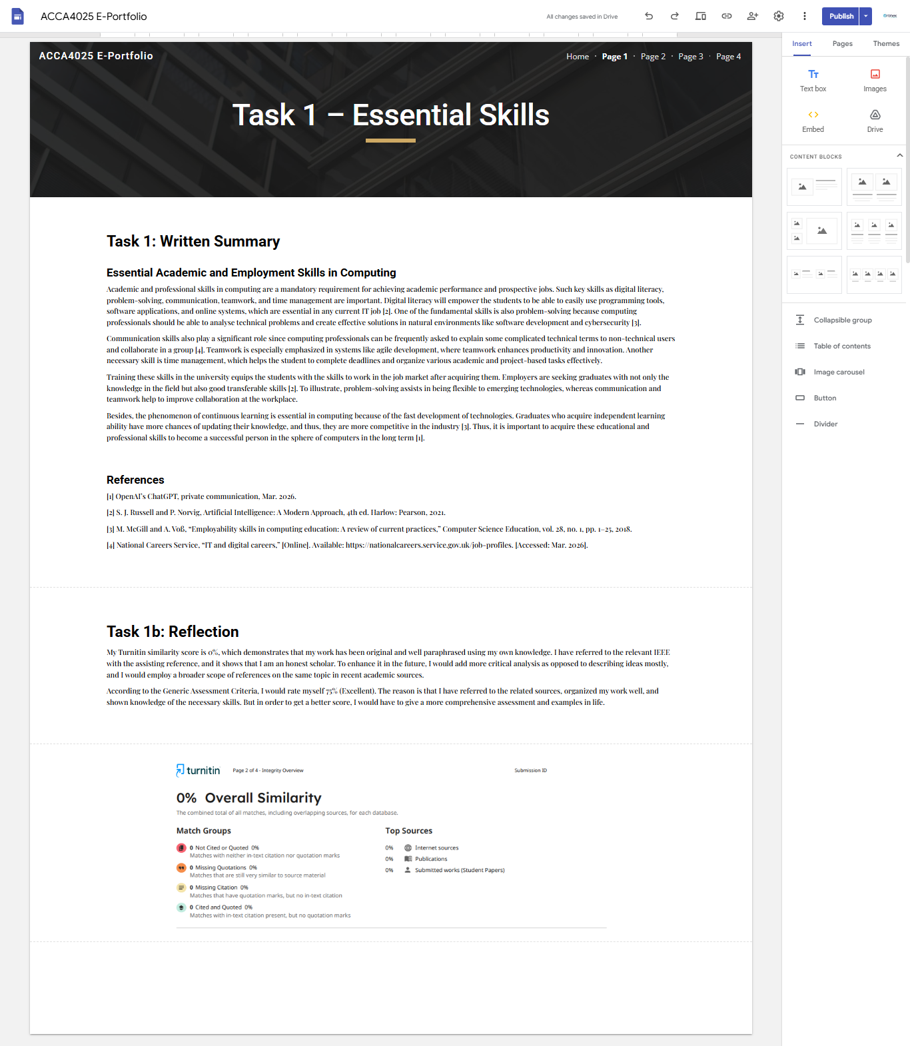

Task 2

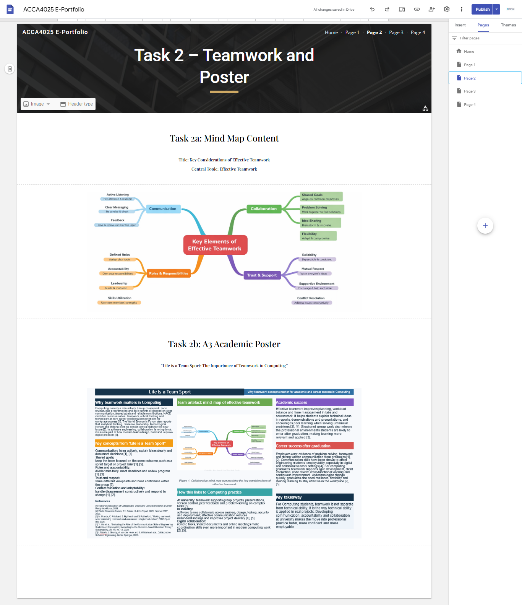

Task 3

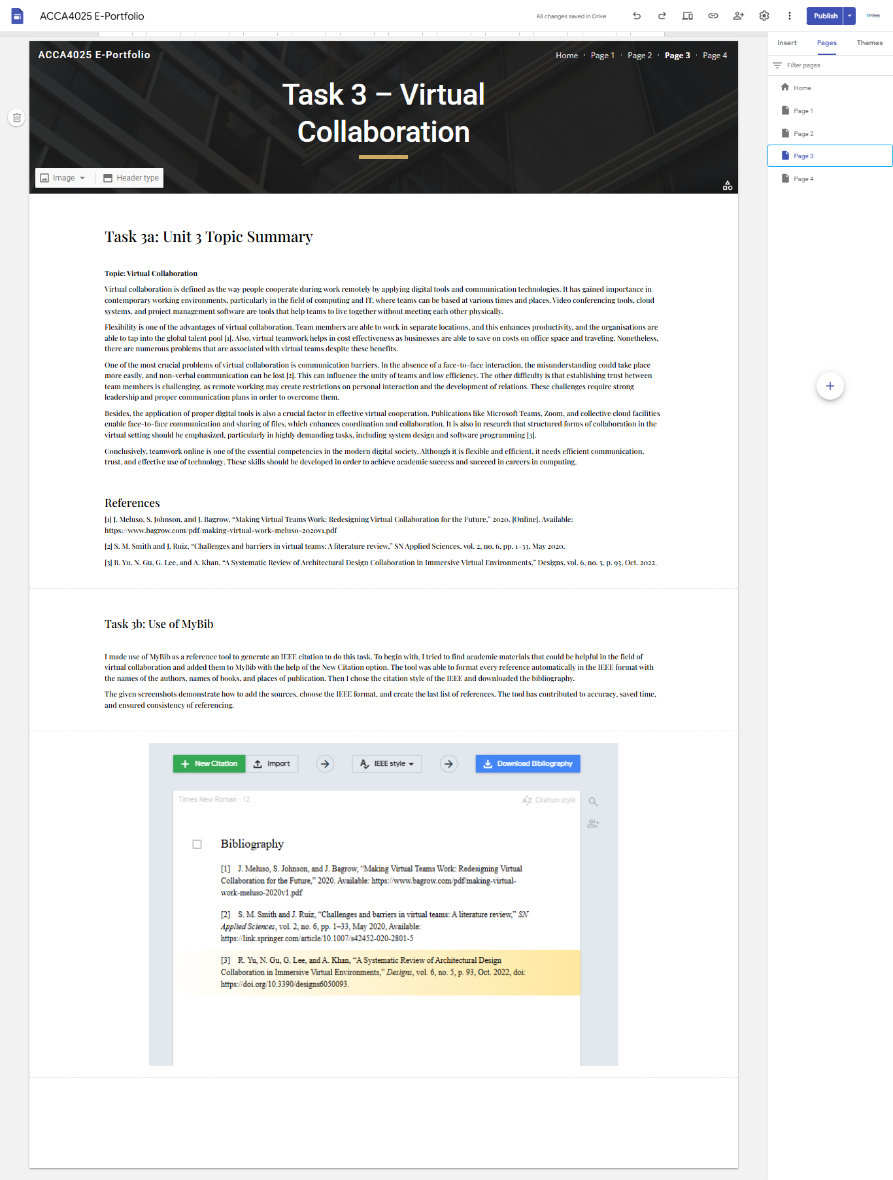

Task 4



