Module Title: Foreign Languages & Cultural Awareness
Intercultural Competence Report
Student Name: Iulia Petronela Ferent
Student ID : 2225255
Module code: BMIH5003
Lecturer: Heidi Prosser
Word Count: 1092

Executive summary
The report will outline the key cultural differences between England and Switzerland. The report will include a comparison between countries based on GLOBE cultural and leadership study. The culture of England and Switzerland is far different from each other. Swiss individuals prefer that when any foreigner visits their country they should speak their native language. The common language of Switzerland is Swiss German while in England English is the most common spoken language. One major cultural difference is that Swiss people spend their free time in physical activities while English people spend their time in shopping. From GLOBE results it has been identified that performance orientation is the most widely used cultural practice in Switzerland while charismatic leadership is the most used leadership style. The report also presents some recommendations for hotel managers to develop intercultural practices in the hotel.

Table of Contents
1 Introduction 2
2 Key differences between England and Switzerland 2
3 GLOBE study comparison 2
3.1 Cultural visualization 3
3.2 Leadership visualization 4
4 Intercultural leadership challenges in the hospitality industry 4
5 Conclusion 5
6 Recommendation 5
7. References……………………………………………………………………………………6

Introduction
The Assistant General Manager at Inclusivity Hotel and Spa in London, England was asked by seniors to visit hotel headquarters in Switzerland before strating role. This visit aims to get an understanding of the hotel chain’s operation and brand standards for which assistant manager have to develop a report. The report will outline the key cultural differences between England and Switzerland. The report will include a comparison between countries based on GLOBE cultural and leadership study. The report will also include challenges that may occur in managing intercultural leadership skills in the hotel industry and provide relevant recommendations.

Key differences between England and Switzerland
Every country has different and various cultures when individuals shift from one to another country they observe cultural differences. The culture of England and Switzerland is far different from each other. Swiss individuals prefer that when any foreigner visits their country they should speak their native language. The common languages that are commonly spoken in Switzerland are Swiss German, Italian, French, and Romansch. Some individuals also speak English and try hard to learn the local language to get mixed with the residents. In England, 98% of individuals speak English, and three dialects of English are common Scottish, Welsh, and Irish English (Lijphart, 2019). In leisure time Swiss people are involved in extra-curricular activities like cycling, hiking, paddle boarding, and skiing. In comparison, the British being an unhealthy nation spend their leisure time shopping as their outlets are bombarded with many offers throughout the years. In Switzerland, it is difficult to shop from 4 pm on Saturday to 9 am on Monday (Shaw et al., 2023).
There are major food differences between Swiss and English cultures. Most English citizens prefer to eat junk food that revolves mainly around eating chips and deep-frozen items. In Switzerland, there is a variety of food. The diet includes fish, meat vegetables, and rice. Swiss people like to eat with their families and have homemade dishes. Due to this difference in eating habits English people usually have ballooned bellies which is incredible to think in Switzerland (Schmitt et al., 2016).

GLOBE study comparison

Cultural visualization
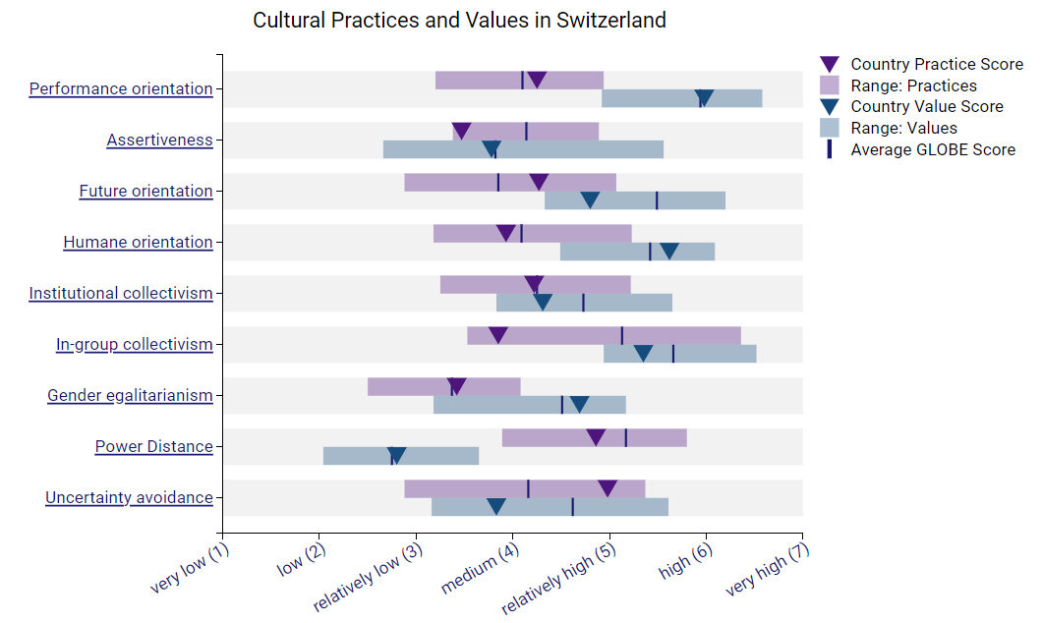
Figure 1Cultural Visualization
(Globeproject.com, 2020 a)

From the cultural visualization GLOBE study of Switzerland, it has been identified that performance orientation has the highest country practice score while gender egalitarianism has the lowest country practice score in Switzerland. Performance orientation in the hotel industry includes market orientation, performance appraisal, performance analysis, and customer satisfaction in the hotel industry (Jalilvand, 2017). Swiss hotels should focus on gender inequality and develop practices for gender equality in the hotel sector.

Leadership visualization
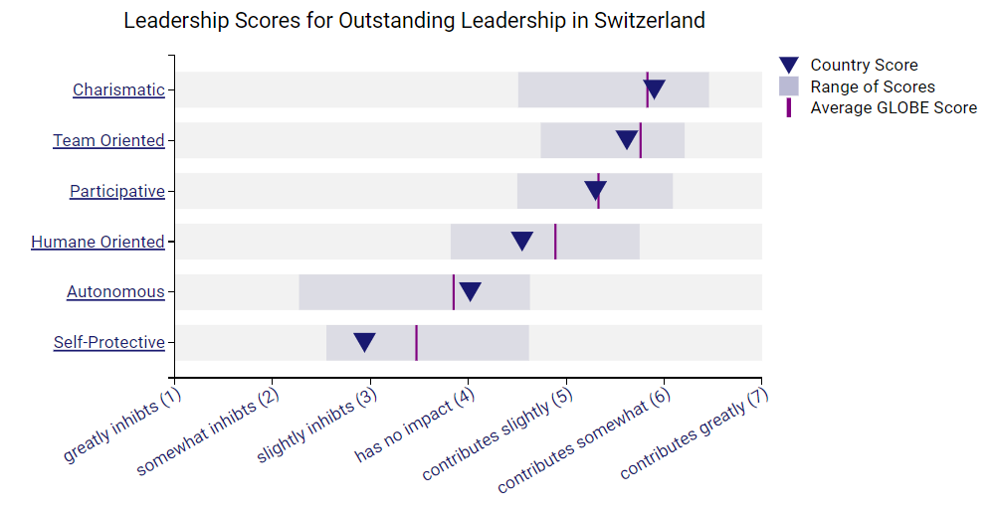
Figure 2 Leadership Visualization
(Globeproject.com, 2020 b)
From the leadership visualization according to the GLOBE project study it has been identified that the charismatic leadership style is the most followed in Switzerland. On the other self-protective leadership style is the least followed leadership style in Switzerland. In the hospitality sector, a charismatic leadership style develops a strong customer service culture, enhances customer satisfaction, and improves employee productivity. This leadership style allows charismatic leaders to communicate through an inspiring vision to guests and staff (Supratman et al., 2021).

Intercultural leadership challenges in the hospitality industry
Due to increased globalization and increased cross-cultural practices in the hospitality sectors hotel staff and employees have to experience cross-cultural practices. These intercultural practices allow them to develop skills related to different cultures. However, these intercultural interactions can be challenging for the hotel staff. In a globalized hotel environment, various guests are from different cultural and social backgrounds due to which communication challenges and misunderstandings among the staff and employees may occur. These guests from different backgrounds have different cultural practices and expectations from hoteliers. These individuals from different backgrounds can understand hotel practices differently (Grobelna, 2015).
Researches show that managers in the hospitality sector spend most of their time in communication activities with hotel guests, team members, supervisors, and also from sub-ordinates. Managers argue that while dealing in intercultural hotel management communication and cultural values appear to be a significant challenge (shukla et al., 2023). The leaders should emphasize these skills for the success of the hotel. Effective communication skills are a key component for successful human resource management and the success of the hotel (Bharwani and Talib, 2017).

Conclusion
Every country has different and various cultures when individuals shift from one to another country they observe cultural differences. The culture of England and Switzerland is far different from each other. The major cultural differences between England and Swiss culture are in the language, eating habits, shopping habits, and leisure time activities. From the cultural visualization GLOBE study of Switzerland, it has been identified that performance orientation has the highest country practice score. The charismatic leadership style is the most followed in Switzerland. Due to increased globalization and increased cross-cultural practices in the hospitality sectors hotel staff and employees have to experience cross-cultural differences. Communication is the major challenge faced by most of the managers in the hotel industry.

Recommendation
Some of the recommendations through which hotel management can overcome intercultural communication and cultural challenges are:
- The hotel managers and assistant managers can organize cultural training programs that help the hotel staff develop a deep understanding of cultural practices and ways of communication to meet customer expectations. The hotel can arrange language training and cultural sensitivity training.
- The hotel should ensure that the employees reflect diverse guest demographics. When employees are from different cultural backgrounds they can easily communicate with individuals from different backgrounds. Diverse employees in the hotel can effectively address the challenges of the diverse hotel guests.
- Hotel managers should promote a sense of cultural intelligence among the employees. This will allow hotel staff to adapt according to different cultures and can easily manage diverse customers (Afsar et al., 2019).

References
Afsar, B., Shahjehan, A., Shah, S.I. and Wajid, A., 2019. The mediating role of transformational leadership in the relationship between cultural intelligence and employee voice behavior: A case of hotel employees. International Journal of Intercultural Relations, 69, pp.66-75.
Bharwani, S. and Talib, P., 2017. Competencies of hotel general managers: A conceptual framework. International Journal of Contemporary Hospitality Management, 29(1), pp.393-418.
Globeproject.com. 2020 a. Switzerland Results - GLOBE Project. [online] Available at: https://globeproject.com/results/countries/CHE%3Fmenu=list.html#list.
Grobelna, A., 2015. Intercultural challenges facing the hospitality industry. Implications for education and hospitality management. Journal of Intercultural Management, 7(3), pp.101-117.
Jalilvand, M.R., 2017. The effect of innovativeness and customer-oriented systems on performance in the hotel industry of Iran. Journal of Science and Technology Policy Management, 8(1), pp.43-61.
Lijphart, A., 2019. Religious vs. linguistic vs. class voting: the “crucial experiment” of comparing Belgium, Canada, South Africa, and Switzerland. In Religion and Politics (pp. 397-413). Routledge.
Schmitt, E., Keech, D., Maye, D., Barjolle, D. and Kirwan, J., 2016. Comparing the sustainability of local and global food chains: A case study of cheese products in Switzerland and the UK. Sustainability, 8(5), p.419.
Shaw, S., Muir, S., Strömmer, S., Crozier, S., Cooper, C., Smith, D., Barker, M. and Vogel, C., 2023. The interplay between social and food environments on UK adolescents’ food choices: implications for policy. Health promotion international, 38(4), p.daad097.
Shukla, B., Sufi, T., Joshi, M. and Sujatha, R., 2023. Leadership challenges for Indian hospitality industry during COVID-19 pandemic. Journal of Hospitality and Tourism Insights, 6(4), pp.1502-1520.
Supratman, O.V., Entang, M. and Tukiran, M., 2021. The relationship of charismatic leadership, employee personality, and employee performance: Evidence from PT. Karya Abadi Luhur. International Journal of Social and Management Studies, 2(2), pp.17-41.

